REOS Recruitment Insights Report – February 2025
Jobs and Skills Australia surveys at least 1,000 employers in the Recruitment Experiences and Outlook Survey (REOS) each month to find out their experiences recruiting staff, and whether they are expecting to increase staffing levels.

Key Findings
Headline figures for February 2025 show a continued favourable recruitment environment. More employers are recruiting, with the national recruitment rate rising back to a level last seen 12 months ago. This is further supported by a sharp rise in the proportion of employers who have increased their staffing numbers over the month.
Along with an increase in recruitment, employers are also finding it less difficult to recruit. The headline recruitment difficulty rate continues to trend downward with most of the easing concentrated in the Capital Cities. The number of vacancies taking longer than 1 month to fill also continues to ease, with the proportion of employers citing unfilled vacancies dropping to another historical low.

Recruitment activity
In February 2025, the recruitment rate was 49%. This was 16 percentage points higher than last month, noting that the January 2025 recruitment rate was unusually low (at 33%) and should be interpreted with caution. Compared with a year ago (February 2024), the recruitment rate has remained unchanged over the year.
This series peaked in both May 2022 and July 2022 at 59% while the record low occurred in June 2020 at 24%.
In the Capital Cities, 46% per cent of employers recruited in February 2025, while this rate was 55% percent in Rest of State areas.
Compared to a year ago (February 2024), the recruitment rate in Capital Cities has decreased by 1 percentage point, versus an increase of 3 percentage points in Rest of State areas.

Recruitment difficulty
The recruitment difficulty rate decreased by 8 percentage points to 43% of recruiting employers in February 2025, which is the lowest reported recruitment difficulty rate since February 2021. Recruitment difficulty is currently 11 percentage points lower than it was a year ago and is 32% points below the record high of 75% in July 2022.
A lower proportion of recruiting employers experienced recruitment difficulty in the Capital Cities areas (38%) compared with Rest of State areas (52%) in February 2025.
In the Capital Cities, recruitment difficulty stands 14 percentage points lower than a year ago (February 2024).
In Rest of State areas, recruitment difficulty is 5 percentage points lower than in February 2024.

Staffing outlook: employers expecting to increase staff
Over the month, the proportion of employers expecting to increase their staffing numbers in the next three months remained steady at 20% of employers in February 2025. This was 6 percentage points lower than it was a year earlier.
This series peaked in April 2022 at 36% while the record low occurred in April 2020 at 4%.
A higher proportion of employers in Capital Cities (20%) were expecting to increase their staffing levels in the next three months compared with Rest of State areas (19%).
These figures now stand 6 percentage points lower than a year ago for Capital Cities and 7 percentage points lower than a year ago in Rest of State areas.

Reason for recruiting
Recruitment due to staff turnover only was the main reason why employers recruited in February 2025 (60% of recruiting employers). Some 28% of recruiting employers aimed to fill new staff positions only, and the remaining 12% were recruiting to fill both new staff and staff turnover positions.

Staffing changes over the last month
Some 17% of employers increased their staff in February 2025. Meanwhile, around 11% of employers said their staff numbers decreased.

Employers unable to fill vacancies in a month
The proportion of recruiting employers who were unable to fill their vacancies in a month fell by 1 percentage point to 36% in February 2025, the lowest recorded of this series. This figure is 18 percentage points lower than the 54% recorded in February 2024.
This series peaked in August 2022 at 72%.

REOS national indicators

Recruitment rate

Proportion of employers currently recruiting or who recruited in the previous month.
Date Recruitment rate Smoothed recruitment rate  Feb 2021 46% 47%  Mar 2021 46% 48%  Apr 2021 46% 47%  May 2021 49% 46%  Jun 2021 48% 44%  Jul 2021 43% 43%  Aug 2021 38% 42%  Sep 2021 36% 42%  Oct 2021 45% 42%  Nov 2021 50% 44%  Dec 2021 51% 48%  Jan 2022 42% 52%  Feb 2022 55% 55%  Mar 2022 56% 57%  Apr 2022 56% 57%  May 2022 59% 58%  Jun 2022 58% 58%  Jul 2022 59% 58%  Aug 2022 55% 58%  Sep 2022 58% 57%  Oct 2022 58% 57%  Nov 2022 58% 57%  Dec 2022 52% 56%  Jan 2023 55% 55%  Feb 2023 55% 54%  Mar 2023 55% 53%  Apr 2023 50% 52%  May 2023 51% 50%  Jun 2023 49% 49%  Jul 2023 51% 49%  Aug 2023 46% 49%  Sep 2023 49% 49%  Oct 2023 49% 49%  Nov 2023 52% 49%  Dec 2023 47% 49%  Jan 2024 48% 49%  Feb 2024 49% 49%  Mar 2024 49% 48%  Apr 2024 48% 47%  May 2024 47% 46%  Jun 2024 39% 45%  Jul 2024 44% 44%  Aug 2024 43% 43%  Sep 2024 45% 43%  Oct 2024 42% 43%  Nov 2024 43% 43%  Dec 2024 44% 43%  Jan 2025 33% 43%  Feb 2025 49% 44%  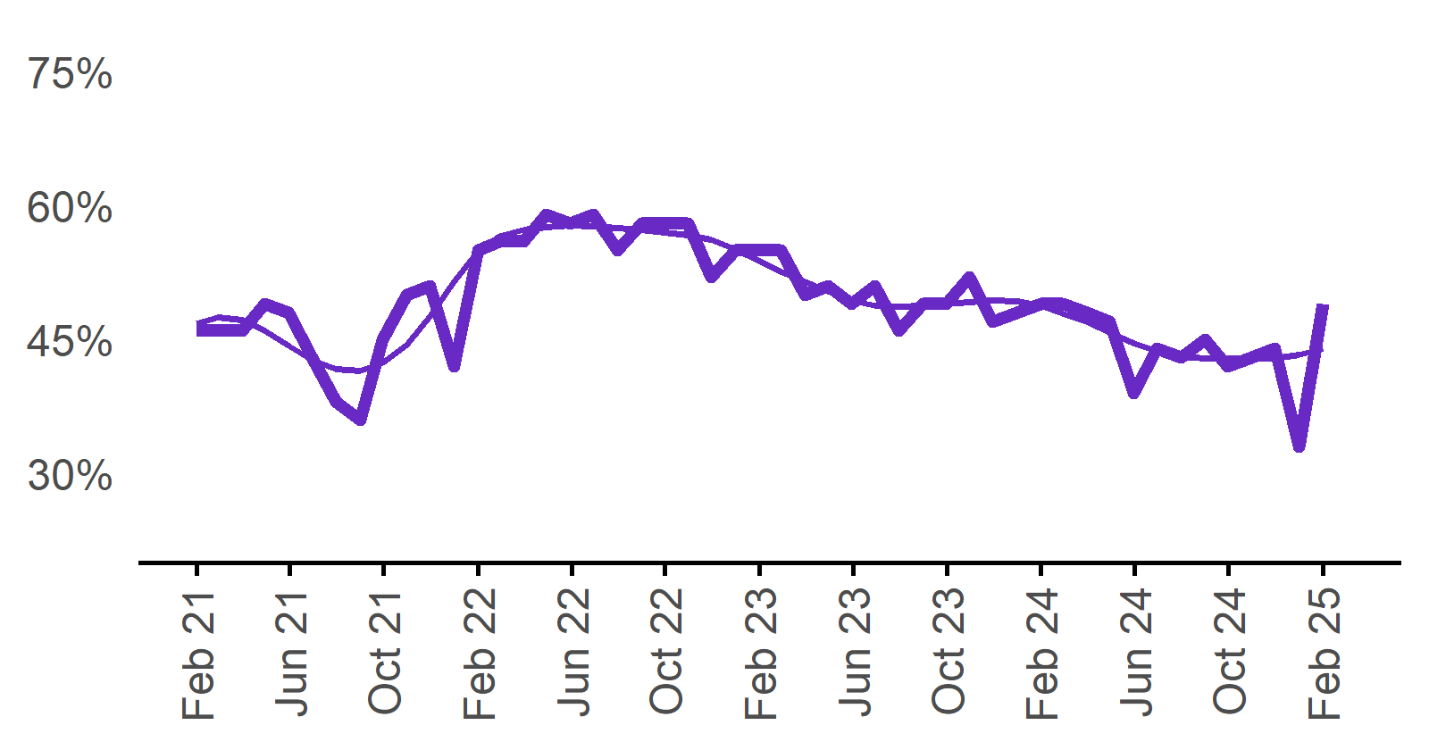 | 49%  Monthly change:  ▲ 16% pts  Annual change:  ◄► 0% pts

Recruitment difficulty rate

Proportion of recruiting employers who stated they had difficulty hiring staff.
Date Recruitment difficulty rate Smoothed recruitment difficulty rate  Feb 2021 37% 43%  Mar 2021 46% 46%  Apr 2021 54% 49%  May 2021 51% 51%  Jun 2021 52% 52%  Jul 2021 53% 52%  Aug 2021 52% 53%  Sep 2021 52% 54%  Oct 2021 54% 56%  Nov 2021 63% 58%  Dec 2021 57% 59%  Jan 2022 68%* 61%  Feb 2022 64% 63%  Mar 2022 64% 65%  Apr 2022 64% 67%  May 2022 68% 68%  Jun 2022 67% 70%  Jul 2022 75% 70%  Aug 2022 74% 71%  Sep 2022 67% 71%  Oct 2022 70% 69%  Nov 2022 69% 68%  Dec 2022 65% 65%  Jan 2023 56% 63%  Feb 2023 61% 63%  Mar 2023 64% 63%  Apr 2023 62% 63%  May 2023 67% 63%  Jun 2023 63% 63%  Jul 2023 59% 61%  Aug 2023 61% 60%  Sep 2023 59% 58%  Oct 2023 56% 57%  Nov 2023 56% 56%  Dec 2023 51% 55%  Jan 2024 55% 54%  Feb 2024 54% 53%  Mar 2024 50% 53%  Apr 2024 53% 53%  May 2024 56% 53%  Jun 2024 55% 52%  Jul 2024 47% 51%  Aug 2024 50% 51%  Sep 2024 52% 51%  Oct 2024 52% 50%  Nov 2024 50% 50%  Dec 2024 47% 49%  Jan 2025 51% 47%  Feb 2025 43% 45%  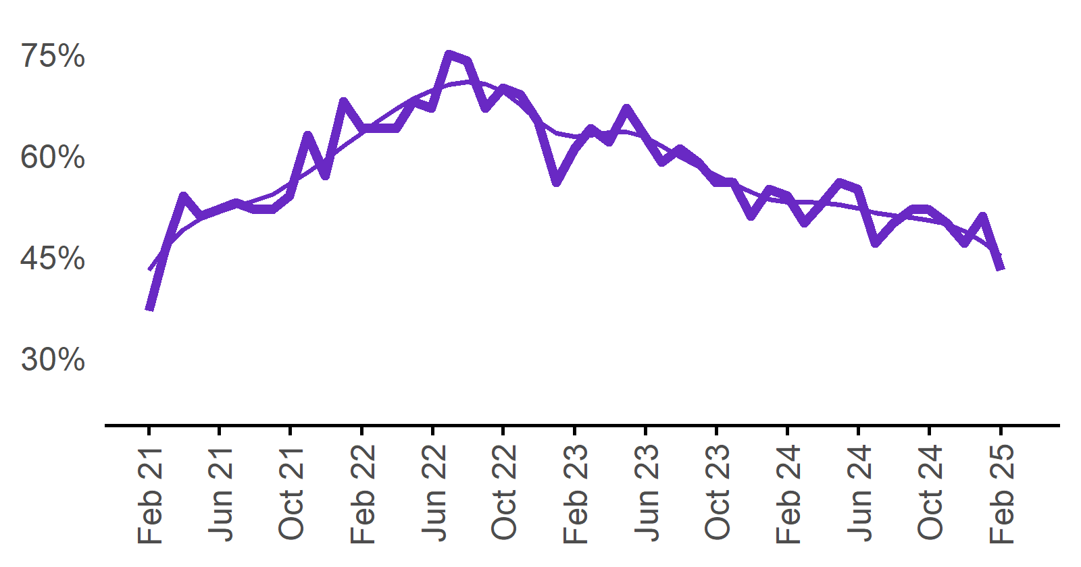 | 43%  Monthly change:  ▼ 8% pts  Annual change:  ▼ 11% pts

Expecting to increase staff

Proportion of employers who expected to increase staffing numbers over the next three months.
Date Expect to increase Smoothed expect to increase  Feb 2021 20% 22%  Mar 2021 23% 21%  Apr 2021 23% 21%  May 2021 20% 20%  Jun 2021 20% 20%  Jul 2021 18% 20%  Aug 2021 18% 21%  Sep 2021 23% 23%  Oct 2021 28% 25%  Nov 2021 30% 27%  Dec 2021 26% 29%  Jan 2022 21% 31%  Feb 2022 33% 32%  Mar 2022 32% 32%  Apr 2022 36% 31%  May 2022 32% 31%  Jun 2022 28% 30%  Jul 2022 25% 29%  Aug 2022 31% 29%  Sep 2022 28% 29%  Oct 2022 31% 29%  Nov 2022 30% 29%  Dec 2022 25% 28%  Jan 2023 24% 27%  Feb 2023 27% 26%  Mar 2023 30% 24%  Apr 2023 20% 24%  May 2023 24% 23%  Jun 2023 21% 23%  Jul 2023 23% 23%  Aug 2023 24% 23%  Sep 2023 25% 22%  Oct 2023 20% 22%  Nov 2023 21% 22%  Dec 2023 20% 23%  Jan 2024 24% 23%  Feb 2024 26% 23%  Mar 2024 22% 22%  Apr 2024 20% 21%  May 2024 19% 20%  Jun 2024 18% 19%  Jul 2024 18% 19%  Aug 2024 22% 19%  Sep 2024 22% 20%  Oct 2024 19% 20%  Nov 2024 18% 20%  Dec 2024 19% 19%  Jan 2025 20% 19%  Feb 2025 20% 19%  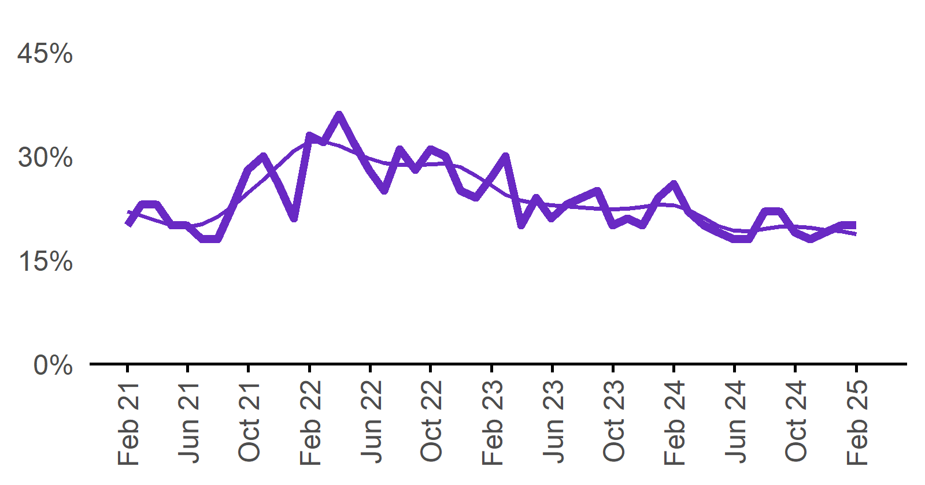 | 20%  Monthly change:  ◄► 0% pts  Annual change:  ▼ 6% pts

Capital City/Rest of State areas

Recruitment rate

Proportion of employers currently recruiting or who recruited in the previous month.
Date Capital Cities - Recruitment rate Rest of State areas - Recruitment rate Capital Cities - Smoothed recruitment rate Rest of State areas - Smoothed recruitment rate  Feb 2021 44% 50% 44% 52%  Mar 2021 44% 49% 45% 52%  Apr 2021 44% 51% 45% 52%  May 2021 44% 58% 44% 51%  Jun 2021 47% 48% 42% 49%  Jul 2021 41% 48% 41% 46%  Aug 2021 36% 43% 40% 44%  Sep 2021 36% 36% 41% 43%  Oct 2021 45% 44% 42% 44%  Nov 2021 50% 51% 44% 45%  Dec 2021 48% 55% 47% 49%  Jan 2022 51% 53%  Feb 2022 55% 54% 54% 57%  Mar 2022 53% 61% 55% 60%  Apr 2022 54% 60% 56% 61%  May 2022 58% 60% 56% 61%  Jun 2022 56% 61% 56% 60%  Jul 2022 57% 62% 57% 60%  Aug 2022 54% 58% 57% 59%  Sep 2022 58% 57% 57% 58%  Oct 2022 58% 58% 57% 58%  Nov 2022 57% 61% 56% 57%  Dec 2022 53% 50% 56% 57%  Jan 2023 54% 56%  Feb 2023 54% 58% 53% 56%  Mar 2023 55% 56% 51% 56%  Apr 2023 48% 53% 50% 55%  May 2023 49% 55% 49% 54%  Jun 2023 46% 54% 48% 52%  Jul 2023 50% 52% 47% 51%  Aug 2023 44% 48% 47% 51%  Sep 2023 49% 49% 47% 52%  Oct 2023 47% 54% 47% 53%  Nov 2023 48% 58% 47% 54%  Dec 2023 44% 53% 47% 54%  Jan 2024 45% 53% 47% 54%  Feb 2024 47% 52% 47% 53%  Mar 2024 46% 53% 46% 51%  Apr 2024 49% 47% 45% 50%  May 2024 45% 51% 44% 49%  Jun 2024 37% 44% 43% 48%  Jul 2024 41% 50% 42% 48%  Aug 2024 42% 45% 41% 47%  Sep 2024 41% 51% 41% 47%  Oct 2024 42% 42% 41% 46%  Nov 2024 40% 50% 41% 46%  Dec 2024 42% 46% 41% 47%  Jan 2025 41% 47%  Feb 2025 46% 55% 41% 49%  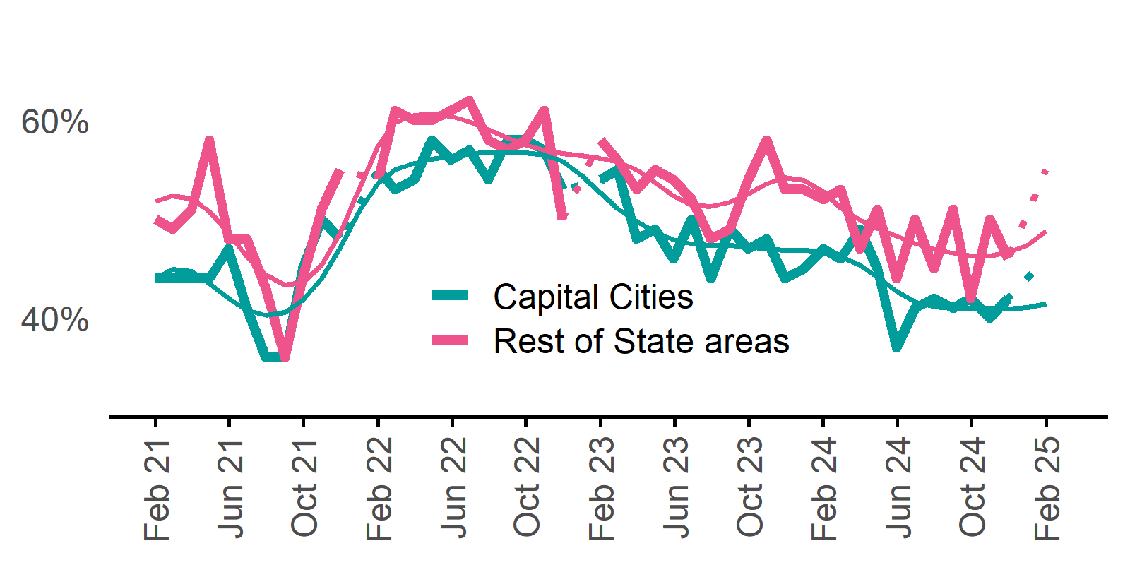 | Capital Cities: 46%  Annual change:  ▼ 1% pt  Rest of State: 55%  Annual change:  ▲ 3% pts

Recruitment difficulty rate

Proportion of recruiting employers who stated they had difficulty hiring staff.
Date Capital Cities - Recruitment difficulty rate Rest of State areas - Recruitment difficulty rate Capital Cities - Smoothed recruitment difficulty rate Rest of State areas - Smoothed recruitment difficulty rate  Feb 2021 35% 40% 39% 49%  Mar 2021 41% 54% 42% 53%  Apr 2021 49% 64% 45% 56%  May 2021 46% 57% 46% 57%  Jun 2021 48% 57% 48% 58%  Jul 2021 48% 61% 49% 58%  Aug 2021 51% 55% 51% 57%  Sep 2021 54% 50% 52% 58%  Oct 2021 50% 62% 54% 59%  Nov 2021 60% 67% 56% 61%  Dec 2021 55% 60% 58% 62%  Jan 2022 60% 64%  Feb 2022 62% 66% 63% 64%  Mar 2022 64% 63% 65% 65%  Apr 2022 65% 62% 67% 67%  May 2022 67% 71% 68% 69%  Jun 2022 66% 67% 69% 70%  Jul 2022 74% 77% 70% 71%  Aug 2022 75% 71% 70% 72%  Sep 2022 66% 68% 70% 72%  Oct 2022 67% 75% 69% 71%  Nov 2022 69% 70% 66% 69%  Dec 2022 63% 68% 64% 67%  Jan 2023 62% 65%  Feb 2023 59% 64% 62% 64%  Mar 2023 65% 64% 62% 65%  Apr 2023 59% 66% 62% 66%  May 2023 65% 69% 62% 67%  Jun 2023 62% 64% 60% 67%  Jul 2023 55% 66% 59% 66%  Aug 2023 57% 67% 57% 65%  Sep 2023 56% 66% 56% 63%  Oct 2023 55% 59% 55% 61%  Nov 2023 54% 58% 53% 60%  Dec 2023 48% 56% 52% 59%  Jan 2024 49% 64% 50% 59%  Feb 2024 52% 57% 50% 58%  Mar 2024 46% 58% 51% 57%  Apr 2024 50% 58% 52% 55%  May 2024 57% 53% 52% 53%  Jun 2024 56% 52% 52% 52%  Jul 2024 48% 46% 51% 52%  Aug 2024 50% 51% 50% 52%  Sep 2024 45% 62% 50% 53%  Oct 2024 50% 55% 49% 53%  Nov 2024 54% 44% 48% 53%  Dec 2024 45% 52% 47% 52%  Jan 2025 45% 51%  Feb 2025 38% 52% 42% 50%  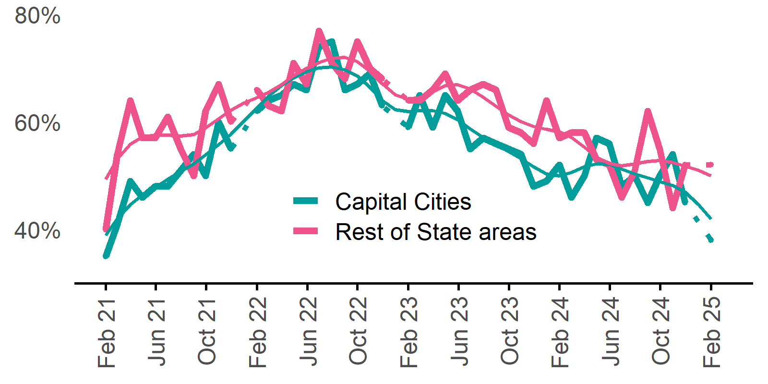 | Capital Cities: 38%  Annual change:  ▼ 14% pts  Rest of State: 52%  Annual change:  ▼ 5% pts

Staffing outlook – Expecting to increase staff

Proportion of employers who expected to increase staffing numbers over the next three months.
Date Capital Cities - % expecting to increase Rest of State areas - % expecting to increase Capital Cities - Smoothed % expecting to increase Rest of State areas - Smoothed % expecting to increase  Feb 2021 19% 22% 21% 24%  Mar 2021 21% 26% 21% 23%  Apr 2021 22% 24% 20% 22%  May 2021 21% 20% 20% 21%  Jun 2021 20% 20% 19% 20%  Jul 2021 18% 19% 20% 20%  Aug 2021 18% 19% 21% 21%  Sep 2021 24% 22% 23% 22%  Oct 2021 28% 28% 25% 24%  Nov 2021 31% 28% 27% 26%  Dec 2021 26% 27% 29% 27%  Jan 2022 31% 29%  Feb 2022 34% 31% 33% 30%  Mar 2022 33% 30% 33% 30%  Apr 2022 37% 35% 32% 30%  May 2022 33% 30% 31% 29%  Jun 2022 28% 27% 30% 28%  Jul 2022 25% 25% 30% 28%  Aug 2022 31% 30% 29% 28%  Sep 2022 30% 24% 29% 28%  Oct 2022 30% 32% 29% 28%  Nov 2022 31% 28% 29% 28%  Dec 2022 23% 28% 29% 28%  Jan 2023 27% 27%  Feb 2023 28% 25% 26% 26%  Mar 2023 29% 30% 25% 24%  Apr 2023 20% 19% 24% 23%  May 2023 23% 24% 23% 23%  Jun 2023 22% 19% 23% 23%  Jul 2023 22% 24% 22% 23%  Aug 2023 22% 28% 22% 23%  Sep 2023 25% 25% 22% 23%  Oct 2023 21% 18% 22% 23%  Nov 2023 20% 25% 22% 23%  Dec 2023 21% 20% 22% 23%  Jan 2024 22% 27% 23% 23%  Feb 2024 26% 26% 23% 23%  Mar 2024 22% 23% 22% 22%  Apr 2024 23% 15% 21% 21%  May 2024 17% 23% 20% 20%  Jun 2024 19% 16% 19% 20%  Jul 2024 17% 18% 19% 20%  Aug 2024 22% 22% 19% 21%  Sep 2024 19% 28% 19% 21%  Oct 2024 19% 19% 19% 21%  Nov 2024 18% 19% 19% 20%  Dec 2024 20% 17% 19% 19%  Jan 2025 20% 18%  Feb 2025 20% 19% 20% 17%  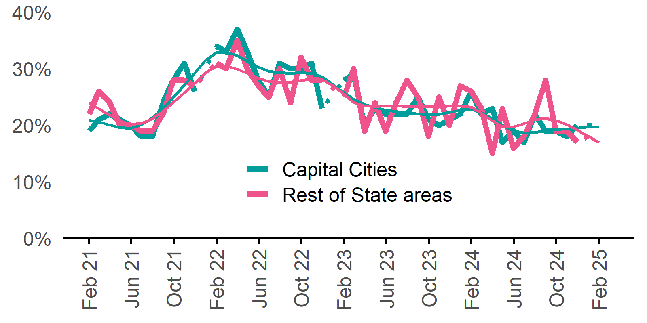 | Capital Cities: 20%  Annual change:  ▼ 6% pts  Rest of State: 19%  Annual change:  ▼ 7% pts

Other recruitment indicators

Reason for recruiting

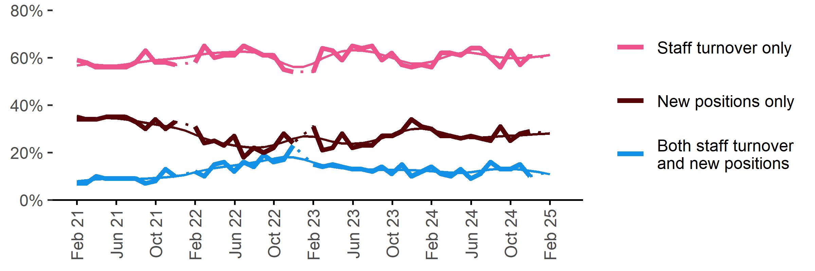
Proportion of employers currently recruiting or who recruited in the previous month.
Date | Staff turnover only | Staff turnover and new positions | New positions only | Smoothed - staff turnover only | Smoothed - staff turnover and new positions | Smoothed - new positions only
Feb 2021 | 59% | 7% | 34% | 57% | 8% | 36%
Mar 2021 | 58% | 7% | 34% | 57% | 8% | 35%
Apr 2021 | 56% | 10% | 34% | 57% | 9% | 34%
May 2021 | 56% | 9% | 35% | 57% | 9% | 34%
Jun 2021 | 56% | 9% | 35% | 57% | 9% | 34%
Jul 2021 | 56% | 9% | 35% | 57% | 9% | 34%
Aug 2021 | 58% | 9% | 33% | 58% | 9% | 33%
Sep 2021 | 63% | 7% | 30% | 58% | 9% | 33%
Oct 2021 | 58% | 8% | 34% | 59% | 9% | 32%
Nov 2021 | 58% | 13% | 30% | 59% | 10% | 31%
Dec 2021 | 57% | 10% | 33% | 60% | 10% | 30%
Jan 2022 |  |  |  | 60% | 11% | 29%
Feb 2022 | 58% | 12% | 31% | 61% | 12% | 28%
Mar 2022 | 65% | 10% | 24% | 62% | 13% | 26%
Apr 2022 | 60% | 15% | 25% | 62% | 13% | 25%
May 2022 | 61% | 16% | 23% | 62% | 14% | 24%
Jun 2022 | 61% | 12% | 27% | 62% | 15% | 23%
Jul 2022 | 65% | 16% | 18% | 63% | 15% | 22%
Aug 2022 | 63% | 14% | 22% | 62% | 16% | 22%
Sep 2022 | 61% | 19% | 20% | 61% | 17% | 22%
Oct 2022 | 61% | 16% | 22% | 60% | 17% | 23%
Nov 2022 | 55% | 17% | 28% | 58% | 18% | 24%
Dec 2022 | 54% | 23% | 24% | 56% | 18% | 26%
Jan 2023 |  |  |  | 56% | 17% | 27%
Feb 2023 | 54% | 15% | 31% | 58% | 16% | 27%
Mar 2023 | 64% | 14% | 21% | 60% | 15% | 26%
Apr 2023 | 63% | 15% | 22% | 61% | 14% | 25%
May 2023 | 59% | 14% | 28% | 63% | 13% | 24%
Jun 2023 | 65% | 13% | 22% | 63% | 13% | 24%
Jul 2023 | 64% | 13% | 23% | 63% | 13% | 24%
Aug 2023 | 65% | 12% | 23% | 62% | 13% | 25%
Sep 2023 | 59% | 14% | 27% | 61% | 13% | 26%
Oct 2023 | 62% | 11% | 27% | 60% | 13% | 27%
Nov 2023 | 57% | 15% | 29% | 59% | 13% | 29%
Dec 2023 | 56% | 10% | 34% | 58% | 13% | 30%
Jan 2024 | 57% | 12% | 31% | 57% | 12% | 30%
Feb 2024 | 56% | 14% | 30% | 58% | 12% | 30%
Mar 2024 | 62% | 11% | 27% | 60% | 12% | 28%
Apr 2024 | 62% | 10% | 27% | 61% | 12% | 27%
May 2024 | 61% | 13% | 26% | 62% | 11% | 27%
Jun 2024 | 64% | 9% | 27% | 62% | 12% | 26%
Jul 2024 | 64% | 11% | 26% | 62% | 12% | 26%
Aug 2024 | 60% | 16% | 25% | 61% | 13% | 27%
Sep 2024 | 56% | 13% | 31% | 60% | 13% | 27%
Oct 2024 | 63% | 13% | 25% | 60% | 13% | 27%
Nov 2024 | 57% | 15% | 28% | 60% | 13% | 27%
Dec 2024 | 61% | 10% | 29% | 60% | 12% | 28%
Jan 2025 |  |  |  | 61% | 12% | 28%
Feb 2025 | 60% | 12% | 28% | 61% | 11% | 28%

Staffing changes over the last month

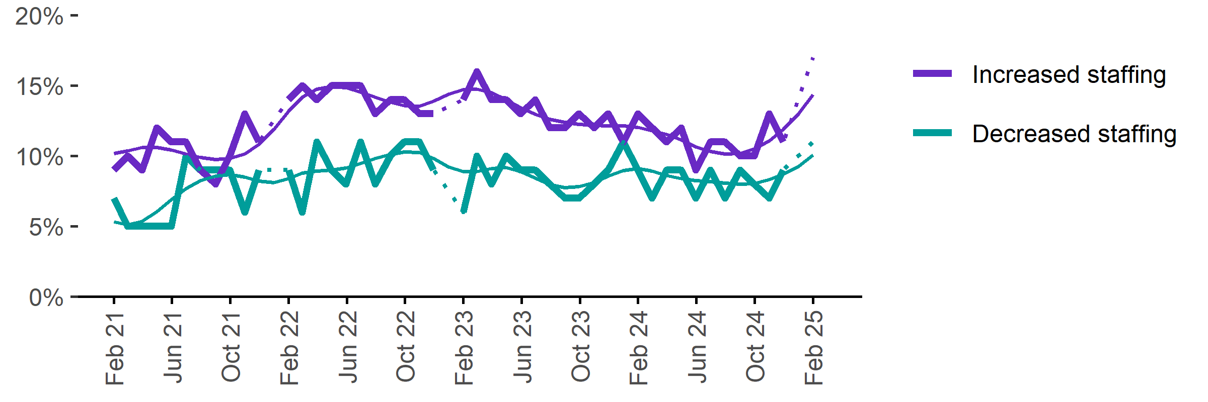
Proportion of employers who said they increased or decreased staffing compared to the previous month.
Date | Increased staff | Decreased staff | Smoothed - increased staff | Smoothed - decreased staff
Feb 2021 | 9% | 7% | 10% | 5%
Mar 2021 | 10% | 5% | 10% | 5%
Apr 2021 | 9% | 5% | 11% | 5%
May 2021 | 12% | 5% | 11% | 6%
Jun 2021 | 11% | 5% | 10% | 7%
Jul 2021 | 11% | 10% | 10% | 8%
Aug 2021 | 9% | 9% | 10% | 8%
Sep 2021 | 8% | 9% | 10% | 9%
Oct 2021 | 10% | 9% | 10% | 9%
Nov 2021 | 13% | 6% | 10% | 8%
Dec 2021 | 11% | 9% | 11% | 8%
Jan 2022 |  |  | 12% | 8%
Feb 2022 | 14% | 9% | 13% | 8%
Mar 2022 | 15% | 6% | 14% | 9%
Apr 2022 | 14% | 11% | 15% | 9%
May 2022 | 15% | 9% | 15% | 9%
Jun 2022 | 15% | 8% | 15% | 9%
Jul 2022 | 15% | 11% | 15% | 9%
Aug 2022 | 13% | 8% | 14% | 10%
Sep 2022 | 14% | 10% | 14% | 10%
Oct 2022 | 14% | 11% | 14% | 10%
Nov 2022 | 13% | 11% | 14% | 10%
Dec 2022 | 13% | 9% | 14% | 10%
Jan 2023 |  |  | 14% | 9%
Feb 2023 | 14% | 6% | 15% | 9%
Mar 2023 | 16% | 10% | 15% | 9%
Apr 2023 | 14% | 8% | 14% | 9%
May 2023 | 14% | 10% | 14% | 9%
Jun 2023 | 13% | 9% | 13% | 9%
Jul 2023 | 14% | 9% | 13% | 8%
Aug 2023 | 12% | 8% | 13% | 8%
Sep 2023 | 12% | 7% | 12% | 8%
Oct 2023 | 13% | 7% | 12% | 8%
Nov 2023 | 12% | 8% | 12% | 8%
Dec 2023 | 13% | 9% | 12% | 9%
Jan 2024 | 11% | 11% | 12% | 9%
Feb 2024 | 13% | 9% | 12% | 9%
Mar 2024 | 12% | 7% | 12% | 9%
Apr 2024 | 11% | 9% | 12% | 9%
May 2024 | 12% | 9% | 11% | 8%
Jun 2024 | 9% | 7% | 11% | 8%
Jul 2024 | 11% | 9% | 10% | 8%
Aug 2024 | 11% | 7% | 10% | 8%
Sep 2024 | 10% | 9% | 10% | 8%
Oct 2024 | 10% | 8% | 10% | 8%
Nov 2024 | 13% | 7% | 11% | 8%
Dec 2024 | 11% | 9% | 12% | 9%
Jan 2025 |  |  | 13% | 9%
Feb 2025 | 17% | 11% | 14% | 10%

Employers unable to fill vacancies within a month

Proportion of recruiting employers who were unable to fill their vacancies within a month.
Date % unable to fill vacancies in a month Smoothed - % unable to fill vacancies in a month  Feb 2022 56% 58%  Mar 2022 59% 61%  Apr 2022 62% 63%  May 2022 66% 66%  Jun 2022 66% 67%  Jul 2022 69% 69%  Aug 2022 72% 70%  Sep 2022 69% 70%  Oct 2022 70% 70%  Nov 2022 71% 68%  Dec 2022 62% 66%  Jan 2023 60% 64%  Feb 2023 58% 62%  Mar 2023 66% 61%  Apr 2023 60% 61%  May 2023 62% 61%  Jun 2023 57% 60%  Jul 2023 57% 58%  Aug 2023 60% 57%  Sep 2023 56% 55%  Oct 2023 53% 54%  Nov 2023 51% 53%  Dec 2023 46% 52%  Jan 2024 56% 52%  Feb 2024 54% 51%  Mar 2024 49% 51%  Apr 2024 50% 49%  May 2024 47% 47%  Jun 2024 45% 45%  Jul 2024 42% 44%  Aug 2024 45% 44%  Sep 2024 44% 45%  Oct 2024 44% 45%  Nov 2024 48% 44%  Dec 2024 43% 43%  Jan 2025 37% 41%  Feb 2025 36% 39%  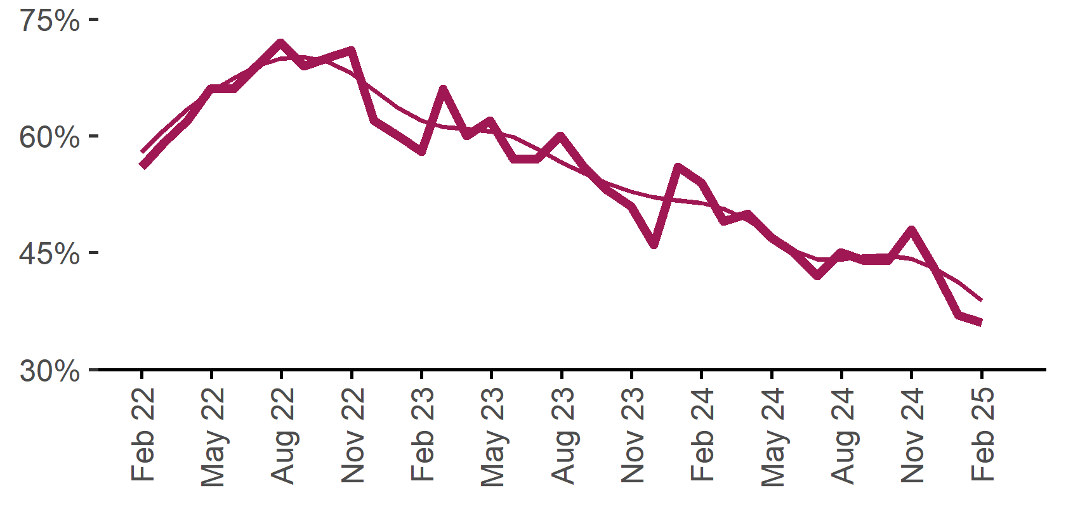 | 36%  Monthly change:  ▼ 1% pt  Annual change:  ▼ 18% pts

Background
Jobs and Skills Australia (JSA) conducts the Recruitment Experiences and Outlook Survey (REOS), a telephone administered survey with the business owner or other person in the business responsible for recruitment. At least 1,000 employers are surveyed each month, with data published on the JSA website. While the data are indicative of recruitment activity, they may be subject to seasonal factors and other volatility and should therefore be used with a degree of caution. In addition, the survey is targeted towards employers with 5 or more employees and excludes many government organisations. Details of the survey methodology can be accessed from the JSA website.

Smoothed series in charts
Charts include Henderson-smoothed lines in addition to original data for most of our recruitment indicators. As the timeseries is not yet long enough for seasonal adjustment, a Henderson smoothed moving average with a 13-term filter (equating to 13 months) has been directly applied to the original series. This provides an indication of the general movement in each recruitment indicator relative to previous months. Due to using 13 months in the moving average, results for the most recent six months will be revised when another month is added to the series.

Referencing this report
Data in this release should be referenced as: Jobs and Skills Australia, Recruitment Insights Report, February 2025.

Contact us
For additional information, email REOS@jobsandskills.gov.au

Also available from the REOS

Data file with monthly and quarterly recruitment indicators
A REOS data file is available on the JSA website. Breakdowns by Capital City/Rest of State area, Business size, and ANZSCO Skill Level are included in the monthly results. Quarterly recruitment indicators provide detail by state, ARIA (ABS’ Accessibility and Remoteness Index of Australia) as well as selected industry and occupation groups.

Next Recruitment Insights Report release:
- March 2025 Recruitment Insights Report – 15 April 2025

Stay up to date
JSA also releases semi-regular reports including spotlight articles, detailing aspects of the REOS that cannot be included in our monthly Recruitment Insights Report. Sign up and get the Recruitment Insights Report notifications sent straight to your inbox.

Upcoming spotlight:
- March Quarter 2025 Quarterly Report – 22 May 2025

Recent additional research:
- Research article – Employers’ experiences of young job applicants – 6 March 2025
- February spotlight – December quarter 2024 results – 6 February 2025

A Henderson smoothed line has been included in the charts to reduce month to month volatility and illustrate long term patterns. See the explanatory note for more information.
Data are not available for January in some years. Data points have been joined by a dotted line between December and February to reflect this. ‘Rest of State’ refers to areas outside the capital cities.

