# Recruitment Experiences and Outlook Survey: December quarter 2024

Jobs and Skills Australia conducts the Recruitment Experiences and Outlook Survey (REOS) to monitor recruitment activity and conditions across Australia. Key national indicators from the survey are released monthly; more detailed data disaggregated by state, area, industry and occupation are released in this quarterly report. For definitions, further information on these data and the REOS, please refer to the notes on the last page.

### Recruitment rate - National level

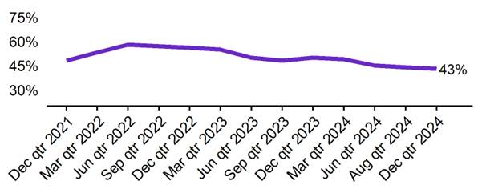

| **Dec qtr 2021** | **Mar qtr 2022** | **Jun qtr 2022** | **Sep qtr 2022** | **Dec qtr 2022** | **Mar qtr 2023** | **Jun qtr 2023** | **Sep qtr 2023** | **Dec qtr 2023** | **Mar qtr 2024** | **Jun qtr 2024** | **Sep qtr 2024** | **Dec qtr 2024** |
| --- | --- | --- | --- | --- | --- | --- | --- | --- | --- | --- | --- | --- |
| 48% | 53% | 58% | 57% | 56% | 55% | 50% | 48% | 50% | 49% | 45% | 44% | 43% |

* The recruitment rate in the December quarter 2024 was 43%.
* This was 7 percentage points lower than this time last year (50%)

### Recruitment difficulty rate - National level

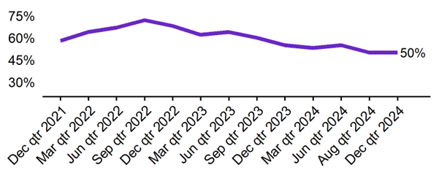

| **Dec qtr 2021** | **Mar qtr 2022** | **Jun qtr 2022** | **Sep qtr 2022** | **Dec qtr 2022** | **Mar qtr 2023** | **Jun qtr 2023** | **Sep qtr 2023** | **Dec qtr 2023** | **Mar qtr 2024** | **Jun qtr 2024** | **Sep qtr 2024** | **Dec qtr 2024** |
| --- | --- | --- | --- | --- | --- | --- | --- | --- | --- | --- | --- | --- |
| **58%** | **64%** | **67%** | **72%** | **68%** | **62%** | **64%** | **60%** | **55%** | **53%** | **55%** | **50%** | **50%** |

* The recruitment difficulty rate in the December quarter 2024 was 50%.
* This was 5 percentage points lower than this time last year (55%).

### 

### Expecting to increase staff - National level

| **Dec qtr 2021** | **Mar qtr 2022** | **Jun qtr 2022** | **Sep qtr 2022** | **Dec qtr 2022** | **Mar qtr 2023** | **Jun qtr 2023** | **Sep qtr 2023** | **Dec qtr 2023** | **Mar qtr 2024** | **Jun qtr 2024** | **Sep qtr 2024** | **Dec qtr 2024** |
| --- | --- | --- | --- | --- | --- | --- | --- | --- | --- | --- | --- | --- |
| 28% | 30% | 31% | 28% | 29% | 28% | 22% | 24% | 21% | 24% | 19% | 20% | 19% |

* In the December quarter 2024, 19% of employers expected to increase staff. This was 2 percentage points lower than this time last year (21%).
* The proportion of employers who expected to decrease staff was 5% in the December quarter 2024.

## Key indicators by state/territory

In the December quarter 2024, Western Australia recorded the highest recruitment rate (54%) of the six states. At 59%, Queensland recorded the highest rate of recruitment difficulty. The Northern Territory (albeit using data averaged over the past two quarters) reported the highest recruitment rate (60%) as well as the highest recruitment difficulty rate (64%) in the December quarter 2024.

### Table 1. Key indicators by state/territory, December quarter 2024

|  | **Recruitment rate** | | **Recruitment difficulty rate** | | **Expect to increase staff** | |
| --- | --- | --- | --- | --- | --- | --- |
|  | **% of employers** | **Annual change (% points)** | **% of recruiting employers** | **Annual change (% points)** | **% of employers** | **Annual change (% points)** |
| NSW | 39% | -10 pts | 50% | -10 pts | 19% | 0 pts |
| VIC | 39% | -8 pts | 43% | -9 pts | 17% | -5 pts |
| QLD | 49% | -6 pts | 59% | 7 pts | 19% | 0 pts |
| SA | 39% | -7 pts | 52% | -8 pts | 20% | -2 pts |
| WA | 54% | 5 pts | 49% | -8 pts | 20% | -4 pts |
| TAS | 48% | -1 pt | 37%* | -6 pts* | 22% | -1 pt |
| NT# | 60% | -7 pts | 64% | 2 pts | 30% | 3 pts |
| ACT# | 43% | -11 pts | 43%* | -8 pts* | 23% | -6 pts |

# Due to smaller sample sizes, data for the NT and ACT are based on six-month average data (Sep qtr. to Dec qtr.).  
* Interpret with caution due to low sample size.

### Figure 1. Recruitment rate by state, December quarter 2023 - December quarter 2024

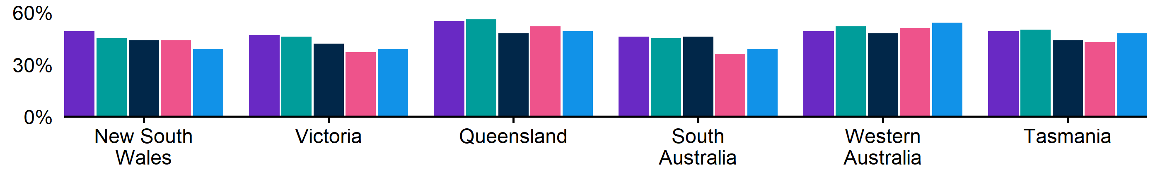

|  | **Dec qtr 2023** | **Mar qtr 2024** | **Jun qtr 2024** | **Sep qtr 2024** | **Dec qtr 2024** |
| --- | --- | --- | --- | --- | --- |
| NSW | 49% | 45% | 44% | 44% | 39% |
| VIC | 47% | 46% | 42% | 37% | 39% |
| QLD | 55% | 56% | 48% | 52% | 49% |
| SA | 46% | 45% | 46% | 36% | 39% |
| WA | 49% | 52% | 48% | 51% | 54% |
| TAS | 49% | 50% | 44% | 43% | 48% |

### Figure 2. Recruitment difficulty rate by state, December quarter 2023 - December quarter 2024

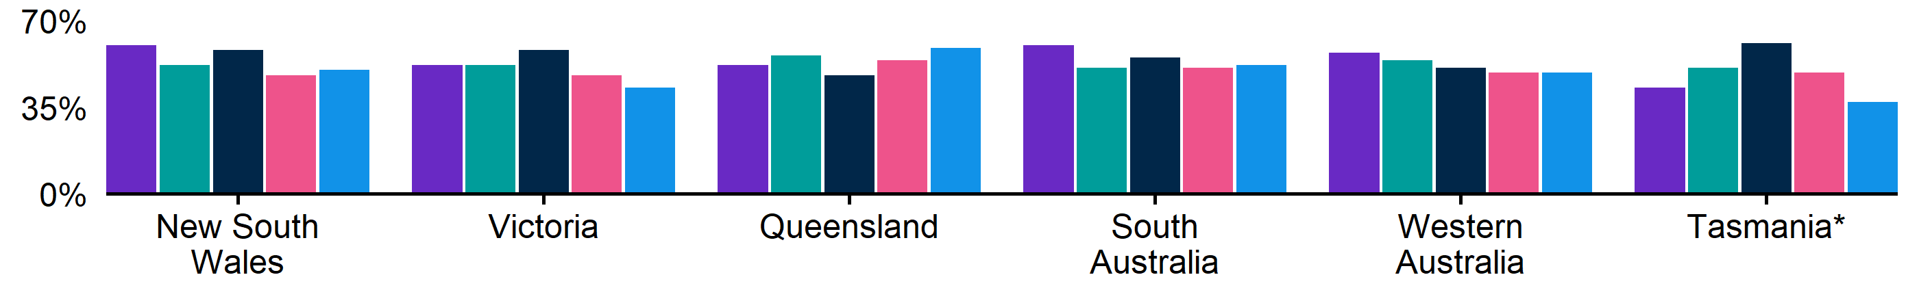

|  | **Dec qtr 2023** | **Mar qtr 2024** | **Jun qtr 2024** | **Sep qtr 2024** | **Dec qtr 2024** |
| --- | --- | --- | --- | --- | --- |
| NSW | 60% | 52% | 58% | 48% | 50% |
| VIC | 52% | 52% | 58% | 48% | 43% |
| QLD | 52% | 56% | 48% | 54% | 59% |
| SA | 60% | 51% | 55% | 51%* | 52% |
| WA | 57% | 54% | 51% | 49% | 49% |
| TAS | 43% | 51% | 61%* | 49%* | 37%* |

### Figure 3. Expecting to increase staff numbers over the next 3 months by state, December quarter 2023 - December quarter 2024

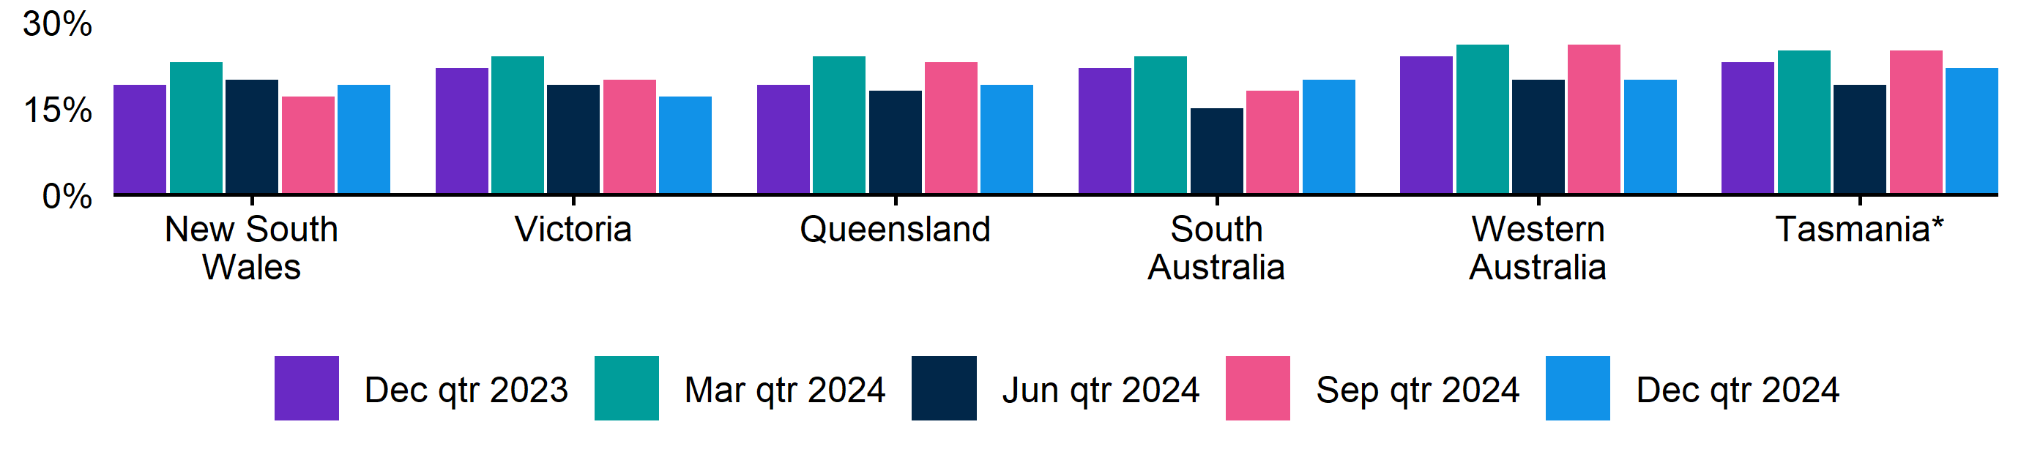

|  | **Dec qtr 2023** | **Mar qtr 2024** | **Jun qtr 2024** | **Sep qtr 2024** | **Dec qtr 2024** |
| --- | --- | --- | --- | --- | --- |
| NSW | 19% | 23% | 20% | 17% | 19% |
| VIC | 22% | 24% | 19% | 20% | 17% |
| QLD | 19% | 24% | 18% | 23% | 19% |
| SA | 22% | 24% | 15% | 18% | 20% |
| WA | 24% | 26% | 20% | 26% | 20% |
| TAS | 23% | 25% | 19% | 25% | 22% |

## Key indicators by remoteness classification[1] (ARIA location)

In the December quarter 2024, Outer Regional, Remote and Very Remote Australia recorded the highest recruitment rate (at 49%) of the ARIA regions. At 58%, Outer Regional, Remote and Very Remote Australia also recorded the highest rate of recruitment difficulty. In all three regions, 19% of employers were expecting to increase their staffing level in the next three months.

### Table 2. Key indicators by ARIA location, December quarter 2024

|  | **Recruitment rate** | | **Recruitment difficulty rate** | | **Expect to increase staff** | |
| --- | --- | --- | --- | --- | --- | --- |
|  | **% of employers** | **Annual change (% points)** | **% of recruiting employers** | **Annual change (% points)** | **% of employers** | **Annual change (% points)** |
| Major Cities of Australia | 41% | -6 pts | 48% | -5 pts | 19% | -2 pts |
| Inner Regional Australia | 46% | -11 pts | 51% | -9 pts | 19% | -2 pts |
| Outer Regional, Remote and Very Remote Australia | 49% | -6 pts | 58% | -1 pts | 19% | -1 pts |

Note: Accessibility and Remoteness Index of Australia (ARIA) classifications of Outer Regional Australia, Remote Australia, and Very Remote Australia have been combined into one category to increase sample size.

### Figure 4. Recruitment rate by ARIA location, December quarter 2023 - December quarter 2024

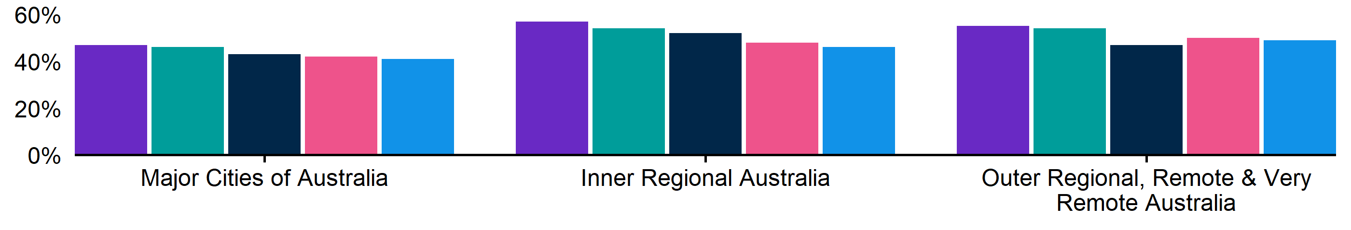

|  | Dec qtr 2023 | Mar qtr 2024 | Jun qtr 2024 | Sep qtr 2024 | Dec qtr 2024 |
| --- | --- | --- | --- | --- | --- |
| Major Cities of Australia | 47% | 46% | 43% | 42% | 41% |
| Inner Regional Australia | 57% | 54% | 52% | 48% | 46% |
| Outer Regional, Remote and Very Remote Australia | 55% | 54% | 47% | 50% | 49% |

### Figure 5. Recruitment difficulty rate by ARIA location, December quarter 2023 - December quarter 2024

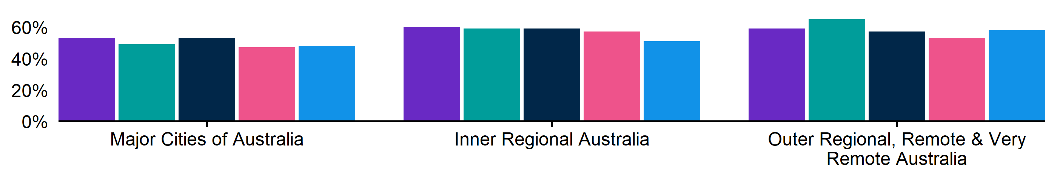

|  | **Dec qtr 2023** | **Mar qtr 2024** | **Jun qtr 2024** | **Sep qtr 2024** | **Dec qtr 2024** |
| --- | --- | --- | --- | --- | --- |
| Major Cities of Australia | 53% | 49% | 53% | 47% | 48% |
| Inner Regional Australia | 60% | 59% | 59% | 57% | 51% |
| Outer Regional, Remote and Very Remote Australia | 59% | 65% | 57% | 53% | 58% |

### Figure 6. Expecting to increase staff numbers over the next 3 months by ARIA location, December quarter 2023 - December quarter 2024

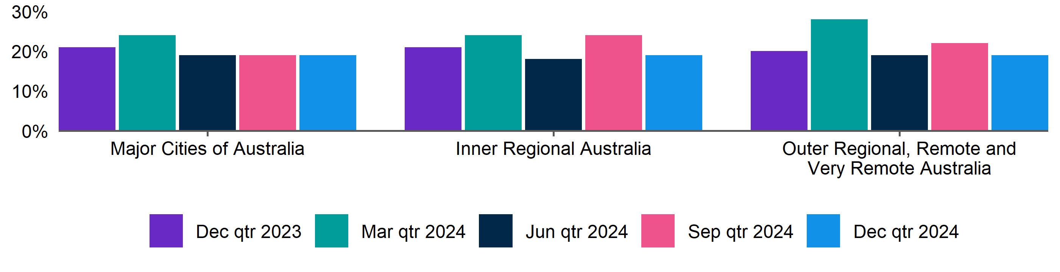

|  | **Dec qtr 2023** | **Mar qtr 2024** | **Jun qtr 2024** | **Sep qtr 2024** | **Dec qtr 2024** |
| --- | --- | --- | --- | --- | --- |
| Major Cities of Australia | 21% | 24% | 19% | 19% | 19% |
| Inner Regional Australia | 21% | 24% | 18% | 24% | 19% |
| Outer Regional, Remote and Very Remote Australia | 20% | 28% | 19% | 22% | 19% |

## Key indicators by selected industries

In the December quarter 2024, Accommodation and Food Services recorded the highest recruitment rate (63%) of the selected industries. At 61%, Construction recorded the highest rate of recruitment difficulty. It is important to note that the Accommodation and Food Services industry reported the lowest recruitment difficulty rate for the quarter (27%) and at the same time, the greatest proportion of employers expecting to increase staff (32%).

### Table 3. Key indicators by industry, December quarter 2024

|  | **Recruitment rate** | | **Recruitment difficulty rate** | | **Expect to increase staff** | |
| --- | --- | --- | --- | --- | --- | --- |
|  | **% of employers** | **Annual change (% points)** | **% of recruiting employers** | **Annual change (% points)** | **% of employers** | **Annual change (% points)** |
| Manufacturing | 39% | -8 pts | 59% | -9 pts | 16% | -7 pts |
| Construction | 42% | -9 pts | 61%* | 2 pts* | 19% | 0 pts |
| Wholesale Trade | 33% | -9 pts | 54%* | 2 pts* | 15% | -3 pts |
| Retail Trade | 41% | -3 pts | 41% | -6 pts | 17% | 0 pts |
| Accommodation and Food Services | 63% | -7 pts | 27% | -14 pts | 32% | 0 pts |
| Professional, Scientific and Technical Services | 31% | -4 pts | 52%* | -17 pts* | 18% | 2 pts |
| Health Care and Social Assistance | 51% | -9 pts | 47% | -9 pts | 16% | -5 pts |

*Interpret with caution due to low sample size.

### Figure 7. Recruitment rate by industry, December quarter 2023 - December quarter 2024

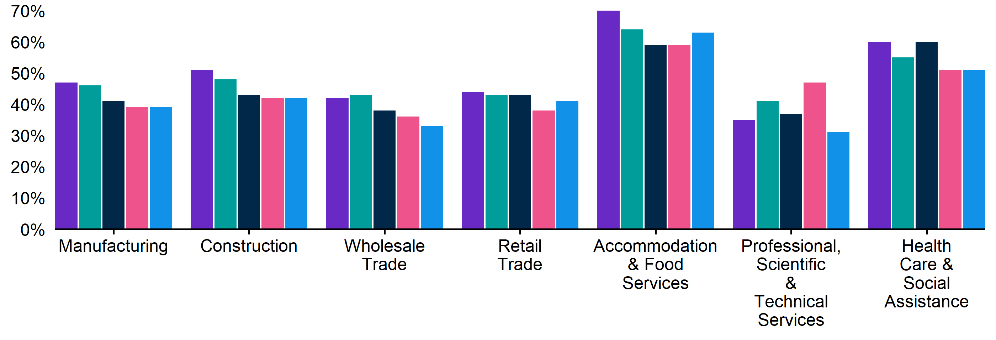

|  | **Dec qtr 2023** | **Mar qtr 2024** | **Jun qtr 2024** | **Sep qtr 2024** | **Dec qtr 2024** |
| --- | --- | --- | --- | --- | --- |
| Manufacturing | 47% | 46% | 41% | 39% | 39% |
| Construction | 51% | 48% | 43% | 42% | 42% |
| Wholesale Trade | 42% | 43% | 38% | 36% | 33% |
| Retail Trade | 44% | 43% | 43% | 38% | 41% |
| Accommodation and Food Services | 70% | 64% | 59% | 59% | 63% |
| Professional, Scientific and Technical Services | 35% | 41% | 37% | 47% | 31% |
| Health Care and Social Assistance | 60% | 55% | 60% | 51% | 51% |

### Figure 8. Recruitment difficulty rate by industry, December quarter 2023 - December quarter 2024

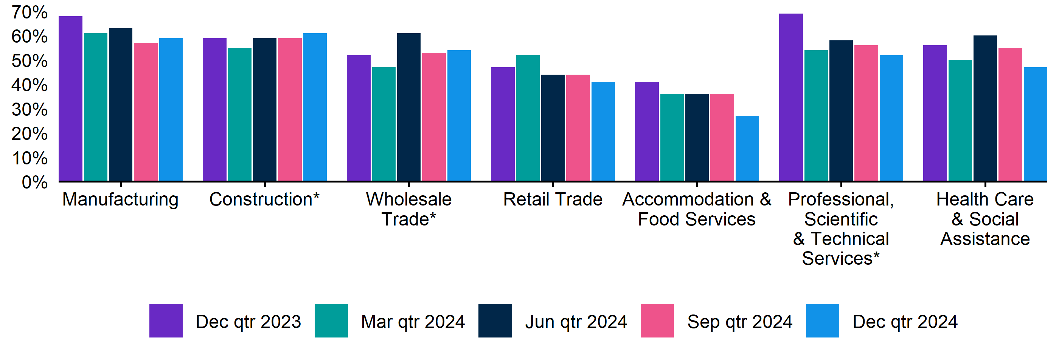

|  | **Dec qtr 2023** | **Mar qtr 2024** | **Jun qtr 2024** | **Sep qtr 2024** | **Dec qtr 2024** |
| --- | --- | --- | --- | --- | --- |
| Manufacturing | 68% | 61% | 63% | 57% | 59% |
| Construction | 59% | 55% | 59%* | 59% | 61%* |
| Wholesale Trade | 52% | 47%* | 61%* | 53%* | 54%* |
| Retail Trade | 47% | 52% | 44% | 44% | 41% |
| Accommodation and Food Services | 41% | 36% | 36% | 36% | 27% |
| Professional, Scientific and Technical Services | 69%* | 54% | 58%* | 56%* | 52%* |
| Health Care and Social Assistance | 56% | 50% | 60% | 55% | 47% |
|  |  |  |  |  |  |
|  |  |  |  |  |  |

## Key indicators by selected occupation groups

In the December quarter 2024, Machinery Operators and Drivers recorded the highest rate of recruitment difficulty (71%). At 64%, employers recruiting for Technicians and Trades Workers had the highest proportion of vacancies unfilled for longer than a month. Compared with a year ago, there are declines in both the recruitment difficulty rate and the share of vacancies taking longer than one month to fill across five of the seven reported occupation groups.

### Table 4. Key indicators by occupation, December quarter 2024

|  | **Recruitment difficulty rate** | | **Vacancies taking longer  than 1 month to fill** | |
| --- | --- | --- | --- | --- |
|  | **% of recruiting employers** | **Annual change (% points)** | **% of recruiting employers** | **Annual change (% points)** |
| Professionals | 54%* | -10 pts* | 53% * | -13 pts* |
| Technicians and Trades Workers | 64% | -9 pts | 64% | -6 pts |
| Community and Personal Service Workers | 49% | -1 pt | 46% | -7 pts |
| Clerical and Administrative Workers | 33% | -3 pts | 39% * | 6 pts* |
| Sales Workers | 40% | -7 pts | 35% | -4 pts |
| Machinery Operators and Drivers | 71%* | 11 pts* | 51% * | 7 pts* |
| Labourers | 39% | -14 pts | 24% | -14 pts |

*Interpret with caution due to low sample size.

### Figure 9. Recruitment difficulty rate by occupation, December quarter 2023 - December quarter 2024

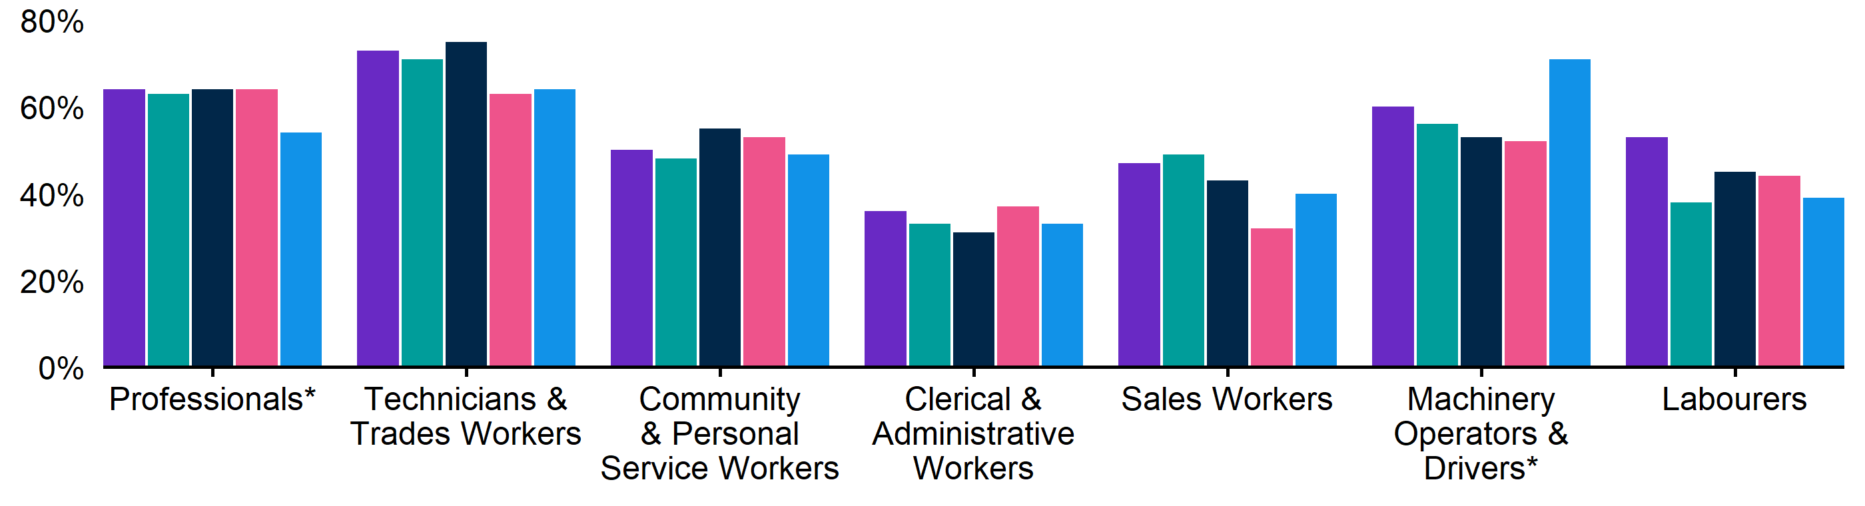

|  | **Dec qtr 2023** | **Mar qtr 2024** | **Jun qtr 2024** | **Sep qtr 2024** | **Dec qtr 2024** |
| --- | --- | --- | --- | --- | --- |
| Professionals | 64% | 63% | 64% | 64% | 54%* |
| Technicians and Trades Workers | 73% | 71% | 75% | 63% | 64% |
| Community and Personal Service Workers | 50% | 48% | 55% | 53% | 49% |
| Clerical and Administrative Workers | 36% | 33% | 31% | 37% | 33% |
| Sales Workers | 47% | 49% | 43% | 32% | 40% |
| Machinery Operators and Drivers | 60% | 56%* | 53%* | 52%* | 71%* |
| Labourers | 53% | 38% | 45% | 44% | 39% |

### Figure 10. Vacancies taking longer than 1 month to fill, by occupation group, December quarter 2023 - December quarter 2024

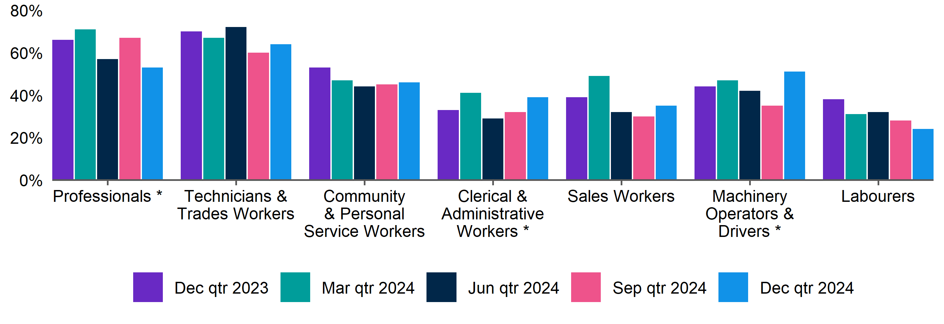

|  | **Dec qtr 2023** | **Mar qtr 2024** | **Jun qtr 2024** | **Sep qtr 2024** | **Dec qtr 2024** |
| --- | --- | --- | --- | --- | --- |
| Professionals | 66% | 71% | 57% * | 67% * | 53% * |
| Technicians and Trades Workers | 70% | 67% | 72% | 60% | 64% |
| Community and Personal Service Workers | 53% | 47% | 44% | 45% | 46% |
| Clerical and Administrative Workers | 33% | 41% | 29% * | 32% * | 39% * |
| Sales Workers | 39% | 49% | 32% | 30% | 35% |
| Machinery Operators and Drivers | 44% * | 47% * | 42% * | 35% * | 51% * |
| Labourers | 38% | 31% | 32% | 28% | 24% |

#### REOS Background and Notes

Jobs and Skills Australia conducts the Recruitment Experiences and Outlook Survey (REOS), a telephone administered survey of at least 1,000 employers each month (except for December and January, during which fewer employers are surveyed). While the results are indicative of recruitment activity, they may be subject to seasonal factors and other volatility and should therefore be used with a degree of caution. In addition, the survey is targeted towards employers with 5 or more employees and excludes many government organisations. More detail is available at <https://www.jobsandskills.gov.au/work/reos-survey-methodology>. REOS data are published on the [Jobs and Skills Australia website](https://www.jobsandskills.gov.au/data/recruitment-experiences-and-outlook-survey).

Data in this release should be referenced as: *Jobs and Skills Australia, Recruitment Experiences and Outlook Survey: December quarter 2024.*

##### Data notations

* Interpret with caution due to low sample size.

##### Recruitment rate

The proportion of employers either currently recruiting or who had recruited in the previous month. It is calculated by dividing the number of employers who recruited or were attempting to recruit by the number of employers that responded to the survey (excluding ‘unsure’ responses).

##### Recruitment difficulty rate

The proportion of recruiting employers who experienced difficulty hiring staff. This indicator focusses on the most recent recruitment round in the month prior to being surveyed. The indicator is calculated as: employers who recruited and reported difficulty, divided by all employers who recruited (excluding ‘unsure’ responses).

##### Expectations to increase staffing levels over the next 3 months

This is calculated as the percentage of employers who expect to increase staff over the next 3 months, divided by all employers. Expectations to decrease staff is also collected.

##### Vacancies taking longer than 1 month to fill

The proportion of recruiting employers unable to fill all their vacancies within a month. It excludes employers with unfilled vacancies who have been recruiting for less than a month.

###### Recent REOS releases

The [Jobs and Skills Australia website](https://www.jobsandskills.gov.au/data/recruitment-experiences-and-outlook-survey) includes:

* the December 2024 monthly REOS report, including a more detailed excel datafile. The datafile includes both the monthly results as well as the quarterly series. The quarterly estimates are aggregated results for the 3 months within each quarter.
* REOS Spotlight series featuring analysis on topics of interest not covered in the regular monthly. Recent spotlight releases cover employers who recruited jobless applicants, and employers’ greatest future concern.

For queries, contact: [REOS@jobsandskills.gov.au](mailto:REOS@jobsandskills.gov.au)

1. Australian Bureau of Statistics, Remoteness Areas, Australian Statistical Geography Standard (ASGS) Edition 3, https://www.abs.gov.au/statistics/standards/australian-statistical-geography-standard-asgs-edition-3/jul2021-jun2026/remoteness-structure/remoteness-areas