



National Skills Taxonomy

Consultation Summary

**06 November 2024**

**Contents**

Executive summary 4

Stakeholders are open to the development of a National Skills Taxonomy 4

Greater clarity on the direction for the NST is needed 4

Value from identified use cases cannot be delivered by an NST alone 5

Design decisions will influence potential adoption and use 6

Successful implementation requires a staged and iterative approach 7

Introduction 8

Existing skills taxonomies contribute to a complex skills ecosystem 9

Stakeholders have varying levels of exposure to taxonomies 9

Numerous challenges affect the usability of existing taxonomies 11

JSA can learn from stakeholder experiences with existing taxonomies 14

A NST’s value is acknowledged but realisation poses challenges 15

Stakeholders identified a diverse range of use cases enabled by a NST 15

Identified use cases feature varying degrees of complexity and risk 16

Interest and perceived value of use cases varies by stakeholder 19

Government and related bodies (including federal/state agencies, JSCs and Skills Commissions) 20

Education peaks and tertiary education providers 20

Employers and industry peaks 20

Skills advisors and experts 20

Unions 21

A clear direction is needed to realise the identified use cases 23

Directional and stylistic changes could strengthen the vision for a NST 23

Stylistic changes 24

Directional changes 24

There are opportunities to consolidate, refine, and introduce new principles 26

Trade-offs are required to balance the principles effectively 29

Skill definitions, structure and granularity are essential for a practical NST 30

Nomenclature is crucial, but there is limited consensus on definitions 30

There are diverse views on structure across both organising approach and skill classifications 32

Organising approach 33

Skill classifications 36

Optimal granularity is a key success factor but challenging to pinpoint 38

Information, skill levels, proficiency and alignment are key elements to driving adoption 40

Information attached to each skill is crucial for effective use 40

Levelling is important but there are different views to work through 42

Proficiency should remain the domain of education providers and employers 42

Alignment to key taxonomies is non-negotiable but there are downsides to be managed 43

Implementation requires robust governance, flexible updates, and key features 44

Governance should adopt a tripartite arrangement 44

A flexible update cycle should combine formal reviews with demand-led changes 49

Several technical features are required to promote the NST’s usability and adoption 51

User experience 52

Integration 52

Governance 52

Documentation 52

Implementation should follow a phased approach 53

A rushed NST rollout poses several key risks 53

Major reforms in the skills landscape further amplify complexity and risk 53

A staged and iterative approach is critical to maintain buy-in and drive adoption 55

Appendix A | Vision submissions 56

Appendix B | Skill definitions 58

Appendix C | Stakeholders engaged throughout the consultation process 61

Figure 1: Consultation summary

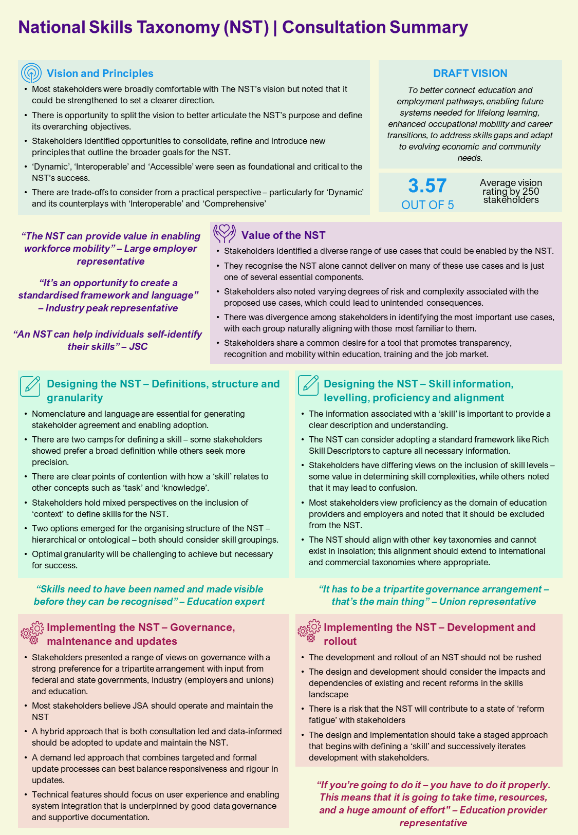

# Executive summary

Jobs and Skills Australia (JSA) has commenced work to explore the potential value and approach to establish a National Skills Taxonomy (NST) consistent with broader aspirations to achieve a more cohesive skills landscape for Australia. This work was commissioned based on the recent decision to decommission the Australian Skills Classification (ASC), and persistent challenges experienced with existing taxonomies and frameworks.

This engagement process included extensive consultations with 443 stakeholder representatives across federal and state government, education, industry, unions and wider skills ecosystem to explore these challenges and identify opportunities for an NST.

## Stakeholders are open to the development of a National Skills Taxonomy

Through consultations, valuable insights have been garnered to inform the design and application of an NST. Most were open to its development citing opportunity to address the shortcomings of existing frameworks and taxonomies. These include challenges with adoption, usability, and relevancy of information. Stakeholders reflected differing views with the overarching purpose for the NST, the perception of its value, and across key design elements such as definitions and structure. Some stakeholders were also cautious following the challenges with the ASC, but still noted value in pursuing the NST, if done well.

## Greater clarity on the direction for the NST is needed

The draft vision resonated with most stakeholders but there is opportunity to be more directive by considering its purpose and objectives. Overall, stakeholders rated the draft vision 3.57 (out of 5) noting that directional and stylistic changes are needed. Many felt that it was lengthy but incorporated the right focus. This could be addressed by using a more concise vision or purpose statement that is accompanied with a more elaborate mission. The draft vision that informed consultation is provided below:

|  |  |
| --- | --- |
| *NST VISION* | To better connect education and employment pathways, enabling future systems needed for lifelong learning, enhanced occupational mobility and career transitions, to address skills gaps and adapt to evolving economic and community needs. |

Stakeholders also see opportunity in revising and consolidating the NST’s principles to provide better clarity. ‘Dynamic’, ‘Interoperable’, and ‘Accessible’ were clear standouts with stakeholders noting they are non-negotiable. Others such as ‘Evolutionary’ and ‘Contextualised’ missed the mark. The draft principles used for consultation are provided in Figure 2.

Figure 2: Draft principles

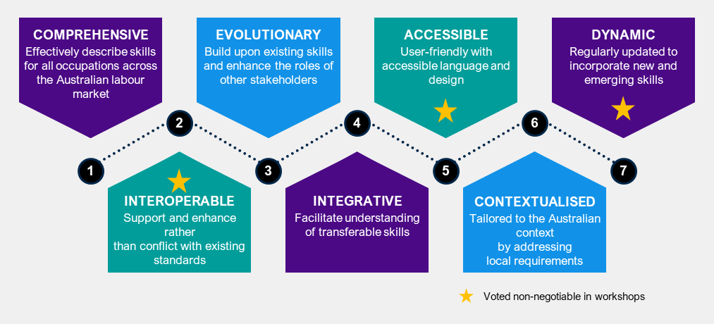

Engagement also identified the trade-offs needed to ensure the principles remain concise but sharp, most were centred around the ‘Dynamic’ principle. Some stakeholders noted that ‘Dynamic’ could conflict with ‘Comprehensive’ – a highly comprehensive taxonomy might become stagnant and challenging to update. Others saw conflict between ‘Dynamic’ and ‘Interoperable’ – linking the NST to other taxonomies that are outdated or have long update times may impair its ability to remain dynamic.

## Value from identified use cases cannot be delivered by an NST alone

Consultations identified that a common language of skills is necessary to enable the potential use cases for the NST. Many stakeholders noted this as a foundational element to realise value across any potential use cases. A summary of identified use cases is outlined in Figure 3.

Figure 3: Outline of use cases and associated stakeholder groups

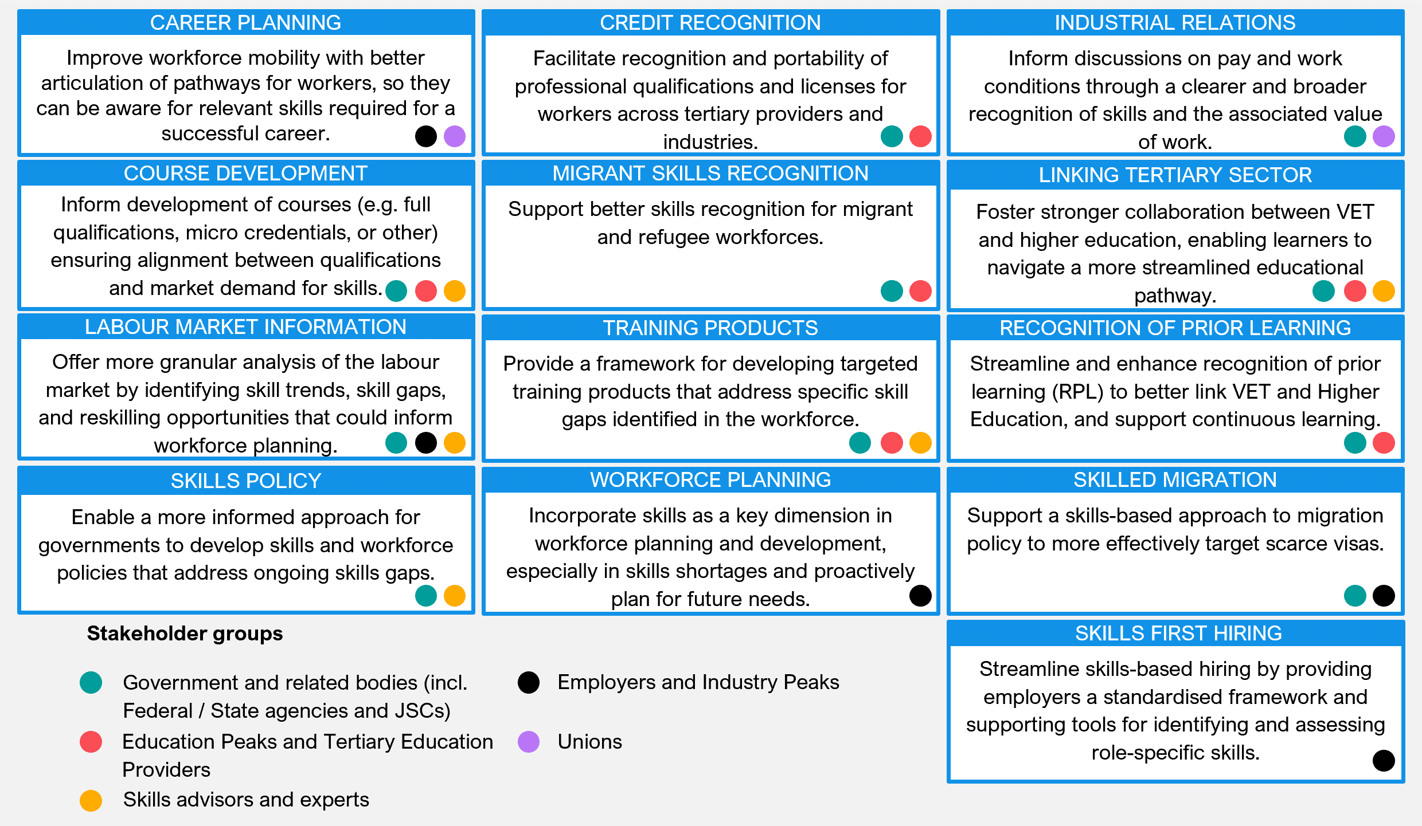

Discussions also highlighted that the NST can play a key role in each use case, but other elements are needed to bring them to life. For example, the NST can be a key source of data for improving the labour market information use case, but other data sources such as occupation and industry, are needed to produce the required insights. Similarly, the NST can play a part in facilitating VET to HE articulation through the recognition of prior learning (RPL), but institution processes and pathways will need to be updated to enable this.

## Design decisions will influence potential adoption and use

Consultations identified key considerations for the NST’s design to support better adoption and useability among stakeholders:

* **Information attached to a skill |** Providing supporting information using Rich Skill Descriptors (RSDs) can provide the detail required to effectively use the NST.
* **Organising structure |** Stakeholders see value in both a hierarchical and ontological approach. A hierarchical classification was favoured for its clarity and ease of use, while an ontological approach was preferred by more technical stakeholders for its ability to highlight relationships.
* **Granularity |** Optimal granularity will be a challenge to pinpoint and should take a demand-led approach with stakeholders. The NST should strike a balance that provides the right level of granularity for detailed use without oversimplifying the skills landscape.
* **Levelling |** Skill levels are seen as important, but the NST should not over-complicate the design and structure to incorporate them.
* **Proficiency |** Stakeholders noted that standards for proficiency should be excluded from the NST as it imposes on the domain of education providers, unions and employers.

In addition to design elements above, the development should also consider how the NST will be governed, updated and maintained. Most stakeholders identified a tripartite governance arrangement as most appropriate, with representation from federal and state government, education, industry and unions. Many stakeholders see JSA as playing a key role in operating and maintaining the NST. They believe a combination of consultation-led, and data informed approaches are necessary to effectively update and maintain the NST.

Engagements also identified concerns and points of divergence in the design among stakeholder groups. Three prominent topics of concern surfaced during discussions – the relationship of skills with knowledge, the relationship between skills and tasks, and the inclusion or refence to ‘context’ when applying a skill. More are likely to arise as development progresses and these points of divergence should be explored further to establish clarity and mitigate any risks with stakeholders.

## Successful implementation requires a staged and iterative approach

The development and rollout should be paced, stakeholders noted that a rushed approach can create risk with adoption. The approach should be considerate of the current and recent reforms and ensure the dependencies are clear and the impacts to stakeholders are well managed. Stakeholders highlighted the Australian and New Zealand Standard Classification of Occupations (ANZSCO) review and the recent Australian Qualifications Framework (AQF) review as key reforms to align with and manage dependencies.

Implementation should start with the foundational elements such as the definitions and successively build on this through iterative testing and engagement with stakeholders. Most stakeholder groups are open to continued engagement and want to actively contribute to the NST. Government can also play a key role by incorporating the NST into policy design, particularly with the coordination of ongoing reforms to ensure clear messaging.

# Introduction

Jobs and Skills Australia (JSA) engaged Nous Group (Nous) to consult with a wide range of stakeholders to inform the development of the National Skills Taxonomy (NST). This consultation process represents an opportunity to:

* understand the role the NST can play
* how future users might interact with it
* the design and features required to deliver on stakeholder ambitions
* considerations for ongoing governance and maintenance.

The work aims to provide the necessary insights that will guide the detailed design and development of the NST. The work was conducted over April to September 2024 with consultations occurring over June to August 2024. During this period, stakeholders were engaged through a variety of avenues, including interviews, workshops, and submissions to the public discussion paper.

Interviews were conducted with key sector influencers. In total 45, 60-minute interviews were conducted with over 70 stakeholders spanning government, industry, education, and expert body stakeholder groups. In parallel, consultations also included a series of in-person and virtual workshops at major cities to test a diversity of perspectives and explore the potential for consensus on key questions around the role and design of the NST.

The workshops engaged 367 attendees from a broad range of stakeholder groups including VET, higher education, industry, union, and the communities’ sectors. In total, JSA delivered five in-person workshops, and six virtual workshops. A full overview of these workshops is provided in Appendix C.

In addition to interviews and workshops, stakeholders were also invited to provide written feedback on the NST by submitting responses to the discussion paper. The discussion paper was produced early in the process and was published for public review on 27th June 2024, with the period for submissions closing on 16th August 2024. In total, 68 unique responses were received via submissions over the period. Many stakeholders who provided feedback through submissions also registered to attend the workshops.

The insights gathered from these engagements as well as the feedback in response to the discussion paper have been consolidated into this comprehensive report.[1]

# Existing skills taxonomies contribute to a complex skills ecosystem

|  |
| --- |
| **Key takeaways**   * Stakeholders have varying degrees of interaction with taxonomies for different purposes. * Stakeholders have experienced a range of challenges with existing taxonomies, including a lack of usability, outdated content, and not fit for purpose. * Some stakeholders acknowledge the benefits of existing taxonomies, including well-organised structures, integration with educational and training systems, and being a first step towards creating a common language of skills. * The strengths and challenges reveal lessons that should be considered in the design and implementation of the NST. |

Experience and familiarity with skill taxonomies and relevant frameworks varied across stakeholders. Those that were familiar outlined several challenges with the existing options. They identified opportunities to address those challenges and build on the strengths of existing taxonomies to create a more effective solution.

## Stakeholders have varying levels of exposure to taxonomies

Consultations revealed varying degrees of interaction with taxonomies for different purposes. Some stakeholders regularly use both Australian and international skills taxonomies, while others, although aware of them, engage less frequently due to perceived complexity and usability issues. A small number of stakeholders indicated they had not engaged with skills taxonomies at all.

There was also variation in the ways that stakeholders engaged with taxonomies, with some interacting at a more macro level, and others are a more micro level, particularly more technical stakeholders. Table 1 below provides a summary of the key taxonomies mentioned, including examples of how they are used by stakeholders.

Table 1: Examples of stakeholder use of existing taxonomies

| Skills taxonomy | Examples |
| --- | --- |
| **Australian Skills Classification (ASC)** | * Edtech stakeholders use the ASC for combining theoretical skill sets with performance criteria to inform educational resource development. * Skills council stakeholders apply the ASC as a basis for discussions on skill categorisation across industry and educational sectors. * International research bodies used the ASC as a key input to the UK classification. * Careers advisers use the ASC to educate people on job requirements. |
| **Training packages** | * Registered training organisations (RTOs) use training packages to develop and deliver vocational education and training programs. * Edtech stakeholders utilise training packages as a guide for its detailed performance criteria and foundational skills in the development of professional training. |
| **Australian and New Zealand Standard Classification of Occupations (ANZSCO)** | * Various stakeholders use ANZSCO for labour market trend analysis. * Education stakeholders use ANZSCO to map formal education and training via the AQF. * Skills council stakeholders use ANZSCO as a foundational piece for cross-sector skills recognition. |
| **Australian Qualifications Framework (AQF)** | * Higher education providers use the AQF to design and align their educational programs and qualifications with nationally recognised standards. * Larger employers with greater capacity use AQF to guide their staff professional development. |
| **Australian Core Skills Framework (ACSF)** | * Union stakeholders note that this supports training and provides a basis for skills development programs and tools. |
| **Australian and New Zealand Standard Industrial Classification (ANZSIC)** | * Skills organisations use ANZSIC data to undertake labour market analysis, such as tracking industry growth, decline, and employment trends |
| **Occupational Information Network (O*NET) and European Skills, Competencies, Qualifications, and Occupations (ESCO)** | * Industry skills bodies adopt O*NET for its consistent classification of skill levels across various professions. * Industry skills bodies also utilise ESCO for identifying transferable skills essential for professional development. * Union stakeholders noted that O*NET can be used for workforce planning and development insights. |
| **Skills Framework for the Information Age (SFIA)** | * Industry stakeholders note that SFIA is valuable in offering structure IT sector skills assessments. |
| **Lightcast** | * Skills organisations have used Lightcast in developing workforce plans and occupation profiles. |
| **SEEK** | * SEEK uses its own internal taxonomies to navigate and cluster labour market data within, and across regional markets. |

## Numerous challenges affect the usability of existing taxonomies

Engagements asked stakeholders to share key benefits or challenges they have experienced with existing taxonomies. Stakeholders focused their attention on the challenges that they have experienced with both national and international taxonomies. There were a range of recurring themes identified, which are summarised in Figure 4 below. A detailed description of each of these challenges follows.

Figure 4: Key challenges with existing skills taxonomies

A diagram of key challenges with existing taxonomies.




* **Lack of adoption:** Current skills taxonomies lack the widespread adoption necessary to act as a common language, which prevents them from delivering their intended benefits. This limits further adoption, creating a negative cycle. One education stakeholder suggested “…*some existing taxonomies are not necessarily widely known by all stakeholders and therefore may not be fully utilised in decision making.*”, an example being the ASC. The lack of adoption is in some cases due to their complexity and lack of user-friendliness.
* **Lack of usability:** Many users find these taxonomies difficult to understand and navigate, leading to insufficient awareness and understanding among industry and employers. An example is the lack of clear definitions and usability, which makes it hard for users to effectively apply these taxonomies in their work. For example, one industry stakeholder noted that it is particularly challenging for careers counsellors to navigate existing taxonomies easily.
* **Integration challenges:** There is a lack of integration of existing national and international skills taxonomies. The absence of this clear alignment makes it difficult to facilitate use, for example, credit recognition and recognition of prior learning (RPL) is difficult when there is no clear connection between competencies in the VET space to curriculum in Higher Education. Challenges like this have larger flow-on impacts such as limiting the ability to address skills shortages and inform skilled migration.
* **Not sufficiently comprehensive:** None of the taxonomies serve as fully comprehensive standalone frameworks. This is largely due to the absence of a universally accepted definition of ‘skill’, leading to varied approaches and omissions. For example, some stakeholders argue that existing taxonomies lack sufficient coverage for the arts and culture sector, while education stakeholders have noted that skills developed in the social sciences and humanities are often overlooked. Further, some not for profits have criticised the ASC for not recognising skills related to self-management, wellbeing, or mental health.
* **Outdated content:** Existing taxonomies often fail to keep pace with the rapidly changing labour market, resulting in outdated and irrelevant content. This lack of agility means many frameworks often do not reflect emerging skills and occupations and tend to lag behind the current industry standards. This results in information that is outdated or not aligned with industry needs.
* **Embedded biases:** Existing skills taxonomies often carry embedded biases and assumptions that can confuse, diminish or preference some skills over others. For instance, some frameworks such as O*NET, rely on what is perceived as being skilled work, which can lead to biases. This can result in certain skills and occupations being undervalued or overlooked. Other dominant binaries include soft/hard skills, technical/non-technical skills, and specialised/generic skills. Current systems also fail to provide an equitable understanding of skills. For example, learned capabilities such as level of judgement or decision-making are less identifiable and often undervalued in the workplace, particularly for feminised occupations and sectors. Further, other education stakeholders note that “*First Nations knowledge and practice does not seem to be well represented in current skills taxonomies*”.
* **Inconsistency:** There is inconsistency and fragmentation in current skills taxonomies. For example, some have specific and granular definitions of skills, while others use much broader terminology. This inconsistency in language and agreement on key terms makes skills data difficult to compare and use effectively.
* **Overly general:** Many existing taxonomies are overly general, which makes it difficult to identify specific skills gaps and needs. These frameworks often fail to reflect the nuances of modern job roles, resulting in a lack of practical application in current industry practices. Being overly generalised also results in some taxonomies not accurately describing skills needs and requirements. This concern was primarily raised by stakeholders who rely on detailed, precise information from skills taxonomies.

Some stakeholders also highlighted specific drawbacks of Australian skills taxonomies. These include:

* **ASC:** A major limitation of the ASC is its reliance on the ANZSCO framework, which overemphasises and occupational lens and limits its usability. Some critics believe it should have taken an industry focus instead. Stakeholders have noted that the ASC struggles to keep technology tools and specialist tasks up to date. Others noted that current ASC skill levels do not adequately reflect occupation specific requirements. There is also more broadly limited awareness and use of the ASC, which has led to limited use in decision-making.
* **Training packages:** A broad range of stakeholders noted that training packages are often outdated and do not keep up with industry changes. Stakeholders also noted that is it also too difficult to amend training packages once established. JSC noted that training package development is an opportunity to start building a common understanding of skills and some are already working to this by simplifying language.
* **ANZSCO:** A key criticism of ANZSCO is that it is not updated regularly enough, which can result in outdated data. Further, a federal government stakeholder noted that ANZSCO limits the ability to accurately differentiate roles within an occupation, making it ineffective for developing people in an occupation. For example, within the occupation category of ‘ICT Manager’, there is no distinction between those managing cloud computing operations and those managing traditional IT infrastructure, even though the skill sets required for these roles are vastly different. Another major criticism is that ANZSCO has a rigid hierarchical structure which does not always map to the labour market reality.
* **AQF:** University stakeholders point to a range of drawbacks of the AQF and suggest that it needs reform to better align tertiary education qualifications, enhance transparency, and improve the recognition of prior learning and micro credentials. Proponents of the AQF see the value it brings as a foundational framework that other taxonomies can ‘build off’. Other university stakeholders argue that the AQF lacks utility as a taxonomy outside professional occupations, as it does not adequately capture learned skills and capabilities outside of formal qualifications. Many stakeholders noted that addressing the recommendations in the 2019 AQF Review would resolve some of the challenges noted.

While most stakeholders highlighted the drawbacks of existing taxonomies, some acknowledged their benefits. For example, one union stakeholder noted that “…*many existing taxonomies offer a well-organised structure that categorises skills into hierarchical levels or domains, which makes them easier to under and navigate*”. The ESCO classification is cited by multiple stakeholders as an example of this. Other stakeholders also noted that ESCO is preferred because it has a greater focus on transferable skills, rather than key tasks. In addition, certain taxonomies, such as SFIA, provide a standardised framework for assessing and certifying skills.

Some benefits of Australian skills taxonomies were also identified. For example, a key strength of the ASC is its initial attempt to create a common understanding of skills in the Australian context, with the recent addition of skill statement data fields further enhancing clarity for users. Other industry and education stakeholders also emphasised that the structure of the ASC and inclusion of core competencies is valuable and should be further developed in the NST.

ANZSCO is valued for its well-established occupation-based structure, which allows for time series analysis of labour market trends. It also enables the mapping of formal education and training to a ‘skill level’ for a given occupation using the AQF. The Australian Standard Classification of Education’s (ASCED) focus on educational activity, both in terms of level and field, is useful for informing the definition and validation of skills. Finally, the ACSF is recognised for its effectiveness in integrating with educational and training systems, making it a strong foundation for developing training and education programs.

## JSA can learn from stakeholder experiences with existing taxonomies

The strengths and challenges identified by stakeholders reveal important lessons that should be considered and design and implementation of the NST. These include:

* A common language and standardised terms can reduce fragmentation and improve alignment across different sectors. This would support greater transferability of skills across the economy.
* A clear and compelling use case is essential to drive positive adoption and ultimately establish this common language.
* A user-friendly design is required to remove barriers to adoption. Simplified definitions and increased usability are crucial to ensure that it can be effectively applied by users across various industries.
* Regular updates to reflect emerging occupations and current industry standards are critical for ongoing relevance. Moving away from an exclusive reliance on job scraping data and focusing on identifying core skills required by employers can help achieve this.
* Alignment with both national and international frameworks is valued.
* Australia can improve how we identify and value skills in an equitable way. This includes recognising skills that have been historically devalued, particularly those in feminised industries. A key step in doing this is by avoiding binaries like ‘soft’ and ‘hard’ skills to avoid an oversimplification of complex skill sets.
* More specific skill categorisations can help better reflect the nuances of modern job roles. This will help in identifying specific skills gaps and aligning training programs with industry needs.
* The inclusion of additional information can enhance clarity for users, potentially drawing inspiration from the ASC's use of skills statement data fields.

# A NST’s value is acknowledged but realisation poses challenges

|  |
| --- |
| **Key takeaways**   * Stakeholders identified a diverse range of use cases that could be enabled by the NST. * They recognise that the NST alone cannot deliver on many of these use cases and is just one of several essential components. * Stakeholders also noted varying degrees of risk and complexity associated with the proposed use cases, which could lead to unintended consequences and potentially undermine confidence and support if not managed proactively. * There was divergence among stakeholders in identifying the most important use cases, with each group naturally aligning with those most familiar to them. * Despite their differing priorities and concerns, stakeholders share a common desire for a tool that promotes transparency, recognition, and mobility within education, training, and the job market. |

Stakeholders widely recognise the potential of the NST as a necessary component of Australia’s skills infrastructure. They identified a breadth of potential use cases that the NST enables but need further convincing to see value in each. Different use cases also carry varying levels of complexity and risk, requiring careful consideration and management. Interest in and perceived value of these use cases also differ across stakeholders.

## Stakeholders identified a diverse range of use cases enabled by a NST

Consultations underscored the diverse perspectives within the skills landscape, and this is evident by the range of use cases identified and discussed. Use cases articulated during the workshops and interviews largely mirrored those presented in the discussion paper, demonstrating consistent stakeholder understanding and priorities. However, stakeholders noted the importance of societal outcomes beyond just employment outcomes, advocating for the NST to be utilised in a broader context.

Figure 5 on the following page provides an outline of the various use cases discussed in consultations and the associated stakeholder groups. In most discussions, stakeholders identified that the NST cannot deliver against these use cases alone, but rather it is one of potentially many required ingredients. There was broad agreement that the first ‘use case’ for the NST is to define a ‘skill’ to enable progress against other identified use cases. A skill expert noted that they *“…want to see that the classification is used in a way that leads to a common definition of skills”.*

Figure 5: Outline of use cases and associated stakeholder groups



Stakeholder groups had a natural affiliation with the use cases that were most familiar to them. For example, employers emphasised workforce planning, skills hiring, and career planning as being of most value while unions highlighted career planning/mobility and potential considerations for industrial relations. Similarly, education providers gravitated towards course and training product development, credit recognition and RPL. Finally, government stakeholders saw the labour market insights as a valuable use case to pursue.

## Identified use cases feature varying degrees of complexity and risk

The potential value of identified use cases enabled by the NST is tempered by the complexities involved. This arises from the view that at best the NST is an enabler, with many other elements required to address identified use cases.

Identified challenges included navigating the broader reform environment, potential additional burden on stakeholders, and changes required to existing and entrenched processes. Further exploration is needed to fully understand and address stakeholder perspectives of complexity, and this will be central to driving adoption of the NST and the associated use cases. Details on the proposed use cases and associated complexities identified in consultations are outlined in Table 2.

Table 2: Proposed use cases and related complexities

| Use cases | Complexities identified |
| --- | --- |
| * **Career Planning** | * Current career planning platforms suffer from a lack of public trust, which presents a challenge that the NST will need to overcome to gain widespread adoption. * Ensuring the NST accurately reflects the evolving skill demands of various career pathways poses a challenge, requiring constant updates and adaptability. * Effectively translating granular skill information into actionable career guidance for individuals with diverse backgrounds and aspirations requires careful consideration and user-centric design. |
| * **Course Development** * **Training Products** | * The value of an NST is dependent on accurately capturing the needs of employers, such that education providers can confidently make decisions based on the information presented. * Transitioning to a skills-informed approach for course development represents a significant shift for universities, potentially perceived as burdensome due to the need to redesign curricula and assessment methods. * Jobs and Skills Councils (JSCs) and VET providers might find it challenging to adapt or map training package courses to the NST framework, potentially incurring additional administrative burdens and costs. * The emergence of micro credentials necessitates clear guidelines and processes for their governance and recognition within the NST, ensuring quality assurance and alignment with broader skill frameworks. * Developing effective assessment methods to accurately measure and validate skills acquired through diverse learning pathways, including micro credentials, will be crucial for ensuring the credibility and value of the NST. |
| * **Skilled Migration** * **Migrant Skills Recognition** | * The NST needs to provide reliable, up-to-date data to inform both skills policy and migration decision-making, requiring robust data collection and analysis mechanisms. * The NST should be designed and implemented to ensure a fair and transparent assessment of migrant skills, avoiding any potential bias or discrimination. * Balancing the need for international alignment with the specific requirements of the Australian context is crucial for effective skilled migration policies. * Accurately recognising and valuing diverse skills and qualifications from different countries poses a significant complexity in skilled migration assessment. |
| * **Credit Recognition** * **Linking Tertiary Sector** * **Recognised Prior Learning** | * Stakeholders highlighted the lack of inherent incentives for tertiary providers, especially universities, to adopt these use cases. This poses a challenge for driving widespread adoption, particularly for credit recognition and RPL. * Significant reforms, including those outlined in the Accord and other VET reforms, are necessary to enable these use cases and create an environment where institutions are encouraged to participate. * Ensuring consistent and transparent assessment processes based on the NST across different institutions is critical to maintaining the credibility and value of credit recognition and RPL. * Stakeholders highlighted potential challenges in recognising occupation-related qualifications and licences, particularly across different industries and states. |
| * **Industrial Relations** * **Skills First Hiring** * **Skills Policy** | * Shifting towards skills-first hiring necessitates a significant change in Australian labour market practices, requiring substantial effort to catch up with leading countries in this area. * Applying the NST to industrial relations considerations, particularly in areas like work value and role definition, demands careful consideration to avoid unintended consequences and disruptions. * Ensuring the NST is used fairly and transparently in hiring and pay decisions is critical to avoid perpetuating biases or creating new inequalities. * Robust and objective methods to assess and validate skills in a skills-first hiring environment will be crucial to ensure the system's effectiveness and credibility. * The taxonomy should remain adaptable to emerging skills and jobs while maintaining a long-term vision that enables the development of meaningful time-series data for policy analysis. * Implementing infrastructure for skills-first hiring, such as skills matching, is technically challenging for most organisations attempting it currently. |
| * **Labour Market Information** * **Workforce Planning** | * Establishing confidence in the NST's ability to provide accurate and reliable skill data is key to driving these use cases, given past concerns with the ASC. * The NST should effectively track and incorporate emerging occupations and skills to remain relevant and valuable for workforce planning. * Merging the NST with diverse employer HRIS and other systems poses technical and logistical complexities, potentially hindering adoption and data sharing. * Striking the right balance between detailed skill information and providing actionable insights for workforce planning is necessary to avoid overwhelming users with data. |

Consultations also highlighted that the diverse range of use cases also bring associated risks. These risks can lead to unintended consequences that may undermine stakeholder confidence and support if not proactively managed. For example, an excessive focus on skills in course and training product development could result in a narrower and limited learning experience for students. As such, use cases can be presented across a spectrum of complexity and their associated risk level, ranging from low to high.

The level of risk is determined by how complementary or disruptive the use cases are to existing systems and processes. In addition, the number of elements and components that need to be aligned to implement the use case is another key consideration. Finally, the complexity of the authorising and stakeholder environment required to take action also affects the associated risk. Figure 6 visualises this relationship for each use case and outlines the leading unintended consequence identified by stakeholders.

Figure 6: Use cases and associated risk

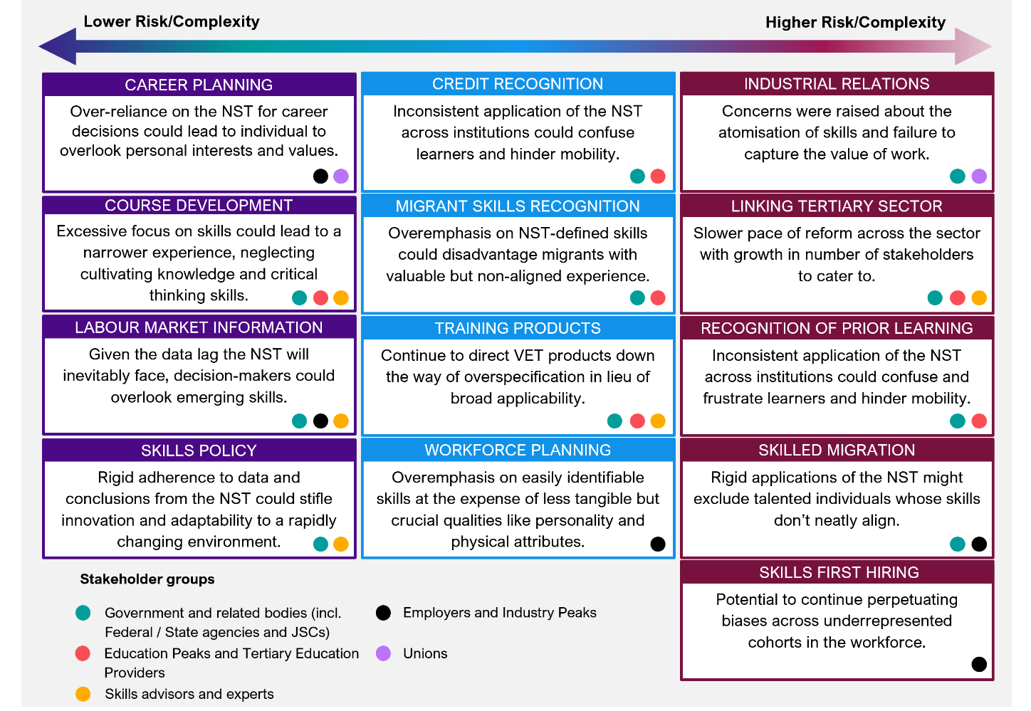

## Interest and perceived value of use cases varies by stakeholder

Stakeholders across the ecosystem recognise the potential value of the NST in enabling various solutions. Discussions consistently identified career planning, workforce planning, credit recognition, and skills-based hiring as being opportunities for the NST. However, stakeholder engagement with the NST is not uniform, ranging from enthusiastic support to cautious optimism. While specific priorities and concerns vary, a common thread is that they desire a tool that facilitates transparency, recognition, and mobility within education, training and the job market. Stakeholder views and interest and in use cases is explored below.

### Government and related bodies (including federal/state agencies, JSCs and Skills Commissions)

Government bodies, both federal and state expressed interest in the NST, recognising its potential to inform and guide skills policy and workforce development initiatives. The utility of creating a common skills language was widely acknowledged. Additionally, stakeholders recognised the NST's potential to inform skills analysis across the economy, beyond the current limitations of occupation- and qualification-based approaches. This would enable more targeted interventions to address skills gaps and shortages.

Supporting this idea a JSC noted that the NST could *“…provide an indication of industry trends and emerging skills needs which can inform our JSC roles of workforce planning and training product development”*. There was also interest in the potential for harmonising the tertiary sector, lowering barriers to entry and improving mobility. However, stakeholders noted that more complex use cases would necessitate accompanying reforms to be fully realised.

### Education peaks and tertiary education providers

While recognising the merits of the NST's use cases and its potential benefits for the tertiary sector (particularly in enabling the Accord and VET reforms through enhanced harmonisation, improved mobility, and reduced barriers to entry), education peaks and tertiary education providers expressed some hesitancy. This primarily stems from concerns about the ‘cost and resource burden’ associated with integrating the NST into their courses and training products, a concern particularly pronounced among VET providers but shared by universities as well. This group also noted the current reform environment creates a sense of reform fatigue and developing the NST is likely to contribute to this sentiment.

### Employers and industry peaks

Employers and Industry Peaks have shown a cautious interest in the NST, adopting a ‘wait and see’ approach. To gain their support, clear evidence of tangible benefits and seamless integration with existing workforce processes will be essential to minimise disruption. There is also a perceived disparity between larger employers and SMEs in realising the value of the NST.

Larger employers with more extensive HR resources are likely to be better placed to utilise the NST while SMEs might struggle due to limited resources. However, it was noted with the right tools and resources, SMEs could be better informed on decisions such as workforce planning, supported in making the change from being used to hiring on qualification to hiring on skills. One industry stakeholder highlighted the need for the NST to include embedded incentives to encourage employers to adopt the NST. They cited the Australian Emergency Care Classification’s (AECC) linkage to funding distribution as a successful example of how incentives can drive uptake.

### Skills advisors and experts

Skills advisors and experts express a high degree of interest in the NST, recognising its potential as a standardised framework for skill recognition and validation. They perceive the NST as providing better connections for tertiary education to the job market, ensuring learner outcomes align with industry needs. Additionally, they see the focus on skills as enhancing mobility within the tertiary sector and lowering barriers to entry. A skills expert noted that *“A NST can help with articulation.”* Streamlined skills matching and improved labour market information for policymaking are also considered valuable benefits to this group.

### Unions

Unions have expressed a cautious but positive outlook on the NST, appreciating the engagement process and are keen to remain involved to ensure their members' views are represented. They are particularly interested in the potential for career planning and *“…navigating pathways for lifelong learning opportunities”,* while remaining concerned about skill atomisation, undervaluation of work, and the potential erosion of traditional job roles.

Further to the identified interest in use cases, stakeholders shared key perceptions on the value that the NST provides through each use case. Noting the risks and complexities discussed in prior sections, stakeholders broadly reflected a positive sentiment in the value they identified for each use case. Figure 7 draws on interviews and submissions to outline stakeholder sentiment on use cases and Figure 8 provides further detail on their perceived value for each use case along with the key stakeholder groups they relate to. It should be noted that this analysis was conducted across the 113 submissions received, including duplicate or multiple responses and the 45 interviews conducted.

Figure 7: Stakeholder sentiment on use cases from interviews and submissions

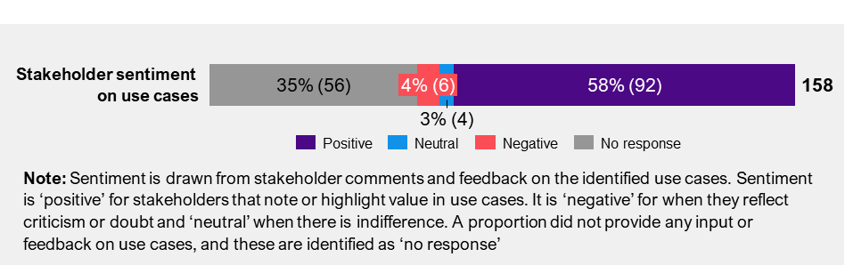

Figure 8: Stakeholder perceptions of value for the identified use cases

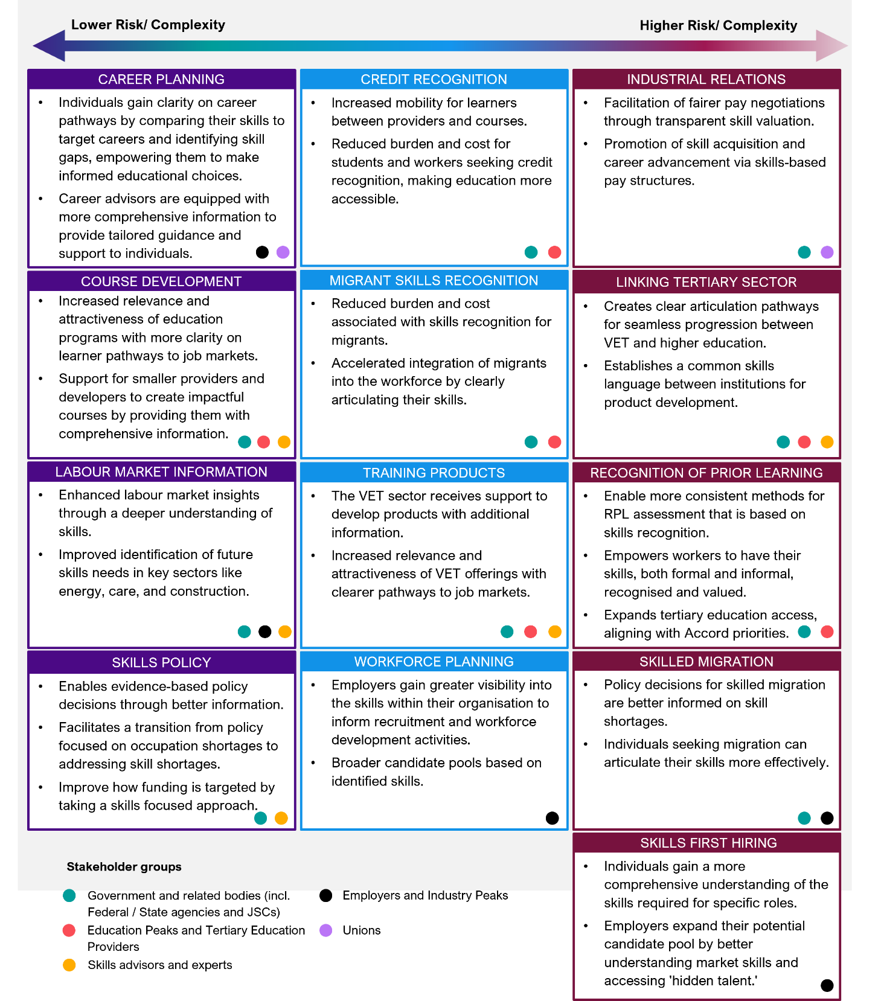

# A clear direction is needed to realise the identified use cases

|  |
| --- |
| **Key takeaways**   * Most stakeholders were broadly comfortable with The NST’s vision but noted that it could be strengthened to set a clear direction. * The vision should consider more than employment and be extended to include participation in education and the workforce. * There is opportunity to split the vision to better articulate the NST’s purpose and define its overarching objectives. * Stakeholders identified opportunities to consolidate, refine and introduce new principles that outline the broader goals for the NST. * ‘Dynamic’, ‘Interoperable’, and ‘Accessible’ were seen as foundational and critical to the NST’s success. * There are trade-offs to consider from a practical perspective – particularly for ‘Dynamic’ and its counterplays with ‘Interoperable’ and ‘Comprehensive’. |

Stakeholder feedback suggests that directional and stylistic adjustments could enhance the vision for the NST. There are also opportunities to consolidate, refine, and introduce new principles. However, achieving this will require trade-offs to maintain a balanced set of principles.

## Directional and stylistic changes could strengthen the vision for a NST

A draft vision was developed for testing with stakeholders during consultations. The draft vision that informed consultation is outlined below:

|  |  |
| --- | --- |
| *NST VISION* | To better connect education and employment pathways, enabling future systems needed for lifelong learning, enhanced occupational mobility and career transitions, to address skills gaps and adapt to evolving economic and community needs. |

Stakeholders across both interviews and workshops were broadly comfortable with the draft vision. In workshops, stakeholders were asked to rate their agreement with the draft vision from 1-5. A total of 250 participants provided their feedback. The draft vision received an overall average score of **3.57.**

In interviews, workshops, and public submissions, specific elements of the vision resonated strongly with stakeholders. The emphasis on lifelong learning was particularly pertinent to many, while others highlighted the importance of educational pathways.

A recurring tension emerged during consultations about whether the NST should be framed as a tool or as a catalyst for broader change across the skills economy. Some stakeholders recommended clarifying what the purpose is for the NST, thereby enabling the outcomes stated in the vision. For example, one union stakeholder noted that “*The points in there are valid but it is not clear to me how they arise from what the NST seeks to achieve*”.

Others suggested that the vision should be more ambitious than outlined in the discussion paper, with a greater emphasis on the NST’s transformative potential. For example, some stakeholders suggested that words like seamless set an unrealistic target, whereas others felt that setting the vision to only improve a set low bar.

Tensions regarding the direction of the NST suggested that splitting the focus into two parts could be beneficial. One part would focus on what the NST aims to achieve, while the other would address what it enables. One union stakeholder recognised these as the “…*first order and second order aspects of the NST*”. This approach would allow the vision to encompass both the primary and secondary purposes of the NST. When tested with stakeholders, this approach was received favourably.

There were also reoccurring suggestions for improvements, which can be grouped into stylistic and directional changes.

### Stylistic changes

Different perspectives on stylistic changes to the vision were influenced by differing views on what a ‘vision’ should be. Some stakeholders advocated for a concise, easily communicable vision, while others argued that a vision statement should be more comprehensive and not simply a slogan.

Overall, most stakeholders appreciated the comprehensive nature of the vision but felt it could be more engaging. Multiple stakeholders also noted that it reads a bit like a “…*typical government vision statement*” and could use simpler language. Suggested stylistic improvements included breaking it into bullet points and making it more concise.

### Directional changes

There were recurring themes in the proposed directional changes to the NST. One of the elements that stakeholders noted as important to include is greater recognition of human skills. Stakeholders noted that it is important the vision recognises the value of skills beyond economic and employment contexts.

Some stakeholders also noted that the vision should explicitly address equity, emphasising the NST's role in promoting equitable access and opportunities. The importance of explicitly addressing social and wellbeing needs was also noted. Stakeholders felt the draft vision was overly focused on economic needs and lacked consideration of broader societal and community aspects. One stakeholder noted that *“…employment is a great goal…but what we shouldn’t do is make employment the only goal”.* Multiple stakeholders suggested refining the vision to include community and wellbeing.

While lifelong learning was acknowledged in the NST vision, stakeholders suggested it should be a more central element. They proposed specifically including lifelong learning and participation in the vision.

Some stakeholders expressed concerns that the vision lacked ambition. For example, some workshop participants felt that the phrase ‘to better connect education and employment pathways’ was too modest. They suggested that the vision should have a more explicit goal of being deeply embedded and widely used. Some university stakeholders, who shared a more ambitious perspective, also suggested aligning the vision with the goals outlined in the Accord Final Report. This includes making skill formation more explicit and transparent, and to assist stakeholders in making more informed decisions.

A few stakeholders, however, felt that the vision was overly ambitious. One education stakeholder, for instance, described the NST as being portrayed as the *“…holy grail…”* but questioned its value beyond educational design. Consequently, they believed the vision did not accurately reflect what the NST could realistically achieve. While most stakeholders suggested revisions to the vision, some proposed entirely reworded versions. Two illustrative examples are noted below, with a complete list of alternative visions provided in Appendix A | Vision submissions.

* **Technical stakeholder submission:** “*Provide a comprehensive and standardised framework for categorising and describing skills and competencies relevant to the Australian labour market. This includes both technical skills specific to industries and occupations, as well as transferable skills that are valuable across various sectors.”*
* **Union stakeholder submission:** *“A proposed vision for the NST could be to create a dynamic, comprehensive, and universally applicable framework that clearly defines and categorises skills, competencies, and qualifications and facilitates the development of a skilled workforce, enhances professional standards, and supports lifelong learning and career progression. This vision includes several key elements:*
* *A dynamic and evolving framework that adapts to changes in industry practices, technological advancements, and emerging skill requirements, ensuring continuous workforce development.*
* *A comprehensive and inclusive taxonomy covering the full spectrum of skills across various professions, including emerging and specialised fields.*
* *Universal applicability across different sectors and regions, allowing for consistency and standardisation while accommodating local and sector-specific needs; clear definition and categorisation of skills, competencies, and qualifications to facilitate understanding, assessment, and application.*
* *Support for workforce development by identifying skill gaps, informing training and educational programs and pathways, and guiding flexible and evolving career development.*
* *Enhancement of professional standards to elevate the quality and consistency of professional practice across industries and regions.*
* *Facilitation of lifelong learning to encourage continuous skill acquisition and adaptation throughout an individual’s career.*
* *Integration with existing educational, certification, and regulatory frameworks to ensure seamless application and recognition of skills.”*

## There are opportunities to consolidate, refine, and introduce new principles

A draft list of seven principles was also developed to be tested with stakeholders in consultations. Figure 9 below provides a summary of the draft principles.

Figure 9: Draft principles

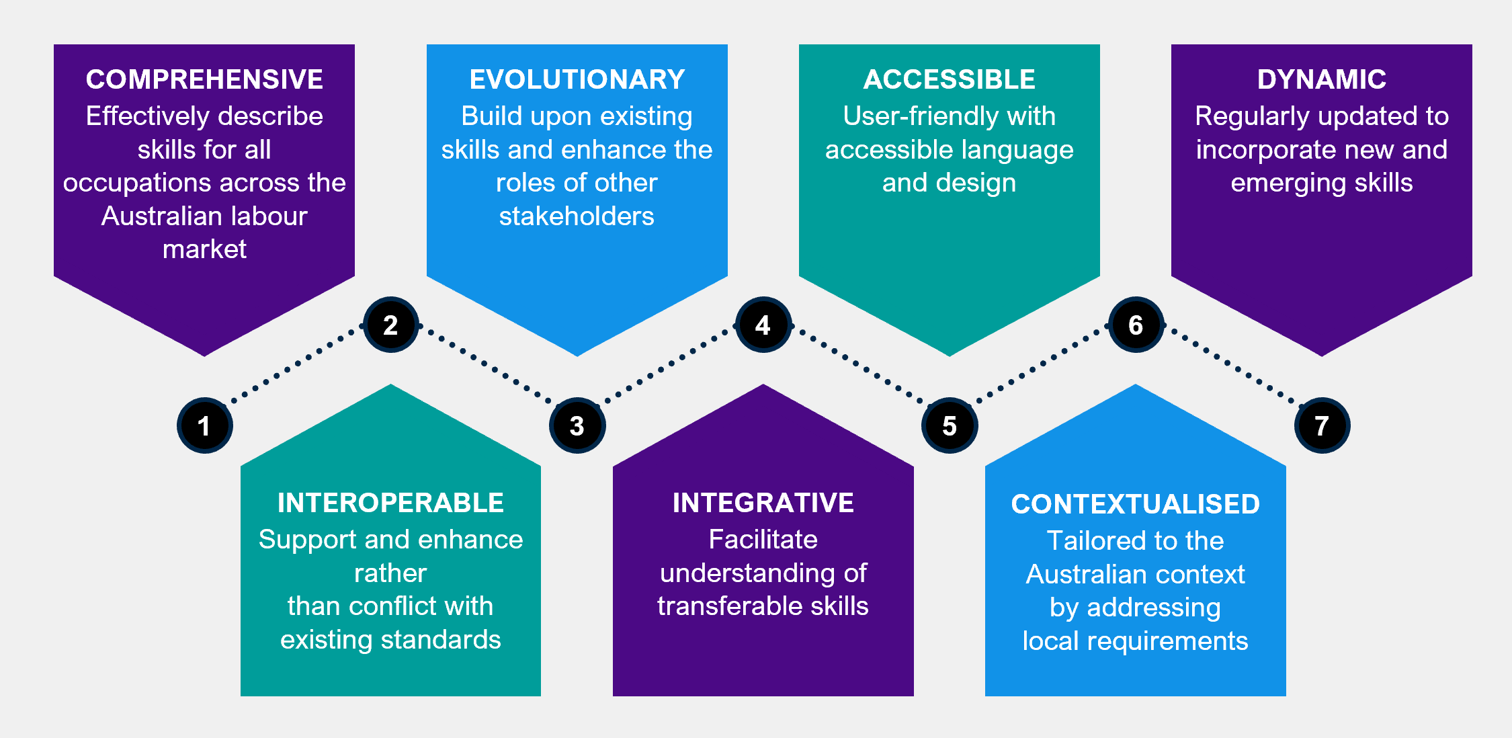

Overall, the draft principles are largely in line with stakeholders' perspectives. During the workshops, participants were asked to vote on their top priority non-negotiable principle and their top three principles. The combined results from all workshops are summarised in Table 3 below.

Table 3: Principle vote responses from workshops

|  |  |  |
| --- | --- | --- |
| Draft principle | Non-negotiable votes | Top 3 |
| Comprehensive | 29 | 88 |
| Interoperable | 48 | 96 |
| Evolutionary | 10 | 46 |
| Integrative | 38 | 98 |
| Accessible | 43 | 98 |
| Contextualised | 13 | 42 |
| Dynamic | 49 | 116 |

There were some principles that were more consistently recognised by stakeholders as their ‘non-negotiables’. These included dynamic (**49 out of 227**), interoperable (**48 out of 227**), and accessible (**43 out of 227**).

‘Dynamic’ was seen as critical in ensuring that the NST is adaptable and responsive to change. This was seen as particularly valuable in the context of a rapidly changing labour market. One industry stakeholder highlighted that “…*you don’t want to build something where in three years’ time it’s irrelevant*”. Stakeholders also specifically noted that for the NST to be dynamic there is a need for regular updates and ongoing industry consultation to be able to incorporate emerging skills. However, stakeholders also noted that it is important that the NST is not updated so frequently that it impacts its usability. One industry stakeholder noted that “…*we need to make sure that what is developed is forward looking and can stand the test of time*”.

Most stakeholders saw ‘Interoperable’ as foundational to the NST’s functionality, ensuring the taxonomy can connect with, build upon, and enhance existing skills frameworks. Many stakeholders emphasised that the NST would have limited value if it cannot be mapped to other taxonomies. For example, higher education stakeholders highlighted the importance of aligning the skills taxonomy with the AQF and occupational and industry classifications. Other stakeholders noted the value of linking the NST to ANZSCO and training packages. However, some stakeholders cautioned that prioritising interoperability might limit the NST’s ability to play the role of establishing a common standard and understanding of skills.

The principle of 'Accessible' was deemed crucial for building trust and adoption. Stakeholders stressed that the NST should be user-friendly for all, including technical users, individuals, and small and medium businesses. It should use simple, clear language and have an intuitive interface. One education stakeholder noted that if it “…*is not understood by employers, learners, workers, and providers then they will not be able to utilise an NST effectively*”. In addition, the NST must also account for inclusivity, cultural sensitivity, and the needs of First Nations peoples and migrants.

In conjunction, stakeholders identified the need to delineate the ‘Accessible’ principle to further emphasise it in the context of accessibility for people with specific needs or people with disabilities. They proposed that accessibility should specifically focus on ensuring the NST is fully inclusive for people with disabilities, such as through accessible website design and descriptive text for images. For example, one education stakeholder noted that “…*it should be accessible for the vision impaired…*” and that a “…*means of accessing translations into First Nations and community languages should be explored*”. To prevent these two principles from being conflated, they recommended establishing a separate principle dedicated to general usability.

There were some principles that were seen as less important. These include evolutionary (**7 out of 227**) and contextualised (**13 out of 227**).

The principle of 'Evolutionary' received limited attention. Some stakeholders found the term problematic and suggested that the NST should reassess current processes and systems rather than build upon them. There was confusion about the difference between 'Evolutionary' and 'Dynamic,' with many stakeholders agreeing that the term needs a clearer definition and distinction from 'Dynamic,' or they should be combined.

The principle of 'Contextualised' also received mixed feedback. Some stakeholders emphasised the importance of tailoring the NST to the Australian context, recognising the diverse skills across jurisdictions, industries, and subsectors. For example, one industry stakeholder noted “…*of course it needs to be contextualised to the Australian context. This is obvious to me*.” This stakeholder noted that the self-evident nature of this principle means that it does not necessarily need to be called out as a specific principle.

Others stressed the need to connect the NST to the international labour market. A balanced approach was also suggested, highlighting the importance of both local and global contexts. Additionally, some stakeholders felt that this principle was already addressed under 'Comprehensive,' which contextualises the NST to the Australian labour market.

Some stakeholders suggested that seven principles might be too many and that there are opportunities to consolidate them. One skills expert stakeholder specifically noted that “*less principles would be better – look to consolidate where appropriate*”. For example, while both ‘Interoperable’ and ‘Integrative’ were considered important by stakeholders, there was confusion among stakeholders on their difference. Moreover, ‘Integrative’ was perceived by some as jargon or government-speak, making it less accessible. To streamline the focus and enhance clarity, some stakeholders suggested merging these two principles to emphasise the importance of ensuring the NST integrates with existing taxonomies and systems.

Stakeholders highlighted the need for several additional principles to be incorporated into the NST. Among these, three principles were most frequently mentioned:

* **Equity and Inclusion:** This principle emphasises fairness and equity, ensuring that previously unrecognised skills are identified and articulated.
* **Usability and Usefulness:** This principle ensures that the NST is practical, easy to use, and meaningful for all stakeholders, including employers, industry, education providers, and others.
* **Enduring:** This principle focuses on the importance of longevity to ensure the NST's long-term success and usability. It underscores the necessity of robust data practices at its foundation.

However, some stakeholders noted that if all other principles are achieved, the principle of 'Enduring' would naturally be fulfilled. In this case, it may not need to be included as a separate principle. This would be the same for useful.

Although not as widely supported as the other principles, some stakeholders mentioned the importance of the principle of ‘Authoritative’. This principle emphasises the NST’s role in establishing a set of protocols and standards for defining skills. One stakeholder noted that setting up these standards would then enable the government “…*to leave it to people to build out the spaces we need*”. These standards should be designed for broad adoption while allowing flexibility for others to expand upon them as needed.

A broad range of other principles were also suggested for inclusion. These are shown in Table 4.

Table 4: Other principles suggested for inclusion

|  |  |  |
| --- | --- | --- |
| Other principles: | | |
| participatory | inclusivity and diversity | unbiased |
| accountability | data driven | non-duplication and efficiency |
| values and attributes | openly available | universally applicable |
| supported | contemporary | applicable |
| scope | relevance | accuracy |
| level differentiation | evidence-based | stakeholder engagement |
| independent | serving the national interest | collective skills alignment |
| flexibility and adaptability | scalability | alignment with educational and professional standards |
| transparency and accountability | skill definition | quality |
| evaluated | occupation | harmonisation |

## Trade-offs are required to balance the principles effectively

Trade-offs may be necessary to balance the NST's principles effectively. These trade-offs were thoroughly explored during engagements, with several consistently highlighted by stakeholders.

Notably, all the identified trade-offs involved the principle of ‘Dynamic.’ Stakeholders stressed that while keeping the NST dynamic is crucial to its relevance, this comes with challenges. Many stakeholders recognised that continuously updating the taxonomy to reflect an evolving skills landscape is essential, but doing so could potentially conflict with other important principles. These conflicts can arise both in practical terms and in a more conceptual sense.

The key trade-off recognised by stakeholders was between ‘Comprehensive’ and ‘Dynamic’. Some stakeholders emphasised that the NST must be comprehensive to be valuable, though opinions varied on the level of comprehensiveness required. Most suggested that it should be comprehensive at a high level, while others, particularly more technical stakeholders, felt it needed to be comprehensive even at a granular level to capture a broader set of skills. Conversely, some stakeholders argued that striving for comprehensiveness could be impractical and hinder the NST's usability. They noted that a highly comprehensive taxonomy might become stagnant and difficult to update regularly, thereby limiting its dynamism.

Another trade off identified is between ‘Interoperable’ and ‘Dynamic’. While most stakeholders recognised the value of a taxonomy in being ‘Interoperable’, they cautioned that the extent of the NST's interoperability with other taxonomies should be considered carefully. They suggested that linking the NST to outdated taxonomies could hinder its ability to remain relevant and adaptable, potentially burdening it with some of the same challenges faced by existing taxonomies.

Further, another trade off was between ‘Usefulness’ and ‘Dynamic’. Stakeholders noted that if the NST is updated too frequently, the utility of the taxonomy could be outweighed by the complexity placed on users to continuously adapt to changes. This could lead to inconsistency in application and potential confusion among users, undermining the taxonomy’s usability. Balancing the need for timely updates with the importance of maintaining stability is crucial to ensuring the NST remains both relevant and practical.

# Skill definitions, structure and granularity are essential for a practical NST

|  |
| --- |
| **Key takeaways**   * Nomenclature and language are essential for generating stakeholder agreement and enabling adoption. * There are two camps to define a skill – some stakeholders prefer a broad definition, while others seek more precision. * There are clear points of contention with how a ‘skill’ relates to other concepts such as ‘task’ and ‘knowledge’. * Stakeholders hold mixed perspectives on the importance of ‘context’ to define skills for the NST. * Two options emerged for the organising structure of the NST – hierarchical or ontological – both should consider skill groupings. * Optimal granularity will be challenging to achieve but is necessary for success. |

Stakeholders recognise the importance of nomenclature, however there is limited consensus among stakeholders on how terms should be defined. There are also diverse views on the appropriate structure of the NST, both in terms of organising models and skill groupings. Moreover, while all stakeholders acknowledge that finding the right level of granularity is critical, pinpointing it proves difficult for stakeholders.

## Nomenclature is crucial, but there is limited consensus on definitions

Establishment of a precise definition of ‘skill’ is paramount to create a consistent nomenclature for skills and related concepts for the NST. This is a foundational piece that must be tackled first to generate agreement. One expert highlighted, “*Skills need to have been named and made visible before they can be recognised*”. [2] While most stakeholders acknowledge that they were not experts in the intricacies of skills taxonomies and were willing to defer to experts on these specifics, they expressed a desire for involvement in confirming the overarching definition.

Consultation feedback showed two general perspectives on how a skill should be defined, aligning to either a broad or narrow definition. Those favouring a broader definition felt it should be broad enough to recognise skills gained through non-traditional avenues. This perspective was shared by some union, peak body, employer and other non-technical stakeholders. These stakeholders expressed a desire for a more comprehensive method and definition that extends beyond readily observable and technical abilities. This includes recognising the importance of ‘**invisible skills**’, such as personal attributes and personality traits that have been historically overlooked and are increasingly influencing hiring decisions. One education stakeholder suggested “…*try and keep it as general as possible to allow for a flow of people moving through a range of roles in their life*”.

Conversely, some skills experts, education providers and other technical stakeholders preferred a more narrow and precise definition to avoid over-complicating the NST. Those supporting a narrower definition argued that it would facilitate more efficient use and reduce complexity in maintaining and updating the NST. For example, one skills expert suggested establishing a prescribed scientific approach that specifies boundary conditions and requirements for when something can be recognised as a skill. However, it is important to note that across both broader and narrower skills definitions, there was no universal agreement within any stakeholder group on a specific definition, with preferences varying.

One key tension identified in discussions is the relationship between **skills and knowledge,** most stakeholders acknowledge that these are two distinct, yet interconnected concepts. The views presented a range from complete integration of the two within the NST, through to not having knowledge in the taxonomy. Some also suggested that knowledge should be an additional layer of contextual detail. This diversity of opinions underscores the need to carefully navigate these perspectives in developing a framework that accurately reflects the dynamic interplay between skills and knowledge. The NST will need to address this as there is a clear perception that skills and knowledge are intertwined.

The relationship between **skills and tasks** was also prominent in consultations. Some stakeholders in the VET sector saw a direct connection to tasks when expressing a skill. For example, the skills involved in safely replacing a lightbulb are only expressed when performing the task. In this example there are ‘skills’ in safely using a ladder and safely removing and replacing the lightbulb. In the workplace, further examples highlighted the potential need for capturing the context to ally or express a skill. One JSC provided the example of pipe-cutting as a skill – as a skill in the trades space, there are different contextual needs for the skill to be applied or expressed depending on the job or task to perform i.e., the skill is expressed differently and to a certain degree when cutting plastic piping versus when cutting metal or ceramic piping.

Stakeholders offered a range of perspectives on what should be considered in the definition of a skill. Discussions on the language used in defining a skill ranged from simple, ‘plain English’ definitions to more academic or abstract. Most stakeholders preferred the use of simple language, where definitions are short and easy-to-understand.

Through engagements and submissions, three primary approaches to defining a skill emerged: competency- or task-oriented, outcomes-based, and context-oriented definitions. An overview of these approaches is provided in Figure 10 below.

Figure 10: Approaches to defining a skill

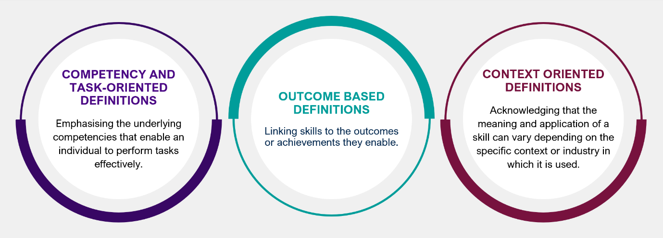

The strengths and limitations of each of these approaches, along with example definitions for each, are outlined in Table 5. These example definitions are not the exact quotes but are similar to those that were provided by certain stakeholders. Appendix B | Skill definitions provides more details on the attributable ideas for a definition and specific definitions provided by stakeholders.

Table 5: Considerations and example definitions based on considerations

|  |  |
| --- | --- |
| Consideration | Example definition |
| **Competency and Task Oriented Definitions**  **Strength** | This approach highlights the practical application and transferable nature of skills across different contexts.  **Limitation** | It may be more challenging to assess or measure. Can also overlook the role and importance of knowledge. | * *“A skill is a demonstrable capability, encompassing knowledge, behaviours, and attitudes, that enables an individual to effectively perform a set of related tasks and achieve desired outcomes across various context.”* – Expert stakeholder * *“A skill is a capability enabling the competent performance of a task.”* – Government stakeholders |
| **Outcome Based Definitions**  **Strength** | This approach focuses on the value that skills create.  **Limitation** | The approach is less specific on actual tasks and attributes. | * *“A skill is a demonstrable capability that enables an individual to achieve specific, measurable results or outcomes, contributing to personal, organisational or societal goals.”* – Government stakeholders |
| **Context Oriented Definitions**  **Strength** | Highlights the transferable nature of skills and can identify unique requirements for specific contexts.  **Limitation** | Can result in duplication or misinterpretation of skills when referenced without the relevant context. | * *“A skill is the adaptable and flexible capability to effectively apply knowledge and expertise to achieve desired outcomes within a specific context, encompassing the understanding of relevant tasks, tools, technologies.”* – Expert stakeholder |

Stakeholders noted that further consultation on the definition of a ‘skill’ will be essential to build acceptance before progressing with NST development. These consultations should focus on socialising the definition of a skill within the NST and making any necessary adjustments to create the alignment needed for successful implementation.

## There are diverse views on structure across both organising approach and skill classifications

The organising approach and skills classifications form the backbone of the NST structure. Organising approach refer to the frameworks or structures used to categorise the overall taxonomy. Skill classifications, on the other hand, involve the grouping of skills into related clusters. They define the relationships between skills and how they are organised within the overarching approach.

### Organising approach

Stakeholders identified two main approaches to potentially structure an NST: a hierarchical taxonomy, or an ontology.

A hierarchical taxonomy is a structured, top-down approach where skills are organised into a tree-like structure with different levels. Skills are grouped based on categories and subcategories, moving from broad categories at the top, to more specific ones as you move down the hierarchy. In contrast, an ontological approach is a more flexible, network-based structure where skills are connected in a web of relationships. Unlike a hierarchy, an ontology does not rely on strict levels; instead, it captures the diverse and often non-linear relationships between skills, such as how one skill might be related to another.

Stakeholders highlighted a range of advantages and disadvantages for each approach. Most stakeholders found a hierarchical approach easy to understand and favoured it for its simplicity and user-friendliness. It was seen as straightforward because it provides a clear, linear path for organising and categorising skills, making it intuitive for users to navigate. However, more technical stakeholders noted that a purely hierarchical approach has limitations, particularly in its ability to reveal connections between different groups of skills, which could hinder its usefulness in more complex or dynamic environments.

These technical stakeholders were more inclined toward an ontological approach, recognising “real-world skill application is more complex than a strict hierarchy”. For example, an ontological approach could reveal linkages between skills across different occupations, providing a more nuanced understanding of relationships. However, these stakeholders also acknowledged that an ontology could be more complex and potentially confusing for other users, underscoring the need for clear guidance to ensure its effective application.

Technical stakeholders also emphasised that regardless of the chosen approach, the underlying metadata schema must be clearly defined to ensure consistency in how data is captured for each skill. This will ensure that information is recognised and applied consistently across the taxonomy. A few also suggested that the organising approach should not extend beyond developing a robust metadata schema, though this perspective was not widely shared.

Table 6 presents a summary of stakeholder feedback on the two primary organising approaches under consideration.

Table 6: Stakeholder insights on the organising approach for the NST

|  |  |
| --- | --- |
| Organising approach | Stakeholder insights |
| Hierarchy | * Generally favoured for its clarity and ease of use, particularly by those less familiar with taxonomies. * Can be structured with multiple levels of granularity, starting with broad groupings at the top level, such as by industry or skill type, and progressively narrowing to capture more specific skills within those categories. * Organising approach should reference, but not be tied to occupations. * Concerns about rigidity and potential limitations in capturing the complexity and interconnectedness of skills. For example, fixed hierarchical layers can make it challenging to adapt to rapid changes in the skills landscape. * The NST should be developed from a foundation of skills and knowledge, which can then once agreed be mapped to relevant occupations and qualifications. |
| Ontology | * Preferred by more technical stakeholders who recognise the limitations of a hierarchical approach. * Highlights the connections between different skills across defined relationships, such as occupational context or industry relevance. * Enables a more nuanced understanding of the skills landscape and its complexities. * Can be more challenging to navigate or interpret for stakeholders with less experience using taxonomies. |

Some stakeholders acknowledged that a hybrid approach could offer a more balanced model, combining the simplicity of a hierarchical classification with the flexibility of an ontological framework. This approach would provide a clear and straightforward foundation for users to navigate while also enabling them to address more complex relationships, creating a dynamic network that illustrates how skills are interconnected across different contexts and categories.

### Skill classifications

Stakeholders expressed a wide range of views on the skill classifications that should be represented within the NST. Their feedback shaped five broad themes, which are outlined in Figure 11 below.

Figure 11: Skills themes

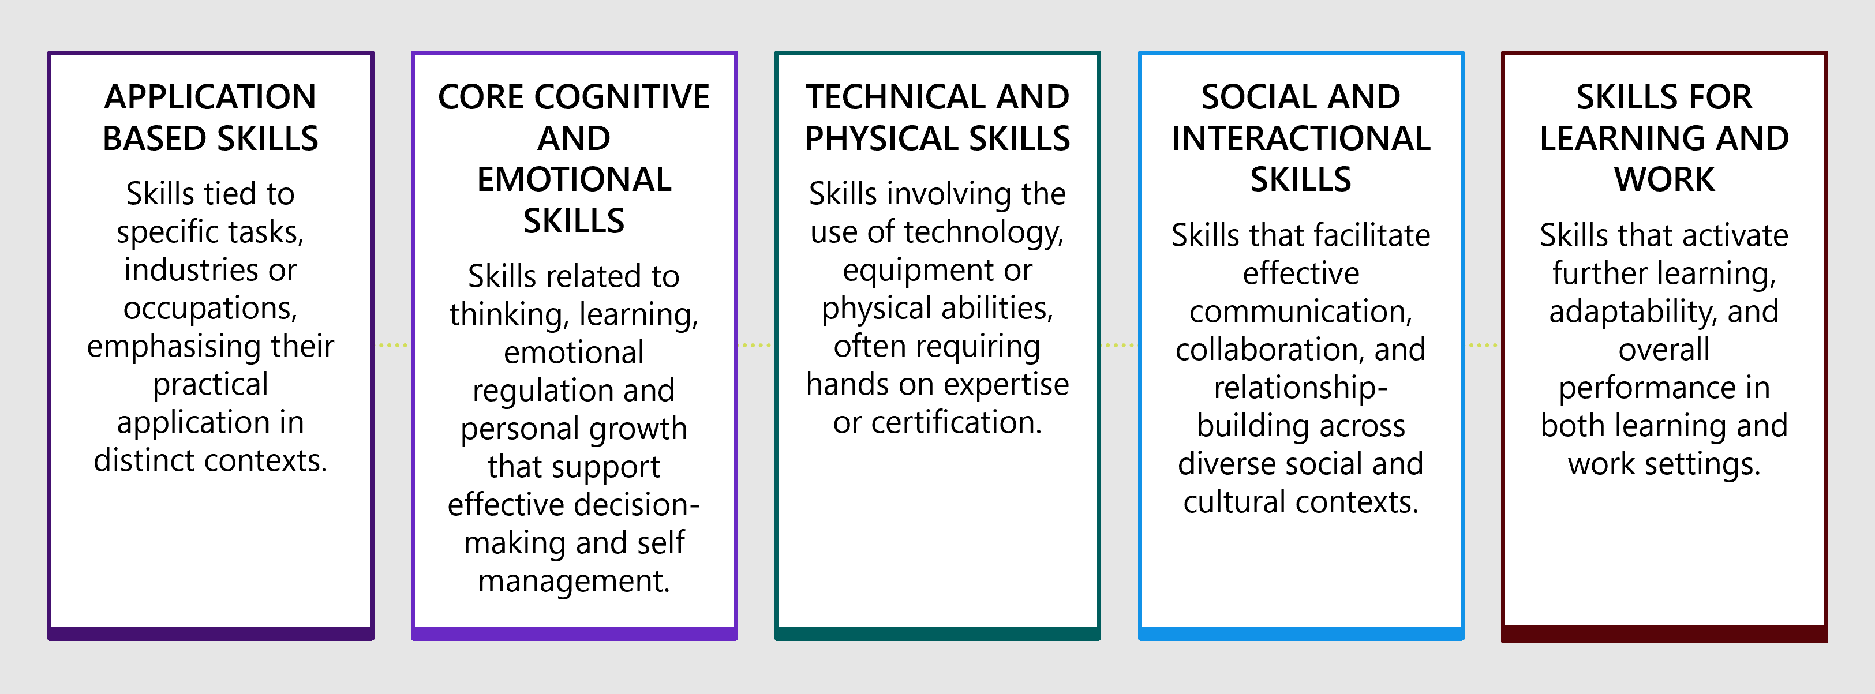

Below is an overview of the specific skills that stakeholders identified within each of these themes. While the list below represents the broad spectrum of types of skills brought up by stakeholders, it is important to note that some overlap exists between both the categories and specific skills listed and feedback indicates some terms are unlikely to be widely accepted by stakeholders (e.g., soft skills). It also worth noting that these groupings are more thematic and are not a basis for any potential grouping or theming of skills within the NST.

**Application based skills**

* Transversal/Transferable Skills: Skills that are applicable across different occupations and industries, offering broad utility (e.g., communication, problem solving).
* Functional Skills: Skills with broad application across industries, such as mathematics and information technology.
* Industry-Specific Skills: Skills that are unique to a particular industry or sector, tailored to the specific requirements of that field.
* Occupation-Specific Skills: Skills directly tied to the tasks and responsibilities of a particular occupation or job role.
* Task-Specific Skills: Skills directly related to performing particular tasks or job duties (e.g. operating machinery, coding, writing reports).

**Core cognitive and emotional skills**

* Cognitive Skills: Skills related to thinking, learning, and problem-solving, enabling effective decision-making and understanding (e.g. analytical thinking, critical thinking).
* Intrapersonal Skills: Skills related to self-management, emotional regulation, and personal growth (e.g. emotional intelligence, self-awareness, resilience).
* Personal Attributes: Non-technical traits influencing behaviour and effectiveness (e.g. integrity, persistence, empathy).

**Technical and physical skills**

* Technical Skills: Skills involving the use of tools, technologies, or specific procedures (e.g. coding, machine operation, software development).
* Operational Skills: Skills that require the use of equipment or machinery, often requiring certification or licensing for safe operation.
* Psychomotor Skills: Physical abilities involving movement, coordination, and manual dexterity (e.g. operating equipment, surgery, sports).

**Social and interactional skills**

* Interpersonal Skills: Skills facilitating interaction and communication with others (e.g. teamwork, negotiation, empathy).
* Cultural Competency Skills: Skills related to understanding, communicating with, and effectively interacting with people across cultures. This includes working effectively with first nations people and communities.
* Human Skills: Skills that facilitate effective interaction and relationship-building with others, such as communication, empathy and collaboration.
* Soft Skills: Non-technical skills that support effective communication, adaptability, and collaboration across different roles and settings.

**Skills for learning and work**

* Foundational Skills: Core skills like language, literacy, numeracy, and basic digital competencies that activate and support further learning and development.
* Invisible Skills: Skills that involve subtle but crucial processes, such as adaptability, time management, and critical thinking, which support overall performance.
* Employability Skills: Skills required to secure, retain and succeed in employment (e.g., communication, teamwork and professionalism).
* Leadership Skills: Skills that enable individuals to inspire, guide, and influence others towards achieving shared goals, while fostering collaboration, decision-making, and team development.
* Wellbeing Skills: Skills that enable individuals to manage their well-being particularly focused on wellbeing outcomes of the workforce.

Different stakeholder groups expressed varying opinions on the most appropriate approach to skill classification. Most VET stakeholders and some industry representatives leaned towards an application-based approach, prioritising industry- or occupation-specific skills. However, other stakeholders, particularly from education, felt this approach could limit mobility between industries. For example, one stakeholder explained, *“If you start to group by industry, that might help a bricklayer transition into concreting. But what if that bricklayer wanted to move into policy? How would they gain visibility on how to make that shift?”*. Some government stakeholders agreed that industry-based groupings were not ideal and instead proposed a combination of skill types, including foundational and psychomotor skills, among others.

Overall, there was no clear consensus on the preferred skill classification. However, there was a strong sentiment that the NST should be independent of existing taxonomies like ANZSCO. Instead, the NST was viewed as an opportunity to create a shared understanding of skills that extends beyond current frameworks.

## Optimal granularity is a key success factor but challenging to pinpoint

Most stakeholders agreed that the granularity of the NST needs to strike a delicate balance. Stakeholders identified benefits and drawbacks of granularity. A highly granular NST, while providing detailed insights into specific skills, could become overly complex, and make it difficult to manage and keep updated, as new skills emerge. This level of granularity might also overwhelm users and make it challenging to navigate. On the other hand, if the NST is too high-level, it risks oversimplifying the skills landscape, potentially missing key distinctions between similar but distinct skills. This could reduce its utility for some use cases.

Striking this balance requires careful consideration of how to maintain a detailed breakdown of skills while ensuring that it remains accessible and user friendly. Multiple stakeholders likened this challenge to reaching the ‘goldilocks’ zone of granularity – where the level of detail is just right, neither too much nor too little. Achieving this balance is seen as a key success factor in ensuring the NST remains both functional and widely adopted.

While most stakeholders agree that there is a need for a more balanced approach to granularity, they have different views on where this balance should be. These differences were often shaped by how they envisioned using the NST, as different use cases demand different levels of granularity. For example, education providers who saw value in the NST for RPL preferred a higher level of detail. Their reasoning is that breaking down skills into specific components makes it easier to assess which skills have been acquired through past experiences. On the other hand, stakeholders focused on providing career advice or managing workforces at a macro scale leaned towards less detail, prioritising the understanding of skill transferability over fine-grained detail.

Table 7belowmaps various NST use cases across the granularity continuum.

Table 7: Use cases across granularity continuum

|  |  |  |  |
| --- | --- | --- | --- |
| Use cases | Low granularity | Medium granularity | High granularity |
| Skills policy | 🗸 | 🗸 | 🗸 |
| Labour market information | 🗸 | 🗸 | 🗸 |
| Career planning | 🗸 | 🗸 | 🗸 |
| Link tertiary sector | 🗸 | 🗸 | 🗸 |
| Course development |  | 🗸 | 🗸 |
| Training products |  | 🗸 | 🗸 |
| Credit recognition |  | 🗸 | 🗸 |
| Skills first hiring |  |  | 🗸 |
| Recognition of prior learning |  |  | 🗸 |

Many stakeholders acknowledged that it will be challenging to find a point of granularity that will satisfy all stakeholders. Consultations clearly revealed that what might be the ideal level of detail for one group, could be less suitable for another. Several stakeholders suggested that a possible solution to accommodate these diverse needs is to develop a taxonomy with variable granularity. This approach would allow users to access different levels of detail depending on their specific needs. Most stakeholders hypothesised that the majority of users would likely only interact at the low to medium granularity levels, but offering finer detail would create opportunities for more technical users to engage with the NST in additional ways.

Some technical providers provided more specific advice on approaches that could be used to determine an appropriate level of granularity, at least at the broader level. One stakeholder suggested that it could be useful to draw on approaches used internally by the ABS in updating ANZSCO. This includes the “rule of 300”, which means that an occupation is only included if there are more than 300 people recorded in the last census. Another approach is to observe whether differences are recognised in practice. For example, if distinctions between occupations are not recognised or used in practice, there is no need to reflect them in a taxonomy. While these examples focus on “occupations” specifically, the thinking behind them can be applied to determining the right level of granularity for the NST.

# Information, skill levels, proficiency and alignment are key elements to driving adoption

|  |
| --- |
| **Key takeaways**   * The information associated with a ‘skill’ is important to provide a clear description and understanding. * The NST can consider adopting a standard framework like Rich Skill Descriptors to capture all necessary information. * Stakeholders have differing views on the inclusion of skill levels – some see value in determining skill complexities, while others noted that it may lead to confusion. * Most stakeholders view proficiency as the domain of education providers and employers and noted that it should be excluded from the NST. * The NST should align with other key taxonomies and cannot exist in insolation; this alignment should extend to international and commercial taxonomies where appropriate. |

Consultations explored stakeholder perspectives on four design elements – the information attached to a skill, the inclusion of skill levels, the inclusion of proficiency, and requirements for aligning with other taxonomies. Stakeholders shared a broad consensus on the essential information that should be made available for a skill and suggested further inclusions that can assist with usability. Stakeholders saw value in the inclusion of levels within the NST to better understand and recognise skills. Proficiency was seen as best considered outside of the NST. Lastly, discussions highlighted mixed views on which taxonomies the NST should align with and what this alignment should look like.

## Information attached to each skill is crucial for effective use

Consultations highlighted the importance of capturing the right information associated with skills. Information such as skill name, definition, skill relationships, relevant occupations, qualifications, licensing requirements, skill examples and industry context were identified as providing valuable context for describing skills. Stakeholders highlighted that this additional information further improves the practicality of the NST and can add value to its use cases.

Rich Skill Descriptors (RSDs)[3] emerged as a potential approach for capturing and presenting skill information. Table 8 outlines the key information elements that were universally highlighted in discussions. These elements are fundamental to providing skill descriptions that enable the NST’s usefulness. Whether implementing RSDs or some other alternative, the NST could start with these elements as a basis to build from and meet additional information requirements.

Table 8: Key skill information identified through consultations

|  |  |
| --- | --- |
| Element | Element description |
| **Skill Identifier** | A unique code that precisely identifies the specific skill within the taxonomy. |
| **Skill Name** | A succinct and descriptive title that accurately encapsulates the essence of the skill. |
| **Alternative Skill Name** | Synonyms and other commonly used terms for the skills, ensuring the skill can be easily identified and understood by different users. |
| **Skill Definition** | A clear, explanation of the skill's nature, scope, and application, providing a precise understanding of its meaning. |
| **Skill Example** | Concrete illustrations demonstrating how the skill is applied in real-world scenarios, aiding comprehension and relevance. |
| **Related Skills** | Connections and references to other similar or related skills within the taxonomy, fostering an understanding of skill interdependencies and enabling transferability. |
| **Occupation Links** | Clear identification of the specific occupations or job roles where the skill is commonly required or utilised. |
| **Skill Metadata** | Comprehensive information about the skills origin including the date of last review, publisher (if open source), source frameworks, version history and other metadata information. |

In addition to the information elements above, some stakeholders also see potential in including:

* Labour Market Data: Current information on the demand and supply of the skill in the labour market.
* Industry and Employer Context: Industries and employers that hire (or are currently hiring) for the skill.
* Training and Education Pathways: Links to relevant educational pathways, licenses, qualifications or training programs that facilitate the acquisition and development of the skill.
* Estimated Time to Proficiency:An approximate timeframe for skill acquisition, considering various learning pathways.

Regardless of the information to be included or approach taken to capture the information, experts cautioned that careful implementation with rigorous supporting controls and standards are necessary to maintain consistency.

## Levelling is important but there are different views to work through

Stakeholders identified a range of examples where the concept of skill levels is embedded in how we think about education and work, from the AQF, to ANZSCO and industrial arrangements. However, in nearly all cases there is a high degree of subjectivity involved.

There was recognition that skill levels could provide an indication of the potential complexity of a skill, providing a structured approach to categorise skills into tiers (e.g., entry-level, mid-level, advanced). Some recognised the potential of skill levels to inform discussions on the value of work, provided it is applied in a rigorous and consistent manner. Levelling was also seen as valuable in the context of career planning, stakeholders identified that linking it to career progression and scaffolding education could provide individuals with a clear path towards desired career outcomes. However, there was resistance to rigidly associating specific levels with career stages. For example, broadly categorising skill levels in terms of ‘early career’ versus ‘late career’ skills was not well received.

Determining the optimal number of levels for the NST is a multifaceted challenge, requiring careful consideration of various factors. Stakeholders acknowledged the importance of aligning the NST's levelling system with existing frameworks like the AQF and ANZSCO, while also considering international best practices and the specific needs of various use cases. Should levelling refer to other systems such as the AQF (as is the case with ANZSCO’s skill levels), the NST should be clear in articulating this to avoid unnecessary complexity.

Stakeholders also reflected opposing views with some noting that levelling can *“…introduce unnecessary complexity”* if too many skill levels are introduced, one stakeholder citied international research from the AQF review suggested that having more than six levels of skill may not be meaningful. Another challenge highlighted was the difficulty of assigning a single level to a skill, given its potential interdependencies and varied contexts of application. Noting that this can also result in the potential for biases and inconsistencies if not done equitably. Some technical stakeholders proposed that achieving sufficient granularity within the taxonomy could enable more effective specification of a skills level.

Overall, stakeholders see value in the inclusion of skill levels within the taxonomy if they are clearly articulated, applied consistently and equitably, and do not add further complexity.

## Proficiency should remain the domain of education providers and employers

Proficiency refers to the degree to which a skill is expressed and can be seen as a representation of comprehension, experience and expertise. It provides a measure of an individual’s demonstrated ability or expertise in performing a specific skill (e.g. novice to mastery) and adds a layer of nuance beyond the inherent complexity of the skill itself. Consultations surfaced stakeholder reservations about the suitability of including proficiency within the NST. Many noted that proficiency adds unnecessary complexity and should not be explored in the NST.

Education providers and employers were largely against its inclusion in the NST, with concerns centred on the potential loss of objectivity in assessing an individual’s proficiency. For example, employers expressed particular concern with job candidates claiming skill proficiencies without any objective methods to assess or validate this.

Incorporating the measurement of proficiency in the NST is also likely to detract from the objectivity and autonomy of education providers and their role in the skills system. Measuring skill proficiency could also lead to unintended consequences, where individuals and users begin to treat proficiency in skills as a checklist exercise in determining requirements to perform a job. One stakeholder noted that proficiency could potentially make the NST resemble a curriculum.

Some stakeholders did see value in having proficiency scales within the NST but stressed that the taxonomy should not make attempts to define what proficiency is for specific skills. For example, this could be a single set of proficiency levels that can be applied without customisation to all skills. However, a skills commission did propose that each skill should have an associated ‘proficiency or experience rating’, suggesting a more nuanced approach is required. Most stakeholders shared the perspective that determining proficiency levels should remain within the purview of employers and education providers, preserving their autonomy.

## Alignment to key taxonomies is non-negotiable but there are downsides to be managed

Consultations revealed significant interest in the notion that the NST *“…cannot exist in isolation and requires alignment with both national and relevant international taxonomies to maximise its utility”*. Two concepts of alignment were explored, the first was a mapping with other taxonomies which could be enabled with information attached to each skill. The second required more detailed mapping where elements of the NST are translated into the language and terminology used in other taxonomies (concordance).

Key Australian taxonomies like ANZSCO, the AQF, ANZSIC and SFIA were frequently cited in consultations as taxonomies that the NST should align with. International taxonomies such as O*NET and ESCO were also seen as valuable, particularly for supporting migration pathways. It was noted that alignment to local taxonomies is likely to involve direct mapping whereas, alignment or connections with international and commercial taxonomies might necessitate development of a concordance that translates concepts and skills across taxonomies.

An emerging point of interest was the importance of aligning the NST with HR Information Systems, HR Tech systems and other skill-based platforms used by employers, such as Workday, SEEK and LinkedIn. Employers are a key end-user of the NST and facilitating alignment to their systems will support usability, particularly in the workforce planning use case.

While the principles of aligning the NST with other taxonomies has been broadly accepted, stakeholders have also expressed concerns about the practical implications. Creating and maintaining the alignment with Australian, international and commercial systems will require significant expertise and methodological rigour. For example, consideration will be needed in managing timings for updates to filter through and from connected taxonomies. Several stakeholders highlighted the importance of relationships with the owners and operators of these taxonomies to establish the approach and minimise the burden.

# Implementation requires robust governance, flexible updates, and key features

|  |
| --- |
| **Key takeaways**   * Stakeholders presented a range of views on governance with a strong preference for a tripartite arrangement with input from federal and state governments, industry (employers and unions) and education. * Most stakeholders believe, JSA should operate and maintain the NST. * A hybrid approach that is both consultation led and data-informed should be adopted to update and maintain the NST. * A demand led approach that combines targeted and formal update processes can best balance responsiveness and rigour in updates. * Technical features should focus on user experience and enabling system integration that is underpinned by good data governance and supportive documentation. |

Stakeholders recognise that the governance of the NST should follow a tripartite arrangement. Two primary approaches to governance have been identified and are explored below. Additionally, stakeholders emphasize the need for a clear yet flexible framework for updating and maintaining the NST, balancing formal reviews with demand-led changes. Finally, several technical features were highlighted by stakeholders as key to enhancing the NST's usability and adoption.

## Governance should adopt a tripartite arrangement

There was strong support among stakeholders for a tripartite governance structure for the NST, involving representation from government, industry (employers, and unions) and educators.

Stakeholders also noted that it was important that tripartite governance includes representation from state and territory governments to ensure jurisdictional input. This was noted as particularly important as state and territories play a crucial role in ensuring that skills shortages are addressed at a state level. Engagement with state and territory stakeholders highlighted that it is necessary to have buy-in from skills ministers. They need to be advocates for the NST and supportive from a state funding perspective.

Union stakeholders emphasised that a tripartite, multi-stakeholder oversight would provide significant benefits, including balance, comprehensiveness, and the consideration of diverse perspectives. One union stakeholder noted clearly that *“…it has to be a tripartite governance arrangement – that’s the main thing”.* This approach would ensure broad industry relevance and keep the taxonomy aligned with current and future industry requirements.

There are two primary governance models that were proposed, each with slight variations. These include JSA with advisory committees and a taxonomy governance group. Each of these options are explored in turn below.

1. **JSA with advisory committees**

The most common governance model raised by stakeholders encompasses variations of JSA with the support of other advisory groups. In these models, JSA would act as the core governing entity, and would be supported by advisory committees. These advisory bodies could feature participation from a broad range of stakeholders, including employers, educators, unions, JSCs, state government representatives, and federal government authorities.

This model offers several benefits. It would leverage JSA’s existing industry relationships and their established capability to manage the NST’s day to day operations. All variations of the model proposed would also ensure broad representation by incorporating input from a diverse range of stakeholders.

However, stakeholders also pointed to various considerations. Some stakeholders raised concerns about whether JSA would enable tripartite representation. One stakeholder noted that JSA “…*is very much seen as a VET focused organisation*”, and that this would need to be acknowledged and addressed. This reinforces the importance of ensuring representation from other stakeholder groups via advisory groups. It was also suggested that JSA should focus on positioning itself more clearly as an organisation with the technical expertise to manage the NST effectively. In addition, some concerns were expressed about the long-term stability of JSA, which could potentially lead to disruptive governance of the NST.

Table 9 articulates the different versions of this model that were put forward, outlining the benefits and considerations of each.

Table 9: JSA and advisory committee governance model options raised

|  |  |  |
| --- | --- | --- |
| Model description | Benefits | Considerations |
| **MAB-driven model**  JSA’s Ministerial Advisory Board (MAB) takes on NST stewardship. The MAB is supported by a singular comprehensive reference group composed of a wide array of key stakeholders. | * Ensures the NST leverages the MAB’s independent and expert advice. * Ensures broad-based stakeholder representation through the inclusion of a wide-ranging reference group. | * The MAB, while strategically positioned, could face challenges staying abreast of all technical and operational nuances of the NST. |
| **JSA and JSC collaboration model**  JSA manages the NST in collaboration with a tripartite reference group, while Jobs and Skills Councils manage sector-specific advisory bodies that keep abreast of evolving skills needs. These insights inform decisions on NST updates. | * Leverages the existing relationships that JSCs have with industry. * Leverages on the work that JSCs are already doing to identify skills needs for their sectors. | * JSC stakeholders noted that their potential involvement in the governance of the NST would necessitate greater levels of funding. |
| **Ministerial-led model**  The Skills and Workforce Ministerial Council could provide strategic direction to the NST, while operational tasks fall under JSA and the MAB. Sector-specific reference groups serve an advisory role. | * Involvement of Skills Minister’s ensures that the NST aligns with national skills strategies and policy priorities. * Ensures greater recognition, as Minister’s represent both federal, state and territory governments. * Enhances opportunities for greater access to resources across government. * Leverages JSA’s capability to manage the NST’s day to day operations. | * Skills Ministers may lack the technical expertise for in-depth understanding of the NST, which could impact the quality of strategic guidance provided. * Ministerial oversight might introduce additional layers of approval. |

All the options presented in Table 9 were put forward by various stakeholders throughout the consultations and submissions. Among these three broad options, no single approach emerged as a clear front-runner; all were seen as potentially valuable approaches for the governance of the NST.

**2. Taxonomies governance group**

A new body would be created to manage all taxonomies. This would ensure strong connections to the Australian Tertiary Education Commission (ATEC), with its responsibility for the AQF, and the Australian Bureau of Statistics (ABS), responsible for ANZSCO, ANZSIC, and ASCED.

This model offers several benefits. It would allow for greater connectivity among various taxonomies, supporting alignment and consistency in updates and management. Centralised management would also enhance the coherence and integration of taxonomies, thereby improving their overall utility and effectiveness.

However, there are important considerations for this model. The new body would require clear terms of reference and robust governance mechanisms to function effectively. It would also need to ensure inclusive representation from all relevant sectors. Stakeholders noted that establishing and maintaining this body would likely require a significant investment in terms of resources and funding.

The table below articulates the proposed taxonomies governance group model, outlining specific benefits and considerations.

Table 10: Taxonomies governance group model

|  |  |  |
| --- | --- | --- |
| Model description | Benefits | Considerations |
| The joint responsibility of all skills taxonomies would sit with the Minister for Skills and Minister for Education. DEWR would convene a multi-agency steering committee involving other agencies with responsibility for related taxonomies. | Positioning the Ministers for Skills and Education at the helm ensures the governance of the skills taxonomies is aligned with government priorities and receives high-level attention. | * There may be resourcing demand to effectively manage multiple taxonomies. * Aligning different agencies with varied priorities could present challenges in achieving consensus and maintaining a cohesive approach. |

These two governance model options are not necessarily mutually exclusive. Even with the creation of a taxonomies governance group, there would still be a need for specific management of the NST, for which most stakeholders believed JSA in combination with relevant advisory bodies is well-suited. Similarly, the ABS would likely continue to manage ANZSCO, ANZSIC and ASCED within this governance body.

A range of other governance model options were also suggested throughout the engagements. Some stakeholders recommended that the NST should be governed by an independent government body that has historically been less affected by changes in the political environment. There were suggestions that the ABS could take on this role, while others proposed ATEC. Education stakeholders noted that ATEC’s functions are expected to include improving the quality and currency of data across the tertiary education sector, including filling critical data gaps. ATEC may also have a function to produce skills and demand forecasting for Australia, including forecasts of supply/demand mismatches at occupation level, which will intersect with a future NST. However, some stakeholders highlighted ATEC's education focus and indicated that its governance of the NST would require substantial consultation with other bodies to maintain a tripartite structure.

Other stakeholders proposed a dual-entity approach. For instance, one stakeholder suggested that ATEC could oversee the NST, with the maintenance carried out by JSA. Others suggested that one organisation could develop the NST and other could manage its operation and ownership.

A small group of stakeholders advocated for an open governance model, where the NST would be government-driven, but not government-controlled. This would likely involve government overseeing the framework without directly creating the content.

Some stakeholders suggested that the initial governance of the NST might differ from the ongoing governance required once it is established. To implement this on a large scale, one education stakeholder recommended that “…*if we are going to do this properly as a large-scale implementation, we might need a temporary independent agency to manage it*.” This agency would encompass multiple roles, including a policy arm, technical experts, and stakeholder engagement specialists. After the initial implementation period, the responsibility for the ongoing day-to-day maintenance of the NST could revert to JSA. However, other stakeholders expressed reservations about creating a new, bespoke governance model, asserting that existing structures are capable of governing the NST effectively.

There were differing opinions on the role of JSCs in the governance of the NST. Some JSCs felt it was essential to be involved in both governance and the update process. Others believed they could take on a role in either governance or updates, but they would require funding to do so. Meanwhile, some stakeholders argued that JSCs were not necessary in the governance structure and could simply be users of the NST instead.

Stakeholders also provided specific advice on the key responsibilities of the governance body, which should be outlined in their terms of reference. These responsibilities, regardless of the chosen model, should include:

* Autonomy to referee debates and make decisions related to the NST.
* Maintaining the currency of the taxonomy.
* Continuously engaging with stakeholders and receiving regular input from users.
* Providing strong guidance to users around expectations for the use of the NST.
* Ensuring transparent operations through regular reporting.
* Maintaining a clear understanding of the NST’s interconnectivity with other educational frameworks.

## A flexible update cycle should combine formal reviews with demand-led changes

Stakeholders recognised the importance of having a clear, well-thought-out framework for the taxonomy to ensure a smooth update process. This framework should ensure that updating the skills in the taxonomy is straightforward and easily repeatable.

Crucially, some stakeholders suggested this framework must be supported by a long-term funding mechanism that enables regular updates and reviews. One education stakeholder noted that “…*resources to maintain and update the NST should be fully funded by the Commonwealth Government and not reliant on users/stakeholders*”. Such a mechanism will ensure government accountability for maintaining the NST and support the ongoing process of keeping the taxonomy current.

Stakeholders emphasised the need for the update and review cycle to be flexible enough to respond to changing circumstances rather than adhering to an overly strict timeline. Updates should be purposeful, recognising that some skills change more rapidly while others remain more stable. Many stakeholders pointed to the advancements in AI over the past year as an example of how a defined update cycle might miss updates to relevant skills around these technological advancements. For example, one stakeholder emphasised that “…*if you said five years ago that no one is going to need skill around generative AI, you would be very wrong*”. Stakeholders also pointed out that certain industries, such as healthcare, are more prone to rapid changes compared to others.

Stakeholders suggested that updates to the taxonomy could follow two distinct processes, each targeting different components of the taxonomy. An overview of this suggested process is provided in Figure 12 below.

Figure 12: Suggested NST update process

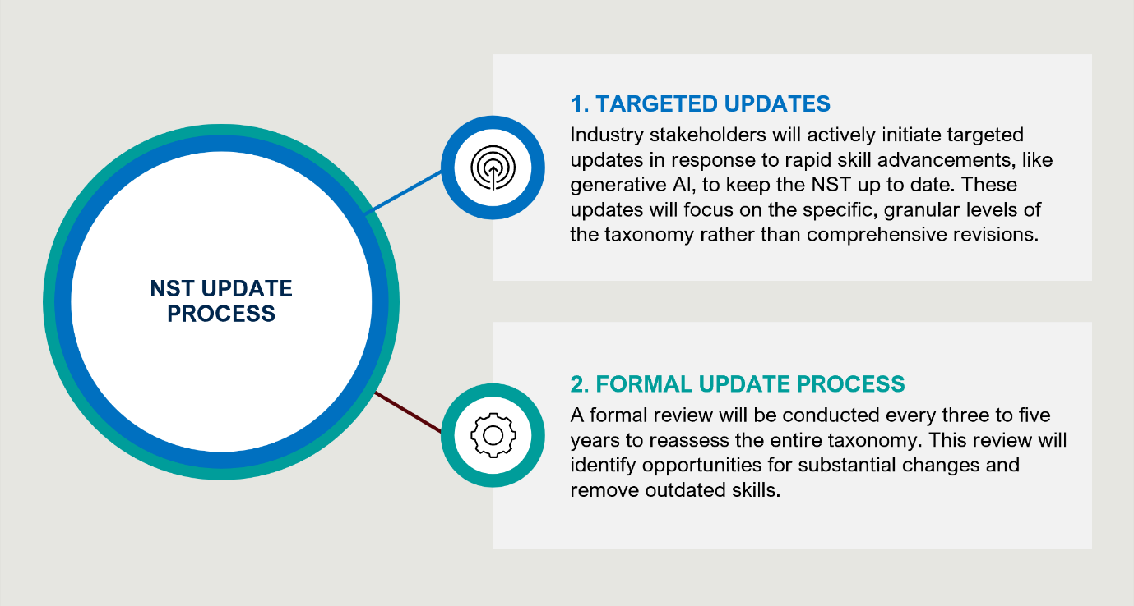

Stakeholders emphasised the importance of not updating the taxonomy too frequently, as this could pose challenges for reporting.

Stakeholders shared a range of views on what they believed the appropriate update cycle should be, with varying levels of confidence in their suggestions. While most stakeholders were comfortable with a five-year update cycle, some felt that more frequent updates might be beneficial. Engagement with more technical stakeholders suggested that although a three-year refresh cycle can be costly, it may be necessary in fast-moving industries. Some stakeholders recommended an annual review and update frequency in the early years of the taxonomy, with a full evaluation every three years. Others proposed identifying rapidly changing industries (e.g., technology, cyber) and conducting targeted and cycled reviews of those industries every 1-2 years. Stakeholders recognised that if this approach is adopted, it would need to be clearly communicated to users that these are not full NST updates.

The approach to updates, whether data-driven or industry-led, was thoroughly evaluated with stakeholders. While preferences varied—some favouring an industry-led approach and others a data-driven method—there was a strong consensus on the importance of combining both strategies for updating and maintaining the NST.

Stakeholders highlighted drawbacks of relying exclusively on either approach. A purely consultative approach was seen as very time-consuming and burdensome due to their specific requirements. There is also the risk that it can be influenced by more vocal stakeholders, potentially skewing the outcomes. Similarly, stakeholders also noted that relying solely on data was also problematic. Issues with job scraping data were noted, such as difficulties in identifying emerging skills and ‘invisible’ skills. Industry peak stakeholders also pointed out that job advertisement data is especially flawed in regional areas, where recruitment is less likely to be represented on large online employment marketplaces like Seek and Indeed.

Stakeholders noted that a combined consultative and data-informed approach would need to be iterative. For example, the process could begin with consultations to form hypotheses, which would then be validated with data, or it could start with data analysis that is subsequently validated through further consultation.

JSCs were recognised as potentially representing appropriate vehicles for industry engagement to inform updates and maintenance. JSCs, could leverage their existing relationships to engage on new relevant skills. One stakeholder explicitly noted that “…*updates should be driven by industry, and JSCs are the best vehicle for that consultation process*.” They should be equipped with clear templates and guidance to enable industry to contribute directly to the taxonomy.

In addition to stakeholder engagement, stakeholders suggested that data-driven approaches should incorporate advanced technologies, such as AI algorithms. These could be used to scan job advertisements, LinkedIn profiles, and even draw on existing skills taxonomies like Lightcast. One technical stakeholder noted that Singapore’s AI scraping model could be considered as a source of data input. However, federal government stakeholders cautioned that AI systems may initially struggle to differentiate between new tools and new skills.

There was a strong consensus that rigorous data quality standards and a robust data quality framework are essential. Data quality standards are specific criteria defining the accuracy, consistency, completeness, and timeliness of data. A data quality framework, on the other hand, includes these standards but also incorporates the processes, tools, roles, and responsibilities needed to manage and maintain data quality. Stakeholders emphasised the need for clear foundations for the NST, including a glossary and a data dictionary. The data dictionary should define terms and data elements used in the NST, while a data framework should be established to ensure that data aligns with these definitions. One stakeholder suggested looking at existing best practice frameworks, such as the UK Government’s data quality framework, which provides principles and practices for assessing, communicating, and improving data quality. This could be a starting point and further adapted to meet the needs of the NST.

## Several technical features are required to promote the NST’s usability and adoption

Technical features are crucial to ensure users can effectively access and use the NST. Stakeholders offered a range of feedback on the technical features they considered important to enable user engagement with the NST. Several key features were identified in relation to the NST’s user experience, integration, governance and documentation. These include:

### User experience

* **User-friendly search interface:** A user-friendly search interface caters to varied user inquiries, making it easier for individuals to find relevant information quickly and efficiently. This includes allowing users to search alphabetically, expand fields, and drill down into specific details.
* **Generative AI capabilities:** Implementing Generative AI capabilities to answer user questions can enhance the user experience by providing quick and personalised information.
* **Table builder functionality:** Incorporating table builder-like functionality would allow users to easily access and customise the specific data cuts they need.
* **Differentiated access points:** Providing non-technical interfaces for general users and more technical options for developers ensures the NST is accessible to all skill levels. This could include having both web and mobile-based apps.
* **Document processing functions:** Functions that enable the translation of alternative information sources against the NST.

### Integration

* **APIs:** Comprehensive APIs are essential to allow the NST to integrate seamlessly with various applications and platforms, such as syncing with other government websites and datasets. Moreover, it was noted that APIs could enable users to input data along with the base case of extracting data.
* **Machine readable formats:** Data should be provided in widely used, machine readable formats to facilitate easy access and integration across platforms and systems.
* **Graph databases:** Graph databases that describe connections between various skill types offer a sophisticated way to understand and visualise relationships within the NST (e.g., Neo4j).
* **Data formats and download capabilities:** Providing users with the ability to extract and download NST data in various formats allows for flexible use and integration into other systems.

### Governance

* **Centralised database:** Housing the NST in a central library prevents the storage of different versions of the same data in multiple locations.
* **Clear metadata standards:** Establishing clear metadata standards on how the NST data is to be logged, classified, and used ensures consistency and reliability of information across the platform.

### Documentation

* **Comprehensive supportive documentation:** User guides, data dictionaries, and FAQs that ensure all users, from individuals to employers and educators, can navigate and utilise the NST effectively.

These features collectively aim to make the NST a robust, user-friendly, and highly functional tool.

# Implementation should follow a phased approach

|  |
| --- |
| **Key takeaways**   * The development and rollout of an NST should not be rushed. * The design and development should consider the impacts and dependencies of existing and recent reforms in the skills landscape. * There is a risk that the NST will contribute to a state of ‘reform fatigue’ among stakeholders. * The design and implementation should take a staged approach that begins with defining a ‘skill’ and successively iterates development with stakeholders. |

Stakeholders acknowledge that a rushed NST rollout poses several key risks. The introduction of the NST is happening amid major reforms in the skills landscape, which adds complexity. As a result, a staged and iterative approach is seen as essential for maintaining stakeholder buy-in and driving successful adoption.

## A rushed NST rollout poses several key risks

Stakeholders have underscored the necessity for a deliberate and gradual rollout of the NST, cautioning against rapid implementation. One education stakeholder emphasised that “…*if you’re going to do it – you have to do it properly. This means that it is going to take time, resources, and a huge amount of effort*.” Key risks associated with a faster rollout include:

* Individuals and organisations may struggle to understand or accept the new common language of skills proposed.
* Rapid implementation could cause misalignment with current reforms, leading to confusion or inconsistency between policies and practices. The challenges associated with current reforms are explored in further detail in the section below.
* If stakeholders feel rushed or inadequately consulted, it could undermine buy-in and ownership.

Stakeholders pointed out that the successful adoption of the NST will demand a shift in both mindset and understanding across the skills landscape. Stakeholders emphasised that it is going to take time for individuals and organisations to familiarise themselves with and embrace the changes the NST will introduce, particularly the adoption of a common language of skills.

## Major reforms in the skills landscape further amplify complexity and risk

Stakeholders recognised that the idea of the NST is being introduced during a period of significant reform across the broader skills landscape, particularly within the education and training system. Key reforms noted in consultations include the AQF review, VET qualifications reform, the ANZSCO review, among others. This has been described by stakeholders as both an opportunity and a source of added complexity. On one hand, stakeholders noted that the NST could strategically complement and enhance these reforms by contributing to:

* harmonisation of the tertiary education sector through its role as a unifying framework
* dynamic and up-to-date training packages which respond to evolving industry needs, ensuring learners gain relevant skills
* fostering stronger connections between education and the labour market by enhancing skills-based learning and outcomes.

Table 11 below outlines the ongoing reforms, detailing the aspects relevant to the NST as noted by stakeholders. It also highlights how the NST could support or enhance these initiatives.

Table 11: Ongoing reforms in the skills landscape

|  |  |  |
| --- | --- | --- |
| Ongoing reform | Relevant aspects of reform | Role for the NST |
| The Australian Universities Accord | * National Skills passport * Establishment of the Australian Tertiary Education Council * Emphasis on equity and access | * Enhance transparency and comparability of qualification and skills across the tertiary sector. * Enhance equity and inclusion for learners. * Facilitate international recognition and learner mobility. * Support life-long learning for individuals by offering a framework to articulate their skills.   * Reforms highlighted by government stakeholders as being important for maintaining alignment and managing interdependencies with the NST. |
| Review of the AQF* | * Changing work requires new skills and learning methods * Potential implementation of Noonan review * Incorporating short form credentials into the AQF (micro-credentials) |
| National Skills Agreement | * Opportunities for Australians to obtain skills * A responsive and accessible VET system |
| VET Qualifications Reform* | * Differentiated qualification system * Self-accreditation pilot for TAFEs |
| RTO Standards | * Enhanced focus on industry outcomes of learners * Skills recognition and transferability |
| ANZSCO Review* | * International comparability * Enhanced focus on skills-based classification |
| Migration Review | * Identifying national skills needs * International mobility and recognition of skills |

Several other reforms in the national skills landscape may also be relevant to the NST, including the Employment White Paper, the University-Industry Collaboration in Teaching and Learning Review (Dawkins Review), and various state and territory-based reviews.

However, stakeholders also highlighted several challenges associated with introducing the NST amid ongoing reforms, including:

* Sector frustration with the addition of reforms that may not align cohesively.
* Increased administrative burden to implement new actions stemming from these reforms.
* A growing sense of reform fatigue among some stakeholders, such as education providers.

## A staged and iterative approach is critical to maintain buy-in and drive adoption

Stakeholders emphasised that a staged approach to the development and implementation of the NST is essential. Across the consultations, stakeholders identified several measures to ensure this approach remains both well-structured and iterative:

* **Define ‘skill’:** A recurring theme among stakeholders was the need to begin the NST's development by clearly defining 'skill'. This definition must be acceptable to all stakeholders, particularly addressing the tensions within the tertiary education sector between ‘skills’ and ‘knowledge’. A clear definition is not only critical to gain buy-in from stakeholders but also serves as a foundational step in the design of the NST. Stakeholders suggested that before developing the taxonomy's structure or other elements, the definition of what constitutes a skill must be firmly established.
* **Maintain momentum through stakeholder engagement:** Stakeholders recognised that strong, ongoing stakeholder engagement is crucial in maintaining momentum, especially in the earlier phases of implementation. They see JSA as playing an active role in facilitating this engagement. This process involves continually involving a broad range of tripartite stakeholders—spanning industry, government, key education peaks, unions, and interested employers —in the ongoing discussions about NST development. This engagement must go beyond keeping stakeholders informed, ensuring they actively shape and refine the taxonomy. Such involvement is seen as key to sustaining progress and fostering a sense of shared ownership over the NST.
* **Iterate user testing and feedback:** Iterative user testing and feedback were highlighted as essential components of a staged rollout. Stakeholders emphasised the importance of releasing the NST in phases. This iterative approach could involve regular user testing at each stage, gathering feedback from stakeholders to ensure the taxonomy is practical and effective. This ongoing development would allow for continuous refinement, enabling the NST to adapt in response to stakeholder needs.
* **Incorporate the NST into policy design:** Further, stakeholders highlighted the critical role of government in fostering the adoption of the NST by incorporating it into policy design, particularly in relation to skills-based policy developments. Coordinating the development of the NST with ongoing reforms, such as the AQF and ANZSCO reform, is perceived as essential in achieving a consistent and coherent approach. Such coordination would ensure that messaging is streamlined and that the NST becomes a central pillar in Australia's evolving skills framework.

# Appendix A | Vision submissions

The table below lists all the alternative visions submitted during the public submission process.

Table 12: Full list of vision submissions

| Source | Revised vision |
| --- | --- |
| **Industry peak stakeholder submission** | Our vision for a National Skills Taxonomy is one that:   1. Must be used to serve the true national interest not just short-term economic interests. 2. Should capture all skills not simply vocational skills. 3. Must serve a future workforce and the future needs of Australia. 4. Be dynamic, responsive and adaptable. 5. Is a tool that works powerfully within its identified context while recognising the boundaries of its remit. 6. Is not used as a tool to guide student preferences in a way that fails to deliver the knowledge, and skills needed to create and maintain national capabilities. 7. Gradation and sophistication of skills associated with different levels of attainment. |
| **Anonymous stakeholder submission** | As business, enterprises and government invest more in training, development and education, individuals will be inspired, understanding and tolerance will increase, and individual, enterprise, national and regional productivity will improve. |
| **Union stakeholder submission** | A proposed vision for the NST could be to create a dynamic, comprehensive, and universally applicable framework that clearly defines and categorises skills, competencies, and qualifications and facilitates the development of a skilled workforce, enhances professional standards, and supports lifelong learning and career progression. This vision includes several key elements:   1. A dynamic and evolving framework that adapts to changes in industry practices, technological advancements, and emerging skill requirements, ensuring continuous workforce development. 2. A comprehensive and inclusive taxonomy covering the full spectrum of skills across various professions, including emerging and specialised fields. 3. Universal applicability across different sectors and regions, allowing for consistency and standardisation while accommodating local and sector-specific needs; clear definition and categorisation of skills, competencies, and qualifications to facilitate understanding, assessment, and application. 4. Support for workforce development by identifying skill gaps, informing training and educational programs and pathways, and guiding flexible and evolving career development. 5. Enhancement of professional standards to elevate the quality and consistency of professional practice across industries and regions. 6. Facilitation of lifelong learning to encourage continuous skill acquisition and adaptation throughout an individual’s career. 7. Integration with existing educational, certification, and regulatory frameworks to ensure seamless application and recognition of skills. |
| **Individual stakeholder submission** | * Bridge the gap between skill shortages and industry and labour market needs. * Facilitate recognition of and seamlessly identify the skills required within the labour market. * Promote accessible and attainable skills, training and qualifications pathways for all individuals. * Connect education and workforce pathways simply and easily. * Facilitating productivity within the labour market. * Enhancing employees access to role and career progression opportunities. * Promote full employment. |
| **Technical stakeholder submission** | Provide a comprehensive and standardised framework for categorising and describing skills and competencies relevant to the Australian labour market. This includes both technical skills specific to industries and occupations, as well as transferable skills that are valuable across various sectors. |
| **Industry stakeholder submission** | The overarching vision for the NST should be to create a dynamic, inclusive, and future-focused system that enhances employability and economic growth. |

# Appendix B | Skill definitions

The table below lists the skills definition considerations noted by stakeholders through the consultations and submissions.

Table 13: Skills definition considerations

|  |  |
| --- | --- |
| Consideration | Attributable ideas |
| Competency and Task Oriented Definitions | **Competency and Behavioural Definitions: Combination of knowledge, skills and behaviours required for effective performance.**   * A broad definition of skill includes observable competencies and less tangible, behavioural aspects. * Behavioural competencies should be integrated alongside knowledge and practical skills.   **Competency Centric Definitions: Centred on underlying capabilities and competencies that enable individuals to perform tasks effectively.**   * Skills as part of a competency-based model, distinct from inherent abilities. * Defines skills in the context of business needs and job role requirements. * All competencies are skills, but not all skills are competencies.   **Action/Performance Based Definitions: Observable actions and behaviours that demonstrate skills proficiency.**   * Skills as verbs requiring action to complete tasks. * Definition includes skills acquisition and expression through demonstrated performance.   **Task Related Definitions: Skills are defined by specific tasks or activities they enable individuals to perform.**   * Skills as the ability to perform a range of tasks, with an emphasis on practicality. * Skills definitions should consider their relationship to tasks and competencies. |
| Outcome Based Definitions | **Outcome Based Definitions: Linking skills to the outcomes or achievements they enable.**   * Skills must be quantified and evaluated, distinguishable from competencies. * Skills involve assessable actions, essential for task completion. |
| Context Oriented Definitions | **Context Based Definitions: Acknowledge that the meaning and application of skills can vary depending on the specific context or industry.**   * Skills should be adaptable and contextually relevant, aligning definitions with skilled execution. * Definitions should cater to the specific industry/role requirements and broader applications. |
| Additional Perspectives | **Broad and Inclusive Definitions: Encompasses a wide range of capabilities, including technical, behavioural, cognitive, and transversal skills.**   * Seeking inclusive and flexible skill definitions that avoid narrow conceptions. * Skills include personal capacity and societal recognition, encompassing autonomous exercise.   **Cultural and Social Competencies: Recognises the importance of cultural awareness and social skills.**   * Incorporating cultural competency and social skills, advocating for comprehensive inclusivity. * Recognising social, emotional, and community-oriented skills as part of broader skill sets.   **Inclusion of Personal Traits and Attitudes: Considers the role of personal characteristics and attitudes in ability to perform tasks and jobs.**   * Coverage of personal traits as part of skill definitions, notably in sectors with prevalent issues. * Embracing a broad definition accommodating knowledge, aptitudes, and behavioural qualities. |

Building on the table above there were several stakeholders who put forward a definition of a skill.

Table 14: Stakeholder definitions of a skill

|  |  |
| --- | --- |
| Skill definition grouping | Specific definitions |
| **Competency and Task Oriented Definitions** | * *“Things that a skill is: A verb, an action, often needed to complete a task, it needs to be assessable.”* * *“Competencies, specific tasks, or familiarity with tools acquired through education and experience”* * *“A capability informing the competent performance of a task.”* * *“Define a skill as the ability to perform a set of tasks”* * *“Skills and tasks required to fulfil a job role”* * *“Skills are the ability to perform a task (physical or mental)”* |
| **Outcome Based Definitions** | * *“Attributes or outcomes of an individual comprising aptitude, knowledge, and skill.”* * *“Skills are considered as outcomes of learning or the ability to perform to achieve an outcome.”* |
| **Context Oriented Definitions** | * *"Someone's knowledge or ability to do a particular job or work-related task."* * *“Attributes that provide utility and function in work and life.”* |

# Appendix C | Stakeholders engaged throughout the consultation process

To inform this consultation paper, an extensive consultation process was undertaken, engaging stakeholders across the diverse Australian skills landscape. This comprehensive process encompassed both workshops and interviews, across the country. In-depth interviews were conducted with 70 individuals representing 45 organisations, while 11 workshops (5 in-person and 6 virtual) were held, with more than 500 participants attending. Additionally, 68 submissions were received from a wide range of organisations, further enriching the consultation process and contributing to the development of this report.

The following table lists the organisations that participated in interviews during the consultation process.

Table 15: Stakeholders interviewed for NST consultation

| Date | Organisation | Stakeholder group |
| --- | --- | --- |
| 1-Jul | Chair of Ministerial Advisory Board (MAB) | MAB Member |
| 4-Jul | Universities of Australia | Education Peak Body |
| 4-Jul | Surf Life Saving Australia | VET Provider |
| 4-Jul | Australian Bureau of Statistics | Australian Government Agency |
| 8-Jul | Edalex | Expert |
| 9-Jul | Regional University Network | Education Peak Body |
| 10-Jul | TAFE Directors Australia | Education Peak Body |
| 11-Jul | National Employment Services Association | Industry and Employer Peak |
| 15-Jul | Manufacturing Skills Alliance | Jobs and Skills Council |
| 15-Jul | Build Skills Australia | Jobs and Skills Council |
| 17-Jul | Jobs and Skills Australia #1 (Commissioner) | Australian Government Agency |
| 17-Jul | Skills NSW | Australian Government Agency |
| 17-Jul | Independent Tertiary Education Council Australia | Industry and Employer Peak |
| 18-Jul | Literacy for Life Foundation | MAB Member |
| 18-Jul | Australian Council of Trade Unions | Union |
| 22-Jul | Mining and Automotive Skills Alliance | Jobs and Skills Council |
| 22-Jul | Australian Industry Group | Industry and Employer Peak |
| 22-Jul | Jobs and Skills Australia #2 (Assistant Secretary) | Australian Government Agency |
| 23-Jul | Future Skills Organisation | Jobs and Skills Council |
| 23-Jul | Australian Chamber of Commerce and Industry | Industry and Employer Peak |
| 23-Jul | Disability Advocacy Network | MAB Member |
| 24-Jul | Public Skills Australia | Jobs and Skills Council |
| 25-Jul | VETASSESS | VET Provider |
| 29-Jul | Industry Skills Australia | Jobs and Skills Council |
| 30-Jul | Career Industry Council of Australia | Industry and Employer Peak |
| 2-Aug | Human Ability | Jobs and Skills Council |
| 1-Aug | Future of Skills and Employment Research Centre | Research |
| 1-Aug | Lightcast | Expert |
| 2-Aug | Australian Nurses and Midwifery Union | Union |
| 5-Aug | National Apprentice Employer Network | Industry and Employer Peak |
| 5-Aug | Western Australia Department of Training and Workforce Development | State Government Body |
| 5-Aug | Department of Jobs, Skills, Industry and Regions, Victorian Skills Authority | State Government Body |
| 7-Aug | Service and Creative Skills Australia | Jobs and Skills Council |
| 7-Aug | Skills Insight | Jobs and Skills Council |
| 7-Aug | Australian Education Union | Union |
| 7-Aug | Bean Centre | Expert |
| 7-Aug | Australian Manufacturing Workers Union | Union |
| 8-Aug | Warwick Institute for Employment Research | Expert |
| 9-Aug | Universities Accord Panel | Education Peak Body |
| 12-Aug | SEEK | Expert |
| 13-Aug | Powering Skills Australia | Jobs and Skills Council |
| 13-Aug | Vocational Education Consultant | Expert |
| 15-Aug | RMIT | Expert |
| 29-Aug | Department of Education | Australian Government Agency |
| 4-Sep | Rural Industries Skill Training Centre | Higher Education Provider |

The following table provides details of the workshops held during the consultation process.

Table 16: List of workshops held during the NST consultation

|  |  |  |
| --- | --- | --- |
| Date | Workshop Title | Format |
| 9-Jul | Virtual Workshop 1 | Virtual |
| 16-Jul | Brisbane Workshop | In-person |
| 17-Jul | Perth Workshop | In-person |
| 18-Jul | Melbourne Workshop | In-person |
| 22-Jul | Virtual Workshop 2 | Virtual |
| 23-Jul | Virtual Workshop 3 | Virtual |
| 25-Jul | Sydney Workshop | Virtual |
| 29-Jul | Education Peak Bodies Workshop | In-Person |
| 30-Jul | State and Territory Officials Workshop | Virtual |
| 1-Aug | Large Employers Workshop | Virtual |
| 13-Aug | APS Agency Workshop | Virtual |

The following table provides a list of the submissions received and reviewed during the consultation process.

Table 17: List of submissions received from the NST consultation

| No. | Author | Stakeholder Group |
| --- | --- | --- |
| 1 | Anonymous Submission | State Government Body |
| 2 | Anton Mahendra | Employer |
| 3 | Anonymous Submission | Higher Education Provider |
| 4 | Anonymous Submission | Other |
| 5 | Anonymous Submission | VET Provider |
| 6 | Unidentified NGO | NFP/NGO |
| 7 | Anonymous Submission | VET Provider |
| 8 | Bruce D. Watson | Research |
| 9 | Anonymous Submission | Other |
| 10 | Anonymous Submission | Expert |
| 11 | Anonymous Submission | Employer |
| 12 | Anonymous Submission | Other |
| 13 | Anonymous Submission | Higher Education Provider |
| 14 | Adrian Tanner | Expert |
| 15 | Edmund Rice Education Australia | Education Peak Body |
| 16 | Anonymous Submission | Other |
| 17 | Australian Retailers Association | Industry and Employer Peak |
| 18 | NSW Jockeys Association | Professional Association |
| 19 | Anonymous Submission | Employer |
| 20 | Australian Institute of Medical and Clinical Scientists | Professional Association |
| 21 | Australian National Committee for Archaeology Teaching and Learning (ANCATL) | Education Peak Body |
| 22 | Australian Nursing and Midwifery Federation (ANMF) | Union |
| 23 | Industry Skills Australia | Jobs and Skills Council |
| 24 | Dr Ann Villiers | Research |
| 25 | Master Builders Australia | Industry and Employer Peak |
| 26 | Primary Industries Skills Council | Industry Skills Advisor |
| 27 | Academy of the Social Sciences in Australia | Professional Association |
| 28 | Deb Carr | Expert |
| 29 | Massage & Myotherapy Australia | Professional Association |
| 30 | Anonymous Submission | Jobs and Skills Council |
| 31 | SFIA Foundation | Expert |
| 32 | Anonymous Submission | Employer |
| 33 | Anonymous Submission | Australian Government Agency |
| 34 | Engineers Australia | Professional Association |
| 35 | Australian Computer Society | Professional Association |
| 36 | Anonymous Submission | State Skills Commission and Bodies |
| 37 | Ai Group Centre for Education & Training | Industry and Employer Peak |
| 38 | Australian Education Union | Union |
| 39 | ANU School of Cybernetics | Research |
| 40 | Australian Academy of the Humanities | Professional Association |
| 41 | Learning Creates Australia | NFP/NGO |
| 42 | Orygen | NFP/NGO |
| 43 | University of Newcastle | Higher Education Provider |
| 44 | Universities Australia | Education Peak Body |
| 45 | University of Technology Sydney | Higher Education Provider |
| 46 | Chris Ainsworth CEM | Other |
| 47 | Swinburne University of Technology | VET Provider |
| 48 | Group of Eight Australia | Education Peak Body |
| 49 | Clean Energy Council | Industry and Employer Peak |
| 50 | Australian Marketing Institute | Professional Association |
| 51 | Anonymous Submission | Professional Association |
| 52 | Anonymous Submission | Other |
| 53 | Australian Council for Educational Research (ACER) | Research |
| 54 | Anonymous Submission | Other |
| 55 | Anne Junor and Ian Hampson (Industrial Relations Research Group, UNSW) | Expert |
| 56 | Council of Small Business Organisations Australia (COSBOA) | Industry and Employer Peak |
| 57 | University of Adelaide and University of South Australia | Higher Education Provider |
| 58 | Anonymous Submission | Education Peak Body |
| 59 | Skills Insight | Jobs and Skills Council |
| 60 | Australasian Council of Deans of Arts, Social Sciences and Humanities (DASSH) | Professional Association |
| 61 | RMIT University | Higher Education Provider |
| 62 | Women in Adult and Vocational Education (WAVE) | NFP/NGO |
| 63 | Australian Digital Inclusion Alliance (ADIA) | NFP/NGO |
| 64 | Anonymous Submission | Australian Government Agency |
| 65 | Anonymous Submission | State Government Body |
| 66 | Anonymous Submission | State Government Body |
| 67 | Anonymous Submission | State Skills Commission and Bodies |
| 68 | Future Skills Organisation | Jobs and Skills Council |

1. It should be noted that not all stakeholders responded to all sections discussed and data presented from engagements varies as such.
2. Prof. A Junor, ‘Report of Honorary Associate Professor Anne Junor’, Fair Work Commission Matter, Amendments to the Aged Care Award 2010 and the Nurses Award 2010, 28 Oct 2021 [[link](https://www.fwc.gov.au/documents/sites/work-value-aged-care/submissions/am202099andors-sub-junorreport-anmf-291021.pdf)]
3. Rich Skill Descriptors is an opensource approach that can provide a common, standardised approach to defining skills and the information attached to skills.