

# RLMI Results – June 2024

## Key Findings

Labour market challenges are more pronounced in many regional and remote areas as they are more likely to experience weaker labour market conditions than their metropolitan city counterparts. With that said, the June 2024 Regional Labour Market Indicator (RLMI) results suggest that a number of metropolitan and regional city areas are showing signs of a gradual easing in labour market conditions, particularly when compared to regional areas where, on average, conditions have improved.

### Labour market challenges are more pronounced in many regional areas

The June 2024 RLMI results confirm that regional and remote areas are more likely to experience weaker labour market conditions than their metropolitan city counterparts, highlighting the additional challenges faced in many regional areas by both employers and jobseekers (see Chart 1).

Chart 1: RLMI ratings of relative labour market performance, June 2024

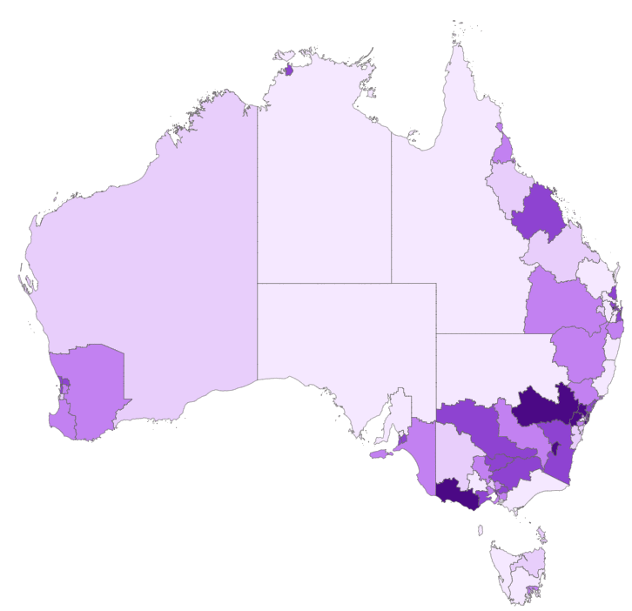

Source: JSA, Regional Labour Market Indicator (RLMI), June 2024

Indeed, 28 of the 39 SA4’s (or 72%) that were rated either ‘strong’ or ‘above average’ in June 2024 were located in metropolitan cities (see Chart 2). By contrast, 19 of the 28 SA4’s (or 68%) that were rated either ‘below average' or 'poor’ in June 2024 were located in regional or remote areas.

Chart 2: RLMI ratings by remoteness category, June 2024

Source: JSA, Regional Labour Market Indicator (RLMI), June 2024

### Recent trends in regional labour market performance

The latest RLMI results suggest there are signs of some easing in labour market conditions in a number of metropolitan/regional city areas, particularly when compared to regional areas, where conditions have improved, on average. For instance, the labour market rating declined for 13 metropolitan/regional city areas (or 25%), and improved for 4 (or 8%), over the year to June 2024. By comparison, the labour market rating improved for 7 regional areas (or 29%), and declined for 4 (or 17%), over the same period.

* For most remote regions, labour market conditions remain weak, with the number of regions rated either ‘below average’ or ‘poor’ unchanged over the year to June 2024 (7 regions, or 82%).

Highlighted below are some of the trends that are contributing to the easing in conditions for metropolitan/regional city areas.

* The average working age employment rate for metropolitan/regional city areas fell by 0.3 percentage points over the year, to 77.8% in June 2024 (see Chart 3), while the average unemployment rate for metropolitan/regional city areas increased by 0.4 percentage points over the year, to 3.9% in June 2024
* By contrast, the average working age employment rate for regional areas increased by 0.5 percentage points over the year, to 76.2% in June 2024, while the average unemployment rate for regional areas increased marginally over the year, by just 0.1 percentage points, to 3.3% in June 2024 (see Chart 4).

Chart 3: Employment rate (15-64 years) by remoteness category, June 2024 to June 2024

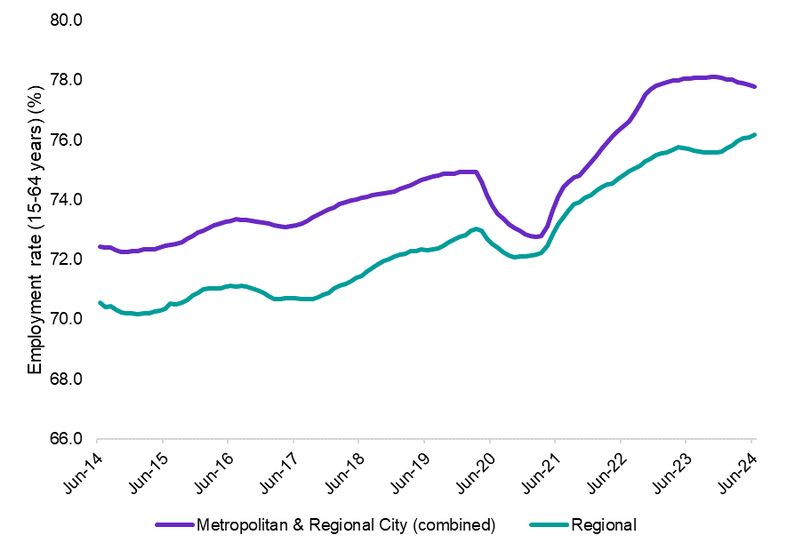

Source: ABS, *Labour Force, Australia, Detailed,* June 2024, 12-month averages of original estimates.

Chart 4: Unemployment by remoteness category, June 2014 to June 2024

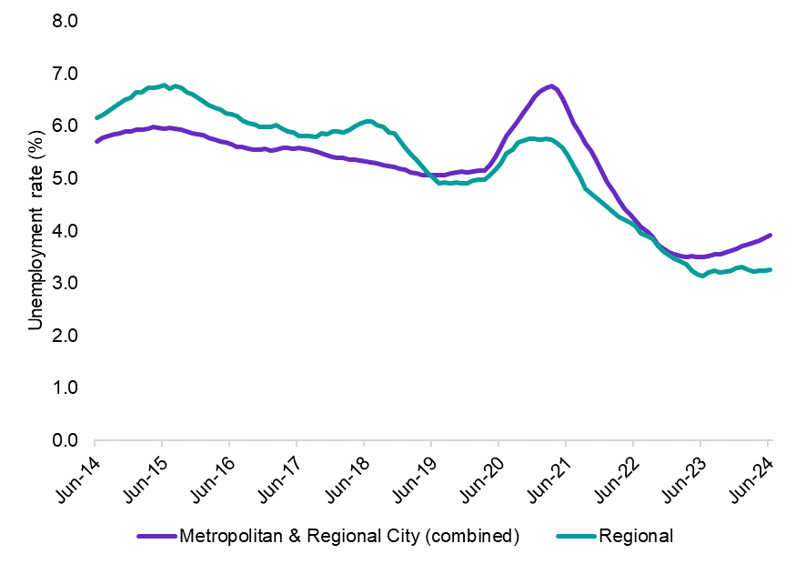

Source: ABS, *Labour Force, Australia, Detailed,* June 2024, 12-month averages of original estimates

#### Recent trends in regional labour market performance: Region spotlight

##### Inner Metropolitan Brisbane[1]

One example of the gradual easing of conditions in a number of metropolitan/regional city areas can be seen in the decline in labour market ratings in inner metropolitan Brisbane over the last year. While overall conditions remain relatively strong, several key indicators of labour market performance have recently softened in a number of these regions. As a result, conditions in Brisbane East, Brisbane North and Moreton Bay – South were rated as ‘above average’ in June 2024, down from their rating of ‘strong’ in June 2023 (see Chart 5).

A legend of the RLMI rating categories (Strong, Above average, Average, Below average, Poor). Chart 5: RLMI ratings of relative labour market performance

**Jun-24**

**Jun-23**

Moreton Bay South

Brisbane East

Brisbane North

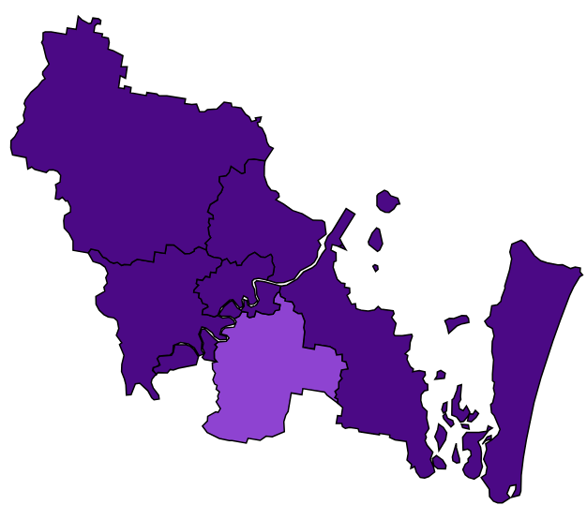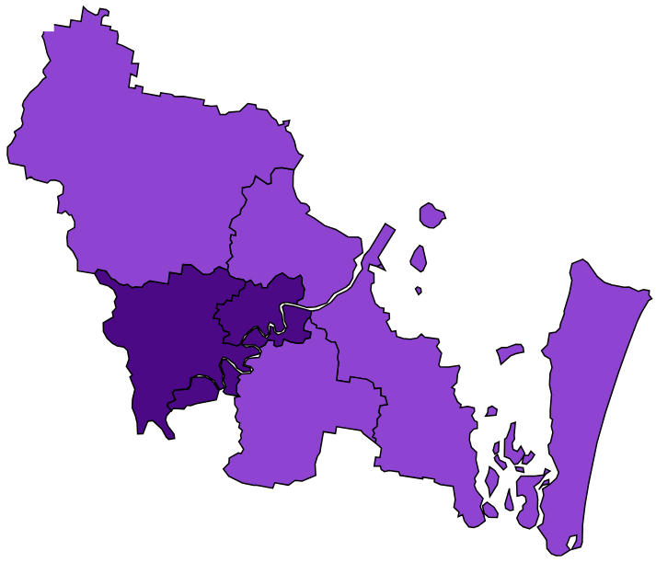

Source: JSA, Regional Labour Market Indicator (RLMI), June 2024

##### NSW/Victoria Border regions

The regions of Murray, Shepparton and Hume (3 regions on the border of New South Wales and Victoria) are just one example of where conditions have improved in regional areas, with labour market conditions in these regions rated ‘above average’ in June 2024, up from their rating of ‘average’ in June 2023 (see Chart 6).

Chart 6: RLMI ratings of relative labour market performance

**Jun-24**

**Jun-23**

Murray

Hume

A legend of the RLMI rating categories (Strong, Above average, Average, Below average, Poor). 

Shepparton

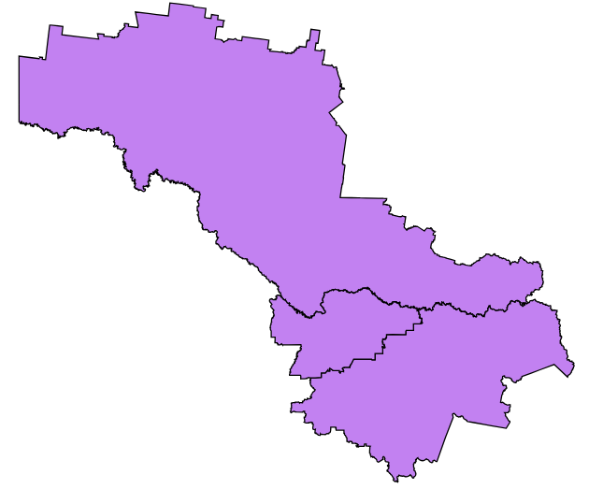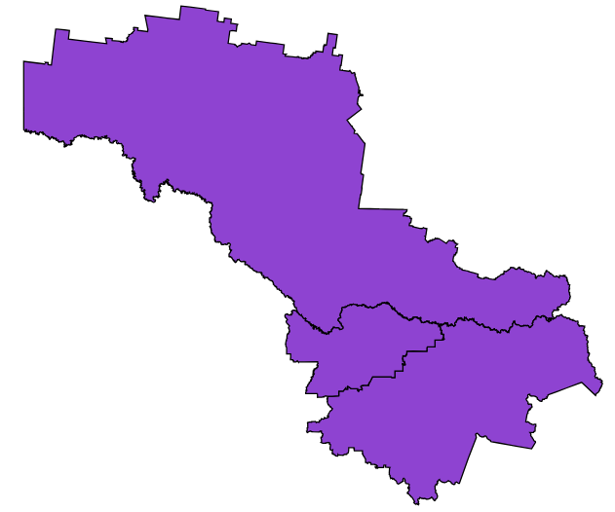

Source: JSA, Regional Labour Market Indicator (RLMI), June 2024

While conditions in these regions have improved over the last year, data at the regional level are inherently volatile. To help identify region-specific trends, it is often useful to compare a region’s rating over a longer period. When viewed from a long-term perspective, it is evident that the relative conditions in these regions have improved, with recent conditions consistently rating above their long-term trend (see Chart 7).

Chart 7: Average RLMI rating for the Murray, Shepparton and Hume SA4 regions, March 2009 to March 2024

Source: JSA, Regional Labour Market Indicator (RLMI), June 2024

Note: RLMI rating category legend: 1 – Strong, 2 – Above average, 3 – Average, 4 – Below average, 5 – Poor.

## RLMI Explanatory Notes

### Overview

The Regional Labour Market Indicator (RLMI) combines key indicators of spare labour market capacity, from both an employee and employer perspective, into a single, and easy to interpret, summary measure. Regions are grouped into distinct categories of overall labour market performance, ranging from ‘poor’ to ‘strong’, which provides an accurate and reliable view of labour market performance, relative to the national average. A strong labour market, that is characterised by a high rate of employment, where employment opportunities are extended to all who want them, is central to a strong economy and prosperous and inclusive society.

**Factors used to assess labour market performance**

The **working age (15-64 years) employment rate** is one of the most commonly used indicators for understanding conditions in the labour market and is a key measure of performance. It provides an insight into the extent to which available labour (some individual’s personal circumstances may prevent them from participating in the labour market) is being used and is unaffected by voluntary changes in labour force participation.

Along with the employment rate, the **unemployment rate** is one of the most commonly used indicators for understanding conditions in the labour market and is a key measure of spare capacity. It provides insights into the availability of unused labour that is willing and available for work.

The **JobSeeker income support rate** is a reliable measure of spare capacity in the labour market and is an important complement to other measures of spare capacity. It is a combination of the JobSeeker payment and Youth Allowance (other) payment, measured as a proportion of the working age population. These payments are designed to provide financial assistance to support those looking for working, including those who may be working part-time.

The **underemployment rate**[2] takes a broad view of underutilisation by measuring the share of the labour force that is employed, but not fully utilised in terms of the amount of work people would like. It is an important complement to the unemployment rate in assessing how much spare capacity could be called upon in adapting to labour market strength and weakness.

The **vacancy fill rate**2is a key measure of unmet demand for labour. A low fill rate indicates that the demand for labour is not matched by the supply of labour from workers. This may be due to a lack of suitable applicants or high search costs that reduce labour market matching efficiency. Poorer-performing regions experience more difficulty filling vacant positions, despite having a higher availability of unused labour willing and available to work.

### Methodology

Please refer to the [RLMI Methodology Paper](https://www.jobsandskills.gov.au/data/regional-labour-market-indicator#methodology) for more information on the RLMI, including its purpose and factor selection.

### Referencing this report

Data in this release should be referenced as: Jobs and Skills Australia, RLMI, June 2024

### Contact us

For additional information, email [RegionalWorkforceAssessment@jobsandskills.gov.au](mailto:RegionalWorkforceAssessment@jobsandskills.gov.au)

1. Includes the SA4 regions of Moreton Bay – South, Brisbane – North, Brisbane – West, Brisbane Inner City, Brisbane – South, and Brisbane – East.
2. Measured at the Greater Capital City Statistical Area (GCCSA) level due to data quality issues with this factor at the SA4 level.