


VET Workforce Study
October 2024


Acknowledgement of Country
Jobs and Skills Australia acknowledges the Traditional Owners of Country throughout Australia and recognises the continuing connection to lands, waters and communities. We pay our respect to Aboriginal and Torres Strait Islander cultures, and to Elders past and present.

Contents
Acknowledgement of Country 1
Glossary 3
Chapter 1: The Study 5
Defining, measuring, and categorising the VET workforce 6
A new approach: a VET workforce taxonomy and occupational framework 12
The sector context – workforce implications 16
Report structure 23
Summary of key findings 24
Chapter 2: Understanding the workforce 26
Workforce size, growth, and predominant roles 27
Demographic characteristics 30
Geographic characteristics 40
Employment characteristics 41
VET workforce data – current and potential future states 54
Conclusion 60
Chapter 3: Job profiles and pathways 61
Training pathways 62
Job profiles 69
Conclusion 102
Chapter 4: Workforce demand and supply pipelines 103
Workforce demand and supply 103
Training pipeline 111
Workforce transitions 121
Conclusion 127
Chapter 5: Key findings 128
Key findings 128
Conclusion 134
Appendix A: VET workforce taxonomy and ANZSCO mapping 135
Appendix B: TAFE and Dual Sector Workforce Profiles 141
TAFE Workforce Profile 141
The Dual Sector VET Workforce 147
References 149

Glossary
Abbreviation | What it stands for
ABS | Australian Bureau of Statistics
ACDE | Australian Council of Deans of Education
ACDEVEG | ACDE Vocational Education Group
ACE | Adult and Community Education
AEU | Australian Education Union
AHPRA | Australian Health Practitioner Regulation Agency
ANZSCO | Australian and New Zealand Standard Classification of Occupations
ANZSIC | Australian and New Zealand Standard Industrial Classification
AQF | Australian Qualifications Framework
ASQA | Australian Skills Quality Authority
ATAR | Australian Tertiary Admission Rank
AVETMISS | Australian Vocational Education and  Training Management Information Statistical Standard
COE | Characteristics of Employment
CPR | Cardiopulmonary Resuscitation
DEWR | Department of Employment and Workplace Relations
ELICOS | English Language Intensive Courses for Overseas Students
ELT | English Language Teaching or English Language Testing
FSK | Foundation Skills Training Package
FTE | Full-time equivalent
IBSA | Innovation and Business Skills Australia
IELTS | International English Language Testing System
IEU | Independent Education Union
IVI | Internet Vacancy Index
JSA | Jobs and Skills Australia
JSC | Jobs and Skills Council
LLN | Language, Literacy and Numeracy
LOTE | Languages Other Than English
NCVER | National Centre for Vocational Education Research
NEAS | National Executive Leadership Team Accreditation Scheme
NFD | Not Further Defined
NSA | National Skills Agreement
PLIDA | Person Level Integrated Data Asset
RTO | Registered Training Organisation
SERA | Survey of Employers who have Recently Advertised
SOS | Student Outcomes Survey
TAC | Training Accreditation Council
TAE | Training and Education Training Package
TAFE | Technical and Further Education
TESOL | Teaching English to Speakers of Other Languages
TESQA | Tertiary Education Quality and Standards Agency
VET | Vocational Education and Training
VNDA | VET National Data Asset
VRQA | Victorian Registration and Qualifications Authority

The Study
Many of the skills shortages across the country rely on the VET system and its dual professional workforce to teach and train Australia’s future workers. If we do not secure a sustainable VET workforce for the future, we cannot fix skills shortages in the wider Australian economy. The purpose of this report is to highlight the extent of this challenge and offer the data and evidence to inform the VET Workforce Blueprint. Both this report and the Blueprint aim to ensure the long-term sustainability of the VET sector by supporting and growing the quality and capability of the VET workforce.
In particular, the VET Workforce study’s purpose is to profile the existing workforce data available, identify its limits and elucidate why consistent, regular workforce data collection is needed to ensure an effective workforce strategy for this crucial part of Australia’s skills system. Indeed, more regular and systematic data collection on the VET workforce is a recommendation of this report.
Profiling VET jobs and pathways into, out of, and within the sector is also key to this overarching study purpose. This profiling offers a more contemporary understanding of the current and emerging VET workforce roles across a diverse and changing sector and contextualises these shifts in current policy reform and industry practice.
This chapter outlines the study’s purpose, scope and approach in detail. The first section focuses on defining, measuring and categorising the VET workforce, noting that there is no current regular VET workforce data collection at the national level, and that VET workforce estimates in recent years have varied. It introduces the most recent survey of the VET workforce – the NCVER 2019 survey – and discusses how ABS industry and occupational codes shape and limit VET workforce data collection.
The second section outlines our approach to profiling the VET workforce, using a new VET workforce taxonomy that categorises the sector into six segments, for a more nuanced understanding of existing workforce data – mainly using the 2021 Census. We also draw on Person Level Integrated Data Asset (PLIDA) data from the ABS to compare against Census data and again provide a more nuanced understanding of the VET workforce. PLIDA data combines information on Australian’s education, employment, health, income and demographic data.
For example, we use data on individuals’ income tax returns from the Australian Taxation Office in the decade from 2011/12 to offer a VET workforce count and demographic insights. We also use VET national activity data in PLIDA to explore training to employment pathways and movements between VET teaching and other occupations.
The third section of this introductory chapter introduces the regulatory and market context of VET with a focus on their workforce implications. Lastly, this chapter outlines the structure of the report and summarises the key findings of the study. Overall, this chapter offers answers to the five foundation questions in the study:

- What VET workforce data currently exists and how reliable is it?
- How do we define the VET workforce and what job areas and specific roles are common?
- Are the occupational and industry classifications used in current data collection fit-for-purpose?
- How is the VET workforce regulated and how does the market context impact the workforce?
- What are the study’s key findings?

Defining, measuring, and categorising the VET workforce
There is no current, regular VET workforce data collection at the national level and VET workforce estimates across recent studies have varied due to different definitions and methodologies. In 2011 the Productivity Commission estimated the total VET workforce was 223,000 workers. In 2019 the NCVER VET Workforce survey estimated a workforce of 246,000 workers with just over 71,000 teachers. In contrast, 2021 Census indicates that there are 58,000 workers in the Technical and Vocational Education and Training industry and 32,000 VET teachers across all industries. This study’s approach, using Census and other PLIDA data does indicate a larger VET workforce at over 110,000. Using all of these data sets and studies offers a robust workforce sample to draw conclusions on, especially in relation to the demographic and employment characteristics of the workforce. However, an accurate overall count or estimate of the VET workforce size remains unclear.

The 2019 NCVER Workforce Survey and the strengths and limits of Census data
Due to these data limitations, largely in relation to workforce size, this study does not make a definitive estimate of the VET workforce but recommends that governments take steps to improve workforce data collection, the evidence base in the future. It relies on a combination of the most recent considered analysis of the workforce: the 2020 NCVER Research Report: Understanding the Australian vocational education and training workforce alongside a new approach to analysing Census data. The NCVER report demonstrated the challenges in profiling VET and the estimates were based on VET employees at a specific time (February 2019) and collected summary data from RTOs, not individual workers. The survey indicates the challenges in attempting to measure the VET workforce, particularly the workforce of RTOs that primarily operate in other domains, such as schools, dual sector universities, and enterprise RTOs.
The results of the 2019 survey, to NCVER’s own acknowledgment, are not necessarily representative of the actual workforce numbers for each type of RTO since the data may have been skewed, depending on how respondents reported staffing numbers in the survey. The 2019 survey also only had a 40% response rate. There has never been a Census of the Australian VET workforce, and this makes any survey limited in what it can reveal. Typically, a survey with sufficient responses can be weighted to the population to estimate the overall workforce profile. However, when the true population is unknown, weighting becomes unreliable. This was the case in the 2019 survey and remains a challenge for any future survey of the VET workforce due to the diverse range of RTO types.
While this study addresses some of these limitations by drawing on multiple data sources, it remains important to seek a more comprehensive and consistent approach to future VET workforce data collection. The limitations of Census data in counting the VET workforce are summarised below:
- Census data overall shows a lower VET workforce and a lower teacher/trainer workforce.
- Two key reasons are that the VET workforce (and RTOs as entities) is spread beyond just the single main industry category (Vocational Education and Training), and Census data reports only one occupation and industry of employment (respondents are asked to answer in relation to “the main job held last week”. Secondary jobs holders are common in VET so are not counted in the standard ABS industry and occupational counts.
- Other common industry categories include Schools, Adult, Community and Other Education, Education and Training not further described, and Higher Education. As well as all the various industries with enterprise RTOs (public and private).
- Likewise, the “Vocational Education Teacher” occupation category does not capture all those delivering VET training and assessment. “Training and Development Professional” and “First Aid Trainer” are common in private RTOs and “University Lecturers and Tutors” and “Teachers of English to Speakers of Other Languages” are also commonly found in VET institutions across both public and private sector (as defined by ABS Census) settings.
- ABS industry and occupational codes that are used for Census data are outdated (see discussion below).
There are also well-known challenges with accurately identifying VET teachers, trainers, and assessors due to their dual professional status and particular issues regarding volunteer trainers, secondary teachers working in VET and trainers who work across multiple RTOs. VET teachers are required to maintain current industry engagement in their industry of expertise, in addition to holding and maintaining training and assessment qualifications. In ABS data classified by either occupation or industry, a VET teacher who identifies more strongly with their industry role than their teaching role may identify more as – for example – an electrician rather than a VET teacher.
Furthermore, not all RTOs operate within VET specific industries. Outside of the VET industry, VET is delivered within enterprises, schools, community education providers and some higher education institutions. Even in Census data, 1 in 5 VET teachers work in one of 243 industries outside Education and Training (see Table 1.1).
Notwithstanding these limitations, the 2021 Census remains the best available data source for interrogating the personal and employment characteristics of the VET workforce until such time as a specific national VET workforce is implemented.

Table 1.1 VET teachers not in education and training industries
Industry of Employment | Persons | % of all VET teachers
Correctional and Detention Services | 438 | 1.5%
Employment Placement and Recruitment Services | 294 | 1.0%
Other Social Assistance Services | 264 | 0.9%
Iron Ore Mining | 208 | 0.7%
Hairdressing and Beauty Services | 183 | 0.6%
State Government Administration | 160 | 0.5%
Labour Supply Services | 158 | 0.5%
Coal Mining | 142 | 0.5%
Aged Care Residential Services | 126 | 0.4%
Takeaway Food Services | 121 | 0.4%
Hospitals (except Psychiatric Hospitals) | 113 | 0.4%
231 more industries with 1-99 VET teachers | 3,624 | 12.0%
Industry inadequately described or not stated | 294 | 1.0%
Total outside Education and Training | 6,125 | 20.3%
Source: ABS (2021) Occupation (OCCP) by Industry of employment (INDP), [Census TableBuilder],
accessed 27 November 2023.

ABS occupational and industry classifications for a changing
VET workforce
There are also broader structural issues with occupational and industry ABS reporting codes not fully reflecting the modern Australian labour market. The ABS has been reviewing the Australian and New Zealand Standard Classification of Occupations (ANZSCO) with the aim of reflecting the current industry practices and shifts in workforces such as VET since 2023. Various proposals for updates and changes to VET workforce classifications were considered by the public and have informed the approach this study takes to understanding and scoping out a more modern VET workforce for Census and other data analysis. The ABS published the latest preliminary proposed changes in June which are:
- Alternative titles of TAFE Lecturer, TAFE Teacher, VET Trainer and Assessor for Vocational Education Teacher including a specialisation of Adult Education Teacher. VET Literacy and Numeracy Educator and Workplace Trainer and Assessor were also considered in previous consultations but not proposed for adoption at this stage.
- Education Consultant as an alternative title for Education Advisor with specialisations such as Curriculum Advisory Teacher, Education Officer, Home-School Liaison Officer, Instructional Designer (Education), Learning Designer, Learning Technologist and Preschool Field Officer. The current ANZSCO classification of Education Reviewer will remain the same.
- New leadership and management occupation classifications with Faculty Head proposed to change to Faculty Manager with specialisations of Academic Manager (RTO), Head Teacher (TAFE) and Dean (University). Tertiary Education Administrator or Manager, Director Vocational Education, and Academic Manager (Deputy Director) were considered in previous consultations.
- Other preliminary proposed changes that likely mean broader use of some occupational classification codes in VET and thus better workforce mapping include:
  - Alternative titles to Aboriginal and Torres Strait Islander Education Officer of Indigenous Australian Education Officer, Aboriginal and Torres Strait Islander Community Education Officer and/or Counsellor. Aboriginal and Torres Strait Islander Education Officer Coordinator is also a proposed specialisation under this occupation which is common in larger public VET providers.
  - Changing Teachers’ Aide to Teaching Assistant with the alternative titles of Education Assistant, Education Support Officer, Learning Support Officer, Student Support Officer and Teacher Aide. Two specialisations across this occupation are also proposed: School Services Officer and Student Liaison Officer.
Figure 1.1 Preliminary proposed specialisations for VET roles
Alternative titles for Vocational Education Teacher
TAFE Lecturer | TAFE Teacher | VET Trainer and Assessor
Specialisation: Adult Education Teacher
Proposed specialisations for Education Advisor
Curriculum Advisory Teacher | Education Officer | Home-school Liaison Officer
Instructional Designer (Education) | Learning Technologist | Learning Designer
Specialisations for Faculty Head which is proposed to change to Faculty Manager
Dean (University) | Head Teacher (TAFE) | Academic Manager (RTO)

These are likely more fit-for-purpose occupation classifications and better reflect the position descriptions, job roles, and organisational charts from providers of varying size and management type that were collected for this study. We have drawn on these to develop our occupational framework and job profiles in Chapter 3.
However, throughout this report our analysis and data depend on the existing occupational and industry codes of ANZSCO 242211 Vocational Education Teacher and ANZSIC 8101 Technical and Vocational Education and Training industry. When we refer to the ‘VET workforce’ we are counting and combining both these categories of workers. See Figure 1.2 below for current definitions of both occupation codes.
JSA also acknowledges that there are debates around the terminology of using teacher, trainer, and assessor to describe all practitioners who deliver VET courses and qualifications and that this may not acknowledge the full extent of pedagogic and support practices various roles like lecturers, facilitators and educators perform.
However, as Wheelahan and Curtin have noted in the past:
Terms can be controversial for detracting the focus in VET away from workplace training but, conversely, the term trainer and training is critiqued for its minimalist conceptions of what VET teachers do and the depth of skills and knowledge
they need to do it.
This study will refer to Teach, Train, and Assess roles in acknowledgement of these debates but when referring specifically to Census and other data that is collected based on the occupational code of Vocational Education Teacher, we use this specific language for data accuracy with an understanding of its limits.

Figure 1.2 Current ANZSCO and ANZSIC descriptions
ANZSCO 24211 Vocational Education  Teacher (Aus) / Polytechnic Teacher | ANZSIC 8101 Technical and  Vocational Education and Training
Teaches one or more subjects within a prescribed course of study at a technical and further education (TAFE) institute, polytechnic or other training institute to tertiary students for vocational education and training purposes. Registration or licensing is required. This ANZSCO is the only in the unit group 2422 Vocational Education Teachers (Aus) / Polytechnic Teachers (NZ).  Tasks include:  - Identifying the various needs of students and creating effective learning options to meet these needs  - Liaising with individuals, industry and education sectors to ensure provision of relevant programs and services  - Planning, designing and developing course curriculum and method of instruction  - Advising students on courses and related matters  - Maintaining records of students’ progress, attendance and training activities  - Teaching students using teaching aids including presentation of lesson materials, discussions, workshops, laboratory sessions, multimedia aids and computer tutorials  - Marking and grading students’ assignments, papers and exams and providing feedback to students about their progress  - Consulting with education managers, librarians, student counsellors and other support staff | The class consists of units mainly engaged in providing technical and vocational education and training. These units offer a large variety of courses covering a range of subjects or specialise in a particular field of education such as computer and business management training.  Primary activities:  - Apprenticeship training program operation  - Business college and school operation  - Information technology training centre operation  - Institute of technology operation  - Professional and management development training  - Technical and further education college operation  - Technical college operation  - Vocational computer training  Exclusions/References:  - Providing sports and physical recreation coaching not predominantly leading to tertiary qualifications are included in Class 8211 Sports and Physical Recreation Instruction; and  - Providing education in the arts not predominantly leading to tertiary qualifications are included in  Class 8212 Arts Education.

A new approach: a VET workforce taxonomy and occupational framework
Using the occupational categories found in the Census, and then further refined with analysis of position descriptions gathered from RTOs and engagement with leaders and experts from the sector, we have developed a VET workforce taxonomy to analyse data in a new way and give a frame for governments, RTOs, and individuals to consider emerging roles, pathways and issues in the VET workforce. The taxonomy categorises the workforce into six segments:
- Teach, Train, and Assess
- Curriculum and Learning Design
- Quality Assurance and Compliance
- Leadership
- Learning Support
- Administration and Operations
A visual representation of the JSA workforce taxonomy and example job roles in each segment is summarised in Figure 1.3. This is not an exhaustive list of job roles and indeed some job roles cross more than one segment. For example, Faculty Heads, depending on the size of the provider may be in part-time teaching roles or in distinct educational executive positions. However, the taxonomy provides a new frame in understanding the workforce and analysing existing data.

Figure 1.3 JSA VET Workforce Taxonomy
Teach, Train, and Assess (48.5%)
Head Teacher | VET Teacher | TAFE Lecturer
Senior Trainer and Assessor | Assessor | LLN Practitioner
Curriculum Development and Learning Design (3.6%) | Learning Support (4.3%) | Quality and Compliance (0.4%)
Curriculum Developer | Librarian | RTO Quality and  Compliance Officer
Instructional Designer | Teaching Aide | Quality Assurance Manager
eLearning Designer | Counsellor | RTO Compliance Coordinator
LMS Designer | Enrolment officer | RTO Risk and Compliance Officer
Administration and Operations (30.3%) |  | Leadership (12.8%)
Human Resource Officer | Receptionist | RTO  Operations Manager / CEO
Administrative Officer | Security Officer | GM Training Services
ICT Officer | Accountant | Chief People Officer
Marketing Specialist | Commercial cleaner | Director – Education Quality

Key | Workforce Segments  (proportion of overall) | Example job titles

The taxonomy as an analytical framework for 2021 Census data shows that just under half of the VET workforce is employed in Teach, Train and Assess roles (48.5%). This is consistent with data provided by TAFEs for this study, which indicate that teachers, trainers and assessors make up generally just over 50% of their workforces. It also aligns with older research by the Productivity Commission in 2011 which estimated 48% of the workforce in VET were ‘Trainers and Assessors’. The 2019 NCVER survey of the workforce provided a lower estimate, reporting that teachers represented just under one third (29%) of the total VET workforce, including those delivering training under supervision (estimated at around 9%) but as discussed above, there were sampling limitations which could have led to this underestimate.
The next largest segment of the VET workforce is Administration and operations roles which make up 29.0% of the workforce, followed by Leadership at 12.8%, and then Learning support 4.3%. Curriculum and learning design is a smaller segment at 3.6%, but other data and trends analysed throughout the report show that job roles in this segment are growing. The smallest segment is Quality assurance and compliance at 0.4%, but as shown in Figure 1.3, other roles in other segments especially Administration and Operations as well as Leadership, include roles that have some compliance and quality assurance tasks from a regulatory perspective.
Existing ABS occupational codes can also be mapped to the taxonomy (see Appendix A), which again highlights the diversity of roles across the sector. For example:
- 88% of the Teach, Train, and Assess segment is made up of Vocational Education Teachers, followed by Teachers of English to Speakers of Other Languages (3.7%) and University Lecturers (roughly 2.7% each). The rest of the occupation mix is split between various teaching roles such as Nursing Educators and ICT trainers as well as Secondary and Early Childhood Teachers.
- Faculty Head is the main occupation in Leadership (18.1%) followed by Chief Executives and or Managing Directors, Human Resource Managers and Office Managers which all make up around 10% of this segment. Sales and Marketing Managers are also a prominent role in leadership at 7.7%, followed by policy and planning managers and education managers (not elsewhere classified), which make up just over 5% of leadership roles.
- However, education-focused managers and/or leadership positions like Academic Directors, Head of Education Quality, and Curriculum Lead, are likely to make up a much larger portion of this segment, these roles are just not reflected in ABS occupational coding. Chapter 5 outlines roles in each segment and can be used as a contrast to ANZSCO codes to understand more recent practice in the sector and broader education industries. Other roles in this segment include managers that you would expect in all organisations – finance, ICT and business administration.
- ‘Training and Development Professionals’ and ‘Education Advisors’ dominate the Curriculum and Learning Design segment (48.4% and 31.5% respectively). Other prominent occupations in this segment include graphic designers and multimedia designers or specialists which make up 13.6% of the segment when grouped together. In Chapter 4, it becomes clear that this segment of the workforce is in high demand and is a growing part of VET. This segment will be key to future workforce data collections to understand the changing nature of occupations and emerging roles in VET. For example, proposed changes to ANZSCO noted above include adding roles like Instructional Designer (Education), Learning Designer, and Learning Technologist in line with recent industry practice.
- The Learning support segment is dominated by Education Aides who make up 39% of this segment, followed by ancillary professional roles like counsellors (17%) and librarians (13.4%). Other occupations that make up this segment include Librarian Technicians and Library Assistants; Student and Career counsellors and Educational Psychologists; Aboriginal and Torres Strait Islander Education Workers, Disabilities Services Officers and Community, Youth and Social Workers. Smaller numbers of occupations such as School Laboratory Technicians and Interpreters are also present.
- The Administration and Operations segment is split among a greater combination of occupations. General clerks make up most of the administrative roles in this segment at 18.2% followed by roles such as Information Officer, Program or Project Administrators, and data entry, accounts, and ICT support roles.
- The Quality Assurance and Compliance segment is split between a small number of roles. More than half are Quality Assurance Managers – over 55% of the segment. Inspectors and Regulatory Officers and a small sample of auditors are also present. The new occupation code of Regulatory Affairs Manager will become more apparent in this segment in the future. Whilst this segment is small from a Census perspective, research on organisational charts and position descriptions as well as engagement with sector leaders, shows that various compliance and quality assurance tasks are performed across roles in VET, including in leadership roles due to corporate services, facilities, records and specialist manager roles.
The study also presents an initial occupational framework that sits underneath the taxonomy and profiles existing and emerging roles in VET. It profiles Teach, Train, and Assess roles across a spectrum of working under supervision, focused, broad and extended scope and responsibility. Figure 1.4 below outlines this spectrum and lists all job profiles included in the study.
Figure 1.4 Job profiles and initial occupational framework for Teach, Train, and Assess roles
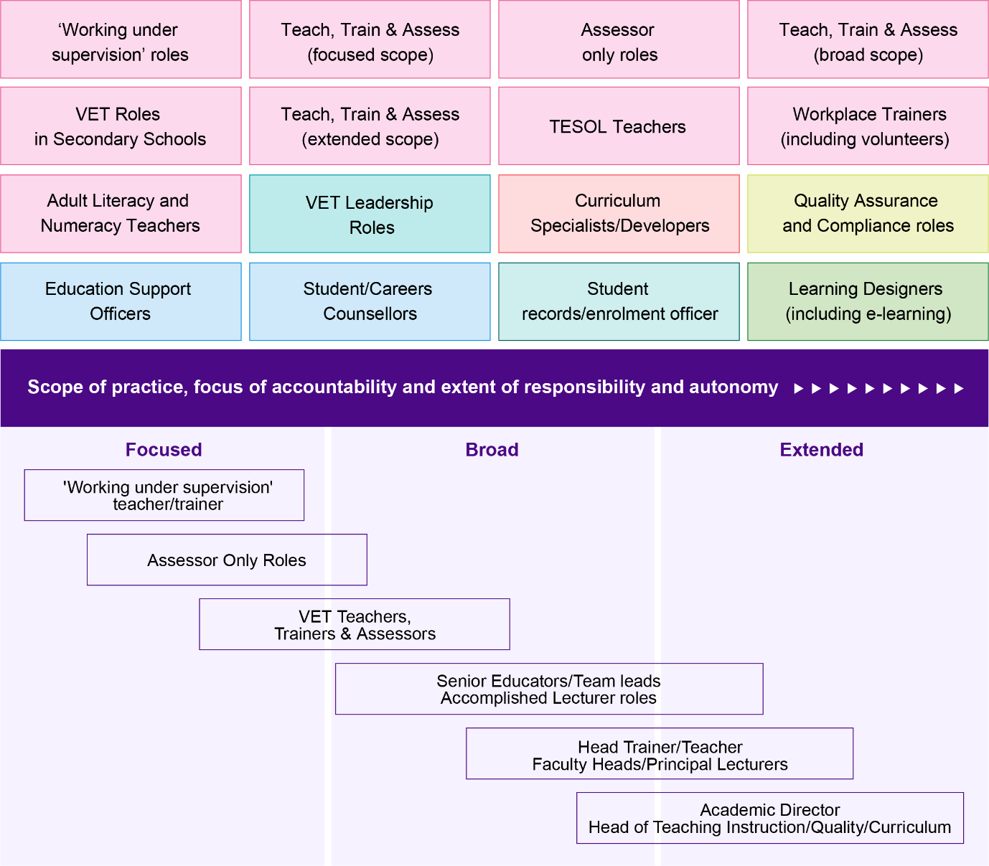

The sector context – workforce implications
VET in Australia is a large and diversified system. Over 4.5 million students were enrolled in VET programs or subjects in 2022, and in 2023 there were 4,088 RTOs delivering training across the country. Students can undertake a range of nationally accredited programs and subjects, including training package qualifications, training package skill sets, accredited qualifications, accredited courses and stand-alone nationally recognised subjects (subject-only enrolments).
This diversity of VET offerings as well as the diverse learning needs of the people enrolled in VET have direct implications for the VET workforce. In this section we introduce the market (both from a provider and student cohort perspective), and regulatory context of VET, including workforce implications. We also touch on some policy context in relation to high enrolments and existing skills shortages, but this is discussed in more detail in Chapter 4.

The market context
Among the thousands of RTO providers are various RTO types including TAFEs, private training providers, schools, dual sector universities, and enterprise and community-based adult education providers. Teaching roles look different in these different types of RTOs.
For example, subject-only enrolments like First Aid and Workplace Safety are delivered mostly in private RTOs. In 2021, NCVER reported that over 90% of this market is provided by the private market and funded on a fee-for-service basis where employers or individuals pay often due to these industry regulatory requirements.
Even though fewer than half (43.6%) of all VET students enrol in qualifications, teachers, trainers and assessors spend more than 80% of their effort (as implied by training delivery hours) delivering qualifications see Figure 1.5.
Figure 1.5 Students enrolled in nationally recognised training, 2022 (%)
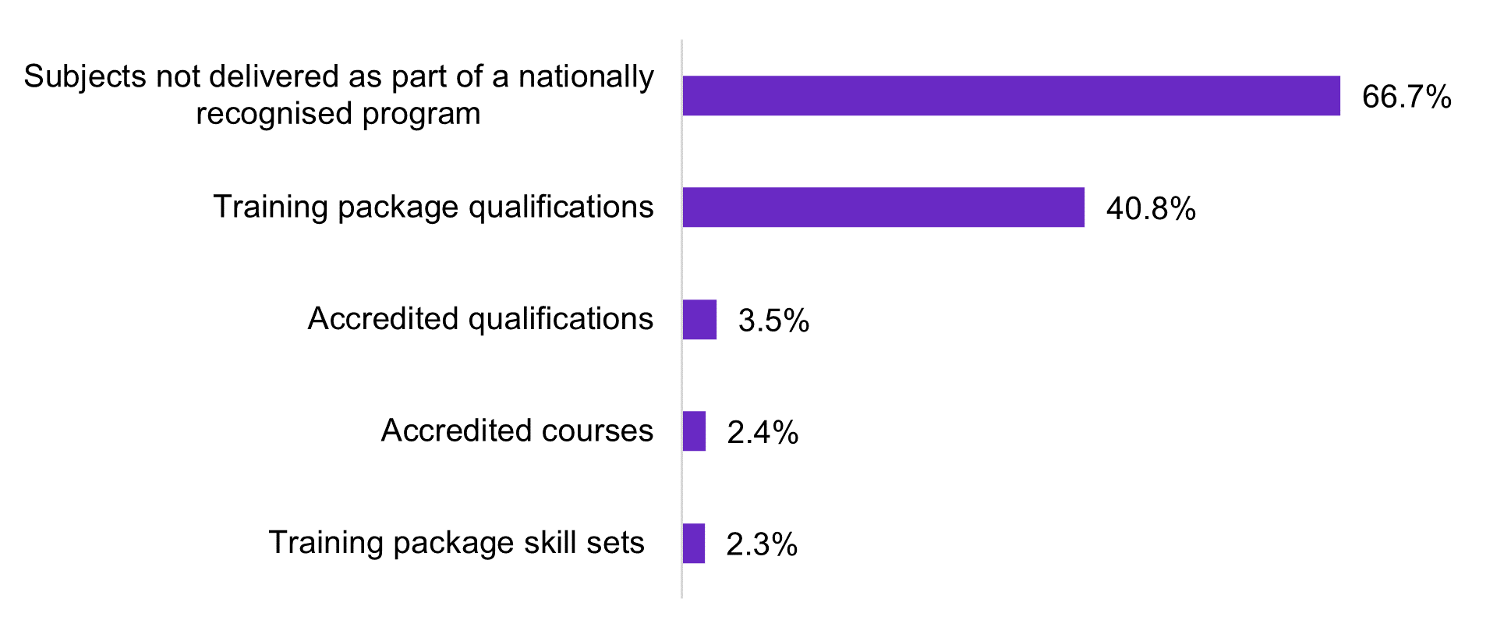
Note: Since some students were enrolled in more than one type of training, percentages sum to more than 100%.
Source: NCVER, Total VET students and courses 2022: Students, Total, Type of training by
Year [DataBuilder] accessed 20 December 2023
Table 1.2 VET reporting hours by type of training, 2022 (millions of hours)
Type of Training | Hours (millions) | % of total hours
Training package qualifications | 643.2 | 77.7
Accredited qualifications | 40.7 | 4.9
Training package skill sets | 5.7 | 0.7
Accredited courses | 5.9 | 0.7
Subjects not delivered as part of a nationally recognised program | 132.4 | 16.0
Totals | 827.8 | 100.0
Source: NCVER, Databuilder, accessed 15 February 2024. Note: Hours of delivery.
Census data also suggest that over two thirds of the VET workforce are employed by public providers and this public provider workforce concentration contrasts with the market proportion of service delivered by that sector – fewer than 3 in 10 programs (29.2%) and a sixth (15.9%) of students.
Certain provider types also have a larger share of the market for certain high enrolment qualifications. For instance:
- private training providers are the predominant providers of the Certificate III in Individual Support and the Certificate III in Early Childhood and Care – critical qualifications for skilling the care economy; and
- TAFEs account for most of the training in the Certificate III in Electrotechnology and Carpentry and both provide the fundamental skills required across a range of roles including in clean energy
More broadly, there is strong alignment between high enrolment qualifications and occupations rated in shortage on the 2023 Skills Priority List (see Table 1.3). This is unsurprising as according to projections produced by Victoria University for JSA, around 44% of new jobs expected to be created over the next 10 years have VET as the primary training pathway. The National Skills Agreement (NSA) and fee-free TAFE initiatives are likely to further increase demand for enrolments in the high-volume qualifications aligned with strong current and future demand.
Government funded training also represents a sizeable portion of the VET market and impacts demand for VET jobs and how they look. On a subject enrolment basis, government funded VET subjects constituted 41% of subject enrolments in 2022. For a summary of the top 10 qualifications by enrolments where most of the VET workforce is engaged in teaching see Table 1.3.
Table 1.3 Top 10 qualifications by number of enrolments, 2022
Program Name | 2022 | Related  Occupation  (ANZSCO) | Skills Priority List 2023 – National Rating
Certificate III in Individual Support | 86,425 | Aged or Disabled  Carer | Shortage
Certificate III in Early Childhood Education and Care | 73,860 | Child Care Worker | Shortage
Certificate III in Business | 71,670 | General Clerk | No Shortage
Certificate III in Carpentry | 55,165 | Carpenter | Shortage
Certificate III in Electrotechnology Electrician | 49,265 | Electrician | Shortage
Certificate IV in Training and Assessment | 39,680 | Vocational Education Teacher | Shortage
Certificate II in Hospitality | 36,500 | Hospitality Workers | No shortage
Certificate III in Fitness | 36,235 | Fitness Instructor Swimming Coach | No shortage Shortage
Diploma of Leadership and Management | 35,615 | Corporate General Manager | No shortage
Certificate II in Skills for Work and Vocational Pathways | 32,025 | N/A | N/A
Note: Table presents combined enrolment figures for qualifications with enrolments across current and superseded versions (e.g. CHC30113 and CHC30121 – Certificate III in Early Childhood Education and Care).
Source: NCVER 2023, Total VET students and courses 2022, Program enrolments, Total, Training package, Program name by Year [DataBuilder], accessed 28 November 2023; training.gov.au; Jobs and Skills Australia, Skills Priority List 2023.
From a student cohort perspective, there is also diversity. The VET cohort ranges from school students to those undertaking their first post-secondary qualification, jobseekers, workers seeking to reskill or upskill, and adults looking for second chance language, literacy, and numeracy training. In doing so, VET delivers a range of supports to the Australian labour market.
Indeed, Government funding and policy influencing student participation in VET, for example through entitlement funding models or interventions to promote uptake by priority cohorts, also has implications for workforce training needs (Atkinson and Stanwick 2016).^{vi} For example, the Fee-Free TAFE initiative implemented by the Australian Government in partnership with state and territory governments, saw places prioritised for a range of priority groups including but not limited to First Nations Australians, young people, and people with disability. The impact of fee-free initiatives on demand have already likely impacted in some jurisdictions.
Where uptake of training by priority groups increases – workforce implications may include increased demand for pedagogical skills in delivering effective training and assessment for these cohorts, and for a workforce capable of providing additional wrap-around supports. This may particularly be the case if change is concentrated in a particular segment of the market, e.g. certain provider types or certain qualifications.
Many VET students also require individualised support for numeracy and literacy, and this impacts the demand for literacy and numeracy teachers. A breakdown of students enrolled in VET by key demographic details is provided in Figure 1.6.
Figure 1.6 VET student demographics (2022)
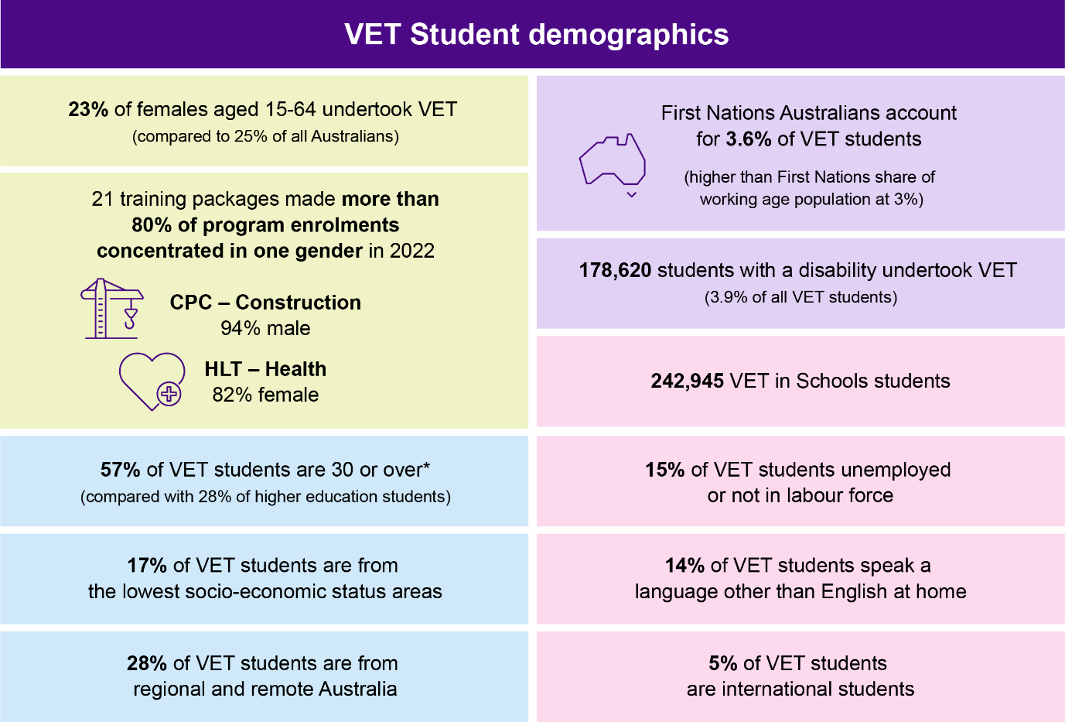
Post-pandemic there has also been a growth in blended delivery and associated decline in VET subjects delivered without any online component. These shifts have workforce implications and require greater digital skills for VET teachers, trainers, and assessors, who are older on average than the workforce as a whole and may have come from an industry background which demanded little digital engagement. There is also increasing demand for e-learning designers and education technologists with skills and experience in planning and delivering quality online learning. This is discussed throughout the report.

Work integrated learning is also increasing in prominence in VET beyond apprenticeships and traineeships, where work-based learning has always been integral. Notwithstanding the benefits of work integrated learning, incorporating work placements into VET programs can add further skills and knowledge requirements (as well as workload) onto staff with respect to coordinating sufficient placements with employers, integrating placement within the course schedule, and assuring the quality of work-based learning.

The regulatory context
The Standards for Registered Training Organisations (RTOs) 2015 (RTO Standards) and the Educational Services (Post-secondary Education) Award 2020 are the two main regulatory instruments in the sector. The RTO Standards set out the requirements for those delivering training and assessment in VET from a competency and qualification perspective. They also set out the requirements to be a training provider and meet training package and accredited course standards. There are also Standards focusing on ensuring consideration of learner’s needs and thus have key workforce implications.
The award outlines and defines key VET workforce roles, qualification credentials and common workforce standards, pay and conditions for the ‘post-secondary educations services industry’. However, the RTO Standards and the award are not the only regulatory instruments in the sector. Some industries have mandatory licensing or other regulatory requirements in high volume subject enrolments like First Aid or Workplace Safety, as a condition of registration or employment. Another example is professional registration requirements including Enrolled Nurses under the Australian Health Practitioner Regulation Agency (AHPRA). Similarly, TESOL and other courses for overseas students are regulated by the National ELT Accreditation Scheme (NEAS). Dual sector institutions are also regulated by both TESQA and ASQA. However, the RTO Standards and the modern award, including the diverse student cohort and provider context, have significant and widespread workforce implications.

Teacher, Trainer and Assessor qualification requirements under the RTO Standards
There are three VET regulators in Australia – the Australian Skills Quality Authority (ASQA) is the national VET regulator, the Victorian Registration and Qualifications Authority (VRQA) and the Western Australian Training and Accreditation Council. All three register and regulate RTOs, that deliver training to domestic students in their respective states or in the case of ASQA nationally, and in VIC and WA if the RTO operates in various states, online or delivers to international students. As VET is a shared responsibility, national standards for the VET sector are agreed by the Australian, and State and Territory Governments and are enabled under the National Vocational Education and Training Regulator Act 2011 (Cth). This is the case in all states except Victoria where the VRQA has their own standards, but these are largely consistent with the RTO Standards. The standards include:
- Standards for Registered Training Organisations (RTOs) 2015 (the RTO Standards);
- Standards for Training Packages;
- Standards for VET Accredited Courses 2021; and
- Standards for VET Regulators.
For the purposes of this study, the RTO Standards specify the requirements for those delivering training and assessment in VET from a competency and qualification perspective. They also set out the requirements to be a training provider and meet training package and accredited course standards. There are also standards focusing on ensuring consideration of learner’s needs and thus have key workforce implications.
Within Part 2 of the RTO Standards, clauses 1.13 to 1.24 specify the requirements for those delivering training and assessment in VET. These standards mandate that training and assessment is delivered only by people who have:
- vocational competencies at least to the level being delivered and assessed;
- current industry skills directly relevant to the training and assessment being provided; and
- current knowledge and skills in vocational training and learning that informs their training and assessment.
The RTO Standards effectively set the Certificate IV in Training and Assessment (TAE) as the minimum teaching and assessment credential for VET, while recognising some alternatives. However, they also give provision for teachers, trainers, and assessors to work under the supervision of a qualified VET teacher. There are also specific skill sets for those who are assessing only. These qualification credentials, including the impact of the recent March 2024 changes to the RTO Standards are discussed in Chapter 3.
Other Clauses in the RTO Standards also set out an RTO’s obligations in implementing, monitoring, and evaluating training and assessment strategies and practices; and engaging with industry. These Clauses focus less on individuals’ qualifications but place the responsibility on the RTO to ensure that collectively the staff of the RTO have the range of capabilities, credentials, and experience to ensure that assessment artefacts and teaching and learning strategies are appropriate. The RTO Standards also outline an RTO’s obligations to learners and clients, and rules about RTO governance and administration, which have more indirect workforce implications as they shape the workplaces VET teachers, trainers and assessors are employed in.

Award Coverage and a default career structure
The Educational Services (Post-Secondary Education) Modern Award 2020, introduced in 2010 created a common workforce standard for the ‘post-secondary educations services industry’, a definition that encompasses:
- VET teaching leading to qualifications recognised within the Australian Qualifications Framework (AQF);
- English language teaching, including to international students and migrants;
- language, literacy and numeracy teaching;
- community and adult education teaching not leading to AQF qualifications; and
- undergraduate and postgraduate teaching leading to higher education degrees, except where taught in a university.

Prior to the commencement of the modern award, employment conditions for the VET workforce employed by TAFE institutes and schools were extensively regulated by their respective awards and enterprise agreements but comparatively less regulation of the VET workforce in other RTO types. The award in effect established a default career structure for VET teachers in the growing private sector, something long called for and elaborated on in this study when introducing our occupational framework.
The award features a classification scale for academic teachers, teachers, and tutor/instructors. This represented a big change when enacted in 2010. For the first time, there was a national classifications standard that required RTOs to consider the qualifications of teaching and training staff when determining their minimum pay.
The award contains two classification structures for teaching and training staff and a separate scale for non-teaching (general) staff. Like the RTO Standards, the award also includes provisions for classifying employees working in teaching, training or assessing roles (the language used in the award is “Academic Teachers” and “Teachers and Tutor/instructors”) based on experience, responsibilities and level of qualifications held. Pay is determined by these variables and whether they are delivering a course of study that is recognised within the AQF. Teachers are employees:
engaged to teach students where a teaching qualification is mandatory or required by the employer, and where the work required involves teaching a course … within or pursuant to the AQF or accredited by a relevant state or territory authority.
Under the award, a ‘tutor/instructor’ is someone engaged to provide tutoring or instruction in a course that is not accredited under the AQF, or by a relevant state or territory authority. Within their classification, teachers and tutors/instructors covered by the award are eligible to move to the next pay point after 12 months service, subject to a satisfactory performance review.
The provisions for General Staff in the Educational Services Award aligns classifications with experience, responsibilities and level of classification but are more indicative, such as providing examples for technical assistant, administrative, and professional roles. This contrasts with higher education where there are two different awards for academic and general staff.
Through the award, teachers, tutors and instructors moving between RTOs have a common basis upon which to have their experience recognised. When implemented, it was expected that in time, the award structure may help to build the occupational identity of the VET workforce and be a prompt for further skills development. Moreover, whilst most of the VET workforce is covered by enterprise agreements, especially in public TAFE providers, award dependence is likely higher in private RTO providers.
The operation of the Better Off Overall Test in enterprise bargaining also means that the classification structure and employment conditions in the award ensure relevance to overall VET workforce pay and conditions, even in RTOs that pay wages above the minimum rates set by the award.

Report structure
This report is organised into 5 chapters that explore different elements of the study.
Chapter 1: The Study provides the study’s purpose, scope and approach including limitations with existing workforce data. It introduces the VET workforce taxonomy and contextualises the market and regulatory context of the sector, highlighting the key workforce implications of both.
Chapter 2: Understanding the workforce profiles the demographic, employment and geographic characteristics of the workforce using the taxonomy as an analytical framework to offer a new understanding of existing VET workforce data. It also includes a national TAFE workforce profile and a case study on dual sector institutions. Through the analysis, we identify the key data gaps in existing workforce data and provide a suite of future workforce data recommendations at the end of the chapter.
Chapter 3: Job Profiles and Pathways introduces the occupational framework and outlines the key training pathways into VET before profiling key and emerging roles in the sector. These job profiles include an analysis of pathways and career progressions between job roles as well as taxonomy segments.
Chapter 4: Demand and Supply Pipelines analyses demand, supply and transitions in and out of the VET workforce. This chapter also explores the training supply pipeline including graduate occupational outcomes and what the future VET workforce might look like. In the workforce transitions section, we look at the job mobility of VET teachers and add a new layer of analysis to the VET teacher skills shortages by identifying which occupations VET teachers come from and move on to. This includes insights on pay increases or decreases that align with these transitions and broader retention and attraction issues at play.
Chapter 5: Key Findings and Next Steps summarises our key findings.

Summary of key findings

The diversity of the VET workforce means different policy levers and workforce strategies are needed.
- Existing VET workforce data is limited and obscures future risk and opportunities for an effective VET system to develop the workforce of the Australian economy.
- The VET workforce taxonomy, job profiles and the initial occupational framework sitting underneath the taxonomy will aid future workforce planning and are aimed at raising the status of VET jobs and their diversity.
- The diversity of VET providers, student cohorts, funding and training offerings has direct implications for the VET workforce. Teaching roles differ across RTOs and need different supports and policy levers. Most teaching effort (by hours) are in training package qualifications and there is strong alignment between these, and occupations rated in skills shortages which has led to high and growing demand for VET teachers.

High demand, low supply and training pipeline issues
- VET teacher numbers have shrunk by between 11-18% over the last decade and training providers are struggling to attract suitable applicants to fill teacher vacancies, with a lower vacancy fill rate than in universities, secondary and primary schools. Projections show Australia will need 3,800 more VET teachers in the next five years.
- The training pipeline is shrinking but is not necessarily impacting supply as drastically as expected. Completions in the key VET teaching qualification (Certificate IV TAE) has fallen by almost 25% since 2016 but almost 70% of graduates are doing the qualification for their existing job.
- Student outcomes survey data shows that only a small proportion of graduates are using the Certificate IV TAE to move into VET teaching roles.
- Migration pathways are infrequently used for VET teachers due to constraints of dual qualifications but there are some visa options available, that could offer a source of supply.

An older and ageing workforce that is lacking diversity, highly casualised and lower paid than their teaching counterparts in other sectors.
- The most distinctive demographic aspect of the workforce is that it is older and ageing. This is even more pronounced for the Teach, Train, and Assess workforce. Almost half of the VET workforce is over 50 years, and the average age is six years older than the Australian workforce average (47 compared to 41). Outside of this, the VET workforce generally reflects the demographic make-up of the wider Australian workforce except on two counts: qualifications and diversity. Future data collection on both is key.
- The VET workforce is more qualified than the Australian workforce but there are key data gaps due to the dual professional status of VET teachers, trainers, and assessors.
- There is a diversity issue in the VET workforce. First Nations peoples and cohorts who speak a Language other than English at home, especially amongst the Teach, Train, and Assess segment is lower than the wider Australian Workforce. This is concerning considering the diversity of the VET student cohort and potential impact on student outcomes. The future VET workforce is also looking less diverse from a training pipeline perspective.
- The VET workforce is more casualised, slightly higher paid and less award dependent than the Australian workforce, but not when compared to their teaching counterparts in other education sectors or industry vocations prominent in VET.
- There is a 16% gender pay gap in VET.
- The VET teaching profession lost more people to other occupations in the eight years leading up to 2018/19 and those that leave to get a pay rise. This presents a challenge for attracting and retaining the VET workforce as prospective teachers must weigh up a teaching role relative to their industry pay and conditions. There is not much career movement in and out of VET teaching, but where there is, it is generally to and from other kinds of teaching, especially Secondary School Teaching. However, there is some evidence of movement within the sector from VET teaching into leadership positions.

The TAFE Workforce has better employment conditions, more diversity and is higher paid.
- It sits at around 40,000 workers, is slightly more feminised, higher paid, more likely to work full-time and older than the broader VET workforce. Over half of the TAFE workforce are teachers and is more diverse in some cases – for example, some TAFEs have a higher proportion of First Nations employees compared to the VET workforce overall. In almost every state and territory, more than half of the VET workforce is aged over 50 years, whereas only 30% of the Australian Workforce is in this age bracket.
- Generally, over 60% of TAFE employees are employed full-time but in NSW there is a higher proportion of casual staff. The 2024 NSW Budget allocated funding to TAFE NSW to support the conversion of 500 casual teachers to permanent employment.
- The dual sector VET workforce is estimated at around 2000 workers nationally and reflects the TAFE workforce profile in demographics and employment conditions.

The biggest data gaps and recommendations for future data collection
- Building a complete workforce profile will require filling key data gaps in industry and teaching qualifications; overall workforce size and demographics; and developing a more nuanced understanding of the diversity of the workforce.
- There are three options recommended and these are not mutually exclusive:
- A regular but minimum collection of data via regulatory bodies such as ASQA;
- The universal implementation of a VET Workforce Standard where RTOs submit workforce data as part of their annual Total VET Activity returns; and/or
- A regular census style survey of RTOs and employees which is piloted systematically, can be extrapolated across the diversity of provider types and includes attitudinal data on why VET teachers leave and what will make them stay.
This study recommends Government considers these options as the basis for more immediate consultation with the sector that balances the imperative for better workforce data, the collection requirements already placed upon RTOs and the funding required to action.

Understanding the workforce
In this chapter we look at the following characteristics of the VET workforce using the study’s taxonomy:
- Demographic characteristics, including sex, age, highest level of education, First Nations status, language other than English spoken at home (LOTE), born overseas and disability status.
- Employment characteristics, including working hours, forms of employment, pay and union membership.
- Geographic characteristics with a focus on state and territory split as well as degree of remoteness.
Like all existing VET workforce data, some of the analysis is illustrative only because of the data limitations outlined in Chapter 1. The demographic and geographical profile of the VET workforce is limited to those workers who identified clearly in the Census that their main job was either a Vocational Education Teacher (ANZSCO) or they worked in the Technical and Vocational Education and Training industry (ANZSIC). While this approach best reflects the characteristics of the VET workforce, it underestimates its size.
Throughout the chapter we also use PLIDA data to provide a contrast and/or reinforcement of workforce counts and demographic trends in Census data. For example, we use data on individuals’ Income Tax Returns from the Australian Taxation Office over the decade from 2011/12 to offer a workforce count. We also use TAFE and dual sector data provided by institutions directly for the study, as further comparisons. The TAFE workforce profile and dual sector institution case study is attached in Appendix B.
We also draw on the 2020 NCVER Research Report: Understanding the Australian Vocational Education and Training Workforce (the NCVER VET Workforce Survey) which is the most considered recent analysis of the workforce. This report demonstrated the challenges in profiling VET: the estimates were based on VET employees at a specific time (February 2019) and collected data directly from RTOs, not individual workers.
In the final section we consider a targeted approach to new data collection, which could begin to address the most critical data gaps, better enabling Australia to plan for a robust VET workforce.

Workforce size, growth, and predominant roles
As Chapter 1 indicated, there are significant issues around measuring the size of the VET workforce. The 2021 Census indicates a workforce size of over 70,000 and PLIDA data indicates a steady workforce size of around 111,000 for the years 2017 to 2021. Whilst both are underestimates and limited in different ways, PLIDA data shows that during a period of rising student demand, over the decade from FY2011/12 to FY2020/2021, the number of VET teachers decreased by 5,214 (18.1%), alongside negligible VET workforce growth of 802 or 0.7%. By contrast, the overall Australian workforce grew by 15.8% (noting large month-to-month swings during the COVID-19 pandemic) – see Figure 2.1.
Census data similarly indicates a decrease in VET Teacher numbers by 10.7% from 2011 to 2021 and a reduction in the VET workforce of 4.6% over the same period.
Figure 2.1 Change in the VET workforce size from FY2011/12 – FY2020/21
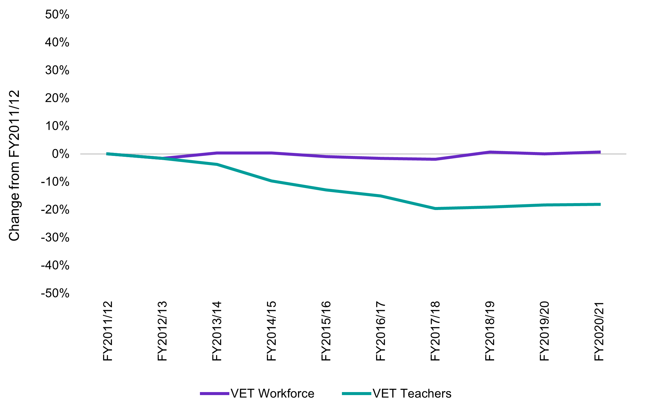
Source: Australian Bureau of Statistics (2023) Microdata: ATO Personal Income Tax (PIT)
(2010-11 – 2020-21) [Datalab]
Over two thirds of the VET workforce are employed by public providers (68.1%), which is higher than a decade ago (64.2%), see Figure 2.2. These workers represent just under half of the VET workforce work in Teach, Train, and Assess roles (48.5%) see Figure 2.3. As noted in Chapter 1, this is consistent with data provided by TAFEs for this study, which indicate that teachers, trainers and assessors typically constitute just over 50% of their workforces. It also aligns with older research by the Productivity Commission in 2011 which estimated 48% of the workforce in VET were ‘Trainers and Assessors’.

Figure 2.2 Count of VET Workforce in public and private sector employment in 2011 and 2021
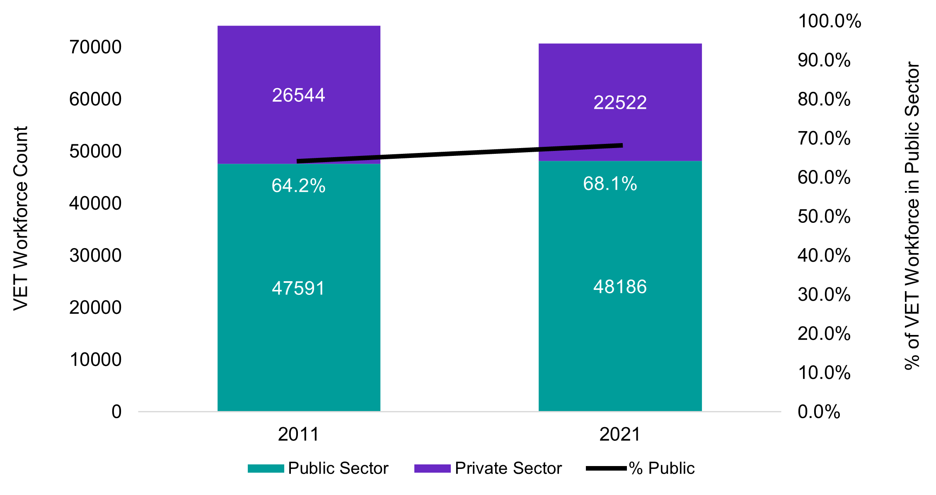
Source: ABS (2021) Occupation (OCCP) and Industry of Employment (INDP) by Sector of Employment (GNGP), [Census TableBuilder] 2021, accessed 25 March 2024.
The 2019 NCVER survey of the workforce provided a lower estimate, reporting that teachers represented just under one third (29%) of the total VET workforce, including those delivering training under supervision (estimated at around 9%). However, NCVER acknowledged that this was likely an underestimation of the VET teaching workforce and that the proportion of the VET workforce made up of teachers, trainers and assessors differs based on provider size.
It reported that for large (1,000 to 9,999 students) and very large (more than 10,000 students) RTOs, these roles constituted 40% and 59% of their workforce respectively, while for medium (100-999 students) and small RTOs (less than 100 students), it was 22% and 20% respectively. This aligns with stakeholder feedback from private and smaller RTOs where the teaching workforce is shared amongst other roles, including executive positions.
As illustrated in Figure 2.3 the next largest segment of the VET workforce is Administration and Operations which makes up 29.0% of the workforce followed by Leadership at 12.8%. Learning Support and Curriculum and Learning Design are smaller segments at 4.3% and 3.6% respectively, though as Chapter 3 demonstrates, job roles in this segment are growing.
The smallest segment is Quality Assurance and Compliance at 0.4% but position descriptions and job profiles in Chapter 3 point to leadership and even some more senior teaching roles in VET having responsibility for some of these regulatory duties. This segment likely constitutes a larger portion of the work than is suggested by roles alone.
Figure 2.3 Share of each VET workforce segment
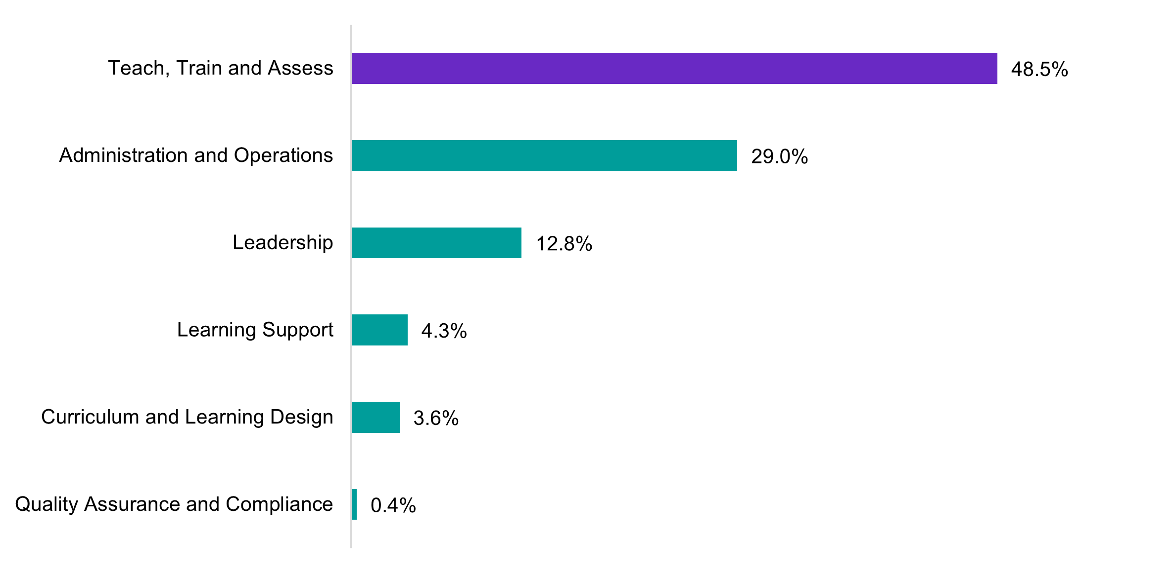
Source: ABS (2021) Occupation (OCCP) and Industry of Employment (INDP) [Census TableBuilder],
accessed 25 March 2024.
The proportions of roles in the VET workforce by state and territory generally mirror the national VET workforce segmentation, except for in the ACT where only 37.0% of the workforce are in Teach, Train, and Assess roles and WA where teaching has the highest percentage of this segment at 56.6%. Public data as well as data collected by WA TAFEs for this study aligns with this Census finding. Victoria and the Northern Territory have larger parts of their workforce in Curriculum and Learning Design (4.1 and 4.4% respectively) than the national figure of 3.6%. NSW, Victoria, and the ACT also have a higher proportion of their workforce concentrated in Leadership.
NSW has the highest proportion of their workforce in Learning Support roles at 5.7%, higher than at national level, which is 4.3%. This could relate to the distinctive classification of Education Support Officer roles in the TAFE NSW enterprise agreement. This is discussed in the employment characteristics section of this chapter and in the next chapter where we profile job roles under each segment and introduce the occupational framework. The territories are outliers in Administration and Operations, with NT having only 17.9% of their workforce in these roles and the ACT having 35.5%, see Table 2.1.
From a traditional ANZSCO framework, the most common occupation in the VET workforce overall was Vocational Education Teacher (21.5%) followed by General Clerk (5.0%). All other occupations represented less than 2.0% of the workforce, including Faculty Head, Teacher of English to Speakers of Other Languages, Training and Development Professional, Program or Project Administrator, Human Resources Manager and Teachers’ Aide.

Table 2.1 State and Territory distribution of VET workforce by segment
 | NSW | Vic | Qld | SA | WA | Tas | NT | ACT
Teach, Train, and Assess | 45.7% | 50.0% | 46.6% | 49.3% | 56.6% | 54.0% | 55.9% | 37.0%
Curriculum and Learning Design | 3.6% | 4.1% | 3.8% | 2.9% | 2.8% | 3.2% | 4.4% | 3.2%
Quality Assurance and Compliance | 0.4% | 0.4% | 0.5% | 0.6% | 0.4% | 0.7% | <0.0% | 0.3%
Leadership | 14.1% | 13.4% | 12.5% | 10.1% | 9.4% | 8.5% | 12.3% | 14.2%
Learning Support | 5.7% | 3.9% | 3.1% | 3.2% | 3.2% | 4.3% | 1.7% | 4.3%
Administration and Operations | 28.6% | 26.4% | 30.8% | 30.1% | 24.6% | 25.0% | 17.9% | 35.5%
Source: ABS (2021) Occupation (OCCP) and Industry of Employment (INDP) by State/Territory (STATE [UR]). [Census TableBuilder], accessed 25 March 2024.

Demographic characteristics
The most distinctive demographic aspect of the VET workforce, especially the Teach, Train and Assess segment of the workforce, is that it is older and ageing. Almost half of the VET workforce is over 50 years, and the average age is seven years older than the Australian workforce average (47 compared to 40).
Outside of this, the VET workforce reflects the demographic make-up of the wider Australian workforce with only slight variations. For example, VET is only slightly more feminised and slightly less culturally diverse that the wider Australian workforce. A similar percentage of the VET workforce is born overseas as the Australian workforce (approximately one third), but it lacks diversity from a language other than English spoken at home (LOTE) perspective.
This lack of diversity is more pronounced in the Teach, Train, and Assess segment of the VET workforce, which is notable considering the diversity of the VET student cohort. Indeed, the most interesting insights in the demographic profile of the VET workforce below are those by segment. For example, the Learning Support segment has the highest proportion of females and First Nations workers (over 75.0% female and 6.0% First Nations) see Table 2.2. We draw out further segment insights throughout this chapter.
The VET workforce further aligns with Australian workforce averages in long term health conditions and the need for assistance with core activities (the best indicator of disability status in the Census) but does vary from the Australian workforce when it comes to highest level of education. Almost half of the VET workforce has a Bachelor degree in contrast to just over one third of the broader Australian workforce.
This higher level of education likely relates to the dual professional status of VET teachers and highlights the unique data gap of the VET workforce’s dual qualifications in both vocational and adult education teaching qualifications. Table 2.2 summarises the demographic profile of the VET workforce, Australian workforce and each taxonomy segment.
Table 2.2 Key demographic characteristics
 | Female | Average Age | First  Nations | Born Overseas | LOTE  at home
VET Workforce | 57.2% | 47.3 | 2.1% | 33.0% | 20.5%
Teach, Train, and Assess | 51.1% | 48.1 | 1.8% | 31.4% | 18.2%
Curriculum and Learning Design | 61.7% | 45.3 | 2.3% | 29.9% | 16.8%
Quality Assurance and Compliance | 70.4% | 39.4 | <0.1% | 35.5% | 19.9%
Leadership | 56.6% | 46.2 | 1.8% | 34.7% | 20.4%
Learning Support | 76.4% | 41.9 | 6.0% | 30.2% | 21.7%
Administration and Operations | 64.6% | 35.7 | 2.0% | 35.7% | 24.5%
Australian Workforce | 48.5% | 40.1 | 2.2% | 32.4% | 23.4%
Source: ABS (2021) Occupation (OCCP) and Industry of Employment (INDP) and Labour Force Status (LFSP) by Sex (SEXP), Age (AGEP), Indigenous Status (INGP), County of Birth (BPLP) and Language Used at Home (LANP), [Census TableBuilder], accessed 25 March 2024.

Gender
Based on 2011, 2016 and 2021 Census data, the VET workforce is made up of more females and this has not varied greatly over the last 13 years. Overall, 58.0% of the VET workforce are female.
In contrast, PLIDA data over the decade between 2010/11-2020/21 indicates a slightly lower proportion of females in the workforce but has steadily grown from 49.6% in 2010/11 to 53.0% in 2015/16 to 54.1% in 2020/21, see Figure 2.4.
Figure 2.4 Count of VET workforce by gender, 2010/2011 - 2020/21 with percentage female
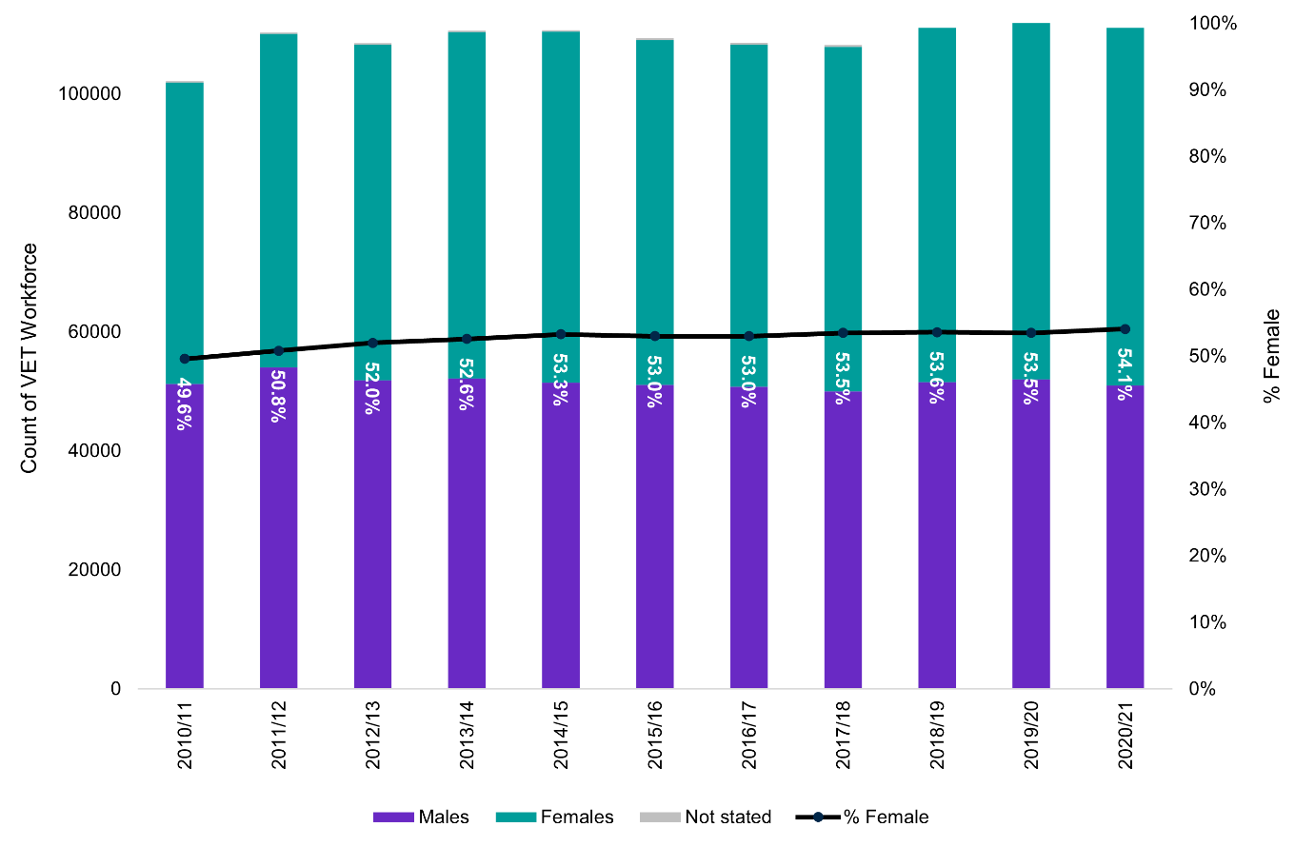
Source: ABS (2023) Microdata: Personal Income Tax Return [Datalab] accessed 1 December 2023
When focusing on the Teach, Train, and Assess segment of the workforce, the distribution of the workforce is more even at 51.1% females. PLIDA data confirms this, showing an even sex distribution amongst VET teachers.
Females make up an even higher majority of workers in the other segments: Learning Support (76.4%); Quality Assurance and Compliance (70.4%); Administration and Operations (64.6%), and Curriculum and Learning Design (61.7%). However, the sex distribution of the Leadership segment reflects the overall VET workforce sex split at 56.6%, see Table 2.2. This is positive and contrasts with other education sectors, where despite a more feminised workforce, management and leadership are more dominated by males. For example, the 2020 Australian teacher workforce Census reported that females made up 76.0% of the registered teacher workforce but 69.0% of senior leader positions.

Age
VET workforce studies have long observed that the sector has an older than average workforce (see⁻). 2021 Census data indicates that the average age of the VET workforce was 47.3, with 46.5% 50 years and over (see Figure 2.5). This is higher than the Australian workforce where the average age is 40.1, and 20.2% are 50 years and older. In the three Census years from 2011 to 2021, the average of the VET workforce has increased by 1.3 years from 46.0 to 47.3 years. This compares with the Australian workforce average overall which got younger (40.3 to 40.1 years).
Figure 2.5 Proportions of ages in the VET and Australian Workforces (2021)

 | <30 | 30-39 | 40-49 | 50-59 | 60-69 | 70+
VET Workforce | 9.7% | 19.4% | 24.4% | 27.3% | 16.9% | 2.3%
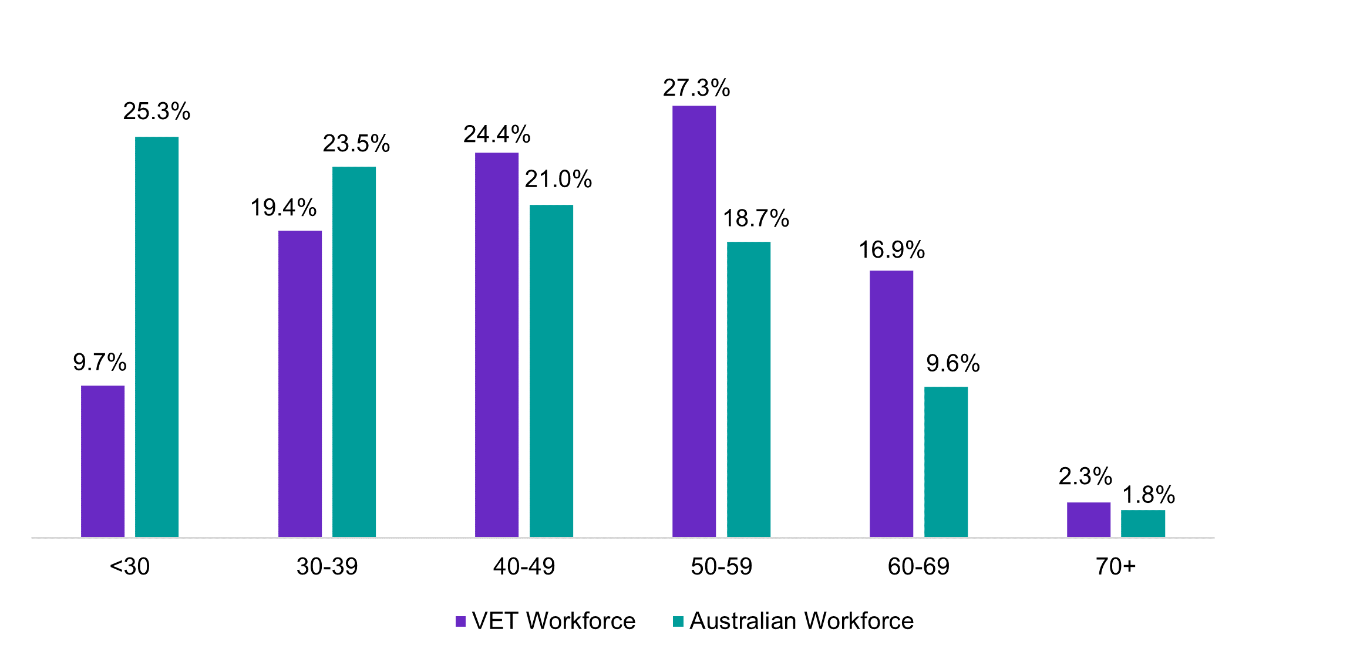  Australian Workforce | 25.3% | 23.5% | 21.0% | 18.7% | 9.6% | 1.8%

Source: ABS (2021) Labour Force Status, Occupation (OCCP) and Industry of Employment (INDP) by Age (AGE5P), [Census TableBuilder], accessed 9 April 2024. Note: Proportions do not sum to 100% due to ABS data perturbation.
Both PLIDA and Census data show that VET teachers are typically older than the wider VET workforce. In PLIDA data the average age of VET teachers was 48.9 years in 2020/21 (see Figure 2.6). According to Census data, the Teach, Train, and Assess segment of the workforce is the most mature with the average age of 48.1 years, followed by Leadership at 46.2 years and Learning Support at 41.9 years. Administration and Operations is the youngest segment with an average age of 35.7 years.
One possible explanation for the older teaching workforce is that VET teachers typically have industry careers and experience before entering VET. Consistent with this, students undertaking TAE at the Certificate IV and Diploma levels are generally older than students undertaking those qualification levels overall. We elaborate on this in Chapter 4.
The VET workforce in public providers skews older than that in private providers. In terms of teaching staff, 58.3% of VET teachers (ANZSCO Vocational Education Teachers) employed in public providers are over 50 years old, compared to 48.7% in private providers. Census data also indicates an average age of 51.2 years for VET teachers in public providers and 48.3 years for private providers. This is in line with previous research that suggests teaching staff in non-TAFE RTOs are generally younger.

It also aligns with comments made by RTOs in 2023 focus groups run by NCVER:
Ten years ago, the age of our trade trainers in VET was probably 50 and above...
This has changed so much. Now we have younger [trainers] coming in who are in their mid-30s to 40s. They love their trade job but want to do something different and see training as a career path. But they will not stay unless they want to.
(Private RTO delivering VfSS).
However, in the larger TAFE institutes:
We still have an ageing workforce, which presents challenges, and a highly casualised teaching workforce which we are working to give more certainty to (TAFE institute).
TAFE data collated by JSA reinforces these insights showing more than half of the workforce for every TAFE across the country is over 50 years old. Data provided by the Victorian Public Sector Commission shows that for TAFE Victoria at least, certain industry and operational areas also have a high percentage of teachers aged 55 and older, especially amongst building and engineering trades, adult community education and automotive, see Figure 2.6. Transport & Storage also had a very high percentage of teachers 55 and over, though from a very small sample. Fields of study with the lowest percentage of teachers aged 55 and older were in more feminised sectors of Wholesale, Retail & Personal Services (22%) and Community Services & Health (32%) where the pay for becoming a VET teacher is generally higher than in industry vocations.
Figure 2.6 Proportion of VET teachers aged 55 years and older across industry areas
in Victorian TAFE institutes
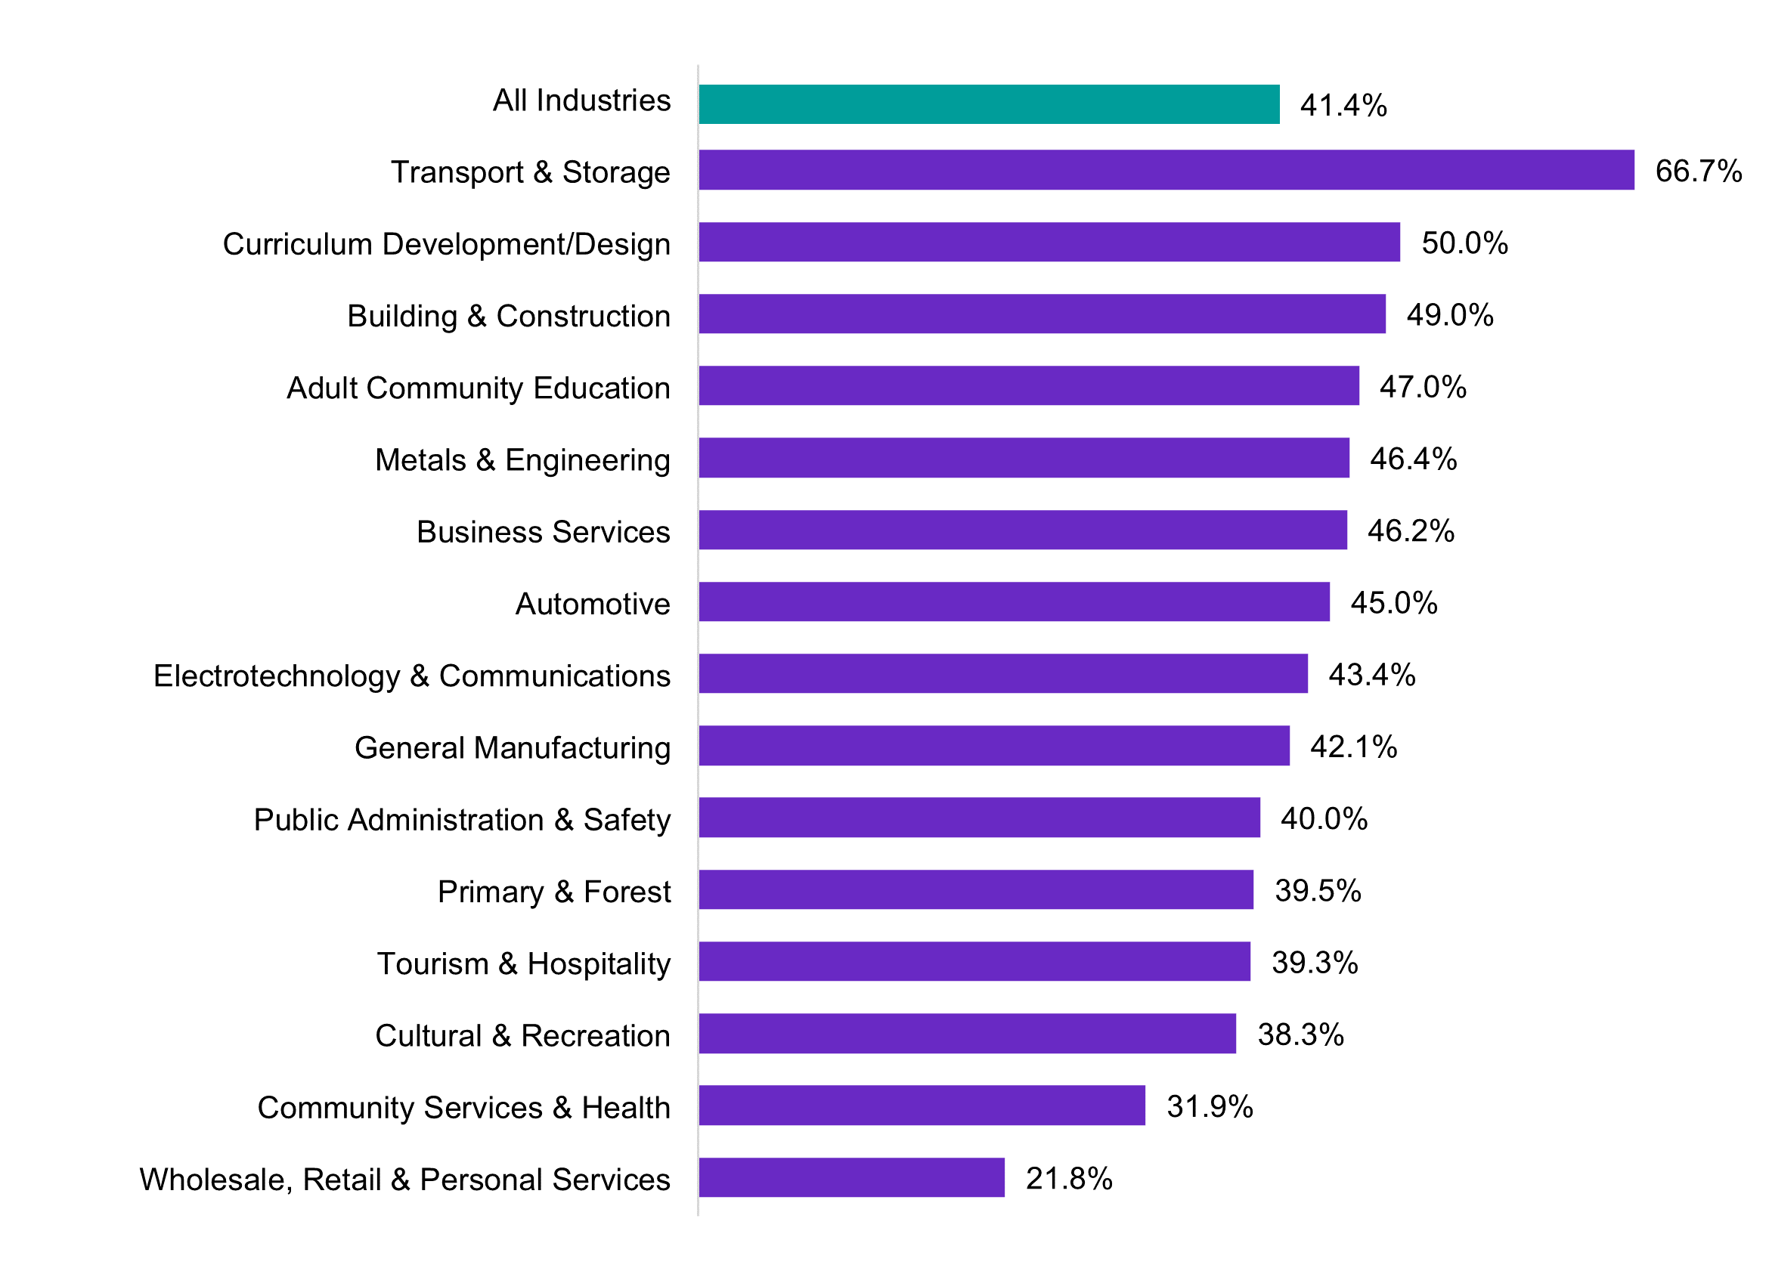
Source: Supplied by the Victorian Public Service Commission.

Highest level of education
The VET workforce has a higher level of education than the wider Australian workforce. Almost half (49.4%) of the VET workforce holds a Bachelor’s degree or higher, compared to 35.4% of the Australian workforce (see Figure 2.7). The level of qualifications differ across the VET workforce segments, though these align to expectations. The Curriculum and Learning Design and Leadership segments of the VET workforce have larger proportions of workers with higher education (undergraduate and above) qualifications than the VET workforce itself (57.1% and 63.6% respectively).
The Administration and Operations segment has the lowest proportion of workers with an undergraduate or above qualification (39.1%), but this is still higher the Australian workforce. The remaining segments each have a similar proportion of higher education ranging from 51.5%-52.7%.
74.2% of the teaching segment of the VET workforce holds qualifications at Diploma or above. These Diploma or higher-level qualifications include both education and industry qualifications: this is a key limitation of Census data when analysing the VET workforce. In short, by asking about ‘highest’ educational level achieved, the Census does not capture the dual qualifications of many VET professionals.
Of the VET teachers holding a qualification at Diploma level or higher, the field of their highest qualification is often education related (35.9%), including around 4.8% that can be identified as Adult Education (Teacher Education: Vocational Education and Training (3.4%), English as a Second Language Teaching (0.9%), Teacher Education: Higher Education (0.4%) and Nursing Education Teacher Training (0.1%).
Outside of the Education fields, the most common is a combined 7.8% across Business and Management NFD, Business Management and Business and Management NEC. Other fields are small (below 3.0%) and widely distributed.
The 2019 NCVER survey did collect (limited) separate information on trainers’ and assessors’ teaching and industry qualifications. It found that 77.1% of trainers and assessors held a Certificate IV TAE as their highest teaching qualification and 16.2% of trainers and assessors had a diploma or higher-level teaching qualification, whereas 37.6% held Diploma level or higher qualifications related to vocational competence in their field or industry of expertise. This, combined with the wide distribution of small fields of education in Census, implies that many of the diploma or higher-level qualifications held by VET teachers in Census data are from their vocational qualification.

Figure 2.7 Highest qualification in VET segments, and VET and Australian workforce

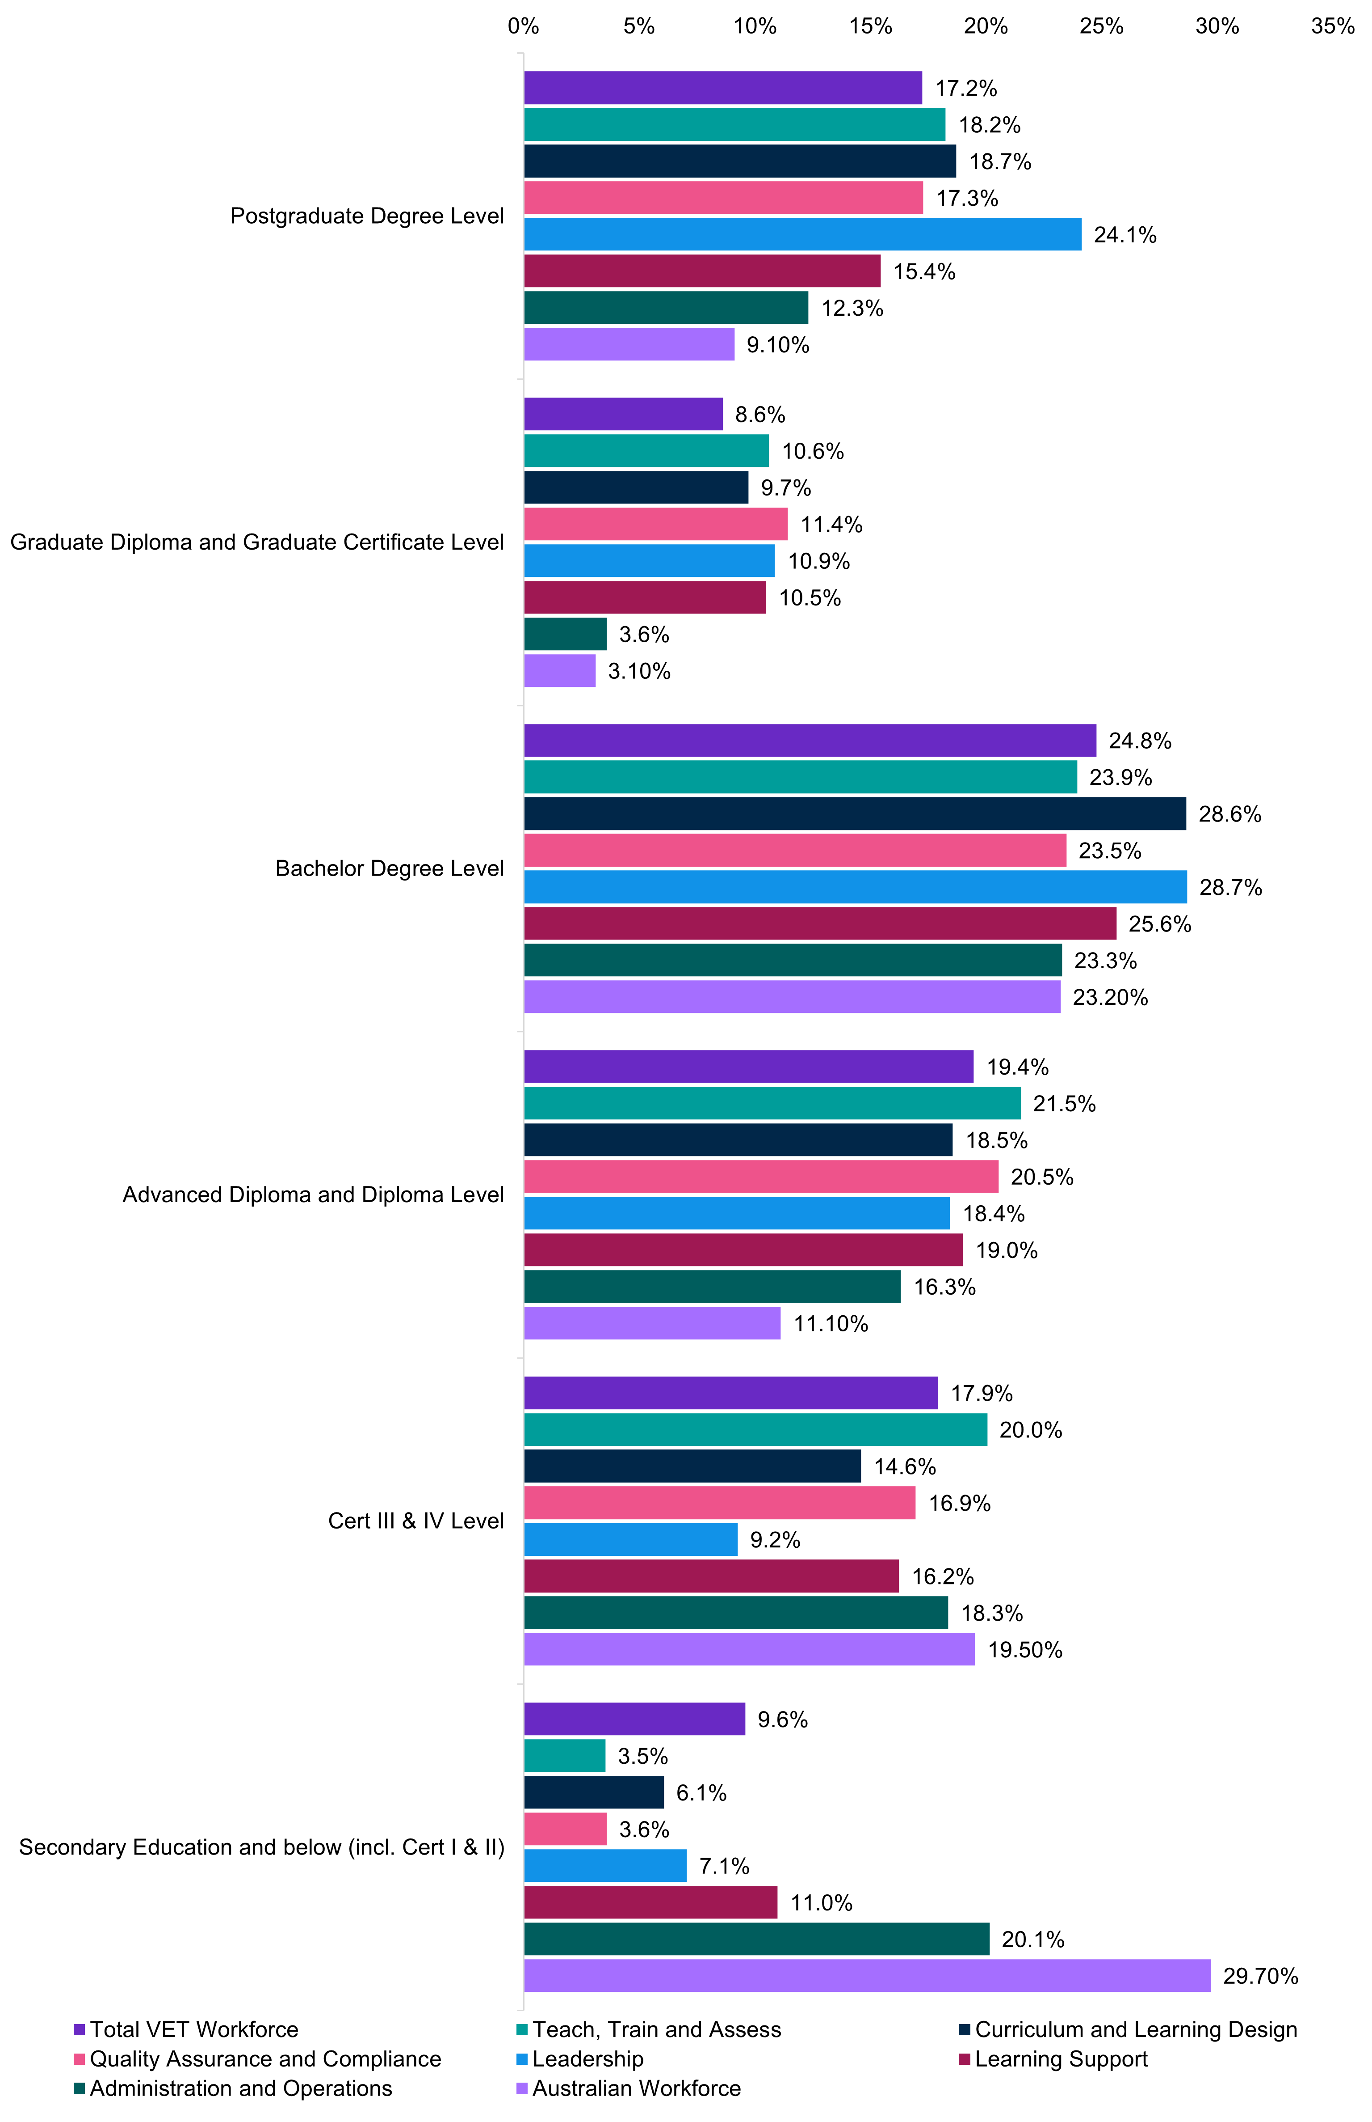 | Postgraduate Degree Level | Graduate Diploma and Graduate Certificate Level | Bachelor Degree Level | Advanced Diploma and Diploma Level | Cert III & IV Level | Secondary Education and below (incl. Cert I & II)
Total VET Workforce | 17.2% | 8.6% | 24.8% | 19.4% | 17.9% | 9.6%
Teach, Train, and Assess | 18.2% | 10.6% | 23.9% | 21.5% | 20.0% | 3.5%
Curriculum and Learning Design | 18.7% | 9.7% | 28.6% | 18.5% | 14.6% | 6.1%
Quality Assurance and Compliance | 17.3% | 11.4% | 23.5% | 20.5% | 16.9% | 3.6%
Leadership | 24.1% | 10.9% | 28.7% | 18.4% | 9.2% | 7.1%
Learning Support | 15.4% | 10.5% | 25.6% | 19.0% | 16.2% | 11.0%
Administration and Operations | 12.3% | 3.6% | 23.3% | 16.3% | 18.3% | 20.1%
Australian Workforce | 9.10% | 3.10% | 23.20% | 11.10% | 19.50% | 29.70%

Source: ABS (2021) Labour Force Status (LFSP), Occupation (OCCP) and Industry of Employment (INDP) by Level of Highest Educational Attainment (HEAP), [Census TableBuilder], accessed 25 March 2024. Due to non-stated responses, not all categories equal 100%.
NCVER also found that public sector VET teachers had higher rates of teaching qualifications than teachers at independent/private RTOs at both the Certificate IV TAE and diploma or higher qualification level (NCVER 2020). For example, 19.3% of teachers in TAFE held a diploma or higher teaching qualification compared to 15.0% in private/independent RTOs. More recent data provided by TAFE Victoria for this study shows Victorian TAFE employees are an even more highly qualified workforce, with 33.1% holding a diploma and above as their teaching qualification and 60.4% holding the Certificate IV TAE.
Figure 2.8 shows, across all levels of qualifications, 35.7% of Vocational Education Teachers reported their field of study is Education, and remaining fields are spread across other industries that align with some of the common qualifications. Later in the chapter, we highlight the need for any future data collection to prioritise mapping and understanding the VET workforce need for dual vocational and educational competencies and qualifications.
Figure 2.8 Vocational Education Teachers' field of study of highest qualification
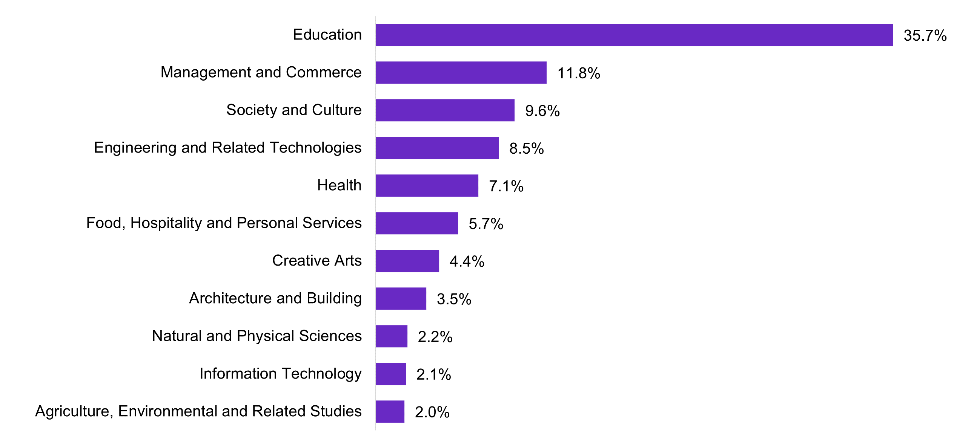
Source: ABS (2021) Occupation (OCCP) and Industry of Employment (INDP) by Field of Study of Non-School Qualification (QALFP), [Census TableBuilder], accessed 20 December 2023. Note: Does not sum to 100% due to non-stated responses.

Born Overseas and language other than English spoken at home
Around 33.0% of the VET workforce was born overseas, like 32.4% of the Australian workforce. The highest proportions are from North-West Europe (8.3%) and Southern and Central Asia (6.3%). By VET workforce segment, the highest proportion of workers born overseas is in Administration and Operations (35.7%), followed by Quality Assurance and Compliance (35.5%), with the Leadership segment (34.7%) also higher than the general Australian workforce. The lowest proportions are in Curriculum and Learning Design (29.9%) and Learning Support (30.2%), with the Teach, Train, and Assess segment (31.4%) also lower than the general Australian workforce (see Table 2.2).
Compared to the wider economy where 10.9% of the workforce arrived from overseas in the decade 2011-2021, only 8.0% of the VET workforce migrated to Australia in that same period. The VET workforce is less likely to speak a language other than English at home (20.5% compared to Australian workforce proportion at 23.4%). The lowest proportions are in those most heavily connected to teaching: Curriculum Development and Learning Design at 16.8% and the Teach, Train, and Assessment segment at 18.2% while the Administration and Operations segment is a little more likely to speak a language other than English at home (24.5%).

First Nations
2021 Census data indicates that 2.1% of the VET workforce identifies as First Nations and only 1.8% in the Teach, Train, and Assess segment. Both are lower than the wider Australian workforce where 2.2% of workers identify as First Nations. A lower proportion of Secondary school teachers identify as First Nations (1.2%) compared to VET teachers. Only the Curriculum and Learning Design (2.3%) and Learning Support (6.0%) segments report a higher proportion of First Nations staff than either the total VET workforce or the Australian workforce figures.
The inclusion of all Aboriginal and Torres Strait Islander Educator Workers in the overall VET workforce in the Learning Support segment may explain this higher First Nations representation. Other segments are below the overall Australian or VET workforce average, most notably the Quality and Compliance segment which shows no First Nations workers at all. By contrast, PLIDA data shows that First Nations peoples make up 3.1% of the VET workforce in 2020/21. JSA does not currently have First Nations PLIDA data at Australian workforce level for comparison.
The VET teaching segment shows a slightly lower but steady First Nations cohort over the decade from 2010/11 growing from 2.0% to 2.3% in 2020/21 (see Figure 2.9), still higher than the Australian workforce at 2.2%, and on par with the Australian Labour Force overall at 2.3%.
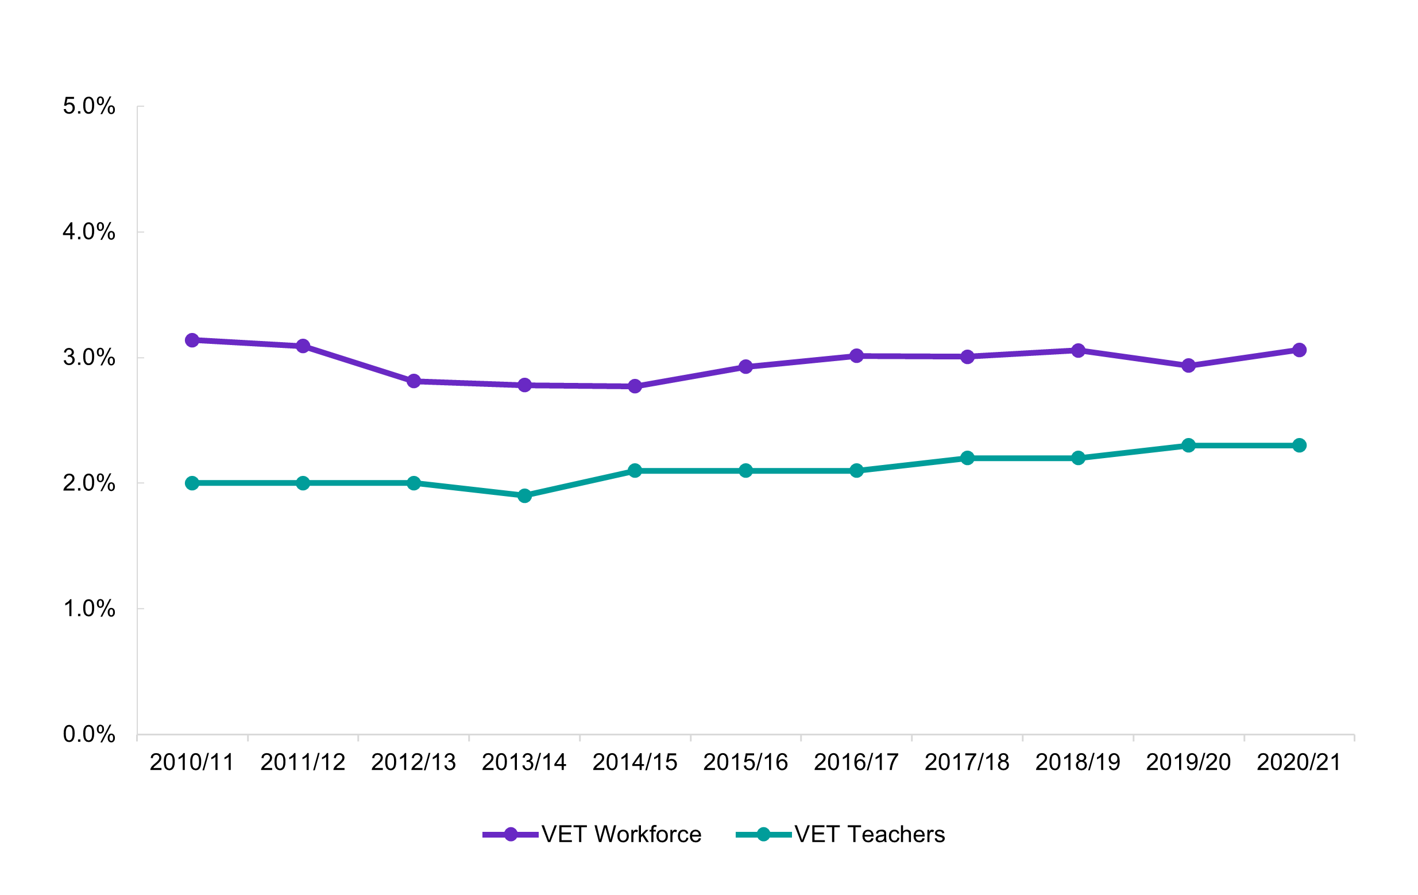
Figure 2.9 Proportion of First Nations VET teachers and workforce between 2010/11-2020/21
VET Workforce | Number of VET teachers | Non-Indigenous | First Nations | First Nations | Non-Indigenous
2010/11 | 102181 | 98974 | 3207 | 3.1% | 96.9%
2011/12 | 110340 | 106930 | 3410 | 3.1% | 96.9%
2012/13 | 108549 | 105496 | 3053 | 2.8% | 97.2%
2013/14 | 110651 | 107575 | 3076 | 2.8% | 97.2%
2014/15 | 110729 | 107660 | 3069 | 2.8% | 97.2%
2015/16 | 109396 | 106194 | 3202 | 2.9% | 97.1%
2016/17 | 108616 | 105343 | 3273 | 3.0% | 97.0%
2017/18 | 108251 | 104996 | 3255 | 3.0% | 97.0%
2018/19 | 111100 | 107704 | 3396 | 3.1% | 96.9%
2019/20 | 111872 | 108588 | 3284 | 2.9% | 97.1%
2020/21 | 111142 | 107739 | 3402 | 3.1% | 96.9%

VET teachers | Number of VET teachers | Non-Indigenous | First Nations | First Nations | Non-Indigenous
2010/11 | 29492 | 28914 | 578 | 2.0% | 98.0%
2011/12 | 29523 | 28944 | 579 | 2.0% | 98.0%
2012/13 | 28984 | 28415 | 569 | 2.0% | 98.0%
2013/14 | 28410 | 27856 | 544 | 1.9% | 98.0%
2014/15 | 26644 | 26091 | 553 | 2.1% | 97.9%
2015/16 | 25663 | 25122 | 541 | 2.1% | 97.9%
2016/17 | 24923 | 24388 | 535 | 2.1% | 97.9%
2017/18 | 23742 | 23229 | 513 | 2.2% | 97.8%
2018/19 | 23854 | 23320 | 534 | 2.2% | 97.8%
2019/20 | 23834 | 23284 | 550 | 2.3% | 97.7%
2020/21 | 23799 | 23246 | 553 | 2.3% | 97.7%

Source: ABS (2023) Microdata: Personal Income Tax Return [Datalab] accessed 1 December 2023

Disability
This report is unable to directly estimate the proportion of the VET workforce that is with disability due to limitations in how Census collects this data, but Table 2.3 does show the proportion of the workforce with one or more long-term health conditions. This proportion is a significant overestimate of disability compared to the ABS Disability, Ageing and Carers survey which shows 8.0% of the Australian workforce with disability (ABS 2019). Table 2.3 also shows the proportion requiring assistance with core activities, which is a significant underestimate of disability compared to the same survey.
The TAFE workforce profile shows that the number of TAFE workers reporting that they live with a disability is generally around 3% which is also lower than the comparable ABS disability, ageing and carers survey.
By contrast, people with a disability are more likely than the general population to hold a Certificate III/IV (27.1% compared to 20.6%) and much less likely than the general population to hold a Bachelor degree or above (18.4% compared to 32.8%), indicating greater reliance on VET for educational attainment.
Table 2.3 VET workforce – people with long-term health conditions or need for assistance with core activities 2021 (% of segment)
Workforce Segment | Long-term  health  condition | Need for  assistance with  core activities
VET Workforce | 36.0% | 1.2%
Teach, Train, and Assess | 38.1% | 1.3%
Curriculum and Learning Design | 37.9% | 1.0%
Quality Assurance and Compliance | 39.7% | 1.0%
Leadership | 32.9% | 0.9%
Learning Support | 41.7% | 1.7%
Administration and Operations | 32.4% | 1.0%
Australian Workforce | 36.0% | 1.2%
Source: ABS (2021) Labour Force Status (LFSP) and Occupation (OCCP) and Industry of Employment (INDP) by whether one has one or more Long-Term Health Condition(s) (HLTHP) and Need for Assistance with Core Activities (ASSNP) [Census TableBuilder], accessed 25 March 2024.

Geographic characteristics
The VET workforce has a similar geographic profile to the Australian workforce. Most of the VET workforce live in major cities (74.8%), with slightly more VET workers in inner regional Australia compared to the Australian workforce (17.5% compared to 16.7%). The VET workforce in outer regional, remote or very remote Australia is slightly lower than the Australian workforce, see Table 2.4.
The combined proportion of Learning Support (32.3%) and Teach, Train, and Assess (27.2%) workers outside major cities is higher than the Australian workforce (26.1%). In remote and very remote Australia, while the Learning Support segment (1.6%) almost matches the Australian workforce (1.7%), the Teach, Train, and Assess segment falls behind (1.3%).
Outside major cities, the Leadership segment has the lowest proportion of workers (a combined 20.6%), followed by Administration and Operations (combined 21.6%). These geographic skews, particularly in remote areas, may indicate that workers in teaching and learning support roles could benefit from improved leadership and administrative support.

Table 2.4 Proportion of workforces in remoteness areas
Workforce Segment | Major Cities  of Australia | Inner  Regional Australia | Outer Regional Australia | Remote  and Very Remote Australia
VET Workforce | 74.8% | 17.5% | 6.4% | 1.2%
Teach, Train, and Assess | 72.6% | 19.0% | 6.9% | 1.3%
Curriculum and Learning Design | 75.9% | 16.7% | 5.6% | 1.1%
Quality Assurance and Compliance | 72.6% | 20.2% | 4.2% | <0.0%
Leadership | 79.2% | 15.0% | 4.9% | 0.7%
Learning Support | 67.8% | 24.2% | 6.5% | 1.6%
Administration and Operations | 77.2% | 15.1% | 5.7% | 0.8%
Australian Workforce | 73.9% | 16.7% | 7.7% | 1.7%
Source: ABS (2021) Labour Force Status (LFSP) and Occupation (OCCP) and Industry of Employment (INDP) by Remoteness Areas (National) (UR), [Census TableBuilder], accessed 25 March 2024.

Figure 2.10 Proportion VET workforce and Australian workforce by state/territory
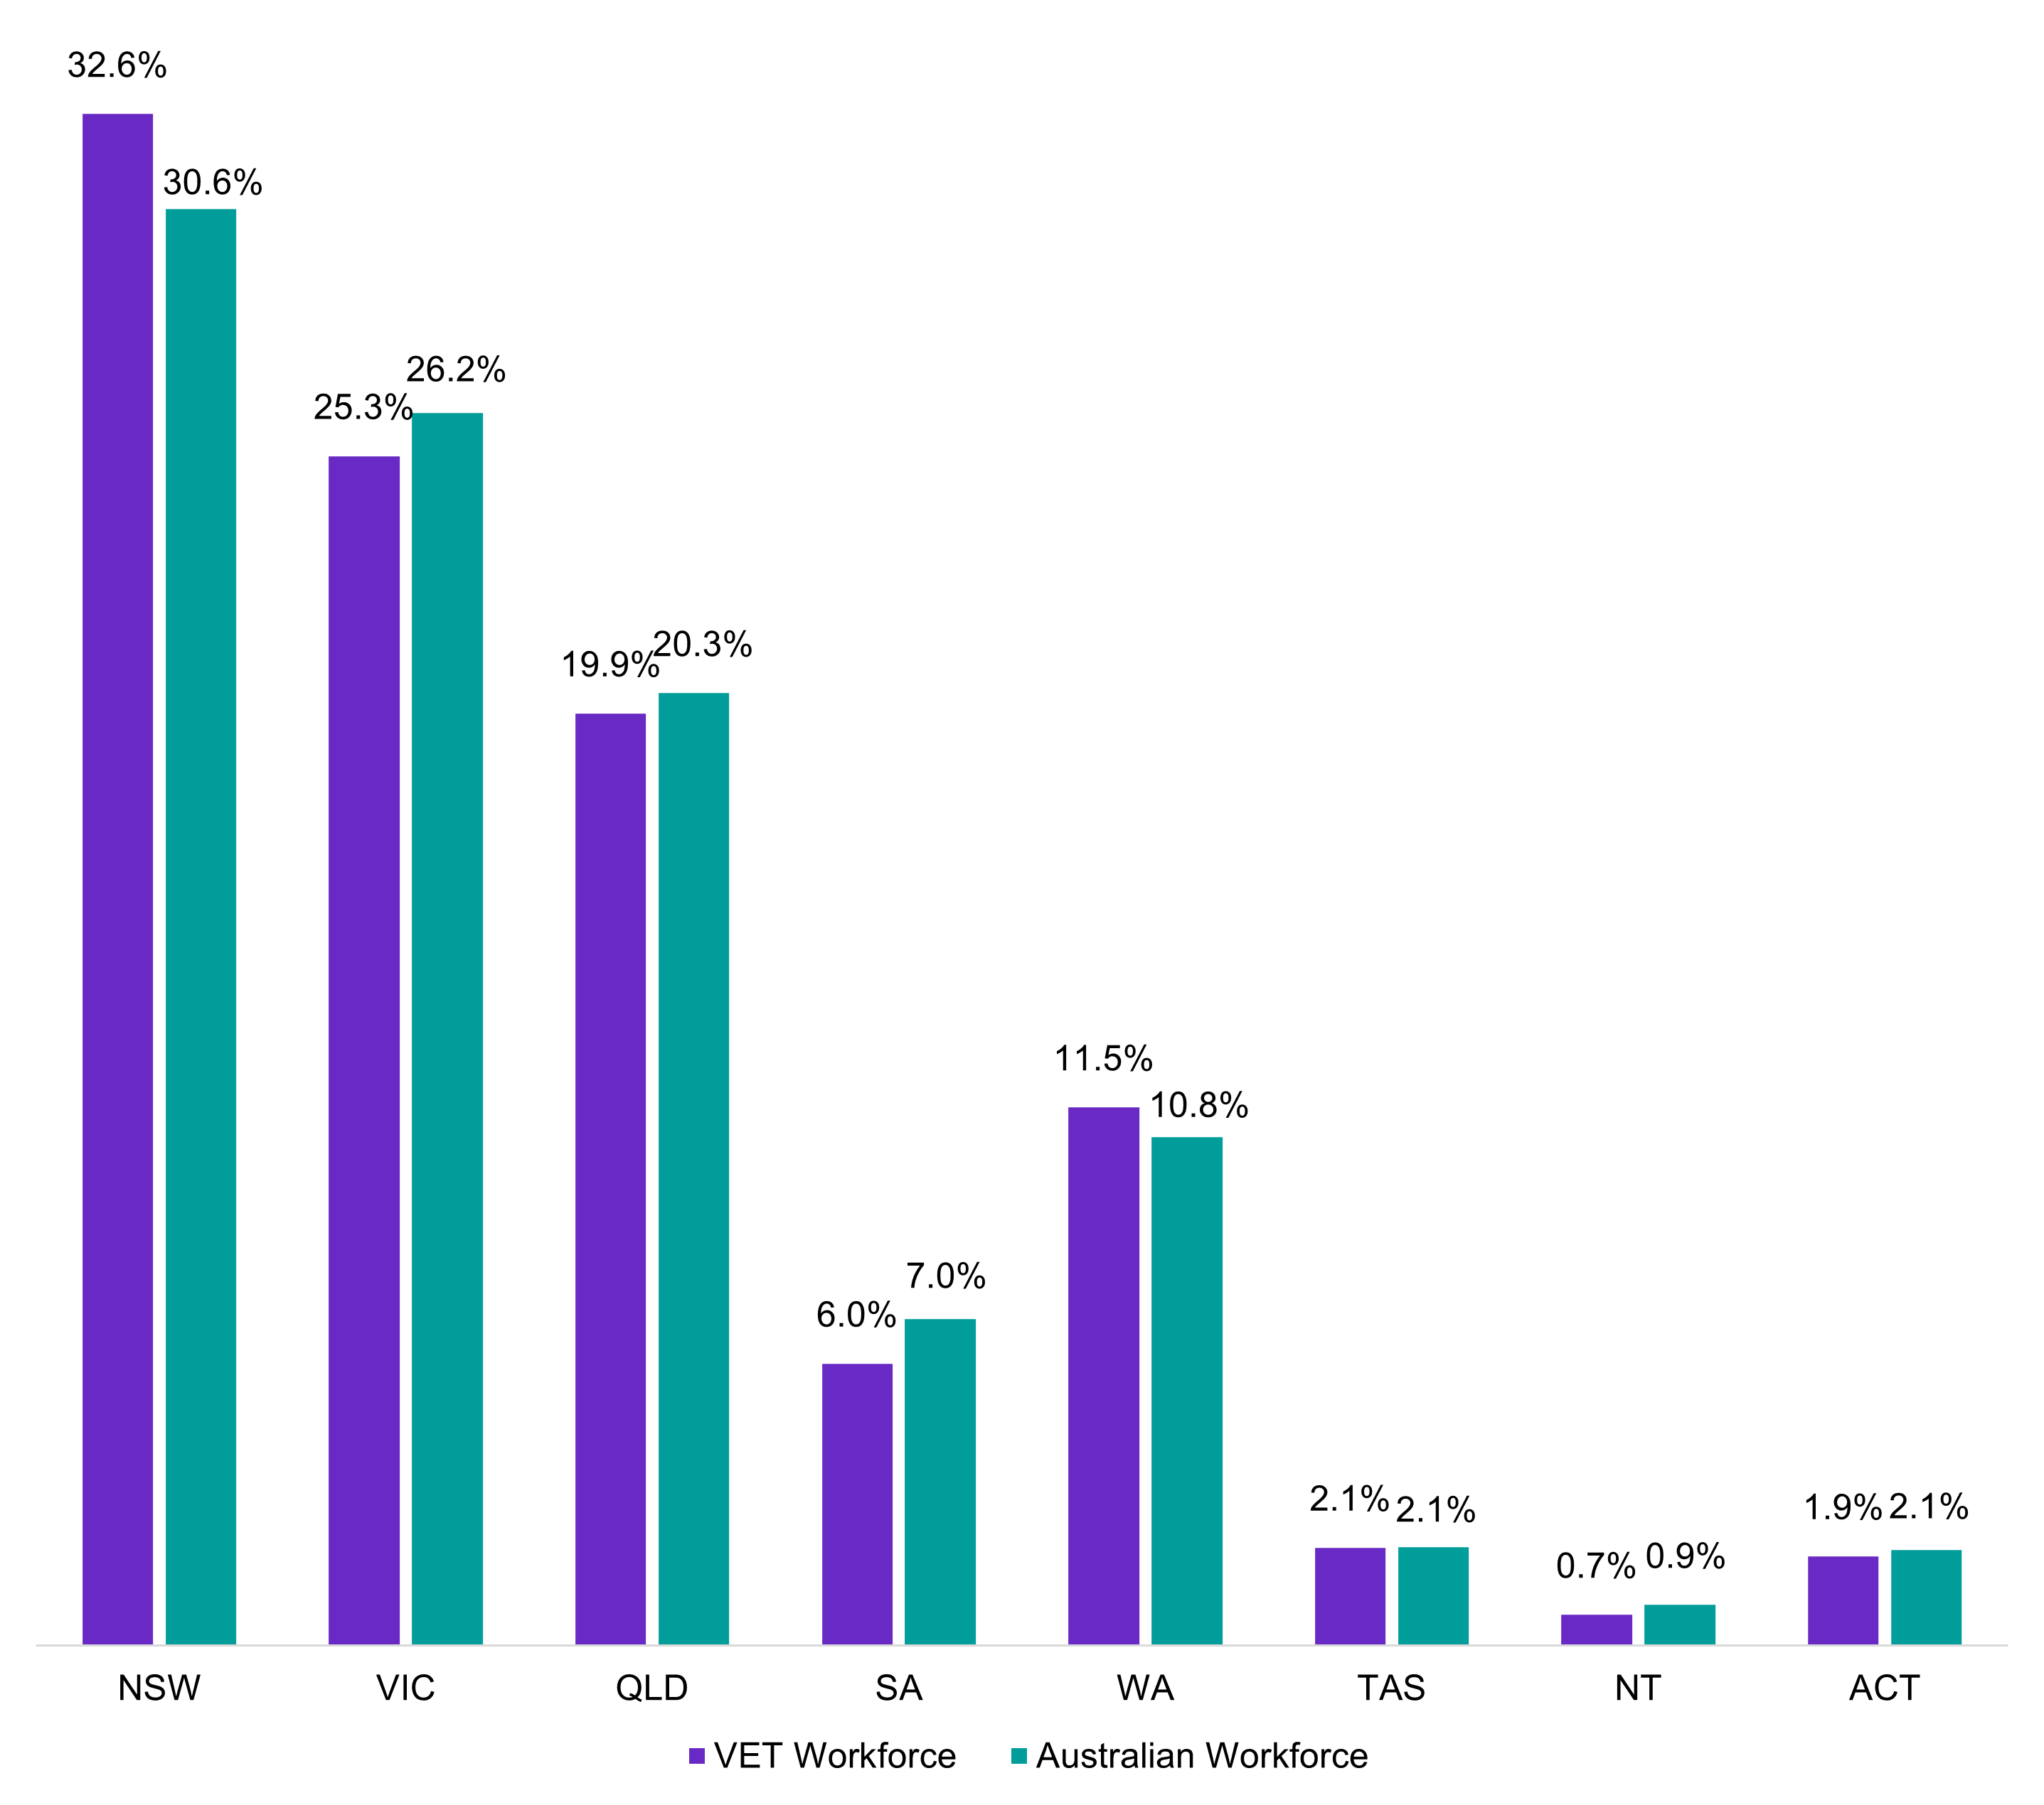 | VET Workforce | Australian Workforce
NSW | 32.6% | 30.6%
VIC | 25.3% | 26.2%
QLD | 19.9% | 20.3%
SA | 6.0% | 7.0%
WA | 11.5% | 10.8%
TAS | 2.1% | 2.1%
NT | 0.7% | 0.9%
ACT | 1.9% | 2.1%

Source: ABS (2021) Labour Force Status (LFSP) and Occupation (OCCP) and Industry of Employment (INDP) by State/Territory (STATE [UR]), [Census TableBuilder], accessed 20 December 2023.

Employment characteristics
The VET workforce is more casualised, slightly higher paid and less award dependent than the Australian workforce, but this is not the case when compared to their counterparts in other education sectors. This section provides an overview of these employment characteristics and comparisons, demonstrating that the public VET workforce has generally better employment conditions and pay. It is also slightly more feminised and older than the overall VET workforce according to Census data.

Hours worked
The VET workforce is most likely to work 30-39 hours per week and less likely than the Australian workforce in general to work 40 hours per week or more, see Figure 2.11. All segments other than Leadership are much less likely than the Australian workforce to work 50 hours per week or more. The Leadership segment is more likely than the Australian workforce to work 40-49 or 50 hours per week or more. The Leadership segment has the lowest proportion of part-time workers (15.0%), while the Learning Support has the highest proportion at 43.0%.
Figure 2.11 Weekly hours worked, VET segments and workforce and Australian workforce
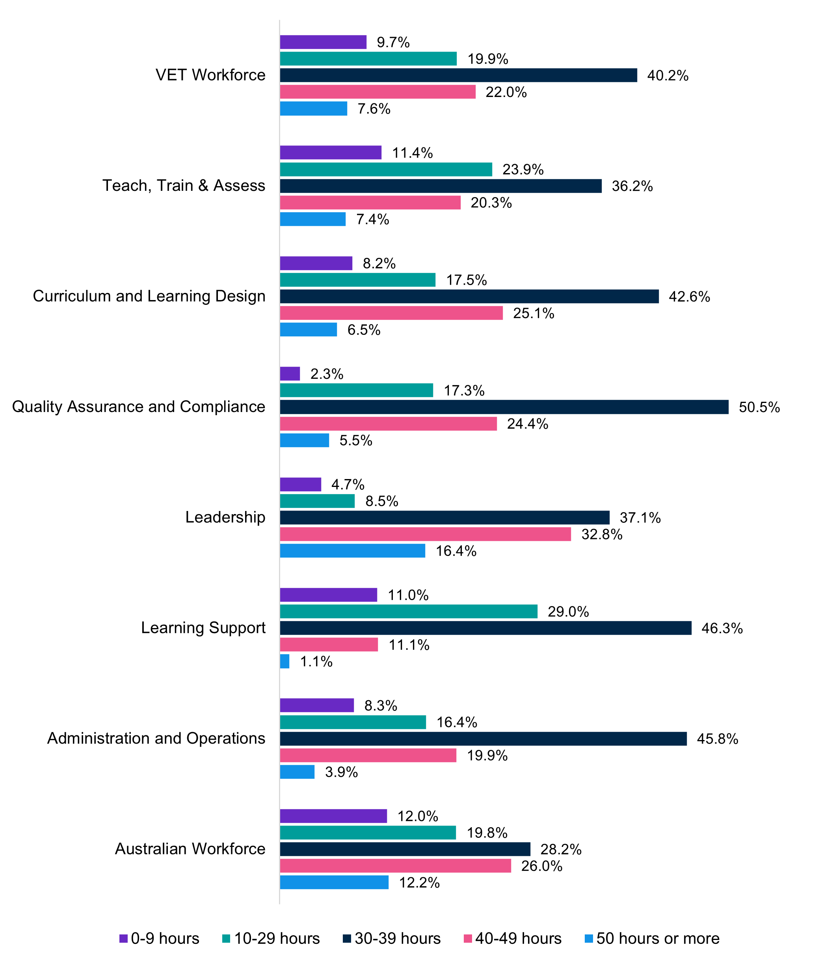
 | 0-9 hours | 10-29 hours | 30-39 hours | 40-49 hours | 50 hours or more
VET Workforce | 9.7% | 19.9% | 40.2% | 22.0% | 7.6%
Teach, Train & Assess | 11.4% | 23.9% | 36.2% | 20.3% | 7.4%
Curriculum and Learning Design | 8.2% | 17.5% | 42.6% | 25.1% | 6.5%
Quality Assurance and Compliance | 2.3% | 17.3% | 50.5% | 24.4% | 5.5%
Leadership | 4.7% | 8.5% | 37.1% | 32.8% | 16.4%
Learning Support | 11.0% | 29.0% | 46.3% | 11.1% | 1.1%
Administration and Operations | 8.3% | 16.4% | 45.8% | 19.9% | 3.9%
Australian Workforce | 12.0% | 19.8% | 28.2% | 26.0% | 12.2%

Source: ABS (2021) Hours Worked (ranges; HRWRP) by Labour Force Status (LFSP), Occupation (OCCP) and Industry of Employment (INDP), [Census TableBuilder], accessed 25 March 2023.

The analysis is similar for VET teachers compared to other education professionals, see Figure 2.12. VET teachers are twice as likely to work 35-39 hours per week and much less likely than secondary school teachers and university lecturers and tutors to work more than 45 hours per week.

Figure 2.12 Weekly hours worked, selected Education Professionals (%)
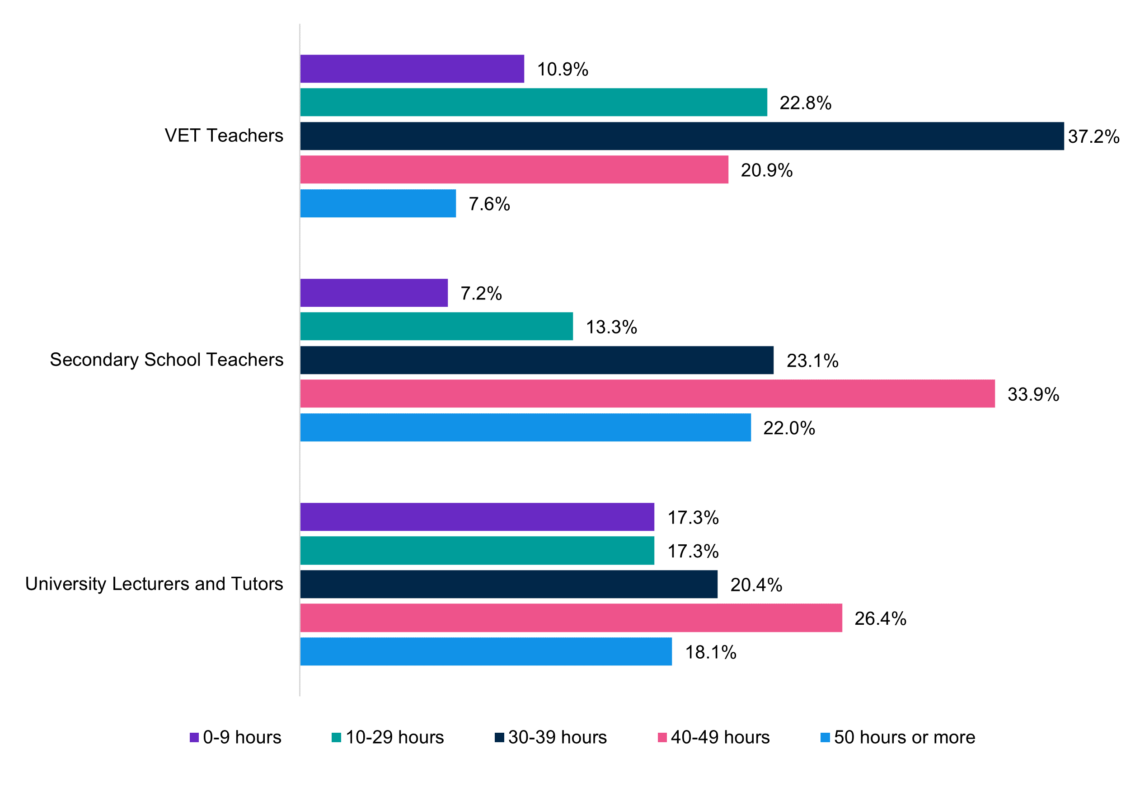
Source: ABS (2021) Hours Worked (ranges; HRWRP) by Occupation (OCCP), [Census TableBuilder], accessed 25 March 2024.
More VET teachers work part-time than the overall VET and Australian workforce (37.4% vs 32.2% and 32.9% respectively), see Table 2.5. Other than in New South Wales, full-time employment status in TAFEs (based on data provided for this study) is generally higher, indicating more secure employment in public providers.
Table 2.5 Full- and part-time work, VET teachers, VET workforce and Australian workforce
 | VET  Workforce | VET  Teachers | Australian  Workforce
Full-time | 62.2% | 56.9% | 58.9%
Part-time | 32.2% | 37.4% | 32.9%
Away from work | 5.5% | 5.7% | 8.2%
Source: ABS (2021) Labour Force Status (LFSP) by Occupation (OCCP) and Industry of Employment (INDP), [Census TableBuilder] accessed 20 December 2023

Forms of employment
Data products which include forms of employment (including permanent, fixed term and casual employment) do not contain the level of industry specificity needed to report on the VET workforce as a whole or its segments. Therefore, our analysis of forms of employment is restricted to VET teachers only.
While most VET teachers are employed as permanent staff (55.8%), a higher proportion of VET teachers are employed on a fixed term or casual basis compared to the Australian workforce at large (14.8% and 27.3% compared to 5.0% and 21.1%). See Table 2.6.
Table 2.6 Proportion of forms of employment of VET teachers and Australian workforce
 | VET teachers | Australian Workforce
Permanent | 55.8% | 69.8%
Fixed term | 14.8% | 5.0%
Casual | 27.3% | 21.1%
Source: ABS (2021) Type of Employee by Occupation [Employee Earnings and Hours TableBuilder] accessed 25 March 2024.
The proportion of VET teachers employed as casuals has fluctuated in recent years, compared to the general workforce and similar industries (see Figure 2.13). In August 2022, the proportion of VET teachers without paid leave entitlement (a proxy for casual employment) had increased by 12.1% since the first ABS Characteristics of Employment Survey in 2014. Conversely, the rate of casual employment across occupations has increased by 0.3% over the same period.
For example, Victorian TAFEs establish ongoing employment as the standard mode of employment and limit the circumstances under which teaching staff can be employed on a fixed term basis. This is discussed in more detail in the next section.
Figure 2.13 Proportion of casuals in selected occupations and across workforce, 2014 – 2023
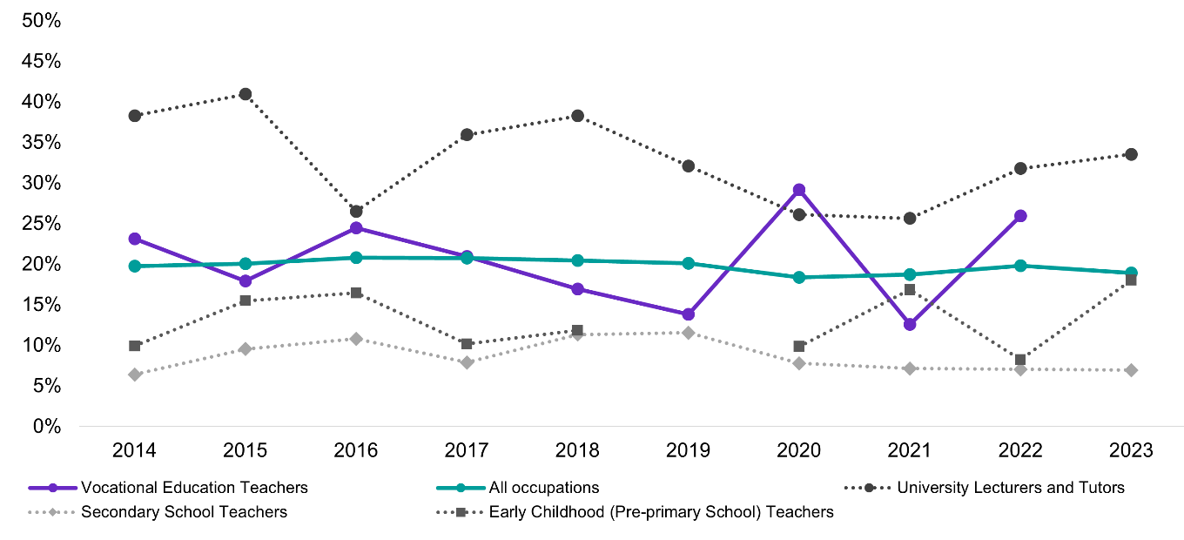
 | 2014 | 2015 | 2016 | 2017 | 2018 | 2019 | 2020 | 2021 | 2022 | 2023
Vocational Education Teachers | 23.1% | 17.9% | 24.4% | 20.9% | 16.9% | 13.8% | 29.1% | 12.6% | 25.9% |  | 2.8%
University Lecturers and Tutors | 38.3% | 40.9% | 26.5% | 35.9% | 38.2% | 32.1% | 26.1% | 25.6% | 31.7% | 33.5% | -6.5%
Secondary School Teachers | 6.4% | 9.5% | 10.8% | 7.9% | 11.3% | 11.5% | 7.7% | 7.1% | 7.0% | 6.9% | 0.6%
Early Childhood (Pre-primary School) Teachers | 9.9% | 15.5% | 16.4% | 10.1% | 11.8% |  | 9.8% | 16.8% | 8.2% | 18.0% | -1.7%
All occupations | 19.7% | 20.0% | 20.7% | 20.7% | 20.4% | 20.1% | 18.3% | 18.7% | 19.8% | 18.9% | 0.1%

Source: ABS (2023) Status in employment of main job by Reference year by Occupation of main job, [Characteristics of Employment TableBuilder] accessed 25 March 2024.
Note: Some data points have been omitted due to unreliable estimates.

Gender differences in part-time and casual employment
In line with the Australian workforce at large, females make up a higher proportion of part-time, and casual VET workers than males, see Table 2.7. For example, despite making up 49.5% of VET teachers, 63.4% of part-time VET teachers and 55.2% of casual VET teachers are female. In the VET workforce overall, 68.2% of part-time employees are female, slightly higher than the Australian workforce where 64.7% of part-time employees are female.
Table 2.7 Proportion of females who make up the workforce, as well as the part-time and casual employees
 | VET  Workforce | VET  Teachers | Australian Workforce
% Female (All employees) ª | 57.2% | 49.5% | 48.5%
% Female (Part-time employees) ª | 68.2% | 63.4% | 64.7%
% Female (Casual employees) ^{b} | - | 55.2% | 57.4%
Sources: (a) ABS (2021) Labour Force Status (LFSP) by Occupation (OCCP), Industry of Employment (INDP) and Sex (SEXP), [Census TableBuilder], accessed 25 March 2024, (b) ABS (2021) Paid leave entitlement and by Sex and Occupation [Employee Earnings and Hours TableBuilder], accessed
25 March 2024.

Multiple jobs
PLIDA data does not support the widely held belief in the sector that multiple job holding is more common among VET teachers than the workforce overall. The PLIDA data show that, in 2021/22, 31.5% of VET teachers declared income from multiple jobs, a somewhat higher proportion than university lecturers (30.8%) but lower than either university tutors (36.5%) or secondary school teachers (32.3%).
At 31.5%, VET teachers are almost as likely to declare more than one income source than the median across all occupations (32.8%). Workers in 64.0% of all occupations are more likely than VET teachers to declare more than one income source. The proportion of VET teachers who declare more than one income source has fallen over the last decade, from 33.2% in FY2012/13.
Secondary school teachers were also more likely to declare more than one income source in FY2012/13 (37.7%). Other tertiary teachers were less likely to declare multiple income sources in FY2012/13 – university lecturers 29.1% and university tutors (31.3%) – than in FY2021/22. One limitation of this PLIDA data is that it will only record someone as a VET teacher if that is their highest earning occupation in that year.

Pay
On different indicators (average income and median earnings) the VET workforce is generally paid more than the Australian workforce but less than their counterparts in other education industry sectors and/or other teaching occupations. The average annual income for the VET workforce is 8.1% higher than the Australian workforce average at $81,245 compared to $74,679, see Table 2.8.
The Teach, Train, and Assess segment average annual income is $79,546 which is still higher than the average Australian workforce annual income but slightly lower than Vocational Education Teachers (from a narrower ANZSCO classification) at $79,859. This also aligns closely with NCVER student outcomes data which indicates that the median salary in the first full-time job upon completion of a Certificate IV in TAE is approximately $79,000.
The Leadership segment has the highest average annual income at $111,810, followed by Quality Assurance and Compliance and Curriculum and Learning Design at $90,685 and $85,154 respectively. The Administration and Operations segment is relatively close to the income of Teach, Train, and Assess at average annual income of $75,726, with the Learning Support segment considerably lower paid at average annual income of $66,185.
Table 2.8 Average annual income by workforce segments
 | Average Annual Income
All VET Workforce | $81,245
Teach, Train, and Assess | $79,546
Curriculum and Learning Design | $85,154
Learning Support | $66,185
Quality and Compliance | $90,685
Administration and Operations | $75,726
Leadership | $111,810
Australian Workforce | $74,679
Source: ABS (2021) Total Personal Income (INCP) by Labour Force Status (LFSP), Occupation (OCCP) and Industry of Employment (INDP), [Census TableBuilder] accessed 17 November 2023.
**Note: Occupations within the Workforce segment of Quality Assurance and Compliance have a count of 168, largely dominated by Quality Assurance Managers. Weekly reported income has been annualised.
When comparing across industries (using ANZSIC classifications), average annual income in VET (8101 Technical and Vocational Education and Training) is lower than all comparative education sectors except for primary education, see Figure 2.14.
Figure 2.14 Average annual income across industries
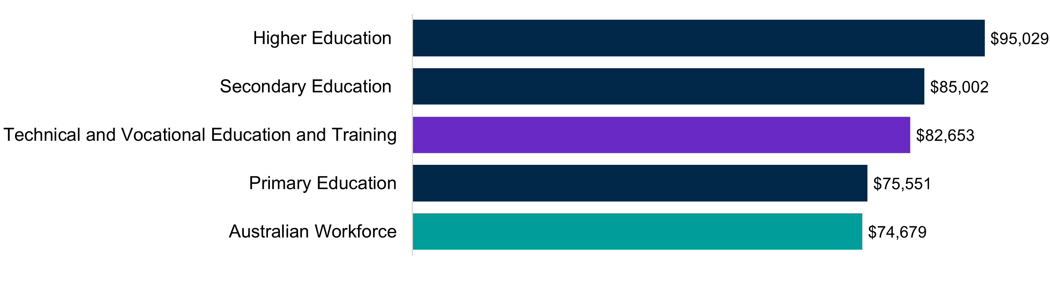
Source: ABS (2021) Total Personal Income (INCP) by Labour Force Status (LFSP) and Industry of Employment (INDP), [Census TableBuilder] accessed 17 November 2023.
Likewise, from an occupational perspective (using ANZSCO classifications) the median weekly total cash earnings of VET teachers are higher than the Australian workforce by 11.1% ($1886 compared to $1697 for total weekly cash earnings) but less than counterparts in teaching or other education roles. For example, Secondary school teachers and university lecturers and tutors (as classified under ANZSCO) earn 14.8% and 44.9% more respectively.
Interestingly, as noted in Chapter 1, Training and Development Professionals and Education Advisors and Reviewers who make up almost half and a third of the Curriculum and Learning Design segment earn more than VET teachers by 13.8% and 21.4%. These occupations are spread across different education (and non-education) sectors which likely explains the higher earnings for these roles but also points towards the lower pay in VET compared to secondary schooling and higher education. It is also notable that VET teachers in public institutions earn 10.3% more than VET teachers overall, and 24.4% more than VET teachers in private RTOs.
In Chapter 4, we use PLIDA data in the workforce transitions section to show further evidence of the lower pay of VET teachers and how those moving out of the profession experience pay rises. However, this is not necessarily due to a return to industry, more so other teaching professions and or management positions (potentially in VET).

Gender Pay Gap in VET
There is a 16% gender pay gap in the VET workforce with women earning an average annual income $14,773 less than their male counterparts, see Table 2.9. The pay gap is even higher for VET teachers, trainers and assessors where it is a 17% pay gap. For full-time workers, this gender pay gap reduces to 9% for overall VET workforce and 7% for the Teach, Train, and Assess segment. This demonstrates that the higher proportion of female casual staff in the VET workforce exacerbates the gender pay gap. The pay gap persists across all segments and is greatest in Administration and Operations (19%) and smallest in the most feminised segment – Learning Support (9%) where full time females earn 1% more.
Table 2.9 Pay gap across segments and workforces
 | Pay gap | Full-time  pay gap
VET Workforce | 16% | 9%
Teach, Train, and Assess | 17% | 7%
Curriculum and Learning Design | 12% | 6%
Learning Support | 9% | +1%
Quality and Compliance | 16% | 10%
Administration and Operations | 19% | 13%
Leadership | 13% | 9%
Australian Workforce (various ABS figures)ª | 8.4% - 26.7% | 12%
Source: ABS (2021) Total Personal Income (INCP) by Labour Force Status (LFSP), Occupation (OCCP) and Industry of Employment (INDP) and Sex (SEXP), [Census TableBuilder] accessed 17 November 2023.
Note: (a) There are various Gender Pay Gap ABS figures based on different measures and WGEA data indicates a November 2023 pay gap of 21.7%.

Awards, employment agreements and union membership
In terms of industrial relations, the university and TAFE sectors share many similarities. Both are relatively highly unionised and yet highly casualised and both have developed workforce structures embedded over many years in awards and enterprise agreements. By comparison with university and TAFE institutes, industrial relations in private registered training organisations is historically characterised by low unionisation, little regulation and no common workforce development standard.
61.7% of VET teachers have their pay set by collective agreements (compared to just over a third for all employees) indicating strong EBA coverage in the sector, though not in comparison to secondary school or primary teachers where collective agreement coverage is above 95%.
Most of the VET workforce that is covered by enterprise agreements is in public TAFE providers. These are mainly teacher specific agreements but do cover managers and learning support roles in some cases. In contrast only 10% of VET teachers have their pay set by the award. As noted in Chapter 1, the introduction of this award in 2010 created default career pathways for VET workers and considered qualifications of teaching and training staff when determining minimum pay.
However, the classification and pay rates in the Award are much lower compared to the bargained rates at both TAFEs and dual sector universities as per Table 2.10 and
Figure 2.15. Reported annual income in the Census also skews higher for VET teachers with public sector employers (Figure 2.16). However, there is a higher proportion of private VET teachers in the highest income ranges compared to public VET teachers.

Figure 2.15 Entry level and highest salaries for VET teachers in dual sector universities, TAFEs, and the Post-Secondary Education Award
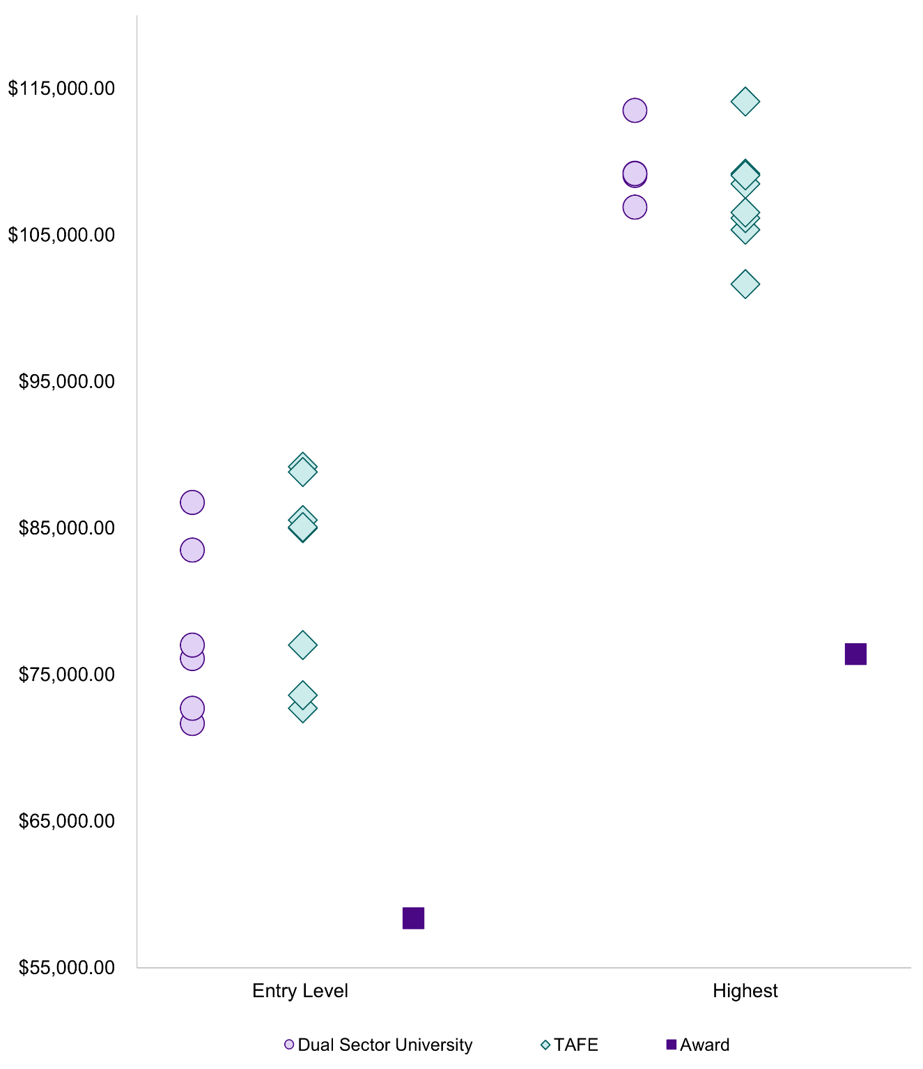
Source: Institution Enterprise Agreements and Fair Work Commission
Notes: For TAFE and Dual Sector, salary rates are drawn from Enterprise Agreements, for teachers with Certificate IV. In some institutions, a lower rate is available for those commencing without Certificate IV.

Table 2.10 Entry level and highest salaries for VET teachers in dual sector universities, TAFEs,
and the Post-Secondary Education Award
 | Entry-level^ | Highest
Dual sector universities
RMIT University | $71,684 | $106,905
Charles Darwin University | $72,702 | $109,071
Swinburne University of Technology | $76,108 | $113,502
CQ University | $86,771 | $109,194
Victoria University | $83,505 | $109,214
Federation University Australia | $77,024 | $109,207
TAFEs
TAFE SA | $89,198 | $101,647
TAFE NSW | $88,842 | $105,362
WA TAFEs | $85,555 | $108,501
Canberra Institute of Technology (CIT) – ACT | $84,997 | $114,113
TAFE QLD | $85,084 | $106,158
Victorian TAFEs | $77,024 | $109,207
Charles Darwin University (CDU) – NT | $72,702 | $109,071
TAFE TAS | $73,595 | $106,536
Post-secondary Education Award 2020
 | $58,363 | $76,391
Source: Institution Enterprise Agreements and Fair Work Commission
Notes: TAFE and Dual Sector salary rates are drawn from Enterprise Agreements, for teachers with Certificate IV. In some institutions, a lower rate is available for those commencing without Certificate IV. Post-secondary education award figures are Level 1 and 12 in the Educational Services (Post-secondary Education) Award 2020, Schedule A and Clause 16.1(a), and Schedule B and Clause 16.1(c).

Figure 2.16 Percentage of public and private VET teachers total personal income by range
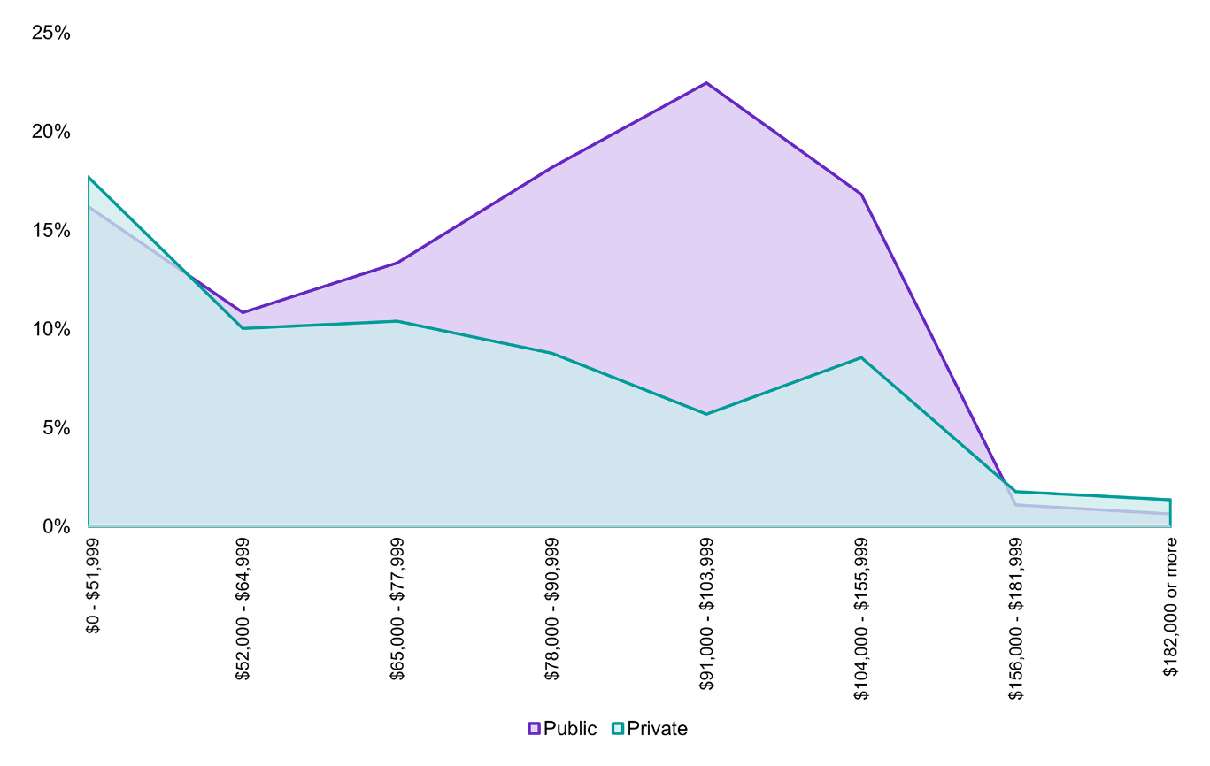
 | Public | Private
$0 - $41,599 | 16.2% | 17.7%
$52,000 - $64,999 | 10.8% | 10.0%
$65,000 - $77,999 | 13.4% | 10.4%
$78,000 - $90,999 | 18.2% | 8.8%
$91,000 - $103,999 | 22.5% | 5.7%
$104,000 - $155,999 | 16.8% | 8.5%
$156,000 - $181,999 | 1.1% | 1.8%
$182,000 or more | 0.6% | 1.3%
Source: ABS (2021) Total Personal Income (INCP) by Occupation (OCCP) and Sector of Employment (GNGP), [Census TableBuilder] accessed 10 March 2024. Weekly reported income is annualised.
Under both the Award and various enterprise agreements in the sector there are limits on teaching and non-teaching hours. From an award perspective, a sessional employee is an employee engaged to work on a full-time or part-time basis for a specified period or periods of not less than 4 weeks or not more than 40 weeks in any calendar year. Across TAFE agreements, the allocated hours for teaching annually range from 720-840 hours with NSW and Victorian Teaching agreements also specifying 400 to 540 hours for non-teaching related duties to support ongoing industry currency.
Agreements also allow employers and workers to negotiate the number of teaching weeks and hours required to adequately deliver and assess the content taught, and this may differ in positions of seniority. Prior to the commencement of the academic year, specific clauses under some enterprise agreements require an approved annual workplan to be established, considering the complex nature of teaching, preparation and learning each teacher is required to perform.
Various agreements across TAFEs also include clauses that discourage the excessive use of casuals or fixed term contracts to fulfill workforce needs with the goal of promoting ongoing employment. All agreements include (or will shortly include in the case of WA) conversion clauses from casual to permanent employment after periods of continuous service.

Union Membership
There are two main unions representing VET teachers, trainers and assessors, the Australian Education Union (AEU), the Independent Education Union (IEU). Other unions with membership among the VET workforce include the National Tertiary Education Union (NTEU) and Community and Public Sector Union.
ABS data on trade union membership for VET teachers is a smaller sample but when considered in conjunction with collective agreement coverage and compared to other teachers gives some insights. VET teachers have a slightly higher level of trade union membership than the overall Australian workforce at 16.6% compared to 12.5%, but this is much lower than their counterparts in schools and universities (see Table 2.11 for a split by the public and private sector). However, the public VET teacher union membership is much higher at 28.3%.
Table 2.11 Proportion of workers belonging to a trade union split by the public and private sector and covered by a collective agreement, select occupations as at August 2022
Occupation | Trade union membershipª |  |  | Collective Agreement coverage^{b}
 | Overall | Public | Private
Primary School Teachers | 42.9% | 44.6% | 40.4% | 96.8%
Vocational Education Teachers/Polytechnic Teachers | 16.6%* | 28.3%* | 9.3%** | 61.7%
Secondary School Teachers | 54.3% | 65.0% | 45.0% | 94.5%
University Lecturers and Tutors | 22.8% | 22.7% | 23.3%* | 97.3%
Source: (a) ABS (2022), Employees trade union membership in main job by occupation of main job, [Characteristics of Employment TableBuilder], accessed 10 April 2024, (b) ABS (2021) Method of pay setting by occupation [Employee Earnings and Hours TableBuilder], accessed 10 April 2024.
Note: Occupation of main job and Trade union membership by Reference Year
*Estimate has a relative standard error of 25 to 50.0% and should be used with caution
**Estimate has a relative standard error greater than 50% and is considered too unreliable for general use

VET workforce data – current and potential future states
As this chapter has shown there are numerous data limitations in profiling the VET workforce. Two very significant key data limitations relate to the dual professional status of VET teachers, trainers and assessors. First, there are data gaps in understanding both teaching and industry qualifications of the workforce. Second, data gaps in identifying a national comprehensive workforce count and composition of the VET workforce, regardless of whether individuals self-identify as a member of VET or their industry.
This chapter also demonstrates gaps in understanding the diversity and age of the VET workforce. There is an immediate need for a more nuanced understanding of the diversity of the VET workforce, especially First Nations status, if Australia is to have a high performing VET system that aligns with the diverse student cohort it serves. The study confirms that the VET workforce is older, and ageing and that better data is needed to manage this risk and secure a sustainable workforce supply in the future. In line with this, this next section outlines the current state of VET workforce data and recommendations for future collection with a focus on these main four data gaps.

Current state
The current state of VET workforce data can be summarised as follows:
- There is no compulsory, comprehensive, regular collection of workforce data from RTOs or individual workers.
- The last attempt to conduct a survey to measure the size of the VET workforce (and some of its core characteristics) occurred in 2019, and encountered difficulty in relation to response rate and designing an instrument that could be equally understood and completed by the diversity of RTO providers. Data from the Australian Census of Population and Housing (held every five years, most recently in 2021) provides some insights into the characteristics of the VET workforce. However, in the past its scope has not aligned to the full extent of the VET workforce due to some misalignment with the ANZSIC and ANZSCO categories and limitations around only allowing survey respondents to identify one singular main job. However, more fit-for-purpose VET occupational classifications will likely be implemented for 2026 which will assist with better workforce mapping. Nonetheless, the inevitable non-sampling error introduced by self-report responses in census remains an issue. While census data provides information on the personal characteristics of VET workers, the method of collecting data on qualifications results in gaps. Only data on highest qualification is collected, whereas for the dual professional status to the VET workforce – both teaching and vocational qualifications are crucial.
- Data collected from RTOs by ASQA and the other registration bodies at the time of registration. The collection of this information is permitted under Standards for Registered Training Organisations (RTOs) 2015. While ASQA may request data from registered RTOs throughout their registration period, currently ASQA and the other registration bodies do not routinely re-survey RTOs or otherwise require RTOs to keep this information current as a condition of registration.
- Data collected by state and territory training authorities as part of their contracting arrangements for delivery of subsidised training (some similar data is collected as part of the approval process for RTOs to offer VET Student Loans). For example, the NSW Government collects student data from Smart and Skilled providers as part of its contracting rounds – and could expand reporting requirements to include workforce data.
- TAFEs and dual sector universities are typically required to report on their staffing levels as part of annual reports required by legislation.
- This compares with an annual workforce data collection for higher education providers and national workforce censuses or surveys for ECEC [and for the aged care] sectors.
- Separately, licensing or registration bodies for occupations (such as School Teachers and registered nurses) may collect information on the individual characteristics. However, there are not national licensing or registration arrangements in place for VET teachers, trainers, and assessors, just as there are not for early childhood educators, for example.
It is also worth noting that even these other sector workforce data collections have limitations and would not address some essential priorities of the VET sector. For example, the National Workforce Census for ECEC does not cover all standalone preschools funded by state and territory governments and is not able to account for multiple job holders. Diversity demographic, tenure and attitudinal data has also not been consistently collected. However, it does include data by provider type which could be replicated in any VET workforce data collection.

The answers sought from VET workforce data
In this section, we identify the data insights that are highly likely to be used by regulators, funders, VET providers, and organisations (VET and higher education providers) offering training for VET teachers, trainers and assessors and other VET roles. The following sections assess that against the current state of VET workforce data collection, identifies lessons from previous data collections, then considers options for data collection in the future.

Workforce size and composition
- How large is the VET workforce?
- How large is the VET teaching, training, and assessing workforce?
- How many VET workers are performing other roles?
- How is the VET workforce distributed across RTO types?
- To the extent possible, how is the VET teaching, training, and assessing workforce distributed across industry and disciplinary fields?
- To the extent possible, how common is multiple job holding by the VET teaching, training, and assessing workforce, both across the VET workforce and between VET and industry?

These are legitimate questions for funders and regulators to understand. Having a more accurate idea of how large the VET teaching workforce is will help regulators and those responsible for developing and delivering VET teaching qualifications gain a picture of the current supply. Collecting data on the wider VET workforce will also provide a picture of which roles support VET students – which is of interest to RTO regulators and governments subsidising VET (or supporting it with access to loans). This information would also be useful for RTOs looking to benchmark their staffing profile to other similar organisations. Similar sectors where government is called on to assure the quality of services (and is often the primary funder) require similar information – higher education, early childhood education and care (ECEC), and aged care.
Assessing the size of the VET workforce would require a measure of both headcount and full-time equivalent workers, preferably by RTO provider type and/or type of training delivered. This would assist in targeting any initiatives to develop or support existing VET workers or train and recruit new ones. An accurate measure of the VET workforce would also need to take into account, where possible, multiple job holding (see further discussion below).

How diverse is the VET workforce?
- Important measures would be gender, and First Nations status.
- Additional valuable measures would be CALD and workers with disability.
Providing opportunities in the VET workforce is important to ensure that it reflects the diversity of the Australian population and the student cohort it serves. Diversity takes on added importance in the VET workforce, as there is considerable evidence that, for example, training providers with First Nations workers are likely to achieve greater success with supporting First Nations students to completion. Information of this nature will help government and other national VET bodies develop and monitor strategies to increase the diversity of the VET workforce.

VET Teaching workforce credentials
- What are the credentials of the VET teaching workforce?
- What are the teaching/education credentials (by level and type) of the VET teaching workforce?
- What are the (non-teaching) credentials (by level and field of education or industry) of the VET teaching workforce?
Collecting this type of data is again of considerable importance for understanding the impact of the RTO Standards and for considering what qualifications – VET and higher education – and ongoing professional development, may be needed for the current and future VET teaching workforce.

VET teaching workforce age profile, VET teaching retention, tenure, and turnover?
- Based on the existing age profile and any other available information (such as tenure and intentions to leave, what are the likely exits from the VET teaching workforce (and potentially other VET specialist roles)?
- How does this vary by field of education or industry?
Throughout this report we examine the evidence that the demand for VET teachers, trainers, and assessors (and any current shortages) vary, with shortages particularly evident in trade areas also experiencing occupation shortage, such as electro-technology. This information is needed to work closely with the relevant industry areas to identify and develop pipelines. In general, the largest driver of exits is age, but any available information on tenure and attitudinal data (e.g. intention to leave), would also be informative.

How is work done?
- What essential RTO functions are performed in-house by RTOs?
  - Training and teaching delivery
  - Assessment
  - Training and assessment material design
  - Quality assurance and compliance
  - Student support
One of the issues that this study highlights is that RTOs have options regarding how to perform the essential activities required to maintain RTO registration, including training delivery, assessment, design of training and assessment materials, quality assurance activities, student marketing, and provision of student support services. Not all work is performed by a directly employed workforce.
The extent to which an RTO elects to outsource some of these activities will markedly influence the size and composition of their VET workforce. Relatedly RTOs operating across similar domains (e.g. schools, dual sector universities) may centralise some of these services and have difficulty accurately identifying or apportioning the VET-relevant component.
Information of this type will help regulators better target education and compliance activities and help governments and national VET bodies develop policies and frameworks for effective regulation, training product design and implementation, and student support. It will also help governments better consider how to effectively factor such activities into their funding models for subsidised training.

Topics that are lower priority but still important
There are questions and topics which are harder to justify for inclusion in a regular data collection of such a diversified sector.
- Collecting information on (average) remuneration for the VET teaching workforce or other VET workers
- Collecting information on the employment arrangements of the VET teaching workforce or other VET workers
- Identifying and tracking individual VET workers
- Collecting information on the qualifications held by VET workers in non-teaching roles (except for some VET specialist roles)

Lessons from previous efforts
Different RTO types operate in very different contexts. RTOs where the primary activity is something other than delivering VET will find it difficult to identify or apportion its non-teaching VET workforce. This would include:
- School RTOs
- Dual sector universities
- Enterprise RTOs
However, there will be many other RTOs not in these categories that also operate across multiple domains (such as group training providers, employment services providers), that would also find this task difficult.
A particular topic where there is a high degree of variation in practice and understanding across the sector is what would constitute (and how to measure) a Full-time equivalent employee for VET teaching, training, and assessing roles.
Relatedly, the issue of multiple job holders (particularly those holding multiple jobs across training providers), is difficult to resolve with an employer survey alone. This is an issue common to other sectors (e.g. the National Workforce Census for ECEC).
Another topic, probably relevant only to a minority of RTOs, is how to account for the activities of volunteer VET teachers, trainers, and assessors and in other roles.

Options
Three options are considered to develop a regular collection of VET workforce data:
- ultra-minimum data collection tied to RTO registration by ASQA
- implementation of a VET Workforce Standard, to be submitted by RTOs as part of their annual total VET Activity returns and
- an RTO survey, ideally with an accompanying employee survey
These options are not necessarily mutually exclusive. One approach could be to conduct option C initially, to better inform the development and implementation of either option A or B, with an RTO survey being held more periodically (such as every 3-5 years), with an evolving set of topics.

Option A: ultra-minimum data collection tied to RTO registration
This option would see ASQA, and the other registration bodies refine the workforce data they currently collect at registration, and then collect on a more regular basis (such as at re-registration or more regularly for those given longer registration periods) and publish annually.

Option B: Implementation of a VET Workforce Standard
A VET Workforce Standard has been considered previously and NCVER has even prepared a VET Workforce Standard. This option would have the benefit of universality, but the issues from previous efforts to measure the VET workforce and feedback from the draft VET workforce standard, indicates that it would still be difficult for many RTOs to answer even a small subset of the workforce questions identified above.

Option C: AN RTO survey, ideally with an accompanying employee survey
Option C would allow all the identified questions above to be answered. However, it would be the most expensive and time consuming to develop and administer. The effectiveness of the survey could be improved by considering the following:

Pre-piloting and piloting
Extensive pre-piloting and piloting is strongly recommended to ensure that a variety of approaches to resolving data uncertainties and information gaps, appropriate to different RTO contexts, are identified.
For example, pre-piloting and piloting would be needed to help identify suitable categories for industry and field of education that most training providers would be able to readily provide data against. Similarly, there may be a range of suitable approaches to deriving full-time equivalent workforce figures based on the RTO’s operating environment.
At this stage, exploratory work using the ABS data assets PLIDA and the Business Longitudinal Analysis Data Environment (BLADE), could also help to produce preliminary estimates for employees in some RTO types.

Survey approach
These options have been informed by the experience conducting the National Skills Commission’s VET Course Cost Collection survey, the first ever national survey of training provider costs. This survey collected cost data representing over 35% of enrolments in subsidised qualifications, and 25% of total enrolments. A general survey instrument was designed and then adapted as needed, to meet particular RTO requirements.

Sampling and instrument design
The RTO Typology, soon to be released by JSA, could assist in developing a more robust sample frame for the RTO survey, and adapting the instrument design to suit different RTO contexts.
The 2019 survey stratified the sample based on:
- RTO type
- Number of enrolments
- The RTO typology includes other dimensions that are likely to be relevant to an RTO’s staffing profile, including:
- Mix of training products delivered (including number of training packages delivered and whether full qualifications or only subject-only enrolments and skill sets)
- Proportion of enrolments receiving at least some government funding
- Number of locations
- Mode of delivery
- Student characteristics, including proportion of international students.
The receipt of government funding is a particularly relevant consideration. RTOs not in receipt of any government funding (or access to student loans) have a stronger case to make that they should not be required to provide detailed workforce information that goes beyond helping inform the development and assurance of the RTO Standards.
On the other hand, the moral (and contractual) basis for requiring more detailed information from RTOs receiving government funding is stronger. Questions of this nature could be agreed with the States and Territories.

Conclusion
This chapter extends previous understandings of the VET workforce from a demographic, geographical and employment characteristics perspective using the taxonomy framework and new PLIDA data. However, JSA acknowledges it falls short of a complete workforce profile due to the data limitations outlined in Chapter 1. Thus, we have identified the four main data gaps and provided recommendations on how to fix them.
The next chapter outlines the current diversity of job roles across the sector under each taxonomy and in different RTO types further demonstrating this. Indeed, Chapter 4 highlights how graduates of the key VET teaching credentials the Certificate IV TAE, are not flowing into VET teaching roles further complicating the picture and why we need a comprehensive profile of the VET workforce.



Job profiles and pathways
In this chapter we explore the diversity of roles in the VET workforce, profiling jobs in each of our six taxonomy segments and the training pathways between them. In doing so, we offer the beginnings of an occupational framework. The rationale for developing an initial occupational framework to sit under the VET workforce taxonomy is threefold:
- Increase understanding of the diversity of job roles in the sector and current industry practice
- Provide a foundation to better understand the factors influencing attraction, retention and career progression within the VET workforce
- Guide a more fit-for-purpose future workforce strategy, planning, training pathways and data collection
The occupational framework focuses on profiling teach, train, and assess roles across a spectrum of focused, broad, and extended responsibilities and scope. For example, teach, train, and assess roles with a more focused scope and responsibility are those ‘working under supervision’ or in assessor-only roles, whereas senior educators have broader responsibilities, and team leads or departmental heads have even further extended responsibilities. We examine the training pathways and typical career progressions in these teaching roles as well as other broader and emerging VET roles. This includes pathways and progressions between roles and across segments including into leadership positions.
We have drawn on a range of data sources including position descriptions, organisation charts, job advertisements, enterprise agreements, existing VET practitioner capability frameworks, training pathways, policy settings and regulation requirements to develop the job profiles. We have sense-checked the job profiles with key sector stakeholders and account for sector diversity including RTO provider type, delivery context and learner cohort throughout the chapter.
The main questions we answer in this chapter are:
- What are the key job roles in each VET workforce taxonomy segment?
- What are the training pathways for becoming a VET teacher, trainer, or assessor and other job roles across the sector?
- Which jobs roles are growing or emerging in current industry practice?
- What does typical career progression pathways in the VET sector look like, especially for teachers, trainers, and assessors?
- What are the migration pathways into VET?
The chapter begins with a discussion of training pathways including a historical overview of how VET qualification credentials have changed over time. The remaining content is structured around the six taxonomy segments, profiling jobs in the same format. This format and the actual jobs included in our analysis are summarised in Figure 3.1.
Figure 3.1 Job profile format and segment profiles
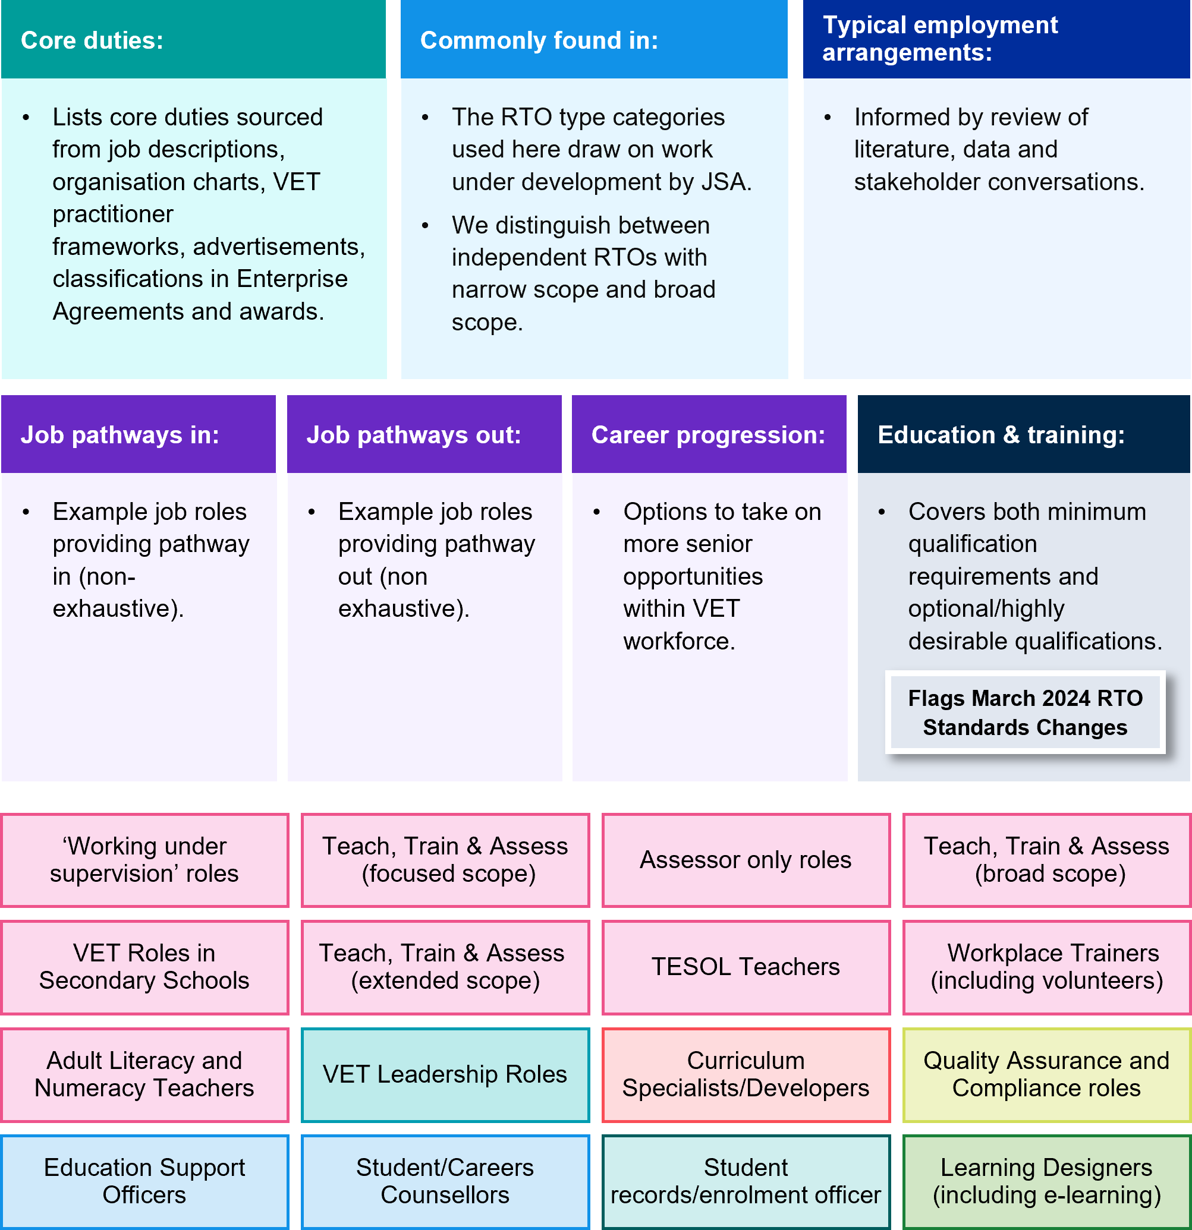

Training pathways
As noted in Chapter 1, the RTO Standards and modern award set out the key credentials and qualifications for VET teaching, training, and assessing roles and the most common qualification used to meet training and assessment credential requirements is the Certificate IV in Training and Assessment (Certificate IV TAE). Vocational education delivery has thus been critical to the VET teaching workforce supply. However, as Chapter 2 identified, the Census shows a more mixed set of qualifications across the VET workforce, with almost one quarter of the VET workforce holding a bachelor's degree as their highest level of qualification. As noted in the previous chapter, the dual professional status of the workforce plays a role in this, but also the higher education pathways into VET based on adult education qualifications at the Diploma level or above.
This also complicates both the training pathways and pipeline analysis of the VET workforce especially when developing insights on supply and demand. This is discussed in the next chapter in detail and in Chapter 5 we offer recommendations on how to better collect qualifications data for the VET workforce in future.
This section begins with a summary of the key training pathways into VET, mainly for teach, train, and assess roles, and how qualification credentials have changed over time. For example, the recent decline in university adult education and VET qualification offerings. We also note qualifications in education management and curriculum design which flow into non-teaching segments in our taxonomy.
Higher education training pathways, especially postgraduate qualifications in learning design and educational technologies, are more common for these roles and segments. There is no specific qualification requirement for work in instructional design, and in recent times a small number of private providers such as Instructional Design Australia, are beginning to offer courses that could be used in VET, but which do not fall under Australia’s AQF system. It is unclear whether these are commonly accepted by industry.

Teach, Train, and Assess Training Pathways
Teachers, trainers, and assessors are the foundation of the VET workforce and, for most providers, make up the largest segment. Analysis of 2021 Census data indicates that around half of the VET workforce is employed in Teach, Train, and Assess roles. These figures are broadly consistent with data provided to JSA by TAFEs across Australia for this study as well as recent research including the NCVER 2019 workforce survey, which noted that between 40-59% of the VET workforce for very large or large RTOs were teachers and trainers.
The unique demands on VET teachers, trainers, and assessors to maintain industry currency and be skilled in adult education means pathways into these roles, typically require dual qualifications and ongoing updating of skills in both their industry specialisation and teaching and training approaches. As Tyler and Dymock (2021) researchers have noted:
Becoming a VET practitioner is an ongoing journey, not a destination, involving vocational and educational preparation; a transition to VET; and continuing practice and updating of skills to maintain the dual professionalism that is required to train, assess, and respond to the changing needs of industry.

The key VET teaching qualifications
As introduced in Chapter 1, the Certificate IV TAE is the minimum training and assessment credential for VET teachers, and this is the main teaching qualification held by most of the workforce - 77.1% of trainers and assessors hold this is as their highest teaching qualification. However, other qualification routes for teachers from the working under supervision to extended spectrum of scope and responsibilities include:
- Various Enterprise Trainer or Assessor-only skill sets are a key route for teachers, trainers and assessors who can work under the supervision of a qualified teacher, trainer, or assessor. The latter is for workers who are only doing assessment.
- The Diploma of Vocational Education and Training and the Diploma of Training Design and Development are two other key routes. Some RTOs define these diploma level qualifications as pre-requisites for career progression for existing teachers, trainers, and assessors.
- Qualification requirements to teach foundation skills (different variations of language literacy, numeracy, digital and employability courses) vary considerably but typically include a Certificate IV TAE and higher education qualifications in Adult Language, Literacy and Numeracy. For example, the Graduate Diplomas in Education (Inclusive Literacies).
- There are also specific qualification routes for specialised teachers including National ELT Accreditation Scheme (NEAS) and specialist TESOL qualifications, for example Certificate IV in Communicative TESOL or in Teaching Another Language. There are also LLND courses, but they are not accredited. All of these are elaborated on in the respective job profiles of specialist teachers.
Qualifications in adult education at Diploma level and above fulfil the requirement to teach VET under supervision, but in practice, are often undertaken after the Certificate IV TAE has been taken. In addition to qualifications such as the Diploma of Vocational Education and Training that are clearly directed at VET, there are various higher education qualification routes in the field of adult education.
For example, there are courses in initial and continuing teaching training offered relating to vocational education and other tertiary teaching courses, but the higher education Associate Degrees are the most common qualification aimed solely at VET teaching practitioners, especially for career progression. Only a small number of universities, RMIT, CQU and CDU offer adult and tertiary education qualifications at Diploma (VET) and Associate Degree (higher education) levels. Some universities do offer Graduate Certificates for established practitioners, but these courses are often targeted at continuing development for VET teaching practitioners, not initial staff development.

Recent changes to the RTO Standards
Recent changes to the RTO Standards in March 2024 have slightly altered the Teach, Train, Assess qualification credentials and thus also the training pathways into VET. It is too early for any analysis or insight from a supply perspective, but the changes have strengthened the pathway into VET for existing secondary school teachers who qualify for school teacher registration. They will now be able to teach under supervision or without supervision if they complete a specific skill set. The recent changes are summarised below:
- Any secondary school teacher that is qualified to register in any state or territory is now able to deliver training under supervision.
- Any secondary school teacher that is qualified to register in any state or territory and holds either the Assessor Skill Set, or the VET Delivered to School Students Teacher Enhancement Skill Set, can train and assess in any VET context without supervision.
- Anyone ‘actively working towards’ the Certificate IV or Diploma from the TAE Training Package, can deliver training and contribute to assessment under supervision. In this case the credential does need to be completed within two years of commencement.
- Enabling industry experts to deliver training alongside a trainer and/or assessor. Under the previous RTO Standards, industry experts could only work alongside the trainer and/or assessor for assessment.
In the next chapter, we provide data on the number of students commencing and completing the above qualification credentials, demonstrating that the training pipeline supply of workers is concentrated in the Certificate IV TAE credential and limited supply is flowing from diploma and above qualifications, whether delivered in VET or higher education settings.
For example, 2021 enrolments in vocational education undergraduate courses in universities were in the low hundreds, whereas in the same year there were over 25,000 enrolments in the Certificate IV TAE. However, this heavy reliance on the Certificate IV credential wasn’t always the case and presents a significant shift since the late 1990s.

Shifts in VET teaching credentials over time
Before the late 1990s, initial VET teacher education typically involved gaining a Diploma or Graduate Diploma (or Bachelor qualification) in adult or vocational education delivered by a university, as a pathway to a full-time teaching role in the TAFE sector. Awards covering TAFE teachers provided for dedicated work time for entry-level teachers to complete their teaching qualification. Prior to the 2000s, it was usual for TAFE institutes to specify that a bachelor-level qualification in education was the minimum qualification required for a teaching role. The qualification levels of VET teachers have dropped considerably since the year 2000.
While Diploma or higher-level qualifications in adult education can still serve as an initial training and assessment credential, these qualifications are more commonly undertaken by later or mid-career teachers, trainers and assessors for the purposes of career progression. For instance, the Victorian TAFE Teaching Staff Agreement 2018 contains approved teacher qualification requirements for progression along the salary scale and appointment to the Education Manager classification. Under this Agreement, an employee will not be eligible for promotion or appointment as an Education Manager without an approved teaching qualification at AQF Level 6 (Advanced Diploma or Associate Degree), or above.
The shift towards the Certificate IV as the baseline requirement to be fully qualified as a trainer and assessor has been linked with a range of factors including:
- the introduction of contestable funding and implementation of a market-based VET system with a greater role for non-TAFE providers
- an increased acceptance of the workplace as a legitimate site of vocational education and training and the consequent growth of workplace trainers and assessors
- the casualisation of the VET workforce, with implications for willingness to undertake, and support to access, higher level qualifications and continued professional development and
- the adoption of competency-based training from abroad

These changes over recent decades in the VET sector have led to an increasingly diversified provider and training landscape, making it more challenging for the Certificate IV in Training and Assessment to suit all contexts. Two common critiques (not easily reconciled) have been that the qualification is:
- too low-level and overly focused on compliance or understanding VET more broadly rather than equipping trainer and assessors with strong pedagogical skills
- too time intensive for those with current industry skills but with limited recent formal education experience
There has also been a decreasing number of institutions offering higher teaching or adult education qualifications (from the twenty-two documented in Guthrie et al., 2011), to just a handful in 2023, as universities have withdrawn from the market. Research from UNE in 2016 also pointed towards this decline in university level adult education courses across the higher education sector. Research cited in the presentation by Smith (2014) found there to be approximately 1700 students enrolled in university based adult educator programs across 12 universities.
Alongside the decline in the requirement for and availability of higher teaching/adult education qualifications, academic research has shown that made the case that higher level qualifications for VET teachers improve teaching quality.
In the next chapter, we discuss how higher education qualifications currently do not provide a training pipeline into VET teaching but instead offer a small number of courses that are more focused on career progression for existing VET teachers, including into leadership roles or education advisor roles.

Training pathways into other segments
Considering the variety of occupations covered by VET, including professions that exist across most large organisations such as accounting, IT and management, this section will focus mostly on the training pathways into educational focused leadership and curriculum and learning design job roles.
Training pathways into roles in the education support and quality assurance and compliance segments are explored in the job profiles below because, again, these roles have qualification credentials that are not specific to the VET context. For example, credentials for ancillary professionals like counsellors and librarians in education support or more generic qualifications in compliance, risk management and auditing for roles in quality assurance and compliance.
Moreover, the regulatory context, especially in relation to the RTO Standards means there are not mandated qualification credentials for roles outside teach, train, and assess roles. However, many RTOs may desire workers in quality and compliance, curriculum and learning design and leadership roles to have a Certificate IV TAE as competency-based training makes VET different from other education sectors.
In leadership, curriculum and learning design and learning support segments, both VET and higher education settings offer credentials in areas such as education studies, educational leadership, and education management. For example, under the Business Services Training Package there is a Graduate Diploma of Management (Learning) and at various universities there is a Master of Educational Leadership and at Swinburne University there is a Bachelor of Education Studies (Non-teaching).
The University of Technology offers Graduate Certificates in Learning Design, Digital Learning and Teaching, and several universities offer Graduate Certificates in Education with specialisations in Career Development, Professional Learning, Innovative Learning Design and Digital Learning including Queensland University of Technology, Monash University, Victoria University, and Flinders University. Key VET teaching qualifications like the Federation University’s Associate Degree of Vocational Education and Training also includes specific subjects on curriculum design and so these are also pathways into this.
Training pathways into learning support roles are either for ancillary education professionals such as psychology degrees for counsellors or information management for librarians but there are also various VET qualifications for learning support roles, that whilst targeted at schools are relevant and used in VET.
For example, the main qualifications in VET are the CHC30221 Certificate III and CHC40221 Certificate IV in School Based Education Support and Diploma of School Based Education Support. At the higher education level, The University of Tasmania offers an Associate Degree in Education Support (42B) and the University of Canberra offers an Undergraduate Certificate in Education Support (40B).
TAFE Queensland also offers a qualification in Aboriginal and Torres Strait Islander Education at both the Certificate III and Diploma level, but is the only RTO currently to do so. The Aboriginal and/or Torres Strait Islander Education Support Skill Set is offered more widely. Other learning support qualifications that support ancillary education professionals in this segment include the Certificate III in Library and Information Services for library assistant roles.
Whilst data on micro-credentials is unclear, there is evidence that these short courses could be used to transfer skills from another teaching qualification to an adult education setting. For example, some current course titles include Inclusive and adult education and Leading the Science of Learning.

Box 3.1 Migration pathways
As outlined in the last chapter, the proportion of the VET workforce born overseas closely resembles the Australian labour force. However, only 19.2% of VET teachers, trainers and assessors born overseas have arrived since 2011 compared to 33.8% of the labour force. This suggests that for VET teachers born overseas, VET teaching was not typically their first job on arrival in Australia. This is unsurprising given the requirements for VET teachers to be dual qualified in vocational education and training as well as their vocational area and have current industry skills. The pool of migrants able to step into a VET teacher role without further study or prior employment in Australia will be limited.
As a direct pathway to fill VET teacher shortages, the role of migration has historically been modest. For instance, the number of temporary resident (skilled) visa holders in Australia with VET teacher as their nominated occupation has ranged between 19 and fewer than five in each period since 2014-15. A Vocational Education and Training Sector visa (subclass 572) was previously in place but closed for new applications on
1 July 2016. Anecdotally, this was not considered a success due to low take-up. The ANZSCO occupation Vocational Education Teacher has been an eligible skilled occupation on the Regional Occupation List since 2018 under a range of visas including:
- Training visa (subclass 407);
- Skilled Regional (Provisional) visa (subclass 489) – State or Territory Nominated;
- Temporary Skill Shortage (subclass 482) – Medium Term Stream;
- Regional Sponsor Migration Scheme (subclass 187);
- Skilled Employer Sponsored Regional (provisional) (subclass 494) – Employer sponsored stream
- Skilled Work Regional (provisional) visa (subclass 491) – State or Territory Nominated
The skilled migration pathway for the previous subclass 457 temporary skilled visa and the current Temporary Skill Shortage (subclass 482) visa have been used infrequently to sponsor Vocational Education Teachers, with generally under 20 visas granted per year over the last decade. None were granted at all in three of these years. Data on the Primary Permanent Skill Stream Visa also indicates that it is little used for Vocational Education Teachers.
Those who migrate to Australia may make a more significant indirect contribution to the VET workforce (e.g. by becoming a teacher, trainer and assessor later in their careers). This may be particularly true for occupations requiring a VET qualification which have the highest proportion of workers born overseas. In the Government’s Migration Strategy, published in December 2023, it noted stakeholder concern with the issue of some education providers helping non-genuine students to access Australia’s labour market through a student visa. The Strategy also suggests that future work will examine the barriers to international students undertaking apprenticeships on student visas where they are pursuing trade qualifications. It suggests that this may be through reforms to the vocational stream of the temporary graduate visa program. In the event this sees an increase in international student demand for VET qualifications, this could significantly impact the already high demand for VET teachers, especially in trade qualifications.

Job profiles

Teach, Train, and Assess
A range of roles are performed by VET teachers, trainers and assessors depending on the employees’ level of experience, expertise, employee preferences, the size of the provider, the delivery context, and the student cohort. This diversity is captured in various VET practitioner capability frameworks, the award and industrial agreements and conceptualises the progression of skills and capabilities of VET teachers, trainers, and assessors.
One example is the VET Practitioner Capability Framework developed by Innovation and Business Skills Australia (IBSA) which identifies three levels of initial, proficient, and advanced. Another developed by Charles Darwin University, the VET Educator Capability Framework is not limited to teaching roles and uses four levels of: industry expert/educator, advanced educator, educational manager and educational leader.
Another is TAFE SA which defines four levels of educator progression: New Lecturer, Lecturer, Accomplished Lecturer and Senior and Principal Lecturer. All four levels have qualification requirements moving from completed skills sets, to Certificate IV TAE, to Diploma and Graduate Diploma/ Bachelor level qualifications in both industry and adult education.
The Australian Institute for Teaching and School Leadership (AITSL) also has four levels of teaching standards from graduate to proficient, highly accomplished and lead but does not apply to VET. After graduation, secondary, primary and some early childhood teachers (depending on the jurisdiction) must apply for provisional registration and work towards full registration which equates to the proficient level of the Teacher Standards.
There are seven standards, each with six criteria across the areas of professional knowledge, practice, and engagement for teachers to refer and progress through. NCVER has noted that in some locally developed VET frameworks, these standards are used as guidelines rather than prescriptions.
Over time, an occupational framework for VET teaching roles in conjunction with the RTO Standards could be adapted or developed to support career progression more formally. However, this does need to be balanced with the unique nature of VET including the requirement to maintain dual competency. As 2021 NCVER research into building capability and quality in VET teaching found there are mixed views on mandatory registration and limited appetite for nationally prescribed capability frameworks. However:
Stakeholders are generally united on the need to implement systematic approaches
to teacher preparation, mentorship support and opportunities for continuing
professional development.
Wheelahan and Moodie (2011) recommended a nested model of teaching qualifications accompanied by appropriate CPD and mentoring, to support new entrants as they transition from new to accomplished teacher and to educational leader if they choose to and remains a sensible approach for a VET occupational framework.
Considering the above, this study profiles VET teachers, trainers, and assessors across a spectrum of entry-level roles working under supervision and that are focused almost exclusively on training and assessment to roles with broader and extended responsibilities and scope. It should not be assumed that all training providers have all or only these teaching levels or classifications. As the forthcoming job profiling shows, linear progression through these levels is not the only option, progression and pathways between teaching and non-teaching roles and even segments in VET, routinely occur.
Moreover, in the smallest RTOs, the lead teacher in a program may also be the sole trainer and assessor in that program or a CEO or RTO Manager, may indeed have some teaching responsibilities. In contrast, larger TAFEs may have significantly more classification teaching levels with pay scale and qualification credentials to match.
Figure 3.2 shows the JSA spectrum of Teach, Train, and Assess roles and Figure 3.3 illustrates the entry-pathways into VET and the potential progressions across roles and segments.
Figure 3.2 A spectrum of VET Teach, Train, and Assess roles
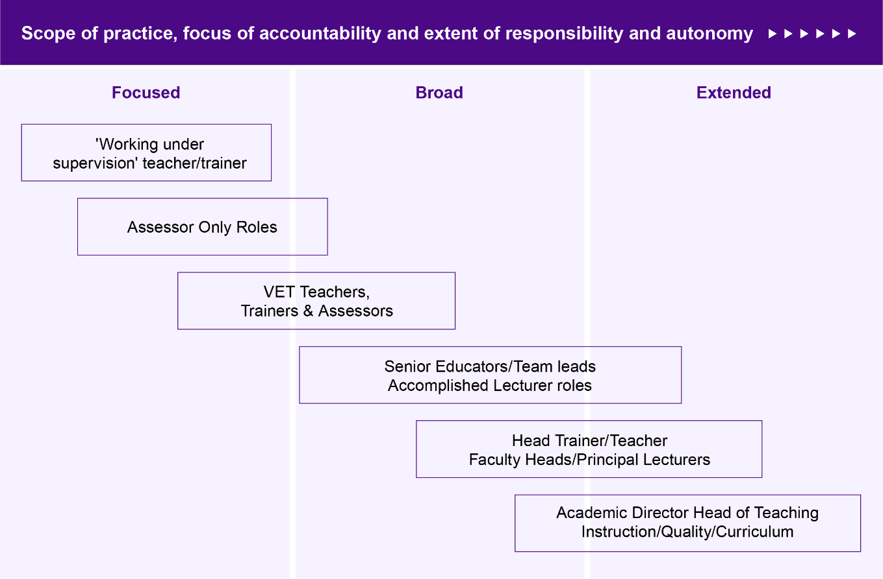
Workforce data from TAFE Queensland provides insight into the proportion of educator staff in a large RTO that make up different roles across the spectrum, as well as the diversity of work tasks they perform. In this organisation, ‘Foundation Educators’ work under supervision and make up a small proportion of the educator workforce (1.1%).
The bulk of educator staff are classified as ‘Teachers and Senior Teacher’ (63.2%) with a smaller proportion of ‘Leading Vocational Teacher’ (11.9%). TAFE Queensland also has on staff ‘Short Course Facilitators’ (.06%), ‘Community Education Lecturers and Teachers’ (0.2%), ‘Higher Education Educators’ (0.4%), ‘Associate Lecturers, Lecturers, and Senior Lecturers’ (1.3%). Finally, ‘Educational Team Leader’ make up 3.9% of the educator workforce.
Figure 3.3 Potential pathways and progressions into VET roles and segments
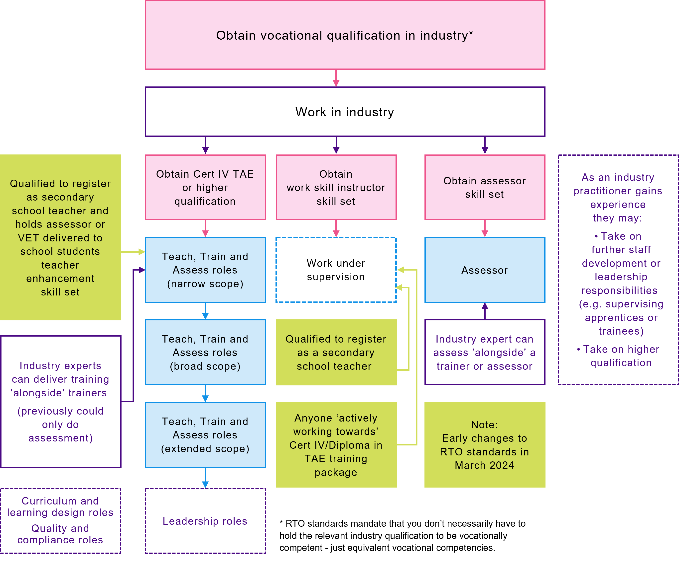

Focused Teach, Train, and Assess Roles
This section profiles entry-level and other focused Teach, Train, and Assess roles including the core duties of those working under supervision, assessing only or in the early years of their VET teaching career. It also profiles workplace trainers who are common in enterprise RTOs and embedded in industry and/or workplaces. These roles are focused on supervising and mentoring apprentices, delivering non-accredited training, managing training within the organisation, or delivering subject-only training in a volunteer capacity.

Entry level ‘working under supervision’ to established teaching roles
Working under supervision is a clear point of entry into the VET workforce for industry practitioners. Prior to March 2024, industry practitioners needed to have demonstrated specific skill sets and be working towards the Certificate IV TAE. However, from March 2024, any industry practitioner who is actively working towards the Certificate IV TAE and/or any Secondary School Teacher who is qualified to register in any state or territory, can teach under supervision in VET. This expands the entry pathways into VET teaching roles but with this change it will be important to uphold the unique offer of VET and need for adult education theory, practice and instruction (andragogy) in VET qualifications.

The main duties of a trainer and assessor operating under supervision may include:
- delivering training sessions for classroom, industry, distance or web-based learners in accordance with the relevant training product requirements under supervision;
- conducting assessment of learner capability using approved assessment strategies under supervision; and
- the more generalist duties of all VET teachers as outlined in Figure 3.4.
Trainers and assessors working under supervision may deliver a narrower range of units and potentially use learning and assessment materials that have been designed by someone else. They are also typically not responsible for the provider’s learning and assessment strategy for the units or qualifications they are delivering. However, they do develop their own pedagogical approach including teaching materials and instruction.
More broadly, across the spectrum of entry-level Working Under Supervision to more narrowly focused teaching roles there is less expectation to assess individual learner needs and put support strategies in place.
For example, the extent of authority of an entry/graduate-level trainer and assessor per the enterprise agreement classification standards in one large dual sector provider, is to refer learning difficulties to other program areas and/or staff. However, the level of expectation may differ based on the size of the RTO and the characteristics of the learner cohort.
For instance, an increasingly established trainer and assessor may be required to take a more active role in adapting teaching strategies and materials, to suit different learner needs at a small community-based provider delivering foundation skills training to adults with low language, literacy, numeracy, or digital skills.
Once a teacher, trainer or assessor gains the Certificate IV TAE credential, core duties largely remain the same but are not performed under supervision as outlined in Figure 3.5. Where a collective agreement is applicable, focused entry-level roles are generally described as Trainer and Assessor – Level A, Teacher – Level 1, Teacher – Base Grade, Lecturer – Grade 1, VET Tutor or other similar terms. For example, TAFE Queensland has a Foundation Educator pathway and TAFE SA positions teachers under supervision as ‘New Lecturers’.

Figure 3.4 ‘Working under supervision’ roles
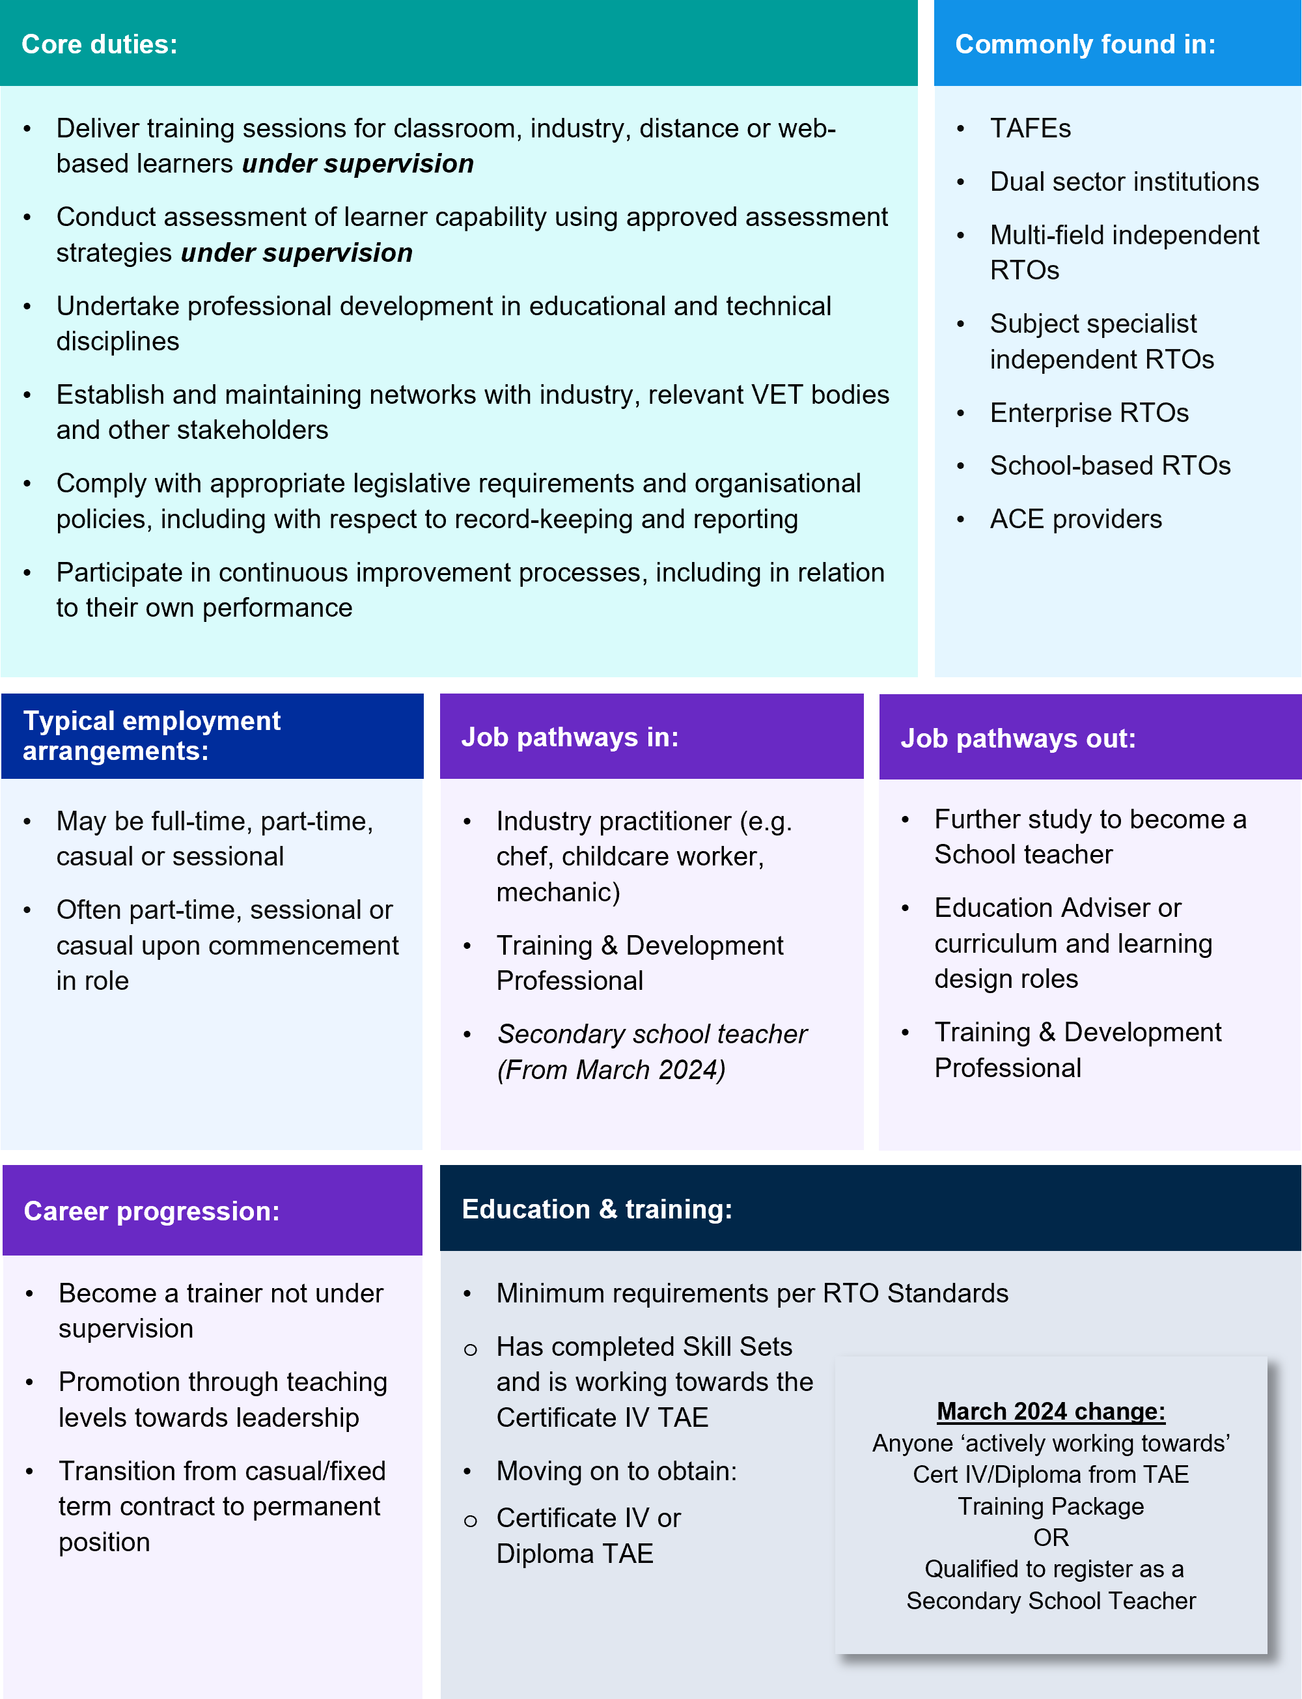

Figure 3.5 Teach, Train, and Assess roles with focused scope
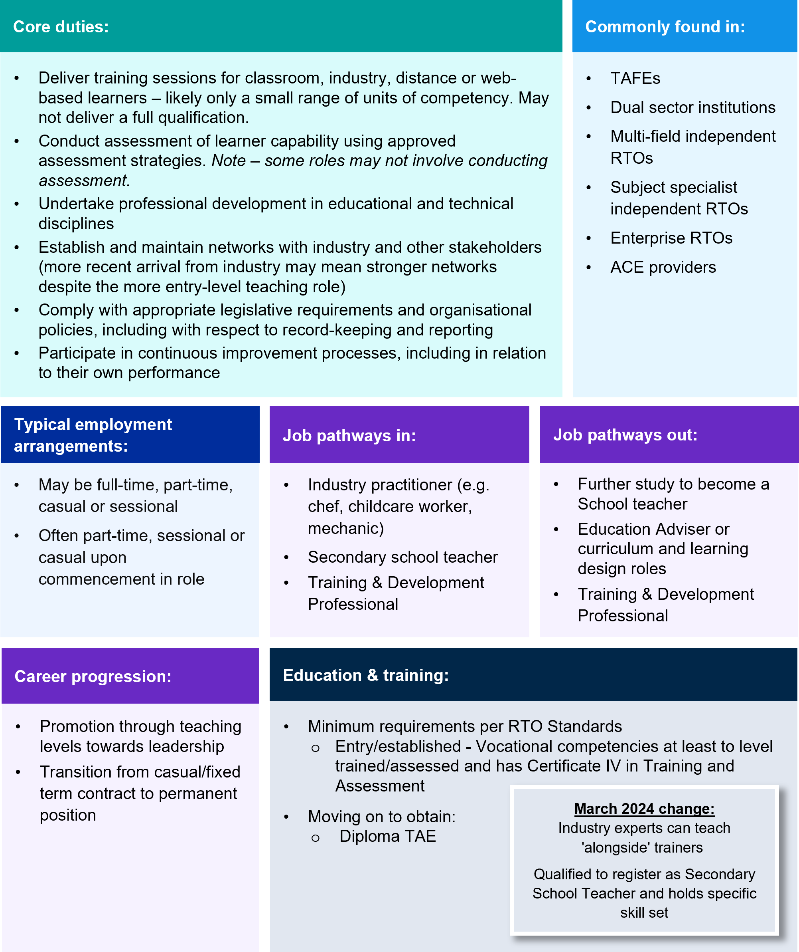
From the perspective of career progression, in some cases entry-level or focused teachers, trainers, and assessors are financially supported or motivated to complete the Certificate IV, Diploma TAE or Associate Degree, to secure more full-time permanent teaching work. For example, the CIT enterprise agreement provides the opportunity for permanent and temporary employees on a contract of 3 years or more, for a reduction of up to 150 hours in allocated annual teaching load for the attainment of an adult learning and development qualification. Industry training funds, such as the South Australian Construction Industry Training Board’s tradie2trainer initiative, is another example. In some cases, financial support is conditional on the trainer and assessor remaining with an RTO for a set period, e.g. at least 12 months. Other initiatives such as the TAFE NSW paid to learn program (see case study below), supports industry professionals to move into a VET teaching career through intensive paid training.
However, as we explore in the next chapter, relatively few teachers, trainers and assessors with the Certificate IV TAE pursue a diploma level qualification. This pathway is often more available and defined in larger providers, where this progression and relevant pay increments is outlined in enterprise agreements which incentivises further study.
In small RTOs with more limited positions for teachers, trainers and assessors, progression may also be closely intertwined with movement of other staff causing a vacancy to open. Alternatively, career progression for individuals who have recently entered the VET workforce may come in the form of moving from casual or fixed-term contract employment to a full-time permanent position.
Another factor impacting career progression or pathways into the Diploma VET teaching credentials is the funding of these in fee-free TAFE initiatives. The Certificate IV TAE only became part of fee-free TAFE from 1 January 2024 for all jurisdictions and only NSW and WA offer the diploma level TAE at no cost.
The various Skill Sets which offer entry-pathways into VET teaching, training and assessing roles – including LLND roles – are mostly only funded by one jurisdiction. The Assessor Skill Set, funded by NT and WA and the Work Skill Instructor Skill Set funded by ACT, TAS and WA are the two exceptions.

Box 3.2 Case studies of pathway programs to entry-level teaching
TAFE NSW Paid to Learn Program
The TAFE NSW Paid to Learn initiative enables participants to complete a Certificate IV in Training and Assessment qualification while being paid. The 14-week program aims to leverage the skills and experience of current industry professionals to help meet the increasing demand for VET teachers across TAFE NSW. Applicants are required to have a nationally recognised qualification in the discipline in which they want to teach and between 3 and 5 years of industry experience (depending on the industry).
Participants undertake intensive training consisting of 35 hours per week over 5 days, typically 8.00am to 4.00pm. Participants earn a teacher’s salary above $100,000 (for a full-time teaching role) while learning and undertaking practical training. The program provides tailored support, including mentors and other wraparound assistance and includes an extended professional development allowance of 72 hours per year in addition to membership of a Teacher Engagement Network.
The recent (March 2024) Commonwealth Government Senate Inquiry report on the perception and status of VET recommends increasing the supply of VET teachers through subsidising Training and Education (TAE) and the expansion of existing fast-track pathways, including the nationalisation of TAFE NSW’s ‘Paid to Learn’ program. Likewise, the NSW VET Review, also released in March 2024, reported stakeholders proposing similar initiatives such as a ‘Day a month’ campaign, to encourage more skilled people to enter into vocational teacher settings, enhancing their awareness of available VET opportunities.
TAFE Queensland Foundation Education Program
In the Foundation Educator Program, over 12-months industry experts complete a Certificate IV in Training and Assessment (fully funded) and practice their skills in a supervised environment, whilst being employed as a paid ‘Foundation Educator’. At the completion of their Certificate IV in Training and Assessment, Foundation Educators can then move to teaching or tutoring positions with TAFE Queensland.
TAFE Western Australia (TAFE WA) Advanced Industry Lecturers
The TAFE WA 2021 Agreement introduced Advanced Industry Lecturers (AIL) for highly regarded industry professionals new to teaching. The Agreement provides 160-hours off teaching over 2 years for new lecturers to enable them to gain their Certificate IV TAE.
TasTAFE Associate Teacher program
The Associate Teacher program with TasTAFE provides new teachers with a 1-year teaching contract to complete the Certificate IV TAE (fully funded), a reduced teaching load and mentoring/supervision by an experienced teacher. Upon successful completion of the Certificate IV in Training and Assessment qualification, and satisfactory performance within the role, the associate teacher will become a fully qualified teacher and a TasTAFE employee.

Assessor only roles
Assessor-only roles are focused roles where there is no training or teaching delivery responsibilities. The core duty of an assessor is to conduct assessment and assess competence. The minimum credential is the Assessor Skill Set. This skill set’s three units of study are indicative of the core duties of the role and are further outlined in Figure 3.6.
- TAEASS412 Assess competence
- TAEASS413 Participate in assessment validation
- TAEDES411 Use nationally recognised training products to meet vocational training needs.
Skilled assessors may also be responsible for conducting assessments for the recognition of prior learning (RPL). This determines the extent to which that individual meets the requirements specified in the training package or VET accredited courses. While a specific RPL unit is offered as an elective in the Certificate IV TAE (TAEASS514 Develop and implement plans for recognition of prior learning), assessors who conduct RPL assessments are typically senior or specialist.
Figure 3.6 Assessor only roles
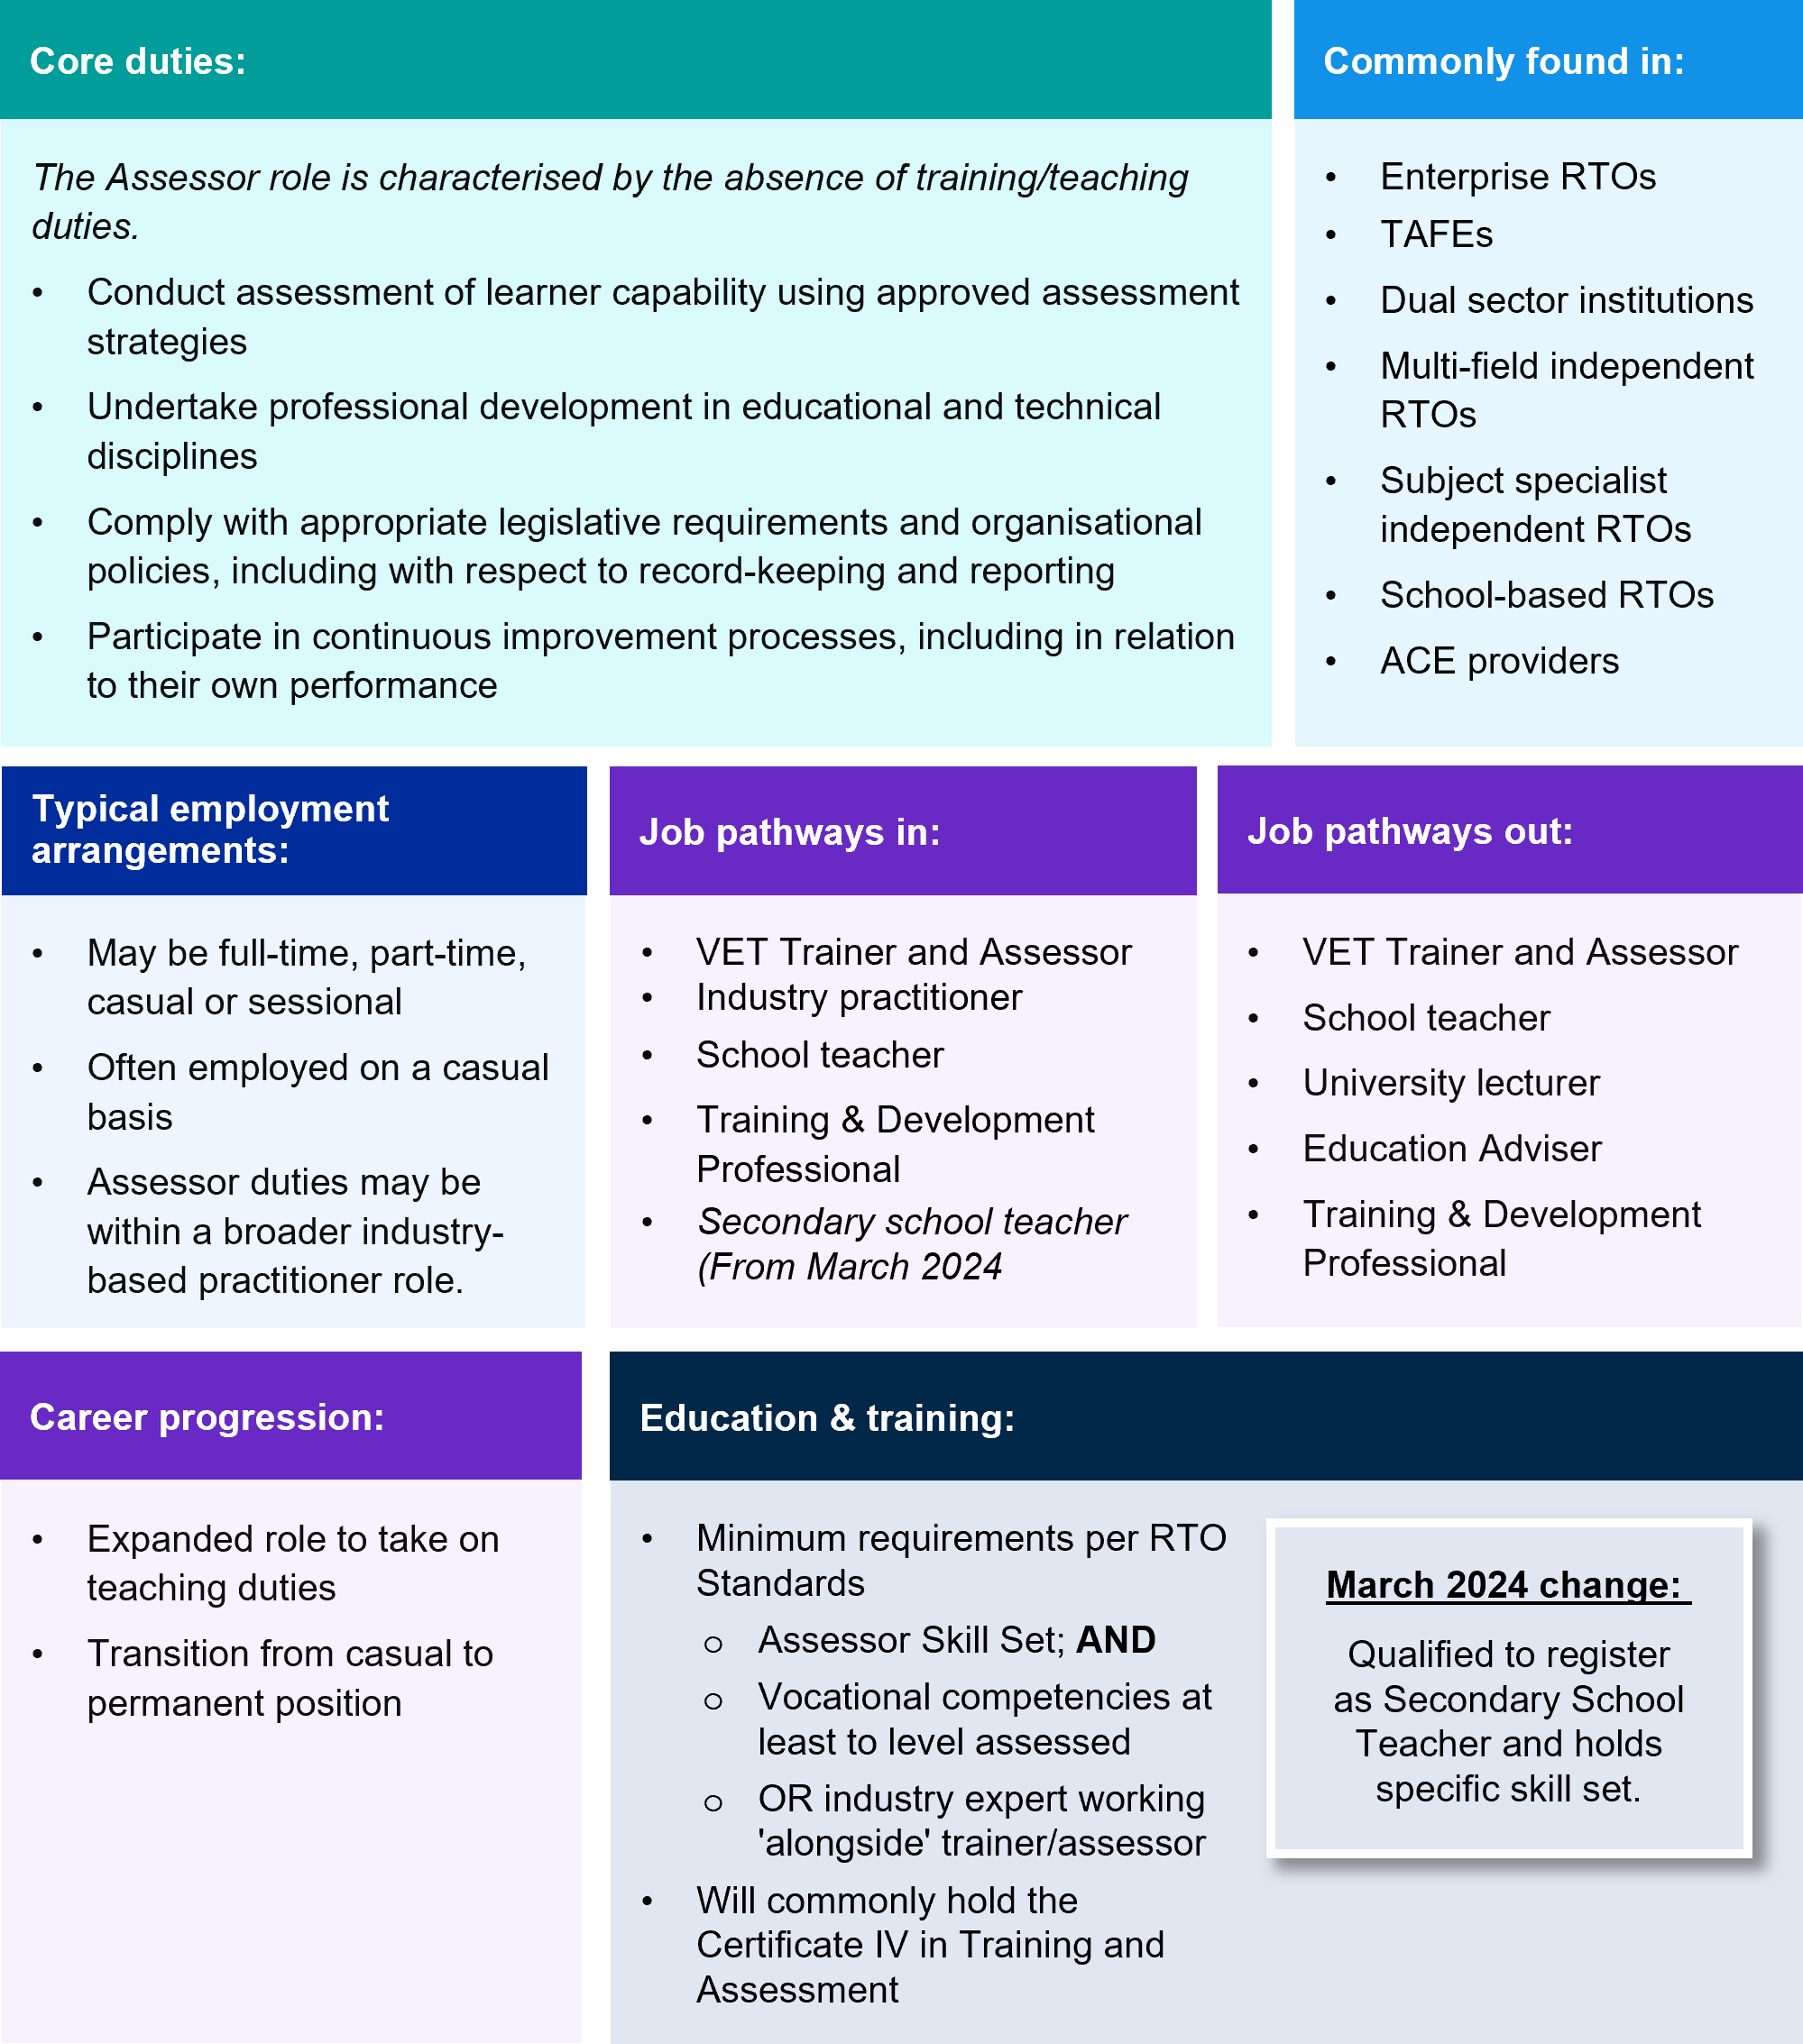
Assessors do not need to hold a Certificate IV TAE, but commonly do. This likely relates to the larger volume of the Assessor Skill Set which encourages many to undertake the full Certificate IV regardless. Thus, while the Assessor Skill Set does provide a shorter training pathway into VET, it is not particularly common and there is a tension between demonstrating current knowledge and skills in vocational training and learning and holding this short-form qualification. Holding the Certificate IV TAE is also considered best practice for assessors. See the next chapter for a discussion of broader increasing TAE Skill Set completions since 2016 against falling Certificate IV TAE completions over the same period.

Whilst the training pathways are like most other Teach, Train, and Assess roles in VET, assessors are commonly employed on a casual basis and are an attractive entry point to industry specialists or emerging experts who want to boundary span between industry and training. An assessor may move between industry and training and assessment roles as personal circumstances and preferences for more flexible working hours change. The role of assessor may also be attractive for those seeking to supplement their income while continuing to work in industry. Providers do engage assessors to provide for additional flexibility in managing the assessment load, particularly where enterprise agreements prescribe the hours that may be allocated to teaching and duties related to teaching (such as marking) as part of an individual’s total workload. This means that in some cases casual or part-time teachers also work as assessors at the same, or across multiple, providers to supplement income.
In one dual-sector institution, the assessor role is described as a VET Marker and is paid the hourly rate of a VET Teacher plus a 25% casual loading. Comparatively, the NSW Enterprise Agreement for TAFE Teachers and Related Roles (2023) includes a dedicated role for assessors without teaching and training duties under the Education Support Classification. Commencing from 1 February 2023, the assessor role had a set annual salary of $82,611, compared to the base level for VET teachers of $88,842 (7% less).

Workplace trainer roles
Another role in the more focused spectrum of teaching scope and responsibility is the workplace trainer. These roles are characterised by delivering training and assessment as part of an individual’s duties in their workplace or the workplace of a client. This role may also be described as an industry trainer, or an industry-based trainer and assessor. The core duties of a workplace trainer and assessor resemble those with a focused scope of teaching responsibility, though a workplace trainer and assessor may have greater responsibility to contextualise training to meet the specific needs of the enterprise or client. A workplace trainer and assessor will often deliver nationally recognised training alongside non-accredited industry training.
Workplace trainers and assessors are also well placed to offer mentorship or informal pastoral care to apprentices. People performing this role hold industry and workplace experience, while being removed from apprentices’ line management chain.
Workplace trainers are commonly found in enterprise RTOs, subject specialist RTOs, and RTOs only delivering single units of competency or skill sets rather than full qualifications. Particularly in enterprise RTOs, workplace trainers and assessors may be developed from within the enterprise as well as from the broader industry. Workplace trainers and assessors may progress within their current enterprise to more senior roles in training teams such as a Training Manager or Coordinator. The role may also provide a pathway to VET teaching in other contexts or to work as a Training and Development Professional.
Workplace trainers can also be volunteer roles where they deliver subject-only training such as CPR in volunteer workplaces such as surf lifesaving clubs or emergency service organisations. Figure 3.7 summarises the core duties of various kinds of workplace/industry/volunteer trainers.

Figure 3.7 Teach, Train, and Assess roles in the workplace/volunteer roles
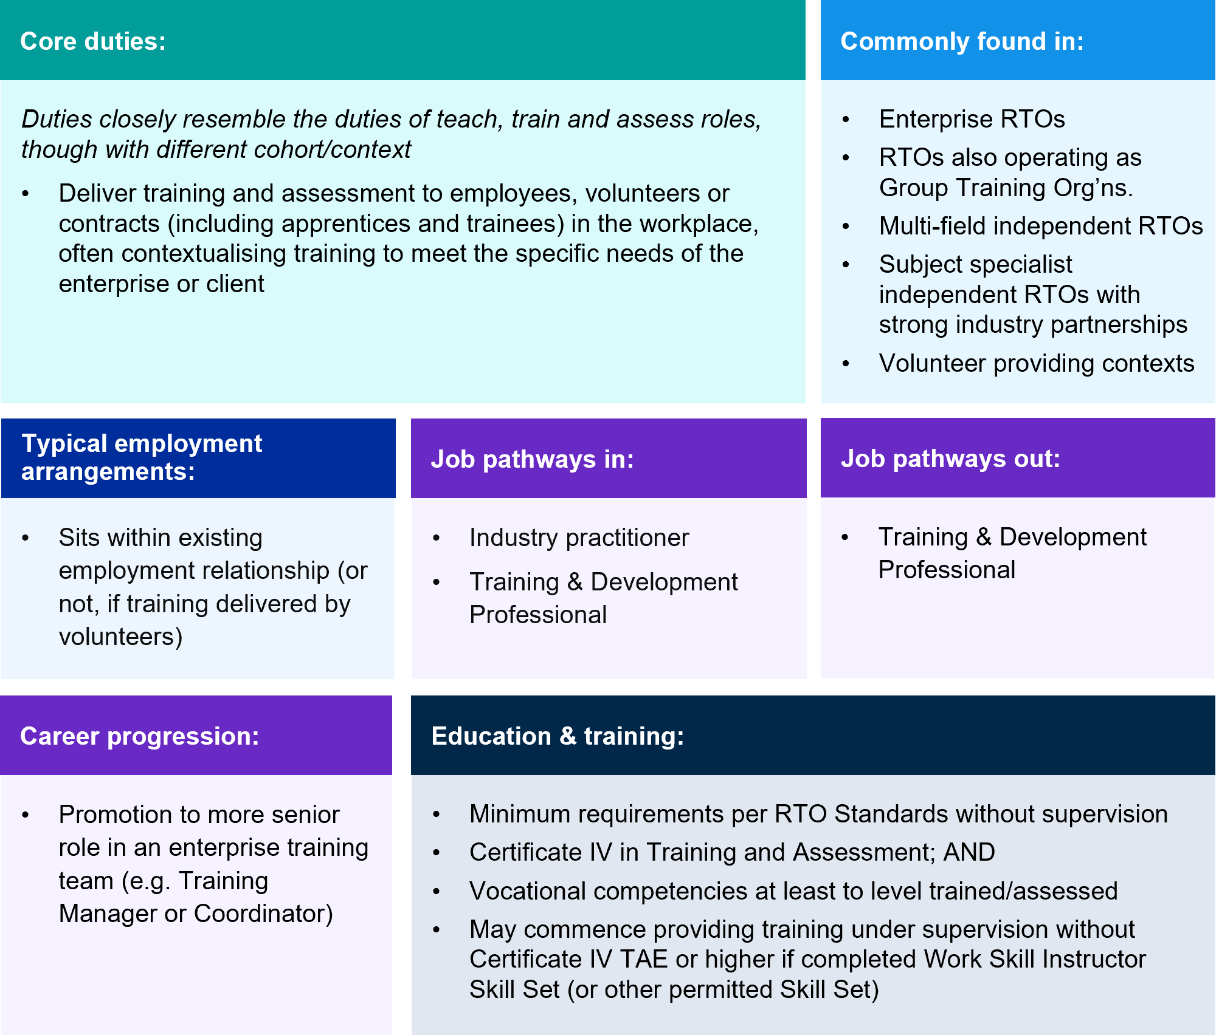

Broader scope Teach, Train, and Assess roles
Many teachers, trainers and assessors will progress to a broader level of responsibility and teaching scope through gaining higher qualifications or multiple years of teaching experience. The core duties of these roles are distinguished from a more entry-level or focused role by the extent to which trainers and assessors deliver a broader range of units and qualifications; mentor and supervise staff and lead industry engagement.
For example, workers at this level may lead place-based approaches for teaching or specific adaptions to service student cohorts. Stakeholders also reported that VET teachers upskill through Diplomas and Associate Degrees so they can play more of a leading role in interpreting training package changes.
Teachers, trainers, and assessors at this level will often report to the leader of a teaching team such as a head trainer or faculty or departmental head in larger RTOs, or an operations manager in smaller providers. At one private RTO based in Brisbane, a Trainer and Assessor – Level B requires a diploma or higher-level qualification in adult education or at least five years of experience as a trainer and assessor. At this RTO, further progression to Level C is linked to ten years or more experience.
A VET diploma qualification is a common requirement for these broader scope roles and job titles at this level are described broadly in enterprise agreements as Trainer and Assessor – Level B or higher, Teacher – Level 2 or higher or Senior Educator, Lecturer, Academic Teacher.
Other job titles at this level in EBAs, practitioner frameworks or progression levels specific to organisations collected for this study are: Accomplished Lecturer, Advanced Skills Lecturer Level 1, Team Leader, Senior Educator. Some of these roles crossover or move into more extended scope and responsibility, hence the spectrum approach to this initial occupational framework. For example, Senior Educator is common across different RTOs in both management type and size to articulate teachers who have broad or extended responsibilities.
Relative to their more entry-level or focused teaching counterparts, a senior trainer and assessor may be more likely to be in ongoing employment on either a full or part-time basis and pursue career pathways into leadership. Teachers with this broader scope are profiled in Figure 3.8.
This level may also be the entry point for some teachers, trainer and assessors who have completed a Diploma or higher-level qualification in adult education or who are shifting into VET as an experienced teacher or educator from another sector (e.g. secondary school education or higher education). However, as noted earlier, industry skills are still required and the unique pedagogical demands of VET teaching mean many providers still prefer a Certificate IV TAE credential.
Figure 3.8 Teach, Train, and Assess roles with broader scope
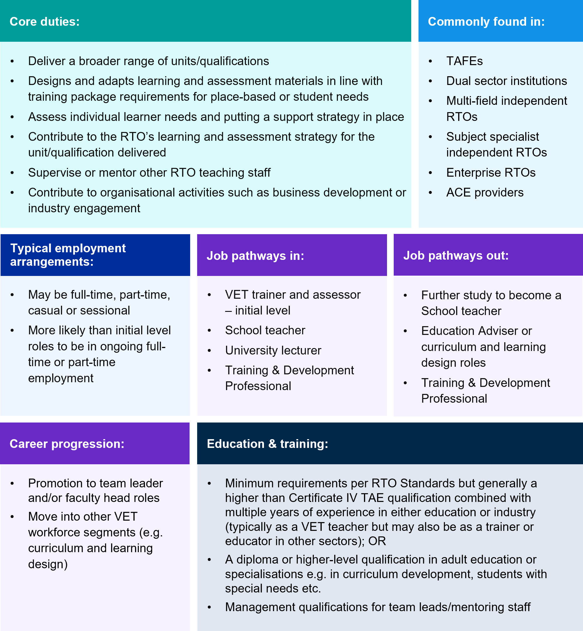

Extended scope Teach, Train, and Assess roles
Teachers, trainers and assessors with extended scope are responsible for a substantial program of training and assessment. A substantial program may be determined by a combination of volume of students, range of qualifications and units delivered, diversity of student cohort and level of additional learning support needs.
Job titles at this level may include Head Trainer, Head Teacher, Program Coordinator, Program Lead, Principal Lecturer, Advanced Industry Lecturer, Advanced Skills Lecturer Level 2, Senior Educator, Educational Team Lead, Faculty Head, Leading Vocational Teacher, or other similar terms. There is of course crossover with the leadership segment in these extended roles, especially in smaller or medium sized RTOs.
The duties associated with this level are distinguished from a practitioner with focused or broad scope and responsibilities, by the extent to which trainers and assessors' quality assure learning and assessment materials, teaching instruction and broader education supports and strategies. They also proactively lead organisational activities within their industry area and teaching supervision is usually a much higher part of their workload than face-to-face teaching. See Figure 3.9 for a detailed profile.
As the leader of their program or teaching team, a Head Trainer/Teacher, Faculty Head or Principal lecturer will typically report to a non-teaching senior leader within the provider, though with considerable autonomy over the educational aspects of their role. Individuals operating at this level will typically hold a diploma or higher-level qualification or combine the Certificate IV TAE with significant experience and expertise through ongoing professional development.
Those operating at this extended scope may move in and out of specialist learning design or quality assurance and compliance roles as a career break from teaching, or specialisation. They may also progress into senior management roles in a provider. Acting roles are common for these managerial positions but tend to be short-term and can be disruptive when teachers return to their substantive positions.
It is also worth noting that some senior teachers would rather remain in substantive teaching roles, but career progression opportunities in such cases can be limited. Also, some teachers do not want to move into management or non-teaching roles due to perceptions of high administrative and compliance workloads, and lack of support from other leaders.
In acknowledgement of this, the most recent review of the Training and Education Training Package considered Braithwaite’s (2018) recommendation to create career paths to teaching excellence. Indeed, the different teaching practitioner frameworks and progressions through various EBAs are an indication that in many parts of VET this is already common practice.
Figure 3.9 Teach, Train, and Assess roles with extended scope
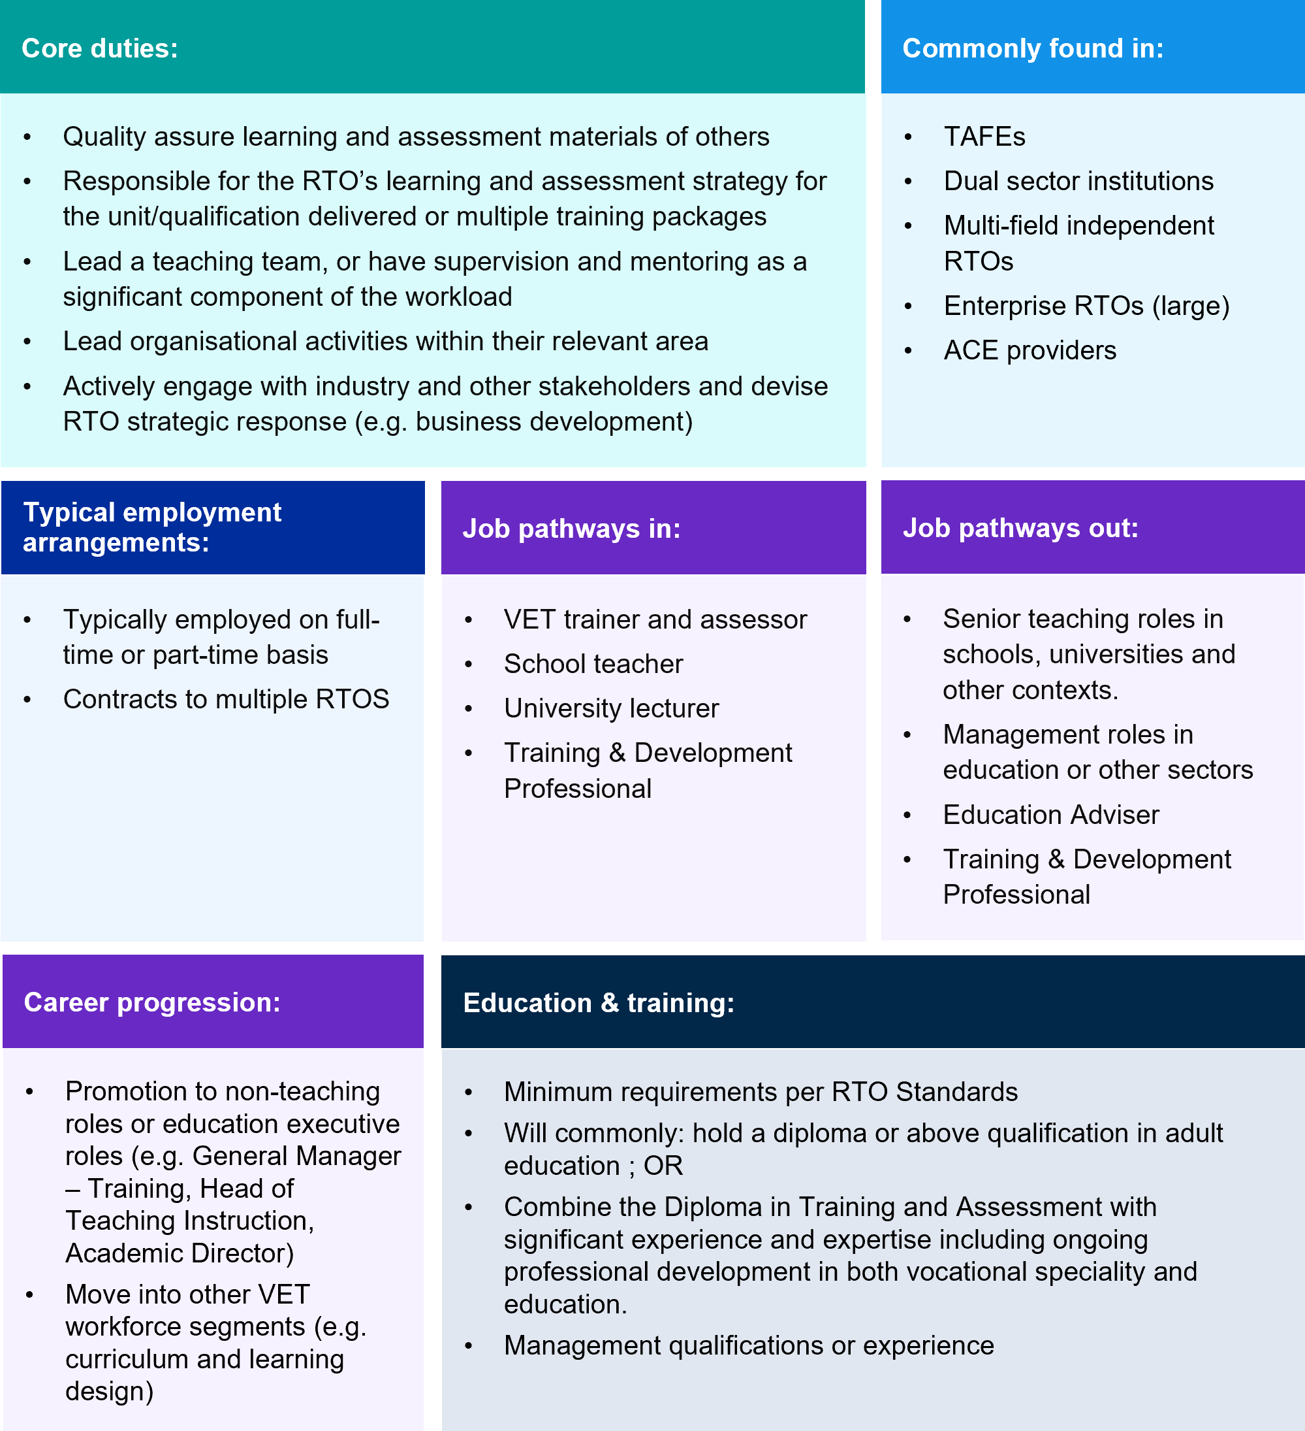

Specialised teaching roles: VET in secondary schools, literacy, and numeracy teachers and TESOL teachers
The VET system encompasses a broad range of provider types and delivery contexts as well as serving a range of purposes from developing vocational skills for a particular industry, to providing literacy and numeracy skills to enable active participation in further education and employment, including VET qualifications. The context in which VET teachers, trainers and assessors operate can have a significant impact on their job role.
It may also shape the extent to which individuals identify more strongly with their industry identity, or their teaching one. This self-identification may be an important factor in an individual’s willingness to invest in developing their pedagogical skills in the case of VET capabilities on one hand, or industry skills, currency and connections on the other. These sentiments are especially relevant for specialist VET teaching roles which are the topic of the next section.
VET roles in secondary schools
According to NCVER, there were nearly 243,000 VET school students in 2022 and there are various models of delivering VET in this context, as per Figure 3.10. These models shape the core duties, typical employment characteristics, and qualifications of VET in secondary school (VETDSS) roles, see Figure 3.11.
For example, where an external RTO delivers or auspices the training and issues qualifications, the job profile of the trainer and assessor closely resembles that of trainers and assessors in other contexts but may require capability development for delivering training and assessment to a secondary school student cohort, such as working with children and managing behaviour.
In contrast, model 1 (Figure 3.10) requires those delivering the training to navigate the requirements of both the 2011 Framework for Teacher Registration in Australia and the Standards for Registered Training Organisations 2015.
Figure 3:10 Five models of VET delivery to secondary students in Australia
Model 1 | Model 2 | Model 3 | Model 4 | Model 5
School/school sector as RTO delivers training and issues qualifications. | School is auspiced/partners with external RTO – school delivers training, qualifications issued by RTO. | School engages RTO to deliver training (within the school or externally). RTO delivers training and issues qualifications. | Students attend external RTO – this could be a TAFE, another school, or a private RTO. | Students undertake school-based apprenticeship – attend RTO (either school or external RTO) and employment external to the school.
Source: AITSL 2021, Building a high quality and sustainable dual qualified VET workforce

As illustrated in Figure 3.11, where employed by a school rather than an external RTO, a secondary school VET Teacher may also carry an additional school-related workload (e.g. yard duty, supervision of extra-curricular activities and pastoral care responsibilities).
In such cases, a secondary school VET teacher will commonly be recruited from within the school’s existing non-VET teaching staff. Stakeholders in the schools’ sector suggested that dedicated VETDSS teachers are rare, except in large schools with trades training centres and most are teachers undertaking VETDSS in addition to the regular curriculum.

Figure 3.11 VET in Secondary Schools role
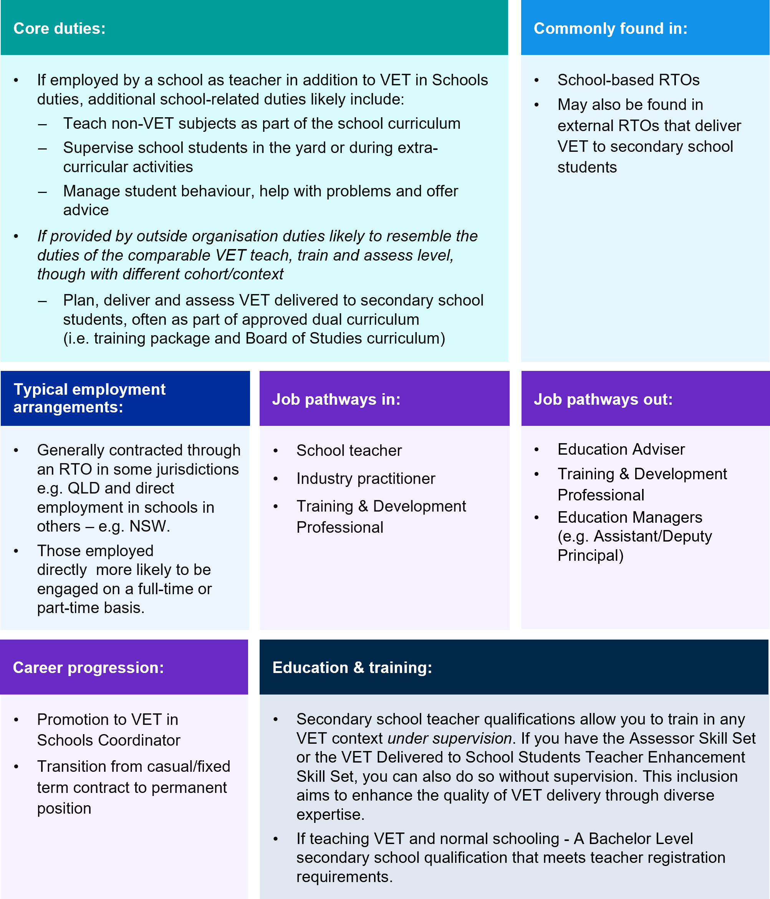
‘Foundation Skills Teachers’ support students to build adult literacy, numeracy, digital literacy and employability skills (LLNDE), see Figure 3.12. These include core skills like collaboration, problem solving, teamwork and engagement with technology. These specialist teachers require deep expertise in education and often enter VET from other teaching professions and or community roles where literacy and numeracy skills and training is a central service.
Unlike other VET teachers, currency in a particular industry is not as valued as a teaching qualification and experience or substantial professional development in literacy and numeracy for example. This part of the VET workforce is also diverse from both a job role and training delivery perspective. For example, some stakeholders saw job roles across three categories: Foundation Skills more broadly (LLNDE); Literacy and Numeracy where some digital skills may be taught (either LN or LND) and Language Literacy and Numeracy (LLN).
These differences in job roles also relate to different training qualifications and programs. These teachers can deliver standalone qualifications like the FSK10219 – Certificate I in Skills for Vocational Pathways; accredited courses designed as alternatives to a Senior Secondary School certificate such as the 11225NAT Certificate IV in Tertiary Preparation; or area teach more closely in partnership with vocational areas (such as providing additional accredited or non-accredited training alongside pre-apprenticeship training in electro-technology or construction).
There are also forms of state accredited courses that are more focused on literacy and numeracy skills such as the Certificate in General Education for Adults (CGEA) which is used in NSW, Victoria, Tasmania and the NT. This and other courses differ from the Foundation Skills training package which is intended to develop literacy and numeracy skills for completing a VET qualification.
These specialist teachers may also instruct specific cohorts of learners through targeted providers – like new migrants (e.g. through settlement service AMES), First Nations people (e.g. through remote training hubs), people with disability (e.g. Deaf Connect), or when delivering VET in prisons.
Across providers, NCVER research found 44.1% of learners enrolled in foundation skills course spoke a language other than English at home, 7.7% were First Nations, and 15.8% were people with disabilities. In addition to developing practical LLN and employability skills, foundation skills providers report improved self-confidence and development of ’soft skills', important for employability and social inclusion.
Where LLNDE-specific classes are unavailable, learners for whom English is their first language may be placed in an ESOL class. Providers have noted that this can be alienating and not meet learner needs.
Figure 3.12 Adult literacy and numeracy teachers
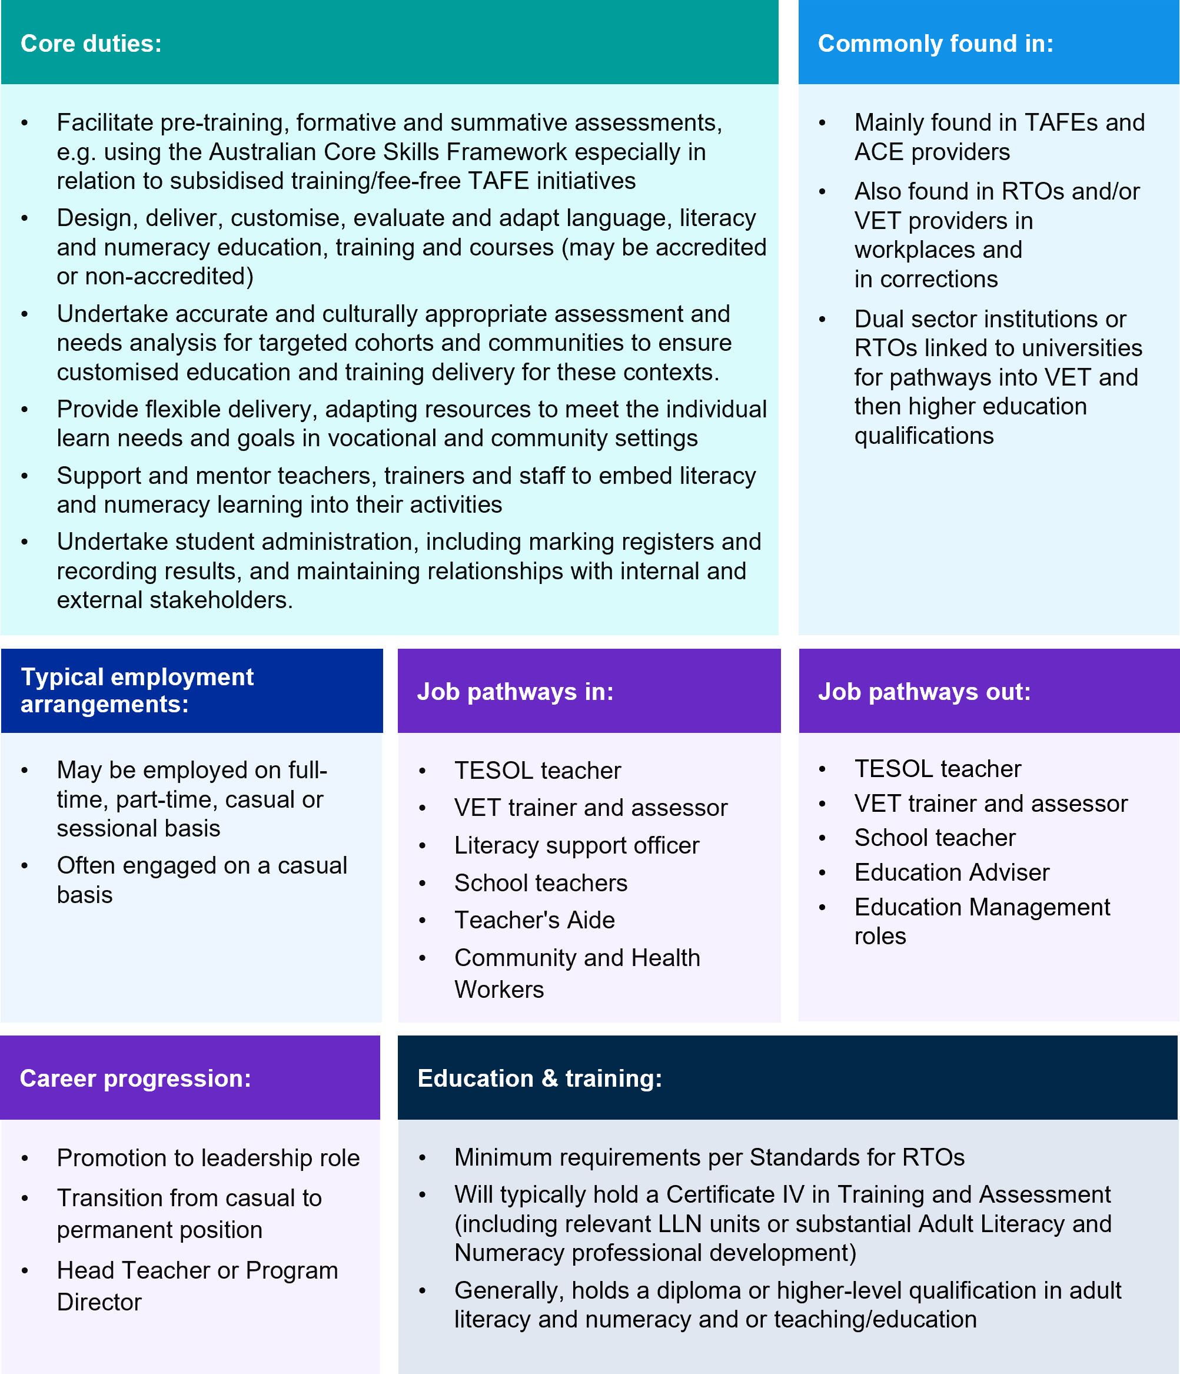

The demand for ‘foundation skills’ teachers is likely to increase with current government reforms. As noted in Chapter 1, the NSA in particular commits to better serve the one in five Australians who have low literacy and numeracy skills including by providing no – or low fee access to foundation skills training for learners with an assessed need.
Additionally, as part of the 2023-24 Budget, the Government is introducing a re-designed Skills for Education and Employment (SEE) program from 1 July 2024, to improve access to foundation skills training for all Australians with LLNDE needs. Alongside this growing importance, there is a declining availability of graduate adult literacy and numeracy teaching courses, posing a challenge to replenishing the stock of leaders and specialists in the field. In a survey of 382 providers, 32% cited lack of qualified teachers as a barrier to delivering LLNDE programs.
TESOL teachers (those teaching English to speakers of other languages) also play an important role in developing foundation skills, see Figure 3.13. TESOL teachers may also be described as English as a second language (ESL) teacher/English as an additional language (EAL) teacher or other similar terms. Related groups of teachers include those teaching other languages, such as Aboriginal languages and Auslan capabilities.

Figure 3.13 TESOL teachers
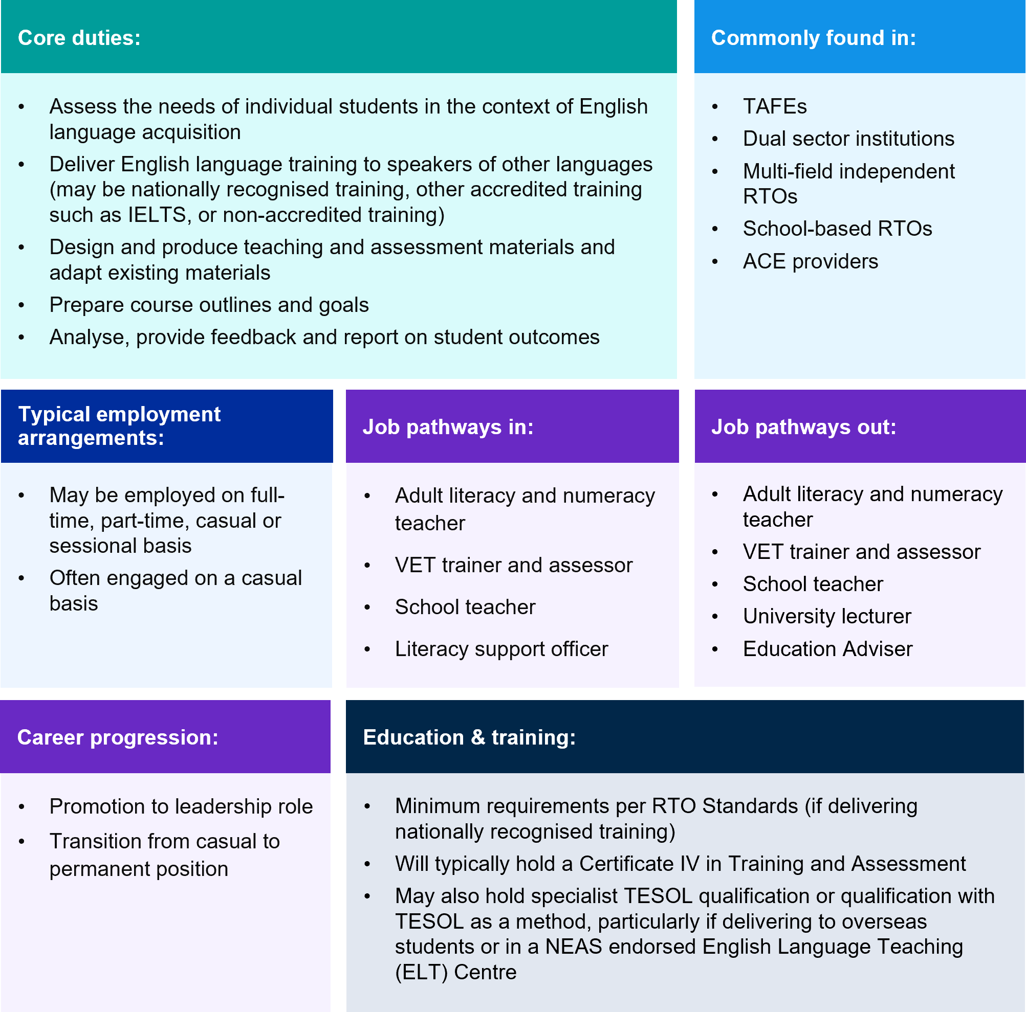

Quality Assurance and Compliance
The quality assurance and compliance segment of the VET workforce ensure the operations of the provider comply with RTO Standards and training package requirements and other regulatory or funding requirements, such as State or Commonwealth government contractual conditions, apprenticeship requirements, Work Cover authorities, and maintaining relevant approvals from occupational licensing bodies and professional and industry accrediting bodies.
This function is required across all provider types. However, smaller providers may absorb this function within teaching or manager roles or procure services externally. This is especially the case at times of training package changes when RTOs often employ ‘surge’ workforces in both quality assurance, compliance, and curriculum specialist roles.
Relevant job titles for this segment of the VET workforce include Compliance and Quality Officer, RTO Compliance Officer, Quality Officer, Education Quality Consultant, Compliance and Audit Coordinator and other similar terms.
Figure 3.14 Quality assurance and compliance roles
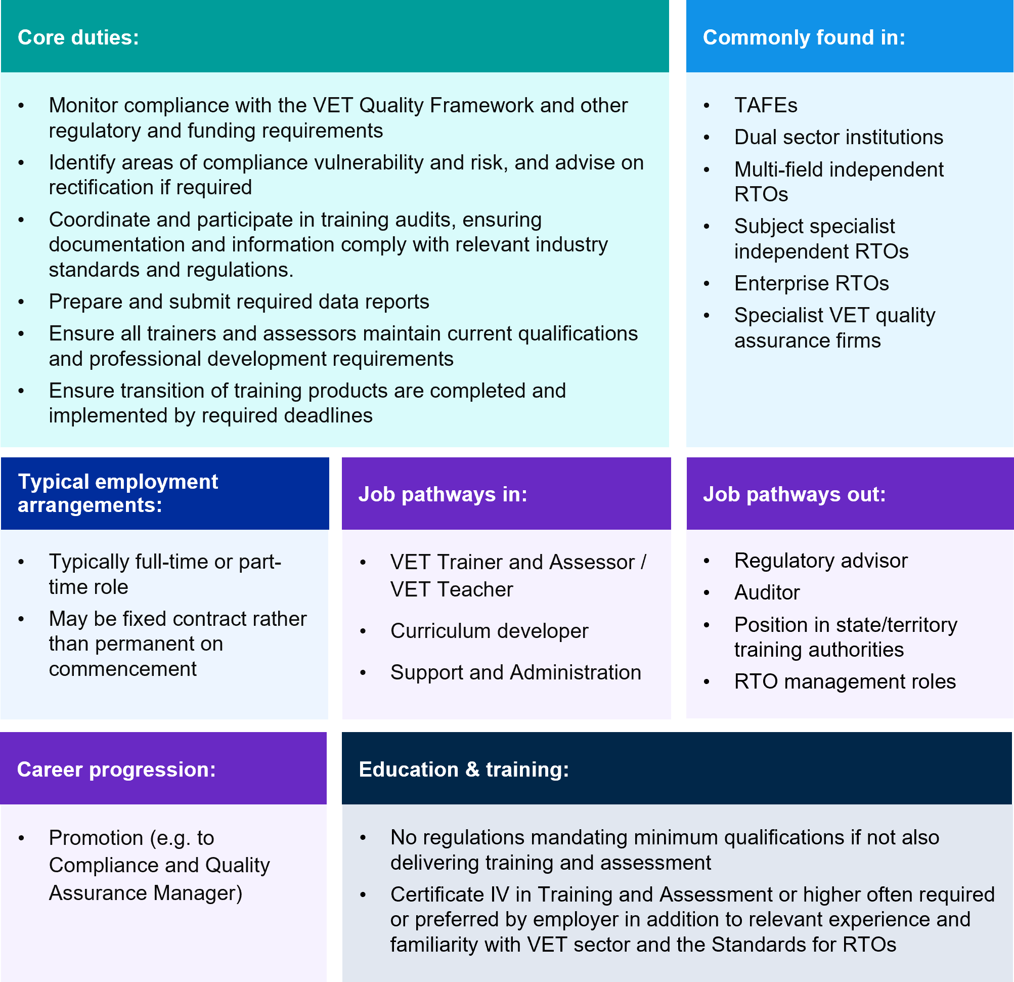
In addition to the core duties outlined in Figure 3.14, those in quality assurance and compliance roles may be responsible for providing advice and support to other staff on how to meet regulatory and contract requirements. Previous research has indicated that the workload associated with compliance and a fear of being found non-compliant can have a significant impact on teacher motivation and retention. This segment of the VET workforce therefore has an important role in supporting efforts to retain VET teachers, trainers, and assessors.
Subject to the responsibility of the role, some employers may require specialist auditing or compliance qualifications (e.g. 11075NAT – Certificate IV in Vocational Education and Training Compliance, BSB50920 Diploma of Quality Auditing, 10980NAT Graduate Certificate in Compliance and Risk Management).
Alongside other VET experience, pathways into quality assurance and compliance include experience in regulation and quality from other sectors (such as aged care or childcare) and demonstrating knowledge of the RTO Standards.

Curriculum and Learning Design
As outlined earlier regarding job profiles, teachers, trainers and assessors across the spectrum from working under supervision to extended scope, play a key role in developing learning materials and delivering training packages in line with different student needs and unique place-based contexts. The Curriculum and Learning Design segment of the VET workforce extends this work, and roles in this segment have a narrower focus on developing the best training needs, designs, solutions, and products to meet the needs of industry, clients and students.
Those employed in this segment may also have a role in evaluating the effectiveness of training programs and providing advice to more junior teachers, trainers and assessors on new and emerging training and assessment approaches and technology. There are generally three types of roles in this segment.

Curriculum specialists, instructional and or learning designers
VET curriculum development must balance consistency (through nationally recognised, competency-based training products) and flexibility (through provider autonomy over how training is delivered). Curriculum specialists are a critical component in how providers navigate this balance, especially at times of training package changes as noted above.
In smaller providers, this function again may be absorbed within teaching or manager roles This again indicates the crossover between this segment and Teach, Train, and Assess roles, see Figure 3.15. Curriculum specialists may also be called curriculum developers, instructional or learning designers, education advisors, learning and development specialists, and curriculum coordinators.
Figure 3.15 Curriculum specialist and instructional/learning designer roles
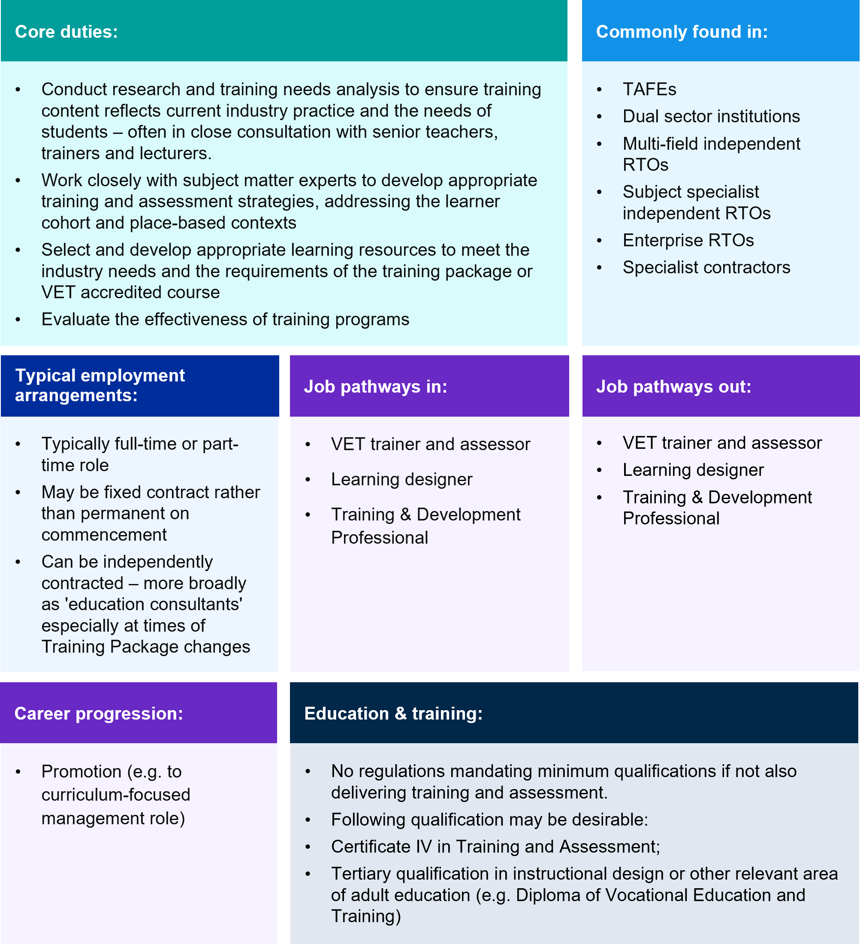

Learning designers (digital specific)
The proportion of VET subjects delivered entirely online increased 24% between 2019 and 2020 largely due to the onset of the COVID pandemic. However, many providers are retaining online delivery modes post-COVID. In fact, the greater change, and a potential emerging trend, is the growth in blended delivery and an associated decline in VET subjects delivered without any online component. In 2021, 62% of providers and 93% of TAFEs surveyed indicated they are likely to use more blended learning in the future.
With more VET courses delivered at least partially online, greater digital skills are required for VET teachers, who are older on average than the workforce as a whole and may have come from an industry background which demanded little digital engagement.
Thus, eLearning specialists and support officers (see learning support segment) have begun to play an increasing role in supporting the VET teaching workforce to deliver online teaching. These digital learning design roles are focused on developing training and assessment resources for e-learning platforms and are also described as Digital Designer, Learning Technology Designer, eLearning Designer, and Digital Experience Developer. Like curriculum specialists, these eLearning roles can also be outsourced.

Figure 3.16 Learning designers, including e-learning designer specialisations
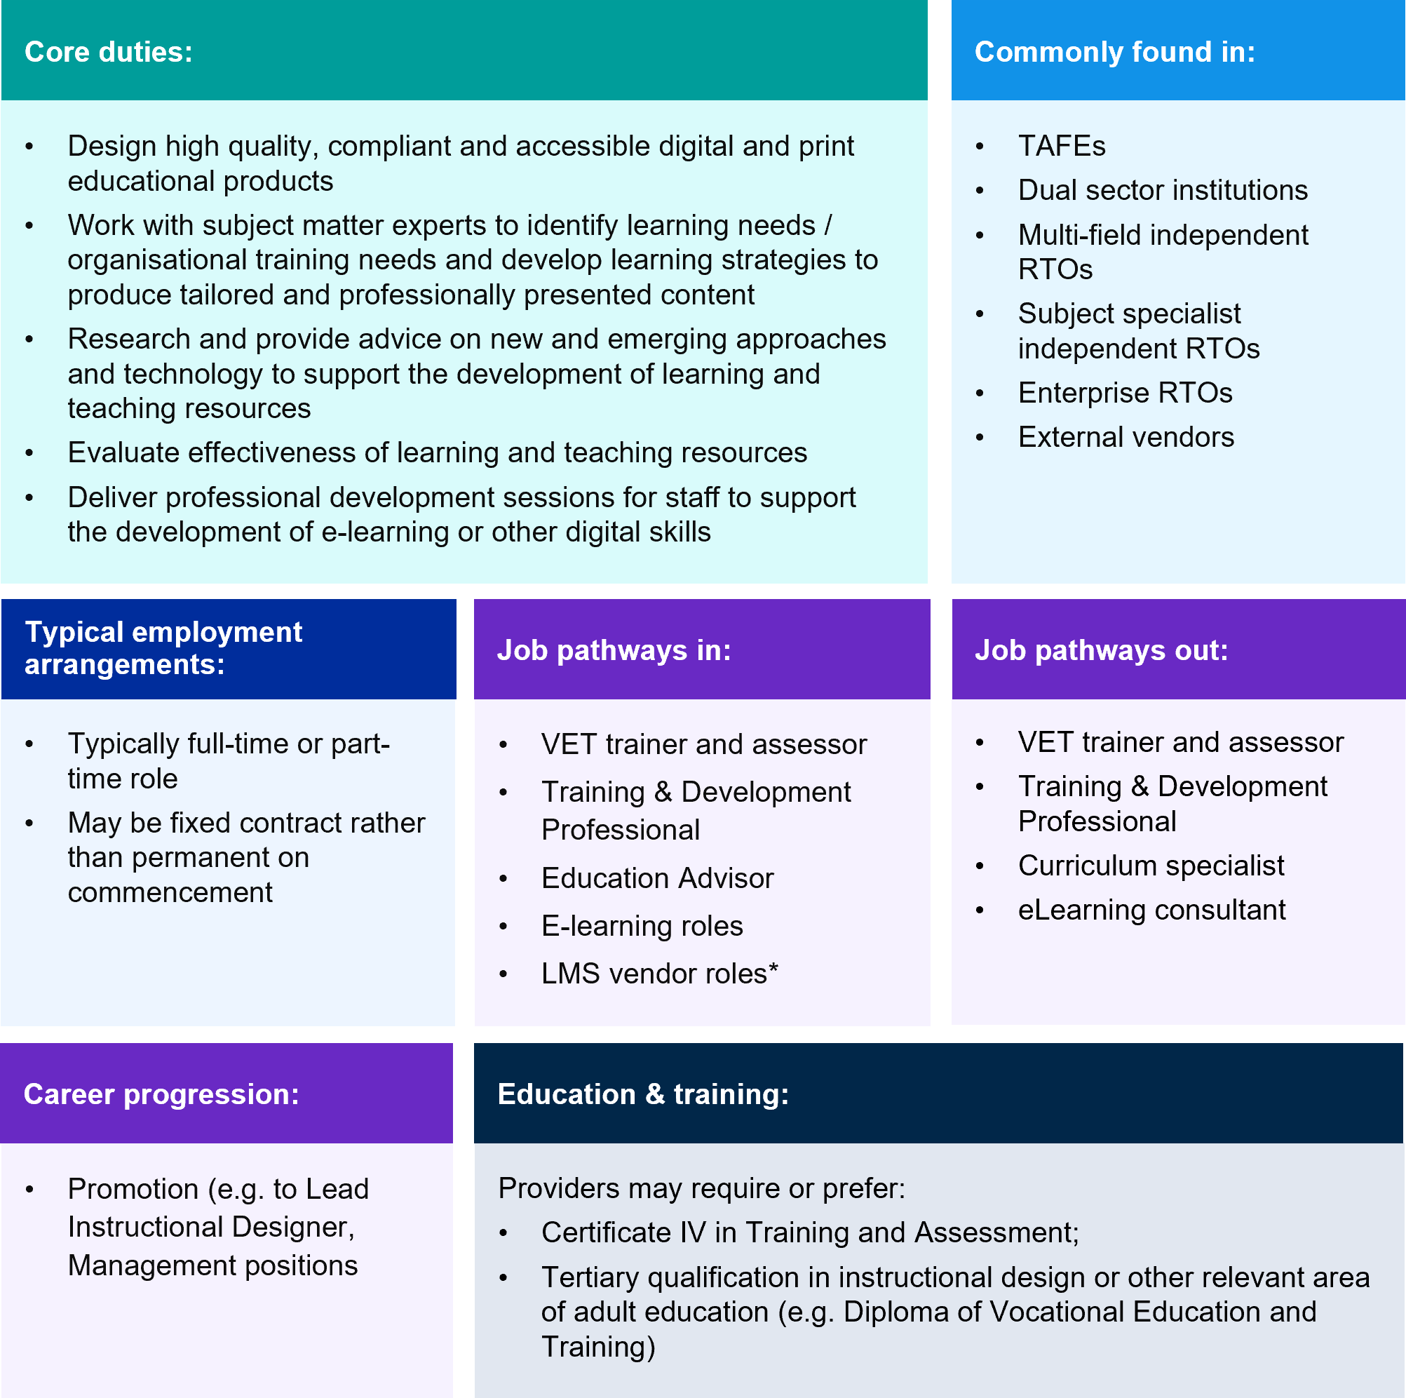
For learning designers, relevant experience in instructional design and the use of Learning Management Systems (LMS) and other digital technologies is common. Indeed, some learning designers in VET move from roles with LMS vendors. Pathways from within the VET sector may also include experienced VET teacher, trainer or assessors and curriculum specialists.

Leadership
VET leadership roles range across areas such as training services, stakeholder relationships and corporate services, and encompasses management positions in each of the VET workforce segments (see Figure 3.17). Relevant job titles include:
- Cross-cutting roles: Chief Executive Officer and Managing Director, RTO Operations Manager and Director of Strategy Performance & Governance
- Teach, Train, and Assess focused leadership roles: Head Teacher, Head Trainer, Director – Training Services; General Manager – Training; Program Coordinator, VET in Schools Coordinator, Course Coordinator, Training Coordinator, Educational Team Leader, Principal Lecturer.
- Quality assurance and compliance focused leadership roles: RTO Compliance Coordinator; Compliance Manager; Quality Assurance Manager; Team Leader – Quality Assurance.
- Curriculum and learning design focused leadership roles: Manager – VET Curriculum, Director – Curriculum Unit eLearning Manager; Chief of Academic Excellence and Innovation.
- Student experience and wellbeing roles: Chief Wellbeing Officer; Chief Student Officer.
- Business development and industry engagement roles: Community and Industry Engagement Manager, Business Development Manager.
Because of this diversity, the capabilities required by VET leaders will differ. VET leadership roles in areas such as corporate services, may require similar skills and capabilities to similar positions outside of the VET sector. As such, pathways for these roles may be from outside the VET sector. Where VET-specific skills, knowledge and experience are required, leadership and managerial roles represent an opportunity for career progression from one or more of the other workforce segments.
In general, VET leaders deal with the tensions between competition and regulation and deploy commercial practices in ways sensitive to educational objectives. They both manage industry clients and manage the expectations of governments. Leaders also set the cultural tone in their institutions by modelling their values and encouraging employees to do the same. This is important to the working ethos and quality of working environments for the broader VET workforce, and thus outcomes for students and their employers.
The VET leadership segment has a higher level of education compared to the VET workforce, with 63.6% of this part of workforce holding qualifications at undergraduate level compared with 49.4% across the total VET workforce). In addition to a qualification commensurate with the complexity and responsibility of their role, leaders and managers are also required to possess a significant level of relevant experience and expertise.
Figure 3.17 VET Leadership
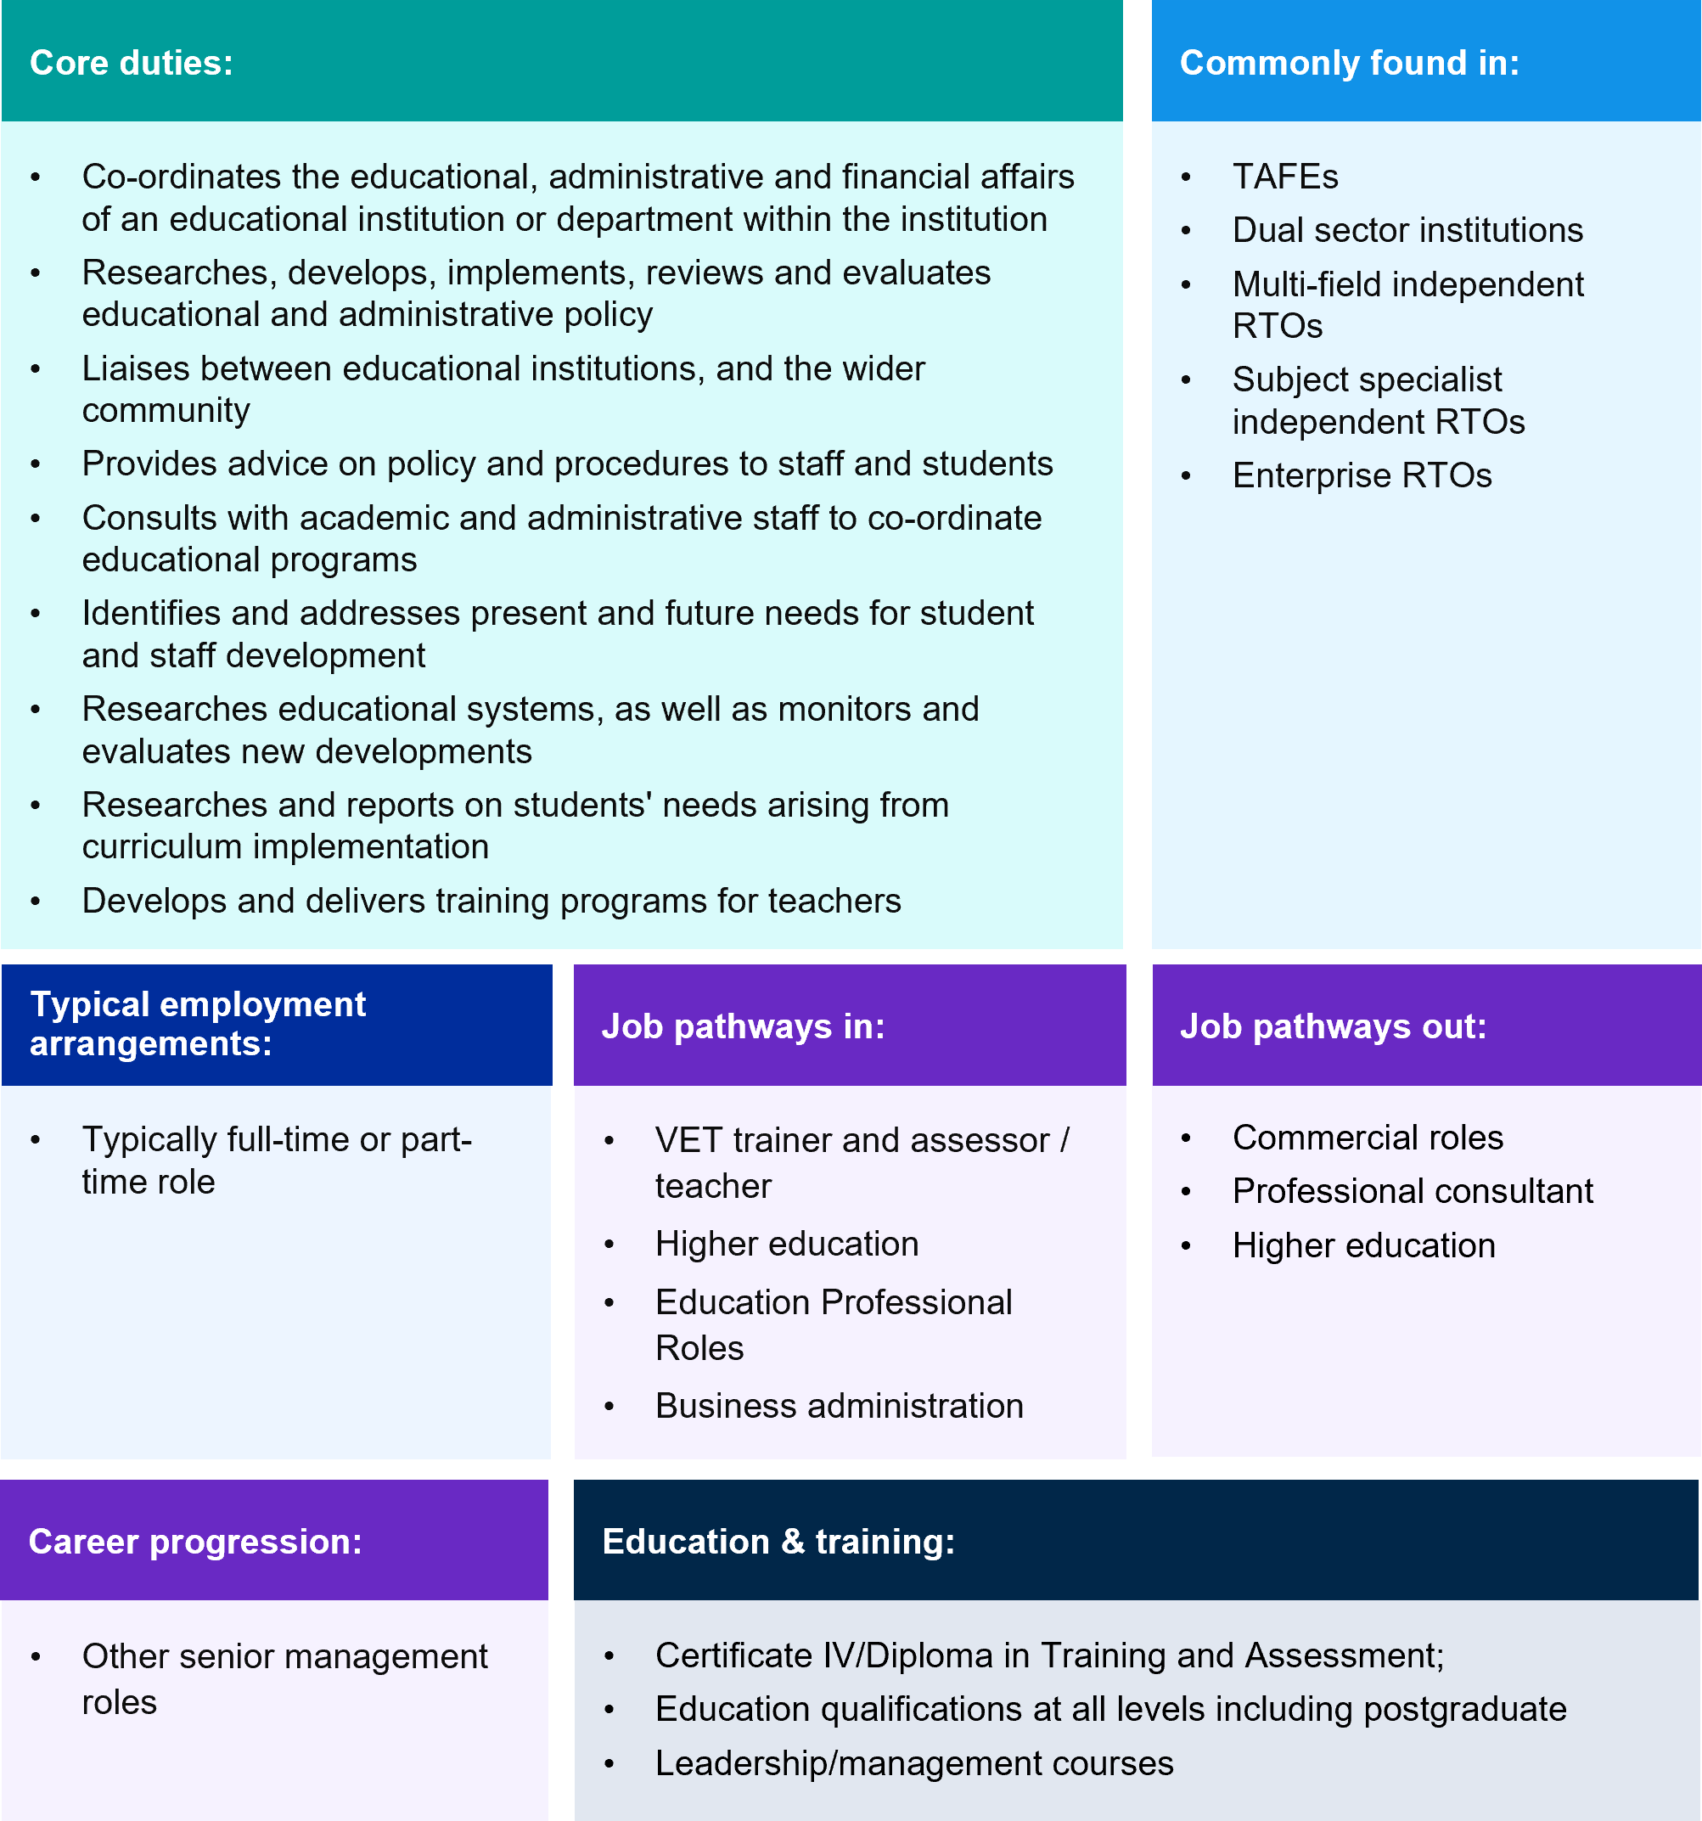
The leadership and management function is common across all RTO types, though roles and responsibilities will vary according to the size and complexity of an RTO’s operations. See Figure 3.18, Figure 3.19 and Figure 3.20 for a selection of organisation charts showing the range of leadership levels and reporting structures at different RTOs.
For example, in large RTOs with a diverse scope of delivery and multiple campuses an individual leader may coordinate the educational, administrative, or financial affairs of a particular department or location within the RTO. Figure 3.18 depicts part of the organisation chart of a larger public provider focusing on its curriculum and learning design function. Here, academic quality is monitored and maintained by a network of leadership staff with a relatively high degree of organisation complexity compared to medium and small RTOs.
In smaller and potentially more specialised RTOs a leader may have more wide-ranging responsibilities across domains such as teaching, curriculum and learning design, compliance, and administration. Figure 3.19 depicts the organisation chart of a medium sized RTO specialising in the delivery of agricultural training and highlights the breadth of oversight responsibilities of the operations manager.
In an even smaller RTO, particularly those operating in niche markets, it is likely that the CEO takes on a central directive role and works with a small managerial hierarchy with few support staff. The CEO and management team are also more likely to be directly involved in teaching, training, and assessment amongst other roles (see Figure 3.20).

Figure 3.18 Large training provider example organisational chart
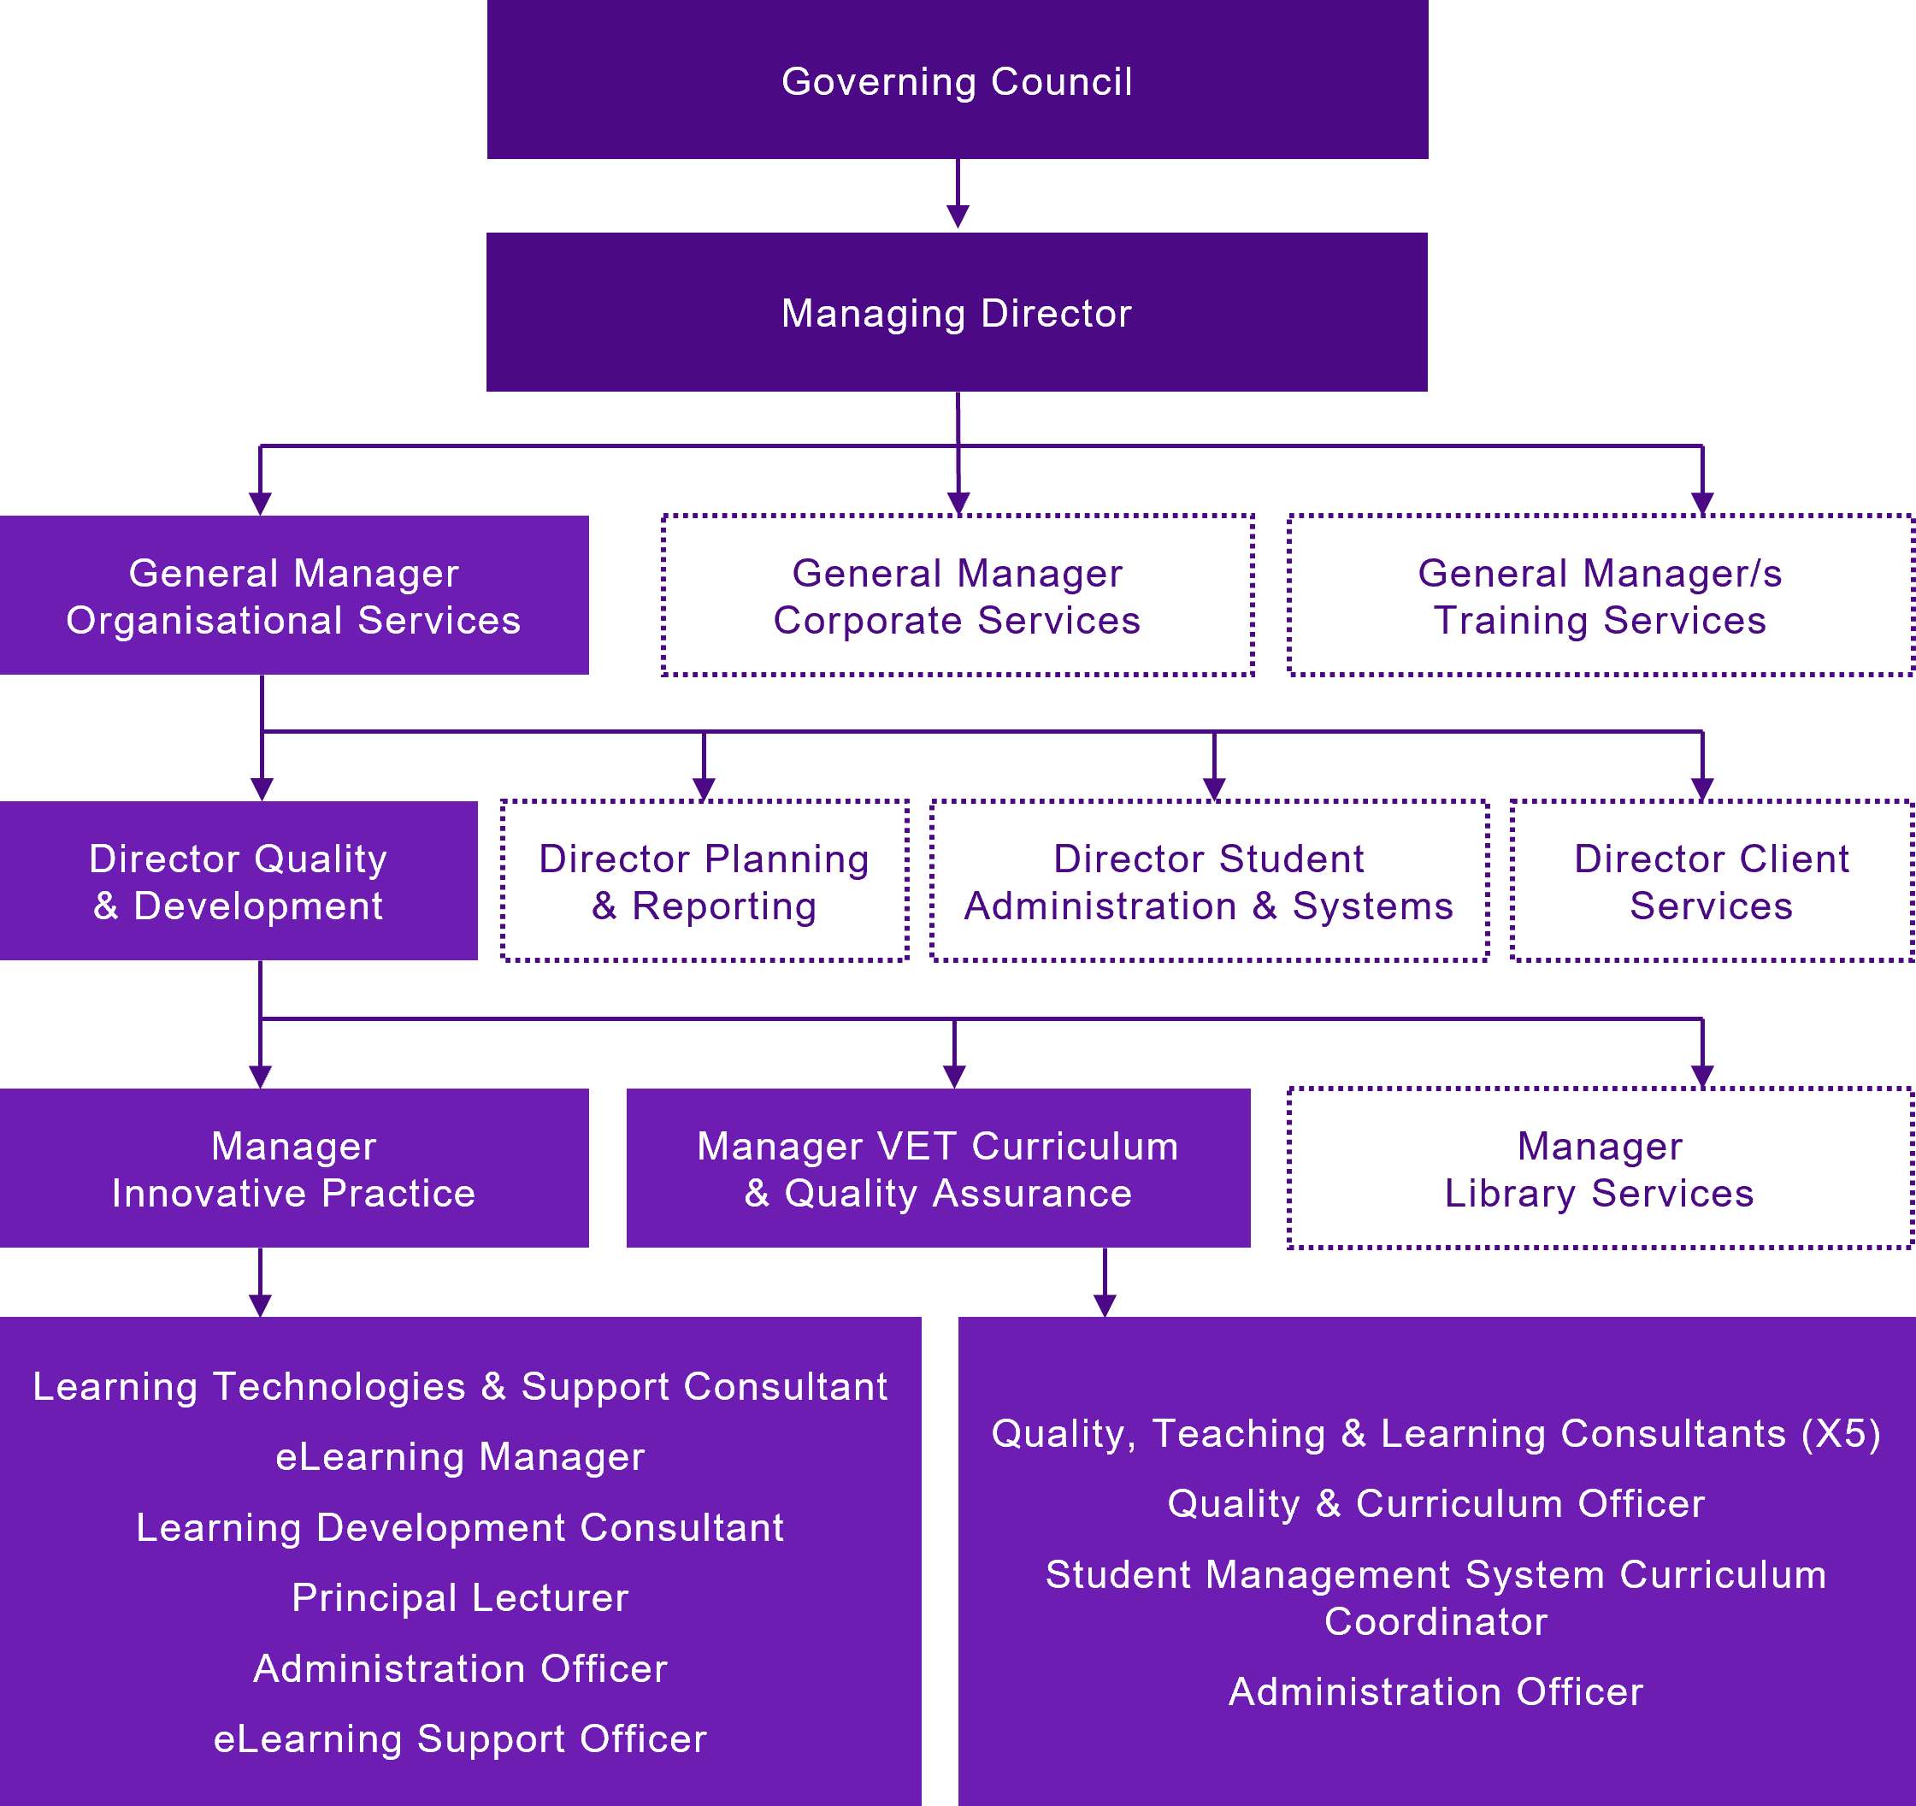
- Governing Council
- Managing Director
  - General Manager – Organisational Services
    - Director – Planning & Reporting
    - Director – Student Administration & Systems
    - Director – Client Services
    - Director – Quality & Development
      - Manager – Innovative Practice
        - Learning Technologies & Support Consultant
        - eLearning Manager
        - Learning & Development Consultant
        - Principal Lecturer
        - Administration Officer
        - eLearning Support Officer
      - Manager – VET Curriculum & Quality Assistance
        - Quality, Teaching & Learning Consultants
        - Quality & Curriculum Officer
        - Student Management System Curriculum Coordinator
        - Administration Officer
      - Manager – Library Services
  - General Manager – Corporate Services
  - General Manager/s – Training Services

Figure 3.19 Medium training provider example organisational chart
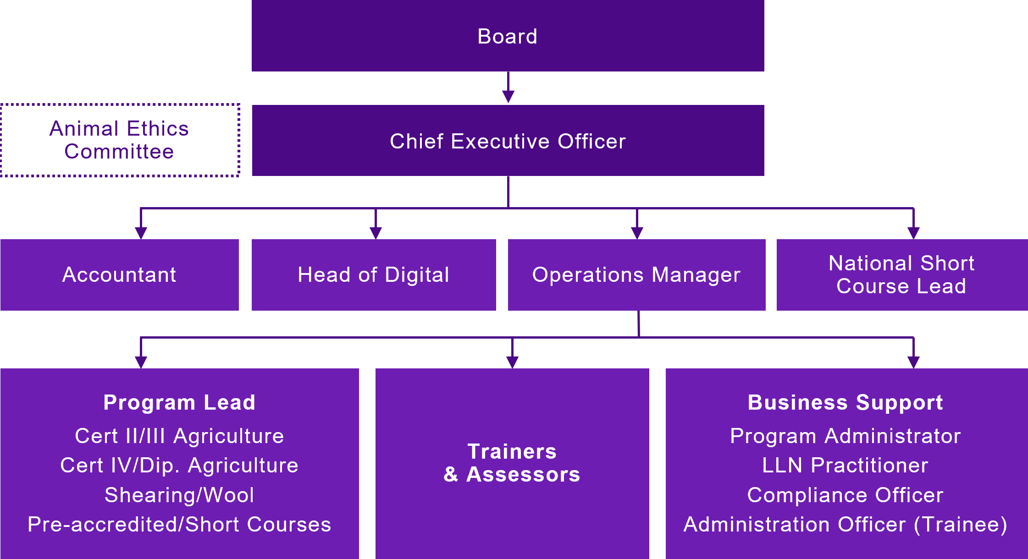
- Board
- Chief Executive Officer
  - Accountant
  - Head of Digital
  - Operations Manager
    - Program Lead for a specific course or course type
    - Trainers & Assessors
    - Business Support functions e.g. Program Administrator, LLN Practitioner, Compliance Officer, Administration Officer (trainee)
  - National Short Course Lead
There may also be advisory functions that sit outside of the main organisation hierarchy, e.g. an Animal Ethics Committee

Figure 3.20 Small training provider example organisational chart
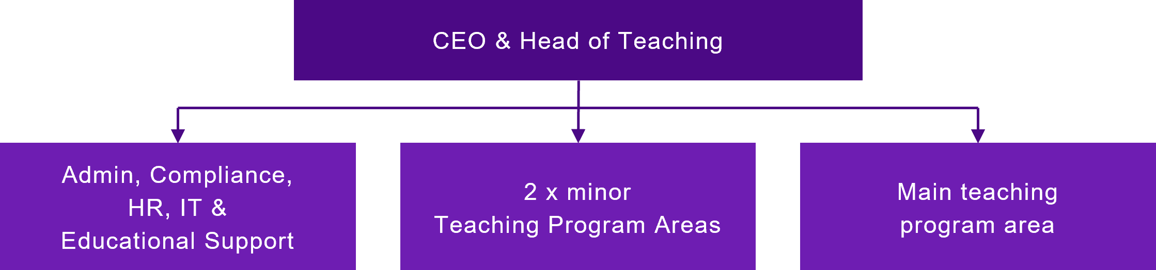

  - CEO & Head of Teaching
    - Admin, Compliance, HR, IT & Educational Support
    - 2 minor teaching program areas
    - Main teaching program area

Learning Support
Roles in the Learning Support workforce segment provide VET specific educational support and ancillary educational professional services, like librarians and counsellors. These roles offer services and supports that may be available to all students (e.g. library services) or may be targeted interventions for specific students or groups of students (e.g. a Disability Liaison Officer or Aboriginal and Torres Strait Islander Education Workers).
For example, a Learning Support Officer may work alongside teaching staff to support students with identified needs to build language, literacy, numeracy or digital literacy skills to complete their VET course (like a Foundation Skills Teacher). Likewise, an eLearning Support Officer may provide technical support to teaching staff about the use and improvement of eLearning tools (holding a similar, but more focused, expertise as an eLearning Designer), see Figure 3.16.

Education Support Officers are like Teachers' Aides and Integration Aides in schools but this ANZSCO occupational code has not been able to capture these similar types of roles in VET. As noted in Chapter 1, preliminary changes to the Teachers’ Aide ANZSCO occupation code will likely allow better mapping of learning support workforce roles in different education contexts. This role will now include alternative titles like Education Assistant, Learning or Student Support Officer which are more common in VET.
Across enterprise agreements educational support roles are described differently. In South Australia, there are Lecturer’s Assistants and Invigilators, while in NSW they are Educational Support Officers. Salaries for these educational support roles fall between around $61,000 (in South Australia) at entry level and $101,402 (in NSW) at the upper level.
Education Support Officers is an example role in this segment. At TAFE NSW, this is a role within its teaching classifications requiring the relevant industry credential being delivered but not a training or assessment credential. An Education Support Officer works under the direction of a teacher to support learners and enhance the student learning experience – including assistance in answering content and learning-related questions. The main duties of this role are summarised in Figure 3.21. There are also specialised First Nations education support, mentoring and liaison roles in VET which will likely be better captured by the proposed changes to the ANZSCO occupation of Aboriginal and Torres Strait Islander (ATSI) Education Officer including specialised counselling and coordination roles.

Figure 3.21 Education Support Officers
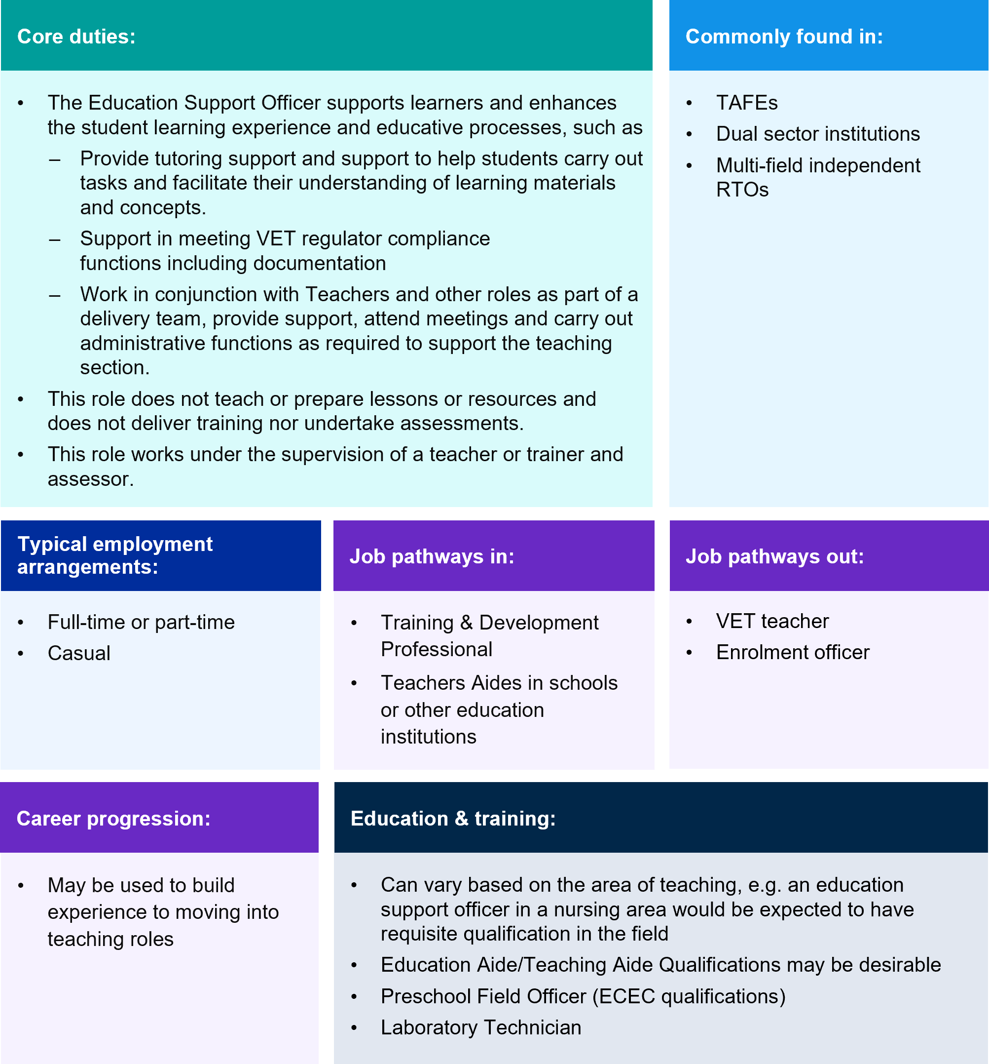
Student and Careers Counsellors are other example roles in the Learning Support segment, see Figure 3.22 for more detail. Counselling is generally offered with objective of improving retention by assisting students to achieve their personal and educational potential.

Figure 3.22 Student/Careers Counsellors
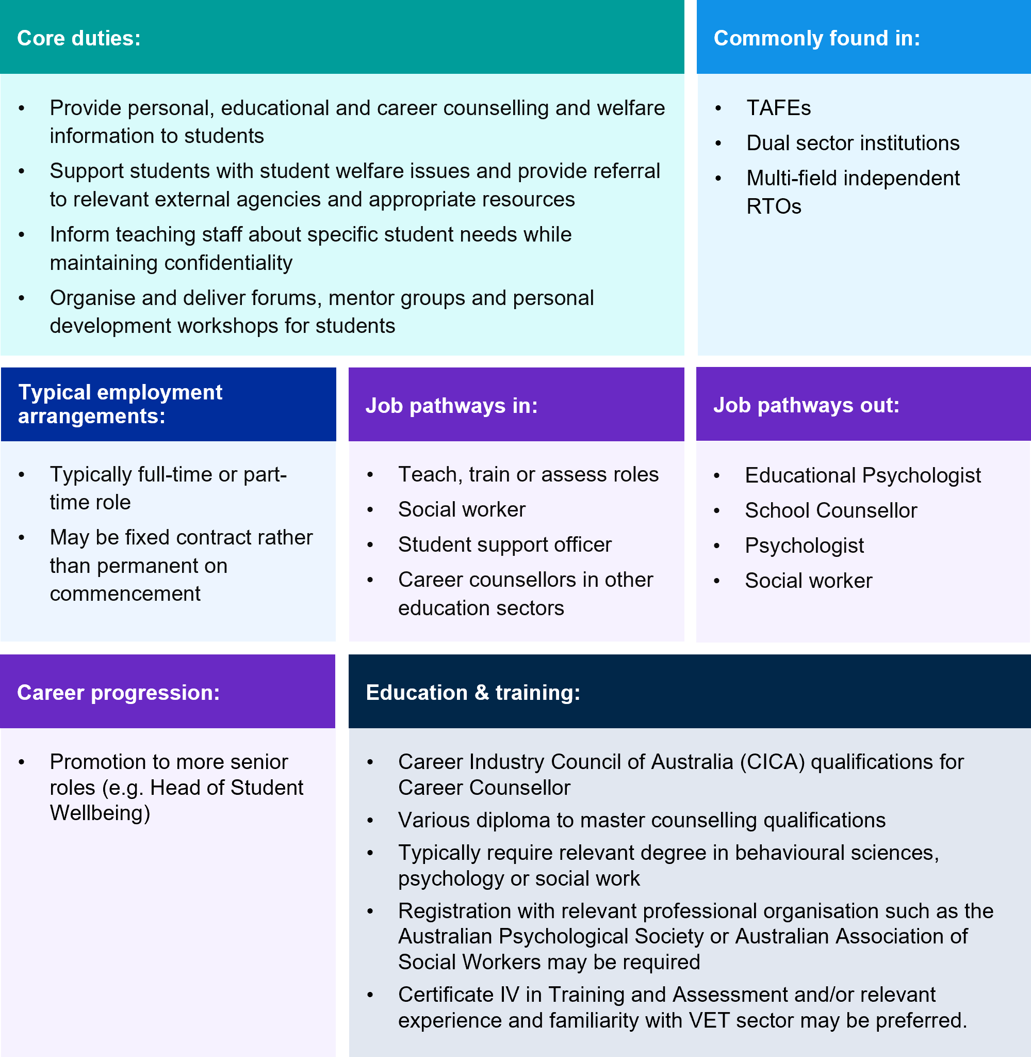
All RTOs are required to determine the support needs of individual learners and provide access to the educational and support services necessary for the individual learner to meet the requirements of the training product (Clause 1.7 of the RTO Standards). Providing counselling services may be part of the educational and support services provided by RTOs in compliance with Clause 1.7. Student support provision varies across RTO sizes and sectors, and RTOs which do not offer counselling may provide information or referrals to external counselling services.
Student counsellors will generally be required to hold a relevant degree in behavioural sciences, psychology, or social work. They may be asked to be eligible for registration with the Australian Health Practitioner Regulation Agency (AHPRA) or with the Australian Association of Social Work. Familiarity with the VET sector and experience working with students will also be looked on favourably by RTOs. Student counsellors may provide broad career information, but specific career counselling services can only be delivered where a counsellor has qualifications from the Career Industry Council of Australia (CICA).
There are also Aboriginal identified counsellor positions that have been advertised. For example, at TAFE NSW this role is charged with providing culturally safe educational and vocational counselling for intending and enrolled students, and personal counselling for enrolled students within TAFE NSW.

Administration and Operations
The successful operation of an RTO as a business requires the support of a range of clerical, administrative and professional roles. Key functions within this segment include IT, marketing, administration (including enrolments and admissions), finance and human resources. These roles include Program/Projects and/or Administration Officer; Student records/admissions/enrolment officer; Accountant; Human Resource Officer; IT Support Officer; Marketing specialist; Commercial cleaner; Security Officer and Receptionist.
These roles and the skills and knowledge required to fulfil them are typically not unique to the VET sector and may be fully or highly transferable from other industries. There are also fewer clear career pathways between this segment and Teach, Train, and Assess roles. However, some roles require a higher degree of expertise in the VET system.
For example, enrolment or student loan support officers are specialised administrative officers that use knowledge of the VET system and their employing RTO to respond to student enquiries, and supports students navigating processes, funding and requirements. This role also assists students to enrol, including through digital enrolment systems, see Figure 3.23. Administrative officers may hold a mix of qualifications, such as a degree in Business, or have administrative experience from education or other industries.

Figure 3.23 Student Records/Admissions/Enrolment Officer
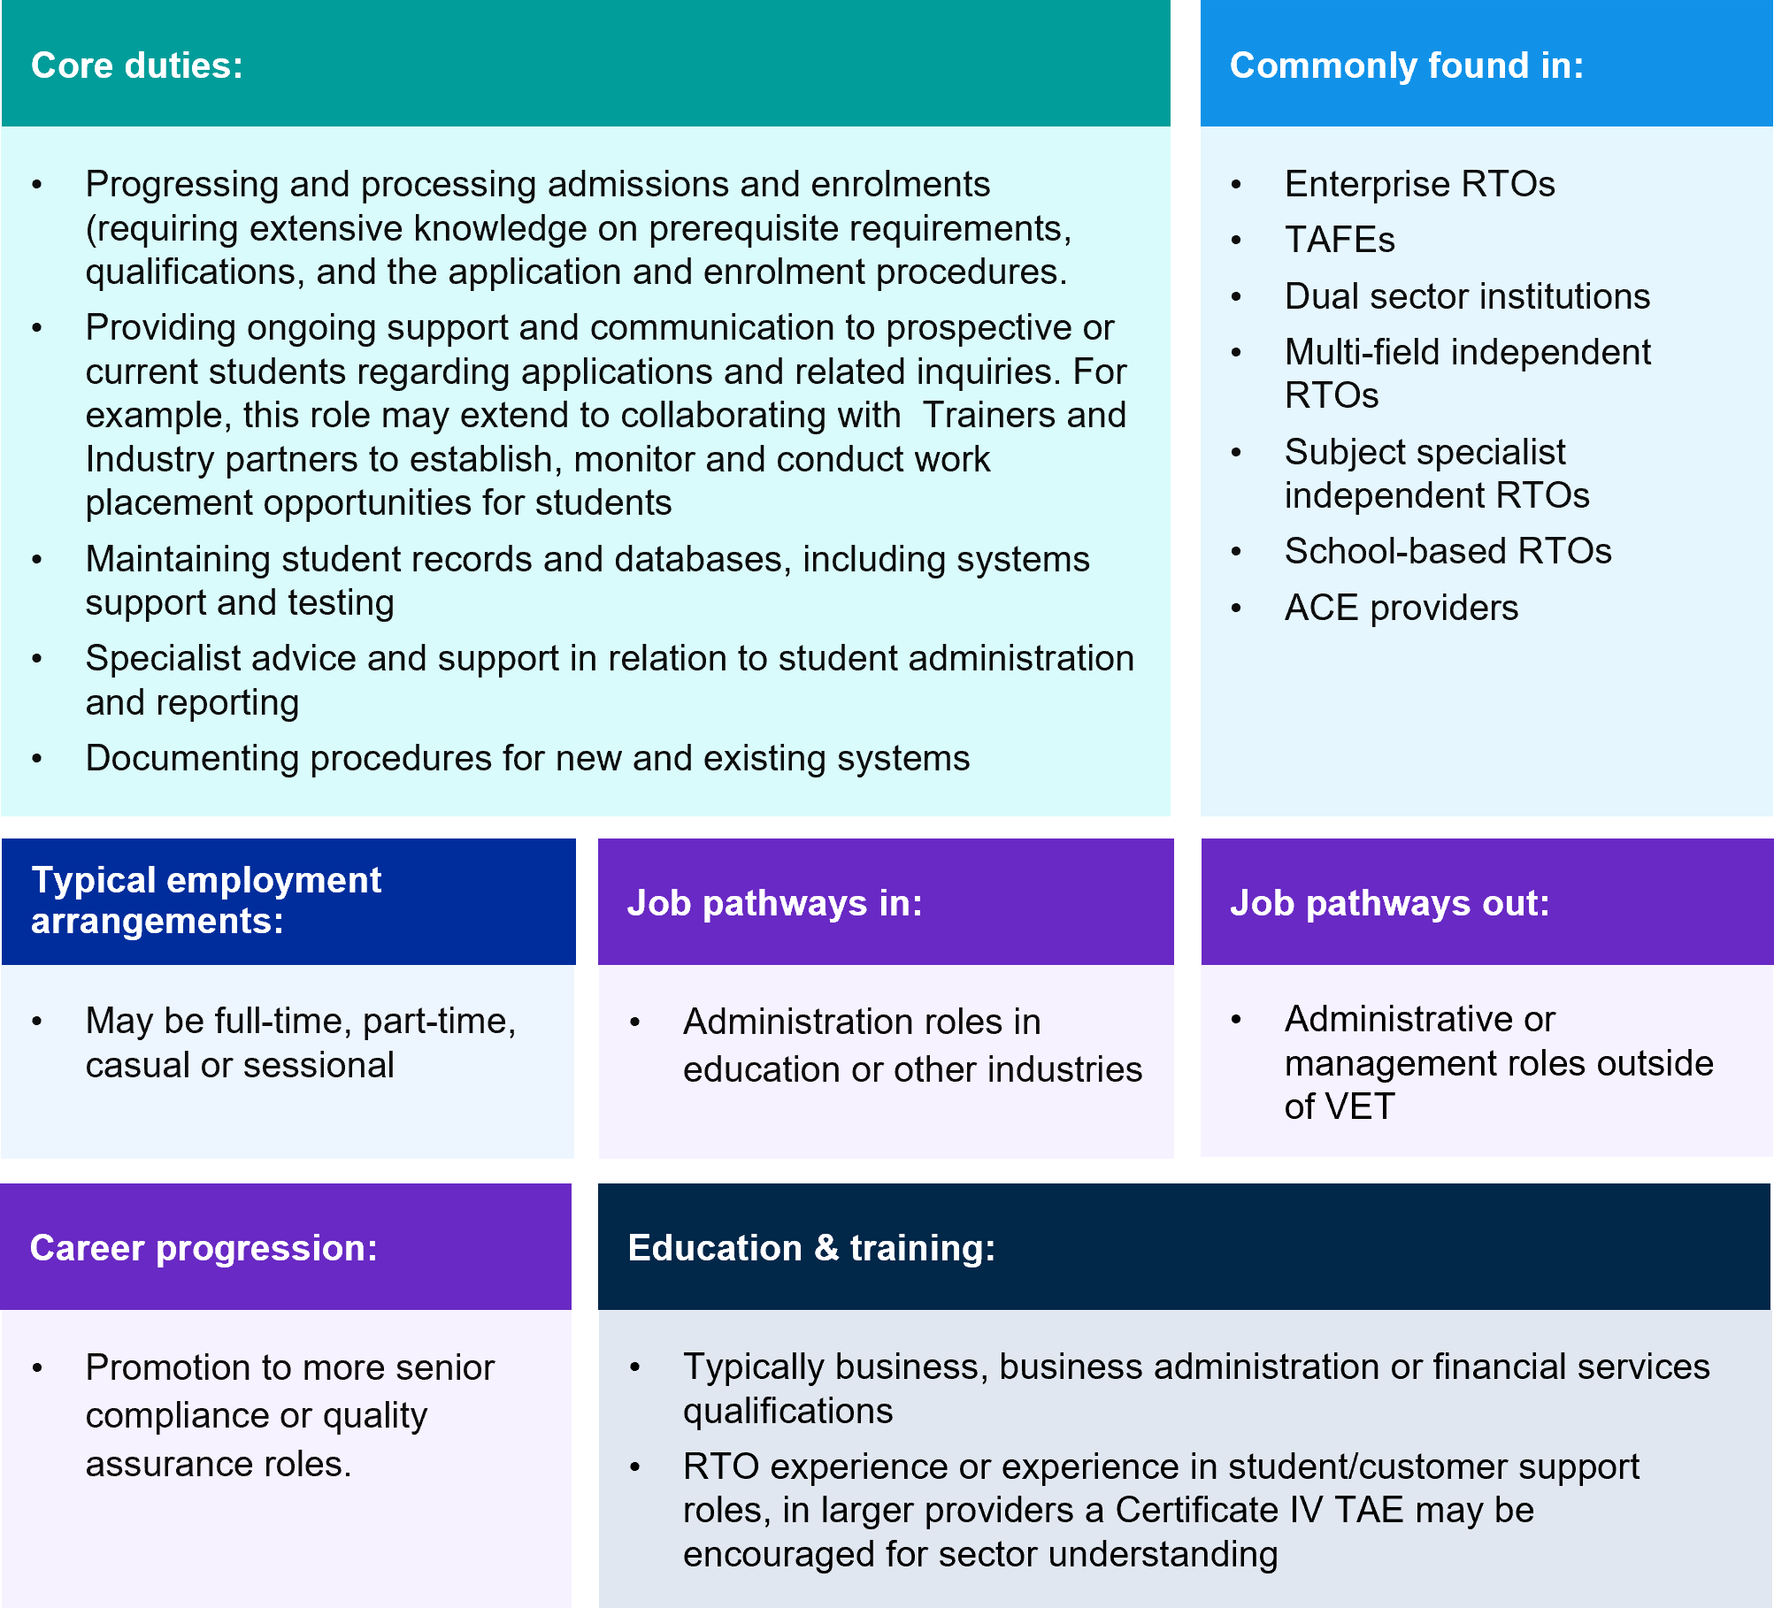
Engagement, sales, and marketing roles attract and convert prospective students through print, digital and in person activities. These roles also use knowledge of the VET system and their employee RTO to respond to enquiries, and they play a role in setting incoming students’ expectations for training and future career prospects. This role may hold a degree, such as in Communications, and be able to learn about the VET sector.

Conclusion
This chapter provides a detailed overview of the roles and work tasks required to offer VET training in Australia. Among teachers, trainers and assessors, the chapter shows that since 1998 the Certificate IV TAE has become a baseline qualification, including in many instances where it is not required, such as for assessors. This segment is complicated, however, by the wide range of fields that are taught in VET, which often require industry qualifications, or specialised educational skills.
Most of the training for these roles is provided within VET itself, with the higher education sector’s role small and declining. To date, migration pathways provide limited inflow to the VET workforce, especially in recent years. There remains mixed views on the purpose and suitability of the Certificate IV TAE. Some stakeholders remain concerned it may not offer adequate training in andragogy for some working in the field, while others consider the qualification demands more time than necessary for people moving from industry into VET teaching and assessment. The former issue is at least partly resolved by the existence of higher-level VET teaching qualifications across VET and higher education that provide more extensive training in andragogy for those who deem it necessary for their roles.
Delivery of VET also requires workers who ensure quality and compliance due to the regulatory demands of the RTO Standards; support curriculum and learning design – including for the increasing portion of VET delivered in blended modes and in a growing minority of cases, fully online. Qualifications for workers performing these roles are highly variable. Skills are developed via non-accredited or accredited courses and via prior work experience in regulation, compliance, or instructional design. Likewise for learning support roles.
VET staff also perform administration for the operations of public and private RTOs, which does not demand skills vastly different to similar roles in organisations outside of VET. On the other hand, VET leadership typically relies on sector knowledge and experience. There is considerable diversity in the responsibilities demanded in leadership roles. Those holding leadership positions have typically completed a higher level of education than others in VET, though these qualifications, and a general lack of support, may not be preparing people providing leadership as adequately as is desirable.

Workforce demand and supply pipelines
This chapter explores the current and future workforce needs of the VET sector. We analyse a range of sources including employment projections to show future demand, employer survey data on recruitment difficulties in the sector and whether the training pipeline will supply adequate VET teachers, trainers, and assessors to meet current skills gaps. We also explore student outcomes survey data and real-world occupation transitions in, out and within the VET workforce to give insights on retention and attraction issues.
The VET teaching credentials are explored in this discussion as well as other structural issues affecting the sector such as the NSA. As noted throughout the report, the NSA will shape workforce demand and supply in target industry areas and Government funded VET for the next 5 years. This chapter explores:
- What is the expected future and current demand for the VET workforce and is it heightened for teaching, training and assessing roles?
- Are there existing skills shortages and do we have the supply of workers and skills to meet future demand?
- What are the training motivations, satisfaction levels and occupational outcomes for graduates of VET teaching qualifications?
- What does this say about the suitability of the main training packages for a changing and diverse VET sector?
- What does the future VET workforce look like demographically based on the training pipeline?
- What are the most common real-world occupational transitions in and out of the VET teaching profession? What does this say mean for pay, retention and attraction issues for those flowing in and out of the VET teaching occupation?

Workforce demand and supply
The labour market is important as a guide to the VET sector on current and future skills needs. Demand for VET graduates across the economy is expected to be high. According to projections produced by Victoria University for JSA, around 44% of new jobs expected to be created over the next 10 years have VET as the primary pathway.
Labour market demand is particularly important in relation to trade occupations and highly regulated industries such as electrotechnology which have historically seen an above-average match between the intended occupation of the training and the post-training occupation outcome. As one example, JSA’s Clean Energy Capacity Study found that Australia will likely need 32,000 more electricians in the next seven years:
Rapid growth of electricians will require rapid growth of VET trainers.
Without addressing the capacity of the VET system, Australia will not
be able deliver the workforce it needs.
In addition to demand-side labour market shifts, changes in the labour market can also impact the supply-side. For industry practitioners considering a movement into the VET workforce, changes in the relative rates of remuneration between a VET teacher, trainer and assessor and their current role is generally an important consideration. As noted in Chapter 1 there is a strong alignment between high enrolment qualifications and occupations rated in shortage on the 2023 Skills Priority List (SPL). This demonstrates that the VET workforce is competing with industry for a limited supply of vocationally skilled workers.

Demand
Employment projections produced by Victoria University for JSA indicate that VET teacher employment is projected to grow by 12% (or 3,800) in the next five years and by 21% (or 6,900) over the next decade. This projected growth exceeds the employment projections for:
- All education professionals: 8% over five years, 14% over ten years;
- All occupations: 7% over five years, 14% over ten years; and is very similar to all employment in the tertiary education industry at 13% over five years, 23% over ten years.
Notably, these projections were made prior to the signing of the NSA to be in effect for five years from 1 January 2024. This agreement will provide an additional 300,000 fee-free TAFE places over three years from 2024 and includes an extra $2.4 billion in flexible funding to support state and territories to deliver national priorities while preserving flexibility for jurisdictions to align local skills supply with demand. For example, the QLD State Government invested $87.5 million in the Diploma of Nursing at the Sunshine Coast Healthy Institute to support the workforce demand for nurses due to the projected industry growth in health care in the Sunshine Coast region.
Existing Fee-Free TAFE initiatives prior to the NSA would have already had some impact on demand, and the focus on priority groups in these programs also has workforce implications. Where uptake of training by priority groups increases, workforce implications may include increased demand for andragogy skills in delivering effective training and assessment for these cohorts, and for a workforce capable of providing additional wrap-around supports. This may particularly be the case if change is concentrated in a particular segment of the market, e.g. certain provider types or certain qualifications.
There will always be a degree of uncertainty in projecting areas of increased demand for training. However, the national priorities identified in the NSA and the key forces expected to shape the economy and labour market identified in the Employment White Paper indicate that VET will be key, see Figure 4.1. For the VET workforce, this means teachers for early childhood, aged care, nursing, agriculture, horticulture, permaculture and animal care; information technology potentially with a focus on cybersecurity; and building and engineering trades with an emphasis on electrotechnology for the net zero transformation.
Figure 4.1 Key national workforce priorities
National Skills Agreement  – National Priorities | Employment White Paper  – Key transformations
Climate change and the net  zero transformation | Supporting the net zero transformation
Population ageing / rising demand for  quality care and support services | Sustaining essential care services
Geopolitical risk and fragmentation | Developing Australia’s sovereign  capability and food security
Increased use of digital and  advanced technologies | Ensuring Australia’s digital and  technology capability

Outside of teaching, the projected growth for other relevant roles includes Education Managers (21% over ten years) and Education Advisers and Reviewers (17% over ten years). Similarly, more education support roles have also shown strong growth across all education sectors. Sources such as online job advertisement and recruitment data sets also give further insights into demand for emerging roles in VET. For example, analysis of LinkedIn data shows that the role of 'Learning Specialist’, which aligns with the Curriculum and Learning Design segment in our taxonomy, has been in high demand over the last year.
Alongside employment projections, datasets drawn from online job advertisements also show that demand for VET teachers is high but not as high as their counterparts in primary and secondary schooling. JSA publishes the Internet Vacancy Index (IVI) each month which looks at the change in online job advertisements for various occupations and recent results indicate that demand for VET teachers has experienced well above average growth. Over the ten years to January 2024, online job advertisements for VET teachers have grown by 201.4% compared to a growth of 79.3% across all occupations. For the five-year period leading up to 2023, the growth was 72.7% compared to 60.1% across all occupations.
Following a series low in May 2020 during the COVID shock, which reflected wider labour market trends, advertisements for VET teachers have rebounded strongly to exceed 100 vacancies in a single month for the first time in both October and November 2023. This dropped to 87 in December but stabilised again in January and February 2024. These trends are illustrated in Figure 4.2.

Figure 4.2 Online job advertisements for Vocational Education Teachers and all occupations
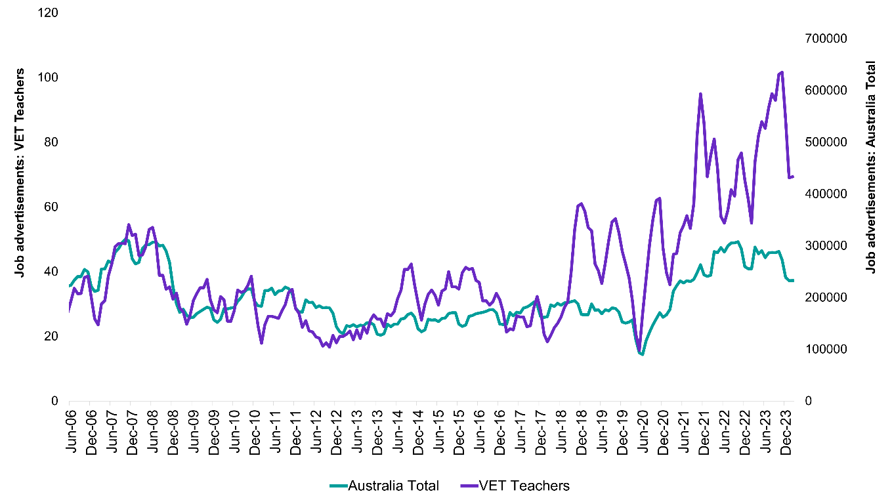
Source: Jobs and Skills Australia, Internet Vacancy Index, March 2024.

Growth in VET teacher job advertisements has not been driven by any one jurisdiction. Advertisements for VET teachers outgrew the all-occupation average in every state and the ACT over the last decade. Only NT was the exception, see Figure 4.3. Except for NT, all saw an above 192% increase in internet vacancies for VET teachers between the decade of 2013 and 2023, with an almost 500% growth in Victoria and above 1000% growth in the ACT.
Consistent with national figures reported above, for the five-year period between 2018 and 2023, VET teacher internet vacancies also outgrew all occupations combined in every state and territory. All states and territories over this period, including the NT had a growth of over 100% in advertisements with significant growth in Tasmania of almost 500%.

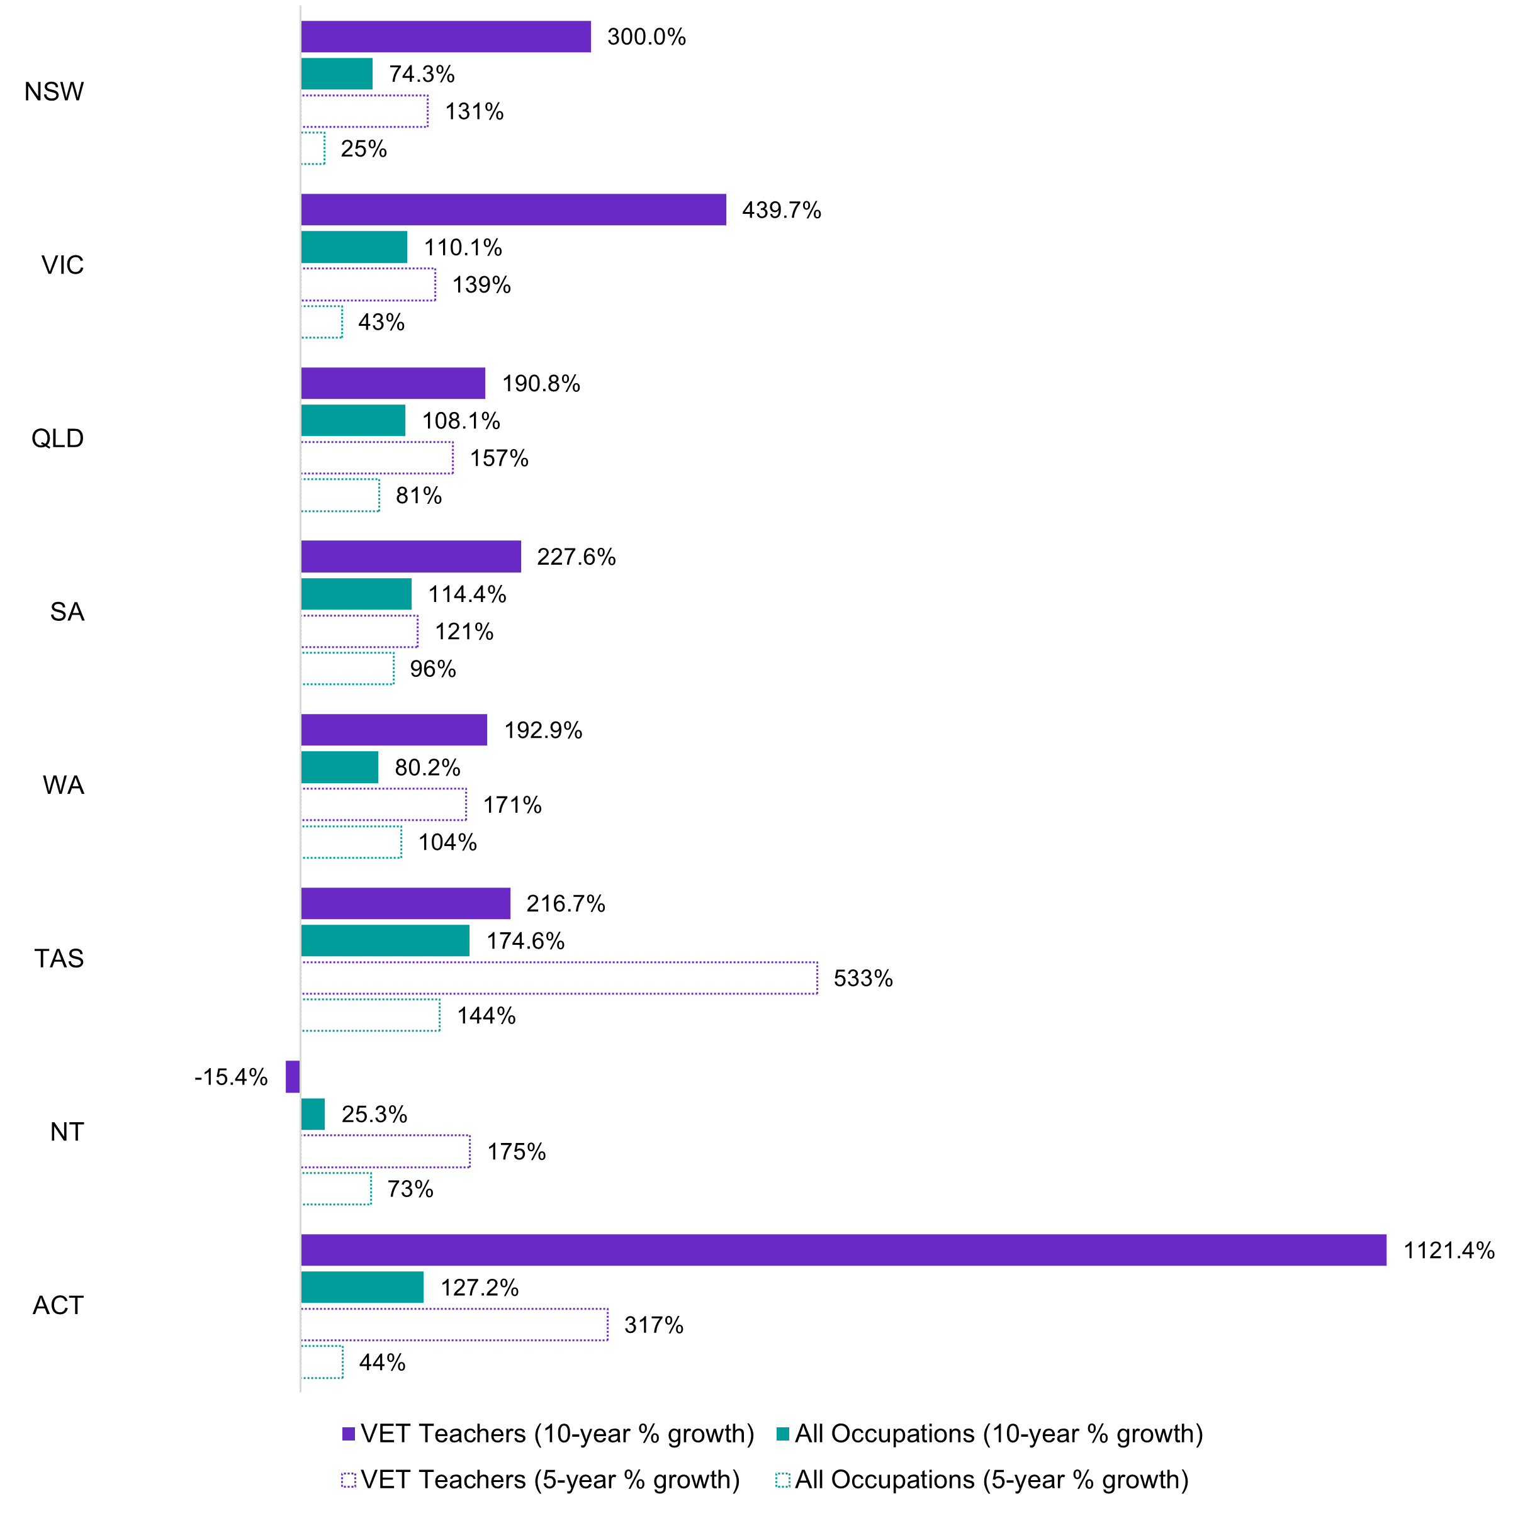
Figure 4.3 Percent change in internet vacancies for VET teachers and for all occupations in the ten and five years to 2023

2013 - 2023
 | VET teachers (10-year % growth) | All Occupations (10-year % growth)
NSW | 300.0% | 74.3%
VIC | 439.7% | 110.1%
QLD | 190.8% | 108.1%
SA | 227.6% | 114.4%
WA | 192.9% | 80.2%
TAS | 216.7% | 174.6%
NT | -15.4% | 25.3%
ACT | 1121.4% | 127.2%

2018 - 2023
 | VET teachers (10-year % growth) | All Occupations (5-year % growth)
NSW | 131% | 25%
VIC | 139% | 43%
QLD | 157% | 81%
SA | 121% | 96%
WA | 171% | 104%
TAS | 533% | 144%
NT | 175% | 73%
ACT | 317% | 44%

Source: Jobs and Skills Australia, Internet Vacancy Index, March 2024
Plausible explanations of this growth in VET teacher vacancies include the creation of new VET teacher jobs in areas of high enrolments; flow on effects from fee-free TAFE initiatives at the state level; turnover at particular providers due to dissatisfaction with working conditions and the replacement of those exiting the occupation (e.g. due to a job change, or training reaccreditation in line with changing RTO standards or retirement considering the more mature profile of VET teachers). Very strong demand for workers in vocational fields where the occupation is also on the skills shortage list (e.g. Electricians) or where the workforce is nearing retirement age (e.g. adult literacy and numeracy specialists) is also a factor.
Some of the top ten qualifications by enrolments as discussed in Chapter 1 have experienced significantly above average rates of growth since 2018. These include:
- Certificate III in Early Childhood Education and Care (up 40%)
- Certificate III in Business (up 33%)
- Certificate III in Individual Support (up 26%)
- Certificate III in Carpentry (up 20%).
It is reasonable to conclude given the enrolment growth for these qualifications that new VET teacher, trainer and assessor jobs have been created in these areas.
The growth in advertisements for other occupations spread across all education sectors including VET was generally lower than that of VET teachers. For example, Education Advisers and Reviewers and Training and Development Professionals saw an increase of 87.4% and 79.6% respectively between February 2014 and February 2024, compared to VET teachers at 201.4%.
Teachers in other education sectors outgrew VET teachers, with advertisements for primary and secondary school teachers increasing over 500% in the same period. Early childhood (pre-primary school teachers) had similar growth to VET teachers but interestingly has been on the skills shortage list for far longer. See Figure 4.4.
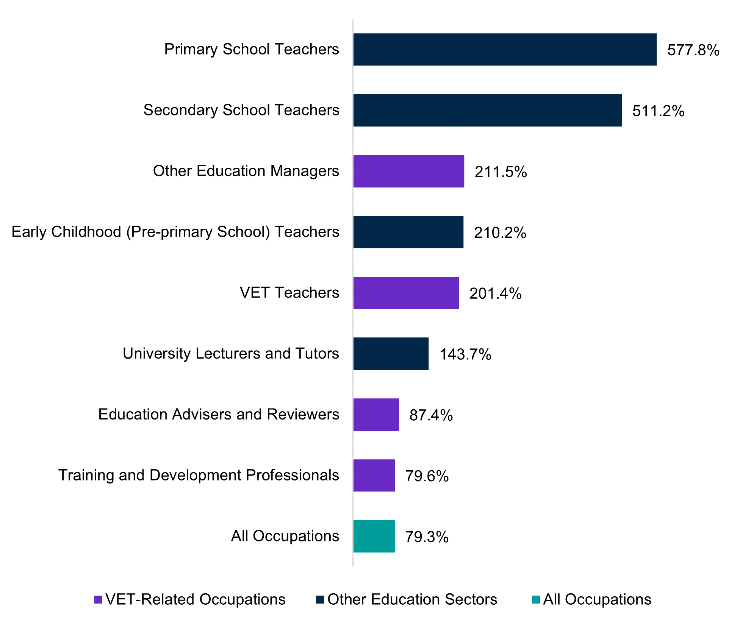
Figure 4.4 Growth in job advertisements from February 2014 - February 2024 by occupation
Primary School Teachers - 577.8%
Secondary School Teachers - 511.2%
Other Education Managers - 211.5%
Early Childhood (Pre-primary School) Teachers - 210.2%
VET teachers - 201.4%
University Lecturers and Tutors - 143.7%
Education Advisers and Reviewers - 87.4%
Training and Development Professionals - 79.6%

Source: Jobs and Skills Australia, Internet Vacancy Index, March 2024.
Box 4.1 LinkedIn data shows emerging jobs like Learning Specialist are growing fast
LinkedIn Talent Insights is a database based on the professional networking site’s
1 billion members worldwide and provides ‘real-time’ insights on skills, employers, job titles and industries. The database has some shortcomings when compared with survey or administrative data – it is skewed towards professional roles and is self-reported. However, it is a useful tool which provides insight into common job titles, skills and areas of growth or decline within the industry including for the purposes of this study, especially in relation to public TAFE providers.
Out of the 23 public TAFE providers operating in Australia, 17 of them have a current LinkedIn company page. In 2023, there are over 22,000 LinkedIn members based in Australia working for a public TAFE provider. Whilst LinkedIn has some limitations and should not be considered a quasi-workforce estimate this is a good sample of the TAFE workforce and stands at 65% of the 38,000 FTE reported by TAFEs from this JSA study. Over 45% of the LinkedIn talent pool is TAFE NSW which is closely aligned with their workforce estimate of almost 16,000.
Almost 43% of the professionals in this talent pool have a job title within the Teach, Train and Assess segment of the VET workforce, however many job titles reported fall under a trade or profession such as plumber, veterinarian or registered nurse which could be reflective of members who both teach and work in their chosen industry. Other common job titles include librarian, administrative assistant, education manager and support officer.
While traditional VET job titles are most common, emerging job titles are growing strongly. For example, the job title of Learning Specialist grew by over 200% in the last 12 months and learning Support roles are up: Education Administrator (up 44%), Customer Service Representative (up 35%), Assistant (up 31%) and Education Services Coordinator (up 25%)
The most common skills among these professionals are staff development, adult education, eLearning, curriculum development and leadership development, however skills outside of teaching, training and assessment are more broadly on the rise. For example, technical skills such as business analysis and soft skills such as customer service have grown over 10% in the last 12 months and, skills in quality assurance have grown by 9%.
Thirty-five large private providers (based on students and qualification enrolments) were also identified as having a company profile on LinkedIn. ‘Teacher’ is the most common profession amongst these private providers but titles and skills are more diverse than those among public providers.
LinkedIn Talent Insights data is derived by aggregating profile data voluntarily submitted by LinkedIn members. As such, LinkedIn cannot guarantee the accuracy of LinkedIn Talent Insights data.

Supply
The SPL, a yearly publication produced by JSA, has listed VET teachers in shortage nationally and in every jurisdiction in both 2022 and 2023. These shortages are particularly acute for teachers, trainers and assessors in occupations that are also on the SPL, particularly building and engineering trades. This is consistent with findings from the JSA Clean Energy Workforce Capacity Study.
The Survey of Employers who have Recently Advertised (SERA) measures fill rates for job openings and gives insights into the supply side of the labour market like online job advertisement datasets do for demand. Whilst it is important to recognise that difficulties in recruiting VET teachers will play out differently in different contexts, recent SERA results do indicate that across the period from January 2021 to August 2023, the fill rate for VET teachers was low at 50%. Relative to educators in other parts of Australia’s education system, this fill rate is comparable only to Early Childhood Teachers, also on the SPL since 2022. See Table 4.1 for a comparison to other education occupations where there are far more suitable applicants per vacancy and thus a steadier workforce supply.
Table 4.1 Vacancy data by selected education occupations
ANZSCO Occupation | Vacancy  fill rate | Applicants  per vacancy | Suitable  applicants  per vacancy
Vocational Education Teacher | 50% | 5.09 | 1.23
University Lecturer | 81% | 14.19 | 2.93
Secondary School Teacher | 75% | 6.17 | 1.72
Primary School Teacher | 74% | 8.49 | 3.19
Early Childhood  (Pre-primary School) Teacher | 50% | 5.81 | 1.42
Source: Jobs and Skills Australia, Survey of Employers who have Recently Advertised (SERA),
January 2021-August 2023

As with other occupations, geographical mismatches may generate recruitment difficulties even if supply and demand for VET teachers was balanced at the national level. However, unlike most occupations, the dual qualified nature of the VET teacher workforce adds a further complication to any supply and demand analysis.
For example, a prospective VET teacher qualified to teach a Certificate IV in Building and Construction is unlikely to be suitable to fill a vacancy to teach Certificate III in Individual Support. It is also clear that industry practitioners often weigh up the value proposition of a VET teaching role relative to their industry pay and conditions. These recruitment and retention issues are discussed in the last section of the chapter.

Training pipeline
This section examines the supply of potential VET teachers, trainers, and assessors through the lens of the key VET teaching credentials outlined in Chapter 3. Both commencements and completions in these qualifications have fallen significantly since 2016. To explore why, we analyse the training motivations, student sentiments and occupational outcomes of VET teaching qualification graduates demonstrating that most people undertaking the key VET teaching credential are doing it as a current requirement of their job. This means the shrinking training pipeline may not as significantly impact workforce supply but does raise questions around the relevance of the Certificate IV TAE. We also find that occupationally, after VET and secondary teachers or training and development professionals, most people doing the qualification are involved in workplace training in health, policy, and emergency services. This section also considers the diversity of workers flowing from the training pipeline and identifies areas where this does not reflect the VET student community or the Australian population more broadly.

A shrinking training pipeline?
Chapter 3 identified that the training pipeline for VET teachers, trainers and assessors consists principally of graduates of the Certificate IV TAE. However, our forthcoming analysis shows that only around one in four of these graduates might flow into traditional teaching roles. The training pipeline for graduates of relevant skill sets – which only supports teaching under supervision – has been low (despite an exponential increase) but has still had little influence on the quantum of the training pipeline. Likewise, Diploma and above level qualifications have also had a low impact.
As outlined in our job profiles discussion, Diploma and above qualifications are often targeted at career progression and maintaining skills currency for existing workers rather than entry to the profession. For example, 85.4% of 2022 graduates of the Diploma of VET/Diploma of Training Design and Development are unlikely to be new to the VET workforce. Qualifications delivered in the higher education sector are more difficult to identify and quantify but the data that we can access indicates an almost insignificant impact on the training pipeline.
The Certificate IV TAE also supports delivery of structured VET in workplaces not just in RTOs and this is likely why less than half (47.8%) of 2022 Certificate IV TAE graduates were teachers (whether VET or other teachers), and/or working in education. Almost the same proportion (43.1%) were neither teachers nor stated they worked in education. Examples of occupations (after training) in this cohort include fire fighters, ambulance officers, beauty therapists, prison officers and occupational health and safety advisers. These workers are likely expert practitioners in their respective occupations, delivering VET in workplaces. This would in fact place them within the intended audience for the qualification, though their roles may involve mainly training, or only occasional training responsibilities. Table 4.2 provides an overview of the known number of completions in the VET training pipeline.
Table 4.2 Completions in VET teacher, trainer and assessor pipeline and related training.
 | 2016 | 2017 | 2018 | 2019 | 2020 | 2021 | 2022ª
Certificate IV in Training and Assessment | 21,635 | 20,065 | 9,972 | 34,235 | 16,730 | 16,469 | 15,609
Diplomas and above in TAE  training package | 1,747 | 1,963 | 803 | 1,213 | 1,179 | 945 | 917
Other VET qualifications in Adult Education at Diploma and above ^{b} | 242 | 300 | 254 | 294 | 524 | 1,155 | 1,603
Specified skill sets that support delivery of VET under supervision ^{c} | 205 | 223 | 658 | 967 | 1,124 | 1,371 | 1,685
Notes:
(a) 2022 qualification completions are preliminary and will increase when final data is published in August 2024.
(b) Examples of other VET qualifications in Adult Education at Diploma and above include Graduate Diploma of Management (Learning) – from the BSB training package (1,101 completions in 2022), and Diploma of TESOL (Teaching English to Speakers of Other Languages) – a Nationally accredited qualification that was not part of any training package (63 completions in 2022).
(c) Includes: TAESS0008/TAESS000013 Enterprise Trainer – Mentoring, TAESS00007/TAESS00014 Enterprise Trainer – Presenting, TAESS000015 Enterprise Trainer and Assessor
Source: VOCSTATS, 'Total VET students and courses' extracted in December 2023, January 2024 and February 2024.

In 2021, commencements in the Certificate IV TAE – were 7,535 (or 22.1%) lower than in 2016 and completions had fallen by 5,166 (23.9%). Although targeted at workers already in the VET workforce, commencements in Diplomas and above in the TAE training package also fell by 45.9% in the same period, to fewer than 1,000 in 2021. The stark declines in the training pipeline occurred during a period when VET student numbers increased, as did enrolments in qualifications like ECEC and the building and engineering trades support occupations, which like VET teachers are on the skills shortage list.
In contrast to this shrinking supply, completions of skill sets allowing training and assessment to be delivered under supervision, while a comparatively small number overall, have increased exponentially over time – up 1,480, more than a sevenfold increase since 2016. Although skill set completion supports quick onboarding of new VET teachers, these partly skilled teachers are not yet reliably translating to more Certificate IV TAE enrolments and completions.
Department of Education data shows that the number of VET teachers undertaking initial teacher training in the Higher Education sector is very small but, due to data classification and other issues, these may be undercounts. According to these counts, in 2021, 227 students were enrolled in Teacher Education (Vocational Education and Training) undergraduate qualifications. The number of students enrolled in postgraduate VET teacher qualifications was not published. Work and consultation with the Australian Council of Deans of Education Vocational Education Group (ACDEVEG) may improve data collection in the future.

What does the future VET workforce look based on the training pipeline?
This section discusses the impact of the training pipeline on VET workforce diversity, through demographic analysis of students commencing in, and graduating from, key VET teaching qualifications – Certificate IV TAE, Diploma of Vocational Education and Training, and Diploma of Training Design and Development. In short, the proportions of females and people living in regional and remote Australia who graduate from Certificate IV and Diploma TAEs are broadly consistent with or higher than their representation in the VET student and Australian populations.
However, the proportions of First Nations people, people with Disability and people speaking a language other than English at home are comparatively low (in some cases very low) against both measures. See Table 4.3 for an overview. A lack of diversity in teaching staff may negatively impact student outcomes and perpetuate disadvantage, as incoming students are less likely to encounter people with whom they identify. Additionally, diverse teachers can themselves experience barriers such as instances of discrimination and requirements to undertake additional inclusion and emotion work.

Cultural diversity
Chapter 2 identified the VET workforce was underrepresented amongst First Nations peoples compared to Australian workforce figures which is again reflected in the VET teacher training pipeline. While First Nations students make up 3.6% of VET students overall, they make up only 2.8% and 2.2% of Certificate IV TAE and Diploma commencements respectively, and only 2.0% and 1.3% of Cert IV TAE and Diploma completions. They do however make up a larger proportion of Skill Sets completions at 6.5%.
VET contributes significantly to English as a Second Language training in Australia, yet the proportion of students completing the VET teaching credentials who speak a language other than English at home is comparatively small. VET students generally are less likely to speak a language other than English at home compared to the Australian population (14.3% compared to 22.3%). This difference is more pronounced in VET teacher training where only 11.9% and 11.6% of Certificate IV and Diploma graduates speak a language other than English at home.

Key Demographics – Age, Gender, Disability
The proportion of training graduates aged over 50 years suggests the VET workforce will continue to age. In the Certificate IV TAE training pipeline, the proportion of graduates aged over 50 years increased by 2.2 % between 2015 and 2021 to 28.0%. This indicates that this pipeline may put further upward pressure on the age of the VET workforce. As noted in Chapter 2, 46.5% of the VET the workforce is aged over 50 years.
Females are well-represented in the VET training pipeline. The female proportion of Certificate IV TAE (50.1%) or VET teaching diploma (53.1%) graduates is higher than the female proportion of VET students overall (46.6%) but like the female proportion of the Australian population (50.7%).
The skill sets training pipeline, however, is made up of far more males (70.3%) which could be an indicator of more masculinised vocations such as building and engineering trades using this qualification route into VET teaching. This may change with the March 2024 RTO Standards changes which allow more industry practitioners to teach ‘alongside’ VET teachers.
The proportion of people with disability in VET teaching qualifications is about the same as among VET students broadly (3.9% in Certificate IV commencements and 4.4% in Diplomas, compared to 3.9% for all VET students), but still substantially lower than the Australian population (5.8%). However, people with disability are more underrepresented in completions (3.5% for Certificate IV and 3.4% for Diploma), affecting the VET workforce pipeline.
Table 4.3 Key diversity characteristics in VET teacher training qualifications, VET students and Australian population wide
 | Certificate IV  TAE  Completions | VET Teaching Diploma  Completions | Skill Set*  TAE  Completions | All VET Students | Australian Population
Language Other than English spoken at home | 11.9% | 11.6% | 3.9% | 14.3% | 22.3%
First Nations | 2.0% | 1.3% | 6.5% | 3.6% | 3.8%
With Disability | 3.5% | 3.4% | 3.6% | 3.9% | 5.8%
Source: NCVER, VOCSTATS, 'Total VET students and courses' extracted in January 2024.
*Skill Sets as per RTO Standards

Box 4.2 Case study: Cert IV TAE taught in Auslan
deafConnectEd is a specialist centre located within Melbourne Polytechnic committed to the inclusion and successful outcomes of students who are deaf and hard of hearing (DHH) in post-secondary education. In 2019, Melbourne Polytechnic received a Victorian Department of Education and Training grant, in part, to tailor the Certificate IV in TAE to meet the needs of DHH people wanting to become accredited educators. The course is delivered primarily in Auslan by a Deaf instructor. In response to COVID, the course was adapted for online delivery and is accessible to students interstate.

Geography
Proportionally, there are more graduates of the Certificate IV TAE from regional and remote Australia than students in VET courses or the Australian population, see Table 4.4. However, whereas students in regional Australia achieve VET teaching diplomas at rates a little higher than their representation in the VET student and Australian populations, a comparatively low proportion of VET teaching diploma graduates live in remote and very remote Australia and an even lower proportion of students who commence VET teaching diplomas live in remote Australia (1.1% compared to 1.8% of the Australian population and 2.2% of all VET students).
Table 4.4 Proportion of VET teacher training qualification students, VET students and Australian population wide living in regional and remote Australia
 | Certificate  IV TAE Completions | VET Teaching Diploma Completions | All VET  Students | Australian Population
Remote and very remote | 2.2% | 1.1% | 2.2% | 1.8%
Outer regional | 9.7% | 9.1% | 8.5% | 8.1%
Inner regional | 20.4% | 18.1% | 17.7% | 17.8%
Total regional and remote | 32.3% | 28.3% | 28.3% | 27.7%
Source: NCVER, VOCSTATS, 'Total VET students and courses' extracted in January 2024.

What can graduate motivations, sentiments and satisfaction levels tell us about training pipeline flows?
The training pipeline for new VET teachers, trainers and assessors is likely less than a quarter of Certificate IV TAE graduates in any given year. Only around 1 in 4 (26.3% of) Certificate IV TAE graduates in 2022 did the qualification to get a job, start their own business or try for a different job. Around two-thirds (67.6 %) were doing the qualification as a requirement of their job, to get extra skills for their current job or to get a better job or promotion. This is even for people working in non-teaching occupations, with 27.0% saying it was a requirement of their current job, and 27.3% stating it was to gain extra skills for their current job.
These trends have been stable since 2016, including for VET teachers and other Teacher occupations, except for 2019 and 2020. In these years over 80% of VET teachers and 75% of other teacher occupations and over 50% of other occupations were doing the Certificate IV TAE as a requirement of their job (note that this related directly to the TAE upgrade at the time).
The proportion of respondents who stated they were undertaking the Certificate IV to get a job, try for a different career, or get a better job or promotion does appear to have increased over the period since 2016 (and especially after the period impacted by the TAE upgrade in 2019 and 2020). It comprised of around four in ten respondents overall, up from three in ten respondents in 2016-2017, and one in five in 2019 and 2020. See Figure 4.5 for an overview of these trends in the main reasons people undertake the key VET teaching credential.
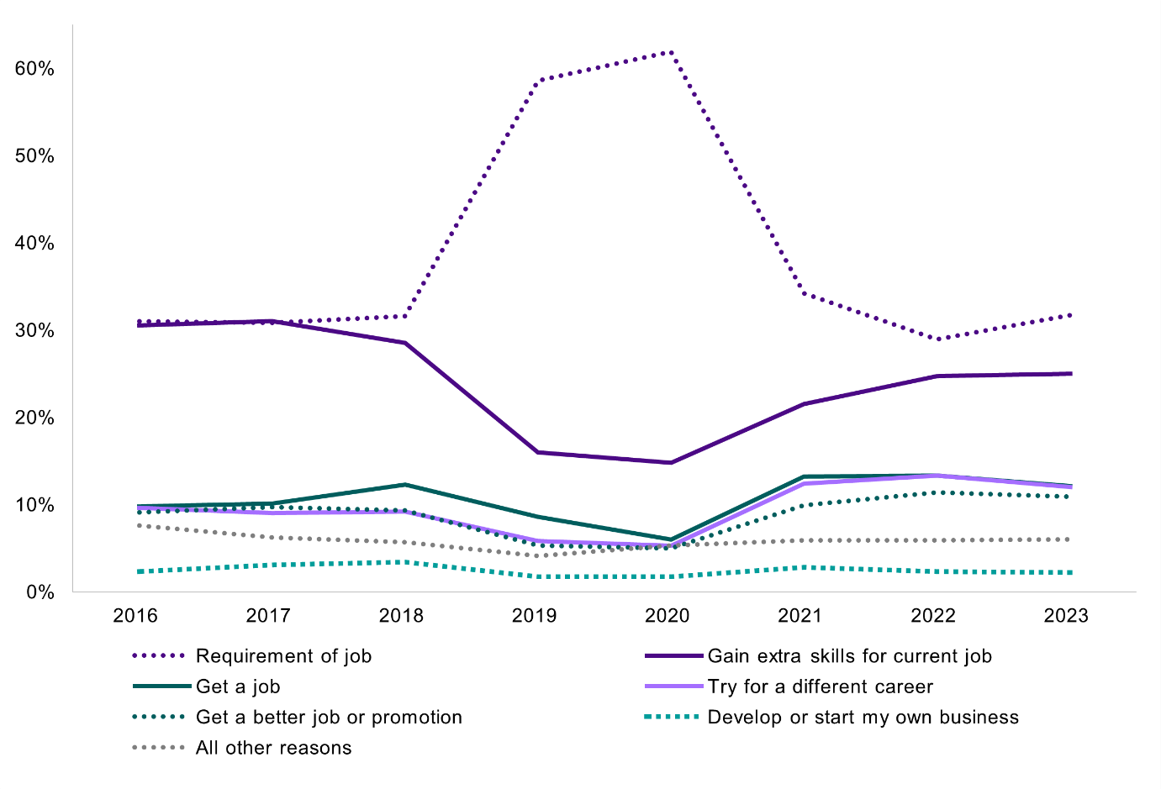
Figure 4.5 Main reason for undertaking training Certificate IV TAE (graduates 2016-2023)
 | 2016 | 2017 | 2018 | 2019 | 2020 | 2021 | 2022 | 2023
Get a job | 9.8% | 10.1% | 12.3% | 8.6% | 6.0% | 13.2% | 13.3% | 12.1%
Develop or start my own business | 2.3% | 3.1% | 3.4% | 1.7% | 1.7% | 2.8% | 2.3% | 2.2%
Try for a different career | 9.6% | 9.0% | 9.2% | 5.8% | 5.3% | 12.4% | 13.3% | 12.0%
Get a better job or promotion | 9.1% | 9.7% | 9.3% | 5.3% | 5.0% | 9.9% | 11.4% | 10.9%
Requirement of job | 31.0% | 30.8% | 31.6% | 58.6% | 61.9% | 34.2% | 28.9% | 31.7%
Gain extra skills for current job | 30.5% | 31.0% | 28.5% | 16.0% | 14.8% | 21.5% | 24.7% | 25.0%
All other reasons | 7.6% | 6.2% | 5.7% | 4.1% | 5.3% | 5.9% | 5.9% | 6.0%

Source: National Student Outcomes Survey (NCVER 2022)
A key finding of this report is that graduates who are working in roles and industries aligned to their vocational skills (vs teaching or education-focused roles and industries) do not find the qualification highly relevant to their job, despite it being a requirement. Only 1 in 3 (33.1%) of non-teachers in non-education industries after training found the qualification was highly relevant to their job and a further 1 in 5 (22.2%) said the qualification had very little or no relevance to their job. In contrast, most VET teachers (after training) found the qualification highly relevant to their job, with relevance decreasing somewhat as the industry moved further from VET – 84.6% working in VET, 84.1% working in other education industries and 79.5% working outside education industries. From 2021 to 2023, approximately half of the VET teacher cohort studying the Certificate IV TAE also found themselves in a better job than their previous role, potentially demonstrating the career progression and higher pay for Certificate IV TAE graduates, discussed in the last chapter.
The cohort in education industries principally comprises secondary school teachers (who are likely teaching VET in Schools) and other teachers and university lecturers and tutors. The cohort outside education industries principally comprises Early Childhood (pre-primary school) Teachers who may be delivering ECEC training in the workplace. Despite the perceived lack of relevance in the non-teaching/non-education cohort, a combined 56.4% of this cohort were doing the qualification for their job – 30.7% to get extra skills for their current job (of whom 90.9% said they achieved this) and 25.6% as a requirement of their job (of whom 98.1% said they achieved this).
The difference between relevance and achievement sentiments may reflect anecdotal commentary, that the qualification has a higher focus on compliance than andragogy and a lower perceived value of and tolerance for this content, outside of VET teachers and people working in VET. It may also reflect differences in what respondents consider their job is.
The comparatively low proportion of graduates who were VET teachers along with the low proportion who were unemployed after training, speaks to much broader demand for graduates of the qualification, which may contribute to teacher shortages. It appears the skills are in those parts of the VET workforce that are difficult to quantify, because practitioners identify with their non-VET teaching occupation.
Qualification to employment outcomes – What occupations are VET teaching credential graduates employed in?
As the above discussion shows, most people doing the key VET teaching qualification are doing it as a requirement of their current job and this is why the biggest proportion of people doing the training are existing VET or secondary school teachers as well as Training and Development Professionals.
As Table 4.5 shows apart from these teaching and training occupations, the types of occupations doing the training reflect the vocations that are widely taught in VET – Nurses, Chefs, Welfare Support Workers, Electricians, Early Childhood Teachers, Beauty Therapists – and/or occupations where workplace training is common – police, paramedics, nurses, fire and emergency workers. The more administrative and managerial occupations are likely workers in non-teaching roles in VET who are completing the qualification as part of career progression or a requirement of their job.
In short, the occupational mix of students enrolling and completing the key VET teaching credential, outside of VET teachers, remains relatively consistent pre- and post-training. Figure 4.6 also shows the top five occupations of Certificate IV TAE graduates are largely teaching and training occupations or, in the case of nurses, an occupation with a large proportion of workplace training roles.
Similarly, from an industry lens, 42.2% of Certificate IV TAE graduates are employed in education and training industries post training and the remainder work in a wide range of other occupations. Figure 4.7 provides insights into the distribution of post-training employment across various industries. Of those who completed the qualification in 2021 and were employed at the end of May 2022, 17.0 % were employed in the Healthcare and Social Assistance industry which crosses over with several high enrolment VET qualifications such as ECEC, nursing, aged care, community services and disability support. The 9.1% in Public Administration likely aligns with roles in leadership, administration, and operations segments across TAFEs.
Table 4.5 2022 Certificate IV TAE graduates: Top occupations before and after training (%)
– occupations forming at least 1% of cohort.
Occupation before training |  | Occupation after training
Secondary School Teachers | 9.8% | Vocational Education Teachers | 20.8%
Vocational Education Teachers | 9.7% | Secondary School Teachers | 9.8%
Registered Nurses | 4.9% | Training & Development Professionals | 5.3%
Training & Development Professionals | 4.3% | Registered Nurses | 4.0%
Contract, Program & Project Administrators | 2.8% | Contract, Program & Project Administrators | 3.1%
Fire & Emergency Workers | 2.6% | Fire & Emergency Workers | 2.5%
Welfare Support Workers | 1.9% | Nurse Educators & Researchers | 1.8%
Ambulance Officers & Paramedics | 1.6% | Ambulance Officers & Paramedics | 1.6%
Nurse Educators & Researchers | 1.6% | Police | 1.3%
Chefs | 1.5% | Welfare Support Workers | 1.3%
Police | 1.4% | Teachers of English to Speakers  of Other Languages | 1.3%
General Clerks | 1.4% | Occupational & Environmental Health Professionals | 1.2%
Occupational & Environmental  Health Professionals | 1.4% | Human Resource Managers | 1.1%
Electricians | 1.3% | University Lecturers & Tutors | 1.1%
Early Childhood (Pre-primary School) Teachers | 1.2% | General Clerks | 1.0%
Education Aides | 1.2% | Specialist Managers | 1.0%
Human Resource Managers | 1.1% | Child Carers | 1.0%
Teachers of English to Speakers  of Other Languages | 1.0% | Education Aides | 1.0%
Beauty Therapists | 1.0% | Total 1% or more | 63.1%
Specialist Managers | 1.0%
University Lecturers & Tutors | 1.0%
Total 1% or more | 53.9%
Source: National Student Outcomes Survey (NCVER 2022)
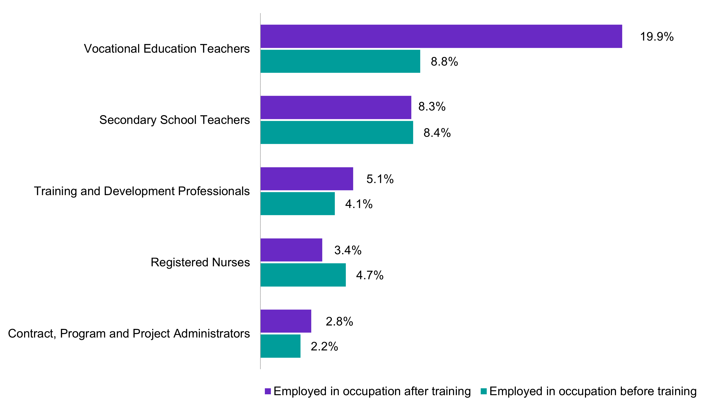
Figure 4.6 Top 5 occupations for Certificate IV in Training and Assessment qualification graduates before and after training (of those employed), 2022
 | Employed in occupation after training | Employed in occupation before training
Vocational Education Teachers | 19.9% | 8.8%
Secondary School Teachers | 8.3% | 8.4%
Training and Development Professionals | 5.1% | 4.1%
Registered Nurses | 3.4% | 4.7%
Contract, Program and Project Administrators | 2.8% | 2.2%

Source: National Student Outcomes Survey (NCVER 2022)

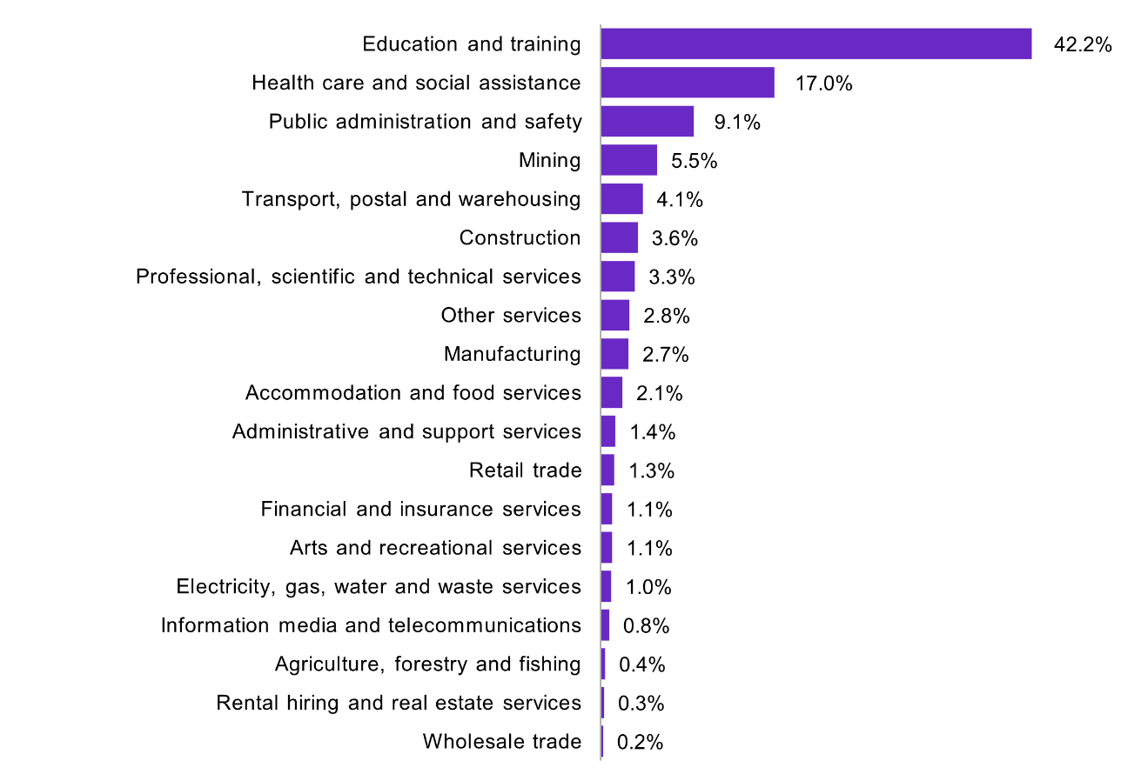
Figure 4.7 Industry of employment for Certificate IV in Training and Assessment qualification graduates after training (of those employed), 2022
Education and training | 42.2%
Health care and social assistance | 17.0%
Public administration and safety | 9.1%
Mining | 5.5%
Transport, postal and warehousing | 4.1%
Construction | 3.6%
Professional, scientific and technical services | 3.3%
Other services | 2.8%
Manufacturing | 2.7%
Accommodation and food services | 2.1%
Administrative and support services | 1.4%
Retail trade | 1.3%
Financial and insurance services | 1.1%
Arts and recreational services | 1.1%
Electricity, gas, water and waste services | 1.0%
Information media and telecommunications | 0.8%
Agriculture, forestry and fishing | 0.4%
Rental hiring and real estate services | 0.3%
Wholesale trade | 0.2%

Source: National Student Outcomes Survey (NCVER 2022)
Analysis by JSA using PLIDA confirms a similar pattern for the occupational outcomes of Certificate IV TAE graduates. This data suggests that even a smaller proportion of these graduates are moving into VET Teacher or Training and Development Professional roles from other occupations. Less than 5% of the 2019 Certificate IV graduates moved into VET Teacher or Training and Development Professional roles in 2020-21 from other occupations in 2017-18.
Secondary school teachers were the largest occupational group undertaking the Certificate IV TAE – 19% in 2018 and 17% in 2019, and over 90% remained secondary school teachers before and after undertaking the training.
Looking more closely at those Certificate IV TAE graduates who do move into VET teacher roles, the entrants come from occupations that align with key VET qualifications. For 2018 and 2019 graduates, the most common previous occupations included Chefs, Hairdressers, Child Carers, Motor Mechanics, as well as Training and Development Professionals but this group made up less than 20 per cent of moving VET teachers in both years. These entrants typically experience an increase in median income, but this is generally because of the lower paid vocational occupation they are coming from. 2018 graduates gained income increases from around $48,000 in 2016-17 to $62,000 in 2019-20. Similarly, for 2019 graduates, median income increased from approximately $51,000 in 2017-18 to $66,000 in 2019-20.
In contrast to Certificate IV TAE graduates, around 1 in 5 (22.6%) 2020 graduates of Diplomas in Adult Education (delivered in the VET system) were already VET teachers in the year before they graduated. In the year post-graduation, the proportion who were VET teachers increased to 23.6%. Training and Development professionals were the next highest proportion of entrants (8.7%), followed by Corporate General Managers and Chief Executives and Managing Directors (combined) which accounted for 4.0% of Diploma level graduates. Post-graduation, there was a lower proportion of Training and Development professionals (8.5%) but an increase in management level occupations (5.2%). This aligns with our commentary in Chapter 3 where we identified that Diplomas in Adult Education are a pathway to more senior roles.
Other non-VET occupations with comparatively high participation were primary school teachers (7.9% of graduates pre-training and 8.2% post-training) and secondary school teachers (5.7% pre-training and 5.9% post-training). Regarding some other occupations of interest to the VET workforce, 1.8% were TESOL teachers pre-training, rising to 3.0% post-training, 1.7% were registered nurses (not elsewhere classified) (falling to 1.5% post-training), 1.5% were nurse educators pre- and post-training and 1.1% were education advisers, rising to 1.7% post-training.
This study also requested qualification to employment outcomes for VET teaching skill sets including assessor only skill sets, but the data could not be released due to small numbers so cannot add nuance to the quite complex training pipeline and supply dilemma in VET.

Workforce transitions
The last section of the chapter expands on the above analysis of occupational outcomes from a VET teaching qualifications perspective to look at the broader occupational flows in and out of the VET workforce using PLIDA data. This 'occupation mobility’ data adds a new layer of analysis to skills shortages and labour market dynamics – including retention, attraction and pay issues at play – by analysing how workers move between occupations.
JSA’s January 2024 report ‘Data on Occupation Mobility Unpacking Workers’ Movements’ gave a labour-market wide view finding that most workers don’t change occupations and that some occupations are ‘stickier’ than others due to licencing, registration, qualifications, longer training times or even pay reasons.
In general, most workers do not change occupations. Data on individuals’ Income Tax Returns from the Australian Taxation Office indicates that over the ten-year period
2011-2012 to 2020-2021 the percentage of people who remained in the same occupation varied between 83% and 92%.
Unsurprisingly, occupations with the smallest transitions (otherwise known as inflows and outflows) tend to be those with a smaller workforce and/or very specialised skills. For example – Teachers of the Sight Impaired. Conversely, there are areas of the labour market from both an occupational and industry perspective which have higher transitions. Occupations with the largest inflows include roles like Disability Services Officers and Community workers whereas the largest outflows are for hospitality occupations – cooks, waiters, housekeepers, and kitchenhands.

VET teacher job mobility
Like Census data, this job mobility data is limited to ANZSCO classifications so we can only offer analysis of the transitions of Vocational Education Teachers specifically, not the overall VET workforce. Over the eight-year financial years from 2011/12 to 2018/19 inclusive, the percentage of VET teachers staying in the same occupation was consistently between 85% and 88% indicating a potentially ‘stickier’ occupation and higher level of retention in the workforce.
However, during this period the VET teacher occupation did lose more people to other occupations than it gained. VET Teacher inflows were greater than outflows as the pandemic began but without more recent data, firmer insights on this data from a demand and supply perspective is limited (see Figure 4.8). Training and Development Professionals also follow this trend, where more people were moving out of the occupation than into it from 2013/14 until the pandemic hit.
It is also notable that a higher proportion of VET teachers changed jobs to a different occupation each year relative to teaching occupations in other sectors and, in most years, relative to individuals across all professional occupations (ANZSCO Major Group 2: Professionals). Primary, secondary and early childhood (pre-primary school) teachers are far ‘stickier’ occupations and, unlike VET teachers, inflows into these teaching positions outnumber outflows over the decade. VET teacher outflows also exceed those in university lecturer and secondary school teachers.
The ability to meet rising demand can be understood by comparing the inflow and outflow of workers as per the previous year’s total workforce size. In the case of VET teachers, outflows have exceeded inflows for eight out of the nine reference years, a potential threat to adequate supply in an environment of increasing demand (see Figure 4.8).
Figure 4.8 Movements into and out of Vocational Education Teacher, 2011/2012 to 2019/2020
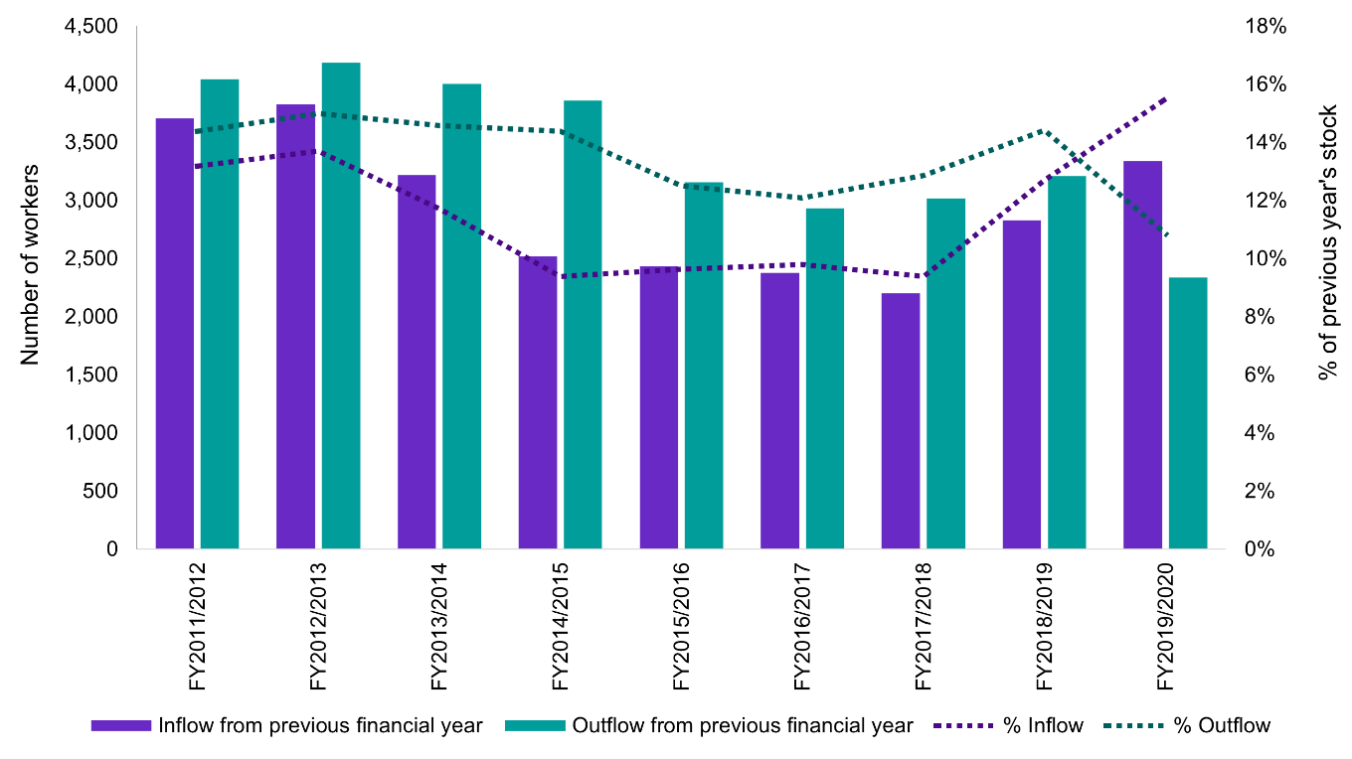
Source: Jobs and Skills Australia (PLIDA ITR data 2011-2012 to 2019-2020)

Regarding specific occupational transitions, the strongest pathways into the occupation of VET teacher were, consistent with analysis earlier in this chapter, other teaching or education focused roles and vocational occupations that align with high-enrolment courses taught in VET.
Outflows are focused more on managerial or executive occupational transitions, but education focused roles also remain common. These movements out of VET teaching likely represent career progression within the VET sector and across taxonomy segments like Teach, Train, and Assess to Leadership and/or Curriculum and Learning design. See Figure 4.9 for the top ten movements into and out of the VET teacher occupation.

Figure 4.9 Top 10 occupation movements into and out of VET teacher, FY2011/12-FY2020/21

Source: Jobs and Skills Australia (PLIDA ITR data 2011-2012 to 2020-2021)
*T&D Professional is Training and Development Professional

Looking at occupational movements over a longer period (the decade of 2011/12 to 2020/21) there are three pathways into the VET Teacher role which can be categorised as:
- Education-related occupation movements, involving other teaching or training occupations, education management, or education aide roles.
- Corporate occupation movements, which are those most connected to the training and development function within organisations. These include general manager roles, human resource manager roles, and human resource professionals.
- Industry occupation movements, which have been defined as all other roles at Skill level 4 and above (although we do not know that the individuals are applying the industry knowledge from their most recent role).
More VET teachers move into the role from education-related roles, such as School Teachers and university lecturers, than from vocational industry-related roles (28.3% compared to 16.5%; see Table 4.6). VET teachers who left for another known role (as opposed to retiring or where the occupation is unknown) mostly stayed within education, moving to roles like School Teacher, University Lecturer or Training and Development Professional. Returning to vocational roles was less common than shifting to corporate or administrative roles (7.2% compared to 9.6%). As above, this likely reflects career progressions within VET as opposed to VET teachers leaving the sector completely.

Table 4.6 Occupational movements into and out of VET teacher (FY2011/12-2019/20)
Previous year occupations  (occupational transitions in) |  | Following year occupations  (occupational transitions out)
Education occupations | 28.3% | Education occupations | 25.7%
School Teachers nfd | 5.8% | Secondary School Teacher | 4.1%
Secondary School Teacher | 4.4% | University Lecturer | 4.1%
University Lecturer | 3.6% | School Teachers nfd | 3.3%
Training and Development Professional | 3.1% | Training and Development Professional | 2.6%
Primary School Teacher | 1.7% | Education Adviser | 1.8%
Other education occupations | 9.7% | Other education occupations | 9.8%
Vocational occupations | 16.5% | Corporate and administrative occupations | 9.6%
Sales Assistant (General) | 1.5% | Corporate General Manager | 1.5%
Chef | 1.5% | Officer Manager | 1.1%
Child Care Worker | 1.4% | Program or Project Administrator | 1.0%
Waiter | 0.8% | Chief Executive or Managing Director | 1.0%
Electrician (General) | 0.8% | Accountant (General) | 0.5%
Other vocation occupations | 10.5% | Other corporation and administrative occupations | 4.5%
Corporate and administrative occupations | 9.2% | Vocational occupations | 7.2%
General Clerk | 2.2% | Sales Assistant (General) | 0.9%
Corporate General Manager | 1.2% | Community Worker | 0.6%
Office Manager | 1.1% | Early Childhood (Pre-primary School) Teacher | 0.5%
Program or Project Administrator | 0.9% | Chef | 0.5%
Other corporation and administrative occupations | 3.3% | Aged or Disabled Carer | 0.4%
Occupation unknown or no income tax return | 46.1% | Other vocation occupations | 4.3%
 |  | Occupation unknown or no  income tax return | 57.6%
Source: Jobs and Skills Australia (PLIDA ITR data 2011-2012 to 2019-2020).

Real time pay changes when moving in or out of VET
PLIDA data confirms this evidence of lower pay for VET teachers. Despite wage increases for some occupations moving into VET ( generally more insecure jobs like Waiters, Private Tutors, Sales Assistants and Aged or Disability Carers) averaged across all occupations over the last three years, there is a decrease in average annual wages when becoming a VET teacher ranging between a 9.5% and 16.5% pay cut across the more recent five years (FY2017-18 to FY2021-22). In the FY2021-22, new VET teachers earned on average $8061.10 less than they did in the previous financial year, before becoming a VET teacher.
However, PLIDA data also shows that despite the generally lower pay in the VET sector, education professionals who become VET teachers did experience a slight increase in their pay. This could be connected to the highly casualised rates of teachers, lecturers and tutors in schools and universities. Across the five-year period Primary School Teachers who became VET teachers had 8.4% increase in their annual average wage. For secondary Teachers that increase was 3.5%, for University Lecturer 2.6%, and for University Tutors 14.8%.
For non-professional but allied education workers like Teachers’ Aide and Private Tutors and Teachers there were even more substantial pay increases at 18.3% and 17.1% respectively. Roles in the Administrative and operations segment also experienced average pay increases boding well for moves into VET from these types of occupations.
Other common occupations to move into VET teaching are not surprisingly those from common and high-enrolment VET teaching qualifications and most experience an increase in annual average wages over the five-year period, especially for lower paid vocations but even for building and engineering trades, albeit only around 5%. For example, Waiters received a 35.5% pay increase, Sales Assistant 23.4% Aged and Disabled Carers 25.3%, Child Care Workers 11.2%, Motor Mechanics 6.1%, Electricians 5.6%, and Chefs 4.5%. See Chapter 4 for further analysis of occupational transitions including pay and how this could relate to existing skills shortages and higher pay in some vocations commonly taught in VET.
Over the same five-year period, VET teachers who exited to other occupations experienced substantial pay increases ranging from 34.0% to 53.3% on average each year. However, these averages are likely skewed, due to very significant pay increases for management and education professional-like occupations, which likely indicate career progression within VET or other education sectors. For example, Chief Executive or Managing Directors (a 25.8% pay increase), Corporate General Managers (10.6%), Program or Project Administrators (11.5%), Education Advisors (10.0%), Training and Development Professionals (5.2%), and Regional Education Managers (2.3%). Moving from VET teaching to Software Engineering is also an outlier skewing this overall higher wage increase at 79.2%.
VET teachers who move into other education roles experience far higher pay increases than those shifting moving into VET. For example, VET teachers who became primary and secondary school teachers experienced an average pay increase over the last five years of 29.3% and 14.1% respectively. Likewise, VET teachers who became University Tutors experienced a 29.7% increase. VET teachers becoming lecturers didn’t experience as high as a pay increase at only 6.7%. It is notable that VET teachers who return to their vocation of Child Care Worker experience a pay decrease.

Conclusion
This chapter has shown that current demand for VET staff, especially VET teachers, is very high and growing. With around 44% of future jobs requiring a VET qualification, it is expected that demand will increase further in the future. The VET workforce has a low fill rate (around 50%), showing that there is currently an inadequate supply of VET teachers.
The number of completions in the Certificate IV TAE has declined substantially and only a minority of completions appear to convert this qualification into a VET Teach, Train or Assess role. Since 2016, completions have fallen by almost 25% in this credential. However, this isn’t impacting supply as drastically as might be expected because almost 70% of graduates gained the qualification as a requirement of their existing job. More than addressing a broad shortfall, Teach, Train and Assess qualifications will be particularly needed among experienced industry professionals in skill shortage areas. The case studies presented elsewhere in this report show this is less about the qualification itself and providing financial assistance and a guaranteed pathway into employment after completion.
The VET workforce tends to be older than the rest of the workforce and the pipeline suggests it will continue to age still further. Equity groups such as those living with a disability are poorly represented among VET teachers, which in turn influences enrolments and job roles among diversity groups.
By contrast, VET teachers are more likely to enter the sector from regional and remote areas of Australia, perhaps reflecting the relative low enrolment in university courses from those regions. There is not much career transitions in and out of VET teaching, but where there is it is generally to and from other kinds of teaching, especially Secondary Teaching. Data challenges the misconception that VET teachers move back to industry after teaching, with almost twice as many VET teachers moving into other education sector occupations, as do vocational occupations.

Chapter 5: Key findings
The VET sector performs a critical, immense, and diverse role in building a prosperous, productive and cohesive Australia – it trains almost 4.5 million students each year and will be responsible for training 44% of new jobs over the next 10 years – including the key jobs of the future in clean energy, care, and technology. Many of Australia’s widespread occupational shortages are also VET-qualified jobs, including VET teachers themselves.
More fundamentally, the contribution that VET makes to improving the literacy, numeracy and other foundation skills of Australian adults creates a more cohesive society and enables greater workforce participation. The VET system needs to be ready to perform and grow and this means ensuring a sustainable, growing, qualified, well-paid, and well-understood VET workforce. This study has been anchored in the objective of understanding the VET workforce and highlighting the extent of this challenge.
This study has offered a new approach to analysing existing VET workforce data through the workforce taxonomy. It presents an initial occupational framework that profiles existing and emerging roles in VET. The report has identified the high demand for the VET workforce but the decreasing supply of VET teachers through key VET teaching credentials and raises questions around the suitability of those credentials for the sector.
It uses new data to reflect real-world pathways in, out and within the sector giving insight into the jobs from which people are most likely to enter VET and how Government might pre-empt and mitigate skills shortages. This final chapter reflects on these key findings and highlights the opportunities for understanding the workforce, particularly in relation to future data collection recommendations.

Key findings

Understanding the current VET workforce
Targeted improvements in workforce data collection will help manage future risk to Australia’s economy, society and VET system by ensuring a sustainable and high quality supply of teachers and trainers, particularly in industry sectors experiencing skills shortages and high employment demand.
Wherever possible, this report has drawn on existing data (including multiple sources where available) to reach conclusions about VET teachers, trainers and assessors in general and the overall VET workforce. However existing data is limited because:
- existing data sources such as the Census do not capture multiple job holders who are not working in VET as their main job, or their characteristics, such as hours of work
- we do not have comprehensive data on the vocational and VET qualifications held by the teach, train and assess workforce

- we cannot segment the VET teach, train and assess workforce by industry area, so we cannot align analysis of the supply and demand of VET teachers, trainers and assessors with broader industry skill shortages
- we cannot use existing data to understand how the VET workforce varies among different types of private and not for profit RTOs.
The VET workforce taxonomy, job profiles and occupational framework will aid future workforce planning and raise the status of VET jobs including the diversity of roles involved in this increasingly dynamic sector.
Governments, RTOs, and individuals can use all three tools to further understand – and indeed market – the different pathways into and diverse roles in VET. We identify how these workforce segments vary across RTOs depend on its student size, scope of delivery (reflected in the scope of registration), diversity of student cohort, funding sources, RTO type and business model. The profiling of Teach, Train, and Assess roles across a spectrum of working under supervision, focused, broad and extended scope and responsibility also opens the door for an occupational framework that cements career development opportunities and allows the best VET teachers to remain teachers if they want. In fact, we have deliberately chosen to highlight six segments, not just focus on teaching, training, and assessing, because they all contribute to the overall success of the VET sector and better reflect current industry practice.
Moreover, most segments provide pathways in and out of Teach, Train, and Assess roles where skills shortages are most apparent, and some segments are increasingly relevant and growing due to market and technological trends in curriculum, instructional and e-learning design roles. The importance of a high-quality, dynamic, and younger leadership cohort for VET is also key to a sustainable workforce and demonstrating the older and ageing profile of this and the teaching workforce is a signal to all stakeholders to act.

The diversity of VET providers, student cohorts, funding and training offerings has direct implications for the VET workforce. Teaching roles differ across RTOs and need different supports and policy levers.
This study offers a more contemporary understanding of the current policy, regulatory and market shifts in the sector and the direct impacts on the workforce, including which parts Government should prioritise in its support. For example, most teaching effort in VET is in qualifications, even though subject only enrolments dominate student enrolments. And many of the high-volume training package qualifications are also concentrated in areas of skills shortages – aged/disability care, early learning, and specific building and engineering trades. Certain provider types also have a larger share of the market for certain high enrolment qualifications and the impact these have on workforce conditions and make-up needs to be considered for workforce strategy. Disadvantaged and priority cohorts are also increasingly taking up VET training and increased pedagogical skills, understanding and wrap around supports for the VET workforce are needed.

High demand, low supply and training pipeline issues

There is strong alignment between high enrolment qualifications and occupations rated in skills shortages which has led to high and growing demand for VET teachers, but VET teacher numbers have shrunk by between 11-18% over the last decade.
The VET workforce is competing with industry for a limited supply of vocationally skilled workers. Projections show we will need 3,800 more VET teachers in the next five years. Future demand for VET teachers is expected to remain strong, with projected employment growth of 21% by 2033. Demand for other tertiary education occupations is also high. In the wider economy, there are skills shortages in key areas requiring VET delivery, including Aged and Disability Care, ECEC, Carpentry and Electrotechnology trades. The top ten qualifications by enrolments have experienced above average rates of growth since 2018, potentially exacerbating existing skills shortages for teaching, training and assessing roles in these areas. VET teachers themselves are in shortage nationally and in every jurisdiction in the last two years. Very strong demand for workers in vocational fields where the occupation is also on the skills shortage list (e.g. Electricians) or is nearing retirement age (e.g. adult literacy and numeracy specialists) is also a factor.

Training providers are struggling to attract suitable applicants to fill teacher vacancies, with a lower vacancy fill rate than in universities, secondary and primary schools.
Over the ten years to January 2024, online job advertisements for VET teachers have grown by just over 200% compared to a growth of around 80% across all occupations. Advertisements for VET teachers outgrew the all-occupation average in every state and the ACT over the last decade. Only NT was the exception. There is also only a 50% fill rate for VET teaching jobs advertised. Plausible explanations of this growth in VET teacher vacancies include the creation of new VET teacher jobs in areas of high enrolments and skills shortages and increasing rates of retirement due to the older age profile of the VET teacher workforce. This has been acute in some areas, including foundation skills and adult literacy and numeracy specialist roles.

The training pipeline is shrinking but is not particularly targeted at new entrants. Completions in the key teaching credential – the Certificate IV TAE – have fallen by almost 25% since 2016. However, this isn’t impacting supply as drastically as expected because almost 70% of graduates are doing the qualification for their existing job.
This means most people doing the key VET teaching credential does not translate into new workforce supply. These trends have been stable since 2016, except for 2019 and 2020 where they were even higher due to TAE upgrades at this time. The stark declines in the training pipeline have also occurred during a period when VET student numbers and enrolments in skill shortage qualifications like ECEC and the building and engineering trades have increased (partly offset by declines in other fields). The data also shows that those who are studying VET teaching diplomas are even more likely to be in VET already and are studying for career progression, better job security and higher pay. Higher education adult education training pathways into VET are similar and even smaller. Both have also shrunk since in recent years.

Student outcomes survey data shows that only a small proportion of graduates are using the Certificate IV TAE to move into VET teaching roles.
One-third of 2022 Certificate IV TAE graduates who were in non-education occupations before their study continued to pursue work outside of Teach, train and assess roles after completing the qualification. However, most Certificate IV TAE graduates who were working as VET teachers after training did find the qualification highly relevant to their job – around 85% for those working in VET and other education sectors.

Migration pathways are infrequently used for VET teachers. There are some visa options available that potentially could offer a source of supply for VET teachers.
Fewer than 20 visas to sponsor VET teachers were granted on average per year over the last decade. For VET teachers born overseas, VET teaching is not typically their first job on arrival in Australia. The pool of migrants able to step into a VET teacher role without further study or prior employment in Australia is limited. However, given the qualification and licencing requirements, additional supports would likely need to be implemented to encourage greater use of a migration pipeline.

An older and ageing workforce that is lacking diversity
The most distinctive demographic aspect of the workforce is that it is older and ageing. This is more pronounced for the Teach, Train, and Assess workforce.
Almost half of the VET workforce is over 50 years, and the average age is six years older than the Australian workforce average (47 compared to 41). Outside of this, the VET workforce reflects the demographic make-up of the wider Australian workforce with only slight variations. For example, VET is only slightly more feminised and slightly less culturally diverse that the wider Australian workforce However a lower proportion of the VET workforce than the wider Australian workforce speaks a language other than English (LOTE) at home. The VET workforce has a similar geographic profile to the Australian workforce.

The VET workforce is more highly qualified than the Australian workforce but there are key data gaps due to the dual professional status of VET teachers, trainers and assessors.
Almost half of the VET workforce has a Bachelor degree in contrast to just over one third of the broader Australian workforce. This higher level of education is not surprising considering the dual professional status of VET teachers but highlights the unique data gap of the VET workforce’s dual qualifications in both vocational and adult education teaching qualifications. We have no way of understanding and differentiating the teaching and industry qualifications of the workforce without a custom data collection.
The VET workforce is not as diverse as its student population.
First Nations peoples and cohorts who speak a Language other than English at home, especially amongst the Teach, Train, and Assess segment is lower than the wider Australian Workforce, a situation that the current training pipeline will reinforce. This is in contrast to the diversity of the VET student cohort, which may negatively impact student outcomes and perpetuate disadvantage, as incoming VET students are less likely to encounter people with whom they identify.

Highly casualised and lower paid than teachers in other education sectors

The VET workforce is more casualised, slightly higher paid and less award dependent than the Australian workforce, but not when compared to their teaching counterparts in other education sectors or industry vocations prominent in VET.
Only 56% of VET teachers are permanent employees, compared to 70% of the Australian workforce. Most TAFE employees are employed in permanent or ongoing roles (62%-85.4%), except for TAFE NSW where almost half of employees are casual. The award wage is substantially lower than enterprise agreements but over 60% of VET teachers are on enterprise agreements, mainly in the public sector. This means that those teaching in private RTOs generally earn less than those with public sector employers because there is higher agreement coverage and union membership in public TAFEs and dual sector institutions. Most (68.5%) VET teachers had only one job in 2021-22, very similar to the average for all occupations (67.2%).

There is a 16% gender pay gap in VET.
Women earning an average annual income $14,773 less than their male counterparts. The pay gap is even higher for VET teachers, trainers and assessors where it is a 17% pay gap. For full-time workers, this gender pay gap reduces to 9% for overall VET workforce and 7% for the Teach, Train, and Assess segment.

The VET teaching profession lost more people to other occupations than it gained in the eight years leading up to 2018/19 and those that leave get higher pay increases than those that enter.
This presents a challenge for attracting and retaining the VET workforce as prospective teachers must weigh up a teaching role relative to their industry pay and conditions. For some occupations, moving into VET comes with a pay increase (mainly from lower paid and more insecure occupations) but on average, new VET teachers earn less than they did in the previous financial year. Likewise, those leaving VET to pursue other teaching or education focused roles on average receive significant pay increases.

There are few common career movements in and out of VET teaching, but where there are it is generally to and from other kinds of teaching, especially Secondary School Teaching. There is also some evidence of career progression within the sector from VET teaching into leadership positions.
Based on the PLIDA data analysed here, the strongest pathways into the occupation of VET teacher are other teaching or education focused roles and vocational occupations that align with high-enrolment courses taught in VET. Outflows are focused more on managerial or executive occupational movements, but education focused roles also remain common. For example, 14% of new VET teachers are from occupations with a VET pathway (like Chef and Sales Assistants), and if they do exit, VET teachers are more likely to move on to corporate and administrative occupations than (back) to vocational occupations likely reflecting career progression or movement within the VET sector.

The TAFE workforce has better employment conditions, more diversity and is higher paid

The TAFE workforce has around 40,000 workers, is slightly more feminised, higher paid, more likely to work full-time and even older than the VET workforce broadly.
Over half of the TAFE workforce are teachers and it is more diverse in some cases – for example some TAFEs also have a higher proportion of First Nations employees compared to the VET workforce overall. Generally, over 60% of TAFE employees are employed full-time but in NSW there is currently a higher proportion of casual staff. In almost every state and territory, more than half of the workforce is over 50 years of age. Only 30% of the Australian workforce is in this age bracket.
The dual sector VET workforce is estimated at around 2000 workers nationally and reflects the TAFE workforce profile in demographics and employment conditions.
It is older, slightly more feminised, and higher paid than the VET workforce overall. However, generally not higher paid than their TAFE counterparts especially at entry-level teaching positions.

Addressing data gaps and recommendations for future data collection

This report has added to our understanding of the characteristics of the VET workforce but building a complete workforce profile will require filling current data gaps in four key areas.
Firstly, understanding the spread of both teaching and industry qualifications across the sector, taking into account how differently job roles are defined across RTO types. Secondly, identifying a national workforce count and composition of the VET workforce that properly accounts for VET workers with multiple jobs, whether between VET and industry or across multiple RTOs. Thirdly, developing a more nuanced understanding of the diversity of the VET workforce, especially First Nations status, if Australia is to have a VET workforce that aligns with the student cohort it serves. We know that the VET workforce is older, and ageing but better data is still needed to manage this risk and secure a sustainable workforce supply in the future. There are also other key data gaps that need attention. For example: more attitudinal data on why VET teachers’ future employment intentions.

Options for future VET workforce data collection
We outline three options for more systematic regular collection of VET workforce data. First, regulatory bodies, such as ASQA, could collect minimum data from RTOs at the time of registration. Second, the universal implementation of a VET Workforce Standard where RTOs submit workforce data as part of their annual Total VET Activity returns. Third, a regular census style survey of RTOs and employees. Systematic piloting of the survey is needed to ensure a representative sample is achieved so a workforce profile across all provider types can be extrapolated. We recommend Government consider these options as the basis for further engagement with the sector, balancing the imperative for better workforce data with the data collection requirements already placed upon RTOs and the significant funding that would be required to fully implement each of the options.

Conclusion
This study has exposed other opportunities that could be explored to ensure a sustainable VET sector that will ensure Australia’s workforce is well prepared into the future. Future decision-making on policy and regulatory levers in the VET workforce should take into consideration the diversity of the VET sector and its workforce. Developing separate workforce strategies for the different types of teachers and types of teaching in VET is needed. This is especially the case for the workforce that delivers single-subject enrolments versus the workforce that delivers training package qualifications. Most of the teaching effort in VET is in qualifications after all and the high enrolment VET courses also align with Australia’s skills shortages.
Further workforce mapping including demand and supply analysis on specific VET teaching vocations areas that align with these skills shortages is needed. Policy levers and workforce strategies on how to attract industry experts to teaching where there are large pay disparities are another priority.
The Australian economy and society rely on the VET system and its professional workforce to teach and train Australia’s future workers. If we don’t secure a sustainable VET workforce for the future, we cannot fix skills shortages or ensure a high performing VET system.


- VET workforce taxonomy and ANZSCO mapping
Study Taxonomy - VET Workforce Segment | Mapped ANZSCO Occupations |  | Common job titles/  sub-sector roles
 | Code | Title
Teach, Train and Assess | 242211 | Vocational Education Teacher | VET practitioner  VET teacher  VET trainer  VET professional  VET lecturer  VET educator  VET in Schools teacher  Head/Senior teacher (Leadership crossover)  Educational Team Leader (Leadership crossover)  TAFE teacher  Industry-based trainer  Industry-based assessor  Trainer and assessor  Language, literacy and numeracy (LLN) practitioner  VET Literacy and Numeracy Educator  Workplace assessor  Workplace Trainer  TESOL teacher/ESL or EAL teacher  Adult Community Education Teacher  Assessor  Head Trainer  Leading VET Teacher  Vocational Instructor  VET tutor  Principal Lecturer (Leadership Crossover)
 | 249311 | Teacher of English to Speakers of Other Languages
 | 242111 | University Lecturer
 | 242000 | Tertiary Education Teachers nfd
 | 240000 | Education Professionals nfd
 | 254211 | Nurse Educator
 | 241411 | Secondary School Teacher
 | 249299 | Private Tutors and Teachers nec
 | 223211 | ICT Trainer
 | 241000 | School Teachers nfd
 | 242112 | University Tutor
 | 241511 | Special Needs Teacher
 | 451211 | Driving Instructor
 | 451815 | First Aid Trainer
 | 241111 | Early Childhood (Pre-primary School) Teacher
 | 231113 | Flying Instructor
 | 241599 | Special Education Teachers nec
 | 249214 | Music Teacher (Private Tuition)
 | 249200 | Private Tutors and Teachers nfd
 | 242100 | University Lecturers and Tutors nfd
 | 249211 | Art Teacher (Private Tuition)
 | 241512 | Teacher of the Hearing Impaired
 | 241213 | Primary School Teacher
 | 249212 | Dance Teacher (Private Tuition)
 | 241311 | Middle School Teacher
 | 241513 | Teacher of the Sight Impaired
Leadership  (Top 30 by count) | 134411 | Faculty Head | Senior Educator (Teach, Train, Assess Crossover)  Education Manager  Program Manager  RTO Manager  Training Director  Course Coordinator  Campus managers  Faculty Heads  Training coordinators and managers (Teach, Train, Assess Crossover)  Industry engagement managers  Industry innovation specialists  Chief Executive Officer  Education Manager  Educational Team Leader (Teach, Train, Assess Crossover)  Academic Director (Deputy Director)  Academic Director (RTO)  Faculty Manager  Chief Product and Quality Officer  Managing Director  Director - Quality & Development  Manager - Innovative Practice  Director - Vocational Education  Tertiary Education Administrator or Manager  Managing Director  Principal Lecturer (Teach, Train, Assess Crossover)  Manager - Innovative Practice  Manager - Curriculum Development  Director- Skills Team  Head of Skills
 | 132311 | Human Resource Manager
 | 111111 | Chief Executive or Managing Director
 | 512111 | Office Manager
 | 131112 | Sales and Marketing Manager
 | 134499 | Education Managers nec
 | 132411 | Policy and Planning Manager
 | 111211 | Corporate General Manager
 | 100000 | Managers nfd
 | 130000 | Specialist Managers nfd
 | 132211 | Finance Manager
 | 149212 | Customer Service Manager
 | 135112 | ICT Project Manager
 | 149913 | Facilities Manager
 | 132111 | Corporate Services Manager
 | 139999 | Specialist Managers nec
 | 134400 | Other Education Managers nfd
 | 131114 | Public Relations Manager
 | 134000 | Education, Health and Welfare Services Managers nfd
 | 134412 | Regional Education Manager
 | 249112 | Education Reviewer
 | 132000 | Business Administration Managers nfd
 | 135100 | ICT Managers nfd
 | 135199 | ICT Managers nec
 | 135111 | Chief Information Officer
 | 134311 | School Principal
 | 224214 | Records Manager
 | 222312 | Financial Investment Manager
 | 134299 | Health and Welfare Services Managers nec
 | 225211 | ICT Account Manager
Quality Assurance and Compliance | 139914 | Quality Assurance Manager | Compliance Officer  Compliance Manager (Leadership crossover)  Compliance Coordinator  Risk and Compliance Coordinator  Training and Compliance Coordinator  Quality Assurance Consultant  Quality Teaching and Learning Consultant  Quality Assurance and Compliance Officer  Assessment Quality Officer  Quality Manager (Leadership crossover)  Quality Specialist  Coordinator VET Quality and LLN Services (Teach, Train Assess crossover)  Head of Academic Quality (Leadership crossover)  VET Curriculum & Quality Assurance Manager (Leadership crossover)
 | 599599 | Inspectors and Regulatory Officers nec
 | 599500 | Inspectors and Regulatory Officers nfd
 | 221213 | External Auditor
Learning support | 422116 | Teachers' Aide | Education Aide  Student Support Officer  Counsellor  Librarian (and) Library Manager  Enrolment Officer  Student Administration Manager
 | 224611 | Librarian
 | 272115 | Student Counsellor
 | 399312 | Library Technician
 | 272199 | Counsellors nec
 | 272111 | Careers Counsellor
 | 422112 | Integration Aide
 | 423111 | Aged or Disabled Carer
 | 411712 | Disabilities Services Officer
 | 224912 | Liaison Officer
 | 272312 | Educational Psychologist
 | 411711 | Community Worker
 | 422111 | Aboriginal and Torres Strait Islander Education Worker
 | 272613 | Welfare Worker
 | 599711 | Library Assistant
 | 272511 | Social Worker
 | 422100 | Education Aides nfd
 | 272412 | Interpreter
 | 411716 | Youth Worker
 | 272311 | Clinical Psychologist
 | 272211 | Minister of Religion
 | 311414 | School Laboratory Technician
 | 272314 | Psychotherapist
 | 411713 | Family Support Worker
 | 252411 | Occupational Therapist
Curriculum Development and Learning Design | 223311 | Training and Development Professional | Content developers  Curriculum designers  Instructional designers  Curriculum Advisory Teacher (Teach, Train, Assess crossover)  Home School Liaison Officer  Learning Designer  Learning Technologist  Learning Technologies and Support Consultant  Education Officer  Training Officer  Education Support Officer  E-learning Support Officer  Preschool Field Officer
 | 249111 | Education Adviser
 | 232413 | Multimedia Designer
 | 232411 | Graphic Designer
 | 212415 | Technical Writer
 | 249000 | Miscellaneous Education Professionals nfd
 | 261211 | Multimedia Specialist
 | 249100 | Education Advisers and Reviewers nfd
 | 261300 | Software and Applications Programmers nfd
 | 212000 | Media Professionals nfd
Administration and Operations  (Top 30 by count) | 531111 | General Clerk | Administration  Administration Assistant  Administration Officer
 | 511112 | Program or Project Administrator
 | 541211 | Information Officer
 | 225113 | Marketing Specialist
 | 532111 | Data Entry Operator
 | 224711 | Management Consultant
 | 551111 | Accounts Clerk
 | 221111 | Accountant (General)
 | 313112 | ICT Customer Support Officer
 | 542111 | Receptionist (General)
 | 200000 | Professionals nfd
 | 223112 | Recruitment Consultant
 | 521111 | Personal Assistant
 | 223111 | Human Resource Adviser
 | 341111 | Electrician (General)
 | 811211 | Commercial Cleaner
 | 621111 | Sales Assistant (General)
 | 224999 | Information and Organisation Professionals nec
 | 599999 | Clerical and Administrative Workers nec
 | 251312 | Occupational Health and Safety Adviser
 | 441312 | Police Officer
 | 551311 | Payroll Clerk
 | 741111 | Storeperson
 | 551211 | Bookkeeper
 | 262113 | Systems Administrator
 | 599916 | Facilities Administrator
 | 149311 | Conference and Event Organiser
 | 261312 | Developer Programmer
 | 225311 | Public Relations Professional
 | 142111 | Retail Manager (General)

- TAFE and Dual Sector Workforce Profiles

TAFE Workforce Profile
This study collected 2022-23 workforce data from TAFEs in every state and territory including Charles Darwin University in the NT which is contracted by government as the public VET provider. The data reveals a remarkable diversity between TAFE institutions across different jurisdictions and regions, particularly in organisational structure but also offers a national workforce profile demonstrating the TAFE VET workforce shares many important characteristics.

TAFE structures across Australia
Across Australia, there is variation in how state and territory governments have chosen to structure TAFE and establish governance arrangements. Broadly, NSW, South Australia, Tasmania and the ACT all have a single TAFE institute operating in their jurisdiction (TAFE NSW, TAFE SA and Canberra Institute of Technology respectively). Victoria and Western Australia have locality-based institutes. In Victoria these are: Bendigo TAFE, Box Hill Institute, Goulburn Ovens Institute of TAFE, Holmesglen Institute, Kangan Institute, Melbourne Polytechnic, Southwest Institute of TAFE, the Gordon Institute of TAFE, Sunraysia Institute of TAFE, TAFE Gippsland, William Angliss Institute (specialising in hospitality), and Wodonga TAFE. Victoria also has five dual sector institutions (see next section). The Western Australia TAFE colleges are: North Metropolitan TAFE, South Metropolitan TAFE, Central Regional TAFE, South Regional TAFE, and North Regional TAFE. As noted above, NT contracts Charles Dawin University as its public VET provider. In Queensland, CQ University is a dual sector institution servicing Central Queensland, with TAFE Queensland servicing the rest of the state.

Size and key demographics:
Based on the data compiled, we estimate there were approximately 40,000 workers nationally across TAFEs during 2022-23. This is lower than 2021 census data which puts the public VET workforce at just over 48,000 workers which was close to 70% of the workforce at the time.
Teachers, trainers and assessors make up on average 54.0% of the TAFE workforce which aligns with the 48.5% proportion in Census based on our taxonomy analysis and the 2011 Productivity Commission report. The 2019 NCVER workforce survey provided a lower estimate, reporting that teachers represented just under one third (29%) of the total VET workforce, including those delivering training under supervision (estimated at around 9%). However, NCVER acknowledged that this was likely an underestimation of the VET teaching workforce and that the proportion of the VET workforce made up of teachers, trainers and assessors differs based on provider size.
It reported that for large (1,000 to 9,999 students) and very large (more than 10,000 students) RTOs these roles constituted 40% and 59% of their workforce respectively, while for medium (100-999 students) and small RTOs (less than 100 students) it was 22% and 20% respectively. This aligns with stakeholder feedback from private and smaller RTOs where the teaching workforce is shared amongst other roles, including executive positions.Demographically, the TAFE workforce is slightly more feminised and older than the overall VET workforce. Females make up close to 65% of the workforce in various larger TAFEs and generally over half of the workforce at each TAFE is over 50 years. Only a third of the Australian workforce is in this older age bracket.
First Nations employment across the workforce varies. CDU has 4.5% of their VET workforce identifying as First Nations but when compared to the population parity of the NT and Darwin itself this is low. In the ACT, the First Nations workforce is higher than the First Nations population – CIT shows a 3.2% First Nations workforce where 2% of the ACT population identifies as First Nations.
Table B.1 TAFE VET Workforce counts and key demographics
 | Headcount |  | % of teachers (headcount) | Female | First Nations | Disability | % 50 years +
TAFE NSW |  | 15,726 | 54.5% | 62.7% | 2.2% | 2.3% | 66.7%  (45 & over)
TAFE QLD |  | 5,073 | 49.5% | 62.4% | 1.9% | 3.0% | 52.0%
TAFE SA |  | 2,315 | 55.4% | 63.6% | 0.9% | 0.5% | 53.8%
TAS TAFE |  | 944 | 51.1% | 54.9% | 2.5% | 2.5% | 61.0%
Victorian TAFEs^ |  | 9,448 | 48.1% | 59.2% | 0.8% | N/A | 48.4%
WA TAFEs* |  | 4,525* | 62.6%† | 63.3%† | 5.7%† | 3.7%† | 68.3%  (45 & over)
Canberra Institute of Technology (CIT) - ACT |  | 875 | 57.0% | 54.9% | 3.1% | 4.6% | 45.0%
Charles Darwin University (CDU) - NT |  | 292 | N/A | 51.0% | 4.5% | N/A | 62.7%  (46 & over)
Total or national TAFE average† |  | 39,198 | 54.0% | 59.0% | 2.7% | 2.8% | N/A
VET Workforce Overall + |  | 70,744 | 48.5% | 57.2% | 2.1% | N/A | 46.5%  (30.1% Australian Workforce)
Source/Notes: Supplied
^ VPSC 2023 data
† Where data is unavailable averages represent averages of available data. Demographic data from WA TAFEs from the selected sample of five TAFE institutions in that state
⁺ 2021 Census/Labour Force Survey data as throughout the report
*WA TAFE headcount sourced from June 2023 WA Public Sector Quarterly Workforce Report

Employment characteristics

Employment Status
Most TAFE employees are employed full time – generally over 60% except for NSW where there is higher casualisation and less than half of the workforce is employed full time. See Table B.2.
The lowest rate of casualisation is in Tasmania, where TAFE has reported that only 3.2% of their workforce is casual. Other TAFE systems report casual rates between around 10-20% of all employees.
Table B.2 Employment Status of VET Workforce across TAFE
 | Full-time | Part-time | Casual | Fixed term | Permanent/  Ongoing
TAFE NSW | 48.8% | 5.9% | 46.0% | 10.5% | 47.1%
TAFE QLD | 71.0% | 19.1% | 9.9% | 18.3% | 70.0%
TAFE SA | 61.4% | 25.7% | 13.0% | 14.5% | 72.5%
TAS TAFE | 62.4% | 34.3% | 3.2% | 11.4% | 85.4%
Victorian TAFEs ^ | 57.7% | 42.3% | 12.6% | 25.6% | 61.8%
WA TAFEs† | 53.9% | 30.3% | 19.8% | 14.7% | 65.0%
Canberra Institute of Technology (CIT) - ACT | 64.6% | 35.4% | 16.7% | 14.6% | 68.6%
Charles Darwin University (CDU) - NT | 79.8% | 4.5% | 15.4% | 6.8% | 77.7%
Source: Supplied
Notes: ^ VPSC 2023 data; † Where complete data is unavailable, we have represented averages of the provided representative sample. All five WA TAFEs did provide data but not across all demographics and in some cases in different formats.
Full-time, part-time and casual rates are based on data supplied by TAFEs, and depending on reporting categories of casual employees will not always sum to 100%.

Teaching Qualifications
The qualification data provided by TAFEs varied by institution and was sometimes specific to the teaching workforce only, so a national profile is not possible, However, we have complete teaching qualification data for one regional TAFE and three jurisdictions – SA, ACT and Victoria. Victoria teaching qualifications are also by industry. This indicates that there is a higher level of teaching qualification than previously reported in the 2019 NCVER analysis on two counts: more workers hold at least one teaching qualification and more hold qualifications at a higher AQF level.
For example, all of CIT’s teaching workforce held a teaching qualification – 9.4% held a Skill Set, 46.5% held a Certificate IV TAE and 44.1% held a Diploma.
In Victoria close to or above 70% of teachers, trainers and assessors in electrotechnology, community services and heath, general manufacturing, public administration and safety and wholesale, retail and personal services hold a Certificate IV TAE. Some industry and operational areas also have above 40% of their teaching workforce with a diploma level teaching qualification. See Figure B.1. These figures are far higher than NCVER figures which put 16.2% of VET teachers and trainers with a diploma and above qualification (19.3% in the public sector).
The data provided by one regional TAFE has even higher teaching qualifications at the Certificate IV TAE level with 82.3% of teaching staff holding this qualification, as do 12% of non-teaching staff. A smaller percentage (12.1%) of teachers at this regional TAFE hold a Diploma of VET, while 3.2% hold a Diploma of Training Design and Development but more than one quarter (28.6%) hold a bachelor level qualification or above, as do 12% of non-teaching staff.

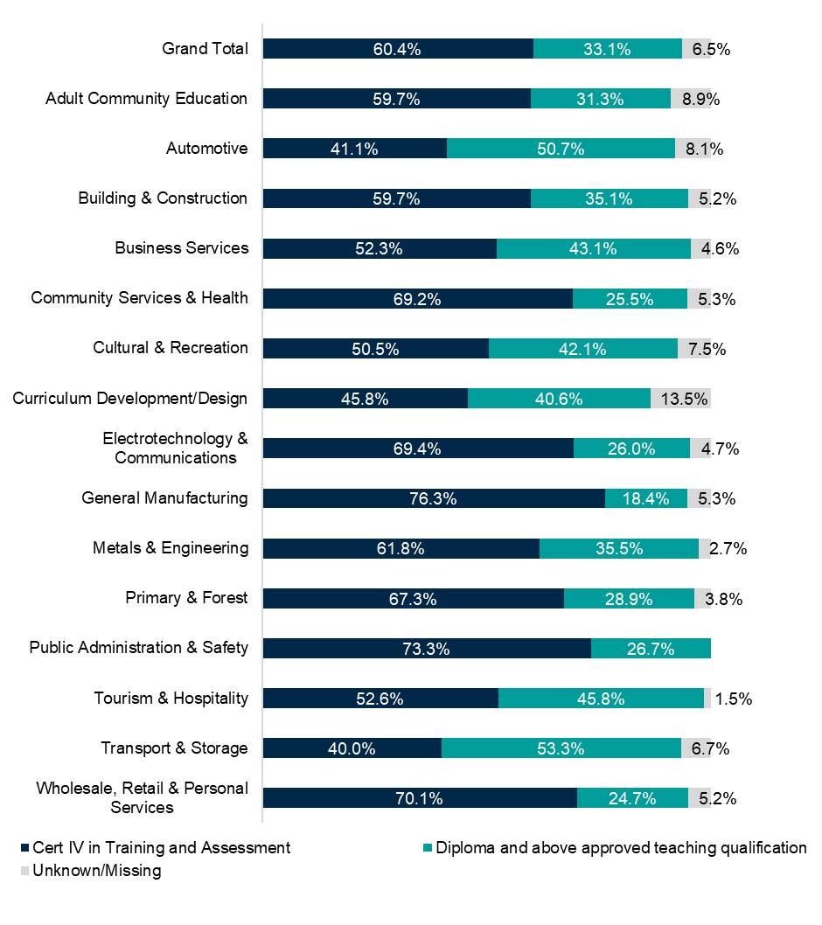
Figure B.1 Level of highest teaching qualification across Victorian TAFEs by industry
Industry | Cert IV in Training and Assessment | Diploma and above approved teaching qualification | Unknown/Missing
Grand Total | 60.4% | 33.1% | 6.5%
Adult Community Education | 59.7% | 31.3% | 8.9%
Automotive | 41.1% | 50.7% | 8.1%
Building & Construction | 59.7% | 35.1% | 5.2%
Business Services | 52.3% | 43.1% | 4.6%
Community Services & Health | 69.2% | 25.5% | 5.3%
Cultural & Recreation | 50.5% | 42.1% | 7.5%
Curriculum Development/Design | 45.8% | 40.6% | 13.5%
Electrotechnology & Communications | 69.4% | 26.0% | 4.7%
General Manufacturing | 76.3% | 18.4% | 5.3%
Metals & Engineering | 61.8% | 35.5% | 2.7%
Missing | 50.0% | 0.0% | 50.0%
Not Defined | 57.1% | 25.6% | 17.3%
Primary & Forest | 67.3% | 28.9% | 3.8%
Public Administration & Safety | 73.3% | 26.7% | 0.0%
Tourism & Hospitality | 52.6% | 45.8% | 1.5%
Transport & Storage | 40.0% | 53.3% | 6.7%
Wholesale, Retail & Personal Services | 70.1% | 24.7% | 5.2%

Source: Supplied (Victorian Public Sector Commission).

Pay
As discussed in the Awards, employment agreements and union membership section in Chapter 2, workers in the Public Sector have a higher rate of collective agreement coverage. These are mainly teacher specific agreements but do cover managers and learning support roles in some cases. In nearly all states and territories, there are single agreements for across the TAFE workforce even when there are separate institutes in the jurisdiction. For example, in Victoria and WA. As noted above, TAFE teachers are paid higher than their counterparts in private RTOs. Most entry-level TAFE teachers commence at around $85K increasing to above $100K for more senior roles. Teaching management roles are also included in these agreements and at the lower salary levels of around $110K likely align with extended scope teaching roles that we profile in Chapter 3. The $119 to $194K salaries at the upper levels likely align with roles in the leadership segment, See Table B.3 for an overview.
Table B.3 Starting and upper-level salaries for teachers and teaching management TAFEs, and the Post-Secondary Education Award
 | Teaching ª |  |  | Teaching Management
 | Starting | Upper | Lower |  | Upper
TAFE SA | $89,198.00 | $101,647.00 | $107,377.00 |  | $151,747.00
TAFE NSW | $88,842.00 | $105,362.00 | $137,934.00 |  | $192,616.00
WA TAFEs | $85,555.00 | $108,501.00 | $115,307.00 |  | $126,810.00
Canberra Institute of Technology (CIT) – ACT | $84,997.00 | $114,113.00 | $133,267.00 |  | $194,774.00
TAFE QLD | $85,084.00 | $106,158.00 | $108,918.00 |  | $122,001.00
Victorian TAFEs | $77,024.00 | $109,207.00 | $109,204.00 |  | $119,302.00
Charles Darwin University (CDU) – NT | $72,702.00 | $109,071.00 | $110,500.00 |  | $130,649.00
TasTAFE | $73,595.00 | $106,536.00 | $108,260.00 |  | $163,747.00
Post-secondary Education Award 2020 ^{b} | $58,363.48 | $76,391.80
VET Teacher (ANZSCO) average ^{c} | $79,589.00
Source: Institution Enterprise Agreements, Fair Work Commission
(a) Salary Rates at entry level and highest rate, drawn from Enterprise Agreements. Note TAFE entry rate includes Certificate IV. In some institutions, a lower rate is available for those commencing without a Certificate IV.
(b) Post-secondary education award figures are Level 1 and 12 in the Educational Services (Post-secondary Education) Award 2020, Schedule A and Clause 16.1(a), and Schedule B and Clause 16.1(c).
(c) ABS (2021) 6-digit level OCCP, INCP [TableBuilder]

The Dual Sector VET Workforce
Dual sector universities are public institutions operating across the full spectrum of Australian VET and higher education qualifications and are accredited by both ASQA who regulates VET and TEQSA which regulates higher education. There are currently six dual sector universities in Australia:
- Charles Darwin University (CDU) Northern Territory
- CQUniversity (CQU) Queensland
- Federation University Australia Victoria
- RMIT University Victoria
- Swinburne University of Technology Victoria
- Victoria University (VU) Victoria
CDU, CQU, VU and Swinburne provided data for this study (late 2022 to early 2024). Based on this sample of four dual sector universities the dual sector VET workforce sits at almost 2000 workers. This aligns with Department of Education data which shows a total VET workforce of 2608 FTE workers in higher education or 2% of the overall FTE higher education staff in 2021 (861 TAFE and 1,474 independent RTO workers).
The demographic profile of the dual sector VET workforce reflects the overall TAFE workforce profile – older and slightly more feminised than the VET workforce overall. Over a half of the workforce is over 50 years except at Swinburne where almost two thirds of the workforce is over 50 years. Limited data on diversity indicators were provided for the study apart from First Nations status where CDU has high participation. See Table B.4 for key demographics.
Table B.4 Key demographics in dual sector universities
 | Headcount | Female  Workforce | First Nations | Disability | %  50 years +
Charles Darwin University (CDU) | 292 | 51.0% | 4.5% | - | 62.7%  (46 & over)
Central Queensland University (CQU) | 392 | 62.5% | 2.8% | 3.3% | 48.2%
Victoria University (VU) | 658 | 63.0% | 0.3% | - | 55.2%  (48 & over)
Swinburne University of Technology | 628 | 58.0% | 0.2% | - | 62.9%
Source: Supplied.
Note: Federation University and RMIT did not supply data
The level of part-time and casual employment in dual sector institutions varies by institution based on the data provided by three universities. CDU and VU have over 74% of the workforce working full-time which aligns with TAFE institutions. However, dual sector universities do have higher rates of casualisation than TAFE (except for NSW). VU and Swinburne are high at 44.3% and 42.2% but these figures are comparable to the higher levels of casualisation in higher education as opposed to VET in Australia. See Table B.5.
Like TAFEs, dual sector university staff are covered by enterprise agreements but pay and working conditions are lower and less advantageous than TAFEs, especially at entry level. Starting salaries are on average more than $4K lower per year than for TAFE teachers, though the upper level is on average higher by about $1.9K per year.
It is noteworthy that most dual sector agreements are standalone and specific to the VET workforce. Academics delivering higher education qualifications are generally covered in separate enterprise agreements which have higher pay and better conditions. However, in recent years VET workers have negotiated for increased parity with their ‘academic’ colleagues. For example, the 2022 CDU and the 2023 CQU agreement now cover both workforces and the 2022 Swinburne agreement secured 17% superannuation from July 2024 despite being a standalone agreement.
Table B.5 Employment status in dual sector universities
 | Full-time | Part-time | Casual | Fixed term | Permanent/Ongoing
Charles Darwin University (CDU) | 79.8% | 4.5% | 15.4% | 6.8% | 77.7%
Victoria University* | 74.6% | 25.4% | 44.3% | 22.5% | 33.2%
Swinburne University of Technology** | 33.1% | 66.9% | 42.2% | 27.5% | 30.3%
Source: Supplied
* Data based on assignment as provided, which exceeds 100%.
** Data based on headcount as provided, which exceeds 100%.

References

We note that this ANZSCO code is outdated and does not reflect current discourse in the sector where early childhood educators find this occupation classification disrespectful and not reflective of the early learning and care they practice.
This means the estimates are not necessarily representative of the actual workforce numbers for each type of RTO, since the data may have been skewed depending on how respondents reported staffing numbers in the survey. It also had a 40% response rate.
Note: A small proportion of those in the VET workforce total are not included in taxonomy segments due to missing occupational codes.
The most accurate data is from ABS Disability, Ageing and Carers Australia, which does not report data by ANZSCO or ANZSIC so does not support breakdown into the workforce segments in this report.
For example, on leave from work.
. Note this is not from 2021 Census data but ABS (2023) Employee Earnings and Hours, Australia 2023, supplied.
. However, note a high (18.2%) RSE for Education Advisors and Reviewers.
. We have estimated the pay gap using the mid-point of the income range reported by individuals in Census and then averaged for males and females in each cohort, i.e. each taxonomy segment. We estimated the pay gap in two ways: without considering the hours worked by individuals (i.e. using income for all employed people regardless of full-time/part-time status) for an overall figure and separately for both the full-time and part-time cohorts. We acknowledge the impacts hours worked has on pay gaps and that Census measure is on income, rather than earnings so may include some non-work-related income. However, for most of the workforce, income closely reflects job earnings and wages. In recognition of these methodological issues, we acknowledge this pay gap is an estimate only and one with considerable limitations.
Through stakeholder consultation, various LLN organisations such have reported this issue for their workforce.
7.6% were unemployed and 1.4% did not state where they were working.
Data are held for the years 2015-2022 inclusive, however 2015 commencements data are unreliably high (because commencements are based on presence or absence in the previous year’s enrolments and 2015 is the earliest year of full data, many 2015 enrolments are incorrectly categorized as commencements) and 2022 completions data are preliminary and low (they will increase when final 2022 commencements are published in 2023 data, released in August 2024). 2016-2021 data are therefore chosen here for comparability and accuracy.
All proportions of VET students who are First Nations or with Disability are under-counts. In VET, the number of students whose First Nations status is unknown (430,560 in 2022) is three times higher than the number who are identified as First Nations people (161,655 in 2022). This is also the case for students with disability (518,580 of unknown status in 2022 compared to 178,620 identified as with disability) https://www.ncver.edu.au/research-and-statistics/data/databuilder.
But note that in DOM data, there are also categories for occupation unknown and no income tax return submitted which make up almost half of the inflows and over half of the outflows.
Percentage difference in year-to-year average wage for VET teachers who were not VET teachers in the previous financial year, adjusted for wage price index – PLIDA.
Bendigo TAFE and Kangan TAFE merged in 2014
- Productivity Commission (2011) Vocational education and training workforce research report, Productivity Commission, Australian Government.
- Knight G, White I and Granfield P (2020) Understanding the Australian vocational education and training workforce, National Centre for Vocational Education Research (NCVER).
- Australian Bureau of Statistics (ABS) (2022) ‘Occupation by industry of employment’ in 2021 Census, Counting persons, Place of usual residence [Table Builder], ABS website, accessed 28 August 2023.
- ABS (2024) Updating ANZSCO: Reflecting a Modern Australian labour Market, [Preliminary] Proposed Changes, Version 2.0, ABS Website, accessed 19 June 2024.
- Guthrie H, Waters M, de Leo J, Lees M, White I and Waugh J (unpublished) VET Workforce Blueprint Project: NCVER Data and Research to Inform the VET Workforce Blueprint Project, NCVER.
- Wheelahan L and Curtin E (2010) The quality of teaching in VET, Australian College of Educators, accessed 17 November 2023.
- Productivity Commission (2011) Vocational education and training workforce research report, Productivity Commission, Australian Government.
- Knight G, White I and Granfield P (2020) Understanding the Australian vocational education and training workforce, NCVER.
- NCVER (2023) VET student outcomes 2023, NCVER, accessed 20 December 2023.
- Palmer B (2021) An analysis of ‘micro-credentials’ in VET, NCVER, accessed 17 November 2023.
- NCVER (n.d.) DataBuilder (ncver.edu.au), accessed 9 April 2024.
- Victoria University (2023) Employment Projections, produced for the Australian Government Jobs and Skills Australia, accessed 17 November 2023.
- Fair Work Commission (FWC) (2020) ‘Section 2. Definitions’ in Educational Services (Post-Secondary Education) Award 2020, FWC website, accessed 17 November 2023.
- Oliver D (2013) ‘The strategic impact of industrial relations among tertiary education providers’ in Beddie F, O’Connor L & Curtin P (eds) Structures in tertiary education and training: a kaleidoscope or merely fragments? Research readings, NCVER.
- NSW Department of Education (2024) ‘NSW Budget: A boost to TAFE NSW with record investment’, NSW Government website, accessed 28 June 2024.
- Knight G, White I and Granfield P (2020) Understanding the Australian vocational education and training workforce, NCVER.
- Productivity Commission (2011) Vocational education and training workforce research report, Productivity Commission, Australian Government.
- Australian Institute for Teaching and School Leadership (September 2023) Spotlight Australia’s teacher workforce today, AITSL website, accessed 29 March 2024.
- Guthrie H and Loveder P (2009) ‘The ageing TVET workforce in Australia: issues and challenges’, in Maclean R & Wilson D(eds), International Handbook of Education for the Changing World of Work, Springer, Dordrecht.
- Productivity Commission (2011) Vocational education and training workforce research report, Productivity Commission, Australian Government.
- Smith E (2020) The VET teaching Workforce in Australia. Federation University Australia, Ballarat.
- Guthrie H and Waters M (unpublished) VET Workforce Blueprint Project - Literature Review, NCVER.
- Knight G, White I and Granfield P (2020) Understanding the Australian vocational education and training workforce, NCVER, accessed 17 November 2023.
- NCVER (2023) VET student outcomes 2023, NCVER website, accessed 20 December 2023.
- ABS (2021) Employee Earnings and Hours, Australia 2021 [TableBuilder], accessed 25 March 2024.
- Oliver D (2013) ‘The strategic impact of industrial relations among tertiary education providers’ in Beddie F, O’Connor L & Curtin P (eds) Structures in tertiary education and training: a kaleidoscope or merely fragments? Research readings, NCVER.
- ABS (2021) Employee Earnings and Hours, Australia 2021 [TableBuilder], accessed 25 March 2024.
- Tyler M and Dymock D (2021) Attracting industry experts to become VET practitioners: a journey, not a destination, NCVER, accessed 17 November 2023.
- Australian Government (2023) National Register of vocational education and training (VET), Training.gov.au website, Australian Government, accessed 20 October 2023.
- Parliament of Australia (2022) Don’t take it as read: Inquiry into adult literacy and its importance, House of Representatives Standing Committee on Employment, Education and Training, Australian Government, accessed 19 February 2023.
- ASQA (2020) Quality is a shared responsibility, ASQA, accessed 20 October 2023.
- Department of Employment and Workplace Relations (DEWR) (n.d.) Early changes to the current Standards for RTOs, DEWR, Australian Government, accessed 29 February 2024.
- Guthrie H (2010) A short history of initial VET teacher training, NCVER, accessed 17 November 2023.
- Smith E (2022) ‘Australian TVET teacher training – once flourishing but now neglected’, in F Bunning, G Spottl & H Stolte (eds.), TVET teacher education and training in international and developmental co-operation – models, approaches and trends. Springer series: Technical and Vocational Education and Training: Issues, Concerns and Prospects. Vol 34, 435-452. https://doi.org/10.1007/978-981-16-6474-8_26.
- Guthrie H (2010) A short history of initial VET teacher training, NCVER, accessed 17 November 2023.
- Li J, Hodge S and Knight E (2023) The concepts of vocational competence and competency: False friends in international policy learning, bwp@. spezial 19, accessed 20 October 2023.
- Tyler M and Dymock D (2021) Attracting industry experts to become VET practitioners: a journey, not a destination, NCVER, accessed 17 November 2023.
- Smith E, Hodge S and Yasukawa K (October 2014) ‘Students in Australian VET and adult education teacher education courses’ [unpublished conference presentation], AUSTAFE National Conference 2014 Sydney.
- Federation University Australia (2023) Course Outline: EDTAS1206 Developing VET Curriculum for Training Providers and Industry, Federation University Australia, accessed 17 November 2023.
- Commonwealth of Australia (2023) Migration Strategy, Australian Government.
- Innovation and Business Skills Australia (IBSA), The VET Practitioner Capability Framework - Implementation Guide, IBSA, East Melbourne, accessed 17 November 2023.
- Charles Darwin University (CDU) (2019) VET Educator Capability Framework Handbook, CDU, accessed 17 November 2023.
- Australian Institute for Teaching and School Leadership (AITSL) Limited (n.d.) [website], accessed 28 February 2024.
- Misko J, Guthrie H and Waters M (2021) Building capability and quality in VET teaching: opportunities and challenges, NCVER, accessed 28 February 2024.
- Misko J, Guthrie H and Waters M (2021) Building capability and quality in VET teaching: opportunities and challenges, NCVER, accessed 28 February 2024.
- Wheelahan L and Moodie G (2010) The quality of teaching in VET, Australian College of Educators, accessed 17 November 2023.
- FWC (2022) Swinburne University of Technology – Vocational Education and Training Enterprise Agreement 2022, FWC, Australian Government, accessed 17 November 2023.
- Guthrie H and Waters M (unpublished) VET Workforce Blueprint Project - Literature Review, NCVER.
- NSW Parliament (2023) Budget Estimates 2023-24 Hearing – 1 November 2023 Supplementary Questions Minister for Skills, TAFE and Tertiary Education.
- FWC (2023) TAFE Commission of NSW Teachers and Related Employees Enterprise Agreement 2023, FWC, Australian Government, accessed 4 April 2024.
- Hodge S and Guthrie H (June 2019) ‘Moving beyond training packages: first steps' [conference paper], AVETRA conference, Paramatta, accessed 17 November 2023.
- Harris R, Simons M and Clayton B (2005) Shifting mindsets: The changing work roles of vocational education and training practitioners, NCVER, accessed 17 November 2023.
- Harris R, Simons M and Clayton B (2005) Shifting mindsets: The changing work roles of vocational education and training practitioners, NCVER, accessed 17 November 2023.
- Braithwaite V (2018) All eyes on quality: Review of the National Vocational Education and Training Regulator Act 2011 report, DEWR, Australian Government.
- Harris R, Simons M and Clayton B (2005) Shifting mindsets: The changing work roles of vocational education and training practitioners, NCVER, accessed 17 November 2023.
- Department of Education (DoE) (2015) Trade Training Centres in Schools Program - Independent Review, prepared by Scott P, DoE, Australian Government.
- Circelli M, Hall M, Li Z, Ong A and Lim P (2022) Journeying through VET: a case study of foundation skills learners, NCVER.
- O’Dwyer L and Mihelic M (2021) Provision of foundation skills training by community education providers in regional Australia, NCVER.
- Reading Writing Hotline (n.d.) Adult Literacy Specialists – still an endangered species, Reading Writing Hotline website, accessed 2 January 2024.
- Social Equity Works (2022) Insights from the classroom – a survey of adult literacy providers: a report on adult literacy, numeracy and digital literacy need, prepared for the Reading Writing Hotline, accessed 2 January 2024.
- Guthrie H (2010) Professional development in VET, NCVER, 2010, accessed 17 November 2023.
- R Harris, M Simons and B Clayton (2005) Shifting mindsets: The changing work roles of vocational education and training practitioners, NCVER, accessed 17 November 2023.
- Hume S and Griffin (2021) The online delivery of VET during COVID 19 Part 1, NCVER.
- Hume S and Griffin T (2022) Delivery of VET: emerging trends in response to the COVID-19 pandemic, NCVER.
- Coates H, Meek L, Brown J, Friedman T, Noonan P and Mitchell J (2013) ‘VET leadership for the future: Contexts, characteristics and capabilities’, Journal of Further and Higher Education, 37(6): 819-843, doi:10.1080/0309877X.2012.684042.
- Lucas B and Claxton G (2013) Pedagogic leadership: creating cultures and practices for outstanding vocational learning, 157 Group, London.
- ABS (2021) ‘Highest level of qualification by occupation and industry’, 2021 Census [Table Builder] accessed 28 August 2023.
- Victoria University (2023) Employment Projections, produced for the Australian Government Jobs and Skills Australia, accessed 17 November 2023.
- Jobs and Skills Australia (2023) The Clean Energy Generation, Jobs and Skills Australia, accessed 17 November 2023.
- Victoria University (2023) Employment Projections, produced for the Australian Government Jobs and Skills Australia, accessed 17 November 2023.
- Queensland Government (31 January 2024) 90 Sunshine Coast students start nursing journey thanks to Free TAFE, Ministerial Media Statements, Queensland Government, accessed 18 March 2024.
- Jobs and Skills Australia (2023) The Clean Energy Generation, Jobs and Skills Australia, accessed 17 November 2023.
- DoE (2022) ‘Table 8.5’ in Selected Higher Education Statistics – Section 8 - Special Courses, DoE, Australian Government, accessed 8 April 2024.
- Acton R and Hennessy M (2023) NSW Education Diversity and inclusion in teacher workforces: Literature review. PeopleBench prepared for NSW Department of Education, NSW Government.
- Victorian Government (n.d.) deafConnectEd [website], accessed 18 March 2024.
- deafConnectEd (13 May 2020) Certificate IV in Training and Assessment - in Auslan, deafConnectEd website, accessed 18 March 2024.
- NCVER (2023) VET student outcomes 2023, NCVER, accessed 20 December 2023.
- Jobs and Skills Australia (2023) Data on Occupation Mobility: Unpacking Workers Movements, Jobs and Skills Australia, accessed 17 November 2023.
- Knight G, White I and Granfield P (2020) Understanding the Australian vocational education and training workforce, NCVER, Adelaide.
- Department of Education (2023) Australia's dual sector universities, Department of Education website, accessed 14 March 2024.
- Swinburne University of Technology (2022) Swinburne staff vote in landmark VET Enterprise Agreement, Swinburne University of Technology website, accessed 14 March 2024.

