



Total New Vacancies experimental series

Methodological note

**October 2024**

# Overview

The new JSA Total New Vacancies (TNV) series provides an estimate of the total number of new vacancies in Australia each quarter, including by 2 digit ANZSCO occupation.

Using insights from JSA’s Recruitment Experiences and Outlook Survey (REOS), JSA has adjusted data from the JSA Internet Vacancy Index (IVI) to account for changes in the use of online recruitment methods over time. The resultant series provides a new estimate of the total number of new vacancies (flow) each quarter. The TNV series complements existing sources of labour market information, including the JSA Internet Vacancy Index and ABS Job Vacancy Series.

As an initial experimental release, JSA is seeking feedback on the series including suggestions for possible improvements. Caution should also be exercised when utilising the JSA TNV data.

## Methodology overview

Understanding vacancy trends is a key component of labour market analysis. Job vacancies data can provide a leading indicator of employment growth and help identify differences in labour market conditions across regions and industries. Job vacancy rates are also a key component of Beveridge Curve analysis, which is useful to helping assess the efficiency of the labour market. As such, having an accurate measure of job vacancies is a key component of labour market analysis.

When it comes to recruitment, employers can use a wide range of methods during recruitment. This includes (but is not limited to) word of mouth, signs in shop windows, social media, newspaper advertisements and online job ads. Such methods may be used by employers as they seek to fill their job vacancies. While the [JSA Internet Vacancy Index](https://www.jobsandskills.gov.au/data/internet-vacancy-index) provides a useful count of the number of newly listed online job advertisements, it understates the total number of new vacancies due to the fact not all vacancies are advertised online. The use of online recruitment methods can also vary by region and industry/occupation. This can make identifying the total number of vacancies for a given occupation challenging.

To address this challenge, JSA has combined JSA IVI data with data from the [JSA Recruitment Experiences and Outlook Survey](https://www.jobsandskills.gov.au/data/recruitment-experiences-and-outlook-survey) (REOS). The JSA REOS is a continuous survey (of at least 1,000 employers each month) that provides a range of insights into employer behaviour, including how recruitment activities are changing over time. This includes surveying employers regarding whether they advertised their vacancies on the online job boards that contribute to the IVI (such as with Seek, CareerOne and/or Workforce Australia)[1].

* By way of example, according to insights on employer behaviour from the JSA REOS, the proportion of job vacancies advertised on IVI job boards rose from around 39% in 2016 to approximately 58% in 2022, reflecting the continued take-up of online job advertising by employers over time. Further, around 66% of vacancies for Professionals were listed on IVI job boards in 2022, compared with just 44% for Sales Workers[2], demonstrating the variation in employer preferences that can occur when recruiting for different occupations.

By combining JSA IVI data with JSA REOS data, the new experimental JSA TNV dataset seeks to account for changes in the use of online recruitment methods over time, as well as differences in use between occupations. The TNV creates a new total vacancy measure by adjusting JSA IVI data according to the proportion of vacancies advertised online using the JSA REOS data. That adjustment helps account for changes over time in the proportion of vacancies advertised online, and differences between occupations in use of online advertising. Smoothing and interpolation are utilised in accordance with standard practices to ensure the data is fit for purpose, which helps to reduce the impacts of point-to-point volatility that may be observed in the input data sources[3].

* In simple terms, and by way of example, suppose that data from the JSA IVI shows that there are approximately 100 online job advertisements for a certain occupation in a given quarter. Suppose also that insights on employer behaviour from the JSA REOS show that for this occupation, around 60 per cent of all vacancies are advertised by employers on an IVI online job board, 40 per cent of vacancies managed through other recruitment methods. In simple terms, we can estimate the total number of vacancies in the labour market for this occupation as 100 / 0.6 = 167 total vacancies. This simple example demonstrates the type of approach taken to create the TNV.

The resultant experimental JSA TNV series is a quarterly estimate of the total number of new vacancies for Australia. This provides a new and complementary estimate of the total number of new vacancies that arose during each quarter, allowing for new insights into vacancy trends and labour demand to be analysed.

# Frequently Asked Questions

### What led to JSA developing the TNV?

JSA’s role includes providing advice on the current, emerging and future skills needs of the economy. As part of this, JSA delivers a range of products that help to provide evidence of current trends in the labour market. The TNV complements these existing sources of labour market information by providing a new experimental estimate of the total number of vacancies arising in the labour market each a quarter. The TNV was developed as part of a related modelling project undertaken by JSA.

### Does the TNV represent total labour demand?

The TNV may help inform estimations of labour demand, noting that employment, wages, hours worked and labour productivity (among other factors) should also be considered when analysing labour demand. Seeking to gain a better understanding of the total level of vacancies in the labour market, and the resultant implications for estimating labour demand, was nonetheless a key factor that led to JSA’s development of the TNV.

### How does the JSA TNV differ from the JSA Internet Vacancy Index and ABS Job Vacancy Series?

Table 1 below provides an overview of the key differences between the JSA TNV, JSA IVI and ABS JVS. This includes differences in the scope, frequency, disaggregation and length of the time series.

Table 1: Understanding the differences in various vacancy estimates

|  |  |  |  |  |  |
| --- | --- | --- | --- | --- | --- |
| **Vacancy series** | **Description** | **Source(s)** | **Freq.** | **Components** | **Start** |
| **ABS JVS** | A **point-in-time stock estimate of vacancies** (a count of currently open job vacancies) on the day of the survey (the Friday of the middle of the reference month) | Employer survey | Qtrly | * National * State * Industry | 1984 |
| **JSA IVI** | Count of **newly listed online job advertisements** on the contributing online job boards during the calendar month | Online job boards data | Monthly | * National * State * IVI regions * 4-digit Occupation | 2006 |
| **JSA TNV -*experimental*** | Modelled estimate of **total new job vacancies** that arose during the quarter | Online job boards data and employer surveys | Qtrly | * National * 2-digit Occupation | 2016 |

The estimate of vacancies from the JSA TNV is substantially larger than that of the JSA IVI. This is for two key reasons. First, the JSA TNV is a quarterly total, whereas the JSA IVI is a monthly total. And secondly, the JSA TNV has been calculated to take into account the fact that not all jobs are advertised online, unlike the JSA IVI which only counts online job advertisements from the job boards that contribute to the JSA IVI. As a result, the figures under the JSA TNV are substantially higher than that of the JSA IVI. Table 2 below provides the estimated levels from each of the relevant sources for May 2024.

Table 2: Different measures of vacancies in Australia – May 2024

|  |  |  |
| --- | --- | --- |
| **Source (measure)** | | **May-24 estimate** |
| ABS | Job Vacancy Survey | 348,000 |
| JSA | IVI online job advertisements - monthly | 238,091 |
| IVI online job advertisements – qtrly total | 720,776 |
| **Total New Vacancies (experimental)** | **1,298,930** |

The difference between the JSA TNV and the ABS JVS can be understood as arising from the difference between point-in-time vacancy stock (as per the ABS JVS) and total vacancy flow (as per the JSA TNV) measures. The ABS Job Vacancy Survey provides a point-in-time estimate of the number of vacancies that are open on the day of the survey (the middle Friday of the reference month). In this way, the ABS JVS series is effectively a stock estimate of vacancies. By contrast, the JSA TNV estimates the total number of vacancies arising on any day point in the quarter. At the end of the quarter, some of these vacancies will remain open (similar to the ABS JVS measure), have been filled, or have been withdrawn from the market (i.e. gone unfilled). The difference between the two series can thus be explained by changes in the duration of time it takes for vacancies to be filled (including changes in the rate of vacancies going unfilled). This helps explain the difference between the JSA TNV and ABS JVS series, as highlighted in Figure 2 below.

Figure 2: Comparison of ABS Job Vacancy Survey and JSA Total New Vacancies series over time

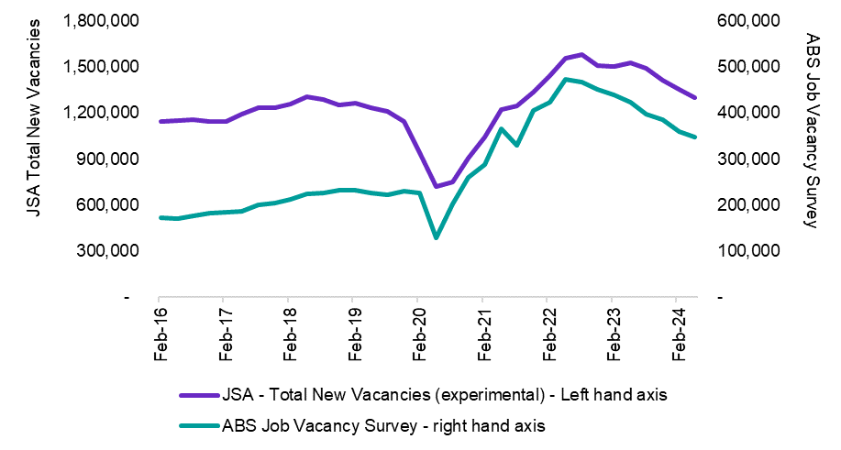

Figure 3: Understanding differences in vacancy measures, including stock and flow measures and sources – an illustrative example

JSA TNV

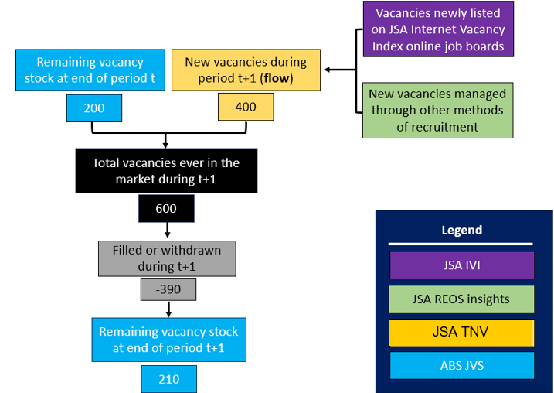

### Does the TNV provide an indication of shortages?

Vacancy data alone does not provide an indication whether there is a labour market shortage, as the fill rates of vacancies can vary across the labour market. As such, caution should be exercised when using vacancy data to infer labour market conditions.

### Is data available for the period prior to 2016?

Data is only available from 2016 onwards as the relevant supporting data from the JSA REOS only started being collected in 2016. As the JSA TNV remains an experimental series, data for more recent periods is also still being estimated.

### Is data on more detailed occupations and regions available?

The JSA Total New Vacancies (TNV) series is as an initial experimental release, with data available for Australia and by 2-digit ANZSCO occupation. JSA is continuing to review and develop the TNV series and may consider publishing the series on a regular basis and at more detailed levels of disaggregation in the future.

# Feedback and future releases

The JSA Total New Vacancies (TNV) series is an initial experimental release. JSA welcomes comments, feedback and questions to help improve the series, as well as feedback on the usefulness of the series for stakeholders. JSA is continuing to review and develop the TNV series and may consider publishing the series on an ongoing basis in the future. To provide feedback or submit an enquiry, please contact: [JSA-Nowcasting@jobsandskills.gov.au](mailto:JSA-Nowcasting@jobsandskills.gov.au)

# Acknowledgements

JSA would like to acknowledge and thank the following people and organisations for their engagement and feedback on the project to date:

* Seek, CareerOne and Workforce Australia for their ongoing contribution to the JSA Internet Vacancy Index.
* ABS, RBA, Treasury, e61 and Jeff Borland for their advice during the development of the TNV series.
* All other stakeholders and interested parties who have provided feedback following the initial release of the TNV series.

1. Further information on the concepts, methods and core questionnaire of the REOS survey can be found [here](mailto:https://www.jobsandskills.gov.au/sites/default/files/2023-06/reos_-_concepts_methods_and_questionnaire_.pdf) noting that there are also additional questions asked in the survey beyond those in the core survey.
2. For reference, the average annual REOS sample size for Sales Workers vacancies was around 2,800 in 2021 and 2022, while for Professionals vacancies the average annual REOS sample size was 1,200.
3. The JSA REOS only collects data in respect of an employer’s *most recent* recruitment round and is subject to sampling variability.