



Food Supply Chain Capacity Study

Discussion Paper

**18 April 2024**

Contents

About the study 3

What is the food supply chain workforce? 6

A shared vision for the workforce 8

Workforce data and information 9

Demand and supply factors 11

Participation and progression 12

Disruption and resilience 13

Education and training 14

Migration 16

Biosecurity skills and workers 19

Getting involved 21

References 22

# About the study

The Australian Government commissioned Jobs and Skills Australia (JSA) to undertake a capacity study on the workforce needs of the food supply chain. The study will provide critical evidence, insights and recommendations to support workforce planning, policy development and program design.

The final Terms of Reference for the study were published on 18 April 2024 and are available on the JSA website. These incorporate feedback from governments, industry, unions, and civil society. JSA has committed to deliver its final report to government by September 2024. It will be published shortly thereafter.

The purpose of this discussion paper is to provide stakeholders, interested parties and the broader community with a sense of the study's scope and approach, and an early opportunity to provide submissions. JSA welcomes feedback on this discussion paper from all interested parties.

## Why are we looking into this workforce?

Australia has a world class food supply chain. We produce a wide variety of high quality foods and export them around the world. The industries, activities and jobs that make up this supply chain are highly diverse and distributed right across the country. Through this study we aim to support a workforce that can:

**sustain regional Australia**. Employment in the food supply chain is heavily concentrated in regional and rural Australia, with food production and manufacturing acting as anchor industries for many communities.

**strengthen the economy.** Industries throughout the food supply chain make a significant contribution to the Australian economy. The value of agriculture production alone is forecast to reach $85 billion in 2024-25, with the sector aiming for $100 billion by 2030. Without an adequate and sustainable workforce, the viability of these   
sectors – and the regional economies they sustain – will be at risk.

**maintain food security.** Access to labour and skills has been widely recognised as a risk to Australia’s food security.[1] While awareness of this risk was heightened by the COVID-19 outbreak and the particular challenges it posed, workforce pressures in Australia’s food supply chain pre-date the pandemic.

**overcome challenges.** Australia’s food supply chain will need to navigate multiple interacting changes over the coming years, including managing high levels of market and climate variability while unlocking opportunities from disruptive technologies.[2] The food supply chain will also need to grapple with persistent challenges such as seasonal fluctuations in labour demand, attracting and retaining a workforce with a diverse mix of backgrounds, skills and experiences, and ensuring all workplaces provide safe, secure and rewarding employment.

## What will the study do?

This study will explore the challenges and opportunities that sit across food production, manufacturing and distribution. By taking a whole of sector view, it will complement the detailed industry-specific work led by Jobs and Skills Councils, Rural Research and Development Corporations (RDCs) and industry groups.

The Terms of Reference outline the full scope of the study and are available on the Jobs and Skills Australia [website](https://www.jobsandskills.gov.au/studies/food-supply-chain-capacity-study).

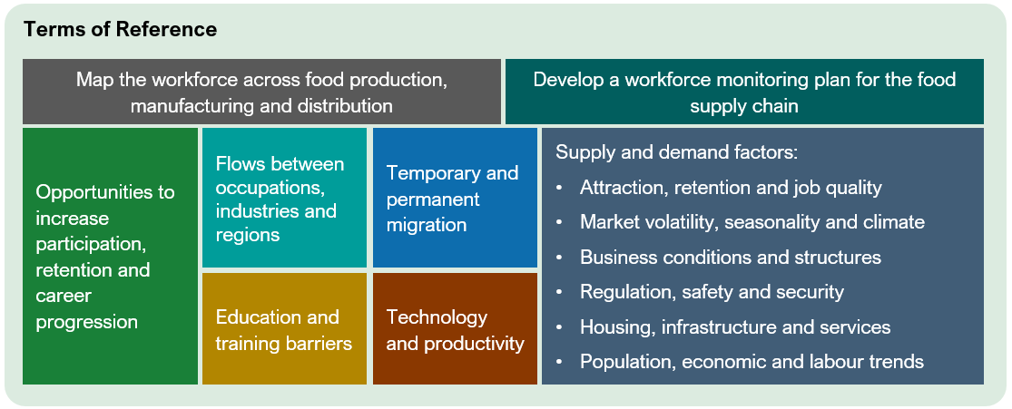

JSA recognises that the challenges facing this workforce are broad and complex. While each element of the Terms of Reference is important, JSA will prioritise its efforts in areas where:

* our data, analysis and expertise has the greatest impact
* challenges are cross-cutting and relevant to the entire supply chain

This will include leveraging the extensive research and analysis that has already been produced on the food supply chain workforce by industry, academia, community advocates and governments.

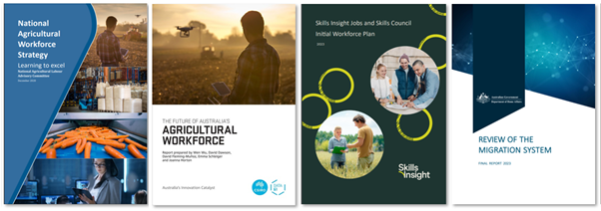

The outcomes of this study will support a number of reforms across government, including activities stemming from the Migration Strategy, National Skills Agreement and Universities Accord. This study will provide a common evidence base for policy development and program design across government and support workforce planning of relevant Jobs and Skills Councils.

## Our approach

JSA was established with a commitment to work closely with state and territory governments, industry, unions and education and training providers. In line with this commitment, the study will be supported by extensive consultation and genuine partnerships.

This discussion paper is an important part of our consultation approach. Through this paper, we are particularly seeking input on:

* a shared vision for the food supply chain workforce – what does success look like?
* a way forward on workforce data and information – how do we measure what matters?
* the labour market dynamics of the food supply chain – what are the issues and how should they be addressed?

Recognising the critical importance of biosecurity at all stages of the supply chain, we also welcome input specifically relating to this topic in the ‘biosecurity skills and workers’ section.

To support this consultation, we have prepared brief overviews and discussion questions on a range of topics that the study will consider. You do not need to respond to every topic or every question. Submissions may also highlight other issues provided they are directly relevant to the Terms of Reference.

# What is the food supply chain workforce?

The ‘food supply chain’ is a helpful lens that we can use to consider many different, but highly connected, industries. While roles and activities differ throughout the supply chain, they are often impacted by the same types of challenges and disruptions (particularly in relation to challenges and disruption impacting regional Australia). Workforce constraints in one section of the supply chain can also impact the demand and supply of workers in other sections. A holistic approach to this study allows us to consider these shared challenges, opportunities and interdependencies.

The primary purpose of this study is to explore the production, manufacturing and distribution of food and beverages. The study will also explore the contribution of pre-production activities and support services, plant and animal biosecurity, and the enduring contribution of First Nations people, land holdings, businesses and practices.

JSA acknowledges that there are many other activities vital to the food supply chain, particularly retail and hospitality. However, these large consumer-facing workforces have very distinct characteristics and challenges and would gain little benefit from being combined with agriculture and food manufacturing.

JSA will continue to work closely with Service and Creative Skills Australia (SaCSA), the Jobs and Skills Council responsible for retail and hospitality, to support workforce development in these sectors.

## Our definition

For the purposes of this study, JSA is using the following definition of the food supply chain workforce.

|  |
| --- |
| The food supply chain workforce includes individuals involved in:   * growing food crops; farming livestock for food; fishing; breeding, raising or farming fish, molluscs and crustaceans; and activities that aid in food production, or in the running of a food production enterprise (‘food production’) * processing and manufacturing food and beverages (‘food manufacturing’), and * (to the extent that their activities relate to food and beverages) transporting freight; providing transport support services or warehousing and storage services; and engaging in wholesale trade (‘transport and distribution’).   This study will also explore the contribution of pre-production activities, biosecurity, research, and the enduring contribution of First Nations people, land holdings, businesses and practices. |

Figure 1 provides an overview of the food supply chain workforce in the three key segments of food production, manufacturing and distribution identified for the purposes of this study.

Figure 1: Overview of the Food Supply Chain Workforce

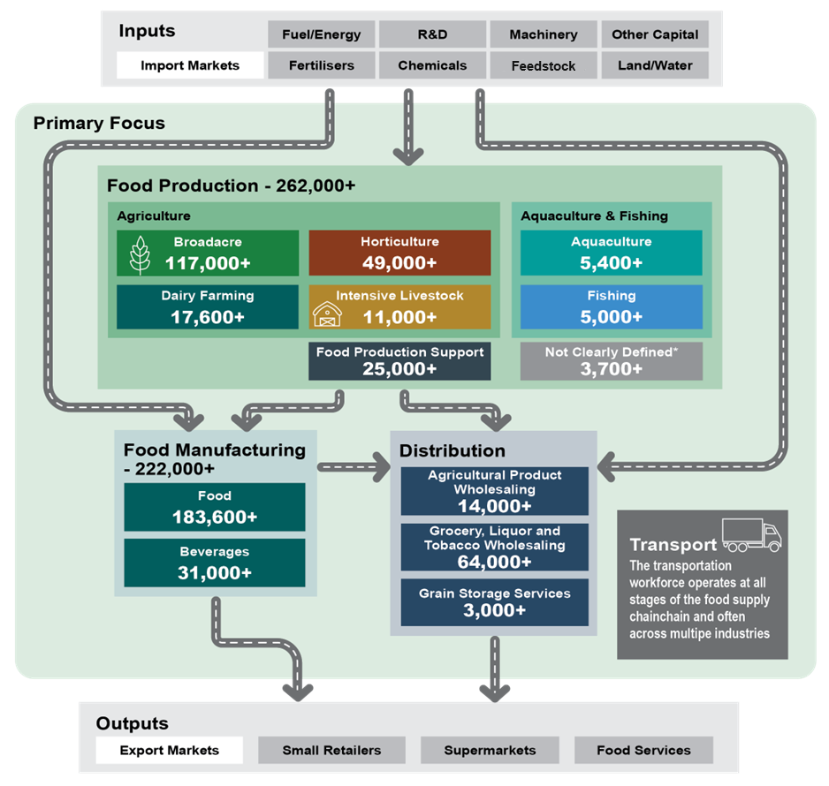

Source: ABS Census of Population and Housing 2021, employment counts by industry codes, with additional estimates produced using relevant ANZSCO occupations by labour supply and “Not Stated” industry codes.

Estimated employment counts in Figure 1 reflect employment in main jobs as at the 2021 Census. As noted in the Workforce Data and Information section below, industry and occupation data from the Census are point-in-time and should not be interpreted as equivalent to the total jobs in each segment. In particular, given the 2021 Census was undertaken during the pandemic, these estimated employment counts may underestimate employment in more normal conditions. In a later section, we discuss current data gaps and limitations.

# A shared vision for the workforce

## What contribution is the study seeking to make?

The food supply chain workforce is a priority of governments, employers, unions and the broader community. However, there is no shared vision that unites these different groups or the many industries that make up the supply chain. The Australian Government’s tripartite Agricultural Workforce Forum has suggested that this study could help lay the foundations for a shared vision through our research and consultation. This vision would ultimately be owned by industry and include clear and measurable objectives.

## What elements could be part of the shared vision?

The objectives outlined in the Terms of Reference for the study provide an indication of what could be included in a shared vision:

|  |
| --- |
| This study will support the development of a sustainable and resilient food supply chain workforce that:   * maintains our position as a major producer of quality food * minimises disruptions to domestic food security * provides safe, secure and rewarding employment opportunities across Australia * has the skills needed to enable industry growth and greater diversification, value-adding and productivity. |

A shared vision for the food supply chain workforce could inform workforce planning at more detailed industry or region levels. It could also help define and contextualise the contribution the sector can make to realising the objectives outlined in the Employment White Paper:

* Delivering sustained and inclusive full employment
* Promoting job security and strong, sustainable wage growth
* Reigniting productivity growth
* Filling skills needs and building our future workforce, and
* Overcoming barriers to employment and broadening opportunity.[3]

**Discussion questions:** A shared vision

1. What objectives should be included in a shared vision for the food supply chain workforce? Why are these objectives important?
2. Who should be responsible for ongoing monitoring and reporting on progress against these objectives?

# Workforce data and information

## What contribution is the study seeking to make?

Where possible within time and resource constraints, the study seeks to bridge major food supply chain workforce data and information gaps. Additionally, the study will work with the Australian Bureau of Agricultural and Resource Economics and Sciences (ABARES), relevant Jobs and Skills Councils and other data holders to develop a sustainable and collaborative monitoring plan for this workforce.

## Who contributes to workforce data and information?

There are many organisations that collect, disseminate and/or analyse food supply chain workforce data and information. This includes work undertaken at a:

* **Whole of economy level** – including by the Australian Bureau of Statistics (ABS) and Jobs and Skills Australia
* **Broad or narrow industry level** – including by ABARES, relevant Jobs and Skills Councils, RDCs and industry bodies.

## The challenges of food supply chain workforce data

The collection, dissemination and analysis of data on the food supply chain workforce presents a series of particular challenges, particularly in relation to the Agriculture, Forestry and Fishing industry. A selection of these challenges is summarised below:

* Agriculture is a heterogeneous and geographically dispersed industry. Data at broad industry levels (often the most granular available from national surveys) may fail to capture labour market dynamics at play in particular sectors or regions.
* In turn, targeted surveys aimed at generating the highly granular insights on sub-populations at commodity or regional level may impose a high respondent burden on that sub-population and/or experience low response rates.
* Parts of the food supply chain experience significant seasonal fluctuations in labour demand and have a high reliance on temporary migration. Patterns of labour use in these industries may not be fully captured in official statistics like those from the Census which are point-in-time and do not capture employment outside an individual’s main job or of those usually resident in Australia for less than one year.
* Recruitment activity in Agriculture, Forestry and Fishing is less likely to occur through online jobs boards compared to most industries. Instead, recruitment activity is more likely to involve methods such as word-of-mouth or social media that are difficult to capture and compile to present a comprehensive picture of labour demand.
* The Agriculture, Forestry and Fishing industry is currently excluded from the scope of ABS labour-related business surveys in line with an International Labour Organisation Resolution that since "hired labour constitutes only a minor part of total labour input" in this industry, it would be disproportionately costly to survey enough of these businesses to obtain a sample of employees to adequately represent this industry. These business surveys are the primary source of labour costs, earnings, job vacancies and industrial disputes, all of which provide insight into the demand for labour in the Australian labour market.[4]

The mix of these and other challenges means that the Agriculture, Forestry and Fishing industry is either excluded from or poorly represented in several data collections that typically inform our understanding of Australia’s labour market.

## How could food supply chain workforce data be improved?

The National Agricultural Workforce Strategy found that there is merit to a more strategic and systematic approach to food supply chain workforce data collection and analysis to maximise the efficiency of current efforts and investments.[5] Such a strategic and systematic approach would need to consider:

* the respective roles of government, industry and other contributors to the collection, dissemination and analysis of food supply chain workforce data, including with reference to the extent of public and private benefit, and
* the capabilities and resourcing required to support the preferred approach.

The ABS is currently modernising its Agricultural Statistics Program due to the increasing availability of other quality data, a commitment to reducing reporting burden and declining survey response rates. The Agricultural Statistics Program is not focused on workforce aspects of the industry. However, there may be lessons from this transition that can be applied to workforce data noting the same factors around data availability, reporting burden and response rates are at play.

Specifically, there are opportunities to enhance the evidence base on the food supply chain workforce associated with the use of administrative data (e.g. data from taxation, migration, education and training, and other systems) and integrated datasets which link this information with person and business-level information collected by the ABS. The Food Supply Chain Capacity Study will seek to extend the evidence base using this approach.

**Discussion questions:** Data and information

1. What are the critical food supply chain workforce data and information gaps?   
   Why do you consider these gaps to be critical?
2. What are the appropriate roles for government, industry and other contributors in the collection, dissemination and analysis of food supply chain workforce data?
3. What new capabilities and resourcing would be required to support a strategic and systematic approach to food supply chain workforce data? How would these be best delivered?
4. Are there examples of good practice in the collection, dissemination and analysis of industry workforce data that this study should consider?

# Demand and supply factors

## What contribution is the study seeking to make?

The study will seek to draw together a range of data sources and assets to expand the evidence base on the demand and supply of labour and skills in the food supply chain. This will include providing insights on labour market mobility, i.e. inflow and outflow of workers between occupations, industries or regions. This will provide a more nuanced picture of retention and attraction in the food supply chain and, in combination with other data sources and industry intelligence, lay the foundation for in-depth analysis of the factors driving demand and supply.

## Why focus on the drivers of demand and supply?

Given the dynamic nature of supply and demand in the labour market, it is possible to place undue emphasis on efforts to quantify labour shortages or surpluses precisely at a particular point in time. It is perhaps more instructive to identify longer-term trends and potential drivers of workforce pressures in different parts of the food supply chain.

Understanding these trends and drivers is important for generating insights on appropriate responses. For example, different strategies will be required to combat workforce pressures stemming from low retention rates compared to a shortage of qualified applicants for a growing skilled occupation.[6] This will be different again from workforce pressures due to attraction issues from negative perceptions of career opportunities, the competitiveness of pay and conditions, or access to housing and services in regional Australia.[7]

Ultimately the goal is to support a more sustainable and productive workforce. The appropriate response will not always necessitate securing additional workers. Rather it may involve leveraging improvements in technology, processes and skills to boost the productivity of existing workers, including through initiatives to improve retention.

**Discussion questions:** Demand and supply

1. What are the key factors influencing demand and supply of labour and skills in the food supply chain?
2. To what extent are attraction and retention in the food supply chain workforce intertwined with broader issues around regional development?
3. What impact will innovation and technology have on the size, composition, future skills needs and productivity of the workforce? What are the key barriers and enablers to innovation and technology adoption?
4. Are there examples of good practices related to improving attraction and retention in the food supply chain that the study should consider?

# Participation and progression

## What contribution is the study seeking to make?

The study will seek to understand the dynamics of participation and career progression in the food supply chain workforce, particularly for cohorts that have historically experienced labour market disadvantage and exclusion. This will include First Nations Australians, women and people with a disability.

The study will also seek to identify opportunities to improve outcomes for these cohorts, drawing on domestic and international examples of good practice.

## Why focus on participation and progression?

Typically workforce analysis uses the lens of “attraction and retention” when considering workforce supply. The study will consider these issues but pay particular focus to increasing participation in the sector and improving and broadening opportunities for career development.

Increasing labour force participation promotes social inclusion and boosts our economic potential.[8] For example, greater participation of First Nations Australians in the food supply chain has the potential to support strong economic participation and development – helping to close the gap and meet the workforce needs of the sector.

Additionally, there is evidence to indicate that strong gender imbalances at an occupation level may be artificially constraining labour supply and increasing the likelihood of shortages.[9] In part, perceptions of gender imbalance in food supply chain industries may be associated with the under-recognised contribution of women in farming business and rural communities.[10] Nevertheless, male-dominated occupations are common across production, manufacturing and distribution in the food supply chain, which may be limiting the sector’s access to labour as well as the perspectives, skills and capabilities of women.

The importance of equal opportunities and diverse workplaces is recognised by industries across the food supply chain. For instance, the National Farmers’ Federation’s 2030 Roadmap includes the aspiration that a career in Australian agriculture is an accessible aspiration for all and commits to promote initiatives that facilitate inclusion of underrepresented communities in the agriculture industry.[11]

**Discussion questions:** Participation and progression

1. What are the key barriers and enablers of increased participation and career progression in the food supply chain, especially for equity groups?
2. Are there examples of good practices related to improving the participation and progression of priority cohorts in the food supply chain that the study should consider?

# Disruption and resilience

Demand for labour and skills across the food supply chain can by volatile, making it challenging for employers and employees to manage. This volatility can be driven by many external factors, including:

* **Seasonality** – many elements of the supply chain rely on temporary, transient and flexible workforces to manage output through peak seasons. The timing of peak seasons can vary between commodities, regions and years. For example, horticulture labour use tends to peak in March for Victoria and July for South Australia.
* **Markets** – market access, prices and consumer preferences can impact what the supply chain produces, therefore impacting labour demand. For example, Australian Eggs notes that the shift in demand from caged to barn-laid and free range eggs has added to industry costs, as more farm workers are needed to care for flocks. While this trend is driven by domestic preferences, employment levels in meat processing are typically driven by export and livestock prices.
* **Climate and disasters** – severe weather events, water contamination, border closures and biosecurity incidents can all constrain the workforce. For example, the Millenium Drought led to a sustained decline in demand for Mixed Crop and Livestock Farm Workers across Australia. Disasters can also impact manufacturing employment, with a Lismore ice cream factory closed in 2022 following catastrophic floods in the region, impacting around 200 workers. Disasters can also impact the supply of labour, such as during COVID-19 when international borders were closed, limiting the availability of Working Holiday Makers.

While many disruptions cannot be averted, the food supply chain workforce can build resilience through research, technologies and new practices. The Future Drought Fund is an example of an initiative designed to provide farmers and communities with skills to plan, manage and persevere through disruptions. Formal training in water, land and climate management through tertiary education can also help build resilience, along with the support of specialist roles like agronomists.

Initiatives like the Drought Employment Program have provided opportunities for affected workers and communities during disruptions. With the risk of climate disasters increasing, it is important to consider how employers, communities and governments can sustainably support and maintain employment during these events.

**Discussion questions:** Disruption and resilience

1. How effectively are we meeting volatile workforce demand across the supply chain?
2. How do external factors (for example climate and market access), influence the employment trajectory of the food supply chain?
3. How do we become more resilient to shocks and disruptions? What is the role of education, training and different migration pathways?
4. How can we better respond to retrenchment and job losses caused by flood, drought and other disruptions?

# Education and training

## Why education and training matters

Higher skilled roles are growing in importance to the food supply chain, with innovation, technology adoption, consolidation and corporatisation changing the size and composition of the workforce. Over time, these trends have reduced the number of labourer roles in the supply chain and created new roles and specialisations as well as increased the reliance on professional services.[12]

Given the food supply chain workforce is regionally based and geographically dispersed, achieving critical mass in education and training pathways can be challenging. This is true for established fields like veterinary science but also emerging fields such as agritech.

There are also challenges in creating and sustaining vocational education and training (VET) pathways that are purpose-built for the sector. For example, aspects of the apprenticeship model were designed with traditional trades in mind at a time when industries such as agriculture were less receptive to the need for formal qualifications.[13]

Education and training in the food supply chain takes many forms ranging from on-the-job training and in-house training programs to full tertiary qualifications.

## Education and training reforms

The Australian Government has committed to a number of education and training reforms that have potential implications for the food supply chain. These include:

* **The National Skills Agreement** – a five-year agreement between the Commonwealth and state and territory governments to ensure the national VET system provides high quality‑, responsive and accessible education and training to boost productivity, deliver national priorities and support Australians to obtain the skills and capabilities they need to obtain well-paid, secure jobs.
  + Developing Australia’s sovereign capability and food security is one of the initial national priorities identified in the Agreement.
* **Jobs and Skills Councils (JSCs)** – 10 industry-owned, not-for-profit companies that provide workforce leadership in their sector. Functions include workforce planning, training product development, implementation, promotion and monitoring, and industry stewardship.
* **VET Qualifications Reform** – Skills and Workforce Ministers established a tripartite Qualification Reform Design Group which has proposed a differentiated qualifications system with three broad purposes:
  + *Purpose 1*: Qualifications leading to a specific occupation (for example a licensed trade), that maintain a level of specificity necessary for safety or licencing requirements, particularly the integrity of the trades, and is unlikely to change substantially from the current approach
  + *Purpose 2*: Qualifications that prepare learners for multiple, related occupations while retaining industry relevance, and
  + *Purpose 3*: Qualifications that develop cross-sectoral or foundation skills and knowledge which may be applied across industries, or lead to tertiary education and training pathways.
* **Fee-free TAFE** – The Australian Government is partnering with state and territory governments to deliver additional fee-free TAFE and vocational education places in areas facing significant skills shortages, with enrolments prioritised for groups excluded or underrepresented in the labour market. As of 31 December 2023, there were over 14,600 enrolments in the agriculture sector.
* **The Australian Universities Accord Final Report** – The Report contains 47 recommendations for government consideration to create a long-term reform plan for the higher education sector to meet Australia’s future skills needs, including a significant focus on tertiary education in regional Australia.
  + As part of the response to the Universities Accord Interim Report, the Government committed to establish up to 20 additional Regional University Study Hubs bringing university closer to students living in the regions.

## What contribution is the study seeking to make?

The study will seek to acknowledge the varied methods of skill and knowledge acquisition that support a skilled food supply chain workforce, including full qualifications, short courses, on-the-job training and extension activities.

Regarding formal education and training, the study will to draw together a range of data sources and assets to expand the evidence base in areas such as:

* critical occupations and the education and training pathways into them
* education and training barriers faced by students, employers and providers, particularly in thin markets
* opportunities to improve access to and relevance of education and training, and
* post-training outcomes of courses relevant to the food supply chain.

**Discussion questions:** Education and training

1. How do full qualifications, short courses, on-the-job training, and extension activities contribute to the development of a skilled food supply chain workforce?
2. What are the education and training barriers faced by students, employers and providers, including in regional Australia?
3. How effectively is the education and training system responding to changes in technology, business structures and other developments? What is the impact of Australia’s research and development workforce?
4. Are there examples that this study should consider of good practice that has improved access to and/or relevance of education and training in the food supply chain, or in regional Australia more broadly?

# Migration

## A new vision for Australia’s migration system

In December 2023 the Australian Government released a Migration Strategy that outlines a new vision for Australia’s migration system. The Strategy is underpinned by five core objectives:

|  |
| --- |
| **Raising living standards** by boosting productivity, meeting skills shortages and supporting exports |
|  |
| **Ensuring a fair go in the workplace** by complementing the jobs, wages and conditions of all workers and preventing migrant worker exploitation |
|  |
| **Building stronger Australian communities** by better planning the migration intake, and giving migrants the opportunity to invest in their lives in Australia through permanent residence and citizenship |
|  |
| **Strengthening international relationships** by building stronger economic and social connections with our region and international partners |
|  |
| **Making the system work** by being fast, efficient and fair for migrants and employers |

Source: Australian Government, Migration Strategy: Getting migration working for the nation

The Strategy commits to a number of key reforms potentially relevant to the food supply chain, including new skilled migration pathways and measures to combat migrant worker exploitation. Reforms to the Pacific Australia Labour Mobility (PALM) scheme have also simplified administration, provided greater flexibility for employers and workers, and introduced important safeguards for workers.

## What contribution is the study seeking to make?

There are several areas of the migration system that the Strategy identified for further exploration, including the:

* future design of the Working Holiday Maker program, including the specified work requirement for second and third year visas
* evaluation of regional migration settings, including regional visas, regional definitions, regional occupation lists and Designated Area Migration Agreements, and
* development of an Essential Skills Visa Pathway – a more regulated pathway for lower paid workers

Each of these migration settings are highly relevant to the food supply chain and will be a key focus of our research. Through this study JSA will contribute to the evidence base in these areas and support future reforms led by the Department of Home Affairs.

## The current contribution of migration

Temporary and permanent migrants contribute significantly to the food supply chain workforce at a range of skill levels from highly skilled specialists to unskilled, low-skilled or semi-skilled migrants where exploitation is a greater risk. High levels of reliance on migration may displace and distort local training and employment activity.

Levels of reliance on the migration system differ considerably by sector within Australia’s food supply chain and are highest in horticulture and food product manufacturing (especially meat and meat product manufacturing). Temporary migration levels can also vary significantly within a sector across the year in line with seasonal fluctuations in labour demand.

Figure 2: Share of migrant employment by sector in the food supply chain, 2021

|  |  |  |  |
| --- | --- | --- | --- |
| **Industry** | **Temporary migrant share of employment (%)** | **Permanent migrant share of employment (%)** | |
| ***Food production*** |  |  |
| Horticulture | 27 | 14 | |
| Intensive livestock | 13 | 16 | |
| Aquaculture | 12 | 11 | |
| Dairy | 11 | 6 | |
| Fishing | 6 | 3 | |
| Broadacre | 2 | 2 | |
| ***Food manufacturing*** |  |  |
| Food Product Manufacturing | 17 | 21 | |
| Beverage Product Manufacturing | 8 | 12 | |
| ***Total workforce*** |  |  | |
| All industries | 14 | 16 | |

Source: Australian Census and Temporary Entrants 2021; Australian Census and Migrants 2021

**Discussion questions:** Migration

1. How effectively do current migration settings address shortages in the food supply chain, support regional development, complement the jobs, career progression, wages and conditions of all workers, and prevent migrant worker exploitation? What types of shortages are these different migration settings trying to address?
2. Thinking about the part(s) of the food supply chain in which you are involved, what problem is migration seeking to address? Is migration an appropriate solution? Is there a need for different migration solutions for seasonal workforce needs?
3. To what extent do the Working Holiday Maker program and regional migration complement other sources of labour supply in food supply chain industries (e.g. the domestic workforce, the Pacific Australia Labour Mobility (PALM) scheme)?
4. To what extent are specified work requirements essential to attracting Working Holiday Makers into work in food supply chain roles in regional Australia?
5. Are there examples of good practice where regional migration has been effectively integrated with planning by governments and industry, infrastructure investment and economic opportunities that this study should consider?

## Other JSA work on migration

JSA’s primary role in the migration system will be to advise on workforce shortages, based on labour market analysis and tripartite engagement, as inputs into the design and delivery of a targeted temporary skilled migration system, including through:

* analysis relevant to the Specialist Skills Pathway (the pathway for highly skilled specialists (excluding ANZSCO Major Groups 3, 7 and 8) earning at least $135,000)
* informing the new Core Skills Occupations List for the Core Skills Pathway (the pathway for applicants whose occupation is on a new Core Skills Occupation List and who will be paid a salary at or above the salary threshold, currently the Temporary Skilled Migration Income Threshold (TSMIT) of $70,000), and
* informing the development of the Essential Skills Pathway.

Separately to this study, JSA is currently consulting on the Draft Core Skills Occupation List and invites interested parties to provide feedback. Further information on how to contribute to this process is available on the [JSA website](https://www.jobsandskills.gov.au/topics/migration-strategy/draft-core-skills-occupations-list-csol-consultation).

Over the coming months the Department of Home Affairs will publish discussion papers on regional migration settings, the Working Holiday Maker program and related matters, building on the labour market analysis and advice from Jobs and Skills Australia.

# Biosecurity skills and workers

Biosecurity is central to the food supply chain. Australia’s biosecurity system protects our plants, animals and ecosystems, enables us to generate high-quality primary produce, provides access to export markets and supports our trusted international reputation with trading partners.[14] Biosecurity also goes hand in hand with food safety, which protects the health and wellbeing of people.

Biosecurity risks need to be managed at all stages of the supply chain, not just as products pass through Australia’s international borders. Incursions can impact everyone including food producers, manufacturers, transporters, traders, international markets and consumers. Identifying, mitigating and responding to biosecurity is therefore everyone’s responsibility.

Without a capable and scalable biosecurity workforce Australia’s food supply chain will be at significant risk. The National Biosecurity Strategy identifies this workforce as key priority for government:

*“We will develop and sustain the pipeline of biosecurity skills needed for the future, within government, industry and the community. We will ensure our people can be deployed when and where they are needed, and that they have the right skills by providing targeted capability and capacity building, education and training”*

## What we know:

* Biosecurity workers are employed by all levels of government and industry. The mix between public and private employment varies between roles
* Biosecurity risks, mitigations and regulations can be highly complex and differ between regions and commodities
* Surge workforce capacity is often needed when responding to major biosecurity events, particularly when they impact multiple jurisdictions
* Food producers and manufacturers need biosecurity skills, experience and awareness to manage day to day risks and comply with regulations
* Biosecurity management draws on specialist occupations including but limited to veterinarians and scientists, many of which are in national or regional shortage
* There are nationally accredited biosecurity units delivered in several training packages, including:
  + Agriculture, Horticulture and Conservation and Land Management (farm and food process workers)
  + Seafood Industry (aquaculture workers)
  + Transport and Logistics (customs brokers and waterside workers)
  + Public Safety (biosecurity emergency response operations)
* The Australian government Department of Agriculture, Fisheries and Forestry is a major source of biosecurity training, experience and information supported by industry (animal and plant health) and tertiary providers that deliver specialist biosecurity education and training.

## Biosecurity roles and pathways

JSA hopes to improve Australia’s understanding of the occupations relevant to biosecurity, particularly as they relate to tertiary education and training. We will also explore food safety, where relevant to food production, manufacturing and distribution. This work will help inform the Australian Government’s National Biosecurity Workforce Strategy and investigation of current and future skills needs. Figure 3 provides an initial overview of the roles and pathways that we have identified.

Figure 3: Roles relevant to biosecurity and food safety in the supply chain

|  |  |  |  |
| --- | --- | --- | --- |
|  | **Inspectors and Regulatory Officers** | **Specialists** | **Producers and Processors** |
| **Role** | Ensuring Australia’s food production and trade is compliant with biosecurity requirements | Providing specialist expertise and services to governments, producers, processors and traders | Day to day risk management and implementation by food producers, processors and transporters |
| **Occupations** | - Customs Officer  - Water Inspectors  - Fisheries Officers  - Meat and Fisheries   Inspectors  - Quarantine Officers  - Invasive Pest, Weed and   Disease Inspectors  - Food Safety   Auditors/Officers  - Biosecurity Officers | - Veterinarians and Veterinary Nurses  - Agricultural, Biological,   Environmental and Life   Scientists (entomology and   epidemiology)  - Customs Brokers  - Chemistry and Life   Science Technicians  - Primary Products Quality   Assurance Officers  - Agronomists | - Farm Managers and Workers  - Aquaculture and Fishing Workers  - Food and Meat Processors. Packers.  - Import-Export Clerks  - Truck Drivers,  Storepersons and Waterside Workers  - Agricultural Consultants  - Food Technologists |
| **Education and training** | Training by the Department of Agriculture, Fisheries and Forestry. Some formal qualification requirements (e.g. Certificate IV in Meat Safety Inspection) | University or VET qualification. Some specialisations and embedded training available (e.g. Bachelor of Biosecurity Science) | Industry experience, knowledge and professional development Embedded in training (e.g. Certificates in Agriculture and Food Processing) |

**Discussion questions:** Biosecurity

1. How do biosecurity risks and regulations impact the roles and responsibilities of workers in the food supply chain? Is there room for improvement in the way these workers identify and manage biosecurity risks or perform regulatory functions?
2. Are there particular parts of the supply chain that would benefit from additional biosecurity skills and experience and/or an increased resourcing pool?
3. What biosecurity skills, knowledge and qualifications need to be promulgated to ensure workers can manage risks relevant to their work? What are the opportunities to embed more biosecurity content in formal education and training pathways?
4. What does a well-prepared surge workforce look like for managing biosecurity incursions? What can be learned from previous incursions?
5. Are there further opportunities to build on synergies between the food supply chain workforce and biosecurity workforce in times of increased need, such as a national food safety incident or biosecurity incursion?

# Getting involved

## How to make a submission

JSA welcomes feedback on the discussion paper from all interested parties by **1:00pm (AEST) on Thursday 16 May 2024**. You can submit responses to the questions in this paper and/or provide supplementary information. Submissions can be made online through the Jobs and Skills Australia website: <https://www.jobsandskills.gov.au/consultations>.

Over the following months, we will also begin meeting with stakeholders and hosting roundtables on different elements of the study. Through these engagements and our Project Advisory Group we will:

* ensure stakeholders and experts have opportunities to inform the study
* test insights and analysis to refine our research, and
* be transparent in the way we work and the decisions we make.

## How to keep updated

Jobs and Skills Australia issues a regular e-newsletter on its broader work including this study. To subscribe, visit [jobsandskills.gov.au](https://www.jobsandskills.gov.au/topics/migration-strategy/draft-core-skills-occupations-list-csol-consultation), scroll down and provide your email where prompted to ‘Subscribe to our newsletter to stay up to date’.

# References

1. House of Representatives Standing Committee on Agriculture (2023) *Australian Food Story: Feeding the Nation and Beyond: Inquiry into food security in Australia*.
2. Hatfield-Dodds, S., Hajkowicz, S., and Eady S. (2021) *Stocktake of megatrends shaping Australian agriculture: 2021 update*, Australian Bureau of Agricultural and Resources Economics and Sciences.
3. The Treasury (2023), *Working Future: The Australian Government’s White Paper on Jobs and Opportunities*.
4. Australian Bureau of Statistics (2023) *Labour Statistics: Concepts, Sources and Methods*, ABS website, accessed March 2024.
5. Azarias, J., Nettle, R., and Williams, J. (2020) *National Agricultural Workforce Strategy: Learning to excel*, National Agricultural Labour Advisory Committee, Canberra, December.
6. Jobs and Skills Australia (2024) *Skills Shortages Drivers - A companion paper*.
7. Davies, A., Tonts, M., Troy, L., and Pelusey, H. (2009) *Australia’s Rural Workforce: An analysis of labour shortages in rural Australia*, RIRDC Publication No. 09/008, Rural Industries Research Development Corporation.
8. The Treasury (2023), *Working Future: The Australian Government’s White Paper on Jobs and Opportunities*, Australian Government.
9. Jobs and Skills Australia (2023) *2023 Skills Priorities List: Key Findings Report*.
10. Azarias, J., Nettle, R., and Williams, J. (2020) *National Agricultural Workforce Strategy: Learning to excel*, National Agricultural Labour Advisory Committee, Canberra, December.
11. National Farmers’ Federation (2019) *2030 Roadmap: Australian Agriculture’s Plan for a $100 Billion Industry*.
12. Azarias, J., Nettle, R., and Williams, J. (2020) *National Agricultural Workforce Strategy: Learning to excel*, National Agricultural Labour Advisory Committee.
13. Pratley, J., and Archer, C. (2017), *Evolution of agricultural education in Australia*, Agricultural Science, vol. 29, no. 1.
14. Department of Agriculture, Fisheries and Forestry (2022), *National Biosecurity Strategy*, Australian Government.