

Engagement and Outreach   
Strategy

2023 - 2024



Acknowledgement of Country

Jobs and Skills Australia acknowledges the Traditional Owners of Country throughout Australia and recognises the continuing connection to lands, waters and communities. We pay our respect to Aboriginal and Torres Strait Islander cultures, and to Elders past, present and emerging.

Contents

1. Engagement with Jobs and Skills Australia 4

2. Our engagement principles 5

[Principle 1 //   
Our engagement is inclusive and aims to ensure our   
analysis and advice represents a diverse community   
and economy 7](#_Toc141625994)

[Principle 2 //   
Our engagement is effective and ongoing,   
which meaningfully impacts on the development,   
delivery, and quality of our work 8](#_Toc141625995)

[Principle 3 //   
Our engagement is two-way and empowers others   
to use our advice to benefit their communities 13](#_Toc141625996)

[Principle 4 //   
Our engagement is open and transparent 15](#_Toc141625997)

[Principle 5 //   
Engaging with us is easy 18](#_Toc141625998)

3. Risks and mitigation strategies 19

4. Measuring successful engagement 20

Connect with us 21

# 1. Engagement with Jobs and Skills Australia

The role of Jobs and Skills Australia is to engage, advise and assist the Australian Government and other stakeholders in decision-making on current, emerging and future skills and workforce needs. Its establishment, formally represented through legislation, creates an industry centric evidence-based skills approach enabled by strong partnerships with business, unions, education and training providers and state and territory governments, researchers and research organisations.

In pursuit of this industry centric evidence-based skills approach, Jobs and Skills Australia is committed to developing and harnessing effective relationships with tripartite partners and other key stakeholders. Engagement – which is collaborative, consultative and shared – is central to the way we work. By working with unions, employers, state and territory governments, higher education and training partners, researchers and research organisations, and other key stakeholders we aim to be a catalyst in activating the potential of Australia’s human capital to meet present and future skills needs.

A number of core engagement forums have been established to support our approach, but we will also engage widely beyond these forums.

This Engagement and Outreach Strategy is a foundational strategy for Jobs and Skills Australia. It sets out the way we embed engagement within our work to reach and work with others, and has been developed in the context of:

* extensive stakeholder discussions and feedback
* Jobs and Skills Australia Act 2022, including the functions of Jobs and Skills Australia
* our vision and strategic objectives.

Specifically, this strategy details:

* our **engagement approach**, which outlines the principles that define what stakeholders can expect of our engagement, and what we expect of our team
* how **we undertake our work in accordance** with this approach
* how **we manage risk** and **evaluate the success of our work**.

This Engagement and Outreach Strategy has been endorsed by the Consultative Forum, established as one of the key core engagement forums in our establishment phase.

# 2. Our engagement principles

Jobs and Skills Australia develops and delivers work through engagement that is informed by the following principles:

1. Our engagement is **inclusive** and aims to ensure our analysis and advice represents a diverse community and economy.
2. Our engagement is **effective** and ongoing, that meaningfully impacts on the development, delivery, and quality of our work.
3. Our engagement is two-way and **empowers** others to use our advice to benefit their communities.
4. Our engagement is open and **transparent**.
5. Engaging with us is **easy**.

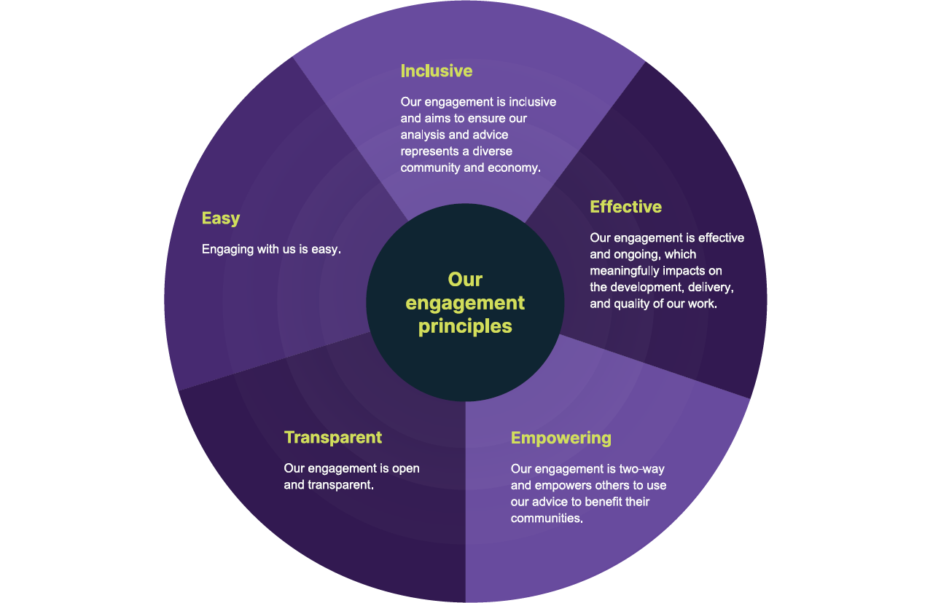

Types of engagement

We create and facilitate many engagement opportunities in the way we undertake our work, from initial establishment of a concept, to providing input and expertise, and in sharing information. The type of engagement will vary across the different work we undertake and deliver, the stage of development, and of impacted and interested stakeholders and their needs.

The following table provides guidance on the varying types of engagement[1] we may use and of our commitment to our tripartite partners and other key stakeholders, including the higher education and vocational education and training sectors.

Types of engagement

|  |  |  |
| --- | --- | --- |
| Collaborate | Consult | Share |
| Aligning the expertise of our partners to effectively define an issue, develop and/or deliver proposed projects. | Gathering views and feedback to inform understanding and development of initiatives, including the Jobs and Skills Australia annual work plan. | Providing data and other information to help guide and influence decisions and actions by others. |
| *We will work together to achieve outcomes and influence how research, analysis, forecasting, and capacity studies are delivered.*  *The outcomes of our key work will enable effective government policy, programs and investment.* | *We will provide opportunities to give views and insights to inform our work.*  *Our work will consider your ideas and provide feedback on how inputs influenced our advice.*  *In preparing the annual work plan, we will invite public submissions as part of our consultation.* | *Our information will be clear, concise, and usable. It will be delivered in a timely and responsive manner.*  *Our communications will keep you informed and updated.*  *It will provide insights that can help inform skills development, employment opportunities and economic growth opportunities.* |

Principle 1 // Our engagement is inclusive   
and aims to ensure our analysis and advice represents a diverse community and economy

**Tripartism** is fundamental to how we operate and is the foundation of our engagement as it enables broader perspectives to inform our work. This strategy outlines several core engagement forums which are central to the engagement and outreach work that underpin our industry centric evidence-based skills approach. Beyond our relationship with all levels of government, unions and business, we also value the **skills, experiences and perspectives** of a range of organisations and individuals across Australia’s skills systems and labour market including the higher education and vocational education and training sectors.

We are deeply committed to actively seeking out and including diverse perspectives in our work and this is reflected in our principle of **inclusive engagement**. When diversity is missing, important ideas and perspectives are missed – and we want to ensure key voices have a seat at the table and the opportunity for genuine engagement on the matters that impact their work and lives.

A key focus for our engagement is ensuring our analysis and advice reflects a **diverse community and economy**. We seek and actively listen to the lived experience of First Nations people, people with disability, culturally and linguistically diverse groups and others who have historically experienced labour market disadvantage and exclusion. Our national, economy-wide outlook is also complemented by a genuine focus on regional, rural and remote Australia, informed by the unique experience and perspectives of those outside our major metropolitan areas.

The work of Jobs and Skills Australia is to improve the identification of labour imbalances across the economy, analyse skills demand and supply, and undertake studies to improve the outcomes for all Australians. We can only effectively deliver in these areas by actively seeking out perspectives from those most impacted.

We have a broad range of stakeholders across industry, government, training and education, research and data, and individuals. Engagement during our interim establishment phase has focused on building relationships through the [Jobs and Skills Australia Consultative Forum](https://www.jobsandskills.gov.au/about/consultative-forum), with states and territories, and with Jobs and Skills Councils. As our work progresses, our network of key voices will also grow – bringing the right expertise and information together to ensure our work continues to be of excellent quality and fit-for-purpose.

Principle 2 // Our engagement is effective and ongoing, which meaningfully impacts on the development, delivery, and quality of our work

Jobs and Skills Australia is **committed to working with others** in determining what we do and how we do it, with the intention that the type of engagement we undertake is appropriate and achieves the best outcome.

Our engagement will have material impact on how our work is designed, delivered, evaluated and improved. We anticipate our engagement opportunities will evolve as our work plan continues to mature.

### Engagement opportunities across our annual work plan and its development

Our work plan is focused on providing high-quality independent advice to underpin Australia’s response to current, emerging and future workforce, skills and training needs. This guides us in undertaking our functions focused on improving skills development, employment opportunities and economic growth. Our work plans comprise a rigorous quantitative and qualitative research and analytic program underpinning our strategic advice and other analyses.

Consulting and engaging to develop the annual work plan will be ongoing, providing the benefit of a rolling and continuous work plan development process. This will include:

* environmental scans that include qualitative insights from engagements with stakeholders
* development of the Jobs and Skills Report, developed in consultation with our tripartite partners and key stakeholders
* a public consultation process
* ongoing tripartite consultation through the Consultative Forum, Jobs and Skills Councils, and Commonwealth, state and territory engagements.

We will share information about engagement opportunities about our annual work plan development process on our website, as well as through our communications and social media channels.

We have conceptualised our work plan as a pyramid. Five elements, each contributing to the others, and each with engagement embedded into practice.

The centrepiece of the work plan is the Jobs and Skills Report, which in due course will incorporate a National Jobs and Skills Roadmap. The Report will be informed by insights and collaboration with Jobs and Skills Councils, our tripartite partners and other key stakeholders.

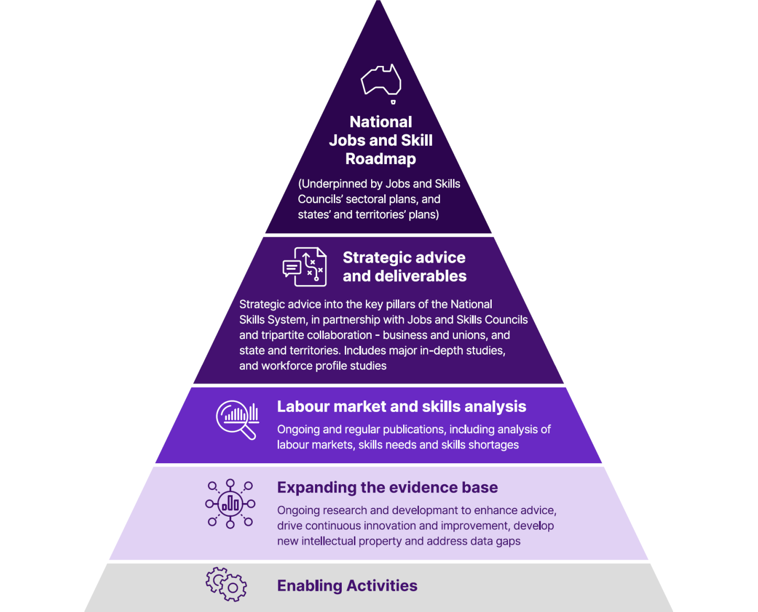The conceptualised work plan illustrates our current programs, projects and products within each layer

| Top layer - National Jobs and Skill Roadmap | (Underpinned by Jobs and Skills Councils’ sectoral plans, and states’ and territories’ plans) |
| --- | --- |
| Second layer - Strategic advice and deliverables | Strategic advice into the key pillars of the National Skills System, in partnership with Jobs and Skills Councils and tripartite collaboration - business and unions, and state and territories. Includes major in- depth studies, and workforce profile studies |
| Third layer - Labour market and skills analysis | Ongoing and regular publications, including analysis of labour markets, skills needs and skills shortages |
| Fourth layer - Expanding the evidence base | Ongoing research and development to enhance advice, drive continuous innovation and improvement, develop new intellectual property and address data gaps |
| Final layer - Enabling activities | (no additional context) |

### Engagement opportunities in major in-depth studies

As part of our strategic advice and deliverables work stream, each year we undertake several major in-depth studies that explore key issues impacting the Australian labour market and skills supply and demand. Studies may also consider regions, emerging industries, technologies and work practices and the capacity of our workforce to respond to them; or studies that focus on improving employment, VET and higher education outcomes for people who have historically experienced labour market disadvantage and exclusion.

While the focus and key experts relating to each major in-depth study will naturally differ, our engagement blueprint outlines what our partners and stakeholders can expect. These studies include a blend of quantitative and qualitative analysis and combine technical analysis with deep two-way stakeholder engagement and on-the ground advice, which will enhance our insights and advice.

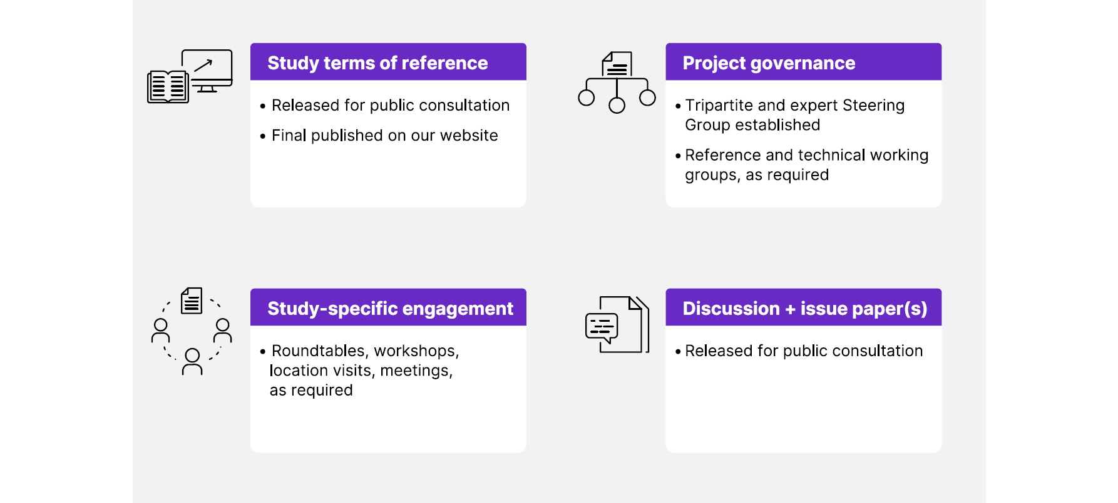Major in-depth study engagement blueprint

| Study terms of reference | Released for public consultation  Final published on our website |
| --- | --- |
| Project governance | Tripartite and expert Steering Group established  Reference and technical working groups, as required |
| Study-specific engagement | Roundtables, workshops, location visits, meetings, as required |
| Discussion + issue paper(s) | Released for public consultation |

Broadly, **sharing** of information and **consultation** will occur throughout a study’s lifecycle, including:

* an opportunity at the start of a study to inform the terms of reference
* bringing together the right mix of stakeholders and partners to inform and advise on aspects of the study in a steering group, and where required in reference and/or technical working groups
* public opportunities to respond to a discussion paper(s) and/or issue(s) papers specifically seeking information and views from stakeholders and partners
* a range of flexible, fit-for-purpose engagement activities as needed to support and inform the study.

Smaller **workforce profile studies** will also be undertaken to build our understanding of workforces in priority areas. Engagement will be reflective of the size and scope of the workforce profile study.

In delivering major studies and strategic advice, focus is given to ensuring diverse voices have meaningful input into studies and analysis that impact their work and daily lives.

### Engagement opportunities in our ongoing analysis and research

Our work plan includes ongoing labour market and skills analysis which addresses a range of detailed and regular data products and insights that help us to understand Australia’s labour market, skills needs, skills shortages and how these are changing. In addition, another key component of our work plan is our research to expand the evidence base.

Here, projects seek to advance our advice, drive continuous innovation and improvement, and address data gaps. Our Skills Priority List and emerging occupations analysis are examples of work in these categories.

We are committed to deploying a range of fit-for-purpose engagement activities which may also include specialist **consultations**, validation and evaluation processes as well as **seeking advice** as relevant through our engagement forums. Potential activities we may undertake are outlined below.

Significant projects and products in these categories will have an individual project or product stakeholder engagement plan. Each plan will clearly outline the purpose of the engagement, identify and analyse the stakeholder mix, and set out the engagement and outreach activities being used.

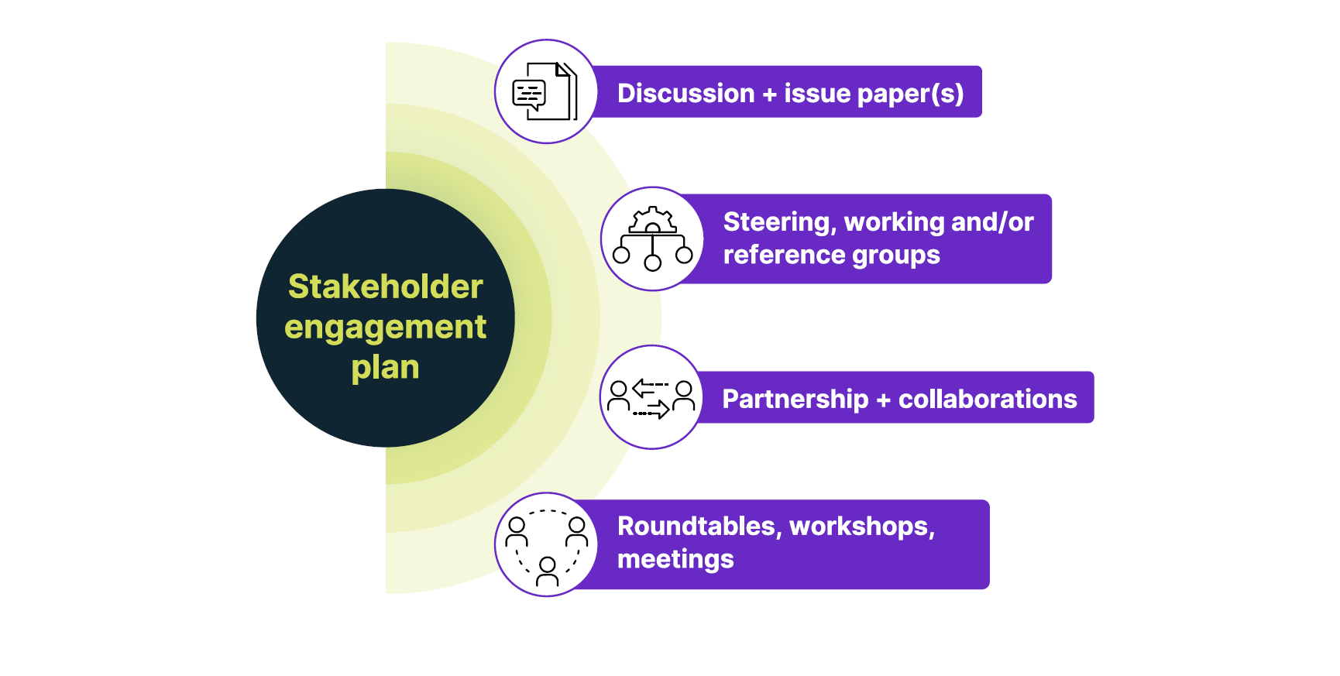Ongoing analysis and research engagement potential activities

Stakeholder engagement plan:

* Discussion + issue paper(s)
* Steering, working and/or reference groups
* Partnership + collaborations

Roundtables, workshops, meetings

Consultation and engagement information about projects and analysis is available on our website, as well as promoted through our communications and social media channels.

### Engagement opportunities with regular data products

We also develop and release a range of regular data products that provide high-quality analysis and advice relevant to the national skills system, and labour market and skills outlook across industry, occupations, regions and cohorts. Engagement activities are tailored to the focus of the dataset, product or analysis,   
and the key relevant stakeholders.

We work closely with our partners to understand their current and future priorities and information needs.

Engagement in this area also focuses on promotion of these data products and **continuous improvement** to:

* improve and refine our methodological approaches
* expand coverage and granularity of the data products
* seek feedback to ensure these products continue to meet user needs over time
* promote their use in enabling other research, policy or program responses relating to improving skills, education and employment opportunities for Australians.

Examples of data products in this category include: Five-yearly employment projections, Internet Vacancy Index, Nowcast of Employment by Region and Occupation (NERO), Recruitment Experiences and Outlook Survey and Recruitment Insights Report; and small area labour markets analysis.

In practice, engagement opportunities supporting continuous improvement may include the use of technical working groups, specialist consultancies, evaluation processes, direct data collection as well as compiling feedback received through both project-specific and general engagement channels.

Principle 3 // Our engagement is two-way and empowers others to use our advice to benefit their communities

**We care about the impact of our work** and are invested in making our engagement a two-way discourse. That is, in addition to seeking feedback on our work and how we go about it, we are committed to ensuring our work provides **valuable and actionable insights** that can be used by others to benefit their work and communities.

We will do this in two ways:

* engaging with relevant stakeholders in our work supporting strategic advice into the national skills system and other policy priorities.
* promoting, sharing and showcasing our work and the insights generated through our research, engagement and analysis.

We know that those who read and use our work service a network of people and interests. We seek to ensure our work is relevant to their diverse range of community needs.

### Engagement in our work delivering strategic advice for the national skills system and policy priorities

A key component of our work is what we do to support and inform the effective operation of the national skills system and its component parts – vocational education and training, higher education and migration – and other policy priorities which have cross-cutting significance within the labour market. In 2023-2024 this includes advice and analytic contributions to the following processes:

* Employment White Paper
* Migration Review
* National Skills Agreement
* Universities Accord.

Each initiative is being led out of an Australian Government department, and we actively contribute by **connecting our independent advice and analysis to these policy priorities**. We do this by participating in interdepartmental committee and working group arrangements, contributing insights from our data and analysis and by seeking out and listening to the perspectives of our stakeholders and partners on these issues. We will also apply what we have learned through our regular engagement, including in our major in-depth studies, which seek to unpack key issues of interest in the Australian skills system.

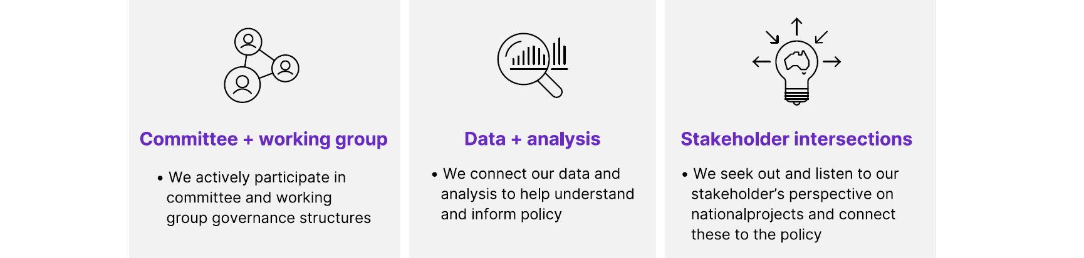Our engagement approach in providing strategic advice

|  |  |  |
| --- | --- | --- |
| Committee + working group | Data + analysis | Stakeholder intersections |
| * We actively participate in committee and working group governance structures | * We connect our data and analysis to help understand and inform policy | * We seek out and listen to our stakeholder’s perspective on national projects and connect these to the policy |

Jobs and Skills Australia’s input into public policy processes may also be in the form of **submissions into other public consultation processes**. In this case, we will publish our submission on our website.

### Promoting, sharing and showcasing our work

Our analysis, informed by others, is rich in **valuable and actionable insights**. As much as possible, we want to make our data and insights widely available so they can inform research, policy, programs and initiatives and improve decision making. We are committed to sharing our work back with those who have contributed to its development, as well as others who can use it to make a real difference in Australia’s skills system.

Consistent with our engagement principles, we have an active outreach program to keep external stakeholders informed about Jobs and Skills Australia and our work.

Our outreach activities use a range of channels and are designed to connect with a broad and expanding stakeholder mix with targeted and tailored content. Below are some of the methods that we currently use, or are planning to deploy, to connect our external stakeholders with the insights from our research, analysis, publications and products, as well as promote engagement and consultation opportunities.

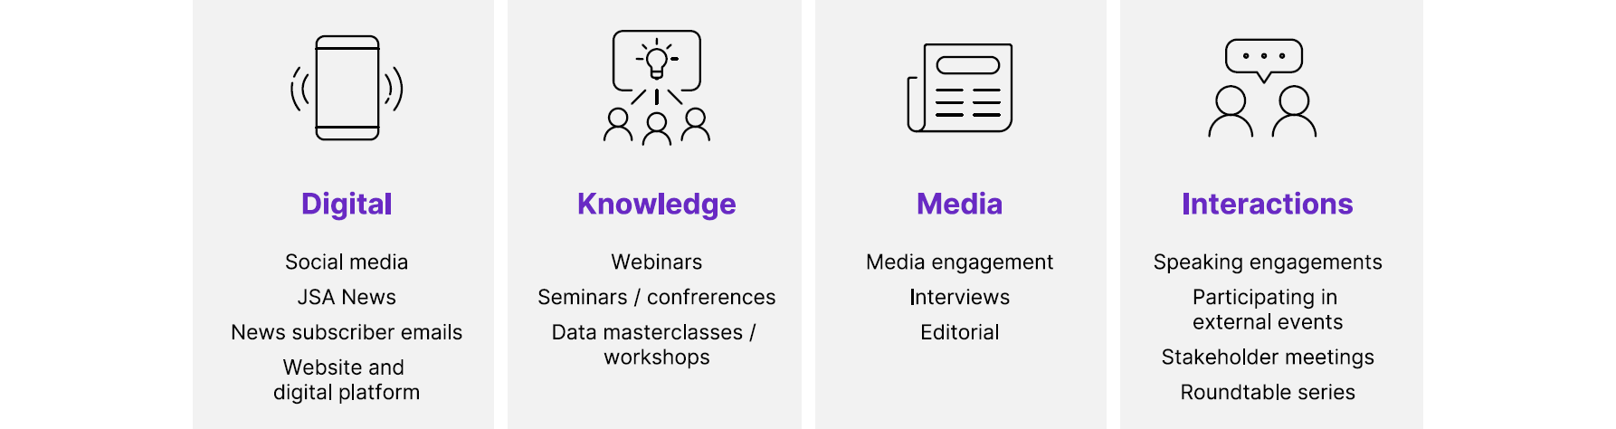How we reach our audience and the general public

|  |  |  |  |
| --- | --- | --- | --- |
| Digital | Knowledge | Media | Interactions |
| Social media  JSA News  News subscriber emails  Website and digital platform | Webinars  Seminars / conferences  Data masterclasses / workshops | Media engagement  Interviews  Editorial | Speaking engagements  Participating in external events  Stakeholder meetings  Roundtable series |

To effectively support the publication and outreach activities we have a range of **supporting strategies and plans** underway to augment and complement our engagement and outreach strategy, covering communications, social media, data and digital.

Principle 4 // Our engagement is open and transparent

At Jobs and Skills Australia, we share information about **engagement opportunities** and are upfront about the **scope, purpose and nature of that engagement**. We also commit to transparency by actively sharing our work, and communicating **our priorities and work program**, including how stakeholder feedback and engagement has informed and impacted our work. We also commit to transparency in our research design and methodology.

Our work program is ambitious, and our expectations are high. It is important for us to be clear about the scope of our engagement activities. We are determined to work with others to support our independent advice on Australia’s current, emerging and future workforce and skills needs.

So far, we have prioritised:

* initiating our **interim core engagement forums**
* initiating **steering groups** for our Clean Energy Capacity Study and National Study of Adult Literacy, Numeracy and Digital Skills
* setting up a dedicated ***Connect with us*** **hub** at [jobsandskills.gov.au/connect-with-us](https://www.jobsandskills.gov.au/connect-with-us)
* **leveraging existing mechanisms** including a regular cadence of outreach activities.

### Interim core engagement forums

#### Consultative Forum

The Consultative Forum has been established by the Hon Brendan O’Connor MP, Minister for Skills and Training, to support the JSA Director, Professor Peter Dawkins AO, with advice on key matters relating to our interim operations. The Consultative Forum provides strategic advice to Jobs and Skills Australia, including about the annual work plan, mechanisms for meaningful stakeholder engagement, and consultation and deliberation about our major studies, research and analysis. The Consultative Forum also informs the foundations for our longer-term ways of working.

The Consultative Forum comprises membership across unions, business, state and territory governments, and higher education and vocational education and training representatives. Forum members are listed on our website.

#### Jobs and Skills Councils CEO forum

We work ‘hand-in-glove’ with Jobs and Skills Councils as collaborative partners within the skills and workforce architecture. This means establishing ways of working to support Jobs and Skills Councils with their responsibilities for industry workforce planning, development of vocational education and training products and industry stewardship. This partnership is two- way and collaborative with Jobs and Skills Councils bringing the on-the-ground experience and expertise of industry with our economy-wide data and outlook.

To drive this partnership, we have established a **Jobs and Skills Councils CEO Forum**. The Chief Executive Officer at each Jobs and Skills Council is members of this forum.

We are also committed to enabling this partnership with access to data and analysis that meets the needs and requirements of Jobs and Skills Councils and have progressed a range of activities to enhance this partnership, including providing advice on how our data can be used to support Jobs and Skills Councils’ workforce planning activities.

#### State and Territory Partnership

We know states and territories have a substantial stake in the skills system. We are committed to working cooperatively with the states and territories to deliver advice and analysis on current, emerging and future workforce and skills needs across Australia’s state and regional labour markets.

We have established a **State and Territory Partnership Forum**, with an initial workshop focused on collaborating on development of our 2023-24 work plan. Senior officials from all state and territory governments will be members of this ongoing forum. Working groups of state and territory officials and Jobs and Skills Australia staff will meet regularly on specific issues to share information, provide input into projects and help build analytical capacity across jurisdictions.

We will continue to participate, as invited/required, in existing arrangements that facilitate engagement between federal, state and territory governments, such as the **State and Territory skills advisory bodies**, National Cabinet’s **Skills and Workforce Ministerial Council** and **the Federated industry Skills Network**.

#### Commonwealth agencies forum

There is a range of existing expertise and activities on workforce issues across the Commonwealth Government. We are establishing an ongoing mechanism to ensure that other parts of the Commonwealth Government are aware of Jobs and Skills Australia’s work plan and data assets to support their work. This will also facilitate input into our work plan development process to ensure that our work supports Commonwealth Government policy priorities.

### Steering groups supporting our work

Our major in-depth studies are high priority items and we have moved quickly to establish **steering** **groups** for the current studies – the Clean Energy Capacity Study and National Study of Adult Literacy, Numeracy and Digital Skills. Steering groups comprise a mix of tripartite members, key stakeholders in higher education and vocational education and training, and experts to help inform our approach to these studies.

We also undertake a range of **product-specific consultations**. These are genuine two-way consultations to seek and obtain input and intelligence to inform the development and enhancement of our products.

### A dedicated Connect with us hub

We acknowledge it is not possible or practicable for everyone to be involved in some, or all, of our formal engagement forums, so it is important for us to have a dedicated mechanism where anyone can connect with us.

We are always ready to listen, and have implemented an always open, online [*Connect with us* hub](https://www.jobsandskills.gov.au/connect-with-us). In addition to featuring our current project and product engagement opportunities, our Connect with us hub enables anyone to contribute information to inform our work plan and work as well as provide feedback by following the online instructions.

### Leveraging existing mechanisms

Outside of structured forums, we also undertake **consultation activities** across our stakeholder mix. We will continue to undertake a mix of organic, proactive, reactive, strategic and topical consultation in mixed formats (including meetings, roundtables, workshops).

Our Director and leadership team have also been very active in participating in a range of **partner and stakeholder-initiated forums**, with several key note addresses, speeches, webinars and interviews. We will actively consider all engagement requests and will commit to those which align with our strategic priorities subject to the availability of relevant members of our team.

### Expansion of our engagement activities

Over time we aim to build a sophisticated and fit-for-purpose engagement approach that achieves an effective, impactful and sustainable balance across partnerships, engagements and outreach. We recognise our engagement will evolve as we continue to work towards achieving this balance.

We are building our strategic relationship capabilities within the Jobs and Skills Australia team to drive partnership opportunities across our stakeholder mix. Initially this is focused on rapidly maturing our ‘hand-in-glove’ partnership with Jobs and Skills Councils. Moving forward, we will leverage our strategic relationships and broad networks to identify further **partnering opportunities** which will contribute meaningfully to improving labour market and training and education outcomes.

Additionally, we continue to explore rolling out further relevant engagement activities to support and enable our work. Areas **of future engagement** focus include:

* new steering groups, working groups and reference groups for our studies, projects and products
* culturally aware and inclusive engagement with First Nations people, people with disability, culturally and linguistically diverse people
* regional, rural, remote and place-based engagement
* inter-departmental committee participation and/or convening these to connect our work more directly within the policy development process, as well as ensuring coverage across our legislated functions.

Future engagement opportunities will be published using our outreach channels, with channels tailored depending on the scope or nature of the engagement or the key stakeholder mix for the activity. Key stakeholders may also be contacted through our existing engagement mechanisms including our established forums or by leveraging other existing stakeholder networks.

Principle 5 // Engaging with us is easy

We want to **make it easy for our partners and stakeholders to connect with us**. This includes offering a range of methods for connecting with stakeholders in ways they need and prefer to engage with us.

We aim to meet and engage with stakeholders in ways that **meet their needs and requirements**. Not everybody can, or feels comfortable to, meet in person – and we need to ensure that digital and remote capability is accessible, user-friendly and effective. Some stakeholders are more comfortable providing real-time or face-to-face feedback while others need or want time to provide longer-form or written feedback, including consolidating or collating responses from their members or other stakeholders.

The below graphic sets out a consolidated overview of the tools we use to facilitate our engagement activities, and this will evolve over time as our consultation approach matures. As practicable, we will also seek to tailor our tools and solutions to individual stakeholder needs, using a range of design-informed techniques.

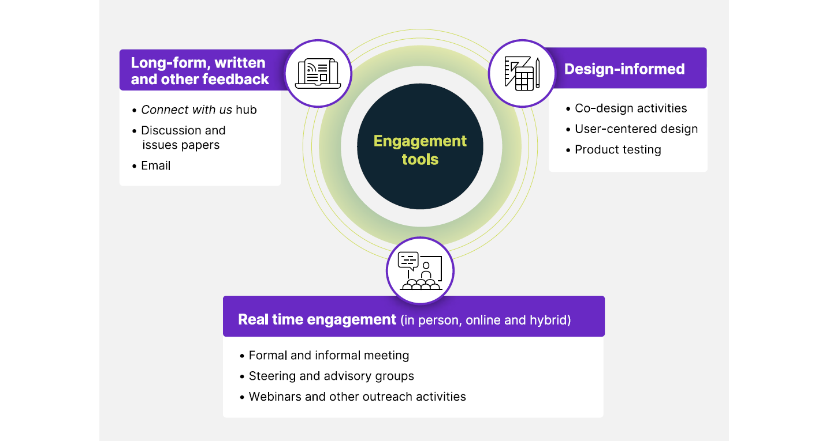Engagement tools

|  |  |  |
| --- | --- | --- |
| Long-form, written and other feedback | Design-informed | Real time engagement (in person, online and hybrid) |
| Connect with us hub  Discussion and issue papers  Email | Co-design activities  User-centered design  Product testing | Formal and informal meeting  Steering and advisory groups  Webinars and other outreach activities |

### Internal capability

In addition, we are investing in the **capabilities of our team** through recruitment for officers with strategic stakeholder engagement skills and experience and providing training and capability uplift opportunities. Further, we are investing in **technology** to support efficient and effective stakeholder engagement, as well as establishing a suite of **guidance materials** to support our team to deliver high-quality engagement experiences for our partners and stakeholders.

# 3. Risks and mitigation strategies

We acknowledge engagement occurs in a complex environment and challenges and sensitivities may arise in the context of our engagement activities. Table 2 outlines some challenges we can foresee and our approach to managing these with respect and professionalism.

Table 2 Engagement risks and mitigation strategies

|  |  |  |
| --- | --- | --- |
| Risk/challenge | Description | Mitigation strategies |
| Divergent stakeholder views | We value diversity of opinions and perspectives, although this can lead to differing or conflicting stakeholder views, sometimes unresolvable. | * Establishing and sustaining deep two-way engagement helps better understand stakeholder views and differences and allows us to bring together different perspectives, or respectfully acknowledge divergence in our advice. |
| Consultation fatigue | There is significant demand across multiple processes for stakeholder contributions, leading to over-consulting and reduced level of engagement and depth of feedback from stakeholders. | * We are building the internal capability of our team with strategic stakeholder engagement skills and experience, including in best practice for avoiding stakeholder fatigue. * We are leveraging existing government relationships and networks as appropriate. * We are consulting with government partners on past engagement activities in order to build on, and not duplicate, previous engagement and advice. * We are establishing appropriate stakeholder relationship management tool for our team to keep track of stakeholder interactions, to more effectively and strategically plan consultations * We are seeking stakeholder preference on frequency of engagements. * Careful project planning, reviewing engagement process, and drawing insights from similar engagements |
| Stakeholder conflicts of interest | Stakeholders can have perceived, potential or actual conflicts of interest when engaging with us and our work. | * We have established processes for managing conflicts of interest and determining the best course of action |
| Capability and capacity to engage | The commitment to engage widely and deeply requires high resources and appropriate skillsets to undertake stakeholder engagement | * We have a plan to develop build and grow our engagement capability, capacity, supported by the right staff capability, enabling tools and supports, including training in culturally aware engagement. |
| Unexpected consultation outcomes | Consultation can lead to outcomes that is different or contrary to our initial  thoughts and approach | * All evidence will be reviewed and used as a basis to  determine whether and how the consultation outcomes/  advice will be incorporated in our work. * Further consultations may be necessary to unpack and  provide better understanding of factors leading to the  consultation outcomes. * We have a growth mindset and a culture of continuous improvement for our work and are open to suggestions for change. |
| Engagement not being fit-for- purpose | Sometimes engagement  may not provide information  or advice that contributes meaningfully to a particular project or work or delivers  value for the stakeholder(s) | * We are building our internal staff capability and regularly review best-practice stakeholder engagement and consultation to maximise the likelihood of fit-for-purpose engagements. * We are drawing on the strategy and other advice for identification of appropriate stakeholders for targeted consultation |

# 4. Measuring successful engagement

Success doesn’t mean getting everything right the first time. Rather, it involves demonstrating our commitment to listen, learn and adapt our approach in undertaking deep and meaningful two-way engagement over time. We have identified an initial set of success metrics to identify areas of improvement and acknowledge aspects of stakeholder engagement that we are doing well. We are reviewing these metrics periodically to ensure we are measuring them appropriately and relevantly.

1. **Engagement is successful and valued in our work:**
2. Fit-for-purpose engagement channels are established.
3. Stakeholders are engaged in the process and provide comments or feedback.
4. Stakeholder comments shape the development and implementation of our work.
5. **Stakeholders value our engagement and outreach:**
6. Stakeholders see the value of their contributions to our work and continue to be engaged.
7. The value of our engagement is reflected in the uptake and use of our work, data, and insights.
8. Surveys and feedback show consistent positive attitudes to engaging with us
9. **We build and utilise our internal capability:**
10. We use our engagement toolkit effectively.
11. Our staff have undertaken relevant training opportunities.
12. We have considered previous government engagement and existing stakeholder networks and avoided duplication.

Measurement of success against these metrics includes a mix of sentiment analysis, surveys, media and social media analysis, direct feedback, ongoing engagement with and participation in our work, web analytics and other data on the uptake and usage of our products.



Connect with us

Our stakeholders and your advice are core to how we operate. We will continuously monitor the way we work, how we engage and the way we communicate, and look to ways we can improve.

Consultations[jobsandskills.gov.au/consultations](https://www.jobsandskills.gov.au/consultations)

Connect with us[jobsandskills.gov.au/connect-with-us](https://www.jobsandskills.gov.au/connect-with-us)

LinkedIn NameJobs and Skills Australia

Twitter HandleJobsandSkillsAu

[**JobsandSkills**.gov.au](https://www.JobsandSkills.gov.au)

1. Adapted from the [Australian Public Service Framework for Engagement and Participation](https://www.industry.gov.au/publications/aps-framework-engagement-and-participation)