

**Recruitment methods used by employers**

**Findings from the Recruitment Experiences and Outlook Survey, 2021-2022**

South Australia

**Contents**

Background and definitions 2

Methods of recruitment: definitions 2

Employers that advertised and didn’t advertise 3

Methods of Recruitment: South Australia 3

Greater Adelaide and Rest of South Australia 4

Skill Levels 4

Use of social media continues to rise 6

# **Background and definitions**

This paper is the first in a series reporting on methods of recruitment data collected as part of Jobs and Skills Australia’s Recruitment Experiences and Outlook Survey. This report provides a summary of recruitment methods used by employers during 2021 and 2022 for South Australia. Separate reports are available for each state and territory.

Jobs and Skills Australia (JSA) conducts the Recruitment Experiences and Outlook Survey (REOS) to monitor recruitment activity and conditions across Australia. Approximately 1,000 employers are surveyed each month to collect information on recruitment activity, recruitment difficulty and staffing outlook. Data are released as close to collection as possible, providing a current view of recruitment activity across Australia. The REOS covers a core set of questions asked each month, including:

* Current staff levels and recent changes
* Recruitment and retention difficulties
* Recruitment methods used; and
* Future staffing expectations.

The REOS provides insights about labour market conditions to help policy makers and analysts monitor and understand current and emerging labour market conditions, and to develop resources to help job seekers understand what employers are looking for. More information on the REOS questionnaire, methodology and key concepts can be found [here](https://www.jobsandskills.gov.au/sites/default/files/2022-12/REOS%20-%20concepts%2C%20methods%2C%20and%20questionnaire%20.pdf).  
  
The [Recruitment Experiences and Outlook Survey (REOS)](https://www.jobsandskills.gov.au/work/recruitment-experiences-and-outlook-survey) is one of a number of JSA sources of labour market information. Others include the [Internet Vacancy Index (IVI)](https://www.jobsandskills.gov.au/work/internet-vacancy-index), [Small Area Labour Markets (SALM)](https://www.jobsandskills.gov.au/work/small-area-labour-markets), the [Monthly Labour Market Dashboards](https://www.jobsandskills.gov.au/work/monthly-labour-market-dashboards), the [Nowcast of Employment by Region and Occupation (NERO)](https://www.jobsandskills.gov.au/work/nero), and [Five-Year Employment Projections](https://labourmarketinsights.gov.au/our-research/employment-projections/).

Any data in this report should be referenced as: Jobs and Skills Australia, Recruitment Experiences and Outlook Survey. For any queries about the findings in this paper or the REOS, please contact reos@jobsandskills.gov.au.

## **Methods of recruitment: definitions**

Recruitment methods reflect the steps employers took to fill their vacancies. The recruitment methods most often reported by employers include advertising on the internet, promoting jobs by ‘word of mouth’, social media, use of recruitment agencies, company websites, and newspapers. The survey does not take into account the role that other parties (such as recruitment agencies or job aggregating websites) may have played in promoting the vacancy.

For their most recent recruitment round, we ask employers “What occupation have you most recently hired or replaced new staff for?”. Employers can provide multiple responses and often use multiple recruitment methods. Where multiple methods are used, the successful method of recruitment used by recruiting employers is not currently collected.

## **Employers that advertised and didn’t advertise**

Recruitment methods can be broadly defined as ‘advertised’ or ‘not advertised’:

* advertised recruitment methods include using the internet (job boards, company websites), newspapers, employment agencies, social media, sign in window, internally advertised/promoted, and ‘other’ formal methods.
* not advertised recruitment methods include word of mouth and job seekers who have directly approached employers.

The JSA defines recruiting employers as ‘not advertising’ if they only use word of mouth and/or consider job seekers who approached the business directly.

The data about these employers have important implications for job seekers looking to maximise their job opportunities: that developing and maintaining social connections is beneficial to the job-search process, and being proactive by calling or approaching employers for work is likely to help to find vacancies that aren’t advertised.

# **Methods of Recruitment: South Australia**

In South Australia, the most notable shift between 2021 to 2022 was an increase in the use of internet job boards, with around 58% of recruiting employers advertising vacancies on the internet in 2022. The 45% of employers using the internet for recruitment in 2021 was the lowest percentage recorded of any state or territory in that year, and 2022 signals a shift back to more usual recruitment practices in South Australia.

The use of other methods was relatively unchanged between 2021 and 2022 in this state, apart from the use of company websites, falling to 4% in 2022 from 11% in 2021.

**Figure 1: Recruitment methods used by employers, South Australia, 2021 and 2022\***

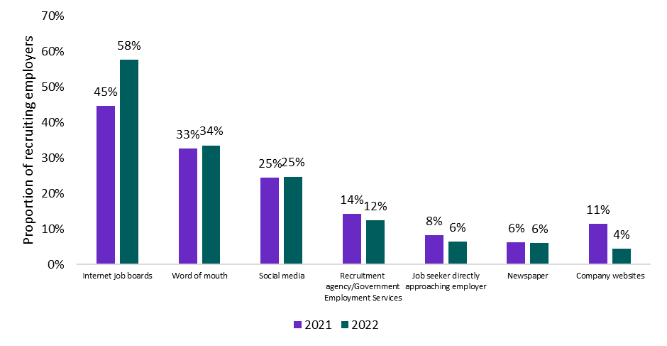

*\*Note: Employers can report multiple methods so numbers may not add to 100%.*

## **Greater Adelaide and Rest of South Australia**

The trends in Adelaide follow similar patterns to other capital cities, with 67% relying on internet jobs boards to recruit; about a third using word of mouth; and at 17%, a slightly lower than average proportion turning to social media to recruit.

However, employers in regional South Australia are quite different to their regional counterparts in other states. The most frequently used method outside Adelaide was social media, and at 43% was one of the highest uses of this method in the country. Only 36% of employers in this area used the internet to advertise their positions - the lowest of any area in Australia in 2022. Contrary to trends elsewhere, a further 17% of employers relied on newspapers here in 2022, along with country Victoria, the equal highest in Australia.

##### **Figure 2: Recruitment methods used by employers, Greater Adelaide and Rest of South Australia, 2022*This a column chart, key points are described in the text. The top three methods for Greater Adelaide are: internet job boards (67%), Word of mouth (32%) and social media (17%). This compares with Rest of South Australia, where the top three methods are social media (43%), word of mouth (37%) and internet jobs boards (36%).**

*\*Note: Employers can report multiple methods so numbers may not add to 100%.*

## **Skill Levels**

Each occupation is assigned a Skill Level which is based on the ABS ANZSCO Skill Level classification (see this [ABS article for more information](https://www.abs.gov.au/articles/how-anzsco-works)). Skill Levels reflect the range and complexity of the tasks undertaken in the occupation, based on required levels of formal education and training, previous experience, and the amount of on-the-job training required. For this report, higher skilled vacancies are defined as ANZSCO Skill Levels 1-3; and lower skilled vacancies as ANZSCO Skill Levels 4-5. Recruitment methods often vary depending on the skill level required for the advertised job.

#### **Greater Adelaide**

Advertising on internet job boards was the most common method used by recruiting employers in Adelaide and was broadly similar regardless of skill level – at 69% for higher skilled vacancies and 65% for lower skilled positions. For employers seeking staff for high skilled jobs, 27% used word of mouth (about average) while only 15% used social media, (low compared with the national average). Word of mouth (36%) and social media (19%) were the next significant method for lower skilled vacancies.

##### **Figure 3: Recruitment methods used by employers, by skill level, Greater Adelaide, 2022\*** **This a column chart, key points are described in the text. The top four methods for higher skilled and lower skilled are the same – Internet job boards, word of mouth, social media and recruitment agencies/government services.**

*\*Note: Employers can report multiple methods so numbers may not add to 100%.*

#### **Rest of South Australia**

The atypical pattern for regional South Australia described above is further reflected when looking at skill levels in this area. Internet job boards were the most commonly used method for employers recruiting higher skilled staff, but at 44%, was low compared with other states. For lower skilled jobs, almost half (47%) of recruiting employers used social media and 38% used word of mouth – both comparatively very high. By contrast, only a third of recruiting employers in this area used the internet to advertise their lower skilled vacancies.

Employers sometimes do not advertise their vacancies, instead relying on job seekers that approach the business looking for work. In 2022, 8% of recruiting employers used this method to fill their vacancies at lower skill levels, while only 3% of recruiting employers used this method for higher skill level vacancies.

**Figure 4: Recruitment methods used by employers, by skill level, Rest of South Australia, 2022\***  
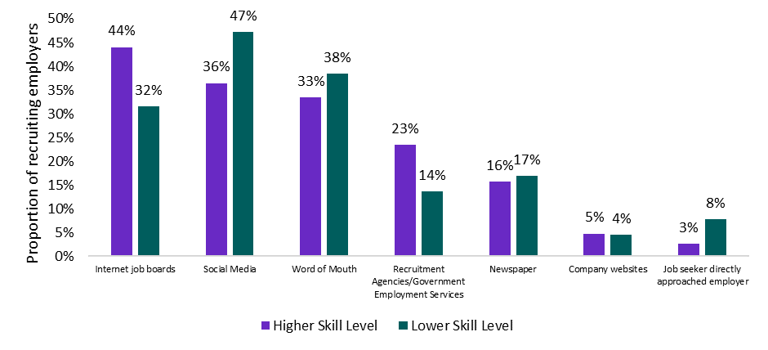

*\*Note: Employers can report multiple methods so numbers may not add to 100%.*

## **Use of social media continues to rise**

An emerging trend over recent years has been the increasing use of social media for recruitment. This involves advertising vacant positions on a social media platform, including advertising on Facebook job groups, Instagram or LinkedIn. Employers use social media for recruitment as it is inexpensive, fast, and allows job ads to have wide exposure amongst job seekers.

Employers in Rest of South Australia have been increasingly using social media to recruit over recent years, with more than double citing social media use in 2022 compared with employers in Greater Adelaide. This trend of employers in regions relying on social media to a greater extent than the city counterparts is one that is commonly seen across the country. [Previous REOS findings](https://labourmarketinsights.gov.au/media/f3ylqoms/recruitment-methods-used-by-employers.pdf) also reveal that social media is more commonly used when recruiting for lower skilled vacancies.

##### **Figure 5. Employers using social media for recruitment, South Australia, 2016 to 2022\*** **This is a line chart, key points are described in the text. In 2016, the proportion of employers using social media stood at 11% in Rest of South Australia, 7% for SA overall and 5% in Greater Adelaide. By 2022, this has risen to 43% in Rest of South Australia, 25% for SA overall and 17% in Greater Adelaide.**

*\*Note: Data from 2016 to 2019 are from the Survey of Employers’ Recruitment Experiences (SERE). Due to changes in questions and methodology from the SERE (2016-19) and the REOS (2020-2022), comparisons with 2019 and prior should be treated with some caution. From November 2019 to March 2020 the survey was suspended due to the COVID-19 pandemic, therefore the data for this time period is imputed. Employers can report multiple methods so numbers may not add to 100%.*