Opportunity and Productivity: Towards a Tertiary Harmonisation Roadmap

# What is tertiary harmonisation?

Tertiary harmonisation is the strategic alignment of the Higher Education and Vocational Education and Training (VET) sectors. It involves the effective coordination and cooperation of key system actors, to enable learners to obtain the combination of knowledge, skills and their application that they need to be successful in a changing labour market.

# What it isn't

Tertiary harmonisation is not about merging VET and Higher Education. Each will remain a distinctive sector, sustaining important differences in mission and approaches to learning.

# The high-level case for harmonising VET and Higher Education

Tertiary harmonisation will correct for distortions in incentives for students, promote equitable access to universal high quality tertiary education, and better enable students to navigate the tertiary education system. This enables learners to obtain the combinations of knowledge, skills and capabilities they need to successfully participate in the changing labour market. Tertiary harmonisation will encourage VET and higher education providers to collaborate in the provision of well-designed education and training programs to secure the development of the knowledge, skills and capabilities needed for the Australia economy.

# Tertiary harmonisation - who, what and why?

Realising the benefits of tertiary harmonisation requires critical stakeholders to come together, complemented by an appropriate system architecture. System actors comprise VET and higher education providers, students, business, employers, unions and both state and commonwealth governments.

Students are the fundamental actor in this system, with conditions such as culture, legislation, funding and regulation all playing a role in how the system operates. The architecture supporting the tertiary system, such as the Australian Qualifications Framework (AQF) and the National Skills Taxonomy (NST) needs to be designed in a way that supports system connectiveness and strategic alignment.

# The 3 pillars and 12 elements of tertiary harmonisation

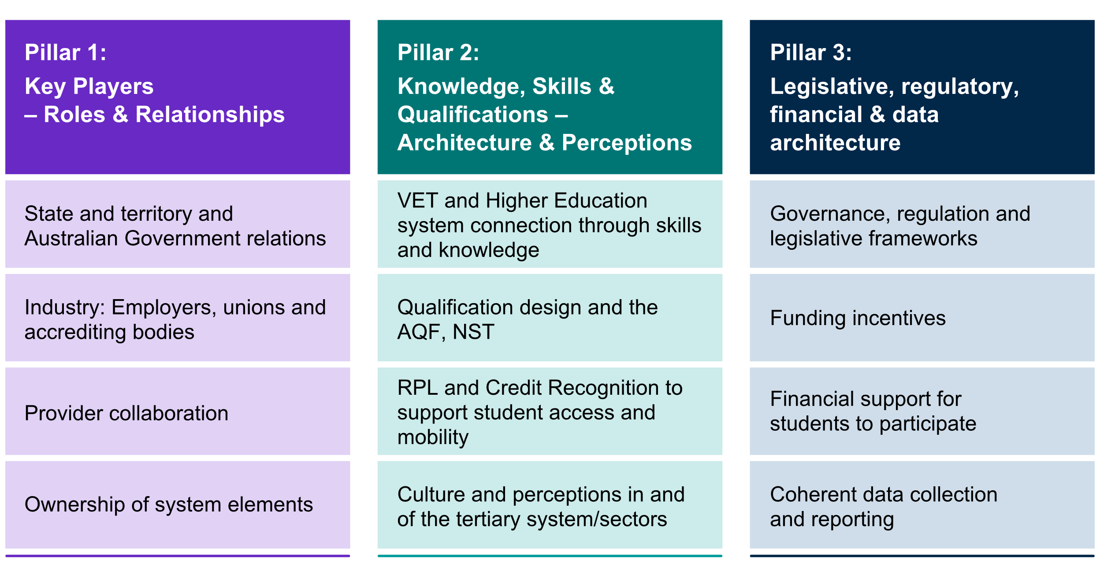

## Pillar 1: Key players: roles and relationships

A roadmap to tertiary harmonisation will require co-operation among diverse system actors. This includes relationships between state and territory governments and the Australian Government, providers, employers, unions and licensing and accreditation authorities.

## Pillar 2: Knowledge, skills and qualifications: architecture and perceptions

Tertiary harmonisation involves developing a common language that will facilitate innovation in qualification design, expand career opportunities that draw on combinations of skill and knowledge levels and that better support industries, especially those in transition.

## Pillar 3: Legislative, regulatory, financial and data architecture

Legislative, regulatory and funding arrangements will need to be reformed to put VET and Higher Education on a level playing field and incentivise harmonisation.

# Recommendations

There are 19 recommendations across 3 categories

including roadmap development, and potential

early to mid-term priorities, supporting the

creation of a sustainable pathway forward

in collaboration with key stakeholders

For access to the full report, see the QR code,

or please contact

[TertiaryHarmonisation@jobsandskills.gov.au](mailto:TertiaryHarmonisation@jobsandskills.gov.au)