

An Essential Ingredient

The Food Supply Chain Workforce

Summary Report



**Acknowledgement of Country**

Jobs and Skills Australia acknowledges the Traditional Owners of Country throughout Australia and recognises the continuing connection to lands, waters and communities. We pay our respect to Aboriginal and Torres Strait Islander cultures, and to Elders past and present.

# Overview

**A resilient workforce is essential to Australia’s food security and strong export industries. This means having the right skills in the right locations at the right time.**

The future of Australia’s food supply chain will be shaped by multiple interacting shifts, including climate change and net zero, technological advances, and demographic changes. Concerns around sovereign capability, industry viability and cost of living also have an impact. In the midst of these developments, the food supply chain workforce will remain an essential ingredient to our continued success.

This study focuses on the key challenges and opportunities that can be addressed through the national skills system. While not exhaustive, our key findings include:

* Workforce needs vary significantly by region, commodity and stage in the supply chain. This diversity makes it difficult to tackle workforce challenges, particularly when needs are highly localised or commodity specific. Finding the balance between bespoke solutions and achieving sufficient scale is a key challenge for workforce planners.
* A significant proportion of food supply chain work is located in regional, rural and remote Australia. These labour markets are experiencing acute skill shortages and face complex challenges around accommodation and housing, transportation, and the availability of services.
* Offering attractive and rewarding career pathways for young people will be critical to secure the next generation of workers. This includes more opportunities to complete recognised qualifications that reflect industry needs and provide tangible employment outcomes for students.
* The demand for skilled workers and post-secondary qualifications is growing. While a positive opportunity, it will be challenging to uplift education and training capacity and overcome thin markets.
* In an increasingly competitive labour market, it is important that employers cast a wide net to find workers and support their career journeys. Female and First Nations employment are predominately low across the supply chain, particularly in skilled positions, senior-level roles and ownership structures. Industry supports at all career stages are needed to make a genuine impact, as is formal education and training.
* Governments, employers and unions must continue their efforts to drive out unsustainable and unethical practices. This is particularly important in settings where exploitation risks are high and to ensure everyone feels safe and welcomed in the workplace.
* There is a genuine opportunity to rethink the current patchwork of migration pathways available to the food supply chain. However, given high levels of reliance on current pathways in parts of the workforce, changes will need to be approached carefully to avoid unintended consequences for employers and workers**.**

# Background

Australia has a world class food supply chain that:

* produces a wide variety of affordable, accessible, nutritious and high-quality food for domestic consumption and for export around the world
* maintains a significant food and beverage manufacturing sector which remains the largest employing component of Australian manufacturing, and
* transports and distributes food to millions of consumers across a vast continent, including remote communities.

The Australian Government commissioned Jobs and Skills Australia (JSA) toproduce an independent study on the workforce needs of the food supplychain. Our role is to provide advice on the effectiveness of Australia’s vocationaleducation and training, higher education, and migration systems to meetAustralia’s future skills and workforce needs.

While there are many activities vital to the food supply chain, the primarypurpose of this study is to explore the production, manufacturing anddistribution of food. Where possible, we have considered the challenges andopportunities that are shared by different industries and regions rather thanreplicate the more detailed workforce planning activities of Jobs and SkillsCouncils (JSCs) and other parties.

This report builds on the extensive work led by JSCs, the Australian Bureauof Agricultural and Resource Economics and Sciences (ABARES), industry,unions and others. We have also considered the wide-ranging reformscurrently being delivered across government to improve the effectiveness ofworkforce pipelines.

## Consultation Process

In accordance with JSA’s legislated mandate, the food supply chain capacity study was informed by a tripartite approach to engagement and consultation.

We worked with relevant Australian Government agencies, JSCs, industry peak bodies, employers, unions, academics and education and training providers. The study was also supported by public Terms of Reference and Discussion Paper processes.

JSA would like to extend our gratitude to all stakeholder contributions, including members of our project advisory group, JSCs and the Australian Government Department of Agriculture, Fisheries and Forestry.



Skills Insight, Industry Skills Australia, and Manufacturing Industry Skills Alliance are Jobs and Skills Councils funded by the Australian Government Department of Employment and Workplace Relations.



Our Food Supply Chain Workforce

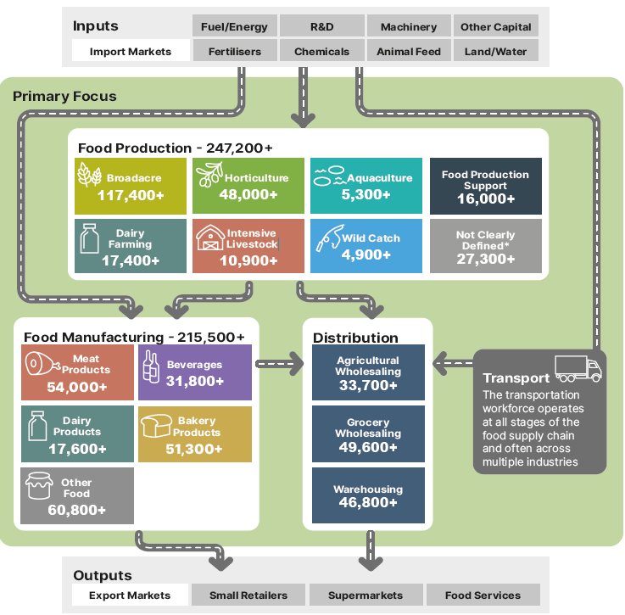

Source: ABS Census of Population and Housing 2021, employment counts by aggregated industry codes. Note: Census data only captures those directly employed in relevant industries as their main job at a single point-in-time. JSA acknowledges that Census is an imperfect measure of total employment by industry. We explore these data limitations and challenges in the full report.

**Note**

The consumer-facing part of the supply chain, such as food retail and hospitality, is **not in scope**.

# Developing a shared workforce vision

The food supply chain workforce is a priority of governments, employers, unions and the broader community. However, there is no shared vision that unites these different groups or the many different industries that make up the supply chain. The Agricultural Workforce Forum suggested that this study could help lay the foundations for a shared vision through our research and consultation.

While the industries, regions and needs of the food supply chain are highly diverse, there are threads that are common to all parties. A workforce vision would be an aspirational statement that sits right across the food supply chain and offers opportunities for collective advocacy and action in areas of commonality.

Once set, a vision could guide workforce planning activities at a more detailed industry level and be expanded to reflect individual needs. This detailed workforce planning could be undertaken by JSCs, peak bodies and/or individual employers to ensure it is genuinely industry-led.

JSA has proposed 6 overarching principles for a shared vision, informed by the consultation and research undertaken for this study. This work builds on the Australian Government’s Employment White Paper and is a starting point for the development of a shared vision. Our report also outlines a range of actions the government could take to advance these objectives.

This vision would recognise the importance of ensuring that the workforce is an enabler of—rather than a barrier to—the objective of a food secure Australia with strong export industries. However, it is also acknowledged that there are other pre-conditions to successfully achieving this objective, including but not limited to:

* access to key inputs and supply chain infrastructure
* sustainability and ability to adapt to a changing climate
* trade and market access
* food quality and safety systems, and
* food safety net programs.

This graphic shows the six principles for a shared workforce vision. They include:
- ensuring safe work
- Building a sustainable, resilient and skilled workforce
- Broadening Opportunities for all
- driving productivity growth
- providing quality jobs
- becoming industries and employers of choice

# Recommendations

**Our final report includes a range of recommendations for the Australian Government to consider.**

These recommendations are grouped into 8 overarching themes and target the Australian Government’s role in workforce development, including through the role of JSCs.

Our full report also provides data, evidence and findings to support actions led by industry, unions, education and training providers, and state and territory governments.

|  |
| --- |
| **Support apprenticeships and traineeships for critical roles** |
| Consider options to target eligibility for apprenticeship incentives more effectively. |
| Skills Insight should continue exploring the case for an Ag Trade Apprenticeship. |
| Industry Skills Australia should continue to support the professionalisation of the road freight workforce, including through advocacy for a Heavy Vehicle Driver Apprenticeship in all jurisdictions. |
| Industry Skills Australia should investigate industry and student interest in ‘earn while you learn’ models for supply chain and logistics roles. |
| Consider opportunities to encourage group training models within Food Production industries as a means of providing workable apprenticeship and traineeship pathways, particularly for small businesses. |

|  |
| --- |
| **Improve the relevance and delivery of tertiary education and training** |
| Provide financial support for First Nations scholarships in agriculture, aquaculture and fisheries sciences and business. These should be co-funded by industry and include wrap around supports. |
| Explore ways to support the delivery of on-Country training programs for First Nations peoples that facilitate flexible career pathways in the food supply chain. |
| Explore mechanisms to improve the sustainability of small-scale qualification pathways that are critical to national priorities, including food security. |
| Jobs and Skills Councils across the food supply chain should review broad-based qualifications to align with reform work underway. |
| Consider a broader suite of options to support entry-level qualifications where they act as a genuine career entry point and demonstrate strong employment outcomes for students. |
| Industry Skills Australia should investigate options to improve the delivery and uptake of formal livestock transport training for truck drivers. |
| Once established, the Australian Tertiary Education Commission should examine postgraduate research pathways in agriculture, fisheries and aquaculture, with a view to ensuring long term viability. |
| Encourage the establishment of a TAFE Centre of Excellence for agriculture to strengthen capability and capacity of the Vocational Education and Training system. |

|  |
| --- |
| **Invest in sustainable veterinary and biosecurity workforce pathways** |
| Reconsider funding arrangements for university-level veterinary science courses to minimise reliance on cross-subsidisation. |
| Include veterinarian students in any expansion of the Commonwealth Prac Payment initiative. |
| Work with state and territory governments to develop a national veterinary workforce strategy in consultation with key stakeholders. |
| Skills Insight should review the mapping of veterinary nursing skills standards in training products in light of potential mandatory registration for veterinary nurses. |
| Support the development of a National Biosecurity Workforce Strategy that improves our understanding of critical roles, skills and pathways. |

|  |
| --- |
| **Combat worker exploitation and ensure migration continues to support regional Australia** |
| Address the need for specified work in the food supply chain by meeting genuine workforce needs through targeted pathways with work as a primary purpose.  Any changes should carefully consider:   * the diverse workforce needs currently addressed by Working Holiday Makers * the extent to which any contemplated changes would impact the supply of labour * the extent to which other viable pathways are available or would be needed * the implications for other labour supply options, including the PALM scheme * the role of specified work in exacerbating the power imbalance between employers and Working Holiday Makers * the range of other levers available to combat migrant worker exploitation and the drivers of non-compliance, and * the merits of a phased or differentiated approach by visa year which could include exploring options to offer a targeted work pathway for Working Holiday Makers after their first year.   Where significant changes are made, these should be accompanied by rigorous monitoring and evaluation to ensure changes are having their desired impact and to identify and address any unintended consequences. |
| Investigate options to trial an employer register in the Working Holiday Maker program. |
| Consider applying minimum English language requirements in the Working Holiday (subclass 417) visa. |
| Undertake a review of visa condition 8547 which limits Working Holiday Makers to a maximum of six months with a single employer. |

|  |
| --- |
| **Harness opportunities within the PALM scheme** |
| Explore options to trial worker-initiated mobility for a limited number of experienced PALM workers, within select industries and/or regions. |
| Elevate the Australian Government’s role in supporting the planning and coordination of portability within the PALM scheme. |
| Consider appropriate options to reduce costs for employers and increase benefits for workers in the PALM scheme, so long as these options maintain the integrity and objectives of the scheme. |
| Continue to monitor the capacity of labour sending countries and Australian Government agencies that administer or support the delivery of the PALM scheme. |
| Prioritise efforts to increase the stock of suitable worker accommodation in key food supply chain regions to support the effective operation of the PALM scheme and Working Holiday Maker program. |
| Commission and resource the Australian Bureau of Agricultural and Resource Economics and Sciences to update and expand its research on the impact of labour choice on farm productivity and profitability. |
| **Improve labour hire practices, enforcement and information** |
| Deliver national labour hire regulation as an immediate priority, including adequate resourcing for regulators to help detect and address cases of worker exploitation. |
| In relation to the role of accommodation providers in supporting the supply of labour to the food supply chain, government should:   * consider the activities of accommodation providers that should be captured within national labour hire regulation, and * commission research into the experiences of temporary migrant workers interacting with accommodation providers in their search for work. |
| Improve data collection on labour hire workers, including the industries and roles to which labour hire workers are on-hired. |
| To improve understanding and compliance of labour hire arrangements:   * provide targeted information to labour hire workers and host employers about workplace rights, entitlements and laws, and * commission research into the drivers of labour hire use and its impact in parts of the workforce where labour hire arrangements are common. |

|  |
| --- |
| **Facilitate better planning of the food supply chain workforce** |
| In response to the Australian Food Story: Feeding the Nation and Beyond report, consider the merits of developing a national food plan or strategy. The objectives of such a national plan could have implications for workforce planning and policy. |
| Continue the development of a tripartite workforce vision with the Agricultural Workforce Forum. |
| Establish a workforce data unit within the Australian Bureau of Agricultural and Resource Economics and Sciences. |
| Include targeted supplementary questions for select occupations in the next Census of Population and Housing. |

|  |
| --- |
| **Address barriers in regional, rural and remote Australia** |
| All levels of government should address significant barriers to supplying suitable and sustainable housing and accommodation for workers and students. |
| Given the significant diversity that exists between primary producing regions, explore options to better tailor workforce programs and policies to local circumstances. |
| Set a clear vision for the number of students studying at regional-based institutions or campuses. |
| In designing a needs-based funding model for higher education, ensure it recognises the high delivery costs in regional Australia and large share of students from low socio-economic areas within regional institutions. |
| In expanding the Regional University Study Hubs program, consider options to:   * provide facilities and services that address the needs of VET students studying remotely * support students undertaking regional, rural and remote placements, and * facilitate face-to-face group learning opportunities. |

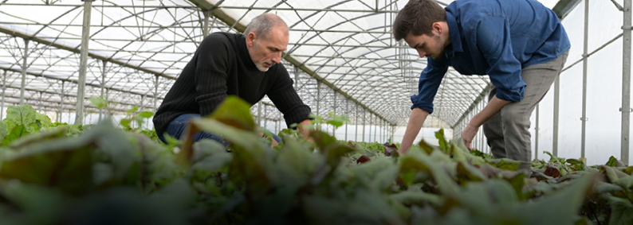

# Education and Training

**A skilled workforce is essential to the future of Australia’s food supply chain. In this workforce, skills are developed through a variety of pathways, each of which provides opportunities for continuous learning and development.**

Lifelong learning is a key theme in the National Agricultural Workforce Strategy, which highlights that ‘in 21st century Australia, AgriFood faces stiff international competition, rapid technological development, and ever-increasing complexities. None of these can be handled without proper development of the capabilities of the people working in the sector’. The same can be said about food manufacturing and transport industries, where disruptive technologies require a skilled and adaptive workforce.

In an increasingly skilled and qualified labour market, the food supply chain may struggle to attract and retain workers in lower skill roles. Offering meaningful, attractive and rewarding career pathways was raised throughout this study as a prerequisite to securing the next generation of workers.

Education and training is delivered by a broad mix of providers, including TAFE institutes, universities, schools, enterprise and private providers. Specialist providers, including agricultural colleges, play a particularly important role delivering industry-specific training that is not offered elsewhere.

|  |  |  |  |  |
| --- | --- | --- | --- | --- |
|  | **Informal and non-accredited training** | | **Formal post-secondary education** | |
|  | **On-the-job**  **Training** | **Non-accredited Training and Extension** | **Vocational  Education and Training** | **Higher  Education** |
| Description | Informal learning that usually occurs through interactions with co-workers as part of day-to-day work | Non-accredited training or instruction that sits outside interactions with co-workers as part of day-to-day work | Nationally recognised training that develops practical skills for certain job roles, tasks and industries | Generalist and specialist education for higher-level occupations |
| Examples | * Day-to-day instruction, demonstration and feedback from managers and supervisors | * Induction processes * Entry programs * Non-accredited upskilling * Supplier-delivered training in proprietary technology * Extension and advisory services | * Certificate II in Meat Processing * Certificate III in Agriculture * Licence to operate a forklift truck * Entry into working in agriculture skill set | * Bachelor of Agricultural Science * Bachelor of Food Technology * Doctor of Veterinary Medicine |

## Supporting work-based learning

As the food supply chain workforce and broader labour market evolve, it is vital that training pathways are attractive and fit-for purpose. The proportion of young people with formal qualifications is growing and workers are increasingly seeking career options that have formal qualification pathways.

There are strong opportunities in the food supply chain to develop and support work-based learning, including apprenticeships and traineeships. For these to be successful, supports must be fit-for-purpose and industry buy-in is essential. Within the higher education system, work-integrated learning already playsan important role in areas like agriculturaland veterinary sciences, but there is room fordeeper industry partnerships, particularly forresearch pathways.

## Improving design and delivery

The food supply chain draws on a wide range of broad-based, specialised and industry specific training. Delivery of smaller courses can be particularly challenging due to geographic and occupational thin markets. Several key courses across the food supply chain are only delivered by a small number of providers nationally. Additionally, the number of providers delivering training in some larger disciplines, including food and meat processing, has declined significantly since 2015.

## Strengthening regional education

It is critical that students are supported tostudy in regional Australia, including viadistance education. Accessing and deliveringeducation and training can be particularlydifficult and costly in regional areas and it isimportant that funding reflects these costs.Encouraging more students to undertakeplacements and other forms of work-basedlearning in Australia’s regions will also paydividends for rural industries and communities,as students who study regionally are morelikely to work regionally post-study.

## Investing in First Nations success

Equitable access to post-secondary education is essential for supporting First Nations success and necessary for meeting Australia’s skills needs. This study finds that supportive scholarships and grant programs, culturally inclusive learning, flexible study options, and on-Country programs can all improve First Nations peoples’ access to, and involvement in, post-secondary education. These opportunities alone, however, will not be enough to overcome the social and structural barriers still faced by First Nations peoples in Australia today which require collective action by all parties.



# Migration

**Migration plays an important role in addressing the diverse workforce needs of the food supply chain where local labour or skills are not available.**

Roles that food supply chain businesses aim to fill through migration may be:

* unskilled, low-skilled or skilled
* highly seasonal, short-term or ongoing, and
* located in one of Australia’s largest cities, one of its most isolated regions or anywhere in between.

Reliance on migrant workers differs considerably between sectors, as does themost common visa pathway used. For example, the Horticulture sector exhibitsa high concentration of temporary migrant workers reflecting the labour supplychallenges of highly seasonal work, often in regional, rural and remote locations.At the individual region and commodity level, the use of migrant workers can bemuch higher during peak periods.

**Temporary migrant share of employment in food production sectors, 2021 (%)**

Source: ABS Australian Census and Temporary Entrants 2021, and Census of Population and Housing 2021.

Note: This data is point-in-time as at Census night in August 2021 during a period in which the number of bridging visas were unusually high due to COVID-19. The share of temporary migrants in sectors where seasonal work is common will also vary throughout the year with point-in-time data from August understating the concentration of temporary migrants during the peak months.

## Working Holiday Maker (WHM) program

The Australian Government is consulting on the future design of the WHM program. This includes undertaking a detailed consultation and research process into the 88-day, 179-day and specified work requirement with a view to

* combat worker exploitation
* improve young visitors’ experience of Australia, and:
* ensure temporary migration continues to support the need for essential skills in regional Australia.

To support this process, JSA was tasked with providing independent data, analysis, and

advice in relation to the food supply chain through this study. Australia’s food supply chain currently relies on WHMs across a range of roles and industries. WHMs are most highly concentrated in Horticulture roles where seasonal work is common. They are also prominent across roles in other parts of the supply chain, including Meat Processing, Cropping and Dairy Farming.

Specified work requirements, first introduced in 2005, have contributed to this high concentration of WHMs and have become an embedded labour supply solution in parts of the food supply chain. As a result, changes to specified work could have far-reaching implications for food supply chain industries.

Like other temporary migrants, WHMs can be more vulnerable to exploitation than local workers. The vulnerability of WHMs is layered and depends on a range of factors including their language and cultural characteristics, program settings which influence their employment options, and whether they are directly employed or engaged through a labour hire firm.

In designing any changes to the WHM program, it will be important that the Australian Government considers:

* the diverse workforce needs of the food supply chain
* the extent to which any contemplated changes would impact the ability to meet workforce needs
* the extent to which other viable options are available
* the range of levers available to combat migrant worker exploitation, and
* the importance of rigorous monitoring and evaluation.

## Pacific Australia Labour Mobility (PALM) scheme

The food supply chain, particularly in the Horticulture and Meat Processing sectors, provides employment for the majority of PALM workers in Australia. While the PALM scheme delivers important benefits for employers and workers in the food supply chain, there are opportunities to enhance the scheme.

One of these opportunities is to trial worker-initiated mobility for experienced PALM workers. Recent analysis from the NSW Anti-slavery Commissioner indicates that the inability of PALM workers to initiate a change of approved employer is a significant risk factor contributing to PALM worker disengagement and vulnerability to exploitation.



**Workforce Profiles**

# Food Production

Food Production includes businesses mainly engaged in Agriculture (excluding non-food commodities), Aquaculture and Wild Catch, as well as those providing support services to these industries.

**Approximate Size**

**247,200+**

**Workers**

On-the-job and non-accredited training continue to have a valuable role in developing the skills of the Food Production workforce. However, post-secondary qualifications are playing an increasing role for Food Production workers and the professional and technical services that Food Production enterprises rely on.

**Largest Food Occupations**

**Beef Cattle Farmer**

**Broadacre Crop and Livestock Farmer**

**Sheep Farmer**

**Grain, Oilseed, Pulse or Pasture Grower**

**Dairy Cattle Farmer**

Food Production sectors currently use a range of migration pathways to meet their workforce needs. Relative to the average across all industries in the economy, temporary migrants make up a higher share of the workforce across most Food Production sectors. This is particularly the case in the Horticulture sector. In contrast, the share of employment comprised by permanent migrants is lower than the national average across all Food Production sectors.

Food Production is an important source of employment in regional, rural and remote Australia and acts as an anchor industry for many regional communities. The distribution of the Food Production workforce by remoteness varies by sector, with Intensive Livestock workers the most likely to reside in major cities and Broadacre, Aquaculture and Wild Catch workers the most likely to live in remote or very remote Australia.

Information in the above boxes is sourced from ABS Census of Population and Housing, 2021.

**76%**

**of businesses are**

**broadacre farms**

**49%**

**Workers who are owner managers or contributing family members**

**47%**

**Proportion of full-time workers working over**

**50+ hours per week**

Workforce demographics vary across Broadacre, Horticulture, Dairy Farming, Intensive Livestock, Aquaculture and Wild Catch sectors. However, between the 2016 and 2021 Census, most Food Production sectors exhibited:

* an increase in the share of employment comprised by women, First Nations Australians and those with disability, and
* a decrease in the share of employment of Australian citizens and full-time workers.

Of the sectors profiled across Food Production, Food Manufacturing and Transport and Distribution, the Broadacre sector has the highest average age of 53. This is likely driven by the high share of owner-operators in the Broadacre sector, significant capital barriers to entry and the choice of many owner-operators to work beyond a more usual retirement age.

Highest employing component of Food Production by place of work (SA2)

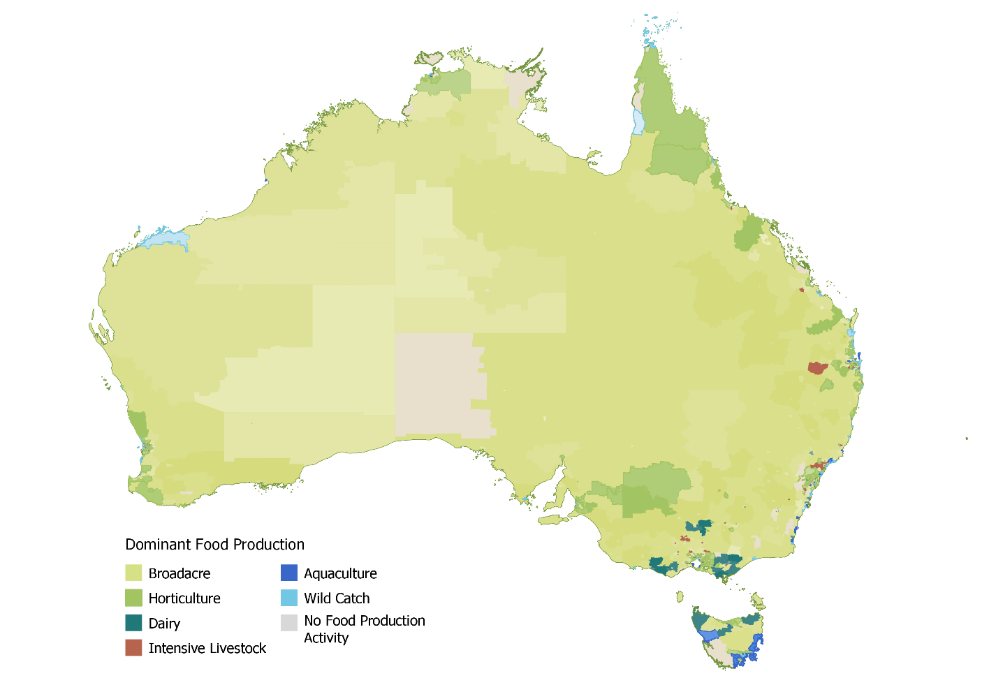

Source: ABS Census of Population and Housing 2021

Workforce characteristics of Food Production sectors

|  |  |  |  |  |  |  |  |
| --- | --- | --- | --- | --- | --- | --- | --- |
|  | **Broadacre** | **Horticulture** | **Dairy  Farming** | **Intensive Livestock** | **Aquaculture** | **Wild Catch** | **All  Industries** |
| Directly Employed | 117,000+ | 48,000+ | 17,400+ | 10,900+ | 5,300+ | 4,900+ | 11,522,000+ |
| Average Age | 53 | 44 - | 44 | 42 **-** | 41 | 47 | 41 |
| Female Workers | 30% | 36% | 34% | 36% | 26% | 19% | 49% |
| First Nations Workers | 1.5% | 1.7% | 2.0% | 3.1% | 5.4% | 4.2% | 2.1% |
| Rate of needing assistance with core activities | 1.7% | 1.1% | 1.3% | 1.5% | 0.8% **-** | 1.4% | 0.9% |
| Australian Citizen Workers | 97% | 72% | 89% | 82% | 84% | 92% | 87% **-** |
| Full Time Workers | 70% | 63% | 70% | 69% | 73% | 48% | 59% |

Source: ABS Counts of Australian Businesses including Entries and Exists June 2023, and ABS Census of Population and Housing 2021 & 2016.  
Note: arrows indicate change from the 2016 census. JSA acknowledges that Census is an imperfect measure of workforce size. We explore these data limitations and challenges in the full report.

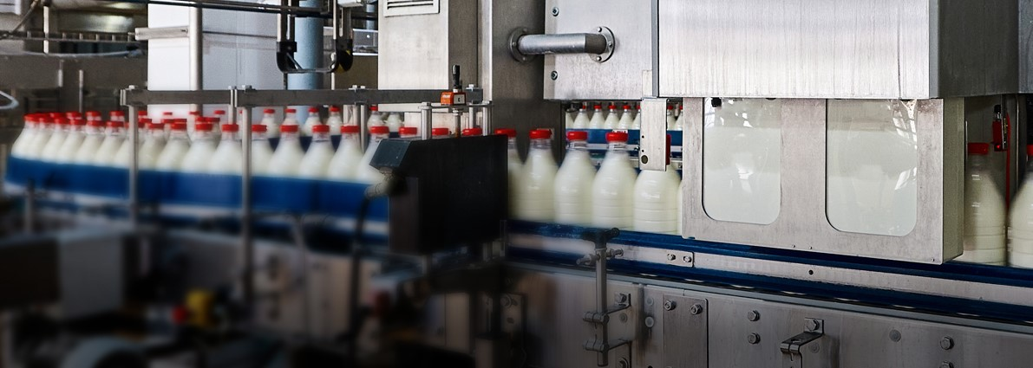

**Workforce Profiles**

# Food Manufacturing

Food Manufacturing includes businesses mainly engaged in processing and manufacturing food and beverages.

**Approximate Size**

**215,500+**

**Workers**

Food Manufacturing is Australia’s largest employing manufacturing sector, accounting for nearly 30% of manufacturing jobs. Employment in Food Manufacturing is growing, with around 34,000 filled jobs being added over the last decade.

**Largest Food Occupations**

**Baker**

**Meat Process Worker**

**Food and Drink**

**Factory Workers nec**

**Production Manager  
(Manufacturing)**

Multiple Food Manufacturing sectors exhibit an above-average reliance on temporary migration. This is particularly true in Meat and Meat Product Manufacturing, where employment of temporary skilled migrants (often through labour agreements), Working Holiday Makers and PALM workers is common. In contrast, the share of permanent migrants in Food Manufacturing is broadly in line with the national average, albeit with a higher share of employment of permanent migrants arriving through the family stream.

**13%**

**Proportion of businesses with 20+ employees**

Where formal education and training is undertaken by domestic workers, there is often strong evidence of positive outcomes such as the high employment change and median income uplift associated with completing the Certificate II in Meat Processing (Abattoirs). A more joined up approach to the national skills system could see VET and migration systems more effectively complement each other for low and middle skilled Food Manufacturing roles.

**Most common**

**post-secondary   
qualification level**

**Certificate III & IV**

Food Manufacturing employment can be found in towns and cities across Australia and is often concentrated in regional population centres in areas of high food production activity. As many Food Manufacturing businesses are medium or large employers, these firms often act as anchor employers in their local community.

**Sector with highest concentration of**

**migrant workers**

**Meat Products**

Relative to all Australian businesses, Food Manufacturing businesses are more likely to be medium-to-large employers. More than 10% of businesses in every sector employ 20+ employees, well above the Australian average of 3%. This is particularly true for dairy products, meat and meat products, and seafood processing.

Workforce data on this page is sourced from ABS Census of Population and Housing, 2021. Business data is sourced from ABS Counts of Australian Businesses, 2023.

Similar to the Food Production workforce, Food Manufacturing sectors between the 2016 and 2021 Census often exhibited:

* an increase in the share of employment comprised by women, First Nations Australians and those with disability, and
* a decrease in the share of employment of Australian citizens and full-time workers.

A significant proportion of manufacturing activity within Food Manufacturing occurs at processing plants or factories. However, Food Manufacturing also includes businesses such as bakeries where products are manufactured and sold to consumers on the same premises.

This difference in worksite, in addition to the nature and timing of work in bakeries, may help explain the variance of Bakery Product Manufacturing from other parts of Food Manufacturing with respect to the average age, share of female workers and share of full time workers.

Geographical distribution of the Food Manufacturing workforce

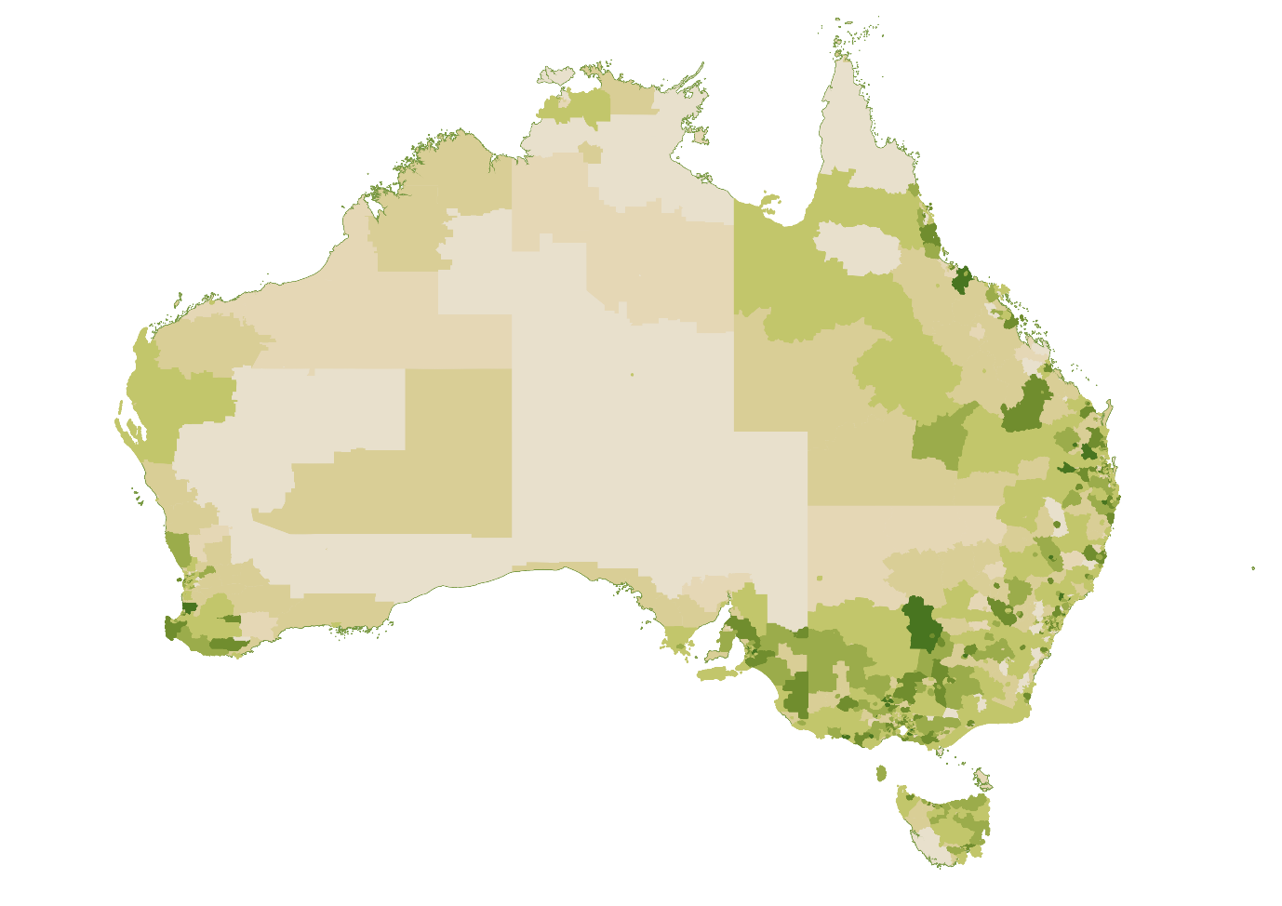



Low High

Source: ABS Census of Population and Housing 2021, Percentage of Total Food Manufacturing Employment by Statistical Area 2 (SA2) and Place of Work (POWP)

Workforce characteristics of Food Manufacturing sectors

|  |  |  |  |  |  |  |
| --- | --- | --- | --- | --- | --- | --- |
|  | **Meat Products** | **Bakery** | **Dairy Products** | **Beverages** | **Other Food** | **All  Industries** |
| Directly Employed | 54,000+ | 51,300+ | 17,600+ | 31,800+ | 60,800+ | 11,522,000+ |
| Average Age | 40 | 36 **-** | 43 | 42 **-** | 43 **-** | 41 |
| Female Workers | 33% | 55% | 34% | 35% | 40% | 49% |
| First Nations Workers | 2.6% | 1.7% | 1.2% | 1.1% | 1.7% | 2.1% |
| Rate of needing assistance with core activities | 0.8% | 1.0% | 0.5% | 0.6% | 0.8% | 0.9% |
| Australian Citizen Workers | 68% | 81% | 84% | 88% **-** | 80% | 87% **-** |
| Full Time Workers | 77% | 45% | 75% | 71% | 72% | 59% |

Source: ABS Counts of Australian Businesses including Entries and Exits June 2023, and ABS Census of Population and Housing 2021 & 2016.Note: Arrows indicate change from the 2016 census.



**Workforce Profiles**

# Transport and Distribution

Transport and Distribution includes businesses mainly engaged in:

**Approximate Size**

**366,700+**

**Workers**

**Largest Food Occupations**

**Truck Driver (General)**

**Storeperson**

**Forklift Driver**

**Dispatching and Receiving Clerk**

**Supply and**

**Distribution Manager**

**135,340**

**workers in the Road Freight Transport industry**

**45**

**Average age of the**

**Freight Transport**

**Workforce**

**16%**

**workers in**

**Freight Transport**

**are female**

Information in the above boxes is sourced from ABS Census of Population and Housing, 2021

* the transport of freight by road, rail, sea or air as well as the provision of transport support services
* the wholesale trade of agricultural products and machinery or grocery products, and
* warehousing and storage.

As at the 2021 ABS Census, Transport and Distribution sectors directly employed over 366,700 people in their main job. Over one-third of this employment was in the Road Freight Transport industry, mostly in the occupation of Truck Driver (General) which is one of the top 10 highest employing occupations in Australia.

JSA heard from stakeholders in the Road Freight Transport industry about the importance of professionalising its workforce, including through the increased use of formal qualifications alongside other efforts to bolster the attractiveness of careers in the industry.

Migrants play a substantial role in some Transport and Distribution sectors such as Warehousing. Many of the temporary migrants working in these sectors are New Zealand citizens and student visa holders rather than migrants in Australia under employer sponsored pathways.

The employment in different Transport and Distribution sectors by remoteness varies significantly depending on each sector’s role and stage in the supply chain process. For example, employment in the Agricultural Product and Machinery Wholesaling (Agricultural Wholesaling) sector, which is mainly engaged in the wholesaling of inputs to agriculture, is significantly more likely to be located in regional, rural and remote Australia than Grocery Wholesaling which trades in finished grocery products.

Albeit from different baselines, most Transport and Distribution sectors between the 2016 and 2021 Census exhibited:

* an in increase in the share of employment comprised by women, First Nations Australians and those with a disability, and
* a decrease in the share of full-time workers.

Of the sectors profiled across Food Production, Food Manufacturing and Transport and Distribution, Freight Transport has the lowest share of female employment with women accounting for only 16% of those working in the sector. Low representation of women in key Road Freight Transport occupations such as Truck Driver (General) could be impacting shortages, with JSA analysis showing that half of all occupations where men constitute at least 80% of the workforce are in shortage.

Table 3.1: Workforce characteristics of Transport and Distribution sectors

|  |  |  |  |  |  |  |  |
| --- | --- | --- | --- | --- | --- | --- | --- |
|  | **Agricultural Wholesaling** | **Grocery Wholesaling** | **Warehousing** | **Freight Transport** | **Air & Space Transport** | **Transport Services** | **All  Industries** |
| Directly Employed | 33,700+ | 49,600+ | 46,800+ | 147,500+ | 37,500+ | 51,600+ | 11,522,000+ |
| Average Age | 44 | 43 | 39 | 45 **-** | 43 | 44 **-** | 41 |
| Female Workers | 31% | 37% | 28% | 16% | 36% | 28% | 49% |
| First Nations Workers | 1.7% | 1.3% | 1.7% | 2.5% | 1.3% | 1.7% | 2.1% |
| Rate of needing assistance with core activities | 0.7% **-** | 0.8% | 1.1% | 0.9% | 0.4% | 0.7% **-** | 0.9% |
| Australian Citizen Workers | 91% | 80% **-** | 77% | 87% | 90% | 86% | 87% **-** |
| Full Time Workers | 79% **-** | 67% | 68% | 75% | 57% | 76% | 59% |

Source: ABS Counts of Australian Businesses including Entries and Exits June 2023, and ABS Census of Population and Housing 2021 & 2016.  
Note: Arrows indicate change from the 2016 census.



**Workforce Profiles**

# Veterinary

**Approximate Size**

**28, 500+**

**Workers**

**The veterinary workforce delivers a range of important benefits for industry and the broader Australian community. It is critical for the health and welfare of production animals, food safety and managing biosecurity threats.**

**79%**

**Proportion with**

**post-secondary**

**qualifications**

The shortage of veterinarians in Australia is persistent and acute, with recruitment difficulty at its highest in regional, rural and remote locations. We are also facing a shortage of veterinary nurses.

Significant factors affecting attraction and retention in the veterinary workforce include pay (starting salaries and earning potential), long hours worked, stress, burnout and the relative attractiveness of regional and rural work.

**Most common**

**highest level of education**

**Bachelor Degree**

Addressing these factors as well as supporting sustainable education and career pathways are likely to be critical to ensuring a high-quality veterinary workforce in the locations and with the skills needed.

**29%**

**Proportion of full-time workers working over**

**50+ hours per week**

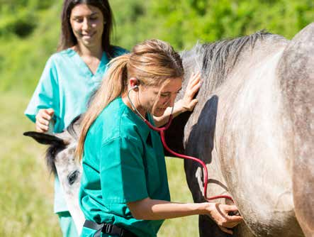

Information in the above boxes is sourced from ABS Census of Population and Housing, 2021.

Data refers to the Veterinary Services industry.



**Workforce Profiles**

# Biosecurity

**Australia’s biosecurity system protects our plants, animals and ecosystems, enabling us to generate high-quality primary produce, providing access to export markets and supporting our trusted international reputation.**

Biosecurity workers are employed by all levels of government and industry. Biosecurity needs often require workers to have wide-ranging knowledge of the interactions between factors such as animal health, environmental systems and monitoring, pest control, and institutional settings and regulations. Food producers and manufacturers need biosecurity skills, experience and awareness to manage day to day risks and comply with regulations.

The upcoming National Biosecurity Workforce Strategy will be an important opportunity to improve our understanding of the roles, pathways and skills critical to biosecurity.

Indicative biosecurity roles and occupations

|  |  |  |  |
| --- | --- | --- | --- |
|  | **Inspectors and Regulatory Officers** | **Specialists** | **Producers, processors and transporters** |
| **Role** | Ensuring Australia’s food production and trade is compliant with biosecurity requirements | Providing specialist expertise and services to governments, producers, processors and traders | Day-to-day risk management and implementation by food producers, processors and transporters |
| **Occupations** | Customs Officer  Water Inspectors  Fisheries Officers  Meat Inspectors  Biosecurity Officers  Invasive Pest, Weed and  Disease Inspectors  Food Safety Auditors/Officers  Primary Products Quality  Assurance Officers | Veterinarians and Veterinary Nurses  Agricultural, Biological,  Environmental and Life  Scientists (entomology and  epidemiology)  Customs Brokers  Chemistry and Life  Science Technicians  Agronomists  Agricultural Consultants  Aboriginal and Torres Strait Islander Land and Sea Rangers (Park Rangers) | Farm Managers and Workers  Aquaculture and Fishing Managers and Workers  Food and Meat Processors  Packers  Import-Export Clerks  Truck Drivers, Storepersons and Waterside Workers  Food Technologists |
| **Surge workforce**  Providing additional capacity during an emergency biosecurity. | | | |

Source: ABS Census of Population and Housing 2021



**Workforce Profiles**

# Labour hire workers

At its best, labour hire can provide an important mechanism for food supply chain businesses—particularly small and medium enterprises—to manage seasonal fluctuations in labour demand, address labour supply challenges, and reduce their administrative burden.

**416,500**

**People employed in Labour Supply Services across the economy**

Labour hire firms also play a large role in connecting those looking for work with employment opportunities, especially for newer participants in the labour market such as PALM workers and Working Holiday Makers.

**Around 1-in-6**

**Employed WHMs estimated to be labour hire workers**

However, the Fair Work Ombudsman has identified that labour hire firms are associated with a significant proportion of non-compliance in the Agriculture sector. Common practices of unscrupulous labour hire firms, including underpayment of wages, are harmful to workers and can create an uneven playing field for employers that are compliant with workplace laws.

**96**

**Approved PALM scheme employers are**

**labour hire firms**

Effective reform to protect labour hire workers from exploitation and regulate the behaviour of labour hire entities would have significant flow-on benefits for combating migrant worker exploitation.

Employment in labour supply services is sourced from ABS Labour hire workers, 2024. WHM labour hire estimates are derived from JSA analysis of linked migration and taxation data. PALM information is sourced from the Department of Employment and Workplace Relations 2024.

The limited visibility of the industries and roles to which labour hire workers are on-hired to is a critical challenge for workforce planning and policy making in high-use industries. This should be a priority area for improved data collection and research.

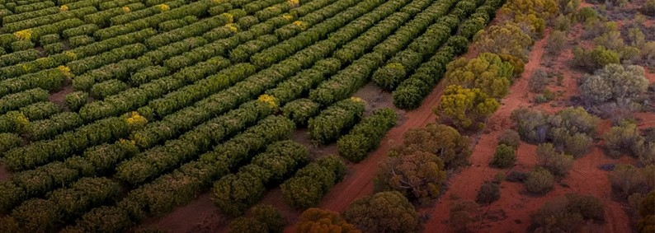

**Workforce Profiles**

# Regional and place-based dynamics

Australia’s regions are incredibly diverse and present a range of opportunities and challenges. These place-based dynamics impact the attraction, retention and experiences of workers in the food supply chain.

**85%**

**Food Production**

**workers living**

**outside major cities**

**38%**

**Food Manufacturing**

**workers living**

**outside major cities**

**27%**

**Transport & Distribution**

**workers living**

**outside major cities**

While no two regions are the same, there are some common dynamics that are experienced by many food producing regions. These include:

* **Accommodation and housing.** The affordability and availability of housing is a major challenge and has worsened in many regions. Poor planning, underinvestment and workforce shortages have also contributed to a general undersupply of new housing. Temporary worker accommodation is particularly important to the food supply chain, including hostels and on-farm accommodation, and presents its own challenges around regulation, quality and safety.

**36%**

**Veterinary Industry**

**workers living**

**outside major cities**

* **Transportation and connectivity.** Remoteness, limited transport options, social isolation and poor internet connectivity can make it difficult to access and attract workers in some parts of the food supply chain.
* **Essential services.** Access to high quality education, childcare and healthcare varies significantly in regional areas. In some of Australia’s most remote communities, the reliable supply of food, water and electricity is also a challenge.

Information in the above boxes is sourced from ABS Census of Population and Housing, 2021.

* **Population change.** While generally lower than in metropolitan areas, population growth in regional Australia is very uneven. Regional cities have experienced very strong population growth in recent years, while many small regional areas are in longer-term decline.
* **Labour availability.** Regional communities are home to some of the highest and lowest rates of unemployment across Australia. On average, regional labour markets have lower vacancy rates and fewer applicants per vacancy than metropolitan areas. Qualification and suitability gaps are also higher. Employment opportunities can be volatile in some regions and impacted by factors including droughts and seasonal fluctuations in labour demand.

While regional, rural and remote Australia faces many challenges, it is important to acknowledge the many benefits of living outside of our major population centres. Strong communities, access to the natural environment and comparatively lower cost of living are just some of the factors that can encourage more people to live, study and work right across Australia.

|  |
| --- |
| Opportunities in urban areas While regional, rural and remote Australia is critical to the food supply chain, there is also considerable agricultural production value generated in and around our greater capital  city areas. Three of Australia’s state capital cities are in the top 10 regions by total value of agricultural production, including Melbourne, Adelaide and Brisbane surrounds. The majority of this value tends to come from the outer periphery of cities, diminishing closer to the city centre.  This urban and peri-urban fringe presents a unique set of location barriers compared to regional areas, including planning, urban sprawl, housing and transportation issues. For example, as Australia’s major cities grow, production activities are often pushed out in favour of urban development, with housing and other city-focused activities taking precedence.  Despite these challenges, production that takes place closer to cities can circumvent some of the location barriers facing the regional food supply workforce. Benefits of proximity for food supply chain businesses and workers can include:   * access to a larger pool of potential workers * education and training being more accessible and less likely to be impacted by diseconomies of scale * greater exposure of people from urban areas to careers in the food supply chain, including through work placements that may not require relocation, and * greater access to the infrastructure and services available in Australia’s major cities.   There is also a growing professional services sector that works within and in support of the food supply chain. It employs high skilled workers across business consultancy, science, data and technology, financial services and many more areas that rely on Australia’s tertiary education system. Many of these roles can be and are performed from anywhere, providing rewarding food supply chain careers closer to major population centres. |

## Regional Lenses

To explore place-based dynamics in more detail we have developed four regional lenses. These include the proportion of employment in food supply chain industries, the value of production in the region, the level of industrial employment diversity and the population trends of each area.

These lenses show that while there are some broad trends such as negative net migration in remote and outer regional areas, each region or cluster must be considered in its own right. This underpins the importance of taking a place-based approach when considering regional issues, as a one-size-fits all approach will not work.

#### Where food supply chain industries are predominant in the local labour market

Food employment regions are clustered together, such as the Beef Cattle Farming trail through the Northern Territory and Northern Queensland, or clusters of Dairy Cattle Farming predominant in Victoria and Northern Tasmania. Additionally, Food Manufacturing industries typically cluster near where food production occurs for their relevant commodities, such as the co-location of Ice Cream or Cheese Production near Dairy Cattle Farming, or Meat Processing near Beef and Sheep Farming regions.

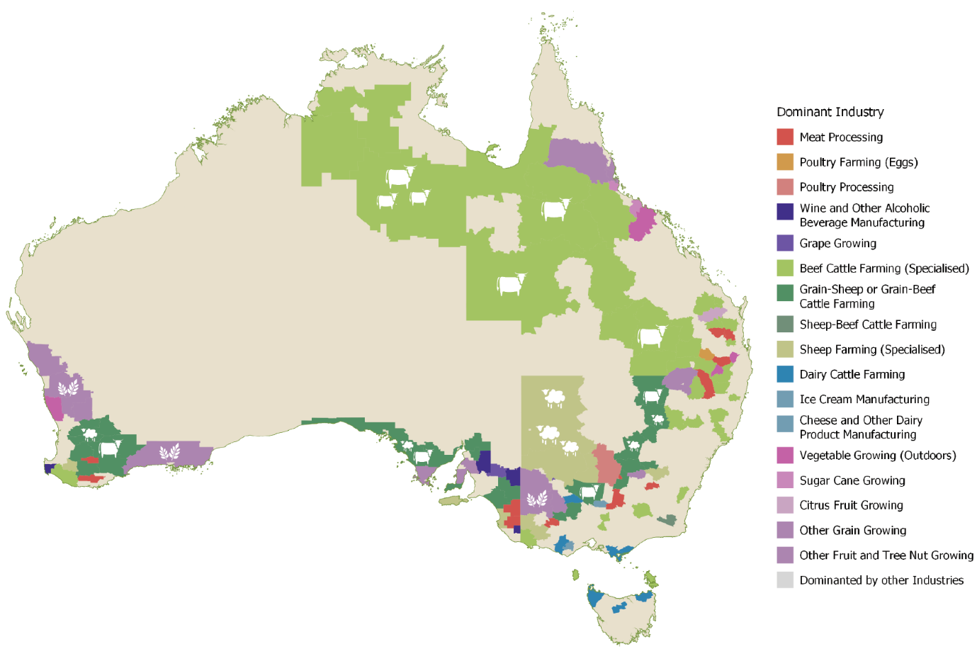

Data on these pages is sourced from ABS Census of Population and Housing 2021. Agricultural production data is sourced from ABS Value of Agricultural Commodities Produced, 2023.

#### This map displays the total agricultural production value across Australia's predominant food regions. High-value regions include parts of southeastern Australia, such as Victoria and New South Wales, as well as isolated areas in Western Australia, while lower production values are seen in central and remote regions.Agricultural Production

**(dark red = high value)**

The Value of Agricultural Production reflects the broader contribution of various regions to agricultural economic output. A number of Southern regions contribute significant value through crops, particularly Griffith in south-west NSW. Meanwhile, significant livestock value is clustered in the north of Australia corresponding with major beef regions, as well as some Southern pockets of sheep and lamb.

#### This map shows the industrial workforce diversity of Australia’s predominant food supply regions. High diversity is concentrated in urban and coastal areas, while low diversity is prevalent in inland and remote regions, particularly in central and northern Australia.Industrial Diversity

**(purple = low diversity)**

Coastal areas and urban centres tend to be much more diverse, while the more rural or regional areas are likely to be specialised, with some very remote regions exhibiting very low diversity. These regions appear to rely on a few concentrated industries to support their populations, particularly in some of the beef, sheep and grain farming regions through the outback.

#### This map illustrates regional migration as a proportion of population in predominant food regions of Australia. Negative net migration is notable in many inland areas, especially in central and western regions, while positive net migration occurs along eastern coastal regions.Regional Migration Trends

**(green = net gain, red = net loss)**

Positive net migration to regional areas is mainly occurring along the coast, or very close to more largely populated farming areas of Victoria and NSW. Very few of the predominantly food producing regions appear to be benefitting. Of our predominantly food supply regions, those that are the most rural/furthest away from cities appear to be more likely to be experiencing negative net migration.

# Looking Forward

Our study supports a workforce that can:

* **Sustain regional Australia.** Employment in the food supply chain is heavily concentrated in regional, rural and remote, Australia, with Food Production and Manufacturing acting as anchor industries for many communities
* **Strengthen the economy.** Industries throughout the food supply chain make a significant contribution to the Australian economy. Without an adequate and sustainable workforce, the viability of these sectors—and the regional economies they sustain—will be at risk.
* **Maintain food security.** Access to labour and skills has been widely recognised as a risk to Australia’s food security. While awareness of this risk was heightened by the COVID-19 outbreak and the particular challenges it posed, workforce pressures in Australia’s food supply chain pre-date and extend beyond the pandemic.
* **Overcome challenges.** Australia’s food supply chain will need to navigate multiple interacting challenges over the coming years, including managing high levels of market and climate variability while unlocking opportunities from disruptive technologies.

Through our recommendations, findings and analysis, we seek to progress a number of opportunities for the food supply chain. These include improvements in education, training, migration and other system settings to lift outcomes for students, workers and employers. However, many of the challenges around attraction, retention and career development will require industry-led solutions.

This study alone is unable to resolve all underlying challenges facing this essential workforce, and invaluable opportunities cannot be realised by working in isolation. Concerted effort is required by all parties, including governments, industry and unions, to ensure the continuation of this important work.

A fit-for-purpose workforce requires:

* a shared vision that unites the different industries and components that make up the food supply chain. Collective advocacy and action can have a greater impact than piecemeal approaches.
* a sustained commitment to tripartite consultation and policy development, supported by the Agricultural Workforce Forum and JSCs.
* elevating food as a national priority in workforce policy and development. The national skills system should reflect the food supply chain’s role in sovereign capability and economic security.
* a joined-up approach to the national skills system so that we can tackle workforce challenges with the best mix of solutions.
* an open-minded approach to trialling new ideas and a commitment to monitoring and evaluating new and established approaches to ensure they are fit for purpose. As the food supply chain continues to evolve, it is important that our workforce systems keep pace as a set and forget approach is unlikely to be effective.
* greater investment in workforce data and analysis. The food supply chain workforce is poorly supported by existing labour market data products and requires new solutions to improve our visibility of workforce pressures.

With the right investments and partnerships, Australia can have a resilient food supply chain that provides rewarding employment opportunities right across the country and supports highly productive industries.





**For more information, see**

***An Essential Ingredient:  
The Food Supply Chain Workforce***

**In full at:**

**JobsandSkills**.gov.au