

Strong and Responsive VET Pathways

2019-20 graduate outcomes from the   
VET National Data Asset (VNDA)

**13 November 2024**



## Acknowledgement of Country

Jobs and Skills Australia acknowledges the Traditional Owners of Country throughout Australia and recognises the continuing connection to lands, waters and communities. We pay our respect to Aboriginal and Torres Strait Islander cultures, and to Elders past and present.

## Acknowledgement of Country

Jobs and Skills Australia acknowledges the Traditional Owners of Country throughout Australia and recognises the continuing connection to lands, waters and communities. We pay our respect to Aboriginal and Torres Strait Islander cultures, and to Elders past and present.

Contents

Key highlights 3

Improved income after training 3

Improved employment rate after training 3

Pathways to higher-level study 3

Reduced reliance on income support 3

Overview 4

The VET National Data Asset (VNDA) 4

What’s new? 4

Important notes 4

Median income 6

Median income by age group 6

Median income by AQF level 7

Median income for priority cohorts 8

Median income by location 9

Median income by select student characteristics 9

Employment outcomes 11

Employment rate by age group 11

Employment rate by AQF level 12

Employment rate for priority cohorts 12

Employment rate by location 13

Employment rate by select student characteristics 14

Further study outcomes 15

Further study by age group 15

Further study by AQF level 15

Further study for priority cohorts 16

Further study by location 17

Further study by select student characteristics 17

Income support outcomes 19

Income support exit rate by age group 19

Income support exit rate by AQF level 20

Income support exit rate for priority cohorts 20

Income support exit rate by location 21

Income support exit rate by select student characteristics 21

Conclusion 23

Further information 23

Disclaimer 24

# Key highlights

## Improved income after training

In the year following completion, Vocational Education and Training (VET) graduates had a median income uplift of $11,800 and earned a median employee income of $48,500.

* **First Nations graduates** attained a median income uplift of $13,000 and earned a median income of $43,100.
* **Female graduates** attained a median income uplift of $11,400 and earned a median income of $41,900.
* **Graduates with disability** attained a median income uplift of $9,100 and earned a median income of $26,100.

## Improved employment rate after training

Nationally, 84% of VET graduates were employed after completing their VET qualification, representing a 15 percentage point increase from before enrolment.

* **First Nations** **graduates** had a 16 percentage point increase in employment, reaching an employment rate of 79% after completion.
* **Female** **graduates** had a 17 percentage point increase in employment, reaching an employment rate of 83% after completion.
* **Graduates with disability** had a 14 percentage point increase in employment, reaching an employment rate of 65% after completion.

## Pathways to higher-level study

Approximately 8% of all VET graduates pursued higher education after completion and 16% enrolled in a higher-level VET qualification than the one completed in 2019-20.

* 5% of **First Nations** **graduates** enrolled in higher education and 20% in higher-level VET.
* 10% of **female graduates** enrolled in higher education and 18% in higher-level VET.
* 7% of **graduates with disability** enrolled in higher education and 21% in higher-level VET.

## Reduced reliance on income support

Among VET graduates who received income support prior to study, 39% were no longer on income support two years after completion (i.e. *income support exit rate*).

* **First Nations** **graduates** had a 34% income support exit rate.
* **Female graduates** had a 36% income support exit rate.
* **Graduates with disability** had a 22% income support exit rate.

# Overview

## The VET National Data Asset (VNDA)

This publication is the latest release from the VET National Data Asset (VNDA), established by Jobs and Skills Australia (JSA) in partnership with the Australian Bureau of Statistics (ABS). VNDA links individual records from the Total VET Activity data collected by the National Centre for Vocational Education Research with other government administrative data, including data from the ABS, the Australian Taxation Office, Department of Education and Department of Social Services.

This release provides statistical insights on over 430,000 domestic, non-school students, who completed a nationally recognised VET qualification in the 2019-20 financial year. The report highlights the economic, employment and further study outcomes at the national level following course completion.

### What’s new?

The 2019-20 statistics builds on the previous VNDA report (2018-19 VET Student Outcomes – Top 100 courses) and introduces a range of additional data, including:

* national outcomes on 500 qualifications
* state and territory outcomes, by Australian Qualifications Framework (AQF) level and Field of Education (FOE)
* national outcomes for a range of student characteristics, such as by age group, location, apprenticeship pathway and prior qualification/employment.

To accommodate the extensive new data, JSA has developed an interactive [dashboard](https://www.jobsandskills.gov.au/data/vet-national-data-asset/dashboard) that allows users to navigate and explore the data in a user-friendly format.

An accompanying [technical document](https://www.jobsandskills.gov.au/data/vet-national-data-asset/2019-20-outcomes) detailing the methodology, data definitions and limitations is also available for download on the JSA website.

This report focuses on the outcomes of graduates at the national level, with analysis for priority cohorts (female graduates, First Nations graduates, and graduates with disability), and a range of different student characteristics, including:

|  |  |  |
| --- | --- | --- |
| Age group | Prior employment | Apprentice/trainee status |
| Location | AQF level | Prior year 12/Certificate III completion |

The VET sector serves a diverse student base, and the student profile of each qualification varies considerably. The analysis shows that outcomes differ by student characteristic and highlights the importance of taking the student profile into consideration when examining outcomes at the qualification level. Qualification level outcomes information is included in the interactive dashboard referred to above.

### Important notes

This release contains descriptive statistics and, as such, does not account for the impact of individual student attributes or socio-demographic circumstances. While the analysis highlights variation in outcomes by student characteristics, there are many other potential factors (e.g. students’ cultural and linguistic diversity, learning styles, motivations and goals) that may contribute to the observed differences in student outcomes.

Administrative data in VNDA are dynamic and may be subject to change over time, as the data mature. The methodology used in VNDA is reviewed regularly and has been updated since the previous release in 2023. Consequently, results from the previous report should not be compared directly to this release. Please refer to the technical paper for a detailed overview of the methodology employed for this release.

Ultimately, the aim of this work is to provide comprehensive data on the outcomes that students are achieving in the VET system. This information is intended to assist all VET stakeholders – students, parents, workers, employers, training providers, researchers and policy makers – in making informed decisions.

To enable the release of more granular data while still protecting personal information, perturbation has been applied to all data for the 2019-20 graduate outcomes. Perturbation is a data processing technique that makes small modifications to some statistics without compromising the analytical value of the data. Given the application of perturbation, all percentages have been rounded to the nearest integer and all dollars have been rounded to the nearest hundred, to avoid overstating precision.

# Median income

|  |
| --- |
| **Data definitions and limitations:**  Median income is defined using employee income declared to the ATO or Centrelink in 2020-21 financial year, after completing a VET qualification in 2019-20. Graduates without an income do not contribute to the median income or median income uplift calculation.  It is important to note that this definition captures income earned as an employee in any occupation, full time or part time. This definition does not capture income from self-employment and business income.  Median income uplift is calculated as the median of the individual differences in income earned in the financial year prior to enrolment and the financial year after qualification completion (2020-21). To enable comparison, all income figures have been inflation adjusted to 2020-21. |

**Improved income after training**

There was a median uplift in employee annual income across all cohorts at the national level. The median income uplift is only calculated for graduates who were employed both prior to enrolment and in the year following completion. Nationally, the median income uplift was $11,800 and the median annual employee income was $48,500 in 2020-21.

Median incomes and income uplifts were examined for a range of different student characteristics, as detailed below. Outcomes varied considerably for different cohorts. The cohorts with the largest median uplift in income following VET completion were:

* Apprentices and trainees (median income uplift of $25,800)
* Graduate Diploma/Certificate completers (median income uplift of $23,700)
* Graduates under the age of 25
  + Median income uplift of $22,200, for those aged under 20 years
  + Median income uplift of $22,400, for those aged 20-24 years.

### Median income by age group

Figure 1.1 shows that graduates in the younger age groups had the largest median uplift in income after completion, of more than $22,000 for the two groups aged under 25. Despite having a similar income uplift, graduates aged 20-24 had a substantially higher median income post completion than graduates aged under 20 ($46,300 compared to $24,900), reflecting likely higher rates of part-time and casual employment in the younger age group.

The uplift in income diminishes with age, however, older age groups had higher incomes post completion (graduates aged 35 and over had median incomes of approximately $58,000). Larger income uplifts are expected in younger cohorts who are often moving from part-time to full-time employment, while older cohorts generally have more work experience, reflected in their higher median incomes post completion.

**Figure 1.1: Median income for 2019-20 VET graduates, by age group**

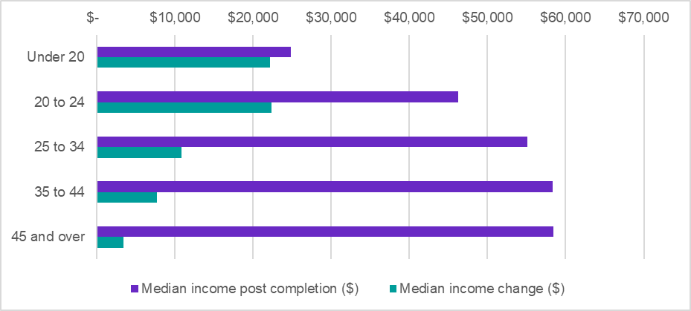Source: Person Level Integrated Data Asset (PLIDA), 2002 – 2022, VET National Data Asset, ABS DataLab. Findings based on use of PLIDA data.

### Median income by AQF level

Figure 1.2 shows that higher Australian Qualifications Framework (AQF) levels are generally associated with higher median incomes, and Graduate Diploma/Certificate completers have the highest median income at $81,700. The exception to this trend is Certificate IV graduates, who have a higher median income than Diploma and Advanced Diploma graduates. This may be partly explained by the higher median age of this cohort (35 years compared to 31 years for Diploma graduates).

**Figure 1.2: Median income for 2019-20 VET graduates, by AQF level**

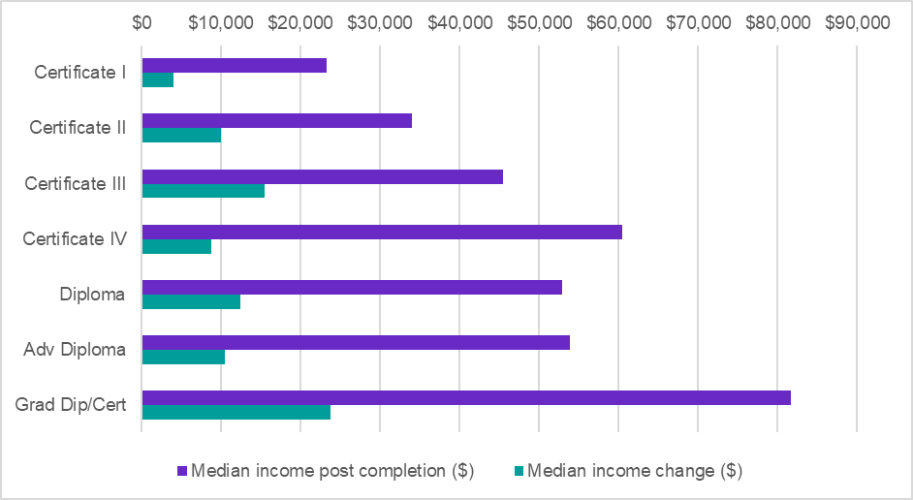Source: Person Level Integrated Data Asset (PLIDA), 2002 – 2022, VET National Data Asset, ABS DataLab. Findings based on use of PLIDA data.

### Median income for priority cohorts

Figure 1.3 shows the median income and income uplift for priority cohorts (i.e. females, First Nations, and graduates with disability). All priority cohorts received an uplift in their income following completion. Males had a higher median income uplift than females ($12,400 and $11,400 respectively) and a higher median income after completion ($58,300 compared to $41,900). This result may in part be due to the difference in the number of hours worked by males and females, as reflected in labour force statistics.[1]

**Figure 1.3: Median income for 2019-20 VET graduates, by priority cohort**

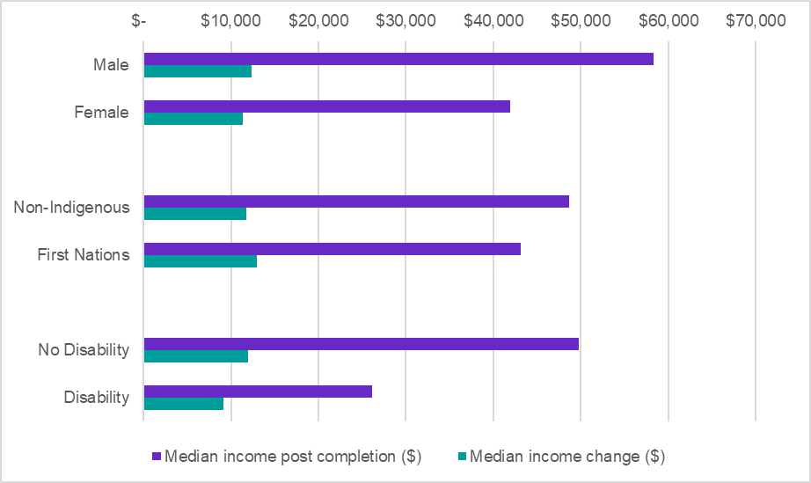Source: Person Level Integrated Data Asset (PLIDA), 2002 – 2022, VET National Data Asset, ABS DataLab. Findings based on use of PLIDA data.

First Nations graduates had a higher median uplift in income than non-Indigenous graduates ($13,000 and $11,800 respectively), thus helping to reduce the gap between First Nations and non-Indigenous median incomes. The median income of First Nations graduates was $43,100 after completion, approximately 12 per cent lower than non-Indigenous graduates ($48,700).

This income disparity may in part be explained by the higher proportion of First Nations graduates in lower AQF qualifications, which are associated with lower incomes post completion.

Graduates with disability (7% of total graduates) also had an income uplift ($9,100). However, it was 24% lower than graduates without disability ($12,000). The median income of graduates with disability was also substantially lower than graduates without disability ($26,100 and $49,800 respectively).[2]

### Median income by location

Figure 1.4 shows the difference in median income by graduates’ residential location. Regional and remote graduates had a higher median income uplift than graduates in major cities ($12,900 and $12,700 respectively, compared to $11,500 for graduates in major cities). Regional and remote graduates also had higher median incomes after completion than graduates in major cities ($50,300 and $62,100 respectively, compared to $47,100 for graduates in major cities).

**Figure 1.4: Median income for 2019-20 VET graduates, by location**

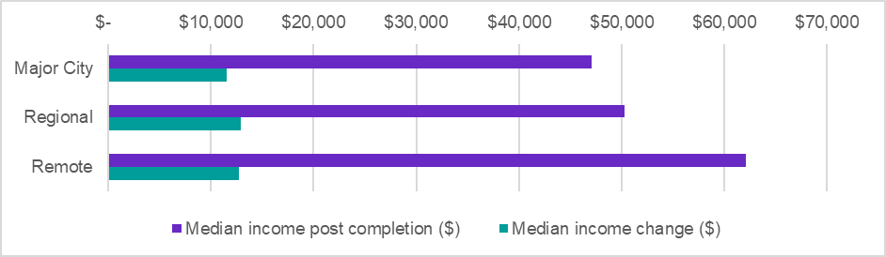Source: Person Level Integrated Data Asset (PLIDA), 2002 – 2022, VET National Data Asset, ABS DataLab. Findings based on use of PLIDA data.

### Median income by select student characteristics

As figure 1.5 shows, the median uplift in income for apprentices and trainees is more than double the median uplift for non-apprentices and trainees ($25,800 and $9,400 respectively). The median income of apprentices and trainees is also higher than non-apprentices and trainees ($55,000 and $46,300 respectively). This disparity may be linked to the substantially longer duration of apprenticeships and traineeships, which had a median completion time of 649 days compared to 222 days for non-apprenticeships. It is also important to note that not all qualifications are available through both pathways.

Figure 1.5 also shows that the median income of graduates who were employed prior to enrolling in their VET qualification, was more than double that of graduates who only gained employment after completion ($54,900 and $26,600 respectively). The strong impact of prior employment on median income is important to consider when examining outcomes by course level. Some qualifications, particularly at the lower AQF levels, have high rates of graduates with no prior employment and, as such, tend to have lower median incomes post completion.

Graduates who had not completed year 12 or a Certificate III[3] or higher qualification previously, had a lower median income uplift ($10,900) and lower median income post completion ($39,700) than graduates who had these qualifications ($12,100 uplift and $51,200 median income).

**Figure 1.5: Median income for 2019-20 VET graduates, by select student characteristics**

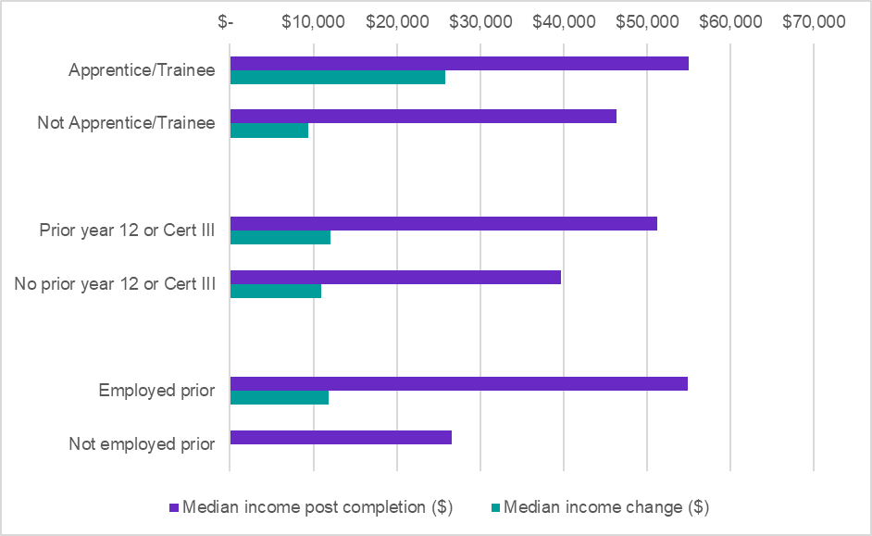Source: Person Level Integrated Data Asset (PLIDA), 2002 – 2022, VET National Data Asset, ABS DataLab. Findings based on use of PLIDA data.

*Apprentice/trainee status is allocated to students who for their first subject, were enrolled as an apprentice or trainee. Otherwise, the student is categorised as a ‘Not apprentice/trainee.’

**The ‘not employed prior’ group doesn’t have ‘median income change’ data because there is no prior income to compare change to. Only individuals with an income both prior to enrolment and post completion contribute to the ‘median income change’ calculation.

# Employment outcomes

|  |
| --- |
| **Data definitions and limitations:**  ‘Employment rate post completion’ is defined as the percentage of domestic VET graduates who earned any employee income in financial year 2020-21 after completing a VET qualification in 2019-20.  It is important to note that this definition captures employment in any occupation, full-time or part-time and does not include self-employment or unpaid work. The employment is not necessarily in an occupation associated with the skills acquired from the completed VET qualification.  This analysis also presents the employment rates in the financial year prior to enrolment. This allows for an observation of the change in employment rate prior to study and following completion.  Please note that for the purpose of this report, the terms ‘employed’ and ‘not employed’ refer specifically to whether a student did or did not earn any employee income in the financial year in question. |

**Improved employment rates after training**

There was an uplift in employment rates across all cohorts, with an uplift of 15 percentage points nationally to 84% in the year following qualification completion.

The largest uplift in employment rates were generally in cohorts that had lower employment rates prior to enrolment. The groups with the largest uplift in employment rates following VET completion were:

* those who were not employed in the year prior to enrolment (uplift of 62 percentage points)
* those aged under 20 (uplift of 37 percentage points)
* those who had not completed year 12 or previously completed a Certificate III or higher qualification (uplift of 20 percentage points).

### Employment rate by age group

Figure 2.1 shows how employment rates vary according to age group. The largest uplift in employment rates were for graduates aged under 20 with an uplift in their employment rate of 37 percentage points to 82% in the year following completion. While positive, this outcome is somewhat expected for young graduates who are entering their first jobs.

The employment rate peaks in the 20-24 age group, with 88% of graduates employed in the year following completion, an increase of 15 percentage points compared to the year prior to enrolment. The high rate of employment in this age group may also be driven by the high percentage of apprentices and trainees in this age group (32% compared to 15% overall). As figure 2.5 shows, apprentices and trainees have an employment rate 13 percentage points higher than non-apprentices and trainees.

**Figure 2.1: Employment rate for 2019-20 VET graduates, by age group**

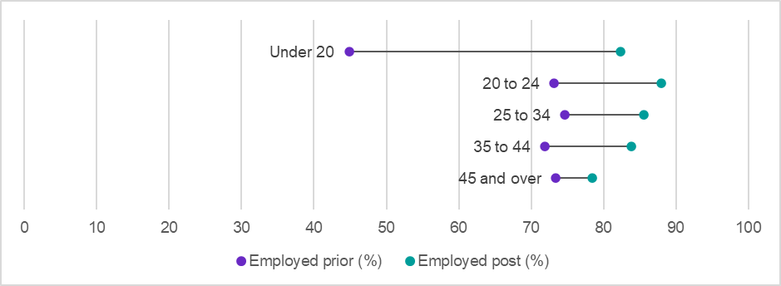Source: Person Level Integrated Data Asset (PLIDA), 2002 – 2022, VET National Data Asset, ABS DataLab. Findings based on use of PLIDA data.

### Employment rate by AQF level

Figure 2.2 shows that higher AQF levels are generally associated with higher rates of employment, with Graduate Diploma and Graduate Certificate completers having the highest employment rate after graduation (92%). Certificate I, II and III graduates all had substantial uplifts in employment rate (between 17 and 21 percentage points). Advanced Diploma graduates were below the trend with a post completion employment rate of 83%. However, as discussed in Section 3 of this report, this may in part be due to the large percentage of Advanced Diploma graduates progressing to higher education (22% compared to 8% overall).

**Figure 2.2: Employment rate for 2019-20 VET graduates, by AQF level**

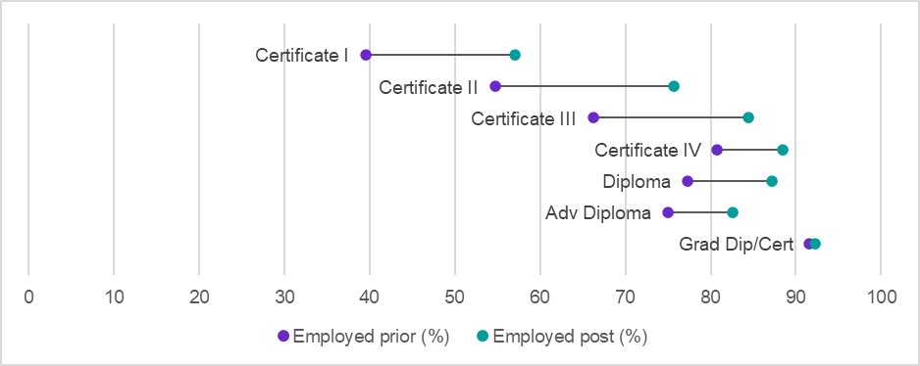Source: Person Level Integrated Data Asset (PLIDA), 2002 – 2022, VET National Data Asset, ABS DataLab. Findings based on use of PLIDA data.

**Employment rate for priority cohorts**

Figure 2.3 shows the employment figures for priority cohorts. The employment rate of females was 7 percentage points lower than males prior to enrolment (66% compared to 73%) but this gap closed to 2 percentage points following completion (83% compared to 85%), with an uplift in female employment rate of 17 percentage points.

The employment rate of First Nations graduates was 7 percentage points lower than non-Indigenous graduates prior to enrolment (63% compared to 70%), and this gap reduced to 5 percentage points following completion (79% vs 84%), with an uplift in employment rate of 16 percentage points.

Graduates with disability had an employment rate 20 percentage points lower than graduates without disability in the year prior to enrolment (51% compared to 71%). Following completion, graduates with disability improved their employment rate by 14 percentage points to 65%. However, the gap in employment rates between graduates with and without disability remained unchanged at 20 percentage points (65% compared to 85%) after course completion.

**Figure 2.3: Employment rate for 2019-20 VET graduates, by priority cohort**

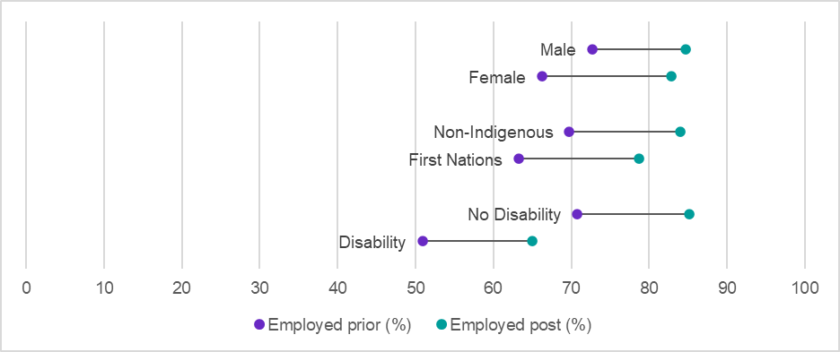Source: Person Level Integrated Data Asset (PLIDA), 2002 – 2022, VET National Data Asset, ABS DataLab. Findings based on use of PLIDA data.

**Employment rate by location**

Figure 2.4 shows the employment rate by graduates’ location. Graduates in major cities had the largest uplift in employment rate (16 percentage points, compared to 13 percentage points for regional graduates and 8 percentage points for remote graduates). However, graduates in regional and remote areas had higher rates of employment post completion (87% and 88% respectively, compared to 83% for graduates in major cities).

**Figure 2.4: Employment rate for 2019-20 VET graduates, by location**

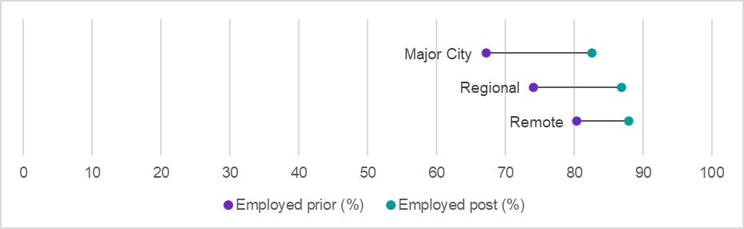Source: Person Level Integrated Data Asset (PLIDA), 2002 – 2022, VET National Data Asset, ABS DataLab. Findings based on use of PLIDA data.

**Employment rate by select student characteristics**

Almost one third (31%) of the 2019-20 graduates were not employed prior to enrolment. Figure 2.5 shows that following qualification completion, 62% of these graduates were employed. This figure also demonstrates that 7% of graduates who were employed prior to enrolment were not in employment in the year following completion. This may be due to graduates moving into further study or out of the workforce for child rearing or other responsibilities.

Apprentices and trainees had the highest rate of employment after completion than all other cohorts examined, with a 95% employment rate. In comparison, graduates who were not apprentices or trainees had a post completion employment rate of 82%.

Graduates who had completed year 12, or a Certificate III or higher qualification prior to enrolment had an employment rate of 86% after completion, up 12 percentage points since prior to enrolment. In comparison, graduates who did not have these qualifications prior to enrolment, had a lower employment rate after completion (78%) but had a larger increase in their employment rate (up 20 percentage points since prior to enrolment).

**Figure 2.5: Employment rate for 2019-20 VET graduates, by select student characteristics**

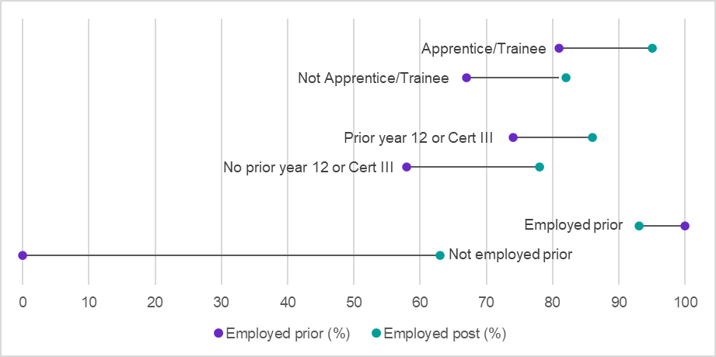Source: Person Level Integrated Data Asset (PLIDA), 2002 – 2022, VET National Data Asset, ABS DataLab. Findings based on use of PLIDA data.

*Apprentice/trainee status is allocated to students who for their first subject, were enrolled as an apprentice or trainee. Otherwise, the student is categorised as a ‘Not apprentice/trainee.’

# Further study outcomes

|  |
| --- |
| **Data definitions and limitations:**  Further study is defined as enrolment in a higher AQF level course than the course completed in 2019-20. Further study enrolments in 2019-20 and 2020-21 are captured. Data is provided for both higher-level VET enrolments and higher education enrolments.  Further study only captures enrolment in, and not completion of, the additional study. The metrics capture enrolments in nationally recognised, AQF level qualifications only.  Enrolment in a higher education or VET qualification are not mutually exclusive of each other. Thus, some graduates who enrol in higher education may also be enrolled in VET at the same time. |

**Pathways to higher-level study**

For some people, completion of a VET qualification serves as an intermediary step from which they continue their learning journey, either to pursue further VET or enrol in higher education. Nationally, the percentage of graduates that commenced higher-level VET study was 16%, while the progression to higher education was 8%.

### Further study by age group

Figure 3.1 shows further study rates by age group. The youngest cohort (under 20 years) had the highest rates of further study in higher education (with 17% enrolling) and higher-level VET study (with 31% enrolling) after completion. Rates of further study decline as the age of the cohort increases, down to 10% for higher-level VET study and 3% for higher education in the cohort aged 45 and older.

**Figure 3.1: 2019-20 VET graduates, further study (%) by age group and study type**

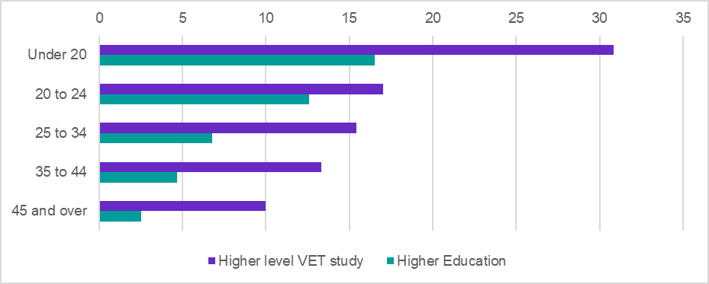Source: Person Level Integrated Data Asset (PLIDA), 2002 – 2022, VET National Data Asset, ABS DataLab. Findings based on use of PLIDA data.

### Further study by AQF level

Figure 3.2 shows that higher AQF levels are generally associated with increased rates of further study in higher education and decreased rates of higher-level VET study. The percentage of VET graduates progressing to higher education study peaks at the Advanced Diploma level (22%). Certificate I graduates have the highest rates of progression to higher-level VET study (40%).

**Figure 3.2: 2019-20 VET graduates, further study (%) by AQF level and study type**

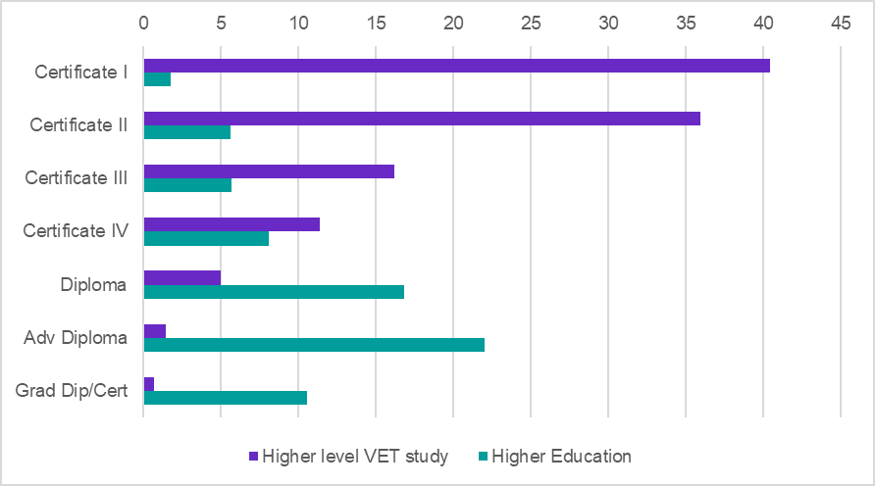Source: Person Level Integrated Data Asset (PLIDA), 2002 – 2022, VET National Data Asset, ABS DataLab. Findings based on use of PLIDA data.

### 

### Further study for priority cohorts

Figure 3.3 presents the rates of further study in key cohorts. This shows that females were more likely than males to progress to both higher-level VET study and higher education (18% and 10% respectively, compared to 15% and 6% for males).

**Figure 3.3: 2019-20 VET graduates, further study (%) by priority cohort and study type**

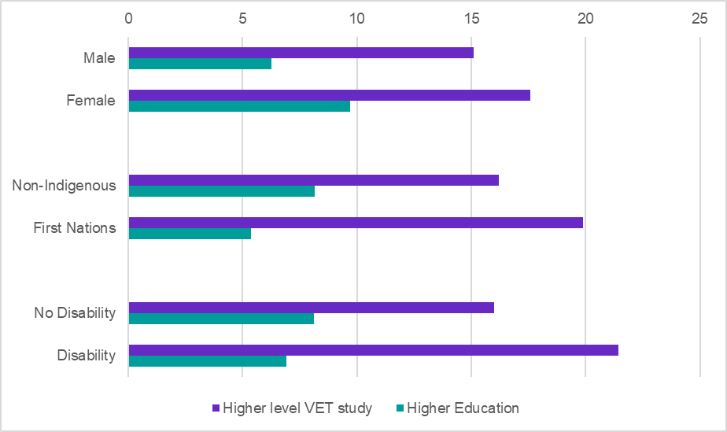Source: Person Level Integrated Data Asset (PLIDA), 2002 – 2022, VET National Data Asset, ABS DataLab. Findings based on use of PLIDA data.

First Nations graduates were more likely than non-Indigenous graduates to enrol in further VET study at a higher-level (20% compared to 16%). However, non-Indigenous graduates were more likely to enrol in higher education than First Nations (8% compared to 5%).

A similar pattern was observed for graduates with disability, where 21% enrolled in further VET study at a higher level, compared to 16% of graduates without disability. The rates of enrolment in higher education were slightly higher for students without disability (8% compared to 7% for students with disability).

### Further study by location

Figure 3.4 shows that 17% of graduates in major cities progressed to higher-level VET study, which is a little higher than regional and remote graduates (15% and 14% respectively). Graduates in major cities were also more likely to enrol in higher education (9% compared to 6% for regional and 5% for remote graduates).

**Figure 3.4: 2019-20 VET graduates, further study (%) by location and study type**

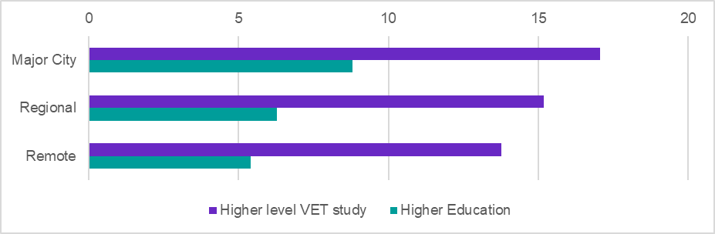Source: Person Level Integrated Data Asset (PLIDA), 2002 – 2022, VET National Data Asset, ABS DataLab. Findings based on use of PLIDA data.

### Further study by select student characteristics

Figure 3.5 shows that graduates who were not employed prior to commencing their VET qualification had the highest rates of further VET study following completion (23%). This is likely a reflection of the low rates of prior employment in the lower AQF levels, which are often used as pathways into higher-level VET. Apprentices and trainees had some of the lowest rates of further study (14% for higher-level VET and 6% for higher education), which may be linked to the high levels of employment experienced by this group (95%, refer to figure 2.5).

Graduates who had completed year 12, or a Certificate III or higher qualification prior to enrolment were more likely to enrol in higher education after completion than students who didn’t have these qualifications (9% compared to 5%) and were less likely to enrol in further VET (16% compared to 18%). The lower rates of further VET study in this group are likely linked to these graduates completing higher-level AQF courses than the group without prior year 12/Certificate III.

**Figure 3.5: 2019-20 VET graduates, further study (%) by select student characteristics and study type**

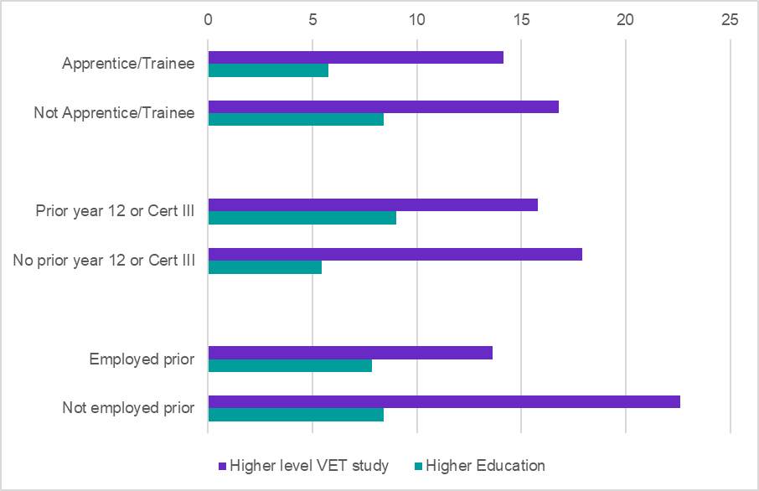Source: Person Level Integrated Data Asset (PLIDA), 2002 – 2022, VET National Data Asset, ABS DataLab. Findings based on use of PLIDA data.

*Apprentice/trainee status is allocated to students who for their first subject, were enrolled as an apprentice or trainee. Otherwise, the student is categorised as a ‘Not apprentice/trainee.’

# Income support outcomes

|  |
| --- |
| **Data definitions and limitations:**  The ‘income support exit rate’ is defined as the percentage of graduates not on income support as at June 2022 (two years after VET course completion), given they were on income support before course enrolment. This timeframe was used to reduce the impact of the COVID-19 pandemic on the results due to the significant policy changes related to income support in 2020 and 2021.  The income support payments used in this analysis are generally income tested and would be expected to reduce with the skills gained in a qualification. For instance, payments such as the JobSeeker and Youth Allowance have been included, while others such as the Age Pension have been excluded. Study-related payments such as Austudy and Abstudy have also been excluded as the completion of study would lead to the ending of such payments, irrespective of any positive student outcomes. For a full list of the income support payments included, see the accompanying technical report.  The income support exit rate measures the percentage of students transitioning out of income support services, reflecting progress towards financial independence. The income support exit rate is also distinct from the change in employment (Section 2 of this report), as many people are both employed and on income support. |

**Reduced reliance on income support**

The national income support exit rate for VET graduates was 39% - that is, 39% of students who were on income support prior to their study were no longer on income support two years after completion.

High income support exit rates were observed among:

* people that completed a Graduate Certificate/Diploma (73%)
* people that were employed prior to study (48%) and
* apprentices/trainees (63%).

Income support exit rates are generally lower for disadvantaged cohorts, however, different eligibility requirements for income support may impact differently on some of these cases. For example, the income support exit rate is relatively low for graduates with a disability (22%), however, this cohort may be eligible for the Disability Support Pension in addition to income received from employment.

### Income support exit rate by age group

Figure 4.1 shows the income support exit rate for different age groups. The income support exit rate is highest for people aged between 25 and 34, at 42%. Compared to the other age groups, students under 20 had by far the lower income support exit rate (11%). Graduates aged 45 and over also had a notable lower income support exit rate at 34%.

**Figure 4.1: 2019-20 VET graduates, income support exit rate (%), by age group**

The figure shows the income support exit rate for VET graduates by age group. The income support exit rate is highest for people aged between 25 and 34, at 42%. 
Source: Person Level Integrated Data Asset (PLIDA), 2002 – 2022, VET National Data Asset, ABS DataLab. Findings based on use of PLIDA data.

### Income support exit rate by AQF level

Figure 4.2 shows how the income support exit rate generally increases with the level of qualification. The lowest income support exit rates are observed for Certificate I (18%) and Certificate II (32%), and the highest for Diploma (52%) and Graduate Certificate/Diploma (73%).

**Figure 4.2: 2019-20 VET graduates, income support exit rate (%), by AQF**  
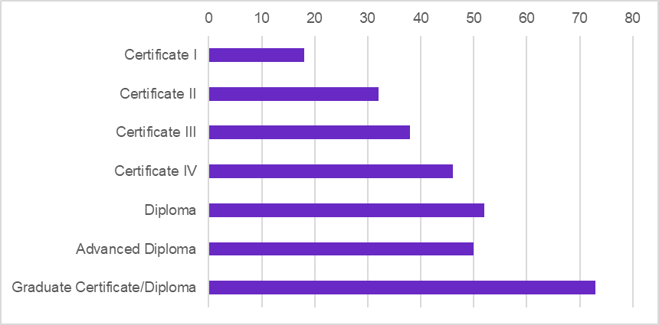Source: Person Level Integrated Data Asset (PLIDA), 2002 – 2022, VET National Data Asset, ABS DataLab. Findings based on use of PLIDA data.

### Income support exit rate for priority cohorts

The income support exit rates for priority cohorts, shown in figure 4.3, highlight that income support exit rates are lower for groups that previously faced barriers to employment. The rates were:

* lower for female graduates (36%) compared to male graduates (43%)
* lower for First Nations graduates (34%) compared to non-Indigenous graduates (39%)
* lower for graduates with disability (22%) compared to graduates without disability (43%).

**Figure 4.3: 2019-20 VET graduates, income support exit rate (%), by priority cohort**   
The figure shows the income support exit rate for VET graduates, by gender, First Nations status and disability status. The income support exit rates are lower for groups that previously faced barriers to employment (females, First Nations and Disability).
Source: Person Level Integrated Data Asset (PLIDA), 2002 – 2022, VET National Data Asset, ABS DataLab. Findings based on use of PLIDA data.

### Income support exit rate by location

Figure 4.4 shows the difference in income support exit rates by location. The rate is 39% in both the major cities and in regional areas but is slightly lower in remote areas at 35%.

**Figure 4.4: 2019-20 VET graduates, income support exit rate (%), by location  
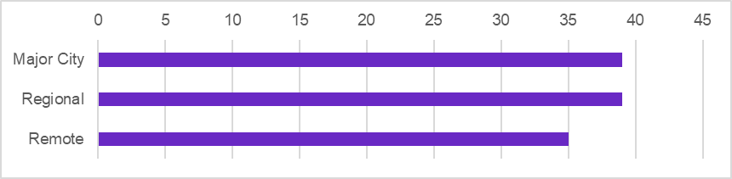**Source: Person Level Integrated Data Asset (PLIDA), 2002 – 2022, VET National Data Asset, ABS DataLab. Findings based on use of PLIDA data.

### Income support exit rate by select student characteristics

Figure 4.5 shows the income support exit rate across select student characteristics. Apprentices/trainees had a very high exit rate, at 63%. Graduates who had a prior year 12 or equivalent (e.g. Certificate III or above) level of education, had a higher income support exit rate than those without this prior education (43% compared to 32%). However, these students are more likely to undertake higher level courses, and as figure 4.2 shows, the income support exit rate generally increases with the level of qualification. Those who were employed prior to study had an income support exit rate of 48%, which is higher than for those who were not employed prior to study (30%).

**Figure 4.5: 2019-20 VET graduates, income support exit rate (%), by select student characteristics  
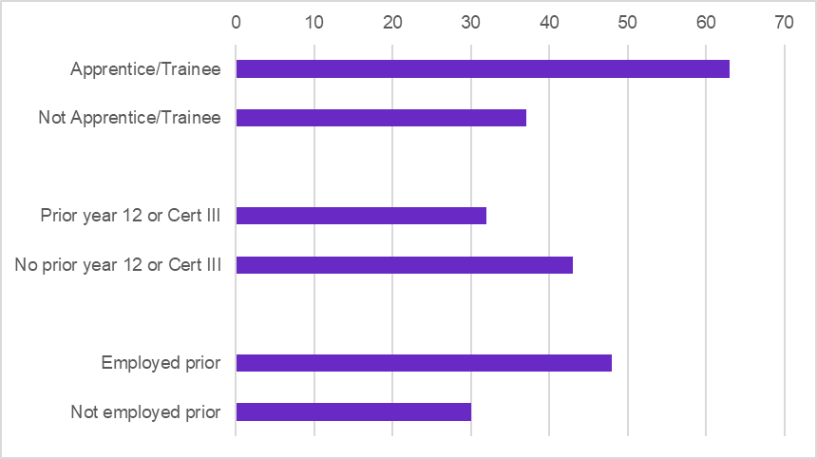**Source: Person Level Integrated Data Asset (PLIDA), 2002 – 2022, VET National Data Asset, ABS DataLab. Findings based on use of PLIDA data.

*Apprentice/trainee status is allocated to students who for their first subject, were enrolled as an apprentice or trainee. Otherwise, the student is categorised as a ‘Not apprentice/trainee.’

# Conclusion

This VNDA report highlights the positive economic and employment gains for VET graduates, including among First Nations students, females and students with disability. First Nations students had a median income uplift of $13,000, higher than the national uplift of $11,800. Female graduates experienced a notable rise in employment rates with a 17 percentage point increase, compared to 15 percentage points nationally. The VET system also reduces graduates’ reliance on income support, with 39% of students who were on income support prior to their study were no longer on income support two years after completion.

The report also underscores the importance of VET in creating pathways to higher-level training, with 40% of graduates in Certificate I progressing to higher-level VET, and 22% of Advanced Diploma graduates commencing higher education. Females, First Nations and graduates with disability all had higher rates of progression to higher-level VET study than the national total (18%, 20% and 21%, compared to 16% nationally).

While the descriptive statistics offer useful insights, JSA is advancing analyses within VNDA, including rigorous modelling, to better understand the relationships and the impact of students’ demographic characteristics on their outcomes. Furthermore, JSA is continuously working to enhance VNDA’s methodology and explore deeper insights into other key dimensions of Australia’s job market, such as occupation, industry profiles, and employment type to maximise the potential of VNDA.

### Further information

This report focused on the outcomes of graduates at the national level, with analysis by a range of different student attributes.

For graduate outcomes by qualification, field of education and by state and territory, please refer to the [interactive dashboard or downloadable excel tables](https://www.jobsandskills.gov.au/data/vet-national-data-asset/2019-20-outcomes) available on the JSA website.

Technical details, including the methodology, data sources, data definitions and limitations are available in the [technical report](https://www.jobsandskills.gov.au/data/vet-national-data-asset/2019-20-outcomes), also available on the JSA website.

JSA welcomes both feedback on this report and direct engagement to help shape both the modelling work that underpins the VNDA data asset and the focus of future analysis. Please get in touch at [VNDA@jobsandskills.gov.au](mailto:VNDA@jobsandskills.gov.au)

# Disclaimer

*The results of these studies are based, in part, on data supplied to the ABS under the Taxation Administration Act 1953, A New Tax System (Australian Business Number) Act 1999, Australian Border Force Act 2015, Social Security (Administration) Act 1999, A New Tax System (Family Assistance) (Administration) Act 1999, Paid Parental Leave Act 2010 and/or the Student Assistance Act 1973. Such data may only used for the purpose of administering the Census and Statistics Act 1905 or performance of functions of the ABS as set out in section 6 of the Australian Bureau of Statistics Act 1975. No individual information collected under the Census and Statistics Act 1905 is provided back to custodians for administrative or regulatory purposes. Any discussion of data limitations or weaknesses is in the context of using the data for statistical purposes and is not related to the ability of the data to support the Australian Taxation Office, Australian Business Register, Department of Social Services and/or Department of Home Affairs’ core operational requirements.*

*Legislative requirements to ensure privacy and secrecy of these data have been followed. For access to PLIDA and/or BLADE data under Section 16A of the ABS Act 1975 or enabled by section 15 of the Census and Statistics (Information Release and Access) Determination 2018, source data are de-identified and so data about specific individuals has not been viewed in conducting this analysis. In accordance with the Census and Statistics Act 1905, results have been treated where necessary to ensure that they are not likely to enable identification of a particular person or organisation.*

1. [Employment of men and women across the life course | Australian Institute of Family Studies (aifs.gov.au)](https://aifs.gov.au/research/facts-and-figures/employment-men-and-women-across-life-course#:~:text=The%20proportion%20of%20women%20working,over%20the%2040%2Dyear%20period.)
2. These lower incomes may in part be associated with higher proportions of graduates with disability in lower AQF qualifications (16% of Certificate I graduates have disability), further study (50% of graduates with disability enrolled in further study compared to 44% without disability) and younger age groups (11% of graduates aged under 20 have disability). It may also reflect fewer hours worked by graduates with disability and challenges they face in seeking work that reflects their needs.
3. For this analysis, Certificate III has been selected as equivalent to the completion of year 12.