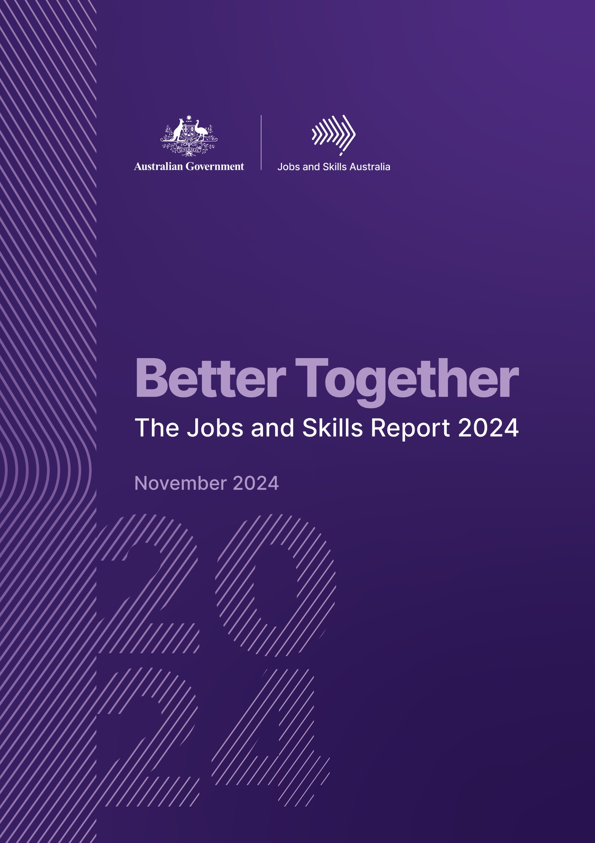



Better Together

The Jobs and Skills Report 2024

**November 2024**



All content is provided under a Creative Commons Attribution 4.0 International Licence with the exception of:

* content supplied by third parties
* the Commonwealth Coat of Arms
* material protected by a trade mark
* any images and/or photographs.

Details of the Creative Commons BY 4.0 licence are available on the [Creative Commons website](https://creativecommons.org/).

Use of all or part of any material on this website must include the following attribution:

© Commonwealth of Australia

Terms under which the Commonwealth Coat of Arms can be used are set out on the [Department of the Prime Minister and Cabinet website](https://www.pmc.gov.au/).

**Attribution**

You may link to this website at your full expense and responsibility. In doing so you must not alter any of the website's contents, frame or reformat the files, pages, images, information and materials from this website on any other website. We reserve the right to prevent linking.

**Other use**

If you want to use material on this website in a way that is beyond the scope of the terms of use that apply to it, ask us for authorisation. You could infringe our copyright if you use anything on this website in a way that is not permitted or otherwise allowed under the Copyright Act 1968 (Cth).

Please email [copyright@dewr.gov.au](mailto:copyright@dewr.gov.au) or address requests and enquiries to:

The Copyright Officer  
Department of Employment and Workplace Relations  
GPO Box 9828 Canberra ACT 2601.



**Acknowledgement of Country**

Jobs and Skills Australia acknowledges the Traditional Owners of Country throughout Australia and recognises the continuing connection to lands, waters and communities. We pay our respects to Aboriginal and Torres Strait Islander cultures, and to Elders past and present.

The background image is an aerial view of the country of the Nhanda people, showing Pink Lake at Port Gregory.

Contents

Commissioner’s Foreword 1

Executive Summary 3

1. Fostering inclusive participation 3

Achieving full employment 4

Addressing barriers to inclusion 4

The role of education and training 6

2. Understanding today’s workforce 6

The big picture – Australia’s labour market today 6

Understanding labour market shortages 7

Investing in our regions 8

3. Shaping Australia’s future workforce 8

2024 Employment projections 8

Emerging roles in the Australian labour market 9

Capacity studies – understanding the forces of change 9

4. Optimising pathways and system architecture 10

The case for a more harmonised tertiary education system 10

The role for a National Skills Taxonomy 11

Combining work and study 11

VET workforce development 11

Skilled migration 12

5. Activating an informed dialogue 12

Chapter 1: Fostering inclusive participation 13

Measuring movements in full employment indicators since the White Paper 15

Indicators of sustained and inclusive full employment 15

Addressing barriers to inclusion 21

Jobs and Skills Councils in focus 22

Supporting First Nations workers 22

Gender equality in the labour market 25

Making progress on the number of female electricians 28

Income volatility as an indicator of insecure work 29

International students 31

The role of education and training 33

Foundation skills 33

VET as an enabling pathway 35

In summary 36

Chapter 2: Understanding today’s workforce 37

The big picture – Australia’s labour market today 39

Understanding labour market shortages 42

Prevalence of shortages in higher skilled occupations 43

Importance of shortages 45

Shortages by industry 47

Occupation shortages by major occupation group 48

Impact of age on occupation shortages 48

Occupation shortage drivers 49

Addressing occupation shortages 54

Case study – The Construction Industry Culture Taskforce 55

Jobs and Skills Councils in focus 56

Investing in our regions 57

Jobs and Skills Councils in focus 58

Recent trends in regional labour market performance 59

Online job advertisements in regional Australia 62

Changing demand for occupations in regional Australia 62

Changing demand patterns in thriving labour markets 65

In summary 67

Chapter 3: Shaping Australia’s future workforce 69

2024 Employment Projections 71

Overall employment growth 71

Industry employment outlook 71

Employment outlook by occupation groups 75

Employment outlook for states and territories 77

Employment outlook by skills level 81

An alternative scenario: what if the educational and training attainment was fully responsive to labour market demand? 82

Key results by major occupation group 83

Key results by occupation skill level 85

Emerging roles in the Australian labour market 86

The rise of artificial intelligence 89

Capacity studies – understanding the forces of change 93

A resilient food supply chain 94

The future of the Early Childhood Education Profession 98

Jobs and Skills Councils in focus 103

In summary 103

Chapter 4: Optimising pathways and system architecture 105

The importance of tertiary pathways 107

The case for a more harmonised tertiary education system 108

Examples of harmonisation in practice 109

Continuing the national conversation 113

The Role for a National Skills Taxonomy 114

Combining work and study 115

Work-integrated learning 115

VET workforce development 119

Challenges in the sector 120

Understanding the workforce 120

First Nations VET Workforce 122

Skilled migration 123

In summary 124

Chapter 5: Activating an informed dialogue 125

How we work 127

Ministerial Advisory Board 127

State and territory partnerships 127

Jobs and Skills Councils 128

Commonwealth Interdepartmental Committee 130

How we listen 130

Steering groups supporting our work 131

Consultations and ongoing feedback 131

Ongoing engagement mechanisms 132

How we have impact 132

Labour market and skills analysis and products 132

Strategic advice and deliverables 134

Measuring our impact 134

Case study: Impacts of the clean energy capacity study 135

Case study: Adapting our insights to better serve our stakeholders 137

The Jobs and Skills Atlas – helping users access more of our insights 138

How Atlas assists Rebekah, a career development practitioner 139

Support for initiatives on the Mid North Coast 139

In summary 140

References 141

Glossary 146

# Commissioner’s Foreword

Labour market insights are critical to understanding the functioning of our economy. They allow governments and other decision makers to monitor how well the economy is performing and help guide decision-making for the settings of policies that affect employment, workforce development, income, and societal wellbeing.

At their heart, however, labour market statistics are about people. They represent how people are engaged in our communities and society, and how they do or do not benefit from the significant forces shaping our economy. Because they sit at the critical intersection between economic and social analysis, these insights help us to understand the barriers to and enablers of success, and how to empower more people to access opportunities and the improved standard of living and wellbeing that comes with them.

As we face skills shortages across many industries and occupations, and while unemployment is at a relatively low level, there is an imperative to ensure that all Australians have access to opportunities to increase their skills, to gain qualifications, and to uplift their earning potential.

The work of Jobs and Skills Australia (JSA) is central to this intent, and we are committed to ensuring our work has a strong focus on equity, access and inclusion across education, training and employment.

There is further work to be done to ensure more Australians can access secure, safe, and fairly paid work, and that Australia’s current and future skills challenges are overcome.

This is work that cannot be done alone. Achieving a truly dynamic, productive, and competitive economy – with sustained and inclusive employment – will require all participants in the system to move forward together with a strong focus on collaboration and providing more equitable access to opportunities.

A focus on inclusion of course means we must aim for the benefits of education, training, and employment to be within reach of more Australians. Critically, they must reach the people and communities who have historically been excluded or faced significant barriers to participation.

JSA is critical to the achievement of this collaboration, as our approach, our methods, and our systems must be inclusive. We must bring together the considerable expertise of our stakeholders to formulate more holistic understandings of our complex economic and social challenges. Our employment, skills, and migration systems must work in concert to ensure we have the right skills and capabilities to thrive as a nation.

Importantly, our higher education and vocational education and training sectors must work together to deliver a well-equipped and thriving workforce, enhancing lives and providing value for employers.

Above all, we must help more Australians access the social and economic benefits of participation.

Critical to this challenge is ensuring we have a well-balanced and aligned post-secondary education profile and encourage more young Australians to consider vocational education and training pathways to employment and further study.

This report has been prepared as required under section 27A of the *Jobs and Skills Australia Act, 2022*. It outlines evidence and analysis JSA has undertaken across 5 strategic pillars that inform our work and guide our advice to achieve a more prosperous future for all Australians.

By working together to foster inclusive participation, we can better understand today’s workforce, prepare for the opportunities and challenges of the future, optimise pathways and system architecture, and activate an informed dialogue between key stakeholders and decision-makers – achieving a fairer, more inclusive, and stronger Australian economy.



Professor Barney Glover AO

Commissioner

Jobs and Skills Australia

# Executive Summary

Jobs and Skills Australia’s establishing legislation requires us to prepare and provide this jobs and skills report to government on Australia’s current, emerging and future skills and training needs and priorities.

As part of this legislative mandate, JSA provides insights on Australia’s current and emerging labour market, including advice on workforce needs and priorities. We also focus on the efficiency and effectiveness of the national skills system, across its core components of vocational education and training, higher education and skilled migration.

Importantly, JSA has a strong focus on ensuring our activities address priority groups in the labour market. JSA’s work seeks to provide advice to government that has the intent of uplifting all Australians to participate to their full potential in the labour market.

We also encourage greater collaboration and cooperation between and across those sections of society contributing to, or participating in, the Australian labour market. Critically, this also means that the benefits of education, training, and employment must be inclusive and within the reach of more Australians. We must ensure more people can participate and thrive.

This report outlines evidence and analysis across 5 strategic pillars that guide our work and help us collaborate effectively to achieve a more prosperous future:

1. **Fostering inclusive participation** – broadening employment opportunities through identifying and removing barriers for people and communities.
2. **Understanding today’s workforce** – building the evidence base to inform and address current and emerging labour market and skills needs.
3. **Shaping Australia’s future workforce** – projecting forward to plan for the opportunities and challenges of our nation’s future workforce needs.
4. **Optimising pathways and system architecture** – monitoring, analysing and advising on the effectiveness of the national skills system.
5. **Activating an informed dialogue** – convening stakeholders across the skills system, to provide the best evidence and advice on Australia’s current and future workforce and skills needs and opportunities.

## 1. Fostering inclusive participation

Behind our statistics, at the heart of our labour market, are people. People seek certainty and confidence they can access the benefits of safe and secure employment including financial independence, health and wellbeing, and social connection. Many groups and communities still face barriers to employment or are unable to work the hours they want and need in order to access the full benefits of paid work. A tight labour market presents opportunities for all groups to be included in the workforce, and more needs to be done to improve access to employment opportunities and remove barriers to participation.

### Achieving full employment

The Australian Government’s White Paper on Jobs and Opportunities, *Working Future*, outlines the government’s vision for:

sustained and inclusive full employment, which means everyone who wants a job should be able to find one without having to search for too long. This recognises that decent jobs and opportunities are central to a strong economy and a prosperous and inclusive society (Commonwealth of Australia, 2023a).

Reflecting the softening in labour market conditions that has occurred over the past year, it is not surprising to note that some full employment indicators have weakened slightly over the period but are still tracking well by historical standards.

Encouragingly, some indicators of *inclusive* full employment have improved over the last year – although more work needs to be done so the benefits of growth can be shared more equitably across a number of disadvantaged groups.

### Addressing barriers to inclusion

JSA has a focus on supporting national agendas aimed at enabling people who have traditionally faced barriers to participate more fully in the labour market, including contributing to the national Closing the Gap targets and outcomes, supporting women’s economic equality and safety, and increasing access for people with disability. In undertaking our work, we actively seek out and include diverse perspectives, including those of First Nations people, people with disability, culturally and linguistically diverse groups, and others who have historically experienced labour market disadvantage and exclusion.

Despite improvement in the number of First Nations people aged 25-64 who are employed, and a narrowing of the gap to non-Indigenous people, barriers remain for First Nations people accessing the full range of economic opportunities to the same degree as all Australians. Analysis shows that First Nations workers account for a lower share of higher‑skilled occupations and a larger share of lower-skilled occupations, which may indicate the presence of persisting barriers to participation.

Over half of the First Nations working age population also reside in regional or remote areas, compared with 22% for all persons. This further highlights the significant, complex, and often interconnected barriers to employment faced by First Nations people, as in addition to the intergenerational trauma experienced by First Nations people, these regions often have a long history of entrenched labour market disadvantage.

Our capacity studies found that within those workforces, First Nations representation is typically lower in comparison to the broader labour force. For many workforces, this was also more prevalent for more highly skilled and more highly remunerated occupations. Recommendations across the studies relate to increasing the relevance of training pathways for First Nations people, but importantly they also include actions intended to increase the cultural safety and support of First Nations people working in, or impacted by, the sectors being studied.

Women are participating in the labour market at higher rates than ever before, but analysis shows that part-time employment is still more common for female than male workers, and this is prevalent across industries, skill levels[1], and occupations.

It is important to recognise the role of part-time work in attracting workers to occupations in shortage, and to allow people the flexibility to balance work and life. It is important to ensure that both men and women can access the working arrangements and flexibility that suit their needs and preferences, and to address the barriers that prevent them from doing so.

Societal and structural barriers not only impact outcomes for women. In addition to the poorer outcomes for men in the ability to access flexible work policies and parental leave, our analysis shows that occupations that have a stronger gender imbalance in the labour market are also more likely to be in shortage. This was true for both male- and female‑dominated occupations and demonstrates one way that challenging gender norms and expectations can have beneficial outcomes for the labour market, and how a more gender‑equal society benefits all Australians.

For example, JSA’s 2023 Clean Energy Capacity Study identified that Australia will need an additional 32,000 electricians by 2030, and that one of the most important pathways to achieving this growth is to increase the number of women undertaking trade apprenticeships. Progress has been made on the number of female electricians, with strong growth in the number of female apprentices since 2017, who now make up around 8% of all electrical apprenticeships. More focused work is needed to address gender imbalances across the labour market, including to increase male participation in female-dominated occupations.

A consideration of insecure work must be part of efforts to foster a truly inclusive labour market. Income volatility can be a measure of insecure work, and JSA has undertaken work to understand the level of income volatility for Australian workers. Employees in jobs who experienced less income volatility, on average, earned a higher annual income and remained in that job for longer. Those who have more than one job experienced higher volatility in additional jobs outside of their main job and remained in these jobs for shorter periods. The next step for this analysis is to undertake correlation analysis to identify the relationship between income volatility and job tenure since this could predict potential shortages in occupations where income volatility is prevalent. This will be possible when data from phase 2 of Single Touch Payroll becomes available in the Person Level Integrated Data Asset (PLIDA)[2].

International students are another vulnerable group. They enrich Australia’s campuses, communities, and economy – but many of those who remain in Australia after graduation face barriers transitioning into the skilled workforce. The changing demography of the student population, a complex visa environment, and challenges in achieving relevant work outcomes are shaping the international education experience in Australia.

Further examination of the impact of the barriers, including how educational experiences prepare work-ready graduates, is required to determine how to better support international graduates to transition more successfully to the skilled workforce.

### The role of education and training

Foundation skills underpin successful participation in society, education, training, and the workplace, and improving these skills can have a direct and positive impact on a person’s economic and social wellbeing. No single identified dataset can provide a detailed understanding of the foundation skills levels of Australian adults, and JSA is undertaking 3 studies to better understand the foundation skills levels of Australian adults.

Evidence shows that Vocational Education and Training (VET) may serve as an important pathway for advancing inclusive participation in the labour market. VET pathways may be attractive options for groups that have historically experienced labour market and other disadvantage given the barriers to qualification requirements and cost (including the option to ‘earn while you learn’).

Analysis from the VET National Data Asset (VNDA) shows that completion of a VET course may contribute to an increase in employment. This rise in employment is similar to all students for First Nations students and people with disability and is higher for female students than for all students. Completion of a VET qualification also likely contributed to an annual medium income uplift for graduates of $11,800, and higher for First Nations graduates at $13,000.

Of the students that were on income support prior to study, 39% were no longer on income support two years after the completion of their VET course. This may indicate the contribution of the VET system in helping to provide students with a pathway off income support and into the workforce. However, this proportion was lower for females (36%), First Nations students (34%) and students with disability (22%), highlighting that there is still work to be done in improving the outcomes for these cohorts.

For First Nations students, females, and people with disability, a higher proportion who had completed VET training went on to pursue further VET programs at a higher level, compared with the proportion of all students. For females, a higher proportion than that of all students also went on to pursue higher education through university. This demonstrates the relevance of VET as an enabling pathway for historically disadvantaged cohorts to access more opportunities to participate, access safe and secure work, and thrive.

## 2. Understanding today’s workforce

A contemporary skilled workforce is critical for delivering outcomes for Australia today, and into our future. We know that skills shortages exist in many occupations and that some shortages are persistent, constraining productivity and economic growth. While shortages are extensive, the drivers and the solutions are varied. Understanding current workforce conditions will help us to ensure the system is aligned to address present skills needs.

### The big picture – Australia’s labour market today

The Australian labour market continues to display remarkable resilience against the backdrop of slowing economic activity and ongoing uncertainty. Despite some emerging challenges, the labour market remains reasonably tight, although the pace of employment growth has eased over the last year, from the robust growth rates recorded in late 2022 and early 2023.

Conditions for a number of disadvantaged cohorts and groups that can face barriers to participation, such as young people and the long-term unemployed, have also eased over the year. This is not surprising, given these cohorts can be particularly vulnerable during periods of labour market softness, as they often have less education and experience than their more highly skilled counterparts. Labour market conditions are also expected to soften further in the period ahead, which may put further upward pressure on the unemployment rate, particularly for those in disadvantaged groups.

Nevertheless, employers continue to experience challenges finding suitably skilled workers to fill vacant positions. While the average number of applicants per vacancy has generally been increasing over the last year, there has only been a marginal increase in the average number of suitable applicants per vacancy, suggesting shortage pressures persist in the labour market.

In the face of challenging conditions, it is more critical than ever that our responses and interventions are inclusive, joined up, and ensure more Australians can participate to the best of their ability.

### Understanding labour market shortages

The structure of Australia’s labour market has changed over the past few decades. Health Care and Social Assistance is now the largest employing industry, and there has been a trend toward service-based industries as well as higher-skilled occupations. This is reflected in the proportion of occupations found to be in shortage from 2021-2024 – which are occupations where employers are unable to fill or have considerable difficulty filling vacancies.

Overall, the proportion of occupations in national shortage in 2024 is lower than in 2023. This is in line with a labour market that, while remaining relatively tight, also eased over the period. The proportion of occupations in shortage was much higher in Construction, Mining, Health Care and Social Assistance, Other Services, and Education and Training – indicating a higher demand for skilled workers in these industries.

Shortages are also persistent, with 136 occupations in persistent shortage from 2021-2024. The reasons for persistent shortages are likely to be multifaceted. They include an ageing population, technological advances, and other impacts of structural changes in the labour market, such as constraints in the supply of qualified and experienced workers, working conditions and pay. Any future solutions to address persistent shortages will, therefore, likely need to be long-term and holistic.

Occupation shortages are not always about supply and demand, and analysis of the driving factors for shortage of relevant occupations can help industries, employers and policy makers to identify barriers to recruitment and possible interventions.

Interventions to address these gaps will depend on the underlying shortage drivers and could include efforts to increase the throughput of qualified workers into the labour market; migration as a short-term solution; investment in the development of employability skills and work experience; and helping employers to understand the skills and capabilities of graduates and to actively contribute to course and program design. Where factors relating to employee retention such as working conditions, workplace culture, social norms and expectations, and remuneration play more of a role in driving shortages, some industries have taken a practical approach to addressing some of these types of issues.

### Investing in our regions

More than one in 4 (27%) Australians live outside a major city. A truly dynamic, productive, and inclusive labour market must ensure that more Australians can access safe and secure work where they choose to live. Historically, regional and remote regions are more likely to experience weaker labour market conditions than their capital city counterparts. Although labour market conditions for many Australian regions have improved in recent years (relative to their own historical performance), persistent disparity exists between stronger and poorer performing regions.

Poorer-performing regions tend to be in regional and remote areas, and face challenges such as high unemployment, limited job opportunities, lower education levels, difficulties recruiting suitable workers into available jobs and lower rates of labour market efficiency. Employees in regional and remote areas are also more likely to experience low and irregular pay – impacting economic security and wellbeing. Our regions are also faced with the reality of an older age demographic – posing the challenge of reduced labour supply and loss of skills as well as additional pressure on the care and support sector which is already facing significant shortages in regional areas.

While labour market challenges are more pronounced in many regional and remote areas, JSA’s Regional Labour Market Indicator (RLMI) results for June 2024 suggest there are signs of some easing in labour market conditions in a number of metropolitan/regional city areas. This is particularly noticeable when compared to regional areas, where conditions have improved, on average. In Australia’s regions, the percentage growth of online job advertisements has been higher and the decline less pronounced which can also be an indicator that an economy is doing well. All regions are unique, and the continued development and refinement of JSA products such as the Internet Vacancy Index, the Nowcast of Employment by Region and Occupation, and the Regional Labour Market Indicator help contribute to understanding and discussion of Australia’s regional labour markets and factors that drive success.

## 3. Shaping Australia’s future workforce

To achieve a truly inclusive, dynamic, and competitive economy we cannot simply respond to our current and imminent skills challenges. We must be proactive in ensuring our future workforce has the skills required to adapt to a changing economy, so that more Australians can share in the benefits. Understanding changing dynamics in society can give us a clue to potential areas of growth, and monitoring the labour market for new roles and evolving skills requirements can help us understand emerging workforce needs and contribute to building a resilient and adaptable workforce.

Major forces are shaping our economy – technological and digital transformation, our response to climate change and the goal of ‘net zero’, an ageing population, and a rising demand for care and support services. Changing societal dynamics and consumer preferences are also impacting jobs and work. In some cases, these forces are shaping how we undertake our work, and in some cases they are driving the emergence of entirely new roles.

### 2024 Employment projections

Australia’s workforce is continuing to shift towards a greater share of higher skilled roles. Employment projections produced by Victoria University for JSA show the long-term structural shift in employment towards services-related industries is projected to continue over the next decade.

An alternative employment projections scenario was also explored, where post-secondary training and education is responsive to market signals, diverting the supply of labour into occupations where demand is strong. In general, we found that when skill supply responds to market demand, there is increased employment in occupations with a VET pathway relative to the baseline, with lower growth in employment in occupations requiring higher education qualifications. The cost of labour associated with occupations that require VET or higher education qualifications is impacted as a result, and we also observe increases in projected employment for all Community and Personal Service occupations, but also for Sales Assistants, General Clerks, Registered Nurses, and Electricians.

### Emerging roles in the Australian labour market

The way we work changes over time. While new skills and ways of working are often incorporated into existing roles in response to new technology, innovation, and changing consumer preferences – sometimes entirely new roles are created. JSA has conducted research to identify new insights on emerging roles in the labour market, taking a broad approach, both qualitatively and quantitatively, as well as through stakeholder consultation, to help industry and education and training providers better prepare to deliver the skills requirements of these new roles.

Thirty-seven emerging roles have been identified across 4 key themes that align broadly with the major forces shaping our economy – Health, Care and Medical, Data and Technologies, Net Zero, and Science and Engineering. The largest number of roles were identified in Health, Care, and Medical, although this was closely followed by Data and Technology. By continuing to monitor shifts in the landscape of Australian jobs and providing detailed skills analysis (supported by initiatives such as a National Skills Taxonomy – outlined later in this report), we can help prepare Australia to adapt to economic change and meet the demand for specific skills.

### Capacity studies – understanding the forces of change

Adapting to change will take effective coordination across skills, education, migration and employment systems as well as time and proper planning to invest in skills development. Targeted capacity studies can help us make informed decisions about how to prepare for a future shaped by the major global forces of change. They help us to better understand how these forces may shape industries and workforces – and equip workers with the right skills to benefit from change.

The 2023 Jobs and Skills report included findings from *The Clean Energy Generation: Workforce needs for a net zero economy*. Findings from the report have already supported a range of government and industry measures. Since the report’s release, JSA has finalised the findings of two capacity studies into the Early Childhood Education and Care (ECEC) sector, and Australia’s food supply chain workforce.

Australia’s food supply chain will be shaped by multiple interacting changes, including climate change and net zero, technological advances, and demographic changes. Concerns around sovereign capability, industry viability and cost of living will also have an impact. In the midst of these developments, a resilient workforce will be essential to Australia’s food security and strong export industries.

Ambitious policies are being implemented by governments to expand access to early childhood education and care, but shortages mean the workforce is already unable to meet existing demand. Improvements must also be made to ensure ECEC services can more appropriately support First Nations educators, families and communities. JSA’s report *The Childhood Education Profession: Early Childhood Education and Care Workforce Capacity Study* (undertaken in partnership with HumanAbility) contains a total of 28 findings and 41 recommendations to address the critical needs of the industry.

## 4. Optimising pathways and system architecture

An understanding of our current and future skills needs cannot help us to realise our vision of a productive, inclusive economy without the pathways and system architecture to equip workers with those skills. We must ensure that our pathways and system architecture are strong and well-equipped to provide Australians with the skills, knowledge, capabilities and understanding they need to thrive in the jobs of today and tomorrow. Our education, skills and training, and migration systems must also work in concert to deliver quality outcomes for both workers and businesses, and to help us address skills shortages and needs.

Employment projections produced by Victoria University for JSA show employment growth will continue to be greatest in higher skilled roles, with more than 90% of employment growth in roles that require post-secondary qualifications. Over the past decade, the growth in educational attainment has been heavily skewed towards the higher education system. If this pattern continues, labour market mismatches and skills shortages will worsen.

Our education and training systems do not only serve to supply skills to the labour market. Education helps people to participate in society and live the kind of lives they want. Evidence shows that attaining post-secondary qualifications contributes to higher full-time weekly earnings, and the higher the qualification, the higher the median weekly earnings. Increasing not only the number of skilled workers, but ensuring they have access to lifelong learning will be important to ensure our future success.

### The case for a more harmonised tertiary education system

Australia’s national skills challenges are complex, with inter-connected issues that cannot be addressed by one sector alone. Successfully addressing challenges such as the transition to clean energy technologies, leveraging the opportunities of digital innovation, and strengthening the health and wellbeing of people and communities, requires a connected tertiary system, where both sectors can collaborate to improve the timeliness and industry relevance of workforce supply.

A more harmonised and better-connected tertiary system, where both sectors can collaborate to improve the timeliness and industry relevance of workforce supply, will play a key role in addressing national challenges by increasing the supply of industry-ready graduates, helping to facilitate major workforce transitions in response to industry changes, and improving access and mobility across both sectors by improving recognition of existing skills and knowledge.

There are a range of examples of attempts at tertiary harmonisation by different institutions which give some insight into the proposed benefits of greater tertiary harmonisation. These examples have arisen organically despite known barriers in the system including regulation, funding and financing arrangements, legislative and support settings, qualifications frameworks, curriculum and pedagogy including assessment and recognition. This pattern of bespoke examples is not scalable without change to address barriers. Further work needs to be undertaken to achieve a wide-scale harmonised and effective system.

### The role for a National Skills Taxonomy

The term ‘skill’ is widely used across education, training, and workforce contexts. However, its definition varies significantly across different stakeholders, use cases and formal frameworks. The absence of a common interpretation and understanding of skills represents a major challenge in the Australian skills landscape, with each actor speaking a different skills language. This fragmentation creates friction and provides challenges when attempting to find alignment between VET, higher education and employment. The primary objective of developing a National Skills Taxonomy (NST) is to establish a common language of skills to support effective collaboration among educators, employers, unions, governments, and individuals.

### Combining work and study

The benefits of combining work with learning are clear. Any work undertaken while studying has a positive impact on employment outcomes, but the type of work also makes a difference, with more beneficial outcomes for those working in ‘career’ as compared with ‘non-career’ jobs.

Structured work-based learning also has clear positive benefits for individuals. Overall, analysis shows that students who complete a VET qualification via an apprenticeship pathway tend to experience better employment outcomes, including a higher income uplift and increased likelihood of working in occupations relevant to their qualifications, compared to those who complete the same qualification via a non-apprenticeship pathway.

Further modelling and analysis are needed to confirm the causal relationship between apprenticeship pathways and employment outcomes, as well as to assess the impact of other contributing factors. Early evidence is promising, however, as to the benefits of work integrated learning as a pathway to addressing skills needs, ensuring success in the workplace, and as a pathway to inclusion for more Australians.

### VET workforce development

VET is a key pathway for skills development, including for occupations in skills shortage. VET teachers and trainers are key to the success of the sector. Challenges in the VET sector include difficulties attracting applicants to fill teacher vacancies, a mismatch between the diversity of students and the diversity of the VET workforce, an older and ageing workforce, casualisation of the workforce, and loss of employees to other occupations.

Targeted improvements in workforce data collection will help manage future risk to Australia’s economy, society and VET system by ensuring a sustainable and high-quality supply of teachers and trainers, particularly in industry sectors experiencing skills shortages and high employment demand. Findings from the VET workforce study have added to our understanding of the characteristics of the VET workforce but building a complete workforce profile will require filling current data gaps in 4 key areas. Considerations in relation to data about or relating to First Nations people in the VET workforce will need to engage meaningfully with the principles outlined in the Framework for Governance of Indigenous Data.

JSA is undertaking research to identify opportunities for improvements for the recruitment, retention, and cultural safety of the First Nations VET workforce as well as support for the Aboriginal Community Controlled and First Nations owned sector. This includes analysing institutional and systematic barriers and enablers for First Nations people joining, staying and progressing in the VET workforce, and identifying promising practices that address barriers and support enablers.

### Skilled migration

Permanent skilled migration should aim to maximise Australia’s long-term prosperity. This goal is distinct from meeting genuine labour shortages, which is a purpose of temporary skilled migration.

The Migration Review was critical of the approach to identifying skills needs, including the limited coordination between elements of the national skills system (education, training, and migration) and the lack of a whole-of-government and tripartite mechanism for assessing Australia’s skills needs.

As a response, the Migration Strategy establishes a formal role for JSA in defining skills needs using evidence, helping to ensure local workers’ skills and job opportunities are prioritised, and that the migration system complements the domestic skills and training system.

## 5. Activating an informed dialogue

Critical to the realisation of a more inclusive, productive Australia is that all participants in the skills system must work together. The evidence presented in this report, across our strategic pillars, has been generated with the Australian people and our stakeholders in mind. This means we have considered how our outputs, products and advice can have an impact in the real world and this has been built into project design. We seek to ensure that our work has the intended impact and reach by communicating in a way that enables broad understanding and meets stakeholder and user needs for our insights.

We understand that the best advice considers a range of evidence and perspectives to reach a more holistic understanding of the issues, as well as better solutions. We value the unique experiences, opinions, skills, and qualities of all participants in the system, and how these can enrich our work, and consider the full suite of evidence to formulate the best advice. We identify important connections between the work we do and the work of others, and how working together can improve outcomes and drive better results.

We have worked closely with our key partners and stakeholders – the Ministerial Advisory Board, Commonwealth and state and territory governments, Jobs and Skills Councils, and education and training providers – to shape our work throughout the year and formulate the evidence and insights within this report. We thank them for their hard work and contributions.

We are committed to continuing to activate an informed dialogue about Australia’s current and future workforce and skills needs and opportunities, because we recognise that it is only together that we can achieve a truly dynamic and inclusive future.

# Chapter 1: Fostering inclusive participation

With the unemployment rate historically low but rising, and with persistent skills shortages across industries and occupations, we have an opportunity and a responsibility to do more work across sectors to improve access to skills and training and employment opportunities, and to remove barriers to participation. This is why JSA has a legislative remit to:

* provide advice on opportunities to remove barriers to achieving gender equality in the provision of training and in the labour market, and opportunities to improve gender equality outcomes
* provide advice on the impact of workplace arrangements, including insecure work, on economic and social outcomes
* analyse skills needs and workforce needs, including in regional, rural and remote Australia, and in relation to migration
* undertake studies, including on opportunities to improve employment, VET and higher education outcomes for cohorts of individuals that have historically experienced labour market disadvantage and exclusion, and support, where appropriate, the evaluation of outcomes of relevant programs and the measurement of targets for these cohorts.

While we have a legislative remit to consider certain aspects of inclusion, JSA’s work across the board has a strong focus on equity, access, and inclusion across education and employment. Our insights aim to help increase understanding of the barriers to, and enablers of, success – and how to empower more people with opportunities to participate to their full potential.

Key themes in this chapter:

* The Australian Government has an objective to deliver sustained and inclusive full employment, as outlined in its White Paper on Jobs and Opportunities, *Working Future*, released in September 2023.
* In measuring progress towards this objective, the White Paper brought together a range of full employment indicators that go beyond just a headline measure of spare capacity and help track government advancement towards its broader full employment goal.
* This chapter monitors developments in those indicators that have occurred over the past year, in what has been a resilient though softening labour market. As could be expected, some indicators have weakened slightly over the period. Encouragingly, however, a number of inclusive full employment indicators have continued to improve.
* First Nations workers account for a lower share of higher-skilled occupations and a larger share of lower-skilled occupations, which may indicate the presence of persisting barriers to full participation.
* Part-time employment is still more common for female workers across industries, skill levels, and occupations; and gender-imbalanced occupations are more likely to be in shortage.
* Income volatility can be a measure of insecure work. Employees in jobs who experienced less income volatility, on average, earned a higher annual income and remained in that job for longer. Those who have more than one job experienced higher volatility in additional jobs outside of their main job and remained in these jobs for shorter periods.
* International students enrich Australia’s campuses, communities, and economy – but many of those who remain in Australia after graduation face barriers transitioning into the skilled workforce. The changing demography of the student population, a complex visa environment, and challenges in achieving relevant work outcomes are shaping the international education experience in Australia.
* Foundation Skills are critical for effective participation in communities, training, and the workplace. The most recent national data suggests that around one in 5 Australians have low literacy and/or numeracy skills (OECD, 2017), but this data is from the Organisation for Economic Co-operation and Development (OECD)’s Programme for the International Assessment of Adult Competencies (PIAAC) survey which was last run in Australia in 2011/12. This is why JSA is undertaking 3 studies to better understand the foundation skills levels of Australian adults.
* Vocational Education and Training pathways may be attractive options for groups that have historically experienced labour market and other disadvantage given the barriers to access can be lower. Completion of VET training may contribute to higher levels of employment, income uplift, and higher chance of undertaking further training at a higher level.

## 

## Measuring movements in full employment indicators since the White Paper

The Australian Government’s White Paper on Jobs and Opportunities, *Working Future*, outlines the Government’s vision for:

*sustained and inclusive full employment, which means everyone who wants a job should be able to find one without having to search for too long. This recognises that decent jobs and opportunities are central to a strong economy and a prosperous and inclusive society* (Commonwealth of Australia, 2023a).

The White Paper notes that understanding and tracking progress towards a sustained and inclusive full employment objective requires the consideration of a broad suite of measures. The Australian Government monitors measures of labour market health at the aggregate level, as well as indicators associated with increasing opportunity for specific cohorts who are more likely to face barriers to work. In addition, indicators that shed light on issues such as the disparity in unemployment across Australia’s regions, as well as the duration of unemployment, also contribute to an understanding of the inclusivity of full employment (Commonwealth of Australia, 2023a).

The broad suite of sustained and inclusive full employment indicators illustrated in the White Paper is outlined below and has been updated (where possible) with the latest available data[3], to highlight how the indicators have progressed since the time of writing of the White Paper. These indicators also help to inform the research and analysis that JSA undertakes, around empowering more people with opportunities to participate to their full potential and we will continue to monitor the progress of these measures.

### Indicators of sustained and inclusive full employment

The *national unemployment rate* is an important headline measure of spare capacity and refers to the number of people who are looking for, and are available to start, work (but who are not currently working) expressed as a share of the labour force. As illustrated in Figure 1, the unemployment rate has drifted up, from 3.7% in August 2023, to 4.2% in August 2024, although it remains reasonably close to historical lows. While the unemployment rate is a crucial headline measure, it is also important to consider other aspects of underutilisation, such as underemployed workers (i.e., those who are employed but want to work more hours).

The *hours-based underutilisation rate* is a broader measure of spare capacity in the labour market and refers to how many additional hours are sought, but not worked, by underemployed workers and the unemployed. As outlined in Figure 2, latest available data show that the hours-based underutilisation rate has increased by 0.6 percentage points over the year, to stand at 6.0% in the June quarter 2024 (latest available data). This is above the equal lowest rate in the series, of 5.2% in the September quarter 2023, but remains well below the 10.4% recorded at the beginning of the series in the September quarter 1994.

The *rates of* *voluntary and involuntary job separation* provide some indication of the economy’s position in the business cycle. Downturns are typically associated with an increase in employment terminations, while strong economic and labour market conditions tend to result in more people leaving their jobs voluntarily to move to better job opportunities (see Figure 2). While the Australian labour market remains tight, the recent easing in labour market conditions has coincided with an increase in the rate of involuntary separation over the year – although it remains reasonably low by historical standards.

| Figure 1: Unemployment rate and hours-based underutilisation rate  This figure is a line chart showing the unemployment rate from February 1978 to June 2024 and the hours-based underutilisation rate from September 1994 to June 2024. The chart shows that both measures have drifted up recently but remain below pre-pandemic rates. | Figure 2: Voluntary and involuntary separation  This figure is a line chart showing four categories of unemployed people as a proportion of the labour force from August 2002 to August 2024. The categories include those who have left their job for voluntary reasons, those who have left their job for involuntary reasons, those who are former workers, and those who have never worked before. The chart shows that the proportion of the labour force that have left their job involuntarily is elevated during economic downturns. |
| --- | --- |
| Source: ABS Labour Account Australia, June 2024; ABS Labour Force, Australia, August 2024. Seasonally adjusted. The hours-based underutilisation rate is calculated as the ratio of ‘Hours sought but not worked’ to ‘Available hours of labour supply’ and has been sourced from the ABS Labour Account publication (earliest available data are for September 1994). | Source: ABS Labour Force, Australia, Detailed, August 2024. Four-quarter average of original estimates.  Note: This chart refers to unemployed people as a proportion of the labour force. The ABS classifies unemployed people who have worked in the last 2 years by whether they left their job for voluntary or involuntary reasons. Unemployed people who have not worked in the last 2 years are classified as either former workers who last worked 2 or more years ago or those who have never worked before (and are looking for their first job). |

The *long-term unemployment (LTU) rate* refers to the share of the labour force that has been unemployed for 52 weeks or more. As shown in Figure 3, there has been an increase in the LTU rate over the last year, from 0.7% in August 2023, to 0.9% in August 2024 (the equal highest rate recorded since May 2022), reflecting the recent softening in the labour market.

The LTU rate is important to our understanding around the inclusivity of full employment because it can indicate structural barriers to finding work encountered by some groups, marginalisation from the labour market and entrenched disadvantage. The long-term unemployed can also suffer skill atrophy during their time away from work, discrimination and discouragement. In addition, they are more likely to report poor health, a physical disability, or age discrimination as their main difficulty in finding work (Cassidy, Chan, Gao, & Penrose, 2020).

The *median duration of unemployment* indicates how many weeks it tends to take for someone looking for work to find a job. It is relevant because the probability of finding work decreases, the longer someone remains unemployed. As shown in Figure 4, the median duration of unemployment (in 12-month average terms) has increased slightly over the year to August 2024, from 11 weeks to 12 weeks, although it remains well below the recent peak of 22 weeks in July 2021 and is reasonably low by historical standards.

|  |  |
| --- | --- |
| Figure 3: Long term unemployment rate  This figure is a line chart showing the long-term unemployment rate from August 1992 to August 2024. The chart shows that the long-term unemployment rate has increased slightly since its post-pandemic trough but remains well below the rate recorded in the years leading up to the pandemic. | Figure 4: Median duration of unemployment  This figure is a line chart showing the median duration of unemployment (expressed in number of weeks) from August 1992 to August 2024. The median duration of unemployment has been trending upwards recently but remains low by historical standards. |
| Source: ABS Labour Force, Australia, August 2024; ABS Labour Force, Australia, Detailed, August 2024. Seasonally adjusted data.  Note: The long-term unemployment rate refers to the number of long-term unemployed people (52 weeks or more) expressed as a percentage of the labour force. | Source: ABS Labour Force, Australia, Detailed, August 2024, 12-month averages of original data. |

Women are participating in the labour market at higher rates than ever before and, as noted in the White Paper, the gap between men’s and women’s labour force participation rates has been decreasing over time – as shown in Figure 5 and Figure 6. Indeed, the *gender participation gap*, which is an important measure of the inclusiveness of the labour force, has continued to narrow over the last year, from 8.5 percentage points in August 2023, to 8.1 percentage points in August 2024. While this reflects fewer barriers to women’s labour force participation over time, there is more work to be done around closing the gender participation gap (Commonwealth of Australia, 2023a).

|  |  |
| --- | --- |
| Figure 5: Participation rates  This figure is a line chart showing male and female participation rates from February 1978 to August 2024. The male participation rate has been trending downwards slightly over time, while the female participation rate has been steadily increasing over the same period. That said, the male participation rate remains above the female participation rate.  Source: ABS Labour Force, Australia, August 2024, seasonally adjusted data.  Note: Participation rate is the number of people participating in the labour force as a share of the civilian population aged 15 years and over. | Figure 6: The gender participation gap  This figure is a line graph showing the gender participation gap from February 1978 to August 2024. Over the past few decades, the participation gap has trended down continuously and is now around its lowest point in the series.  Source: ABS Labour Force, Australia, August 2024, seasonally adjusted data.  Note: Gender participation gap is the male participation rate minus female participation rate. |

Historically, the *youth unemployment rate* (people aged 15 to 24 years) has remained persistently higher than the unemployment rate for other age cohorts (Figure 7). In line with the recent softening in the Australian labour market, the youth unemployment rate has increased over the last year, from 8.3% in August 2023, to 10.0% in August 2024 (its highest rate recorded since November 2021), highlighting the extent of underutilisation of this cohort.

The rate of young people aged 20 to 24 years who are ‘*not in employment, education, or training’ (NEET)* provides another measure of the potential for more young people to join the workforce. Reflecting the recent increase in the youth unemployment rate, the NEET rate has also risen over the past year, from 10.3% in August 2023, to 11.1% in August 2024 (Figure 8). The NEET rate can reflect entrenched disadvantage, with young people who are NEET being at risk of not developing the skills they need to secure employment.

|  |  |
| --- | --- |
| Figure 7: Unemployment rate by age group  This figure is a line chart showing the unemployment rates for youth (15-24 years), prime age (25-54 years) and mature age (55 years and over) people from February 1978 to August 2024. The chart shows that youth have tended to have an unemployment rate around double that of the prime age and mature age cohorts. | Figure 8: Youth (20 to 24 years) not in employment, education, or training  This figure is a line chart that shows the proportion of people aged 20-24 who were not in employment, education, or training over the period from August 2015 to August 2024. The chart shows that the proportion of young people not in employment, education, or training has declined slightly over the period, although it continues to remain above 10%. |
| Source: ABS Labour Force, Australia, August 2024, seasonally adjusted data. | Source: ABS Labour Force, Australia, Detailed, August 2024, original data. Data are released on a quarterly basis. |

The *employment rate for working-age people with disability* has remained consistently lower than for those with no reported disability since 1998 (earliest available data) although the former has risen, from 47.8% in 2018, to 56.1% in 2022 (Figure 9). Illustrative of the data gaps for some cohorts, however, the latest available data on the employment rates for people with disability are from 2022. That said, more recent Workforce Australia survey data[4] indicate that the employment rate for people with disability who have participated in employment services has remained lower than for those with no reported disability.

The *First Nations employment rate* is persistently lower than the rate for non-Indigenous people (Figure 10), with a small improvement in the gap between the employment rate for First Nations people and non-Indigenous people over the past 30 years. The most reliable source of data is extracted from the five-yearly Census, which also highlights the data gaps for this cohort.

|  |  |
| --- | --- |
| Figure 9: Employment rate for people living in households with reported disability and no reported disability  This figure is a line chart showing the employment rate for people living in households with reported disability and no reported disability from 1998 to 2022. The chart shows that the employment rate for people with disability has remained well below the employment rate for people with no reported disability over the period, although the former has increased from 2018 to 2022. | Figure 10: Employment rates of Aboriginal and Torres Strait Islander people and non-Indigenous people  This figure is a line chart showing the employment rates of Aboriginal and Torress Strait Islander people and non-Indigenous people from 2001 to 2021. The chart shows that the employment rate for Aboriginal and Torres Strait Islander people has remained well below the employment rate for non-Indigenous people over the period. |
| Source: ABS Disability, Ageing and Carers, Australia, 1998-2022.  Note: The employment rate refers to the number of employed people as a percentage of the population aged 15–64 years in the same group. | Source: ABS Census of Population and Housing, 2021. Aboriginal and Torres Strait Islander people aged 15–64.  Note: The employment rate refers to the number of employed people as a percentage of the population aged 15–64 years in the same group. |

*Regional differences in the unemployment rate* are evident across Australia. For instance, as illustrated in Figure 11, the difference between the ABS Statistical Area Level 4 (SA4[5]) with the highest unemployment rate and the SA4 with the lowest unemployment rate has ranged from a low of 3.5 percentage points in September 2022, to a high of 7.1 percentage points in January 2020. As at August 2024, the difference stood at 3.9 percentage points, down from 4.2 percentage points in August 2023. This helps to shed some light on the diversity of labour market conditions across the country. There is clearly difficulty in accurately measuring labour market performance across regions in Australia. An alternative approach to measuring labour market disparity is explored in more detail in chapter 2.

|  |
| --- |
| Figure 11: Regional differences in the unemployment rate  This figure is a line chart showing the national unemployment rate and the highest and lowest unemployment rates by Statistical Area Level 4 (SA4) from February 2020 to August 2024. The chart shows the difference between the highest and lowest SA4 unemployment rates and that the gap between these has narrowed somewhat over the period. |
| Source: ABS Labour Force, Australia, Detailed, August 2024, table MRM1 - Modelled estimates of labour force status, by SA4.  Note: The minimum and maximum unemployment rate are the lowest and highest rate recorded for SA4s in each month. Earliest available modelled SA4 unemployment rate estimates are for January 2020. |

Reflecting an overall softening in economic and labour market conditions over the last year, it is not surprising that a number of full employment indicators have weakened slightly over the period – although they are still tracking well by historical standards. It is encouraging to note that some of the indicators of *inclusive* full employment have improved over the last year. While this is welcome progress, it is clear that the improvement has not been widespread across all cohorts and that more work needs to be done.

Treasury forecasts are for labour market conditions to ease further, with the unemployment rate expected to rise gradually to 4.5% by the June quarter 2025, while the participation rate is expected to decline modestly, as softening labour market conditions may discourage some workers from participating in the labour force (Commonwealth of Australia, 2024). As noted in the White Paper, however, the Government remains committed to supporting more people to work to their capacity and is providing targeted support to those who face barriers in the labour market, as part of pursuing sustained and inclusive full employment.

## Addressing barriers to inclusion

Sharing the benefits of participation more broadly has benefits for the economy through greater economic activity, increased revenue, and reduced pressure on government spending. Importantly, it is also beneficial for individuals through increased financial independence, social connection, higher standards of living, and health and wellbeing (Commonwealth of Australia, 2023a). In what is still a reasonably tight labour market, there continue to be opportunities for all Australians to be included in work or training and, while the White Paper outlines progress for some cohorts in the labour market, it is apparent that barriers to participation and inequalities in the labour market persist. Too many groups and communities still face barriers to education and employment or are unable to work the hours they want and need in order to access the full benefits of participation in the labour market.

JSA has a focus on supporting national agendas aimed at enabling people who have traditionally faced barriers, to participate more fully in the labour market, including contributing to the national Closing the Gap targets and outcomes, supporting women’s economic equality and safety, and increasing access for people with disability. In undertaking our work, we actively seek out and include diverse perspectives, including those of First Nations people, people with disability, culturally and linguistically diverse groups, and others who have historically experienced labour market disadvantage and exclusion.

|  |
| --- |
| Jobs and Skills Councils in focus Among the publicly available Jobs and Skills Councils workforce plans, many referenced challenges in attracting and retaining diverse workers (including young people, women, First Nations people, people with disability, and people from culturally and linguistically diverse backgrounds).  Some specific challenges referenced included the under-representation of First Nations people in higher skilled or leadership roles, data limitations that present a barrier to workforce analysis, and known barriers to entry into particular workforces. |

### Supporting First Nations workers

First Nations people make important contributions to Australia’s workforce and economic development, and drive innovation and provide leadership in many sectors. However, gaps continue to exist in education and employment outcomes for First Nations people at the population level, and barriers to participation in work and study persist.

All Australian governments are working together in partnership with First Nations people and their communities and organisations to implement the National Agreement on Closing the Gap (Commonwealth of Australia, Department of the Prime Minister and Cabinet, 2024a).

The *Closing the Gap Annual Data Compilation Report July 2023* noted mixed progress overall, but good improvement against target 8: *By 2031, increase the proportion of Aboriginal and Torres Strait Islander people aged 25–64 who are employed to 62 per cent*:

Nationally in 2021, 55.7% of Aboriginal and Torres Strait Islander people aged 25–64 years were employed, an increase from 51.0% in 2016 (the baseline year). This is a good improvement with the national target of 62% on track to be met (Productivity Commission, 2023).

The report also notes that the gap to non-Indigenous people has narrowed, implying that improvements in First Nations employment rates are due to more than beneficial economic conditions resulting in higher employment levels overall (Productivity Commission, 2023). This analysis was based on 2021 data, and there was no new data available for this target in the 2024 Annual Data Compilation Report. The 2024 report did note, however, that progress is reported at a national level, so may not reflect the diverse and individual experiences of all Aboriginal and Torres Strait Islander people and communities. Factors such as living with disability or living in a remote area can impact outcomes, for example, and disaggregation of the data could provide more insights into the outcomes and experiences of different groups and regions (Productivity Commission, 2024a).

#### Employment skill level for First Nations workers

While there has been clear progress in relation to First Nations employment, and the Closing the Gap target progresses, more work can and must be done to ensure structural barriers to employment and participation are removed. As outlined in Figure 12, JSA Analysis shows that First Nations workers account for a lower share of higher-skilled occupations and a larger share of lower-skilled occupations.

Figure 12: Share of First Nations employment by skill level

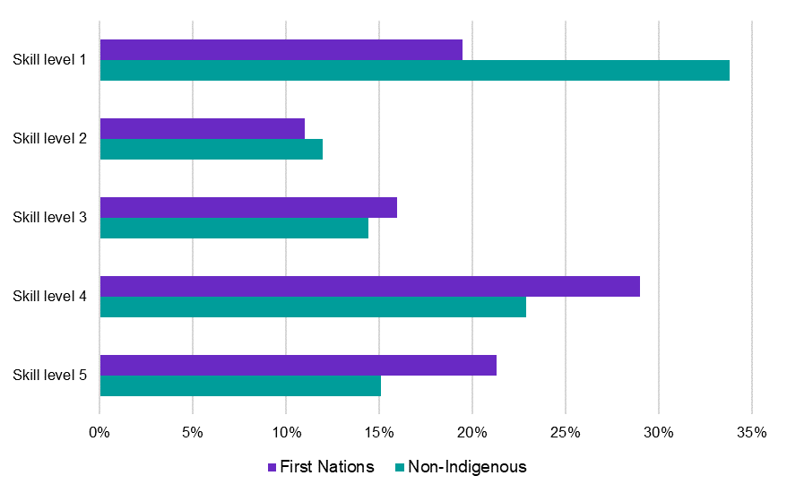

Source: Census of Population and Housing, 2021, TableBuilder.

Note: Skill Level 1 relates to bachelor’s degree or higher qualification; Skill Level 2 relates to Advanced Diploma or Diploma; Skill Level 3 relates to Certificate IV or III (including at least 2 years on-the-job training); Skill Level 4 relates to Certificate II or III; Skill Level 5 relates to Certificate I or secondary education.

This may be partly linked to lower levels of educational attainment among First Nations people. It can also be linked to the tendency for First Nations people to live in regional and remote areas which generally have a long history of entrenched labour market disadvantage characterised by persistently high unemployment and limited employment and training opportunities. JSA analysis shows that half (or 52%) of the First Nations working age population reside in regional or remote regions, well above the 22% recorded for all persons. This further highlights the significant, complex, and often interconnected barriers to employment faced by First Nations people (Jobs and Skills Australia, 2024a)

#### Key findings from JSA’s capacity studies

First Nations representation is typically lower for the workforces included in our capacity studies as compared to the broader labour force (with the Early Childhood Education and Care (ECEC) workforce an exception). For some workforces, this was also particularly noticeable for more highly skilled and more highly remunerated occupations. Recommendations across the studies relate to increasing the relevance of training pathways for First Nations people, but importantly they also include actions intended to increase the cultural safety and support of First Nations people working in, or impacted by, the sectors.

##### The Clean Energy Capacity Study

A smaller proportion of First Nations people work in Australia’s clean energy workforce than the broader labour force. Notably, a higher proportion work in the ‘transitioning segment’ (fossil-fuel related groups which will decline or transform substantially as a result of decarbonisation), including coal mining. An income gap was also observed for First Nations people in the clean energy workforce (Figure 13).

Figure 13: First Nations average income gap for selected critical occupations in the clean energy workforce

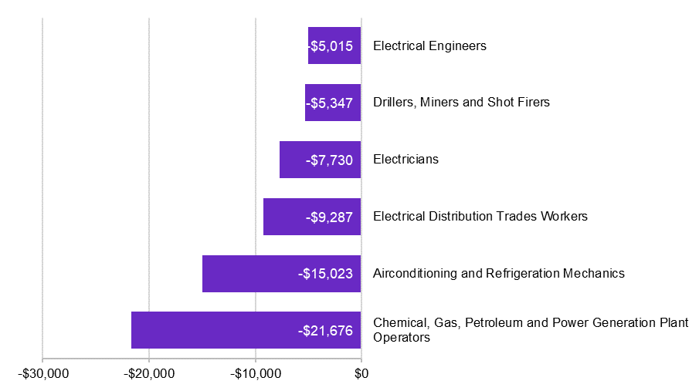

Source: JSA Clean Energy Capacity Study 2021; ABS Census of Population and Housing, 2021.

Growing the number of First Nations tertiary graduates will take time but is critical to ensuring First Nations employment in the clean energy sector does not mimic the trends of the transitioning sector in concentrating First Nations employment at the lower skilled and lower paid operational level of the workforce (Brereton & Parmenter, 2008).

##### The ECEC Workforce Capacity Study

In contrast to the clean energy workforce, a larger proportion of First Nations people are represented in the overall ECEC workforce than in the broader labour force. First Nations people are not as well represented across the more highly remunerated occupations in the sector, however.

First Nations children have a lower ECEC participation rate compared to non-Indigenous children (about 50% of 0-5 year old First Nations children attended ECEC in 2022 as compared to 60% of all children) (Commonwealth of Australia, Australian Competition and Consumer Commission, 2023b). Evidence suggests that critical factors for promoting the participation of First Nations children in ECEC services are the presence of culturally inclusive ECEC and the presence of First Nations educators (Biddle, 2007).

While there are a number of Aboriginal Community Controlled Organisations (ACCO) involved in the delivery of ECEC, well-supported, culturally safe opportunities for First Nations ECEC staff in non ACCO settings are less embedded in the ECEC sector and these opportunities should be assured.

The study recommended that Education Ministers should incentivise and include an explicit focus on Aboriginal and Torres Strait Islander Workforce both within ACCOs and across mainstream services and investigate sustainable funding for ACCOs. It also recommended that governments should formalise a process for ensuring the ECEC sector is given adequate guidance from First Nations peak bodies and representatives on strategies to promote the employment, cultural safety and support of First Nations people working in the sector.

##### The Food Supply Chain Workforce Capacity Study

First Nations employment is low across the food supply chain, particularly in skilled positions and senior level roles. The capacity study recommended potential actions that could assist by improving the relevance of tertiary education and training pathways for First Nations students including:

* financial support that includes industry funding for a First Nations scholarship in agricultural science, aquaculture sciences, or business
* the delivery of on-Country training programs for First Nations people that facilitate flexible career pathways
* supporting culturally inclusive learning, including recognition of First Nations people’s historical and continued contribution to agriculture and land management.

These recommendations alone, however, will not be enough to overcome the social and structural barriers still faced by First Nations people in Australia today. Meaningful inclusion of First Nations people in food supply chain sectors will need to include eliminating racism across industries, enhancing cultural awareness and safety in the workplace and wider recognition of traditional and cultural knowledges and practices. It will also require more First Nations involvement as employers, leaders and investors in the industry.

Findings from the VET workforce study relevant to outcomes for First Nations people have been included as part of chapter 4.

### Gender equality in the labour market

Women are participating in the labour market at higher rates than ever before. The gap between men’s and women’s labour force participation has been narrowing over time as outlined under the exploration of full inclusive employment. While this reflects that barriers to women’s labour force participation may have reduced over time, there is more work to do in closing the participation gap which remains at more than 8 percentage points (Commonwealth of Australia, 2023a).

#### Female part-time employment

Part-time employment is still more common for female than male workers, and this is prevalent across occupations, skill levels, and industries (Figure 14).

Figure 14: Female part-time employment

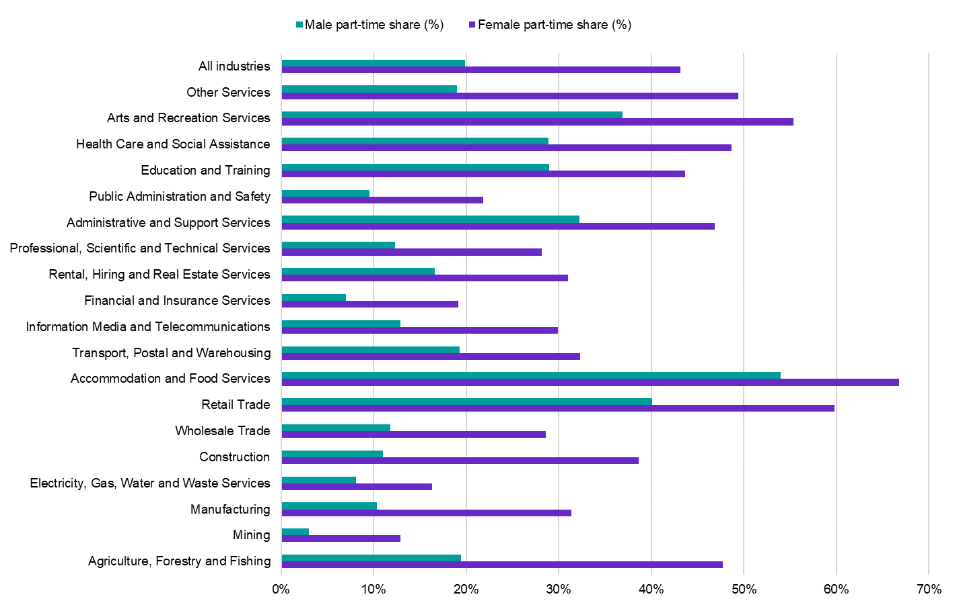

Source: ABS, Labour Force, Detailed, August 2024, four-quarter average of original estimates.

To fully understand this phenomenon, it needs to be explored in the context of potential barriers such as disincentives for secondary earners to participate in paid work (Commonwealth of Australia, 2023a), access to early childhood education and care, and societal norms and gender attitudes that may impact choice, behaviour, and outcomes (Commonwealth of Australia, Department of the Prime Minister and Cabinet, 2024b).

While it is important to ensure that all individuals who wish to or are able to transition from part-time to full-time work, it is important to acknowledge that part-time work can be a conscious choice or preference. Part-time work provides people with the flexibility to participate in the workforce while balancing other responsibilities and can be a factor in attracting workers to occupations in shortage. Many women also report that the ability to work part time is important for their participation in work (Commonwealth of Australia, 2023a). It is important to ensure that both men and women can access the working arrangements and flexibility that suit their needs and preferences, and to address the barriers that prevent them from doing so.

#### Gender imbalanced occupations are more likely to be in shortage

Societal and structural barriers to women’s workforce participation – particularly in relation to social norms and expectations – not only impact outcomes for women. Men experience stigma, bias, and other barriers to accessing flexible work arrangements or leave to manage caring responsibilities (Australian Institute of Family Studies, 2017), or to work in occupations more traditionally undertaken by women (Commonwealth of Australia, Department of the Prime Minister and Cabinet, 2024b).

Greater gender equality is also beneficial for the labour market. Based on results and analysis from the 2024 Occupation Shortage List (OSL), formerly known as the Skills Priority List, occupations that have a stronger gender imbalance in the labour market were also more likely to be in shortage (Figure 15)[6]. This is true for both male- and female-dominated occupations.

Half of all occupations where males make up at least 80% of the workforce were found to be in shortage, and 39% of occupations where females make up at least 80% of the workforce were in shortage. By contrast, only 22% of occupations with less gender skewed workforces (with more than 20% of either males or females) were in shortage.

Figure 15: Percentage of gender-imbalanced occupations that were in shortage (%), 2021-2024 OSL

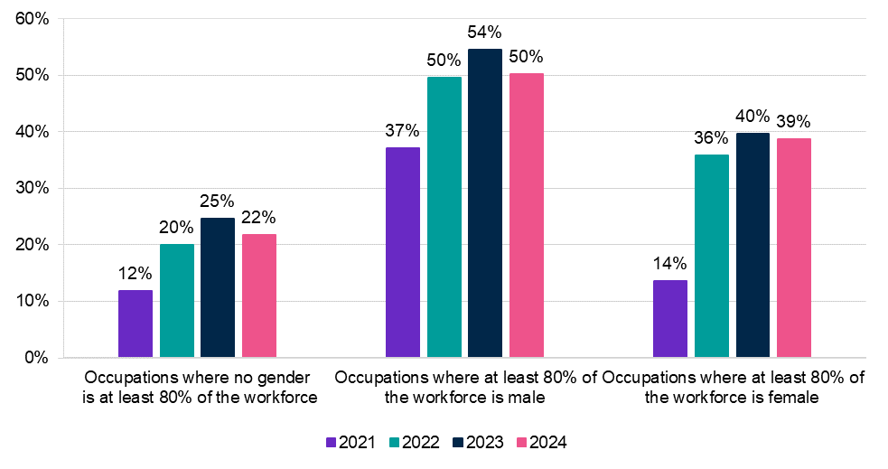

Source: Jobs and Skills Australia, *Occupation Shortage List,* 2021–2024.

Some examples of occupations where females make up the majority of the workforce include Registered Nurse, Aged or Disabled Carer, Primary School Teacher, Child Care Worker and Hairdresser. For occupations where males were the majority of the workforce, occupations in shortage were concentrated in the Technicians and Trades Workers, Machinery Operators and Drivers, and Labourers major groups. For example, in the Electrician (General) and Truck Driver workforces, more than 9 in 10 workers were men.

Many Information Communication and Technology-based occupations, within the Professionals major group, employed men predominately and were also in shortage. Some of these include Software Engineer and Developer Programmer, where more than 4 in 5 workers were male.

Several of the occupations mentioned above were also in persistent shortage (in shortage for at least 4 years). Some other occupations (not previously mentioned above) in persistent shortage include Carpenter (99% male) and Personal Care Assistant (86% female).

Heavily gender-skewed workforces may inadvertently constrain the labour supply, thereby increasing the likelihood of entrenched shortages. Addressing the gender imbalance of occupations is a sound long-term strategy to mitigate occupation shortages in the labour market and pathways to doing so should be further explored.

|  |
| --- |
| Making progress on the number of female electricians JSA’s 2023 Clean Energy Capacity Study identified that Australia will need an additional 32,000 electricians by 2030, and that one of the most important pathways to achieving this growth is to increase the number of women undertaking trade apprenticeships.  There has been strong growth in the number of female apprentices since 2017, who made up around 8% of all electrical apprenticeships in the first quarter of 2024, up from 2% a decade ago (Figure 16). Of note:   * In Western Australia and Queensland this share was above 10%. * Females make up a larger share of electrical apprentices in regional and remote Australia compared to metropolitan areas. * Large employers (500+ employees) are much more likely to hire female apprentices than small or medium employers.   Figure 16: Female electrotechnology apprenticeship commencements  This chart shows strong growth in the number of female electrical apprenticeship commencements. It starts at 83 commencements in 2003 (1% of all commencements) and reaches 1,090 in 2023 (7% of all commencements).  Source: Jobs and Skills Australia’s analysis of NCVER 2024, Apprentices and Trainees data.  Note: Data for 2024 only includes commencements from January to March.  From 2013 to 2023 there was also strong growth in the female share of commencements in other critical clean energy apprenticeships. These include Mechanical Engineering Trades Workers (up 8 percentage points), Electrical Distribution Trades Workers (up 7 percentage points) and Automotive Electricians (up 6 percentage points).  JSA’s capacity study made a number of recommendations to improve commencements, completions and experiences of female apprentices. This includes targeted financial incentives and opportunities to improve peer support networks by clustering female students in workplaces and classrooms. In response to JSA’s report, the government is:   * reviewing the Australian Apprenticeship Incentives System * expanding eligibility criteria for the New Energy Apprenticeships Program * reimbursing Group Training Organisations that reduce their fees for small and medium enterprises engaging in clean energy, manufacturing and construction industries * establishing climate careers promotion activities across government, industry, civil society, and the education and training sector * establishing the Building Women’s Careers Program to advance structural and cultural change that improves women’s access to inclusive training and work opportunities in key male-dominated industries and sectors. |

### Income volatility as an indicator of insecure work

One of JSA’s responsibilities is to provide advice on the impact of workplace arrangements, including insecure work, on social and economic outcomes. While there is no formal Australian definition of what constitutes insecure work, definitions tend to include aspects such as unpredictable and fluctuating pay; lack of access to paid leave, employment entitlements, and other protections; limited bargaining power; irregular working hours; and lack of job security (ACTU, 2012).

Insecure work occurs in a range of situations in the labour market but can be problematic when it is used as a substitute for what could feasibly be ongoing direct employment. The Senate Select Committee on Job Security heard evidence that insecure work causes ongoing uncertainty and financial insecurity which can impact physical and mental health (Commonwealth of Australia, 2022).

Since the introduction of Single Touch Payroll (STP) in 2019 it has become possible to measure one of the indicators of insecure work – fluctuating pay (ACTU, 2012), as well as the number of jobs a person has, and which is their highest earning job.

Importantly, however, while fluctuating pay is an indicator of insecure work, it alone does not mean a person is in insecure work. For some workers, jobs with fluctuating pay are a conscious choice that allows them to manage their lives, goals, and responsibilities. Fluctuating pay can also be a normal feature of some secure jobs - for example through overtime hours.

JSA has developed a metric of income volatility defined as the proportion of the total time employed when an employee experiences a change (either increase or decrease) in income of at least 25% as compared to the previous week. For example, if a person experiences 5 weekly changes in income, greater than 25%, over a period of 50 weeks, that person has income volatility of 10% (5 divided by 50)[7]. The median figures for all jobs are expressed in this section[8].

We propose a next step would be correlation analysis to identify the relationship between income volatility and job tenure since this might predict potential shortages in occupations where income volatility is prevalent. STP phase 2 requires employers to report on the employment status of employees (e.g. full time, casual, labour hire) (Australian Taxation Office, 2024). When this data becomes available in PLIDA, JSA will also analyse how this additional aspect of insecure work impacts workers and interacts with fluctuating pay.

#### Key findings

Compared to employees in jobs with stable incomes, employees who experienced more income volatility in a job, tended to earn less annual income and remained in that job for shorter periods of time. Those who have more than one job experienced higher volatility in their additional jobs outside of their main job (their highest earning job) and remained in these jobs for shorter periods.

Over time, the median volatility for employees in their highest earning job went from 7.7% in 2020–21 up in the following financial year to 9.1% in 2021–22 and down to 7.9 % in 2022–23. In other words, in 2022-23, half of reported employees only experienced income volatility, at most the equivalent to 4 weeks per year (7.9% of 52 weeks).

#### Gender analysis

In their highest earning job, females experienced marginally higher median volatility than males in 2022-23. When this is combined with a lower median weekly income, it equates to an average annual income difference of $23,300[9] per annum less for female employees.

For females, second and other jobs provide a more extreme picture to that shown for highest earning jobs. In 2022-23, female employees were more likely than male employees (29% as compared to 26%) to have more than one job, and female employees were more likely to experience income volatility in their second and other jobs than male employees.

Female employees in their secondary jobs will also experience a longer period of volatility equivalent to a median of 12 weeks in a year (23.8% of 52 weeks) compared with 9 weeks in a year for male employees. This is combined with a median weekly income for females equating to approximately 56% of the male median weekly income, or an average total income for females that is approximately 69% of that of male employees.

As a possible next step, JSA will need to investigate the working arrangements in the industries where women work secondary jobs and compare income volatility for men employed in the same industries. While information on second occupation is not available, industry and locality of work can be investigated.

#### First Nations workers

Compared to all employees, in 2022-23, First Nations workers[10] were more likely to be employed in two or more jobs, and more likely to experience income volatility in their highest earning job. They experienced income volatility equivalent to nearly 7 weeks in a year, compared to around 4 weeks or 7.9% for all employees, and received less annual income (an average total income of $49,429 per annum as compared to $63,581 for all employees).

When second and other jobs are considered, First Nations workers were *less* likely to experience volatility than in their main job (29% of First Nations workers employed in two or more jobs throughout 2022-23 experienced no income volatility in their second and other jobs, as compared to 16% in their highest earning jobs). For those who did experience volatility, however, the period of volatility was greater. First Nations workers who experienced volatility in their second and other jobs experienced a median volatility equivalent to 13 weeks in a year (25% of 52 weeks).

### International students

International students enrich Australia’s campuses and communities by bringing cultural diversity and sharing new ideas and perspectives. International graduates have also become an important contributor to Australia’s permanent migration program. In addition to their rich civic, social, and cultural contributions, permanent skilled migrants, including students securing permanent skilled visas, are projected to contribute approximately $3 million each to the Australian economy over their working lives (Commonwealth of Australia, 2023b). In the 2023 calendar year, international education was worth $47.8 billion to the Australian economy, including education export income of $31.8 billion for the higher education sector and $11.1 billion for the VET sector (Commonwealth of Australia, Department of Education, 2024).

The Review of the Migration System found that international graduates’ employment outcomes are not commensurate with the qualifications they have completed (Commonwealth of Australia, 2023b). The Government’s Migration Strategy subsequently recommended that JSA undertake study to consider the barriers limiting international graduates from transitioning into the skilled workforce, which would support ongoing consideration of how the sector’s value to Australia can be safeguarded and maximised. Interim work on the study has explored the student population, examined pathways to participation in the permanent workforce, and observed the outcomes graduates achieve. Consideration of the interim findings of the study is underway to deliver a final report.

#### Exploring and defining the international student population

The shape and demographic profile of Australia’s international student cohort has been changing over the past decade. While the top 10 source countries have been stable over that period, enrolments are shifting away from being dominated by Chinese students toward South Asia. Enrolments from India, Nepal and other South Asian countries have been increasing in both higher education and VET courses (Figure 17).

Figure 17: Relative change in the proportion of international student enrolments since 2012, by level of qualification

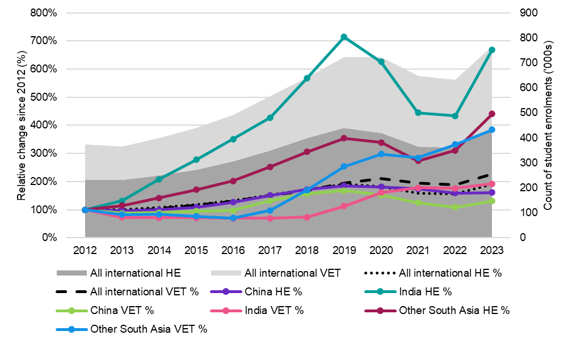

Source: Department of Education, PRISMS data, 2024.

#### Student aspirations and patterns of visa use

When choosing Australia as a destination, international students have indicated that work and migration opportunities are important considerations. As part of the study’s qualitative research, international students reported that at times these aspirations may be ahead of education aspirations. In considering how these aspirations manifest in behaviour, the study identified a correlation between course choices for higher education and VET international students with requirements for skilled and permanent migration visas. This correlation requires further investigation, including more detailed analysis of patterns of student behaviours observed by the study, including:

* responses by students collected during JSA qualitative research and to surveys undertaken as part of the Quality Indicators for Learning and Teaching (QILT) program
* the favouring of VET courses that can be offered flexibly and cheaply with no mandatory work placements
* the favouring of VET and higher education courses that support permanent residence outcomes
* evidence of students packaging courses to extend stay and achieve the Australian Study Requirement
* visa use patterns that that support aspirations for permanent residence status.

#### Barriers faced by international students and graduates

The study has observed that international VET students and graduates face more difficult visa pathways than higher education students and graduates but appear to experience better outcomes in the workforce. That is, they experience employment outcomes that better align with the skills and qualifications they have attained. However, despite better matching between employment and qualifications, VET students and graduates face significant barriers. These barriers include lower visa grant rates compared to higher education applicants and shorter VET courses that are not well suited to meeting the Australian Study Requirement. Post-study, potential barriers include that the Temporary Graduate Visa (TGV) Post-Vocational Education work stream has a more limited 18-month duration than the two- and three-year Post-Higher Education Work stream and is constrained by occupation and other required activity. It may take longer, with more visa transitions, for VET applicants to achieve permanent residence.

International graduates from both VET and higher education pathways also face barriers to skilled employment post-study, including securing employment in their field and qualification level and earning less than their domestic counterparts (Figure 18). As part of JSA’s qualitative research, employers reported a reluctance to recruit temporary visa holders in skilled roles. Employers indicated that international graduates often did not have sufficient English proficiency or Australian cultural experience to enable them to confidently perform in the workplace. It is important to note that the English language requirements for the TGV were strengthened in March 2024 to protect vulnerable community members from exploitation and support graduates to succeed in the labour market. The study also heard that international students need to work to live while studying, and taking time off to participate in non-mandatory work placements, which might promote language and cultural proficiency, is difficult.

Figure 18: Median annual income of fulltime employed domestic graduates and Temporary Graduate visa holders, aged between 20-34 years, by VET and HE in 2021

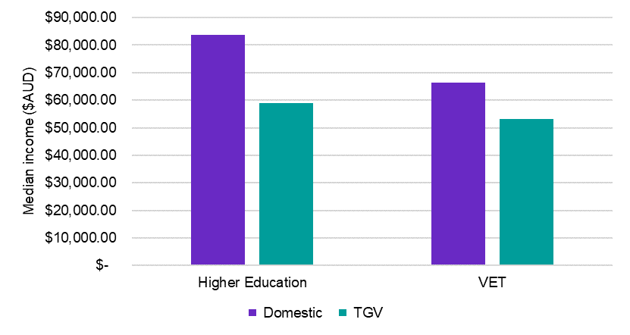

Source: Jobs and Skills Australia’s analysis of ABS, Australian Census and Temporary Entrants Integrated Dataset (ACTEID), 2021 – primary applicants.

Note: Domestic refers to Australian Citizens, employed full time, highest level of education attained, aged 20-34 years, measured 2021. ABS Australian Census. TGV refers to 485 temporary graduate visa holders, employed full time, primary applicants, highest level of education attained, aged 20-34 years, measured 2021, ABS Australian Census and Temporary Entrants.

Further examination of the impact of the barriers, including how educational experiences prepare work-ready graduates, is required to determine how to better support international graduates to transition more successfully to the skilled workforce.

The study’s observations are also largely based on data which pre-dates the Government’s changes to the Temporary Skill Shortage (TSS) visa work experience requirements, and the Government’s increase to the Financial Capacity Requirement for Student and Student Guardian visas. If the analysis was undertaken in future after these recent policy changes have fully flowed through to observed behaviours and data, we may observe different patterns emerging.

## The role of education and training

Education is not only a pathway for individuals to learn the skills for the jobs they want. It helps people to participate in society, develop the reasoning and judgement skills to find solutions to problems, and to live the lives that they want. Access to education and training is an important factor in increasing inclusivity as it can improve outcomes for individuals in terms of the workforce, health and wellbeing, and life satisfaction (OECD, 2016).

### Foundation skills

Foundation skills – like the ability to read, write, and engage with technology – directly impact a person’s economic and social wellbeing because they underpin successful participation in society and community, education and training, and the workplace. Data has suggested that around one in 5 Australians have low literacy and/or numeracy skills (OECD, 2017), but the most recent national data available on adult foundation skills is the OECD’s PIAAC survey which was last conducted in Australia in 2011/12. This is why JSA is currently undertaking 3 major pieces of work to better understand the foundation skills levels of Australian adults – the administrative data project, the national survey of adult literacy and numeracy skills, and the Murtu Yayngiliyn study.

The administrative data project explores personal level integrated data to uncover new insights on the literacy and numeracy levels of priority groups of interest (women, First Nations people, people from a culturally and linguistically diverse background, and people with disability). To date, the project has largely collected data from Australian government skills training programs and a demographic profile will be analysed for each dataset to understand who is participating in foundation skills programs. The project has found that no single administrative dataset can provide a detailed understanding of the foundation skills level of Australian adults, but good administrative data exists for the education sector, Job Seekers, and programs specific to uplifting low levels of foundation skills. Key data gaps include data for the most disadvantaged Australians who experience barriers such as access, capability, or confidence to participate, employed people and those not seeking work who are not in the education system, and people with the highest levels of foundation skills. A report on this element of the project is being prepared and is expected to be published by the end of 2024, and the next steps for the project include investigating Foundation Skills within the education sector.

The national survey of adult literacy and numeracy skills, known as *Understanding Skills Across Australia*, will measure adult literacy and numeracy levels and form an up-to-date national evidence base to assist researchers, policy makers and program managers to improve services related to foundation skills. The survey will provide reliable literacy and numeracy results at the national and state and territory levels and will use the OECD’s literacy and numeracy skills assessment tool *Education and Skills Online*, allowing comparison with other literacy and numeracy data sources.

Several rounds of survey testing have recently been completed, including a field trial, with results currently being used to update and refine the survey before main data collection next year. JSA is continuing to consult with stakeholders through the study’s steering committee and the survey’s advisory group, and final results are expected in 2026.

#### Murtu Yayngiliyn – Walking Together

The Murtu Yayngiliyn study has been developed in response to an absence of a contemporary and cohesive national data set on First Nations people’s foundation skills. Policies and programs to build the skills pipeline, and the Australian Government’s broader commitment to ensure no one is left behind and no one is held back, mean an evidence base on foundation skills for First Nations people is essential.

In consultation with the National Indigenous Australians Agency, JSA is undertaking a feasibility study to determine how best to assess the literacy, numeracy, and digital literacy levels of First Nations people including those living in regional and remote areas, in a culturally safe, responsive, and statistically sound manner. The proposed study is critical to the delivery of policy and services in skills and training, employment, education and First Nations equity.

Literacy, numeracy and digital literacy (foundation skills) are critical skills for individuals, necessary in all parts of their lives for meaningful work and active participation in the community, and are determinate to the health, social, and economic wellbeing for First Nations people. Strengthening foundation skills for First Nations people is a target for the Australian Government aligning to the National Agreement on Closing the Gap.

A First Nations Cultural Advisory Panel has been established to provide governance, advice and guidance to the study.

Recommendations from the study will enable governments and the community sector to better understand First Nations people’s foundation skills needs and to implement strategies to address them.

### VET as an enabling pathway

VET may serve as an important pathway for advancing inclusive participation in the labour market – positively impacting employment rates, income levels, and the pursual of further study at a higher level.

Analysis of 2019-20 graduates’ outcomes from the VNDA, a joint project undertaken in partnership between JSA and the Australian Bureau of Statistics in collaboration with the National Centre for Vocational Education Research, shows that completion of a VET course may contribute to an increase in employment, with 84% of graduates employed post-training compared with 69% employed before commencing their studies. As shown in Table 1, nationally there was a similar rise in employment for all students, including for First Nations students and people with disability. The post-completion employment rate was also higher for female students than for all VET students.

Table 1: Employment rate after completion of VET

|  |  |  |  |  |
| --- | --- | --- | --- | --- |
| Measure | National | Females | First Nations people | People with disability |
| Employment rate after completion (%) | 84% | 83% | 79% | 65% |
| Change in employment rate (percentage points) | 15 percentage points | 17 percentage points | 16 percentage points | 14 percentage points |

Source: Personal Level Integrated Data Asset (PLIDA), 2002-2022, VET National Data Asset, ABS DataLab. Findings based on use of PLIDA data.

Completion of a VET qualification also likely contributed to a medium income uplift for graduates of $11,800. The uplift was higher for First Nations graduates at $13,000. There was also an increase for females ($11,400) and people with disability ($9,100), although these were lower than the national figure. The top courses for uplift in employee income are predominantly in the fields of Engineering and Related Technologies, and Architecture and Building, demonstrating the importance of VET training in these areas.

Completion of VET training may also contribute to the pursual of further study. As outlined in Table 2, a greater proportion of First Nations students, females, and people with disability who had completed VET training went on to pursue further VET programs at a higher level, compared with the national figure. For females, a greater proportion than the national figure also went on to pursue higher education through university. This may point to the relevance of VET as enabling pathway for historically disadvantaged cohorts to access more opportunities to participate, access safe and secure work, and thrive.

Table 2: Further study outcomes at the national level and by cohorts

|  |  |  |  |  |
| --- | --- | --- | --- | --- |
| Measure | National | Females | First Nations people | People with disability |
| Progression to further VET (%) | 16% | 18% | 20% | 21% |
| Progression to Higher Education (%) | 8% | 10% | 5% | 7% |

Source: Personal Level Integrated Data Asset (PLIDA), 2002-2022, VET National Data Asset, ABS DataLab. Findings based on use of PLIDA data.

Another measure that can be used to help assess the impact of the VET system is the proportion of students that leave the income support system after their training is completed. Of the students that were on income support prior to study, 39% were no longer on income support two years after the completion of their VET course. This shows the likely contribution of the VET system in providing students with a pathway off income support and into the workforce. However, this proportion was lower for females (36%), First Nations students (34%) and students with disability (22%), highlighting that there is still work to be done in improving the outcomes of these cohorts (Table 3).

Table 3: Income support exit rate at the national level and by cohorts

|  |  |  |  |  |
| --- | --- | --- | --- | --- |
| Measure | National | Females | First Nations people | People with disability |
| Income support exit rate (%) | 39% | 36% | 34% | 22% |

Source: Personal Level Integrated Data Asset (PLIDA), 2002-2022, VET National Data Asset, ABS DataLab. Findings based on use of PLIDA data.

## In summary

Understanding and tracking progress towards an inclusive full employment objective can be aided by understanding developments around a broad suite of measures that go beyond an examination of the unemployment rate in isolation.

Reflecting the softening in labour market conditions that has occurred over the past year, it is not surprising to note that some full employment indicators have weakened slightly over the period but are still tracking well by historical standards.

Encouragingly, some indicators of *inclusive* full employment have improved over the last year – although more work needs to be done so the benefits of growth can be shared more equitably across a number of disadvantaged groups.

There have been improvements in outcomes for many cohorts. First Nations employment levels have improved, and women are participating in the workforce at higher levels than ever before. Indicators such as the employment share of lower-skilled occupations and incidence of part-time employment, however, show that there is more work to be done to achieve true equality in the workforce and that barriers to participation persist. Income volatility also exists for many Australians, which is an indicator of insecure work.

JSA is undertaking a range of projects to better understand the barriers to full participation including an international students study and work to better understand the foundation skills levels of Australian adults.

Education is an important enabler of successful participation in the workforce and society as a whole. VET pathways may be attractive options for groups that have historically experienced labour market and other disadvantage given the barriers to access can be lower in terms of cost, time, and entry requirements. Completion of VET training may contribute to higher levels of employment, income uplift, and pathways to undertaking further training at a higher level.

Continued monitoring and exploration of the indicators of full inclusive participation will be important in measuring progress and developing beneficial interventions to break down social and structural barriers. JSA will continue to undertake relevant research and analysis to support and inform better understanding of persistent issues and possible solutions.

# 

# Chapter 2: Understanding today’s workforce

A contemporary skilled workforce is critical for delivering for Australia today and into our future, and a truly inclusive economy ensures that all Australians who want a job can find one without searching for too long. Accurate and timely labour market insights enable employers, individuals, and governments to make good decisions about hiring, study, job transitions, policies, and programs that benefit our people, businesses, and the economy.

This is why a key strategic function for JSA is to provide labour market information and analysis. Our enabling legislation outlines that a part of our role is to:

* identify labour market imbalances and analyse the demand and supply of skills
* analyse skills needs and workforce needs, including in regional, rural and remote Australia, and in relation to migration
* provide advice on Australia’s current and emerging labour market, including advice on workforce needs and priorities
* provide advice on Australia’s current, emerging and future skills and training needs and priorities (including in relation to apprenticeships, VET and higher education).

JSA’s intelligence can enable Australians to better understand the realities of today’s labour market, the opportunities present under current conditions, and the skills required to realise them. This chapter outlines key evidence about the economy and labour market over the past year, including skills shortages, their drivers, and the picture for Australia’s regions.

Key themes in this chapter:

* Despite significant economic challenges, the Australian labour market has remained reasonably tight - although the unemployment rate has drifted up over the last year.
* While the labour market outlook remains a little uncertain, a number of partial forward indicators of labour demand continue to point to a softening in labour market activity in the period ahead.
* Skills shortages in the labour market are persistent, but the driving factors are varied and require different responses.
* Our regions continue to face unique challenges, and categorising regional labour markets can help inform and target policy responses.

## The big picture – Australia’s labour market today

The Australian labour market has displayed remarkable resilience against the backdrop of significant economic headwinds generated by the COVID-19 pandemic that commenced in March 2020. Nevertheless, we continue to face considerable economic challenges and some uncertainty around the economic and labour market outlook.

Following the height of the COVID-19 pandemic, most major economies around the world experienced an increase in the rate of inflation. In Australia, the CPI index rose by 7.8% over the year to December 2022, the highest increase recorded since March 1990. More recently, the rate of inflation has begun to decline, with CPI rising by 3.8% in the year to June 2024, noting it remains above the Reserve Bank of Australia (RBA) inflation target band of between 2.0% to 3.0% per annum (Figure 19).

|  |  |
| --- | --- |
| Figure 19: Inflation  A bar chart showing the annual change in the ABS Consumer Price Index (a measure of inflation) as compared with the RBA Inflation Target band of 2% to 3%. The findings show that in recent years inflation has risen above the RBA target band and stood at 3.8% in the year to June 2024.  Source: ABS Consumer Price Index, June 2024 and RBA Inflation Target. | Figure 20: Wages  A line chart showing an index of real wages in Australia (estimated using the ABS Wage Price Index and ABS Consumer Price Index) from 2004 to 2024. The findings show that real wages have declined in recent years to stand at a level in June 2024 that was equivalent to the level recorded in 2010, noting that real wages have stabilised in recent periods.  Source: ABS Wage Price Index and Consumer Price Index, June 2024. |

Initially, wages struggled to keep up with inflation, falling (in real terms) to the equivalent of 2010 levels (Figure 20). More recently, wages growth has picked up, recording annual nominal growth exceeding 4.0% for four consecutive quarters for the first time in 15 years, with growth in award wages particularly strong (Reserve Bank of Australia, 2024).

Nevertheless, the rate of economic growth has slowed considerably, with GDP rising by just 1.0% over the year to June 2024 (and declining by 1.5% over the period in per-capita terms). Despite these challenging economic conditions, the Australian labour market has remained reasonably tight and the pace of jobs growth has been strong over the last year.

For instance, ABS Labour Force Survey data show that the level of employment has risen by 374,200 (or 2.7%) over the period, to stand at a record high of 14,458,600 in August 2024, above the decade annual average growth rate (of 2.3%). That said, the pace of annual employment growth has eased from the robust rates recorded in late 2022 and early 2023.

With respect to the composition of employment growth, full-time employment has increased by 164,200 (or 1.7%) over the last 12 months, to 9,979,100 in August 2024, while part-time employment has risen by 209,900 (or 4.9%), to a record high of 4,479,500.

* While the annual rate of growth in full-time employment has picked up recently (from a low of 0.6% in May 2024), it remains below its decade average rate, of 2.2%, and is significantly lower than the current pace of annual part-time employment growth.

Against the backdrop of a resilient labour market, aggregate hours worked has also improved somewhat over recent months and has risen by 32.8 million hours (or 1.7%) over the year to August 2024. Nevertheless, it remains below the current pace of annual employment growth (of 2.7%) – as in Figure 21.

Figure 21: Annual change in employment and aggregate hours worked (%), August 2019 to August 2024

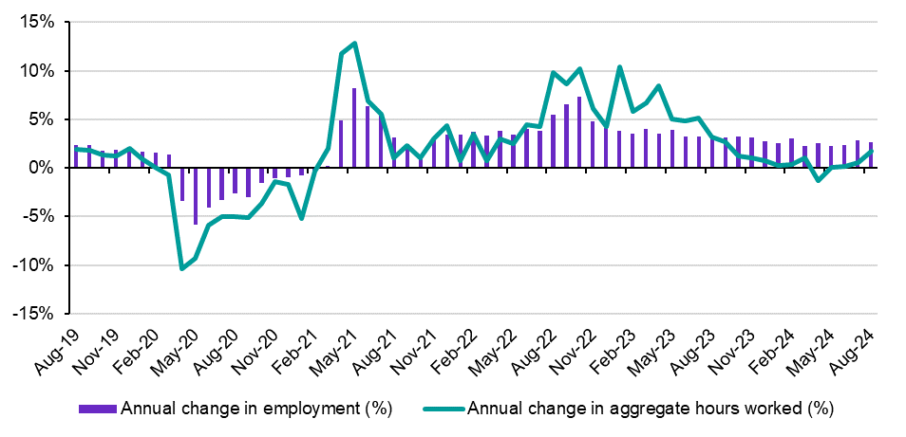

Source: ABS, Labour Force, Australia, August 2024, seasonally adjusted data.

Note: Annual percentage change is defined as the observation from the current month minus the observation from the equivalent month of the previous year, divided by the observation from the equivalent month of the previous year.

The unemployment rate has increased over the year, from 3.7% in August 2023, to 4.2% in August 2024, although this has occurred in conjunction with a 0.4 percentage point rise in the participation rate over the period, to an equal record high of 67.1% in August 2024. These results suggest that the gradual increase in the unemployment rate has been due, predominantly, to stronger growth in labour supply. While labour demand has softened somewhat, employers appear to be choosing, at least in the first instance, to reduce hours worked instead of laying off workers.

In line with the recent improvement in aggregate hours worked and pick-up in the pace of full-time jobs growth, the underemployment rate has decreased slightly, from 6.6% in August 2023, to 6.5% in August 2024, although it remains above the recent trough of 5.9% recorded in February 2023.

The *level* of underemployment, however, has risen by 14,100 (or 1.5%) over the last year, to stand at 975,600 in August 2024.

Conditions for young people (15-24 years) have been more mixed over the year, with the level of employment increasing by 42,300 (or 1.9%) over the period, below the decade average annual growth rate, of 2.1%. Moreover, the rise in employment for youth was due, entirely, to a robust increase in part-time jobs (up by 138,900 or 11.8%), while full-time employment decreased strongly, by 102,700 (or 10.2%) over the period[11].

Against the softer backdrop for the cohort, the youth unemployment rate rose significantly, from 8.3% in August 2023, to 10.0% in August 2024. In addition, the youth participation rate decreased over the year, by 0.1 percentage points, to 70.8% in August 2024. The easing in labour market conditions for youth reflects the fact that young people can be particularly vulnerable during periods of labour market softness, as they tend to have less education, skills and experience than their prime-age counterparts.

Similarly, the number of people who were long-term unemployed increased by 26,100 (or 24.3%) over the year, to stand at 133,200 in August 2024, and is now at its highest level since June 2022. It is also worth noting that long-term unemployment is 45,900 (or 52.6%) above the recent trough of 87,300 recorded in April 2023.

Going forward, a number of partial indicators of labour demand continue to point to a further easing in labour market activity in the period ahead, consistent with the Government’s official economic forecasts from the 2024-25 Budget.

For instance, while JSA’s Internet Vacancy Index (IVI) shows that online job advertisements increased by 4.8% (or 10,600 job advertisements) over the month, to 231,200 in August 2024, they are 16.9% (or 47,100) below the level recorded a year ago. That said, vacancies remain at relatively high levels historically.

In addition, results from JSA’s Recruitment Experiences and Outlook Survey (REOS) show that recruitment activity[12] declined by 1 percentage point over the month, to 43% of employers in August 2024, and is 3 percentage points lower than a year ago.

Consistent with trends in labour market conditions mentioned above, data from the Survey of Employers who have Recently Advertised (SERA) showed that employers were finding it easier to fill advertised roles. The percentage of advertised vacancies filled (the fill rate) increased to 69.5% in June 2024, from 59.4% in June 2023. Moreover, the number of total applicants, qualified applicants and suitable applicants per vacancy increased in 2023-24 compared to 2022-23. In particular, the number of total and qualified applicants per vacancy increased by 8.1 and 1.9 persons per vacancy, respectively.

Against the backdrop of challenging economic conditions, it is more critical than ever that our responses and interventions are inclusive (particularly for those who are most vulnerable in the labour market), joined up, and help to ensure that more Australians can participate to the best of their ability.

## Understanding labour market shortages

The structure of Australia’s labour market has changed over the past few decades. Health Care and Social Assistance is now the largest employing industry, while in 1994 it was Manufacturing. There has also been a trend toward service-based industries as well as higher-skilled occupations (Figure 22 and Figure 23).

Figure 22: Industry share of total employment 1994 and 2024, grouped by ‘Service Industries’ and ‘Producing Industries’

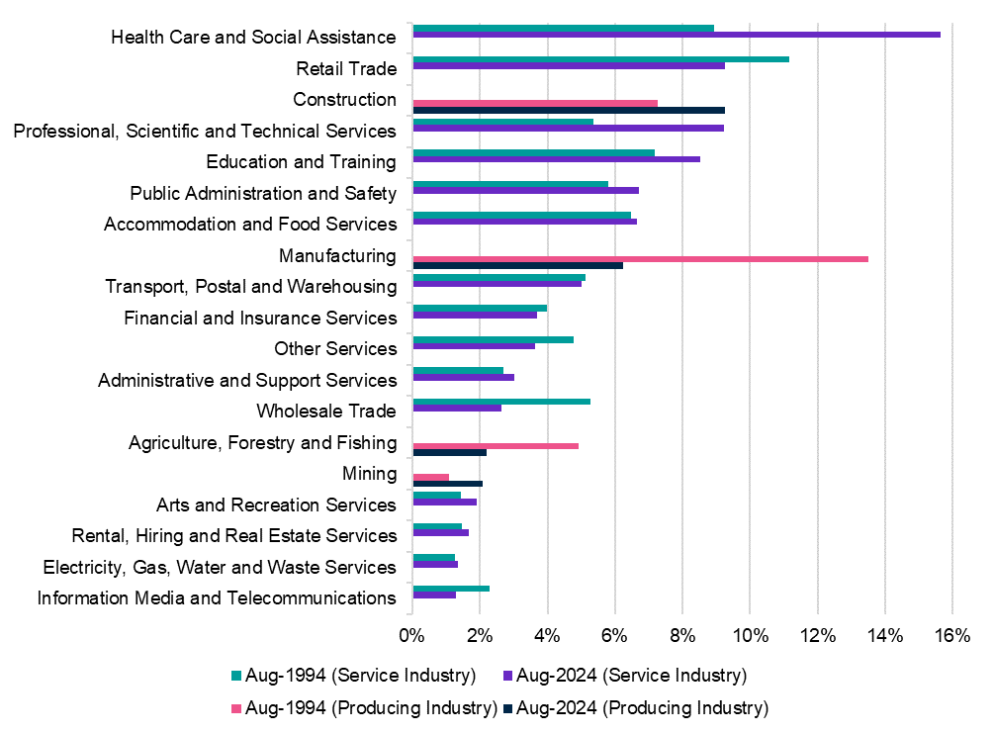

Source: ABS, Labour Force, Detailed, August 2024, data trended by Jobs and Skills Australia.

Figure 23: Change in share of employment 1994 and 2024 (skill level)

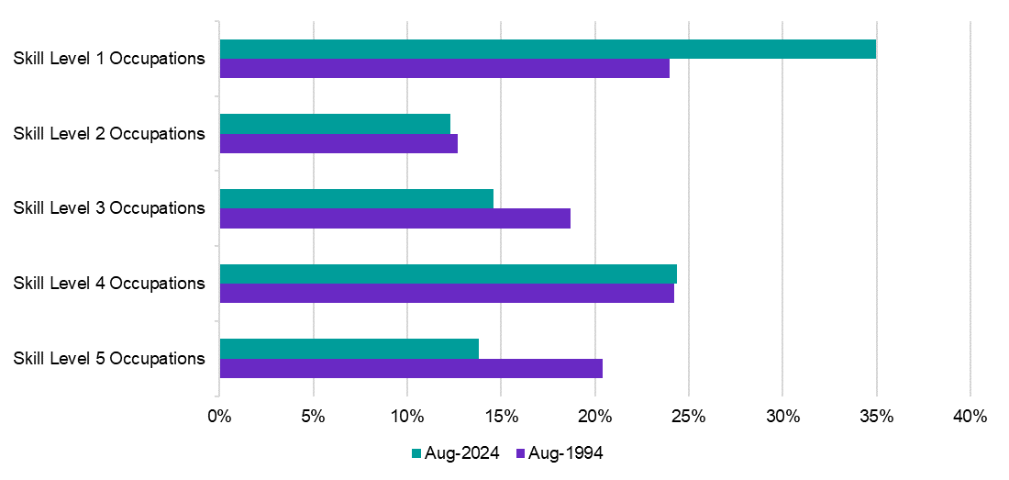

Source: ABS, Labour Force, Detailed, August 2024, data trended by Jobs and Skills Australia.

These broad trends are also reflected in the proportion of occupations found to be in shortage from 2021-2024, which indicated a higher demand for skilled workers across industries, with a large proportion in both Health Care and Social Assistance and Other Services encompassing a broad range of service-based occupations.

Occupations are considered to be in shortage when employers are unable to fill or experience considerable difficulty filling vacancies for that occupation or cannot meet specialised skill needs within that occupation. This difficulty must also be experienced at current levels of remuneration and conditions of employment, and in reasonably accessible locations. Based on this, the primary measure of an occupation shortage is the ability of employers to fill vacancies (fill rate).

### Prevalence of shortages in higher skilled occupations

Against the backdrop of current labour market conditions, the percentage of occupations in shortage has declined in Australia[13]. As shown in the 2024 OSL, 33% of occupations (303 out of 916 assessed occupations) are in national level shortage (Figure 24). This is 3 percentage points less than the result in 2023 (36%) but is 1 percentage point higher than the 2022 result (32%).

Figure 24: Percentage of occupations in shortage (%) in 2021 to 2024 OSL

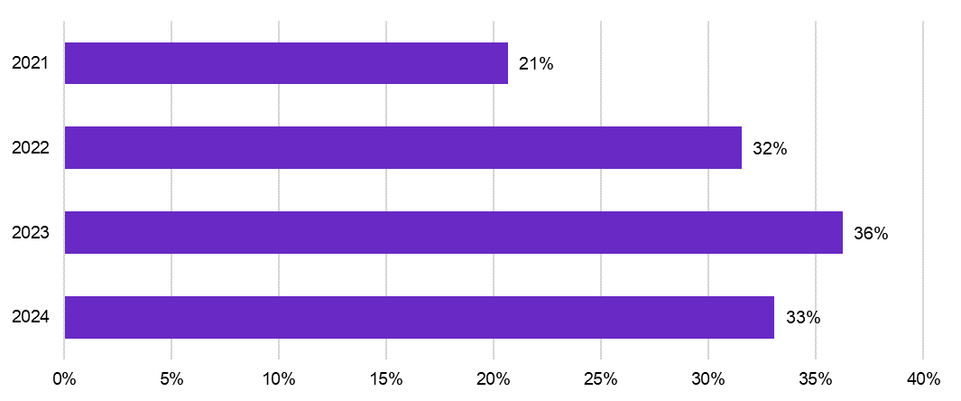

Source: Jobs and Skills Australia, Occupation Shortage List, 2021–24.

The easing labour market conditions primarily impacted on the major groups which have a higher concentration of lower skill level occupations. In 2024, occupations in shortage within the Machinery Operators and Drivers and Labourers were respectively 10 percentage points and 18 percentage points lower than in the 2023 OSL.

The recruitment difficulty rates for higher skilled occupations (Skill Levels 1–3), remained mostly elevated over 2023 and parts of 2024, while below the peak recorded in the second half of 2022. In contrast, the recruitment difficulty rates for lower skilled occupations (Skill Levels 4–5) fell over the same period. This is evident when viewing occupations in shortage by skill level (Figure 25).

Figure 25: Percentage of occupations in shortage (%), by Skill Level, 2021–24

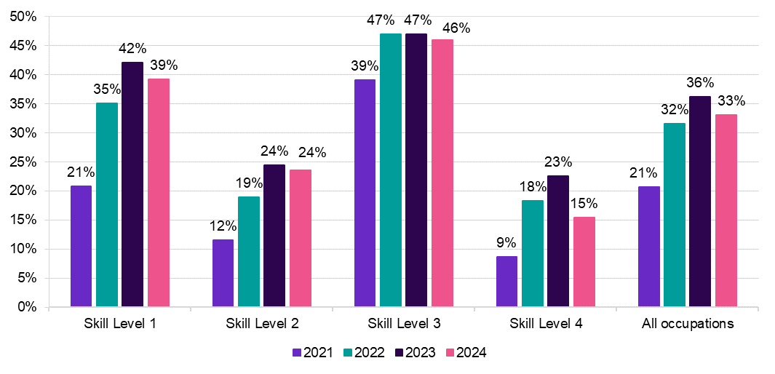

Source: Jobs and Skills Australia, Occupation Shortage List, 2021–24.

Compared to 2023, the percentage of occupations in shortage for Skill Level 4 were lower in 2024 by over 7 percentage points; that is, it fell from 23% to 15%[14]. However, Skill Level 1 and 3 occupations in shortage remain largely elevated (39% and 46%, respectively). The results reflect the large percentage of Professionals and Technicians and Trades Workers occupations in shortage in 2024. That is, occupations with higher education and VET as the primary pathway to the labour market had a larger percentage of occupations in shortage.

### Importance of shortages

The OSL percentage of occupations in shortage are based on the count of occupations in shortage relative to the total number of occupations assessed. This calculation treats all occupations equally regardless of their employment size or growth. For example, cyber security roles have shown rapid employment growth due to increasing demand, whereas occupations like Printing Table Worker have seen negative growth due to technological advances. Therefore, the total number and percentage of occupations in shortage may be skewed by a large number of very small employing occupations, or by occupations with declining employment.

#### Occupations in shortage, accounting for employment size and growth

Employment levels from 2021 ABS Census of Population and Housing (ABS Census) were incorporated into the 2021 to 2024 OSL shortage results to better gauge implications of larger or growing occupations in shortage on overall labour market performance.

All assessed occupations were scaled by their employment share using 2021 ABS Census[15]. Essentially, this provides a proxy for the percentage of workforce shortage.

Further, to remove the impact of occupations that may not be material to overall labour market performance, occupations with declining employment between 2016 and 2021 ABS Census and occupations with fewer than 1,500 workers as at 2021 ABS Census were assumed to be not in shortage. The results are presented in Figure 26.

Figure 26: Percentage of occupations in national shortage (%), 2021-24 OSL, without and with employment size and growth thresholds.

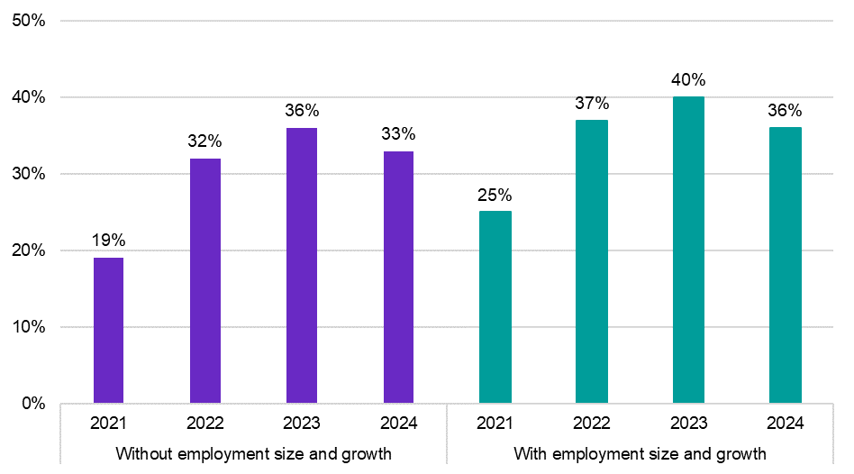

Source: Jobs and Skills Australia, Occupation Shortage List, 2021–24; ABS, 2021 Census of Population and Housing.

Note: This analysis is based on the ABS 2013 ANZSCO version.

The overall pattern of workforce shortage from 2021 to 2024 is similar between the 2024 OSL and the alternative analysis. They both indicate that shortages peaked in 2023 and then fell in 2024, in line with changes in labour market conditions over that time.

The alternative analysis suggests that in 2024, there was a workforce shortage of 36%, whereas the 2024 OSL results show that 33% of occupations were in shortage in 2024. The reason for the difference is due to the fact that occupations that were considered to be in shortage, on average, were larger employing occupations[16].

Further, unlike the 2024 OSL results, the alternative analysis suggests that there was a smaller workforce shortage in 2024 than in 2022 (36% compared to 37%). Given the way the analysis was produced, this might mean that there were fewer large employing and growing occupations in shortage in 2024 than in 2022. This reinforces the conclusion that shortages have eased with the easing labour market.

Accounting for employment size and growth in occupations may provide a clearer sense of the impacts of structural change on occupations in shortage. For example, the economy is shifting toward health, care, education and business services. With that, the overall percentage of occupations in shortage may remain elevated overtime (in the absence of any policy response) if:

* large employing and growing occupations related to health and care, teaching and early childhood education, and engineering remain in shortage
* small employing but fast-growing occupations related to business services remain in shortage.

### Shortages by industry

An industry is likely to feel shortage pressures when the largest employing occupations within that industry are in shortage. To explore this, employment sizes of occupations within an industry that were in shortage in the 2024 OSL were summed and divided by the total employment size of that industry (Figure 27)[17]. Essentially, occupation shortage ratings at the national level were weighted by the within-industry distribution of employment.

Figure 27: Workforce shortage pressures (%), by industry, 2021–24

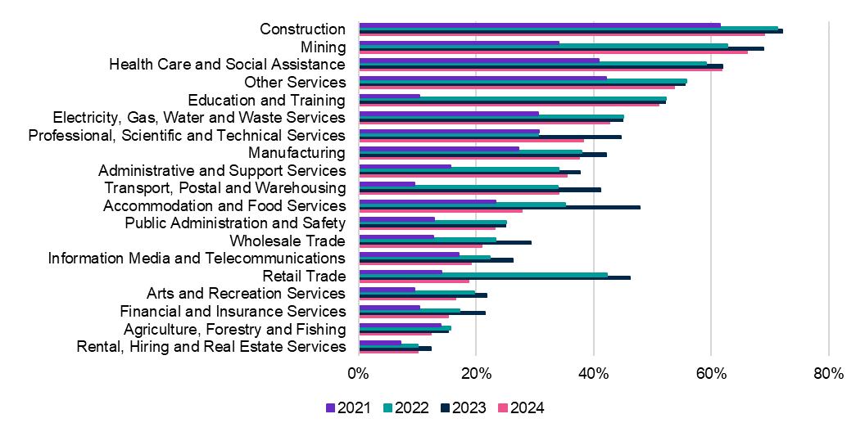

Source: Jobs and Skills Australia, Occupation Shortage List, 2021–24; ABS, 2021 Census of Population and Housing.

Compared to other industries, Construction, Health Care and Social Assistance, Mining, Other Services, and Education and Training appear to have more acute shortage pressures[18]. All 5 of these industries have had shortage pressures of 51% to 72%, in the period since 2022. While not as high as the top 5, Professional, Scientific and Technical Services also had relatively high shortage pressures at 45%.

Except for Mining and Other Services, these industries are large employing, including those where the share of employment has been increasing over time. The results reflect the impacts of structural change such as impacts of an ageing population and the flow on increasing demand for health and care services, technology change and the shift towards a knowledge-services based economy, increasing the demand for high skilled workers. Further, the impact of a backlog of infrastructure projects in the Construction industry is also a factor.

### Occupation shortages by major occupation group

Occupations in shortage for 3 or more years are defined as being in persistent shortage. There were 136 occupations in persistent shortage from 2021 to 2024 (Table 4). Of these, 49% (67 out of 136) were in the Technicians and Trades Workers major group, while occupations in the Professionals major group made up 40% (55 out of 136).

Several of these occupations were among the top 20 largest employing occupations in shortage in the 2024 OSL. Occupations within the Technicians and Trades Workers major group included Electrician (General), Carpenter, Chef and Motor Mechanic (General), while occupations in the Professionals major group included Software Engineer, General Practitioner and Developer Programmer.

The reasons for persistent shortages are likely to be multifaceted. They include an ageing population, technological advances, and other impacts of structural changes in the labour market, such as constraints in the supply of qualified and experienced workers, working conditions and pay. Any future solutions to address persistent shortages will, therefore, likely need to be long-term and holistic.

Table 4: Summary of major groups in persistent shortage in the 2021–24 OSLs

|  |  |  |
| --- | --- | --- |
| In Shortage from 2021 to 2024 | Occupations (No.) | Occupations (%) |
| Managers | 3 | 2 |
| Professionals | 55 | 40 |
| Technicians and Trades Workers | 67 | 49 |
| Community and Personal Service Workers | 4 | 3 |
| Machinery Operators and Drivers | 7 | 5 |
| **All occupations** | **136** | **100** |

Source: Jobs and Skills Australia, Occupation Shortage List, 2021–24.

### Impact of age on occupation shortages

Analysis of the age composition of the workforce can help explain the role of inclusion of older workers in skills shortages (Jobs and Skills Australia, 2024b). Figure 28 shows the percentage of occupations in shortage, by the composition of mature aged workers (aged 55 or older). Each occupation has been categorised into 1 of 3 groups:

* less than 10% of mature aged workers
* between 10% and 30% of mature aged workers
* more than 30% of mature aged workers.

Figure 28: Percentage of occupations in shortage (%), by mature age worker composition, 2021-2024

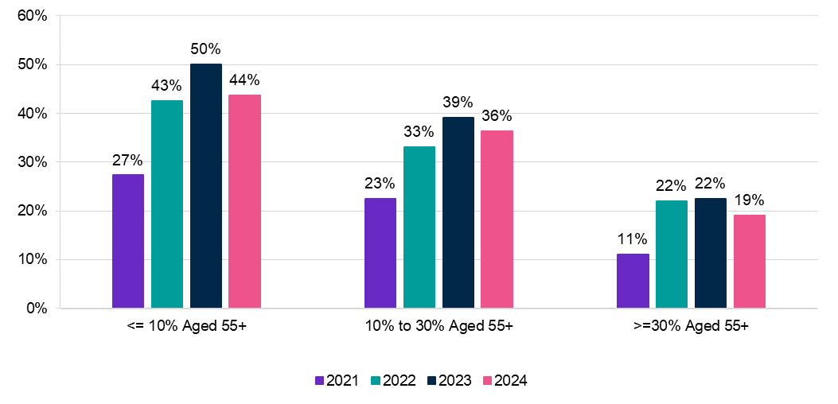

Source: Jobs and Skills Australia, Occupation Shortage List, 2021–24; ABS, 2021 Census of Population and Housing.

Figure 28 implies that an occupation that has a larger proportion of its workforce aged 55 years or older were less likely to have a shortage rating.

* For occupations with at least 30% of workers aged 55 and above, 19% were in shortage.
* For occupations with no more than 10% of workers aged 55 and above, 44% were in shortage.

The above results points to the importance of age-inclusiveness in employment particularly in an ageing population as increasing employment for older workers may help to alleviate occupations in shortage.

### Occupation shortage drivers

Analysis of the driving factors for shortage of relevant occupations can help industries, employers and policy makers to identify barriers to recruitment and possible interventions.

JSA’s Occupation Shortage Drivers (OSD) is a classification of occupation shortages into 4 types, based on the most likely cause of the shortage. The 4 types were based on data from the *Survey of Employers who have Recently Advertised* (SERA). The categorisation was based on a typology published by Sue Richardson (Richardson, 2007) (Table 5).

The categorisation was first introduced in the inaugural 2023 Jobs and Skills Report, *Towards a National Jobs and Skills Roadmap*. As the OSD database grows over the coming years, the data will enable researchers and policy makers to identify whether occupations in shortage are driven by one factor, consistently, or multiple factors due to changing economic conditions. This insight may further inform the development of targeted labour market and training policies and programs. Analysis of the shortage drivers of occupations was undertaken at the ANZSCO unit group level[19]. To do this, a unit group version of the OSL was first created.[20]

Table 5: Richardson’s occupation shortage classifications

|  |  |
| --- | --- |
| Classification | Definition |
| **Level 1 shortage** | Only a few people have the essential technical skills and there is a long training time for development. |
| **Level 2 shortage** | Only a few people have the essential technical skills and there is a short training time for development. |
| **Quality gap** | There are sufficient people with the essential technical skills, but they lack some qualities that employers consider important. |
| **Skills mismatch** | There are sufficient people who have the essential technical skills, but they are not willing to apply for the vacancies under current conditions. |

Source: Richardson, 2007.

Considering Richardson’s typology, JSA produced the shortage typology described in   
Table 6.

Table 6: Jobs and Skills Australia’s occupation shortage driver typology

|  |  |
| --- | --- |
| Classification | Definition |
| **Long training gap** | Analogous to Richardson’s level 1 shortage, a long training gap shortage is defined by few qualified applicants per vacancy and a long training pathway – corresponding to a Certificate III or above. |
| **Short training gap** | Analogous to Richardson’s level 2 shortage, a short training gap shortage arises when there are few applicants per vacancy and a qualification less than a Certificate III is required. |
| **Suitability gap** | Analogous to Richardson’s quality gap, the suitability gap shortage is where there are enough qualified applicants, but they are not regarded as suitable. |
| **Retention gap** | Analogous to Richardson’s skills mismatch, a retention gap shortage is where there are below average rates of retention, potentially reinforced by low numbers of new applicants per vacancy. |
| **Uncertain/Unknown** | There may be cases where the shortage driver of a unit group is uncertain. This may occur when unit groups do not satisfy any of the above definitions or requirements. Uncertainty can also arise when there is not enough data of sufficient quality to identify the primary driver of a shortage[21]. |

Source: Jobs and Skills Australia.

The 4 classifications may appear mutually exclusive; however, not all unit group shortages fit neatly in one category or another. Some unit groups assigned to one category may have some issues in common with unit groups in other categories. For example, a unit group may be simultaneously experiencing a lack of qualified applicants and a large amount of turnover. The shortage driver given by JSA for a unit group, therefore, was the primary driver of shortage (based on available evidence). This typology is a useful way to understand a complex set of dynamics in the labour market.

Table 7 shows the top 10 employing unit groups for each shortage driver, and reveals the following pattern of results:

* ‘Long training gap’ was the primary shortage driver for various health and teaching unit groups, including other large employing Skill Level 1 (equivalent to a bachelor’s degree or above) unit groups within the Professionals major group. This shortage driver also includes various large employing Technicians and Trades Workers unit groups. This suggests a need to increase the number of available skilled workers noting significant time lags involved in the training process.
* ‘Suitability gap’ was the primary shortage driver for large employing engineer and manager unit groups. This suggests that for several large employing engineer and managerial roles, workers may not be equipped with the rights skills and experience in demand. This is a category where simply increasing the throughput of qualified people is a questionable strategy.
* For large employing care, other nurse related roles (other than registered nurses), and food and hospitality-based unit groups, ‘retention gap’ was the primary shortage driver. This suggests that there may be enough people with the requisite skills, qualifications and experience to fill vacancies in each unit group, but workers for these unit groups may not remain in the role long due to current working conditions. As such, employers undertake more regular/frequent recruitment activities to fill the vacancies.
* For Skill Level 3 unit groups (equivalent to a Certificate III or IV qualification) and large employing Technicians and Trades Workers unit groups, both long and short ‘training gap’ and ‘retention’ gap were the primary shortage drivers. Alleviating shortages for Technicians and Trades Workers unit groups may then require more holistic solutions that improve the throughput of qualified workers and improvement in working conditions.
* The ‘retention gap’ or ‘unknown/uncertain’ categories were the primary shortage drivers for unit groups with fewer barriers to entry in the labour market, such as lower Skill Level 4 unit groups, including Machinery Operators and Drivers.

Table 7: Top 10 largest employing unit groups for each shortage drivers

|  |  |  |  |  |
| --- | --- | --- | --- | --- |
| Long training gap | Short training gap | Suitability gap | Retention gap | Unknown/  Uncertain |
| Registered Nurses | Truck Drivers | Advertising, Public Relations and Sales Managers | Aged and Disabled Carers | Earthmoving Plant Operators |
| Primary School Teachers | Landscape Gardeners and Irrigation Technicians | Software and Applications Programmers | Child Carers | Auditors, Company Secretaries and Corporate Treasurers |
| Secondary School Teachers | Electronics Trades Workers | Construction Managers | Nursing Support and Personal Care Workers | Plasterers and Renderers |
| Electricians | Telecommunications Trades Workers | Civil Engineering Professionals | Chefs | Other Medical Practitioners |
| Carpenters and Joiners | Aircraft Maintenance Engineers | Security Officers and Guards | Structural Steel and Welding Trades Workers | Air Transport Professionals |
| Motor Mechanics | Floor Finishers | Financial Investment Advisers and Managers | Drillers, Miners and Shot Firers | Veterinary Nurses |
| Metal Fitters and Machinists |  | Industrial, Mechanical and Production Engineers | Enrolled and Mothercraft Nurses | Train and Tram Drivers |
| Plumbers |  | Architects and Landscape Architects | Cooks | Civil Engineering Draftspersons and Technicians |
| Solicitors |  | Engineering Managers | Bakers and Pastrycooks | Tourism and Travel Advisers |
| General Practitioners and Resident Medical Officers |  | Electrical Engineers | Structural Steel Construction Workers | Agricultural, Forestry and Horticultural Plant Operators |

Source: Jobs and Skills Australia, 2024 Occupation Shortage Drivers.

Note: There are only 6 unit groups in Short training gap in 2024.

#### Changes in shortage drivers from 2023 to 2024

For unit groups that were in shortage in both 2023 and 2024, 17 had a different primary shortage driver in 2024 than in 2023 (Table 8). This means that in 2024, different factors were the predominant drivers of the shortage for the unit groups.

Table 8: Unit groups that changed shortage driver classification from 2023 to 2024

|  |  |  |
| --- | --- | --- |
| Unit group | 2023 Shortage driver | 2024 Shortage driver |
| Auditors, Company Secretaries and Corporate Treasurers | SG | U |
| Urban and Regional Planners | SG | LTG |
| Mining Engineers | SG | U |
| Agricultural, Fisheries and Forestry Scientists | SG | U |
| Civil Engineering Draftspersons and Technicians | RG | U |
| Metal Casting, Forging and Finishing Trades Workers | LTG | RG |
| Sheetmetal Workers | LTG | RG |
| Structural Steel and Welding Trades Workers | LTG | RG |
| Aircraft Maintenance Engineers | U | STG |
| Bricklayers and Stonemasons | STG | LTG |
| Glaziers | RG | LTG |
| Plasterers and Renderers | RG | U |
| Roof Tilers | RG | U |
| Wall and Floor Tilers | RG | LTG |
| Security Officers and Guards | STG | SG |
| Gallery, Museum and Tour Guides | STG | U |
| Tourism and Travel Advisers | STG | U |

Source: Jobs and Skills Australia.

Note: LTG: Long training gap, RG: Retention gap, SG: Suitability gap, STG: Short training gap and U: Unknown/Uncertain.

There were 8 unit groups which transitioned from a specific shortage driver group in 2023 to the category where the primary driver is ‘unknown/uncertain’ in 2024. There were also more unit groups in the ‘unknown/uncertain’ category in 2024 than in 2023. This implies there was a less pronounced primary driver in 2024. The changes in shortage drivers can also reflect the impact of changing labour market conditions. This suggests that labour markets are dynamic and evolve over time, which means that the balance of factors that drive shortages (training, suitability and retention gaps) will also evolve over time.

### Addressing occupation shortages

Possible interventions to address these gaps will depend on the underlying shortage drivers.

For occupations with a training gap (long or short), shortages are driven largely by a lack of qualified applicants. While these shortage types can partially be addressed by employers through measures aimed at improving employee retention, solutions will largely come from policy and educational providers increasing the throughput of qualified workers into the labour market. While knowledge or licensing requirements will mean some occupations require workers to undertake formal qualification pathways, interventions for other occupations could utilise a more flexible approach including on-the-job training. Migration is often a suitable short-term solution for these occupations, particularly when the training time is long.

For suitability gaps, applicants may hold the requisite qualifications for a job but still be deemed unsuitable for the role by the employer – perhaps due to lacking the skills or experience considered necessary. Interventions could examine training programs for these occupations and whether they adequately prepare individuals for the workforce or increase focus on enhancing the attributes of qualified individuals through investment in employability skills and work experience. These shortages may also indicate that employers have unrealistic expectations of graduates, or that they are recruiting for more senior roles within an occupation category that require a greater deal of work experience and management as well as technical skills.

For retention gaps, factors such as working conditions, workplace culture, social norms and expectations, and remuneration may play more of a role in driving shortages. Some industries have taken a practical approach to addressing some of these types of issues, as in the construction industry.

|  |
| --- |
| Case study – The Construction Industry Culture Taskforce An Australian Construction Industry Culture Taskforce has been established to help improve the productivity and performance of construction, offer a great workplace experience for employees in the sector, and address some of the culture challenges considered to be affecting the success of the industry. These issues were deemed to include work hours, fatigue, mental health, and issues attracting a diverse workforce.  The Taskforce is made up of the Australian Constructors Association (representing Australia’s largest construction firms), the governments of New South Wales and Victoria, and Australia’s leading workplace researchers.  A draft Culture Standard has been introduced by the Taskforce to help address industry-wide culture issues in relation to work hours, diversity, and health and wellbeing (RMIT University, 2021), and is being piloted across 5 construction projects to evaluate its effect.  Across the 5 pilot projects, actions observed relating to the standard have so far included:   * adopting work schedules which varied between pilots in line with project circumstances which give employees more certainty about when they will be required to work and when they can schedule personal commitments * adapting to employee preferences for a five- or six-day week (including retaining the option for employees at one site to work Saturdays if they have a preference to do so) * providing informal support for flexible work time in order to meet family or other commitments * implementing programs to support worker health and wellbeing and providing strong support from management for wellbeing * providing a two-day weekend to improve rest and recovery * implementing a zero-tolerance approach to offensive language, material, and behaviour, and in some cases a respect policy for subcontractor contracts * representation of women in management, professional, and leadership positions in some projects * provision of appropriate site amenities for female staff (Construction Work Health and Safety @ RMIT, 2023).   When the Culture Standard is finalised, governments will be called upon to incorporate compliance with the Culture Standard into their standard procurement requirements (Australian Constructors Association, 2024). |

|  |
| --- |
| Jobs and Skills Councils in focus Among the publicly available Jobs and Skills Council work plans, several made reference to addressing shortages and recruitment difficulty. This included the importance of further understanding the drivers of shortages and structural issues in key occupations across their relevant industry sectors, analysing career pathways and considering attraction and retention issues. Working together across sectors to address shortages was also called out as important.  The Mining and Automotive Skills Alliance, in their *Industry Workforce Plan: Moving Ahead Together*, has a specific area of focus relating to cultural reform.  AUSMASA proposes to collaborate with other JSCs to develop an accredited training program, with supporting resources, for developing safe and respectful workplaces. This program would be made available across multiple training packages(Mining and Automotive Skills Alliance, 2024)*.* |

Interventions could also focus on helping employers to understand their options in responding to skills shortages and the relative success of different approaches. Evidence shows that most employers make limited changes to their recruitment strategy when faced with difficulty filling a vacancy. As shown in Figure 29, in the 2024 OSL period, 73% of employers reported that they continue advertising in the same place when they did not fill a vacancy. Employers also sometimes sought applicants through different channels, such as word of mouth (24%) or advertising in different places (15%). These 3 actions were the most common in each of the OSL periods from 2021 to 2024.​

Figure 29: Employer responses to unfilled vacancies in the 2021-2024 OSL

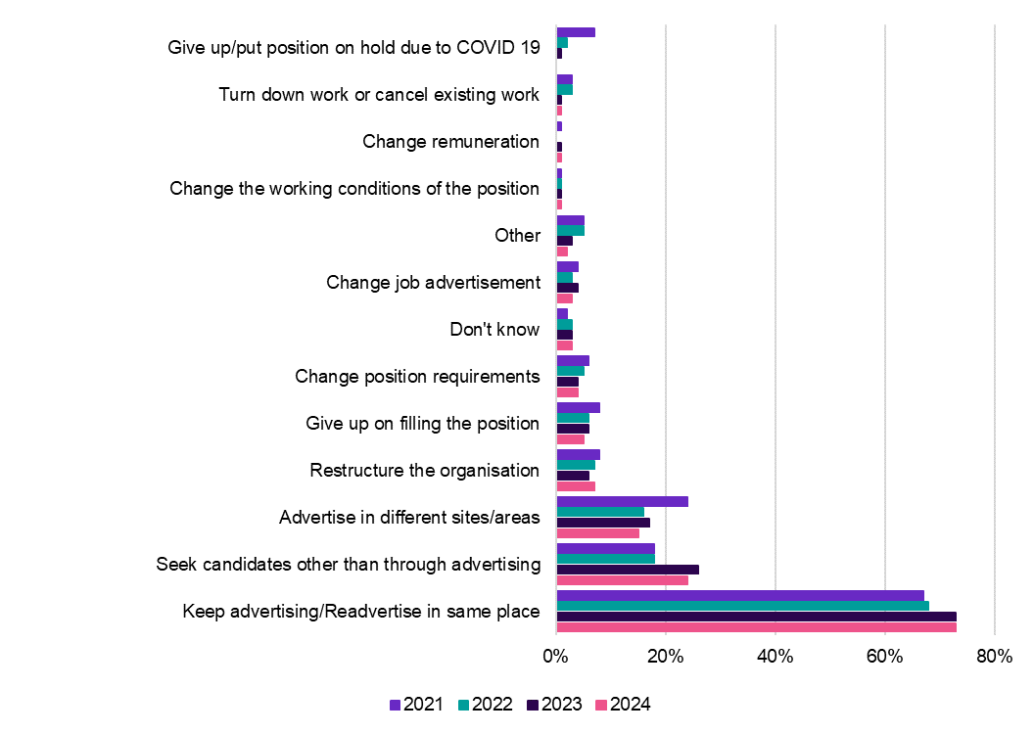

Source: Jobs and Skills Australia, Survey of Employers who have Recently Advertised, 2021–24.

More work could be undertaken to understand how different approaches yield different outcomes for addressing skills shortages, including considering this data in the context of the reason for shortage or recruitment difficulty. Responses could also assist employers and workers to better understand the skills that contribute to task completion and how these are applicable across contexts.

## Investing in our regions

More than one in 4 (27%) Australians live outside a major city. A truly dynamic, productive, and inclusive labour market must ensure that more Australians can access safe and secure work where they choose to live. Historically, regional and remote regions are more likely to experience weaker labour market conditions than their capital city counterparts.

Poorer-performing regions tend to be in regional and remote areas, and face challenges such as high unemployment, limited job opportunities, lower education levels, difficulties recruiting suitable workers into available jobs and lower rates of labour market efficiency. Employees in regional and remote areas are also more likely to experience low and irregular pay – impacting economic security and wellbeing.

Some of our regions are also faced with the reality of an older age demographic. This poses the challenge of reduced labour supply and loss of skills, as well as additional pressure on the care and support sector which is already facing significant shortages in regional areas.

The June 2024 JSA RLMI[22] results confirm that regional and remote areas are more likely to experience weaker labour market conditions than metropolitan cities (Figure 30). The overwhelming majority (72%) of SA4s that were rated either ‘strong’ or ‘above average’ were located in metropolitan cities, whereas 68% of SA4s rated ‘below average’ or ‘poor’ were located in regional or remote areas.

Figure 30: RLMI ratings of relative labour market performance, June 2024

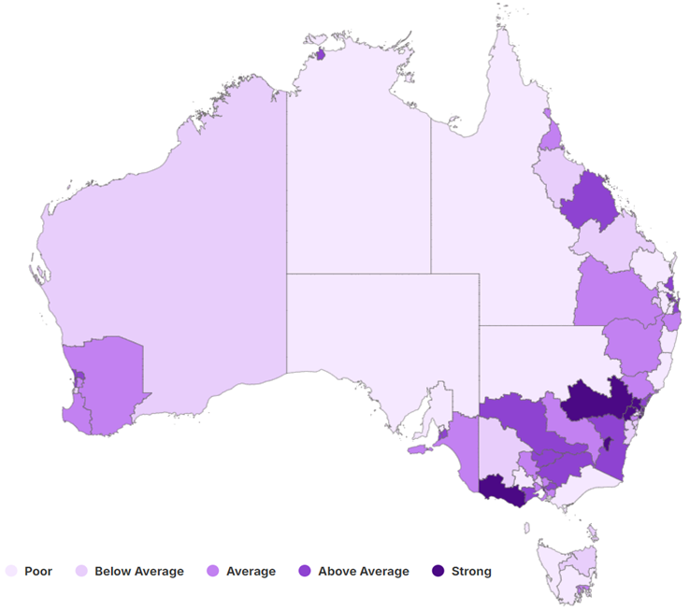

Source: Jobs and Skills Australia, Regional Labour Market Indicator (RLMI), June 2024.

|  |
| --- |
| Jobs and Skills Councils in focus Among the publicly available Jobs and Skills Councils workforce plans, supporting Regional Australia was a key focus for many. They identified regional challenges such as skills shortages including issues with attraction and retention, but also factors such as issues with digital connectivity and lack of access to skilling opportunities. |

### Recent trends in regional labour market performance

While labour market challenges are more pronounced in many regional and remote areas, the June RLMI results suggest there are signs of some easing in labour market conditions in a number of metropolitan/regional city areas, particularly when compared to regional areas, where conditions have improved, on average. For instance, the labour market rating declined for 13 metropolitan/regional city areas (or 25%), and improved for 4 (or 8%), over the year to June 2024. By comparison, the labour market rating improved for 7 regional areas (or 29%), and declined for 4 (or 17%), over the same period.

Some of the trends that are contributing to the easing in conditions for metropolitan/regional city areas are:

* The average working age employment rate for metropolitan/regional city areas fell by 0.3 percentage points over the year, to 77.8% in June 2024 (Figure 31), while the average unemployment rate for metropolitan/regional city areas increased by 0.4 percentage points over the year, to 3.9% in June 2024.
* By contrast, the average working age employment rate for regional areas increased by 0.5 percentage points over the year, to 76.2% in June 2024, while the average unemployment rate for regional areas increased marginally over the year, by just 0.1 percentage points, to 3.3% in June 2024 (Figure 32).

Figure 31: Employment rate (15-64 years) by remoteness category, June 2014 to June 2024

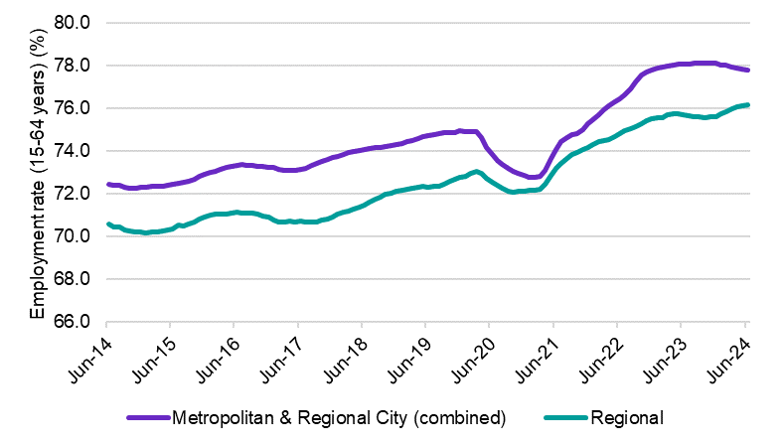

Source: ABS, Labour Force, Australia, Detailed, June 2024, 12-month averages of original estimates.

Figure 32: Unemployment rate by remoteness, June 2014 to June 2024

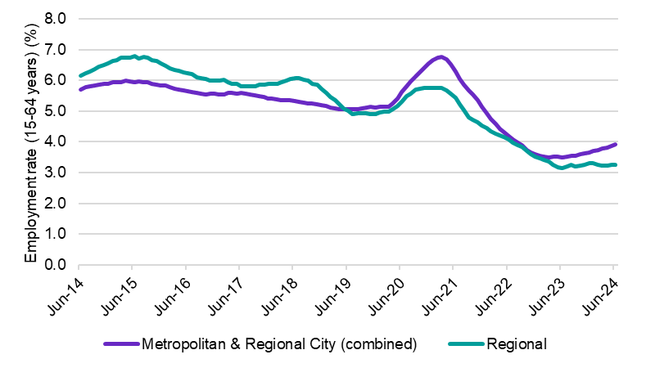

Source: ABS, Labour Force, Australia, Detailed,June 2024, 12-month averages of original estimates.

|  |
| --- |
| Recent trends in regional labour market performance: Region spotlightInner Metropolitan Brisbane[23] One example of the gradual easing of conditions in a number of metropolitan/regional city areas can be seen in the decline in labour market ratings in inner metropolitan Brisbane over the last year. While overall conditions remain relatively strong, several key indicators of labour market performance have recently softened in a number of these regions. As a result, conditions in Brisbane East, Brisbane North and Moreton Bay – South were rated as ‘above average’ in June 2024, down from their rating of ‘strong’ in June 2023 (Figure 33).  Figure 33: RLMI ratings of relative labour market performance – Inner Metropolitan Brisbane  A map of Inner Metropolitan Brisbane displaying the RLMI ratings of labour market performance (Strong, Above average, Average, Below average, Poor). The map shows the decline in labour market rating in Moreton Bay South, Brisbane North and Brisbane East over the year to June 2024.  Source: Jobs and Skills Australia, Regional Labour Market Indicator (RLMI), June 2024. NSW/Victoria border regions The regions of Murray, Shepparton and Hume (3 regions on the border of New South Wales and Victoria) are examples of where conditions have improved in regional areas, with labour market conditions in these regions rated ‘above average’ in June 2024, up from their rating of ‘average’ in June 2023 (Figure 34).  Figure 34: RLMI ratings of relative labour market performance – NSW/Victoria border regions  A map of select NSW/Victoria Border regions displaying the RLMI ratings of labour market performance (Strong, Above average, Average, Below average, Poor). The map shows the improvement in labour market rating in the regions of Murray, Shepparton and Hume over the year to June 2024.  Source: Jobs and Skills Australia, Regional Labour Market Indicator (RLMI), June 2024.  While conditions in these regions have improved over the last year, data at the regional level are inherently volatile. To help identify region-specific trends, it is often useful to compare a region’s rating over a longer period. When viewed from a long-term perspective, it is evident that the relative conditions in these regions have improved, with recent conditions consistently rating above their long-term trend (Figure 35).  Figure 35: Average RLMI rating for the Murray, Shepparton and Hume SA4 regions, June 2009 to June 2024  A line chart showing the average RLMI rating category for the Murray, Shepparton and Hume SA4 regions. The Map illustrates that the relative conditions in these regions have improved, with recent conditions consistently rating above their long-term trend.  Source: Jobs and Skills Australia, Regional Labour Market Indicator (RLMI), June 2024.  Note: RLMI rating category legend: 1 – Strong, 2 – Above average, 3 – Average, 4 – Below average, 5 – Poor. |

### Online job advertisements in regional Australia

An increase in job advertisements can be an indicator that an economy is doing well, as it may signal that employers are experiencing strong demand for their goods and services and have a requisite demand for labour.

JSA’s Internet Vacancy Index (IVI) is a monthly data series measuring online job advertisements. IVI data showed a dramatic increase in online job advertisements across Australia following the COVID-19 downturn, and when compared to a decade ago, the growth in regional Australia was especially pronounced. While online job advertisements have been declining from this series high, advertisements remain elevated and particularly for regional Australia (Figure 36). While the number of job advertisements overall is higher for capital cities, the percentage growth for regional Australia has been stronger, and the decline has been less pronounced.

Figure 36: Online job advertisements regional Australia, August 2014 to August 2024

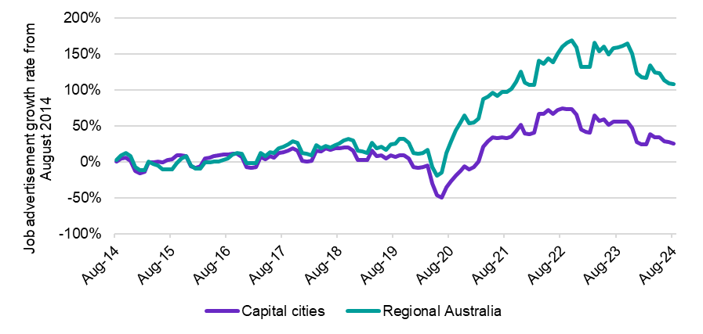

Source: Jobs and Skills Australia, Internet Vacancy Index, August 2024, 3-month average data.

### Changing demand for occupations in regional Australia

The occupation mix in regional Australia has changed markedly over the last decade, with growth in demand for Professionals accounting for a considerable share of the observed increase in recruitment activity. Across both metropolitan and regional Australia, occupations in the health care sector are experiencing strong demand while other Professional occupations, frequently employed in capital cities, have recorded easing demand.

However, in making these comparisons, it is also important to recognise that recruitment methods vary across regions. Some regions use internet job boards (such as those captured in the IVI) for a high proportion of their total recruitment activity, while other regions use internet job boards less frequently, focusing more on recruitment methods such as social media and word of mouth. Equally, JSA’s Recruitment Experiences and Outlook Survey data shows that internet job boards are more frequently used when recruiting for higher skill level jobs.

Changing online job advertisement numbers in regional Australia over the last decade demonstrate the long-term growth in the provision of healthcare services and the wider care sector. Underlying these growth trends are shifts such as demographic change and the increasing diversity of labour market participation.

Over the decade to August 2024, the largest increases in the share of total advertisements in regional Australia were recorded for Professionals, and Community and Personal Service Workers (Figure 37). Job advertisements seeking Professionals made up almost one-quarter of all online job advertisements in regional Australia, an increase of 5.7 percentage points over the last decade, with much of this growth attributed to demand for healthcare workers and other occupations in the care sector. For example, online job advertisements for Medical Practitioners and Nurses increased by more than 200% (or 2,700 job advertisements) over the last decade, and large increases were also recorded for Health Diagnostic and Therapy Professionals (up by 218% or 1,600). While numbers also increased markedly for Legal, Social and Welfare Professionals (up by 291% or 2,000), meaningful proportions of this growth stemmed from demand for Social Workers, Counsellors and Psychologists.

Online job advertisements for Community and Personal Service Workers recorded the second largest increase in share of total advertisements in regional Australia over the last decade. Almost 15% of all online job advertisements sought Community and Personal Service Workers in August 2024, an increase of 2.9 percentage points. Primary among these occupations experiencing increasing demand were Carers and Aides, with a 230% (or 3,300) increase, followed by Health and Welfare Support Workers (up by 283% or 940). Among Carers and Aides, Aged and Disabled Carers and Child Carers recorded the largest increases in online job advertisements and among Health and Welfare Support Workers, the largest increases were recorded for Welfare Support Workers and Enrolled and Mothercraft Nurses.

Figure 37: Online job advertisements for Major Occupation groups in regional Australia, August 2014 to August 2024

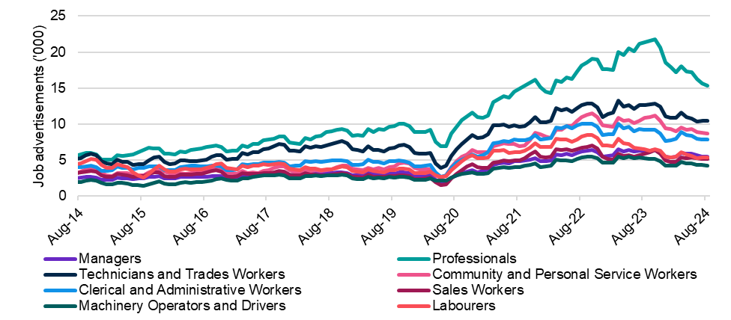

Source: Jobs and Skills Australia, Internet Vacancy Index, August 2024, 3-month average data.

The increasing demand for more highly skilled jobs in the Australian labour market has had an uneven impact on our regions. Unlike capital cities and regional cities, where there has been the largest shift in the share of employment towards skill level 1 occupations, regional and remote areas have experienced a shift in the share of employment towards occupations where VET is the primary pathway (skill levels 2 to 4), in addition to an increase in skill level 1 occupations (Figure 38).

Figure 38: Skill level employment share, change (% pts) between 2019 and 2024

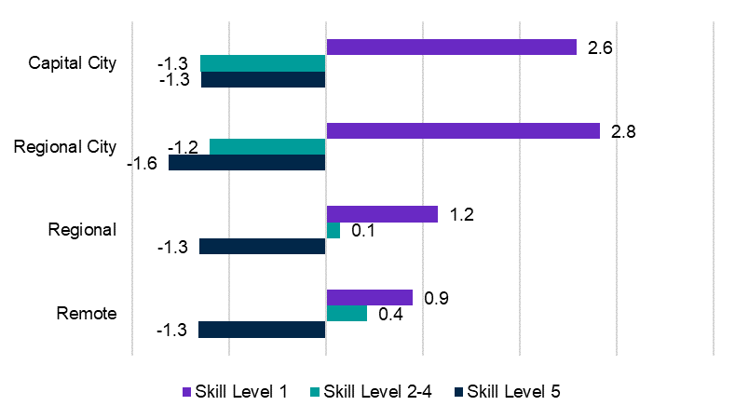

Source: Jobs and Skills Australia, NERO, April 2024.

Note: Skill Level 1 relates to bachelor’s degree or higher qualification; Skill Level 2 relates to Advanced Diploma or Diploma; Skill Level 3 relates to Certificate IV or III (including at least 2 years on-the-job training); Skill Level 4 relates to Certificate II or III; Skill Level 5 relates to Certificate I or secondary education.

|  |
| --- |
| Changing demand patterns in thriving labour markets Three regional labour markets, namely New South Wales Central West, Geelong and Sunshine Coast recorded a notable improvement in current relative labour market conditions in recent years, when compared to their long-term average (Jobs and Skills Australia, 2024c). A combination of IVI results with other data for these regions show a number of existing and emerging drivers of demand are contributing to beneficial conditions in these labour markets.  In these regions, the online job advertisement growth rate exceeded the rapid increase in recruitment activity across Australia since the COVID-19 pandemic (Figure 39). While online job advertisements in these regions have eased since their peak in late 2022, this has only been at a marginally sharper rate than the national level. Taken together, this means that job advertisement growth rates remain somewhat more elevated in these regions.  Figure 39: Online job advertisement growth rate August 2019 to August 2024 for three regions in focus  This graph shows the growth rate in online job advertisements in Central West New South Wales, Geelong and Sunshine Coast from August 2019 to August 2024 with a comparison line showing the Australia total growth rate. This figure shows that after the COVID-19 downturn in 2020, the growth in online job advertisements in the three regional labour markets exceeded even the strong growth rate recorded nationally. Since reaching the peak level of online job advertisements in late 2022, declines have been recorded that are somewhat sharper than the average recorded across Australia. Notably, the declines in Sunshine Coast have been smaller than the other regional labour markets.  Source: Jobs and Skills Australia, Internet Vacancy Index, August 2024, 3-month average data.  The occupation groups driving recruitment activity in these regions are indicative both of prevalent social trends (commonalities between regions) and the resilient contribution of each region’s existing drivers and emerging economic contributors (differences between regions).  The clearest commonality between regions is strong growth in demand for Community and Personal Service Workers, particularly for Carers and Aides (largely Aged and Disabled Carers, and Child Carers) – indicative of demographic changes in these regions and across Australia.  For Geelong, distinct drivers of online job advertisement growth include rapid population growth, a long history of industrial and manufacturing activity, and the evolution into modern high-tech manufacturing and research (Victoria State Government Department of Jobs, Skills, Industry and Regions, 2023) (Australian Bureau of Statistics, 2024a). This has led to a strong demand for Professionals, Managers and Sales Workers. While Central West and Sunshine Coast have also recorded a strong growth in demand for Professionals, this has only translated into growth in the share of total vacancies for Geelong.  In August 2024, almost one-third of all online job advertisements in Geelong sought Professionals, representing a 10% increase in this share over the last 5 years (the second largest increase of any Major Occupation group in the region behind Community and Personal Service Workers). While this features healthcare and education professionals as expected for a rapidly growing regional city, recent employment growth for occupations such as Software and Applications Programmers; Other Information and Organisation Professionals; and Industrial, Mechanical and Production Engineers point to the evolving economic contributors in the region (Jobs and Skills Australia, 2024d).  In contrast, Central West has a relatively stable population level and a notably high employment to population ratio (Australian Bureau of Statistics, 2024a) (Australian Bureau of Statistics, 2024b). The region is rich with natural resources, and primary industry continues to drive recruitment activity growth, with Mining recording the largest increase in the share of the region’s employment over the 5 years to August 2024 (Australian Bureau of Statistics, 2024b).  Health Care and Social Assistance increased its share as the largest employing industry in the region, but the strongest employment growth over the 5 years to August 2024 was recorded in Arts and Recreation Services (up by 353.6%), increasing this industry’s share of regional employment by 1.3 percentage points (from 0.4% to 1.8%) (Australian Bureau of Statistics, 2024b).  Sunshine Coast has sustained among the strongest rates of population growth across Australian regional areas (Australian Bureau of Statistics, 2024a). The robust contribution of the tourism sector to online job advertisement growth is evident, but drivers of growth also originate from a comparatively diverse range of industries.  Of the 3 regions, Sunshine Coast has recorded the strongest growth in online job advertisements over the 5 years to August 2024 (up by 105.9%). Underlying this growth are particularly strong increases in recruitment activity for occupations supporting tourism, logistics, mining, construction and agribusiness, speaking to the region’s economic diversity.  The continued development and refinement of JSA products such as the Internet Vacancy Index, the Nowcast of Employment by Region and Occupation, and the Regional Labour Market Indicator can help contribute to understanding and discussion of Australia’s regional labour markets and how we can ensure that more Australians can share in the benefits of a strong economy. |

## In summary

The Australian labour market continues to display remarkable resilience against the backdrop of a slowing in economic activity and ongoing uncertainty. Despite some emerging challenges, the labour market remains reasonably tight, although the pace of employment growth has eased over the last year, from the robust growth rates recorded in late 2022 and early 2023.

Conditions for a number of disadvantaged cohorts and groups that can face barriers to participation, such as youth and the long-term unemployed, have also eased over the year. This is not surprising, given these cohorts can be vulnerable during periods of labour market softness, as they often have less education and experience than their more highly skilled counterparts.

Labour market conditions are also expected to soften further in the period ahead, which may put further upward pressure on the unemployment rate, particularly for those in disadvantaged groups.

Nevertheless, employers continue to experience challenges finding suitable skilled workers to fill vacant positions. While the average number of applicants per vacancy has generally been increasing over the last year, there has only been a marginal increase in the average number of suitable applicants per vacancy, suggesting shortage pressures persist in the labour market.

Skills shortages in the labour market are persistent, but the driving factors are varied and require different responses. Responses can include actions by employers, policy makers, education providers and individuals, and more work could be undertaken to understand how different approaches yield different outcomes for addressing skills shortages, including considering this data in the context of the reason for shortage or recruitment difficulty.

A truly dynamic, productive, and inclusive labour market must ensure that more Australians can access safe and secure work where they choose to live. Historically, regional and remote regions are more likely to experience weaker labour market conditions and our regions continue to face unique challenges. Categorising regional labour markets can help inform and target policy responses and interventions, and the continued development and refinement of JSA products such as the Internet Vacancy Index, the Nowcast of Employment by Region and Occupation, and the Regional Labour Market Indicator can help contribute to understanding and discussion of Australia’s regional labour markets.

JSA’s intelligence can enable individuals, businesses, education providers, and governments to make better decisions by increasing understanding of the realities of today’s labour market, the opportunities present under current conditions, and the skills required to realise them. A key strategic function for JSA is to provide the labour market and analysis that supports an understanding of the current and future labour market and enables the development of a contemporary skilled Australian workforce.

# 

# Chapter 3: Shaping Australia’s future workforce

Major forces are shaping our economy. They are shifting the way we live and how we work – creating new roles and changing existing ones. Digital and technological transformation is driving change across roles – creating demand not only for specific technical skills but also for related skills in the management, ethics, and governance of new technologies. Our response to climate change and the shift to a ‘net zero’ economy is driving innovation and new ways of working. Shifting population demographics and an ageing population are impacting the pool of skills in the existing labour market as well as contributing to rising demand for care and support services.

Understanding evolving skills and workforce needs, and potential areas of growth, can help Australia better adapt to a changing economy and ensure more Australians can share in the benefits of growth. That is why JSA has a legislative remit to:

* provide advice on Australia’s current and emerging labour market, including advice on workforce needs and priorities
* provide advice on Australia’s current, emerging and future skills and training needs and priorities (including in relation to apprenticeships, VET and higher education)
* prepare capacity studies, including for emerging and growing industries and occupations
* undertake workforce forecasting, assess workforce skills requirements and undertake cross industry workforce analysis
* identify labour market imbalances and analyse the demand and supply of skills
* analyse skills needs and workforce needs, including in regional, rural and remote Australia, and in relation to migration.

**Key themes in this chapter:**

* Australia’s workforce is continuing to shift towards a greater share of higher skilled roles. Employment projections produced by Victoria University for JSA show the long-term structural shift in employment towards services-related industries is projected to continue over the next decade.
* An alternative projections model scenario was also explored, where post-secondary training and education is responsive to market signals, diverting the supply of labour into occupations where the demand is strong.
  + In general, we find that when skill supply responds to market demand, there is increased employment in occupations with a VET pathway relative to the baseline, with a reduction in employment in occupations requiring higher education qualifications. The cost of labour associated with occupations that require VET or higher education qualifications are impacted as a result.
  + We observe increases in projected employment for all Community and Personal Service occupations, most notably Aged and Disabled Carers, Education Aides, Nursing Support and Personal Care Workers, and Child Carers. Other occupations to expand relative to the 10-year baseline projections include Sales Assistants, General Clerks, Registered Nurses, and Electricians.
* There are 37 emerging roles that have been identified in the Australian Labour Market, across 4 key themes that align broadly with the major forces shaping our economy – Health, Care and Medical, Data and Technologies, Net Zero, and Science and Engineering.
* Targeted capacity studies help us to better understand how industries and workforces are changing and emerging – and can inform decision-making about how to prepare for a likely future labour market.
  + The 2023 Jobs and Skills report included findings from *The Clean Energy Generation: Workforce needs for a net zero economy*. Findings from the report have already supported a range of government and industry measures. Since the report’s release, JSA has finalised the findings of two capacity studies into the ECEC sector, and Australia’s food supply chain.
  + Australia’s food supply chain will be shaped by multiple interacting changes, including climate change and net zero, technological advances, and demographic changes. Concerns around sovereign capability, industry viability and cost of living will also have an impact. In the midst of these developments, a resilient workforce will be essential to Australia’s food security and strong export industries.
  + Ambitious policies are being implemented by governments to improve access to ECEC services, but shortages mean the workforce is already unable to meet existing demand. Improvements must also be made to ensure ECEC services can more appropriately support a diverse workforce, including First Nations educators, families and communities.

## 2024 Employment Projections

JSA’s employment projections are useful for understanding the impact of the current economic and labour market outlook on Australia’s future workforce needs. The projections give insights into trends and growth areas in the labour market and are used by industry and governments to inform policy decisions and workforce planning activities.

This year, JSA has worked with Victoria University (VU) to produce employment projections to 2034, using the VU Employment Forecasting Model (VUEF) which is underpinned by a computable general equilibrium (CGE) model.

The VUEF model brings together a large body of demographic data, employment data, and macroeconomic data, as well as forecasts from government and industry bodies, into a single set of detailed employment forecasts for Australia.

The employment projections outlined in this chapter have been calibrated to the macroeconomic and labour market outlook provided by the Australian Treasury. It offers a 5‑year outlook to highlight the shorter-term employment trends, and a 10-year horizon, to show the impact of longer-term or structural trends.

It is important to note however, that like any model these projections are based on assumptions and contain a degree of inherent uncertainty. They should be used as indicative of the future trends based on our current knowledge, rather than a precise prediction of the future.

### Overall employment growth[24]

Over the 5 years from May 2024 to May 2029, total employment in Australia is projected to increase by 6.6%, or around 950,000 people, reaching 15.3 million employed persons.

Over the 10 years from May 2024 to May 2034, total employment is projected to increase by 13.7%, or nearly 2.0 million people, reaching 16.3 million employed persons. These projections are slightly weaker than those included in the 2023 edition of the JSA Jobs and Skills Report *Towards a National Jobs and Skills Roadmap*.

### Industry employment outlook

The long-term structural shift in employment towards services-related industries is projected to continue over the next decade, with just 3 services industries i.e. Health Care and Social Assistance, Professional, Scientific and Technical Services, and Education and Training, contributing half (50.4%) of the projected employment growth in Australia over this period (Figure 40).

Figure 40: 5 and 10-year employment outlook, by industry, persons, Australia

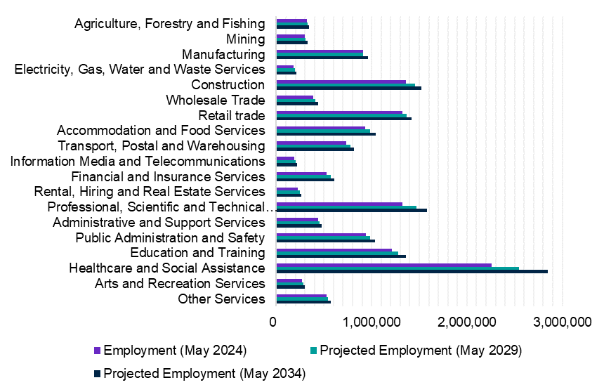

Source: 2024-2034 Employment Projections, produced by Victoria University for Jobs and Skills Australia.

The overall industry structure of the Australian labour market is projected to remain largely unchanged over the next decade, with most industries maintaining their relative shares of total employment. The most noticeable growth (by share of employment) is projected to occur in the Health Care and Social Assistance industry (up by 1.7 percentage points). While the Retail Trade and Manufacturing industries are projected to decrease their respective shares of total employment (by 0.5 of a percentage point each), they will remain large employers (Table 9).

The top 5 largest employing industries in terms of share of total employment in Australia are the same over both the 5- and 10-year projections:

* The Health Care and Social Assistance industry’s share of total employment is projected to increase from 15.7% in 2024 to 17.4% in 2034. Employment in the industry is projected to grow by 283,100 persons (or 12.5%) to 2029 and by 585,000 persons (or 25.9%) to 2034.
  + Strong employment growth in sectors such as Hospitals, Other Social Assistance Services, Allied Health Services, Residential Care Services, and Medical Services is projected over the next decade.
* The Professional, Scientific and Technical Services industry’s share of total employment is projected to increase from 9.2% in 2024 to 9.7% in 2034. Employment in the industry is projected to grow by 144,500 persons (or 10.9%) to 2029 and by 254,600 persons (19.2%) to 2034.
  + Strong employment growth in sectors such as Computer System Design and Related Services, Architectural, Engineering and Technical Services, and Legal and Accounting Services is projected over the next decade.
* The Construction industry’s share of total employment is projected to decline slightly from 9.5% in 2024 to 9.3% in 2034. Despite this, employment in the industry is projected to grow by 95,100 persons (or 7.0%) to 2029 and by 162,600 persons (or 12.0%) to 2034.
  + Strong employment growth in sectors such as Residential Building Construction, Building Installation and Completion Services, and Heavy and Civil Engineering Construction is projected over the next decade.
* The Retail Trade industry’s share of total employment is projected to decline from 9.2% in 2024 to 8.7% in 2034. Despite this, employment in the industry is projected to grow by 46,500 persons (or 3.5%) to 2029 and 99,800 persons (7.6%) to 2034.
  + Strong employment growth in sectors such as Pharmaceutical and Other Store-Based Retailing, Supermarket and Grocery Stores, and Clothing, Footwear and Personal Accessory Retailing is projected over the next decade.
* The Education and Training industry’s share of total employment is projected to remain broadly unchanged between 2024 and 2034 at around 8.3%. Employment in the industry is projected to grow by 71,500 persons (5.9%) to 2029 and 150,100 persons (12.4%) to 2034.
  + Strong employment growth in sectors such as Tertiary Education, School Education, and Adult, Community and Other Education is projected over the next decade.

Table 9: Projected employment growth over the next 5 and 10 years, by industry, Australia

|  |  |  |  |  |  |  |  |  |  |  |
| --- | --- | --- | --- | --- | --- | --- | --- | --- | --- | --- |
| Industry  (1-digit ANZSIC) | Baseline | | 5-year outlook | | | | 10-year outlook | | | |
| Empl. (‘000) May 2024 | Share of total empl. | Empl. (‘000) May 2029 | Share of total empl. | Change | | Empl. (‘000) May 2034 | Share of total empl. | Change | |
| Level (‘000) | % | Level (‘000) | % |
| Agriculture, Forestry and Fishing | 322.8 | 2.2% | 330.2 | 2.2% | 7.4 | 2.3% | 345.6 | 2.1% | 22.8 | 7.1% |
| Mining | 300.4 | 2.1% | 307.3 | 2.0% | 6.9 | 2.3% | 326.4 | 2.0% | 26.0 | 8.7% |
| Manufacturing | 909.1 | 6.3% | 907.3 | 5.9% | -1.9 | -0.2% | 959.3 | 5.9% | 50.1 | 5.5% |
| Electricity, Gas, Water and Waste Services | 184.2 | 1.3% | 197.4 | 1.3% | 13.2 | 7.2% | 209.2 | 1.3% | 25.1 | 13.6% |
| Construction | 1,357.7 | 9.5% | 1,452.8 | 9.5% | 95.1 | 7.0% | 1,520.3 | 9.3% | 162.6 | 12.0% |
| Wholesale Trade | 384.2 | 2.7% | 411.6 | 2.7% | 27.5 | 7.2% | 437.6 | 2.7% | 53.5 | 13.9% |
| Retail trade | 1,320.3 | 9.2% | 1,366.8 | 8.9% | 46.5 | 3.5% | 1,420.1 | 8.7% | 99.8 | 7.6% |
| Accommodation and Food Services | 929.9 | 6.5% | 984.8 | 6.4% | 54.9 | 5.9% | 1,040.6 | 6.4% | 110.8 | 11.9% |
| Transport, Postal and Warehousing | 736.9 | 5.1% | 773.9 | 5.1% | 36.9 | 5.0% | 812.6 | 5.0% | 75.6 | 10.3% |
| Information Media and Telecommunications | 191.1 | 1.3% | 203.8 | 1.3% | 12.7 | 6.6% | 219.2 | 1.3% | 28.1 | 14.7% |

|  |  |  |  |  |  |  |  |  |  |  |
| --- | --- | --- | --- | --- | --- | --- | --- | --- | --- | --- |
| Industry  (1-digit ANZSIC) | Baseline | | 5-year outlook | | | | 10-year outlook | | | |
| Empl. (‘000) May 2024 | Share of total empl. | Empl. (‘000) May 2029 | Share of total empl. | Change | | Empl. (‘000) May 2034 | Share of total empl. | Change | |
| Level (‘000) | % | Level (‘000) | % |
| Financial and Insurance Services | 529.9 | 3.7% | 571.0 | 3.7% | 41.2 | 7.8% | 608.0 | 3.7% | 78.2 | 14.7% |
| Rental, Hiring and Real Estate Services | 226.2 | 1.6% | 245.1 | 1.6% | 18.9 | 8.4% | 260.8 | 1.6% | 34.6 | 15.3% |
| Professional, Scientific and Technical Services | 1,324.6 | 9.2% | 1,469.1 | 9.6% | 144.5 | 10.9% | 1,579.1 | 9.7% | 254.6 | 19.2% |
| Administrative and Support Services | 437.6 | 3.0% | 452.5 | 3.0% | 14.9 | 3.4% | 474.4 | 2.9% | 36.8 | 8.4% |
| Public Administration and Safety | 941.8 | 6.6% | 983.0 | 6.4% | 41.2 | 4.4% | 1,034.1 | 6.3% | 92.3 | 9.8% |
| Education and Training | 1,210.2 | 8.4% | 1,281.8 | 8.4% | 71.5 | 5.9% | 1,360.3 | 8.3% | 150.1 | 12.4% |
| Healthcare and Social Assistance | 2,260.4 | 15.7% | 2,543.5 | 16.6% | 283.1 | 12.5% | 2,845.3 | 17.4% | 585.0 | 25.9% |
| Arts and Recreation Services | 270.5 | 1.9% | 284.6 | 1.9% | 14.1 | 5.2% | 300.7 | 1.8% | 30.2 | 11.2% |
| Other Services | 525.5 | 3.7% | 544.1 | 3.6% | 18.6 | 3.5% | 571.8 | 3.5% | 46.3 | 8.8% |
| **Total** | **14,363.3** | **na** | **15,310.7** | **na** | **947.4** | **6.6%** | **16,325.5** | **na** | **1,962.2** | **13.7%** |

Source: 2024-2034 Employment Projections, produced by Victoria University for Jobs and Skills Australia.

### Employment outlook by occupation groups

All major occupation groups are projected to increase in employment over the next decade (Figure 41) with the largest growth among Professionals.

Figure 41: 5 and 10-year employment outlook, by major occupation group, persons, Australia

This shows the projected increase in employment by major occupation group, over the 5 years to May 2029, and 10 years to May 2034. 
All major occupation groups are projected to increase in employment over the next decade, with the largest growth among Professionals.

Source: 2024-2034 Employment Projections, produced by Victoria University for Jobs and Skills Australia.

The occupation groups projected to experience the highest employment growth over the next 5 and 10 years include:

* Professionals (projected to grow by 409,800 persons or 10.9% to 2029 and by 785,000 persons or 20.9% to 2034).
  + This will include Health Professionals such as Registered Nurses, General Practitioners, Physiotherapists, and Psychologists; Business, Human Resource and Marketing Professionals such as Management and Organisation Analysts, Accountants, and Advertising and Marketing Professionals; ICT Professionals such as Software and Applications Programmers; and Engineering Professionals such as Civil Engineering Professionals.
* Community and Personal Service Workers (projected to grow by 146,000 persons or 8.8% to 2029 and by 294,500 people or 17.7% to 2034).
  + This will include Carers and Aides such as Aged and Disabled Carers, and Nursing Support and Personal Care Workers; Hospitality Workers such as Waiters, and Bar Attendants and Baristas; and Health and Welfare Support Workers including Ambulance Officers and Paramedics, and Enrolled and Mothercraft Nurses.
* Managers (projected to grow by 151,500 persons or 8.2% to 2029 and by 291,100 people or 15.7% to 2034).
  + This will include Specialist Managers such as Construction Managers, Advertising, Public Relations and Sales Managers, ICT Managers, and Hospitality, Retail and Service Managers.

It is expected that the shift towards employment in occupation groups such as Professionals and Managers will continue over the next decade. Currently, these two occupation groups constitute 39.1% of total employment in Australia and this employment share is projected to increase to 41.0% by May 2034. Growth in care and support occupations is also expected to continue with the employment share of Community and Personal Services Workers projected to increase from 11.6% in May 2024 to 12.0% by May 2034 (Table 10).

Table 10: Projected employment growth over the next 5 and 10 years, by major occupation group, Australia

|  |  |  |  |  |  |  |  |  |  |  |
| --- | --- | --- | --- | --- | --- | --- | --- | --- | --- | --- |
| Occupation  (1-digit ANZSIC) | Baseline | | 5-year outlook | | | | 10-year outlook | | | |
| Empl. (‘000) May 2024 | Share of total empl. | Empl. (‘000) May 2029 | Share of total empl. | Change | | Empl. (‘000) May 2034 | Share of total empl. | Change | |
| Level (‘000) | % | Level (‘000) | % |
| Managers | 1,856.9 | 12.9% | 2,008.4 | 13.1% | 151.5 | 8.2% | 2,148.1 | 13.2% | 291.1 | 15.7% |
| Professionals | 3,763.2 | 26.2% | 4,173.1 | 27.3% | 409.8 | 10.9% | 4,548.3 | 27.9% | 785.0 | 20.9% |
| Technicians and Trades Workers | 1,967.8 | 13.7% | 2,049.5 | 13.4% | 81.7 | 4.2% | 2,154.6 | 13.2% | 186.8 | 9.5% |
| Community and Personal Service Workers | 1,666.1 | 11.6% | 1,812.1 | 11.8% | 146.0 | 8.8% | 1,960.7 | 12.0% | 294.5 | 17.7% |
| Clerical and Administrative Workers | 1,855.1 | 12.9% | 1,923.7 | 12.6% | 68.6 | 3.7% | 2,029.6 | 12.4% | 174.6 | 9.4% |
| Sales Workers | 1,116.1 | 7.8% | 1,155.9 | 7.5% | 39.8 | 3.6% | 1,204.1 | 7.4% | 88.1 | 7.9% |
| Machinery Operators and Drivers | 920.2 | 6.4% | 960.0 | 6.3% | 39.8 | 4.3% | 1,007.7 | 6.2% | 87.5 | 9.5% |
| Labourers | 1,217.9 | 8.5% | 1,227.9 | 8.0% | 10.0 | 0.8% | 1,272.4 | 7.8% | 54.6 | 4.5% |
| **Total** | **14,363.3** | **na** | **15,310.7** | **na** | **947.4** | **6.6%** | **16,325.5** | **na** | **1,962.2** | **13.7%** |

Source: 2024-2034 Employment Projections, produced by Victoria University for Jobs and Skills Australia.

### Employment outlook for states and territories

Employment is projected to increase in all states and territories over the 10 years to May 2034. The largest increase in employment by persons is projected for Victoria (627,700 persons or 16.9%), followed by NSW (523,300 persons or 11.7%), Queensland (395,100 or 13.5%), and WA (226,600 or 14.2%) (Figure 42, Table 11).

Figure 42: 5 and 10-year employment outlook, by state and territory, persons

**This shows the projected employment levels for each State and Territory over the 5 years to May 2029 and 10 years to May 2034.
Employment is projected to grow in all States and Territories over the next decade, with the largest employment increases projected for Victoria (up 627,700) and NSW (up 523,300) by May 2034.**

Source: 2024-2034 Employment Projections, produced by Victoria University for Jobs and Skills Australia.

Table 11: Projected employment growth over the next 5 and 10 years, by state and territory

|  |  |  |  |  |  |  |  |
| --- | --- | --- | --- | --- | --- | --- | --- |
| State/Territory | Baseline | 5-year outlook | | | 10-year outlook | | |
| Empl.  (‘000)  May 2024 | Empl.  (‘000)  May 2029 | Change | | Empl.  (‘000)  May 2034 | Change | |
| level  (‘000) | % | level  (‘000) | % |
| NSW | 4,473.5 | 4,709.6 | 236.1 | 5.3% | 4,996.7 | 523.3 | 11.7% |
| VIC | 3,724.8 | 4,040.4 | 315.6 | 8.5% | 4,352.5 | 627.7 | 16.9% |
| QLD | 2,929.2 | 3,129.7 | 200.5 | 6.8% | 3,324.3 | 395.1 | 13.5% |
| SA | 945.0 | 979.9 | 34.9 | 3.7% | 1,035.1 | 90.1 | 9.5% |
| WA | 1,600.3 | 1,711.5 | 111.3 | 7.0% | 1,826.9 | 226.6 | 14.2% |
| TAS | 285.9 | 300.6 | 14.6 | 5.1% | 317.4 | 31.4 | 11.0% |
| NT | 136.1 | 145.8 | 9.7 | 7.1% | 155.5 | 19.4 | 14.2% |
| ACT | 268.5 | 293.2 | 24.7 | 9.2% | 317.1 | 48.6 | 18.1% |
| Australia | 14,363.3 | 15,310.7 | 947.4 | 6.6% | 16,325.5 | 1,962.2 | 13.7% |

Source: 2024-2034 Employment Projections, produced by Victoria University for Jobs and Skills Australia.

Analysing trends in industry employment across the states and territories over the 10 years to May 2034 shows some common themes.

* Health Care and Social Assistance is the largest employing industry by share of employment in 2034 in all states and territories, except for the ACT. It is projected to be the highest contributing industry to employment growth across all states and territories over the next decade, except for the ACT, where it is the second largest contributor to employment growth.
* Professional, Scientific and Technical Services is projected to be the second largest employing industry in NSW, Victoria, and the ACT, contributing over 10.0% of employment in these jurisdictions. This industry is projected to be the second highest contributor to employment growth across all states and territories over the next decade, except in the ACT and NT.
* Construction is projected to be the third largest employing industry in NSW, Victoria, South Australia, and Western Australia, and the second largest employer in Queensland and Tasmania. It is projected to be one of the highest contributors to employment growth across all states over the next decade, excluding the territories.

Figure 43 shows growth in industry employment for each state and territory over the 10 years to May 2034.

Figure 43: Change in industry employment for each state and territory over the 10 years to May 2034

This shows projected growth in industry employment for each State and Territory over the next decade.

Healthcare and Social Assistance is projected to be the highest contributing industry to employment growth across all states and territories over the next decade, except for the ACT.

Source: 2024-2034 Employment Projections, produced by Victoria University for Jobs and Skills Australia.

Overall, the industry structure of the workforces across all jurisdictions remains largely unchanged over the 10 years to May 2034 (Table 12).

Table 12: Projected industry shares of total employment, by state and territory, May 2034

|  |  |  |  |  |  |  |  |  |
| --- | --- | --- | --- | --- | --- | --- | --- | --- |
| Industry | NSW | VIC | QLD | SA | WA | TAS | NT | ACT |
| Agriculture, Forestry and Fishing | 1.7% | 2.1% | 2.3% | 4.0% | 1.8% | 5.4% | 2.3% | 0.3% |
| Mining | 0.7% | 0.3% | 2.5% | 1.6% | 9.3% | 1.2% | 2.7% | 0.0% |
| Manufacturing | 5.6% | 6.7% | 6.0% | 6.8% | 4.9% | 6.5% | 2.1% | 1.7% |
| Electricity, Gas, Water and Waste Services | 1.1% | 1.3% | 1.4% | 1.5% | 1.3% | 2.1% | 1.8% | 0.9% |
| Construction | 9.3% | 9.7% | 9.5% | 8.7% | 9.3% | 9.3% | 7.3% | 5.7% |
| Wholesale Trade | 2.7% | 2.9% | 2.5% | 2.9% | 2.8% | 1.9% | 1.5% | 0.9% |
| Retail trade | 8.8% | 8.8% | 9.0% | 8.9% | 8.0% | 8.6% | 7.1% | 5.9% |
| Accommodation and Food Services | 6.5% | 5.9% | 6.9% | 5.8% | 6.2% | 7.4% | 6.7% | 5.7% |
| Transport, Postal and Warehousing | 5.2% | 4.9% | 5.3% | 4.3% | 5.0% | 4.1% | 4.6% | 2.1% |
| Information Media and Telecommunications | 1.6% | 1.6% | 1.0% | 1.0% | 0.9% | 1.1% | 0.8% | 1.5% |
| Financial and Insurance Services | 5.2% | 4.3% | 2.5% | 2.7% | 2.1% | 1.9% | 0.9% | 1.6% |
| Rental, Hiring and Real Estate Services | 1.7% | 1.6% | 1.7% | 1.2% | 1.4% | 1.5% | 1.4% | 1.2% |
| Professional, Scientific and Technical Services | 11.0% | 10.2% | 8.3% | 7.8% | 8.3% | 6.7% | 6.0% | 14.3% |
| Administrative and Support Services | 2.9% | 2.7% | 3.2% | 3.3% | 2.8% | 2.7% | 2.9% | 2.4% |
| Public Administration and Safety | 6.0% | 5.0% | 6.4% | 6.1% | 5.4% | 7.6% | 15.0% | 29.0% |
| Education and Training | 8.0% | 8.8% | 8.4% | 7.6% | 8.1% | 8.4% | 9.7% | 9.1% |
| Healthcare and Social Assistance | 16.5% | 17.9% | 17.9% | 20.2% | 16.8% | 18.8% | 19.7% | 13.1% |
| Arts and Recreation Services | 1.9% | 2.1% | 1.6% | 1.6% | 1.8% | 1.5% | 3.2% | 2.1% |
| Other Services | 3.5% | 3.2% | 3.7% | 3.9% | 3.9% | 3.5% | 4.3% | 2.6% |

Source: 2024-2034 Employment Projections, produced by Victoria University for Jobs and Skills Australia.

### Employment outlook by skills level

It is estimated that over 90% of the employment growth over the next 10 years, will be in occupations commensurate with post-secondary qualifications (skill levels 1 to 4) – with over half (51.0%) of the projected growth being in occupations related to a bachelor’s degree or higher as the primary education pathway (skill level 1), and 42.6% in occupations with VET as the primary pathway (skill levels 2 to 4) (Figure 44). While the overall trend is consistent with last year’s projections, the proportion of higher education qualified roles is slightly higher, and the proportion with VET pathways is slightly lower than in last year’s Jobs and Skills Report.

Figure 44: 5 and 10-year employment outlook, by skill level of occupation, persons, Australia

This shows the projected employment levels in Australia by skill levels, over the 5 years to May 2029 and 10 years to May 2034.
Over the next decade, the largest increase in employment in Australia is projected for skill level 1 occupations.
Note: Skill level 1 relates to bachelor degree or higher qualification; Skill level 2 relates to advanced diploma or diploma; Skill level 3 relates to Certificate IV or III (including at least 2 years’ on-the-job training); Skill level 4 relates to Certificate II or III; Skill Level 5 relates to Certificate I or secondary education.

Source: 2024-2034 Employment Projections, produced by Victoria University for Jobs and Skills Australia.

Note: Skill level 1 relates to bachelor’s degree or higher qualification; Skill level 2 relates to advanced diploma or diploma; Skill level 3 relates to Certificate IV or III (including at least 2 years’ on-the-job training); Skill level 4 relates to Certificate II or III; Skill Level 5 relates to Certificate I or secondary education.

Based on current educational attainment patterns, it is expected that the proportion of people employed in jobs commensurate with post-secondary qualifications (skill levels 1 to 4) will increase slightly from 85.5% in May 2024 to 86.4% in May 2034. On the other hand, employment in low skill jobs (where a formal post school qualification is not required) will decline from 13.8% in 2024 to 12.8% in 2034 (Table 13).

Table 13: Projected employment growth over the next 5 and 10 years, by skill level[25], Australia

|  |  |  |  |  |  |  |  |  |  |  |
| --- | --- | --- | --- | --- | --- | --- | --- | --- | --- | --- |
| Skill level | Baseline | | 5-year outlook | | | | 10-year outlook | | | |
| Empl. (‘000) May 2024 | Share of total empl. | Empl. (‘000) May 2029 | Share of total empl. | Change | | Empl. (‘000) May 2034 | Share of total empl. | Change | |
| Level (‘000) | % | Level (‘000) | % |
| Skill level 1 | 4,940.4 | 34.4% | 5,465.5 | 35.7% | 525.1 | 10.6% | 5,940.5 | 36.4% | 1,000.1 | 20.2% |
| Skill level 2 | 1,753.9 | 12.2% | 1,846.9 | 12.1% | 93.0 | 5.3% | 1,960.3 | 12.0% | 206.3 | 11.8% |
| Skill level 3 | 2,106.0 | 14.7% | 2,173.4 | 14.2% | 67.4 | 3.2% | 2,276.2 | 13.9% | 170.2 | 8.1% |
| Skill level 4 | 3,476.7 | 24.2% | 3,696.1 | 24.1% | 219.4 | 6.3% | 3,935.7 | 24.1% | 459.0 | 13.2% |
| Skill level 5 | 1,984.2 | 13.8% | 2,019.6 | 13.2% | 35.4 | 1.8% | 2,096.5 | 12.8% | 112.3 | 5.7% |

Source: 2024-2034 Employment Projections, produced by Victoria University for Jobs and Skills Australia.

Note: Skill level 1 relates to bachelor’s degree or higher qualification; Skill level 2 relates to advanced diploma or diploma; Skill level 3 relates to Certificate IV or III (including at least 2 years’ on-the-job training); Skill level 4 relates to Certificate II or III; Skill Level 5 relates to Certificate I or secondary education.

### An alternative scenario: what if the educational and training attainment was fully responsive to labour market demand?

A key factor in the VUEF modelling framework is the skills[26] supply constraint, which ensures that the current and forecast educational attainment profile of the population is considered when forecasting employment by occupation and industry. The model effectively projects ‘equilibrium’ employment: that is, the intersection of demand for and supply of labour, considering modelled constraints on the availability of labour supply.

For example, the limited supply of people with qualifications at the Certificate III and IV levels in the Engineering field of study constrains the supply of qualified tradespeople, and therefore places limits on the possible rate of expansion in employment in the construction sector.

The projected composition of skills in the Australian labour market is based on observed trends in educational attainment by age, gender and level and field of qualification. The main patterns observed in these projections include a strong increase in higher education qualifications (bachelor’s degree and above), a stagnation in the number of people with VET qualifications, and a reduction in the number of people with no post-secondary qualifications. A key driver of this change is older cohorts, who typically have lower levels of educational attainment (including a large proportion of people with no post-secondary qualification), retiring and exiting the labour force; and a large proportion of increasingly higher education qualified younger cohorts entering the labour force.

These projected skill supply levels and the constraints that they impose on occupational employment are a key feature of JSA’s 2024 baseline employment projections discussed in this report.

JSA and VU have analysed an alternative scenario, where instead of continuing recent trends, the skill supply constraints are responsive to market conditions, diverting the supply of labour into occupations where the demand is strong[27].

In this ‘unconstrained skill supply’ scenario, we assume that the no post-secondary and Certificate I-II skill cohorts remain on their baseline trajectories, however, the supply of cohorts with a Certificate III and above is allowed to respond to demand in the market. In other words, in this alternative scenario, the same number of people decide to undertake post-secondary education as in the baseline, but their choice of level and field of study is dictated by the projected demand for labour assumed by the models’ estimates of economic output by industry.

In general, we find that when skill supply is allowed to respond to market demand, the strong movements towards higher education qualified employment that we see in the baseline case are moderated. A greater supply of VET qualifications reduces the cost of labour associated with activities such as retail, hospitality, and residential care. On the other hand, the reduced supply of university qualified workers (relative to the baseline case) raises the costs of activities such as professional services and education, which typically hire workers with bachelor’s degrees and above.

These results lend support to the argument that is more fully developed in Chapter 4, that Australia’s education and training system needs some rebalancing to give a greater prominence to the VET system in order to meet Australia’s future workforce needs.

### Key results by major occupation group

In general, compared to the baseline, there is a shift away from professional and managerial occupations towards all other occupations under the unconstrained skill supply scenario. It is important to note that employment for Professionals and Managers grows in both, the baseline and the unconstrained supply scenarios, however this growth is not as strong in the latter (Figure 45, Table 14).

Figure 45: ‘Unconstrained skill supply’ scenario – deviation from baseline employment projections for May 2034, by major occupation group, persons, Australia

This shows the deviation from the baseline projections for major occupation groups, under the unconstrained skill supply scenario.
While employment is projected to grow for all occupation groups in both scenarios, in the unconstrained scenario, there is lesser growth in employment for Professionals (41,200 fewer than in the baseline projection) and Managers (6,300 fewer). This is offset by higher growth in projected employment for all other occupation groups, when compared to the baseline projections.

Source: 2024-2034 Employment projections (unrestricted skills supply scenario), produced by Victoria University for Jobs and Skills Australia.

Table 14: ‘Unconstrained skill supply scenario’ – projected employment growth over the next 5 and 10 years, by major occupation group

|  |  |  |  |  |  |  |  |
| --- | --- | --- | --- | --- | --- | --- | --- |
| Occupation | Current Employment | | Baseline Projection | | Unconstrained Skill Supply Scenario Projection | | |
| Empl.  (‘000)  May 2024 | Share of empl. | Empl.  (‘000)  May 2034 | Share of empl. | Empl.  (‘000)  May 2034 | Share of empl. | Deviation from baseline projection  (‘000) |
| Managers | 1,856.9 | 12.9% | 2,148.1 | 13.2% | 2,141.7 | 13.1% | -6.3 |
| Professionals | 3,763.2 | 26.2% | 4,548.3 | 27.9% | 4,507.0 | 27.6% | -41.2 |
| Technicians and Trades Workers | 1,967.8 | 13.7% | 2,154.6 | 13.2% | 2,162.4 | 13.2% | 7.8 |
| Community and Personal Service Workers | 1,666.1 | 11.6% | 1,960.7 | 12.0% | 1,981.2 | 12.1% | 20.6 |
| Clerical and Administrative Workers | 1,855.1 | 12.9% | 2,029.6 | 12.4% | 2,037.2 | 12.5% | 7.6 |
| Sales Workers | 1,116.1 | 7.8% | 1,204.1 | 7.4% | 1,208.8 | 7.4% | 4.7 |
| Machinery Operators and Drivers | 920.2 | 6.4% | 1,007.7 | 6.2% | 1,010.6 | 6.2% | 2.8 |
| Labourers | 1,217.9 | 8.5% | 1,272.4 | 7.8% | 1,276.2 | 7.8% | 3.8 |
| **Total** | **14,363.3** | **na** | **16,325.5** | **na** | **16,325.2** | **na** | **0.0** |

Source: 2024-2034 Employment projections (unrestricted skills supply scenario), produced by Victoria University for Jobs and Skills Australia.

In the unconstrained skill supply scenario, the biggest shift by May 2034 (relative to the baseline projections) is a further increase of over 20,000 Community and Personal Service Workers in the Australian workforce, most notably Carers and Aides such as Aged and Disabled Carers Nursing Support and Personal Care Workers, and Child Carers. This higher growth in the care workforce is offset by lower growth (compared to baseline projections) in various Professional occupations including Business, Human Resource and Marketing Professionals, and Education Professionals[28].

Other occupations to grow relative to the 10-year baseline projections include Sales Assistants, General Clerks, Registered Nurses, and Electricians. The higher growth in these occupations is partly offset by lower growth in occupations including Specialist Managers such as HR Managers and Advertising, Public Relations and Sales Managers, and Legal, Social and Welfare Professionals such as Solicitors.

### Key results by occupation skill level

The strong supply of people with higher education qualifications in the baseline projections inflates the supply to high skill occupations (skill level 1), relative to all other occupations. This highlights the challenges facing the sector in the baseline scenario where young people have a far greater propensity to undertake higher education than the retiring cohorts that they will replace in the labour market.

Like the baseline case discussed in the previous section, in this scenario, over 90% of the employment growth over the next 10 years is estimated to be in occupations commensurate with post-secondary qualifications (skill levels 1 to 4). However, the proportion of the projected growth in occupations related to a bachelor’s degree or higher as the primary education pathway (skill level 1) declines from 51.0% to 48.5% and increases from 42.6% to around 45.0% for occupations with VET as the primary pathway (skill levels 2 to 4).[29]

In the unconstrained skill supply scenario, we observe that temporarily strong growth in dwelling investment stimulates supply to Certificate III and IV qualifications in the Architecture and Building broad field of education, the qualification that supplies many trades to the residential building sector. With respect to longer term trends, we find that there is increased qualification attainment in the Health field of study, providing more Personal Carers and Assistants and Nurses, and lesser supply to Education, leading to lower growth in School Teachers.

Compared to the baseline 10-year employment projections, employment in the unconstrained scenario is projected to grow by almost 48,000 fewer persons in Skill Level 1 occupations (commensurate with bachelor’s degree or above), which is offset by higher growth in projected employment for all other skill levels (Figure 46, Table 15).

Figure 46: ‘Unconstrained skill supply’ scenario – deviation from baseline employment projections for May 2034, by skill level, persons, Australia

**This shows the deviation from the baseline projections for each skill level, under the unconstrained skill supply scenario.
Compared to the baseline projections, employment in the unconstrained scenario is projected to grow by 47,000 fewer persons in Skill Level 1 occupations (commensurate with bachelor degree or above), which is offset by higher growth in projected employment for all other skill levels.**

Source: 2024-2034 Employment projections (unrestricted skills supply scenario), produced by Victoria University for Jobs and Skills Australia.

Table 15: ‘Unconstrained skill supply scenario’ - Projected employment growth over the next 5 and 10 years, by skill level

|  |  |  |  |  |  |  |  |
| --- | --- | --- | --- | --- | --- | --- | --- |
| Occupation | Current Employment | | Baseline Projection | | Unconstrained Skill Supply Scenario Projection | | |
| Empl.  (‘000)  May 2024 | Share of empl. | Empl.  (‘000)  May 2034 | Share of empl. | Empl.  (‘000)  May 2034 | Share of empl. | Deviation from baseline projection  (‘000) |
| Skill level 1 | 4,940.4 | 34.4% | 5,940.5 | 36.4% | 5,892.9 | 36.1% | -47.6 |
| Skill level 2 | 1,753.9 | 12.2% | 1,960.3 | 12.01% | 1,966.9 | 12.0% | 6.6 |
| Skill level 3 | 2,106.0 | 14.7% | 2,276.2 | 13.94% | 2,284.3 | 14.0% | 8.2 |
| Skill level 4 | 3,476.7 | 24.2% | 3,935.7 | 24.11% | 3,961.5 | 24.3% | 25.7 |
| Skill level 5 | 1,984.2 | 13.8% | 2,096.5 | 12.84% | 2,103.7 | 12.9% | 7.3 |

Source: 2024-2034 Employment projections (unrestricted skills supply scenario), produced by Victoria University for Jobs and Skills Australia.

Note: Some occupations in the employment projections data with an 'NFD' status cannot be assigned a skill level. Therefore, the sum of employment by skill levels will not add up to the total employment presented in other tables.

Note: In the unconstrained scenario, educational and training attainment is fully responsive to labour market demand, whereas in the baseline scenario it is based on recently observed trends in educational attainment by age, gender, and level and field of education.

## Emerging roles in the Australian labour market

Work has continuously changed over time as new skills and ways of working arise. Often, this happens in response to new technology, innovation, and changing consumer preferences. While these changes are often incorporated into existing roles in the labour force by changing parts of roles or how work is undertaken, sometimes entirely new roles are created.

The Australian Bureau of Statistics maintains Australia’s official framework for classifying occupations in the labour market. The Australian and New Zealand Standard Classification of Occupations (ANZSCO) was first published in 2006, and the ABS has recently completed a major update, introducing nearly 300 new occupations and retiring over 200. The new classification will be called the Occupation Standard Classification for Australia (OSCA) and will be released on Friday 6 December 2024.

JSA has conducted research to identify new insights on emerging roles in the job market. Emerging roles may not meet workforce size and other guidelines designed to ensure statistical reliability in ANZSCO and OSCA. Identifying emerging roles provides an early indication of new developments in the labour market which may need to be incorporated into official statistics in the future. It may also provide useful information to education and training providers about new demands in the labour market that they may need to take into account when developing education and training products.

JSA’s emerging roles work takes a broad approach, both qualitatively and quantitatively, as well as through stakeholder consultation. To be determined as emerging, the role must meet the principles for validation shown in Figure 47 – it must be found to be distinctive from well-established roles in the labour market, require a new/emerging/diverse skill set, be growing in demand (either appearing in the labour market for the first time in recent years or growing quickly from a small base), and a reasonably large size (at least 50 job ads in 2022 and at least 100 job ads over the past 5 years, between 2018-2022).

Figure 47: Principles for validation

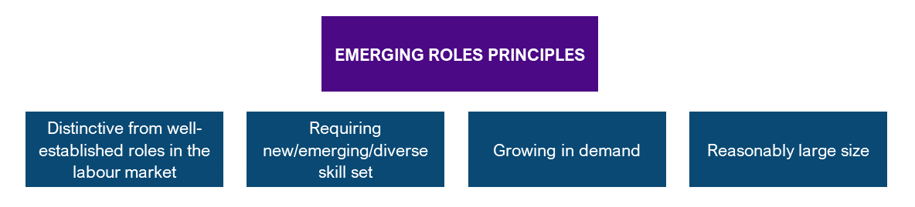

As a result, 37 emerging roles in the Australian labour market were identified. As shown in Figure 48, Figure 49, Figure 50, and Figure 51, the roles were identified across 4 key themes that align broadly with the major forces shaping our economy – Health, Care and Medical, Data and Technologies, Net Zero, and Science and Engineering. The largest number of roles were identified within Health, Care, and Medical, although this was closely followed by Data and Technologies.

Figure 48: Emerging roles in the Australian labour market with online job ad counts in 2022 – Health, care and medical

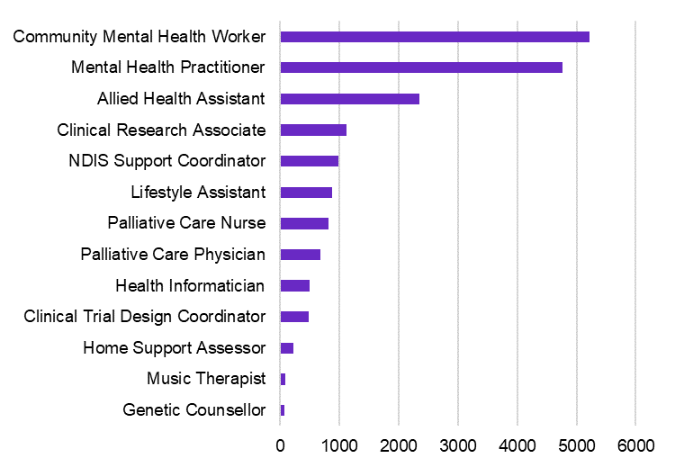

Source: Lightcast data 2022, Jobs and Skills Australia’s analysis.

Figure 49: Emerging roles in the Australian labour market with online job ad counts in 2022 – Data and technologies

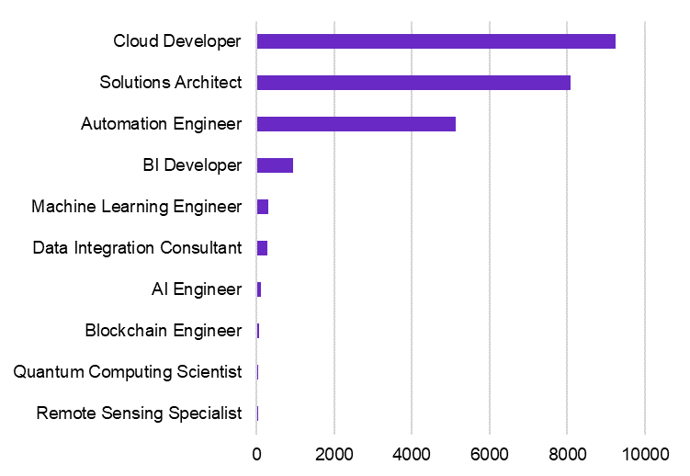

Source: Lightcast data 2022, Jobs and Skills Australia’s analysis.

Figure 50: Emerging roles in the Australian labour market with online job ad counts in 2022 – Net zero

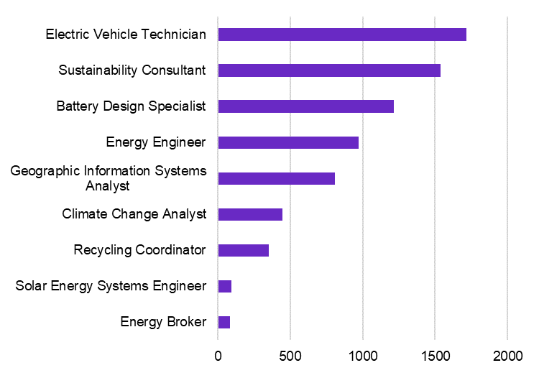

Source: Lightcast data 2022, Jobs and Skills Australia’s analysis.

Figure 51: Emerging roles in the Australian labour market with online job ad counts in 2022 – Science and engineering

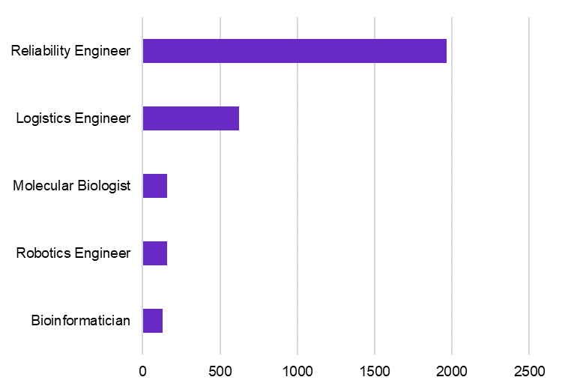

Source: Lightcast data 2022, Jobs and Skills Australia’s analysis.

The identified emerging roles reflect growing trends in the labour market such as the rising need for allied health services, rapid advances in technology uptake, the clean energy transformation, and innovation that may be closely related to other key themes. While emerging roles are not a prediction of a role that might appear in the future, they experience growing demand and grew quickly from a small base. By continuously monitoring these changes to the labour market and offering detailed skills analysis, JSA plays a crucial role in preparing Australia to adapt to economic changes and meet the demand for specific skills.

### The rise of artificial intelligence

Artificial intelligence (AI) is predicted to transform the way we work. While new applications for AI are emerging every day, and it has the potential to revolutionise industries, streamline tasks and create new opportunities; evidence from current Australian internet job advertisement data suggests the take up of AI to date is modest. Analysis indicates that the proportion of online job ads listing AI skills increased between 2018 and 2020 but declined in more recent years. AI skills were more prominent among technical occupations related to data and technologies.

Roles requiring AI skills in Australia were predominantly found in ICT, Data, and Professional Services. The most common roles with internet job ads listing AI skills were Data Scientist and Systems Engineer, with 13% and 7% of all AI related job ads, respectively (Figure 52).

Figure 52: Top 10 AI skills-related job titles

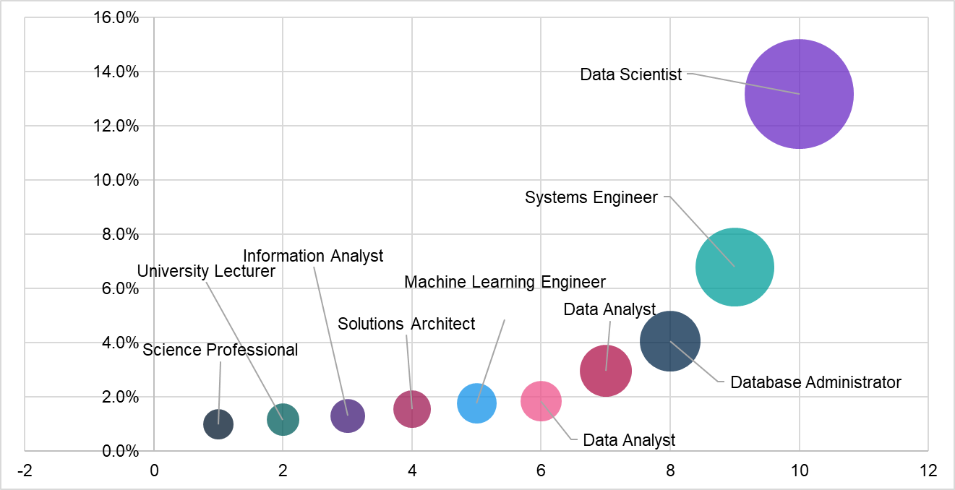

Source: Lightcast data 2018 - 2023, Jobs and Skills Australia’s analysis.

The majority of job ads requiring AI skills were specifically seeking candidates with expertise in Machine Learning, accounting for 93% of the total AI skills-related job market. The second most common cluster was Deep Learning, which includes skills related to neural networks and large language modeling, accounting for 43% of all AI listings. The Artificial Intelligence cluster, covering high level or generic descriptions of skills and techniques used widely in AI, accounted for 26% of AI related job ads.

Ethical AI and Risk Management appeared in 11% of ads listing AI skills. This highlights the importance of ensuring AI technologies are developed and used responsibly. Promoting ethical practices can help to mitigate potential risks associated with AI.

While AI skills such as Machine Learning, Deep Learning and Generative AI can overlap, this analysis categorises them distinctly. It’s important to note that job postings list various AI skills that could fall under multiple categories.

#### AI Engineer appears to be an emerging role

Although AI skills are embedded in a wide range of jobs, including both technical and non-technical roles, online job ad data from Lightcast suggests that AI Engineer itself could be an emerging role. AI Engineers build software that can perform various tasks without human involvement. AI Engineers are also responsible for developing, programming and training complex networks of algorithms that function like a human brain (Microsoft, 2024). Starting from a very low base, online job ads increased significantly (about 300%) between 2018 and 2022. However, the number of job ads remains low at 105 job listings. Similarly, data from Census of Population and Housing 2021 also recorded a small number of Australians who reported their occupation as AI Engineer (41 people).

Within the AI Engineer workforce, 12% are female and 88% are aged between 25 and 44 years old. The majority of AI Engineers worked in a full-time capacity (81%). Similar to other emerging roles in the technology space, AI Engineer is a high-skill – high-paying role, with 90% of the workforce holding a bachelor’s degree or above, and 59% earning at least $2,000 per week.

|  |
| --- |
| Case study: AI Engineer Artificial intelligence (AI) Engineers are responsible for developing tools, systems, and processes to enable the application of artificial intelligence in real-world contexts. Workforce profile (obtained from Census of Population and Housing 2021) Figure 53: Workforce profile – AI Engineer  This graphic shows workforce characteristics for AI engineer. It shows that the workforce size is 41 people, that 12% of the workforce is female, that 88% are aged between 25 and 44, and that 81% of the workforce works full time.  Source: Census of Population and Housing 2021, Jobs and Skills Australia’s analysis.  Figure 54: Weekly income – AI Engineer  This column chart shows the weekly income for AI engineers. 41% of the workforce received less than $2,000, 59% received $2000 or above on a weekly basis.  Source: Lightcast data 2018 – 2022 and Census of Population and Housing 2021, Jobs and Skills Australia’s analysis.  Figure 55: Highest qualification attainment – AI Engineer  This column chart shows the highest qualification attainment for AI engineers. 90% of the workforce held a Bachelor level degree or above, and 10% held a Certificate I-IV or Diploma.  Source: Lightcast data 2018 – 2022 and Census of Population and Housing 2021, Jobs and Skills Australia’s analysis. Demand from online job advertisements Figure 56: Number of online job ads – AI Engineer  This chart shows the number of online job ads for AI Engineer between 2018-2022.  There were 28 AI Engineer job ads in 2018, followed by 32 in 2019, 61 in 2020, 98 in 2021, and the number of job ads increased to 105 by 2022.  Source: Lightcast data 2018 – 2022 and Census of Population and Housing 2021, Jobs and Skills Australia’s analysis. |

|  |
| --- |
| Figure 57: Top ten skills required for AI Engineer  This bar chart shows the top 10 skills for AI Engineer between 2018-2022.  The most commonly listed skill was AI (61%), followed by Machine Learning (52%) and Python (40%). Towards the bottom of the chart is Natural Language Processing (21%), followed by Software Engineering (22%), followed by Teamwork / Collaboration (23%).  Source: Lightcast data 2018 – 2022 and Census of Population and Housing 2021, Jobs and Skills Australia’s analysis.  Sample job ad text:  We are seeking an Artificial Intelligence Engineer to join our qualified team. We are looking for expertise in building Retrieval-Augmented Generation (RAG) factories using any large language models, and integrating the RAG components (retrieval models, generation models, ranking models) into a functional pipeline for efficient information retrieval and generation. You will build Gen AI-based applications on cloud platforms. |

## Capacity studies – understanding the forces of change

JSA undertakes targeted capacity studies to help inform decision-making about how to prepare for a likely future labour market. These studies help us to better understand how industries and workforces are changing and emerging – and ensure we have an adaptable workforce with the right skills to benefit from the opportunities of the future.

The 2023 Jobs and Skills report included findings from *The Clean Energy Generation: Workforce needs for a net zero economy*. Findings from the report have already supported a range of government and industry measures. Analysis and advice on the skills and workforce needs of the sector informed the Australian Government through outcomes of the 2024-25 Budget, such as the expanded New Energy Apprenticeships program and various measures under the Skilling the Clean Energy Workforce package, including climate careers advocacy and promotion activities, a pilot program for Group Training Organisation (GTO) reimbursements, a new capital and equipment investment fund for facility upgrades, and investment to turbocharge the VET teacher, trainer and assessor workforce for clean energy. The study also informed government strategies such as the Migration Strategy, the Universities Accord, the Employment White Paper and upcoming National Energy Workforce Strategy. It supported new TAFE Centres of Excellence for Electric Vehicles (ACT) and Clean Energy (WA), and Batteries (QLD), will inform the government’s net zero sectoral plans and has been a valuable resource for Jobs and Skills Council workforce plans.

Since the study’s release, JSA has finalised reports from two further capacity studies – *An Essential Ingredient: The Food Supply Chain Workforce* and *The Future of the Early Childhood Education Profession: Early Childhood Education and Care Workforce Capacity Study*. JSA’s capacity studies provide critical evidence, insights, and recommendations as appropriate to support current and future workforce planning, policy development and program design to build and strengthen the sectors.

### A resilient food supply chain

A resilient workforce is essential to Australia’s food security and strong export industries. The future of Australia’s food supply chain will be shaped by multiple interacting shifts, including climate change and net zero, technological advances, and demographic changes. Concerns around sovereign capability, industry viability and cost of living also have an impact.

Our study supports a food supply chain workforce that can:

* **sustain regional Australia**. Employment in the food supply chain is heavily concentrated in regional and rural Australia, with Food Production and Manufacturing acting as anchor industries for many communities.
* **strengthen the economy**. Industries throughout the food supply chain make a significant contribution to the Australian economy. Without an adequate and sustainable workforce, the viability of these sectors – and the regional economies they sustain – will be at risk.
* **maintain food security**. Access to labour and skills has been widely recognised as a risk to Australia’s food security. While awareness of this risk was heightened by the COVID-19 outbreak and the particular challenges it posed, workforce pressures in Australia’s food supply chain pre-date and extend beyond the pandemic.
* **overcome challenges**. Australia’s food supply chain will need to navigate multiple interacting challenges over the coming years, including managing high levels of market and climate variability while unlocking opportunities from disruptive technologies.

While there are many activities vital to the food supply chain, the primary purpose of this capacity study was to explore the production, manufacturing and distribution of food   
(Figure 58).

Figure 58: Our food supply chain workforce

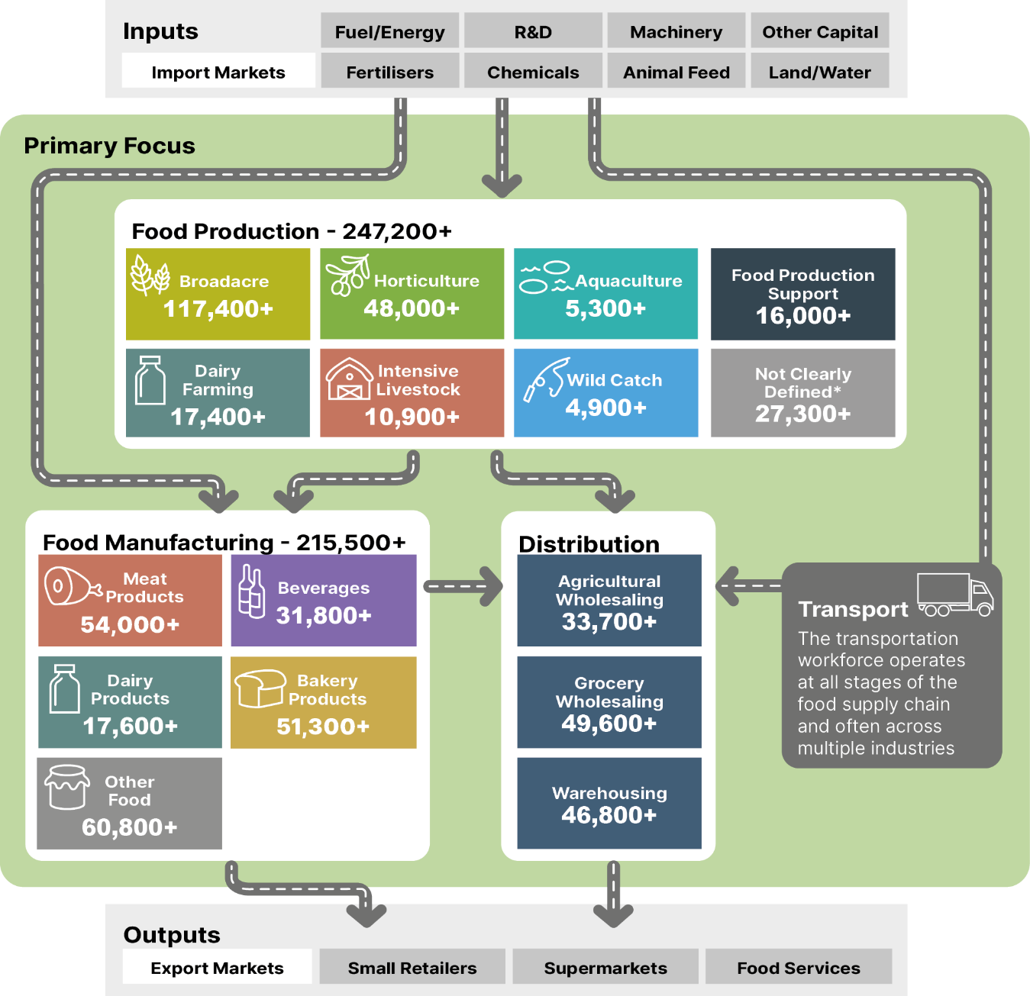

Source: ABS Census of Population and Housing, 2021, employment counts by aggregated industry codes.

Note: This Census data only captures those directly employed in relevant industries as their main job. JSA acknowledges that Census is an imperfect measure of workforce size. We explore these data limitations and challenges in the full report.

#### Education and training

In an increasingly skilled and qualified labour market, the food supply chain may struggle to attract and retain workers in lower skill roles. Offering attractive and rewarding career pathways for young people will be critical to securing the next generation of workers. This includes more opportunities to complete recognised qualifications that reflect industry needs and provide tangible employment outcomes for students. There are also strong opportunities to develop and support work-based learning, including apprenticeships and traineeships. For these to be successful, supports must be fit-for-purpose and industry buy-in is essential.

The food supply chain draws on a wide range of broad-based, specialised and industry specific training. Delivery of smaller courses can be particularly challenging due to geographic and occupational thin markets. Several key courses across the food supply chain are only delivered by a small number of providers nationally. Additionally, the number of providers delivering training in some larger disciplines, including food and meat processing, has declined significantly since 2015.

Education and training is delivered by a broad mix of providers, including TAFE institutes, universities, schools, enterprise and private providers. Specialist providers, including agricultural colleges and other private RTOs, play a particularly important role delivering industry-specific training that is not offered elsewhere (Figure 59).

Figure 59: Proportion of VET student completions in food production by provider type in 2022

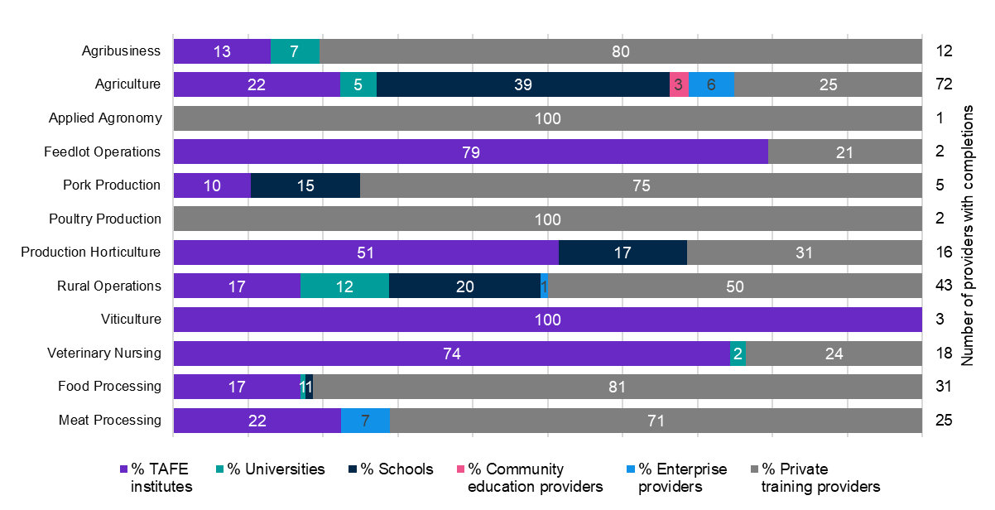

Source: Jobs and Skills Australia’s analysis of NCVER TVA program completions 2015-2022, Year by Type of accreditation by Provider type, for 2022. Number of providers refers to how many providers had program completions in that discipline in 2022.

#### Migration

Migration is an important pathway to addressing the diverse workforce needs of the food supply chain where local labour or skills are not available. For example, the Horticulture sector exhibits a high concentration of temporary migrant workers used to address labour supply challenges associated with highly seasonal work, often in regional, rural and remote locations (Figure 60).

Figure 60: Weekly payroll jobs in select Horticulture industries

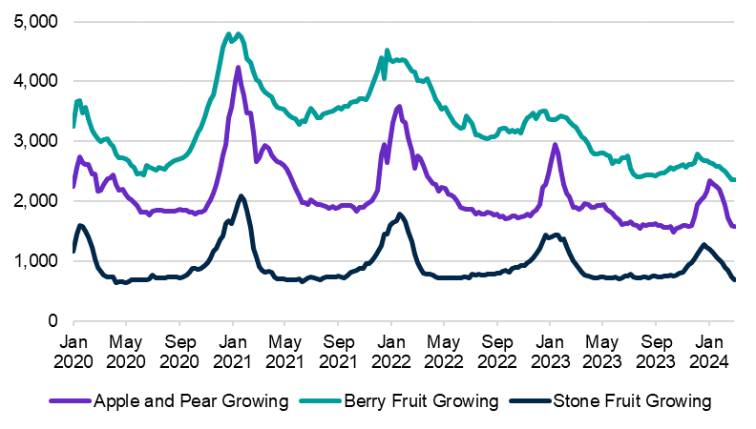

Source: Jobs and Skills Australia’s analysis of linked Single Touch Payroll data, 2024.

There is a genuine opportunity to rethink the current patchwork of migration pathways available to the food supply chain, including within the Working Holiday Maker (WHM) program and Pacific Australia Labour Mobility (PALM) scheme. However, given high levels of reliance on current pathways in parts of the workforce, changes will need to be approached carefully to avoid unintended consequences for employers and workers.

In designing any changes to the WHM program, it will be important that the Australian Government considers:

* the diverse workforce needs of the food supply chain
* the extent to which any contemplated changes would impact the ability to meet workforce needs
* the extent to which other viable options are available
* the range of levers available to combat migrant worker exploitation
* the importance of rigorous monitoring and evaluation.

While the PALM scheme delivers important benefits for employers and workers in the food supply chain, there are also opportunities to enhance this scheme through:

* trialling worker-initiated movement
* better planning and coordination
* reducing costs for employers and increasing benefits for workers in ways that are consistent with the integrity and objectives of the scheme
* increasing the stock of suitable worker accommodation in key regions.

#### Recommendations

Through our recommendations, findings and analysis, we seek to progress a number of opportunities for the food supply chain. These include improvements in education, training, migration and other system settings to lift outcomes for students, workers and employers. However, many of the challenges around attraction, retention and career development will require industry-led solutions.

Our recommendations are grouped into 8 overarching themes:

* Support apprenticeships and traineeships for critical roles.
* Improve the relevance and delivery of tertiary education and training.
* Invest in sustainable veterinary and biosecurity workforce pathways.
* Combat worker exploitation and ensure migration continues to support regional Australia.
* Harness opportunities within the PALM scheme.
* Improve labour hire practices, enforcement and information.
* Facilitate better planning of the food supply chain workforce.
* Address barriers in regional, rural and remote Australia.

This study alone is unable to resolve all underlying challenges facing this essential workforce, and invaluable opportunities cannot be realised by working in isolation. Concerted effort is required by all parties, including governments, industry and unions, to ensure the continuation of this important work. With the right investments and partnerships, our study finds that Australia can have a resilient food supply chain that provides rewarding employment opportunities right across the country and supports highly productive industries.

### The future of the Early Childhood Education Profession

Over 200,000 individuals are a part of Australia’s early childhood workforce – across roles that work directly with children (the majority of the workforce – Early Childhood Educators and Early Childhood Education Room Leaders), and provide educational and organisational leadership (Early Childhood Teachers and Children’s Education and Care Service Directors), as well as those who provide support (education and care professionals and assistants, as well as Administration Assistants, Cooks, and Cleaners).

JSA’s capacity study, undertaken in partnership with the relevant Jobs and Skills Council, HumanAbility, focused on ECEC workforce and skills issues, with particular attention on training, attraction, and retention, to complement the broader scope of the other inquiries undertaken in this space, including by the Productivity Commission and the Australian Competition and Consumer Commission (ACCC) (Commonwealth of Australia, Australian Competition and Consumer Commission, 2023a) (Productivity Commission, 2024b). The final report has a total of 28 findings and 41 recommendations to address the critical needs of the industry. It is important to note that from 8 October 2024, early learning providers were able to apply for Commonwealth Government funding to deliver early childhood education and care workers a wage increase of 15% above the modern award rates over 2 years.

#### Existing and emerging gaps

Ambitious policies are being implemented by Government to expand ECEC, including increased access for families. This will require a larger ECEC workforce, however the system is already experiencing shortages. The sector is also impacted by system settings that affect the ability to attract and retain staff by undermining job satisfaction, career progression opportunities, and cultural and gender inclusion, and wages are low relative to comparable occupations and sectors (Figure 61).

Figure 61: Median weekly wages, ECEC and comparative occupations

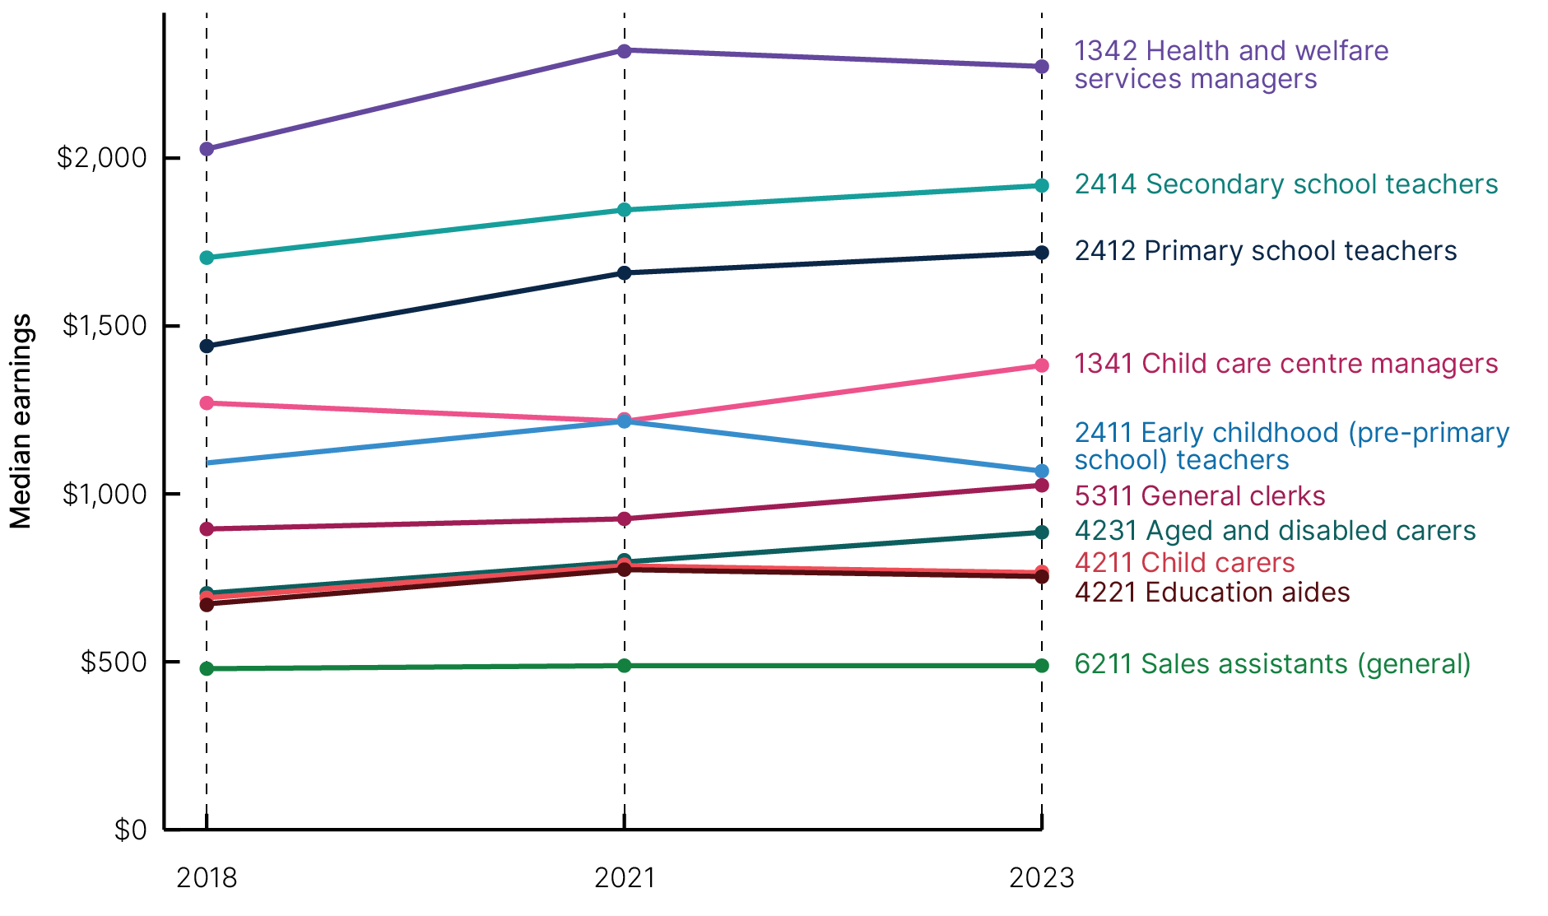

Source: ABS Employee Earnings and Hours, 2018, 2021, and 2023, Tablebuilder.

Modelling indicates that there is a current 2024 shortfall of around 21,000 qualified ECEC professionals needed to meet existing demand and support more sustainable working conditions. To break this figure down further:

* There is a shortfall of 3,700 ECEC professionals just to meet the estimated enrolment to employment ratios currently in place (making no allowance for additional above-ratio staffing).
* An additional 700 ECEC professionals (particularly early childhood teachers) are needed to resolve currently approved ratio waivers.
* To move the workforce to more sustainable working conditions with better provision for ongoing professional development and reduced reliance on overtime would require an additional 16,400 ECEC professionals.

To meet estimated unmet demand for places from children not already in care, and additional hours for children currently in services, would require a further 17,700 ECEC professionals. It is important to note though that workforce shortfalls are not the only constraint to meeting this unmet demand – additional places in services would also be required. This may require capital investment and planning and regulatory approval to open new services and/or expand existing services.

Finally, to increase the number of places or alter the mix of places to fully meet the participation levels intended by the changes to Child Care Subsidy and expanded preschool provision would require an additional 18,400 ECEC professionals (see Figure 62).

Figure 62: Nature of workforce shortfalls by component by workforce demand, 2024

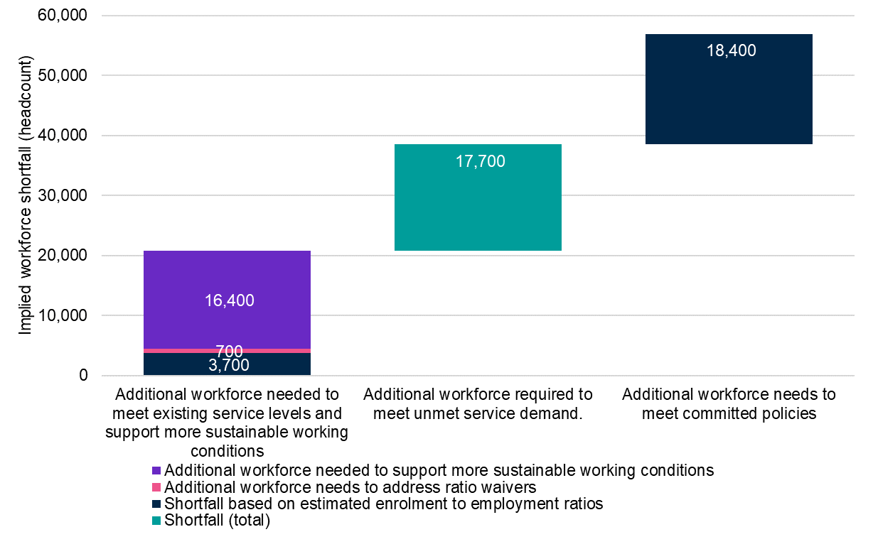

Source: Commissioned Deloitte Access Economics modelling for Jobs and Skills Australia’s ECEC Capacity Study.

Looking to the future, without any further intervention (such as wage increases), the shortfall of ECEC professionals to meet existing demand and support more sustainable working conditions would decrease to around 12,600 by 2034. This decrease is primarily due to a slight increase in projected workforce supply and changes in the expected population of children accessing services (both driven mainly by population forecasts).

However, the estimated additional workforce shortfall in order to meet unmet service demand would change from 17,700 in 2024 to 20,100 in 2034. As more states and territories begin to implement expanded preschool, the additional workforce needed to meet policy changes would increase from 18,400 in 2024 to 34,000 in 2034 (see Figure 63).

Figure 63: Nature of workforce shortfalls by component by projected workforce demand, 2034

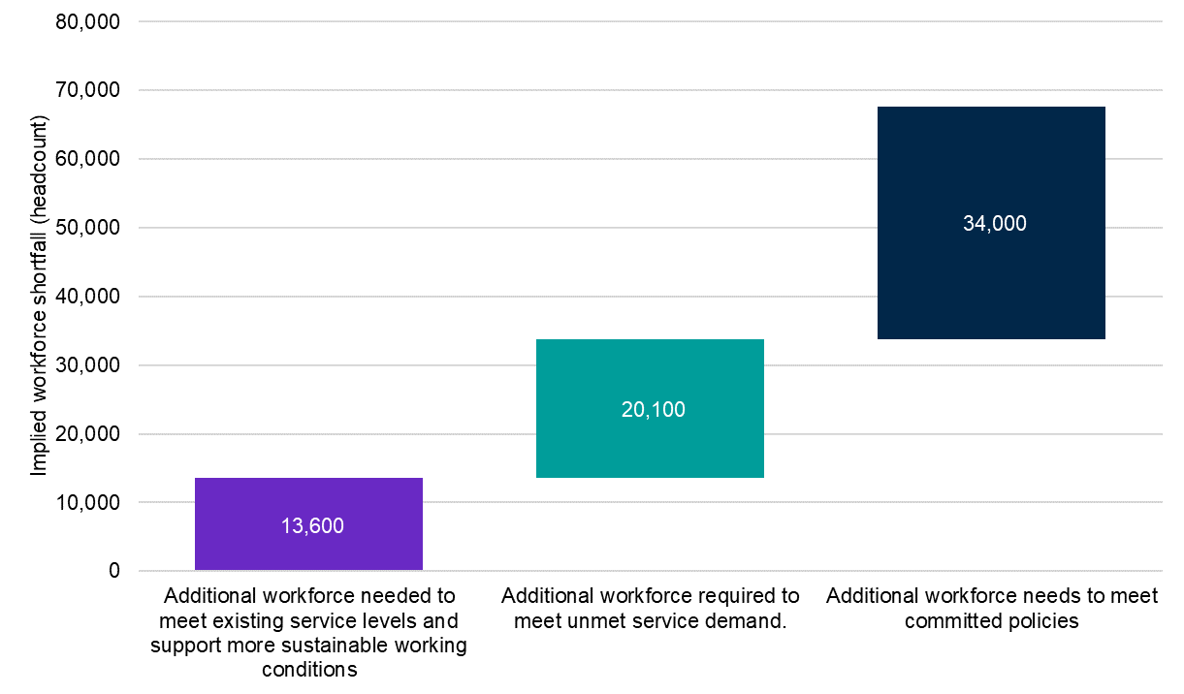

Source: Commissioned Deloitte Access Economics modelling for Jobs and Skills Australia’s ECEC Capacity Study.

#### First Nations quality delivery needs

A key part of the Closing the Gap Targets 3 and 4 that focus on the early years is to ensure that children engage in high quality, culturally appropriate ECEC. *The Sector Strengthening Plan: Early Childhood Care and Development* supports the Closing the Gap Target and Priority Reform 2 (build the Aboriginal and Torres Strait Islander community-controlled organisations - ACCOS - sector) by supporting increased service delivery, coverage, capacity, quality and resources for Aboriginal and Torres Strait Islander community-controlled organisations (Joint Council on Closing the Gap, 2021).

First Nations children have a lower ECEC participation rate compared to non-Indigenous children (Commonwealth of Australia, Australian Competition and Consumer Commission, 2023b), and evidence suggests the presence of First Nations educators and culturally inclusive ECEC are critical in promoting participation of First Nations children in ECEC services (Biddle, 2007). The need for greater cultural inclusivity in ECEC programs was made clear in the submission paper SNAICC – National Voice for our Children made to JSA:

Culture is a critical part of Aboriginal and Torres Strait Islander children’s development, identity and self-esteem and strengthens their overall health and wellbeing. For Aboriginal and Torres Strait Islander children and families to experience cultural safety, early years services must be grounded in cultural frameworks that reflect the protocols and practices of local families and communities. (Jobs and Skills Australia, 2024e)

A lack of suitable workforce was raised as the major barrier to accessing high quality and culturally appropriate ECEC programs. Culturally responsive training to facilitate First Nations children’s engagement in ECEC is linked to ensuring First Nations staff are well-represented and supported in the workforce. In the National Agreement on Closing the Gap under Clause 45 a key element of a strong sector is sustained capacity building and a dedicated, appropriately trained and identified Aboriginal and Torres Strait Islander workforce.

While there are a number of ACCOs involved in the delivery of ECEC, well-supported, culturally safe opportunities for First Nations ECEC staff in non-ACCO settings are less embedded in the ECEC sector and these opportunities should be assured. The representation of First Nations individuals is greater in the ECEC workforce across all ECEC occupations at 3.7% (Table 16), relative to all occupations, and on par across all of the study’s focus ECEC occupations with the broader population. However, First Nations people are also not as well represented across the more highly remunerated occupations in the sector (Table 16).

Table 16: Selected characteristics of the ECEC Workforce by unit group, 2021

|  |  |  |  |  |  |  |
| --- | --- | --- | --- | --- | --- | --- |
|  | 4211  Child Carers | 4221  Education Aides | 2411  Early Childhood (Pre-primary School Teachers) | 1341  Child Care Centre Managers | Total ECEC Occupations | All Occupations |
| Average age | 34 | 45 | 40 | 41 | 37 | 40.8 |
| Female (%) | 95.6% | 88.6% | 97.6% | 91.8% | 93.3% | 48.8% |
| Aboriginal and/or Torres Strait Islander (%) | 2.9% | 5.7% | 1.7% | 2.5% | 3.7% | 1.7% |
| Has a certificate III and above (%) | 79.1% | 71.3% | 95.6% | 93.1% | 78.7% | 66.1% |
| Born overseas (%) | 37.4% | 20.8% | 29.0% | 25.9% | 30.5% | 28.5% |
| Main language spoken other than English (%) | 31.4% | 12.9% | 21.7% | 17.0% | 23.6% | 21.3% |
| Has a long-term health condition (%) | 30.5% | 36.7% | 36.4% | 32.4% | 33.0% | 28.6% |

Source: ABS Census of Population and Housing, 2021, TableBuilder.

The proportion of First Nations people employed in ECEC occupations are higher in the Education Aides (5.7%) and Child Carers (2.9%) occupations which have a lower indicative skill level than Early Childhood (Pre-primary) Teachers (1.7%) and Child Care Centre Managers (2.9%). This may indicate a lack of development and educational opportunities for First Nations ECEC educators and is particularly noticeable in the Northern Territory with a 27 percentage point difference between Education Aides and Child Care Centre Managers. The Northern Territory has the highest proportion of First Nations people employed in the ECEC workforce, with 34.4% employed as Education Aides, 14.4% as Child Care Workers, 10.9% as Early Childhood Teachers, and 6.8% as Child Care Centre Managers.

There are also relatively few ACCO education providers delivering ECEC qualifications for First Nations Australians. For these and other reasons the First Nations community may be poorly served by education and training pathways into ECEC, particularly for higher education routes including relating to curriculum, assessment, and delivery arrangements. The study calls on governments to seek ongoing guidance from First Nations voices in order to better support careers in ECEC to enhance provision of ECEC to First Nations people and communities.

Further to these insights, case studies and rich detail is available in the study report. The report is available on the JSA website in a summary form to succinctly communicate these insights, and an extended form that expands on the thorough research behind these conclusions.

|  |
| --- |
| Jobs and Skills Councils in focus Jobs and Skills Councils workforce plans consider not only current, but also emerging and future workforce challenges. This includes developing an understanding of the megatrends impacting the labour market and how they may impact work into the future.  Among the publicly available Jobs and Skills Councils workforce plans, key trends relating to the net zero transition, demographic change, and technological advances were identified, along with the need to ensure the workforce can keep pace with this change.  This included a focus for many on ensuring current and ongoing digital capability, with some identifying a current digital capacity gap as well as noting a trend of increasing digitisation. |

## In summary

To achieve a truly inclusive, dynamic, and competitive economy we cannot simply respond to our current and imminent skills challenges. We must be proactive in ensuring our future workforce has the skills required to adapt to a changing economy, and more Australians can share in the benefits of growth and change.

JSA contributes to the evidence base by making employment projections and undertaking scenario modelling, monitoring the labour market for changing or emerging occupations and skills needs, and undertaking targeted capacity studies. These activities help us to better understand change, prepare for an emerging and likely future labour market, and ensure we have an adaptable workforce with the right skills to benefit from the opportunities of the future.

# 

# Chapter 4: Optimising pathways and system architecture

With persistent skills shortages, and with projections indicating that over 90% of the employment growth over the next ten years will be in occupations commensurate with post-secondary qualifications, a strong and harmonised skills system with the right settings, pathways, and system architecture is critical to fulfilling Australia’s current and future skills needs.

This requires the different parts of our national skills system to work effectively together. Our education, skills and training, and migration systems must work in concert to deliver quality outcomes and to address skills shortages.

Key aims for a more complementary and harmonised skills system include strong and effective connections with industry to ensure the right skills are being delivered, and improved navigability for students to obtain the skills, capabilities, and knowledge they need for success.

Greater complementarity between the sectors, including better collaboration, could also unlock innovation and enable the design of more fit-for-purpose education and training that capitalises on the strengths of both sectors to deliver quality outcomes. This includes ensuring graduates are job ready and have the requisite employability skills to succeed in the workplace.

A strong skills system with access to lifelong learning will serve not only to provide critical skills to the Australian economy, but that more Australians can access the social, health, and wellbeing benefits of education and training.

JSA assists by providing analysis and advice on a more cohesive education and training sector. It’s why we have a legislative remit to:

* report on Australia’s current, emerging and future skills and training needs and priorities – including specifically in relation to apprenticeships
* provide advice on the adequacy of the Australian system for providing VET, including training outcomes
* provide advice on pathways into VET and pathways between VET and higher education
* undertake studies, including on opportunities to improve employment, VET and higher education outcomes for cohorts of individuals that have historically experienced labour market disadvantage and exclusion, and support, where appropriate, the evaluation of outcomes of relevant programs and the measurement of targets for these cohorts
* undertake research and analysis on the resourcing and funding requirements for registered training organisations (within the meaning of the National Vocational Education and Training Regulator Act 2011) to deliver accessible quality VET courses.

Key themes in this chapter:

* Tertiary education will be critical to providing the right skills for the jobs of the future. It also provides economic returns for workers in addition to social and well-being benefits.
* A more harmonised tertiary education system with greater collaboration between the sectors could enhance the ability of students to navigate the education and training system and obtain the knowledge, skills and capabilities they need to successfully participate in the labour market, especially for groups who have historically experienced labour market disadvantage. It could also lead to greater system effectiveness through the provision of well-designed collaborative education and training, and help address national challenges, increase productivity and enhance labour market outcomes.
* A National Skills Taxonomy could provide a common understanding and language of skills across contexts and help align parties in the national skills system in a collective response to skills challenges.
* The benefits of combining work with learning are clear. Any work undertaken while studying has a positive impact on employment outcomes, but the type of work also makes a difference, with more beneficial outcomes for those working in ‘career’ as compared with ‘non-career’ jobs.
* Structured work-integrated learning also has clear positive benefits for individuals. Students who undertake a course of study via an apprenticeship pathway have better outcomes in terms of both income and employment (including employment relevance) when compared with non-apprenticeship pathways.
* VET is a key part of the national skills system and a key pathway for skills development. A critical part of the successful functioning of the VET system are VET teachers and trainers, and JSA has undertaken a VET workforce study to better understand the nature of the VET workforce and key challenges in the sector.
* The VET workforce study identified targeted improvements to workforce data collection and recommends the development of a VET workforce taxonomy, job profiles and occupational framework to help identify and address key challenges.
* The Migration Review was critical of the approach to identifying skills needs, including the limited coordination between elements of the national skills system (education, training, and migration) and the lack of a whole-of-government and tripartite mechanism for assessing Australia’s skills needs.
* As a response, the Migration Strategy established a formal role for JSA in defining skills needs using evidence, helping to ensure local workers’ skills and job opportunities are prioritised, and that the migration system complements the domestic skills and training system.

## 

## The importance of tertiary pathways

In addition to helping ensure individuals and employers have the skills they need for a strong and functional labour market; education also helps people participate in society and live the kind of lives they want. Education can contribute to improved overall health, higher rates of civic participation, and increased trust and happiness (OECD, 2013).

Attaining post-secondary qualifications contributes to higher participation rates and lower unemployment rates. Unemployment rates for persons aged 25-34 without Year 12 or any tertiary qualification are above 10 per cent. For those with a higher education that figure is just 3.5 per cent. It also leads to higher full-time weekly earnings, and the higher the qualification, the higher the median weekly earnings. As shown in Figure 64, median weekly earnings for workers with a Certificate III/IV as their highest qualification ($1,534) are below the national median ($1,600), however that cohort has experienced the strongest growth in weekly earnings over the past 5 years, increasing by 20% or $252.

Figure 64: Median weekly full-time earnings by highest level of educational attainment August 2023

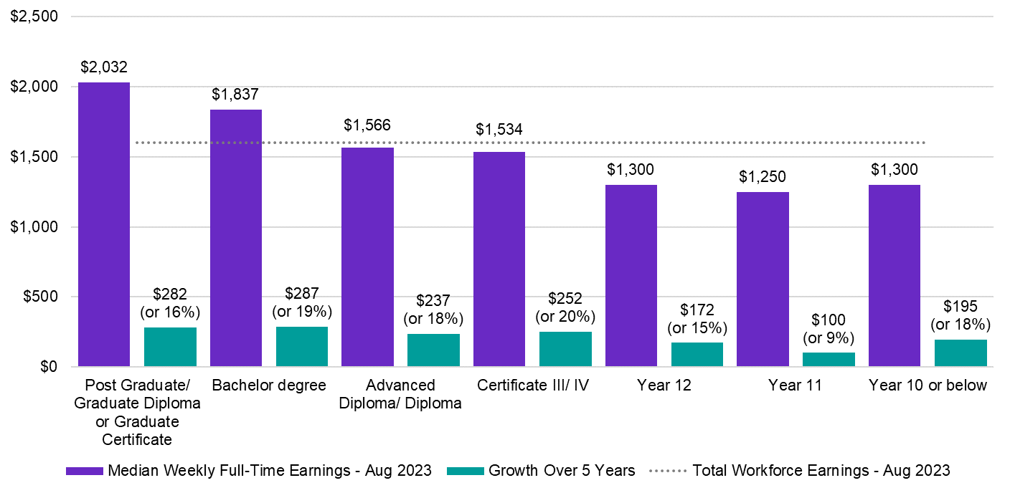

Source: ABS, Characteristics of Employment, August 2023, TableBuilder extract.

Note: Median weekly earnings for full-time workers in their main job. Year 10 or below classification contains Certificate I/II and Certificate not further defined (nfd) qualifications.

Ensuring access to lifelong learning (including people with higher education qualifications who later undertake VET as part of their current profession or retraining) can not only benefit the labour market, but have beneficial returns for individuals and society economically, and in terms of social cohesion, health and well-being.

Employment projections produced by Victoria University for JSA estimate that over 90% of the employment growth over the next 10 years will be in occupations commensurate with post-secondary qualifications (skill levels 1 to 4) – with around half (51.0%) of the projected growth being in occupations related to a bachelor’s degree or higher as the primary education pathway (skill level 1), and 42.6% in occupations with VET as the primary pathway (skill levels 2 to 4).

Since 2016, the growth in educational attainment in Australia has been skewed toward the higher education system. In the 2021 Census, over 11 million Australians reported having a post-secondary qualification, a 20 per cent increase since 2016. Around 5.5 million reported having a bachelor’s degree or higher as their highest level of education, a 31 per cent increase since 2016. In the 2021 Census, 4 million people reported having Certificate I to IV as their highest level of education, which is a 11 per cent increase since 2016 (Australian Bureau of Statistics, 2022a). Compared to 2011, the number of people with a bachelor’s degree or higher has grown 67%, whereas the Certificate I to IV group has grown only 25%[30]. These figures probably underestimate the role of the VET system because they record the highest level of education attainment, and there may be many people who have both higher education and VET qualifications who would be captured in group with bachelor’s degree or higher as their highest level of education.

With strong growth needed in the trades due to a strong focus on construction, infrastructure, and the net-zero transition, we will need to ensure growth in attainment matches the projected skills needs for the future. The scenario analysis undertaken in the chapter 3 reinforces the argument to rebalance the education and training system to increase the focus on the VET system.

## The case for a more harmonised tertiary education system

Australia’s tertiary education system is largely divided into two sectors with distinctive structures, cultures, and administrative and educational norms. Both sectors play distinct and important roles in delivering quality education and training that meets student need and develops the skills required by industry. This has historically been underpinned by the Australian Qualifications Framework (AQF), which has guided education and training course development and accreditation.

Without arguing for a merger of VET and higher education, an argument can be made for greater connectedness and harmony between them – building on historical connections between the sectors that have been useful to students and industries. This would result in two sectors working in harmony within one system, rather than two systems operating side‑by-side.

The argument for a more harmonised and connected tertiary education system has been present since at least the Unified National System was created at the end of the 1980s. The final report of the Universities Accord (Australian Government, 2024), acknowledged “the role that a more integrated tertiary education system will play in meeting skills demand and the need to foster greater parity of esteem between the two sectors” (p69). The Australian Government’s *Working Future: White Paper on Jobs and Opportunities* also identified the growing importance of improving collaboration between the vocational and higher education sectors to improve access to lifelong learning to increase the volume of Australians with the skills needed to meet future workforce needs (Commonwealth of Australia, 2023a).

In the final chapter of *Rethinking Tertiary Education: Building on the Work of Peter Noonan*, a book brought together in honour of Peter Noonan, a member of the panel undertaking the *2008 Review of Australian Higher Education* (the Bradley Review), the authors (his collaborators) also argued for strengthened connections between the sectors. They argued that this could enhance the ability of students to navigate the education and training system to obtain the knowledge, skills and capabilities they need to successfully participate in the labour market (Dawkins, Lilly, & Pascoe, 2023).

They also argued that tertiary harmonisation could promote equitable access to universal, high quality tertiary education, correct for distortions in incentives for students to participate in one part of the tertiary education and training system rather than another, and encourage vocational education providers, higher education providers and employers to collaborate in the provision of well-designed education and training programs to secure the development of the knowledge, skills and capabilities needed for the Australian economy (Dawkins, Lilly, & Pascoe, 2023).

In summary, the argument is that both students and industry would benefit from gaining more ready access to the full range of knowledge, skills and capabilities that they need for Australia to have a successful economy and thriving society.

### Examples of harmonisation in practice

There are a range of examples of attempts at tertiary harmonisation by different institutions which give some insight into the proposed benefits of tertiary harmonisation. These examples have arisen organically despite known barriers in the system including regulation, funding and financing arrangements, legislative and regulatory settings, qualifications frameworks, curriculum and pedagogy including assessment and recognition. This pattern of bespoke examples is not scalable without change to address barriers.

The examples also demonstrate the different expected benefits of harmonisation:

1. Greater system effectiveness.
2. Improved access and equity.
3. Supporting national challenges.
4. Higher productivity and better labour market outcomes.

#### Tertiary harmonisation and greater system effectiveness

The benefits of tertiary harmonisation for system effectiveness include ease of navigation of the system by students and industry, increased efficiency and lower cost in obtaining the skills needed, and increased synergy of VET and higher education working together with industry to produce outcomes that would not otherwise be possible. There are examples of where tertiary harmonisation has been applied to create scenarios of system effectiveness.

South Australia has developed a state-based model which provides students with the opportunity to apply for a dual-offer course which includes study at both TAFE SA and one of the 3 universities in South Australia. The dual offer courses enable students to apply for a TAFE SA qualification connected to a University Program in one application, so a student is guaranteed a place at an SA University on completion of the VET program.

Students can apply for a Diploma, an Advanced Diploma or an associate degree and then upon completion of this qualification transfer into a university bachelor’s degree, with credit applied to the TAFE studies completed.

Additionally, TAFE SA has a range of established credit transfer arrangements with the South Australian universities for students who have undertaken VET and wish to consider higher education study later, while still being recognised for their previous TAFE education attainment.

The development of this harmonisation model brings a number of benefits to students, with a strong focus on student mobility between the two sectors. Additional benefits include:

* Ease of navigation due to both the TAFE and university application being completed in the one application via SATAC (South Australian Tertiary Admission Centre), with a guaranteed entry into the university course on completion of the TAFE course. Application is also free to the student.
* Non-ATAR entry options: students who may not have had an ATAR or did not meet the ATAR requirement are able to enter into bachelor’s qualifications through a TAFE pathway.
* Established credit transfer agreements between TAFE and university saves students both time and money.
* The qualification can be started whilst located regionally as there are TAFE campuses located in South Australian regional areas including in Ceduna, Port Augusta, and Coober Pedy. This saves study time, lowers living expenses and the need for relocation by the student.

|  |  |  |  |  |  |  |  |  |  |  |  |  |  |  |  |  |  |  |  |  |  |  |  |  |  |  |  |  |  |  |  |  |  |  |  |  |  |  |  |  |  |  |  |  |  |  |  |  |  |  |  |  |  |  |  |  |  |  |  |  |  |  |  |  |  |  |  |  |  |  |  |  |
| --- | --- | --- | --- | --- | --- | --- | --- | --- | --- | --- | --- | --- | --- | --- | --- | --- | --- | --- | --- | --- | --- | --- | --- | --- | --- | --- | --- | --- | --- | --- | --- | --- | --- | --- | --- | --- | --- | --- | --- | --- | --- | --- | --- | --- | --- | --- | --- | --- | --- | --- | --- | --- | --- | --- | --- | --- | --- | --- | --- | --- | --- | --- | --- | --- | --- | --- | --- | --- | --- | --- | --- | --- |
| TAFE SA and South Australian universities Financial considerations like fees may be a barrier for students choosing the best course for them, and a more aligned tertiary system may help. Fee setting is state based for VET, so scenarios look different in each state and territory, adding further complexity to choice. Alongside the specifically designed dual-offer courses, TAFE SA and the South Australian universities have a range of credit recognition pathways students can use to save both time and money when completing their studies.  In a hypothetical example, ‘Michelle[31]’ is a domestic student living in South Australia. She recently finished a Diploma of Information Technology (Advanced Networking) and (Cloud Engineering) Award Course at TAFE South Australia for 12 months for $8,113 under the state government subsidy scheme.  Michelle wants to pursue a Bachelor of Information Technology (Networking and Cybersecurity) at the University of South Australia. The duration is 3 years (full-time), and the fee is $9,314/ year.  For comparison, there are 3 scenarios Michelle could consider for her studies.  Scenario 1:  In this scenario, Michelle completes a 1-year VET Diploma of IT through TAFE SA and she receives 1 year of credit towards the Bachelor of IT (Table 17).  Table 17: harmonisation example 1   |  |  |  |  |  |  |  |  | | --- | --- | --- | --- | --- | --- | --- | --- | | VET Year 1 | VET Year 2 | VET Year 3 | HE Year 1 | HE Year 2 | HE Year 3 | Total​ Time | Total Cost* | | With Harmonisation – Award Course | | | | | | | | | $8,113​ | n/a​ | n/a​ | Diploma Credit​ | $9,314​ | $9,314​ | 3 years​ | $26,741​ |   Source: Diploma of Information Technology (Advanced Networking) (TAFE SA, 2024) and Student contributions data (University of South Australia, 2024).  The completion of the Diploma and the recognition of 1 years’ worth of credit means Michelle only has to complete two years of university study. This pathway takes her 3 years of full-time study and costs her $26,741[32] in total, for two qualifications.  This is an example of harmonisation where a ‘pathway’ between VET and HE is established through the granting of credit.  Scenario 2:  In scenario 2, Michelle undertakes the same qualifications as in scenario 1 but no credit is awarded and the TAFE and university qualifications are undertaken separately. This scenario is theoretical and explores what would happen when there is no harmonisation between the TAFE and the university. In this scenario, credit recognition for the study Michelle completed in the TAFE Diploma does not exist (Table 18).  Table 18: harmonisation example 2   |  |  |  |  |  |  |  |  | | --- | --- | --- | --- | --- | --- | --- | --- | | VET Year 1​ | VET Year 2​ | VET Year 3​ | HE Year 1​ | HE Year 2​ | HE Year 3​ | Total​ Time | Total Cost* | | Without Harmonisation – VET and HE undertaken separately and consecutively | | | | | | | | | $8,113 | n/a​ | n/a​ | $9,314​ | $9,314​ | $9,314​ | 4 years​ | $36,055​ |   Source: Diploma of Information Technology (Advanced Networking) (TAFE SA, 2024) and Student contributions data (University of South Australia, 2024).  This scenario, without harmonisation, adds both time and cost (an additional $9,314) for the student, along with the possibility of the student re-learning material in the bachelor’s qualification which was already covered in the TAFE Diploma. This can be demotivating and frustrating for a student.  Scenario 3:  A third scenario is one where Michelle decides to only study the bachelor’s degree. This approach costs Michelle slightly more ($1,201) than scenario 1, takes the same amount of time (3 years) but she completes her studies holding only one qualification (Table 19). She also doesn’t gain the additional practical skills she would obtain from completing the Diploma of IT with TAFE.  Table 19: harmonisation example 3   |  |  |  |  |  |  |  |  | | --- | --- | --- | --- | --- | --- | --- | --- | | VET Year 1​ | VET Year 2​ | VET Year 3​ | HE Year 1​ | HE Year 2​ | HE Year 3​ | Total​ Time | Total Cost* | | Undergraduate only | | | | | | | | | n/a​ | n/a​ | n/a​ | $9,314​ | $9,314​ | $9,314​ | 3 years​ | $27,942​ |   Source: Diploma of Information Technology (Advanced Networking) (TAFE SA, 2024) and Student contributions data (University of South Australia, 2024). |

#### Tertiary harmonisation as an enabler of access and equity

Tertiary harmonisation can enable greater access and equity to tertiary education including increased participation of under-represented groups (for example First Nations people, those living in rural and remote areas, and individuals with low socioeconomic status). It can also increase the status of VET which has a higher representation of under-represented groups.

An essential element of tertiary harmonisation is designing and delivering qualifications that enable student mobility between education levels, and transitions from study to work. Pathways between VET and higher education support access to higher education for all students, but especially for groups who experience labour market disadvantage or are under-represented in the tertiary education system.

By removing or significantly reducing the barriers between VET and higher education, students will have increased opportunities to find the right pathways to study what they want, how they want and to gain the skills needed by industry and the economy.

|  |
| --- |
| TAFE NSW and the University of Canberra TAFE NSW and the University of Canberra are working in partnership to deliver the Bachelor of Event and Tourism Management. As part of this partnership, students can study for this bachelor’s degree at TAFE NSW St Leonards, combining academic study with practical learning through work-integrated industry experiences like the Royal Easter Show (TAFE NSW, 2024).  Upon completing a TAFE NSW Diploma or Advanced Diploma in Event Management, Hospitality Management, or Travel and Tourism Management, students can apply for entry to the Bachelor of Event and Tourism Management through the University of Canberra website. TAFE NSW and the University of Canberra have pre-negotiated credits which are automatically granted upon application and the degree is delivered at TAFE NSW either face-to-face or online, with no requirement for students to attend the University of Canberra campus.  The pathway may address barriers to higher education access and equity through its clear credit recognition, no requirement for relocation, flexible online option or familiar TAFE learning environment with smaller classroom size and increased access to teachers and support (Tafe Directors Australia, 2023).  Other benefits of this pathway include industry relevant learning since the degree integrates theory with practical learning through work-integrated industry experiences reduced cost and time of study, with students able to complete the degree in 2 years following completing the relevant VET qualification – saving one year of study and $16,992 (University of Canberra, 2024). |

#### Tertiary Harmonisation supporting national challenges

Australia’s national skills challenges are complex, with inter-connected issues that cannot be addressed by one sector alone. Successfully addressing challenges such as the transition to clean energy technologies, leveraging the opportunities of digital innovation, and strengthening the health and wellbeing of people and communities, requires a connected tertiary system.

A harmonised and better-connected tertiary system, where both sectors can collaborate to improve the timeliness and industry relevance of workforce supply, can play a key role in addressing national challenges by increasing the supply of industry ready graduates, helping to facilitate major workforce transitions in response to industry changes, and improving access and mobility across both sectors by improving recognition of existing skills and knowledge.

|  |
| --- |
| Case Study: TAFE Queensland enrolled nurse to registered nurse pathway A more harmonised tertiary education system will ensure a steady supply of entry workers as well as flexible options for career-long upskilling and reskilling.  TAFE Queensland has structured its Bachelor of Nursing program to allow enrolled nurses to transfer into higher education level study.  Graduates with a Diploma of Nursing receive credit and are fast tracked into the second year of the degree. This also allows students to use their skills and knowledge by working in healthcare while they complete their studies.  While the Bachelor of Nursing is not a Commonwealth Supported Place, this pathway can reduce costs for students as the Diploma of Nursing is eligible for FEE-Free TAFE and/or subsides and concessions. |

#### Tertiary harmonisation and productivity and labour market outcomes

A more harmonised VET and higher education sector has the potential to improve the participation, productivity and inclusiveness in the Australian labour market and economy. These benefits will flow to both workers and employers, but also have subsequent benefits to education providers and the government more broadly.

The potential labour market impacts of more harmonised tertiary education can be separated into the first-round or initial impacts and the subsequent benefits that flow thereafter. First round impacts include the potential for improvements in the overall level of participation in the labour market, the better alignment of employee skillsets with the needs of industry, improvements in labour market matching, and greater dynamism and responsiveness to opportunities and challenges.

Subsequent benefits include the potential for higher social and economic returns on the government’s investment in education and training, more efficient funding arrangements, including via higher tax revenues, and increased global competitiveness. For education providers, tertiary harmonisation may lead to higher rates of educational participation and completion, supporting the viability and stability of providers. A more harmonised tertiary sector may also provide more flexibility for education providers to deliver a better mix of knowledge, technical skills and general skills to help meet the needs of employers.

### Continuing the national conversation

The benefits of harmonisation across a range of key themes are clear. However, for examples such as this to become more widespread and to have system wide value, systemic change is needed. As the national conversation on tertiary harmonisation continues, JSA is in a unique position to contribute to this agenda as an advisor on the national skills system (including both VET and higher education) in collaboration with a proposed Australian Tertiary Education Commission.

Contributions from JSA to the ongoing agenda could include:

* Disseminating concrete examples of possible models of VET and higher education collaboration.
* Dialogue with Jobs and Skills Councils on what skills are needed across VET and higher education for their sectors.
* A future relationship with the proposed Australian Tertiary Education Commission.
* Considering a common language and framework that contributes to higher education and VET connectivity.
* Data from the VET National Data Asset, Skills Tracker, and other data sources.
* Research on the benefits of joint VET and Higher Education pathways.

This includes work to support 2024-25 Budget measures that the Department of Employment and Workplace Relations and the Department of Education are progressing with relevant agencies to deliver reforms recommended by the Australian Universities Accord.

### The Role for a National Skills Taxonomy

A common skills language is crucial for ensuring effective collaboration among educators, employers, unions, governments, and individuals. Currently, without a standardised language or a common definition to distinguish skills, tasks, units of competency, or knowledge, conversations can turn to stalemate due to the use of homophones.

The primary objective of developing a National Skills Taxonomy (NST) is to establish a common language of skills. Building a shared understanding of skills among stakeholders will require time and a significant shift in how skills are identified and communicated.

The term ‘skill’ is widely used across education, training, and workforce contexts. However, its definition varies significantly across different stakeholders, use cases and formal frameworks.

Australia currently lacks a unified language of skills, with no single framework consistently describing the range of skills in Australia. This has resulted in different stakeholders employing their own definitions for skills. The absence of a common interpretation and understanding of skills represents a major challenge in the Australian skills landscape, with each actor speaking a different skills language. This fragmentation creates friction and provides challenges when attempting to find alignment between VET, higher education and employment.

A NST can offer a starting point for tertiary harmonisation to reset the language of education in the context of a tertiary system with a common objective – a comprehensive education underpinned by a broad portfolio of skills. With this foundation an NST can enable clearer identification of gaps in education that inhibit pathways and more nuanced discussion on how education can best scaffold across a tertiary system. With a foundation of a common language, further progress can be made ahead of more explicit and systematic responses to tertiary harmonisation in later years such as credit recognition across sectors.

To support high-level conversations and ensure the NST meets additional use cases in education, employment, and labour market analysis, the NST will be developed exclusively with skills in mind. This offers an alternative methodology to the previous Australian Skills Classification, which incorporated specialist tasks, technology tools, and based itself on occupation. This approach will make the NST immune to changes in occupational or educational architecture, such as recent ANZSCO changes.

Ensuring the widespread adoption of the NST as the common skills language requires engaging with stakeholders as a critical component of its development. Through collaborative design processes across all sectors, JSA aims to find common ground among stakeholders to form the foundations of the NST. It is understood that this will take time and necessitates a top-down approach to building key levels of the NST, ensuring that no use case, sector, or skills domain is compromised in the early stages of development.

The first level of a NST will be a skills definition, with the aim of achieving an as close to common definition of the term skill within Australia. Consultation on a proposed skills definition is anticipated to occur in the first quarter of 2025.

## Combining work and study

Experience in the workforce of any kind has benefits for individuals including the opportunity to explore different career options, gain an understanding of workplace expectations, culture, and environments, and increase employability skills, self-confidence and independence.

Any employment while studying is also associated with higher rates of employment after study. For young people (age 25) all categories of work experience (regardless of skill level) result in a higher rate of employment than for those who did not have any work experience while studying. When skill level is considered, those who had work experience while studying at a high skill level were then 14-24% more likely to be working in a high-skill job by age 25 than those with no work experience during study (Dawkins, Lilly, & Pascoe, 2023).

The type of work also makes a difference to outcomes. Analysis undertaken by the National Centre for Vocational Education Research (NCVER) found that students who work in a job they would like as a career (a ‘career job’) while studying are more likely to complete study than those who do not (4 percentage points more likely for full-time students and 10 percentage points more likely for part-time students). While working in a job at all during the last year of study was also associated with a higher probability of employment in the first year post-study, the magnitude of this benefit changed whether this was a ‘career’ or ‘non-career’ job. For students in higher education, working in a career job made them 74 percentage points more likely to be in employment in their first year post-study compared to students who did not work in their last year of higher education. This difference was a smaller 25 percentage points for those working in a non-career job. For VET students, this difference was 68 percentage points and 65 percentage points respectively (Polidano & Rezida, 2011).

### Work-integrated learning

Work-integrated learning combines academic and classroom-based study with time in a workplace learning and practicing relevant skills and tasks. Examples of work-integrated learning include apprenticeships, cadetships, placements, simulations, practicums, and fieldwork. It can form part of professional accreditation requirements or can introduce students to relevant work practices without being a prerequisite for entry into work.

This type of learning can be beneficial for individuals by helping to consolidate learning and bridge the gap between theory and practice through the application of skills learned in the classroom. It can also help individuals to gain experience of workplace culture and make beneficial professional connections and may have beneficial outcomes in terms of wages and employment prospects post-completion.

For employers, benefits can include access to an additional resource, staff development opportunities from mentoring of a student, and fresh ideas and approaches. It also provides opportunities for employers and education providers to make connections that can benefit both parties. Employers can provide feedback and input into teaching and training practices, and education and training providers may identify new and innovative methodologies and practices based on how skills are being used and applied in an industry context.

#### Apprenticeships

JSA has a legislative requirement to report on Australia’s current, emerging and future skills and training needs and priorities – including specifically in relation to apprenticeships. Apprenticeships are a form of work-based learning that allow individuals to obtain a qualification through a combination of learning at a training organisation and on the job, and also to ‘earn while they learn’. Apprenticeship completion rates have been in steady decline over several years, and the Australian Government is undertaking a review of the Australian Apprenticeship Incentive System (AAIS) to determine how support can be best placed to increase the completion rate (Australian Government Department of Employment and Workplace Relations, 2024).

As part of analysis undertaken to support the review, JSA found that students who complete a VET qualification via an apprenticeship pathway (formal apprenticeships supported through the AAIS) tend to experience better employment outcomes compared to those who complete a qualification via a non-apprenticeship pathway. These include a higher income uplift and increased likelihood of working in occupations relevant to their qualification.

##### Income

While the overall median incomes for those who have completed an apprenticeship pathway and those completing a non-apprenticeship pathway are similar (around $60,000), several indicators demonstrate an income benefit to completing an apprenticeship pathway.

Across many fields of education, the annual employee median income for those who have completed an apprenticeship pathway is higher (Figure 65). Among the top five fields of education, the biggest difference was for study in the field of *Food, Hospitality, and Personal Services* which had a median income of $50,000 for those who completed an apprenticeship pathway and $44,000 for those who completed a non-apprenticeship pathway.

Figure 65: Median income after training for those with an apprenticeship pathway and non-apprenticeship pathway, for the top field of education courses (by completions) and at the overall level

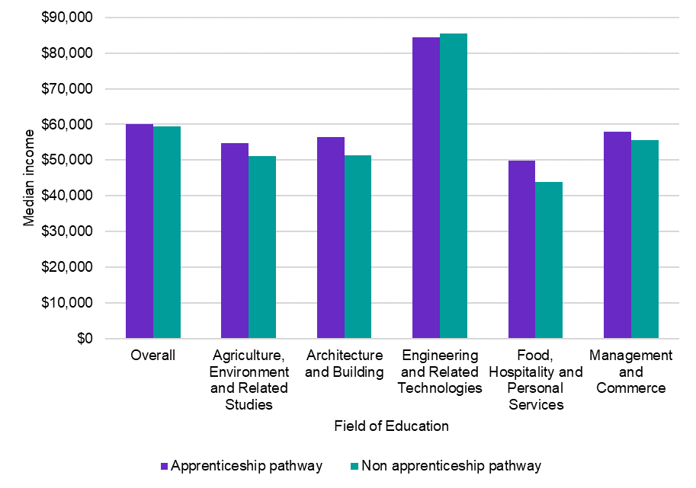

Source: Jobs and Skills Australia, VET National Data Asset (VNDA), May 2024. 2002-2022, VET National Data Asset, ABS DataLab. Findings based on use of PLIDA data.

When the income *uplift* provided by a qualification of either type is considered (income for a person in the year after completing a qualification as compared to their income in the year before completion), the overall median income uplift is also higher for apprenticeship pathways ($21,000) compared to non- apprenticeship pathways ($9,000) (Figure 66).

Figure 66: Median income uplift after training for those with an apprenticeship pathway and non-apprenticeship pathway, for the top field of education courses (by completions)

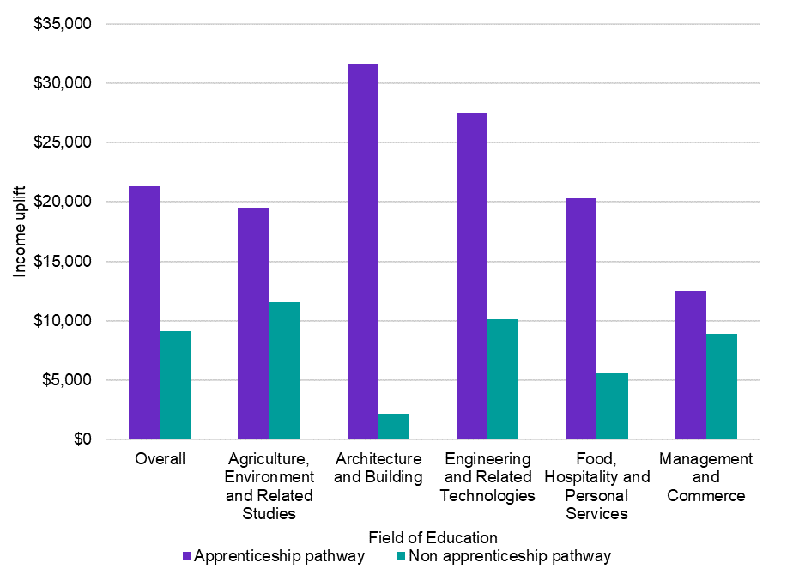

Source: Jobs and Skills Australia, VET National Data Asset (VNDA), May 2024. 2002-2022 VET National Data Asset, ABS DataLab. Findings based on use of PLIDA data.

A similar benefit is observed when the data is considered at the occupation rather than the course or field of study level. For all occupations as a group, young new entrants[33] into an occupation in scope (occupations that are from skill levels 2 to 5 and have between 10% and 75% apprenticeship pathway) via an apprenticeship pathway have a higher median starting income compared to non-apprentices ($36,700 compared to $24,600). They also have a higher median income 2 years later ($47,800 compared to $40,700) (Figure 67). When considered by ANZSCO major occupation group, this is the case for all groups except Professionals, which have the least occupations in scope. The income differences two years on are particularly large for apprentices who are Labourers ($43,900 compared with $33,700) and Sales Workers ($45,900 compared with $33,600). The most common Labourers occupation for people who completed an apprenticeship or traineeship was ‘Other Miscellaneous Labourers’ which includes Bicycle Mechanics and Electrical or Telecommunications Trades Assistants. A range of relevant courses can be completed as apprenticeships and traineeships, such as Certificate II in Bicycle Mechanical Technology or Certificate II in Telecommunications Technology.

Figure 67: Median income in the base year and two years after commencing an occupation, for those with an apprenticeship pathway and non-apprenticeship pathway, by ANZSCO Major Group

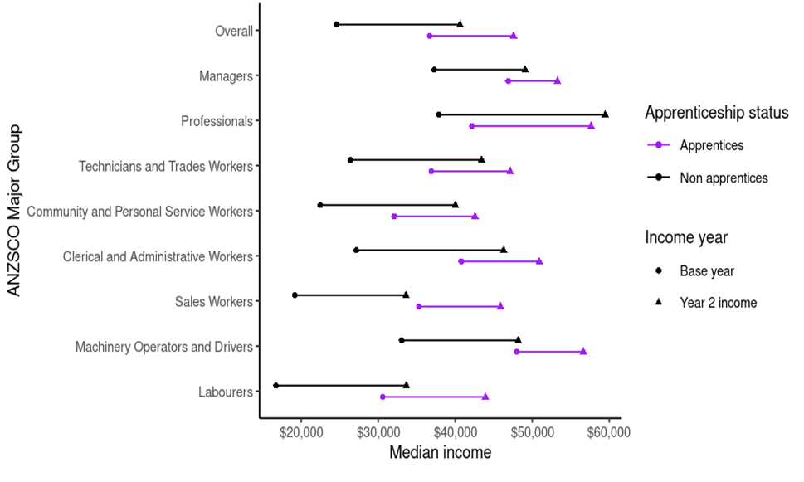

##### Source: Jobs and Skills Australia’s Analysis, Skills Tracker, May 2024. ABS (2024) [Datalab], Income Tax Returns 2011-2019, Australian Apprenticeship Incentive Program 2006-2019; Jobs and Skills Australia’s Analysis.

##### Employment outcomes

In addition to improved monetary outcomes, apprentices are also more likely to have both a higher employment rate and occupation relevancy rate than non-apprentices.

For occupation relevancy, this was true across all top 5 fields of education, and across fields of education overall. It was also true for all skill levels and all major occupation groups, but particularly observed for skill level 3 jobs and for Technicians and Trade Workers.

For employment rates, this was true after a year for all major occupation groups, but particularly for Labourers (94% as compared to 88%) and Professionals (99% as compared to 94%). It was also true across all skill levels, but the biggest difference was observed for Skill Level 5 occupations (94% compared to 89%).

When this is analysed at the occupation level over a longer period of time (3 years), apprentices were still better off overall. For apprentices, 117 occupations have a higher employment rate after 3 years and higher rate of working in similar occupations after 3 years than their respective median rates (Figure 68 top right quadrant). This is compared to 44 occupations for non-apprentices.

Figure 68: Proportion of occupation entrants who are employed three years after entering an occupation, and in a similar occupation after 3 years, by occupation (unit group) and apprentice pathway

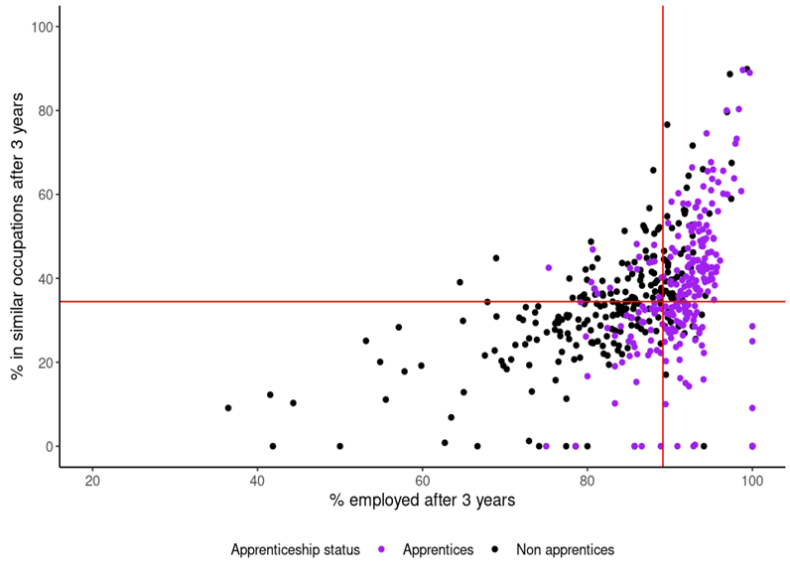

Source: Source: ABS (2024) [Datalab], Income Tax Returns 2011-2019, Australian Apprenticeship Incentive Program 2006-2019; JSA Australian Skills Classification Occupation Similarity, Jobs and Skills Australia’s Analysis.

Further modelling and analysis are needed to confirm the relationship between apprenticeship pathways and employment outcomes, as well as to assess the impact of other contributing factors. Early evidence is promising, however, as to the benefits of work-integrated learning for individual outcomes.

## VET workforce development

With projections showing more than 90% growth in post-secondary qualifications, and VET playing a major part in these qualifications, a strong VET sector is critical to Australia’s future labour market. VET teachers and trainers are at the centre of a successfully functioning VET system, and JSA undertook a VET workforce study to inform the VET Workforce Blueprint as part of the National Skills Agreement.

The study profiled this important workforce and identified recommendations on how to support, sustain and build the VET teachers and trainers of the future. In particular, it recommended better workforce data collection to help manage future risk to Australia’s economy and society by ensuring a sustainable and high-quality supply of teachers and trainers, particularly in industry sectors experiencing skills shortages and high employment demand. The study developed a new VET workforce taxonomy, profiled the increasingly dynamic jobs in the sector and identified demand and supply issues to aid future workforce planning.

### Challenges in the sector

VET delivers the skills needed for occupations in shortage, and there is strong alignment between high enrolment qualifications and occupations rated in skills shortages. Addressing the shortage of VET teachers and trainers themselves is a critical step in addressing occupational shortages.

While there is high and growing demand for VET teachers, VET teacher numbers have shrunk by between 11 and 18% over the last decade.

The VET teaching profession also lost more people to other occupations than it gained in the 8 years leading up to 2018/19 and those that leave get higher pay increases than those that enter. There are few common career movements in and out of VET teaching, but where there are it is generally to and from other education occupations, rather than from vocational occupations.

Some training providers are finding it difficult to attract suitable applicants to fill teacher vacancies, with a lower vacancy fill rate than in universities, secondary and primary schools. Considering skills supply challenges, the training pipeline is shrinking and not particularly targeted at new entrants to the occupations – that is, completions are lower and more likely to be undertaken by existing workers. Completions in the key mandatory teaching credential – the Certificate IV in Training and Assessment – have fallen by almost 25% since 2016. However, this isn’t impacting supply as drastically as expected as only a small proportion of graduates are using the Certificate IV in Training and Assessment to move into VET teaching roles, and overall, almost 70% of graduates are doing the qualification for their existing job. It is also notable that due to qualification upgrades in 2016 and 2022 large numbers of VET teachers and trainers undertook the qualification to maintain currency – explaining some of the shortfall. Migration pathways are also infrequently used for VET teachers, however there are some visa options available that potentially could offer a source of supply for VET teachers.

VET has a 16% gender pay gap. The VET workforce is slightly higher paid than the Australian workforce, but not when compared to their teaching counterparts in other education sectors or industry vocations prominent in VET. Although VET is less award dependent, it is more casualised than the Australian workforce.

### Understanding the workforce

Using census data and industry supplied position descriptions and expert advice from sector leaders, the study developed a VET workforce taxonomy to analyse workforce data in a new way and provide a framework for governments, RTOs, and individuals to consider emerging roles, pathways and issues in the VET workforce. The taxonomy categorises the workforce into 6 segments (Figure 69).

Figure 69: JSA VET workforce taxonomy

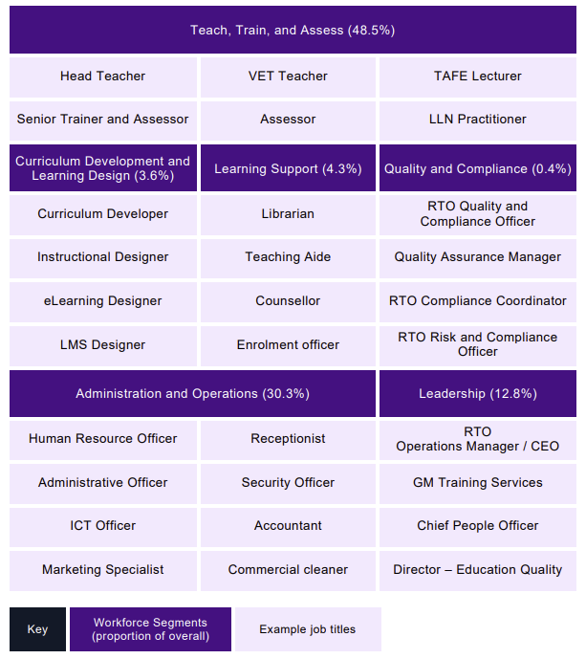

Note: Please see glossary for explanation of terms.

Demographically, the most distinguishing characteristics of the VET workforce is that it is older and more feminised, and this is more pronounced for the Teach, Train, and Assess workforce. The VET workforce is also not as diverse as the student cohort they teach   
(Table 20).

Table 20: Key demographic findings on VET workforce

|  |  |  |  |
| --- | --- | --- | --- |
|  | Australian workforce | VET workforce | Teach, Train and Assess |
| Female | 48.50% | 57.20% | 51.10% |
| Average age​ | 40.1 | 47.3 | 48.1 |
| First Nations people | 2.20% | 2.10% | 1.80% |
| Born overseas ​ | 32.40% | 33.00% | 31.40% |
| LOTE at home | 23.40% | 20.50% | 18.20% |

Sources: ABS, 2021 Census of Population and Housing, counting persons, 15 years and over, TableBuilder ANZSCO6, ANZSIC4, AGE5P, INGP, SEXP, LFS, LANP2.

Note: LOTE stands for Languages Other Than English.

There is currently no national data collection mechanism for the VET workforce and the report recommends future options for workforce data collection. The broader VET Workforce Blueprint has taken on these study recommendations and funded further work to extend the study’s findings.

As part of the nationally led actions, JSA will undertake:

* comprehensive occupational mapping of the VET workforce
* development of a VET workforce data strategy
* establishment of an ongoing research program for key workforce issues.

These foundational actions will lead to improved workforce data and fill key gaps identified in the VET Workforce Study. They will provide an evidence base for further responses to support the VET workforce.

### First Nations VET Workforce

A key part of building and maintaining a sustainable vocational education and training workforce is ensuring that the First Nations VET workforce is grown and supported, including the sustainability of the Aboriginal Community-Controlled (ACC) and First Nations Owned (FNO) training sector.

The First Nations working age population participate in VET at a rate double that of the non-First Nations population, and in very remote and on-community delivery contexts, delivery of VET by First Nations staff correlates with more positive learner outcomes (Windley, 2017).

JSA is undertaking research to identify opportunities for improvements for the recruitment, retention, and cultural safety of the First Nations VET workforce. This includes analysing institutional and systematic barriers and enablers for First Nations people joining, staying and progressing in the VET workforce, and identifying promising practices that address barriers and support enablers. Considerations in relation to data about or relating to First Nations people in the VET workforce will need to engage meaningfully with principles outlined in the Framework for Governance of Indigenous Data.

It is expected that the experiences of First Nations VET workers will differ substantially between individuals, their roles (e.g., teaching, training and assessing and other roles) and contexts (e.g., Public TAFE, independent RTOs, First Nations owned or Aboriginal Community Controlled and delivery setting of RTOs, whether urban, regional and remote). JSA will share findings in early 2025.

## Skilled migration

In addition to the rich cultural and social contributions of migrants to our country, there is a positive link between migration and labour productivity (OECD, 2023), and skilled migration plays an important role in providing skills and labour to supplement workforce needs.

A strong skill focus to Australia’s migration system can help to address changing workforce needs, including those arising from technological and digital transformation; increased demand for health services; climate change and net zero transformation. Temporary and permanent skilled migration also assists to fill identified skill shortages and facilitates the transfer of specialist knowledge and skills that are difficult to fill in Australia.

Permanent skilled migration should aim to maximise Australia’s long-term prosperity. This goal is distinct from meeting short term labour shortages, which is a purpose of temporary skilled migration. For 2023-24, the permanent Migration Program was delivered at 190,000 entrants which included 137,100 Skill Stream; 52,720 Family Stream and 180 Special Eligibility places[34].

The Australian Government’s White Paper on Jobs and Opportunities, *Working Future*, noted that:

There is also scope to better use the skills and experience that migrants bring to Australia. Nearly a quarter of permanent skilled migrants are working in a job beneath their skill level (Committee for Economic Development of Australia, 2021). This could reflect a range of reasons, including challenges navigating licensing systems, completing top-up qualifications, and working through Australian recruitment processes. Discrimination and unconscious bias among employers can also adversely impact migrant employment outcomes (Booth, Leigh, & Varganova, 2012). Some occupations exhibit particularly poor results for migrant skills matching. Migrant engineers and accountants stand out among the occupations not matching well into their nominated occupation (Commonwealth of Australia, 2023a).

It also noted that temporary migrants can play an important role in meeting short term skills needs, but those selected on a skills basis currently make up a small proportion of the temporary migration system:

Students and New Zealand citizens, who are not selected on a skill-based criteria, make up about 60 per cent of people holding a temporary visa. Australia only actively shapes a very small proportion of its migrant intake, with the overwhelming majority of migrants arriving in Australia for non-work purposes but then participating in the labour market. This creates tension between the objectives of specific visa classes, for instance balancing student work rights with study requirements (Commonwealth of Australia, 2023a).

The Australian Government’s Migration Strategy was released in December 2023, following the comprehensive review of Australia’s migration system which captured valuable insights and directions for reform. It also drew on extensive consultation and public submissions.

The Migration Review was critical of the approach to identifying skills needs, including the limited coordination between elements of the national skills system (education, training, and migration) and the lack of a whole-of-government and tripartite mechanism for assessing Australia’s skills needs. It recommended a more forward looking and evidence-based approach led by JSA that includes consideration of domestic training and workforce planning efforts (Commonwealth of Australia, 2023b).

The Migration Strategy establishes a formal role of JSA in defining skills needs using evidence, including advice from tripartite mechanisms. JSA will also have a role in helping to ensure local workers’ skills and job opportunities are prioritised, and that the migration system complements the domestic skills and training system and is guided to areas of best use. The Migration Strategy notes that JSA’s role in the new Skills in Demand visa for employer sponsored temporary migration will include:

* providing labour market analysis relevant to the Specialist Skills Pathway
* providing advice for a new Core Skills Occupation List for the Core Skills Pathway
* providing advice on appropriate sectors and occupations in the Essential Skills Pathway.

The Government, through the Migration Strategy has committed to explore a reformed points test to better identify migrants who will drive Australia’s long-term prosperity (Commonwealth of Australia, Department of Home Affairs, 2023). JSA will actively contribute to the policy discussions around the points test review.

The Government has also commissioned a study through JSA to better analyse international student outcomes and pathways into the labour market. Initial outcomes from this study are included in chapter one.

JSA’s aim is to ensure a common analytical approach and understanding of current and future skills needs is applied to its advice on migration, higher education and VET. This is core to working towards a more joined up national skill system that will better meet Australia’s future workforce skills needs.

## In summary

A strong national skills system is critical to fulfilling Australia’s current and future skills needs. It requires not only the elements of the system to be strong and well-functioning, but also for the elements to work in harmony. This means that the migration system complements the domestic skills and training system and is guided to areas of best use. It means that there is fit-for-purpose education and training that capitalises on the strengths of both sectors to deliver quality outcomes. It means that individuals can navigate and access the education and training they need throughout their life course to support ongoing skills development needs.

JSA contributes to the optimisation of a strong national skills system by providing analysis and advice on the performance and outcomes of various components – including for specific cohorts of interest. This also includes research, analysis and advice that can inform efforts to better optimise and align the system.

# 

# Chapter 5: Activating an informed dialogue

Activating an informed dialogue is about impact. In part, this is about ensuring the insights and advice we provide at JSA are impactful and make a difference to a variety of users across governments, industry, education and training, and beyond. This means we have considered how our outputs, products and advice can have impact in the real world and have built this into project design. We seek to ensure that our work has the intended impact and reach by communicating in a way that enables broad understanding and meets stakeholder and user needs for our insights.

Importantly, though, it’s also about the impact of others. It’s about enabling more voices to be part of the conversation about skills needs in Australia. This means that we give stakeholders a voice in how our products are developed and shaped. Our work is guided by the insights, expertise and involvement of others so we can better understand workforce and skills opportunities. This means that the advice we provide to government is better informed and grounded in the real world experience of our partners.

Because we understand that the best advice considers a range of evidence and perspectives to reach a more holistic understanding of the issues, as well as better solutions, we have a strong focus on listening and collaboration. We value the unique experiences, opinions, skills, and qualities of others, and how these can enrich our work, and consider the full suite of evidence to formulate the best advice. We identify important connections between the work we do and the work of others, and how working together can improve outcomes and drive better results.

It's why we have mechanisms such as the Ministerial Advisory Board, partnerships, and forums embedded into how we work to keep collaboration and tripartism at the centre of all that we do. It’s why we have an ‘always open’ hub for people to connect with us at any time. And it’s why JSA has a legislative remit to:

* contribute to industry consultation forums
* inform the public about JSA’s advice, analysis, and work
* collect, analyse, share and publish data to inform policy development and program delivery
* consult and work with others on what we do
* publish the annual Jobs and Skills report on Australia’s current, emerging and future skills and training needs and priorities.

Key themes in this chapter:

* Activating an informed dialogue on Australia’s emerging and future skills and workforce needs requires JSA to work collaboratively with our tripartite partners and other stakeholders.
* Consultative and collaborative mechanisms such as our Ministerial Advisory Board, partnerships, and forums, are embedded into how we undertake our work.
* We consult widely on our key products and analysis and have dedicated channels to help us to listen and understand.
* Our products have impact within government and beyond, and we are committed to ensuring the ongoing relevancy, currency, and meaning of our work.

## How we work

JSA’s role is to engage, advise, and assist government and other stakeholders in decision-making on current, emerging and future skills and workforce needs. To do so, we work collaboratively with our key partners and other stakeholders to activate an informed dialogue, and to ensure our analysis and advice represents a diverse community and economy and meets the evolving needs of Australia’s labour market.

Tripartism is key to how we work, and we undertake ongoing tripartite consultation through our Ministerial Advisory Board, engagement with Jobs and Skills Councils and project specific steering committees. Key forums are embedded into our governance structure to ensure tripartism is embedded in all that we do.

### Ministerial Advisory Board

JSA’s Ministerial Advisory Board (Advisory Board) was established by the Hon Brendan O'Connor MP, formerly Minister for Skills and Training, on 27 March 2024. The Advisory Board is chaired by Ms Cath Bowtell and provides expert, independent advice and insight to the JSA Commissioner and the Minister for Skills and Training on the performance of JSA’s legislated functions.

The Advisory Board also ensures a voice for tripartite partners and other stakeholders in addressing skills, labour market and workforce development needs. In August 2024, the Advisory Board established the Education and Training Reference Group to provide advice on matters relating to tertiary education and its intersection with the performance and function of JSA.

A program of regular engagement has been agreed with a current, forward and rear view integrated into the Advisory Board work plan. This allows the Board to focus on providing strategic direction on JSA priorities and projects, including early input on scope of major projects. This also ensures that the Advisory Board supports the findings of JSA studies and can more widely distribute and promote them.

Current initiatives informing the Advisory Board’s strategic discussions include the Employment White Paper, Migration Strategy, Future Made in Australia, Homes for Australia Plan, the care and support economy, clean energy and net zero transformation, digital transformation and the defence industry, the National Agreement on Closing the Gap, the Australian Disability Strategy, and the Working for Women National Gender Strategy.

The Advisory Board is actively interested in the work of Jobs and Skills Councils, beginning a series of regular presentations to find out about research in their industries and the landscape of skills and employment in those industries.

State and territory partnerships

JSA works closely and cooperatively with the states and territories to deliver our analysis and advice – including across regional labour markets. In addition to continued participation in existing arrangements such as the state and territory skills advisory bodies, National Cabinet’s Skills and Workforce Ministerial Council, and the Federated Industry Skills Network, JSA has established a State and Territory Partnership Forum to further drive collaboration.

Senior officials from all state and territory governments are members of the forum, and meet regularly to discuss specific issues, share information, provide input into projects and help build analytical capacity across jurisdictions. JSA has worked with states and territories to understand their data needs and provide insights on what the skills and employment landscape is indicating at a national level. This allows states, territories, and industry to take issues forward as relevant for their jurisdiction. For example, JSA’s analysis and advice on the skills and workforce needs of the Clean Energy workforce informed TAFE Centres of Excellence for electric vehicles in the ACT and clean energy in WA. Input from states and territories, including on their data and analysis, has also helped JSA to expand the evidence base and make continuous improvements to our data and analysis.

### Jobs and Skills Councils

Jobs and Skills Councils (JSCs) are not-for-profit companies that are industry-owned and industry-led. As part of a national network, there are 10 JSCs that provide leadership to address skills and workforce challenges for their industry.

JSCs have been established to provide industry with a stronger voice to ensure Australia’s vocational education and training sector delivers better outcomes for learners and employers.

JSA and the 10 JSCs are critical parts of Australia’s workforce and skills system architecture that fulfil separate but complementary roles (Figure 70). JSA has a broad remit to provide information, analysis, and advice on economy-wide labour market, workforce, skills and training needs and the performance of the national skills system. JSCs focus within their industry and bring together employers, unions and governments in a tripartite arrangement to find solutions to skills and workforce challenges.

The Department of Employment and Workplace Relations (DEWR) works with JSA and JSCs to gain a ‘whole of economy’ view of the workforce.

Figure 70: Role of DEWR, JSA and the JSCs

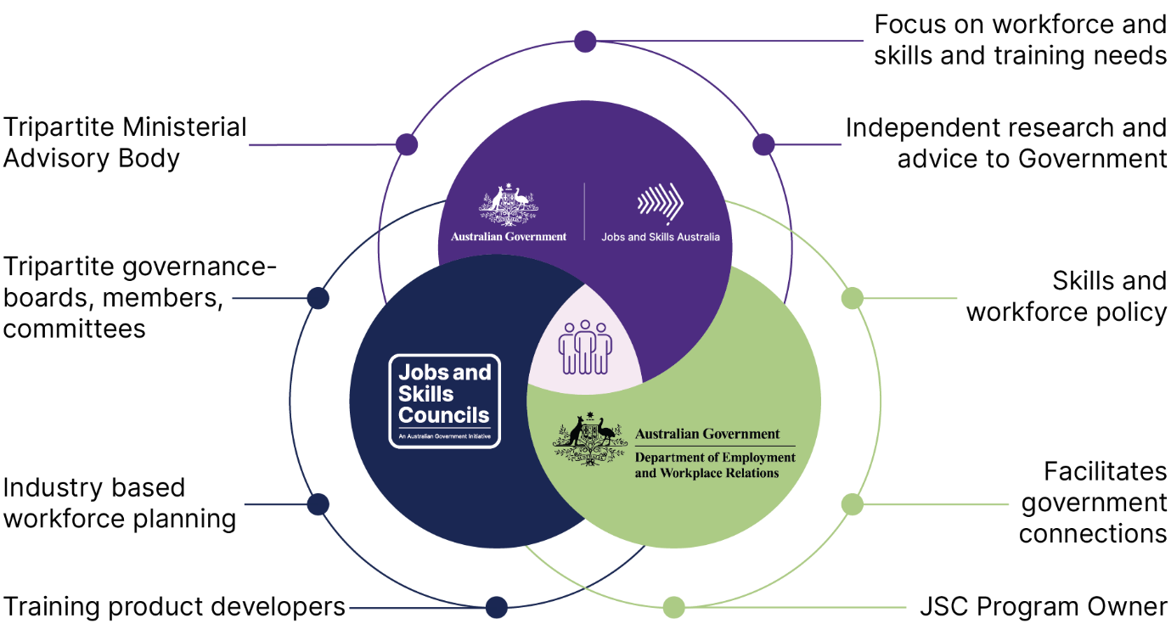

JSA works closely with JSCs as collaborative partners, working through the established DEWR JSC CEO forum. This partnership is two-way, with JSCs bringing the on-the-ground experience and expertise of industry to our economy-wide data and outlook. JSA is also committed to providing JSCs with access to data and analysis that enhances and supports their activities, including providing advice on how our data can be used to support workforce planning activities.

#### JSC workforce planning

Workforce planning is a key strategic function of JSCs. It involves developing an in-depth understanding of Australia’s current, emerging, and future workforce challenges and opportunities (including skills gaps and shortages) for all sectors within a JSC’s remit, and developing advice and strategies to address the challenges and take advantage of the opportunities.

JSA, DEWR, and JSCs work together (Figure 71) in the development of workforce plans, with a key role for JSA in providing national data as well as technical guidance.

Figure 71: JSC workforce planning

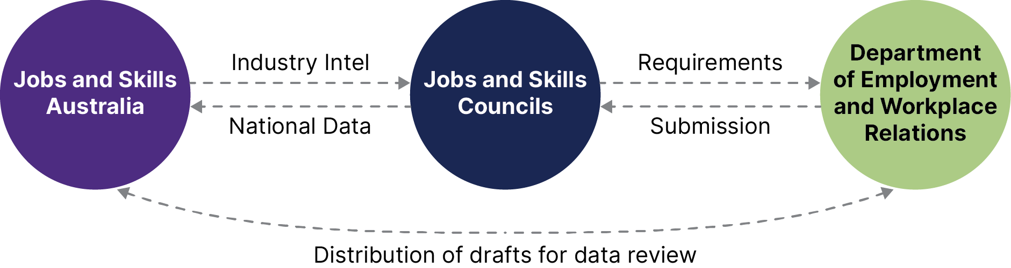

Across the published JSC workforce plans, common themes have arisen, including the need for addressing regional and rural employment with respect to various sectors, and key crosscutting megatrends such as the rise in the need for digital skills. A key theme is the need to increase workforce diversity and remove barriers to participation for under-represented cohorts, including women, First Nations persons, migrants, and people with disability.

JSA supports the understanding and analysis of this aspect of workforce planning by providing data on under-represented cohorts including the undertaking of specific cohort-focused studies. While each dimension of diversity is generally treated in isolation, ongoing research is being undertaken to understand the combined effect of different dimensions of diversity, which could be used to support future workforce plans.

#### Capacity studies

JSA’s capacity study projects are a key example of a partnership approach with JSCs. Demonstrating tripartism in action, our ECEC capacity study was undertaken in partnership with HumanAbility (the JSC responsible for the health and human services, aged and disability, children’s education and care, and sports and recreation industries).

The study was also supported by an expert steering group of 37 members from the sector and state and territory representatives. The report’s findings and recommendations will support HumanAbility and other stakeholders to identify workforce challenges and inform practical actions to overcome them.

Our food supply chain capacity study looked across multiple sectors and was delivered with the support of 3 JSCs: Skills Insight, Manufacturing Industry Skills Alliance and Industry Skills Australia. By working together, we were able to look at the workforce challenges shared by these sectors and develop cross-cutting opportunities for the food supply chain. This study was also supported by an expert advisory group with members from industry, unions, JSCs and the higher education sector, along with state and territory government stakeholders and a wide range of academic experts.

#### The contribution of JSCs

JSCs have provided critical input into the development of a number of JSA’s key products and analysis. JSCs also support JSA by communicating industry-sector intelligence to support the development of two of our key legislated deliverables, the annual work plan and the Jobs and Skills Report.

JSA will continue to undertake collaboration with JSCs in order to strengthen tripartite input into the national evidence base and facilitate the JSCs role in determining sectoral workforce needs through industry insights. This includes continued partnerships to identify workforce and training data and evidence gaps and ways to address them over time, and capability-building exercises to ensure the strength, currency, and integrity of how our data is used to build the evidence base.

### Commonwealth Interdepartmental Committee

To provide a key connection for Australian Government agencies to input into JSA’s work plan development, data assets and key priorities, we have established a Commonwealth Interdepartmental Committee (IDC). The committee builds on existing engagement mechanisms and adopts an evidence-based approach across government agencies to support key government outcomes and priorities for jobs and skills.

JSA’s work with IDC members has provided an opportunity for Australian Government agencies to collaborate on shared areas of interest and to understand the strategic implications of emerging insights from JSA’s labour market and skills analysis work. Together we have explored evidence bases and ways to address data gaps, including through data sharing, as well as potential partnership opportunities across agencies and stakeholders.

The forum enables the delivery of evidence-based policy across multiple portfolios – with particular value to the skills and migration portfolios. It has provided an important point of connection for the ongoing reform processes across VET, higher education, and migration – and collaboration on the development of the regional jobs and skills roadmap.

The IDC has also provided a mechanism for Australian Government agencies to input into JSA’s work plan development, including to inform key priorities and potential commissioning of future capacity, cohort, and other major studies or strategic advice.

## How we listen

A key part of ongoing dialogue with our stakeholders is listening to understand. We listen to and work with others to ensure our advice is accurate, timely, and fit for purpose. To help ensure our stakeholders can engage with us on our work, we share information about engagement opportunities and are upfront about the scope, purpose and nature of that engagement.

We also demonstrate our commitment to transparency by actively sharing our work, and communicating our priorities and work program, including how stakeholder feedback and engagement has informed and impacted our work. This includes transparency in our research design and methodology.

Our engagement is informed and guided by the following principles, outlined in our Engagement and Outreach Strategy (Figure 72):

Figure 72: Our engagement principles

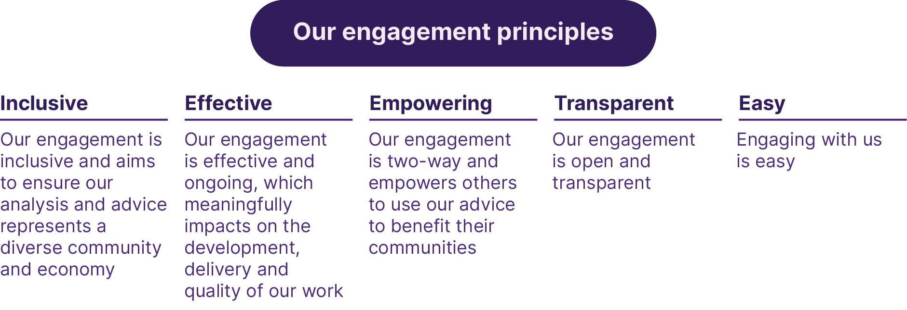

### Steering groups supporting our work

Our key pieces of work, including our major in-depth studies, are guided by steering groups comprising a mix of tripartite members, key stakeholders in higher education and vocational education and training, and experts to help inform our approach. This helps ensure that all groups with a stake in our products and analysis, or that may be affected by their outcomes, have a seat at the table and input into the development and enhancement of our work.

JSA established several critical project steering committees to inform our work and ensure all voices were represented, heard, and reflected. These groups include representation from industry peaks, unions, education and training providers and research organisations.

Steering committees for our capacity studies have met multiple times across the lives of the projects to guide different aspects of the work as it has progressed, including endorsing terms of reference and research methodology, providing feedback on data analysis and desktop research, assisting with broader stakeholder consultations, and reviewing draft findings and recommendations.

|  |
| --- |
| Consultation in focus: The National Skills Taxonomy For the National Skills Taxonomy work, JSA has held 11 sessions between July and August 2024 to consider key foundational elements. During this period the consultation process was referenced in newsletters and on websites and social media by subject matter experts and tripartite partners – which helped create engaging discussions. More than 500 people engaged with consultations through workshops, 1:1 interviews, and over 70 submissions from a range of different stakeholder groups. Engagements continue to help inform the development of the NST through direct stakeholder meetings and through various JSA channels including the Education and Training Reference group and States and Territories working group. The next round of public consultations is anticipated to be held in February 2025 to consider setting a clear definition of skills. |

### Consultations and ongoing feedback

In recognition of the fact that it is not possible or practicable for everyone to be involved in some, or all, of our formal engagement forums, JSA has a dedicated mechanism where anyone can connect with us at any time.

Our online *Connect with us* hub enables anyone to contribute information or provide feedback, but also provides an important method to feature our current project and product engagement opportunities.

Across 2024, JSA has undertaken 6 public consultation processes, for which we received 866 submissions. These were supported by workshops, interviews, roundtables, meetings and focus groups across Australia and online (Figure 73).

Figure 73: Key consultation figures



### Ongoing engagement mechanisms

JSA actively participates in existing engagement activities such as government committees, steering and working groups, roundtables and stakeholder or partner-initiated forums and workshops. We also undertake organic, proactive, reactive, and strategic consultation outside our structured forums, and actively seek to understand the experiences of employers in an ongoing fashion through our survey mechanisms.

## How we have impact

It is also critical to understand how our products, analysis, and advice have impact and how they are or can be used. We have impact through our work with stakeholders, through regular analysis of the labour market, through input and advice that supports decision-making, and through targeted capacity and cohort studies that seek to expand the evidence base.

### Labour market and skills analysis and products

JSA publishes a range of regular labour market data and analysis that provide ongoing insights into how the labour market is performing and assist our partners, stakeholders and others to make informed decisions on matters relating to skills and the labour market.

This includes monthly reports on online vacancies, recruitment demand and confidence, and a nowcast of employment in Australian occupations. Quarterly, JSA publishes labour market updates, small area labour market updates, occupation shortage information, and information for recent or potential migrants and the service organisations who assist them. JSA’s Occupational Shortage List directly informs subsidy allocation under the Australian Apprenticeship Support System and informs skilled migration policy through its impact on JSA’s advice on the Core Skilled Occupation List.

JSA additionally develops a range of resources which provide insights on the labour market and employment conditions across Australia including labour market dashboards, recruitment trends and employer needs profiles, and industry profiles.

|  |
| --- |
| Recruitment Experiences and Outlook Survey JSA’s Recruitment Experiences and Outlook Survey (REOS) collects information on employer recruitment activity, recruitment difficulty, and staffing outlook that helps policy makers and analysts monitor and understand current and emerging labour market conditions. Insights from the survey can also help job seekers understanding what employers are looking for.  The REOS surveys employers across Australia, and up to **14,000** businesses respond to the survey throughout the year. The REOS questionnaire continually evolves to stay current with changes in the Australian labour market, and data are released as close to collection as possible to provide an almost real-time view of recruitment activity across Australia. Survey of Employers who have Recently Advertised The Survey of Employers who have Recently Advertised (SERA) collects information about recruitment experiences from employers and recruiters who have recently advertised vacancies online. On average, SERA collects data on **9,000** employers annually, covering approximately **350** occupations.  The survey asks employers a range of questions on their recruitment experience for advertised vacancies, collecting both quantitative and qualitative data. This information is used to produce insights on current labour market conditions and to identify occupations and sectors that are experiencing occupation shortages.  SERA insights are also critical for the production of important publications, including the Occupation Shortage List (OSL), the Occupation Shortage Report, the Labour Market Update, and the Annual Jobs and Skills Report. |

#### Sharing our insights

The JSA Commissioner and other Senior Executive staff have made over 245 speeches and presentations since October 2023!   
  
These have included a public address at the National Press Club and several keynote addresses at forums held by a range of key actors across the national skills system.

### Strategic advice and deliverables

JSA regularly works with stakeholders to provide advice to government and inform decision-making, undertake targeted studies and analysis, and periodically release significant reports and data tools. Across 2024, this has included continued work to assess current foundation skills across Australia, the release of the Registered Training Organisation (RTO) Typology methodology paper, and the commencement of several capacity and cohort studies including on the workforce needs of Australia’s food supply chain, the VET workforce, the ECEC workforce, and the migration pathways and labour market barriers experienced by international students.

JSA also had input into the Migration Strategy and continues our ongoing dialogue with the Department of Home Affairs. This included the development of the Migration Labour Market Indicator Model, which in combination with tripartite consultation and qualitative analysis, will inform JSA’s advice to Government on the Core Skills Occupation List.

JSA contributes to many national projects and priorities and is frequently engaged by other areas of Government seeking evidence and customised data to support their work. JSA has had a significant impact across key government initiatives. These include influence in the Care and Support Economy Strategy, the Employment White Paper, Net Zero Transition, Closing the Gap, Gender Equality and Safety, the National Skills Agreement, the Australian Universities Accord, and Migration Strategy. JSA will continue to work with agencies on issues such as the food supply chain, Strategic Fleet, the Strategic Review of the Apprenticeships Incentive System, VET qualifications reform, housing affordability and the proposed Australian Tertiary Education Commission.

JSA has made public submissions and appeared before multiple parliamentary inquiries. These included the House Standing Committee on Employment, Education and Training inquiry into the Perceptions and Status of Vocational Education and Training, the House of Representatives Committee on Workforce Australia Employment Services Inquiry into Workforce Australia Employment Services, the House of Representatives Committee on Regional Development, Infrastructure and Transport Inquiry into Local Government Sustainability, and the Joint Standing Committee on Aboriginal and Torres Strait Islander Affairs on the Inquiry into economic self-determination and opportunities for First Nations Australians.

### Measuring our impact

JSA’s impact will be measured over time through short-, medium- and long-term indicators. JSA does not have regulatory powers, nor is there any formal requirement for other parties utilise our analysis and advice. We seek to have impact through influence.

As JSA is still in our establishment phase, we have largely seen short-term impacts realised. We have seen this through a range of bodies citing our analysis and advice, and through industry considering our advice in the development of workplans (for example Jobs and Skills Councils).

Medium-term impacts would include having our recommendations and analysis incorporated into the process of policy development and implementation. While it is still early in our establishment, we have started to see this occur in areas like the clean energy transition, tertiary harmonisation and the Universities Accord recommendations, working closely with the Department of Education on the development of the Australian Tertiary Education Commission.

Long-term impacts would include improvement in the matching in the labour market between skills and employment, employers getting the skills they need, and participants in the labour market having access to a range of easily navigable pathways to acquire the skills they need. It would also include the flow-on societal and social benefits of this occurring.

|  |
| --- |
| Case study: Impacts of the clean energy capacity study The Clean Energy Generation report was released in late 2023 and has already supported a range of government measures. Analysis and advice on the skills and workforce needs of the sector informed federal government through outcomes of the 2024-25 Budget, such as the expanded New Energy Apprenticeships program and various measures under the Skilling the Clean Energy Workforce package, including climate careers advocacy and promotion activities, a pilot program for Group Training Organisation (GTO) reimbursements, a new capital investment fund for facility upgrades, and investment to turbocharge the VET teacher, trainer and assessor workforce for clean energy.  The study will also inform the government’s net zero sectoral plans and has been a valuable resource for Jobs and Skills Council workforce plans. There has also been international interest through the Australia-Singapore Green Skills Roundtable.  Figure 74: Clean Energy Capacity Study impacts  This figure illustrates the impact of the clean energy demonstration report described immediately preceding the figure, including informing federal government strategies and outcomes of the 2024-25 budget. |

Prior to the ECEC study publication, its analysis of remuneration for ECEC professionals had already contributed to recent government policy initiatives, including the worker retention payment. The VET Workforce study is complementary to and supports the DEWR-led VET Blueprint.

We can also measure our impact by analysing data on how many people are accessing and utilising our work. A key mechanism for communication is the JSA website, where the majority of our work and analysis is published. As shown in Figure 75, across the year to 31 August 2024, the website had 5,002,627 views, representing 1,020,853 people.

The top 3 products viewed on the JSA website during this period were the Occupational Shortage List (formerly the Skills Priority List), Occupations and Industries, and the Jobs and Skills Atlas. In the year to August 31, 2024, JSA’s LinkedIn page also gained 3,850 new followers (a 60% gain over the year) – making 254,000 impressions and obtaining 140 comments, 692 shares, 5,170 likes and 10,816 mentions.

Figure 75: Jobs and Skills Australia reach and engagement

This infographic shows JSA's reach and engagement across 2024. Across the year to 31 August 2024, the website had 5,002,627 views, representing 1,020,853 people. 
The top 3 products viewed on the JSA website during this period were the Occupational Shortage List (formerly the Skills Priority List), Occupations and Industries, and the Jobs and Skills Atlas. In the year to August 31, 2024, JSA’s LinkedIn page also gained 3,850 new followers (a 60% gain over the year) – making 254,000 impressions and obtaining 140 comments, 692 shares, 5,170 likes and 10,816 mentions.

Source: Google Analytics, LinkedIn Analytics, Sprinklr.

In the year to August 31, 2024, JSA was mentioned at least 10,816 times on platforms including news media, blogs, podcasts, and social media[35].

Diving deeper into our website analytics can also help us to confirm whether responses to stakeholder feedback have been successful, and who our insights may be helping and enabling – as is the case for our Internet Vacancy Index (IVI) insights report.

|  |
| --- |
| Case study: Adapting our insights to better serve our stakeholders JSA’s IVI, or Internet Vacancy Index, is a data product that dates back through various predecessors of the organisation to the mid-2000s. In June 2024, JSA re-vamped the IVI Vacancy Report to make it more user friendly, better meet the criteria and vision of JSA, and meet known and anticipated stakeholder demand for:   * Demonstrations of how IVI can be incorporated into their own analysis and products. * Examples of how IVI can be married with other datasets for comprehensive views of sectors or occupations within the labour market. * Easily accessible key insights for briefing and information requirements.   A key change to the report is the inclusion of a ‘spotlight’ feature, that brings together various labour market data to explore a theme or topic using a narrative approach. These spotlights have presented information from a geographic, cohort, and occupational perspective and helped us to better meet stakeholder need for information and guidance.  As a result, JSA has a monthly opportunity to be proactive or reactive to trends in the labour market or stakeholder feedback, and to provide real world examples of how our datasets can be used with each other or with external data sources to create a more comprehensive, cohesive narrative on labour market topics.  Since the launch of the re-vamped insights, downloads of the Vacancy Report are up 160% and users are up 174%. Users have also benefitted from the addition of the previous reports section, allowing users to refer to previous spotlight analyses, attracting further downloads.  We have also seen a change in the proportion of users accessing the insights from IVI via a mobile device – rising from 11.4% to 16.5% over the year to August 2024 (Figure 76).  Figure 76: Percentage of users access to IVI via mobile device  This graph shows the percentage of users who accessed IVI via a mobile device. The graph begins at around 12% in August 2023 and hovers near to that percentage before it starts to rise in February 2024. While it dips slightly in May 2024 it rises again to a peak of over 16% by August 2024  Source: Google analytics – Jobs and Skills Australia website.  This change may indicate that IVI insights are reaching an expanded cohort of users. While more technical audiences may tend to access the insights via a desktop device where they can also access and utilise the data downloads, the increase in mobile device users may mean that a wider audience is accessing and utilising the broad insights from IVI. This would demonstrate that our IVI insights are more user-friendly, accessible, and useful for a broader audience than before. |

We can also track our impact through the flow-on effect into how our work informs or supports other government measures – as for our Clean Energy Generation report explored previously, and stakeholder feedback also gives us insights into how our work enables others.

|  |
| --- |
| The Jobs and Skills Atlas – helping users access more of our insights On 14 August 2024, after a year in beta during which stakeholders and the public were invited to provide feedback, JSA officially launched the Jobs and Skills Atlas (Atlas).  Atlas is an interactive data visualisation and exploration tool that combines datasets produced by JSA, the Australian Bureau of Statistics (ABS), the National Centre for Vocational Education Research (NCVER) and other agencies. It is the first platform of its kind to combine this kind of expert data and provide a comprehensive view of labour market data at national, state, and regional levels by occupation, industry and training in a searchable, user-friendly interface (Figure 77).  Figure 77: Jobs and Skills Atlas Interface  This figure shows a screenshot of the Atlas interface. It shows a map of Australia and the different ways the data can be explored.  Source: Jobs and Skills Australia website  Atlas is a unique product for JSA as it attempts to reach the widest audience possible. As of 1 September 2024, the Jobs and Skills Atlas was one of the most viewed pages on the JSA website. Atlas and its beta version received 437,162 views across 53,506 total users including 9,500 international users to this date.  Atlas is designed for a wide range of specialist and non-specialist users across the community: policy analysts, educators, economists, managers, employers, employment providers, industry associations, career advisors, local councils, businesses, and the public. |

|  |
| --- |
| How Atlas assists Rebekah, a career development practitioner **Rebekah is a career development practitioner and assists mature-age clients transition into other work.**  *I help clients to identify growth industries and understand future employment projections so they can align their skills with a labour market that is rapidly evolving to meet macro-economic goals such as net zero emissions.*  *For each of these work streams, I rely heavily on accurate and current data. Previously, I’d go to a variety of sources, including paying $12 per report for a particular occupation, to obtain the breakdown of state and regional employment numbers. This kind of information was very generic and quickly out of date. There was not a lot of real time capture.*  *With Atlas, all the information I need is available in one place for free. And the data is richer, deeper and broader than ever before. I now have access to real-time data about skills shortages, regional shortages and no shortage classifications which helps identify future job opportunities.*  *Atlas really aligns with my values in helping clients to identify new directions for the future. They get a buzz as they realise their life is not ending. This process helps inspire hope because Atlas data can speak to them through a practitioner who can interpret it according to individual needs.*  *I have a lot of confidence in Atlas, especially as the industry body for career development practitioners - the Career Development Association Australia (CDAA) – got on board with it early in its formation.* |

|  |
| --- |
| Support for initiatives on the Mid North Coast JSA research and data was used as a foundation for the development of the Mid North Coast Taskforce’s Youth Engagement and Employment Strategic Priority. JSA data and briefing allowed the Australian Government Employment Facilitator in the Mid North Coast to bring together key stakeholders across the region for a full-day strategy session that was underpinned by employment and participation data.  This session led to the implementation of a regional Youth Forum at which over 70 local leaders in the Youth Support sector from all levels of government and the community (including young people) came together to develop a collective and coordinated strategy and approach to supporting youth engagement and employment across the region over a five-to-ten-year horizon. This is now being delivered by working groups supported by the Local Jobs Program team. These groups collaborate on a broad range of topics from improved coordination of services for disengaged youth, to collective advocacy for entry-level skills development in non-traditional trades in the local manufacturing sector. Using research and data developed and tailored by JSA provides confidence that the approach is evidence based. |

## In summary

JSA is committed to continuing to activate an informed dialogue about Australia’s current and future workforce and skills needs and opportunities, because we recognise that it is only together with all parties in the national skills system that we can achieve a truly dynamic and inclusive future.

We have worked closely with our key partners and stakeholders – the Ministerial Advisory Board, Commonwealth and state and territory governments, Jobs and Skills Councils, and education and training providers – to shape our work throughout the year and formulate the evidence and insights within this report. We thank them for their hard work and contributions.

# References

ACTU. (2012). *Lives on hold: unlocking the potential of Australia's workforce. The report of the independent inquiry into insecure work in Australia.* ACTU. Retrieved from https://www.actu.org.au/wp-content/uploads/2023/06/media609158lives-on-hold-final.pdf

Australian Bureau of Statistics. (2021, June). *Statistical Area Level 4 Australian Statistical Geography Standard (ASGS) Edition 3 July 2021 - June 2026*. Retrieved from https://www.abs.gov.au/statistics/standards/australian-statistical-geography-standard-asgs-edition-3/jul2021-jun2026/main-structure-and-greater-capital-city-statistical-areas/statistical-area-level-4

Australian Bureau of Statistics. (2022a). *Education and training: Census.* Canberra: Australian Bureau of Statistics. Retrieved October 2024, from https://www.abs.gov.au/statistics/people/education/education-and-training-census/2021

Australian Bureau of Statistics. (2022b). *Conceptual basis of ANZSCO*. Retrieved October 2024, from https://www.abs.gov.au/statistics/classifications/anzsco-australian-and-new-zealand-standard-classification-occupations/2022/conceptual-basis-anzsco

Australian Bureau of Statistics. (2024a). *Regional population 2022-23*. Retrieved from https://www.abs.gov.au/statistics/people/population/regional-population/2022-23

Australian Bureau of Statistics. (2024b, August). *Labour Force Australia, detailed*. Retrieved from https://www.abs.gov.au/statistics/labour/employment-and-unemployment/labour-force-australia-detailed/latest-release

Australian Constructors Association. (2024). *Culture in construction*. Retrieved from https://www.constructors.com.au/advocacy/initiatives/construction-industry-culture-taskforce/

Australian Government. (2024). *Australian Universities Accord Final Report.* Canberra: Department of Education. Retrieved from https://www.education.gov.au/australian-universities-accord/resources/australian-universities-accord-final-report-summary-report

Australian Government Department of Employment and Workplace Relations. (2024). *Strategic Review of the Australian Apprenticeships Incentive System.* Canberra: Department of Employment and Workplace Relations. Retrieved from https://www.dewr.gov.au/download/16296/strategic-review-australian-apprenticeships-incentive-system-background-paper/37296/strategic-review-australian-apprenticeships-incentive-system-background-paper/pdf

Australian Institute of Family Studies. (2017). *Fathers and Parental Leave*. Retrieved September 6, 2024, from https://aifs.gov.au/resources/short-articles/fathers-and-parental-leave#footnote-001

Australian Taxation Office. (2024). *How to report employment and tax information through STP Phase 2*. Retrieved October 10, 2024, from https://www.ato.gov.au/businesses-and-organisations/hiring-and-paying-your-workers/single-touch-payroll/in-detail/single-touch-payroll-phase-2-employer-reporting-guidelines/how-to-report-employment-and-tax-information-through-stp-phase-2

Biddle, N. (2007). Indigenous Australians and preschool education. Who is attending? *Australasian Journal of Early Childhood, 32*(3). Retrieved from https://journals.sagepub.com/doi/10.1177/183693910703200303

Booth, A., Leigh, A., & Varganova, E. (2012). Does ethnic discrimination vary across minority groups? Evidence from a field experiment. *Oxford Bulletin of Economics and Statistics, 74*(4). doi:doi: 10.1111/j.1468-0084.2011.00664.x

Brereton, D., & Parmenter, J. (2008). Indigenous Employment in the Australian Mining Industry. *Journal of Energy & Natural Resources Law, 26*(1), 66-90. doi:doi:10.1080/02646811.2008.11435178

Cassidy, N., Chan, I., Gao, A., & Penrose, G. (2020, December). Long-term Unemployment in Australia. *Reserve Bank of Australia December 2020 Bulletin*. Retrieved 2024, from https://www.rba.gov.au/publications/bulletin/2020/dec/pdf/long-term-unemployment-in-australia.pdf

Committee for Economic Development of Australia. (2021). *A good match: Optimising Australia’s permanent skilled migration.* Melbourne: CEDA. Retrieved from https://www.ceda.com.au/Admin/getmedia/150315bf-cceb-4536-862d-1a3054197cd7/CEDA-Migration-report-26-March-2021-final.pdf

Commonwealth of Australia. (2022). *The Senate Select Committee on Job Security - The job insecurity report.* Canberra: Senate Printing Unit. Retrieved from https://parlinfo.aph.gov.au/parlInfo/download/committees/reportsen/024780/toc_pdf/Thejobinsecurityreport.pdf;fileType=application%2Fpdf

Commonwealth of Australia. (2023a). *Working Future: the Australian Government's White Paper on Jobs and Opportunities.* Canberra: Commonwealth of Australia. Retrieved from https://treasury.gov.au/sites/default/files/2023-10/p2023-447996-working-future.pdf

Commonwealth of Australia. (2023b). *Review of the Migration System 2023.* Canberra: Commonwealth of Australia. Retrieved from https://www.homeaffairs.gov.au/reports-and-pubs/files/review-migration-system-final-report.pdf

Commonwealth of Australia. (2024). *Budget 2024-25 Budget Paper No. 1: Budget Strategy and Outlook.* Canberra: Commonwealth of Australia. Retrieved from https://budget.gov.au/content/bp1/download/bp1_2024-25.pdf

Commonwealth of Australia, Australian Competition and Consumer Commission. (2023a). *Childcare Inquiry - final report.* Canberra: Commonwealth of Australia. Retrieved from https://www.accc.gov.au/system/files/ACCC%20Childcare%20Inquiry-final%20report%20December%202023.pdf?ref=0&download=y

Commonwealth of Australia, Australian Competition and Consumer Commission. (2023b). *Childcare Inquiry Roundtable Summary: First Nations. Virtual Roundtable.* Canberra: Commonwealth of Australia. Retrieved from https://www.accc.gov.au/system/files/Childcare%20Inquiry%20Roundtable%20Summary%20- %20First%20Nations%20Virtual.pdf

Commonwealth of Australia, Department of Education. (2024). *Education export income - Calendar Year*. Retrieved from https://www.education.gov.au/international-education-data-and-research/education-export-income-calendar-year

Commonwealth of Australia, Department of Home Affairs. (2023). *Migration Strategy: Getting migration working for the nation.* Canberra: Commonwealth of Australia. Retrieved from https://immi.homeaffairs.gov.au/programs-subsite/migration-strategy/Documents/migration-strategy.pdf

Commonwealth of Australia, Department of the Prime Minister and Cabinet. (2024a). *A new way of working together: Closing the Gap*. Retrieved from https://www.closingthegap.gov.au/

Commonwealth of Australia, Department of the Prime Minister and Cabinet. (2024b). *Working for Women: A Strategy for Gender Equality.* Canberra: Department of the Prime Minister and Cabinet. Retrieved from https://genderequality.gov.au/sites/default/files/2024-03/working-for-women-a-strategy-for-gender-equality.pdf

Construction Work Health and Safety @ RMIT. (2023). *Culture in Construction Pilot Projects: Interim Report.* Melbourne: RMIT University. Retrieved from https://www.rmit.edu.au/about/schools-colleges/property-construction-and-project-management/research/research-centres-and-groups/construction-work-health-safety-research/projects/work-hour-cultures-gender-equality

Dawkins, P., Lilly, M., & Pascoe, R. (Eds.). (2023). *Rethinking Tertiary Education: Building on the work of Peter Noonan.* Melbourne: Melbourne University Press.

Jobs and Skills Australia. (2024a). *Towards a Regional, Rural and Remote Jobs and Skills Roadmap.* Canberra: Jobs and Skills Australia. Retrieved from https://www.jobsandskills.gov.au/publications/regional-rural-and-remote-australia-jobs-and-skills-roadmap

Jobs and Skills Australia. (2024b). *2024 Occupation Shortage List Key Findings and Insights Report.* Canberra: Jobs and Skills Australia. Retrieved from https://www.jobsandskills.gov.au/sites/default/files/2024-10/2024_osl_key_findings_and_insights_report_0.pdf

Jobs and Skills Australia. (2024c, March). *Labour Market Update - March 2024*. Retrieved from https://www.jobsandskills.gov.au/publications/labour-market-update-march-2024

Jobs and Skills Australia. (2024d, August). *Nowcast of Employment by Region and Occupation (NERO)*. Retrieved from https://www.jobsandskills.gov.au/data/nero

Jobs and Skills Australia. (2024e). *The Future of The Early Childhood Education Profession: Early Childhood Education and Care Workforce Capacity Study.* Canberra: Jobs and Skills Australia. Retrieved from https://www.jobsandskills.gov.au/publications/future-early-childhood-education-profession

Joint Council on Closing the Gap. (2021). *Sector Strengthening Plan: Early Childhood Care and Development, National Agreement on Closing the Gap.* Canberra: Commonwealth of Australia. Retrieved from https://www.closingthegap.gov.au/sites/default/files/2021-12/sector-strengthening-plan-early-childhood-care-development.pdf

Microsoft. (2024). *Training for AI Engineers*. Retrieved from https://learn.microsoft.com/en-us/training/career-paths/ai-engineer

Mining and Automotive Skills Alliance. (2024). *Industry Workforce Plan: Moving ahead together.* Mining and Automotive Skills Alliance. Retrieved October 2024, from https://ausmasa.org.au/media/5vxngfo2/ausmasa-industry-workforce-plan-2024.pdf

OECD. (2013). What Are the Social Benefits of Education. *Education Indicators in Focus, 10*. doi:https://doi.org/10.1787/5k4ddxnl39vk-en.

OECD. (2016, December). How are health and life satisfaction related to education? *Education indicators in focus*(47). Retrieved from https://www.oecd.org/en/publications/how-are-health-and-life-satisfaction-related-to-education_6b8ca4c5-en.html

OECD. (2017). *Building Skills for All in Australia: Policy Insights from the Survey of Adult Skills.* Paris: OECD Skills Studies, OECD Publishing. doi:https://doi.org/10.1787/9789264281110-en

OECD. (2023). Regional productivity, local labour markets, and migration in Australia. *OECD Regional Development Papers, 39*. doi:https://doi.org/10.1787/3cc8f669-en

Polidano, C., & Rezida, Z. (2011). *Outcomes from combining work and tertiary study.* Adelaide: NCVER. Retrieved from https://www.ncver.edu.au/__data/assets/file/0028/9856/combining-work-and-tertiary-study-2320.pdf

Productivity Commission. (2023). *Closing the Gap Annual Data Compilation Report July 2023.* Productivity Commission. Retrieved from https://www.pc.gov.au/closing-the-gap-data/annual-data-report/2023/closing-the-gap-annual-data-compilation-july2023.pdf

Productivity Commission. (2024a). *Closing the Gap Annual Data Compilation Report July 2024.* Canberra: Productivity Commission. Retrieved from https://www.pc.gov.au/closing-the-gap-data/annual-data-report

Productivity Commission. (2024b). *A path to universal early childhood education and care, Inquiry Report No. 106.* Canberra: Productivity Commission. Retrieved from https://www.pc.gov.au/inquiries/completed/childhood/report

Reserve Bank of Australia. (2024). *Statement on Monetary Policy August 2024.* Reserve Bank of Australia. Retrieved from https://www.rba.gov.au/publications/smp/2024/aug/pdf/statement-on-monetary-policy-2024-08.pdf

Richardson, S. (2007). *What is a skill shortage?* National Institute of Labour Studies - Flinders University - NCVER. Retrieved from https://www.ncver.edu.au/__data/assets/file/0019/7282/what-is-skill-shortage-4022.pdf

RMIT University. (2021). *Triple Wins: Work Hour Cultures for Health, Safety and Gender Equality in Construction.* Melbourne: RMIT University. Retrieved from https://www.rmit.edu.au/about/schools-colleges/property-construction-and-project-management/research/research-centres-and-groups/construction-work-health-safety-research/projects/work-hour-cultures-construction

Tafe Directors Australia. (2023). *First in family students access university through TAFE NSW*. Retrieved September 2024, from https://tda.edu.au/first-in-family-students-access-university-through-tafe-nsw/

TAFE NSW. (2024). *Bachelor of Event and Tourism Management*. Retrieved September 2024, from https://www.tafensw.edu.au/event-tourism

TAFE SA. (2024). *Diploma of IT (Advanced Networking) & (Cloud Engineering)/Bachelor of IT (Networking and Cybersecurity) - UniSA Pathway*. Retrieved October 2024, from https://www.tafesa.edu.au/xml/course/aw/aw_DP20020.aspx?Y=2025

University of Canberra. (2024). *Domestic fees and costs*. Retrieved September 2024, from https://www.canberra.edu.au/future-students/study-at-uc/fees-and-costs/domestic-fees-and-costs

University of South Australia. (2024). *Student contributions*. Retrieved October 2024, from https://i.unisa.edu.au/campus-central/fees-and-finance/commonwealth-supported-students/student-contributions/

Victoria State Government Department of Jobs, Skills, Industry and Regions. (2023, July 31). *Innovation hub expands Geelong's manufacturing credentials*. Retrieved from https://djsir.vic.gov.au/news-and-articles/innovation-hub-expands-geelongs-manufacturing-credentials

Windley, G. (2017). *Indigenous VET participation, completion and outcomes: change over the past decade.* Adelaide: NCVER. Retrieved from https://www.ncver.edu.au/research-and-statistics/publications/all-publications/indigenous-vet-participation-completion-and-outcomes-change-over-the-past-decade

Workplace Gender Equality Agency. (2024). *What is the gender pay gap*. Retrieved October 2024, from https://www.wgea.gov.au/the-gender-pay-gap

# Glossary

|  |  |
| --- | --- |
| AAIS | Australian Apprenticeship Incentive System |
| ABS | Australian Bureau of Statistics |
| ACC | Aboriginal Community-Controlled |
| ACCC | Australian Competition and Consumer Commission |
| ACCO | Aboriginal Community Controlled Organisations |
| ACTEID | Australian Census and Temporary Entrants Integrated Dataset |
| AI | Artificial Intelligence |
| ANZSIC | Australian and New Zealand Standard Industrial Classification |
| ANZSCO | Australian and New Zealand Standard Classification of Occupations |
| AQF | Australian Qualifications Framework |
| Atlas | Jobs and Skills Atlas |
| ATO | Australian Tax Office |
| CEO | Chief Executive Officer |
| COVID-19 | Coronavirus disease 2019 |
| DEWR | Department of Employment and Workplace Relations |
| ECEC | Early Childhood Education and Care |
| FNO | First Nations Owned |
| GDP | Gross Domestic Product |
| GM | General Manager |
| GTO | Group Training Organisation |
| HELP | Higher Education Loan Program |
| ICT | Information and Communications Technology |
| IDC | Interdepartmental Committee |
| ITR | Income Tax Return |
| IVI | Internet Vacancy Index |
| JSA | Jobs and Skills Australia |
| JSC | Jobs and Skills Council |
| LCN | Learning and Change Network |
| Lightcast | A source of online job advertisements |
| LMS | Learning Management System |
| LTU | Long-term unemployment |
| NEET | Not in employment, education or training |
| NCVER | National Centre for Vocational Education Research |
| NST | National Skills Taxonomy |
| NQF | National Quality Framework |
| OECD | Organisation for Economic Co-operation and Development |
| OSD | Occupation Shortage Drivers |
| OSL | Occupational Shortage List |
| QILT | Quality Indicators for Learning and Teaching |
| PALM | Pacific Australia Labour Mobility |
| PIAAC | Programme for International Assessment of Adult Competencies |
| PLIDA | Personal Level Integrated Data Asset |
| REOS | Recruitment Experiences and Outlook Survey |
| RBA | Reserve Bank of Australia |
| RLMI | Regional Labour Market Indicator |
| RTO | Registered Training Organisation |
| SA4 | ABS Statistical Area Level 4 |
| SERA | Survey of Employers who have Recently Advertised |
| STP | Single Touch Payroll |
| TAFE | Technical and Further Education |
| TGV | VET Temporary Graduate Visa |
| VET | Vocational Education and Training |

**Table of figures**

Figure 1: Unemployment rate and hours-based underutilisation rate 16

Figure 2: Voluntary and involuntary separation 16

Figure 3: Long term unemployment rate 17

Figure 4: Median duration of unemployment 17

Figure 5: Participation rates 18

Figure 6: The gender participation gap 18

Figure 7: Unemployment rate by age group 19

Figure 8: Youth (20 to 24 years) not in employment, education, or training 19

Figure 9: Employment rate for people living in households with reported disability and no reported disability 20

Figure 10: Employment rates of Aboriginal and Torres Strait Islander people and non-Indigenous people 20

Figure 11: Regional differences in the unemployment rate 21

Figure 12: Share of First Nations employment by skill level 23

Figure 13: First Nations average income gap for selected critical occupations in the clean energy workforce 24

Figure 14: Female part-time employment 26

Figure 15: Percentage of gender-imbalanced occupations that were in shortage (%), 2021-2024 OSL 27

Figure 16: Female electrotechnology apprenticeship commencements 28

Figure 17: Relative change in the proportion of international student enrolments since 2012, by level of qualification 31

Figure 18: Median annual income of fulltime employed domestic graduates and Temporary Graduate visa holders, aged between 20-34 years, by VET and HE in 2021 33

Figure 19: Inflation 39

Figure 20: Wages 39

Figure 21: Annual change in employment and aggregate hours worked (%), August 2019 to August 2024 40

Figure 22: Industry share of total employment 1994 and 2024, grouped by ‘Service Industries’ and ‘Producing Industries’ 42

Figure 23: Change in share of employment 1994 and 2024 (skill level) 43

Figure 24: Percentage of occupations in shortage (%) in 2021 to 2024 OSL 44

Figure 25: Percentage of occupations in shortage (%), by Skill Level, 2021–24 44

Figure 26: Percentage of occupations in national shortage (%), 2021-24 OSL, without and with employment size and growth thresholds. 46

Figure 27: Workforce shortage pressures (%), by industry, 2021–24 47

Figure 28: Percentage of occupations in shortage (%), by mature age worker composition, 2021-2024 49

Figure 29: Employer responses to unfilled vacancies in the 2021-2024 OSL 57

Figure 30: RLMI ratings of relative labour market performance, June 2024 58

Figure 31: Employment rate (15-64 years) by remoteness category, June 2014 to June 2024 59

Figure 32: Unemployment rate by remoteness, June 2014 to June 2024 60

Figure 33: RLMI ratings of relative labour market performance – Inner Metropolitan Brisbane 60

Figure 34: RLMI ratings of relative labour market performance – NSW/Victoria border regions 61

Figure 35: Average RLMI rating for the Murray, Shepparton and Hume SA4 regions, June 2009 to June 2024 61

Figure 36: Online job advertisements regional Australia, August 2014 to August 2024 62

Figure 37: Online job advertisements for Major Occupation groups in regional Australia, August 2014 to August 2024 63

Figure 38: Skill level employment share, change (% pts) between 2019 and 2024 64

Figure 39: Online job advertisement growth rate August 2019 to August 2024 for three regions in focus 65

Figure 40: 5 and 10-year employment outlook, by industry, persons, Australia 72

Figure 41: 5 and 10-year employment outlook, by major occupation group, persons, Australia 75

Figure 42: 5 and 10-year employment outlook, by state and territory, persons 77

Figure 43: Change in industry employment for each state and territory over the 10 years to May 2034 79

Figure 44: 5 and 10-year employment outlook, by skill level of occupation, persons, Australia 81

Figure 45: ‘Unconstrained skill supply’ scenario – deviation from baseline employment projections for May 2034, by major occupation group, persons, Australia 83

Figure 46: ‘Unconstrained skill supply’ scenario – deviation from baseline employment projections for May 2034, by skill level, persons, Australia 85

Figure 47: Principles for validation 87

Figure 48: Emerging roles in the Australian labour market with online job ad counts in 2022 – Health, care and medical 87

Figure 49: Emerging roles in the Australian labour market with online job ad counts in 2022 – Data and technologies 88

Figure 50: Emerging roles in the Australian labour market with online job ad counts in 2022 – Net zero 88

Figure 51: Emerging roles in the Australian labour market with online job ad counts in 2022 – Science and engineering 89

Figure 52: Top 10 AI skills-related job titles 90

Figure 53: Workforce profile – AI Engineer 91

Figure 54: Weekly income – AI Engineer 91

Figure 55: Highest qualification attainment – AI Engineer 92

Figure 56: Number of online job ads – AI Engineer 92

Figure 57: Top ten skills required for AI Engineer 93

Figure 58: Our food supply chain workforce 95

Figure 59: Proportion of VET student completions in food production by provider type in 2022 96

Figure 60: Weekly payroll jobs in select Horticulture industries 97

Figure 61: Median weekly wages, ECEC and comparative occupations 99

Figure 62: Nature of workforce shortfalls by component by workforce demand, 2024 100

Figure 63: Nature of workforce shortfalls by component by projected workforce demand, 2034 101

Figure 64: Median weekly full-time earnings by highest level of educational attainment August 2023 107

Figure 65: Median income after training for those with an apprenticeship pathway and non-apprenticeship pathway, for the top field of education courses (by completions) and at the overall level 116

Figure 66: Median income uplift after training for those with an apprenticeship pathway and non-apprenticeship pathway, for the top field of education courses (by completions) 117

Figure 67: Median income in the base year and two years after commencing an occupation, for those with an apprenticeship pathway and non-apprenticeship pathway, by ANZSCO Major Group 118

Figure 68: Proportion of occupation entrants who are employed three years after entering an occupation, and in a similar occupation after 3 years, by occupation (unit group) and apprentice pathway 119

Figure 69: JSA VET workforce taxonomy 121

Figure 70: Role of DEWR, JSA and the JSCs 128

Figure 71: JSC workforce planning 129

Figure 72: Our engagement principles 131

Figure 73: Key consultation figures 132

Figure 74: Clean Energy Capacity Study impacts 135

Figure 75: Jobs and Skills Australia reach and engagement 136

Figure 76: Percentage of users access to IVI via mobile device 137

Figure 77: Jobs and Skills Atlas Interface 138

1. This refers to the ABS concept of skill level which is “defined as a function of the range and complexity of the set of tasks performed in a particular occupation. The greater the range and complexity of the set of tasks, the greater the skill level of an occupation. Skill level is measured operationally in ANZSCO by the level or amount of formal education and training, the amount of previous experience in a related occupation, and the amount of on-the-job training.” Measurement of formal education and training is measured in terms of educational qualifications as set out in the Australian Qualifications Framework (AQF) and the New Zealand Qualifications Framework (NZQF) (Australian Bureau of Statistics, 2022b).
2. This is a secure data asset held by the Australian Bureau of Statistics that combines information on health, education, government payments, income and taxation, employment, and population demographics (including the Census) over time.
3. For consistency purposes, and for the purposes of this analysis, updated ABS monthly Labour Force Survey data for the full employment indicators refer to changes over the last year using the latest available data (which at time of writing were for August 2024).
4. Department of Employment and Workplace Relations, Post Program Monitoring Labour Force Survey, July 2022 to June 2023 through to January 2023 to December 2023 (latest available data).
5. Statistical Areas Level 4 (SA4) are geographical areas that represent labour markets or groups of labour markets within each State and Territory. They are designed with an emphasis on stability over time to support the release of time series statistics. (Australian Bureau of Statistics, 2021).
6. Historical data has been updated to align with the current scope of occupations included in the 2024 OSL. For example, Detectives were not included within the 2024 OSL occupations but were so in the 2022 OSL. The change has resulted in a minor difference in the data reported on the percentage of male dominated occupations in Shortage in 2022, which changes from 49% (as reported in 2023 OSL) to 50% (as shown in Figure 15).
7. Further refinements to the methodology and analyses are expected with the availability of STP Phase 2 in 2025.
8. The median being the actual middle value in a set of values when those values are sorted from highest to lowest. The mean being a calculated amount when all values are summed then divided by total number of values.
9. This version of the gender pay gap should not be compared to the Workplace Gender Equality Agency (WGEA) Gender Pay Gap. The data collection methods are different. The WGEA Gender Pay Gap is calculated at 21.7 per cent as at November 2023 and comes from their annual Employer Census (Workplace Gender Equality Agency, 2024).
10. The First Nation identifier is borrowed from the EVER_INDIGENOUS_PERSON flag in the ABS Combined Demographics table in PLIDA as of December 2023. This ABS product utilises data from various sources including the Census, Department of Social Security, Medicare, Australian Taxation Office and Death Registrations to create a triangulated identity profile. Employees who do not have a record with some of these departments or censuses may not be identifiable in the Combined Demographics table.
11. Note that youth full-time and part-time employment data are seasonally adjusted separately by the ABS. Accordingly, the sum of the change in full-time and part-time employment over the year will not add to the change in total employment for youth over the period.
12. Recruitment activity (also referred to as the ‘recruitment rate’) refers to the proportion of all employers who are either currently recruiting or who had recruited in the previous month.
13. Occupations are considered to be in shortage when employers are unable to fill or experience considerable difficulty filling vacancies for that occupation or cannot meet specialised skill needs within that occupation. This difficulty must also be experienced at current levels of remuneration and conditions of employment, and in reasonably accessible locations.
14. The percentage of occupations in Shortage for Skill Level 4 occupations fell from 22.6% to 15.4%, making the difference 7.2 percentage points.
15. Occupations that were in shortage in each year (2021 to 2024) were summed and divided by the total employment size of occupations assessed in each of those years.
16. The average employment size of occupations in shortage was 20,600, while the average employment size of occupations not in shortage was 8,700.
17. The definition of industry is based on Australian and New Zealand Standard Industrial Classification (ANZSIC).
18. Other Services includes a broad range of services like hairdressing and beauty services; diet and weight management centres; funerals, crematoriums and cemeteries; religious services; car repair and maintenance; machinery repair services; private households employing staff; and other personal services.
19. ANZSCO is a skill-based classification used to classify all occupations and jobs in the Australian and New Zealand labour markets. It is organised into a 5-level hierarchy: major groups, sub-major groups, minor groups, unit groups and occupations. Occupation level refers to the most granular 6 digit ANZSCO level at which occupations are distinguished from others on the basis of detailed skill specialisation. Unit group level refers to the next most granular level (4 digit ANZSCO) where groups of occupations in unit groups are distinguished from other unit groups on the basis of skill specialisation and by skill level where necessary. For more details on ANZSCO refer to the Australian Bureau of Statistics (ABS) website.
20. Refer to the 2024 Occupation Shortage Drivers Report for more details.
21. Unit groups are classified into the 4 shortage driver types based on a set of criterions which uses averages of various metrics (or boundary/threshold rules). These boundary/threshold rules help determine the primary shortage driver of a unit group. Uncertainty arises when unit groups fall on the boundary/threshold rather than being above or below it. For example, a unit group with above average job mobility and below average qualified applicants per vacancy would be classified as Retention Gap. However, it would be challenging to establish the primary shortage driver of the unit group, if it had both average job mobility and average qualified applicants per vacancy. More information on the criteria used to classify the unit groups is in the 2024 Occupation Shortage Drivers Report.
22. JSA’s RLMI combines key indicators of spare labour market capacity, from both an employee and employer perspective, into a single, and easy to interpret, summary measure. For a detailed overview of the RLMI, see the RLMI Methodology Paper.
23. Includes the SA4 regions of Moreton Bay – South, Brisbane – North, Brisbane – West, Brisbane Inner City, Brisbane – South, and Brisbane – East.
24. The 2024 employment projections are based off a starting point of employment estimated at May 2024 using the JSA trended series of the ABS’ Detailed Labour Force Survey data, which may not align with estimates of employment from other data sources.
25. Note: Some occupations in the employment projections data with an 'NFD' status cannot be assigned a skill level. Therefore, the sum of employment by skill levels will not add up to the total employment presented in other tables.
26. The term “skill” is used here as shorthand for educational attainment.
27. Note that aggregate employment does not change. Labour market clearing by skill group implies movements in skill-specific wages, with an upward movement in the wage relative to the economy-wide average implying excess demand and a downward movement implying excess supply.
28. In the baseline, most education professionals hold a bachelor’s degree or above, and those levels of attainment are growing strongly however, demand growth for Education Professionals is only moderate and is forecast to gradually decline as a share of GDP. Relaxing the skill attainment constraints in the scenario, alleviates the over-supply of Education Professionals in the baseline projection.
29. When compared to the baseline employment projections by skill levels.
30. Analysis based on Australian Bureau of Statistics, Census of Population and Housing, 2011 and 2021, TableBuilder.
31. ‘Michelle’ is a fictional person created to illustrate this case study.
32. *Does not account for additional fees and charges, or potential VSL/HELP loans, repayments or indexing.
33. New entrants into an occupation are defined as those who have reported working in an occupation for the first time compared to their previous returns in their income tax returns between 2011-2019. The age in scope for the analysis are those aged 25 and under when reporting a new occupation.
34. However, it is important to note that the majority (about 100,000 per annum) of permanent migrants are not selected on the basis of their skills and rather enter Australia as the partners of migrants in the Skill Stream or as partners of Australian citizens and permanent residents entering under the Family Stream. That is, only about one third of new permanent residents are selected (in part) on the basis of their skills or human capital.
35. Source: Sprinklr

    Note: JSA mentions in the topic parameters of: ‘Regional’, ‘Training’, ‘Skills’, ‘Recruitment’, ‘Occupations’, ‘Migration’, ‘Labour Market’, and ‘Industries’ across platforms.