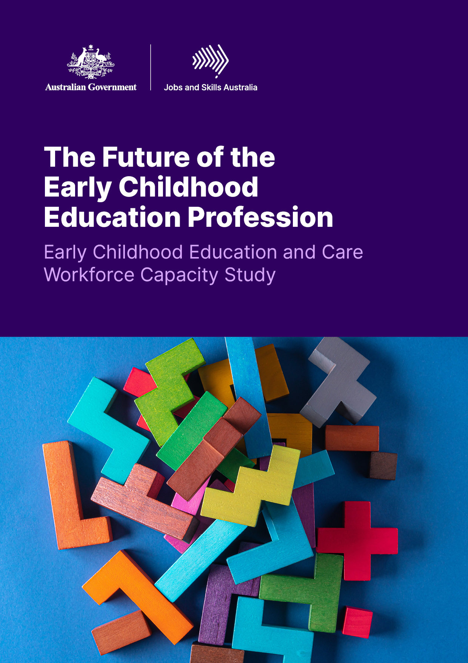The Future of the Early Childhood Education Profession

Early Childhood Education and Care Workforce Capacity Study



**Acknowledgement of Country**

Jobs and Skills Australia acknowledges the Traditional Owners of Country throughout Australia and recognises the continuing connection to lands, waters and communities. We pay our respect to Aboriginal and Torres Strait Islander cultures, and to Elders past and present.

Contents

Glossary v

Commissioner’s Foreword vi

Executive Summary 1

What the Study Does 1

The Early Childhood Workforce Today 4

Future states 9

Sustainable and ongoing learning and development 10

Strong foundations for rewarding ECEC careers 15

Introduction 19

The Role of this Study 20

What is a Capacity Study? 20

The Terms of Reference 21

The ECEC Sector 21

Engaging with the Sector 28

Structure of the Report 29

Chapter 1: System and Structure 30

Introduction 31

ECEC System Overview 31

Provision of ECEC 44

Summary 56

Chapter 2: The ECEC Workforce 56

Defining the ECEC Workforce 57

Characteristics of the ECEC Workforce 61

Migration Routes 63

Remuneration and Other Employment Conditions 67

Workforce Demand and Hiring Trends 80

Occupational Flows 87

Summary 91

Chapter 3: Pathways into the ECEC Workforce 92

Qualification Routes for the ECEC Workforce 93

Summary 109

Chapter 4: Future States 110

Introduction 111

Approach and Assumptions 112

Future Demand 118

Future Workforce Supply and Emerging Gaps 122

Summary 129

Chapter 5: Sustainable and Ongoing Learning and Development 130

ECEC - An Applied Vocation 132

Growth in the Workplace 150

Summary 152

Chapter 6: Strong Foundations for Rewarding ECEC Careers 153

Pay, Security and Time 155

Rewarding Passion 160

ECEC Scopes of Practice 164

Overcoming Barriers to Job Satisfaction 168

Community Values and Expectations 173

Summary 177

Appendices 178

References 193

Data Sources 198

# Glossary

|  |  |
| --- | --- |
| **Abbreviation** | **What it stands for** |
| ABS | Australian Bureau of Statistics |
| ACCC | Australian Competition and Consumer Commission |
| ACCO | Aboriginal Community Controlled Organisation |
| ACECQA | Australian Children’s Education and Care Quality Authority |
| ACFC | Aboriginal Child and Family Centres |
| ACMID | Australian Census and Migrants Integrated Dataset |
| AITSL | Australian Institute for Teaching and School Leadership |
| AQF | Australian Qualifications Framework |
| ASQA | Australian Skills Quality Authority |
| ATAR | Australian Tertiary Admissions Rank |
| CALD | Culturally and Linguistically Diverse |
| CBDC | Centre-Based Day Care |
| CCS | Child Care Subsidy |
| ANZSCO | Australian and New Zealand Standard Classification of Occupations |
| ANZSIC | Australian and New Zealand Standard Industrial Classification |
| DAE | Deloitte Access Economics |
| ECEC | Early Childhood Education and Care |
| ECPP | Early Childhood Care and Development Policy Partnership |
| ECT | Early Childhood (Pre-Primary) Teacher |
| EYLF | Early Years Learning Framework |
| FBT | Fringe Benefits Tax |
| FDC | Family Day Care |
| FTE | Full-time Equivalent |
| FWC | Fair Work Commission |
| HEI | Higher Education Institutes |
| IELTS | International English Language Testing System |
| IHC | In-Home Care |
| ISP | Inclusion Support Program |
| IVI | Internet Vacancy Index |
| JSA | Jobs and Skills Australia |
| JSC | Jobs and Skills Council |
| NCVER | National Centre for Vocational Education Research |
| NDIS | National Disability Insurance Scheme |
| NERO | Nowcast of Employment by Region and Occupation |
| NQF | National Quality Framework |
| NQS | National Quality Standard |
| NWC | National Workforce Census |
| OSHC | Outside School Hours Care |
| PALM | Pacific Australia Labour Mobility |
| PC | Productivity Commission |
| PD | Professional Development |
| PLIDA | Person Level Integrated Data Asset |
| RPL | Recognition of Prior Learning |
| RTO | Registered Training Organisation |
| SPL | Skills Priority List |
| TAFE | Technical and Further Education |
| TEQSA | Tertiary Education Quality and Standards Agency |
| ToR | Terms of Reference |
| VET | Vocational Education and Training |
| YBFS | Year Before Full-Time Schooling |

# Commissioner’s Foreword

I am delighted to present Jobs and Skills Australia’s (JSA) second workforce capacity study, *The Future of the Early Childhood Education Profession* (‘the Study’).JSA has undertaken this study at a time of significant growth and reflection for the sector, with the ACCC report, the Productivity Commission inquiry and the development of the Early Years Strategy coming after the implementation of the National Quality Framework review. High-quality Early Childhood Education and Care (ECEC) depends on the relationships between children and their early childhood educators and teachers, as affirmed in the Strategy. JSA has undertaken literature and policy reviews, international desktop comparisons, deep data analysis, economic modelling and qualitative analysis of stakeholder submissions and consultations in order to deliver 28 findings and 41 recommendations on the future of the ECEC workforce.

The Study highlights the significant workforce growth needed to meet the demand for early childhood education. It is in the sector’s long-term interest that this growth is achieved in an inclusive manner.

Gender equality is a core theme within this Study due to the highly feminised workforce. The National Agreement on *Closing the Gap* is another major concern within the Study, recognising the importance of an early childhood sector which is both culturally safe and responsive to the needs of First Nations staff, families and communities in all service types. The report further strongly supports Aboriginal community control of settings as well as peak First Nations engagement at a strategic level to integrate conceptions of First Nations knowledge, learning and care of Country into all settings.

Recognition of the professional orientation of the early childhood workforce is a key contribution of this Study. The varied scopes of practice of educators and early childhood teachers are recognised and valued by the Study, as is the need for specialist skills and adaptability between service types. This Study has continued JSA’s work in delivering its mission of tripartite engagement, partnering with the Jobs and Skills Council responsible for Children’s Education and Care, HumanAbility.

This report is submitted with confidence that the early childhood sector has the potential to grow and develop to meet the needs for all Australian children while appreciating the essential and complex work educators and early childhood teachers provide.

**Professor Barney Glover AO**

**Commissioner**

**Jobs and Skills Australia**

# Executive Summary

The Government commissioned Jobs and Skills Australia to undertake a capacity study on the workforce needs for Australia’s Early Childhood Education and Care (ECEC) sector (‘the Study’). The Study has been undertaken in partnership with HumanAbility, the Jobs and Skills Council (JSC) with responsibility for the Children’s Education and Care, Aged Care and Disability Support, Health, Human Services and Sport and Recreation sector.

## What the Study Does

The Study provides critical evidence, insights, and recommendations as appropriate to support current and future workforce planning, including a detailed understanding of the current state and future needs of the sector’s workforce to support the development of Government strategy and vision on early years education and care of Australia’s children. It focuses on ECEC workforce and skills issues, particularly attraction and retention, to complement the broader scope of the other inquiries.

The Study also identifies and analyses occupations for each of the different parts of the sector (pre-schools and kindergartens, centre-based day care (CBDC), family day care (FDC), in-home care (IHC), outside school hours care (OSHC), including services delivered through Aboriginal Community Controlled Organisations (ACCOs)), their respective supply and demand factors, and geographical considerations to understand factors that impact training, attracting, and retaining the ECEC workforce.

The Study has investigated the whole ECEC sector but for analytical ease focused on the two relevant ANZSIC industry groups ‘871 *Child Care Services’* and ‘801 *Preschool Education’*and eight target ANZSCO Occupations (6-digit level) which were validated by the consultation paper.

### Engagement and Research Process

The Terms of Reference (ToRs) for the ECEC Capacity Study were open for consultation in late 2023, approved by the Minister of Skills and Training, the Hon Brendan O’Connor MP and published on 14th February 2024.

The Study was overseen by a Steering Group with representatives drawn from the sector, including peak bodies, specialist groups, trade unions and researchers and met formally 5 times between December 2023 and May 2024. The Study’s consultation paper was published on the 20th November 2023, with over 50 submissions received. Stakeholder engagement opportunities were held between November 2023 and March 2024, including three online roundtable-style discussions in March 2024. Steering group members provided extensive feedback on modelling of future workforce demand and supply under various scenarios, undertaken by JSA and Deloitte Access Economics (DAE).

The Study has been conducted with consideration of the Productivity Commission (PC)’s and Australian Competition and Consumer Commission (ACCC)’s inquiries into the ECEC sector in Australia, and other policy developments.

JSA acknowledges the important and widely accepted shift within the ECEC sector to move towards a language of “early education” as opposed to “child care”. Specifically, ECEC workers are now more properly referred to as “early childhood educators” instead of “child carers” to better reflect their work processes, qualifications and expertise. However, statistical naming conventions typically lag behind cultural shifts, and some of the data sources used for this report are only subject to comprehensive review infrequently. JSA notes that the Australian Bureau of Statistics (ABS) is currently undertaking a comprehensive review of the Australian and New Zealand Standard Classification of Occupations (ANZSCO), with future changes flagged for occupations relevant to ECEC.

Throughout this report, terms such as ‘early childhood educators and teachers’ are used when speaking generally about the workforce. However, to avoid confusion, when referencing a dataset specifically for accuracy field titles as given by the relevant classification used in the dataset, acknowledging that job titles such as ‘Childcare Worker’ are inconsistent with current preferred terminology. The report has italicised ANZSCO and Australian and New Zealand Standard Industrial Classification (ANZSIC) names throughout to indicate where an official classification has been used. ANZSCO current occupation titles and Preliminary Proposed Changes are shown in Figure 1.

Figure 1: Scope of the ECEC Workforce considered for this Study

Current Australian and New Zealand Standard Classification of Occupations (anti-clockwise):​

134111 Child Care Centre Manager​

421112 Family Day Care Worker​

421114 Out of School Hours Care Worker​

422115 Preschool Aide​

421111 Child Care Worker​

241111 Early Education (Pre Primary-School) Teacher​

422111 Aboriginal and Torres Strait Islander Education Worker​

421113 Nanny​

​

Proposed occupation titles (anti-clockwise):​

Children’s Education and Care Service Director​

Family Day Care Educator​

Family Day Care Coordinator​

Out of School Hours Educator​

Early Childhood Educator​

Early Childhood Educator ​

Early Childhood Education Room Leader​

Note: Figure includes current (dark purple) and any currently preliminary proposed (light purple) occupation titles in the Australia and New Zealand Standard Classification of Occupations.

Findings have been drafted to align with *Shaping Our Future, The National Children’s Education and Care Workforce Strategy* (2022-2031); the jurisdictional workforce strategies and the *Early Childhood Care and Development Sector Strengthening Plan* related to Priority Reform 2 of *the National Agreement on Closing the Gap.* While the *Shaping Our Future*, *National Children’s Education and Care Workforce Strategy* is well received within the sector and has strong intent, the co-owned nature of the strategy means that the implementation accountability is distributed. Ongoing work for coordinated evaluation of the strategy is important and progress is being made.It is also noted that there are existing programs in place as part of work on these strategies that align with this report’s recommendations.

Jobs and Skills Australia takes care to ensure that all data, figures, and research are true and accurate at the date of publication. Please note however, that they may be subject to change after publication and that changes may be made to the data and the Jobs and Skills Australia website at any time.

## The Early Childhood Workforce Today

Australia’s early childhood workforce is made up of well over 200,000 individuals. The majority are Early Childhood Educators, including Early Childhood Education Room Leaders, who work directly with children. Early Childhood Teachers and Children’s Education and Care Service Directors provide educational and organisational leadership. The sector is also supported by specialised education and care professionals and assistants, and roles such as Administration Assistants, Cooks, and Cleaners.

The ECEC workforce is overwhelmingly female, noting a higher proportion of men working in OSHC settings. The primary caring responsibilities women carry often play a part in the staffing arrangements of the sector and flexible work is a key issue.

There are barriers to employment of those with caring responsibilities for young children, mothers especially, in ECEC. The rate of return to employment following birth of first child (70% for *Child carers*) is lower than for occupations such as *Aged and disabled carers* (76%), and *General clerks* (78%). However, women in ECEC occupations return to employment in the sector at slightly higher levels than *Hairdressers*, *Waiters*, *Beauty therapists*, and *Sales* *assistants*.

The sector’s age distribution is similar to all occupations but varies significantly by service type with educators, particularly those working in OSHC, younger than the general labour force, with FDC educators having an older age profile.

The representation of First Nations individuals is greater in the ECEC workforce, relative to all occupations, as noted in table 1 below, and on par across all focus ECEC occupations with the broader population. However, First Nations people are not as well represented across the more highly remunerated occupations in the sector.

In the ECEC workforce there is a higher proportion of people born overseas than for all occupations, with 4 in 10 FDC educators born overseas and a higher proportion of people who have a main language other than English at home.

The majority of the workforce were Australian citizens at the time of the last census, but there is considerable variation by occupation, including between educators in different service types. Many temporary ECEC staff are on study visas with relatively few coming through temporary skilled visa categories.

There are fewer people with disability[1] in the ECEC workforce than the general population but a slightly higher proportion of staff with a long-term health condition.

Table 1: Selected characteristics by ANZSCO Unit Group, 2021

|  |  |  |  |  |  |  |
| --- | --- | --- | --- | --- | --- | --- |
|  | 4211  Child Carers | 4221  Education Aides | 2411 Early Childhood (Pre-primary School) Teachers | 1341  Child Care Centre Managers | Total ECEC Occupations | All Occupations |
| Median age | 34 | 45 | 40 | 41 | 37.9 | **39.9** |
| Female (%) | 95.6% | 88.5% | 97.6% | 91.8% | 93.3% | **48.6%** |
| Aboriginal and/or Torres Strait Islander (%) | 2.9% | 5.7% | 1.7% | 2.5% | 3.7% | **1.7%** |
| Has a Certificate III and above (%) | 79.1% | 71.3% | 95.6% | 93.1% | 78.7% | **66.1%** |
| Born overseas (%) | 37.4% | 20.8% | 29.0% | 25.9% | 30.5% | **28.5%** |
| Main language spoken other than English (%) | 31.4% | 12.9% | 21.7% | 17.0% | 23.6% | **21.3%** |
| Has a long-term health condition (%) | 30.5% | 36.7% | 36.4% | 32.4% | 33.0% | **28.6**% |

Source: ABS Census of Population and Housing, 2021, TableBuilder  
Note: Please see Figure 1 above for details of occupations included within each ANZSCO Unit Group.

The ECEC workforce is overwhelmingly reliant on the relevant Award[2] for pay and working conditions, with fewer workers on collective agreements than in other education sectors. In May 2023, educators (*Child Carers* 4211) had similar average weekly ordinary time earnings to *Aged and Disabled Carers* despite working around five additional hours per week, and ECEC staff earn casual loading less frequently than care sector workers. When comparing the earnings of educators (*4211*) to other occupations, both male and female educators had lower average weekly earnings than *Storepersons* (7411)and *General Clerks* (5311) despite requiring much higher levels of qualification and significantly lower average weekly earnings than *Security Officers and Guards* (4422), *Truck Drivers* (7331), *Motor Mechanics* (3213) despite similar qualification requirements.

*Early Childhood Teachers* earn substantially less than *Primary School Teachers*, despite the prevalence of dual qualification, and this is intensified for those not working in Preschool settings. Managers in the ECEC industry typically earn less than those in the Health and Welfare Service industry and substantially less than senior staff in other education sectors such as Principals.

Table 2: Employment conditions by occupation, 2023

|  | 4211  Child Carers | 4221  Education Aides | 2411  Early Childhood (Pre-primary School) Teachers | 1341  Child Care Centre Managers | Total ECEC Occs. | All Occs. |
| --- | --- | --- | --- | --- | --- | --- |
| Average hours1 | 25.7 | 22.7 | 24.6 | 32.7 | 24.9 | 30.5 |
| Average weekly earnings1 | $758.7 | $752.3 | $1094.7 | $1374.0 | $816.4 | $1439.1 |
| Union Membership2 | 4.8% | 32.5% | 7.0% | 13.0% | 15.1% | 11.6% |
| Has a second job2 | 6.8% | 12.9% | 10.4% | 6.6% | 9.2% | 6.8% |
| Fixed term employment3 | 2.4% | 29.8% | 4.0% | 0.0% | 12.5% | 4.7% |
| Casual employment3 | 30.2% | 14.5% | 8.9% | 0.0% | 21.2% | 21.9% |
| Paid award only3 | 70.1% | 3.7% | 29.0% | 15.9% | 39.8% | 23.2% |
| Paid collective agreement3 | 11.7% | 86.7% | 54.6% | 14.9% | 42.8% | 34.0% |
| Paid individual arrangement3 | 17.8% | 9.2% | 13.2% | 44.9% | 16.0% | 38.7% |

Sources:  
(1) ABS (2023), Employee Earnings and Hours, TableBuilder, ordinary time  
(2) ABS (2023), Characteristics of Employment, TableBuilder  
(3) ABS (2023), Employee Earnings and Hours, TableBuilder

The sector’s overall regulatory framework has been designed to promote quality education and care. Regulations do add to supply pressures, but funding constraints, increasing service demand, and a tight labour market are also contributing to current workforce pressures. The National Quality Framework (NQF) provides the workforce with an essential quality standard to assure children’s safety and quality early learning. *Shaping Our Future*,and its linked jurisdictionally based ECEC workforce strategies, provide a strong basis for further development and professionalism of this critical education sector. The Early Years Learning Framework (EYLF) provides a robust base for training and development in the sector which underpins initial ECEC education in Australia and educators should be supported to engage with it in ongoing training and development.

Average wages in the ECEC sector are currently lower than in a number of related sectors, as noted above, and occupations for both Early Childhood Educators and *Early Childhood Teachers*. Various processes are underway through the Fair Work Commission (FWC) to consider wage increases for workers in the sector (apart from standalone Preschools, where higher rates currently apply). Stakeholders universally report workforce strain, exacerbated by high levels of recruitment activity driven by growth and turnover which impacts service delivery capability and pressures quality. There are relatively high rates of work-related injuries in ECEC which can further contribute to worker attrition. The rate of serious injury claims in the Childcare Services industry group (ANZSIC 871) in 2021-22p[3] (Safe Work Australia NDS for Compensation-based Statistics) was 14.2 claims per million hours worked, compared to 6.5 claims per million hours worked in all industries. These reports are corroborated by JSA evidence of high and increasing vacancy rates since 2015 and stakeholder reports of recruitment difficulty. These workforce pressures impact staff remaining in the sector through workload strain and stress in roles, significant out of paid hours working, including collaborative working such as evening unpaid meetings. There has been a large increase in the reliance on trainees to meet demand for new Early Childhood Educators, relying on the ‘actively working towards a qualification’ provision in the regulations. High reliance on trainees impacts the quality and amount of contact time that can be provided by the trainees and the experienced staff supervising them.

Consultation showed strong community feeling of unmet demand for ECEC services which is linked anecdotally to workforce shortages. Unmet demand is felt particularly within regional and remote areas which impact wider labour force participation, specifically the participation of primary carers who are overwhelmingly female. This is supported by the analysis of Child Care Subsidy (CCS) and Early Childhood Education and Care National Workforce Census (NWC) data, while noting that it also shows some pockets of underutilised capacity.

Modelling indicates that there is a current shortfall of around 21,000 qualified ECEC professionals needed to meet existing demand and support more sustainable working conditions. An additional 18,000 qualified ECEC staff would be required to meet estimated unmet demand in services not yet established. Finally, over 18,000 staff would be required to fully realise CCS changes and expanded preschool policies.

1. **Current workforce levels are not sustainable to even meet current levels of demand taking into account numerous factors including:**

* **Evidence of overtime being worked**
* **Insufficient provision for ongoing professional development**
* **Increasing reliance on trainees to meet workforce requirements, given their 20% allocation of paid work time for off-the-job learning**
* **Time spent by more established staff recruiting and onboarding new staff and providing on the job supervision to trainees. The high and increasing use of waivers by services not meeting National Regulations regarding staffing arrangements**.

Worker screening (e.g. WWCC/WWVP) and child safety regulatory requirements have an impact on workforce recruitment practices. However, it is important to consider any efforts to grow the workforce in balance with ensuring the safety of children and suitability of workers particularly in light of the review of Child Safety Arrangements under the NQF and outcomes of the 2023 Ministerial Forum on Child Safety. The National Strategy to Prevent and Respond to Child Sexual Abuse 2021-2030 highlights the key role of organisations in providing services to children and young people in a child safe way, which includes implementing the National Principles for Child Safe Organisations and enhancing national arrangements for information sharing. Regulatory differences across jurisdictions (States and Territories) and service types (e.g. CBDC, FDC, OSHC & preschool/kindergarten) impact movement interstate and equity of esteem in an increasingly nationalised system and cause barriers for sharing of good practice, resources and training.

Noting proposed changes to ANZSCO occupation classifications, current role descriptions do not capture the work required and performed in ECEC. Clear understanding of roles is particularly important in providing appropriate training and professional development that ensures ECEC staff and centre managers are providing the services communities and families need.

The NWC provides an important insight on the ECEC workforce but could be further strengthened with alignment to *Shaping Our Future*, reporting on service profile as well as individual educator, more attentiveness to roles, hours worked, including at multiple services and study engagement of staff. There would be benefits should the NWC be able to be completed by individual educators and staff not just the service manager.

1. Data gaps and inconsistencies constrain effective workforce planning. This includes difficulty capturing the extent of unmet service demand, inconsistencies in scope and estimates between the National Workforce Census (NWC) and Australian Bureau of Statistics Labour Force Survey and other collections, and insufficient data on the First Nations ECEC workforce.

|  |
| --- |
| CAMEO: Chelsea and Shelly, Room leaders  Chelsea and Shelly were at different stages in their lives when they both applied to be trainees at Jenny’s Early Learning Centres in Bendigo, Victoria. Chelsea was 17 when she finished high school and began her traineeship at Jenny’s ELC, five years later Chelsea is a room leader loving her work. In contrast, Shelly was aged 46 when she left her career in sewing at a factory to undertake a traineeship. Shelly’s former workmates “thought [she] was crazy to switch jobs”, however ten years later, Shelly is also a room leader and is happy she didn’t take that advice.  Source: Department of Education, (2023), *Case study: Jenny’s Early Learning Centres*, Australian Government, <https://www.education.gov.au/early-childhood/case-studies/case-study-jennys-early-learning-centres>. |

|  |
| --- |
| CAMEO: Melissa Harpur, Early Childhood Teacher  Melissa’s journey to becoming an Early Childhood Teacher began when she completed her diploma at TAFE and gained a position at a local preschool. With support from the preschool, Melissa enrolled in the Bachelor of Education the Early Years where she was partnered with mentor ‘Aunty’ Deb Wray from the Woolyungah Indigenous Centre for additional support. In her final year of study, Melissa undertook practical experience at an early learning centre where she grew in confidence. Melissa now works as an Early Childhood Teacher at this centre and collaborates with other services in playgroups for Aboriginal children and families.  Melissa enjoys her career but finds it very busy. Nevertheless, she finds it interesting and has plans for further training in the field. In 2023 Melissa was undertaking further training at TAFE and plans to study a Master of Special Education with a focus on First Nations perspectives in the early childhood sector.  Source: My Future, (2024), *Early Childhood Educator addresses her future*, My Future, <https://myfuture.edu.au/career-stories/details/early-childhood-educator-addresses-her-future>. |

## Future states

Modelling commissioned by JSA looked at the likely future demand for early childhood services over the next ten years. The modelling took into account current levels of unmet demand (for children already accessing services only), future population growth and changes in the participation rate, and the commitments that have been made to expand preschool access for 3 and 4 year olds.

1. To meet projected national population growth increases (1.3 per cent per year) and increased female participation in the workforce, the ECEC workforce will need to grow by around 1.5 per cent per year by 2034 to service the increase in demand.
2. The current ECEC workforce would likely need to grow by an extra 8 per cent to satisfy current estimated unmet demand for early childhood services and another 8 per cent to meet unmet demand for qualified workers*.*
3. In order to meet the various policies already committed to by Commonwealth, State and Territory governments, the ECEC workforce will likely need to increase by an annual average growth rate of 1.9 per cent per year overall and by 3.2 per cent per year for Early Childhood Teachers.

There is evidence that further expanding access to early childhood education to a universal model of up to 30 hours per week, including universal preschool for 3 and 4 year olds, could deliver substantial benefits for child development, social inclusion and long-term skills growth, as well as women’s labour force participation. Achieving this secular increase in access would add to the scale of future workforce demand.

1. To implement universal access and universal preschool for 3 and 4 year olds and up to 30 hours per week over three days of ECEC to be available to all children, the ECEC workforce will likely need to grow by 3.0 per cent per year with Early Childhood teachers needing to grow by 5.4 per cent per year.

Attention therefore needs to turn to the likely future supply of *Early Childhood Educators* and *Early Childhood Teachers*. Aggregate supply is expected to increase by 2.0% per year over the next 10 years. The biggest contributions to supply growth are expected to come from ‘movements between occupations’ and Vocational Education and Training (VET) completions.

1. If current pay and conditions are maintained the sector will need to draw in aggregate supply for *Child Care Workers* from outside the labour force, requiring extra training effort and time and exacerbating existing workforce pressures. In 2034, the *Early Childhood (Pre-primary School) Teacher* occupation is expected to continue to record a shortfall in staff.
2. When examined at the regional (SA4) level workforce shortages are apparent in most regions across major cities, regional and remote Australia and are forecast to persist over the next ten years.

## Sustainable and ongoing learning and development

In submissions and through roundtable discussions, stakeholders affirmed their commitment to improving and sustaining quality education and care, their support for the current NQF settings as the means for achieving that, and the importance of a close relationship with the education and training system in delivering and maintaining a skilled workforce.

Broadly, the existing qualifications and delivery mechanisms continue to serve the sector well but there are some tensions and gaps relating to

* The appropriate content for the Certificate III in Early Childhood Education and Care as the bedrock qualification
* Opportunities for students and workers to enter the sector in supporting roles (e.g. excluded from ratios) without undertaking the Certificate III
* The strain arising from a large increase in Certificate III traineeships to meet workforce demand
* Enrolment arrangements for the Diploma of Early Childhood Education and Care that may be too strict
* Accessibility of work placements without financial support for VET and higher education students (or being able to count current employment towards placements)
* A lack of flexibility to recognise the potential for professionals with alternative qualifications to substitute for Early Childhood Teachers where there is already at least one ECT employed in the service
* Access to funded training for international students

There is also an opportunity to foster a more supportive environment to assist more First Nations Australians to complete qualifications. These concerns could be alleviated by taking an orientation to sustainable and ongoing learning and development and are further explored in findings and recommendations outlined in this section.

1. Developing the ECEC profession and assuring high quality workforce practice is linked to high quality qualifications delivery and assessment and availability of ongoing professional development, including relating to child safety.
2. Services and ECEC workers delivering high quality ECEC, quality assessments, and improved professional development are identified, and their practices disseminated across the sector. Pathways could potentially include through the proposed Shaping our Future national professional practice network, or through development of additional recognition and incentive tools by governments.
3. The Certificate III ECEC is the bedrock workforce qualification across service types. However, there is a widespread concern across the ECEC sector that the current content of Certificate III ECEC is too complex and broadly focused. Current delivery methods of the Certificate III ECEC also contribute to making success in ECEC more difficult for some cohorts, including delivery in schools. The block-mode delivery requiring intensive focus away from family or community, and for those with differing levels of literacy.
4. HumanAbility to review the current content of the Certificate III in Early Childhood Education and Care, in collaboration with States and Territories, to identify opportunities to reduce the complexity of the learning outcomes, without detracting from quality.
5. HumanAbility to consider how the national training system can better support more graduated pathways into Early Childhood Educator roles. Education and Training Providers should work with Governments to continue to develop and fund programs that will provide an accessible pathway into Early Childhood Educator roles by:
6. encouraging development of pre-employment programs.
7. assessing the appropriateness of SkillSets for different service types where the full qualification is not nationally mandated for workforce (particularly OSHC) including reviewing existing OSHC SkillSets.
8. incentivising the development of resources to support high quality simulated training and assessment before on the job placement.
9. Governments should support completions of ECEC qualifications in school-based apprenticeships and traineeships to ensure sustainability and drive access. As a senior secondary pathway alternative, consider supporting the further development of a taster skillset designed to be delivered in VET in schools and other settings with explicit arrangements with RTOs and ECEC providers that support the student to complete the Certificate III in Early Childhood Education and Care.
10. Traineeships form a critical part of the workforce pipeline and should offer a well-supported way to earn and learn. In an expanding system, new trainees are very important, but the recent, very large influx of traineeships (doubling since 2020) has produced a bottleneck for senior staffing in terms of meeting regulatory compliance and on-the-job mentorship.
11. The sector should systematically recognise the role of senior and experienced staff in supporting trainee induction, development, assessment and mentoring. Classification arrangements and role descriptions (including in any relevant Award review) and in allocation of non-contact time is also in scope.
12. The role of Diploma qualified educators is the fulcrum of the long day care setting and Diploma enrolments have fallen in recent years. A contributing factor is that the Diploma entry requirement of a completed Certificate III ECEC within the two most recent training packages, and the minimal pay increase associated with the higher qualification, has discouraged Diploma enrolments since 2021.
13. States and Territories should examine ways to support enrolments in ECEC Diploma courses, including by not limiting the time since completing the Certificate III in Early Childhood Education and Care which allows for staff currently working in the sector to access funding.
14. HumanAbility should review training package arrangements to ensure they are fit for purpose. Further considerations could include developing a bridging course for the current Diploma ECEC targeted at educators returning to the sector who already hold a recognised ECEC qualification but have not worked in the system for several years, or potentially expanded to those transitioning from adjacent sectors.
15. Many students enrolled in ECEC courses also work in the sector. However, outside formal traineeships employment experience only in specific situations counts towards their qualification, raising concerns about placement poverty. This places pressure on the system of placements, where there are significant hours required in both VET and higher education ECEC qualifications. This may also place significant financial strain on students, noting current plans to introduce paid placements for higher education students.
16. To support an ongoing pipeline of well qualified workers completing qualifications in a timely fashion, there should be consideration of financial investment in ‘wrap-around support’ for existing educators to attain higher qualifications e.g. paid study leave and the negotiation of study calendars and assessment that fit in with workplace needs.
17. In order to support the career progression of people with primary carer responsibilities, training providers in VET and higher education should have explicit strategies for the inclusion of parents in key ECEC courses. This includes ensuring there are processes in place to identify the cultural and family needs of the learner cohort and ensuring reasonable access to support services including for the education and care of children and other supports for parents such as scheduling for training, placements and assessment with consideration to cultural and family needs.
18. A key issue contributing to the shortage of *Early Childhood Teachers* is leaks in the pipeline from dual accredited degree courses. Education providers frequently offer Early Childhood and Primary School training as a combined course. There are significant sectoral concerns particularly with crowded curriculum in dual accredited accelerated courses and in the 0-12 years accredited routes. The ECEC sector may be less served by shared training, since graduates are more likely to seek work in schools, typically offering better pay and working conditions which makes the sector less competitive.
19. Governments should seek to improve completions in ECEC by:
20. continuing to support paid placements within ECEC with potential outcome measures relating to time spent work in the sector or in regional or remote settings.
21. scoping career changer accelerated programs for ECTs aimed at those working in related sectors with some educational or development expertise.
22. reconsidering any arrangements within the Higher Education Loan Program that create inequity between universities and other institutes of higher education, incentivising students to enrol in one over the other.
23. Accreditation authorities and education and training providers to consider:
24. accreditation of exit awards, particularly higher education diploma level qualifications after the first year to recognise partial/progress completion of bachelor’s degree at AQF Level 5 as equivalent to a Diploma.
25. investigation of space in higher education programming to enable a Certificate III in Early Childhood Education and Care to be undertaken alongside Tertiary Primary School Teaching study in a concurrent mode, using RPL or similar.
26. Noting the importance of child safety within the context of teacher registration, progress national teacher registration alignment to enable movement between jurisdictions of qualified ECTs and for teachers from other sectors willing to upskill with ECEC qualifications. Continue to support refinements in overseas assessment recognition of ECT courses.
27. In meeting and filling persistent and ongoing workforce shortages for ECTs, ACECQA and jurisdictions could consider reviewing the definition of a ‘suitably qualified person’ including the potential, possible temporary, inclusion of other non-teaching degrees which provide a sound foundation for Early Childhood Teacher capabilities.
28. International students have been a recently increasing cohort, particularly in early childhood teaching courses, it is important to ensure that supports are in place to support them and their workplaces.
29. TEQSA and ASQA should ensure education and training providers have plans for the protection of international students in settings to prevent misunderstandings of employment arrangements including hours of work and duties.
30. Higher education institutions may consider whether the Professional IELTS[4] is more appropriate than the Academic IELTS for Early Childhood Education courses.
31. Higher education institutions should ensure that progress assessment protocols within accredited courses particularly for newly arrived international students are robust to enable students to have time to settle into their new national contexts and professional identities before placements. ACECQA should continue to offer eLearning induction materials provided as part of Shaping our Future.
32. First Nations leadership of education and training providers has been shown to make a significant difference to access and success of First Nations students. However, there are relatively few Aboriginal Community Controlled education and training providers delivering ECEC qualifications for First Nations Australians. For these and other reasons the First Nations community may be poorly served by education and training pathways into ECEC, particularly for higher education routes including relating to curriculum, assessment and delivery arrangements.
33. Governments examine the viability of current funding arrangements for ACCO led registered training organisations (RTOs) and higher education providers in supporting Aboriginal and Torres Strait Islanders to gain ECEC qualifications.
34. Ensure that all education providers have strategies e.g. reconciliation action plans, including explicit engagement with culturally safe, appropriate and responsive curriculum, assessment and delivery arrangements.
35. There is not sufficient First Nations curriculum coverage in either Certificate III or Diploma ECEC and higher education qualifications, including relating to cultural safety. The current unit (CHCECE054) offered within the ECEC Training Package is not sufficient for Aboriginal and Torres Strait Islander learners to engage with culture within an early learning education context.
36. HumanAbility should encourage the development of units in the ECEC training package that extend cultural knowledge and Indigenous knowledges. Higher education providers should establish teacher education programs that recognise, enable and celebrate First Nations ways of learning and being.
37. Recognise and explore the importance of cultural knowledge in the ECEC workforce through prioritised inclusion in enterprise agreements.
38. Many new ECEC educators are working towards qualifications. It helps the sector to count these workers in compliance with regulatory requirements. However, this may place some in senior positions without sufficient preparation.
39. Provide advice – and establish a link to support the provision of – guidance to education and training providers around satisfactory progress to support ECEC service-based assessment of staff meeting working towards requirements.
40. Employers to allow for ongoing professional development for all staff through investigating the impact of closure days or paid backfill. This includes for meeting compliance requirements including medical training such as First Aid, CPR, Anaphylaxis and support to facilitate child safety. Also consider the funding of professional support coordinators with remit to take into account specific community and regional needs.
41. Across ECEC training pathways there is in practice little recognition of prior learning (RPL) and experience. This intersects with problems with credit transfer, RPL and advanced standing in educational settings. It also fails to acknowledge learning that has taken place in workplaces and other settings impeding ECEC qualification uptake and completion.
42. Regulators and HumanAbility should consider qualification protocol changes to incentivise quality RPL and investigate system wide protocols for evidencing experiential learning and facilitating advanced standing for higher education and credit transfer for VET.
43. Clarifying RPL protocols for the existing ECEC workforce and for those wishing to re-engage with the ECEC sector to make RPL more accessible to staff.
44. Investing in ECEC training package specific toolkits which support the processing of RPL within RTOs combined with assurance of compliance with RTO Standards for RTOs offering RPL and credit transfer.

|  |
| --- |
| CAMEO: Marcquis Hepburn, Early Childhood Educator  Marcquis, an Early Childhood Educator, acknowledges that the support of colleagues and mentors helped him achieve the Illawarra and Shoalhaven Child Care Trainee of the Year. In a female dominated sector, Marcquis encourages males to enter the sector to facilitate learning and development in children. Marcquis is passionate about ECEC and plans to undertake a university degree in early childhood. In the future, Marcquis sees himself directing his own centre and would like to specialise in education and care for children with additional needs.  “Marcquis supports networking in the child care and early learning sector and emphasises the importance of attending courses and conferences with other early childhood educators to ensure a streamlined approach to children’s development needs.”  Source: My Future, (2024), *Early childhood educator celebrates the small steps*, My Future, <https://myfuture.edu.au/career-stories/details/early-childhood-educator-celebrates-the-small-steps>. |

## Strong foundations for rewarding ECEC careers

A fundamental barrier for many people looking to build a successful career in ECEC is the low levels of remuneration. Avenues to improve remuneration levels would improve the attractiveness of ECEC, improve retention and promote more career progression. Other issues that detract from successful careers include:

* The low pay rate premium for Diploma-qualified staff relative to Certificate III-qualified staff
* Low recognition and absence of funding for specialised roles, particularly to support more inclusive education and care settings
* Demands placed upon Centre Directors, without adequate options for training and support
* Barriers for migrants from progressing to more senior roles
* Support for First Nations workers, both in ACCOs and other service settings.

Overall, these issues could be progressed by re-examining roles within ECEC using a scopes of practice approach and are further explored in findings and recommendations outlined in this section.

1. ECEC remuneration is low compared to other competing occupations, which presents a significant disincentive to entry and accelerates attrition.
2. Wage rates in awards and enterprise agreements should be as competitive as possible, particularly for ECTs with respect to primary school teachers and Early Childhood Educators with respect to other VET-trained occupations in the care and administrative sectors.
3. Governments should contribute funding to drive long-term wage growth for ECEC workers.
4. Consider a campaign to ensure new and existing staff are aware of their pay and condition entitlements.
5. The rewards for further study, especially wages at Award Rates between Certificate III and Diploma ECEC are insufficient for many ECEC staff to find motivating. One key consequence is that this impedes pathways into middle leadership in the sector.
6. As part of any award review, consider the levels of remuneration provided to Diploma-qualified educators working in room leader positions, Educational Leaders, middle leaders, workplace assessors, mentors and other specialised roles as a matter of temporary or permanent career progression.
7. A key barrier to workforce entry and retention is that ECEC workplaces may be located at a considerable distance from workers’ homes, including in metropolitan settings where there is lack of affordable housing where there is the highest density of service provision.
8. Improve the attractiveness of ECEC work by considering the provision of employee incentives. This could further enable employers to offer benefits to employees who have barriers to return – in particular for transport for hard to reach services in regional or high-cost areas and subsidy of ECEC for their own children.
9. Incentivise and promote rostering and staffing arrangements that provide flexibility, with options considered including four-day work week or a nine-day fortnight to enable ECEC staff to better manage work-life balance, stress and workload.
10. ECEC requires staff who are skilled in a wide range of specialisations. However, the ways that ECEC careers are currently structured offer relatively few opportunities for specialised roles. The inability to specialise causes gaps in provision and career progression opportunities for ECEC staff and can be contrasted against other sectors.
11. Governments should consider how funding might be made available to support educators to meet identified needs, including:
12. appropriate funding for subsidised supervision sessions for senior staff in regional and remote locations with a Child Behaviour Specialist or Psychologist to debrief and discuss children’s educational concerns.
13. investment in evidence-informed trauma resources and trauma informed training for educators, to support children with additional needs.
14. resources and training to support early years educators in implementation of the NDIS recommendations in relation to identification of children’s developmental needs and establishing inclusive educational and care settings.
15. HumanAbility to consider specialisation pathways within the Certificate III ECEC and Diploma ECEC to serve different service types particularly IHC, OSHC and FDC delivery. This could include identifying alternative existing units that could support inclusive education for different identified needs and particularly for First Nations children.
16. ECEC staff report a lack of leadership structure and capacity with the sector which often results in administrative overload — including complying with regulation and managing parent expectations — which is a psychosocial hazard that detracts from job satisfaction and drives attrition.
17. HumanAbility to consider sectoral need for ECEC use of leadership skillsets, micro credentials or similar, including reviewing previous usage of advanced diploma leadership qualifications that were specific to children’s education and care, or the development of elective units in current leadership and management qualifications.
18. Ensure that employer guidance and education is improved on WHS duties and obligations to eliminate or minimise psychosocial hazards (and any other hazard) so far as is reasonably practicable, and all ECEC staff are provided access to a high quality Employee Assistance Program to support their wellbeing.
19. There are straightforward routes for new migrants to complete entry level qualifications. However, migrant ECEC staff often face particular barriers, including funding, to their career development in Australia.
20. States and Territories should review arrangements for course fee rates for international students working within services while studying.
21. As part of the Migration Strategy implementation, relevant parties should consider Early Childhood Educator (421111) & Teacher (241111) roles for eligibility in employer sponsored skilled visa programs, with broad consultation across the ECEC sector.
22. There is increased demand for early childhood education that appropriately serves diverse families and their communities including CALD communities, regional and remote areas, for neurodiverse children and those with disabilities.
23. All governments to explore in shared guidance and resources including to support early years educators in identification of children’s developmental needs and establishing inclusive care settings.
24. The Department of Education and state and territory departments support the development and implementation of innovative solutions or incentives to staffing issues of identified need, including programs that provide financial and mentoring support to members of communities with specific needs to enter the ECEC workforce.
25. The presence of First Nations staff within early childhood settings is critical for promoting participation, growth and development of First Nations children. While there are a number of Aboriginal Community Controlled Organisations involved in the delivery of ECEC, well-supported, culturally safe opportunities for First Nations ECEC staff in non ACCO settings are less embedded in the ECEC sector and these opportunities should be assured. Appropriate and culturally safe service provision requires more specialised roles, especially for First Nations children.
26. Education Ministers should incentivise and include an explicit focus on Aboriginal and Torres Strait Islander Workforce both within ACCOs and across mainstream services and investigate sustainable funding for ACCOs.
27. Governments should formalise a process for ensuring ECEC sector is given adequate guidance from First Nations peak bodies and representatives on strategies to promote the employment, cultural safety and support of First Nations peoples working in the sector.
28. Scopes of practice are a valuable concept for workforce development. The roles, regulations and hierarchies that govern the ECEC workforce have a significant impact on staffing and their ability to deliver services that serve the needs of families and their communities.
29. The Australian Government should develop a national information resource to promote ECEC career and training pathways and attract new entrants from school leavers and people seeking career changing opportunities. This should include strategies to boost the diversity of the ECEC workforce and align to the [Early Childhood Care and Development Sector Strengthening Plan](https://www.closingthegap.gov.au/sites/default/files/2021-12/sector-strengthening-plan-early-childhood-care-development_0.pdf) with increased education, training and recruitment of First Nations professionals as a priority.
30. Multiple parties should review the role of supernumerary staff (excluded from ratio and not responsible for supervising children) for administrative support and other roles. Gaps could be identified for any positions which are not recognised and considered through industrial instruments for administrative educational support roles to be created in the ECEC sector. A particular focus may also be to scope resources that services can use to support the creation of specialised administration support roles.

|  |
| --- |
| CAMEO: Krista Lynch, Centre Manager  Proud Kamilaroi woman Krista is a qualified Early Childhood Educator and leader in Tamworth NSW. Krista has completed a Certificate III and Diploma in Early Childhood Education and Care which has enabled her to lead several centres in northwest NSW. Through additional training and study, Krista was able to work her way up from room leader to centre manager and is now an area manager travelling across centres in NSW.  While Krista has completed four TAFE courses, Krista “loved being able to study while gaining on the job experience in early childhood education” and strongly encourages other First Nations People to consider a career in ECEC. Krista says “On the job learning is a great way for mob to earn and learn” and allows you to pass on cultural knowledge and practice to future leaders.  Source: Your Career, (2023), *Krista's path to a successful career in early education*, Australian Government, <https://www.yourcareer.gov.au/resources/case-studies/krista-lynch>. |



# Introduction

Chapter 1

**The study**

Provides the study’s purpose, approach and contextual information. Outlines the domestic and international policies driving the energy transition.

## The Role of this Study

Australian Governments, at both the national and state/territory levels, have recognised the importance of quality early childhood education and care (ECEC) to our current and future productivity and wellbeing, as well as to tackling disadvantage in our society.

Ambitious policies are already in train to expand early childhood education and care, including work towards universal access and extending the reach of free preschool in many states and territories.

Expanding access to ECEC services will require a larger ECEC workforce. As a human-centred activity, opportunities to automate or completely replace ECEC staff with technology rarely exist – and quality ECEC requires staff to be well trained. In particular, expanding preschool access will mean more early childhood teachers are needed relative to other ECEC educators.

Yet the system is already experiencing shortages. The sector is characterised by low wages relative to comparable occupations and sectors. There are also system settings undermining job satisfaction, career progression opportunities, and cultural and gender inclusion, which affect the sector’s ability to attract and retain staff.

This Study expands on the existing evidence, identifying concrete measures that can help the sector build a more sustainable workforce that can attract and retain the additional workers it requires.

This Study achieves this by looking at both the individual and holistic components of the ECEC workforce, the training pathways through VET and higher education, the influence of the regulatory framework on training arrangements and workloads, and the funding and industrial relations settings as the principal determinants of wage levels in the sector. It further considers attrition factors, including burnout, lack of career prospects, and the workforce strain.

## What is a Capacity Study?

Jobs and Skills Australia (JSA)’s capacity studies assess the current and future demand for, and supply of, labour and skills in critical areas of the economy. They also make recommendations on how the current and future skills and workforce needs can be met, within set time, resource and legislative constraints and government objectives.

JSA has established an ongoing capacity study function to:

* bring together subject matter experts, data specialists and people with stakeholder engagement expertise
* be informed by project Steering Groups, with key stakeholders directly represented
* provide a detailed assessment of labour and skills supply and demand, employment arrangements, and education, training, and migration pathways
* produce long-term modelling of future workforce demand and supply.

## The Terms of Reference

The Study’s Terms of Reference (ToRs) were developed following robust internal and external consultation. Designed to avoid duplication and to complement current inquiries being undertaken by the Productivity Commission and the Australian Competition and Consumer Commission (ACCC), a key focus of the Study’s ToRs is to ensure stakeholder insights are taken into account. This ensures the Study has a transparent scope and delivers findings which add to the skills and workforce research and planning landscape. Terms of Reference were opened for comment on Friday 27 October 2023 and received over 30 submissions.

The complete terms of reference are included at Appendix A. Broadly the ToRs required the study to:

* Examine the characteristics of the current ECEC workforce and employment settings.
* Assess the current training and migration pipelines for supplying ECEC workforce.
* Estimate future demand of the ECEC workforce based on unmet and proposed service demand estimates and compare this with expected supply.
* Consider the diversity of the current ECEC workforce and what changes could support greater workforce participation and career progression, particularly for First Nations Australians.

## The ECEC Sector

### Importance and Purpose of the Sector

The ECEC sector plays a critical role in the development of children and in enabling parents’ and carers’ workforce participation. The ECEC sector shares responsibility for a child’s first 1000 days, the time between conception and 2 years of age that is critical for children’s body and brain development.

ECEC provides educational and developmental support for children aged 0 to 12 years through a variety of settings. In 2022, 1.3 million children attended ECEC services approved for Child Care Subsidy (CCS) and 550,000 children attended a preschool program (Productivity Commission [PC], 2023b). Centre-based day care (CBDC) (61.5%) and outside school hours care (OSHC) (36.6%) were the main services accessed with a small proportion attending family day care (FDC) (6.4%) and in-home care (IHC) (0.2%) (PC, 2023b).

Access to ECEC services has improved participation in the labour force, particularly for women. The participation rate of women with children aged under 15 increased from 65% to 75% between 2009 and 2021 (PC, 2023c). Additionally, the proportion of persons aged 15 years and over not in the labour force mainly due to childcare service-related reasons fell from 40.5% in 2015 to 28.1% in 2022 (PC, 2023b).

While accessibility to ECEC services has improved over time, supply shortages of particular occupations have been identified. Early Childhood Educator roles and Early Childhood Teacher roles in particular were in widespread shortage in 2023, and shortages in ECEC occupations have become more widespread since 2021 (JSA Skills Priority List, 2024).

There is also a widening accessibility gap across Australia with the number of places available declining by remoteness area. In major capital cities, there were 391 approved CBDC and FDC places per 1000 children compared to 212 places in remote and 166 in very remote Australia (ACCC, 2024).

|  |
| --- |
| **CASE STUDY – Thriving Futures: Empowering regional and remote communities**  Thriving Futures is a workforce development program focused on continuing and initial professional development for educators that was first launched in 2020 in the Pilbara region in Western Australia. This has since expanded to the Goldfield region (WA) and Roxby Downs (South Australia). Philanthropically funded, this program was launched to address ongoing shortages in regional and remote communities, offering wage supplements and financial incentives as well as professional development and mentoring. Thriving Futures is available for qualified ECEC educators and anyone looking to start a career in ECEC. The mentor team at Thriving Futures provide ongoing phone and online support as well as face-to-face consultations throughout the year.  Source: Thriving Futures, (n.d.), *The Thriving Futures Project*, <https://thrivingfutures.org.au/about-us/our-project/>. |

### First Nations ECEC Provision

In July 2020, the Coalition of Aboriginal and Torres Strait Islander Peak Organisations and all Australian Governments agreed on a National Agreement on Closing the Gap to tackle entrenched inequality faced by First Nations people and to ensure their life outcomes are equal to all Australians (Closing the Gap, 2020a). There are 19 targets across a variety of areas, including two targets related to early childhood (Closing the Gap, 2020b).

Source: Closing the Gap. *National Agreement on Closing the Gap*. Australian Government. (2020a).

Australian Governments are working together, along with the ECEC sector, to support these targets by introducing several initiatives, including:

* Mainstream initiatives, such as *The Cheaper Child Care Packages* (includes changes to the activity test for First Nations Families).
* *The Early Childhood Care and Development Policy Partnerships (ECPP) -* a $10.2 million partnership between Australian and Jurisdictional governments and First Nations representatives.
* *Connected Beginnings* which improve education, health and development outcomes for First Nations children.
* *Community Child Care Fund Restricted Grant Program* which improves accessibility of services in disadvantaged and vulnerable communities (PC, 2023a).

The *Early Years Strategy (2023-2034)* aims to improve wellbeing outcomes for all children in Australia aged 0-5 years. The strategy places importance on children and families, with a strong emphasis on making services culturally safe and ensuring connection to a child’s own culture, language, beliefs and identity are supported. This includes ensuring First Nations children have a strong connection to their own cultural identity and that their culture and knowledge is acknowledged and respected. While the strategy is predominately aimed at the children, it also recognise the importance of having a quality and stable ECEC workforce to meet the needs of children and their families (Department of Social Services, 2023).

|  |
| --- |
| **CASE STUDY – Engaging the local community in remote Western Australia**  In Western Australia, the Baya Gawiy Children and Family Centre has implemented the ‘Flooding the Floor’ strategy. This strategy brings locals from all language groups to participate in informal work experience. The centre offers trauma-informed courses aligned to a healing model from proud Bunuba woman, June Oscar AO. This provides culturally safe and quality education and care to the local children and encourages workforce participation in the community. While this activity is not included in the educator to child ratios, it does allow for more storytelling, culture and language work with the children. Alongside this the centre maintains a 1:3 educator to child ratio to support the high needs of some of the children in their care.  Submission 32 - Regional Development Australia (RDA) Kimberley |

### Description of ECEC Sector

Table 1 provides an overview of ECEC services in Australia that are in scope for the Study.

Table 1 Sector overview

|  |  |  |  |  |
| --- | --- | --- | --- | --- |
| **CBDC (0-6 years)** | **FDC (0-12 years)** | **IHC (0-12 years)** | **Preschool (3-5 years)** | **OSHC (5-12 years)** |
| * Education and care services other than FDC (National Regulations). * Includes most long day care, preschool and OSHC that are delivered at a centre. | * Education and care service delivered through two or more educators at an FDC residence or another approved venue (National Law). * FDC services operate from two or more residences (National Law). | * Flexible form of education and care provided in the child’s home. * Restricted to families unable to access other services. | * Delivered by a qualified teacher, preschools provides an early childhood education program, often on a sessional basis in a dedicated service. * Alternative names include kindergarten, pre-preparatory and reception. | * Provides care before and after school hours and during school holidays (vacation care) and on pupil-free days. |
| **Main provider types (2023)1** | | | | |
| * Private for profit(68%) * Not for profit[5] (26%) * State/Territory & Local Gov. managed (4%) * Other schools[6] (3%) | * Private for profit (60%) * Not for profit5 (25%) * State/Territory & Local Gov. managed (16%) | n/a | * Not for profit5 (60%) * State/Territory & Local Gov (22%) * Government schools (11%) * Other schools66 (7%) | * Private for profit (48%) * Not for profit5 (34%) * Government schools (8%) * Other schools66 (7%) * State/Territory & Local gov. managed (3%) |
| **Number of children attending (2022)** | | | | |
| 818,310 | 85,622 | 2,283 | 553,542[7] | 486,310 |
| **Number of services (2023)1** | | | | |
| 8,7472 | 429 | 372 | 3,051 | 4,984 |

Sources:   
1. Data as at 1 January 2024. Australian Children’s Education and Care Quality Authority. *NQF Snapshot: Q4 2023*.

2. Data current at 2022. Productivity Commission. *Report on Government Services 2023: 3 Early childhood education and care. Table 3.8, 3.15 and 3.18.*

This table shows the largest service type is CBDC with over 800,000 children attending and almost 9,000 approved services in 2023. The next largest service type is OSHC with approximately 500,000 children attending and just under 5,000 services in 2023.

ECEC services are predominately funded by the Australian Government and State and Territory Governments, alongside parental contributions. In 2021-22, the Australian Government contributed 80% ($10.2 billion) of expenditure on child care services via subsidy arrangements, while state and territory governments contributed $2.6 billion.

Out of scope for this report are informal ECEC services that are outside the remit of the *National Quality Framework*. This includes arrangements within the child’s home (apart from CCS-eligible IHC), such as nannies and babysitting, and irregular ECEC provided in settings such as shopping centres and entertainment and accommodation venues.[8]

### Key Policy Drivers

Figure 1 below shows current key initiatives and policies related to the ECEC sector. *Shaping our Future* is the existing workforce strategy for the sector, published in 2021. *The Early Years Strategy (2024-2034), Approved Learning Frameworks* and *National Quality Framework* (NQF) provide overall direction for the sector. Policy initiatives by federal, state and territory governments seek to expand access to ECEC, including for First Nations Children. Specific initiatives including the establishment of HumanAbility as the responsible Jobs and Skills Council, are increasing investment and capability in ECEC skills and workforce. Complementing this Study are inquiries by the ACCC and Productivity Commission.

|  |
| --- |
| **CASE STUDY – Singapore: A skills framework for the early childhood workforce**  In 2021, following a review of the Skills Framework for Early Childhood Care and Education, the Singapore Government launched a refreshed framework. In the updated Skills Framework, career pathways and competencies are mapped out including new Educator roles such as Deputy Centre Leader and Curriculum/Pedagogy Specialist. In addition to the career map, the framework includes information on emerging trends, in-demand skills and desired attributes to assist Educators, operators and training providers in targeting their management and development strategies. To complement the release of the Skills Framework, the Early Childhood Development Agency has developed the Continuing Professional Development (CPD) Roadmap and the Leadership Development Framework (LDF) and training roadmap.  Sources:   1. Early Childhood Development Agency (n.d.), *Skills Framework for Early Childhood,* ECDA, <https://www.ecda.gov.sg/early-childhood-educators-(ece)/careers-in-early-childhood-sector/skills-framework-for-early-childhood#careermap>. 2. Singapore Ministry of Social and Family Development, (2021), *New Initiatives to Support Children and Early Childhood Sector,* MSF, <https://www.msf.gov.sg/media-room/article/new-initiatives-to-support-children-and-early-childhood-sector>. 3. Skills Future Singapore, (2022), *Skills Framework for Early Childhood,* Early Childhood Development Agency (ECDA), <https://www.ecda.gov.sg/docs/default-source/default-document-library/early-childhood-educator/skills-framework-for-early-childhood-(sfw-ec)-guidebook.pdf?sfvrsn=c2e14746_11>. |

Figure 1 Key policies and initiatives

Sources:

1. Education Council *(2021). National Children’s Education and Care Workforce Strategy Shaping Our Future.*
2. Department of Social Services. (2023). *The Early Years Strategy 2024-2034*.
3. Australian Children’s Education and Care Quality Authority. (n.d). *Approved learning frameworks,* ACECQA. https://www.acecqa.gov.au/nqf/national-law-regulations/approved-learning-frameworks.
4. Australian Children’s Education and Care Quality Authority, (n.d), *What is the NQF?*. ACECQA.
5. Australian Competition and Consumer Commission. (2024). *Childcare inquiry 2023: Final report*.
6. National Careers Institute. (n.d.). *Fee-Free TAFE - Frequently asked questions.* Australian Government.
7. Closing the Gap. *National Agreement on Closing the Gap*. Australian Government. (2020a).
8. Department of Education, Australian Government. (2023). *2023-24 Budget*.
9. HumanAbility. (2023). *About us*.
10. Australian Competition and Consumer Commission. (2023d). *Childcare inquiry*
11. Productivity Commission. (n.d.). *Early childhood education and care.*

## Engaging with the Sector

JSA, in partnership with HumanAbility, committed to working with ECEC stakeholders to help inform the Study. Key activities undertaken are outlined in Figure 2 below, with further account of activities in the report’s Appendix 2.

Figure 2 Timeline of the Study's events

**October 2023​

Draft Terms of Reference (ToR) opened for public consultation.​

​

November 2023​

Consultation paper published inviting public submissions until 30 Jan 2024.​

​

December 2023​

First steering group meeting held.​

​

January 2024​

Consultation paper closed to public.​

​

February 2024​

Second steering group meeting held. ​

Final ToR published.​

​

March 2024​

Deep dive topic sessions (roundtables) held.​

Third steering group meeting held.​

​

April 2024​

Fourth steering group meeting held.​

Initial findings feedback sessions held.​

​

May 2024​

Final steering group meeting held.​**

## Structure of the Report

The Study report summarises the current state of the ECEC workforce, identifies key issues and findings, and offers policy recommendations developed through in-depth analysis and extensive consultations. The report is organised into six chapters. The first three provide contextual information on the ECEC workforce and sector, chapter 4 describes modelling results, while chapters 5 and 6 provides findings and contextualised recommendations for consideration to help support ECEC workforce planning for the next 10 years.

**Chapter 1: ECEC System and Structure.** *Details the ECEC sector including the types of services and the regulations in which these services operate under, market structure and the demand for these services.*

**Chapter 2: ECEC Workforce Composition, Conditions and Characteristics.** *Explores the size and composition of the ECEC workforce. This includes information on demographic, geographic and employment characteristics.*

**Chapter 3: ECEC Education and Training Pathways and Pipelines.** *Details the pathways into ECEC roles from VET and higher education.*

**Chapter 4: Future States.** *Discusses modelling results and their implications for the ECEC sector.*

**Chapter 5: Sustainable and Ongoing Learning and Development.** *Explores opportunities to address education and training challenges. This includes continuing professional development following formal qualifications in VET and higher education.*

**Chapter 6: Strong Foundations for Early Childhood Careers.** *Explores motivations for ECEC careers and opportunities to address challenges in this space. This includes employment conditions, including wages, working hours and travel time, and career progression, job satisfaction and community values.*

# Chapter 1: System and Structure

## Introduction

ECEC is embedded within our social and economic structures across Australia. Most families with young children will have some interaction with at least one service type. This chapter presents the scale of ECEC activity across geographical areas and various service types, including for First Nations families, children with specialised needs, and a variety of family socio-economic characteristics. It also explores how ECEC is delivered and regulated, covering topics including:

* Systems overview, including ECEC Service types
* Regulatory arrangement
* Provision of ECEC Services, including growth in the sector, drivers of availability and organisations delivering ECEC
* Consideration of capacity constraints and unmet demand

These aspects have significant implications for the workforce, as we assess in the following chapters.

Analysis presented throughout this section focuses predominantly on CBDC and OSHC, for which the data is sufficiently detailed and robust to allow for a detailed examination of service usage and provision.[9] The work draws heavily on Department of Education administrative data, including the Child Care Subsidy (CCS) data and National Workforce Census (NWC), as well as high-level data compiled by ACECQA. This largely precludes analysis of children in preschool programs, or standalone preschools, which do not attract CCS funding and are administered separately by state and territory governments.

The data presented in this chapter are primarily drawn from the 2021 NWC and 2021 ABS Census of Population and Housing. The 2024 NWC is currently underway and will provide a more up to date picture of ECEC activity.

## ECEC System Overview

### ECEC Services

ECEC is delivered in a range of contexts and settings reflecting differences in the requirements and characteristics of families. Children’s education and care is predominantly delivered through CBDC settings, which enrol children from birth to school age (Figure 1.1).

Figure 1.1: Share of services and workers by service type, 2021[10]

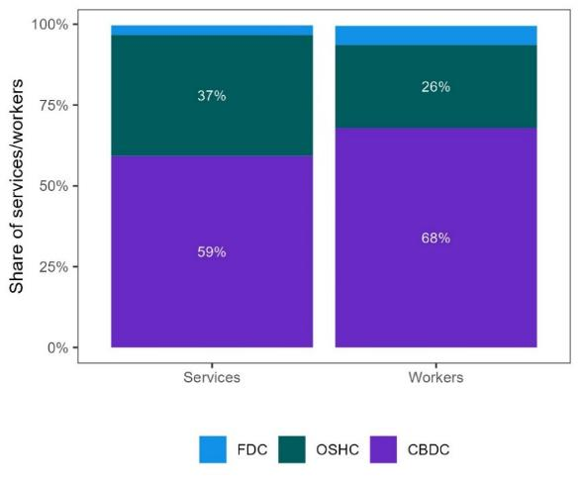

|  | **Services** | **Workers** |
| --- | --- | --- |
| Family Day Care | 3% | 6% |
| Out of School Hours Care | 37% | 26% |
| Centre Based Day Care | 59% | 68% |

Source: JSA analysis of Department of Education CCS and NWC (2021) data

Around one third of children aged 0-12 years utilise formal care, and this share has been increasing over the past few years, driven by an increase in CBDC usage by families with younger children (Figure 1.2). Rates of OSHC usage have remained relatively steady over the analysis period, with just over one fifth of children aged 5-9 years attending OSHC.

|  |
| --- |
| **CASE STUDY – Kindy Care Trial – Out of hours preschool care**  The South Australia Government has developed the Kindy Care trial in response to the Royal Commission into Early Childhood Education and Care. The trial, due to begin in July 2024 at 20 different preschools, provides extended hours for preschool aged children in the form of OSHC at the same government preschool venue. The trial enables continuation of Educators from the preschool program to OSHC programs. The trial will have a minimum of two educators, regardless of the number of children present, with one Diploma trained and one Certificate III trained educator. A full evaluation will be conducted alongside the trial and will continue following the trial, forming recommendations on the feasibility and continuity of the trial.  *Additional Consultation – Skills South Australia* |

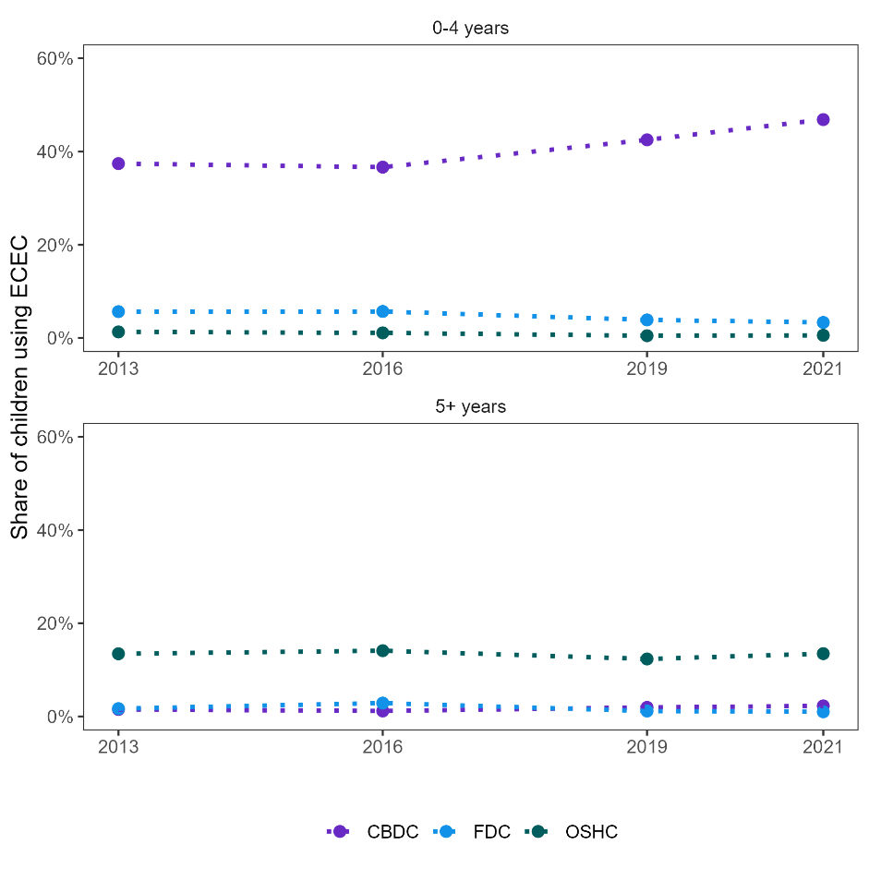Figure 1.2: Share of children using ECEC by age group and service type, 2013-2021[11]

|  |  |  |  |  |  |
| --- | --- | --- | --- | --- | --- |
|  |  | **2013** | **2016** | **2019** | **2021** |
| **0 to 4 years** | Centre Based Day Care | 37% | 37% | 43% | 47% |
|  | Family Day Care | 6% | 6% | 4% | 3% |
|  | Out of School Hours Care | 1% | 1% | 0% | 1% |
|  |  | **2013** | **2016** | **2019** | **2021** |
| **5 years and over** | Centre Based Day Care | 2% | 1% | 2% | 2% |
|  | Family Day Care | 2% | 3% | 1% | 1% |
|  | Out of School Hours Care | 13% | 14% | 12% | 13% |

Source: JSA analysis of Department of Education CCS and NWC (2021) data; ABS, Estimated Resident Population (ERP)

Around 67% of 3 year olds and 86% of 4 year olds were enrolled in a preschool program in 2021. This rate has increased around 9 percentage points for 3 year olds since 2016, but has not changed substantially for 4 year olds.[12]

ECEC usage varies across Australia. As illustrated in Figure 1.3 below, children in major cities are the most likely to be utilising formal ECEC, with around half of children aged 0-4 attending a CBDC service. Usage drops substantially in regional and remote areas, and disproportionately so for OSHC use among 5-12 year olds.

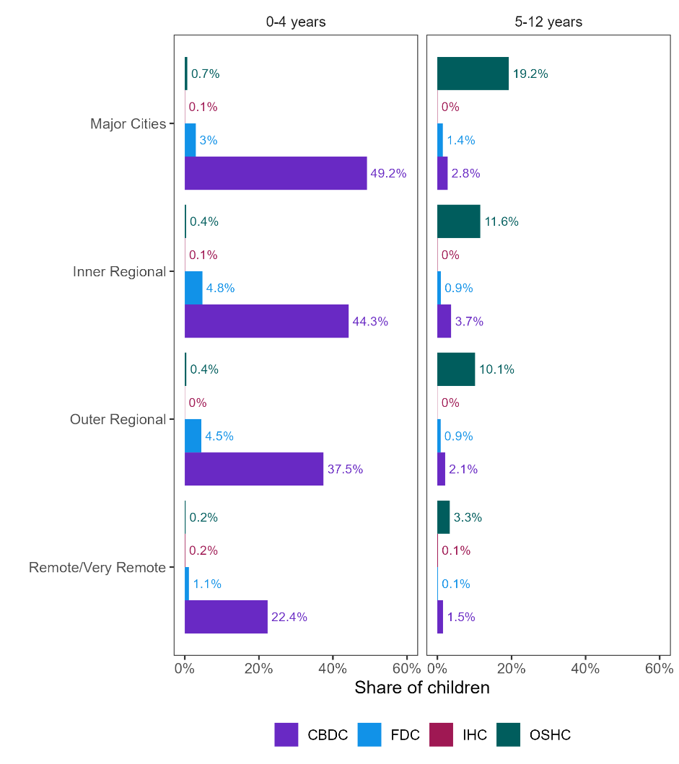Figure 1.3 Share of children using ECEC by age group, remoteness, and service type, 2021[13]

|  |  |  |  |  |  |
| --- | --- | --- | --- | --- | --- |
|  |  | **Major Cities** | **Inner Regional** | **Outer Regional** | **Remote and Very Remote** |
| **0 to 4 years** | Centre Based Day Care | 50.7% | 45.6% | 39% | 24.2% |
|  | Family Day Care | 3.1% | 4.9% | 4.6% | 1.2% |
|  | In Home Care | 0.1% | 0.1% | 0.0% | 0.2% |
|  | Out of School Hours Care | 0.7% | 0.4% | 0.4% | 0.2% |
|  |  | **Major Cities** | **Inner Regional** | **Outer Regional** | **Remote and Very Remote** |
| **5 years and over** | Centre Based Day Care | 2.8% | 3.8% | 2.1% | 1.6% |
|  | Family Day Care | 1.5% | 0.9% | 0.9% | 0.1% |
|  | In Home Care | 0.0% | 0.0% | 0.0% | 0.1% |
|  | Out of School Hours Care | 19.6% | 11.8% | 10.5% | 3.6% |

Source: JSA analysis of Department of Education CCS data; ABS ERP

Enrolments in preschool are consistently high for 4 year olds, ranging from 85% of children in major cities and remote/very remote regions to 88% for children in inner regional areas.[14] Variation in enrolment rates for children of other ages, particularly 3 year olds, is driven by state-specific schooling policies such as the expansion of 3 year old kindergarten and preschool starting age.

#### Service Delivery in a Diverse Range of Settings

There are modes of service delivery within the market that are also high quality services but remain outside the scope of the NQF, for example, occasional care services and some Aboriginal and Torres Strait Islander services. Such services are a critical part of delivering culturally responsive ECEC as noted in the Productivity Commission’s draft report:

Community controlled organisations, such as Aboriginal Community Controlled Health Organisations and Aboriginal Community Controlled Organisations (ACCOs) can help promote access to culturally safe ECEC that reflects the priorities of Aboriginal and Torres Strait Islander families and offer better outcomes for Aboriginal and Torres Strait Islander people.  
(PC, 2023c, p. 25)

Sitting outside the primary framework for funding and regulating ECEC services can provide some benefits, especially the flexibility to address localised needs and take account of local labour market conditions. However, it can also present challenges such as funding uncertainty, limited First Nations visibility, and representation in determining the primary regulatory and training settings.

##### ECEC Services for First Nations Children

First Nations children have a lower ECEC participation rate compared to non-Indigenous children. About 50% of 0-5 year old and 16% of 6-13 year old First Nations children attended ECEC in 2022, compared to 60% and 25% of all children in the respective age groups (ACCC, 2023b). The ACCC’s First Nations Roundtable reported that the NQF does not capture First Nations cultural norms and values, however it is noted that the guiding principles for the NQF include that Australia’s Aboriginal and Torres Strait Island cultures are valued and principles of equity, inclusion and diversity underlie the Law. Barriers also include difficulties using and accessing Childcare Subsidy system for a variety of reasons, affordability, and a lack of integrated delivery models to address increasing number of children presenting with complex needs. A lack of suitable workforce was raised as the major barrier to accessing high quality and culturally appropriate ECEC programs.

Evidence suggests the presence of First Nations educators and culturally inclusive ECEC are critical in promoting participation of First Nations children in ECEC services (Biddle, 2007). The need for greater cultural inclusivity in ECEC programs was made clear in the submission paper SNAICC – National Voice for our Children made to JSA:

Culture is a critical part of Aboriginal and Torres Strait Islander children’s development, identity and self-esteem and strengthens their overall health and wellbeing. For Aboriginal and Torres Strait Islander children and families to experience cultural safety, early years services must be grounded in cultural frameworks that reflect the protocols and practices of local families and communities. (Submission 8)

The Productivity Commission’s draft report identified a need for new pathways for First Nations people to obtain ECEC qualifications to increase the First Nations ECEC workforce, recognising the cultural knowledge and experience First Nations people already have (PC, 2023c). As noted by SNAICC – National Voice for Our Children:

An Aboriginal and Torres Strait Islander early years workforce with appropriate skills, capabilities and experience is an essential pillar for a thriving and sustainable community controlled early years sector. (Submission 8)

The Australian Government supports First Nations children's access to quality ECEC services through a number of targeted measures including the National Agreement on *Closing the Gap* and the *Early Childhood Care and Development Policy Partnership* between the First Nations representatives and governments. The Australian Government also invests in integrated services delivered through culturally safe programs including Connected Beginnings, Aboriginal and Torres Strait Islander community-controlled organisations (ACCOs) and Aboriginal Child and Family Centres (ACFCs). However, ACCOs often face funding challenges and uncertainty (PC, 2023c). Since mid-2021 the Australian Government has funded ACECQA to deliver the Community Child Care Fund Restricted (CCCFR) Quality and Safety Project which is a professional development training program focused on quality improvement and building capability. There are nearly 150 CCCFR services, formerly known as Australian Government Budget Based Funded (BBF), most of which operate in regional and remote Aboriginal and Torres Strait Islander communities across all states and territories.

**Other Specialised and Family-Responsive Services**

|  |
| --- |
| **CASE STUDY – The Boori Milumba program: improving life trajectories for First Nations children**  In February 2024, a new Aboriginal-led ECEC program co-developed by SNAICC – National Voice for our Children along with local communities and Aboriginal and Torres Strait Islander leaders was launched at Cullunghutti Aboriginal Child and Family Centre in Nowra, NSW. The Boori Milumba program aligns with Closing the Gap Targets 3 and 4 and is tailored to meet the individual and cultural needs of First Nations children who are experiencing family stress and hardship. Children aged from birth to three receive five hours of education and care five days a week at no cost. Boori Milumba seeks positive outcomes for both First Nations children and early childhood staff. Boori Milumba is funded by the Australian Government and philanthropy and is being undertaken as a collaborative partnership between SNAICC – National Voice for our Children, Cullunghutti Aboriginal Child and Family Centre, Parkville Institute, and Social Ventures Australia.  Submission 8 – SNAICC National Voice for our Children  Source: SNAICC National Voice for our Children, (2024), *Media Release: New program supports Aboriginal children to thrive in Nowra,* <https://www.snaicc.org.au/wp-content/uploads/2024/02/BOORI-MILUMBA-MEDIA-RELEASE.pdf>. |

An important dimension of providing quality ECEC, and one with significant workforce implications, is the need to provide services that respond to the particular needs of children requiring additional specialised care and for children from specific communities, especially where they are at greater risk of experiencing educational disadvantage. One in twenty children (5%) attending ECEC programs have disability or other specific needs and ACCC’s recent survey revealed that families of the children with disability and other complex needs are facing challenges finding a place for their child due to the lack of qualified staff with specialist skills (PC, 2023c; ACCC 2023a). As noted by a peak workforce development body:

Providing access to ECEC services for children with complex or special needs, including children with disability, Aboriginal and Torres Strait Islanders, children from disadvantaged or trauma backgrounds such as refugees will need to be considered in future delivery of ECEC services. (Submission 51)

The Australian Government provides funding and support through the Inclusion Support Program (ISP) to support CCS-approved providers to enable children with additional needs the opportunity to learn, develop and achieve positive learning outcomes. The Australian Government committed $133 million in 2021 and more than 17,600 children were supported through the ISP in 2021-22 (PC, 2023c). The Productivity Commission’s draft recommendations make significant suggestions about the ISP as well as outcomes from the NDIS review and the Foundational Supports Strategy that would impact this delivery for children with additional needs in the early years.

Approximately one in five children (19%) attending ECEC come from a non-English speaking background. Children from non-English speaking background tend to have a greater share of enrolments in FDC (34%) compared to other delivery settings (18%) (PC, 2023c). ACCC indicated that this could reflect a preference of the families to use educators who speak the same first language (ACCC, 2023a).

### Regulatory Overview

Operation of the ECEC sector is governed by regulatory settings and administration at all levels of government, from funding and quality standards at the national level down to the size and location of services at the local level. This section focuses on the NQF, which directly impacts the ECEC workforce by establishing educator to child ratios and qualification requirements, as well as determining the staffing mix within services.

|  |
| --- |
| **CASE STUDY – Aotearoa New Zealand: Culturally Engaged Curriculum (Te Whàriki)**  First published in 1996, Te Whāriki, was one of the first national curriculums for early childhood education and is highly regarded in Aotearoa New Zealand and internationally. The curriculum, still in use today, emphasises a society that recognises Māori as tangata whenua (“people of the land”) and ensures an obligation to protect Māori language and culture and for Māori to enjoy educational success. Te Whāriki is an inclusive curriculum that encompasses gender, ethnicity, different abilities and learning needs, family structure and values, socio-economic status and religion. It places importance on the development of knowledge, skills, attitudes and dispositions that support lifelong learning. In 2017, Te Whāriki was revised for the first time to incorporate societal changes, shifts in policy and research about curriculum, assessment, pedagogy and practice.    Source: New Zealand Ministry of Education, (2017), *Te Whāriki,* New Zealand Government, <https://www.education.govt.nz/assets/Documents/Early-Childhood/ELS-Te-Whariki-Early-Childhood-Curriculum-ENG-Web.pdf>.  The whāriki on the cover were developed by expert kairaranga (weaver) Mari Te Hei-Ropata (Ngāpuhi, Ngāti Raukawa ki te Tonga, Te Āti Awa me Ngāti Toa Rangatira) and graphic designer Te Iwihoko Rangihirawea (Ngāti Rangi, Ngāti Pikiahuwaewae). The cover represents part of the underside of a whāriki or woven mat. The green symbolises new life, growth and potential and references harakeke and pandanus, which are used throughout Te Moana-nui-a-Kiwa as materials for weaving. When the document is opened at the place where the two parts of the flip book meet, it can be seen that the whāriki is unfinished, with loose strands still to be woven. This acknowledges the child’s potential and their ongoing educational journey. |

#### Ratio Requirements

Educator to child ratios are set to ensure that there are sufficient educators working directly with children to maintain safety and quality of education and care outcomes. The ratios vary by service type, child and age, with some jurisdictions setting requirements above the national minimum and some services choosing to operate above ratio to the extent possible by available funding and workforce.

For CBDC services, national ratios range from 1:4 for children aged from birth to 24 months in all states and territories, to 1:15 for children over preschool age (Figure 1.4 below).

Figure 1.4: Educator to child ratios for CBDC[15]

"In all states and territories there must be at least 1 educator to every 4 children aged from birth to 24 months.
For children aged 24 to 36 months there must be at least 1 educator to every 4 children in Victoria,  and at least 1 educator to every 5 children in all other states and territories.
For children aged 36 months up to and including preschool age, there must be at least 1 educator for every 10 children in New South Wales, Tasmania and Western Australia. For all other states and territories, it is 1 educator to every 11 children.
For children aged over preschool age, there must be at least 1 educator for every 10 children in Western Australia, 1 for every 11 children in the Australian Capital Territory, and 1 for every 15 children in all other states and territories."

Source: Adapted from ACECQA, [Educator to child ratios](https://www.acecqa.gov.au/nqf/educator-to-child-ratios).

These ratios are applied across the whole service for centre-based care, counting only educators who are working directly with children. This provides services with the ability to manage hard-to-fill/recruit locations (such as rural and remote areas), allowing them to manage ratios regardless of group or room arrangements. In addition to the minimum ratio requirements, the NQF also requires the adequate supervision of children to be maintained at all times. Despite these requirements, there have been some concerns about safety and quality due to inadequate supervision, as well as insufficient time for educators to perform key additional tasks such as planning and clerical duties (Zillman,2024). As noted by a peak educational body in their submission to JSA:

The burden of regulatory requirements, including record-keeping, on staff and services is reported by the sector to be impacting on time available to provide quality care and discouraging career progression. (Submission 51)

#### ****Qualification Requirements****

Educators employed in ECEC are required to hold certain qualifications under the NQF, typically, either, at a minimum a Certificate III or Diploma level qualification in ECEC, or an early childhood teaching qualification.

CBDC services must meet the following requirements:

* At least 50% of educators must be Diploma-level qualified or higher.
* All other educators must be Certificate III-level qualified.
* An educator may be counted in CBDC ratios if they are actively working toward a qualification at that level.

Different qualification requirements exist for educators in OSHC services in each jurisdiction as there are no national qualification requirements for educators working with school age children in OSHC services. For FDC services, all educators must have a Certificate III level or above qualification, and the coordinator is required to hold a Diploma-level qualification.[16] In addition, CBDC services must engage or “have access to” at least one *Early Childhood Teacher* (ECT). The number of hours an ECT must be available (and if additional teachers are required) depends on the number of children in attendance at any one time.

#### Regulatory Waivers

Temporary waivers are an exemption from a requirement that an approved education and care service comply with a prescribed element(s) of the NQS or regulation of the National Regulations. While a temporary waiver is in force, the approved service is not required to comply with the element(s) or regulation(s) specified in the waiver (Australian Children’s Education & Care Authority [ACECQA], n.d.). Approved providers may therefore apply to a regulatory authority for a waiver. Waivers play an important role in helping providers maintain their level of service to families while dealing with special circumstances or unexpected events. There are transitional provisions in place for *Early Childhood Teachers* in most states and territories which result in a waiver not being required if certain conditions are met. If these transitional arrangements weren’t in place ECT waivers would be higher, as has been the case in QLD when they were ceased.

The prevalence and scale of waivers differs across service type (Figure 1.5 below), with CBDC services representing around 60% of services but 90% of all waivers. There has been an uptick in the number and prevalence of waivers from around 2019 for both CBDC and OSHC services, with the number of waivers per service approximately doubling between 2019 and 2023.

Figure 1.5: Total number of waivers and waivers per service, 2015-2023

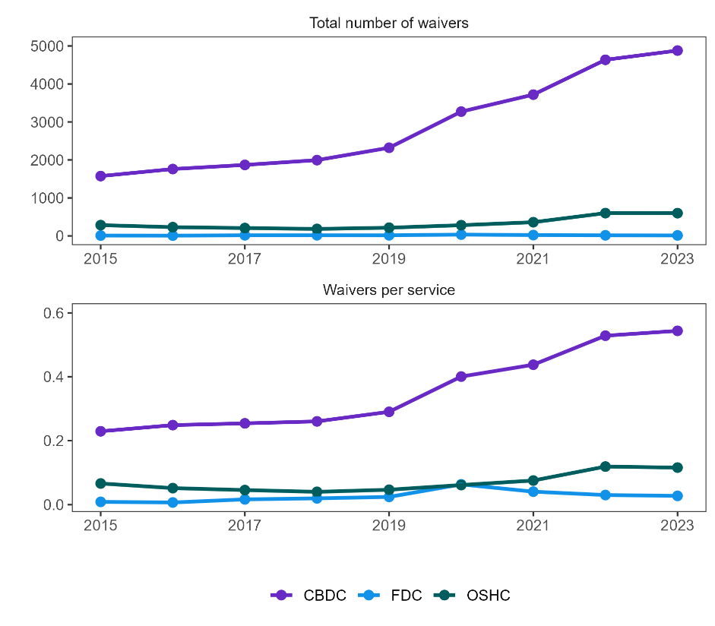

|  |  |  |  |  |  |  |  |  |  |  |
| --- | --- | --- | --- | --- | --- | --- | --- | --- | --- | --- |
|  |  | **2015** | **2016** | **2017** | **2018** | **2019** | **2020** | **2021** | **2022** | **2023** |
| **Total number of waivers** | Centre Based Day Care | 1575 | 1760 | 1869 | 1995 | 2320 | 3272 | 3719 | 4636 | 4879 |
|  | Family Day Care | 10 | 8 | 17 | 17 | 16 | 35 | 22 | 16 | 13 |
|  | Out of School Hours Care | 284 | 230 | 207 | 184 | 216 | 282 | 361 | 600 | 599 |
|  |  | **2015** | **2016** | **2017** | **2018** | **2019** | **2020** | **2021** | **2022** | **2023** |
| **Waivers per service** | Centre Based Day Care | 0.23 | 0.25 | 0.25 | 0.26 | 0.29 | 0.40 | 0.44 | 0.53 | 0.54 |
|  | Family Day Care | 0.01 | 0.01 | 0.02 | 0.02 | 0.02 | 0.06 | 0.04 | 0.03 | 0.03 |
|  | Out of School Hours Care | 0.07 | 0.05 | 0.05 | 0.04 | 0.05 | 0.06 | 0.08 | 0.12 | 0.12 |

Source: JSA analysis of ACECQA, National Registers and Waivers data

The composition of different waiver types, where regulations that apply to a similar service are grouped together, also varies across service type. Figure 1.6 below presents the total number of waivers by service and waiver type for CBDC and OSHC services. There has been a marked increase in the number of waivers in CBDC for ECT requirements since 2019, suggesting pressing workforce shortages exist for ECTs. There has also been a small increase in waivers for qualification requirements for CBDCs in 2021 and 2022. Waivers in OSHC services for qualification requirements, as well as educator to child ratios, have increased since 2020.

Figure 1.6: Waivers per service by waiver and service type, 2015-2023

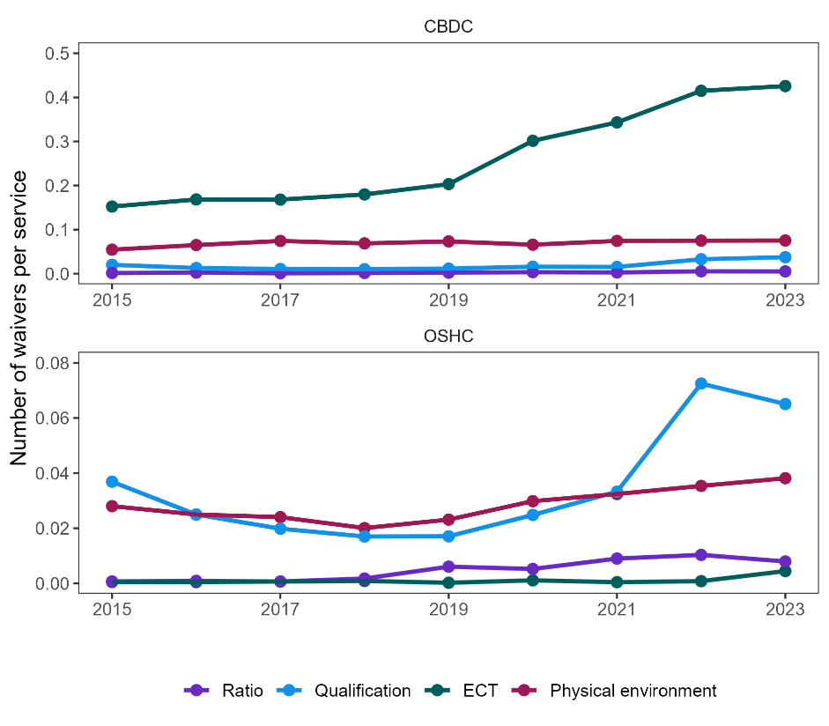

|  |  |  |  |  |  |  |  |  |  |  |
| --- | --- | --- | --- | --- | --- | --- | --- | --- | --- | --- |
|  |  | **2015** | **2016** | **2017** | **2018** | **2019** | **2020** | **2021** | **2022** | **2023** |
| **Centre Based Day Care** | Ratio | 0.0015 | 0.0024 | 0.001 | 0.0016 | 0.0023 | 0.0034 | 0.0027 | 0.0054 | 0.0051 |
|  | Qualification | 0.0201 | 0.0129 | 0.0106 | 0.0102 | 0.0115 | 0.0158 | 0.0153 | 0.0327 | 0.0374 |
|  | ECT | 0.1523 | 0.1683 | 0.168 | 0.1798 | 0.2032 | 0.3015 | 0.3432 | 0.4149 | 0.4257 |
|  | Physical environment | 0.0545 | 0.0649 | 0.0743 | 0.0687 | 0.0732 | 0.0658 | 0.0744 | 0.0749 | 0.0752 |
|  |  | **2015** | **2016** | **2017** | **2018** | **2019** | **2020** | **2021** | **2022** | **2023** |
| **Out of School Hours Care** | Ratio | 0.0007 | 0.0009 | 0.0007 | 0.0017 | 0.0061 | 0.0052 | 0.009 | 0.0103 | 0.0079 |
|  | Qualification | 0.0369 | 0.025 | 0.0198 | 0.017 | 0.0171 | 0.0248 | 0.0332 | 0.0725 | 0.0651 |
|  | ECT | 0.0005 | 0.0004 | 0.0007 | 0.0009 | 0.0002 | 0.0011 | 0.0004 | 0.0008 | 0.0045 |
|  | Physical environment | 0.028 | 0.025 | 0.024 | 0.0201 | 0.0231 | 0.0298 | 0.0324 | 0.0353 | 0.0381 |

Source: JSA analysis of ACECQA, National Registers and Waivers data.

Focusing specifically on waivers for educator to child ratios, the primary driver of educator numbers and a key indicator of wide-ranging workforce shortages, Figure 1.7 illustrates the number of waivers as well as the share of services with a ratio waiver.[17] Despite a slight increase in ratio waivers over the past several years, very few services overall receive a waiver for educator to child ratios. On average, ratio waivers apply to less than 1% of services, or around 7,200 places (capacity) across CBDC and OSHC.

Figure 1.7: Ratio waivers for educator to child ratios by service type, 2017-2023

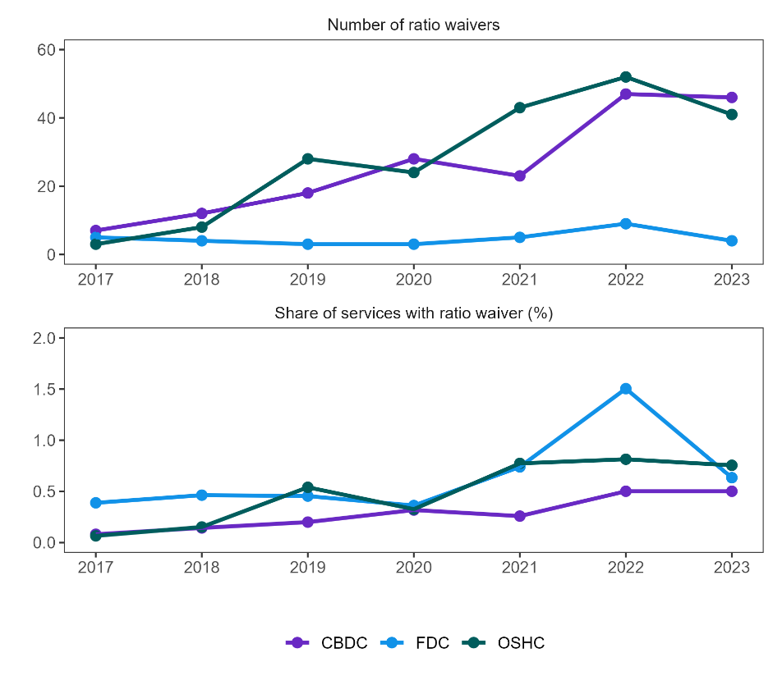

|  |  |  |  |  |  |  |  |  |
| --- | --- | --- | --- | --- | --- | --- | --- | --- |
|  |  | **2017** | **2018** | **2019** | **2020** | **2021** | **2022** | **2023** |
| **Number of ratio waivers** | Centre Based Day Care | 7 | 12 | 18 | 28 | 23 | 47 | 46 |
|  | Family Day Care | 5 | 4 | 3 | 3 | 5 | 9 | 4 |
|  | Out of School Hours Care | 3 | 8 | 28 | 24 | 43 | 52 | 41 |
|  |  | **2017** | **2018** | **2019** | **2020** | **2021** | **2022** | **2023** |
| **Share of services with ratio waiver (%)** | Centre Based Day Care | 0.08 | 0.14 | 0.20 | 0.32 | 0.26 | 0.50 | 0.50 |
|  | Family Day Care | 0.39 | 0.46 | 0.45 | 0.36 | 0.74 | 1.50 | 0.63 |
|  | Out of School Hours Care | 0.07 | 0.15 | 0.54 | 0.33 | 0.77 | 0.81 | 0.76 |

Source: JSA analysis of ACECQA, National Registers and Waivers data.

## Provision of ECEC

Core outcomes of the ECEC sector—including ensuring families have access to affordable and quality care that promotes child development—are the result of a complex interaction between family preferences, regulatory settings, and the behaviour of services and providers. The following section examines the supply of ECEC, examining key characteristics across service type and the interaction with high-level workforce indicators.

### Growth in the Sector

Driven by shifting demand and core regulatory and funding changes, there has been strong growth in CBDC and OSHC over the past decade resulting in around 4,000 additional services in 2023, a growth of 40% relative to 2013 (Figure 1.8). In contrast, the FDC sector has seen rapid decline since around 2015 or 2016, when government increased regulatory compliance measures in the sector.

Figure 1.8: Number of services by type, 2013-2023

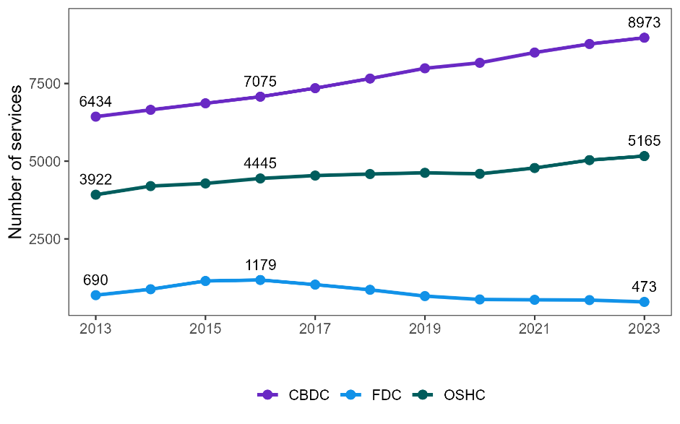

|  |  |  |  |  |  |  |  |  |  |  |  |
| --- | --- | --- | --- | --- | --- | --- | --- | --- | --- | --- | --- |
|  | **2013** | **2014** | **2015** | **2016** | **2017** | **2018** | **2019** | **2020** | **2021** | **2022** | **2023** |
| **Centre based day care** | 6434 | 6653 | 6863 | 7075 | 7350 | 7659 | 7989 | 8166 | 8496 | 8771 | 8973 |
| **Family day care** | 690 | 881 | 1146 | 1179 | 1029 | 863 | 660 | 552 | 541 | 532 | 473 |
| **Out of school hours care** | 3922 | 4199 | 4285 | 4445 | 4538 | 4587 | 4627 | 4594 | 4782 | 5036 | 5165 |

Source: ACECQA, National Registers.

This strong growth in services has been almost entirely driven by Private For-Profit providers. All service types experienced an increase in the share of for-profit services between 2013 and 2023 (Figure 1.9 below).[18] However, the number services from other management types has remained largely constant over the period.

Figure 1.9: For-profit share of services by type, 2013 and 2023[19]

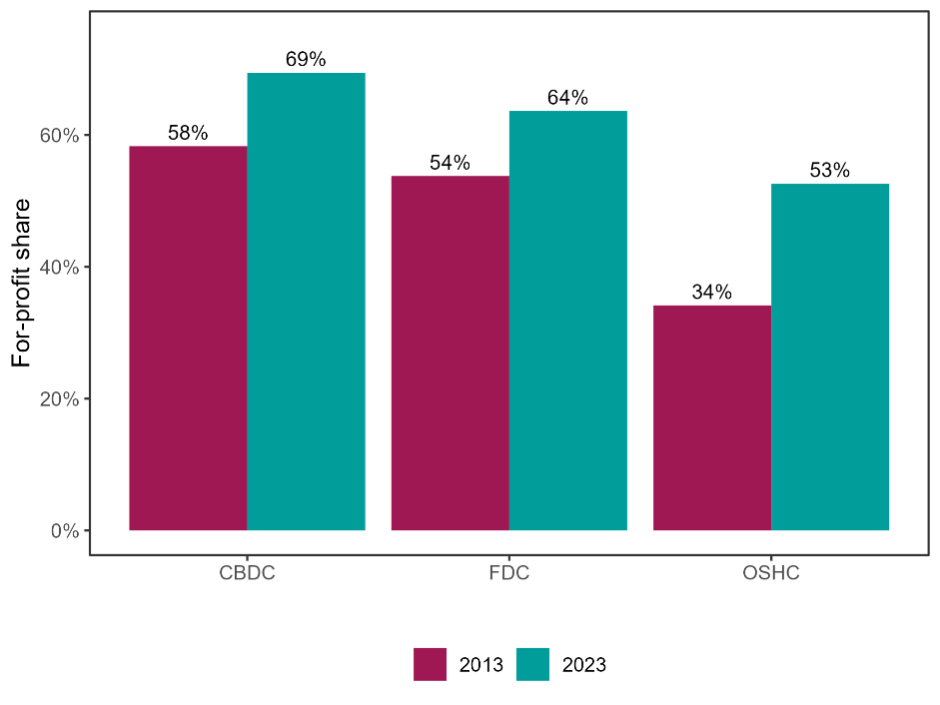

|  |  |  |  |
| --- | --- | --- | --- |
|  | **Centre based day care** | **Family day care** | **Out of school hours care** |
| **2013** | 58% | 54% | 34% |
| **2023** | 69% | 64% | 53% |

Source: ACECQA, National Registers.

For CBDCs, this increase is largely concentrated around major cities, with the highest growth levels and largest number of services, analysis of ACECQA, National registers suggest. Victoria also experienced the largest increases in the number of services over this time. However, the increasing share of for-profit services is not evenly distributed across regions in Australia (Figure 1.10). Areas with the largest increase in the share of for-profit services tend to be the inner and outer regional areas bounding major cities (for example, north-west of Melbourne).

Figure 1.10: Change in for-profit share of services and service growth, SA4 2013-2023

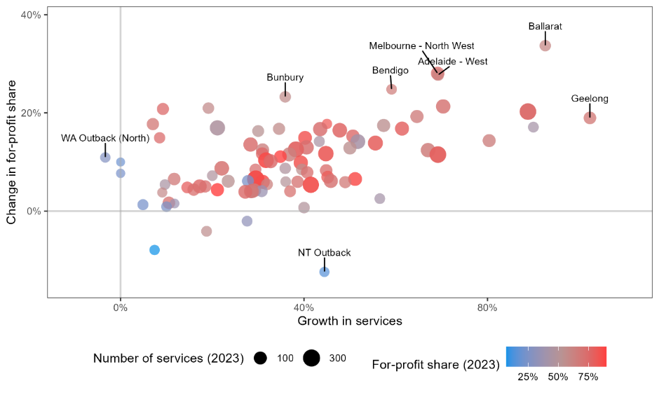

Source: JSA analysis of ACECQA, National Registers.

### Drivers of Availability

The following section examines the relationship between key regional characteristics and the provision of ECEC, including both the number of services as well as their approved places. It considers a “market” for ECEC services at the SA3 level, balancing the willingness and ability of families to travel to attend care.

Figure 1.11 presents key results from the analysis of relationships between the supply of ECEC and key characteristics. Each figure illustrates the supply of ECEC (the number of services per child or places per child) in each SA3 against that region’s characteristic (average female employee income, or the female labour force participation rate). Point size is scaled based on the child population (0-13 years). The line in each figure represents the line of best fit around each point.

The accessibility of care, both services and licensed places, is strongly related to child population. Importantly, ECEC availability has a positive relationship to both female income and female labour force participation for CBDC and OSHC. Further, average fees are also strongly related to income for CBDC (correlation = 0.69, not pictured). Together, this indicates that the provision of care reflects characteristics that drive the demand for care, resulting in an unequal distribution of care accessibility for families across Australia.

Figure 1.11: Number of services and maximum total places, by SA3, 2021

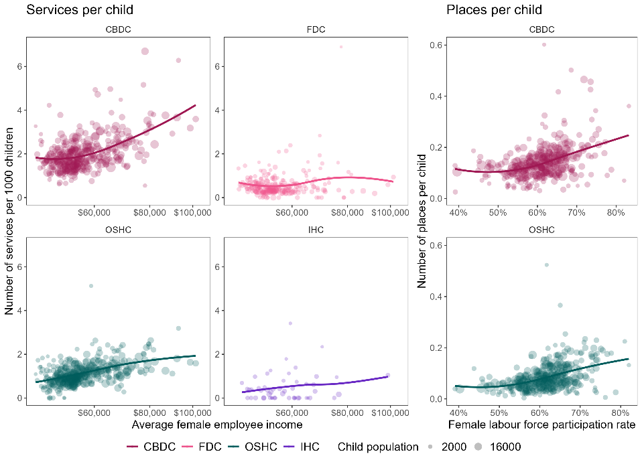

Source: JSA analysis of Department of Education, CCS data; ABS, Census of Population and Housing, ERP, Personal Income in Australia, 2021

### Organisations Delivering ECEC

Services deliver ECEC in a competitive environment driven by the needs and preferences of families. This operating environment is characterised by strong regulation and oversight governing staffing arrangements and enrolment numbers.

Individual services, or centres,[20] are managed by approved providers of varying management types, including private for-profit, private not-for-profit, community, and government schools. This section explores the characteristics that delineate providers of ECEC, including management type and size, and the implications for the workforce arising from differences across organisation type.

Private for-profit providers are the most prevalent of the sector, representing 52% of all services and 69% of CBDC services (Figure 1.12). Almost one quarter of CBDCs, and one third of OSHCs, are run by either private not-for-profit or community providers. As expected, school providers play a larger role in the provision of OSHC relative to CBDC.

Figure 1.12: Service provider management type by service type, 2023[21]

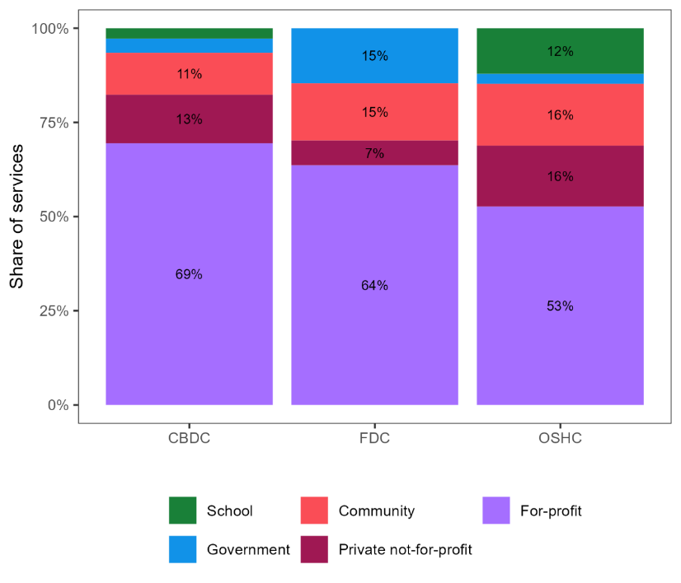

|  |  |  |  |
| --- | --- | --- | --- |
|  | **Centre based day care** | **Family day care** | **Out of school hours care** |
| **School** | 3% | n/a | 12% |
| **Government** | 4% | 15% | 3% |
| **Community** | 11% | 15% | 16% |
| **Private not-for-profit** | 13% | 7% | 16% |
| **For-profit** | 69% | 64% | 53% |

Source: JSA analysis of ACECQA, National Registers

For children enrolled in preschool programs, around 40% are delivered in a school (14%) or stand-alone (27%) setting (ABS, 2021, *Children enrolled in a preschool program*). Of children enrolled in a single provider type, almost 70% are in non-government CBDCs, indicating the majority of preschool programs are delivered in a CBDC setting. However, this differs by jurisdiction, with QLD, NSW, ACT, and VIC having higher shares of preschool delivered in a CBDC setting (Figure 1.13).

Figure 1.13: Preschool enrolments in non-government CBDC, 2021[22]



|  |  |  |  |  |  |  |  |  |
| --- | --- | --- | --- | --- | --- | --- | --- | --- |
|  | **NSW** | **VIC** | **QLD** | **SA** | **WA** | **TAS** | **NT** | **ACT** |
| **Share of enrolments in non-government centre based day care (%)** | 72.2% | 65.0% | 81.5% | 56.1% | 42.1% | 46.5% | 45.3% | 66.5% |
| **Number of enrolments in non-government centre based day care** | 121,674 | 85,470 | 84,392 | 15,724 | 19,754 | 4,684 | 1,958 | 6,276 |

Source: ABS, Preschool Education, 2021

#### Competition and Ownership Concentration

The market for ECEC is quite concentrated, with around one fifth of CBDC services and half of OSHC services operated by a large provider (with 25 or more services). In general, increased centralisation may impact key outcomes, such as the affordability and accessibility of care for families, as well as the setting of wages and conditions for educators and other staff.

The top five providers, by number of services of each type, accounted for over 15% of children in care across both CBDC (18% of children and 15% of services) and OSHC (22% of children and 26% of services).[23] Across both service types, multi-service providers account for more than half of services (Figure 1.14).

Figure 1.14: Cumulative share of services by provider size rank, 2021

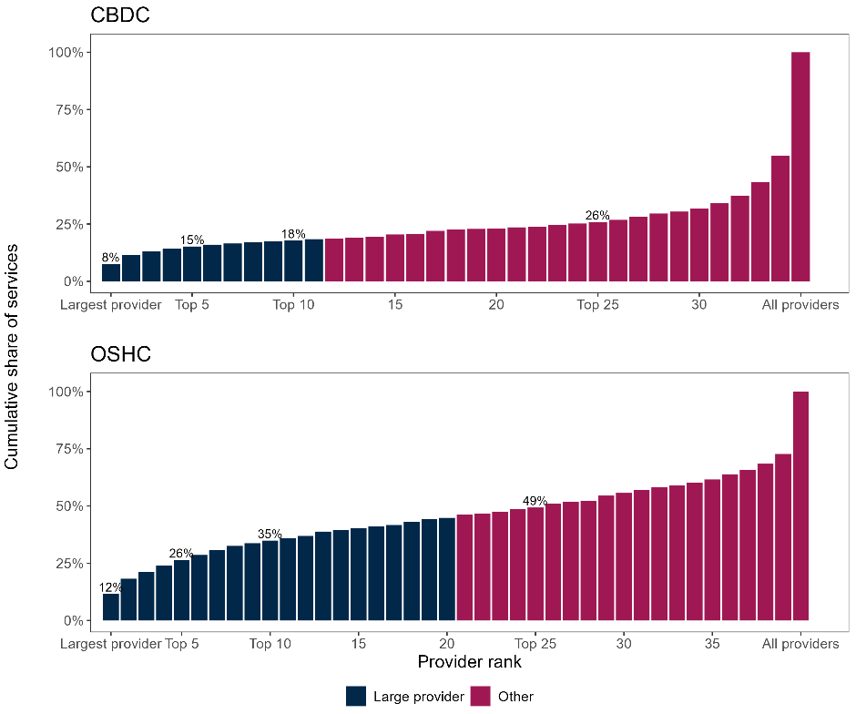

Source: JSA analysis of Department of Education NWC (2021) and CCS data; ACECQA, National Registers

Figure 1.15 below illustrates the distribution of services by whether they belong to a ‘Single service’ provider, a ‘Multi-service (small)’ provider (managing fewer than 25 services), or a ‘Multi-service (large)’ provider (managing 25 or more services). There are substantial differences between CBDC and OSHC, and across management type, in the split of services by provider size. For CBDCs, almost three quarters of private not-for-profit services belong to a large provider, substantially more than other management types.

Figure 1.15: Share of all services by provider type and size, 2021

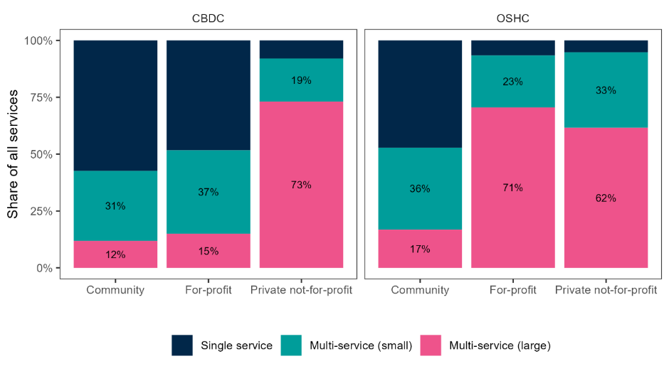

|  |  |  |  |  |
| --- | --- | --- | --- | --- |
|  |  | **Single Service** | **Multi-service (small)** | **Multi-service (large)** |
| **Centre based day care** | Community | 57% | 31% | 12% |
|  | For-profit | 48% | 37% | 15% |
|  | Private not-for-profit | 8% | 19% | 73% |
|  |  | **Single Service** | **Multi-service (small)** | **Multi-service (large)** |
| **Out of school hours care** | Community | 47% | 36% | 17% |
|  | For-profit | 7% | 23% | 71% |
|  | Private not-for-profit | 5% | 33% | 62% |

Source: JSA analysis of Department of Education NWC (2021) and CCS data; ACECQA, National Registers

### Capacity Constraints and Unmet Demand

ECEC is only accessible for families if there are sufficient places available in a service that meets their needs, including location, perceived quality, and affordability (ACCC, 2023a).[24] This section examines the extent to which there is additional capacity in the sector, the results of which indicate that growth will be driven largely by the entry of new services due to constraints on expansion within current services. An important consequence of this observation is that there is likely a degree of unmet demand already present across the system (Weiss, 2024). That is, families require additional hours/days in their current service that are not available due to capacity or staffing constraints, or those using other forms of care (including not working) would enrol in formal care if it were available.

The matching of child to service is a complex and dynamic process. Families may consider several services that meet their requirements and enrol in wait lists possibly years before intending on enrolling. Services enrol children across different age groups and sessions throughout the week ensuring they are compliant with regulation, set fees to (at least) cover staffing and other costs, and maintain a high quality of education and care.

The enrolment process therefore involves interactions between the number of hours/days required by families (that they are able to afford), the number of places and sessions available at each service throughout the week, and the ability of each service to meet staffing requirements. The total number of children a service can care for at any one time, known as its “approved places”, is determined largely by the physical size of the centre. Services may choose to offer fewer places due to room sizes and differing staffing requirements across age groups, or to maintain a particular standard of care for children.

Figure 1.16 below presents the number of services and their vacancy status, measured by whether the service typically cares for fewer children than they have licensed places, by service and management type. Across the sector, around half of CBDCs and 70% of OSHCs have some additional physical capacity. For-profit CBDCs are the least likely to have additional capacity, although they represent the majority of services with capacity overall.

Figure 1.16: Number of services by whether at capacity, by management and service type, 2021

|  |  |  |  |  |
| --- | --- | --- | --- | --- |
|  |  | **At Capacity** | **Vacancy** | **Total** |
| **Centre based day care (number of services)** | For-profit | 2,914 | 2,290 | 5,204 |
|  | Private not-for-profit | 186 | 908 | 1,094 |
|  | Community | 457 | 476 | 933 |
|  |  | **At Capacity** | **Vacancy** | **Total** |
| **Out of school hours care (number of services)** | For-profit | 405 | 1,522 | 1,927 |
|  | Private not-for-profit | 152 | 538 | 690 |
|  | Community | 282 | 525 | 807 |
|  |  | **At Capacity** | **Vacancy** | |
| **Centre based day care (proportion)** | For-profit | 56% | 44% |  |
|  | Private not-for-profit | 17% | 83% |  |
|  | Community | 49% | 51% |  |
|  |  | **At Capacity** | **Vacancy** | |
| **Out of school hours care (proportion)** | For-profit | 21% | 79% |  |
|  | Private not-for-profit | 22% | 78% |  |
|  | Community | 35% | 65% |  |

Source: JSA analysis of Department of Education CCS and NWC (2021) data; ACECQA, National Registers

Figure 1.17 further breaks down the occupancy of services with a vacancy, illustrating the number of services by their rate of occupancy (the number of children typically cared for as a proportion of approved places). Most CBDC services do not have a large amount of additional capacity. Among those services with a vacancy, three quarters (76%) of licensed places are typically in use.

Figure 1.17: Typical occupancy rate of approved places by service type,[25] 2021

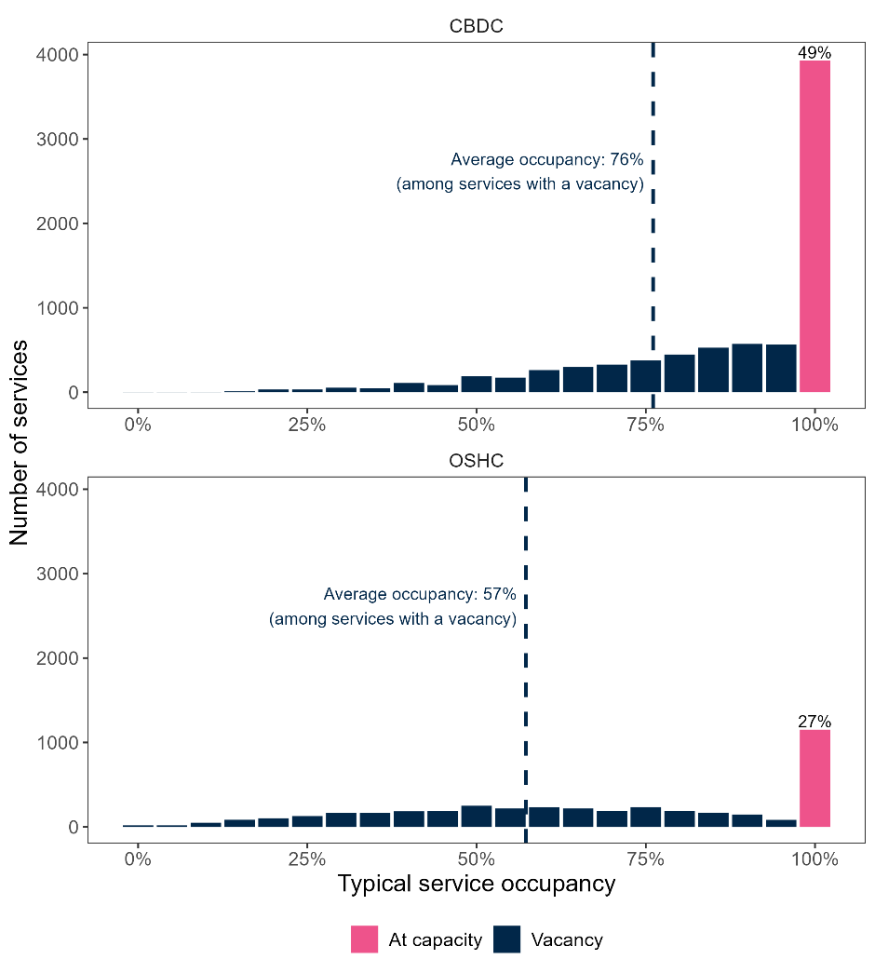

Source: JSA analysis of Department of Education NWC (2021) and CCS; ACECQA, National Registers

Further, most services (around three quarters of CBDCs and two thirds of OSHCs) are fully utilising their approved places—as indicated by the ratio of the service’s maximum number of children cared for at any one time relative to their approved places.[26] That is, although half of CBDCs typically have additional capacity, just one quarter could theoretically accommodate more children based on their physical approved places.

This suggests that the sector is relatively efficient in its use of approved places. Over half of CBDC services, and almost half of OSHCs, that typically have a vacancy will fill those remaining places when at their maximum, allowing for day-to-day fluctuations in demand. These services likely have access to educators and other staff to care for these children, although potentially not on an ongoing basis or all at the same time.[27]

However, the availability of services with additional capacity is not distributed evenly across Australia. Figure 1.18 below illustrates the share of services within each remoteness area with a vacancy, across both the typical and maximum levels of occupancy. Among CBDCs, services in more remote regions are more likely to have additional capacity despite having fewer services and places per child.

Figure 1.18: Share of services with additional capacity by remoteness, 2021

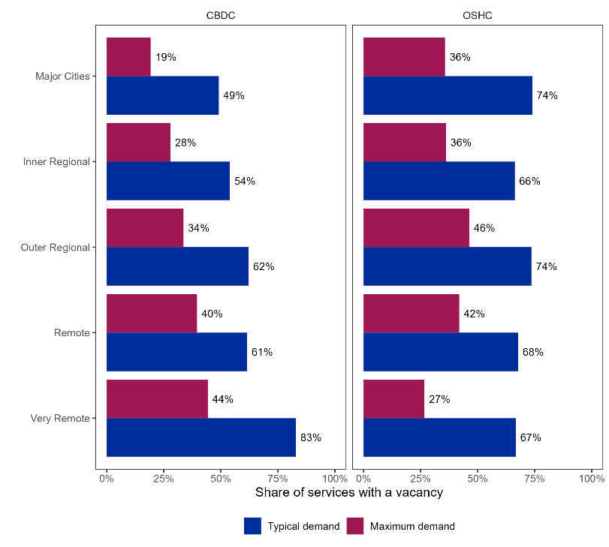

|  |  |  |  |
| --- | --- | --- | --- |
|  |  | **Typical demand** | **Maximum demand** |
| **Centre based day care** | Major cities | 49% | 19% |
|  | Inner regional | 54% | 28% |
|  | Outer regional | 62% | 34% |
|  | Remote | 61% | 40% |
|  | Very remote | 83% | 44% |
|  |  | **Typical demand** | **Maximum demand** |
| **Out of school hours care** | Major cities | 74% | 36% |
|  | Inner regional | 66% | 36% |
|  | Outer regional | 74% | 46% |
|  | Remote | 68% | 42% |
|  | Very remote | 67% | 27% |

Source: JSA analysis of Department of Education NWC (2021) and CCS; ACECQA, National Registers

With just 22% of CBDCs and 36% of OHSCs accommodating a maximum level of demand less than approved places, the sector is most likely constrained by the number and size of existing services. Future growth and expansion will be driven by the opening of new services centred around major cities and inner regional areas. This will have implications for the required future staffing mix.

## Summary

Chapter 1 introduces the systems and structures making up the ECEC sector, including differences in the type and provision of services. ECEC services operate within a strong regulatory framework, which encompasses the number and qualifications of educators as well as the number of children in each service. The sector is responsive; the number and mix of services differs substantially across the country, reflecting the differing characteristics and needs of families and children. Service types reflect specific community and family needs, especially for First Nations children. However, greater access to quality and culturally accessible ECEC programs is needed to increase First Nations participation, noting current government investment in integrated services delivered through culturally safe programs including Connected Beginnings, Aboriginal and Torres Strait Islander community-controlled organisations (ACCOs) and Aboriginal Child and Family Centres (ACFCs). However, ACCOs often face funding challenges and uncertainty (PC, 2023c).

Analysis demonstrates several key features in the provision of ECEC, namely that ownership of CBDC and OSHC, the largest components, is quite centralised, dominated by private for-profit organisations, and concentrated in Australia’s major cities. Over the past decade, expansion of the sector has been driven almost entirely by private for-profit services, and this trend is likely to continue. The following chapter explores differences in key workforce characteristics across service provider type, including private for-profit services.

Finally, the chapter examines the sector’s ability to accommodate additional demand. Regulatory waiver data indicates that very few services have a waiver for the number of educators. However, there has been a recent increase in waivers for ECTs and qualification requirements, suggesting a potential workforce limitation to future growth. The approved places of a service is a limiting factor to enrolling more children. Although around three fifths of services have additional capacity based on typical enrolments, more than half of these will fill remaining capacity if required. Hence, only around 27% of services reported additional physical capacity at their maximum level of demand.

Looking ahead, the entry of new services will be required meet ongoing increases in demand for education and care, with limited scope for existing services to accommodate more children. It is likely that this many of these new services will be privately operated for-profits located around major cities.

# Chapter 2: The ECEC Workforce

The current ECEC workforce is at the core of this Study and this chapter aims to better understand who they are – the work they do, their characteristics and qualifications, the previous experience they bring to their work and their conditions of employment.

The chapter uses data classified by ANZSCO and Australian and New Zealand Standard Industrial Classification (ANZSIC) to examine the size and characteristics of the ECEC sector, and other ABS and JSA data to explore hiring trends, occupational flows and the role of skilled migration. The chapter also identifies particular trends within the workforce, especially with regard to First Nations educators and migrant educators, and we examine how demand for the ECEC workforce varies across Australia.

## Defining the ECEC Workforce

Our study broadly defines the ECEC workforce as all staff who operate in any ECEC service regulated by the NQF. The 2021 NWC reported approximately 217,000 staff within the scope of the NWC. Table 2.1 provides the breakdown by service type and jurisdiction.

Table 2.1 Size of ECEC workforce, 2021 ECEC National Workforce Census

|  |  |  |  |  |  |  |  |
| --- | --- | --- | --- | --- | --- | --- | --- |
|  | **CBDC** | **FDC** | **IHC** | **OSHC** | **VAC** | **Total** | **Total (%)** |
| NSW | 48,995 | 4,341 | 300 | 10,312 | 7,841 | **71,789** | 33.1 |
| VIC | 37,427 | 3,873 | 378 | 5,405 | 3,156 | **50,238** | 23.2 |
| QLD | 32,093 | 2,783 | 204 | 6,604 | 6,573 | **48,258** | 22.3 |
| SA | 8,910 | 379 | 51 | 3,198 | 3,195 | **15,732** | 7.3 |
| WA | 11,474 | 1,189 | 100 | 3.059 | 2,209 | **18,030** | 8.3 |
| TAS | 2,495 | 311 | 0 | 818 | 440 | **4,064** | 1.9 |
| NT | 1,569 | 61 | 0 | 432 | 303 | **2,365** | 1.1 |
| ACT | 3,763 | 154 | 5 | 1,259 | 963 | **6,144** | 2.8 |
| **Total** | **146,726** | **13,091** | **1,038** | **31,085** | **24,679** | **216,619** | 100 |
| Total (%) | 67.7 | 6.0 | 0.5 | 14.3 | 11.4 | 100 |  |

Source: Social Research Centre 2022, Table 3, p. 16

The NWC excludes staff employed in dedicated preschools (for which participation in the NWC is not mandatory). In addition to the numbers reported in Table 2.1, the 2021 NWC estimates there are approximately 25,000 staff working in dedicated preschools across Australia (noting that the preschool data for Western Australia and South Australia is based on administrative rather than survey data), which makes for a total ECEC workforce of approximately 240,000.

This is around 10% larger than a corresponding estimate based on the 2021 ABS Census of Population and Housing, focusing on everyone employed in the categories of Child Care Services and Preschool Education, and roles clearly associated with ECEC (e.g*. Child Carer, Early Childhood Teacher)* in other sectors such as Primary Schools and Local Government, which commonly operate preschools and other ECEC services. Further details are contained in Appendix 3.

The discrepancy between the NWC and ABS Census estimates can be attributed to a range of factors, including multiple job holding (individuals working across multiple ECEC services, whereas in the Census they would be counted only once), inconsistencies in how casual employment is counted, as well as measurement error across both data sources (for example, the Census has quite high rates of “not classified” for both occupation and sector, due to the respondent providing insufficient information.

While the NWC estimates are more specific to the ECEC sector, using the ABS Census data is more useful for demographic characteristics, changes over time, and comparisons with other parts of the workforce where the data is only available in relation to the ANZSCO occupations. For this reason, the analysis derived from the ABS Census data is typically used to examine trends and proportions rather than absolute numbers.

### Occupations in the ECEC sector

For much of the workforce analysis using ABS data, we focus on occupation (ANZSCO) rather than sector (ANZSIC). This is for multiple reasons, such as the importance of occupation to training pathways and because some data sources, particularly for employment conditions, are only available by occupation at the level of detail we require.

The key classification ANZSCO is used to group job roles into occupations but the current occupation titles and role descriptions relating to ECEC are widely acknowledged as out of date. The ABS has proposed changes to ANZSCO expected to take effect for data published from 2024 but for now historical data remains in the current categories.

In this report, we focus on 8 key ECEC ANZSCO occupations, drawn from 4 ANZSCO unit groups. Table 2.2 outlines the focus occupations, starting with the sector’s preferred language. The occupations in focus*, Child Care Workers, Child Care Centre Managers, Early Education (Pre-Primary School) Teachers*, *Family Day Care Workers, Out of School Hours Care Workers, Nannies, Preschool Aides*, and *Aboriginal and Torres Strait Islander Workers* (shown in the table below) comprise the overwhelming majority of the sector (over 85% of employees in Preschool Education and Child Care Services according to the 2021 ABS Census of Population and Housing).

Table 2.2 Focus Occupations

|  |  |  |
| --- | --- | --- |
| **Terms used in this report** | **ANZSCO Unit Group** | **ANZSCO Occupation Code and Principal Title** |
| Children’s Education and Care Service Director | 1341 Child Care Centre Manager | 134111 Child Care Centre Manager |
| Early Childhood Teacher | 2411 Early Childhood (Pre-primary School) Teacher | 241111 Early Childhood (Pre-primary School) Teacher |
| Early Childhood Educator | 4211 Child Carer | 421111 Child Care Worker |
| 421112 Family Day Care Worker |
| 421113 Nanny |
| 421114 Out of School Hours Care Worker |
| 4221 Education Aide (part) | 422111 Aboriginal and Torres Strait Islander Education Worker |
| 422115 Preschool Aide |

Source: ABS ANZSCO Classification

It is important to acknowledge the distinct contribution of other occupations to ECEC services. There are three other occupations that each comprise at least 1% of total employment across the two sectors, namely: *Cooks*, *General Clerks* and *Chefs*. While there are comparatively fewer workers in the remaining occupations, they can be grouped into categories:

* **Other Education and Care occupations**: Welfare Support Workers, Aged and Disabled Carers, Education Advisers and Reviewers, Special Education Teachers, and Social Workers
* **ECEC support occupations**: Cooks and Chefs, followed by General Clerks, Office Managers, Commercial Cleaners, Accounting Clerks and Bookkeepers, etc.
* **Generalist manager roles**: Chief Executives and Managing Directors, General Managers, etc.

The significance of these roles is noted later in the report, in discussions on growing demand for specialised skills to service children with complex needs, and the increasing complexity of ECEC service management and administration.

|  |
| --- |
| **CASE STUDY – Permanent relief team at KU Children’s Services**  While KU Children’s Services has been recognised as an Employer of Choice with over 30% of staff with a tenure of 10 years or more, it does experience workforce shortages. To address this, KU has built a permanent relief team with qualified teachers and educators to fill permanent staff vacancies and leave, allowing services to continue operating. A key part of this is hiring staff prepared to travel within specific regions, providing consistency and continuity for children and staff in the different services in a region.  *Submission 24 – KU Childrens Services* |

### Change Over Time

With professionalisation and greater government funding, the ECEC workforce has grown over the last 35 years in absolute and relative terms. Figure 2.1 shows the data from the ABS Labour Force Survey quarterly occupation series on the number of *Child Care Centre Managers*, *Early Childhood (Pre-Primary School) Teachers*, and *Child Carers* employed over time (left axis) and what proportion of the total workforce employees in these three ANZSCO occupations comprised (right axis).

Figure 2.1 Proportion of total workforce in selected ECEC occupations, 1986-2023

From 1986 to 2022 the total number of employed Child Carers, Child Care Centre Managers, and Early Childhood Teachers grew from approximately 36,000 to 243,3000. The proportion of staff employed in this occupations against all occupations grew from 0.5% to 1.7% between 1986 and 2022. This growth dropped between 2020 and 2022 due to the effects of COVID-19 and associated workforce restrictions.


Source: ABS, Quarterly Labour Force Survey, EQ08, November 2023

These three core ECEC occupations have grown in absolute and relative terms between 1986 and 2024, with the number of staff employed in the three selected ECEC occupations increasing from approximately 36,000 to 243,000 people. At the same time, the proportion of staff employed in these three ECEC occupations increased as a proportion of the total workforce from 0.5% to 1.7% over the same period.

While the rate of growth plateaued for both the individual occupations and the proportion of the workforce overall between 2020 and 2022, noting the effects of COVID-19 and associated workforce restrictions, these statistics suggest that the ECEC workforce has grown faster than the workforce overall.

Further, the growth in ECEC occupations between 1990 and 2010 was also driven almost entirely by growth in *Child Carers.* The number of *Early Childhood Teachers* and *Child Care Centre Managers* remained fairly constant, though from 2012, the number of ECTs has increased at a similar rate to *Child Carers*.

## Characteristics of the ECEC Workforce

This section provides an overview of the characteristics of the main ECEC occupations and how they differ from the overall Australian workforce. Table 2.3 shows selected ECEC Workforce characteristics by each 4-digit unit group from the 2021 ABS Census of Population and Housing.

Table 2.3 Selected characteristics by unit group, 2021[28]

|  |  |  |  |  |  |  |
| --- | --- | --- | --- | --- | --- | --- |
|  | **4211**  **Child Carers** | **4221**  **Education Aides** | **2411 Early Childhood (Pre-primary School) Teachers** | **1341**  **Child Care Centre Managers** | **Total ECEC Occupations** | **All Occupations** |
| Median age | 34 | 45 | 40 | 41 | 37.0 | 40.8 |
| Female (%) | 95.6% | 88.6% | 97.6% | 91.8% | 93.3% | 48.8% |
| Aboriginal and/or Torres Strait Islander (%) | 2.9% | 5.7% | 1.7% | 2.5% | 3.7% | 1.7% |
| Has a Certificate III and above (%) | 79.1% | 71.3% | 95.6% | 93.1% | 78.7% | 66.1% |
| Born overseas (%) | 37.4% | 20.8% | 29.0% | 25.9% | 30.5% | 28.5% |
| Main language spoken other than English (%) | 31.4% | 12.9% | 21.7% | 17.0% | 23.6% | 21.3% |
| Has a long-term health condition (%) | 30.5% | 36.7% | 36.4% | 32.4% | 33.0% | 28.6% |

Source: ABS Census of Population and Housing, 2021, TableBuilder

Several key insights arise from using ABS Census data to examine the ECEC workforce characteristics, these include:

* The ECEC workforce is overwhelmingly female in all occupations, and around 93% female overall.
* Overall, the average age of staff in ECEC occupations is 37, slightly younger than the average age for all Australian workers (40.8). However, across and within ECEC occupations there is marked variation:
  + *Child Care Workers* are younger on average, and *Nannies* and *Out of School Hours Care Workers* even more so. More than 70% of *Out of School Hours Care Workers* are under 35 years of age (not shown in table).
  + *Education Aides,* while having a similar skill level, are on average older, with nearly 40% aged 50 years or older. *Family Day Care Workers* have a similar age distribution.
* First Nations Australians participate in the ECEC workforce at a higher rate than in the overall workforce, as shown in Table 2.4 above.
* The largest non-English language groups in the ECEC workforce are South Asian, Chinese and Arabic (not shown in table).

As a sector with such a high level of female employment and comparatively young workforce, the impact of employment arrangements and workforce settings on the retention of workers with young children is particularly important to consider. Drawing on data from the Australian Census Longitudinal Dataset 2016-2021, JSA has estimated the rate of return to employment following birth of first child (70% for Child Carers) is lower than for occupations such as *Aged and disabled carers* (76%), and *General clerks* (78%). However, women in ECEC occupations return to employment in the sector at slightly higher levels than *Hairdressers*, *Waiters*, *Beauty therapists*, and *Sales assistants* (65%, 62%, 61%, and 63%, respectively).

|  |
| --- |
| **CASE STUDY – Attracting, supporting and retaining diverse cohorts in education and training programs**  The Victorian Government has provided funding to support Victorian students looking for a career in ECEC. There are 11 courses being supported through the Early Childhood Tertiary Partnerships (ECTP) program. The type of support given is dependent on the place of enrolment (university, TAFE, or RTO). For example, Victoria University (VU) TAFE, supports to Certificate III and Diploma ECEC students through the Diversity and Innovation in Childhood Education (DICE) program. The DICE program target diverse cohorts such as First Nations students, males, people with disabilities, and culturally and linguistic diverse (CALD) people. DICE aims to improve student retention and provide wraparound student support (language, literacy and numeracy [LLN] assistance, work ready skills, cultural ambassadors and mentor) which helps ensure a successful transition to employment in the sector.  Submission 28 – Victoria University  Source: State Government of Victoria, (2024), *Early Childhood Tertiary Partnerships Program*, Vic Gov, <https://www.vic.gov.au/early-childhood-tertiary-partnerships-program>. |

### First Nations ECEC Staff

Figure 2.2 shows that the proportion of First Nations people employed in ECEC occupations are higher in the *Education Aides* (5.7%) and *Child Carers* (2.9%) which have a lower indicative skill level than *Early Childhood (Pre-primary) Teacher*s (1.7%) and *Child Care Centre Managers* (2.9%). This figure also shows that the Northern Territory has the highest proportion of First Nations people employed in the ECEC workforce, with 34.4% employed as *Education Aides,* 14.4% as *Child Care Workers,* 10.9% as *Early Childhood Teachers*, and 6.8% as *Child Care Centre Managers*. This figure may indicate a lack of development and educational opportunities for First Nations ECEC educators. This is particularly noticeable in the Northern Territory with a 27 percentage point difference between *Education Aides* and *Child Care Centre Managers.*

Figure 2.2 Indigenous status by jurisdiction and occupation 2021

|  |  |  |  |  |  |  |  |  |  |
| --- | --- | --- | --- | --- | --- | --- | --- | --- | --- |
|  | **New South Wales** | **Victoria** | **Queensland** | **South Australia** | **Western Australia** | **Tasmania** | **Northern Territory** | **Australian Capital Territory** | **Australia** |
| Education Aides | 8.3% | 1.5% | 6.1% | 5.3% | 5.2% | 5.7% | 34.4% | 3.0% | 5.7% |
| Child Carers | 3.8% | 1.0% | 4.2% | 1.7% | 2.0% | 6.2% | 14.4% | 1.2% | 2.9% |
| Early Childhood (Pre-primary School) Teachers | 2.3% | 0.5% | 2.2% | 1.5% | 1.2% | 2.2% | 10.9% | 1.0% | 1.7% |
| Child Care Centre Managers | 2.5% | 1.0% | 3.9% | 1.0% | 1.8% | 5.2% | 6.8% | 1.9% | 2.5% |

Source: ABS, Census of Population and Housing, 2021, TableBuilder

## Migration Routes

Approximately one third of ECEC educators in the report’s focus occupations were born outside Australia (Table 2.3) and 15% of ECEC workers in focus occupations were not Australian citizens at the time of the 2021 Australian Census. However, there is considerable variation by occupation, including within the ANZSCO *Child Carer* categories. Figure 2.3, shows that *Child Care Centre Managers*, *Preschool Aides* and *Out of School Hours Care Workers* are the most likely to be Australian citizens and born in Australia. *Nannies* were the least likely to be Australian citizens and *Family Day Care Workers* were the least likely to be an Australian citizen since birth.

Figure 2.3 Citizenship status and year of arrival by ECEC occupation 2021[29]

Source: ABS, Census of Australian Population and Housing, 2021, TableBuilder

Figure 2.4 uses data from the linked Census-Migrants dataset to compare the temporary visa arrangements of ECEC staff with the overall temporary migrant workforce. There are some limitations to this analysis given 2021 was heavily impacted by COVID-19 restrictions on entry to Australia. Compared with the overall temporary migrant workforce population, the ECEC workforce has a higher proportion of staff on student visas, graduate visas and temporary activity visas and a lower reliance on skilled migration visas (and workers from New Zealand).

Figure 2.4 Visa category for temporary migrants in an ECEC occupation, 2021[30]

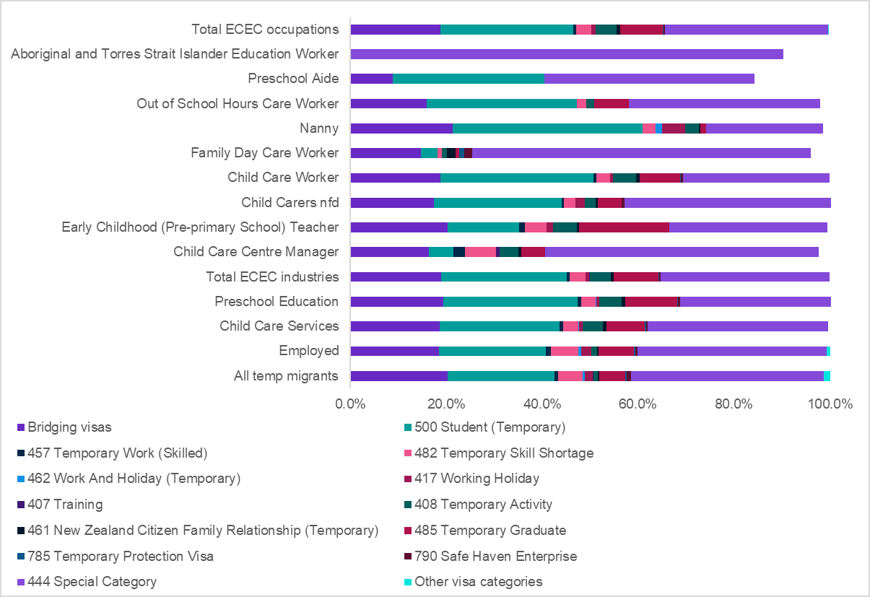

Source: ABS, Australian Census and Migrants Integrated Dataset (ACMID), 2021, TableBuilder

The participation of temporary migrants in the ECEC workforce is similar to the workforce overall. However, there is considerable variation by occupation/service type, with large proportion of *Family Day Care Workers* and *Nannies* born outside Australia.

For educators trained overseas, it is a very involved process to work in NQF approved services, without additional local training, due to the complexities around assessments and approval process (ACECQA, 2019). In addition to their visa assessments and approvals, overseas trained educators may also be required to undergo multiple assessment and approval processes. For example, an overseas trained ECT may need to apply to Australian Institute for Teaching and School Leadership (AITSL) for a skills assessment as an *Early Childhood (Pre-Primary School) Teacher* and then apply to the relevant jurisdiction’s regulatory authority for teacher registration.

The linked ACMID-Census data suggests that the migrant ECEC workforce is well qualified and may be held back from career progression by a lack of recognition for qualifications gained outside Australia. Figure 2.5 shows 55.7% of migrants working in ECEC hold undergraduate or postgraduate qualifications, much higher than observed for the general ECEC workforce. In particular, a majority of ECEC staff on temporary visa arrangements have at least a bachelor degree or higher. As you’d expect, the majority of temporary migrant *Early Childhood Teachers* have a degree with Education as their field of study (81%). However, while half of temporary migrant *Child Carer Workers* have a degree, only a minority of such migrant staff report that the field of education of their highest qualification is in Education (36%), with the next most common field of education being Management and Commerce (21%) (Source: Australian Census and Migrants Integrated Dataset (ACMID), 2021).

Figure 2.5 Highest education level for temporary migrants in ECEC occupation, 2021[31]

|  |  |  |  |  |  |  |  |  |  |
| --- | --- | --- | --- | --- | --- | --- | --- | --- | --- |
|  | **Preschool Aide** | **Out of School Hours Care Worker** | **Nanny** | **Family Day Care Worker** | **Child Care Worker** | **Child Carers nfd** | **Early Childhood (Pre-primary School) Teacher** | **Child Care Centre Manager** | **All selected ECEC Occupations** |
| Bachelor degree or higher | 42.5% | 51.9% | 42.2% | 30.2% | 52.7% | 30.1% | 86.5% | 62.5% | 55.7% |
| Advanced Diploma and Diploma Level | 16.3% | 14.5% | 15.4% | 30.0% | 23.8% | 26.8% | 7.3% | 30.1% | 20.9% |
| Certificate III & IV Level | 21.9% | 10.2% | 7.6% | 20.0% | 11.5% | 9.7% | 2.1% | 3.3% | 9.6% |
| All other education levels (inc not stated) | 9.9% | 23.2% | 34.9% | 21.5% | 12.1% | 34.7% | 4.0% | 4.8% | 13.7% |

Source: ABS, Australian Census and Migrants Integrated Dataset (ACMID), 2021, TableBuilder

In their consultation paper submitted to JSA, the Australian Childcare Alliance observed some difficulties and barriers migrants face with visas and having their prior overseas qualifications recognised, which is reflective of the above Census data:

There are range of challenges in creating a culturally diverse ECEC workforce, particularly for migrants to Australia who would like to work in the ECEC sector, or currently work in the sector but need visa extensions or their previous studies recognised in order to fulfil more senior roles. Currently, 28% of staff working in ECEC services across Australia are migrants obtaining visas, with many ECEC roles not recognised under the Skilled Migration List having their prior ECEC skills and qualification recognised equally and consistently across all states and territories. (Submission 25 – ACA)

## Remuneration and Other Employment Conditions

Table 2.4 provides an overview of employment conditions by each 4-digit ECEC occupation compared to all occupations. It shows significant differences between ECEC occupations and all occupations, except for casual employment.

Table 2.4 Employment conditions by occupation, 2023

|  | **4211**  **Child Carers** | **4221**  **Education Aides** | **2411**  **Early Childhood (Pre-primary School) Teachers** | **1341**  **Child Care Centre Managers** | **Total ECEC Occupation** | **All Occupations** |
| --- | --- | --- | --- | --- | --- | --- |
| Average weekly hours1 | 25.7 | 22.7 | 24.6 | 32.7 | 24.9 | 30.5 |
| Average weekly earnings1 | $758.7 | $752.3 | $1094.7 | $1374.0 | $816.4 | $1439.1 |
| Union Membership2 | 4.8% | 32.5% | 7.0% | 13.0% | 15.1% | 11.6% |
| Has a second job2 | 6.8% | 12.9% | 10.4% | 6.6% | 9.2% | 6.8% |
| Fixed term employment3 | 2.4% | 29.8% | 4.0% | 0.0% | 12.5% | 4.7% |
| Casual employment3 | 30.2% | 14.5% | 8.9% | 0.0% | 21.2% | 21.9% |
| Paid award only3 | 70.1% | 3.7% | 29.0% | 15.9% | 39.8% | 23.2% |
| Paid collective agreement3 | 11.7% | 86.7% | 54.6% | 14.9% | 42.8% | 34.0% |
| Paid individual arrangement3 | 17.8% | 9.2% | 13.2% | 44.9% | 16.0% | 38.7% |

Sources:  
(1) ABS (2023), Employee Earnings and Hours, TableBuilder, ordinary time  
(2) ABS (2023), Characteristics of Employment, TableBuilder  
(3) ABS (2023), Employee Earnings and Hours, TableBuilder

Among the ECEC workforce, *Child Carers* are overwhelmingly reliant on the award (70.1%) which is well above the level for workers in all occupations (23.3%). The 2021 ECEC National Workforce Census indicated more than half of all employees were paid at award rates, while noting the proportion was slightly lower for workers with a bachelor’s degree or above (PC, 2023c).

Remuneration in ECEC occupations is relatively low, including when compared with sectors with similar training requirements and even some (such as retail and clerical roles) with no or lower formal training requirements. As noted by Charles Sturt University in their submission to JSA, the relatively low renumeration rates for ECEC staff is viewed as a challenge and does not reflect the formal qualifications needed and informal expectations required to work in ECEC:

There are extraordinary everyday challenges for the ECEC workforce, which is largely female, often underpaid, and significantly undervalued, yet charged with the huge responsibility of the education, care and safety of our youngest citizens. (Submission 36)

Remuneration in ECEC occupations was canvassed in the Productivity Commission 2023 draft ECEC report, and some further evidence is provided in Figure 2.6 which depicts median weekly wages (ordinary time) for the four ECEC 4-digit occupations as well as a select number of comparators. *Child Carers* earn similar wages on average to *Aged and Disabled Carers* despite working around five additional hours per week, (noting there are sector differences in common employment conditions with *Aged and Disabled Carers* more often receiving casual loading as compensation for more precarious employment). A similar pattern occurs for *Education Aides* (albeit working fewer hours on average than *Child Carers*). *Early Childhood Teachers* earn substantially less than teachers in primary and secondary schools, even though in 2021 all three occupations had similar median working hours.

Figure 2.6 also shows that *Child Carers* earn less than *General Clerks*, and a similar amount to *Sales Assistants*. *Child Care Centre Managers* on average earn less than *Early Childhood Teachers* and *Health and Welfare Services Managers*. *Child Care Centre Managers* earned a similar weekly median wage to *Early Childhood Teachers* 2021, although typically worked two more hours per week.

Figure 2.6 Median weekly wages, ECEC and comparative occupations

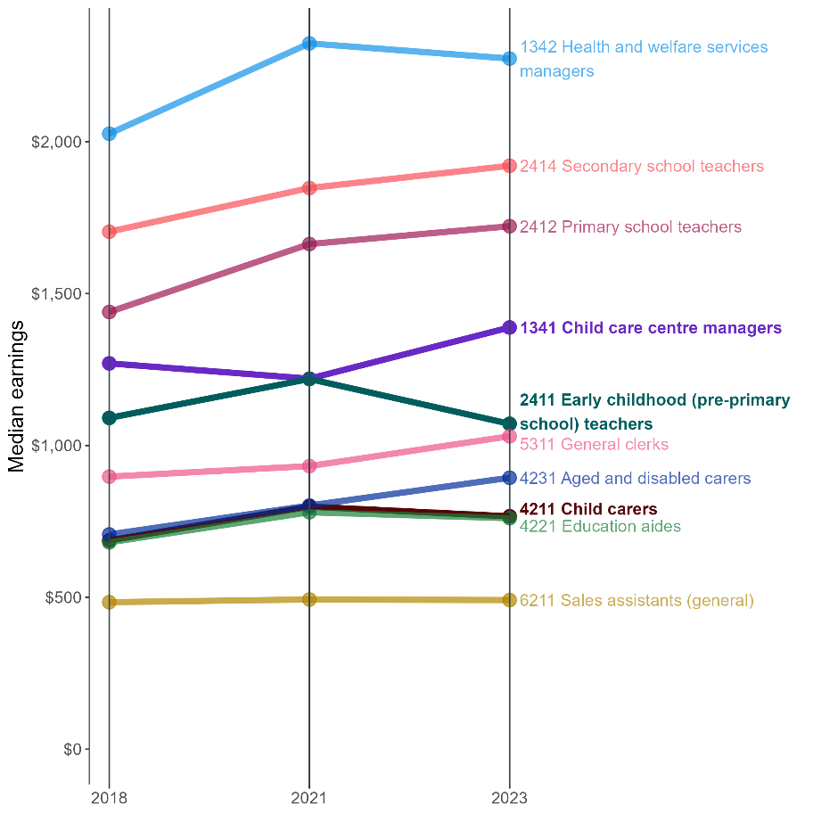

|  |  |  |  |
| --- | --- | --- | --- |
|  | **2018** | **2021** | **2023** |
| 1341 Child care centre managers | $1,270.4 | $1,220.0 | $1,389.0 |
| 1342 Health and welfare services managers | $2,026.6 | $2,324.0 | $1,071.0 |
| 2412 Primary school teachers | $1,090.8 | $1,663.3 | $767.0 |
| 2414 Secondary school teachers | $1,439.6 | $1,847.7 | $761.0 |
| 2411 Early childhood (pre-primary school) teachers | $1,704.0 | $1,219.1 | $2,274.0 |
| 4211 Child carers | $687.4 | $798.7 | $1,722.0 |
| 4221 Education aides | $681.2 | $780.2 | $1,921.0 |
| 4231 Aged and disabled carers | $707.1 | $802.4 | $894.0 |
| 5311 General clerks | $897.5 | $932.2 | $1,030.0 |
| 6211 Sales assistants (general) | $484.0 | $493.0 | $491.0 |

Source: ABS Employee Earnings and Hours, 2018, 2021, and 2023, Tablebuilder

As detailed above, the ECEC workforce (particularly the educator role) has a high degree of award reliance, as do many of the comparator occupations. Table 2.5 shows selected award rates of pay (as at 4 January 2024) for award classifications in the Children’s Services, Aged Care, Hospitality (General), General Retail and Clerical – Private Sector modern awards. The chosen classifications are the minimum for a worker with a relevant Certificate III-level classification in Children’s Services and Aged Care, and the minimum classification for the other awards. Pay rates in all cases reflect adults aged 21 years or older who are employed casually and not apprentices or trainees nor receiving a supported wage. The table also includes the current national minimum wage for a casual employee. The results support the above findings, reflecting that minimum rates of pay for Certificate III qualified workers in Children’s Services are lower than in Aged Care, and only 10% above the rates for workers not requiring a qualification or significant experience in the retail and hospitality industries or clerical roles.

Table 2.5 Award rates of pay

|  | **Hourly rate of pay (casual) ($)** | **% of Children’s Services 3.1[32] rate** |
| --- | --- | --- |
| Children's Services employee level 3.1 | 32.73 | 100.0% |
| Aged care employee - direct care - level 4 | 37.64 | 115.0% |
| Retail employee level 1 | 30.91 | 94.4% |
| Clerks - Private Sector Award - Level 1, year 1 | 29.96 | 91.5% |
| Hospitality Industry (General) Award - Level 1 guest service grade 1 | 29.04 | 88.7% |
| National Minimum Wage | 29.04 | 88.7% |

Source: Fair Work Ombudsman “Pay and Conditions Tool”, as at 4 January 2024.

Low remuneration is consistently identified by stakeholders as a driver of poor retention within the sector. Differences in remuneration also play a role in driving movement within the ECEC workforce between different service types. For example, preschools within the public education system offer significantly higher wages than *Early Childhood Teachers* in CBDC services and the significantly higher wage and better conditions (such as reduced teaching calendar due to pre-school holidays mirroring school terms) draws early childhood education graduates into primary school teaching.

### Role of Industrial Relations Settings in Workforce

The sector is characterised by a high level of award reliance and commensurately low levels of collective bargaining agreement coverage. Employees covered by collective agreements often have higher remuneration levels than those under the relevant award.

In 2022, the Parliament passed the Government’s *Fair Work Legislation Amendment (Secure Jobs, Better Pay) Act 2022* which amended the *Fair Work Act 2009,* introducing the ‘supported bargaining stream’ which replaced the previous low-paid bargaining stream. The intent of the supported bargaining stream, explained in the Revised Supplementary Explanatory Memorandum to the Secure Jobs, Better Pay Bill 2022 is to ‘assist those employees and employers who may have difficulty bargaining at the single-enterprise level’ (para 921). ECEC was also specifically mentioned in the explanatory memorandum as an industry where employers may ‘lack the necessary skills, resources and power to bargain effectively’ as single enterprises (para 921).

To assist those bargaining in the supported bargaining stream, which are often reliant on third party funding, the Fair Work Commission (FWC) can direct third party funders, such as the Commonwealth, to attend bargaining conferences if satisfied that the party exercises such a degree of control over the terms and conditions of the [employees](https://www5.austlii.edu.au/au/legis/cth/num_act/fwa2009114/s12.html#employee) who will be covered by the agreement that their participation in bargaining is necessary for the agreement to be [made](https://www5.austlii.edu.au/au/legis/cth/num_act/fwa2009114/s12.html#made).

On 6 June 2023, an application was lodged in the FWC by three trade unions for authorisation to bargain in the supported bargaining stream for a multi-enterprise agreement in a part of the ECEC sector (covering 64 employers and approximately 14,000 employees). On 27 September 2023, the FWC authorised the parties to bargain in the supported bargaining stream.

As part of the 2024-25 Federal Budget, the Government confirmed that it has committed to provide funding towards a wage increase for childcare workers with details to be finalised following consideration of relevant FWC processes.

The FWC has also commenced proceedings to consider variations to five modern awards to remedy potential gender undervaluation, including the *Children’s Services Award 2010*. The FWC intends for the proceedings to be completed by the time of the Annual Wage Review 2025 decision, anticipated to occur in June 2025. Note that Early Childhood Teachers (ECTs), covered by the *Educational Services (Teachers) Award 2020,* were recently the subject of a full assessment of work value and will not be considered as part of this process.

### Geographic Distribution

Over the last decade, there has been steady growth of employment in ECEC. Figure 2.7 below illustrates the distribution of contact staff, as well as the typical number of children in a service, across remoteness areas.[33] Across all service types, the majority of educators and children are located in major cities, reflecting the general population distribution. The share in regional and remote regions is slightly higher in IHC, and the regional share higher for FDC services.

Figure 2.7 Remoteness distribution of contact staff and children in ECEC, 2021[34]

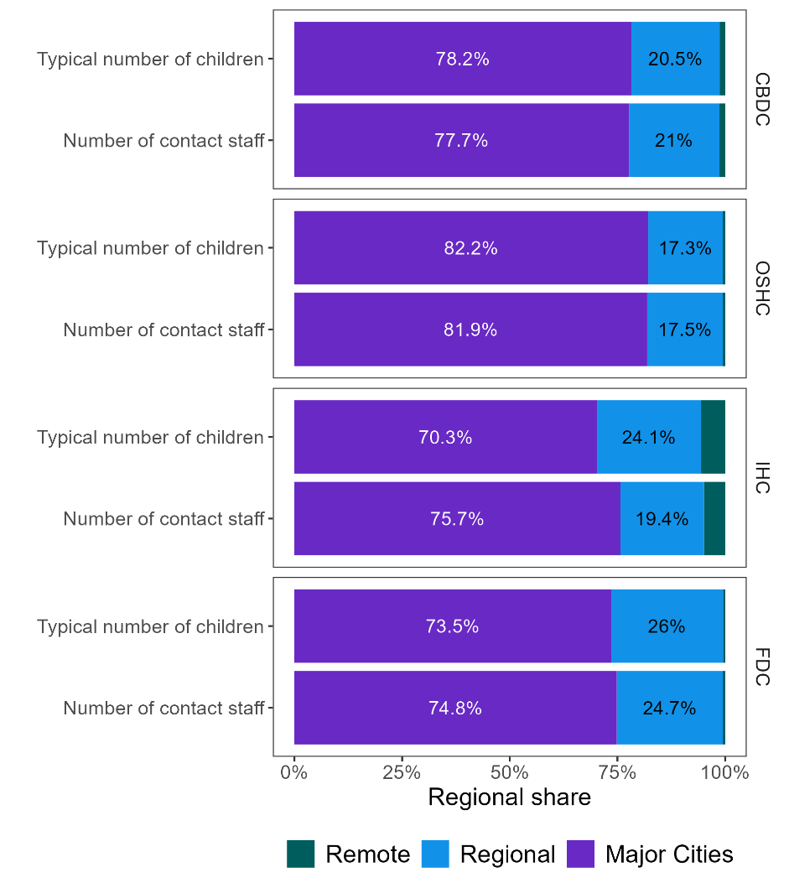

|  |  |  |  |  |
| --- | --- | --- | --- | --- |
|  |  | **Major Cities** | **Regional** | **Remote** |
| **Centre Based Day Care** | Typical number of children | 78.2% | 20.5% | 1.3% |
|  | Number of contact staff | 77.7% | 21.0% | 1.3% |
|  |  | **Major Cities** | **Regional** | **Remote** |
| **Out of School Hours Care** | Typical number of children | 82.2% | 17.3% | 0.6% |
|  | Number of contact staff | 81.9% | 17.5% | 0.6% |
|  |  | **Major Cities** | **Regional** | **Remote** |
| **In Home Care** | Typical number of children | 70.3% | 24.1% | 5.6% |
|  | Number of contact staff | 75.7% | 19.4% | 4.9% |
|  |  | **Major Cities** | **Regional** | **Remote** |
| **Family Day Care** | Typical number of children | 73.5% | 26.0% | 0.5% |
|  | Number of contact staff | 74.8% | 24.7% | 0.5% |

Source: JSA analysis of DoE’s CCS and NWC (2021)

Although maintaining specific educator to child ratios is a regulatory requirement, measuring the actual ratios presents an empirical challenge. Required ratios differ across age groups and apply at the service-level, implying that a comparison of ratios may be driven by differences in the composition of child ages rather than underlying differences in the specific ratios. Further, the data does not accurately capture the number of children in a service at any one time—which is how the ratios are specified—and instead captures measures such as the total number of children attending over a period, or the typical number of children on a given day.

Figure 2.8 below illustrates the educator to child ratio by remoteness for each service type, where educators include all contact staff. Two different ratios are presented, based on the “total number of children on a typical day” and the “maximum number of children to whom care is offered at any one time”. For CBDC, there are typically fewer educators per child in more central regions. For OSHC, the number of educators per maximum number of children in care tends to increase from Major Cities to Remote regions.

Figure 2.8 Educator to child ratio by remoteness area and service type, 2021[35]

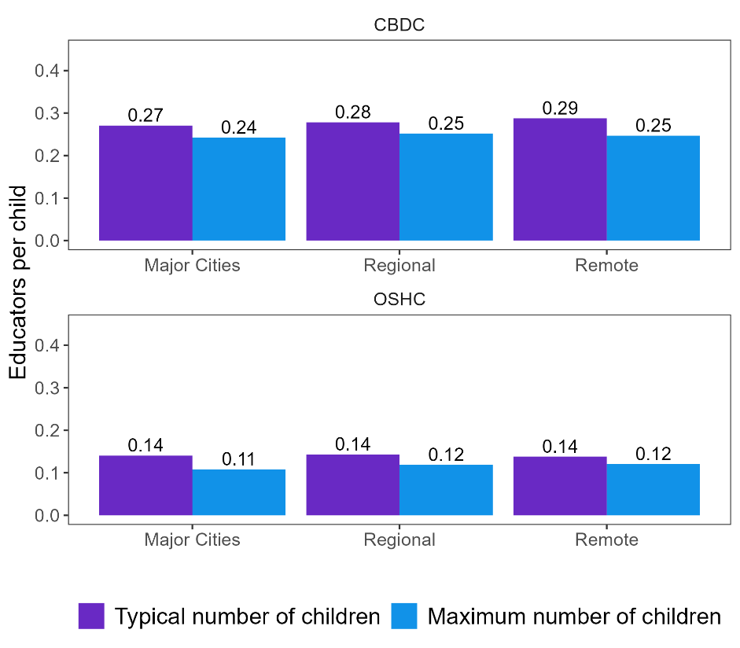

|  |  |  |  |  |
| --- | --- | --- | --- | --- |
|  |  | **Major Cities** | **Regional** | **Remote** |
| **Centre Based Day Care** | Typical number of children | 78.2% | 20.5% | 1.3% |
|  | Number of contact staff | 77.7% | 21.0% | 1.3% |
|  |  | **Major Cities** | **Regional** | **Remote** |
| **Out of School Hours Care** | Typical number of children | 82.2% | 17.3% | 0.6% |
|  | Number of contact staff | 81.9% | 17.5% | 0.6% |
|  |  | **Major Cities** | **Regional** | **Remote** |
| **In Home Care** | Typical number of children | 70.3% | 24.1% | 5.6% |
|  | Number of contact staff | 75.7% | 19.4% | 4.9% |
|  |  | **Major Cities** | **Regional** | **Remote** |
| **Family Day Care** | Typical number of children | 73.5% | 26.0% | 0.5% |
|  | Number of contact staff | 74.8% | 24.7% | 0.5% |

Source: JSA analysis of DoE’s CCS and NWC (2021)

Breaking down these ratios by staff role, analogous to occupation, highlights differences in composition across regionality and service type. For CBDCs and OSHCs the relative shares of non-management educators—including educators, group leaders, and ECTs—decreases with remoteness. In OSHCs, directors tend to make up a relatively large share of the workforce, with slightly fewer group leaders and ECTs. FDC is predominantly delivered by educators, as is IHC in major cities and inner regional areas.

Figure 2.9 Employment role breakdown of staff per child, 2021[36]

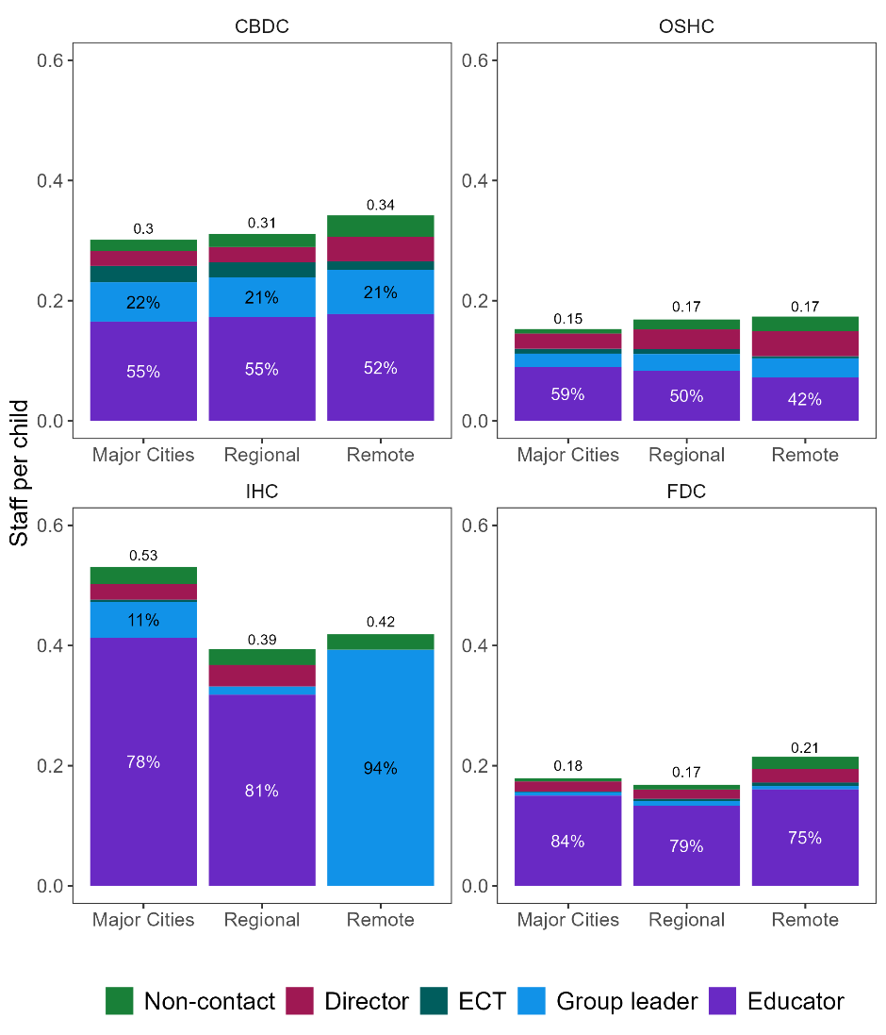

|  |  |  |  |  |
| --- | --- | --- | --- | --- |
|  |  | **Major Cities** | **Regional** | **Remote** |
| **Centre Based Day Care** | *Staff per child* | *0.3* | *0.31* | *0.34* |
|  | Non-contact | 6% |  |  |
|  | Director | 8% |  |  |
|  | Early Childhood Teacher | 9% |  |  |
|  | Group leader | 22% | 21% | 21% |
|  | Educator | 55% | 55% | 52% |
|  |  | **Major Cities** | **Regional** | **Remote** |
| **Out of School Hours Care** | *Staff per child* | *0.15* | *0.17* | *0.17* |
|  | Non-contact | 5% |  |  |
|  | Director | 17% |  |  |
|  | Early Childhood Teacher | 5% |  |  |
|  | Group leader | 15% |  |  |
|  | Educator | 59% | 50% | 4200% |
|  |  | **Major Cities** | **Regional** | **Remote** |
| **In Home Care** | *Staff per child* | *0.53* | *0.39* | *0.42* |
|  | Non-contact | 5% |  |  |
|  | Director | 5% |  |  |
|  | Early Childhood Teacher | 1% |  |  |
|  | Group leader | 11% |  | 94% |
|  | Educator | 78% | 81% |  |
|  |  | **Major Cities** | **Regional** | **Remote** |
| **Family Day Care** | *Staff per child* | *0.18* | *0.17* | *0.21* |
|  | Non-contact | 3% |  |  |
|  | Director | 9% |  |  |
|  | Early Childhood Teacher | 0% |  |  |
|  | Group leader | 3% |  |  |
|  | Educator | 84% | 79% | 75% |

Source: JSA analysis of DoE’s CCS and NWC (2021)

### Provider Type and Staffing Arrangements

The relatively high prevalence of for-profit provision, combined with differences across provider size, has implications for key workforce outcomes. Figure 2.10 (CBDCs) to Figure 2.11 (OSHCs) on the following pages illustrate the wages paid, educator to child ratios, staff turnover,[37] the share of educators working towards an ECEC qualification, and the share of staff employed on a permanent basis across management type and provider size for 2021.

#### Centre Based Day Cares

While all services must pay *at least* the award rate, for-profit CBDCs are more likely to pay at the award, along with single service private not-for-profits. In contrast, community providers, as well as larger independent nonprofits are more likely to pay above the award (although typically by less than 10%).

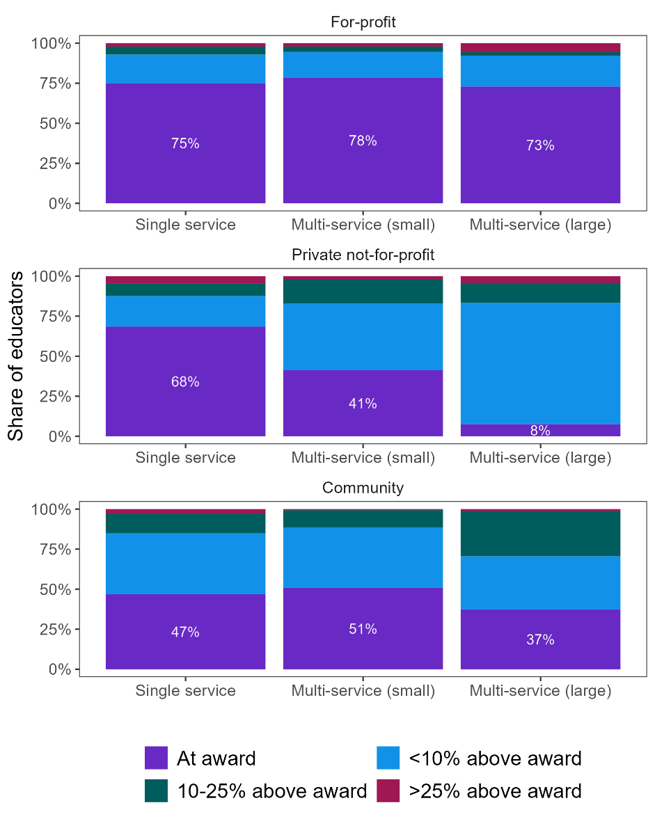Figure 2.10 CBDC staff wages by service type and provider size[38]

|  |  |  |  |  |
| --- | --- | --- | --- | --- |
|  |  | **Single service** | **Multi-service (small)** | **Multi-service (large)** |
| **For-profit** | At award | 75% | 78% | 73% |
|  | Less than 10% above award | 18% | 16% | 19% |
|  | 10-25% above award | 5% | 3% | 2% |
|  | Greater than 25% above award | 2% | 2% | 6% |
|  |  | **Single service** | **Multi-service (small)** | **Multi-service (large)** |
| **Private not-for-profit** | At award | 68% | 41% | 8% |
|  | Less than 10% above award | 19% | 42% | 76% |
|  | 10-25% above award | 8% | 15% | 12% |
|  | Greater than 25% above award | 5% | 2% | 4% |
|  |  | **Single service** | **Multi-service (small)** | **Multi-service (large)** |
| **Community** | At award | 47% | 51% | 37% |
|  | Less than 10% above award | 38% | 38% | 33% |
|  | 10-25% above award | 12% | 11% | 28% |
|  | Greater than 25% above award | 3% | 1% | 1% |

Source: JSA analysis of Department of Education NWC (2021) and CCS data; ACECQA, National Registers

Educator to child ratios tend to be lowest in for-profits, although are comparable, on average, for private not-for-profit multi-service providers. Staff turnover varies substantially across provider type and size but is generally lower in community providers as well as large for-profits. Turnover rates are highest in single-service and smaller multi-service for-profits as well as in large private not-for-profit services.

Single-service and small multi-service providers tend to have higher rates of educators working towards their ECEC qualification. The prevalence is highest among for-profit single and small multi-service providers, where around one-quarter are working towards either their Certificate III or Diploma in ECEC.

Figure 2.11 CBDC other staff characteristics by service type and provider size, 2021[39]

|  |  |  |  |  |
| --- | --- | --- | --- | --- |
|  |  | **For-profit** | **Private not-for-profit** | **Community** |
| **Educator to child ratio** | Single service | 28% | 33% | 35% |
|  | Multi-service (small) | 28% | 31% | 32% |
|  | Multi-service (large) | 29% | 32% | 36% |
|  |  | **For-profit** | **Private not-for-profit** | **Community** |
| **Educator turnover** | Single service | 30% | 22% | 18% |
|  | Multi-service (small) | 32% | 23% | 22% |
|  | Multi-service (large) | 22% | 32% | 17% |
|  |  | **For-profit** | **Private not-for-profit** | **Community** |
| **Working towards Certificate III or Diploma qualification** | Single service | 24% | 17% | 14% |
|  | Multi-service (small) | 24% | 12% | 15% |
|  | Multi-service (large) | 11% | 9% | 9% |
|  |  | **For-profit** | **Private not-for-profit** | **Community** |
| **Non-permanent educators** | Single service | 19% | 26% | 22% |
|  | Multi-service (small) | 17% | 25% | 20% |
|  | Multi-service (large) | 20% | 26% | 22% |

Source: JSA analysis of Department of Education NWC (2021) and CCS data; ACECQA, National Registers

Out of School hours care services for OSHCs, all management types and sizes generally pay educators at the award rate. Large community providers are more likely to pay 10-25% above award, as are (to a lesser extent) single service private not-for-profits.

Figure 2.12 OSHC staff wages by service type and provider size[40]

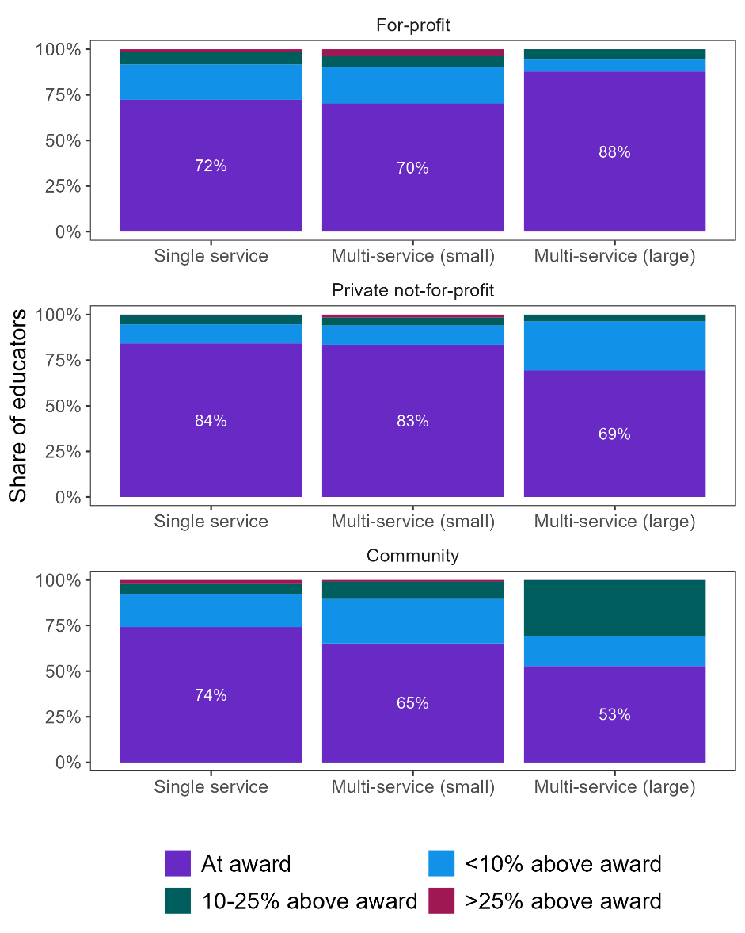

|  |  |  |  |  |
| --- | --- | --- | --- | --- |
|  |  | **Single service** | **Multi-service (small)** | **Multi-service (large)** |
| **For-profit** | At award | 72% | 70% | 88% |
|  | Less than 10% above award | 19% | 20% | 7% |
|  | 10-25% above award | 7% | 6% | 6% |
|  | Greater than 25% above award | 1% | 4% | 0% |
|  |  | **Single service** | **Multi-service (small)** | **Multi-service (large)** |
| **Private not-for-profit** | At award | 84% | 83% | 69% |
|  | Less than 10% above award | 10% | 11% | 27% |
|  | 10-25% above award | 5% | 4% | 4% |
|  | Greater than 25% above award | 1% | 2% | 0% |
|  |  | **Single service** | **Multi-service (small)** | **Multi-service (large)** |
| **Community** | At award | 74% | 65% | 53% |
|  | Less than 10% above award | 18% | 24% | 17% |
|  | 10-25% above award | 5% | 10% | 31% |
|  | Greater than 25% above award | 2% | 1% | 0% |

Source: JSA analysis of Department of Education NWC (2021) and CCS data; ACECQA, National Registers

Educator turnover is generally higher in OSHC services than CBDCs. Single service and large for-profit and private not-for-profit services have higher turnover rates relative to community services and small multi-service providers. The rate of educators working towards their qualification is generally higher in smaller providers, apart from the large private not-for-profits. Similarly, the share of staff on permanent contracts is also lower in OSHC services, relative to CBDCs, where larger community providers and small multi-service for-profits exhibit the highest shares of permanent employment among OSHCs.

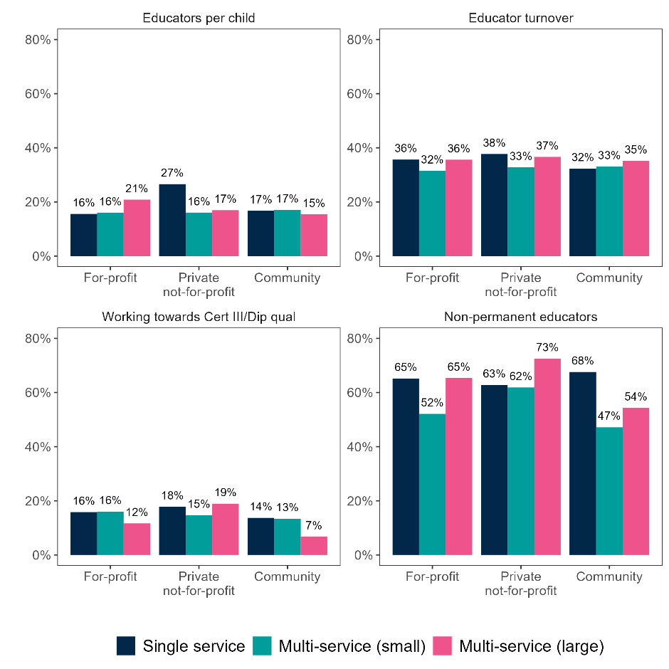Figure 2.13 OSHC other staff characteristics by service type and provider size[41]

|  |  |  |  |  |
| --- | --- | --- | --- | --- |
|  |  | **For-profit** | **Private not-for-profit** | **Community** |
| **Educator to child ratio** | Single service | 16% | 27% | 17% |
|  | Multi-service (small) | 16% | 16% | 17% |
|  | Multi-service (large) | 21% | 17% | 15% |
|  |  | **For-profit** | **Private not-for-profit** | **Community** |
| **Educator turnover** | Single service | 36% | 38% | 32% |
|  | Multi-service (small) | 32% | 33% | 33% |
|  | Multi-service (large) | 36% | 37% | 35% |
|  |  | **For-profit** | **Private not-for-profit** | **Community** |
| **Working towards Certificate III or Diploma qualification** | Single service | 16% | 18% | 14% |
|  | Multi-service (small) | 16% | 15% | 13% |
|  | Multi-service (large) | 12% | 19% | 7% |
|  |  | **For-profit** | **Private not-for-profit** | **Community** |
| **Non-permanent educators** | Single service | 65% | 63% | 68% |
|  | Multi-service (small) | 52% | 62% | 47% |
|  | Multi-service (large) | 65% | 73% | 54% |

Source: JSA analysis of Department of Education NWC (2021) and CCS data; ACECQA, National Registers

## Workforce Demand and Hiring Trends

### Workforce Demand

Job vacancy information in ECEC can provide insight into workforce shortages, as well as trends in the needs and composition of roles within the sector.

This section draws on two JSA data products – the Internet Vacancy Index (IVI) and the Nowcast of Employment by Region and Occupation (NERO) to compare vacancy rates across regions and over time for three ECEC occupations – *Child Carers,* *Early Childhood Teachers* and *Child Care Centre Managers*. This extends some of the analysis that appeared in the Productivity Commission draft report.

Data for NERO and IVI are available from 2015 onward. Capital City SA4s have been aggregated into single regions for this analysis and includes all the SA4s within the greater capital city statistical area. The rest of state SA4s have been allocated into two categories – regional and remote. Remote includes those SA4s that cover outback areas of Queensland, Western Australia, and the Northern Territory, all non-capital city SA4s in South Australia, Far West Orana in NSW, Victoria North West and West and North West Tasmania. All other SA4s have been classified as regional. It should be noted that Darwin and Hobart are classed as capital cities even though they have lower population than some regional SA4s such as the Gold Coast.

Figure 2.14 shows the average annual vacancy rate by region category. This shows that while all occupations have experienced a sharp increase in vacancy rate since 2020, the vacancy rate for *Child Carers* and *Early Childhood Teachers* in capital cities has been consistently higher than the vacancy rate in regional and remote Australia.

Figure 2.15 shows the average annual vacancy rate by state or territory. Differences among the states and territories are less consistent and harder to identify, but in general vacancy rates have been lower in Tasmania, South Australia and Northern Territory than the other states and territories and Australia overall.

Figure 2.14 Average annual vacancy rate by region for selected ECEC occupations

|  |
| --- |
| ***Child Carers*** |
| ***Early Childhood Teachers*** |
| ***Child Care Centre Managers*** |

Source: JSA IVI and NERO

Figure 2.15 Average annual vacancy rates by state/territory for selected ECEC occupations, 2015-2023

***Child Carers***

***Early Childhood Teachers***

***Child Care Centre Managers***

Source: JSA IVI and NERO

However, regional labour markets across Australia are very distinct and there can be significant variation between states and territories. Table 2.6 shows the regions with the 5 largest and 5 lowest vacancy rates for each of the three ECEC occupations.

Western Australian and Queensland regions, both capital city and regional, feature frequently on the regions with the highest vacancy rates, alongside regional Victorian areas. Vacancy rates for *Early Childhood Teachers* appear to be greater in certain regional areas than metropolitan areas and Australia overall.

Consistent with the state and territory results, a number of regions from South Australia and Tasmania feature among those with the lowest vacancy rates. However, outer suburban areas of South East Queensland and Victoria are also represented. This may be connected with other drivers such as women’s workforce participation, working hours, and post-school attainment.

Table 2.6 Regions with highest and lowest average annual vacancy rate (2023), selected ECEC occupations

|  |  |  |  |  |  |  |  |  |
| --- | --- | --- | --- | --- | --- | --- | --- | --- |
|  | **Region** | **State** | **Type** | **Rate** | **Region** | **State** | **Type** | **Rate** |
|  | **Highest** | | | | **Lowest** | | | |
| **Child Carer** | | | | | | | | |
| 1 | Brisbane | QLD | Capital | 5.4% | NT - Outback | NT | Remote | 0.8% |
| 2 | Latrobe - Gippsland | VIC | Regional | 5.0% | SA - Outback | SA | Remote | 0.8% |
| 3 | Queensland - Outback | QLD | Remote | 5.0% | SA - South East | SA | Remote | 0.9% |
| 4 | Perth | WA | Capital | 4.2% | South East | TAS | Regional | 0.9% |
| 5 | Ballarat | VIC | Regional | 4.0% | Logan - Beaudesert | QLD | Regional | 1.0% |
| **Early Childhood Teacher** | | | | | | | | |
| 1 | Shepparton | VIC | Regional | 10.8% | Barossa - Yorke - Mid North | SA | Remote | 0.6% |
| 2 | WA - Outback (North) | WA | Remote | 9.6% | South East | TAS | Regional | 0.7% |
| 3 | Murray | NSW | Regional | 8.4% | Launceston and North East | TAS | Regional | 0.8% |
| 4 | Moreton Bay - North | QLD | Regional | 8.2% | South Australia - South East | SA | Remote | 0.8% |
| 5 | Queensland - Outback | QLD | Remote | 7.9% | West and North West | TAS | Remote | 0.9% |
| **Child Care Centre Manager** | | | | | | | | |
| 1 | Queensland - Outback | QLD | Remote | 11.8% | South East | TAS | Regional | 0.0% |
| 2 | Perth | WA | Capital | 9.4% | Mornington Peninsula | VIC | Capital | 0.4% |
| 3 | WA - Wheat Belt | WA | Remote | 8.3% | Logan - Beaudesert | QLD | Regional | 0.4% |
| 4 | Ballarat | VIC | Regional | 8.2% | Ipswich | QLD | Regional | 0.6% |
| 5 | Bunbury | WA | Regional | 6.4% | Gold Coast | QLD | Regional | 1.0% |

Source: JSA IVI and NERO

|  |
| --- |
| **CASE STUDY – Recruitment assistance for family day care services**  In late 2021, Family Day Care Australia (FDCA) launched the ‘Your Business, Their Future’ family day care (FDC) educator recruitment program to promote FDC as a career of choice, and to support approved services to connect with prospective educators, and in doing so, enhancing the recruitment pipeline through a nationally consistent and centralised recruitment function, reducing administrative burden and streamlining the process of entering the FDC sector.  Through applicant pre-screening of qualifications, fitness and propriety checks, and suitability of premises assessments, FDCA delivers ‘pre-qualified’ leads to approved service members, reducing the duplication of effort in educator recruitment across the sector. FDCA provides ongoing support to applicants in their recruitment journey and builds capacity at the local level through recruitment insights and good practice guidance for approved service members.  The program has achieved significant success with over 100 educators placed with 75 approved services since its inception and showcases the value of engaging specialist skills in an efficient, targeted and centralised national recruitment program.  Source: Family Day Care Australia, (2023), *Annual Report 2022-2023*, FDCA, <https://insurance.familydaycare.com.au/assets/public-pdf/About-FDCA/Annual-Reports/FDCA_2022-2023_Annual_Report.pdf?updated=1697674851>. |

### Hiring Trends

As noted earlier, the roles of ECEC workforce and the expectations placed on them have evolved markedly since the last major update to ANZSCO definitions. A sample of job advertisements from 2019-2023 (inclusive) has therefore been analysed to better understand the ECEC labour market. Lightcast is a database of online job advertisements from across the internet and has been used to gain insight into these trends.

Job titles provide a lot of context for different ECEC roles. Titles generally reflect the desire within the sector of moving towards an ‘education’ framework, as opposed to a ‘care’ framework. The majority of roles advertised are for Early Childhood Educators (corresponding to the ANZSCO *Early Childhood (Pre-Primary School) Teacher*, followed by “Educator”, “Lead Educator”, “Child Care Educator”, “Casual Educator”, and “Centre Manager”).

Aside from the occupation being advertised, the most common wording included in job titles is the term “Trainee”, indicating that the need and recognition of the qualifications might be waived in some cases as a result of the staff shortages and immediate demand. This term is followed closely by “trustworthy”. Jobs for *Nanny* educators (largely out of scope for this study but a potential source of competition and future supply for the ECEC workforce) also include specialised skills information (such as languages required), location information, and the number of children a *Nanny* educator will need to support in the title.

Figure 2.16 Job titles used in advertisements

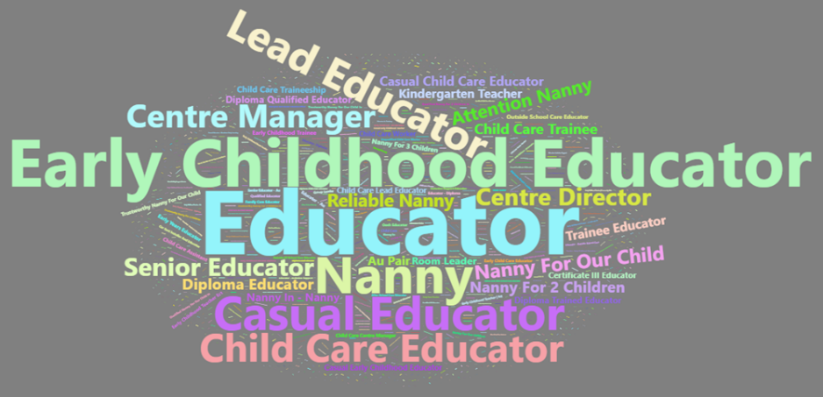

The skills most often requested in ECEC jobs can be classified into four main groups, and vary widely, reflecting the breadth of different needs across occupation and educational settings:

1. Core skills – relate to the educational role, for example: early childhood education, child caring, educational programmes, and teaching.
2. Skills related to health and safety: for example, first aid, working with patient and/or condition: anaphylaxis, CPR, vaccinations (including both being vaccinated, and knowledge of the vaccination process and requirements) and child protection.
3. Enterprise and organisational skills: teamwork/collaboration, budgeting, management training, customer service, social media skills, and conflict management.
4. Specialised skills: for example – sustainability and gardening, music, working with patient and/or condition: trauma, mental health, laundry, cooking, and a specific language.

There are ten skills which are requested of almost all ECEC staff across all occupations in online job advertisements, which include educational programming, child protection, teamwork, First Aid, CPR and Anaphylaxis training.

Figure 2.17 below shows the next most frequently occurring skills requested of ECEC staff in online job advertisements outside of the ten most frequent. Showing the range of settings and roles within the sector, these skills are diverse and comprehensive, ranging from *Social Media, Music to Laundry and Sales.*

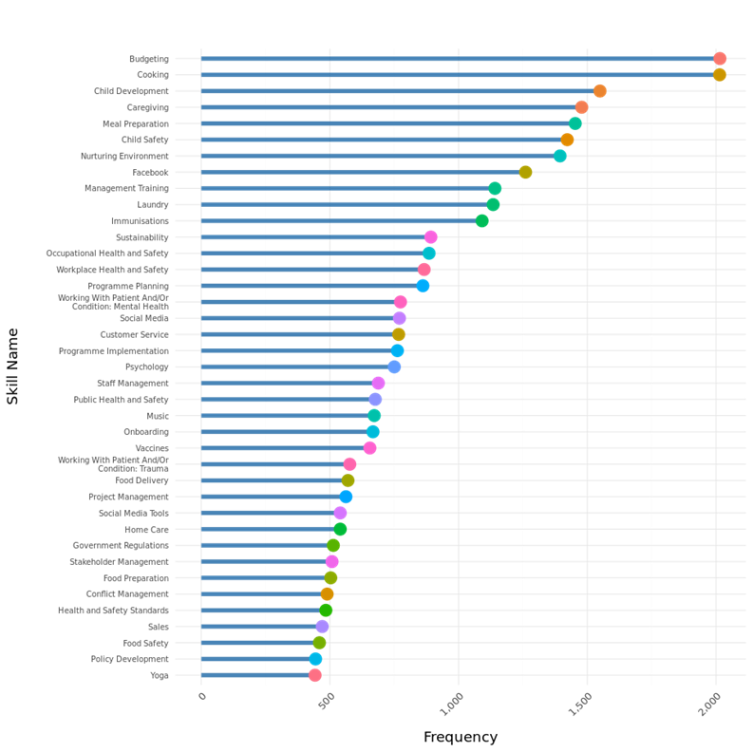Figure 2.17 Frequently requested specialist skills in ECEC job ads

|  |  |
| --- | --- |
| **Skill Name** | **Frequency** |
| Budgeting | 2015 |
| Cooking | 2014 |
| Child Development | 1549 |
| Caregiving | 1478 |
| Meal Preparation | 1453 |
| Child Safety | 1422 |
| Nurturing Environment | 1394 |
| Facebook | 1260 |
| Management Training | 1141 |
| Laundry | 1134 |
| Immunisations | 1091 |
| Sustainability | 892 |
| Occupational Health and Safety | 885 |
| Workplace Health and Safety | 866 |
| Programme Planning | 861 |
| Working With Patient And/Or Condition: Mental Health | 774 |
| Social Media | 770 |
| Customer Service | 767 |
| Programme Implementation | 762 |
| Psychology | 750 |
| Staff Management | 688 |
| Public Health and Safety | 676 |
| Music | 672 |
| Onboarding | 667 |
| Vaccines | 655 |
| Working With Patient And/Or Condition: Trauma | 577 |
| Food Delivery | 570 |
| Project Management | 562 |
| Social Media Tools | 540 |
| Home Care | 540 |
| Government Regulations | 513 |
| Stakeholder Management | 508 |
| Food Preparation | 503 |
| Conflict Management | 489 |
| Health and Safety Standards | 484 |
| Sales | 470 |
| Food Safety | 459 |
| Policy Development | 444 |
| Yoga | 442 |

Source: JSA analysis of Lightcast data

In examining the skills requested across the board by employers of ECEC staff, 11 skills could be found in almost every online job advertisement. These 11 fundamental skills can be grouped into three categories, being:

1. Intrinsic skills – related to the nature of the work, and including: *Early Childhood Education*, *Child Care*, *Teaching*, and *Educational Programmes*
2. Skills related to health and safety, for example: First Aid, *Working with Patient and/or condition: Anaphylaxis, CPR*, *Vaccinations* (both being vaccinated, and knowledge of the Australian medical vaccination schedule and procedures), and *Child Protection*
3. Business skills, such as *Teamwork* and *Collaboration*

These skills appear the most frequently and consistently since they reflect exactly how the sector works. It is geared towards these three themes – early education, providing for the safety and wellbeing of children, and working together with colleagues in a business environment.

Perhaps more interesting, however, were the next most commonly occurring skills. The other skills most frequently requested by employers in the space varied immensely, reflecting the breadth and differentiation of the roles of educators. These did not appear in every job advertisement, rather according to each role. For example, Cooking, Laundry, and Yoga, are more likely to be required in hands-on roles, such as *Child Carers*, Pre-Primary School Teachers and Nannies. On the other hand, skills like Budgeting, Government Regulations, and Social Media, are more relevant for managerial roles (Child Care Centre Managers or Room Leaders).

Requiring such a variety of skills in the single workforce indicates that employers are expecting and seeking well-rounded staff. It also provides further evidence of the difficulties in navigating career pathways across the sector because the skill mix differs greatly between roles. For example, it may be challenging for Child Carers wanting to move into an administrative role to obtain the necessary experience with skills like Budgeting or Project Management if they are engaged in more hands-on skills most of the time.

## Occupational Flows

In order to better understand where potential staff may come from and may leave to, JSA has analysed personal income tax data from the financial years of 2017-18 to 2020-21 to look at the flows of staff moving into, and out of, ECEC occupations.[42] This data is coded using the ANZSCO framework and these labels are maintained throughout.

The majority remain within the same occupation from year-to-year. Between 2017-18 and 2020-21, around 85% of individuals did not change occupation between years for those employed as *Child Care Centre Managers*, *Child Care Workers*, and *Early Childhood (Pre-primary School) Teachers*. For *Out of School Hours Care Workers*, approximately 76% remained within the same occupation from one year to the next.

Figure 2.18 shows the most common occupations previously held by staff moving into *Child Care Worker, Out of School Hours Care Worker, Early Childhood (Pre-primary School) Teacher*, and *Child Care Centre Manager* roles.

For *Child Care Worker,* the largest ECEC occupation, inflows come from a range of occupations and typically staff are not coming from other ECEC roles. The single most commonly occurring occupation is *Sales Assistant*, followed by *Primary School Teacher*. *Waiter, Office Cashier* and *General Clerk* also feature among the most common source occupations. Approximately one in five *Child Care Workers* were not in the dataset for the previous year, suggesting they are either new entrants to the Australian workforce or have been out of the workforce for a period of time.

In contrast, many new *Out of School Hours Care Workers* have experience working *as Child Care Workers*, though *Sales Assistants, Office Cashiers, General Clerks, Waiters* and *Fast Food Cooks* are also common.

The most common occupation for *Early Childhood (Pre-Primary School) Teachers* is *Child Care Workers,* though it still only accounts for just over one in five new entrants. The other common previous occupations for *Early Childhood (Pre-Primary School) Teachers* include *Primary School Teachers, Teachers’ Aides* and *Preschool Aides*.

The most common source occupations for new *Child Care Centre Managers* are other ECEC roles, including *Child Care Worker, Early Childhood (Pre-Primary School) Teacher,* and *Out of School Hours Care Worker.*

Figure 2.19 shows the most common occupational destinations for those leaving ECEC roles. The most common occupation for departing *Child Care Workers* is *Primary School Teacher*, followed by *Child Care Centre Manager* and *Early Childhood (Pre-Primary School Teacher). General Clerk, Education Aide* and *Sales Assistant* feature commonly. Less common are hospitality or Aged or Disabled Carer roles.

Departing *Out of School Hours Care Workers* also commonly become *Primary School Teachers*, with *Secondary School Teachers* also featuring. There is also movement to *Child Care Worker roles* in other service types.

Nearly 25% of departing *Early Childhood (Pre-Primary School) Teachers* leave to become *Primary School Teachers*. In contrast, less than 15% move on to *Child Care Worker* roles and less than 5% become *Child Care Centre Managers*.

The number of departing *Child Care Centre Managers* is much smaller. Typically, they move on to other roles in ECEC, *Primary School Teacher* roles, or other managerial roles.

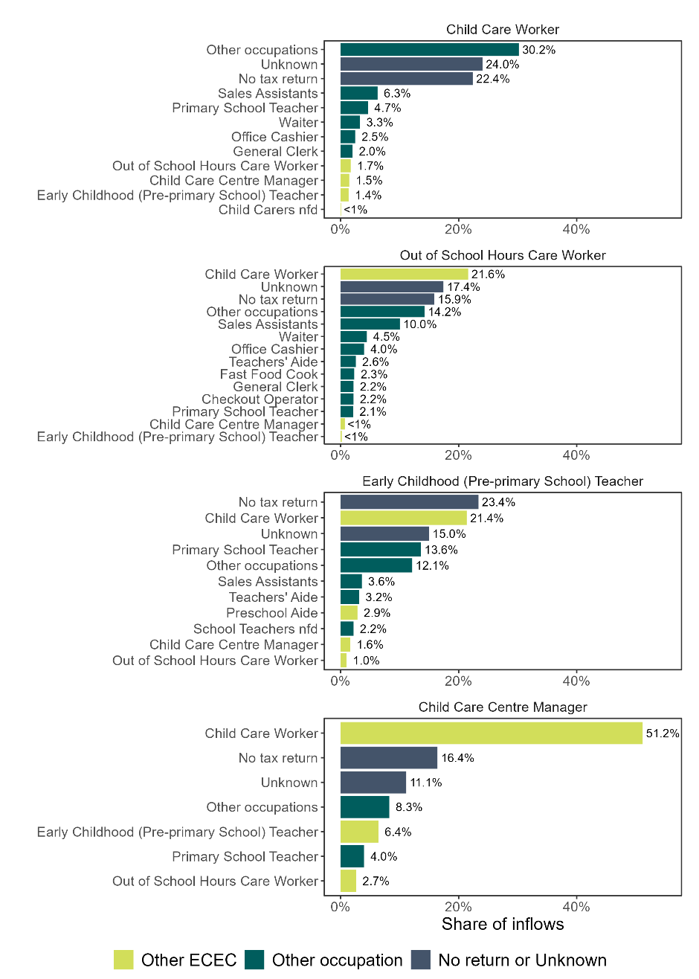Figure 2.18 Occupational flows into ECEC occupations, average of FY2017-18 to FY2020-21

|  |  |  |  |  |
| --- | --- | --- | --- | --- |
|  |  | **Other ECEC** | **Other Occupation** | **No return or unknown** |
| **Child Care Worker** | Other occupations |  | 30.2% |  |
|  | Unknown |  |  | 24.0% |
|  | No tax return |  |  | 22.4% |
|  | Sales Assistants |  | 6.3% |  |
|  | Primary School Teacher | | 4.7% |  |
|  | Waiter |  | 3.3% |  |
|  | Office Cashier |  | 2.5% |  |
|  | General Clerk |  | 2.0% |  |
|  | Out of School Hours Care Worker | 1.7% |  |  |
|  | Child Care Centre Manager | 1.5% |  |  |
|  | Early Childhood (Pre-primary School) Teacher | 1.4% |  |  |
|  | Child Carers nfd | 0.1% |  |  |
|  |  | **Other ECEC** | **Other Occupation** | **No return or unknown** |
| **Out of School Hours Care Worker** |  |  |  |  |
|  | Child Care Worker | 21.6% |  |  |
|  | Unknown |  |  | 17.4% |
|  | No tax return |  |  | 15.9% |
|  | Other occupations |  | 14.2% |  |
|  | Sales Assistants |  | 10.0% |  |
|  | Waiter |  | 4.5% |  |
|  | Office Cashier |  | 4.0% |  |
|  | Teachers' Aide |  | 2.6% |  |
|  | Fast Food Cook |  | 2.3% |  |
|  | Checkout Operator | | 2.2% |  |
|  | General Clerk |  | 2.2% |  |
|  | Primary School Teacher | | 2.1% |  |
|  | Child Care Centre Manager | 0.7% |  |  |
|  | Early Childhood (Pre-primary School) Teacher | 0.2% |  |  |
|  |  | **Other ECEC** | **Other Occupation** | **No return or unknown** |
| **Early Childhood Teacher** | No tax return |  |  | 23% |
|  | Child Care Worker | 21% |  |  |
|  | Unknown |  |  | 15% |
|  | Primary School Teacher | | 14% |  |
|  | Other occupations |  | 12% |  |
|  | Sales Assistants |  | 4% |  |
|  | Teachers' Aide |  | 3% |  |
|  | Preschool Aide |  | 3% |  |
|  | School Teachers nfd | | 2% |  |
|  | Child Care Centre Manager | 2% |  |  |
|  | Out of School Hours Care Worker | 1% |  |  |
|  |  | **Other ECEC** | **Other Occupation** | **No return or unknown** |
| **Child Care Centre Manager** | Child Care Worker | 51.2% |  |  |
|  | No tax return |  |  | 16.4% |
|  | Unknown |  |  | 11.1% |
|  | Other occupations |  | 8.3% |  |
|  | Early Childhood (Pre-primary School) Teacher | 6.4% |  |  |
|  | Primary School Teacher | | 4.0% |  |
|  | Out of School Hours Care Worker | 2.7% |  |  |

Source: JSA (2023), Data on Occupation Mobility

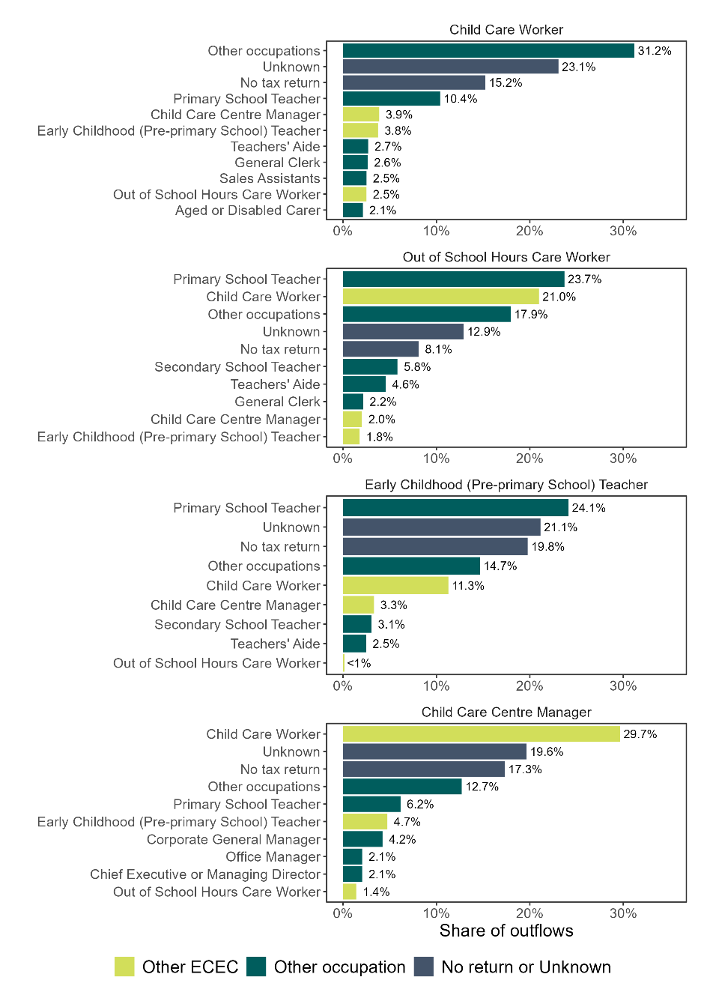Figure 2.19 Occupational flows from ECEC occupations, average of FY2017-18 to FY2020-21

|  |  |  |  |  |
| --- | --- | --- | --- | --- |
|  |  | **Other ECEC** | **Other Occupation** | **No return or unknown** |
| **Child Care Worker** | Other occupations |  | 31.2% |  |
|  | Unknown |  |  | 23.1% |
|  | No tax return |  |  | 15.2% |
|  | Primary School Teacher | | 10.4% |  |
|  | Child Care Centre Manager | 3.9% |  |  |
|  | Early Childhood (Pre-primary School) Teacher | 3.8% |  |  |
|  | Teachers' Aide |  | 2.7% |  |
|  | General Clerk |  | 2.6% |  |
|  | Sales Assistants |  | 2.5% |  |
|  | Out of School Hours Care Worker | 2.5% |  |  |
|  | Aged or Disabled Carer | | 2.1% |  |
|  |  | **Other ECEC** | **Other Occupation** | **No return or unknown** |
| **Out of School Hours Care Worker** | Primary School Teacher | | 23.7% |  |
|  | Child Care Worker | 21.0% |  |  |
|  | Other occupations |  | 17.9% |  |
|  | Unknown |  |  | 12.9% |
|  | No tax return |  |  | 8.1% |
|  | Secondary School Teacher | | 5.8% |  |
|  | Teachers' Aide |  | 4.6% |  |
|  | General Clerk |  | 2.2% |  |
|  | Child Care Centre Manager | 2.0% |  |  |
|  | Early Childhood (Pre-primary School) Teacher | 1.8% |  |  |
|  |  | **Other ECEC** | **Other Occupation** | **No return or unknown** |
| **Early Childhood Teacher** | Primary School Teacher | | 24.1% |  |
|  | Unknown |  |  | 21.1% |
|  | No tax return |  |  | 19.8% |
|  | Other occupations |  | 14.7% |  |
|  | Child Care Worker | 11.3% |  |  |
|  | Child Care Centre Manager | 3.3% |  |  |
|  | Secondary School Teacher | | 3.1% |  |
|  | Teachers' Aide |  | 2.5% |  |
|  | Out of School Hours Care Worker | 0.2% |  |  |
|  |  | **Other ECEC** | **Other Occupation** | **No return or unknown** |
| **Child Care Centre Manager** | Child Care Worker | 29.7% |  |  |
|  | Unknown |  |  | 19.6% |
|  | No tax return |  |  | 17.3% |
|  | Other occupations |  | 12.7% |  |
|  | Primary School Teacher | | 6.2% |  |
|  | Early Childhood (Pre-primary School) Teacher | 4.7% |  |  |
|  | Corporate General Manager |  | 4.2% |  |
|  | Officer Manager |  | 2.1% |  |
|  | Chief Executive or Managing Director | | 2.1% |  |
|  | Out of School Hours Care Worker | 1.4% |  |  |

Source: JSA (2023), Data on Occupation Mobility

## Summary

This chapter examines the characteristics of the ECEC workforce including the ECEC occupations and industries in focus, especially in childcare services and preschools. We draw on various data sources including ABS data, NWC, Lightcast, NERO and IVI to examine hiring trends, occupational flows and the role of skilled migration. This data shows that a very wide variety of skills are needed in ECEC, though they are concentrated on a relatively narrow selection of occupation categories, especially *Child Care Workers.*

Overall, ECEC occupations receive low levels of remuneration compared to other related work, which has a significant role in the movement of employees. Vacancy rates suggest high demand for ECEC workers, especially in certain regional areas. The chapter further describes the concentration of First Nations educators in the Northern Territory and in lower-paid segments of the ECEC workforce. While temporary migration accounts for some of the ECEC workforce, skilled migration provides fewer ECEC workers than might be expected.

# Chapter 3: Pathways into the ECEC Workforce

Ensuring Australia has an ECEC sector that is fit for purpose demands a robust education and training system that ensures an adequate supply of appropriately trained workers. JSAexamined pathways into the ECEC workforce via both VET and higher education. This chapter identifies trends in early childhood education qualifications and features of the cohorts that may impact workforce composition covering topics:

Qualification routes for the ECEC workforce

Characteristics of those in training, training market provision and training modes of delivery.

Work-based training and continuing professional development.

The issues that emerge from our analysis of this data are further articulated in Chapter 5 including relating to the content of ECEC qualifications and quality of training delivery.

## Qualification Routes for the ECEC Workforce

In the ten years between 2011 and 2021, the proportion of ECEC staff holding a non-school qualification increased from 67.6% to 82.5% (ABS Census 2021). This growth is aligned with the establishment of the NQF in 2012, which introduced qualification requirements and staff ratios for ECEC services within its remit. As a result, educators must hold (or be working towards) at least a Certificate III-level ECEC qualification in service types with the most enrolled children (CBDC and FDC), with services also needing to ensure that they have access to a certain number of educators with diploma-level and bachelor-level (or equivalent) qualifications, in line with enrolments.

There have also been increases in educational attainment noted in the 2021 ABS Census data on highest non-school qualification for respondents in ECEC focus occupations not directly attributable to the NQF. These include the increase in *C**hild Care Centre Managers* and *Early Childhood Teachers* with postgraduate qualifications, and that more than a quarter of educators possessed a bachelor-level qualification.

While the NQF, among other state and territory based regulations, puts in place qualification requirements and staffing ratios it does allow flexibility through the operation of waivers and rules that enable enrolment in a qualification to satisfy requirements that educators hold a qualification under certain conditions.

Largely because of the guardrails put in place by the NQF and the relevant modern awards, the VET and higher education pathways into ECEC roles are well established. The qualification mix of the workforce reflects the strong VET training pathways into the sector[43].

* The Certificate III in Early Childhood Education and Care is the dominant pathway into educator level roles.
* The Diploma of Early Childhood Education and Care provides the progression to more senior educator roles within middle management, such as Group or Room Leader. In the current training package the pre-requisite for entry into the Diploma is a Certificate III Early Childhood Education and Care, from one of the two most recent qualification versions.
* Various bachelor degree programs provide the main pathway into *Early Childhood Teacher* roles, which may be specialised as pre-primary (0-5) or provide a dual pathway into primary teaching as well (0-12).
* Other higher education pathways into *Early Childhood Teacher* roles include graduate diplomas and masters programs for candidates with usually a three year degree, not always in early childhood education. In some instances, these routes are open to those with a Diploma in ECEC and significant workplace experience. Postgraduate diplomas and masters qualification have seen recent proportional increases for international students.
* Qualification routes for the ECEC workforce.
* Characteristics of those in training, training market provision and training modes of delivery.
* Work-based training and continuing professional development.

### Characteristics of Training

This study mapped the qualification pathways in Australia which are recognised by the national authority ACECQA to meet the staffing requirements of ECEC. Figure 3.1 below shows the number of Certificate III and Diploma ECEC enrolments over the years 2018 to 2022 - together these enrolled 113,095 in 2022, with a marked, and increasing, preference for Certificate III over the longer Diploma. Enrolment figures in higher education are shown in Figure 3.2. VET courses enrol almost six times as many students into ECEC routes as universities in Australia.

Figure 3.1 ECEC program enrolments, by level of education, 2018-2022

|  |  |  |  |  |  |
| --- | --- | --- | --- | --- | --- |
| **Program name** | **2018** | **2019** | **2020** | **2021** | **2022** |
| Certificate III in Early Childhood Education and Care | 52,835 | 55,005 | 55,030 | 64,445 | 73,855 |
| Diploma of Early Childhood Education and Care | 52,240 | 48,750 | 44,945 | 49,910 | 39,240 |
| Total | 105,075 | 103,755 | 99,975 | 114,355 | 113,095 |

Source: NCVER 2023, Total VET Students and courses 2022.

Figure 3.2 Enrolments in Early childhood education higher education enrolments, time series

|  |  |  |  |  |  |  |  |  |  |  |  |
| --- | --- | --- | --- | --- | --- | --- | --- | --- | --- | --- | --- |
| **Program name** | **2012** | **2013** | **2014** | **2015** | **2016** | **2017** | **2018** | **2019** | **2020** | **2021** | **2022** |
| Teacher Education: Early Childhood 01. Postgraduate | 1,424 | 1,545 | 1,940 | 2,089 | 2,200 | 2,314 | 2,557 | 2,667 | 2,911 | 3,282 | 4,247 |
| Teacher Education: Early Childhood 02. Undergraduate | 13,340 | 14,419 | 16,678 | 16,141 | 15,536 | 14,690 | 13,563 | 12,904 | 13,589 | 16,222 | 17,281 |

Source: Higher Education statistical collection – student data, Department of Education. Custom data request, 23_526 based on detailed field of education = 070101 Teacher Education: Early Childhood.

#### Vocational Education

Vocational education delivery has been critical to the ECEC workforce, particularly based on the core educator role, which is the foundation of workforce. ECEC accounts for a very high proportion of enrolments in VET nationally: consistently over the last five years around 1 in 25 students enrolled in any VET course is studying towards an ECEC qualification. ECEC is also one of the most frequently enrolled VET courses for First Nations people. In 2022, 70% of VET enrolments in ECEC qualifications were subsidised, with enrolments for Diploma level courses more commonly subsidised than for Certificate III/IV level courses (73.7% vs 67.9%).[44]

Early childhood education and care falls under one of the Commonwealth and State Government designated areas of initial national priority[45] and as a result enrolments in VET courses leading to an ECEC qualification are more commonly subsidised than VET courses overall.

The number of qualification completions for ECEC courses dipped to a low of 12,300 for Certificate III in 2020 during COVID-19 but increased in 2021 and per 2022 interim figures, displayed in Table 3.1, have returned to a level similar to pre-COVID years. Similarly, in 2021, Diploma completions returned to levels prior to 2020 and a 30% significant increase of completions from 13,860 in 2021 to 18,000 in 2022.

Table 3.1 ECEC program completions, by level of education, 2018-2022

| Program ID | Program name | 2018 | 2019 | 2020 | 2021 | 2022 |
| --- | --- | --- | --- | --- | --- | --- |
| CHC30113/CHC30121 | Certificate III in Early Childhood Education and Care | 15,730 | 15,700 | 12,300 | 15,730 | 17,610 |
| CHC50113/CHC50121 | Diploma of Early Childhood Education and Care | 13,570 | 12,625 | 9,990 | 13,860 | 18,000 |
|  | Total | 29,300 | 28,325 | 22,290 | 29,595 | 35,605 |

Source: NCVER 2023, Total VET students and courses 2022.

In terms of VET graduate outcomes there was very high rate of satisfaction with both Certificate III and Diploma in the most recently published Student Outcomes Survey, with a 91% satisfaction across both courses, which tracks well against other qualifications in the same Training Package as the ECEC qualifications. Satisfaction rates of ECEC were higher than those in the same training package (CHC) and all VET courses (both 89%). As this data was collected from graduates who completed their training in 2022, they will have been enrolled in the 2013 versions of both qualifications.

ECEC Certificate III and Diploma graduates receive relatively large economic benefits, with 2017-18 graduates gaining an increase in income of around $16,000 in the financial year after they graduate.[46] Both courses rank among the top 15 in terms of income uplift, as well as transitioning to employment, excluding programs in the traditional trades, as presented in Table 3.2 below.

Table 3.2: Top 15 post-completion outcomes, FY18-19, by median income gain[47][48]

| Program ID | Program name | Employed | Gained emp. | Income | Income uplift |
| --- | --- | --- | --- | --- | --- |
| CSC30120 | Certificate III in Correctional Practice | 99% | 9% | $80,739 | $23,837 |
| SHB30416 | Certificate III in Hairdressing | 84% | 21% | $37,811 | $23,137 |
| HLT35015 | Certificate III in Dental Assisting | 93% | 20% | $41,869 | $18,093 |
| CHC43115 | Certificate IV in Disability | 94% | 18% | $56,714 | $17,757 |
| HLT54115 | Diploma of Nursing | 94% | 16% | $47,928 | $17,640 |
| CHC30113 | Certificate III in Early Childhood Education and Care | 84% | 31% | $35,020 | $17,149 |
| ACM40418 | Certificate IV in Veterinary Nursing | 96% | 14% | $46,535 | $17,146 |
| SIT30816 | Certificate III in Commercial Cookery | 92% | 13% | $45,456 | $16,046 |
| CHC52015 | Diploma of Community Services | 88% | 11% | $60,008 | $16,044 |
| SIR30216 | Certificate III in Retail | 79% | 16% | $29,150 | $15,716 |
| CHC50113 | Diploma of Early Childhood Education and Care | 85% | 18% | $43,771 | $15,296 |
| FNS50615 | Diploma of Financial Planning | 90% | 6% | $64,526 | $14,744 |
| CHC33015 | Certificate III in Individual Support | 87% | 35% | $38,885 | $14,488 |
| ICT50220 | Diploma of Information Technology | 69% | 13% | $38,521 | $13,976 |
| BSB30120 | Certificate III in Business | 74% | 11% | $38,140 | $13,062 |

Source: VET Student Outcomes – Top 100 courses, VET National Data Asset (VNDA), accessed from [VET National Data Asset (VNDA) | Jobs and Skills Australia](https://www.jobsandskills.gov.au/data/vet-national-data-asset-vnda).

As shown in Table 3.3, of the 113,095 students enrolled in ECEC VET courses in 2022, 65% were in Certificate III programs, 35% were enrolled in Diploma courses.

Table 3.3 ECEC program enrolments by level of education and program ID, 2022

|  |  |  |  |
| --- | --- | --- | --- |
| Program ID | Program name | Enrolments | Proportion |
| Total Diploma | | 39,240 | 35% |
| CHC50113 | Diploma of Early Childhood Education and Care | 30,415 | 27% |
| CHC50121 | Diploma of Early Childhood Education and Care | 8,825 | 8% |
| Total Certificate III | | 73,855 | 65% |
| CHC30113 | Certificate III in Early Childhood Education and Care | 38,590 | 34% |
| CHC30121 | Certificate III in Early Childhood Education and Care | 35,265 | 31% |
| Total |  | 113,095 | 100% |

Source NCVER 2023, Total VET students and courses 2022

According to National Centre for Vocational Education Research (NCVER) data, in 2022:

* 94% of ECEC VET students are female,
* 50% enrolled in Certificate III programs are employed,
* 59% of Diploma CHC50113 and 72% of Diploma CHC50121 are employed, and
* 7% of students reported having a disability.

Compared to the ECEC workforce, where ABS Census 2021 shows the average age to be 41, those studying ECEC are relatively young: 43% of ECEC VET students are under 25 and 83% are under 40. In 2022, school based learning contributes around 1 in 7 of these students, with 14% of Certificate III students also studying at school, though only 1% of Diploma students are at school.

The highest proportion of students (64%) are based in Australia’s major cities, followed by inner regional areas (18%), outer regional areas (8%), and remote and very remote regions (2%) – the remainder are unknown.

The proportion of enrolments were consistent across the first four quintiles of relative socio-economic disadvantage (approximately 20%), where 12% of students fall into the most advantaged group (the remainder are unknown) based on address at time of enrolment.

More than half (57%) of all students were born in Australia. Of all those born overseas, the highest enrolments were among students born in India (8,275), China (3,795), Philippines (2,960), New Zealand, (1,755), Pakistan (1,750), Nepal, (1,515), Sri Lanka (1,240), Bangladesh (1,190), Vietnam (1,135), and England (1,085). First Nations students constitute 5% of Certificate III and Diploma courses. Students who speak a main language other than English make up 28%.

#### Higher Education

Enrolments in ECEC higher education courses have rebounded after COVID-19. However, completions in undergraduate early childhood teaching courses were significantly impacted by placement barriers during the COVID-19 pandemic. Higher education enrolments have increased over the last ten years as shown with significant growth in postgraduate pathways over the last ten years in Figure 3.2 above.

Higher education providers report the basis of admission for courses[49], which shows pathways into ECEC courses that differ from other areas of study. For public universities had higher rates of work and life experience (meaning fewer students enter education straight out of school) for ECEC courses (17%) compared to all (13%). Higher education ECEC courses have a much higher proportion of students who reported using VET as the basis for their admission compared to all other undergraduate degrees (DoE, Custom data request 23_526). Correspondingly, there were much lower rates of ATAR-only admissions for ECEC at just 6% against 29.5% for all courses. Despite this, movement between sectors is obstructed by the lack of well-established pathways and/or credit agreement pathways from VET to higher education.

Entry requirements vary considerably for single (e.g. ECT only) or dual pathway (e.g. ECT and Primary) degrees, with ATAR entrance scores ranging anywhere from 60 to mid 80. Additionally, international students are required to meet the English language requirements of International English Language Testing System (IELTS) Academic of 7 and above, however this may vary between institutions.

In 2021 there were 19,500 students enrolled in higher education institutions to pursue ECEC:

* 83% were taking undergraduate degrees,
* 97% of undergraduate and 91% of postgraduate ECEC students were female,
* 88% of all students were enrolled in public universities, and
* 97% of postgraduate students study in public universities.

Most ECEC students are from mid socio-economic status locations – 47% of undergraduates and 31% of postgraduates (though for a very high percentage of postgraduate enrolments socio-economic status of their entry location is unknown). One-fifth (21%) of ECEC undergraduate students and 9% of postgraduates are from low socio-economic status locations and 16% of all ECEC students are from high socio-economic status locations, a figure that is based on similar figures among undergraduate (15%) and postgraduate (17%) cohorts.

Most enrolments are domestic students, though this is much higher at undergraduate (83%) than at postgraduate (58%) levels. Approximately 1 in 8 (12%) ECEC students at higher education level speak a language other than English at home – this is higher amongst postgraduates, where 16% speak a language other than English. First Nations people constitute 2% of enrolments, almost all are enrolled on undergraduate degrees.

Four year completion rates for higher education courses are shown in Table 3.4. ECEC course completions have been steady against the all course undergraduate rates but dipped for the 2018 commencing cohort who had their final study years during the COVID-19 pandemic and experienced placement disruptions.

Table 3.4: Four year undergraduate completion rates, time series[50]

|  |  |  |  |  |  |  |  |  |  |  |
| --- | --- | --- | --- | --- | --- | --- | --- | --- | --- | --- |
| *Commencement year* | 2010 | 2011 | 2012 | 2013 | 2014 | 2015 | 2016 | 2017 | 2018 | 2019 |
| Domestic ECE | 45.1 | 44.9 | 44.02 | 42.9 | 42.1 | 41.9 | 42.6 | 41.3 | 40.9 | 40.8 |
| Domestic All | 45.3 | 45.1 | 44.2 | 42.9 | 42.0 | 42.1 | 43.0 | 41.7 | 41.0 | 40.9 |
| International ECE | 71.0 | 70.6 | 70.7 | 71.1 | 70.1 | 69.7 | 70.1 | 69.7 | 66.7 | 65.3 |
| International All | 71.2 | 70.8 | 71.0 | 71.2 | 70.8 | 69.5 | 69.6 | 69.3 | 65.9 | 65.0 |

Source: ECEC Higher Education statistical collection – student data, Department of Education. Custom data request, 23_526 based on detailed field of education = 070101 Teacher Education: Early Childhood.

All course completion rates from [Completion Rates of Higher Education Students - Cohort Analysis, 2005-2022 - Department of Education, Australian Government](https://www.education.gov.au/higher-education-statistics/resources/completion-rates-higher-education-students-cohort-analysis-20052021)

|  |
| --- |
| **CASE STUDY – Supporting higher education student placements in central Victoria**  The Early Childhood Professional Practice Partnership program (ECP3), delivered by higher education providers including La Trobe University and funded by the Victorian Department of Education, supports pre-service teachers completing placements in central Victoria while undertaking the Bachelor of Early Childhood and Primary Education. The program first began in 2019, supporting Early Childhood services to provide effective placements for Early Childhood students by giving mentor teachers professional learning opportunities. The ECP3 program promotes the early childhood pathway to dual qualification (e.g. ECE and Primary) students by offering additional support in preparing for and during placement. Additionally, the ECP3 program strengthens partnerships between La Trobe University, ECEC providers and students.  *Submission 23 – La Trobe University*  Source: La Trobe University, (n.d.), *Enhanced Teacher Preparation,* La Trobe University, <https://www.latrobe.edu.au/school-education/preparing-educators/enhanced-teacher-preparation>. |

#### Market Provision and Modes of Delivery

There has long been a mix of public and private training providers for ECEC courses across a broad geographic footprint. Analyses show that in 2022 every SA4 (the largest sub-state level in the ASGS) had at least one provider delivering Early Childhood Education and Care VET courses, however, these areas can be extremely large particularly in remote areas. In VET, private training providers accounted for over two thirds of ECEC program enrolments in 2022 as shown in Figure 3.3 and Figure 3.4. Less than a quarter of ECEC program enrolments are at a TAFE institute, with a change between TAFE and private provider delivery of VET over the five years up to 2022.

Figure 3.3 Certificate III ECEC enrolment proportion by RTO provider type

|  |  |  |  |  |  |
| --- | --- | --- | --- | --- | --- |
| **RTO Provider Type** | **2018** | **2019** | **2020** | **2021** | **2022** |
| TAFE institutes | 31.7% | 30.0% | 30.4% | 28.4% | 25.4% |
| Universities | 1.8% | 1.6% | 1.9% | 2.0% | 1.5% |
| Schools | 1.8% | 1.7% | 1.5% | 1.7% | 1.3% |
| Community education providers | 8.5% | 8.7% | 8.2% | 8.1% | 7.7% |
| Enterprise providers | 0.7% | 0.5% | 0.3% | 0.3% | 0.1% |
| Private training providers | 55.4% | 57.4% | 57.7% | 59.6% | 64.0% |

Source: NCVER 2023, Total VET students and courses 2022.

Figure 3.4 Diploma ECEC enrolment proportion by RTO provider type

|  |  |  |  |  |  |
| --- | --- | --- | --- | --- | --- |
| **RTO Provider Type** | **2018** | **2019** | **2020** | **2021** | **2022** |
| TAFE institutes | 23.9% | 18.1% | 19.9% | 18.9% | 17.1% |
| Universities | 1.7% | 1.5% | 2.1% | 2.1% | 1.6% |
| Schools | 0.1% | 0.0% | 0.0% | 0.0% | 0.0% |
| Community education providers | 6.7% | 7.1% | 7.2% | 6.7% | 7.8% |
| Enterprise providers | 2.3% | 1.7% | 1.1% | 0.7% | 0.3% |
| Private training providers | 65.3% | 71.6% | 69.6% | 71.6% | 73.3% |

Source: NCVER 2023, Total VET students and courses 2022.

Between 2015 and 2022, there has been increasing market concentration of training delivery. In 2015, 15% of enrolments in relevant ECEC VET qualifications was delivered by the three RTOs with the largest market shares (NCVER, Total VET students and courses (unperturbed data) 2022). In 2022, that proportion had increased to 22%. There was also concentration in the next largest band, the 10 RTOs with the largest enrolments. Their market concentration increased from 28% in 2015 to 41%. Among the top ten RTOs in 2022 were included two TAFE institutes, 1 community education provider and the remaining 7 were private training providers. Based on JSA’s RTO typology (2024), 5 of the 7 private RTOs were “Early Educators specialists” (meaning more than 80% of their enrolments are in the relevant early childhood qualifications) and the remaining 2 were human services specialists (meaning more than 80% of enrolments were in the Community Services (CHC) training package, which encompasses early childhood, aged care, disability care, and other community services qualifications). Since 2019, the 25 largest RTOs have held a majority of enrolments (out of approximately 330-375 RTOs with enrolments) according to NCVER’s ‘Total VET students and courses (unperturbed data) (NCVER, 2022).

Figure 3.5 Market % share of RTOs delivering ECEC qualifications

|  |  |  |  |  |  |  |  |  |
| --- | --- | --- | --- | --- | --- | --- | --- | --- |
|  | **2015** | **2016** | **2017** | **2018** | **2019** | **2020** | **2021** | **2022** |
| Top 3 RTO market share | 14.9% | 14.4% | 15.5% | 14.6% | 20.7% | 21.9% | 22.2% | 22.4% |
| Top 10 RTO market share | 12.7% | 12.7% | 13.0% | 14.5% | 16.4% | 16.8% | 17.3% | 18.2% |
| Top 25 RTO market share | 16.6% | 16.3% | 14.8% | 15.7% | 14.4% | 16.1% | 15.7% | 16.5% |

Source: JSA analysis of Total VET Activity 2015-2022

For higher education, as shown below in Figure 3.6, ECEC enrolments are almost entirely within public universities. There has, however, been growth in undergraduate domestic students enrolling in self-accrediting institutions and non-university high education providers. There was no postgraduate domestic delivery outside public universities in the reference period.

Figure 3.6 Undergraduate domestic ECEC enrolments proportion by higher education provider type 2021

|  |  |  |  |  |
| --- | --- | --- | --- | --- |
|  | **2018** | **2019** | **2020** | **2021** |
| Table A Institutions | 94.6% | 94.9% | 95.8% | 94.0% |
| Table B Institutions | 3.8% | 3.5% | 2.7% | 2.1% |
| Non-University Higher Education Institutions | 1.6% | 1.7% | 1.4% | 3.9% |

Source: Unistats data request, Department of Education, 2023

Notes: Logarithmic scale used

|  |
| --- |
| **CASE STUDY – Aboriginal managed and controlled RTO – Bubup Wilam**  Bubup Wilam Aboriginal Child and Family Centre, meaning ‘Children’s Place’ in Woi Wurrung, is an Aboriginal community-controlled education, health, and well-being organisation in Thomastown, Naarm (Melbourne). Bubup Wilam aims to ensure local Aboriginal communities can make decisions that directly affect them and exercise their right to self-determination in a meaningful and effective way.  Bubup Wilam offers a unique model of integrated, wrap-around health and wellbeing services that are interwoven within the centre and within the delivery of the educational program. Bubup Wilam is one of only three Aboriginal service providers nationally to offer preventive and early childhood intervention services as NDIS providers. This includes allied health services such as hearing tests, speech pathologists, visits to general practitioners, a comprehensive primary school integration program, and access to other health care services without fear, shame, racism, and the burden of additional, often prohibitive, time-consuming costs and need to take time off work. Through this quality, culturally safe, and accessible model, Bubup Wilam reinforces children’s strong sense of Aboriginal identities and personal self-esteem as the foundation for lifelong learning, health, and well-being.  Delivering this model requires a highly skilled, multi-disciplined, and strong workforce who build strong relationships with children and their families and are aware of, and responsive to their cultural, educational, health and wellbeing needs. This requires commitment to the attraction, training and retention of Aboriginal employees who bring specific skills and knowledge that are imperative to quality education and care for Aboriginal children.  Bubup Wilam stands out in the health, wellbeing and early years and adult education programs they offer, evident in the fact they were rated exceeding National quality standard in all quality areas in their recent assessment and rating and are now eligible to apply for recognition to achieve an Excellent rating. Bubup also won the 2023 national NAIDOC award for education and has recently become a Registered Training Organisation (RTO) with ASQA.  Source: Bubup Wilam, (n.d), Bubup Wilam Aboriginal Child and Family Centre, [*https://bubupwilam.org.au/*](https://bubupwilam.org.au/). |

### Work-based Training

There is a heavy practical component in both VET and HE courses leading to ECEC qualifications. For example, for a Certificate III ECEC course requires 160 hours of work in a regulated children’s education and care service while the Diploma level qualification requires 280 hours. Significant supervised professional experience / work placement is also needed in higher education qualifications for Early Childhood Teachers. The practical orientation of training means that ECEC work is well suited to the apprenticeship/traineeship model, and higher education courses incorporate significant work integrated learning elements. Table 3.5 looks at the ECEC VET program cluster (the Certificate III ECEC and Diploma ECEC) against other program clusters to see what the rate of employment and apprentice/trainee rates were, revealing that ECEC has enrolments with the highest rate of concurrent employment and a far higher rate of apprentice/trainee delivery than chosen comparison program clusters.

Table 3.5: ECEC VET programs cluster comparison with employment components, compared to other clusters, 2022[51]

|  |  |  |  |
| --- | --- | --- | --- |
| Selected VET programs within occupation group | Programs in cluster | Employed at commencement | Apprentice/ trainee |
| Early Childhood Education and Care | Certificate III in Early Childhood Education and Care  Diploma of Early Childhood Education and Care | 54.0% | 21.7% |
| Health and Welfare Support | Certificate II in Community Services Certificate III in Community Services Certificate IV in Community Services Diploma of Community Services Diploma of Mental Health | 49.0% | 3.4% |
| Education Support | Certificate III in Education Support Certificate IV in Education Support Certificate III in School Based Education Support Certificate IV in School Based Education Support | 47.2% | 3.0% |
| Personal Care and Assistance | Certificate III in Individual Support  Certificate IV in Mental Health  Certificate IV in Ageing Support | 47.5% | 5.3% |

Source: NCVER 2023, Total VET students and courses 2022.

Currently, *Child Care Worker* is among the occupations listed on the Australian Apprenticeships Priority List, which entitles employers of trainees in this occupation (studying a related qualification, including both the Certificate III in Early Childhood Education and Care and the Diploma of Early Childhood Education and Care, alongside certain other qualifications) to a Priority Wage Subsidy. *Out of School Hours Care Worker* was added to the Apprenticeships Priority List in February 2024.

Traineeship commencements in ECEC appear to be highly sensitive to incentive arrangements. Figure 3.7, using the NCVER Apprentices and Trainees collection, looks at the number of apprentices and trainees in training in ECEC-related occupations back to 1994. For each quarter, the total is segmented by the training occupation and the level of the qualification. The graph clearly shows that trainee numbers were increasing steadily until 2014, when incentive payments were removed from ECEC professional staff along with many other non-trade occupations. The number of apprentices and trainees in training began to increase again from 2020, when the Boosting Apprenticeships Commencement initiative began.

Figure 3.7: Apprentices and Trainees in training in ECEC related occupations, by occupation and qualification level, July-September 1994 to July-September 2023

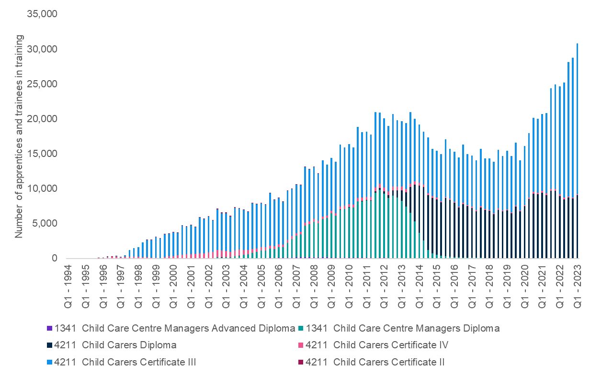

Source: NCVER, Apprentice and Trainee collection.

Note: Certificate III/IV level qualifications include CHC30113, CHC30121, CHC40113, CHC41208. Diploma level qualifications include: CHC50113, CHC50121, CHC50202, CHC50213, CHC50211.

The graph also shows the rapid increase in the proportion of apprentices and trainees in ECEC undertaking training at the Certificate III level – indeed almost all the growth in trainees since 2020 is accounted for by an increase in the Certificate III level, such that they have increased from 53% of total ECEC trainees in July-September 2021 to 70% in July-September 2023. The proportion of all *Child Carers* who were undertaking a traineeship increased from an estimated 7% in Q3 2019 to 13% in Q3 2023 (JSA analysis of NCVER Apprentice and Trainee Collection data and ABS Quarterly Labour Force Survey data).

Facilitating adequate work placements for other students (including HEI students) remains a challenge, and not just because of funding. There are emerging initiatives in a range of jurisdictions to support paid placements. As those qualifying to become *Early Childhood Teachers* cannot complete their course without undertaking practicum days at a service other than their employer, it can be financially challenging for students. As noted by La Trobe University in their submission to this Study:

ACECQA requirements for placements do not allow credit to be awarded for work experience or placements undertaken in prior studies (if lesser qualifications). For example, an upskilling diploma qualified educator may have run a 0-2 childcare room for 5 years but is still required to undertake ten days mandatory placement in a 0-2 setting to meet Bachelor qualification requirements. (Submission 23)

From July 2023, the Australian Government has launched a scheme to support paid leave for ECEC educators taking practicums to complete their qualification (Department of Education, 2024b).

VET and higher education courses attract substantial funding contributions from government, leaving the student with little or no upfront cost for tuition, setting aside study material costs. There is strong government support in both VET and HE sectors for ECEC courses (Fee Free TAFE/Job Ready Graduate rates that are alongside health and other education courses) and income-contingent loans are available on diplomas/degrees for students. Employer sponsorship is also common to fund student fees and in most cases exempt from Fringe Benefits Tax (FBT) if related to work (individual FBT rules applying to employers). However, the opportunity cost from lost income during time spent training is also a substantial barrier, addressed in part by various scholarship schemes offered by state and territory governments, often targeted at priority cohorts.   To support students managing the costs associated with undertaking mandatory placements, the Australian Government has launched an initiative to provide HE and VET students in teaching and selected health and social work disciplines with financial assistance. Available from 1 July 2024, students will be able to access a weekly payment (benchmarked to the single Austudy rate) for the duration of their placement. The payment is means-tested to target students who need it the most (Department of Education, 2024a).

#### Continuing Professional Development

Qualification requirements for staff are established by the NQF, with higher education and vocational education courses being oriented towards initial training and progression to other roles within the workforce. However, there are few formal education qualifications with the purpose of developing staff in their current role. Key peak bodies have a breadth of professional learning opportunities available, including face-to-face, online offerings and conferences which maps to the National Quality Standard (NQS).

The emphasis on developing an effective culture of lifelong learning has led to an increase in the delivery of microcredentials through providers and well-established organisational development departments within large multisite providers, with some organisations offering specific courses in relation to management and understanding children’s behaviour. Some of these courses may be accredited by the relevant issuing state authority. An early childhood advocacy organisation noted the importance of professional development in their submission to our Study:

The need for quality professional development for early childhood educators cannot be overstated. Continued professional development, mentoring and support is critical to a skilled and supported workforce. Ongoing professional learning is essential to ensure the time, effort and cost spent in completing qualifications does not go to waste and the benefits do not fade away. Continuing PD fills the gaps in knowledge and skills that are often apparent in practice after initial training, and it keeps educators in touch with research into best practice. (Submission 9)

Across numerous service types, staff members may be required to hold additional certifications in relation to first aid, anaphylaxis management and emergency asthma management training, as stipulated under the Education and Care Services National Regulations as these certifications may require refreshers as regularly as every 12 months. There are concerns from stakeholders about possible barriers to professional development as noted by an early childhood advocacy organisation:

Barriers to completing professional learning include the costs and time to complete courses, as well as the variable quality of professional learning available to educators. (Submission 9)

A key policy concern has been to strengthen both systems of induction and ongoing opportunities and there are numerous efforts nationally, in jurisdictions and across service types to do this. Within the *Shaping our Future - National Children’s Education and Care Workforce Strategy* there are several actions which directly seek to develop these staff support systems including (*Shaping Our Future,* 2021):

* FA1-3 – Enhance mentoring and induction support for new teachers
* FA3-1 – Improve access to core professional development for educators and teachers
* FA3-2 – Improve access to an increasing range of micro-credentials for educators and teachers in areas of identified need.

|  |
| --- |
| **CASE STUDY – Supporting professional development and new students with mentorships**  TAFE NSW has developed a pilot mentorship program in which existing ECEC educators can complete two free VET units as professional development. The two units, part of the Certificate IV in Training and Assessment, are TAEDEL414 Mentor in the Workplace and TAEDEL311 Provide Work Skill Instruction. Participants in the program supervise and mentor current ECEC students benefiting both existing educators in their pursuit to become leaders and new students looking for a career in early childhood. The program provides students with a support system, while existing educators will develop skills in supervision, providing instructions, coaching and mentoring. TAFE NSW will undertake an evaluation of the pilot in the near future.  *Submission 2 – TAFE NSW* |

## Summary

This chapter describes the dominant education and training pathways to ECEC roles, showing that most ECEC educators enter the field via VET, with a smaller proportion attaining ECEC qualifications via higher education. VET pathways include a diverse mix of public and private institutions, while most higher education courses are confined to public universities. It also noted the characteristics of the students and learners who participate in these formal qualification pathways and used census data on age, gender, employment location status, disability, location, and socio-economic status to show that those entering ECEC tend to be female and from mid socio-economic status location backgrounds. Workplace-based education is fundamental to the ECEC workforce pathway and there has been a rapid increase in apprenticeships and traineeships since 2020.

This chapter found that it is important to facilitate adequate paid work placements as a pathway into the ECEC workforce. The opportunity for ongoing, on-the-job professional development, including greater support for progression to other, more specialised roles, is also an important consideration.

# Chapter 4: Future States

## Introduction

With such high expectations placed on the ECEC sector and its workforce, a key objective of the Study was to analyse future demand and supply at the national, state and regional level for the ECEC workforce over the next 10 years. To do this, JSA commissioned Deloitte Access Economics to assist with detailed economic modelling. Modelling results were iterated and refined based on feedback from Steering Group members.

To build a picture of future workforce demand, the following components were taken into account:

* The current levels of met demand for ECEC services and current workforce levels
* Evidence that the current workforce is being unsustainably stretched to meet current levels of demand, such as additional hours worked and lack of provision for ongoing professional development
* Existing unmet demand, such as parents and carers seeking additional hours of ECEC for their children
* The expansion in services and workforce that will be required to continue the rollout of committed policies, such as preschool for 3 year olds.
* The further expansion in services and workforce that would be required to achieve more ambitious proposals, notably a universal entitlement for up to 30 hours a week available to all children.

This layered picture of demand was built up from the smallest level of regional data available (SA4) to take into account differences in communities’ population and existing patterns of ECEC participation as well as variation in state and territory policy settings.

The future demand analysis looks at the main ECEC roles separately (*Child Carer, Early Childhood Teacher*) and together.

The assessment of future workforce supply was built up in a similar way, beginning with the current workforce and drawing on historical data to model the likely flows in and out of ECEC roles attributable to various factors, including completion of VET and higher education qualifications, occupational movements within and out of the sector, migration and retirements.

As for future workforce demand, the future workforce supply is considered for each of the core ECEC occupations and overall.

The results of this analysis are stark but consistent with the evidence already presented in earlier chapters. There will not be sufficient ECEC workforce to meet anticipated demand if current workforce settings and trends continue, with particularly large shortages for *Early Childhood Teachers* emerging and persisting over the remainder of the ten year forecast horizon.

As with any modelling exercise, there are uncertainties involved in developing projections of the future, including with data inputs, model structure, and parameterisation. Nevertheless, the analysis provides an indication of how the ECEC workforce supply and demand may change over the next decade under different scenarios.

## Approach and Assumptions

### Occupational Categories and Data Sources

The modelling exercise focused on three occupational categories of particular importance to the ECEC sector:

* Child Carer
* Early Childhood Teacher
* Child Care Centre Manager

The modelling also includes the occupational category *Education Aides*, to the extent these are employed in ECEC services as opposed to schools and other settings. Further details on the occupations and sectors in scope for the modelling is set out in Appendix 4.

While other occupations make a valuable contribution to the work of ECEC services (as acknowledged in Chapter 2), they are either occupations with low barriers to entry and not currently experiencing shortage (e.g. Cleaners, Administration Assistants) or found in very low numbers.

The principal data sources for the modelling exercise are: 2021 Census of Population and Housing (for workforce composition and characteristics), the Australian Census Longitudinal Dataset (to examine occupational flows). Service demand modelling relied on the Department of Education’s NWC and CCS administrative data and the ABS Preschool Education collection. Treasury forecasts for labour force participation rates were used, as were Deloitte Access Economics population forecasts for more detailed regional estimates.

### Estimating Future Demand

The model builds up from first principles to derive workforce demand. First, the demand for ECEC services by children and families is estimated based on historic usage rates and other core drivers such as female labour force participation. Then, the demand for educators required to meet that level of service demand is derived based on a combination of empirical and theoretical staffing patterns.

The following sections outline the structure underpinning the model, presenting details on each of the four scenarios, and explores sustainability of the workforce.

#### Current Met Demand

First, current estimates of ECEC service usage and hours were estimated for 2021 and 2022 using:

* ABS Preschool Education data, which captures enrolments in Standalone Preschools and Centre Based Day Cares for children aged between three to six in August.
* CCS data, which captures enrolments in Child Care (including CBDC, FDC, IHC and OSHC) over an average week in June.

2021 usage patterns were used for 2021 and supports consistent comparisons with other data sources (including the 2021 ABS Census and ECEC NWC), while 2022 usage patterns were used as the basis of the projections.

Service demand was then projected over the next 10 years, taking into account population growth and changes in ECEC usage patterns (hours and participation), including female labour force participation and the propensity to use ECEC by labour force status, relative to 2022 levels.

##### Converting Service Demand to Workforce Demand

Incremental[52] service demand projections were converted into incremental workforce demand by sector, SA4 and occupation using two sets of ratios - the actual ‘employment-to-demand’ ratio and the theoretical ‘employment-to-demand’ ratio.

* The actual ‘employment-to-demand’ ratio compared 2021 service demand (as measured by weekly enrolment hours) with 2021 staff demand, which accounted for both employees in the sector and an estimate of unmet workforce demand, as indicated by staffing waivers.[53]
* The theoretical ‘employment-to-demand’ ratio determined the minimum staff requirements for a given level of service demand (enrolment hours) based on the regulatory requirements for educator numbers, qualifications and working conditions.

This forms the basis for the first demand scenario modelled that maintained current trends and policy settings (up to and including 2022).

#### Sustainable Workforce Levels

Discussion with sector stakeholders indicates that the ECEC sector is under significant strain. The below adjustments were built into the modelling to account for current and sustainable working conditions.[54]

Both the current and sustainable working conditions adjustments are added to the theoretical ‘employment-to-demand’ ratio, to better reflect the practical worker requirements to meet service demand.

Only the sustainable working conditions adjustments are added to the actual ‘employment-to-demand’ ratio and captures the workers should have been employed in 2021 to support service delivery in a sustainable way.

**Figure 4.1: Workforce tensions in ECEC workforce**

#### Considering Unmet Service Demand

Unmet service demand, which refers to any existing supply constraints in the ECEC sector that results in unfulfilled demand for families, was also factored into the modelling. The below indicators were used to identify Statistical Area 2 (SA2) where unmet demand for CBDC was mostly likely to occur in 2021.

1. Licensed places per child (aged 0-12): based on ACECQA data on licensed places of CBDC services based in a SA2 compared to the resident population of 0-12 in the same region. Fewer licensed places available per child suggests that ECEC usage is lower compared to other regions.
2. Use of existing capacity, with a high level of utilisation suggesting families are unable to increase their usage.
   1. Reported use of services in the National Workforce Census, which compares the maximum places offered per day in a service to the number of places actually filled.
   2. Estimated use of services, comparing the maximum charged days over a week in June 2021 with their maximum capacity (licensed places multiplied by days open).

These indicators were then equally weighted and combined to create a single measure of unmet demand by SA2. This component is referred to as ‘unmet service demand’.

#### Rollout of Committed Policies

The demand modelling also examines the potential changes in ECEC service demand and workforce demand as a result of Commonwealth, State and Territory policy changes from 2023 onwards is also presented. This includes:

* Increasing CCS, which commenced in July 2023. Increases to the payment rate and expanded eligibility is expected to result in greater affordability and ECEC usage;
* Expanding preschool access to 30 hours for four-year-olds in Victoria and New South Wales, which is expected to affect ECEC usage in CBDCs and standalone preschools; and,
* Expanding preschool access for three-year-olds up to 15 hours per week in Victoria, New South Wales, South Australia and Australian Capital Territory.

This component is referred to as ‘Committed Policies’ in the chapter.

#### Scaling up to Universal Access

A potential universal preschool and childcare scenario that considers the likely growth path of ECEC service and workforce demand as a result of a uniform uplift in preschool service provision is also presented. More specifically:

* Ensure up to 30 hours per week of ECEC is available to all children[55]
* Expand access for 4-year-old preschool for the remaining jurisdictions (at 30 hours per week)
* Expand access for 3-year-old preschool for remaining jurisdictions (at 15 hours per week)

This scenario is referred to as ‘Universal Access’ in the chapter.

### Modelling Workforce Supply

Workforce supply was modelled using a stocks-and-flows approach. The starting stock of labour supply was estimated at a base year (2021), after which a series of inflows and outflows were taken into account for each year of the projection period. These flows included:

* Inflows to the ECEC workforce through new education and training completions
* Outflows from the ECEC workforce due to retirements
* Inflows and outflows due to international and interstate migration
* Inflows and outflows from/to employment in non-ECEC occupations (and between ECEC occupations)
* Movements into employment from unemployment or ‘not in the labour force’ (NILF) status, and vice-versa.

There are two components of the workforce supply estimates: A *ready workforce supply*, comprising existing ECEC workforce and recent VET and higher education graduates, and flows from within the workforce (referred to as Core Supply). The additional *potential workforce supply* component, which includes those inflows and outflows from unemployment or ‘not in the labour force’ (NILF) status, and vice-versa. Inflows from this category may require training to meet NQF requirements.

The modelling of future workforce supply assumes current trends and policy settings (up to and including 2022) are maintained into the future.

### Limitations of the Modelling

This section details the limitations of the modelling and methodological constraints.

Measuring the ECEC workforce is challenging due to different workforce data sources having different methodologies, scope and reference periods. Modelling assumptions and decisions about inclusions and exclusions can cause more complications. A result of this is that comparing projected ECEC supply (which is based off the ABS Census) with projected demand (which is informed by service distribution and regulation requirements) is intrinsically difficult.

As already noted, the modelling primarily uses the ABS Census as the main source of data. While employment totals for the four ECEC occupations modelled at the 4 digit ANZSCO level broadly align with ABS Labour Force Survey for the same reference period (August 2021), there are some differences at the individual occupation level. Further, this exercise has modelled the portion of these occupations working in the ECEC sector, as informed by detailed ANZSIC sectors. This modelling has relied on the figures available from ABS Census, to inform a detailed starting estimate for the ECEC workforce. This limits the extent of direct comparability to alternative sources (that may not include this layer of granularity).

Deloitte Access Economics also undertook illustrative modelling to identify SA2s where unmet CBDC service demand was most likely to be occurring. It should be noted that these modelled estimates only serve as a broad indication of what unmet demand is currently or likely to be in the future. There is likely to be unmet demand in other sectors including FDC which has not been captured due to the lack of appropriate data (despite intense efforts during the Study) and subsequent modelling challenges.

Also, average weekly participation rates and average hours from June[56] were utilised for ECEC services (excluding preschool). There are likely to be variations in demand across the year, and during peak periods, worker demand could be higher than what has been estimated. As mentioned in the previous section, estimated use of services, compares the average charged days over a week in June with their maximum capacity.

The modelling also doesn’t account for the number of service providers in the sector operating within a given region. For example, growth in the sector might have to come from increases in the number of service providers, as existing service providers are likely to be fully occupied and cannot readily increase capacity. This could lead to a change in the mix of service types, and therefore staffing arrangements, going forward.

It must also be noted that the calculation of ratios and other analyses are performed at the ‘market level’. This doesn’t consider the heterogeneity across individual services and across services of different characteristics (e.g. quality, provider management type).

Projections for the Committed Policies Scenario are illustrative only. Indeed, in some jurisdictions there is no current, stated policy position or proposal. The specific policy proposals (in terms of rollout schedule, provision across different policy settings) will affect the workforce demand projections. Where policy commitments are not in place, reliable estimates will only be able to be generated once proposals of sufficient detail have been developed.

Further, the Universal Access Scenario, which includes modelling of up to 30 hours per week of ECEC for all children, was based on the PC’s recommendation in the *Path to Universal Early Childhood Education and Care* draft report. In the event the PC updates its modelling methodology for its final report, the results presented in this report will not be comparable.

The modelling results also rely on detailed data from the 2021 ECEC National Workforce Census and the ABS Census 2021 which are dated. Data used to inform certain elements of the supply modelling also rely on observations between points in time, either using the 2016 to 2021 ABS Australian Census Longitudinal Dataset (ACLD) or the 2016-17 to 2020-21 Data on Occupation Mobility (DOM). These data sources, however, are the most detailed ‘up to date’ data available on the ECEC workforce.

Where possible, the supply modelling has drawn on historical data at the most detailed occupation, industry, and regional level. However, in some instances, limited observations or suppression of small counts required the modelling to draw on a higher level of definition (e.g., retirement rates are based on 4-digit ANZSCO unit groups because 6-digit ANZSCO occupation data was unavailable).

The data used to inform some supply flows creates a possibility of double-counting, in particular, between training completions and movements between occupations where, for example, a person both changes occupation and obtains a higher qualification. Data from the 2021 ABS Census, National Centre for Vocational Education Research (NCVER), and Department of Education Higher Education Statistics have been used to avoid double-counting by estimating the ‘additionality’ of new training completions to the workforce.

While ABS Census provides educational attainment, other aspects of ECEC workforce supply such as occupational movements and migration limit the extent to which disaggregation can occur at this level of detail. The ECEC workforce supply is therefore not modelled with a qualification breakdown, despite the significant distinction in requirements and remuneration for early childhood educators with a Certificate III qualification and those with a Diploma qualification. Proposed ANZSCO changes will help to address this in future data collection and analysis.

Finally, as discussed in Chapter 2, for-profit providers have driven the strong growth recorded in CBDC and OSHC services in recent years. It should be noted that the characteristics of for-profit services have changed over time particularly with regard to workforce composition, prices and quality of service. The modelling projections presented in this chapter do not capture these dynamics.

Finding - Data gaps and inconsistencies constrain effective workforce planning. This includes difficulty capturing the extent of unmet service demand, inconsistencies in scope and estimates between the National Workforce Census (NWC) and Australian Bureau of Statistics Labour Force Survey and other collections, and insufficient data on the First Nations ECEC workforce.

## Future Demand

Future demand for Early Childhood Education and Care was estimated by looking at service demand and workforce demand, this section presents projections on both elements.

### Future Outlook for Service Demand

As outlined above, estimates for future workforce demand under committed policy settings have been developed in four stages:

* current levels of serviced demand for ECEC services, growing in line with Treasury forecasts for female labour force participation and Deloitte Access Economics population growth and
* taking into account the current extent of understaffing in the sector
* existing levels of unmet demand (to the extent this could be reliably measured)
* the expansion in services and workforce that will be required to continue the rollout of committed policies, such as preschool for 3 year olds.

Taking into consideration population projections (1.3% per year over the next 10 years) and increased female labour force participation[57], and the impact of committed policies, more than 1.6 million enrolments in the ECEC sector are projected by 2034, representing an average growth rate of 1.2% per year (Committed Policies Scenario). Consistent with the emphasis on expanding preschool access, the age profile of children and recent service type usage trends, the largest average annual growth rate is expected to be in standalone preschools and preschool delivered within CBDC settings. Smaller growth is expected for the other service types (details shown in Table 4.1).

Table 4.1 Number of children (enrolments) and growth rate by service type (2024-2034), Committed Policies Scenario

|  |  |  |
| --- | --- | --- |
| **Service type** | **2034** | **CAGR[58] (%)** |
| Preschool | 304,000 | 1.4% |
| CBDC (preschool) | 300,000 | 1.7% |
| CBDC (non-preschool) | 543,000 | 1.2% |
| FDC | 76,000 | 1.1% |
| IHC | 2,000 | 0.9% |
| OSHC | 411,000 | 0.7% |
| **Total** | **1,636,000** | **1.2%** |

Source: Commissioned Deloitte Access Economics modelling for JSA ECEC Capacity Study

### Workforce Demand

When these projected increases in service demand are mapped to workforce levels, it is expected to have the following impacts:

To meet expected increases in population and changes in the female labour force participation rate, the total ECEC workforce will need to grow by 1.5% on average each year for the next 10 years. While all occupations will need to grow, faster growth is required among *Child Carers.*

Finding - To meet projected national population growth increases (1.3 per cent per year) and increased female participation in the workforce, the ECEC workforce will need to grow by around 1.5 per cent per year by 2034 to service the increase in demand.

The modelling captures unmet workforce demand through the use of staffing related waivers and exemptions by services, and where additional staff would be required to support sustainable working conditions for the existing workforce.

ACECQA data suggests that in 2023, 0.9% of CBDCs and 2.1% of OSHCs had an active staffing waiver related to ratio, and NWC data finds that services with ratio waivers have contact staff to child ratios that are on average lower by 12% and 2% lower for CBDCs and OSHCs respectively.

Analysis of ABS Census data suggests that full-time ECEC staff are working 8% more than the nominal full time workload (38 hours). Assuming these trends hold across all ECEC staff, this means that the workforce would need to be larger by 8% to ensure workers do not work overtime, and have two days a year set aside for professional development.

Engagement with the Study steering group and stakeholders participating in roundtable discussions confirmed understaffing led to widespread inability to participate in the minimum two days per year allocated for ongoing professional development.

The number of additional workers required to address understaffing and meet current levels of unmet demand was calculated based on minimum ratio requirements as well as the need to take into account provision for sick leave and annual leave for permanent and fixed term employees. Taken together, this amounts to an 8 per cent understaffing level in the sector, applied uniformly across occupational categories.

Finding - The current ECEC workforce would likely need to grow by an extra 8 per cent to satisfy current estimated unmet demand for early childhood services and another 8 per cent to meet unmet demand for qualified workers*.*

These estimates reflect only those settings that existed in 2021, when the baseline workforce data was collected. To take account of policy changes that have occurred since then, and which governments have committed to implementing over the next ten years, will require additional workforce. This includes the 2023 changes to the CCS, intended to result in greater ECEC usage by addressing affordability. It also includes state and territory government commitments to expand preschool access, in various stages of implementation:

* Expanding preschool access to 30 hours for four-year-olds in Victoria and New South Wales, which is expected to affect ECEC usage in CBDCs and standalone preschools; and,
* Expanding preschool access for three-year-olds up to 15 hours per week in Victoria, New South Wales, South Australia and Australian Capital Territory.

Considering these policy commitments and factoring in unmet service demand, the modelling estimates current workforce demand to be around 260,000 staff (headcount)[59]. These changes together are expected to increase demand for ECEC staff by an average of 1.9 per cent per year (over the ten years to 2034 or 54,000 extra staff for the forecast period). Predictably given the emphasis on expanding preschool access, the required growth in demand for *Early Childhood Teachers* is even higher – 3.2 per cent per year on average, or at least an additional 14,000 teachers within ten years.

**Finding -** In order to meet the various policies already committed to by Commonwealth, State and Territory governments, the ECEC workforce will likely need to increase by an annual average growth rate of 1.9 per cent per year overall and by 3.2 per cent per year overall for Early Childhood Teachers.

There is evidence that further expanding access to early childhood education to a universal model of up to 30 hours per week, including universal preschool for 3 and 4 year olds, could deliver substantial benefits for child development, social inclusion and long-term skills growth, as well as women’s labour force participation.

Universal preschool access assumes 85% of 3 year olds will participate in preschool, and 100% of 4 year olds already enrolled in preschool will increase their usage to 30 hours per week. The modelling assumes that existing market share for 4 year olds is maintained.

Universal access to child care is modelled using the assumptions underpinning the Productivity Commission's draft recommendation 6.2. By modifying the CCS to allow (1) all families to access up to 30 hours or three days of subsidised child care per week without an activity requirement, and (2) families with annual income at or below $80,000 should be eligible for a subsidy rate of 100% of the fee, up to the hourly rate cap, the Productivity Commission estimates a 12% increase in total ECEC hours demanded.

Achieving this increase in access would add to the scale of future workforce demand. The ECEC workforce will likely need to grow by 3.0 per cent per year over the ten years to 2034 (or 89,000 additional staff for the forecast period)[60], with Early Childhood Teachers needing to grow by 5.4 per cent per year or 26,000 extra staff for the forecast period.

**Finding -** To implement universal access and universal preschool for 3 and 4 year olds and up to 30 hours per week over three days of ECEC to be available to all children, the ECEC workforce will likely need to grow by 3.0 per cent per year with Early Childhood Teachers needing to grow by 5.4 per cent per year.

Table 4.2 ECEC staff demand projections by occupation 2024-34[61]

|  |  |  |  |  |  |  |
| --- | --- | --- | --- | --- | --- | --- |
| **ECEC specific occupations** | **Expansion to implement Committed Policies** | | | **Universal Access** | | |
| Total Workers (2034) | Additional staff demand (2024 to 2034) | **CAGR[62]** | Total Workers (2034) | Additional staff demand (2024 to 2034) | **CAGR[63]**% |
| Child Care Manager | 30,000 | 6,000 | 2.3 | 35,000 | 10,000 | 3.6 |
| Early Childhood Teacher | 51,000 | 14,000 | 3.2 | 63,000 | 26,000 | 5.4 |
| Child Carers | 228,000 | 33,000 | 1.6 | 246,000 | 52,000 | 2.4 |
| **Total ECEC Workforce** | **314,000** | **54,000** | **1.9** | **349,000** | **89,000** | **3.0** |

Source: Commissioned Deloitte Access Economics modelling for JSA ECEC Capacity Study.

Figure 4.2 ECEC staff demand projections by scenario 2024-34

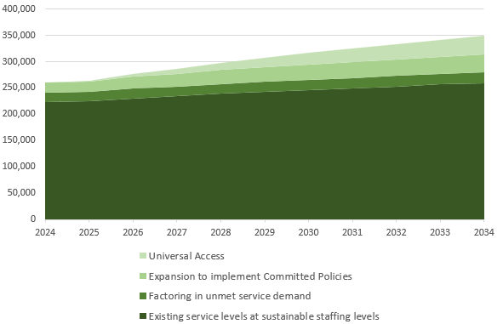

Source: Commissioned Deloitte Access Economics modelling for JSA ECEC Capacity Study.

## Future Workforce Supply and Emerging Gaps

This section presents analysis on future workforce supply and emerging gaps and covers supply of *Child Carers*, *Early Childhood Teacher* and *Childcare Centre Managers.* The section concludes with analysis of emerging gaps and findings.

The below occupational supply projection gives us an indication of supply trends if existing conditions are maintained. The number of qualified staff supplied is expected to increase by 2.0% per year over the next 10 years (or around 44,000 additional staff over the period) from the current modelled estimate of around 203,000 appropriately qualified staff. The biggest contributions to aggregate supply growth are expected to come from VET completions and ‘movements between occupations’.

### Supply of *Child Carers*

The supply of *Child Carers* is expected to grow over the next 10 years by 2.0% per year (or around 35,000 additional staff over the period). The *Child Care Worker* occupation is expected to experience the highest injection of supply from new training completions (1.9% per year) and movements between occupations (1.3% per year). Workforce inflows into the *Child Care Worker* occupation predominantly came from outside the ECEC sector. This includes both lower-skilled roles (such as retail or hospitality) and non-ECEC teacher roles, who may initially work as *Child Care Workers* before being qualified as *Early Childhood (Pre-primary School) Teachers*.

### Supply of *Early Childhood Teachers*

The *Early Childhood Teacher* occupation is anticipated to record modest supply growth increasing by 1.9% per year (or around 6,000 extra staff over the period). The occupation is expected to experience growth in supply mainly from ‘movements between occupations’ (1.9% per year). This is partly due to upskilling from other ECEC roles, with sizeable inflows also observed from Primary School Teachers (and to a lesser extent Secondary School Teachers), who may obtain an ECEC qualification or registration to work in preschool education.

### Supply of *Child Care Centre Managers*

The supply of *Child Care Centre Managers* is expected to increase by around 4,000 additional staff over the forecast period. The *Child Care Centre Manager* occupation is expected to experience the biggest net inflows (3.5% per year), with almost 90% of inflows into this role likely coming from other ECEC-specific occupations. Retirements for this occupation (1.7% per year) were also the highest, reflecting a workforce composed of staff that are older on average than the other ECEC occupations.

Table 4.3 Core Supply Projections by occupation 2024-34[64]

|  |  |  |  |
| --- | --- | --- | --- |
| **ECEC specific occupations** | **Total Staff Supplied in 2034** | **Additional Staff Supplied between 2024 and 2034** | **CAGR[65]%** |
| Child Care Centre Manager | 18,000 | 4,000 | 2.5 |
| Early Childhood Teacher | 36,000 | 6,000 | 1.9 |
| Child Carers | 189,000 | 35,000 | 2.0 |
| **Total ECEC Supply Workforce** | **247,000** | **44,000** | **2.0** |

Source: Commissioned Deloitte Access Economics modelling for JSA ECEC Capacity Study

Table 4*.*4 Contributions to National Workforce Supply growth 2024-34[66]

|  |  |  |  |  |
| --- | --- | --- | --- | --- |
| **ECEC specific occupations** | **Average annual (%) contributions to growth** | | | |
| **Retirements** | **New training completions** (students not working) | **Net overseas migration** | **Movements between occupations**  (Incl. working students) |
| Child Care Centre Manager | -1.7 | 0.4 | 0.7 | 3.5 |
| Early Childhood (Pre-primary School) Teacher | -1.4 | 0.7 | 0.7 | 1.9 |
| Child Carers | -1.5 | 1.9 | 0.7 | 1.3 |
| **Total** | **-1.5** | **1.6** | **0.7** | **1.5** |

Source: Commissioned Deloitte Access Economics modelling for JSA ECEC Capacity Study

### Existing and Emerging Gaps

Bringing together the bottom-up analysis of workforce demand and the analysis of ECEC workforce supply suggests that there is a current shortfall of around 21,000 qualified ECEC professionals needed to meet existing demand and support more sustainable working conditions.

Breaking this figure down further,

* There is a shortfall of 3,700 ECEC professionals just to meet the estimated enrolment to employment ratios currently in place (making no allowance for additional above-ratio staffing).
* An additional 700 ECEC professionals (more particularly, early childhood teachers) are needed to resolve currently approved ratio waivers.
* To move the workforce to more sustainable working conditions with better provision for ongoing professional development and reduced reliance on overtime would require an additional 16,400 ECEC professionals.

(As stated elsewhere, these are headcount figures and assume the average ordinary weekly hours remain unchanged.)

To meet estimated unmet demand for places from children not already in care and additional hours for children currently in services would require a further 17,700 ECEC professionals. It is important to note though that workforce shortfalls are not the only constraint to meeting this unmet demand – additional places would be required through capital investment and planning and regulatory approval to open new services and expand existing services.

Finally, to increase the number of places alter the mix of places to fully meet the participation levels intended by the changes to CCS and expanded preschool provision would require an additional 18,400 ECEC professionals (see Figure 4.3).

Figure 4.3 Nature of workforce shortfalls by component by workforce demand, 2024

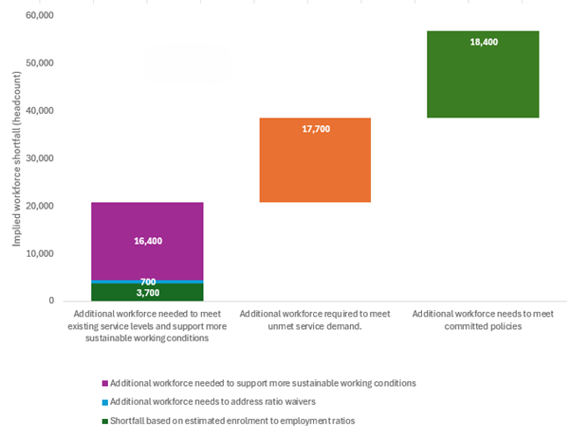Source: Commissioned Deloitte Access Economics modelling for JSA ECEC Capacity Study

Without any further intervention (such as wage increases), the shortfall of ECEC professionals to meet existing demand and support more sustainable working conditions would decrease to around 12,600 by 2034. This decrease is primarily due to a slight increase in projected workforce supply and changes in the expected population of children accessing services (both driven mainly by population forecasts).

However, the estimated additional workforce shortfall in order to meet unmet service demand would increase from 17,700 in 2024 to 20,100 in 2034. And as more states and territories begin to implement expanded preschool, the additional workforce needed to meet policy changes would increase from 18,400 in 2024 to 34,000 in 2034 (see Figure 4.4).

Figure 4.4 Nature of workforce shortfalls by component by workforce demand, 2034

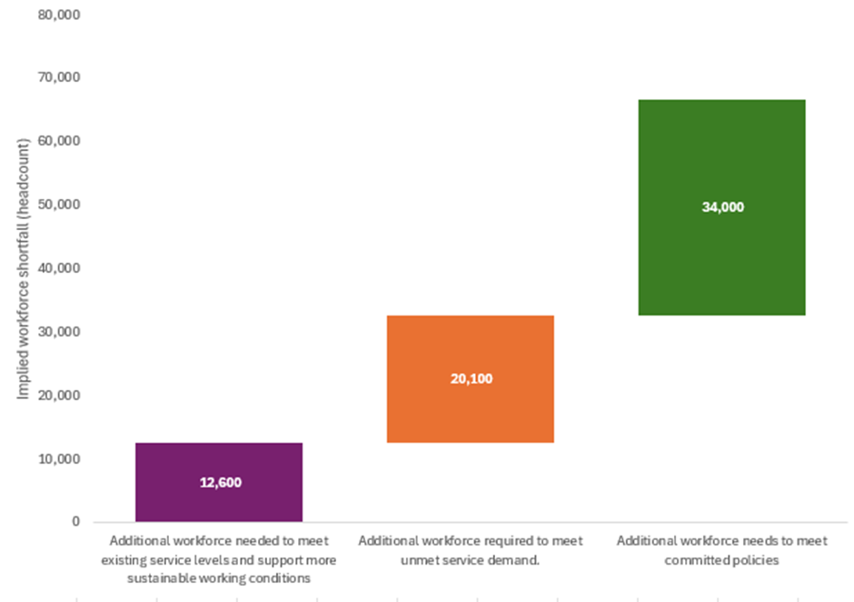

Source: Commissioned Deloitte Access Economics modelling for JSA ECEC Capacity Study

The current supply of active *Child Carers* is estimated to be just below the current demand level, without factoring in unmet service demand. The expected net growth in the supply of active *Child Care Workers* under current trends and workplace settings is not even sufficient to close the gap on current levels unmet demand, let alone respond to the expansion in service provision from committed policies. This would require settings to convert the potential workforce into active *Child Carers* on a sustained basis. Implementation of universal access is well beyond even the potential workforce.

Figure 4.5 Supply and Demand projections for *Child Carers*

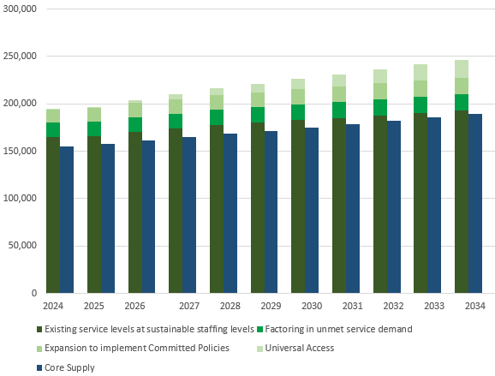

Source: Commissioned Deloitte Access Economics modelling for JSA ECEC Capacity Study

As for *Child Carers*, the net supply of *Early Childhood Teachers* is only expected to grow modestly under current settings and is not able to resolve unmet service demand. The forecast gap in supply of *Early Childhood Teachers* is expected to accelerate in particular from 2026, when planned policy commitments proceed to implementation.

Figure 4*.*6 Supply and Demand projections for *Early Childhood Teachers*

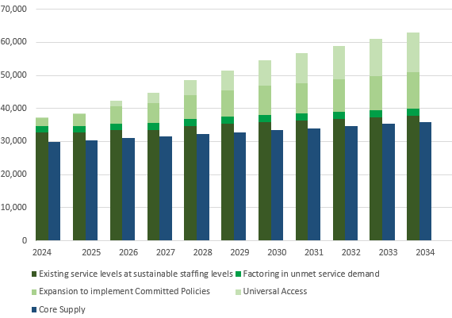

Source: Commissioned Deloitte Access Economics modelling for JSA ECEC Capacity Study

As shown in Figure 4.7, the same pattern of growing shortfalls for *Child Carers* is expected to impact *Child Care Centre Managers*. In practice, most *Child Care Centre Managers* are recruited from workers already in the sector. So while these projected shortfalls may not result in unfilled roles, they are likely to result in centres taking on candidates with less experience than they consider ideal, and an exacerbation of shortages for *Early Childhood Teachers* and *Child Carers* (especially room leaders and other Diploma-qualified staff).

Figure 4.7 Supply and Demand projections for *Child Care Centre Managers*

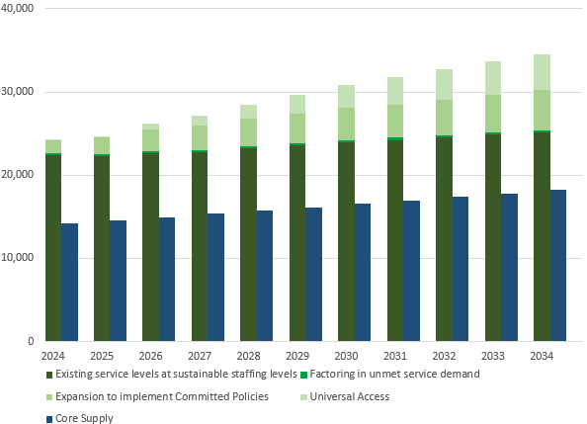

Source: Commissioned Deloitte Access Economics modelling for JSA ECEC Capacity Study

Finding - If current pay and conditions are maintained the sector will need to draw in aggregate supply for *Child Care Workers* from outside the labour force, requiring extra training effort and time and exacerbating existing workforce pressures. In 2034, the *Early Childhood (Pre-primary School) Teacher* occupation is expected to continue to record a shortfall in staff.

### Regional Dimensions

The Study Terms of Reference had particular focus on demand and supply at the regional workforce and projections were undertaken to support the foundational work of the study and drawing on submissions to the consultation.

Constraints in regional labour mobility are particularly important when considering the extent of workforce shortfalls across the country. That is, workforce shortfalls in one region may not be easily addressed by excess supply of workers in another region.

Figure 4.8 shows the share of SA4 regions that may experience workforce shortfalls, in 2024 and 2034. This assumes that labour mobility is constrained within an SA4, accounting for historic trends in relationships between place of usual residence and place of work (for example, that inner city regions continue to benefit from workers in other regions). However, it assumes these remain fixed, and does not allow labour to move freely between regions.

Finding - When examined at the regional (SA4) level workforce shortages are apparent in most regions across major cities, regional and remote Australia and are projected to persist over the next ten years.

Figure 4.8 Share of regions experiencing localised shortages, assuming labour mobility within an SA4[67]

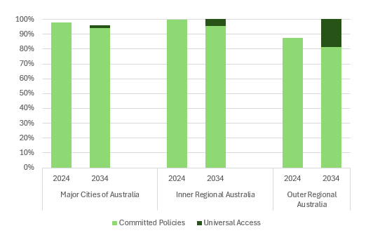

Source: Commissioned Deloitte Access Economics modelling for JSA ECEC Capacity Study

## Summary

This chapter has explored the implications on demand and supply for the ECEC sector.

The modelling illustrates that there are likely to be workforce challenges for the sector particularly under ‘Committed Policies’ and ‘Universal Access’ scenarios. This will lead to a substantial increase in staff demanded across the sector particularly *Early Childhood Teachers*.

The biggest shortfalls for ECEC staff at the SA4 and regional level are likely to be within the major city areas.

It should be noted that the modelling presented in this chapter is indicative of the challenges that the sector may face in the future. However, it should be kept in mind that there are uncertainties that come with any modelling exercise.

This chapter has highlighted the regional and occupational shortfalls for the ECEC sector. The final two chapters in this study will outline strategies for consideration to overcome these shortfalls in the sector.

# Chapter 5: Sustainable and Ongoing Learning and Development

Learning is fundamental to the delivery of early childhood education and care. As a sector immersed in lifelong study for regulatory and quality purposes, learning is the core mission for children in Australia (as enshrined by the objectives and guiding principles of the National Law).

This chapter is organised around answering the following core questions:

* How does the education and training system prepare future ECEC workers?
* What is the attractiveness and suitability of the apprenticeship/traineeship model (for higher level as well as introductory roles)?
* How can we ensure a balance between training package content, meeting the requirements and intent of the NQF, and ensuring that learners can successfully engage with their course?
* How do the arrangements for work placements across VET and higher education courses align with the requirements for services? How does this ensure high-quality ECEC?
* How can well-supported and continuing professional development be facilitated for those within the workforce?

The Study engages with a ten-year horizon and seeks to consider how training requirements and educational developments may impact future workforce preparation. Such long-term foundations will be developed by looking at more than just attracting new workers through training pipelines and upskilling existing workers. A sustainable pipeline should also recognise and reward the informal learning that takes place to support new skill development, and general day to day practice development and improvement which is underpinned by the NQF.

Broadly, the existing qualifications and delivery mechanisms continue to serve the sector well but there are some tensions and gaps relating to:

* The appropriate content for the Certificate III in Early Childhood Education and Care as the bedrock qualification and related to this, the content for the Diploma in Early Childhood Education and Care.
* Absence of skillsets to enable enhanced support for educators and early years teachers other than to supervise children and help with administration, including safety and compliance documents and learning activity preparation.
* Enrolment arrangements for the Diploma of Early Childhood Education and Care that may be too strict.
* Barriers to timely completion of qualifications for those employed.
* The strain for the existing workforce arising from a large increase in Certificate III traineeships to meet workforce demand due to the increased need for mentoring and supervision arrangements.
* Accessibility of work placements, lack of financial support for VET and higher education students while on placements (or being able to count current employment towards placements).
* A lack of flexibility during acute workforce shortages to recognise the potential for professionals with alternative qualifications to substitute for *Early Childhood Teachers* where there is already at least one ECT employed in the service.
* Lack of access to funded training for international students and concerns about potential exploitation of people while studying.

There is also an opportunity to foster a more supportive environment to assist more First Nations Australians to complete qualifications.

## ECEC - An Applied Vocation

The Early Childhood Education and Care sector is fundamentally based on a workforce engaging in an education paradigm with a vocation to deliver high quality learning experiences to children while assuring their care. In consultations, stakeholders emphasised the importance of considering aspects of vocational orientation in understanding sector dynamics: The orientation towards quality delivery for children was affirmed by stakeholder submissions as critical to all training within the early childhood sector.

Fenech and Watt also emphasised that the intrinsic vocation was what most influences quality in ECEC workforce delivery:

Intrinsic supports and motivators—passion, commitment to high-quality ECE, and a drive to improve practice—and not extrinsic regulatory requirements (Fenech & Watt, 2022)

Notably, all ACECQA accredited courses are practice orientated, evidencing the vocational orientation of VET and higher education routes to practice. There are strong links between learning and work throughout all services, particularly those that are able to offer traineeships and placements (which excludes FDC and IHC). Informal learning at work, including mentoring on the job during and post qualification, is a core feature of the ECEC sector. The ability to learn within the workplace is another essential component of training pathways into all areas of ECEC and barriers to education and training can constrain worker supply. With approximately 130,000 people studying ECEC qualifications in VET or Higher Education each year (as at 2022) and a workforce of around 240,000 according to the 2021 NWC early childhood is fundamentally entwined with formal learning.

### Quality and Qualifications

Quality of delivery of early years learning is embedded through the regulation of the NQF and approved learning frameworks in recognised training pathways. The workforce has been shaped by regulations introduced in 2011, updated in 2018, and further changed in 2023. Moreover, outcomes of the 2019 NQF review will only be fully in force from July 2024. Regulatory intervention has been significant in changing not just technical aspects of service delivery, but the engagement educators have with their work and the introduction of workforce higher level qualifications such as Diploma and degrees have been shown to have an empirical link (Jackson, 2018).

While this professionalism is felt within the sector and evidenced through professional activities, the status of early years educators and the sector is not universally recognised. Throughout JSAs’ engagements and research, stakeholders called for greater recognition. Workforce development strategies including *Shaping Our Future –* the  *National Children’s Education and Care Workforce Strategy* and state and territory based strategies as well as strategies targeted to the First Nations workforce are in place to continue this enhancement work. Raising the status of the ECEC profession and ensuring ‘greater public recognition of the importance and complexity of ECEC work’ (Jackson, 2018, p.28) will likely be achieved in part through greater understanding of the intensive nature of ECEC training pathways.

The 2023 Interim Draft Productivity Commission report still notes a lack of evidence proving the link between staff qualifications and children’s outcomes (also observed by the PC in its 2014 report) and noted in ACCC (2024) report.

Qualifications function as a signal in the employment market without extensive quantitative evidence of a link between content/curriculum and quality outcomes nor pedagogic specific markers linking to effectiveness. Although a more highly qualified workforce is universally considered important, there is even less information about the mix of qualifications needed to deliver high quality ECEC. Certain approaches within ECEC settings, including guided learning and play and leisure-based pedagogy, enhance children's exploration of the world. Incorporating these approaches in ECEC settings is therefore important for improving quality outcomes for all children. There are indications that professionalisation of the workforce drawing on capability approaches can contribute to transformative learning experiences (Molla & Nolan, 2019).

Finding - Developing the ECEC profession and assuring high quality workforce practice is linked to high quality qualifications delivery and assessment and availability of ongoing professional development, including relating to child safety.

**Recommendation -** Services and ECEC workers delivering high quality ECEC, quality assessments, and improved professional development are identified, and their practices disseminated across the sector. Pathways could potentially include through the proposed *Shaping our Future* national professional practice network, or through development of additional recognition and incentive tools by governments.

#### First Nations Quality Delivery Needs

A key part of the *Closing the Gap* targets 3 and 4 that focus on the early years is to ensure that children engage in high quality, culturally appropriate ECEC. The *Sector Strengthening Plan: Early Childhood Care and Development* supports the *Closing the Gap* target and aims to achieve increased service delivery, coverage, capacity, quality and resources for Aboriginal and Torres Strait Islander community-controlled organisations. Culturally responsive training to facilitate First Nations children’s engagement in ECEC is linked to ensuring First Nations staff are well-represented in the workforce. In the *Closing the Gap National Agreement* under Clause 45 a key element of a strong sector is sustained capacity building and a dedicated, appropriately trained and identified Aboriginal and Torres Strait Islander workforce.

Regulatory training pathways and strict higher education qualification requirements for entry into the ECEC workforce have been noted by sector stakeholders as largely insufficient in developing capacity for a well-represented First Nations workforce, particularly for regional and remote Aboriginal communities. Particular concerns were raised about culturally appropriate delivery, coverage of Indigenous knowledges, understanding of First Nations care approaches and lack of flexibility in teaching modes or assessment to accommodate for cultural or family needs.

In the JSA-led topic-based discussion sessions multiple barriers faced by individuals from regional and remote communities were noted when pursuing a career in ECEC. The barriers identified relate largely to successful completion of ECEC formal qualifications, more specifically the Certificate III, and include the following: language barriers for those with multiple First Nations languages, the level of achievement expected of those who complete the Certificate III (the majority of stakeholders, even when referring to urban areas, considered the Certificate III as unduly complex), and a lack of access to and opportunity for 'taster programs’ and flexible learning modes. In the same series of JSA-led discussion sessions, another stakeholder noted that they had witnessed many students from regional and remote communities struggle to complete the ECEC Certificate III despite being committed to working with and educating young children due to some of these barriers as well as the modes of delivery not taking into account the needs of the community.  
In their consultation paper submitted to JSA, SNAICC – National Voice for our Children reiterated these concerns:

Workforce shortages are compounded in regional, rural and remote areas where there is high Aboriginal and Torres Strait Islander unemployment and an ageing workforce. Recruiting and retaining Aboriginal and Torres Strait Islander staff challenges in some communities stem from difficulties attaining the qualifications needed, the transient nature of some community members (particularly in remote communities), and stressful working conditions exacerbated complex needs of children and families. (Submission 8)

Through submissions, stakeholders contributed understandings about the importance of Aboriginal Community Controlled Registered Training Organisations (RTO) which provide culturally embedded training options with wrap around support for Aboriginal and Torres Strait Islander students. This kind of support has been shown to be critical to strong completion rates and learner success. Stakeholders further noted that ACCOs receive no baseline operational funding and are solely dependent on a dollar per training hours payment.

A proposed solution to several of these critical issues impeding the development and expansion of the First Nations workforce, which is noted in Chapter 3 as lacking representation particularly at the higher qualified occupations, was suggested by SNAICC – National Voice for our Children as being to:

Acknowledge and explore the critical role of ACCO led registered training organisations (RTOs) in supporting Aboriginal and Torres Strait Islander workers to gain ECEC qualifications and highlight the importance of these organisations being sustainably funded on an ongoing basis. (Submission 8)

Finding - First Nations leadership of education and training providers has been shown to make a significant difference to access and success of First Nations students. However, there are relatively few Aboriginal Community Controlled education and training providers delivering ECEC qualifications for First Nations Australians. For these and other reasons the First Nations community may be poorly served by education and training pathways into ECEC, particularly for higher education routes including relating to curriculum, assessment and delivery arrangements.

**Recommendation -** Governments examine the viability of current funding arrangements for ACCO led registered training organisations (RTOs) and higher education providers in supporting Aboriginal and Torres Strait Islanders to gain ECEC qualifications.

**Recommendation -** Ensure that all education providers have strategies e.g. reconciliation action plans, including explicit engagement with culturally safe, appropriate and responsive curriculum, assessment and delivery arrangements.

|  |
| --- |
| CASE STUDY – Developing the local workforce by delivering locally  One Tree Community Services (One Tree) is a not-for-profit ECEC service operating across Australia. The One Tree centre in Kununurra within the Kimberley region of Western Australia operates as an ECEC service with multiple trainees studying through One Trees RTO. This centre develops the local workforce through their RTO status and can internally support training opportunities for staff. One Tree in Kununurra have many local Aboriginal people working in the service at various levels, including those working towards certificate and diploma qualifications. The responsive nature of One Tree means it has been able to operate at full capacity and has built a positive reputation in the region for being an employer of choice. Additionally, One Tree’s RTO supports other services in the region through free traineeships, supporting local skill development in early education and care more broadly.  *Submission 32 – Regional Development Australia (RDA) Kimberley* |

### Qualification Pathways

The ECEC Sector draws on both VET and higher education sectors for its formal qualifications, with most ECEC providers requiring a staff mix that draws on strengths from both sectors.

Shaping Our Future Stratification typically relates to current occupational need, which obscures the true content and attainment when most if not all of those with a diploma also hold a Certificate III and this is a desired outcome for sector quality. Stakeholders affirmed that it was of great importance that qualifications had a consistent alignment with AQF levels as well as alignment with job roles. (Submission 2 – A peak educational body)

While maintaining well established pathways, it is not clear that the current ECEC training pathway segmentation will provide a sufficient pipeline for the sector on an ongoing basis, even if the uncompetitive wage and workplace conditions issues are addressed (see Chapter 6). This segmentation is determined by qualification level: entry level Certificate III ECEC training, intermediate diploma qualifications and *Early Childhood Teachers* requiring a four-year degree often embedded alongside primary school teacher training courses.

The next sections report on stakeholder insights and draw on earlier data presented in Chapter 3 on educational and training enrolment, completion and characteristics.

#### Certificate III

The current Certificate III ECEC CHC30121 was released July 2021. There are 23 units approved including 14 core units. Emerging sector feedback indicated an overall concern about the level of complexity of the Certificate III ECEC qualification (submission 2 - a peak educational body) as well as related to breadth and possible delivery modes of the qualification. There were stakeholder calls for the Certificate III ECEC qualification to be confirmed as the core bedrock qualification but perhaps somewhat redeveloped to support success of learners often in their first post-school qualification (submission 5 – Swinburne University).

The course load of the program is noted to be large, in common with many complex training package qualifications with rich and deep practice contexts. There was significant feedback from the sector on the knowledge elements of the qualification and involved nature of many of the units. Consultations reflected on the competency based nature of the VET qualification and the appropriateness of involved knowledge requirements at the Certificate III level.

Complexity, especially knowledge of theoretical and conceptual understandings, is one suggested factor contributing to ongoing concerns about completion rates, at a low in 2020 during COVID against all other completions but in 2022 interim figures have now aligned with previous rates. There were some concerns raised about whether the influx of entrants in response to fee-free TAFE may have impacted completion rates, but little evidence on completions is available as yet. Submissions attest that course attrition and retention are being negatively impacted by the current Certificate III ECEC (CHC30121) training package (submission 21 - TAFE Directors Australia) and further contributed that:

Feedback also reported that with recent changes to the Certificate III (becoming the entry requirement for the Diploma of ECEC), the Certificate III is now more challenging than a standard Certificate III…resulting in non-completions of the Certificate III and a drop in enrolment. (Submission 51 - A peak workforce development body)

While published data shows national increases in VET in Schools enrolments, particular issues were raised about the requirements of the Certificate III ECEC in current senior secondary pathway arrangements. It was noted that in some jurisdictions these pathway arrangements are potentially causing delivery challenges in the school sector where students cannot include the Certificate III part of any ATAR calculation and therefore have to undertake a heavy academic load so that they receive an ATAR (individual submission 18).

There were further concerns related to the breadth of the qualification, which is currently designed to serve a range of service types including IHC, FDC and OSHC and CBDC. Some responding to the ECEC Capacity Study consultation paper saw this as a concern:

The content of the current Certificate III in Early Childhood Education and Care (CH30121) is largely geared towards preparing educators for work in CBDC settings, in particular long day care. Work placements also focus on long day care settings. (Submission 40 – Family Day Care Australia)

A significant gap arose in the access for OSHC Educators to a Certificate III level qualification. (Submission 49 - National Outside of School Hours Services Alliance)

While it is noted that there is a drive towards reducing specialisations in VET qualifications, there are needs in the diverse ECEC sector for different content delivery, opportunities for use of clusters of units for specific service types and also use of skillsets.

The assessment in courses were raised as concerns which add to complexity, including rigidity in assessment as explained by this submission:

Trying to break assessing human interactions into discrete lists of competencies often does not support the nuances of quality human interaction. (Submission 2 – A peak educational body)

To this end methods of assessing workplace based learning both in placements and in continuing professional development need investigation. There is opportunity to consider third party assessments, previously mooted by NCVER (Misko, J. & Halliday-Waynes, S., 2013) and this is intensified by some of the extensive assessment requirements noted in this submission:

A core unit CHCECE035 has 37 performance criteria and 46 pieces of knowledge evidence. (Submission 33 - Individual)

Further noted is the difficulty in assessing the invisible skills critical for success in the ECEC workforce that are used by early childhood educators but are often an implicit part of assessments. Stakeholders suggested that there are existing skills in the workforce that are used every day that can be better recognised, which is largely linked to the lack of recognition to gender biases in the workforce.

Finding - The Certificate III ECEC is the bedrock workforce qualification across service types. However, there is a widespread concern across the ECEC sector that the current content of Certificate III ECEC is too complex and broadly focused. Current delivery methods of the Certificate III ECEC also contribute to making success in ECEC more difficult for some cohorts, including delivery in schools. The block-mode delivery requiring intensive focus away from family or community, and for those with differing levels of literacy.

**Recommendation** - HumanAbility to review the current content of the Certificate III in Early Childhood Education and Care, in collaboration with States and Territories, to identify opportunities to reduce the complexity of the learning outcomes, without detracting from quality.

**Recommendation** - HumanAbility to consider how the national training system can better support more graduated pathways into Early Childhood Educator roles. Education and Training Providers should work with Governments to continue to develop and fund programs that will provide an accessible pathway into Early Childhood Educator roles by:

1. encouraging development of pre-employment programs.
2. assessing the appropriateness of SkillSets for different service types where the full qualification is not nationally mandated for workforce (particularly OSHC) including reviewing existing OSHC SkillSets.
3. incentivising the development of resources to support high quality simulated training and assessment before on the job placement.

**Recommendation** - Governments should support completions of ECEC qualifications in school-based apprenticeships and traineeships to ensure sustainability and drive access. As a senior secondary pathway alternative, consider supporting the further development of a taster skillset designed to be delivered in VET in schools and other settings with explicit arrangements with RTOs and ECEC providers that support the student to complete the Certificate III in Early Childhood Education and Care.

#### Traineeship Routes

As noted in Chapter 3, the number of traineeships in the sector has more than doubled since 2020. Certificate III ECEC traineeship enrolments have increased significantly over the last five years, with an 85% increase between 2018 and 2022. This is a larger increase than all ECEC VET enrolments over the same period (7%),and has impacted on the wider workforce with the increased need for supervision in the workplace which is a critical part of delivery of traineeships. Traineeships are an attractive pipeline for the ECEC workforce and appeal to employers and students as noted by this submission:

The traineeship’s blended learning approach, where students can earn and learn, is a very effective model. (Submission 15 - Chisholm Institute)

One-fifth of ECEC VET students undertake study as part of a traineeship. During JSA's consultations and submissions, questions arose as to whether this mode could be expanded or extended to new qualifications. There were barriers noted to the expansion of traineeships, which include lack of flexibility, however the advantages for students were also commented on by stakeholders:

Most candidates need to earn and learn so traineeships are attractive. They are also attractive to employers, however, the deficit in these programs is in the effective mentoring/coaching and support from team members with consolidated and good practice. Traineeships and other workplace delivery models get workers and students into services and working with children while they study (Submission 21 -TAFE Directors Australia)

Other emerging trends, as discussed in Chapter 3, include growth in some jurisdictions of diploma traineeships. The rise in traineeships includes the provision of traineeships in large ECEC providers who have their own RTOs offering qualifications and upskilling to staff, as also noted by the ACCC (2023a). These affordances are not available across all service types, however, noting IHC and FDC cannot host traineeships, due in part to their workplace structures.

**Finding -** Traineeships form a critical part of the workforce pipeline and should offer a well-supported way to earn and learn. In an expanding system, new trainees are very important, but the recent, very large influx of traineeships (doubling since 2020) has produced a bottleneck for senior staffing in terms of meeting regulatory compliance and on-the-job mentorship.

**Recommendation -** The sector should systematically recognise the role of senior and experienced staff in supporting trainee induction, development, assessment and mentoring. Classification arrangements and role descriptions (including in any relevant Award review) and in allocation of non-contact time is also in scope.

#### Diploma

The Diploma is a critical qualification for the delivery of ECEC and facilitates the room or group leader role. These roles have been recognised by an interim change to the existing *Child Care Worker* ANZSCO occupation and may be formalised by the ABS Comprehensive Review of ANZSCO recommendation where the preliminary proposed changes create a separate occupation for those educators qualified with diplomas. The importance of diploma qualified staff is great recognition for the ECEC workforce, and a particular shortage of these experienced and qualified educator staff was noted after COVID-19, as observed by a stakeholder:

There is a growing shortage of experienced educators especially at the Diploma level, due to dropping enrolments and changes to eligibility requirements for the qualification. (Submission 38 - Community Child Care Association and Community Early Learning Australia)

Many ECEC educators after a period in the sector have traditionally progressed to a Diploma with high rates of employment during Diploma study. However, a peak workforce development body noted:

The Diploma is additionally onerous for existing workers in the sector who are expected to undertake this study while maintaining their employment. (Submission 51)

The current version of the Diploma ECEC was approved in July 2021 and last had a major review leading up to 2021. There are 26 units approved. Stakeholders noted the changes in the recent training package which included stringent entry requirements for entrants to hold either the CHC30121 Certificate III in Early Childhood Education and Care or the CHC30113 Certificate III in Early Childhood Education and Care which were framed by stakeholders as a qualification progression barrier as experienced educators are not progressing to higher qualifications (individual submission 33 & a peak educational body submission 2). Submissions noted additional changes such as the lack of crossover or study credits for any earlier Certificate III ECEC completed, unlike in earlier iterations of the training package (submission 51 - a peak workforce development body).

The drop in diploma enrolments has been explored in Chapter 3 and as key evidence to this:

Rather than bar on re-consider the concept of ‘non-current’ qualifications as not being suitable for course progression. A registration/currency process would be more beneficial. (Submission 21 - TAFE Directors Australia)

**Finding -** The role of Diploma qualified educators is the fulcrum of the long day care setting and Diploma enrolments have fallen in recent years. A contributing factor is that the Diploma entry requirement of a completed Certificate III for ECEC within the two most recent training packages, and the minimal pay increase associated with the higher qualification, has discouraged Diploma enrolments since 2021.

**Recommendation -** States and Territories should examine ways to support enrolments in ECEC Diploma courses, including by not limiting the time since completing the Certificate III in Early Childhood Education and Care which allows for staff currently working in the sector to access funding.

**Recommendation -** HumanAbility should review training package arrangements to ensure they are fit for purpose. Further considerations could include developing a bridging course for the current Diploma ECEC targeted at educators returning to the sector who already hold a recognised ECEC qualification but have not worked in the system for several years, or potentially expanded to those transitioning from adjacent sectors.

#### Higher Education Routes

*Early Childhood Teacher* roles requiring higher education are important to the delivery of education in early years settings and noted in Chapter 3 and 4 as a particular workforce shortage now and in the future. ECT courses are delivered either as covering 0-5, 0-8 or 0-12 years with the latter two covering primary school teaching qualification. Thus, many of those enrolled in degrees which cover early childhood education may be pursuing or may ultimately choose primary school teaching.

In recent years, the Bachelor of Education has been a common route for qualifying as an *Early Childhood Teacher* but lately there have been diverse higher education products developed at the AQF 8 level. Shorter, work-based, often online Graduate Diploma options are becoming popular, particularly as they occasionally enable recognition for paid work. However, stakeholders shared concerns about the quality of the accelerated routes, particularly if they did not combine intensive teaching nor require previous study and experience. These courses are often targeted at experienced early childhood educators holding Diplomas.

Novel training providers from non-university settings are entering the higher education ECEC market with exponential growth in enrolments. This includes the widespread adoption of ECEC bachelor degrees in TAFE, despite the lack of availability for Commonwealth Supported Places for domestic student higher education at these providers.

There are other emerging developments in the higher education space, including the introduction during COVID-19 years of undergraduate certificates which may bridge between Certificate III ECEC and Bachelor of Education programs. Further, noting the increased need for placements due to the rise in higher education enrolments, there have been a range of promising delivery practices shared as part of the consultation for this study. Individual providers and Federal and jurisdictional governments have implemented programs to support *Early Childhood Teacher* training. This includes accelerated and asynchronous approaches delivered in innovative settings and modalities and practicum exchanges. Across the teacher education sector there are discussions on the appropriate development of degree apprenticeships and how they may contribute to workforce development.

**Finding -** A key issue contributing to the shortage of Early Childhood Teachers is leaks in the pipeline from dual accredited degree courses. Education providers frequently offer Early Childhood and Primary School training as a combined course. There are significant sectoral concerns particularly with crowded curriculum in dual accredited accelerated courses and in the 0-12 years accredited routes. The ECEC sector may be less served by shared training, since graduates are more likely to seek work in schools, typically offering better pay and working conditions which makes the sector less competitive.

**Recommendation -** Governments should seek to improve completions in ECEC by:

1. continuing to support paid placements within ECEC with potential outcome measures relating to time spent work in the sector or in regional or remote settings.
2. scoping career changer accelerated programs for ECTs aimed at those working in related sectors with some educational or development education.
3. reconsidering any arrangements within the Higher Education Loan Program that create inequity between universities and other institutes of higher education, incentivising students to enrol in one over the other.

**Recommendation -** Accreditation authorities and education and training providers to consider:

1. accreditation of exit awards, particularly higher education diploma level qualifications after the first year to recognise partial/progress completion of bachelor’s degree at AQF Level 5 as equivalent to a Diploma.
2. investigation of space in higher education programming to enable a Certificate III in Early Childhood Education and Care to be undertaken alongside Tertiary Primary School Teaching study in a concurrent mode, using RPL or similar.

**Recommendation -** Noting the importance of child safety within the context of teacher registration, progress national teacher registration alignment to enable movement between jurisdictions of qualified ECTs and for teachers from other sectors willing to upskill with ECEC qualifications. Continue to support refinements in overseas assessment recognition of ECT courses.

**Recommendation -** In meeting and filling persistent and ongoing workforce shortages for ECTs, ACECQA and jurisdictions could consider reviewing the definition of a ‘suitably qualified person’ including the potential, possible temporary, inclusion of other non-teaching degrees which provide a sound foundation for Early Childhood Teacher capabilities.

As noted in Chapter 3 there have been significant increases in international students, particularly in higher education and an emergence of post-graduate *Early Childhood Teacher* courses at non-university higher education courses. During consultations there was testimony of concern for international students’ welfare which align with national issues about knowledge of work rights and understanding of entitlements. Further there was also interest in supporting newly arrived international students’ understandings of Australian society to smooth their transition into workplaces on placement. Some early integration issues were also seen by stakeholders to be linked to education providers use of academic IELTS[68] which is less orientated to a practice based vocation such as early childhood where students will need to be interacting early in their course in workplaces.

Finding - International students have been a recently increasing cohort, particularly in early childhood teaching courses, it is important to ensure that supports are in place to support them and their workplaces.

**Recommendation -** TEQSA and ASQA should ensure education and training providers have plans for the protection of international students in settings to prevent misunderstandings of employment arrangements including hours of work and duties.

**Recommendation -** Higher education institutions may consider whether the Professional IELTS is more appropriate than the Academic IELTS for Early Childhood Education courses.

**Recommendation -** Higher education institutions should ensure that progress assessment protocols within accredited courses particularly for newly arrived international students are robust to enable students to have time to settle into their new national contexts and professional identities before placements. ACECQA should continue to offer eLearning induction materials provided as part of *Shaping our Future*.

### Delivery of Qualifications

A key interest throughout the Study was supporting educational innovation in course providers, including shorter or embedded courses and noting growing popularity of accelerated courses without compromising quality. Further, there is rising discussion within the sector about the delivery of short form or microcredential elements to qualification delivery, including with a *Shaping Our Future* focus area. However, stakeholders in submissions and consultations cautioned on the use of microcredentials and noted that they ‘must not be used to displace the minimum current sector certification requirements’ (submission 46 – a peak body).

There was overall feedback from stakeholders that training package content needs a better balance between meeting the requirements and intent of the NQF and ensuring that learners can successfully engage with their course. Some of this concern was also aligned with the need to offer multiple formats for study while still managing risks of attrition, which is anecdotally more common with online provision. There are significant advantages to online and flexible delivery options as described by this stakeholder:

Technology also provides opportunities to remove barriers caused by location and provide access to quality ECEC for children who may be unable to access it otherwise. Exploring flexible solutions, such as the online delivery of early childhood education combined with in-person care, could allow Early Childhood Teachers to support more families than they would if they had to physically attend each location. (Submission 19 - The Hon Fiona Nash – Regional Education Commissioner)

There might be opportunity to expand the traineeship model to include aspects of career progression, including diploma traineeships and potential degree apprenticeships. This includes foreseen opportunities to link traineeships to higher education degrees, including postgraduate study and cadetships.

As well as formats of study, the availability of training was raised as an issue. The importance of ensuring that there are adequate numbers of quality RTOs to deliver training, particularly in regional areas (submission 29 – Local Government NSW) was raised in multiple submissions. This was important both for access and equity but also has benefits for early years delivery connected to local communities and without the financial burden of moving away (submission 46 – a peak body).

Quality of training delivery was of consistent interest throughout consultations and submissions with feedback from many sources indicating that while great improvements have been made, vigilance about quality of delivery must be maintained. Comments included:

[...] significant feedback about the poor quality of many Certificate III courses available online, in particular from some private providers. This suggests there needs to be better oversight / quality control of providers and their course material to ensure a reliable pipeline of family day care educators to meet the future needs of families. (Submission 40 – Family Day Care Australia)

Unfortunately, deficits exist in these programs within ongoing coaching and mentoring required both from training provider and employer. (Submission 5 – Swinburne University)

Investigate consistency within higher education and vocational education content and quality standards, meeting current and future-focused needs of team entering and engaging with the sector. (Submission 35 – An ECEC provider)

Reflecting on novel skills and capability requirements, we note that there have been impacts on skill development in some VET courses as RTOs moved to reduce centre visits. A decline in the basic knowledge of child development and the planning and assessment cycle has also been noticeable in graduates of both VET and Higher Education ECEC courses. (Submission 12 – Goodstart Early Learning)

#### Placements

There are structural barriers to on-the-job assessment within VET and higher education due to barriers to recognising on-the-job hours as work integrated learning, requiring unpaid placements for ECTs. Placements as a formal part of qualifications and placement poverty across educational sectors are key issues.

The Certificate III in Early Education and Care includes a compulsory 160 hours of work. Unpaid work placements required for the achievement of the qualification can be a barrier to students completing or enrolling. Registered Training Organisations have also reported that there are often challenges in accessing employers willing the provide the hours of work. (Submission 10 – A peak educational body)

There are opportunities to develop high quality protocols to recognise other ECEC work as contributing to placement requirements. Stakeholders also suggested the ability to recognise placement in related fields such as primary teaching could be considered. The limiting of placements to initial training in formal qualifications was also raised as a concern, as well as the ability to include placement in workplaces other than one’s own as part of continuing professional development. Potentiality for specialised roles such as inclusion support and other innovative work-based learning opportunities were foreseen by this stakeholder:

Immersion courses that allow prospective students to complete some units and a placement before starting a traineeship is also valuable. (Submission 24 - KU Children's Services)

It is noted that there is considerable attention on this issue at the moment including financial support for students while on placements, noting the 2024 Federal Budget announcement for higher education placement support. Researchers are particularly interested in how these institutions are navigating potential opportunities for students to undertake professional placements in their own workplace.

There are opportunities that grow from facilitating educator growth and development in the workplace. Currently, many studying towards an ECEC qualification already work in the sector, but this paid experience is not recognised as contributing to their training and it is noted it is important to have experience outside one workplace.

Australian Children's Education & Care Quality Authority (ACEQCA) requirements have made it increasingly difficult for higher education settings to recognise work experience via subject or placement credits. For example, placements undertaken in Diploma studies cannot be credited toward Degree programs. (Submission 23 – La Trobe University)

Similarly, as people gain more experience after their first qualification, this learning and development could be better acknowledged in formal and informal recognition of career progression.

**Finding -** Many students enrolled in ECEC courses also work in the sector. However, outside formal traineeships employment experience only in specific situations counts towards their qualification, raising concerns about placement poverty. This places pressure on the system of placements, where there are significant hours required in both VET and higher education ECEC qualifications. This may also place significant financial strain on students, noting current plans to introduce paid placements for higher education students.

**Recommendation -** To support an ongoing pipeline of well qualified workers completing qualifications in a timely fashion, there should be consideration of financial investment in ‘wrap-around support’ for existing educators to attain higher qualifications e.g. paid study leave and the negotiation of study calendars and assessment that fit in with workplace needs.

**Recommendation -** In order to support the career progression of people with primary carer responsibilities, training providers in VET and higher education should have explicit strategies for the inclusion of parents in key ECEC courses. This includes ensuring there are processes in place to identify the cultural and family needs of the learner cohort and ensuring reasonable access to support services including for the education and care of children and other supports for parents such as scheduling for training, placements and assessment with consideration to cultural and family needs.

#### Curriculum and Content

The content of courses that lead to an ECEC outcome is linked to the approved learning frameworks and all courses are accredited by ACECQA. However, there was much feedback from stakeholders on inclusion of key items in curriculum. Many of those suggested are already present in programs but they are contributed here to ensure that novel curriculum developments are noted. A list of all curriculum areas noted from stakeholder feedback as critical for development are as below:

Figure 5.1 Curriculum areas noted from stakeholder feedback

Cultural and linguistic​

CALD specialisms including in-language delivery​

Cultural and linguistically diversity training​

​

First Nations​

Cultural awareness for workforce beyond Cert III mandatory unit​

Aboriginal and Torres Strait Islander ECEC focused routes​

Understandings of First Nations conceptions of care and kinship​

Indigenous knowledges​

​

Inclusion needs​

Trauma informed approaches​

Family liaison training, including identification of need​

Integration Allied health settings integrated in early years​

Training for inclusive settings / children with disabilities (in receipt of NDIS)​

Inclusion / behavioural related (including those children not in receipt of NDIS)​

​

Workforce supports​

Delivering in remote and regional areas​

Driving requirements​

Training to safely provide all hours care​

Leadership​

Pedagogical leadership​

​

Digital​

Digital delivery / supervision issues (particularly training)​

Digital safety​

Augmented reality​

​

Enhancements​

Cooking specialisms​

Environmental education for bush kindergartens​

Augmented reality​

Source: JSA, ECEC Capacity Study stakeholder submissions and consultations

There are also structural constraints within the VET system, both within the training package design and expediency of delivering such a dense course to a large cohort of students. There were queries raised about the programming of VET courses which were said to be delivered with little scope for electives which was a particular issue for some service types such as IHC and OSHC. There were also specific concerns about content inclusions:

The main barrier to completing the entry-level Certificate III qualification can be found in the course content. Since the focus of this course is on regulatory requirements, it lacks units that provide students with the skills to work with children. Although understanding regulatory requirements is vital, it needs to be balanced out with students learning fundamental skills. (Submission 47 - Aspire Learning and One World for Children)

Current training package design means that the current ECEC qualifications lack content around play-based pedagogies in areas of language and literature, STEM, creative arts (such as drama, music, dance, visual arts, etc.) as well as content on child development and how to support development. This is counterintuitive to the reasons those wishing to enter the sector do so – i.e., to learn how to apply play-based pedagogies and advance children’s development. Feedback received from both students and industry is that the lack of training package focus on these important areas of skill development leads to a lack of engagement which results in lower retention and greater withdrawal rates from ECEC qualifications. (Submission 2 – A peak educational body)

Another key issue raised by stakeholders is the current underrepresentation of First Nations practices and traditions in the Certificate III. The current unit in the Certificate III ECEC 'CHCECE054 Encourage understanding of Aboriginal and/or Torres Strait Islander peoples' cultures’ while thought of as robust, does not engage in sufficient depth for extended understanding. It is therefore essential that we reconsider the specific needs of First Nations people, including remote and regional Aboriginal communities, and include greater cultural content in the Certificate III in order to encourage and increase First Nations participation in the ECEC workforce.

Finding - There is not sufficient First Nations curriculum coverage in either Certificate III or Diploma ECEC and higher education qualifications, including relating to cultural safety. The current unit (CHCECE054) offered within the ECEC Training Package is not sufficient for Aboriginal and Torres Strait Islander learners to engage with culture within an early learning education context.

**Recommendation -** HumanAbility should encourage the development of units in the ECEC training package that extend cultural knowledge and Indigenous knowledges. Higher education providers should establish teacher education programs that recognise, enable and celebrate First Nations ways of learning and being.

**Recommendation -** Recognise and explore the importance of cultural knowledge in the ECEC workforce through prioritised inclusion in enterprise agreements.

#### Prior and Experiential Learning

ECEC educators experience considerable difficulties in pursuing RPL, producing formal and informal barriers to further study, specialisation, and career progression. Within ACECQA’s published requirements there are particular stipulations which note that required supervised professional experience days would not expect to be credited from lower level AQF qualifications to recognise the different levels of engagement. In the National Workforce Strategy FA5-2 ‘Review requirements for early childhood teaching programs under the NQF’ credit and RPL is being considered.

Whilst RPL can be seen as a viable alternative in meeting the demand for ECEC services, it is reported that implementation barriers are faced during the recognition process. RPL might provide educators currently in possession of a Certificate III in ECEC to upgrade to a Diploma as they transition towards leadership roles within a particular service, but anecdotal evidence raised by stakeholders suggests that the RPL process can be time-consuming and onerous. This discourages educators (especially those unable to access standard delivery options) from pursuing the Diploma. This can result in increased pressure on regional and remote educators who hold Diplomas, further exacerbating skill shortages in regional Australia. As noted by a peak workforce development body in their submission to JSA:

The assessment process of Recognition of Prior Learning in the case of ECEC can be difficult to access and complete. For students it can be complex, time consuming and costly, to the point it would be beneficial to repeat the training as per a new entrant. In some cases, there is a lack of interest by registered training organisations (RTOs), meaning key skills and knowledge are not necessarily evaluated, which puts the employer, care workers and children at risk. This becomes of greater risk of occurring as courses become more complex and RPL processes longer – as seen with the 2021 changes to the childcare training package. This may encourage RTOs in guiding students to enrolling and completing the full qualifications to meet their regulatory requirements rather than use the RPL option if appropriate. (Submission 51 – A peak workforce development body)

Stakeholders suggested that there should be no expectation that those undertaking a Diploma should necessarily complete recent competencies that have already been relevantly and reliably evidenced. However, formal recognition of RPL has been implemented in a piecemeal manner. While this is important to assess the quality and claims of all applicants, the stakeholder view was that the requirements were difficult and arduous to understand. As mentioned above, stakeholder representation to JSA has suggested that the RPL is a lengthy process and is difficult to navigate. This not only inhibits candidates for the Diploma from seeking RPL, but it also discourages those holding a Certificate III from pursuing further study.

The complexity of RPL is an inhibitor at Certificate III level too, where only 1.4% of credit was found to be RPL. Better recognition of prior study and experiential learning was felt by stakeholders as being able to improve the flow of workers into ECEC, though it requires a delicate balance, given the regulation of the qualified workforce, and the need for appropriate guardrails. While recognition of prior experiential learning would be appropriate, it is also important to recognise the professional nature of the educational skills and knowledge that ECEC educators develop through their training. It is particularly important to recognise skills relating to quality and learning frameworks rather than, as several researchers have found, imagining training to merely extend ‘natural’ caring skills (McDonald, Thorpe & Irvine, 2018).

ECEC therefore faces the complex issue of needing to expand and better recognise RPL while also maintaining controls that ensure appropriate skills are brought to bear on the care and education of children. Ensuring RPL protocols are industry informed, consistently applied and administratively straightforward with a rigorous regard for upholding quality is a crucial priority of stakeholders:

Recognised prior learning (RPL) by tertiary institutions should be industry-informed and rigorously determined to ensure we are creating a pipeline of quality Early Childhood Teachers who are suitably resourced, experienced and job-ready. (Submission 45 – Early Learning and Care Council of Australia)

Developing a more robust, and yet more straightforward, RPL process would apply to placements and experiential learning too. Placements that have been completed in one program (such as a diploma) should also be recognised in another (such as the bachelor degree).

Finding - Across ECEC training pathways there is in practice little recognition of prior learning (RPL) and experience. This intersects with problems with credit transfer, RPL and advanced standing in educational settings. It also fails to acknowledge learning that has taken place in workplaces and other settings impeding ECEC qualification uptake and completion.

**Recommendation -** Regulators and HumanAbility should consider qualification protocol changes to incentivise quality RPL and investigate system wide protocols for evidencing experiential learning and facilitating advanced standing for higher education and credit transfer for VET.

1. Clarifying RPL protocols for the existing ECEC workforce and for those wishing to re-engage with the ECEC sector to make RPL more accessible to staff.
2. Investing in ECEC training package specific toolkits which support the processing of RPL within RTOs combined with assurance of compliance with RTO Standards for RTOs offering RPL and credit transfer.

|  |
| --- |
| **CASE STUDY – Evidence based leadership program incorporating peer support**  Introduced in 2021, From the Ground Up is an innovative six-month leadership program for educators in ELACCA member organisations which won the 2023 Australian Council of Deans of Education Excellence and Impact award. Co-designed by Queensland University of Technology (QUT) and ELACCA, the program builds and strengthens leadership skills for early-career educators and emerging and experienced leaders. There have been over 200 educators graduating across all jurisdictions in Australia, including strong representation from regional and remote areas. Facilitated by QUT academics in collaboration with ELACCA, participants work in pairs to build skills and knowledge that can be put into practice straight away. Along with leadership skills, the program builds confidence and creates connections and support networks for educators.  *Additional consultation: Early Learning and Care Council of Australia (ELACCA)* |

## Growth in the Workplace

Employers have a role to play supporting their staff to undertake training, whether to achieve career advancement or for continuing professional development. This is an important responsibility that underpins many aspects of career progression as well as for developing and improving the quality and availability of ECEC services.

This is an issue held in common across the education sector. Various states and territories require teacher registration for ECTs, which means mandated hours of training. School teachers receive employer funded professional development to which most ECTs do not routinely have access.

Although ECTs are not benefiting from some of the resources available to teachers, there are indications that ECEC providers contribute to staff training, particularly for NQF relevant qualifications and this is a key focus of *Shaping Our Future* – *the National Children’s Education and Care Workforce Strategy.* Australian Government initiatives to provide support for these organisations recognises the limited capacity service providers otherwise would have to provide this support under current funding models.

Feedback collected by JSA reinforces what we know about the workplace foundation to all forms of skilling and upskilling. This suggests that it is important not to rely too heavily on externally delivered training that is not well-integrated with workplace-based experience.

There's a real risk that the quality is starting to drop when those courses and the grads coming through just haven't had enough time to kind of sit learning in the industry before they’re thrown out amongst it all, and in some cases actually running centres due to the shortage of staff. (Consultation 3)

A more supportive workplace through increased mentoring and coaching to trainees (given staff shortages and mandated qualifications trainees are put on the floor immediately which means this increased support is essential) (Consultation 3)

In addition, other ECEC students also work in the sector, but not in formal traineeship programs. Accommodating the workplace mentoring as well as the administration and overheads for these placements places additional burdens on services. Even for trainees, the supervisory arrangements create additional workload and administration for the experienced staff within the service.

Traineeships are a great way to encourage new entrants to the sector, but the program needs improvement. To ensure traineeships are incentivised for the trainee, wages need to be higher and completion of qualifications incentivised. For the employer, funding and support is required to ensure centre based staff can adequately supervise the trainee. Counting the trainee as in-ratio staff should only occur if supervision is guaranteed and the trainee is paid as entry level to the relevant role. (Submission 43 – Creche and Kindergarten Association)

However, this presents a challenge to ECEC workplaces. The recent influx of trainees is important, but since experienced staff were lost during COVID-19 lockdowns, this has also placed increased strain on senior staff who are needed to act as mentors. Mentors provide a crucial service, ‘voluntary, nonjudgmental, and collaborative partnership’ (Hanft & Rush et al., 2004, p. 1) since so much of ECEC learning and development happens on the job, but they need more support to perform this role.

Mentoring ‘on the job’ helps with this, but due to current climate of staffing shortages and lack of time for experienced staff off the floor to actively mentor less experience staff, this is exceptionally challenging to achieve. (Submission 45 – Early Learning and Care Council of Australia)

When considering efforts to grow the workforce in balance with ensuring the safety of children and suitability of workers in light of the review of Child Safety Arrangements under the NQF and outcomes of the 2023 Ministerial Forum on Child Safety. The National Strategy to Prevent and Respond to Child Sexual Abuse 2021-2030 highlights the key role of organisations in providing services to children and young people in a child safe way, which includes implementing the National Principles for Child Safe Organisations and enhancing national arrangements for information sharing and awareness raising.

Finding - Many new ECEC educators are working towards qualifications. It helps the sector to count these workers in compliance with regulatory requirements. However, this may place some in senior positions without sufficient preparation.

**Recommendation -** Provide advice – and establish a link to support the provision of – guidance to education and training providers around satisfactory progress to support ECEC service-based assessment of staff meeting working towards requirements.

**Recommendation -** Employers to allow for ongoing professional development for all staff through investigating the impact of closure days or paid backfill. This includes for meeting compliance requirements including medical training such as First Aid, CPR, Anaphylaxis and support to facilitate child safety. Also consider the funding of professional support coordinators with remit to take into account specific community and regional needs.

|  |
| --- |
| **CASE STUDY – Professional Development support for In Home Care Educators**  The Professional Development Subsidy, established by the Federal Department of Education in 2023, was made accessible to In Home Care Providers for all early childhood educators. This enabled IHC Educators to receive payment for their time taken to complete professional development and mandatory certification such as first aid, asthma and allergies management, child protection and mandatory reporting requirements, food handling and hygiene. The subsidy has been successful in supporting a cohort of specialised educators providing care to children with complex and challenging needs, providing them with the recognition of their important work and the ongoing development of their skills and education.  *Additional Consultation - Australian Home Childcare Association* |

## Summary

This chapter draws on the material presented in previous chapters to consider and present this study's finding and recommendations on the learning and development needs of the ECEC sector. As an applied vocation, ECEC has an interest in developing tools and mechanisms for sharing quality practices and ensuring the Certificate III and Diploma programs, in particular, are fit for purpose. Support for learning for international students, for all students during placements and that makes formal spaces for continuing professional development are important. Similarly, many educators entering ECEC have substantial valuable prior learning experiences that are not currently being recognised in their training pathways. First Nations content needs to be better incorporated into all curricula and cultural safety in all forms of learning and development continually fostered.

# Chapter 6: Strong Foundations for Rewarding ECEC Careers

At the core of attracting and retaining a quality ECEC workforce are the fundamentals of every job – fair pay, safe and rewarding employment conditions, a positive working environment, and the prospect of career advancement. Building a robust and adaptive ECEC sector demands attention to all of those factors. Creating increased opportunity for career progression in quality work environments, including growing specialist roles to align with community needs, is also important. It also requires that the system be adaptive to the needs of the communities ECEC serves and to accommodate the unique learning and development needs each child has to thrive within ECEC. Ensuring careers are developed in ways that are flexible, while at the same time offering structures that help scaffold career goals and opportunities, is a key challenge for the sector.

As in many other occupations, ECEC educators hold intrinsic motivations which may draw them to work in the sector, such as a passion for children’s learning and development. It is important that these are valued and nurtured in workplaces. However, decades of research on work motivation and performance show that such important intrinsic values do not override the significance of factors such as pay and working conditions. Attracting and retaining ECEC staff at all levels and across the sector, particularly as it competes with other sectors for labour within a tight labour market, requires a framework that will fulfil both kinds of motivations. The framework should also recognise that the extent of either type of motivation will vary from person to person, and may also vary over time as individual circumstances change.

Educators do not work in isolation, their working life is an intricate set of interactions within complex organisations and cultures (McKinlay et al., 2022).

This chapter examines:

* aspects of extrinsic foundations for pursuing a career in ECEC, including wages, working hours, travel to work time, job security and flexibility, and the rewards attached to levels of education.
* particular scopes of practice, drawing together observations from Chapter 5 on the educational settings for ECEC with factors influencing ECEC careers.
* intrinsic motivations, including connections between career structure rewards and the values educators bring to their work, barriers to job satisfaction (particularly burnout), inadequate staffing and overload from administrative burden.

Central to these issues is emotion work and emotional labour, which contribute on one hand to job satisfaction and to burnout on the other hand. Intrinsic motivations are also entangled with community values and expectations about the ‘correct’ way to care for and educate children, specific community and child needs and cultural safety. These values include ECEC’s status in the community, which influences recruitment and retention in the sector.

## Pay, Security and Time

### Employment Conditions

The previous chapters of this report have shown that ECEC staff are sensitive to employment conditions. The flow of labour from ECEC to related fields with higher pay, less strain in the workplace or less travel time to get to work exposes the centrality of employment conditions to recruitment and retention in ECEC.

#### Wages

ECEC wages are low relative to other sectors: average weekly ordinary time earnings are more than $622 lower than the average for the workforce, and more than $680 lower for the majority of ECEC staff working in the *Child Carer* occupation classification. Given the education requirements for ECEC roles, these low wages act as a disincentive to entry and are a cause of attrition.

It is important to note that pay and conditions for Certificate III and Diploma graduates are poor. This is accentuated given it is a highly gender biased workforce. Thus attraction and retention become problems when competing industries such as primary education are far better remunerated with better opportunities for career progression. (Submission 51 – A peak workforce development body)

Incomes for ECEC roles at different levels are also relatively flat, meaning that pay increases are not commensurate with the effort required to complete further study, take on additional responsibilities, or seek specialised roles (see Table 2.5 within Chapter 2).

Frequent changes in legislation, the levels of award coverage and limited union representation compared to other education sectors may also point to difficulties in recognising and accessing entitlements. This may be related to the gendered nature of ECEC: the Workplace Gender Equality Agency (2018) has shown that although women have become more outspoken in seeking employment benefits, they nevertheless tend not to benefit as extensively as men. Ensuring ECEC educators are able to negotiate and access employee entitlements will bolster the extrinsic drivers of work in the sector.

The ECEC workforce is relatively low paid which adds to recruitment and retention issues. ECEC centres are unable to compete with the higher wages offered in other industry sectors, particularly the mining sector. (Submission 51 – A peak workforce development body)

Stakeholder feedback provided to JSA through this Study indicates that while remuneration is a key extrinsic motivator, it also interacts with intrinsic motivations. The feedbackpointed to the perceived low status of ECEC work compared to other occupations that require a similar level of skill and training. Low wages imply that the work has low social value, contributing not only to a personal sense that one’s specific efforts are under-appreciated, but also a generic belief across the sector that the work is of low status. Recognising that employment conditions, including remuneration, are important for both extrinsic and intrinsic reasons will be crucial in building a new framework for rewarding ECEC careers.

Finding - ECEC remuneration is low compared to other competing occupations, which presents a significant disincentive to entry and accelerates attrition.

**Recommendation -** Wage rates in awards and enterprise agreements should be as competitive as possible, particularly for ECTs with respect to primary school teachers and Early Childhood Educators with respect to other VET-trained occupations in the care and administrative sectors

**Recommendation -** should contribute funding to drive long-term wage growth for ECEC workers.

**Recommendation -** Consider a campaign to ensure new and existing staff are aware of their pay and condition entitlements.

#### Job Security and Flexibility

There is high employer demand for ECEC roles, which can make this field of work seem like an attractive, dependable source of income. However, strong demand for services in this sector does not necessarily translate to greater job security. The Federal Senate Select Committee on Work and Care Final Report that concluded in 2023 expressed concern about job security in care sectors, including early childhood (*Select Committee*, 2023, 8.82). The Select Committee was also concerned about the increased casualisation of the sector. They found that the ‘loading’ that was intended to compensate for casual workers’ inability to access sick and vacation leave was often not paid, and when it was it ‘[did] not fully compensate for the many conditions lost, including basic job insecurity’ (*Select Committee*, 2023).

At the same time, many roles are insufficiently flexible to meet the needs of ECEC workers, including those with children. Long hours, including unpaid time in high stress environments, encourage even those staff committed to staying in the sector to seek improved conditions elsewhere.

This disrupts both ECEC careers and services, as staff move frequently from service to service seeking to improve pay, hours, flexibility and reduce the time it takes to travel to work. As pointed out by the Creche and Kindergarten Association to JSA:

In a labour scarcity environment where demand is high, and candidate supply is low, it is very easy for an individual unsatisfied with their current role to ‘shop around’ and secure another role with minimal difficulty. We are experiencing a trend of permanent staff opting to work in our casual workforce to overcome issues like administrative burden, flexibility and fatigue. (Submission 43)

Despite employers feeling the need to attract and retain staff in high-churn environments, constrained funding typically limits opportunities. Job security and flexibility in ECEC, alongside other conditions including wages and workload provisions, have not markedly improved.

#### Recognition of Skills and Qualifications

Early childhood educators have a significant responsibility for both care and education at a crucial stage of children’s learning and development. This necessary combination of research-informed care and pedagogy demands a set of skills and behaviours that has led the sector to impose minimum educational qualifications, as detailed in Chapter 2.

Entry to the ECEC workforce is usually based on a Certificate III qualification with opportunity to progress to higher qualifications, apart from Early Childhood Teacher roles. However, there are unnecessary impediments to accessing Diploma level and above qualifications, including the need to have graduated from the most current (or previous) version of the Certificate III first, meaning a candidate cannot enrol in the higher qualification directly. The rewards for further study, especially pay rates but also career progression, are insufficient for many ECEC staff to find motivating.

We found that younger educators transitioned from school to the workforce, qualified and ready to continue studying. This finding highlights the ECEC sector’s opportunity to work with the school sector to enhance the professional image of working in ECEC and increasing student knowledge of career pathways (McKinlay et al, 2023).

As the previous chapter demonstrated, ECEC education requires on the job training usually through formal placements or traineeships. This means that as a large influx of new staff enter the field, effective workplace supervision and mentorship presents a bottleneck. In an expanding system that has faced high staff attrition, experienced ECEC staff are frequently already overworked. While they need new staff to help deliver education and care, mentoring produces additional stress and can lead to burnout. In some cases, there are not enough experienced staff to provide mentorship for all new trainees.

While qualifications are a key determinant of career path and pay structures, ECEC staff find it important that the skills that they have gained in other ways are recognised too. ECEC staff gain many skills and knowledge via workplace experience. There is now opportunity to recognise these, alongside other sources of prior learning in early childhood settings. Similarly, skills gained in other care professions could be transferred into ECEC, and a closer relationship forged between ECEC and Primary School Teaching.

Finding - The rewards for further study, especially wages at Award Rates between Certificate III and Diploma ECEC are insufficient for many ECEC staff to find motivating. One key consequence is that this impedes pathways into middle leadership in the sector.

**Recommendation -** As part of any award review, consider the levels of remuneration provided to Diploma-qualified educators working in room leader positions, Educational Leaders, middle leaders, workplace assessors, mentors and other specialised roles as a matter of temporary or permanent career progression.

#### Working Hours

There are considerable complexities shaping ECEC educator experiences of working hours, many related to work tasks that are required for the job, but which are not allocated within everyday staff workload. Staff report being asked to spend time outside of paid hours, or in excess of normal hours, fulfilling administrative responsibilities, communicating with families, dealing with covering staff absence due to exposure to illnesses and participating in meetings. This is consistent with the evidence of additional hours worked by full-time employees presented in Chapter 4. As noted by Charles Sturt University in their submission to JSA’s ECEC Capacity Study consultation paper:

Excessive workloads, unpaid work and ‘under-the-roof ratios’ are huge problem (where ratios are calculated across a service rather than within a room) with over two-thirds of educators reporting an increase in their workload over the last few years, and one-quarter of educators reporting at least 5-10 hours unpaid work each month. (Submission 36)

Workload management practices mean ECEC staff can experience significant difficulty finding time for planning educational activities for children, including for play-based learning but also more structured activities. As a result, educators are often preparing activities while also teaching and caring for children, which is stressful and not optimal for educational outcomes. Moreover, very close management of times for tasks, as it necessarily occurs in ECEC workplaces, not only increases workplace stress, but it also decreases perceptions of autonomy and job satisfaction. As expressed by a stakeholders in their submissions to JSA:

ECEC educators reporting feeling micromanaged in a time pressured environment to complete daily tasks. (Submission 23 – La Trobe University)

The top three reasons educators were choosing to leave the sector were:

• Low pay – I can’t afford to stay.

• Excessive workload and insufficient time to provide quality ECEC; and

• Feeling undervalued (Submission 37 – United Workers Union)

#### Travel to Work

ECEC staff, like other teachers, are often unable to afford to live in the areas in which they work. Although travel to work issues have lessened for occupations that have the ability to undertaken remotely, teaching in schools and early childhood settings still requires that teachers be physically present to perform the combination of care and education their roles require. Educational researcher Eacott (2024) has shown that more than 90% of teaching roles are located in areas that are unaffordable, even on teacher salaries at the top end of the scale.

Analysis of rental housing affordability for ECEC educators paints a similar picture. For educators looking to rent a one-bedroom dwelling near their service on the commencing award band, housing would be unaffordable for 64% of educators on the Certificate III level of the award, and 32% on the Diploma award according to analysis of Census 2021 with the Children’s Services Award (2021).

As illustrated in Figure 6.1 below, the starting qualified award wage in the Children Services Award (2021) is generally insufficient to meet rental costs in regions surrounding Brisbane, Sydney, Canberra, and Melbourne.[69]

Figure 6.1 Rental housing affordability for ECEC educators, SA4 level

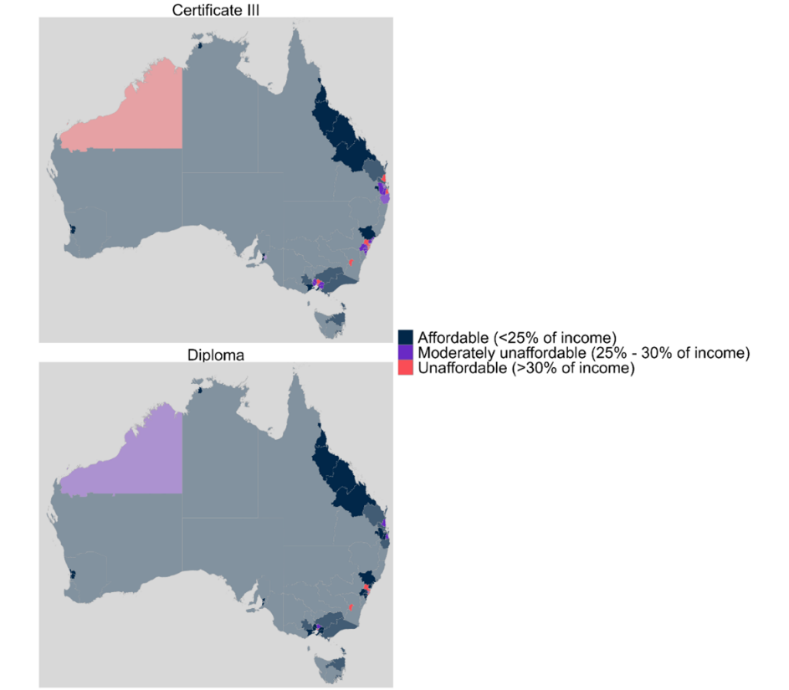

Source: JSA analysis of Census of Population and Housing (2021) and the Children’s Services Award (2021)

Unlike schools, which are broadly distributed across Australia to enable accessibility for all students, ECEC services are typically concentrated in the most socioeconomically advantaged parts of Australia where housing is least affordable. The location of ECEC services in these areas, coupled with the relatively low wages paid to those working in the sector, increases travel to work time and is a significant factor affecting both stress levels and staff retention.

Finding - A key barrier to workforce entry and retention is that ECEC workplaces may be located at a considerable distance from workers’ homes, including in metropolitan settings where there is lack of affordable housing where there is the highest density of service provision.

**Recommendation -** Improve the attractiveness of ECEC work by considering the provision of employee incentives. This could further enable employers to offer benefits to employees who have barriers to return – in particular for transport for hard to reach services in regional or high-cost areas and subsidy of ECEC for their own children.

**Recommendation -** Incentivise and promote rostering and staffing arrangements that provide flexibility, with options considered including four-day work week or a nine-day fortnight to enable ECEC staff to better manage work-life balance, stress and workload.

## Rewarding Passion

Like other teaching occupations, ECEC work is often linked to values that are considered intrinsic, such as care for children and a passion for supporting their learning and development. In the 1970s, psychologists erroneously believed that offering extrinsic rewards would undermine such intrinsic motivations (Sansone & Harackiewicz, 2000). Such beliefs may have contributed to ongoing underpayment of ECEC workers based on the false intuition that offering financial rewards might weaken the values that make the ECEC system function. As this chapter has discussed, the reverse is true: people enter ECEC, often via intrinsic motivators, but extrinsic qualities of the work can push them to find an alternative. When the flow of labour into senior ECEC roles such as *Child Care Centre Manager* or *Early Childhood (Pre-primary School) Teacher* are mostly from within the ECEC sector, any failure to address the relationship between intrinsic and extrinsic values presents a risk to the ECEC workforce and its capacity for leadership (see Chapter 5).

Nevertheless, intrinsic motivations are central to job satisfaction and therefore retention. In their recent study on ECEC retention, McDonald, Thorpe and Irvine (2018) found that intrinsic motivators were key. At the same time, however, these intrinsic motivations can also be the reason to leave ECEC. Pouring passion into work – some of which is dirty, complex or invisible ­– that is not valued or appreciated by parents, institutions or society can contribute to burnout; encouraging even the most talented and passionate ECEC educators to seek work elsewhere. Some ECEC educators reported to the researchers that they needed to top up their low incomes with contributions from their own families. As noted by an early childhood advocacy organisation:

The top four reasons why educators left the sector as poor rate of pay (41%), work stress (34%), developing new skills (26%), and high workload (25%). The supporting qualitative research further indicated that ‘poor rate of pay’ is the cumulative effect of many unpaid hours of work, constant demands and insufficient staff to deliver a good service. Educators described that feeling physically and emotionally burnt out from working in the sector, coupled with no ability to control their own working environment, left them feeling that leaving the sector was the only option. Supporting and sustaining our current workforce is a key strategy that must be capitalised upon. (Submission 9)

It is therefore essential to structure ECEC careers and job descriptions in ways that reward passion, including allocating sufficient paid non-contact time to prepare learning activities, offering opportunities to apply new learning obtained via qualifications, continuing professional development or on the job training, and monetary reward for increased responsibility. It is also important to address barriers to job satisfaction, including administrative load (particularly any load that falls into unpaid hours) and the costs of what is known as ‘emotional labour’.

Teachers’ professional identities, or the professional images teachers have of themselves, play an essential role in teachers’ pedagogical knowledge and their propensity to stay in the profession … the social images of EC teachers, professional learning in universities, and requirements in kindergartens were perceived as the main obstacles to achieving a high identity, which refers to a strong, emotional recognition of ECE, satisfaction with the teacher education programme, and positive career prospects. (Submission 36 - Charles Sturt University)

### Career Progression Settings

Career paths for prospective and current ECEC educators are influenced by social assumptions about vocational choice and innate traits. Traditions encourage young women into ECEC, for example, implicitly draws on 1950s ‘Holland Codes’ that often connected individual interests to job satisfaction. These notions of traditional interests have contributed to the stereotypes that both ECEC and women as occupational ‘helpers’ which have been historically undervalued in the labour force (Australian Government, 2022).

More holistically (for example McMahon & Patton, 1995), theories of career development have prioritised a systemic view of career decision making. These understandings seek to go beyond career interests and include gender, the wider social context, environment, public and media ideas about roles, capacity and health, as qualities that may impact decision making. In reviewing ECEC career settings, it is important to take into account educators’ aptitudes and preferences, while acknowledging that these may change over time and be influenced by a range of shifting ideas and institutional settings. Building a more flexible career path that allows ECEC educators to grow into a role that suits both their (changing) personality traits and their circumstances will make for a more resilient sector.

### Roles and Practice Orientation

|  |
| --- |
| **CASE STUDY – England’s Early Years Pathway Map: Mapping pathways in ECEC to showcase career trajectories**  Following research on how to enhance the stability of the early years workforce, several projects were undertaken to showcase the rich range of careers for early childhood professionals. The Childcare and Early Years [careers progression map](https://www.ncfe.org.uk/media/mrxhz3m0/dfe-career-pathway-map.pdf) was designed by Early Years experts and stakeholders, supported by the Department for Education (DfE). The map provides detailed information about different early years job roles, entry points and progression routes. The map is aimed at:   * anyone considering a career in the sector * careers practitioners, employment services workers and primarily early years practitioners who wish to progress their careers employers.   Source: United Kingdom Department for Education, (2022), *Pathway into early years education*, UK Government, <https://www.gov.uk/government/publications/pathway-into-early-years-education/pathway-into-early-years-education>. |

The intersection of the NQF, award classifications, intensive service delivery requirements and limited professional development funding restrict opportunities for workers to pursue career advancement and specialisations. For example, there are specialisations for those interested in more training that lead to allied workforce options and departure from core workforce (e.g. occupational therapist, speech pathology for young children not in workforce). However there is not necessarily the funding for ECEC providers, outside the public sector and the largest private operators, to engage them. There are very few ‘leading teacher’ roles like those in the school sector, where *Early Childhood Teachers* can progress outside management roles. Moreover, the small size of most childcare providers means post qualification training opportunities are limited, with the career ladder topping out early (that is, there are few senior roles and higher qualifications).

### Career Progression Options

Chapter 5 shows that improvements to the qualification map will help structure ECEC in ways that create better opportunities for those working in the sector. Currently, staff typically enter ECEC as *Child Care Workers* and stay in that role. The opportunities usually available for career progression are to become an *Early Childhood Teacher* and/or a *Child Care Centre Manager*. Management and teaching do not reflect the full breadth of either the talents and skills of ECEC staff, nor the skills and abilities that the sector requires.

As Chapter 5 discussed, there are few entry points to ECEC work without extensive qualifications, limiting the ability for work experience opportunities. Some opportunities may be available via administrative support in large services or auxiliary support work to enable ECEC educators.

A more rewarding career structure will also provide further opportunities to progress in a career not only via management but based on workplace learning and performance in specialist or distinct roles. This may require continuing professional development, individual interests, and specialised roles including taking up higher education further study. Such an approach would enable ECEC educators to pursue a career with rewards that increase beyond those currently available.

### **Specialised Roles**

Unlike in fields such as nursing where specialisations such as Geriatric Nursing enable nurses to focus and develop their interests and skills for the benefit of the community, ECEC career structures do not currently offer opportunities for formal specialisation. Studies (for example Mills, J et al., 2016) have found that when early career nurses perceive that they are supported to pursue choices of specialised work, retention is improved. By enabling nurses to pursue specialisations that interest them, they are not only more engaged in their work, but are also able to improve their performance. The possibilities for varied career progression relates to job satisfaction and performance (Ward & Shields, 2001).

JSA analysis of hiring trends (see Chapter 2) shows that a very wide range of skills are expected from ECEC workers, including core skills like caregiving and creating a nurturing environment as well as a wide range of extrinsic skills, like cooking, immunisations, program planning, music, mental health and yoga.

Emerging skill areas, such as First Nations cultural safety, cultural and linguistic diversity (including bilingual teaching to include languages other than English), and Disability support also signal the need for increased specialisation in ECEC. The growing need for ECEC educators to work alongside allied health professionals such as Speech Pathologists further demonstrates that there are likely benefits for children and the community when educators seek career opportunities via specialisation or other forms of professional development. Creating opportunities for staff to pursue professional development is a matter of resourcing so that services are not under further pressure while staff are undertaking their training.

There is considerable scope for specialisation in ECEC work, like that available for staff in healthcare. Some of these specialisations could allow ECEC workers to develop curriculum specialisms without significant further training, such as sport and fitness, environmental care and permaculture, or creative arts and music. Others might require formal study, such as bilingual education, disability support and speech development.

Unfortunately in the current climate, it is challenging to backfill educators to attend professional development. This may result in educators attending out of hours, leading to further burnout, rather than have the intended effect of inspiration and retention. (Submission 45 – Early Learning and Care Council of Australia)

As the sector evolves, these specialised roles should also grow. It will be important for a new career structure in ECEC not only to allow for these specialisations but also to be adequately flexible as new areas of focus develop.

Finding - ECEC requires staff who are skilled in a wide range of specialisations. However, the ways that ECEC careers are currently structured offer relatively few opportunities for specialised roles. The inability to specialise causes gaps in provision and career progression opportunities for ECEC staff and can be contrasted against other sectors.

**Recommendation -** Governments should consider how funding might be made available to support educators to meet identified needs, including:

1. appropriate funding for subsidised supervision sessions for senior staff in regional and remote locations with a Child Behaviour Specialist or Psychologist to debrief and discuss children’s educational concerns.
2. investment in evidence-informed trauma resources and trauma informed training for educators, to support children with additional needs.
3. resources and training to support early years educators in implementation of the NDIS recommendations in relation to identification of children’s developmental needs and establishing inclusive educational and care settings.

**Recommendation –** HumanAbility to consider specialisation pathways within the Certificate III ECEC and Diploma ECEC to serve different service types particularly IHC, OSHC and FDC delivery. This could include identifying alternative existing units that could support inclusive education for different identified needs and particularly for First Nations children.

## ECEC Scopes of Practice

The ECEC workforce is currently structured via qualification pathways so that a mix of certificate, diploma and higher educated ECEC educators work together with implicitly distinct scopes of practice, as Chapter 5 demonstrated. Since these qualification pathways are linked to award rates, there is a tendency to define ECEC work via qualification rather than by the work that is needed and how this might change over time. In this context, services find it more difficult to tailor roles that serve specific needs, and individual careers are frequently constrained by the qualification with which they entered ECEC.

It is important to ensure that education pathways provide quality training in the work that is done in ECEC. ECEC qualifications do this quite successfully, but explicit scopes of practice for ECEC roles would help the sector define what is needed in a way that could be more flexibly applies and, if required, revise educational programs to match. In particular, more explicit scopes of practice would address key concerns about the distinctions between certificate, diploma, bachelor and postgraduate-qualified ECEC practitioners, enable a more efficient allocation of resources and help facilitate specialisation within levels.

Other professions, including several in healthcare (nursing is the most relevant), have developed explicit scopes of practice for different roles. These scopes of practice include qualifications, placement requirements and educational outcomes that are mapped to a broad description of the specific role. It is possible, as has been done for midwives, to add extended scopes of practice for more experienced practitioners, and for the creation of specialised roles.

I think there needs to be a significant piece of work that actually looks at what would you want to see from somebody just coming into your job role. What would you like to see somebody working at Certificate III level but being around for a little bit longer? What would you then like to see the difference between that and somebody working at the diploma level? What would you like to see as somebody has a diploma and has been more experienced over a few years?  
And what's the difference between that and the teacher?  
And even then, a teacher who's been around for a few years, so we've actually got a sort of a stage career life, life within early childhood. And yes, I know I'm putting pay things like that on the back shelf because I think we actually just have to focus on what we're actually looking at while we're working in the sector. (Consultation 3)

Defined scopes of practice can be revised as needed by ECEC, and new ones added. Scopes of practice for *Midwives, Enrolled Nurses, Registered Nurses* and *Nurse Practitioners* legally limit certain work tasks to those registered to perform them, but it is not only about placing hard borders between roles. Importantly, it also acknowledges that ‘the scope of practice of individual practitioners is influenced by the settings in which they practice…[including] the health needs of people, the level of competence and confidence of the nurse and the policy requirements of the service provider. As the nurse gains new skills and knowledge, their individual scope of practice changes’ (Nursing and Midwifery Board, 2023).

Anne Gardner and Glenn Gardner (2005) describe a process of developing the scope of practice for *Nurse Practitioners. Nurse Practitioners* have been introduced to address inequitable provision of healthcare and ease the burden on GPs. In a trial, each *Nurse Practitioner* worked in a team, ‘working into’ their role. This meant that they could develop the scope of practice for the *Nurse Practitioner* role based on what people did in response to real clinical needs rather than impose the role description from an abstract starting point. The advantage of a similar approach in ECEC is that it would enable scopes of practice for ECEC roles to align to the needs of children, communities and services. It would also allow for the career structure to recognise and reward the ways that, within boundaries, ECEC educators also make their own roles that align with their own strengths and abilities.

We're looking at trying to capture and build to create pathways for people, but also to build the capacity to playgroup environments. It really just highlights that there are different roles that aren't being picked up. It was put in the training package update initially as Cert II, but then it was dropped out. But there is potential. (Consultation 1)

Building coherent, but flexible, scopes of practice for ECEC roles would in turn help to strengthen the educational infrastructure required to support a robust, growing ECEC sector. Currently, pathways into ECEC diverge between VET and higher education courses, which each have different reporting requirements and protocols so that data on ECEC qualifications is reported separately. Identification of and support for training pathways was a key area of focus in the recent PC report:

ensuring career and qualification pathways needs are addressed must be a priority before other changes in the sector can be realised. (PC, 2023, p.5)

The current relationship between the Certificate III and Diploma ECEC was intended, as Korbel (2018) outlined in NCVER’s analysis of the training package, to perform some of the roles that scopes of practice would achieve:

The findings suggest that the Certificate III in Early Childhood Education and Care is generally used as a pathway into the early childhood education and care sector, while the Diploma of Early Childhood Education and Care is used to improve employment prospects once a person is already working in the sector. Most graduates are employed after training in a relevant occupation, although more certificate III graduates continue on with further study. The strong occupational connection and the requirements of the National Quality Framework seem to underpin the positive employment outcomes of the qualifications. (Korbel, 2018, p.10)

However, the need to hold the most recent version of the Certificate III ECEC qualification is presenting barriers to those wishing to progress, as the reality that the increase in pay is relatively slight and increase in responsibilities is significant. There are high numbers of enrolments in the two main VET programs as shown in Chapter 3.

Scopes of practice provide a framework that describes and supports all ECEC work, but this also needs to be understood in the context of factors at macro- (structural, legal, external conditions), meso- (local and community) and micro- (individual work environment) levels. This is important, preventing scopes of practice from imposing bureaucratic procedures inappropriately.

Table 6.1 Barriers and enablers to scope of practice in ECEC

|  |  |
| --- | --- |
| **Barriers** | **Enablers** |
| ***Macro – perceived structural, legal, regulatory and external conditions that are beyond the influence of individual organisations or educators*** | |
| * Regulatory mismatches between states and territories * Qualification barriers – progression Cert III to Diploma and between VET and Higher Education * Low Wages and attrition, especially in providing adequate mentors for trainees | * Implicit scopes of practice embedded in qualifications * Strength of educational infrastructure in VET and Higher Ed * Regulations and ratio requirements |
| ***Meso – Local Institutional factors and influences, as well as community issues that often characterise or define the parameters of service delivery*** | |
| * Under the roof ratios stretch educators too far. * Travel time/housing affordability in areas with high demand for ECEC * Lack of community recognition of the complexity and value of ECEC | * Community demand for ECEC services * Networks of ECEC services with local Primary Schools, allied health providers |
| ***Micro – day-to-day practice and attributes or characteristics of individual educators and their work environment that affect how ECEC services are delivered*** | |
| * Administrative and other tasks that ECEC educators perceive fall outside scope of practice. * Lack of allocated workload time to prepare educational activities. * Stress and burnout. | * Role expectations of service provider and educator align. * Supportive work environment in which educators feel they belong. * Organisations that actively support staff wellbeing. |

Source: Adapted from Smith, T. et al., 2019.

I think that that actually is something that it requires some deep examination against job roles, descriptions, tasks, incentives from room leader up. (Consultation 3)

**Finding -** Scopes of practice are a valuable concept for workforce development. The roles, regulations and hierarchies that govern the ECEC workforce have a significant impact on staffing and their ability to deliver services that serve the needs of families and their communities.

**Recommendation -** The Australian Government should develop a national information resource to promote ECEC career and training pathways and attract new entrants from school leavers and people seeking career changing opportunities. This should include strategies to boost the diversity of the ECEC workforce and align to the Early Childhood Care and Development Sector Strengthening Plan with increased education, training and recruitment of First Nations professionals as a priority.

**Recommendation -** Multiple parties should review the role of supernumerary staff (excluded from ratio and not responsible for supervising children) for administrative support and other roles. Gaps could be identified for any positions which are not recognised and considered through industrial instruments for administrative educational support roles to be created in the ECEC sector. A particular focus may also be to scope resources that services can use to support the creation of specialised administration support roles.

## Overcoming Barriers to Job Satisfaction

Researchers exploring workforce retention have concluded that while ECEC workers may be pushed out of the sector, often reluctantly, by low wages and long hours, job satisfaction is even more important. Full-time careers are at the centre of the economic imaginary and are not only largely occupied by men, but also contribute to *masculine capital*, a relative kind of ‘wealth’ that is brought to the workplace (Huppatz & Goodwin, 2013). Masculine capital partly explains the devaluation of ECEC work by building an association between care work as ‘feminine’ and women’s supposedly innate skills and aptitudes, falsely implying that there is little complexity or skill required. Stakeholders have reported to JSA that such devaluation is a key barrier to job satisfaction. In contrast Tronto (1987) argues that care work in early childhood requires a set of complex skills that include attentiveness, responsibility, responsiveness, and competent performance. Overcoming old ideas about care work as either menial or a natural expression of women’s inner selfhood would improve the conditions enabling job satisfaction, recognising and rewarding the complexity and importance of the work.

This gendered positioning of ECEC work has also acted to exclude men from the sector. In seeking to retain men in ECEC, job satisfaction is particularly important. Men working in ECEC are more likely to struggle with feeling included and supported. Anyone who does not feel that they belong in their workplace is at risk of leaving the workplace or the sector. Steven Roberts at Monash University (eg Roberts & Prattes, 2023) has used the concept of ‘caring masculinities’ to help bring gender balance into ECEC and related fields – though others think gender diversity, rather than balance, is a more important quality to bring to child-centred education (Warin, 2019).

One way of overcoming barriers to job satisfaction is to explore the qualities that lead to retention. McCullen et al, (2020) for example, show that several workplace characteristics are strongly associated with staying in ECEC. One is ‘community belonging’, characterised by friendship, respect and being able to contribute ideas. Another is safety and security, including workplace stress. A third, which has already been the subject of this chapter, is professional identity. As noted in a JSA-led topic-based discussion session:

There's very little representation from the coalface and when you talk to the services [...]They're exhausted, so they don't, you know, they don't know where to go to voice their concerns. They feel powerless. (Consultation 3)

### Avoiding Burnout and Promoting Wellbeing

ECEC workers who are excessively stressed, burned out or thinking about leaving the sector find it more difficult to perform their work ‘attentively, sensitively and appropriately’, leading to poorer outcomes for children (McMullen et al., 2020). While employee wellbeing varies across workplaces, influenced by factors such as management and workplace relationships, policy settings and workforce capacity also shape the environment that enables wellbeing – or not.

Data suggest what stakeholders reported to JSA: ECEC educators have a higher risk of burnout than all occupations. Burnout describes a state of emotional fatigue, which can contribute to poor health and low job satisfaction. Burnout is a key reason for workers to seek an alternative career path. It presents a significant risk to the ECEC sector.

High job demands, poor support, and inadequate reward and recognition contributing to burnout are considered psychosocial hazards, which a person conducting a business or undertaking must manage under model Work Health and Safety laws which have been, or are in the process of being, adopted nationally. Safe Work Australia publishes rates of serious injury claims, including relating to psycho-social hazards. The rate of serious injury claims in the Childcare Services industry group (ANZSIC 713) in 2021-22p[70] (Safe Work Australia NDS for Compensation-based Statistics) was 14.2 claims per million hours worked compared to 6.5 claims per million hours worked in all industries as seen in table below.

Table 6.2 Frequency rate of serious claims (per million hours worked) for selected industry divisions and groups[71]

|  |  |  |  |  |  |  |  |  |
| --- | --- | --- | --- | --- | --- | --- | --- | --- |
| **Industry of employer** | **2014-15** | **2015-16** | **2016-17** | **2017-18** | **2018-19** | **2019-20** | **2020-21** | **2021-22p** |
| Education and Training | 4.6 | 4.4 | 4.3 | 4.3 | 4.6 | 4.3 | 4.8 | 4.9 |
| *Preschool education (801)* | *2.9* | *2.8* | *2.4* | *2.8* | *2.6* | *2.7* | *2.5* | *2.5* |
| Health Care and Social Assistance | 8.5 | 7.4 | 7.7 | 7.4 | 8.2 | 8.5 | 10.0 | 8.8 |
| *Child care services (871)* | *7.4* | *7.4* | *8.0* | *7.1* | *9.6* | *10.3* | *12.9* | *14.2* |
| ***All industries\**** | ***5.9*** | ***5.6*** | ***5.6*** | ***5.5*** | ***5.8*** | ***6.1*** | ***6.5*** | ***6.5*** |

*All industries includes all ANZSIC industry divisions, including those not listed separately in the table.

Source: Safe Work Australia, National dataset for compensation-based statistics.

Rates of serious injury claims, including psycho-social by occupation are also concerning with ECTs, Educators (*Child Carers)* and Education aides particularly, having much higher rates of serious claims when compared with all occupations (table 6.3).

Table 6.3 Frequency rate of serious claims (per million hours worked) for selected occupations[72]

|  |  |  |  |  |  |  |  |  |
| --- | --- | --- | --- | --- | --- | --- | --- | --- |
| **Occupation** | **2014-15** | **2015-16** | **2016-17** | **2017-18** | **2018-19** | **2019-20** | **2020-21** | **2021-22p** |
| Child Care Centre Managers (1341) | 3.3 | 3.4 | 2.3 | 2.5 | 2.9 | 2.3 | 3.1 | 1.9 |
| ECTs (2411) | 4.1 | 4.1 | 4.1 | 4.2 | 5.3 | 6.1 | 7.4 | 9.6 |
| Child Carers (4211) | 7.0 | 6.4 | 7.5 | 6.2 | 7.4 | 9.2 | 10.6 | 9.2 |
| Education Aides (4221) | 10.1 | 8.3 | 8.1 | 9.6 | 9.5 | 9.5 | 11.5 | 11.1 |
| ***All occupations\**** | ***5.9*** | ***5.6*** | ***5.6*** | ***5.5*** | ***5.8*** | ***6.1*** | ***6.5*** | ***6.5*** |

* All occupations includes all ANZSCO occupation groups, including those not listed separately in the table..

Source: Safe Work Australia, National dataset for compensation-based statistics.

A meta-analysis (Ng et al., 2023) of burnout risk factors in ECEC showed that several personal factors increased the risk of burnout, especially poor health or limited family and social support. Feedback provided to JSA suggests that this can be particularly difficult for those beginning their ECEC career.

Many start in the profession and have to negotiate initiation into working life at the same time as taking on study for the appropriate qualifications. Many cannot handle this early transition process and this provides for inconsistency in staffing at services. (Submission 22 - Individual)

However, structural factors are also necessary to explain the elevated risk of burnout across the sector. Low wages make life more stressful in general, cause ECEC educators to feel under-valued and reduce workplace motivation. Other factors include a lack of resources to perform the work, a lack of clarity about work expectations or expectations that do not match the role and high job demands. Additionally, challenging relationships with colleagues, managers and parents are a key source of burnout, as is a lack of focus on staff wellbeing, few opportunities for professional development and progression and a perception that the occupation is held in low esteem. High levels of staff turnover itself acts as an indicator for burnout, intensifying the problem (Ng et al., 2023). This suggests that improving the extrinsic conditions described above, including wages, working hours and travel to work, would help reduce burnout. Ensuring that ECEC staff have sufficient non-contact time to prepare play-based learning activities would also help provide some relief from the relationship-based sources of burnout.

To progress beyond provisional registration, new ECT’s need someone to mentor and support them, coach and sign off their provisional ECT status to reach proficiency. However, with the pressure on the existing workforce, there are too few experienced educators that have capacity to do this. (Submission 9 - An early childhood advocacy organisation)

Recent growth in the number of trainees in ECEC in Australia has intensified the workload for experienced ECEC educators, contributing to burnout. With fewer senior staff relative to the expanding number of trainees, administrative work is often pushed into contact time with children, or in unpaid overtime. This further increases the probability of burnout and attrition. Stakeholder data collected by JSA repeatedly described the enormous satisfaction many ECEC educators experience by the *emotion work* that they do, which contributes to the children and families they encounter and is central to their own wellbeing at work.

By contrast, emotional labour, which demands ECEC educators perform emotions, including managing facial expressions and body language to create the right environment for others, demands unfelt enthusiasm for children’s activities, professional calm for parents and warmth for colleagues. Far from the wellbeing of authentic emotion work, such labour produces emotional dissonance, contributing significantly to burnout in ECEC. In so doing, they may become more cynical about their work, which not only reduces their performance but also negatively affects job satisfaction for themselves and their colleagues.

Figure 6.2 ACECQA Progressing a national approach to the children’s education and care workforce.

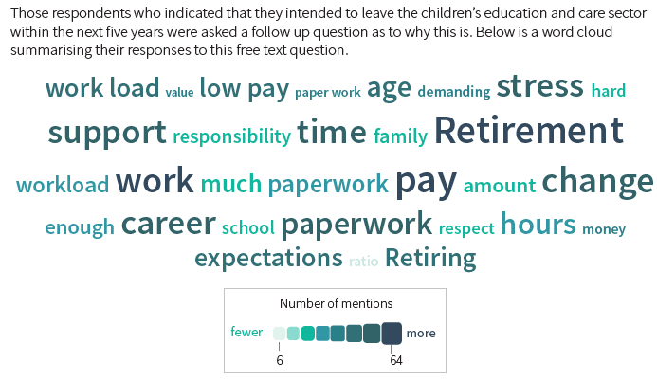

Source: ACECQA Workforce Report, November 2019, p.41

Recruiting and retaining qualified ECEC educators and teachers: This is usually due to systemic issues such as: educator burnout; poor wellbeing and morale of educators; low profession status, low wages and poor working conditions; increasing burden of quality assurance processes; emotional cost of early childhood work; and the increasingly complex needs of children, families, and communities. (Submission 23 – La Trobe University)

Some aspects of ECEC work are routinely overlooked, contributing to unpaid overtime. Often, these are the ‘soft’ tasks, such as maintaining relationships, but also includes processes such as moving between work areas or dealing with unexpected tasks. Invisible work can be stressful, not only because it might demand accelerated work that may overflow into unpaid hours, but also because it requires modifying work processes to align with expectations that have not been made explicit (Junor & Hampson, 2005). One response to invisible work is often to manage work processes even more closely, which can be counterproductive. Giving ECEC staff more space and autonomy to make decisions as the need arises is a better way to improve job satisfaction.

As well as reconsidering structural aspects of ECEC influencing burnout, such as wages, research shows that improvements to factors influencing wellbeing are also important. Meta-analysis of studies of wellbeing in ECEC show that the following factors improve job satisfaction and reduce burnout for ECEC educators (Cumming, Wong & Logan, 2021):

* **Quality work environments:** good employment conditions, fairness, colleagues who share one’s commitment to the work.
* **Job autonomy:** performance expectations are linked to aspects of the work that are supported in the workplace and over which educators can make decisions.
* **Aligned discourses:** ways of thinking about childcare and education among colleagues, parents and the community that align to the practices in the workplace.
* **Positive collegial relationships:** harmonious and constructive relationships with colleagues that enable a sense of belonging at work is a key predictor of retention in ECEC.
* **Inclusion and diversity:** staff profiles that embrace diversity and work environments that promote inclusion are more supportive.

All these factors rely on quality leadership in the sector and in specific services. Ensuring an adequate pipeline, training and support of ECEC leadership is needed to assure the viability of ECEC staff wellbeing.

Finding - ECEC staff report a lack of leadership structure and capacity with the sector which often results in administrative overload — including complying with regulation and managing parent expectations — which is a psychosocial hazard that detracts from job satisfaction and drives attrition

**Recommendation –** HumanAbility to consider sectoral need for ECEC use of leadership skillsets, micro credentials or similar, including reviewing previous usage of advanced diploma leadership qualifications that were specific to children’s education and care, or the development of elective units in current leadership and management qualifications.

**Recommendation -** Ensure that employer guidance and education is improved on WHS duties and obligations to eliminate or minimise psychosocial hazards (and any other hazard) so far as is reasonably practicable, and all ECEC staff are provided access to a high quality Employee Assistance Program to support their wellbeing.

|  |
| --- |
| **CASE STUDY – Identifying the right candidates for ECEC careers**  To improve the mismatches between potential educators and available work, Early Childhood Australia (ECA) Tasmania contracted ECA National to develop a ‘good fit’ tool (funded through the Australian Government Department of Employment and Workplace Relations, Local Jobs program). The online Education and Care Good Fit Tool was created to assess potential educators with the ECEC sector. The tool supports local areas to create pathways for training and identifies characteristics and attributes of candidates to be matched to roles in ECEC. The tool benefits both educators looking for roles in ECEC and services looking for educators.  *Submission 39 – Early Childhood Australia Tasmania* |

## Community Values and Expectations

ECEC educators are under pressure to comply with a wide range of values and expectations from parents, their local community, the wider community, the sector and quality regulators.

As discussed in the previous section, discourses about appropriate and quality childcare and education have a significant impact on job satisfaction. These include

* The social status of ECEC professions
* Ideas about quality and processes of quality management
* The needs of specific communities
* Ensuring cultural safety for First Nations children and communities.

Working with young children to help them thrive and learn is no easy undertaking. However, historically it has been seen as the easier alternative to school teaching. Perhaps a little more fun, less rigorous or busy and certainly something to consider if someone ‘failed’ to be accepted into an Education (Primary or Secondary) degree. This messaging is counterproductive to our push for quality and the drive towards attracting, preparing and retaining the very best people to work in ECEC. (Submission 9 - An early childhood advocacy organisation)

### Regulation, Quality Management and Administrative Load

While assuring quality ECEC is important, according to Elise Hunkin at RMIT, systems of measurement tend to emphasise narrow economic concepts centred on human capital development rather than the wider set of purposes sought by the community (Hunkin, 2018), marginalising the expectations and values brought by parents and ECEC workers in the regulatory system. Excessive measurement can also impinge on job autonomy, which as this report has shown, is strongly correlated to job satisfaction.

The ACCC identified the increasing responsibilities and burdens on educators as a key factor contributing to ECEC workforce shortages, particularly in smaller workplaces. What is not currently understood is how this burden arises – to what extent can it be separated into:

• Direct regulatory requirements;

• Approved Provider (employer-driven) requirements;

• Regulatory operational systems (like the National Quality Agenda IT System, a nationally accessible online tool for ECEC services to communicate directly with regulatory authorities and intended to reduce paperwork and duplication);

• Provider operational systems, including the Commonwealth’s CCS requirements; and

• Staff competency issues (which may be due to poor training or a pre-existing lack of an individual’s skills and abilities)

(Submission 51 - A peak workforce development body)

In Australia’s federal system, quality measures and other regulations vary between jurisdictions. This increases the cost of regulating the system and adds administrative burden to organisations with enterprises across state lines. In a system where experienced educators are under pressure, the administrative costs of regulation are often spread through enterprises, increasing the stress on staff with complex caring and teaching roles. Rather than increased regulatory administration, the sector would benefit from support structures that would enable ECEC educators – and, potentially, primary school teachers – to share approaches, pedagogies and tools that support quality education and care.

### Serving a Specific Community

Early childhood education services are deeply entrenched with their local community, often serving specific needs. For communities that include recent migrants and refugees, for example, parents may seek bilingual education and centres that are sympathetic to specific cultural and religious values.

As well as facilitating professional development and career pathways that acknowledge the kinds of specialised skills that communities require, ECEC needs to be attentive to also ensuring diversity and inclusion in the ECEC workforce. Stakeholder feedback emphasised the importance of diversity and inclusion to feelings of belonging, for children as well as for staff.

Conversely, better pay and conditions, stable employment, and a working environment that supports psychological and emotional wellbeing contribute to higher levels of staff retention, as does a more diverse and inclusive workforce. (Submission 36 – Charles Sturt University)

In some regions and suburbs, it will also be particularly important for ECEC services to maintain consultative and respectful relationships with communities to ensure that ECEC is meeting their needs. This leadership work also needs to be acknowledged and valued.

For migrant communities in particular, recruitment and retention from within the community not only assists with embedding services and individuals, but also provides support and role models for children.

Finding - There are straightforward routes for new migrants to complete entry level qualifications. However, migrant ECEC staff often face particular barriers, including funding, to their career development in Australia.

**Recommendation -** States and Territories should review arrangements for course fee rates for international students working within services while studying.

**Recommendation -** As part of the Migration Strategy implementation, relevant parties should consider Early Childhood Educator (421111) & Teacher (241111) roles for eligibility in employer sponsored skilled visa programs, with broad consultation across the ECEC sector.

**Finding -** There is increased demand for early childhood education that appropriately serves diverse families and their communities including CALD communities, regional and remote areas, for neurodiverse children and those with disabilities.

**Recommendation -** All governments to explore in shared guidance and resources, including to support early years educators in identification of children’s developmental needs and establishing inclusive care settings.

**Recommendation -** The Department of Education and state and territory departments support the development and implementation of innovative solutions or incentives to staffing issues of identified need, including programs that provide financial and mentoring support to members of communities with specific needs to enter the ECEC workforce.

|  |
| --- |
| **CASE STUDY – Embedding inclusive practices in outside of school hours care**  In 2023, the National Outside of School Hours Services Alliance (NOSHSA) developed a range of resources to build the skills of OSHC educators and embed inclusive practices in the OSHC sector. This includes mentoring and coaching tools to support educators of all levels in their day-to-day inclusive practice with children. The focus of these resources is to manage complex issues and challenging behaviours in children. The areas of focus are:   * Complex behaviour support. * Neurodiversity affirming practice. * Trauma informed practice.   Source: National Outside of School Hours Services Alliance, (2023), *Inclusion Project,* NOSHSA, <https://www.noshsa.org.au/inclusionproject>. |

#### Ensuring Cultural Safety for First Nations Staff and Children

A guiding principle of the NQF is that Australia’s Aboriginal and Torres Strait Islander cultures are valued. Children’s education and care services have a shared responsibility to contribute to building a better society and sustainable environment and to support children, families, colleagues and the local community to understand, respect and value diversity. Educators and teachers take every opportunity to extend children’s understanding of their local context and of their wider world. Through their practice, educators and teachers are able to continue to challenge stereotyping and bias.

Cultural safety for First Nations people is key priority, enabling the benefits of early childhood education to accrue to First Nations communities. Some educators see this as a ‘reconceptualising’ task, considering education from a child-centred perspective. Such reframing of traditional educational settings to better focus on individual needs, skills and talents may well benefit all children, as well as those from First Nations groups, but requires professional development for ECEC educators (Miller, 2016).

Roundtable feedback to JSA suggested that cultural safety extends beyond decolonising education to an understanding of traditional and contemporary First Nations cultures, norms and taboos. This is also important for First Nations ECEC staff who have a right to a culturally safe work environment. Cultural safety demands professional development training, arguably for all ECEC educators, but certainly for those working in services with high First Nations enrolments. This cultural safety does not only refer to a wider understanding of First Nations culture to ensure staff operate sensitively and inclusively in ECEC; it also includes a critical understanding of power differences in the workplace. Acknowledging power differences enables those with structurally or discursively less power to participate in workplace decision making, a process that supports self-determination (Miller, 2016).

Stakeholder feedback to JSA indicated that for many First Nations educators, cultural knowledge adds a workload burden. Cultural knowledge adds value to ECEC settings by offering informal education, pastoral care for colleagues and children, and for supporting the task of decolonising the curriculum. As well as an often implicit expectation that First Nations ECEC staff will assume this burden, this work demands considerable emotional work – and sometimes emotional labour. Many First Nations educators argue that this work needs to be explicitly acknowledged to ensure appropriate inclusion and prevent burnout. Including cultural knowledge in workload allocations will help avoid burnout in the First Nations segment of the ECEC workforce.

Finding - The presence of First Nations staff within early childhood settings is critical for promoting participation, growth and development of First Nations children. While there are a number of Aboriginal Community Controlled Organisations involved in the delivery of ECEC, well-supported, culturally safe opportunities for First Nations ECEC staff in non ACCO settings are less embedded in the ECEC sector and these opportunities should be assured. Appropriate and culturally safe service provision requires more specialised roles, especially for First Nations children.

**Recommendation -** Education Ministers should incentivise and include an explicit focus on Aboriginal and Torres Strait Islander Workforce both within ACCOs and across mainstream services and investigate sustainable funding for ACCOs.

**Recommendation -** Governments should formalise a process for ensuring ECEC sector is given adequate guidance from First Nations peak bodies and representatives on strategies to promote the employment, cultural safety and support of First Nations peoples working in the sector.

## Summary

This chapter draws on data presented in previous chapters and in stakeholder consultation to establish the foundation of this report’s findings and recommendations that will provide a foundation for rewarding ECEC careers. This is important, since a rewarding career, from both extrinsic and intrinsic perspectives, is crucial to attracting and retaining ECEC educators. We show that ensuring a robust ECEC sector that will serve children, the economy and the community needs to provide flexible pathways to increasingly specialised roles in early childhood education. Developing scopes of practice, good employment conditions, including higher remuneration, and supporting career progression, will ensure that Australia’s current and future workforce is supported by quality ECEC.

# Appendices

## Appendix 1 - Terms of Reference

### Overview

The Government has commissioned Jobs and Skills Australia (JSA) to undertake a capacity study on the workforce needs for Australia’s Early Childhood Education and Care (ECEC) sector. The Capacity Study will be undertaken in partnership with HumanAbility, the Jobs and Skills Council with responsibility for the early childhood education and care sector. The study will provide critical evidence, insights and recommendations as appropriate to support current and future workforce planning, including a detailed understanding of the current state and future needs of the workforce to support the development of Government strategy and vision on early years education and care of Australia’s children.

The ECEC Capacity Study will be conducted with consideration of HumanAbility’s workforce planning mandate and industry engagement, the [Productivity Commission](https://www.pc.gov.au/inquiries/current/childhood#draft)’s and [Australian Competition and Consumer Commission (ACCC)](https://www.accc.gov.au/inquiries-and-consultations/childcare-inquiry-2023)’s inquiries into the ECEC sector in Australia, and other policy developments. The ECEC Capacity Study will focus on ECEC workforce and skills issues, particularly attraction and retention, including incentives, to complement both inquiries broader scope of examining ECEC and the impacts on Australia’s economic growth and outcomes for children and families.

### Scope

The ECEC Capacity Study will identify and analyse occupations for each of the different parts of the sector (pre-schools and kindergartens, centre-based day care, family day care, home-based care, outside school hours care, including services delivered through Aboriginal Child and Family Centres (ACFCs) and Aboriginal Community Controlled Organisations (ACCOs)), their respective supply and demand factors and geographical and cohort considerations to understand factors that impact training, attracting, and retaining the ECEC workforce.

It will:

1. Report on the current state of the ECEC sector workforce – including but not limited to demographic and geographic composition, occupation, skill level, job mobility, numbers of employers, job vacancies, sector pay and working conditions, traineeship numbers, and labour costs – in a manner consistent with HumanAbility’s Workforce Plan
2. Analyse future demand (at the national, state, and regional level) for ECEC roles over 10 years based on different systemic and population scenarios, alongside the impact on demand for employment in intersecting sectors that the ECEC workforce may come from, or leave to work in
3. Analyse the potential supply (at the national, state, and regional level) of the ECEC workforce over the next 10 years by:
   1. examining the education, training and professional development pathways that will support workforce entering the ECEC sector.
   2. identifying the underlying drivers of attrition, retention, and career progression in the ECEC sector, including analysing the role of wages, hours of work and location
   3. understanding the dynamics of staff performing multiple roles or working across multiple employers
   4. understanding the needs for and impact of performing complex and diverse roles within the ECEC sector, such as supporting priority cohorts
   5. exploring job mobility and skills transferability between different roles, settings, and regions within ECEC and between ECEC and other sectors
   6. exploring the career transitions of those workers who have left the ECEC sector and factors that could induce them to return to the sector,
   7. considering international labour supply factors, such as the recognition of overseas qualifications in the sector and the impact of targeted migration programs
4. Identify the enablers and barriers faced by universities, TAFEs and other education and training providers to attracting and supporting students in ECEC, including differences between States and Territories
5. Explore opportunities for, and barriers to, full participation in the ECEC workforce for priority cohorts, including but not limited to First Nations Australians, people in rural and regional areas, people with disability and culturally and linguistically diverse Australians.
6. Explore current and potential governance and regulatory settings that apply to the ECEC workforce.
7. Consider the policy interactions between wages and workforce participation.
8. Consider the experiences of the ECEC sector in other countries, especially those that have comparable economies and patterns of workforce participation to Australia.

### Governance and Consultation

The ECEC Capacity Study will be underpinned by close consultation and collaboration with stakeholders. Consultation and stakeholder engagement for the capacity study will be co-designed by HumanAbility and JSA, ensuring HumanAbility’s unique role in leading industry representation and engagement frames the approach. This will also include carefully planning stakeholder engagement to leverage existing processes where possible to minimise stakeholder burden.

The study will be overseen by a representative Project Steering Group, co-chaired by JSA and HumanAbility under the JSA’s tripartite arrangement. Membership will include representatives from other key Australian Government agencies, State and Territory governments, industry peak bodies, employers, unions, universities, TAFEs and other training providers, and advocacy groups.

Jobs and Skills Australia will regularly brief and inform the Australian Minister for Skills and Training, Minister for Education, Minister for Employment and Workplace Relations and the Minister for Early Childhood Education on the study’s progress and interim findings.

### Process

Jobs and Skills Australia will report on interim progress by February 2024 and provide a final report by May 2024. The timing of the final report will ensure relevant evidence from industry for HumanAbility’s 2024 Workforce Plan can inform it.

## Appendix 2 - Stakeholder Engagement

### Study Steering Group

The Early Childhood Education and Care Capacity Study was sponsored by the Department of Education. JSA undertook this study in partnership with HumanAbility (HA), the Jobs and Skills Council (JSC) with responsibility for the Children’s Education and Care, Aged and Disability, Health, Human Services and Sport and Recreation industries.

A Steering Group was established to provide expert advice about the sector to inform and support the Study. Membership was broad to ensure it is representative of key stakeholders needed to inform the Study, and to ensure representativeness of expertise and potential views.

Table 2 Steering Group membership

|  |  |  |  |  |
| --- | --- | --- | --- | --- |
| **Sector associations​** | **Unions​** | **Education & Training**  **bodies​** | **Parent/ Community**  **groups​** | **Government**  **organisations​** |
| Australian Childcare Alliance​ | Australian Education Union​ | TAFE Directors Australia ​ | Minderoo Foundation​ | Department of Education​ |
| Community Early Learning Australia​ | United Workers Union ​ | Independent  Tertiary Education Council Australia​ | Federation of Ethnic  Communities’  Council of Australia​ | Department of the Prime Minister and Cabinet​ |
| Early Learning and Care Council of Australia​ | Independent Education Union | Universities Australia​ | The Parenthood​ | Department of Social Services​ |
| SNAICC​ – National Voice for our Children |  | Australian Early Childhood Teacher Network​ | Regional Early Education and Development​ | The Australian Children’s Education and Care Quality Authority​ |
| Family Day Care Australia​ |  |  |  | State & Territory  Government  representatives​ |
| Outside of School Hours Council of Australia​ |  |  |  | Australian Education Research Organisation​ |
| Australian Home Childcare  Association ​ |  |  |  |  |

The purpose of the Steering Group was to:

* Assist with the study’s strategic direction (outlined by the research scope) and assist with identifying key issues and overall framing for the report.
* Provide subject matter expertise and technical advice to the ECEC Study Team (the Team) on the overall structure and settings of the ECEC sector.
* Provide views and technical expertise relating to the current state of the ECEC workforce and its future needs, within their own and related areas of expertise, to assist in identifying, analysing, and reporting on sector workforce pressures, now and into the future (ten-year period).
* Review study products as required ahead of their publications, such as interim reporting and the final report.
* Encourage economy-wide views from stakeholders to inform the study’s research enquiries, seeking to ensure broad stakeholder input into the study, including supporting the Team to target specific stakeholders for views and to facilitate engagement opportunities such as roundtables, where appropriate.
* The Steering Group was advisory and did not have any decision-making powers in relation to the Study.

The Study Steering Group members were invited to five formal minuted and three optional meetings between December 2023 – May 2024.

* Meeting 1 – 13th December 2023
* Meeting 2 – 28th February 2024
* Meeting 3 – 20th March 2024
* Meeting 4 – 19th April 2024
* Meeting 5 – 29th May 2024
* Out of session meetings
  + Review of modelling – 12th April 2024
  + Out of session: Review of initial report findings – 30th April 2024
  + Feedback on proposed report case studies – 24th May 2024

### Engagement

The purpose of stakeholder engagement and partner consultation was to enableJSA to gather robust qualitative data and insights from ECEC stakeholders across the economy and the country.

By seeking diverse views, JSA gained a deeper understanding of the current and future workforce demand and supply factors and aim to bridge gaps to improve the advice to Government on the sector’s longer-term workforce needs.

JSA’s [Engagement and Outreach Strategy](https://www.jobsandskills.gov.au/about/engagement-and-outreach-strategy#:~:text=How%20we%20engage,two%2Dway%20sharing%20of%20information.) articulates the following engagement principles, which have informed the development of the engagement plan for this study:

*1. Our engagement is* ***inclusive*** *and aims to ensure our analysis and advice represents a diverse community and economy*

*2. Our engagement is* ***effective*** *and ongoing, that meaningfully impacts on the development, delivery, and quality of our work*

*3. Our engagement is two-way and* ***empowers*** *others to use our advice to benefit their communities*

*4. Our engagement is* ***open*** *and* ***transparent***

*5. Engaging with us is* ***easy.***

#### Written Submissions

The key questions for partners and stakeholders were outlined in the Study’s Terms of Reference and in the Study’s Consultation Paper, both of which invited submissions from the public on the issues the study considered.

Following a consultation on the terms of reference for the Early Childhood Education and Care Capacity Study, a consultation paper was launched on 20th November 2023 with an original closing date of 11th January 2024. Following stakeholder representations and discussion at the 13th December 2023 steering group, the consultation period was extended to 30th January 2024.

There were over 50 substantive submissions received by the Capacity Study team and these have been analysed using manual coding using inductive and deductive codes drawn from the foundational work of the Capacity Study.

Stakeholder submissions have been used in the preparation of the Study report and where the submission was marked as public, stakeholder organisation names have been cited.

#### Consultation

JSA partnered with the relevant Jobs and Skills Council, HumanAbility including for stakeholder engagement and consultation. Stakeholder engagement was coordinated alongside HumanAbility and the JSA team is participated in HumanAbility facilitated events which included:

* Engagements at HumanAbility roadshows in Canberra, Perth, Adelaide.
* IAC consultation meeting 1 – 27th February 2024
* IAC consultation meeting 2 – 29th April 2024
* Stakeholder session feedback on initial findings – 2nd May 2024

As part of the foundational work of the study three key topics were identified for discovery, with four cross-cutting themes which must be considered in depth within each topic areas of interest. Supported by HumanAbility in dissemination, JSA led invited topic based sessions which took place in March 2024 with over 100 participants targeting key topic areas for the Study.

* **Consultation 1 -** Making ECEC a Competitive and Attractive Career Choice – 18th March 2024
* **Consultation 2 -** An ECEC Career Structure that Supports Intrinsic and Extrinsic Motivations – 20th March 2024
* **Consultation 3 -** Ensuring Work Based Learning Works for the ECEC Workforce – 21st March 2024

## Appendix 3 - Defining the ECEC Workforce

For this Study, JSA is interested in all staff directly involved in providing ECEC, as well as all others employed in ECEC services. Our technical definition of the ECEC workforce has two dimensions:

* All educators providing ECEC services in CBDC, FDC, OSHC, IHC, kindergartens and preschools, including but not limited to those working in roles described and regulated by the NQF.
* Any staff who are employed in other industries not formally designated as ECEC, but whose primary role involves delivering ECEC. For example, the Study includes educators who provide ECEC services within sports facilities or those who educate children onsite as part of an employer-provided childcare scheme. These may typically be classified as being part of the sports industry, or in the industry of that employer, but only representative of a small fraction of that industry’s workforce.

This technical definition ensures that we capture all relevant staff when using data from sources that don’t completely align with the categorisation of ECEC services by ACECQA.

The Study acknowledges the important and widely accepted shift within the ECEC sector to move towards a language of “early education” as opposed to “child care”. Specifically, ECEC staff are now more properly referred to as “childhood educators” instead of “child carers” to better reflect their work processes, qualifications and expertise. Unfortunately, statistical naming conventions typically lag behind cultural shifts, and numerous data sources used for this report are only subject to comprehensive review once every five to ten years.

### Preliminary proposed ANZSCO changes

In 2022, the Australian Bureau of Statistics (ABS) commenced public consultation on the proposed changes to the ANZSCO as part of their comprehensive review (ABS 2023), including specific preliminary recommendations to ANZSCO occupations relating to ‘Childcare Services’.

The ABS noted in their comprehensive review document that all stakeholders advocated for an update in terminology, the introduction of middle-management positions and to reflect skill level changes due to heightened regulation and qualification requirements. All submissions were assessed against the ANZSCO Assessment Criteria[73].

The below table reproduces the proposed changes noted in the ANZSCO [Preliminary] Proposed Changes document, published in August 2023.

Table 3 Proposed changes to ANZSCO

|  |  |  |
| --- | --- | --- |
| ANZSCO existing | ANZSCO proposed | Recommended updates as per ANZSCO Comprehensive Review, Preliminary Proposed Changes [74] |
| 134111 – Child Care Centre Manager | 134111 – Children’s Education and Care Service Director | 1. Retain occupation  2. Update principal title from Child Care Centre Manager to Children’s Education and Care Service Director  3. Remove alternative titles – Child Care Centre Director; Child Care Coordinator  4. Add alternative title – Children’s Education and Care Service Manager  5. Update lead statement to include regulated children’s education and care service  6. Add specialisations – Preschool Director; Out of School Hours Care Coordinator |
|  | 134113 – Family Day Care Coordinator | Create occupation from 411711 Community Worker  8. Add principal title – Family Day Care Coordinator  9. Add lead statement  10. Assign skill level |
| 241111 - Early Childhood (Pre-primary School) Teacher | 241113 - Early Childhood (Pre-primary School) Teacher | 1. Relocate the specialisation Preschool Director to 134111 Child Care Centre Manager  2. Retire the occupation 241111 Early Childhood (Pre-Primary School) Teacher  3. Create occupation 241113 Early Childhood (Pre-primary School) Teacher 241111 from Early Childhood (Pre- primary School) Teacher  4. Add principal title – Early Childhood (Pre-primary School) Teacher  5. Add alternative titles – Kindergarten (Pre-primary School) Teacher, Preschool Teacher  6. Add lead statement  7. Assign skill level 1 |
| 421111 - Child Care Worker | 421117 - Early Childhood Education Room Leader (proposed) | 1. Retire and replace with two proposed occupations – 421117 Early Childhood Education Room Leader; 421118 Early Childhood Educator  2. Create occupation from 421111 Child Carer Worker  3. Add principal title – Early Childhood Education Room Leader  4. Add alternative title – Early Childhood Education Group Leader  5. Add lead statement  6. Assign skill level 2 |
|  | 421118 - Early Childhood Educator | 7. Create occupation from 421111 Child Care Worker  8. Add principal title – Early Childhood Educator  9. Add lead statement  10. Assign skill level 3 |
| 421112 - Family Day Care Worker | 421112 - Family Day Care Educator | 1. Retain occupation  2. Update principal title from Family Day Care Worker to Family Day Care Educator  3. Remove alternative title – Family Day Carer  4. Update lead statement to include educational aspects of the jobs involved  5. Change skill level from 4 to 3 |
| 421114 - Out of School Hours Care Worker | 421114 - Out of School Hours Care Educator | 1. Retain occupation  2. Update principal title from Out of School Hours Care Worker to Out of School Hours Care Educator  3. Update lead statement to include educational aspects of the jobs |
| 422115 - Preschool Aide |  | 1. Retire occupation and merge residual |

Throughout this report, to avoid confusion, we refer to the names of ECEC staff as given by the relevant dataset (classified to ANZSCO), acknowledging that these job titles may be outdated and inconsistent with current preferred terminology.

### Our Principal Data Sources

The Study uses the ANZSCO and the ANZSIC to identify key occupations and industries related to ECEC from various data sources. We refer to the standard data available from the ABS for the identified ECEC occupations and industries.

The Study also has access to the Early Childhood Education and Care National Workforce Census (NWC) data for 2013, 2017 and 2021. The NWC data on occupations does not use ANZSCO and cannot be directly compared with ABS data. It is nevertheless included for completeness, and valuable insights into the ECEC sector.

Lightcast data is also used to provide insights into the ECEC labour market between 2019 and 2023. Lightcast is a proprietary dataset containing online job advertisements across Australia.

Where possible, this report has used the most up-to-date and relevant data sources available to JSA. This includes the ABS Census of Population and Housing (the Census), the ABS Person Level Integrated Data Asset (PLIDA), JSA internal projects, and ABS employment figures from the Labour Force Survey (LFS). Key limitations are that the most recent detailed data is from 2021, and the datasets (notably, the Census, PLIDA, and the NWC) only provide a sequence of data points at 3-, 4 or 5-year intervals. The NWC only has four reference years because it is a newer survey (conducted in 2010, 2013, 2017 and 2021) and so transitional and time-series analysis is limited. Nevertheless, in light of its usefulness we present data for those years when it has been made available.

### ECEC Occupations

Early childhood education and care is necessarily served by a large proportion of all occupations. We identified many occupations from within the two primary ANZSIC industries related to ECEC (*871 Child Care Services* and *801 Preschool Education*), for practicality the Study will focus on eight key occupations as a subset of all those occupations within the industry. This expands on the Productivity Commission’s report into ECEC, which for similar reasons elected to focus on only the two ANZSCO occupations of Educators, *Child Care Worker*s and *Early Childhood Teachers*. This report considers eight key ANZSCO occupations in the ECEC labour market, selected using the following criteria:

* **High Priority Occupations** – Occupations have been chosen based on their impact to the sector and their importance to policy measures, for example, including those occupations experiencing a labour shortage. Indicators used to help identify these high priority occupations include the Skills Priority List, employment projections and other internal analysis and modelling.
* **Occupation Coverage** – Occupations have been selected based on the number of people employed within that occupation to ensure sufficient coverage across the majority of ECEC sector employees.
* **Importance to the aims of the study** – some occupations (such as *Aboriginal and Torres Strait Islander Education Worker)* might not meet the above criteria, but their inclusion is important to address all the terms of reference.

Table 4 presents the eight ANZSCO occupations chosen for focus in the Study and their corresponding ANZSCO occupation codes. The left column corresponds to the unit group represented by the 4-digit ANZSCO codes.

Table 4 Focus Occupations

| **ANZSCO Unit Group** | **ANZSCO Occupation Principal Title** | **6-Digit ANZSCO Occupation Code** |
| --- | --- | --- |
| Child Care Centre Manager | Child Care Centre Manager | 134111 |
| Early Childhood (Pre-primary School) Teacher | Early Childhood (Pre-primary School) Teacher | 241111 |
| Child Carer | Child Care Worker | 421111 |
| Family Day Care Worker | 421112 |
| Nanny | 421113 |
| Out of School Hours Care Worker | 421114 |
| Education Aide (part) | Aboriginal and Torres Strait Islander Education Worker | 422111 |
| Preschool Aide | 422115 |
| Note: The unit group Education Aide also includes the *Integration Aide* and *Teacher’s Aide* occupations, which are employed predominantly in Primary Schools and treated as out of scope for this study. | |

Throughout this report, occupational analysis is provided at the 6-digit ANZSCO level to account for each occupation’s unique characteristics. Where data is unavailable at that level, the Study provides a 4-digit ANZSCO level analysis.

To describe each of these key occupations in more detail - in terms of the duties, responsibilities, qualifications, and licensing required for each role – the Study draws on three primary sources:

* The NQF.
* The relevant Modern Awards. These are the Children’s Services Modern Award (for all roles except *Early Childhood Teachers*) and the Education Services (Teachers) Modern Award for *Early Childhood Teachers*.
* The ANZSCO classification, noting that it is currently under review and stakeholders have made submissions for revisions to the classification descriptions for ECEC occupations.

Table 5 below provides an overview of how each of the eight key occupations are represented across the different primary sources, which helps to navigate differences in terminology. The left column shows the terminology used in this report, which follows the sector’s current preferred usage, also adopted in the draft Productivity Commission report. The second column shows the NQF definition, which is less granular, differentiating ECEC staff only by whether they have completed a certificate or a diploma. The other occupations in the NQF are synonymous with the ANZSCO definition. The Modern Awards column specifies the awards for each corresponding occupation. Lastly, the ANZSCO classifications which align with the terms used in the report, the bold text shows the ANZSCO Unit Group and the non-bolded text shows ANZSCO Occupation. ANZSCO differentiates each occupation by ECEC setting (e.g. FDC Centre, OSHC etc) and required qualifications. There are more awards than ANZSCOs, which means that within each 6-digit ANZSCO occupation, remuneration differs, usually based on level of education.

Table 5 Comparison of occupation definitions for ECEC Capacity Study focused roles[75]

|  |  |  |  |
| --- | --- | --- | --- |
| **Terms used in this report** | **NQF** | **Modern Awards** | **ANZSCO** |
| **Early Childhood Educator** | **Educator** | **Children’s Services Employees (CSEs)**  Level 1 – no formal qualifications  Level 2 – 12 months in Level 1 or relevant Certificate II | *ANZSCO groups workers by education and care setting, as well as level of qualification required etc.*  **4211 Child Carers**  421111 Child Care Worker  421112 Family Day Care Worker  421113 Nanny  421114 Out of School Hours Care Worker  **4221 Education Aides**  422111 Aboriginal and Torres Strait Islander Education Worker  422115 Preschool aide |
| Educator (Certificate III qualified) | Educator (Certificate III qualified) | Level 3 – Certificate III |
| Educator (Diploma level qualified) | Educator (Diploma level qualified) | Level 4 – Diploma  Level 5 – Diploma qualified and assistant director or coordinator |
| **Early Childhood Teacher** | Teacher | Educational Services (Teachers) Award 2020  Level 1 – Graduate teacher  Level 2 – Teacher with proficient accreditation  Level 3 – Teacher with proficient accreditation and 3 years’ service at level 2  Level 4 - Teacher with proficient accreditation and 3 years’ service at level 3  Level 5 – Teacher with Highly Accomplished/Lead Teacher accreditation | **2411 Early Childhood (Pre-Primary School) Teachers**  241111 Early Childhood (Pre-Primary School) Teacher |
| **Children’s Education and Care Service Director** |  | Children’s Services Employees (CSEs)  Level 6 – Director | **1341** **Child Care Centre Managers**  134111 Child Care Centre Manager |
| Other education and care occupations |  | *Various occupational awards* | **2415 Special Education Teachers**  **4117 Welfare Support Workers** |
| Other occupations in ECEC services |  | Children’s Services Support Employee (CSSE)  CSSE 1 – Assistant cook, cleaner, gardener  CSSE 2 – 12 months experience at Level 1  CSSE 3 – Cert III qualified (e.g. chef) or equivalent skills | ***Various Unit Groups*** *(selection below)*  351411 Cook  811211 Commercial Cleaner  512111 Office Manager  551211 Bookkeeper |

Sources: ACECQA, National Quality Standard; Children’s Services Modern Award; Education Services (Teachers) Modern Award, ABS, ANZSCO; ABS, 2021 Census of Population and Housing

### ECEC Industries

The Study focuses on two ANZSIC classifications: *Child Care Services 8710* and *Preschool Education 8010* industries, which correspond to the service types primarily regulated by the National Quality Framework (NQF). In the ABS categories, these service types include: “before and/or after school care service”, “child care service”, “children’s nursery operation [except preschool education]” and “family day care service”, which is encompassed in the *Child Care Services* ANZSIC. The other service types regulated by NQF relate to preschools, which correspond to the *Preschool Education* ANZSIC.

ECEC staff in occupations of interest are employed across several other industries, some of which are also regulated by the NQF, such as preschool services – those operating within schools, services operated by local government, and those run by religious or community institutions. There are also ECEC services that may fall outside the NQF. Services provided by hospitals and nannies employed by private households are two such examples.

Table 4below shows the distribution of employment in ECEC occupations across the two key ANZSIC sectors. Overall, just under 80% of employees in the eight ANZSCO occupations work within the ANZSIC sectors, but there is substantial variation by occupation, such as for *Nanny*.

Table 6 Distribution of ECEC occupations by ANZSIC industry

|  |  |  |  |  |
| --- | --- | --- | --- | --- |
| Occupation | Total employed | ANZSIC industry (%) | | |
| Child Care Services | Preschool Education | Other industry |
| Child Care Worker | 123,800 | 50 | 38 | 12 |
| Family Day Care Worker | 8,300 | 92 | 3 | 5 |
| Nanny | 7,100 | 12 | 3 | 85 |
| Out of School Hours Care Worker | 11,200 | 50 | 5 | 45 |
| *Child Carers nfd* | *12,000* | *63* | *16* | *21* |
| *Child Carers (total)* | *162,500* | *52* | *30* | *18* |
| Early Childhood (Pre-primary School) Teacher | 30,000 | 23 | 44 | 34 |
| Preschool aide | 3,100 | 6 | 49 | 44 |
| Aboriginal and Torres Strait Islander Education Worker | 2,200 | <1 | <1 | 99 |
| Child Care Centre Manager | 14,600 | 55 | 25 | 20 |
| Total (selected ECEC occupations) | **212,400** | **47** | **32** | **21** |

Source: ABS, Census of Population and Housing, 2021

Table 7 shows which other ANZSIC industries employ ECEC employees in the eight key occupations. The next largest industry is *School Education*, particularly for *Out of School Hours Care Workers*, *Early Childhood (Pre-primary School) Teachers*, *Preschool Aides* and *Aboriginal and Torres Strait Islander Education Workers*. The only other sector employing a substantial proportion of ECEC providers is private households, which employ 40.2% of *Nannies*.

Table 7: Most common industries for ECEC occupations (apart from Child care services and preschool education)

| **Occupation** | **% of all in that occupation working in industry class** | | | |
| --- | --- | --- | --- | --- |
| **School Education** | **Local Government Administration** | **Sports and Physical Recreation Activities** | **Private Households Employing Staff[76]** |
| Child Care Worker | 3.7 | 2.3 | 1.4 | <1 |
| Family Day Care Worker | <1 | <1 | <1 | <1 |
| Nanny | <1 | <1 | 2.5 | 40.2 |
| Out of School Hours Care Worker | 30.2 | <1 | 3.6 | <1 |
| *Child Carers nfd* | 3.0 | <1 | 2.3 | <1 |
| *Child Carers (total)* | 5.2 | 1.9 | 1.6 | 1.8 |
| Early Childhood (Pre-primary) Teacher | 25.6 | 2.9 | <1 | <1 |
| Preschool aide | 33.5 | 3.6 | <1 | <1 |
| Aboriginal and Torres Strait Islander Education Worker | 80.7 | <1 | <1 | <1 |
| Child Care Centre Manager | 8.3 | 2.1 | 2.3 | <1 |
| **Total (selected ECEC occupations)** | 9.5 | 2.0 | 1.5 | 1.4 |

Source: ABS, Census of Population and Housing, 2021

## Modelling approach - further details

The modelled ECEC workforce captures ECEC-specific ANZSCO occupations (4 digit) such as *Child Carers, Early Childhood Teachers, Child Care Centre Managers and Education Aides* directly in formal care services, defined within a subset of industries. The full scope of the ECEC workforce modelled is summarised in Table 8 below. Based on this definition of occupations and sectors, the starting point – in terms of the levels of employment – is informed by the Australian Bureau of Statistics Census of Population and Housing (2021).

**Table 8: ECEC workforce modelling scope by ANZSCO and ANZSIC**

|  |  |  |  |  |  |
| --- | --- | --- | --- | --- | --- |
| **Occupation**  **(6-digit ANZSCO)** | **Industry (4-digit ANZSIC)** | | | | |
| ***Preschool Education*** | ***Child Care Services*** | ***Primary Education*** | ***Combined Primary and Secondary Education*** | ***Local Government Administration*** |
| Child Care Centre Manager | **✓** | **✓** | **✓** | **✓** | **✓** |
| Early Childhood (Pre-primary School) Teacher | **✓** | **✓** | **✓** | **✓** | **✓** |
| Child Care Worker | **✓** | **✓** | **✓** | **✓** | **✓** |
| Family Day Care Worker | **✓** | **✓** | **✓** | **✓** | **✓** |
| Nanny | **✓** | **✓** | **✗** | **✗** | **✗** |
| Out of School Hours Care Worker | **✓** | **✓** | **✓** | **✓** | **✓** |
| Child Carers nfd* | **✓** | **✓** | **✓** | **✓** | **✓** |
| Aboriginal and Torres Strait Islander Education Worker | **✓** | **✓** | **✗** | **✗** | **✗** |
| Integration Aide | **✓** | **✓** | **✗** | **✗** | **✗** |
| Preschool Aide | **✓** | **✓** | **✓** | **✓** | **✓** |
| Teachers' Aide | **✓** | **✓** | **✗** | **✗** | **✗** |
| Education Aides nfd* | **✓** | **✓** | **✗** | **✗** | **✗** |

* nfd occupations are not modelled separately, but counts are redistributed proportionally across other 6-digit occupations within the same 4-digit group to preserve totals at the 4-digit level.

### Main Data Sources

A variety of data sources were combined in the construction of the ECEC workforce supply and demand model. Supply and demand projections build from 2021, which encompasses the most detailed data available on the ECEC workforce’s occupation, demographics, and geographic distribution.

Starting stocks for supply were based on the Census 2021, supplemented with ACLD ‘flows’ to estimate capacity among those not currently employed. Service demand—including the number of children, participation rate, and hours used—built from Preschool Education (ABS, 2021), as well as the Department of Education’s NWC and CCS administrative data.

Population growth over the next 10 years is a key input to both service demand and workforce supply modelling. This study uses population projections (DAE Modelling) by single year of age[77] and SA4.

Supply projections dependent on:

* + population estimates by five-year age group and SA4 as inputs to training completions projections, and
  + projections of inbound and outbound international, interstate and interregional migration.

## References

Australian Bureau of Statistics. (2023). *ANZSCO [Preliminary] Proposed Changes*. <https://consult.abs.gov.au/standards-and-classifications/anzsco-comprehensive-review-round-1/results/final_consultationround1_preliminaryproposedchanges.pdf>

Australian Children’s Education & Care Authority. *(*2019). *Progressing a national approach to the children’s education and care workforce*. <https://www.acecqa.gov.au/sites/default/files/2022-01/ProgressingNationalApproachChildrensEducationCareWorkforce.pdf>

Australian Children’s Education & Care Quality Authority. (n.d.). *Applying for a Waiver.* <https://www.acecqa.gov.au/resources/applications/applying-for-a-waiver>

Australian Children’s Education and Care Quality Authority, (n.d), *Approved learning frameworks,* ACECQA, <https://www.acecqa.gov.au/nqf/national-law-regulations/approved-learning-frameworks>

Australian Children’s Education and Care Quality Authority. (2024). *NQF Snapshot Q4 2023*. <https://www.acecqa.gov.au/sites/default/files/2024-02/NQF%20Snapshot%20Q4%202023%20FINAL.PDF>

Australian Children’s Education and Care Quality Authority. (n.d.). *What is the NQF?.* Australian Government. <https://www.acecqa.gov.au/nqf/about>

Australian Competition and Consumer Commission (2023a). *Childcare inquiry 2023: Interim report*. <https://www.accc.gov.au/inquiries-and-consultations/childcare-inquiry-2023/june-2023-interim-report>

Australian Competition and Consumer Commission. (2023b). *Childcare Inquiry Roundtable Summary: First Nations*. Virtual Roundtable. <https://www.accc.gov.au/system/files/Childcare%20Inquiry%20Roundtable%20Summary%20-%20First%20Nations%20Virtual.pdf>

Australian Competition and Consumer Commission. (2023c). *Childcare inquiry 2023: Final report.* <https://www.accc.gov.au/system/files/ACCC%20Childcare%20Inquiry-final%20report%20December%202023.pdf?ref=0&download=y>

Australian Competition and Consumer Commission. (2023d). *Childcare inquiry.* <https://www.accc.gov.au/inquiries-and-consultations/childcare-inquiry-2023>

Australian Competition and Consumer Commission. (2024). *Childcare inquiry 2023: Final report*. <https://www.accc.gov.au/system/files/ACCC%20Childcare%20Inquiry-final%20report%20December%202023.pdf?ref=0&download=y>

Australian Government. (2022, September). *Jobs and Skills Summit Outcomes*. Jobs and Skills Summit. <https://treasury.gov.au/sites/default/files/inline-files/Jobs-and-Skills-Summit-Outcomes-Document.pdf>

Bexley, E., & James, R., & Palmer, N. (2011). *Selection and Participation in Higher Education: University selection in support of student success and diversity of participation*. Centre for the Study of Higher Education, University of Melbourne. <https://melbourne-cshe.unimelb.edu.au/__data/assets/pdf_file/0004/1490980/Selection_and_Participation_in_Higher_Education.pdf>

Biddle, N. (2007). Indigenous Australians and preschool education. Who is attending? *Australasian Journal of Early Childhood*, *32*(3). <https://journals.sagepub.com/doi/10.1177/183693910703200303>

Billett, S., et al. (Eds.). (2022). *The Standing of Vocational Education and the Occupations It Serves*. <https://link.springer.com/book/10.1007/978-3-030-96237-1>

Bray, J Rob. (2023). *Childcare in Australia: Historical trends in provision and Australian Government funding. A statistical compendium 1969-2022*. <https://csrm.cass.anu.edu.au/sites/default/files/docs/2023/7/bray-_child_care_numbers_1969_to_2022_revised_draft_14_2.pdf>

Closing the Gap. *Closing the Gap targets and outcomes*. Australian Government. (2020b). <https://www.closingthegap.gov.au/national-agreement/targets>

Closing the Gap. *National Agreement on Closing the Gap*. Australian Government. (2020a). <https://www.closingthegap.gov.au/national-agreement/national-agreement-closing-the-gap>

Cumming, T., Wong, S., & Logan, H. (2021). Early childhood educators’ well-being, work environments and ‘quality’: Possibilities for changing policy and practice. *Australasian Journal of Early Childhood*, *46*(1), 50-65. <https://journals.sagepub.com/doi/full/10.1177/1836939120979064>

Department of Education, Australian Government. (2023). *2023-24 Budget.* <https://www.education.gov.au/about-department/corporate-reporting/budget/budget-202324-overview#:~:text=Early%20Childhood%20Education%20and%20Care,to%20complete%20current%20professional%20studies%2C>.

Department of Education, (2024a), *Commonwealth Prac Payment*, Australian Government, <https://www.education.gov.au/higher-education/commonwealth-prac-payment>.

Department of Education, (2024b). *Paid practicum subsidy.* Australian Government, <https://www.education.gov.au/early-childhood/early-childhood-workforce/professional-development-opportunities/paid-practicum-subsidy>

Department of Social Services, (2023), *The Early Years Strategy 2024-2034*, <https://engage.dss.gov.au/wp-content/uploads/2023/12/draft-consultation-early-years-strategy.pdf>

Eacott, S. (2024). The systemic implications of housing affordability for the teacher shortage: The case of New South Wales, Australia. The *Australian Educational Researcher, 51*, 733–755. <https://link.springer.com/article/10.1007/s13384-023-00621-z#citeas>

Eadie, P., Levickis, P., Murray, L., et al. (2021). Early Childhood Educators’ Wellbeing During the COVID-19 Pandemic. Early Childhood Education Journal, 49, 903–913. <https://link.springer.com/article/10.1007/s10643-021-01203-3>

Gardner, A., & Gardner, G. (2005). A trial of nurse practitioner scope of practice. *Journal of Advanced Nursing*, *49(*2), 135–145. <https://onlinelibrary.wiley.com/doi/10.1111/j.1365-2648.2004.03273.x>

Hanft, Barbara E., Rush, Dathan D., & Shelden, M’Lisa L. (2004). *Coaching Families and Colleagues in Early Childhood*. Brookes Publishing Company. <https://eric.ed.gov/?id=ED491774>

HumanAbility. (2023). *About us.* <https://humanability.com.au/about>.

Hunkin, E. (2018). Whose quality? The (mis)uses of quality reform in early childhood and education policy. *Journal of Education Policy*, *33*(4), 443–456. <https://www.tandfonline.com/doi/full/10.1080/02680939.2017.1352032>

Huppatz, K., & Goodwin, S. (2013). Masculinised jobs, feminised jobs and men’s ‘gender capital’ experiences: Understanding occupational segregation in Australia. *Journal of Sociology*, *49*(2-3), 291-308. <https://journals.sagepub.com/doi/10.1177/1440783313481743>

IDP IELTS Australia. (n.d.). *Official IELTS Australia. English Test For Migration, Study & Work*. <https://ielts.com.au/australia>

Jackson, J. (2018). *Towards inclusive workforce development: Socio-economic diversity in the Australian early childhood workforce and its implications for practice* [PhD, Victoria University]. <https://vuir.vu.edu.au/37853/1/JACKSON,%20Jen-Final%20Thesis_nosignature.pdf>

Jobs and Skills Australia. (2024). *RTO Typology: Methodology Paper*. Australian Government. <file:///C:/Users/DG2998/Downloads/rto_typology_-_methodology_paper%20(1).pdf>

Junor, A., & Hampson, I. (2005). Invisible Work, Invisible Skills: Interactive Customer Service as Articulation Work. *New Technology Work and Employment*, *20*(2), 166–181. https://www.researchgate.net/publication/215439446_Invisible_Work_Invisible_Skills_Interactive_Customer_Service_as_Articulation_Work

McDonald, P., Thorpe, K., & Irvine, S. (2018). Low pay but still we stay: Retention in early childhood education and care. *Journal of Industrial Relations*, *60*(5), 647-668. <https://doi.org/10.1177/0022185618800351>

McKinlay, S., Irvine, S., Whiteford, C., Brownlee, J., & Farrell, A. (2022). Who is studying what in Early Childhood Education and Care? Composite narratives of Australian educators engaging in further study. *Australasian Journal of Early Childhood*, *48*(1). 66-80. <https://journals.sagepub.com/doi/10.1177/18369391221118699>

McMahon, M., & Patton, W. (1995). Development of a Systems Theory of Career Development: A Brief Overview. *Australian Journal of Career Development*, *4*(2), 15–20. <https://journals.sagepub.com/doi/10.1177/103841629500400207>

McMullen, M., Lee, M., Choi, J., & McCormick, K. (2020). Early Childhood Professional Well-Being as a Predictor of the Risk of Turnover in Child Care: A Matter of Quality. *Journal of Research in Childhood Education*, *34*(1), 1–15. <https://www.researchgate.net/publication/338956362_Early_Childhood_Professional_Well-Being_as_a_Predictor_of_the_Risk_of_Turnover_in_Child_Care_A_Matter_of_Quality>

Miller, M.G. (2017). Reconceptualist Work in a Colonising Context: Challenges for Australian Early Childhood Education. In Li, M., Fox, J., & Grieshaber, S. (Eds) *Contemporary Issues and Challenge in Early Childhood Education in the Asia-Pacific Region*. (pp. 33-50). Springer. <https://doi.org/10.1007/978-981-10-2207-4_3>

Mills, J., Chamberlain-Salaun, J., Harrison, H., Yates, K., & O’Shea, A. (2016). Retaining early career registered nurses: A case study. *BMC Nursing*, *15*. <https://bmcnurs.biomedcentral.com/articles/10.1186/s12912-016-0177-z>

Misko, J. & Halliday-Waynes, S. (2013). *Assessment issues in VET: minimising the level of risk*. National Centre for Vocational Educational Research. <https://view.officeapps.live.com/op/view.aspx?src=https%3A%2F%2Fwww.ncver.edu.au%2F__data%2Fassets%2Ffile%2F0019%2F9019%2Fassessment-issues-in-vet-2620.docx&wdOrigin=BROWSELINK>

National Careers Institute. (n.d.). *Fee-Free TAFE - Frequently asked questions.* Australian Government. <https://www.yourcareer.gov.au/fee-free-tafe/faq>

Ng, J., Rogers, M., & McNamara, C. (2023). Early childhood educator’s burnout: A systematic review of the determinants and effectiveness of interventions. *Issues in Educational Research*, *33*(1). <https://www.iier.org.au/iier33/ng.pdf>

Nolan, A., & Molla, T. (2019). Identifying professional functionings of early childhood educators. *Professional Development in Education*, *45*(4). <https://www.tandfonline.com/doi/full/10.1080/19415257.2018.1449006>

Nursing and Midwifery Board. (2023) *Scope of Practice and Nurse Capabilities*. <https://www.nursingmidwiferyboard.gov.au/Codes-Guidelines-Statements/FAQ/Fact-sheet-scope-of-practice-and-capabilities-of-nurses.aspx>

Nutbrown, C. (2021). Early childhood educators’ qualifications: a framework for change. *International Journal of Early Years Education*, *29*(3), 236–249. <https://www.tandfonline.com/doi/full/10.1080/09669760.2021.1892601>

Osborne, K., & Cameron Serich. (2020). Exploring the recognition of prior learning in Australian VET. *NCVER*. <https://www.ncver.edu.au/research-and-statistics/publications/all-publications/exploring-the-recognition-of-prior-learning-in-australian-vet>

Productivity Commission. (2014). *Inquiry Report: Childcare and Early Childhood Learning*. <https://www.pc.gov.au/inquiries/completed/childcare/report/childcare-volume2.pdf>

Productivity Commission. (2023a). *Productivity Commission Inquiry into Early Childhood Education and Care: Australian Government Department of Education Submission*. <https://www.pc.gov.au/__data/assets/pdf_file/0018/360108/sub090-childhood.pdf>

Productivity Commission. (2023b). *Report on Government Services 2023: 3 Early childhood education and care*. <https://www.pc.gov.au/ongoing/report-on-government-services/2023/child-care-education-and-training/early-childhood-education-and-care>

Productivity Commission. (2023c). *Full draft report: A path to universal early childhood education and care*. <https://www.pc.gov.au/inquiries/current/childhood/draft/childhood-draft-full.pdf>

Productivity Commission. (n.d.). *Early childhood education and care.* <https://www.pc.gov.au/inquiries/current/childhood#report>

Roberts, S., & Prattes, R. (2023). Caring Masculinities in Theory and Practice: Reiterating the Relevance and Clarifying the Capaciousness of the Concept. *Sociological Research Online*. <https://journals.sagepub.com/doi/10.1177/13607804231205978>

Sansone, C., & Harackiewicz, J. (2012). Intrinsic and Extrinsic Motivation: The Search for Optimal Motivation and Performance. *Elsevier Science & Technology.* <https://www.researchgate.net/publication/232566368_Intrinsic_and_Extrinsic_Motivation_The_Search_for_Optimal_Motivation_and_Performance>

*Shaping Our Future: A ten-year strategy to ensure a sustainable, high-quality children’s education and care workforce 2022-2031*. (2021). <https://www.acecqa.gov.au/sites/default/files/2021-10/ShapingOurFutureChildrensEducationandCareNationalWorkforceStrategy-September2021.pdf>

Smith, T., McNeil, K., Mitchell, R., Boyle, B., & Ries, N. (2019). A study of macro, meso- and micro-barriers and enablers affecting extended scopes of practice: the case of rural nurse practitioners in Australia, *BMC Nursing*, *18*(1), 1-14. <https://bmcnurs.biomedcentral.com/articles/10.1186/s12912-019-0337-z>

The Social Research Centre, (2022), *2021 Early Childhood Education and Care National Workforce Census*. Department of Education. <https://www.education.gov.au/early-childhood/resources/2021-early-childhood-education-and-care-national-workforce-census-report>

*The Senate Select Committee on Work and Care: Final Report*. (2023). Commonwealth of Australia. <https://parlinfo.aph.gov.au/parlInfo/download/committees/reportsen/024994/toc_pdf/FinalReport.pdf;fileType=application%2Fpdf>

Treasury. (2024). *Budget 2024-25*. Australian Government. <https://budget.gov.au/content/overview/download/budget-overview-final.pdf>

Tronto, J. C. (1987). Beyond Gender Difference to a Theory of Care. *Signs*, *12*(4), 644–663. <http://www.jstor.org/stable/3174207>

Ward, M., & Shields, M. (2001). Improving Nurse Retention in the National Health Service in England: The Impact of Job Satisfaction on Intentions to Quit. *Journal of Health Economics*, *20*. <https://www.researchgate.net/publication/344433131_Improving_Nurse_Retention_in_the_National_Health_Service_in_England_The_Impact_of_Job_Satisfaction_on_Intentions_to_Quit>

Warin, J. (2019). Conceptualising the value of male practitioners in early childhood education and care: Gender balance or gender flexibility. *Gender and Education*, *31*(3), 293–308. <https://www.tandfonline.com/doi/abs/10.1080/09540253.2017.1380172>

Warren, D. & de New, J. (2013). *Early Bird Catches the Worm: The Causal Impact of Pre-school Participation and Teacher Qualifications on Year 3 National NAPLAN Cognitive Tests* (34/13). Melbourne Institute of Applied Economic and Social Research, University of Melbourne. <https://melbourneinstitute.unimelb.edu.au/downloads/working_paper_series/wp2013n34.pdf>

Weiss, A. (2024). *Competition in Quantity Constrained Markets with Nonprofit Provision: Early Childhood Education in Australia* [PhD, University of Melbourne]. <https://minerva-access.unimelb.edu.au/items/5141d4b1-8d36-44b5-b71f-90b0af4cdc5e>

Workplace Gender Equality Agency. (2018). *Gender and Negotiation in the Workplace*. Australian Government. <https://www.wgea.gov.au/publications/gender-and-negotiation-in-the-workplace>

Zillman, S*. (2024, March 5). ‘*Illegally Operating Every Day’: Here’s What Educators Have Told Us about ‘under the Roof’ Ratio Misuse. *ABC News*. <https://www.abc.net.au/news/2024-03-06/under-the-roof-loophole-childcare-centres-called-out/103543974>

## Data Sources

| **Name** | **Source** | **Description** |
| --- | --- | --- |
| [ANZSCO Occupations](https://www.abs.gov.au/statistics/classifications/anzsco-australian-and-new-zealand-standard-classification-occupations/latest-release) | ABS | Contains detailed descriptions of occupations within Australia and New Zealand. The ANZSCO was first established in 2006, followed by partial revisions in subsequent years and a comprehensive update across 2023 and 2024 to better reflect the contemporary labour market and meet stakeholder needs. |
| [Apprentice and Trainee collection](https://ncver.edu.au/research-and-statistics/collections/apprentices-and-trainees-collection) | NCVER | Collected quarterly from state and territory training authorities, this dataset provides information on persons employed under a training contract including both apprentices and trainees. It contains information on training rates and duration of training. Data is available from 1994-2023. |
| [Australian Census and Migrants Integrated Dataset (ACMID)](https://www.abs.gov.au/about/data-services/data-integration/integrated-data/australian-census-and-migrants-integrated-dataset-acmid) | ABS | Contains data on people who were granted a permanent Skilled, Family, Humanitarian or Other Permanent visa and arrived in Australia between 1 January 2000 and Census night 2021. These datasets link data from the Census of Population and Housing with the Department of Home Affairs Settlement Database.  It provides information on characteristics of permanent migrants including demographics, visa characteristics, employment, education and income. |
| [Australian Census Longitudinal Dataset](https://www.abs.gov.au/about/data-services/data-integration/integrated-data/australian-census-longitudinal-dataset-acld) | ABS | Using data from the 2006, 2011, 2016 and 2021 Census of Population and Housing, this dataset can be used as a research tool for exploring how the Australian society has changed overtime. The dataset was initially created from taking a 5% panel sample from the 2006 Census which was linked to subsequent Censuses. Subsequent Censuses also took a new 5% panel sample to account for new records (e.g. new births and migrants). The multi-panels allow users to draw on the most appropriate panel for their research. |
| [Census of Population and Housing](https://www.abs.gov.au/census/guide-census-data/census-methodology/latest-release) | ABS | Collected every five years, the Census collects information on all people in Australia on Census night. It provides person-level and household-level data including health, population, education, employment and cultural diversity data.  The Study primarily used data from the 2021 Census to inform our analysis, with 2016 Census used in selected charts., . |
| [Characteristics of Employment](https://www.abs.gov.au/methodologies/characteristics-employment-australia-methodology/aug-2023) | ABS | Collected annually in August, CoE collects information from persons aged 15 years over about employee earnings, working arrangements, trade union membership and labour hire workers. Some concepts in the survey are collected every 2 years on an alternating basis. It also provides information on demographics and education and qualifications.  The Study used 2022 and 2023 data |
| [Child Care Subsidy Data](https://www.education.gov.au/early-childhood/early-childhood-data-and-reports/quarterly-reports-usage-services-fees-and-subsidies) | DoE | The Department of Education collects a range of information in the course of administering the child care subsidy system. JSA has been provided with a service-level summary of this data for 2019, 2021, 2022, and 2023. Additional individual-level data is used as an input to the modelling. |
|  |  |  |
| [Completion Rates of Higher Education Students - Cohort Analysis, 2005-2024](https://www.education.gov.au/higher-education-statistics/resources/completion-rates-higher-education-students-cohort-analysis-20052021) | DoE | DoE's Skills and Employment's Cohort Analysis tracks student outcomes 4, 6, and 9 years after they begin studying at an institution of higher education. Student ID numbers (within institution), Commonwealth Higher Education Student Support Number, and CHESSN(a) (across institutions) are used to collect this data. The results indicate how many students complete their study, how many are still studying, how many do not complete their qualification, and how many transfer institutions. |
| [Data on Occupation Mobility](https://www.jobsandskills.gov.au/publications/data-occupation-mobility-unpacking-workers-movements) | JSA | This dataset is derived from administrative data on individuals Income Tax returns from the Australia Tax Office over the period of 2011-2012 to 2020-21 to assist in the understand of how workers move between occupations within the labour market. |
| [Employee Earnings and Hours](https://www.abs.gov.au/methodologies/employee-earnings-and-hours-australia-methodology/may-2023) | ABS | Conducted every two years, the EEH Survey provides detailed statistics on the composition and distribution of employee earnings. EEH is collected from employers.  This study uses the 2018, 2021 and 2023 EEH. |
| [Estimated Resident Population (ERP)](https://www.abs.gov.au/methodologies/national-state-and-territory-population-methodology/sep-2023) | ABS | ERP is based on Census counts and adjusted quarterly to account for new births, deaths and migrants. |
| [Graduate Outcome Survey (GOS)](https://www.qilt.edu.au/surveys/graduate-outcomes-survey-(gos)#anchor-3) | Quality Indicators for Learning and Teaching (QILT) | Measures employment and study outcomes of recent graduates from a higher education course. Graduates typically undertake the survey 6 months after their graduation.  This survey is collected by the Social Research Centre on behalf of QILT and is funded by DoE. |
| [Internet Vacancy Index (IVI)](https://www.jobsandskills.gov.au/data/internet-vacancy-index) | JSA | IVI is a monthly count of online job advertisements compiled by JSA. Data is available by occupational groups, skill level groups, state or territory and by regional areas. This Study consulted data from 2015 onwards. |
| [Labour Force Survey](https://www.abs.gov.au/methodologies/labour-force-australia-methodology/apr-2024) | ABS | Collected monthly, the LFS collects information on labour force characteristics of the population. It collects data on employment status, full-time/part-time status, and duration of job search. It estimates employment, unemployment, underemployment, participation and hours worked.  This Study primarily used 2023 data. |
| [Lightcast Data](https://kb.lightcast.io/en/articles/6957688-lightcast-data-collection-and-processing-methodology) | Lightcast | Lightcast data is a proprietary data set containing online job advertisements in Australia. The data used in this Study is from 2019-2023 inclusive. The study specifically focused on job titles and the skills requested by employers in job ads. |
| [National Dataset for Compensation-based Statistics](https://www.safeworkaustralia.gov.au/doc/national-dataset-compensation-based-statistics-3rd-edition-revision-1) | Safe Work Australia (SWA) | This was a custom data request for the JSA ECEC Capacity Study. It includes data from 2012-2022, with 2022 being provisional data.  This dataset consists of national workers’ compensation statistics and collects data from workers’ compensation authorities in each state, territory and the Commonwealth Government. It is SWA’s primary source of information on work-related injuries and diseases and includes serious incident claims. |
| [National Registers](https://www.acecqa.gov.au/resources/national-registers) | ACECQA | The national registers contains information about approved education and care services and providers. The register data is provided on a quarterly basis from Q3 2013. |
| [National Workforce Census (NWC)](https://www.education.gov.au/early-childhood/early-childhood-data-and-reports/national-workforce-census) | DoE | The ECEC NWC is collected by the Social Research Centre on behalf of DoE. It collects a range of staffing information from approved providers and services. JSA has been provided with the data for 2013, 2016, and 2021, although its collection dates back to 1986. |
| [Nowcast of Employment by Region and Occupation (NERO)](https://www.jobsandskills.gov.au/data/nero) | JSA | NERO provides estimates of employment in 355 occupations across 88 regions in Australia and is produced on a monthly basis. This Study uses data from 2015 onwards. |
| [The Pay and Conditions Tool (PACT)](https://calculate.fairwork.gov.au/FindYourAward) | FWC | PACT is a free online tool that provides information on minimum pay rates, penalty rates, overtime and other entitlements under the FWC. This Study used data available as at 4 January 2024. |
| [PLIDA](https://www.abs.gov.au/about/data-services/data-integration/integrated-data/person-level-integrated-data-asset-plida) | ABS | A secure data asset that combines information on health, education, government payments, income and taxation, and population demographics (including the Census) over time. The asset holds data from various datasets from Commonwealth, State and Territory Governments and one authorised private sector dataset. |
| [Preschool Education](https://www.abs.gov.au/methodologies/preschool-education-methodology/2023) | ABS | Collected annually in August, this dataset provides information on children enrolled in and attending preschool programs, and information on service providers.  In this Study the 2016 and 2021 years were used for analysis. |
| [Skills Priority List](https://www.jobsandskills.gov.au/data/skills-shortages-analysis/skills-priority-list) | JSA | The SPL provides a current assessment of the Australian labour market, including a detailed view of occupations in shortage and the anticipated future demand for occupations. Data currently only available for 2023. |
| [Total VET activity](https://www.ncver.edu.au/research-and-statistics/collections/students-and-courses-collection/total-vet-students-and-courses) | NCVER | Provides an estimate of the extent and nature of nationally recognised VET delivered each year by Australian RTOs. The information reports on students who undertook government funded training and those who undertook training on a fee-for-service basis. Years 2015-2022 were consulted for this Study. |
| Unistats | DoE | 2023, 2024 Bespoke data request for JSA Early Childhood Education Capacity Study |
| [VET National Data Asset (VNDA)](https://www.jobsandskills.gov.au/data/vet-national-data-asset-vnda) | JSA | VNDA gathers information on the outcomes of VET graduates using linked administrative data. The VET Student Outcomes - Top 100 Courses report (consulted for this Study) publishes key insights into the 2019-20 outcomes of students who completed a VET qualification in 2018-19. |
| Waiver Data | ACECQA | Custom data provided to JSA on the regulatory waivers of approved providers and services to December 2023. |

1. As indicated by a Core Activity Need for Assistance in the ABS Census 2021. The census does not publish disability statistics, however, need for assistance can be used as a proxy. Need for assistance includes short- and long-term health conditions, disability, old or young age, and difficulty with English.
2. Award - Children’s Services Award 2010
3. SWA Data for 2021-22 are preliminary (denoted by a ‘p’) and subject to revision in future years as further claims are finalised. 'Serious claims' are claims involving one working week or more off work.
4. https://ielts.com.au/australia
5. Private not for profit includes community managed and other organisations.
6. Other schools include Independent and Catholic schools.
7. Includes children who attended a preschool program within a CBDC service.
8. In some cases, data cited in this report includes some positions that are out of scope. This is indicated in the relevant notes.
9. Where possible, analysis includes FDC and IHC. However, the data is limited and incomplete in a number of key aspects, including location (for example, an FDC ‘service’ can be responsible for several family day care homes or venues that aren’t separately recorded in the data) .
10. Due to small counts this figure omits IHC, which accounts for almost 0.4% of services and 0.5% of workers.
11. Number of children using care constructed using CCS (“Count of children in the service in the last 4 weeks of June”; 2019 and 2021) and NWC (“Number of children attending during reference week”; 2013 and 2016) data used to construct the number of children using care. Both data sets do not account for children who attend more than one care type within the reference period. ABS ERP data used to construct the total number of children.
12. Source: ABS, Preschool Education and ERP (Q3). Approximately 23% of 5 year olds and 2% of 6 years olds were enrolled in 2021.
13. CCS attendance data used to construct number of children using ECEC. Total number of children by age group and remoteness constructed by upscaling Census remoteness by single year of age to match ERP remoteness by age group (0-4, 5-9, 10-14).
14. To determine proportions of children enrolled in a preschool program, ABS ‘Preschool Education’ was used to provide the numerator (number of children enrolled in a preschool program). The total number of children aged 3, 4, and 5 years was constructed by upscaling the census population by remoteness and single year of age using the ERP population by age group (0-4 years and 5-9 years).
15. Several exceptions apply, see ACECQA website for details.
16. The ability for FDC services to employ educators ‘working towards’ their qualification was removed for all new educators from 1 July 2023.
17. Services may hold or be issued multiple waivers for different regulations.
18. A full breakdown of provider management type is outlined in the subsection below.
19. For-profit status identified as the provider management type “Private for profit”
20. FDCs and IHCs operate in potentially multiple locations associated with a single registered service.
21. The ACECQA data does not include IHC services. ‘PSK’ and ‘Other’ services have been omitted (the majority of which could not be matched to other administrative data sources), as have a very small proportion with management type ‘Other’.
22. Excludes children who attended multiple provider types (around 8% of enrolled children).
23. For CBDC, these are Goodstart Early Learning, G8 Education, Affinity Education, Guardian Community Early Learning Centres, and Think Childcare Services. For OSHC, these are Camp Australia, OSHClub, TheirCare, Team Holiday, and the Roman Catholic Archdiocese of Brisbane.
24. This resource helps families find suitable services and guides them through the process: [Home | Early Childhood Education & Care | StartingBlocks.gov.au](https://startingblocks.gov.au/)
25. Average occupancy calculated for services that have some additional capacity.
26. Not pictured. Calculated based on responses in the NWC to “Maximum number of children to whom care is offered at any one time”.
27. If, for example, service providers are able to use staff across a number of individual centres to accommodate temporary demand fluctuations.
28. Please see Figure 2 above for details of occupations included within each ANZSCO Unit Group.

    These statistics are based on all respondents in the relevant occupation groups, including those outside the scope of the ECEC workforce for this report, such as *Teacher Aides* within Education Aides and *Nannies* working in informal arrangements in the home within Child Carers.
29. NA = Not applicable
30. To minimise the risk of identifying individuals in aggregates, the ABS uses the technique of perturbation (random adjustment of data) to protect the confidentiality of the data. These adjusts may result in the sum of rows/columns to differ from table totals.
31. The ABS randomly adjusts data to avoid the release of confidential information. Discrepancies may occur between sums of the component items and totals, resulting in proportion totals not equalling 100% for some occupations. Please note, in cases where totals do not equal 100%, caution should be used.
32. Children’s Services Employee Level 3.1 is for those with Certificate III ECE qualified staff and is used as the ‘standard rate’ minimum weekly rate in Clause 14-Minimum wages in the award.
33. Contact staff include primary contact workers—who mainly have direct contact with children, including educators, teachers, teachers’ assistants/aides, specialist teachers and therapists–and other contact workers—who have some duties involving direct contact with children, including centre managers, coordinators principals, and deputy principals.

    Typical number of children is the total number of children on a typical day.
34. The ‘Regional’ category aggregates remoteness areas ‘Inner Regional’ and ‘Outer Regional’. ‘Remote’ aggregates ‘Remote’ and ‘Very Remote’.
35. Service level ratios are aggregated weighting by the number of children.
36. Service level ratios are aggregated weighting by the number of children.
37. Measured as the number of contact staff left in the past 12 months divided by the current number of contact staff.
38. Aggregation across services weights by the number of contact staff.
39. Aggregation across services weights by the number of contact staff.
40. Aggregation across services weights by the number of contact staff.
41. Aggregation across services weights by the number of contact staff.
42. Published [Data on Occupation Mobility: Unpacking Workers Movements | Jobs and Skills Australia](https://www.jobsandskills.gov.au/publications/data-occupation-mobility-unpacking-workers-movements). The use of personal income tax data for occupational analysis presents several limitations, including that individuals are not required to update the occupation field, and that it does not capture individuals who do not pay tax.
43. The current in force Training Package for Children’s Education Care dates from 2021 when substantial changes were made, including to entry requirements.
44. Source: NCVER (2023) Total VET Activity program enrolments. Included are CHC30113, CHC30121, CHC40113, CHC41208, CHC41208, CHC50113, CHC50121, CHC50202, CHC50213, CHC50221
45. National Skills Agreement, 2023, A28. Initial National Priorities, including ‘Sustaining essential care services.’
46. JSA (2023). VET Student Outcomes – Top 100 courses, VET National Data Asset (VNDA).
47. Columns ‘Employed’ and ‘Income’ refer to nominal income in FY18-19, the year following completion of training. ‘Income uplift’ represents median change in income following training completion for individuals employed prior to commencing training. “Gained emp.” represents the proportion of graduates that were not employed prior to commencing training who were employed in FY18-19.
48. Excludes programs in the 'Agriculture, Environment, and Related Technologies', 'Architecture and Building’ and ‘Engineering and Related Technologies’ fields of education. For Certificate III and above qualifications.
49. It should be noted that there is a high degree of missing data in the Basis of Admission collection.
50. Commencing students(a): 4 years completions Rates. Data for ECEC higher education is based on courses with a primary field of education 070101 Teacher Education: Early Childhood. This is to ensure consistency in the measure of completions going forward and to maintain robustness to changes in the composition of individual courses within the FoE structures. There are courses with a primary FoE of 070103 Teacher Education: Primary but with ECEC as a secondary FoE, indicating possible additional supply not captured in the analysis. However, JSA analysis suggests that only around 5% of these students go on to an ECEC role following completion.
51. Values have been rounded to the nearest 5, therefore cannot be summed to equal totals. All data is publicly available on DataBuilder.
52. Incremental refers to additional demand relative to 2021 levels. Additional service demand relative to 2021 levels, is converted to ‘incremental’ workforce demand with the ratios. This is then added to the 2021 actual workforce numbers (adjusted for unmet demand).
53. Ratio waivers have been captured but not staffing waivers. Unmet workforce demand captures the additional workers required by services with ratio related staffing waivers. That is, they have insufficient educators given their level of service demand. Qualification related staffing waivers have not been modelled within unmet workforce demand, as while the workers may not have the appropriate qualifications, their labour is captured within 2021 employed workers.
54. It is assumed that the actual employment-to-demand ratio captures current working conditions and is only adjusted for the sustainable working conditions.
55. In line with draft recommendation 6.2 in the *Draft* *Productivity Commission Report*, this involves modifications to the CCS to allow all families access up to 30 hours or three days of subsidised care per week without an activity requirement, and ensure families with an annual income at or below $80,000 are eligible for a subsidy rate of 100% of the fee, up to the hourly rate cap.
56. 2021 for the 2021 results. 2022 rates were adopted as the baseline for all subsequent years.
57. Deloitte Access Economics modelling estimates that labour force participation for primary carers with children 0-12 is likely to increase from 81% in 2023/24 to 82% in 2033/34.
58. Compound Annual Growth Rate
59. Modelled numbers are a headcount.
60. Current workforce demand is expected to be around 260,000 staff (the same as the Committed policies scenario). The outlined polices in the Universal scenario come into effect during the forecast period.
61. The total incudes *Education Aides* working in ECEC.
62. Compound Annual Growth Rate
63. Compound Annual Growth Rate
64. The total incudes *Education Aides*.
65. Compound Annual Growth Rate
66. The ECEC workforce total includes *Education Aides.*
67. Each SA4 is approximately assigned to the ASGS remoteness structure, given SA4s do not align perfectly to ARIA regions.
68. Widely used English language testing system - https://ielts.com.au/australia
69. Affordability based on gross median rents for a one bedroom dwelling versus the commencing award rate for Certificate III, Diploma, and Director level educators (2021). Categories of affordability based on Eacott (2024): Very affordable (0-20%), Acceptably affordable (20-25%), Moderately unaffordable (25-30%), Highly unaffordable (30-38%), Severely unaffordable (38-60%), and Extremely unaffordable (60% and above).
70. SWA Data for 2021-22 are preliminary (denoted by a ‘p’) and subject to revision in future years as further claims are finalised. 'Serious claims' are claims involving one working week or more off work.
71. Serious claims are defined as accepted workers’ compensation claims which have resulted in one or more working weeks lost (excluding fatalities and journey claims). 2021-22 data are preliminary (denoted by ‘p’). Revisions in preliminary results are likely over future years as open claims are finalised. A break in series occurred in 2021-22 for work-related injury frequency rates as improvements were made to the estimates of the working population covered by workers’ compensation schemes. As a result, Safe Work Australia advises caution when comparing 2021-22 figures to previous years of data.
72. Serious claims are defined as accepted workers’ compensation claims which have resulted in one or more working weeks lost (excluding fatalities and journey claims). 2021-22 data are preliminary (denoted by ‘p’). Revisions in preliminary results are likely over future years as open claims are finalised. A break in series occurred in 2021-22 for work-related injury frequency rates as improvements were made to the estimates of the working population covered by workers’ compensation schemes. As a result, Safe Work Australia advises caution when comparing 2021-22 figures to previous years of data.
73. [ANZSCO Assessment Criteria | Australian Bureau of Statistics (abs.gov.au)](https://www.abs.gov.au/about/consultation-and-conferences/updating-anzsco/participate-anzsco-consultations#anzsco-assessment-criteria)
74. [ANZSCO [Preliminary] Proposed Changes (abs.gov.au)](https://consult.abs.gov.au/standards-and-classifications/anzsco-comprehensive-review-round-1/results/final_consultationround1_preliminaryproposedchanges.pdf)
75. Terms used are based on the language JSA chooses to use in this report, reflecting current sector practice and anticipating changes which may be reflected in 2024 ANZSCO updates.
76. The full title of this ANZSIC title is Private Households Employing Staff and Undifferentiated Goods and Service-Producing Activities of Households own Use
77. For children aged 0-13.