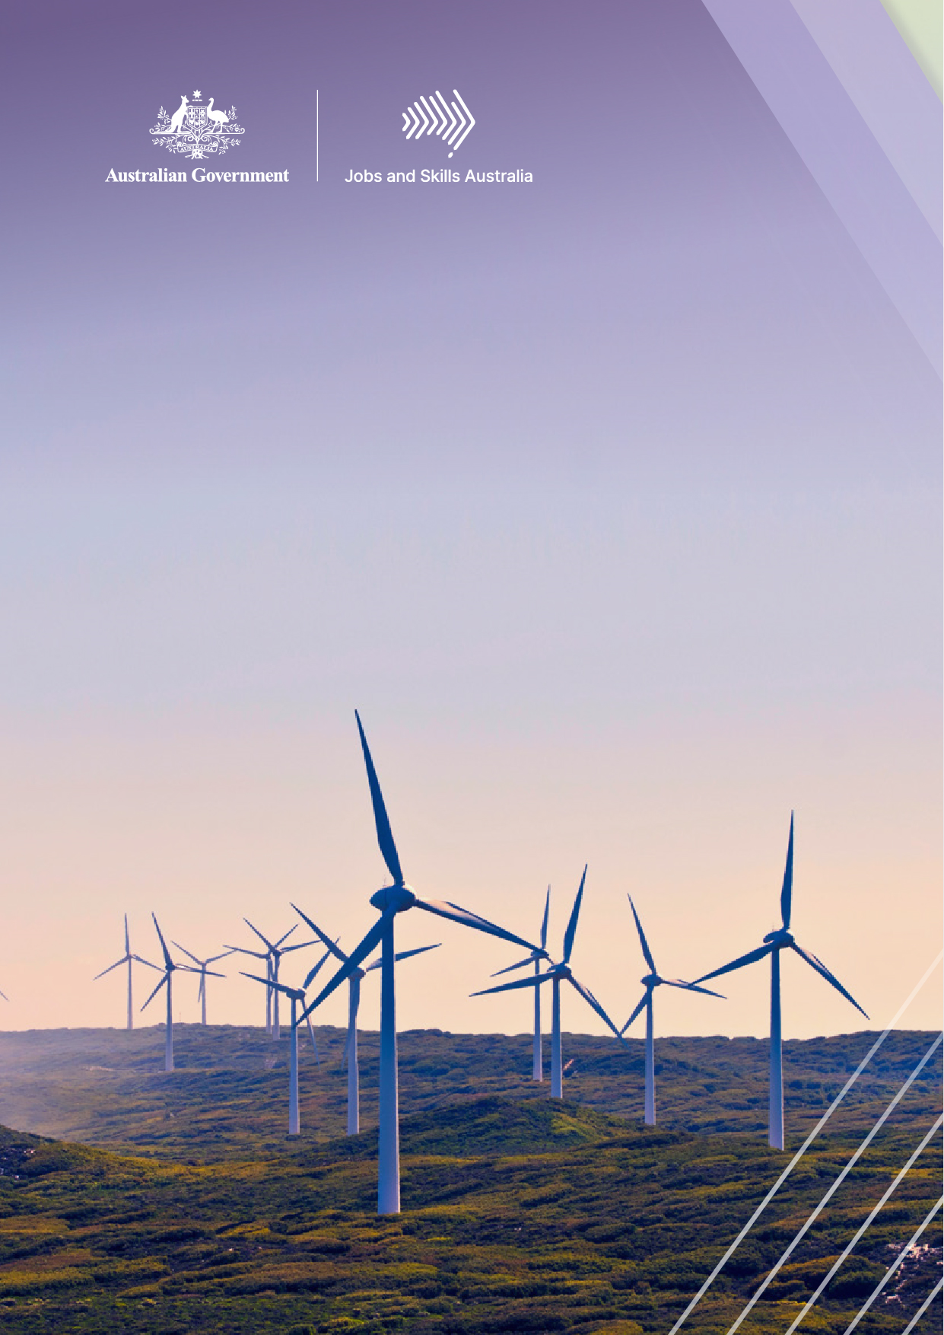
The Clean Energy Generation
Supplementary modelling report

Contents

Contents 2
Glossary 3
Introduction 4
The central and other scenarios 5
Workforce demand 11
Workforce supply and shortfalls 24
Summary 38
References 42

Glossary
Abbreviation
ABS | Australian Bureau of Statistics
AEMO | Australian Electricity Market Operator
ANZSIC | Australia and New Zealand Standard Industry Classification
CGE | Computable general equilibrium
DAE | Deloitte Access Economics
DCCEEW | Department of Climate Change, Energy, the Environment and Water
IEA | International Energy Agency
ISP | Integrated System Plan
JSA | Jobs and Skills Australia
NEM | National Electricity Market
REZ | Renewable Energy Zones
SPL | Skills Priority List
SSP | Shared Socioeconomic Pathway
VET | Vocational Education and Training

Introduction
This report builds on the preliminary modelling work presented in Jobs and Skills Australia’s Clean Energy Generation report. It explores pathways for Australia’s transition to Net Zero and presents analysis of the workforce implications of them. We analyse the jobs that are likely to be in demand; the industries that will likely change; the regions where clean energy jobs will most likely be needed; and the likely skills gaps that we need to prepare for. We also identify the jobs and regions that are likely to be impacted by the transition away from fossil fuels but also the opportunities that will arise from the broader economic transformation.
The modelling was undertaken for Jobs and Skills Australia (JSA) by Deloitte Access Economics (DAE) and uses a computable general equilibrium (CGE) model with an integrated assessment model, incorporating damages caused by climate change.
Our central scenario for the transition to Net Zero broadly aligns with current Government climate and energy policy, and future policy intent. This scenario is contrasted with two alternative pathways to Net Zero that illustrate different policy and technology directions that could emerge. The bulk of the analysis relates to the central scenario for this reason.
Modelling results find that achieving the current national 2030 interim emissions and renewable energy targets is necessary for higher economic and jobs growth in the face of the economic damage associated with climate change. Our central scenario models sustained investment (at an increasing rate), resulting in the delivery of the target of 82 per cent renewable energy in the National Electricity Market (NEM) by 2030 and supporting the achievement of the interim emission reduction target of 43 per cent (below 2005 levels) at a relatively lower transition cost.
Following this, our scenarios focus on possible policy interventions and coordination at the national level and plot different paths the Australia’s economy could follow. All three scenarios achieve Net Zero by 2050 but differ in the extent to which they assume implementation of Rewiring the Nation, electrification of transport and other sectors, and the adoption of alternative low-emission technologies for industry. All three scenarios were constructed with reference to the Australian Electricity Market Operator’s (AEMO) 2023 proposed scenarios, including the central, which is a variation of AEMO’s Orchestrated Step Change scenario.
This study acknowledges the uncertainties that come with climate change and workforce modelling, however the methodological approach for this study helps us focus policy attention on how the labour market may change through this transformation. Thus, the accompanying results offer insights into the long-term view of the impacts of climate change, Australia’s response to this, and what conclusions we can draw about changes in industries, regional economies and ultimately occupations.

The central and other scenarios
The analysis outlined in the following sections has been tested across three scenarios which model how sectors and regions interact based on different assumptions about technology, investment, consumption, wages, and broader economic activities (Figures 1 and 2). This allows us to identify what jobs we will likely need, which regions they need to be in and how many workers we will need to fill them. We can then examine the different workforce, training, and migration pathways Australia might need for the Net Zero transition. The main scenario is:
- a central scenario that sees coordinated policy action with increased investment into low-emissions activities. Australia delivers Rewiring the Nation, and the NEM has 82 per cent renewable energy by 2030. Beyond 2030, continued coordination of investment across higher emitting sectors, such as agriculture, reduces the costs of transition by increasing new low-emission activities. This scenario broadly aligns to current government climate and energy policy to 2030, including Government support for hard-to-abate sectors and reflects the stated policy intent to meet Net Zero by 2050 (see Figure 1).
The other two alternative scenarios (Figure 2) are:
- a low scenario that does not deliver current Federal Government policy settings and sees slower progress in expanding the share of renewable energy in the NEM with only 69 per cent renewable energy by 2030.
- a high scenario that sees more ambitious and coordinated policy action, giving the NEM over 90 per cent renewable energy by 2030. The investment in low-emission technologies is three times larger and more renewable energy capacity supports exporting green manufacturing (including iron) and a larger critical minerals mining and processing industry. Australia becomes a clen energy exporter due to its role in global supply chains. While there is increasing interest in the notion of Australia becoming a clean energy superpower, the assumptions underpinning this scenario are more ambitious than the measures outlined within current Government policies.

Key differences across the scenarios
Co-ordinated investment would likely drive employment growth
The central scenario is broadly aligned to current Government climate change and energy policy settings to 2030 and represents a stylised view to policy intent to 2050. By 2030, Australia achieves 82 per cent renewables in the NEM through coordinated implementation of Government policy, including full implementation of the Rewiring the Nation policy, investment into low-emissions activity and renewable energy increases.
The 43 per cent interim emissions reduction target by 2030 is met and the scenario assumes that this is achieved with a lower economic cost of transition due to increases in alternative industry activity within particularly hard to abate sectors. By maintaining output and employment within these sectors, alternative activities offset the costs of high-emission industry transition (the economic abatement cost is lower). The central scenario assumes continued investment post 2030 (to capitalise on the investments already made to 2030), resulting in higher regional growth in employment and across industries through to 2050.
In the decade following meeting Australia’s interim targets, Australia starts to see higher growth rates in hard to abate industries, such as manufacturing, construction and agriculture, and continued growth in the clean energy sectors compared to the low scenario. The modelling suggests the central scenario is likely to result in 1.2 million more workers in the economy in 2050 compared to the low scenario, through increased labour force participation. There is also a relatively higher paid workforce and the creation of higher skilled jobs in this scenario compared to the low scenario.
Figure 1. Central scenario
Scenario ​ | Scenario alignment | Emissions reduction | Renewable energy mix | Key policy settings
Central | Full implementation of global target commitments  SSP1-2.6, 1.7°C by 2050 | 43 per cent emissions reduction below 2005 levels by 2030  Net zero emissions by 2050 | 82 per cent clean energy in the NEM by 2030 | - AEMO: Orchestrated Step Change, ISP2023  - Rewiring the Nation: full and coordinated implementation to 2030  - Global climate alignment: SSP1-2.6, 1.7°C by 2050, full implementation of global target commitments

Slower implementation of a clean energy market likely means industry must take on a larger share of emissions reduction, with greater impacts on employment
The low scenario provides a contrast to existing Government policy commitments. In this scenario, by 2030 Australia has not met current Government policy to achieve 82 per cent renewables in the NEM or implemented Rewiring the Nation. The 43 per cent interim emissions reduction target is still met by broader-based declines in emissions, but this is achieved at a higher economic transition cost as industries take up abatement opportunities that are at a higher cost than renewable energy. There is some regional and industry growth in employment to 2030, as some effort is made to transform the NEM.
However, with an assumption of only 69 per cent share of clean energy achieved in the NEM by 2030, modelling suggests growth in employment slows over the following decades to 2050, with some regions likely experiencing declines in employment due to higher transition costs. It is a ‘harder and harsher’ structural adjustment. From 2040 to 2050, Australia’s cost of transition remains relatively high, resulting in much slower employment and industry growth.
By 2050, the scenario assumes that emissions intensive activity declines and is not replaced. As global demand for low emissions goods and services ramps up post 2030, Australia is not able to meet this demand, leading to declines in employment outcomes for some sectors.

Becoming a clean energy superpower increases the benefits of transition by 2050, but requires significant effort
The third scenario imagines a situation where investment in Australia’s natural endowments is accelerated, and Australia becomes a significant clean energy exporter. The high scenario assumes targeted investment in Australia’s competitive advantages and strong global action to transition to a low-emission industrial economy. From the 2030’s this leads to the deployment of new technologies to enable economy-wide emissions reduction. This occurs as the world steps up decarbonisation and limits global temperature rise to 1.5˚C by 2050. The scenario assumes that Australia invests in new and emerging technologies such as hydrogen; expands critical minerals mining and green manufacturing (especially green iron); and builds its competitive advantage in the export of low-emissions goods and services as global demand increases. In this scenario, there is a significant transformation in Australia’s processing and manufacturing capabilities, underpinned by a growing green hydrogen sector and significantly larger volumes of renewable energy.
The modelling of this scenario assumes that a substantial amount of investment (around three times the level under the low scenario) is directed to clean energy. This accelerates and exceeds the 2030 targets (achieving almost over 90 per cent renewable energy in the NEM by 2030), with results indicating likely higher growth in employment in the next decade compared to the other scenarios.

On exceeding 2030 targets, the high scenario assumes that Australia has signalled to global markets its role as a clean energy superpower in the global transition to Net Zero. Significant effort is required to build domestic industrial capabilities to meet increased foreign demand. Further, this scenario assumes that by 2050, Australia’s cost of transition is offset by diversifying economic activity to low-emission exports and increasing industrial competitiveness in terms of industry output and associated net employment growth facilitated by higher participation in the labour market.
In his book The Superpower Transformation, Professor Ross Garnaut suggests that Australia could become a major exporter of net-zero emissions manufactured goods. By using our own green hydrogen, Australia could refine and smelt iron ore and bauxite competitively. However, to realise this goal Australia would require around 10,000 terawatt-hours of annual power generation, which is over 50 times the current capacity of the NEM and 10 times the capacity required under AEMO’s hydrogen superpower scenario.
Figure 2. Alternative scenarios
Scenario ​ | Scenario alignment | Emissions reduction | Renewable energy mix | Key policy differences
Low | Full implementation of global target commitments  SSP1-2.6, 1.7°C by 2050 | 43 per cent emissions reduction below 2005 levels by 2030  Net zero emissions by 2050 | 69 per cent clean energy in the NEM by 2030. | - AEMO: Orchestrated Step Change, ISP2023  - Rewiring the Nation: lack of coordinated implementation and no targeted investment (public and private) to 2030  - Global climate alignment: SSP1-2.6, 1.7°C by 2050, full implementation of global target commitments
High | Net Zero Emissions by 2050 – global coordinated action  SSP1-1.9, 1.5.0°C by 2050  AEMO: Net zero (energy exports)  IEA: Net Zero Emissions by 2050. | Approximately 46 per cent emissions reduction below 2005 levels by 2030  Net zero emissions by 2050 | 92 per cent clean energy in the NEM by 2030. | - AEMO: Net Zero (green energy exports scenario)  - Rewiring the Nation: fully implemented earlier, with the energy system transformed beyond current policy settings by 2030 and a larger quantum of clean energy in the economy  - Global climate alignment: SSP1-1.9, 1.5°C by 2050, global coordinated action to meet net zero by 2050

Alignment with Australia’s emissions projections
The Australia’s emissions projections 2023 publication produced by the Department of Climate Change, Energy, the Environment and Water (DCCEEW) provides the latest annual projections of Australia’s future greenhouse gas emissions to 2035. The purpose of the report is to assess how Australia is tracking against its legislated emissions reduction targets - 43 per cent reduction on 2005 levels by 2030 and net zero by 2050.
The DCCEEW report presents emissions projections for two scenarios, ‘Baseline’ and ‘With additional measures’. Under the ‘Baseline’ scenario, emissions are projected to be 386 Mt CO2-e or 37 per cent below 2005 levels by 2030, while under the ‘With additional measures’ scenario, emissions are estimated to reach 358 Mt CO2-e in 2030 or 42 per cent below 2005 levels by 2030.
The Central scenario presented in this study closely aligns with the ‘With additional measures’ scenario both in terms of the projected emissions (see Table 1) and the broad measures to reach them. However, as different forecasting models have been used (as the model used in the JSA study also needs to include information on economic and employment outputs) and contain different emissions categories, the emissions contributions of the various sectors across both reports do not precisely align.
Table 1. Comparison of DCCEEW and JSA emissions projections by 2030
Government's target | 43% | 351 Mt CO2-e
DCCEEW Scenarios
Baseline | 37% | 386 Mt CO2-e
With additional measures | 42% | 358 Mt CO2-e
JSA scenarios
Central | 43% | 351 Mt CO2-e
Low | 43% | 351 Mt CO2-e
High | ~46% | 336 Mt CO2-e
Source: DAE modelling, DCCEEW’s Australia’s emissions projections 2023 publication

Comparison with other estimates of future employment impacts
The modelling approach uses both integrated assessment modelling (IAM) and labour market supply and demand modelling undertaken by Deloitte Access Economics. This approach is different from the methodology used to produce other forecasts for the clean energy workforce, which rely on employment factors to produce workforce numbers based on ratios of workers to units of energy production (or similar). The approach adopted here models how regional workforces transform under different scenarios.
Global conditions and changes in technology over time are included in the assumptions. The regions of Australia have been constructed to coincide wherever possible with renewable energy zones (REZs).
The results from the model presented here looks to solve for an outcome – in this case Net Zero emissions by 2050 – in an economically efficient way. It considers the availability of capital and labour (including the distribution of skills within the labour force) as well as relative prices for inputs and outputs across the different sectors of the economy. This is a more sophisticated and comprehensive framework than that deployed by analyses of the future clean energy workforce in Australia that use an employment factors approach.

Workforce demand
Overview
Under the three scenarios, the modelling leads to different patterns of industry transformation and job growth across the country and regions. All three scenarios involve structural change across the economy and higher than average growth in the core clean energy sectors is likely. Again, across all three, the strongest employment growth is likely to occur in the next seven years, driven by investments in clean energy.
The shift from emissions intensive power sources to clean electricity means that construction and renewable energy are likely to see particularly high growth in employment demand under the central and high scenarios. This is driven by large-scale investment and requires a significant workforce to support construction and ongoing operations.
Industries that contribute to the supply of electricity or facilitate the demand of electricity experience growth as Australia’s economy transforms. The significant investment in renewable energy capacity results in likely strong jobs growth in wind, offshore wind, solar and hydroelectricity over the next seven years. Employment growth in these emerging sectors under the central and high scenarios outpaces that of the low scenario over the same period. Some industries decline in importance, but new industries also emerge.
From an occupational perspective, the modelling shows the sum of all 38 critical clean energy occupations exhibit a higher growth rate of jobs growth than the overall labour market and there is high demand for trades and technician workers, especially electricians (including in the regions).

How are industries likely to transform?
Our analysis has looked at how employment is likely to change through the lens of the clean energy segments that were defined in the main report for this study.
Our analysis shows the clean energy ‘Supply - Generation’ segment which includes industries such as Hydro-Electricity Generation and Other Electricity Generation is likely to record the strongest employment growth in the initial forecasting period, 7.9 per cent per year for the central scenario and 15.1 per cent for the high scenario (see Table 1). Strong growth for this sector is expected to continue out to 2050 period albeit at a subdued rate.
The ‘Supply – distribution’ segment is a crucial sector for the Net Zero transformation. While the modelling suggests this segment is likely to see minimal annual growth over the period to 2030, the growth rate will likely increase to just over 1 per cent per year beyond 2030 (under the central scenario). Together, these two segments will likely see an increase in employment from 53,000 today to 84,000 by 2050 under the central scenario.

The ‘Demand - Energy Usage’ segment which includes the installation of small scale (residential) solar and other industries such as electrical services and air-conditioning and heating services. This segment is likely to record strong employment growth in the initial forecasting period (to 2030) with around 4.5 per cent growth per year, an increase in employment of over 55,000 over the period (central scenario). Employment growth under the high scenario is likely to be even stronger with 6.7 per cent average annual growth and over 91,000 jobs being created (see Table 2). Employment growth for this sector under the central scenario is likely to continue for the entire forecasting period up until 2050 (see Tables 3 and 4).
The ‘Demand - Energy Performance’ segment, relates to reducing energy demand and includes industry groups that directly contribute to improving energy efficiency in residences and other buildings (e.g. house construction, carpentry services, glazing services, plumbing services) and supporting industry groups in the value chain (e.g. glass and glass product manufacturing). This segment is also likely to see strong employment growth under all scenarios up to 2030. Under the central scenario, employment growth is likely to be around 4.4 per cent per year with around 200,000 jobs being created. Under the high scenario employment of 6.6 per cent per year is expected with over 327,000 jobs for the period (see Table 1). The employment growth trend is likely to continue for the latter periods, albeit at a slower rate of around 1.0 per cent (see Tables 3 and 4).
The ‘Enabling – Engineering, Procurement and Construction’ segment contains a combination of professional services (engineering design and consulting, architectural services, scientific testing and analysis services) and the group of heavy and civil engineering construction that covers electricity infrastructure. This segment is also likely to experience strong growth over the first period to 2030 (average annual growth of 2.4 per cent under the central scenario), after which growth is likely to slow (to just below one per cent for the latter periods). Overall, this segment is likely to see an increase in employment of close to 118,000 by 2050.
Analysis also shows declines are likely across the ‘Transitioning’ segment, which includes fossil-fuel intensive electricity generation and coal mining, of around -1.1 per cent per year to 2030, a lower rate of decline through the middle decade (-0.2 per cent per year) and then some modest growth for the last decade modelled (around 1.4 per cent per year), under the central scenario. This initial decline is driven by legacy coal plants reaching end of life being replaced by renewable generation and storage, with associated mine closures as well as international and other factors. Due to scheduled closures of ageing assets, analysis shows overall, this segment is likely to see the largest employment falls in percentage terms, but in terms of levels this segment could contract by around 11,000 employees by 2030 under the central scenario. However, it should be noted that this will occur over a period in which the economy is likely to add around 1.5 million jobs overall. In the final decade, as industries in this sector move to adopting clean energy technology and practices, employment is expected to increase by 1.4 per cent per year (central scenario).
Under the high scenario, the ‘Transitioning’ segment records a minor employment decline in the initial forecast period (-0.2 per cent per year) before experiencing increasing positive employment growth in subsequent periods (0.2 per cent per year and 0.9 per cent per year). Under the low scenario, however, negative employment growth is expected throughout the forecast period as lower levels of investment result in a slower adoption of clean energy technology. Alongside the climate transition, another significant driver of the declines in employment in this segment under all three scenarios is the underlying adoption of greater automation and capital intensity, something which is independent of climate change responses.
The ‘Direct Emissions Intensive’ segment (such as metal, chemical and non-metallic mineral product manufacturing), is likely to see employment contract at a rate of 2.5 per cent per year on average to 2030 and representing a likely decline in employment of close to 13,000 under the central scenario (see Table 2). As for the ‘Transitioning’ segment, technological change leading to automation contributes substantially to the employment declines expected in the ‘Direct Emissions’ segment and would be expected occur across all scenarios.
Table 2. Employment by clean energy sectors, average annual growth and change in the level of employment between 2023 to 2030
Industry | Low |  | Central |  | High
 | per cent | Level change | per cent | Level change | per cent | Level change
Supply - generation | 2.4 | 800 | 7.9 | 3,500 | 15.1 | 8,800
Supply - distribution | 0.1 | 400 | 0.2 | 500 | 0.3 | 1,000
Demand - energy usage | 3.3 | 39,100 | 4.5 | 55,300 | 6.7 | 91,300
Demand - energy performance | 3.3 | 143,900 | 4.4 | 200,200 | 6.6 | 327,400
Demand - transport | 0.7 | 22,800 | 0.6 | 21,300 | 0.3 | 11,100
Enabling - education, training, research & technology | 1.7 | 39,200 | 1.7 | 38,600 | 1.7 | 38,200
Enabling - finance, legal, business | 1.5 | 72,700 | 1.5 | 73,200 | 1.5 | 77,200
Enabling - engineering, procurement & construction | 2.0 | 44,500 | 2.4 | 54,400 | 3.3 | 77,000
Enabling - regulatory | 1.5 | 62,600 | 1.5 | 62,900 | 1.5 | 64,200
Enabling - supply chain | 0.1 | 2,300 | 0.0 | 700 | -0.2 | -3,400
Enabling - vehicle & equipment production, trade & maintenance | 0.3 | 7,400 | 0.3 | 7,100 | 0.1 | 3,100
Carbon lifecycle | 1.0 | 4,800 | 1.0 | 4,800 | 1.0 | 4,600
Transitioning | -1.8 | -18,200 | -1.1 | -11,100 | -0.2 | -2,200
Indirect emissions-intensive | -0.4 | -14,800 | -0.6 | -19,800 | -1.1 | -36,400
Direct emissions-intensive | -2.4 | -12,300 | -2.5 | -12,900 | -3.5 | -17,300
All other industry groups | 1.5 | 1,022,000 | 1.6 | 1,096,200 | 1.8 | 1,271,000
All industries | 1.4 | 1,417,400 | 1.5 | 1,575,000 | 1.9 | 1,915,700
Source: Deloitte Access Economics 2023.
Indirect emissions-intensive industries include: Food, beverages, textiles manufacturing; Wood and paper product manufacturing and printing; Gravel and sand mining from Other mining (all other mining categories were captured elsewhere); and, Polymer Product and Rubber Product Manufacturing from Petroleum and chemical products.

Table 3. Employment by clean energy sectors, average annual growth and change in the level of employment between 2031 to 2040
Industry | Low |  | Central |  | High
 | % | Level change | % | Level change | % | Level change
Supply - generation | -0.1 | -100 | 4.4 | 4,200 | 4.1 | 6,900
Supply - distribution | 0.5 | 2,400 | 1.0 | 4,600 | 1.5 | 7,200
Demand - energy usage | 0.4 | 8,000 | 0.9 | 18,300 | 0.3 | 5,600
Demand - energy performance | 0.5 | 32,900 | 1.0 | 73,400 | 0.3 | 24,700
Demand - transport | 0.5 | 23,200 | 0.6 | 25,600 | 0.6 | 26,800
Enabling - education, training, research & technology | 1.4 | 47,700 | 1.4 | 47,600 | 1.5 | 50,900
Enabling - finance, legal, business | 0.8 | 58,600 | 0.9 | 62,100 | 0.9 | 68,200
Enabling - engineering, procurement & construction | 0.7 | 22,200 | 0.9 | 29,000 | 0.7 | 23,800
Enabling - regulatory | 0.8 | 50,000 | 0.9 | 53,000 | 0.9 | 56,200
Enabling - supply chain | 0.6 | 15,300 | 0.8 | 20,900 | 1.7 | 42,700
Enabling - vehicle & equipment production, trade & maintenance | 0.6 | 22,000 | 0.6 | 23,500 | 0.7 | 28,400
Carbon lifecycle | 0.4 | 2,500 | 0.5 | 3,500 | 0.7 | 5,000
Transitioning | -1.4 | -15,500 | -0.2 | -2,100 | 0.2 | 3,300
Indirect emissions-intensive | 0.0 | -1,500 | 0.0 | 800 | 0.3 | 12,400
Direct emissions-intensive | -1.2 | -6,700 | -0.8 | -4,500 | -0.6 | -3,300
All other industry groups | 0.9 | 877,800 | 1.0 | 974,000 | 1.0 | 1,011,300
All industries | 0.8 | 1,138,700 | 0.9 | 1,333,900 | 0.9 | 1,370,100
Source: Deloitte Access Economics 2023.

Table 4. Employment by clean energy sectors, average annual growth and change in the level of employment between 2041 to 2050
Industry | Low |  | Central |  | High
 | % | Level change | % | Level change | % | Level change
Supply - generation | 5.2 | 3,300 | 6.1 | 9,700 | 4.4 | 11,000
Supply - distribution | 0.2 | 1,100 | 1.2 | 6,100 | 1.2 | 6,800
Demand - energy usage | 0.0 | 400 | 1.1 | 22,800 | 1.3 | 31,000
Demand - energy performance | 0.1 | 5,000 | 1.1 | 91,200 | 1.3 | 109,300
Demand - transport | -0.1 | -3,400 | 0.3 | 16,400 | 0.3 | 13,300
Enabling - education, training, research & technology | 1.0 | 36,400 | 1.2 | 46,200 | 1.3 | 49,800
Enabling - finance, legal, business | 0.3 | 22,200 | 0.7 | 51,400 | 0.8 | 59,800
Enabling - engineering, procurement & construction | 0.2 | 6,400 | 0.8 | 28,500 | 0.9 | 35,800
Enabling - regulatory | 0.4 | 25,800 | 0.7 | 48,700 | 0.8 | 55,100
Enabling - supply chain | -0.4 | -9,300 | 0.2 | 4,600 | 0.6 | 17,900
Enabling - vehicle & equipment production, trade & maintenance | -0.1 | -3,100 | 0.4 | 15,200 | 0.3 | 13,800
Carbon lifecycle | -0.1 | -500 | 0.4 | 2,600 | 0.4 | 3,000
Transitioning | -0.3 | -3,300 | 1.4 | 18,400 | 0.9 | 13,300
Indirect emissions-intensive | -1.1 | -46,200 | -0.5 | -19,400 | -0.7 | -27,500
Direct emissions-intensive | -3.2 | -14,800 | -1.8 | -9,300 | -2.3 | -11,200
All other industry groups | 0.4 | 412,400 | 0.8 | 877,400 | 0.9 | 966,300
All industries | 0.3 | 432,300 | 0.8 | 1,210,600 | 0.8 | 1,347,400
Source: Deloitte Access Economics 2023.

What occupations are likely to be in demand?
In the main Clean Energy Generation study report Jobs and Skills Australia identified 38 occupations critical for the clean energy transformation. In total, the modelling indicates we are likely to see employment for these 38 occupations to follow a higher growth rate than the broader workforce (see Figure 3). In the central scenario, employment for these 38 occupations is likely to increase by around 15 per cent in the next seven years to deliver the Net Zero transformation. This represents an increase of almost 240,000 workers.
Figure 3. Employment growth by scenario
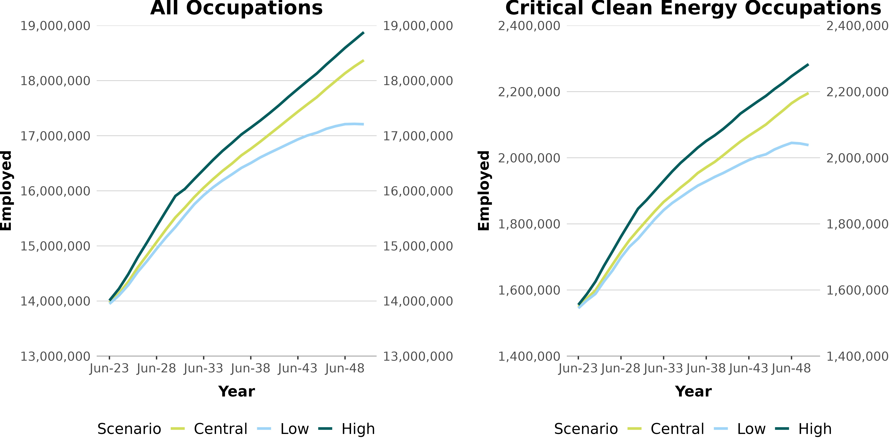

Source: Deloitte Access Economics 2023.
Of the critical clean energy occupations, the highest average annual growth rates in the next seven years (2023-2030) include Telecommunications Trades Workers (8.1 per cent under the central scenario), Electronics Trades Workers (6.1 per cent) and Electrical Engineering Draftspersons and Technicians (5.2 per cent) (Table 5). These occupations are likely to continue to see the largest growth rates over the later modelling periods (Tables 6 and 7).
In terms of the likely increase in the number of workers in occupations we are likely to see the largest increased demand for Electricians (32,200 by 2030 under the central scenario) and Construction Managers (27,500) (Table 5). These two occupations are likely to see continued increase in demand over the following two decades, with an increase of over 25,000 in each between 2031 and 2040, and over 20,000 each between 2041 and 2050.

Table 5. Employment by occupation, average annual growth and change in the level of employment between 2023 and 2030
Occupation | Low |  | Central |  | High
 | % | Level change | % | Level  change | % | Level change
Telecommunications Trades Workers | 7.9 | 13,600 | 8.1 | 14,000 | 8.4 | 14,800
Electronics Trades Workers | 6.0 | 13,300 | 6.1 | 13,700 | 6.5 | 14,800
Electrical Engineering Draftspersons and Technicians | 5.2 | 5,200 | 5.2 | 5,200 | 5.4 | 5,600
Structural Steel Construction Workers | 2.9 | 5,300 | 3.2 | 5,800 | 3.9 | 7,400
Construction Managers | 2.6 | 24,000 | 2.9 | 27,500 | 3.7 | 35,900
Agricultural and Forestry Scientists | 2.7 | 1,900 | 2.8 | 2,000 | 3.2 | 2,300
Airconditioning and Refrigeration Mechanics | 2.4 | 5,600 | 2.6 | 6,200 | 3.2 | 7,800
Plumbers | 2.3 | 17,100 | 2.6 | 19,700 | 3.4 | 25,800
Electricians | 2.1 | 26,500 | 2.5 | 32,200 | 3.3 | 42,500
Urban and Regional Planners | 2.3 | 3,200 | 2.4 | 3,300 | 2.7 | 3,800
Other Engineering Professionals | 2.3 | 2,500 | 2.3 | 2,600 | 2.6 | 2,900
Industrial, Mechanical and Production Engineers | 2.0 | 6,100 | 2.1 | 6,200 | 2.4 | 7,200
Engineering Managers | 1.7 | 3,500 | 1.7 | 3,600 | 2 | 4,300
Electrical Engineers | 1.5 | 3,300 | 1.6 | 3,400 | 1.9 | 4,200
Civil Engineering Professionals | 1.5 | 8,400 | 1.4 | 8,300 | 1.9 | 11,200
Source: Deloitte Access Economics 2023.

Table 6. Employment by occupation, average annual growth and change in the level of employment between 2031 to 2040
Occupation | Low |  | Central |  | High
 | % | Level change | % | Level change | % | Level change
Telecommunications Trades Workers | 2.4 | 8,200 | 2.5 | 8,800 | 2.5 | 9,100
Electronics Trades Workers | 2.2 | 9,100 | 2.4 | 9,900 | 2.4 | 10,400
Electrical Engineering Draftspersons and Technicians | 2.3 | 4,100 | 2.5 | 4,500 | 2.6 | 4,900
Structural Steel Construction Workers | 1.6 | 4,400 | 1.5 | 4,300 | 1.8 | 5,700
Construction Managers | 1.5 | 21,600 | 1.8 | 26,300 | 1.7 | 27,100
Agricultural and Forestry Scientists | 1.1 | 1,200 | 1.3 | 1,400 | 1.2 | 1,300
Airconditioning and Refrigeration Mechanics | 1.1 | 3,900 | 1.3 | 4,700 | 1.4 | 5,300
Plumbers | 1.1 | 12,700 | 1.4 | 15,900 | 1.5 | 17,600
Electricians | 1.2 | 21,900 | 1.3 | 25,200 | 1.3 | 26,100
Urban and Regional Planners | 1.3 | 2,700 | 1.4 | 3,000 | 1.5 | 3,200
Other Engineering Professionals | 1.1 | 1,900 | 1.2 | 2,100 | 1.3 | 2,300
Industrial, Mechanical and Production Engineers | 1.0 | 4,400 | 1.1 | 4,900 | 1.2 | 5,500
Engineering Managers | 1.1 | 3,300 | 1.2 | 3,800 | 1.3 | 4,300
Electrical Engineers | 1.1 | 3,300 | 1.2 | 3,700 | 1.3 | 4,100
Civil Engineering Professionals | 1.1 | 8,800 | 1.3 | 10,500 | 1.5 | 12,700
Source: Deloitte Access Economics 2023.

Table 7. Employment by occupation, average annual growth and change in the level of employment between 2041 to 2050
Occupation | Low |  | Central |  | High
 | per cent | Level change | per cent | Level change | per cent | Level change
Telecommunications Trades Workers | 0.8 | 3,100 | 1.3 | 5,300 | 1.4 | 5,900
Electronics Trades Workers | 0.8 | 3,800 | 1.3 | 6,500 | 1.4 | 7,000
Electrical Engineering Draftspersons and Technicians | 1.0 | 2,000 | 1.3 | 3,000 | 1.1 | 2,500
Structural Steel Construction Workers | 0.3 | 900 | 0.8 | 2,700 | 0.5 | 1,600
Construction Managers | 0.7 | 11,500 | 1.3 | 23,000 | 1.4 | 24,600
Agricultural and Forestry Scientists | 0.7 | 800 | 1.1 | 1,300 | 1.1 | 1,400
Airconditioning and Refrigeration Mechanics | 0.4 | 1,600 | 0.9 | 3,800 | 1.1 | 4,600
Plumbers | 0.4 | 4,700 | 1.1 | 13,700 | 1.0 | 13,800
Electricians | 0.4 | 7,900 | 1.0 | 22,300 | 1.2 | 27,800
Urban and Regional Planners | 0.7 | 1,600 | 1.2 | 2,800 | 1.2 | 2,900
Other Engineering Professionals | 0.6 | 1,100 | 1.1 | 2,000 | 1.0 | 1,900
Industrial, Mechanical and Production Engineers | 0.4 | 1,700 | 0.8 | 3,800 | 0.7 | 3,500
Engineering Managers | 0.7 | 2,300 | 1.1 | 3,900 | 1.0 | 3,600
Electrical Engineers | 0.7 | 2,200 | 1.1 | 3,900 | 1.0 | 3,600
Civil Engineering Professionals | 0.7 | 6,500 | 1.2 | 10,900 | 0.9 | 9,100
Source: Deloitte Access Economics 2023.

Which regions are likely to experience jobs growth?
The modelling undertaken by Deloitte for this study included a regional dimension (see Appendix C for a description of the regions). It should be noted that this regional dimension is quite broad, with each of the large states (NSW, Queensland and Victoria) being split in to three regions, SA and WA having the capital city and rest of state as regions, and the whole of the NT and Tasmania. ACT is grouped with Southern NSW. While this regional dimension provides some indication of likely changes across regional Australia from the Net Zero transformation, it is not granular enough to support detailed regional workforce planning.
Generally, the modelling shows employment growth is likely to be stronger in regional Australia than metropolitan Australia under the central scenario, although there is some variation across regions. The continued investment modelled in the central scenario post 2030 capitalises on the investments in low-emissions activity and renewable energy in the first decade, resulting in higher regional growth in employment and across industries through to 2050.
Likely clean energy jobs growth in various regions to 2030
Under the central scenario the modelling shows many regions are likely to have average annual employment growth rates close to 2 per cent between 2023 and 2030, including Northern NSW and ACT and Southern NSW. Eastern Victoria and the Northern Territory also have relatively high growth rates (close to 2 per cent) but in these two regions growth is off a smaller base. This growth reflects renewable energy projects and the associated construction pipelines. Some of these regions, for example Northern NSW and Eastern Victoria, also have transitioning sectors. These regions are also likely to have stronger growth rates under the high scenario (above 2 per cent per annum). Under the high scenario Tasmania and South-Eastern Queensland are also likely to have annual average growth above 2 per cent.
In the decade to 2040, overall average employment growth rates will moderate across all regions with regional Victoria (both Eastern and Western) likely to have average annual growth rates of around 1.3 per cent and 1.5 per cent respectively, under the central scenario. South-East Queensland and Melbourne are also likely to have relatively strong growth. In the decade to 2050 overall annual employment growth for most regions is likely to be slower than the early periods of the transformation. Under the central scenario Western and Eastern Victoria and ACT and Southern NSW are likely to see the relatively largest average annual growth rates.
Regional Western Australia is likely to record low employment growth over the forecast period under the central scenario, while regional South Australia is expected to record negative growth for the first two periods before experiencing positive employment growth. These employment forecasts are likely due to the low populations in these areas along with capital intensive nature of the scheduled clean energy projects.
Figure 4. Overview of regional average annual employment growth – 2023-2030
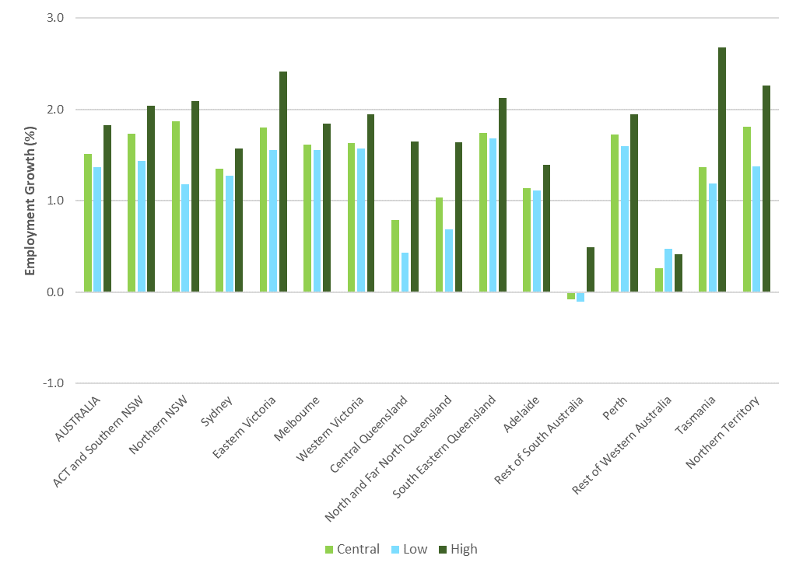
Source: Deloitte Access Economics 2023.
Note: Tasmania benefits in the initial forecast period as it gains relatively more renewable energy early and does not have to transition away from high emitting activity and can therefore export renewable energy to the rest of the country. It is a much lower cost and high net gain transition for Tasmania. It should be noted that the ‘levels’ of employment are relatively small.

Figure 5. Overview of regional average annual employment growth – 2031-2040
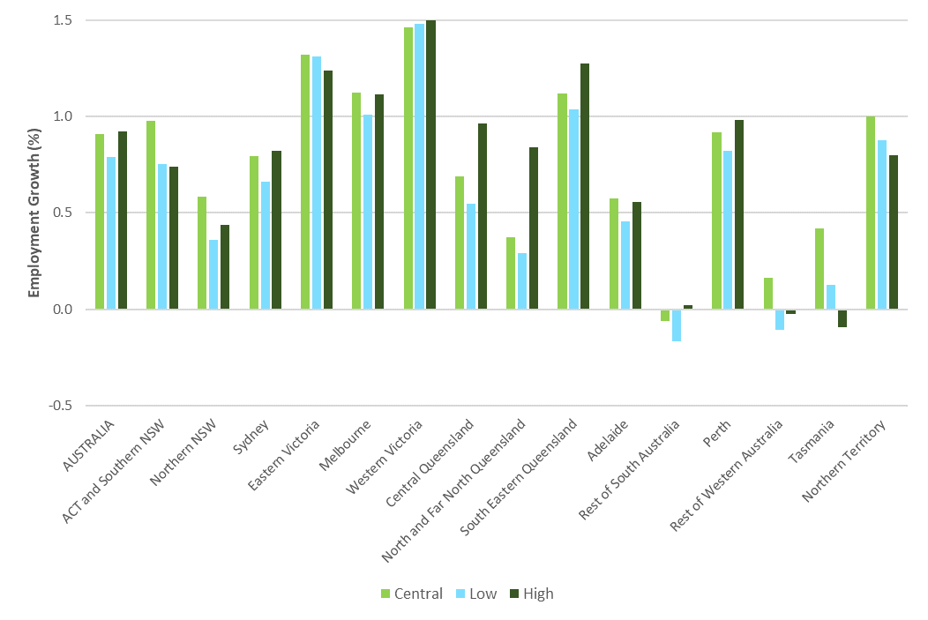
Source: Deloitte Access Economics 2023.
Figure 6. Overview of regional average annual employment growth – 2041-2050
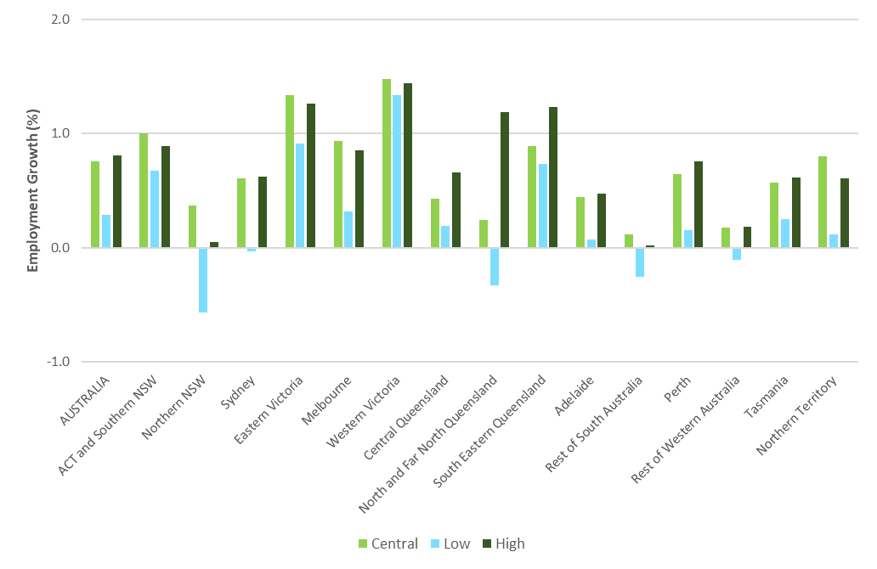
Source: Deloitte Access Economics 2023.

Workforce supply and shortfalls
The modelling for the study also included estimates of the likely supply of workers by occupation. This was based on the existing qualifications available in the labour market and net movements in and out of the workforce, reflecting retirements, migration, completions of study and movements between jobs. The supply modelling is informed by Treasury’s 2023 Intergenerational Report population projections, where each region’s working-age population is the key subset of the population when thinking about individuals using their skills in the labour market. The future skills held by the working population is augmented by training, as well as other labour market flows that include: people ageing (retirements and labour force entry); deaths; international migration; and, internal migration.
Through comparing the employment modelling to the supply modelling, an assessment of possible workforce supply gaps (or surpluses) can be determined. This suggests that in total, Australia is likely to have enough workers to meet demand for the transition period across all scenarios, but demand is likely to exceed supply for clean energy occupations in the first decade. The modelling undertaken does not take account of current shortages experienced across occupations, and the JSA Skills Priority List (SPL) can provide additional insights about the current labour shortages experienced by businesses for critical occupations.
Electrical trade roles and nearly all the building and engineering trades that are critical to the construction and maintenance of renewable energy are likely to experience shortfalls. This will be apparent in regional areas across all three scenarios and is even the case under the low scenario. The modelling (based on historical qualification completion rates) suggests we are likely to have enough engineers but there are some gaps for some professional occupations like environmental scientists. These are the potential shortages Australia needs to plan for.

Which occupations are likely to be in short supply?
While overall the modelling suggests there is likely to be sufficient workers to meet the demand of the transformation to Net Zero, we see tight demand for VET qualified occupations. At the more detailed occupational level, we still expect to see ongoing and severe shortages for several critical clean energy occupations.

Electrical trade roles shortages likely the largest
Electricians are the leading example of the critical occupation where total demand is likely to be higher than supply over the next seven years, even under the low scenario. Electricians are currently listed as an occupation in shortage on the SPL right across Australia, indicating there is currently a shortage.
The modelling suggests labour supply for electricians is forecast to grow slowly, due to relatively flat completions and a relatively older current workforce. This means that there are likely to be growing supply gaps under all scenarios unless there is a significant increase in enrolments and completions from the VET system, with those completions also converting into actual employment as electricians. In addition, electricians are an occupation where there is significant opportunity to address the stark gender imbalance currently seen among this occupation. The challenges around the transformation change required to address this is covered in chapter 8 of the main report for the study.
Modelling under our central scenario suggests we would likely need almost 85,000 more electricians by 2050, representing a 27 per cent gap over supply.
Under the central and high scenarios other electrical trade roles are expected to experience supply gaps – even though supply is growing, it is not expected to be sufficient to keep pace. Most of the occupations within these occupation groups are also currently in shortage as indicated by the SPL. These include:
  - Electrical Engineering Draftspersons and Technicians
  - Airconditioning and Refrigeration Mechanics
  - Electronics Trades workers
  - Telecommunications Trades workers
Electrical Distribution Trades Workers are an electrical trade role that is not likely to experience a shortfall under our central scenario over the next thirty years. However, this is based on the current and historical training completions for the relevant VET course. Like the other occupations described, this occupation is also listed as being in shortage across Australia in the SPL, suggesting some further misalignment between the supply pipeline and employment demand.

Building and engineering trade shortages likely also to persist
Nearly all the building and engineering trades that are critical to the construction (and maintenance) phases of renewable electricity generation are also likely to experience supply gaps under our central scenario, drawing on the modelling.
While there may be growth in the future supply of Metal Fitters and Machinists and for Structural Steel and Welding Trades workers, it will likely not be enough to keep up with expected demand, particularly in the next twenty years. Growth in demand for Metal Fitters and Machinists is expected to outpace supply across all scenarios for most of the transition period. Structural Steel and Welding Trades workers, currently in shortage across Australia, also have a supply gap, climbing to roughly 10,000 by 2037 (around a 10 per cent gap) and hovering around that mark until 2050.
Under all scenarios, there are likely to be shortfalls of Civil Engineering Draftspersons & Technicians (currently in shortage) and Architectural, Building & Surveying Technicians. In the longer term, the supply estimates suggest that there will be a shortfall of 2,200 Civil Engineering Draftspersons and Technicians will be needed by 2050. There is an even bigger shortage of Architectural, Building & Surveying Technicians across most of the transition period to 2050, or about 30 per cent of the likely demand. While VET completions for Architectural, Building & Surveying Technicians are likely to increase modestly over the time, they do not offset the projected relatively high level of retirements and movements out of the occupation, which are driving a declining supply projection.
There is likely to be an emerging supply gap in Chemical, Gas, Petroleum and Power Generation Plant Operators emerge from approximately 2030. This is despite the likely decrease in employment in fossil fuel power generation and gas production and distribution, with offsetting employment growth in renewable energy and hydrogen over time.
Figure 7. Demand (all scenarios) and supply for electrical trades and technicians, 2023-2050
Source: Deloitte Access Economics 2023.

Figure 8. Demand (all scenarios) and supply for other trades and technicians, 2023-2050
Source: Deloitte Access Economics 2023.

A likely steady supply of engineers, but some scientist shortfalls
The modelling results for professional occupations are more varied. Engineering occupations, which are currently mostly in shortage on the SPL across Australia, are likely to have sufficient supply based on the supply projections, under both the central and low scenarios, with the only exception being Mining Engineers. The supply projections are based on historical trends in completions, and the gap between demand and supply does not take into account any current shortages present for particular occupations.
A shortage of mining engineers is likely to be most acute in the medium term. The projected supply for this occupation will likely drop in the short-term driven by high levels of retirements relative to university completions, coupled with likely movements to other occupations. In the subsequent years increased net migration along with increasing completions relative to retirements will lead to supply trending upwards towards 2050.
The projected supply is likely to be close to likely demand for other engineering roles including Chemical and Materials Engineers, Civil Engineering Professionals and Other Engineering Professionals. Given these roles are currently on the SPL there is still a risk of skill shortages occurring.
In particular, the Civil Engineering Professionals occupation is likely to experience strong demand under all scenarios. Projected supply in this occupation will be driven by a combination of consistent qualification completions, net migration and occupation transitions into the occupation, offset by a relatively high and increasing level of retirements. This results in supply being reasonably close to demand, and while the modelling suggests supply will be sufficient under the central scenario, even small shifts could result in supply shortages over time.
Other professional occupations like Agricultural and Forestry Scientists and Environmental Scientists are likely to experience some shortfalls as we transition to Net Zero. The shortfalls are likely to be around 2,000 workers in 2050 under the central scenario for both Agricultural and Forestry Scientists and Environmental Scientists. The modelling suggests there will likely be a sufficient supply of Geologists, Geophysicists and Hydrogeologists, with supply being driven by movements into the occupation and strong net migration.
Our assessment about the supply of engineers in general being adequate, should be qualified with the following caveats. First, it is important to note that these projections of labour supply for engineers (indeed, for all professional occupations) are based on past trends in higher education attainment. This has been significantly shaped by the demand driven system of higher education, where there was a substantial expansion of university graduates. The projections assume continued strong pipeline growth on the number of graduates as a result.
However, the demand-driven system has been discontinued and the future size of the higher education sector is uncertain. It is currently under review as part the Universities Accord Review process. An adequate supply of engineers to enable the clean energy transition will be an important priority of the system going forward. Second, even if we continue to have strong pipeline of engineering graduates, we need to ensure that they have the attributes required for the available jobs. Skills shortages could still happen for reasons outlined in the next section.
Figure 9. Demand (all scenarios) and supply for engineering professionals, 2023-2050
Source: Deloitte Access Economics 2023.

Figure 10. Demand (all scenarios) and supply for selected other professionals, 2023-2050

Source: Deloitte Access Economics 2023.

Skills shortages for occupations could still happen
It is important to be very clear that skill shortages for a given occupation can still occur even when the modelling suggests there will likely be sufficient supply. Skill shortages can exist when:
- There is an insufficient number of available workers with the required skills
- Potential workers have the requisite general skills but lack the required level of experience or other attributes sought by employers
- There are sufficient workers with the skills, but relative wages and other employment conditions mean that many prefer to work in alternative roles (even ones that do not make full use of their qualifications and skills).
This broad range of factors is reflected in the assessments undertaken as part of JSA annual Skills Priority List.
Recent JSA analysis of engineers demonstrates this situation. While employers report they attract sufficient applicants for engineering vacancies with the required qualifications, applicants often lack the amount or type of experience employers want for the role.
For these reasons, it is very difficult (and likely misleading) to attempt to forecast skill shortages well into the future. The labour supply projections here are a benchmark based on current trends, around which to assess likely demand, and an indicator of where gaps may otherwise emerge.
As well as the quantity of graduate engineers coming into the labour market, particular attention will need to be given to their employability attributes. It will be important for industry and tertiary education providers to work closely together to provide work experience to students and support the development of their employability skills.

What are the likely skills shortages in the regions?
As described earlier, employment growth is likely to be stronger in regional Australia than metropolitan Australia. There is likely to be a much tighter demand for VET qualified workers in the transition to Net Zero, especially in the regions. Some professional roles are also likely to be in shortage in some regions.
Below the overall pattern of likely sufficient supply within the labour market, there are notable differences in the projected labour market supply between metropolitan and regional Australia. Figure 11 shows the estimated total worker surplus or shortfall for each region in 2030, with Northern NSW likely to experience an overall shortage of workers under the central scenario. Surpluses are likely to be smaller, or supply close to demand, in regional areas than metropolitan areas (noting the South-Eastern Queensland also includes Brisbane so is a mixed region). This result suggests that greater net internal migration from metropolitan to regional areas will be needed. One element of that could be less migration from regional areas to metropolitan areas once more local job opportunities arise.
Figure 11. Estimated worker surplus/shortfall by region (all occupations), 2030
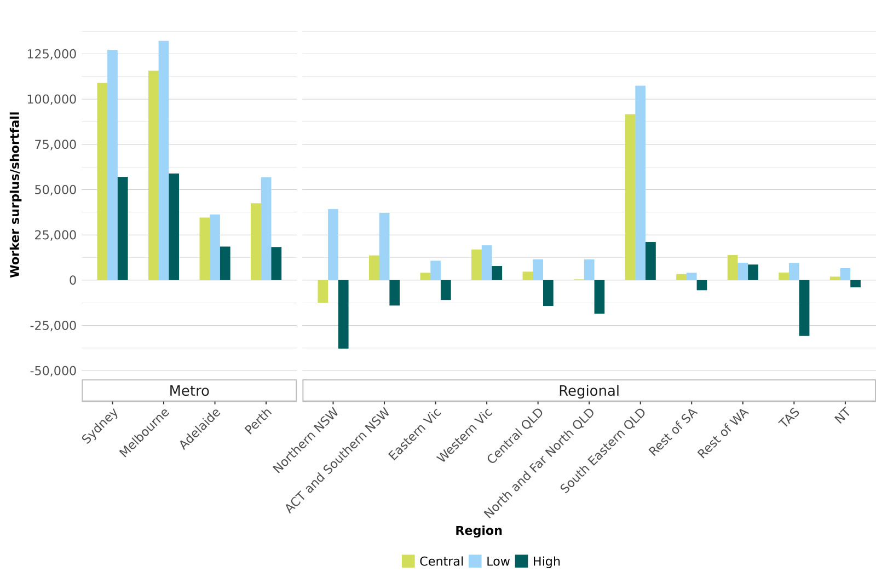
Source: Deloitte Access Economics 2023.

Figure 12. Estimated worker surplus/shortfall by region (all occupations), 2040
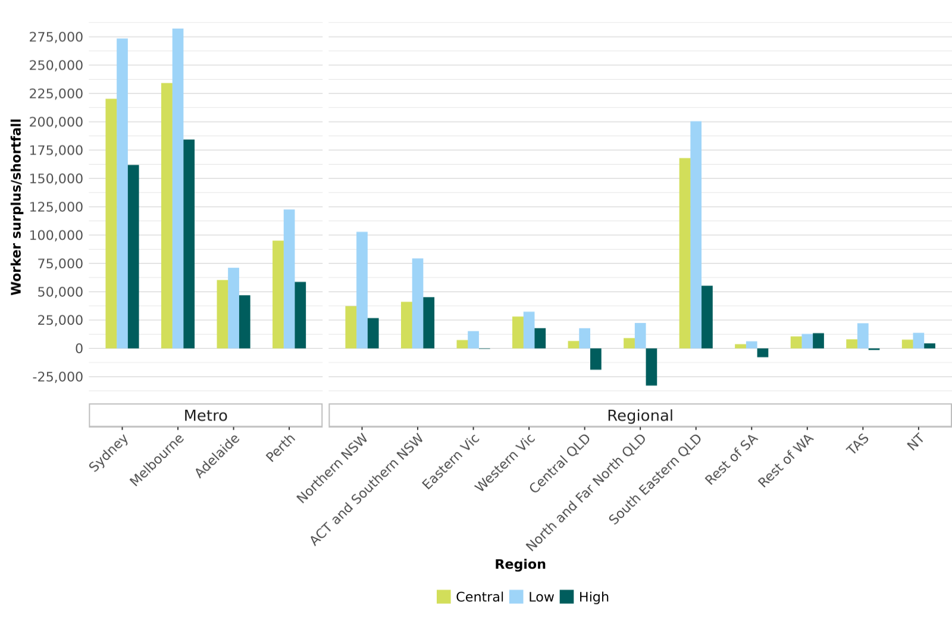
Source: Deloitte Access Economics 2023.
Figure 13. Estimated worker surplus/shortfall by region (all occupations), 2050
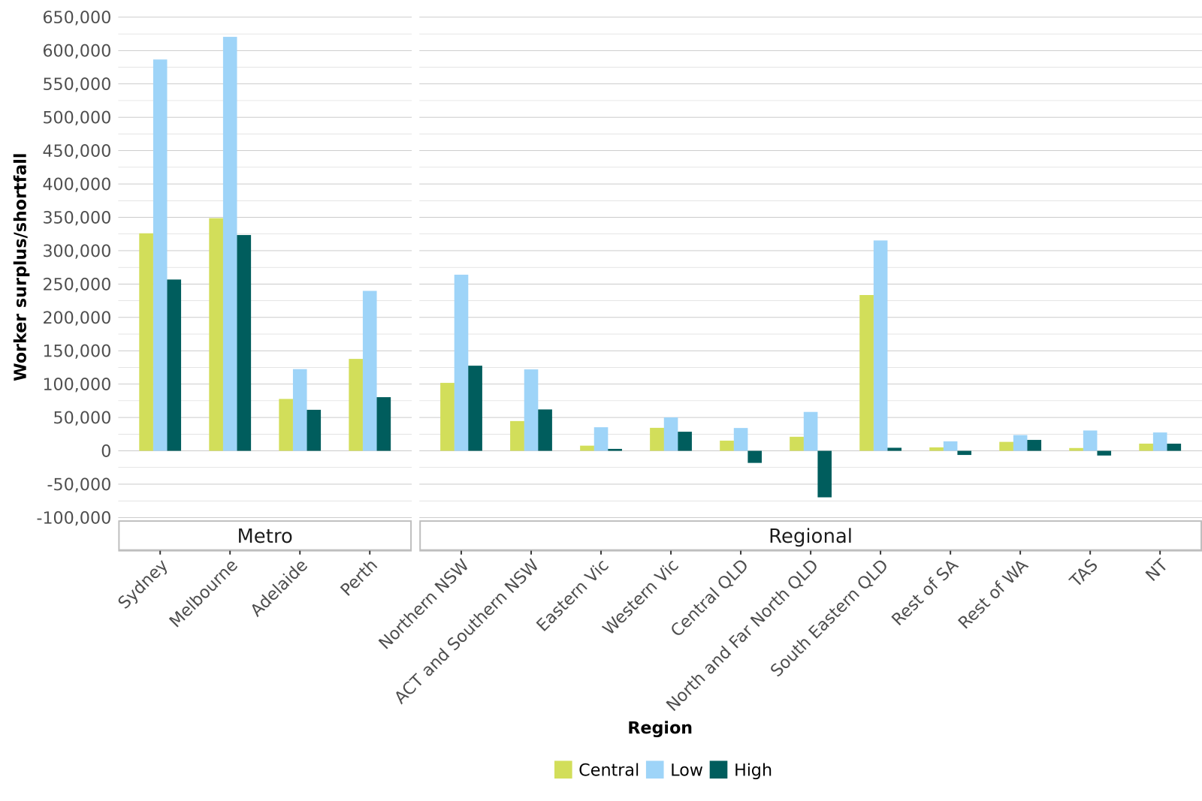
Source: Deloitte Access Economics 2023.

The disparity between metropolitan and regional Australia is more pronounced when looking at the modelled match between supply and demand for Skill Level 3 workers – these capture many of the clean energy critical occupations in the Technicians and Trades Workers major group. Figure 14 below suggests that the labour market for Skill Level 3 workers is likely to be tight in all regional areas across all scenarios by 2030, with shortfalls likely in Northern NSW, Southern NSW and North and Far North Queensland under the central scenario.
Looking further ahead, based on the current assumptions about a general strong potential supply of workers relative to employment demand, supply of Skill Level 3 workers in regional areas is likely to remain close to demand (Figures 15 and 16).
Figure 14. Estimated worker surplus/shortfall by region (Skill Level 3 occupations only), 2030
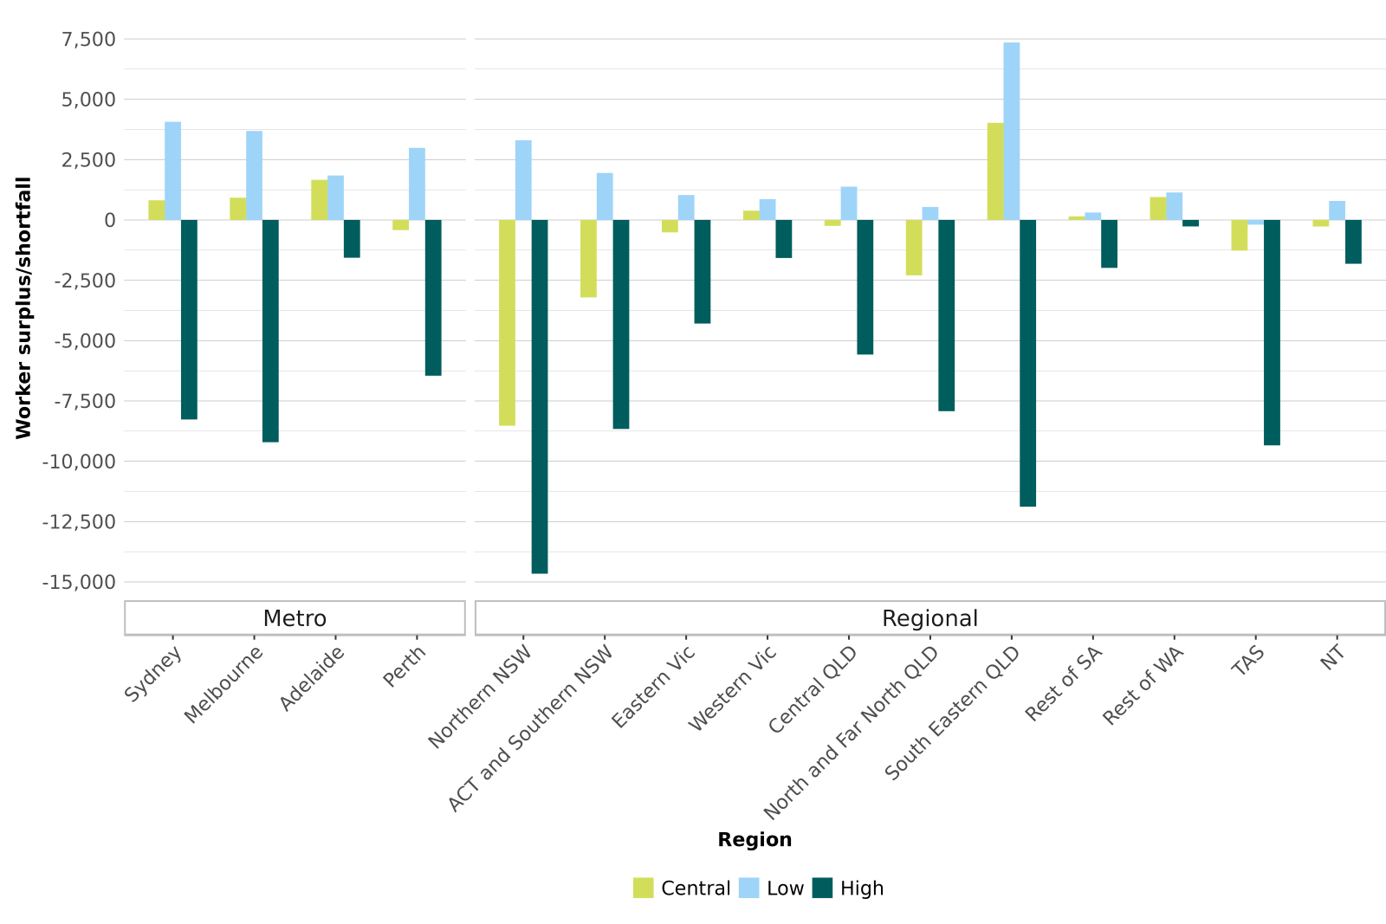
Source: Deloitte Access Economics 2023.

Figure 15. Estimated worker surplus/shortfall by region (Skill Level 3 occupations only), 2040
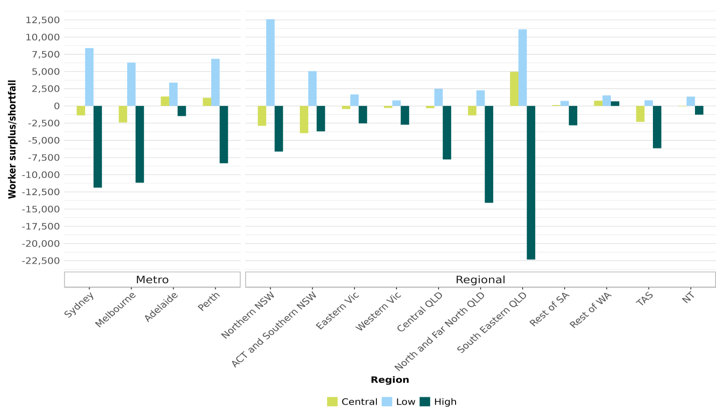

Source: Deloitte Access Economics 2023.

Figure 16. Estimated worker surplus/shortfall by region (Skill Level 3 occupations only), 2050
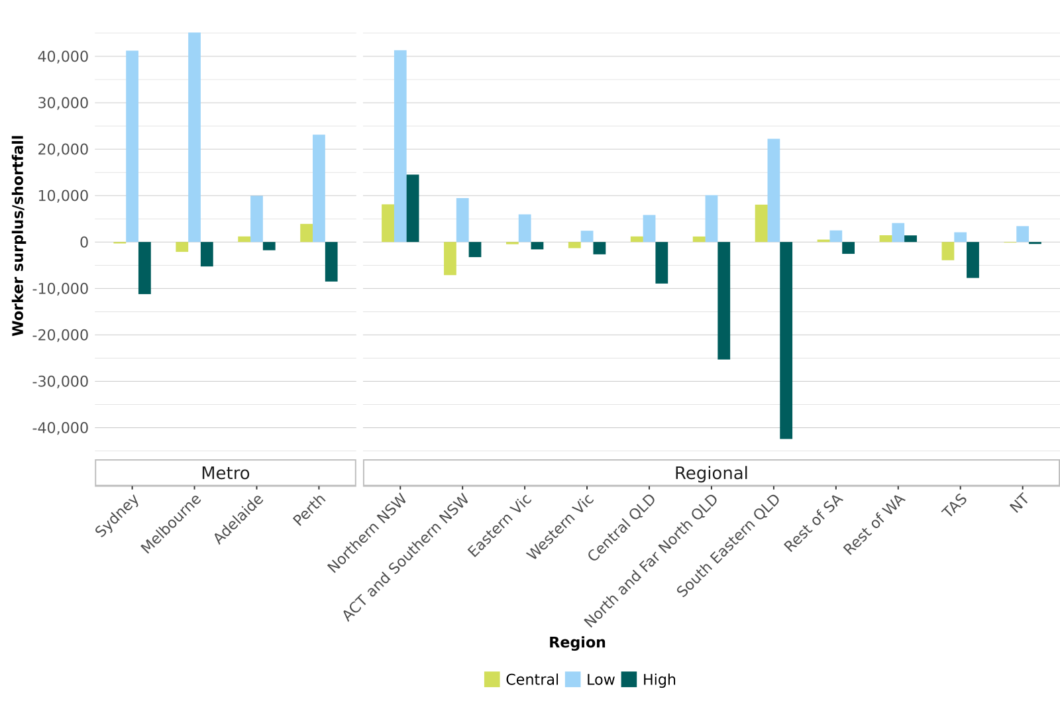
Source: Deloitte Access Economics 2023.

Looking at one particular occupation in more detail, Electricians are likely to be in short supply across all regions, scenarios and forecast periods. Under the central scenario the biggest shortages are likely to be in metropolitan areas of Melbourne and Sydney, as well as South-Eastern Queensland (mix of metropolitan and regional), as well as in regions such as Northern NSW over all scenarios throughout the forecast period (Figure 17).
Figure 17. Supply gaps for Electricians by region, 2030, 2040 and 2050
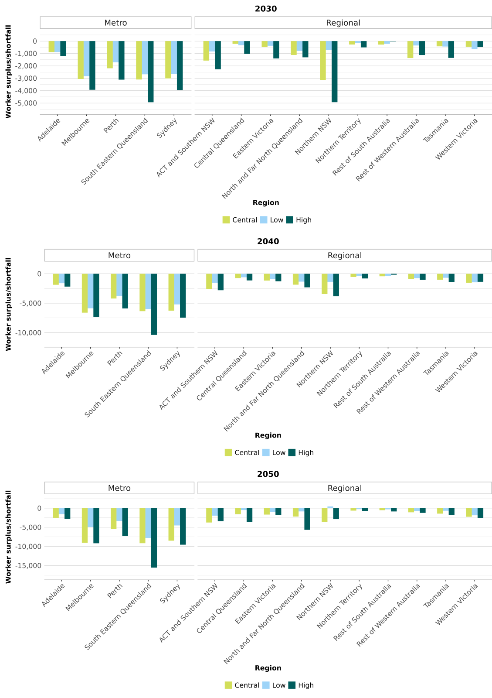
Source: Deloitte Access Economics 2023.

Summary
This report has explored the workforce implications of three different pathways for Australia to reach Net Zero by 2050.
With active investment and clear policy direction to ensure all emissions-intensive sectors have the incentives to transition to lower emissions technology, Australia can achieve a higher level of employment and industrial diversity, while still decarbonising the economy. With a higher level of ambition and investment, Australia could expand its production of low emissions goods to create an export market to replace what we can expect to lose from fossil fuels.
There are clear workforce challenges associated with both the central and high scenarios. Indeed, even under the low scenario, there are the same challenges in the next seven years as we look to convert our electricity grid to renewable sources and as broad-based trends to increase capital intensity to automate tasks and roles continue to impact employment in all sectors.
These are the strong growth in trades and technical occupations, particularly the occupations that are critical to clean energy such as electricians, metal fitters and machinists, and plant operators. The modelling supply results suggest there may not be sufficient capacity in the training and migration pipelines based on recent trends to meet this demand.
Growth in these occupations is likely to be concentrated in regional Australia. There is great opportunity here, as it will continue to provide well paid employment opportunities that might otherwise be lost as global demand for fossil fuels decreases. However, the concentration of growth in trades and technical employment in regional Australia will require an even more substantial uplift in the training infrastructure if local students and workers are going to share in the opportunities.
In examining workforce trends over a thirty-year period, there is necessarily a lot of uncertainty. To better understand the skill gaps as emerging occupations become more established, as well as capturing the impacts as the sectoral plans are finalised, there is merit in repeating such modelling exercises regularly.

Appendix A: Mapping of the Australian workforce to clean energy segments
Segment, Description & Sub-segment | Share of Australia’s  total workforce |  |  | Estimated proportion working in clean energy
Clean energy supply |  |  | 0.4%
Industry groups that are essential to clean energy generation and supply. Currently, distribution and supply supports both renewable and fossil-fuel-reliant energy sources. As we transition, these will predominantly support renewable energy.
Supply – generation |  |  | 0.03% | 100%
Supply – distribution |  |  | 0.3% | 35%
Clean energy demand |  |  | 8.0%
Industry groups that relate to energy demand, noting that most industry groups are about more than energy. Industry groups in the clean energy demand segment will have skill and job role implications. Clean energy is already a significant (albeit minority) proportion of activity and likely to grow.
Demand – energy usage |  |  | 1.1% | 20%
Demand – energy performance |  |  | 3.7% | 15% - 20%
Demand – transport |  |  | 3.2% | < 5% - 8%
Clean energy enabling |  |  | 17.1%
Industry groups which enable clean energy production, supply and usage but where the clean energy component is small. Generally, clean energy workers in these sectors are distinguished by subject matter expertise rather than distinct job roles or skills.
Enabling – education, training, research & technology |  |  | 2.2% | 4% - 5%
Enabling – finance, legal, business |  |  | 4.4% | < 1%
Enabling – engineering, procurement & construction |  |  | 2.1% | 10%
Enabling – regulatory |  |  | 3.9% | 4%
Enabling – supply chain |  |  | 1.7% | < 1%
Enabling – vehicle & equipment production, trade & maintenance |  |  | 2.7% | Up to 8%
Carbon lifecycle |  |  | 0.5%
Industry groups which will have a substantial contribution to managing the carbon lifecycle, through carbon capture or the circular economy.
Transitioning |  |  | 1.1%
Fossil-fuel related groups which will decline and transform substantially as a result of decarbonisation.
Emissions-intensive sectors |  |  | 4.0%
ANZSIC groups such as cement production and other industrial processes that are emissions intensive.
Direct emissions-intensive sectors |  |  | 0.6%
Indirect emissions-intensive sectors (high energy users) |  |  | 3.4%
All other industry groups |  | 61.6%
All other ANZSIC groups. No substantial contribution to clean energy generation or energy performance or direct contribution to decarbonisation, though there may be some specialised contributions and/or more general job demand and skill impacts because of decarbonisation and climate change.
Unallocated* | 7.6%
Due to use of census data, there is an unallocated category where responses had missing information or insufficient detail.
Source: JSA ANZSIC mapping, 2021 ABS Census of Population and Housing

Appendix B: Definition of Regions
Database Regions | State | SA4 Name | Renewable Energy Zone | Total Employment
Sydney | NSW | Central Coast, Sydney - Baulkham Hills and Hawkesbury, Sydney - Blacktown, Sydney - City and Inner South, Sydney - Eastern Suburbs, Sydney - Inner South West, Sydney - Inner West, Sydney - North Sydney and Hornsby, Sydney - Northern Beaches, Sydney - Outer South West, Sydney - Outer West and Blue Mountains, Sydney - Parramatta, Sydney - Ryde, Sydney - South West, Sydney - Sutherland |  | 2,310,013
ACT and Southern New South Wales | NSW | Capital Region, Illawarra, Murray, Riverina, Southern Highlands and Shoalhaven, ACT | South West REZ, Illawarra REZ | 678,277
Northern New South Wales | NSW | Central West, Coffs Harbour - Grafton, Far West and Orana, Mid North Coast, New England and North West, Newcastle and Lake Macquarie, Richmond - Tweed | Hunter-Central Coast REZ, New England REZ, Central West REZ | 766,687
Eastern Victoria | VIC | Latrobe – Gippsland, Hume, Shepparton | Gippsland REZ, Ovens Murray REZ, Central North REZ | 262,276
Melbourne | VIC | Melbourne - Inner, Melbourne - Inner East, Melbourne - Inner South, Melbourne - North East, Melbourne - North West, Melbourne - Outer East, Melbourne - South East, Melbourne - West, Mornington Peninsula |  | 2,327,525
Western Victoria | VIC | Ballarat, Bendigo, Geelong, North West, Warrnambool and South West | Geelong Warnambul and Murray River REZ, Western Victoria REZ, Southern West REZ | 425,397
South Eastern Queensland | QLD | Brisbane - East, Brisbane - North, Brisbane - South, Brisbane - West, Brisbane Inner City, Darling Downs - Maranoa, Gold Coast, Ipswich, Logan - Beaudesert, Moreton Bay - North, Moreton Bay - South, Sunshine Coast, Toowoomba | Southern REZ | 1,788,185
North and Far North Queensland | QLD | Cairns, Mackay - Isaac - Whitsunday, Townsville, Queensland - Outback | Northern REZ | 334,695
Central Queensland | QLD | Central Queensland, Wide Bay | Central REZ | 208,369
Adelaide | SA | Adelaide - Central and Hills, Adelaide - North, Adelaide - South, Adelaide - West |  | 649,031
Rest of SA | SA | Barossa - Yorke - Mid North, South Australia - Outback, South Australia - South East |  | 162,158
Rest of WA | WA | Bunbury, Western Australia - Wheat Belt, Western Australia - Outback |  | 235,378
Perth | WA | Mandurah, Perth - Inner, Perth - North East, Perth - North West, Perth - South East, Perth - South West |  | 1,008,776
Tasmania | TAS | Hobart, Launceston and North East, South East, West and North West |  | 248,655
Northern Territory | NT | Darwin, Northern Territory - Outback |  | 102,299
Source: Deloitte Access Economics

Appendix C: Alignment of Eastern Australia regions with Renewable Energy Zones
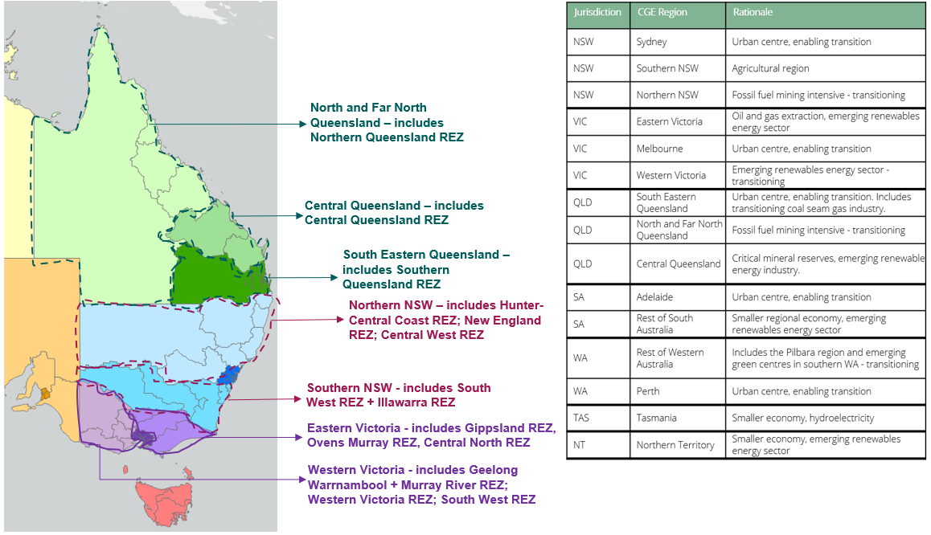
Source: Deloitte Access Economics

References

This scenario was developed with input from Dr Alan Finkel AC, Professor Ross Garnaut AC and Rod Sims AO, and JSA would like to thank them for their contribution.
The ‘baseline’ scenario includes federal and state and territory policies that have been implemented or where detailed design is well progressed.
The ‘with additional measures’ builds on the baseline scenario but also incorporates additional policies that have been announced but where detailed design is still under consultation.
R Garnaut, The Superpower Transformation, La Trobe University Press, 2022.
2 JSA (Jobs and Skills Australia), Skills Priority List 2023, JSA website, accessed November 2023.
JSA, ‘Skills Shortage Quarterly June 2023’, JSA website, accessed September 2023.

