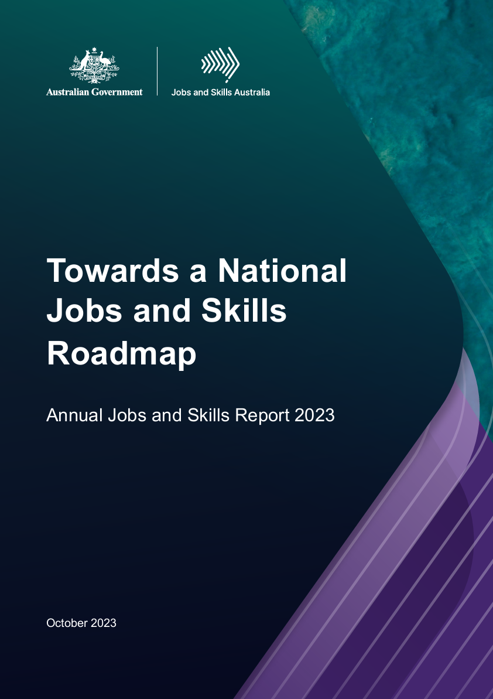

Towards a National Jobs and Skills Roadmap

Annual Jobs and Skills Report 2023

October 2023

<BLANK PAGE FOR INSIDE COVER>

Acknowledgement of Country

Jobs and Skills Australia acknowledges the Traditional Owners of Country throughout Australia and recognises the continuing connection to lands, waters and communities. We pay our respect to Aboriginal and Torres Strait Islander cultures, and to Elders past, present and emerging.

Contents

Acknowledgement of Country 3

Acting Commissioner's foreword 9

Executive summary 10

Chapter 1 Context 26

1.1 The skills challenge 27

1.2 Jobs and Skills Australia: a catalyst in activating Australia’s skills potential 27

1.3 The national skills system: a conceptual view 28

1.4 Towards a joined-up national skills system: a shifting policy landscape 32

1.5 The strategic objectives underpinning the case for a joined-up national jobs and skills roadmap 33

1.6 The aims of a national jobs and skills roadmap 36

Chapter 2 Megatrends shaping the economy and workforce 37

2.1 Skills for the digital transformation 38

2.2 Clean energy and the net zero transformation 42

2.3 The growth of the health, care and support workforce 42

2.4 Conclusions 44

Chapter 3 Current skills shortages 46

3.1 Skills shortages remain elevated 47

3.2 The types of skills shortages 56

3.3 Responding to skills shortages 62

3.4 Conclusions 64

Chapter 4 Employment projections for the decade ahead 65

4.1 Approach to the employment projections 66

4.2 The industry outlook over the next 5 and 10 years 66

4.3 The occupations outlook over the next 5 and 10 years 69

4.4 Employment of VET and higher education graduates is expected to grow strongly 71

4.5 The employment outlook for the states and territories 71

4.6 Areas of common focus across current skills shortages and the projections 73

4.7 Conclusions 75

Chapter 5 Meeting the skill needs of the clean energy transformation 76

5.1 Understanding the clean energy transformation 77

5.2 Opportunities for the Australian economy and our workforce 77

5.3 Conclusions from the clean energy capacity study 81

Chapter 6 The national skills system: an emerging reform agenda 83

6.1 The role of the national skills system in the labour market 84

6.2 Differences between the VET and higher education sectors 90

6.3 The need to strengthen the VET sector 92

6.4 The need to strengthen the higher education sector 96

6.5 Reform of the VET sector 97

6.6 Higher education reform and the Australian Universities Accord 98

6.7 A more joined-up tertiary education system 100

6.8 Migration system reform 105

6.9 Joining up tertiary education and migration policy 106

6.10 Conclusions 107

Chapter 7 Towards a national jobs and skills roadmap 109

7.1 What is a roadmap? 110

7.2 Priorities guiding the roadmap’s development 111

7.3 Jobs and Skills Australia's work plan 113

7.4 Conclusion 113

References 116

Glossary 122

Appendix A 124

Jobs and Skills Australia 2023–24 work plan 124

Appendix B 129

First Nations workforce analysis 129

Appendix C 133

Top 20 occupations in demand in each state and territory, 2023 133

Appendix D 142

Occupational profiles by shortage type 142

**List of Figures**

Figure 1: The national skills system: conceptual view (illustrative) 11

Figure 2: Employment projections by industry, May 2023 to May 2033, persons 17

Figure 3: National jobs and skills roadmap elements 23

Figure 4: The national skills system: conceptual view (illustrative) 29

Figure 5: Top 10 occupations with the highest numbers of job listings requesting digital and data skills in 2022 39

Figure 6: Top 10 occupations with highest growth in the percentage of jobs requesting digital and data skills, 2018 to 2022 40

Figure 7: Projected employment growth by future demand and automatability score 41

Figure 8: Care and support workforce employment to 2033 (‘000 persons) 43

Figure 9: Proportion of occupations in shortage in Skills Priority Lists: 2021, 2022 and 2023 48

Figure 10: Share of occupations in shortage in the 2021, 2022 and 2023 SPLs, by gender imbalanced occupations 51

Figure 11: Professionals: proportion of sub-group in shortage (%), 2023 SPL 52

Figure 12: Health Professionals: proportion of vacancies filled (%) and suitable applicants per vacancy (number), 2021 to 2023 53

Figure 13: Community and Personal Service Workers: proportion of sub-group in shortage (%) 54

Figure 14: Technician and Trades Workers: proportion of sub-group in shortage (%) 54

Figure 15: Location as a reason for receiving few applicants or for a vacancy remaining unfilled, remoteness areas, 2023 55

Figure 16: Proportion of employers requiring qualifications and employers who cite a lack of qualifications 60

Figure 17: Proportion of employers identifying lack of specific skills as reason for unsuitability and average number of years of experience sought 61

Figure 18: Employer responses to unfilled vacancies (share of employers with unfilled vacancies) 62

Figure 19: Possible responses by skills shortage type 63

Figure 20: Employment projections by industry, May 2023 to May 2033, persons 67

Figure 21: Employment projections by major occupation group, May 2023 to May 2033, persons 70

Figure 22: Employment projections by state and territory, May 2023 to May 2033, persons 72

Figure 23: VET and higher education distribution across occupations (1-digit level) 84

Figure 24: Post-school qualification growth rates for people in labour market, 2006–2021 85

Figure 25: Qualification completions by 1-digit occupation and SPL shortage status 86

Figure 26: Projected employment to 2033, by major occupation group and skill level 87

Figure 27: Australian born employed and overseas born employed as a share of the labour force 88

Figure 28: Years since arrival in Australia by labour force participation rates (percentage) for broad country of birth groups—12 months to May 2023 89

Figure 29: Years since arrival in Australia by unemployment rate (percentage) for broad country of birth groups—12 months to May 2023 89

Figure 30: National jobs and skills roadmap elements 110

Figure 31: Priorities guiding development of the roadmap 111

Figure 32: First Nations and non-Indigenous employment index from February 2020 to May 2022 129

Figure 33: Difference between First Nations and non-Indigenous employment rates for gender by age 130

Figure 34: First Nations and non-Indigenous people working in occupations related to their studies 130

Figure 35: Level of education for people who had studied an IT qualification 131

**List of Tables**

Table 1: Persistent shortage since 2021 in ANZSCO major occupation groups 13

Table 2: Top 20 occupations in demand by shortage type, 2023 16

Table 3: Projections by skill level, May 2023 to May 2033, persons 18

Table 4: Top 20 largest employing occupations in shortage, 2023 SPL 49

Table 5: Persistent shortage since 2021 in ANZSCO major groups 56

Table 6: Top 20 occupations in demand by shortage type, 2023 59

Table 7: Projected employment growth and share of employment by industry 10 years to May 2033 68

Table 8: Share of employment by occupation, 10 years to May 2033 70

Table 9: Projections by skill level, May 2023 to May 2033, persons 71

Table 10: Share of employment by state and territory, May 2023 to May 2033 72

Table 11: Key institutional differences between VET and higher education 91

Table 12: Top 20 occupations in demand in New South Wales 134

Table 13: Top 20 occupations in demand in Victoria 135

Table 14: Top 20 occupations in demand in Queensland 136

Table 15: Top 20 occupations in demand in South Australia 137

Table 16: Top 20 occupations in demand in Western Australia 138

Table 17: Top 20 occupations in demand in Tasmania 139

Table 18: Top 20 occupations in demand in the Northern Territory 140

Table 19: Top 20 occupations in demand in the Australian Capital Territory 141

Acting Commissioner's foreword

In today’s strong labour market there is much to celebrate. This includes low levels of unemployment and high participation rates. There is a greater share of women in Australia employed than ever before.

But there are very significant challenges. In particular, our national skills system is confronted with extensive skills shortages, and with how to play its role in lifting Australia's current low levels of productivity growth.

A focused and coordinated effort is required to ensure Australians are equipped with the knowledge, skills and capabilities needed for today and tomorrow.

Our vocational and higher education sectors will need to do much of the heavy lifting, collaborating with each other and with industry. And this will need to be supplemented by an efficient migration system.

The Minister for Skills and Training and his state and territory counterparts, the Minister for Education, and the Minister for Home Affairs, and the associated reviews of higher education and migration have all committed to a joined-up approach to solving these challenges and realising opportunities.

Critical to a well-functioning and joined-up national skills system is quality advice and analysis of Australia’s skills and workforce needs, which is informed by the best available data and the on‑the-ground intelligence from participants in the system. A well-functioning national skills system also needs robust assessment of how well the national skills system is meeting those needs. This is the fundamental role of Jobs and Skills Australia.

To this end, this inaugural Jobs and Skills Report 2023, provides Jobs and Skills Australia’s initial assessment of the national skills system and Australia’s current, emerging and future skills needs, as required by the Jobs and Skills Australia Act 2022. It also lays the groundwork towards a national jobs and skills roadmap to be developed over the coming year and beyond, in collaboration with industry, Jobs and Skills Councils, the education and training sectors, states and territories, and Australian Government agencies.

I am grateful for the generosity of insights from our tripartite partners and other stakeholders, in particular, but not only, from our Consultative Forum and from the new Jobs and Skills Councils, since Jobs and Skills Australia’s establishment in late 2022. These insights have greatly enriched our analysis and the considerations outlined in this report. Importantly, though, this report reflects the independent advice of Jobs and Skills Australia and the views outlined here are not necessarily shared by all partners and stakeholders.

Professor Peter Dawkins AO

Acting Commissioner  
Jobs and Skills Australia

Executive summary

Context

The role of Jobs and Skills Australia

Australia faces a skills challenge not seen since the 1960s. In response to this challenge, Jobs and Skills Australia was established in November 2022 under interim legislation, superseded by permanent legislation in August 2023. Its mission is to be a catalyst in activating the potential of Australia’s human capital to meet the present and future skills needs.

Jobs and Skills Australia’s central role is to advise government and key partners in the national skills system on Australia’s skills needs and the adequacy of the skills system in meeting those needs. It has been supported by a tripartite Consultative Forum, to be replaced by a tripartite advisory board under the permanent legislation and works closely with the 10 Jobs and Skills Councils, and with the states and territories.

Strategic objectives across the labour market and the economy

In 2023, Australia is experiencing a tight labour market and extensive skill shortages, as well as significant price inflation and continuing low productivity growth. Despite this tightness, the labour market has been slow to lift wages growth, which have been stagnant for a decade.

As the Reserve Bank of Australia (RBA) focuses on bringing inflation into the 2 to 3% target range, a focus on matching workforce skills with industry’s needs is required to enable the economy to minimise the level of unemployment and underemployment that can be achieved alongside stable inflation.

A focus on enhancing Australians’ skills also aims to support increased productivity, real wage growth, increased labour force participation and sustainable economic growth.

A focus on enhancing opportunities for those who are disadvantaged in the labour market aims to support more equitable outcomes in employment opportunities and rewards.

These are the high-level objectives that Jobs and Skills Australia is seeking to support: minimising unemployment and underemployment; increasing productivity, real wages, participation and sustainable economic growth; and increasing equity and reducing disadvantage. Supporting these objectives will involve anticipating how jobs and skills need to evolve to help the national skills system deliver the skills people will need for the objectives to be achieved.

The Australian Government’s recently released Employment White Paper, *Working Future*, outlines 5 objectives in its vision for the future of the Australian labour market, which we see as highly congruent with the 3 objectives outlined above.

Towards a national jobs and skills roadmap and a joined-up national skills system

Three key pillars of the national skills system are: vocational education and training (VET), higher education, and migration (Figure 1). Jobs and Skills Australia focuses primarily on these 3 key pillars and how they work within the broader jobs and skills ecosystem which includes, for example, the school system, informal on-the-job training, unaccredited and industry-based training, and system settings, like employment services and wage setting and workplace relations frameworks, and especially the way that wages adjust in the labour market.

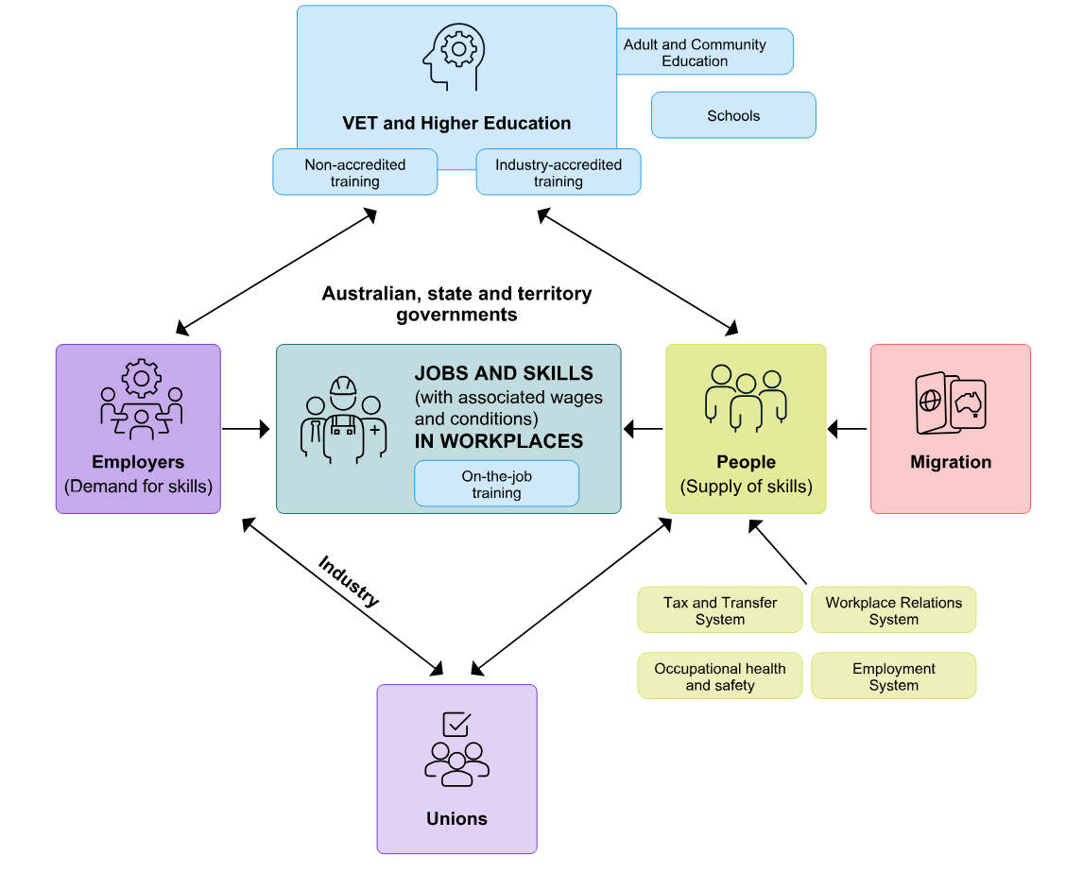Figure 1: The national skills system: conceptual view (illustrative)

The diagram shows a conceptual, illustrative depiction of the national skills system.

There are 6 main actors in the diagram.

VET and higher education includes Adult and Community Education, Schools, Industry-accredited training and non-accredited training as associated parts of the tertiary education system. VET and higher education is depicted as having 2-way relationships with Employers, who represent the demand for skills, and with People, who supply skills.

At the centre is a box labelled as JOBS AND SKILLS IN WORKPLACES (with associated wages and conditions) including on-the-job training, linked to employers and people. This box recognises that both employers and people have a role in JOBS AND SKILLS IN WORKPLACES.

The Employers box also has a 2-way relationship with Unions, and this relationship is denoted as forming part of industry. The People box also has a 2-way relationship with Unions.

The People box has a one-way relationship with migration, where the relationship flows from migration to people, denoting migration’s role, alongside VET and higher education, of people and skills to work in jobs.

The Tax and Transfer system, Workplace Relations System, Employment System and Occupational health and safety are noted as having a one-way relationship flowing towards People, denoting that these systems interact with the national skills system.

Source: Jobs and Skills Australia

To meet the current skills challenge and the skills needs of the future, Australia will need a systematic approach to building foundation skills for all those entering the workforce, through to the extensive knowledge and workforce skills that are required at the highest level. This will require our education, training, and migration systems to effectively complement each other and flexibly respond to skills and workforce needs. And we will need the whole population to be supported by a lifelong learning system that enables them to continually develop their skills to meet the needs of a dynamic economy and changing labour market.

An interconnected systems view of the national skills system to better address current and future skills challenges is recognised by stakeholders as beneficial, while also acknowledging that industry, jurisdictional and pillar-specific nuances will continue to be important.

In 2023, a number of important reform processes of systemic importance to the national skill system have been progressed, with negotiations towards a new National Skills Agreement, a review of higher education leading towards a new Universities Accord, and the Australian Government's Migration Strategy which will also lead to significant reforms. These reform processes have identified the importance of synergy between each of these pillars of the national skills system, and a role for Jobs and Skills Australia in supporting the implementation and monitoring of policies in a way that seeks to ensure that they complement each other.

As these reform processes are charted out, Jobs and Skills Australia will develop a national jobs and skills roadmap in partnership with Jobs and Skills Councils, states and territories, business and unions, the education and training sector, and Australian Government agencies. Such a roadmap starts with an analysis of jobs and skills pressures and drivers, which is a key feature of this 2023 report. It would then map out the reforms required to deal with these pressures and drivers. Then comes the policy implementation stage. Finally, the implementation of policies will need to be monitored against the objectives they are seeking to achieve, with the feedback leading to further refinement of the strategies adopted.

Megatrends are shaping the economy and the workforce

Digital transformation

Digitalisation, automation, and emergence of artificial intelligence is a key megatrend that opens up significant productivity enhancing opportunities, and brings with it a critical skills agenda. Some jobs will be lost, and many others will change in nature. The whole workforce needs to be digitally literate. On top of that, higher level digital skills are in increasing demand. The power of artificial intelligence, as well as the associated risks, has come under particular scrutiny as its capability and applications unfold.

If Australia is going to take advantage of this trend a focus on the economy-wide implications is a key issue for Jobs and Skills Australia to analyse and advise on and work with the Jobs and Skills Councils, especially the Future Skills Organisation, as well as other key partners. Significant skill gaps exist in this area and the implications, for example, for our education and training pipeline and for lifelong learning, can only be expected to increase over time.

Technology and associated digital skills are a key enabler in meeting the opportunities of this megatrend.

Clean energy and the net zero transformation

The clean energy transformation is another megatrend that has been a major focus of Jobs and Skills Australia’s work in 2023. The transition opens up significant opportunities for Australia with its abundant renewable energy resources and a significant construction effort required in the near-term. It also brings with it many challenges to confront, particularly for people and communities affected by the transition away from fossil fuels. The development of the skills required for successful transition is a key enabler within a broader transition policy framework. Stakeholders have consistently emphasised Australia will need to lift the pipeline of VET-trained workers, including in regional areas, to meet the needs of the clean energy transition.

The growth of the care and support economy

The growth of the care and support economy associated with an ageing and increasingly diverse population, a transition from informal to formal care, and increased citizens’ expectations of government, is another important megatrend. This area is already experiencing skills shortages with employment in the care and support economy projected to grow strongly in future.

The health care sector is subject to similar pressures and growth expectations, with the nursing occupations experiencing significant skill shortages and projected strong growth in demand.

Current skills shortages

Skills shortages remain elevated

Analysis of current skills shortages shows that 36% of occupations assessed were in national shortage (332 out of 916) in 2023, 5 percentage points higher than the 2022 Skills Priority List (SPL).

Shortages were most common for Technicians and Trades Workers, with 50% of occupations in the category assessed as being in national shortage, broadly consistent with findings of previous SPLs. For example, all occupations in the Construction Trades Workers and Food Trades Workers groups were found to be in national shortage.

Shortages were also pronounced for the Professionals group, particularly Health Professionals. About 48% of the occupations within the Professionals group occupations were in shortage in 2023. A common thread among shortages in these occupations is that they require a high level of skills and knowledge, qualifications and experience.

Shortages grew amongst Community and Personal Service Workers (to 24% of occupations in 2023). As with the Health Professionals category, shortages for Community and Personal Service Workers in the health, care and support sectors are considerable.

New shortages have emerged in 2023 but many are persistent

Comparisons with the 2022 SPL highlight that there were 66 (or 7%) occupations newly in shortage in 2023, concentrated among high-skilled professional occupations – such as Sales and Marketing Manager, Taxation Accountant, Biomedical Engineer and Solicitor. The main drivers included a decrease in fill rates for these occupations and employers receiving fewer suitable and qualified applicants per vacancy.

There were also 266 occupations (or 29%) that were in shortage in both years. Among these, 47% were professional occupations mostly related to health, engineering, information communication technology (ICT) and science. Another 33% were occupations within various technician and trade roles.

Table 1: Persistent shortage since 2021 in ANZSCO major occupation groups

|  |  |  |  |
| --- | --- | --- | --- |
| **Major group** | Description | Occupations in persistent shortage | Percentage of major group |
| 1 | Managers | 3 | 3% |
| 2 | Professionals | 55 | 17% |
| 3 | Technicians and Trades Workers | 67 | 33% |
| 4 | Community and Personal Service Workers | 5 | 6% |
| 7 | Machinery Operators and Drivers | 8 | 10% |

Source: Jobs and Skills Australia  
Note: the number of occupations assessed has changed for each SPL. This reflects both changes in the Australian and New Zealand Standard Classification of Occupations (ANZSCO) framework and the inclusion of skills shortage assessments for 'not elsewhere classified' (nec) occupations in both the 2022 and 2023 SPL assessments.

Three consecutive years of the SPL enables us to make an assessment of the persistence of skills shortages. The overwhelming conclusion from this assessment is how persistent many skill shortages are. In general, the labour market has not adjusted quickly, for example, through real wage increases, to clear these skilled shortages. The standout problem is the persistence of shortages among Technicians and Trade Workers, though there are also persistent shortages in Community and Personal Service Workers, a range of Professionals occupations, and Machine Operators and Drivers (Table 1).

Occupations that have a strong gender imbalance were more likely to be in shortage

Jobs and Skills Australia’s analysis reveals that gender imbalance is a feature of many skill shortage areas. Occupations that have a highly gender skewed workforce are significantly more likely to be experiencing shortages than occupations where the gender balance is more even. Male dominated occupations (in the occupation groups of Machinery Operators and Drivers, Labourers, and Technicians and Trades Workers) and female dominated occupations (in the Community and Personal Service Workers occupation group), stand out.

#### Skills shortages were more pronounced in regional areas

In recent times, skill shortages have been particularly acute in regional areas, especially for the highly skilled. The share of employers reporting location as a reason for recruitment difficulties increased with remoteness. In Very Remote areas, more than 80% of employers believed the reason they did not receive many applicants was because of the job location and over 40% of employers had a suitable applicant not take a job offer because of the location. In the Northern Territory, 55% of employers who had few applicants and 25% of employers with an unfilled vacancy listed location as the reason. In Western Australia, these figures were 36% and 20%, respectively.

****Wage growth to address shortages has not responded as expected****

For all skills shortages, conventional economics suggest that increasing wages is one lever that employers can pull to attract more workers. How successful that will be depends on the 'elasticity of supply of labour' which is contingent partly on how many people have the skills required.

The existence of extensive persistent skill shortages in our labour market implies that it is one in which wage adjustments of this kind are not solving the problem. This could be that for some reason, wage adjustments are not being used as much as they could be, or that there are wider issues at play.

Recent analysis by both Jobs and Skills Australia and the Reserve Bank of Australia highlights that wage adjustments are rarely used by employers as a short-term response to skills shortages.

Jobs and Skills Australia's Survey of Employers who have Recently Advertised (SERA) found that over the 3 years from 2021 to 2023, few employers changed remuneration in response to skill shortages. In the 2023 SPL period, around 1% of employers adjusted remuneration to attract skilled workers to fill vacancies. While this is surprisingly low, it was up significantly on the 2022 result when 0.4% of employers adjusted remuneration for this purpose.

The results are consistent with research undertaken by the Reserve Bank of Australia, which show limited evidence that firms raise wages in response to firm-wide or job-level skill shortages, at least in the short-term (Leal, 2019).

Further analysis of wage growth over a longer time horizon may shed light on whether wage adjustments are being used as much as they could be, particularly for occupations that have been in persistent shortage.

Not all skills shortages are the same

Jobs and Skills Australia has adopted a typology of skills shortages based on an insightful conceptual framework developed by Professor Sue Richardson. This provides a simplified approach to a complex set of labour market dynamics, and a helpful starting point for analysing both the causes and the potential solutions to the shortages (Table 2).

It needs to be noted that not all shortage occupations fit neatly in one category or another, and for some occupations assigned to one category, they may have some issues in common with occupations in other categories.

****Longer training gap****

Longer training gap shortages are defined by there being few qualified applicants per vacancy and a long training pathway – a bachelor degree, Certificate IV, diploma or apprenticeship is required by successful applicants.

This suggests that there is a need to increase the number of available skilled workers but with significant time lags involved in the training process.

In this category there may be a strong case for increasing the supply or throughput of qualified people either by a larger intake of students or higher completion rates. However, there would be a significant time-lag in creating this throughput. In the short-term, this could be addressed by upskilling people with some of the relevant skills, attracting back people who have left the occupation through improved remuneration and/or working conditions, or migration options.

Examples of occupations in this category are: Early Childhood (Pre-primary School) Teachers, Occupational Therapists, Physiotherapists, Registered Nurses, and Electricians.

****Shorter training gap****

Shorter training gap shortages arise when there are few applicants per vacancy and a Certificate I to III or less is required.

A priori, this suggests that there is a need to increase the number of available skilled workers, with shorter time lags involved in the training process.

This is a category where there may also be a strong case for increasing the throughput of qualified people either by a larger intake or higher completion rates. The time lag would be shorter than for longer training gap shortages, which means it would be fixed quicker if the throughput could be increased. If not, the alternative strategies of upskilling people with some of the relevant skills, attracting back people who left the occupation, or for some occupations migration options may also need to be explored.

Examples of occupations in this category are Retail Managers.

****Suitability gap****

The suitability gap category is those occupations where there are enough qualified applicants but too many are not hired because they are not regarded as suitable.

Suitability gap shortages are defined by many qualified applicants per vacancy but few suitable applicants per qualified applicant, which results in many of these vacancies remaining unfilled. Reasons often cited for this suitability gap are lack of employability skills and lack of work experience. Another factor which may be in play is unconscious bias of employers.

This is a category where simply increasing the throughput of qualified people is a questionable strategy. A priori, it appears that the challenge is to enhance the attributes of qualified applicants through investing in their employability skills and their work experience.

Examples of occupations allocated to this category are: Advertising, Public Relations and Sales Managers, Construction Managers, and Civil Engineering Professionals.

****Retention gap****

Retention gap shortages are where there is above average job mobility (below average rates of retention) potentially reinforced by low numbers of new applicants per vacancy. A priori, the retention gap category is where low job retention appears to be the core driver of the problem.

This is a category where simply increasing the throughput of qualified applicants, if it were possible, is unlikely to solve the problem, because of the low likelihood of retaining them in the occupation.

A priori, it appears that what needs to be explored are ways to enhance the attractiveness of the occupation through improved remuneration and/or working conditions, professional development and clearer career pathways. If attention was paid to that, then increasing the throughput of qualified people would be more likely to pay dividends. Migration options may be another part of the strategy.

Examples of occupations in this category are: Human Resource Professionals, Chefs, Child Carers, and Aged and Disabled Carers.

Table 2: Top 20 occupations in demand by shortage type, 2023

|  |  |
| --- | --- |
| **Classification of skills shortage** | ****Top 20 occupations in demand**** |
| Longer training gap  Few qualified applicants per vacancy, bachelor degree, Certificate IV or apprenticeship required | Early Childhood (Pre-primary School) Teachers  Occupational Therapists  Physiotherapists  Registered Nurses  Solicitors  Social Workers  Metal Fitters and Machinists  Electricians |
| Shorter training gap  Few qualified applicants per vacancy, Certificate I to III or less required | Retail Managers |
| ****Suitability gap****  Many qualified applicants per vacancy, but few suitable applicants per qualified applicant | Advertising, Public Relations and Sales Managers  Construction Managers  Advertising and Marketing Professionals  Civil Engineering Professionals |
| ****Retention gap****  Above average job mobility (below average rates of retention), potentially reinforced by low number of total new applicants per vacancy | Human Resource Professionals  Chefs  Child Carers  Aged and Disabled Carers |

Source: Jobs and Skills Australia, Skills Priority List, 2023  
Note: There are 3 occupations in the top 20 occupations in demand – General Practitioners and Resident Medical Officers, Software and Applications Programmers, and Motor Mechanics – which are yet to be categorised. Additional analysis required as they may fall in more than one skills shortage category.

It can be seen there are likely to be a number of factors that need to be addressed to deal with persistent shortages and the strategy may need to be multi-pronged. For example, increasing training places while exploring migration options in the short-term, combined with higher wages to attract more workers to the roles. Aged and disabled carers are an interesting case in point.

Employment projections for the decade ahead

Aggregate growth

Total employment in the Australian economy is projected to increase by around 6.5% over the next 5 years to stand at 14.8 million, and 14.2% over the next 10 years, to stand at 15.9 million. That is, around 2 million more people will be employed in the Australian economy in 2033 than presently.

All industries are expected to grow

While growth across industries is broad-based, the greatest growth, by far, is expected in Health Care and Social Assistance, with its share of total employment projected to increase from 15.2% in 2023 to 16.7% in 2033. Other sectors expected to increase their employment significantly, in terms of actual increases in persons employed, are Professional, Scientific and Technical Services and Education and Training (Figure 2). After a long period of decline in its share of employment, Manufacturing is expected to experience significant growth in employment and slightly increase its share of total employment over the decade ahead. Mining is also expected to grow strongly in percentage terms over the next 10 years.

Figure 2: Employment projections by industry, May 2023 to May 2033, persons

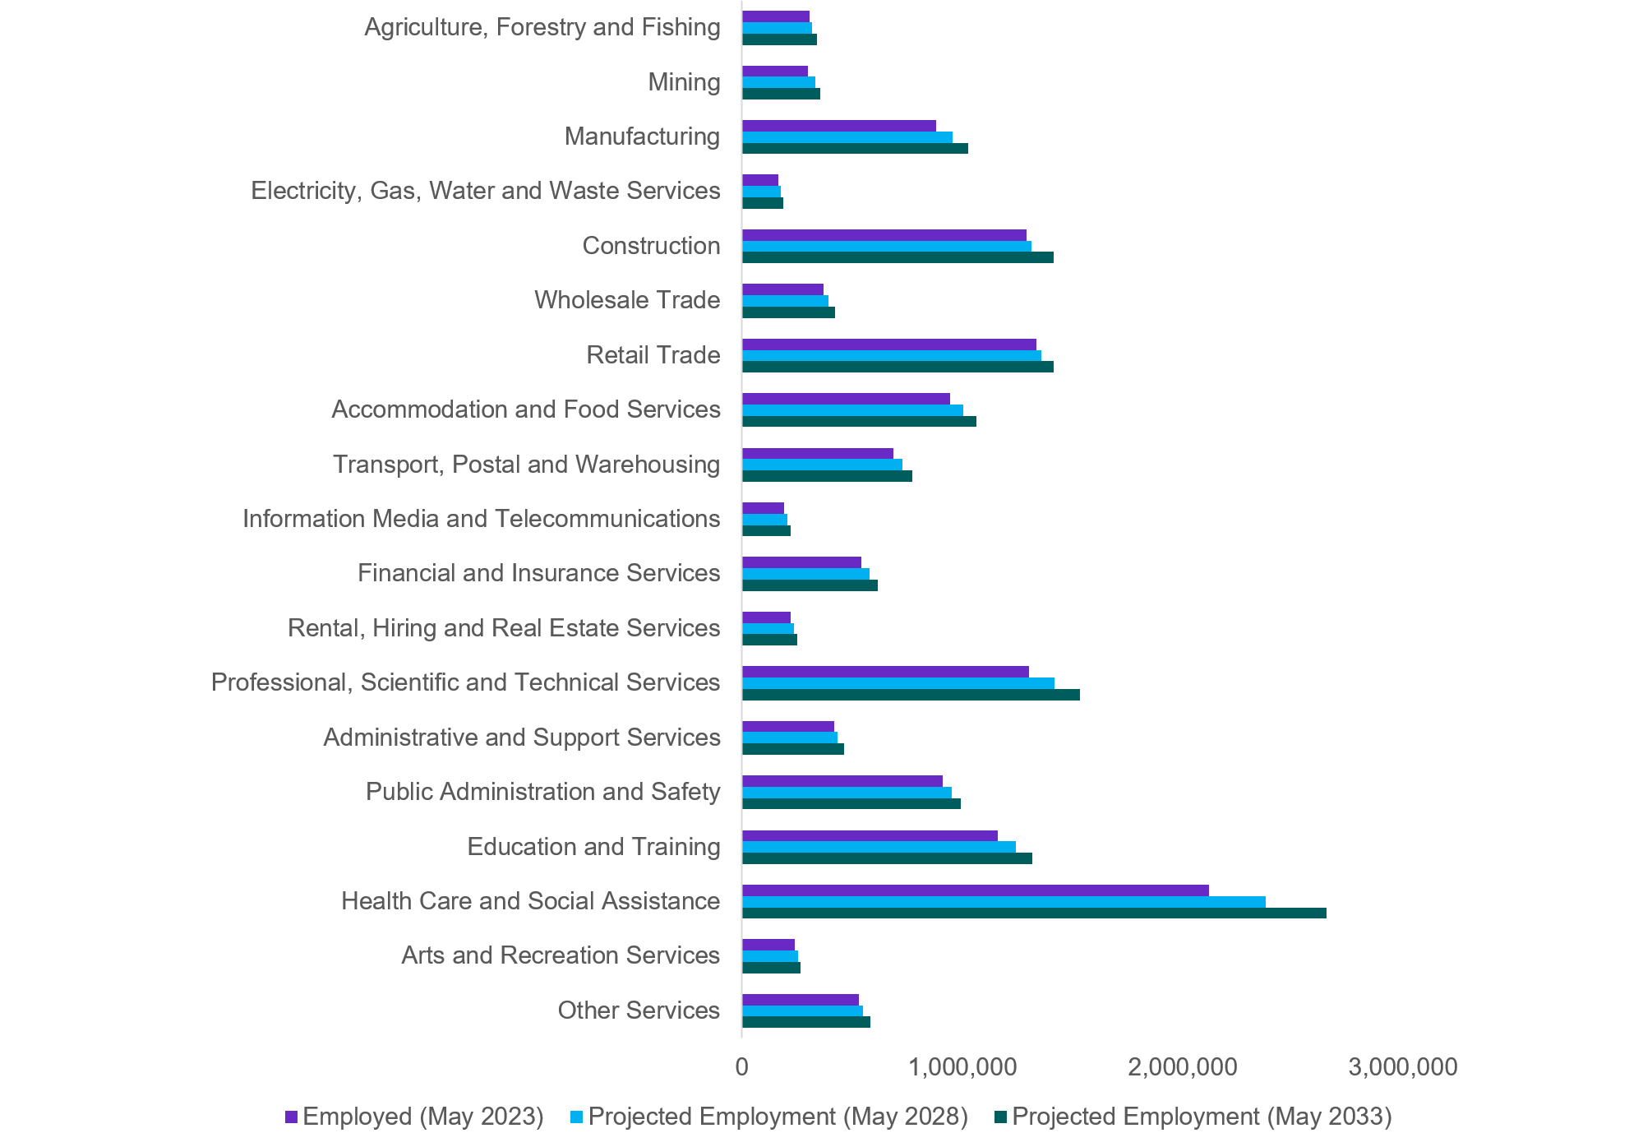

| Industry | Employed (May 2023) | Projected Employment (May 2028) | Projected Employment (May 2033) |
| --- | --- | --- | --- |
| Agriculture, Forestry and Fishing | 306031 | 319417 | 341,047 |
| Mining | 298107 | 333457 | 354,011 |
| Manufacturing | 880987 | 953883 | 1,024,618 |
| Electricity, Gas, Water and Waste Services | 164185 | 175740 | 187,411 |
| Construction | 1290865 | 1314356 | 1,413,457 |
| Wholesale Trade | 370027 | 392081 | 420,625 |
| Retail Trade | 1334493 | 1358921 | 1,415,921 |
| Accommodation and Food Services | 944967 | 1004405 | 1,063,107 |
| Transport, Postal and Warehousing | 688448 | 727375 | 771,173 |
| Information Media and Telecommunications | 191682 | 205936 | 220,924 |
| Financial and Insurance Services | 542373 | 577774 | 617,157 |
| Rental, Hiring and Real Estate Services | 219725 | 234778 | 251,273 |
| Professional, Scientific and Technical Services | 1301680 | 1418536 | 1,535,327 |
| Administrative and Support Services | 420108 | 434349 | 463,975 |
| Public Administration and Safety | 910590 | 953475 | 991,126 |
| Education and Training | 1162323 | 1243918 | 1,318,361 |
| Health Care and Social Assistance | 2117481 | 2374746 | 2,650,930 |

Source: Projections produced by Victoria University for Jobs and Skills Australia

Occupational variations

The occupation groups projected to experience the strongest employment growth, in terms of actual increases in persons employed, in the next decade are Professionals, Managers, and Community and Personal Service Workers.

It is anticipated that the shift towards employment in occupations such as Professionals and Managers will continue over the next decade, with these 2 groups constituting 39.1% share of total employment in May 2023, and projected to make up 40.7% of employment in May 2033. The continued trend of growth in care and support occupations is also expected to continue with Community and Personal Services Workers expected to make up 11.4% of those employed in May 2033, compared to 11.1% in May 2023.

Demand for VET and higher education graduates is expected to grow strongly

Over the next 10 years, more than 9 out of 10 new jobs (around 92%) expected to be created will require post-secondary qualifications (Skill Levels 1 to 4). Around half (48.4%) will require a bachelor degree or higher qualification as the primary education training pathway (Skill Level 1), and around 44% will have VET as the primary pathway (Skill Levels 2 to 4) (Table 3).

Table 3: Projections by skill level, May 2023 to May 2033, persons

|  |  |  |  |  |
| --- | --- | --- | --- | --- |
| **Skill Level** | **Employed, May 2023 (000s)** | **May 2033 projection (000s)** | **10-year employment growth (000s)** | **Share of 10‑year employment growth (%)** |
| Skill Level 1 | 4,811 | 5,766 | 955 | 48.4% |
| Skill Level 2 | 1,720 | 1,941 | 221 | 11.2% |
| Skill Level 3 | 2,049 | 2,275 | 226 | 11.5% |
| Skill Level 4 | 3,322 | 3,744 | 422 | 21.4% |
| Skill Level 5 | 2,012 | 2,162 | 150 | 7.6% |
| **Total** | **13,915** | **15,889** | **1,974** | **100.0%** |

Source: Projections produced by Victoria University for Jobs and Skills Australia  
Note: Skill Level 1 relates to bachelor degree or higher qualification; Skill Level 2 relates to advanced diploma or diploma; Skill Level 3 relates to Certificate IV or III (including at least 2 years on-the-job training); Skill Level 4 relates to Certificate II or III; Skill Level 5 relates to Certificate I or secondary education.

All states and territories are expected to experience employment growth

The employment growth across states and territories is expected to be in the range of around 12 to 16% over the next decade. The strongest percentage growth is expected in Victoria and the weakest in South Australia, with largest absolute growth being in Victoria, New South Wales and Queensland.

Many of the same drivers and pressures for increased numbers of tertiary qualified workers, increases in health and care, greater digital skills and increased capability in the clean energy sector, are anticipated in all jurisdictions. Regional variations will be an increasing focus of our work going forward.

It will be important to work with partners across jurisdictions and sectors, including with Jobs and Skills Councils and states and territories, to enhance the employment projections over time and make them more accessible to better inform workforce planning and decision-making.

Meeting the needs of the clean energy transformation

Three scenarios about the clean energy future

Jobs and Skills Australia has undertaken a detailed study of the workforce implications of the transition to net zero with preliminary modelling of 3 scenarios.

Under all the scenarios, demand for employment in the sectors related to clean energy – supply, demand and enabling – will be among the sectors with the strongest employment growth in the Australian economy over the next 10 years.

Workforce implications

Jobs and Skills Australia has identified 38 critical occupations, mainly in trades and technical occupations, that occur across the various clean energy segments involved in developing, generating, storing, transmitting and distributing energy generated from renewable, net zero emissions sources, installing and maintaining the technology that uses clean energy rather than fossil fuels, and enabling the clean energy transition through education, training, regulation, and supply chains. Electricians and Electrical Engineers are critically important across these areas. Metal Fitters and Machinists, Industrial, Mechanical and Production Engineers and managerial occupations such as Production Managers and Construction Managers are also very important. In all the net zero scenarios, demand for these occupations will be greatest.

Regional implications

The preliminary modelling suggests that employment growth in regional Australia is likely to be higher than in metropolitan areas. By region, under the central scenario many regions are likely to have average annual employment growth rates close to 2% between 2023 and 2030, including Northern NSW and Southern NSW, Eastern Victoria and the Northern Territory. This growth reflects renewable energy projects and the associated construction pipelines. Some of these regions, for example Northern NSW and Eastern Victoria, also have transitioning sectors.

Implications for the skills system

The education and training sectors have a critical role to play, complemented by the migration system. It will be critical to stand up initiatives to increase the number of apprentices in electrical and related trades. This is a big challenge, noting that this is already an area of significant skills shortage.

It will be necessary to substantially increase the number of completions in electrotechnology and other critical trade apprenticeships, maintain high levels of graduates across many engineering disciplines, as well as ensure we maintain university programs in several other specialist fields such a geology and metallurgy. As important is ensuring that these graduates have the attributes and sector-specific technical skills that will be needed in the clean energy sector. Ensuring there are sufficient VET instructors and teachers with relevant clean energy sector experience will also be critical.

Stronger links between higher education and industry and the VET sector will be needed, including expanding and regularising higher apprenticeships and promoting degree apprenticeships and other combinations of the VET and higher education sectors.

An emerging reform agenda

To achieve low unemployment, strong productivity and wages growth and increase inclusion in the labour market will require all elements of the national skills system to improve and work better together. A focus on matching workforce skills with industry’s needs will help retain low unemployment with stable inflation. Enhancing Australians’ skills is also an important productivity enhancing strategy both directly but also to help facilitate innovation, a key driver of long-term productivity growth, which in turn should support real wage growth. And the skill system is a key lever to bring disadvantaged groups into stable, rewarding and valuable work. Increased skills should also enhance labour force participation, another contributor to sustainable and inclusive growth.

Vocational education and training

Workers qualified through VET pathways play a key role in the Australian economy. Job roles requiring applied learning and practical skills continue to be in demand and in persistent shortage across Australia.

A key challenge of the VET sector is its status and perceptions relative to higher education. A House of Representatives Committee is undertaking an inquiry into the status and perceptions of VET. A priority for Australia in meeting its skills challenges of the future is to raise the status of skills relative to knowledge, and VET relative to higher education, through raising the value of the application of skills and knowledge, contextualised to the workplace. Quality improvement of the VET sector, a focus on excellence, the development of higher-level vocational qualifications, and reform of the school system to place greater value on vocational skills, and enabling pathways for lifelong learning, are amongst the elements of a reform agenda required to support the culture change needed.

The VET sector in general, and Technical and Further Education (TAFE) in particular, have been significantly challenged relative to the higher education sector in the attention paid to their resourcing in recent decades. The negotiation of a new National Skills Agreement aims to start a process of addressing that problem, to strengthen the sector and initiate a reform process, so that VET can progressively improve in its ability to meet Australia’s skills needs of the future.

The proposed National Skills Agreement would embed a new model of shared national stewardship of the VET sector to support a more collaborative and evidence-driven approach to delivering high quality, responsive and accessible education and training to boost productivity and support Australians to obtain the skills they need to participate and prosper in the modern economy.

Completion rates of VET courses is a concern that Skills and Workforce Ministers have identified as a problem to be addressed and a taskforce led by South Australia is currently analysing this issue.

A strong focus on developing required competencies is a strength of the VET sector, but sometimes these competencies are too detailed. This can stifle innovation and flexibility in training delivery and hinder the recognition of transferable skills and increase upskilling and reskilling costs. Other strengths include the direct relationship with industry in the development and delivery of training and the ability to rapidly upskill to meet changing skills needs in the workforce. At the same time, the time it takes to update VET courses to include new skills demanded by employers is a challenge identified by many stakeholders. An increased focus on transferrable skills, resilience and adaptability are viewed by stakeholders as increasingly important in a rapidly changing labour market. Skills Ministers have established a tripartite process to implement reforms to VET qualifications to make them more fit for purpose.

Ten Jobs and Skills Councils with deep understanding of the VET sector and industry needs have been established to support the VET sector in meeting industries' needs and providing industry with a stronger voice. Keen understanding of the cross-cutting pressures and challenges across their sectors, for example, on the need for digital skills, will be a strength of the new system.

Higher education

Australia’s higher education sector, in general, and its universities in particular, are highly ranked internationally. The sector has also achieved remarkable growth in the last 15 years, driven largely by the now lapsed ‘demand-driven system’, resulting in a substantial increase occurring in the share of the labour force with higher education degrees, especially bachelor degrees. The employment projections suggest that this growth will need to continue.

One problem to be solved is that the current construct of higher education poses a challenge to providers in terms of balancing their research and knowledge accumulation role with teaching and preparing students with the skills and knowledge they will need in the workplace.

There is a current review of higher education in place, to establish a Universities Accord. The Review Panel is considering current and future skills needs, learning and teaching, access and opportunity, research, innovation, international education, funding and regulatory settings, employment conditions and strengthening engagement between the higher education and vocational education and training sectors.

There is a very strong focus on the need for the higher education sector to play an important role in meeting Australia' s skills needs. The Interim Report identifies Jobs and Skills Australia's analysis as an important source of intelligence on current and future demands for skilled graduates.

Most young Australians undertake some form of tertiary education following school, with higher education currently being the most popular pathway. This is likely to continue although there are pleasingly some signs of VET recovering from its decline in popularity.

Higher education provides the attainment and transfer of knowledge, generally providing a broader knowledge base than required to succeed in a particular occupation. However, there is evidence that many qualified graduates find it difficult to get a foothold in the labour market because of a lack of work experience and practical employability skills. This is one of the key issues identified in the Accord Panel's Interim Report. Stronger collaboration between universities and industry is warranted.

Further, the Interim Report concludes that to successfully tackle our big national priorities, our higher education sector needs to become much, much stronger. It identifies 10 possible system shifts over the next decade. The first listed shift that it envisages is a more integrated tertiary system, with a commitment to access for everyone and achieving significant growth in pursuit of national skills and equity targets. Other shifts identified include for example: the transformation of teaching and learning, with an ambitious commitment to student experience and the use of technology; reskilling and lifelong learning provided though more modular, stackable qualifications, including microcredentials, with full scaffolding of pathways; population parity in participation by 2035; and First Nations at the heart of higher education.

A more joined-up tertiary education system

The Accord Panel's Interim Report cites a focus on skills and on stronger connections with VET as key priorities. Indeed, there has been a growing interest in the case for greater complementarity between the VET and higher education sectors over a number of years. A key aim would be to enhance the ability of students to navigate the tertiary education system to obtain the knowledge, skills and capabilities they need to successfully participate in the labour market. It should also help industry to work more effectively with both sectors to obtain the skills it needs, and encourage education and training providers from both sectors, and industry, to collaborate on designing fit for purpose education and training programs, drawing on the strengths of both sectors.

The Interim Report and the Employment White Paper both see this as an important priority. The Interim Report argues that Australia's skills needs will only be met if the higher education sector and an expanded VET sector, with TAFE at its core, work together within a more integrated system to deliver flexible, transferrable skills people want and need. The Interim Report also argues the case for working towards parity of esteem between VET and higher education.

Policy considerations in the Accord Review include, for example: the creation of a universal learning entitlement; new types of qualification closer aligning VET and higher education starting in areas of national priority – like clean energy, the care economy and defence; and expanding commonwealth supported higher education places at some Australian Qualifications Framework (AQF) levels to the TAFE sector.

The Interim Report also suggests that the reform of the AQF proposed by the Noonan Review could be a critical element of new joined-up tertiary system and that an Australian Skills Taxonomy relevant to both VET and higher education would offer common language between sectors that would assist with the co-design of fit for purpose qualifications. A national skills passport using a common skills language could also be explored as a way of increasing the transparency of the skills people possess and increasing the efficiency of the market for skills.

It also indicates that the Review is giving further consideration to the benefits of establishing a Tertiary Education Commission, whose initial focus would be to oversee the higher education funding model, but over time in partnership with the states and territories could encompass the whole tertiary system to pursue greater opportunities for alignment and collaboration between the VET and higher education sectors.

Migration systems reform

The Australian Government Review of the Migration System released in April 2023, concluded that the migration system is not fit for purpose.

The Review considered that Australia needs a new data-driven approach to identifying skills needs, with Jobs and Skills Australia playing an important role as the trusted source of evidence, research and analysis on the labour market and workforce skills and training needs.

It also pointed to the need for a tripartite approach, involving perspectives from industry, unions and government in determining the role of migration in meeting labour market gaps and delivering fair and efficient outcomes.

The Australian Government's subsequent Migration Strategy will set out a wide range of reforms so that skilled migration can more effectively address labour shortages and boost productivity. The Government is progressing this as a priority and has indicated that it will build in a greater role for Jobs and Skills Australia.

A joined-up national skills system

There is significant policy work underway across the national skills system and each element has called for a more joined-up, whole-of-system approach to meet Australia’s current and future skills needs.

This will require our higher education, VET and migration systems to effectively complement each other and flexibly respond to skills and workforce needs. And we will need the whole population to be supported by a lifelong learning system that enables them to continually develop their skills to meet the needs of a dynamic economy and changing labour market.

The potential benefits of a joined-up national skills system are immense. A more joined-up system has the potential to contribute to minimising unemployment, increasing productivity, economic growth, participation and real wages, and increasing equity and reducing disadvantage. The challenge is to clearly articulate the essential components of the joined-up national skills system, how they differ from the current approach within systems, and how to progress towards a joined-up system.

There is much potential in these reforms in delivering the skills Australia needs now and into the future. All of these reforms have signalled the importance of each of these pillars of the system working together and a role for Jobs and Skills Australia to bring together practitioners, academics, business, unions, policy makers, service providers and data holders together to set out a roadmap to achieving this goal.

Towards a national jobs and skills roadmap

A roadmap would create an indicative strategic plan for the national skills system and chart major steps or milestones along the way. A roadmap for the national skills system is anticipated to include the 4 elements outlined in Figure 3.

Figure 3: National jobs and skills roadmap elements

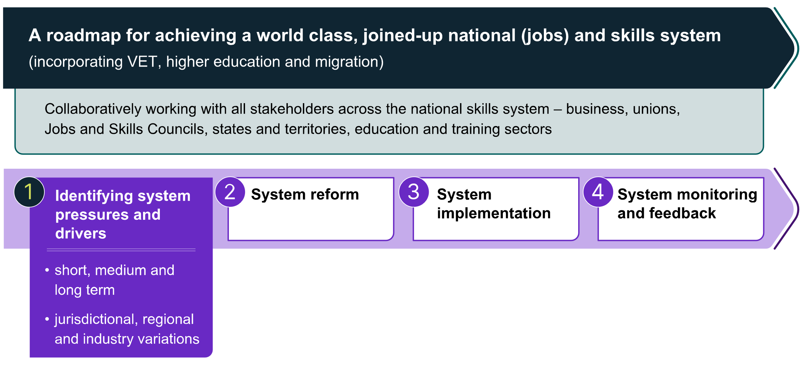

Source: Jobs and Skills Australia

Pressures and drivers

The first step in the development of a national jobs and skills roadmap is to identify the key pressures and drivers that need to be attended to, to enhance the ability of the skills system to meet the nation’s skills needs. This is a key focus of this 2023 Jobs and Skills Report and will be further developed and refined over the next year in partnership with the Jobs and Skills Councils and the states and territories, in consultation with business, unions and education and training providers, and with relevant Australian Government agencies.

Reform

The next step in the development of a roadmap, is to undertake reform of the national skills system where it is deemed to be inadequate or in need of significant improvement. A range of reforms have been under active consideration and development this year, to the tertiary system encompassing the VET and higher education sectors, and to the migration system – which has been outlined in the previous section. These reform agendas will be further shaped and refined in the months ahead and move to their respective implementation stages.

Implementation

The third step in the national jobs and skills roadmap is policy implementation, progressively incorporating a range of reforms over time. Over the next year we can expect the progressive introduction of a range of new initiatives, reforms and ways of working to the VET sector, higher education, and the migration system.

Monitoring and feedback

The last step in the roadmap is monitoring policy implementation and assessing its success against its objectives. This will then provide feedback to the system to act on and into the policy development process to support its refinement and further policy reform.

Jobs and Skills Australia is uniquely placed to provide insights and analysis in relation to VET, higher education and the migration system, with the added advantage it can monitor the coherence and complementarity of the component parts across the national skills system. Partnership with Jobs and Skills Councils and the states and territories will be a key success factor in this process.

Conclusions: Roadmap priorities and opportunities

The roadmap is starting to emerge, both through analysis, the policy development process and extensive stakeholder consultation.

We suggest 8 priorities should guide the further development of the national jobs and skills roadmap:

* deep engagement with key partners and stakeholders
* close collaboration with key policy advising/policy making bodies and departments of government
* set ambitious goals/outcomes, such as the 3 strategic objectives for the Australian population as a whole and keep them in mind
* set and chart goals and milestones for how the national skills system and each of its 3 key pillars are seeking to contribute to these goals/outcomes
* ensure that Jobs and Skills Australia focuses strongly on the interoperability and complementarity of the component parts of the national skills system
* produce subsidiary roadmaps in priority areas (industry, regions and cohorts)
* chart progress against roadmap milestones
* ensure feedback loops and continue to enhance the evidence base.

Fourteen potential roadmap opportunities are presented to help facilitate this dialogue.

|  |
| --- |
| Potential roadmap opportunities   1. Identifying Australia’s top 20 persistent skill shortages and charting a joined-up approach to solving them, including the respective roles of a range of different levers such as:    * increasing the throughput of qualified workers by increasing intake and/or completion rates of relevant training and education pathways    * enhancing the attributes of graduates of VET and higher education by improving their employability skills and creating greater work experience opportunities    * working with employers and unions and governments to enhance job opportunities through better working conditions, including strategies to tackle gender imbalance in key skill shortage occupations    * supplementing the Australian workforce through well-targeted migration. 2. Continue the dialogue between Jobs and Skills Australia, the states and territories and Jobs and Skills Councils on a nationally consistent approach for labour market and skills forecasting, and improve the coherence of workforce planning across regions and industries. 3. Support the reform of the VET, higher education and migration systems by providing advice and analysis and monitoring achievement of progress against their objectives. This should be done in a way that highlights the synergies between the 3 reform processes. 4. Work with Jobs and Skills Councils to assess how the range of reforms implemented as a result of the National Skills Agreement, the Australian Universities Accord and migration reforms, help meet the skills needs of industry. 5. Identifying the top 10 examples of weak pathways between VET and higher education, where collaboration between VET and higher education, supported by Jobs and Skills Australia and Jobs and Skills Councils, in consultation with business and unions can create a stronger pipeline of skilled graduates. 6. Identifying VET qualifications which if completed alongside higher education qualifications would enhance graduate employability. 7. Supporting the existing process of VET qualifications reform to enhance the adaptability, resilience and employment prospects of VET graduates. 8. Identifying key enhancements in the evidence base that will assist the development of the roadmap and improve our ability to monitor its success, including in relations to the outcomes of learners and workers. For example, expanding the VET National Data Asset into the higher education sector. 9. Supporting the net zero transition challenge by charting a roadmap for education, training and migration to make that transition successful, in partnership with the new Net Zero Authority. 10. Shaping a national skills taxonomy in a collaborative partnership between business, unions, higher education and VET, and the Jobs and Skills Councils, to underpin more joined-up tertiary education system. 11. Develop a regional Australia jobs and skills roadmap to identify the key steps in enhancing regional Australia’s human capital in ways that will ensure success in meeting regional employment opportunities. 12. Co-create a First Nations workforce roadmap in partnership with First Nations people and with key partners in the national skills system. 13. Develop a roadmap for enhancing the prospects of international students playing a significant role in enhancing Australia's skills profile as permanent migrants. 14. Establish a dialogue between Jobs and Skills Australia and the Productivity Commission to identify key elements of the national jobs and skills roadmap that will assist Australia’s productivity growth strategy. |

In parallel, Jobs and Skills Australia will work with partners and stakeholders to progress a range of projects, outlined in our 2023–24 work plan (Appendix A), to enhance and expand the analysis and evidence to activate Australia’s skills potential. All projects will provide insights into at least one of the above 14 roadmap opportunities.



# Context



|  |
| --- |
| Key themes in this chapter  There are multiple dimensions to Australia’s current skills challenges. Deepening our understanding of skills needs now and into the future is essential.  Activating Australia’s skills potential and realising the big strategic objectives for our nation will require a joined-up approach across the pillars of the national skills system.  Our starting point is strong, but more needs to be done. A national jobs and skills roadmap can help guide the way. |



## The skills challenge

In 2023, Australia is facing a multifaceted, multi-horizon skills challenge.

Over the last 2 years Australia has experienced widespread skill shortages reminiscent of the 1960s. The 1960s were largely characterised by low rates of unemployment and sustained increases in the level of employment (RBA, 1978). Skills shortages are again prominent and persistent. The ongoing effects of the COVID-19 recovery, along with the changing economic landscape, have created challenges across many occupations and resulted in recruitment difficulty for employers.

Addressing skills shortages in the short-term will be critical, as is anticipating how skills needs will change in the coming decades and the structural shifts shaping our nation’s economy and labour market. Changes which are already underway will see increased demand for a skilled workforce to:

* realise the benefits of digital transformation
* deliver Australia’s transformation to a net zero economy
* meet the growing demand for aged care, disability support, early childhood education and care and health services.

Foundation skills (which include language, literacy, numeracy, digital skills, and employability skills) are critical for meaningful work and active participation in the community. A lack of basic literacy or numeracy skills, or both, often results in exclusion from education, training and secure work, as well as difficulty engaging in society more broadly. The current evidence base is limited and the data on the situation in Australia is over a decade old. In 2011–12, around 3 million adult Australians did not possess the levels of literacy and/or numeracy required to effectively participate in the labour market (OECD, 2017). Digital literacy is also becoming increasingly important as a foundation skill.

Meeting the skills challenge of the future will require Australia to get foundation skills right. And beyond that we will need our whole population to possess and continually enhance the high levels of skills needed to ensure sustainable economic development, higher real wages, improved living standards and the more equitable society that we aspire to as a nation.

## Jobs and Skills Australia: a catalyst in activating Australia’s skills potential

The September 2022 Jobs and Skills Summit brought together Australians, including unions, employers, civil society and governments, to address our shared economic challenges. As an immediate action following the Summit, the Australian Government established Jobs and Skills Australia as a priority to address workforce shortages and skills challenges.

|  |
| --- |
| The mission of Jobs and Skills Australia is to be a catalyst in activating the potential of Australia’s human capital to meet present and future skills needs. |

This inaugural Jobs and Skills Report reflects Jobs and Skills Australia’s first annual analysis and advice with a focus on identifying the system pressures and drivers that are shaping the nation’s skills landscape over the short-, medium-, and long-term.

We do this by harnessing our insights and analysis in consultation with our tripartite partners, including business, unions, states and territories, and Australian Government agencies, as well as the recently established Jobs and Skills Councils, training and education sectors, and other stakeholders. This ensures Jobs and Skills Australia’s advice to government considers a wide range of perspectives, including jurisdictional regional and industry needs.

## The national skills system: a conceptual view

The national skills system provides Australia access to a skilled, diverse, productive and resilient workforce able to meet current and future labour market and economic needs. The availability of skills underpins Australia’s labour market participation and productivity, and will ensure Australians get the full benefits of good, secure jobs of the future.

At its core, the role of the national skills system is to enable effective connections and pathways to supply skills to meet the growing and changing skills demand of employers and the economy. The result is well-matched jobs in workplaces which meet the needs and preferences of both employees and employers. It is important to note that wages and working conditions attached to the jobs in workplaces is a key factor in shaping the supply and demand for skills and this will be a factor in our analysis of the national skills system.

Central to the concept of the national skills system that Jobs and Skills Australia has been asked to focus on are 3 key pillars (Figure 4) – vocational education and training, higher education and migration – each integral and contributing to the development and provision of Australia's human capital.

**Pillar 1: Vocational education and training**

* The vocational education and training sector serves a range of economic and social objectives for governments, including technical skill for the workforces to support industry, general and foundational education and programs to support entry to further vocational or higher education. The sector includes a diverse mix of public and privately funded Registered Training Organisations delivering nationally accredited, competency-based training. This can lead to qualifications across 4 levels of certificates (Certificate I, II, III and IV), as well as diploma, graduate certificates, graduate diplomas, and advanced diploma courses. Secondary students can also commence a VET pathway while at school.
* Policy, funding and regulatory responsibilities for the VET sector are shared among Australian, state and territory governments (which are the primary funders).

**Pillar 2: Higher education**

* Higher education is focused on the advancement and passage of knowledge, although qualifications supporting some specialised professions have a substantial vocational component. Higher education comprises universities and other institutions which deliver courses leading to associate, bachelor, master or doctorate degrees, advanced and graduate diplomas, and undergraduate and graduate certificates in specific disciplines (or fields of study).
* A small number of institutions are dual sector, delivering both VET and higher education courses.
* Higher education funding and policy making is primarily an Australian Government responsibility, with state and territory governments having a limited regulatory and policy making role.

**Pillar 3: Migration**

* Beyond the domestic supply of skills through training and education pathways, the migration system provides temporary and permanent pathways for people to come to Australia to live, work and study. Migrants play a critical role in Australia’s society and labour market including in key sectors with skills and labour shortages where demand cannot be met through domestic pathways. Migrants also often bring new skills and new ways of working to Australia.
* Migration is an Australian Government legislative and policy responsibility.

Figure 4: The national skills system: conceptual view (illustrative)

The diagram shows a conceptual, illustrative depiction of the national skills system.

There are 6 main actors in the diagram.

VET and higher education includes Adult and Community Education, Schools, Industry-accredited training and non-accredited training as associated parts of the tertiary education system. VET and higher education is depicted as having 2-way relationships with Employers, who represent the demand for skills, and with People, who supply skills.

At the centre is a box labelled as JOBS AND SKILLS IN WORKPLACES (with associated wages and conditions) including on-the-job training, linked to employers and people. This box recognises that both employers and people have a role in JOBS AND SKILLS IN WORKPLACES.

The Employers box also has a 2-way relationship with Unions, and this relationship is denoted as forming part of industry. The People box also has a 2-way relationship with Unions.

The People box has a one-way relationship with migration, where the relationship flows from migration to people, denoting migration’s role, alongside VET and higher education, of people and skills to work in jobs.

The Tax and Transfer system, Workplace Relations System, Employment System and Occupational health and safety are noted as having a one-way relationship flowing towards People, denoting that these systems interact with the national skills system.

Source: Jobs and Skills Australia

Each pillar makes a strong contribution to the economy and meeting Australia’s skills needs. Historically these pillars have largely been considered and developed in isolation, rather than holistically.

Further, these pillars interface with and operate alongside many other contributors to Australia's human capital both in the formal early education and schooling systems and informal skills acquisition through industry determined and directed courses and informal learning in work and social settings.

Other settings administered across the Australian Government, state and territory government levels shape and inform the operation of the labour market and national skills system. For example:

* workplace relations settings such as job classifications defined in modern awards (instruments that set minimum pay and conditions under Australia’s national workplace relations system) which link formal qualifications to pay rates and set scope of practice of workers within industries
* a number of regulatory requirements under Australia’s model work health and safety legislation are based on the principle that workers must be trained and have the appropriate skills to carry out a particular task safely
* employment services which assist in connecting people to work, including through skills development and training
* the design and operation of the tax-transfer system which can shape individual decisions about whether to work or study, including whether additional earnings may be offset by higher effective marginal tax rates, which may deter participation.

Stakeholders have various aims and aspirations for the national skills system (Box 1), which highlights the potential value of taking a systems-wide, rather than pillar-specific, view of the national skills system.

|  |
| --- |
| Box 1:What we’ve heard from stakeholders about the concept of the national skills system  Stakeholders have told us that a well-functioning national skills system:   * is accessible, adaptable and flexible providing people with the appropriate skills needed for a productive and competitive economy * is responsive to current and emerging workforce needs, including where these needs differ across regions, industries and cohorts * delivers a quality and sustainable domestic pipeline of skills, complemented by better targeted, more efficient and outcomes-focused migration * makes it easier for employers to meet their skills needs and make the most of opportunities now and into the future * removes barriers and creates opportunities for people to reach their full potential and facilitates lifelong learning * provides seamless connections and pathways across the tertiary education system and jobs which recognises skills and grows experience * provides opportunities for people to find secure work that matches their skills and preferences for how they work.   In general stakeholders have responded positively to the conceptual diagram of the national skills system (Figure 4), noting that it should not be taken too literally, and a number of alternative ways of representing it have been canvassed with us. This could be the basis of a useful ongoing discussion. |

Importantly, the skills system aggregates and codifies knowledge and skills for passing on to citizens through regulated and accredited delivery as a public benefit for citizens, which supports Australian industry and social advancement. Ultimately, its aim is to build the wellbeing of the Australian people, by opening access to meaningful work and income to sustain a high quality of life, provide the goods and services that people need, and support broader social and environmental objectives.

A wide range of stakeholders have a direct interest in the effective operation of the national skills system and include, but are not limited to:

* People who participate in the system to develop skills in line with job opportunities available to them. People also participate as learners undertaking training and education
* Employers who shape the demand for skills, driving the creation of jobs and organising their workforce, workplace conditions and worker compensation to maximise the effectiveness of the workplace
* Unions which represent the interests of workers in particular industries or occupations by contributing to bargaining of wages and conditions on behalf of members and shaping those VET qualifications that have a close relation to awards
* Education and training providers which deliver courses and issue qualifications to students of the national skills system, working with industry and other stakeholders.

Australian, state and territory governments collaborate with partners across the system and set its overall enabling environment and regulatory settings. Governments also provide funding to subsidise the cost of education and training and ensure widespread access to the system.

Two recent additions to the national skills system are Jobs and Skills Councils and Jobs and Skills Australia (Box 2).

|  |
| --- |
| Box 2: The complementary roles of Jobs and Skills Councils and Jobs and Skills Australia  Jobs and Skills Councils are a national network of 10 industry-owned and industry-led organisations, established to provide industry with a stronger, more strategic voice on skilling, that delivers stronger outcomes for learners and employers. As industry bodies they have been formed collaboratively with business and union representatives and operate on tripartite principles. Their functions are:  Workforce planning – address workforce challenges through strategies to identify, forecast and respond to skills needs across a range of educational pathways, including VET and higher education  Training product development – develop training products in line with standards set by Skills Ministers to improve the quality, speed to market and responsiveness of training products. This includes piloting emerging products and testing new approaches to meet workforce, skills, and industry needs and working with Registered Training Organisations to ensure delivery issues are considered early in training product design  Implementation, promotion and monitoring – work with training providers and organisations to align workforce planning objectives and national training products with career advice to ensure training delivery meets employer needs, career pathways are mapped and promoted, and the impact of delivery is monitored  Industry stewardship – act as a source of intelligence on workforce issues affecting their industries and provide advice on national training system policies.  Jobs and Skills Councils will work closely with Jobs and Skills Australia to provide a strong evidence base to inform decision making and workforce planning, and better prepare governments and industry to steward the economy through change and capitalise on emerging opportunities. This includes drawing on the labour market and skills analysis of Jobs and Skills Australia to undertake workforce planning for their industry sectors, creating a consistent understanding of the skills landscape and how skill gaps can be addressed.  Jobs and Skills Australia has a whole-of-economy perspective and a deep data and analytical capability, while Jobs and Skills Councils will bring a deep knowledge of, and connection to, their specific industries. The Australian Government's intention is for Jobs and Skills Councils to operate in partnership with Jobs and Skills Australia, providing on the ground perspective of the economy and leading workforce planning for their industries utilising industry experience and educator expertise with economy wide data and analysis, to provide powerful insights into Australia's current, emerging and future skills needs. |

## Towards a joined-up national skills system: a shifting policy landscape

The national skills system is undergoing a significant period of change and reform.

Along with establishing Jobs and Skills Australia and Jobs and Skills Councils, the policy context for VET, higher education, migration and the labour market is also shifting. There is much potential in these reforms for a more joined-up approach across the national skills system.

In VET, partnership and collaboration across all jurisdictions is a key focus of negotiations towards a new National Skills Agreement. The vision for the Agreement recognises that 'Australia needs a VET sector that provides high-quality, responsive and accessible education and training to boost productivity and support Australians to obtain the skills they need to participate and prosper in the modern economy' (DEWR, 2023f). As part of the National Skill Agreement negotiations, all jurisdictions have committed to shared stewardship of the national VET system.

Similarly, the aspirations for the Australian Universities Accord are to ‘improve the quality, accessibility, affordability and sustainability of higher education, in order to achieve long-term security and prosperity for the sector and the nation’ (Department of Education, 2023a). An aligned tertiary education system shaped by the strongest features of both the higher education and VET sectors has been a focus of the Australian Universities Accord process. Greater complementarity, collaboration and alignment of VET and higher education will contribute to meeting the nation’s diverse skills needs (Department of Education, 2023b).

In April 2023, the Australian Government also released a draft outline of its migration strategy – A Migration System for a More Prosperous and Secure Australia – which highlights the needs for an ‘evidence-based approach to migration decisions, and better coordination and integration of the labour market, the training and education systems with the migration system’ (Department of Home Affairs, 2023b).

More broadly, the Australian Government's Employment White Paper has also highlighted the need for a more collaborative tertiary education system, with Jobs and Skills Australia central in helping government coordinate policy across tertiary education and migration (The Treasury, 2023a).

Policy considerations in each of the key pillars of the national skills system call for a more joined-up, whole-of-system approach to meet Australia’s current and future skills needs. The potential benefits of a joined-up national skills system are immense, and all partners and stakeholders will need to work together to realise these benefits.

## The strategic objectives underpinning the case for a joined-up national jobs and skills roadmap

Realising the benefits of complementarity within the national skills system will require focused effort and practical action – brought together through a national jobs and skills roadmap. Three strategic objectives underpin the national jobs and skills roadmap:

* minimising unemployment and underemployment
* increasing productivity, participation, economic growth and real wages
* increasing equity and reducing disadvantage.

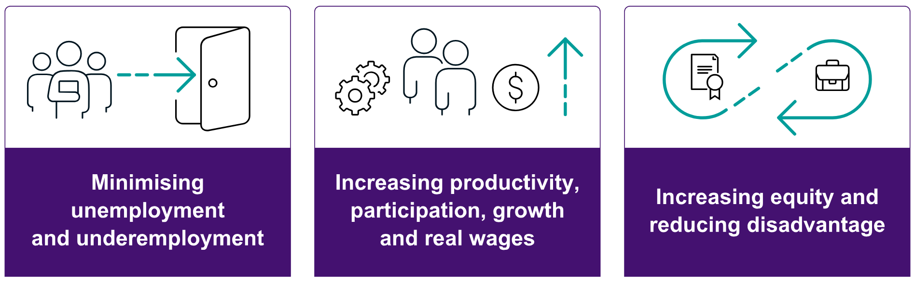

### Minimising unemployment and underemployment

In recent years unemployment in Australia has fallen to about 3.5% – levels not seen in 50 years. High rates of inflation, however, triggered by international and domestic supply shocks, has resulted in a strong tightening of monetary policy in Australia, in common with many other Organisation for Economic Co-operation and Development (OECD) countries (OECD, 2022).

There is considerable speculation whether unemployment will rise as monetary tightening aimed at addressing inflation dampens economic activity and jobs growth. This includes much discussion about the rate of unemployment that is consistent with stable inflation – the non-accelerating inflation rate of unemployment (NAIRU). Estimates of the NAIRU have been declining over the last 20 years (The Treasury, 2021). One of the key determinants of the NAIRU is how efficiently labour supply can be matched to labour demand. One way to reduce the NAIRU is to better match skills in demand with the skills that are supplied. In the 1960s unemployment below 3% did not cause accelerating wage inflation or price inflation.

Current signs are that price inflation is declining significantly while unemployment has stayed below 4%. Navigating a soft landing now is key – where price inflation is returned to the RBA’s target band while unemployment is kept below Treasury’s estimate of the NAIRU at 4¼%. If that can be achieved, it forms the basis for renewed efforts to drive unemployment down again towards 3%, without creating bottlenecks so severe that they constrain productivity growth and stimulate inflationary pressures.

As well as minimising unemployment, seeking to minimise underemployment is also an important objective to achieve what the Employment White Paper has called ‘sustained and inclusive full employment’.

This is one key driver of the case for a joined-up national jobs and skills roadmap.

### Increasing productivity, participation, economic growth and real wages

Australia has experienced an extended period of sluggish productivity growth. While productivity growth slowed before the pandemic, COVID-19 era disruptions exacerbated a relatively flat labour market (Lowe, 2023). The pandemic saw businesses across Australia delay investment plans as the focus changed to maintaining, rather than growing, their operations. Skill shortages intensified and unemployment fell to the lowest rate recorded since August 1974 (NSC, 2022), as workers took early retirement and the number of temporary entrants who also work decreased. Supply chain issues also affected large sections of the labour market, with Australia experiencing virtually zero productivity growth over this period (Nugent, 2023).

This said, there was also considerable innovation during this period as businesses found new ways of working. A significant proportion of professional roles transitioned to either working from home or hybrid working arrangements. This generally increased workers’ productivity through greater autonomy to manage their workflow and decrease distractions (Productivity Commission, 2021). Digital adoption also accelerated through changing consumption patterns and modes of delivery, with e-commerce expanding considerably across businesses of all size during the COVID-19 pandemic (NSC, 2021b). Many businesses increased or brought forward the adoption of automation practices or new technologies to negative the ongoing effects of the pandemic (NSC, 2021b).

Enhancing the skills of the workforce is critical to productivity growth. More highly skilled workers are more likely to drive product innovation and find new and innovative ways to produce outputs (OECD, 2011). Ultimately, stronger productivity growth will be the main source of sustainable growth in wages and living standards.

Wages growth was lower than might have been expected in the lead up to the COVID-19 pandemic and has not responded as quickly as expected to the tight labour market since. Explanations for this relatively sluggish wage growth include overall weak productivity growth and reduced dynamism in the labour and product markets. Declining firm entry and dynamism may have lowered wages growth by reducing competition for labour amongst existing firms. Declining union coverage and occupational mobility may have also played some role (Hambur, 2023).

Other factors affecting the lack of responsiveness of wages to the tight labour market include the impact of methods of pay setting which fix wages growth for multiple periods, public sector wage caps, and employers responding differently to the uncertainty of the post-COVID labour market (Borland, 2023).

Persistent shortages in the labour market at a time of labour market tightness indicates that segments of the labour market are not matching as well as it should. As discussed in Chapter 3, some skill shortages may be resulting from employers not making the job offer sufficiently attractive, including through higher wages.

The strength of the labour market in recent years has also facilitated an increase in labour force participation. During periods of high unemployment, people often lose attachment to the labour market – becoming long-term unemployed or withdrawing from the labour market altogether. Skills atrophy and people lose their confidence in engaging with the labour market. This then reduces the potential labour supply and creates a handbrake on economic activity. Maintaining low and stable unemployment avoids this vicious cycle.

These factors constitute a second key driver of the case for a joined-up national jobs and skills roadmap.

### Increasing equity and reducing disadvantage

Current labour market conditions, while strong, are not felt evenly across cohorts and regions. First Nations people make diverse and important contributions to Australia’s workforce and are leading the way at the pinnacle of many sectors, but unacceptable gaps persist in education and employment outcomes at the population level. First Nations people continue to face additional barriers to work, and study compared to other Australians (see Appendix B for more detailed analysis).

Enhancing the position of First Nations peoples in the education and training system is an important priority, as is a focus on enhancing pathways for young people from low socio‑economic backgrounds. Gender equity is another key focus.

Two key factors that can cause poverty and disadvantage are unemployment and lack of skills and educational attainment. Reducing unemployment and raising skills and capabilities are 2 key elements in improving equity and reducing disadvantage.

This needs to be comprehensive in its approach, starting with early childhood development and progressing into enhanced school education especially for disadvantaged groups. Pathways from school to tertiary education and employment need to be more seamless. The approach also needs to include working with disadvantaged adults to strengthen their foothold in the labour market and enable them to secure well remunerated employment.

This is the third key driver for a national jobs and skills roadmap.

### The complementarity of low unemployment and growing productivity, real wages and participation, and enhanced equity

These 3 key drivers are highly complementary (Dawkins & Garnaut, 2022). As an economy approaches full employment and skill shortages emerge, this encourages firms to invest in training and increases employment opportunities for unemployed workers who might otherwise find it difficult to obtain a foothold in the labour market (Martin, 2022). Reducing long-term unemployment helps to avoid the atrophy of skills that occurs with long-term unemployment and is particularly important for disadvantaged job seekers.

Approaching full employment also encourages employers to raise wages to attract and retain employees which further enhances labour force participation. Employees also have greater opportunity to leave jobs that do not suit them and find other jobs – often moving from lower productivity to higher productivity firms (Dawkins & Garnaut, 2022). Rising real wages also encourages investment in physical capital due to enhanced consumer demand and labour scarcity, which further enhances productivity and helps create a virtuous cycle. Because the economy is at full employment a focus on raising productivity through automation and digitalisation is an easier adjustment to make so long as attention is given to upgrading workforce skills. When unemployment is high, policy focuses on job creation rather than investment in technological change.

The Australian Government’s recently released Employment White Paper, *Working Future*, outlines 5 objectives in its vision for the future of the Australian labour market, which we see as highly congruent with the 3 objectives outlined above.

## The aims of a national jobs and skills roadmap

Achieving these strategic objectives will require coordinated action and shared understanding of the diverse, changing and priority skills needs across our nation. A core recommendation of this inaugural Jobs and Skills report is to develop a national jobs and skills roadmap over the coming year, in collaboration with our tripartite partners and stakeholders.

The central aim of the national jobs and skills roadmap will be to create the enabling environment for a joined-up approach to collaborative stewardship of the national skills system. A system that is flexible, responsive and well-calibrated to meet the nation’s current and future skills needs. This will require regular and ongoing identification of the pressures within the system and their drivers, leading to system reform and implementation to address these pressures and a focus on monitoring and feedback to continuously improve and optimise the system over time.

The national jobs and skills roadmap will provide framing for major system reforms to key elements of the system – the Universities Accord, the National Skills Agreement and the Migration Strategy. It will be informed by the workforce plans developed by each Jobs and Skills Council. The roadmap will also draw on the work of state and territory governments in developing skills plans for each jurisdiction.

# Megatrends shaping the economy and workforce



|  |
| --- |
| Key themes in this chapter  The economy is always evolving, but there are some key trends that are driving the overall shape of the labour market.  Data and digital technologies are playing a growing role across the economy and shaping current and future workforce needs.  Emerging generative artificial intelligence can be expected to have profound impacts on the labour market. Further analysis is needed to better understand and anticipate these impacts and harness the opportunities they bring.  The net zero transformation will create new opportunities in emerging green industries that will facilitate a decarbonised global economy.  Growing demand for quality care and support services is reshaping our economy.  These 3 trends are shaping our economy today, and a whole-of-systems view will assist the national skills system respond effectively now and plan for change. |



The economy is always in a state of change as a consequence of short and long-term factors. Three important structural changes are already underway and will see increased demand for a skilled workforce to:

* realise the benefits of digital transformation
* deliver Australia’s transformation to a net zero economy and reduce greenhouse gas emissions
* meet the growing demand for care services.

## Skills for the digital transformation

The need for both expert digital skills and digital literacy have been consistent themes raised by stakeholders as an economy-wide issue, where the education and training systems will need to do more. Building digital and data proficiency at all skill levels will be increasingly fundamental for people to enter the workforce and achieve their full potential in the labour market (DSO, 2023), as well as participate fully in social and community life. The entire Australian workforce will need to be digitally literate and digital literacy has emerged as a foundation skill (Box 3). At the same time, Australian employers are recognising the need for more specialised digital and data skills. Yet, businesses have reported that a lack of skills and knowledge was one of the top barriers to adoption of digital technology (Productivity Commission, 2023a).

|  |
| --- |
| Box 3: Digital literacy is a critical foundation skill, together with basic literacy and numeracy  The ability to read, write, count, and engage with technology is a critical foundation for meaningful work and active participation in the community. The commonly quoted research shows around 3 million Australians lack basic literacy or numeracy skills, or both. This often results in exclusion from education, training, and secure work, as well as difficulty engaging in society more broadly.  There is clear consensus about the strong value of foundation skills, and yet there is no up‑to-date national level data on these skill levels.  While digital literacy is becoming increasingly important as a foundation skill, there is no agreed definition on digital literacy and how to assess it, let alone data on Australians’ digital literacy. Jobs and Skills Australia is leading the development of a national study on adult literacy, numeracy and digital literacy skills – the foundation skills study. The study consists of 4 elements:   * a survey of Australian adults to assess their current literacy and numeracy skills levels (the survey) * a feasibility study into how best to collect the literacy, numeracy and digital literacy levels of First Nations people (the feasibility study) * analysis of Commonwealth administrative and other data into the results for priority groups * defining digital literacy and exploring measurement approaches.   Jobs and Skills Australia is currently engaging with stakeholders on all aspects of the study. |

To close these skills gaps, the education and training systems will need to both deliver new skills and adapt in how they deliver them. While predicting the future of technological change is inherently difficult, a responsive skills system will help set Australians up to respond to digital transformation and share the benefits (Commonwealth of Australia, 2023).

Occupations with higher levels of digital engagement and occupations requiring specialised data and digital skills are projected to grow at faster rates than other occupations.[1] By 2028, occupations which require a high level of digital proficiency are projected to increase by 11.4%, compared to 6.9% for those with intermediate proficiency and 2.6% for those with basic proficiency.[2] Occupations where people tend to spend more than 50% of their time using specific data and digital skills (like writing code or managing Information Technology (IT) systems) are projected to grow at twice the rate (12.5%) of other occupations (6.2%).

The demand for digital and data skills is spreading quickly across the Australian labour market. As the COVID-19 pandemic showed, technological changes in business operations and ways of working can reach widely and rapidly across industries (The Treasury, 2023b).

Much of the growth in demand for digital skills is outside of traditional IT or technology jobs. This indicates the importance of data and digital skills across the economy. In 2022, 5 of the 10 occupations with the highest numbers of job listings requesting digital and data skills were not data and digital occupations (Figure 5).

Figure 5: Top 10 occupations with the highest numbers of job listings requesting digital and data skills in 2022

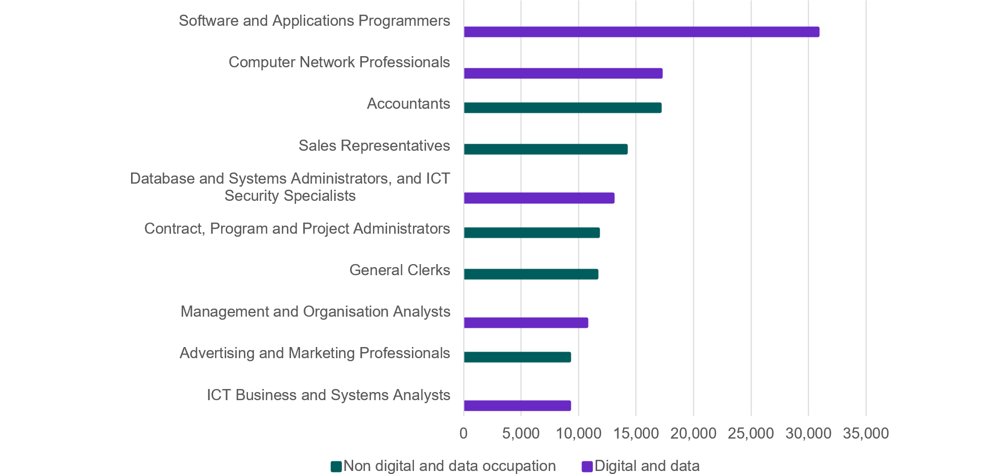

|  |  |  |
| --- | --- | --- |
| Occupation name | Digital and data | Non digital and data occupation |
| ICT Business and Systems Analysts | 9177 |  |
| Advertising and Marketing Professionals |  | 9177 |
| Management and Organisation Analysts | 10674 |  |
| General Clerks |  | 11582 |
| Contract, Program and Project Administrators |  | 11692 |
| Database and Systems Administrators, and ICT Security Specialists | 12972 |  |
| Sales Representatives |  | 14102 |
| Accountants |  | 17084 |
| Computer Network Professionals | 17171 |  |
| Software and Applications Programmers | 30799 |  |

Source: Lightcast (2022); Jobs and Skills Australia analysis

Occupations with the highest growth in the proportion of job listings requesting digital and data skills include a variety of occupations, not only digital and data occupations (Figure 6).

Figure 6: Top 10 occupations with highest growth in the percentage of jobs requesting digital and data skills, 2018 to 2022

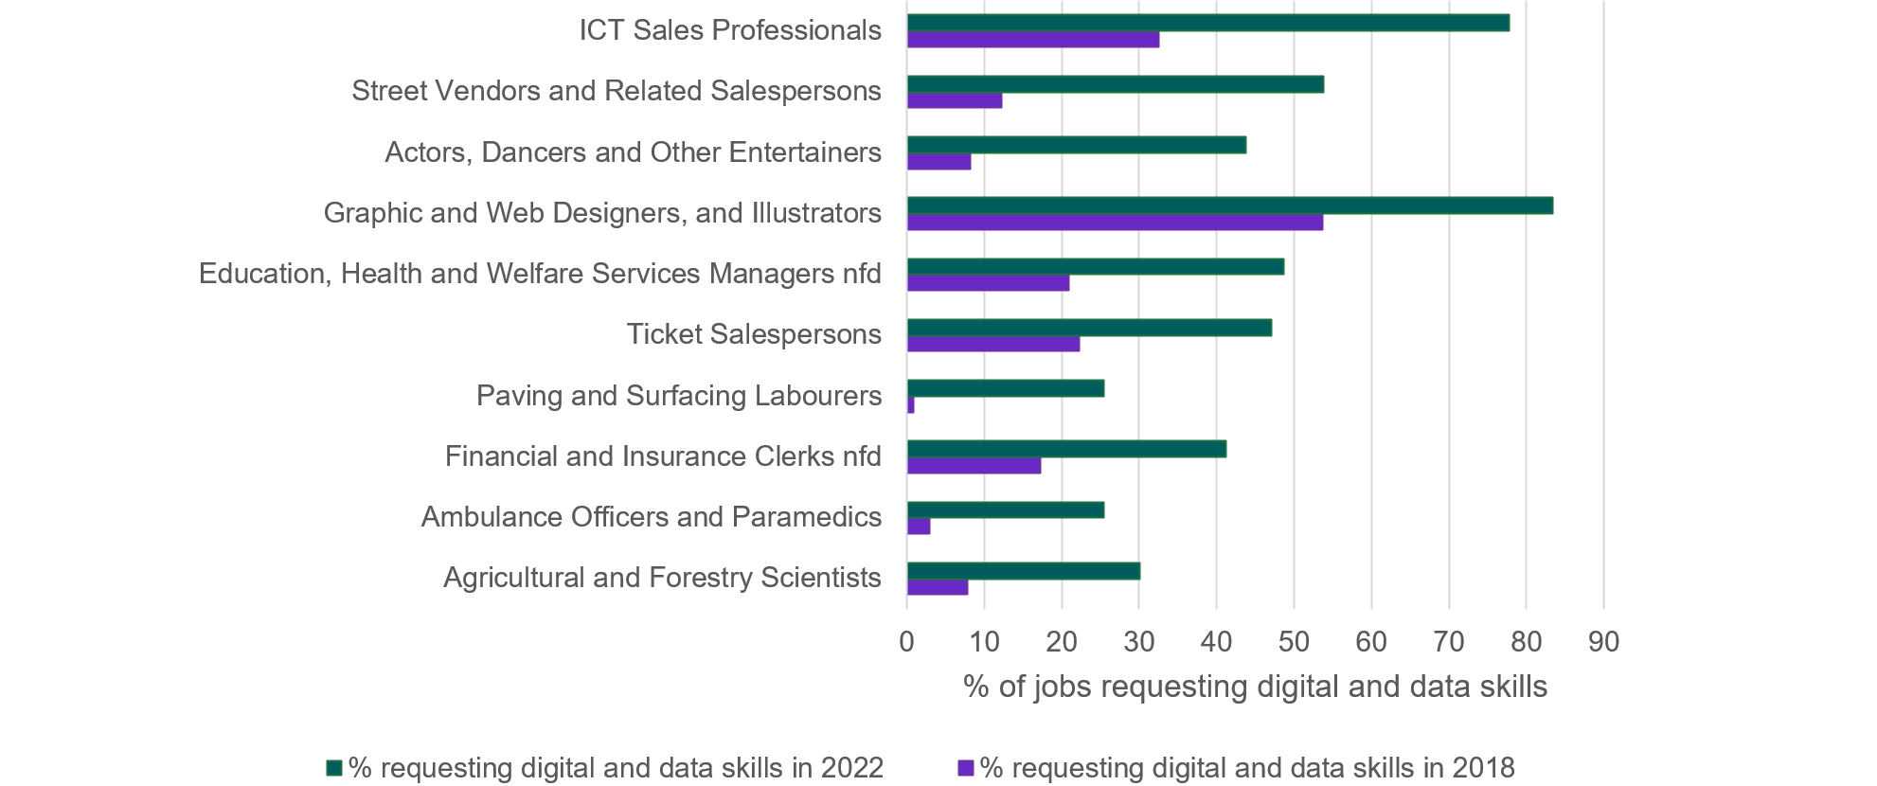

|  |  |  |
| --- | --- | --- |
| ANZSCO Unit Description | % requesting digital and data skills in 2018 | % requesting digital and data skills in 2022 |
| Agricultural and Forestry Scientists | 7.79 | 30.11 |
| Ambulance Officers and Paramedics | 2.99 | 25.39 |
| Financial and Insurance Clerks nfd | 17.28 | 41.2 |
| Paving and Surfacing Labourers | 0.81 | 25.43 |
| Ticket Salespersons | 22.22 | 47.11 |
| Education, Health and Welfare Services Managers nfd | 20.95 | 48.72 |
| Graphic and Web Designers, and Illustrators | 53.71 | 83.33 |
| Actors, Dancers and Other Entertainers | 8.15 | 43.83 |
| Street Vendors and Related Salespersons | 12.17 | 53.85 |
| ICT Sales Professionals | 32.54 | 77.78 |

Source: Lightcast (2018 – 2022); Jobs and Skills Australia analysis

### Automation in the labour market

Analysis of occupations’ susceptibility to automatability[3] raises implications for the skills system (Duckworth, Graham, & Osbourne, 2019). Long-term trends in the automation of routine manual and cognitive tasks have been affecting work in Australia over the last 50 years and continue to play out in the labour market (Heath, 2020). As shown in Figure 7, more automatable occupations are predicted to have less growth in the future than occupations with less potential for automatability.[4]

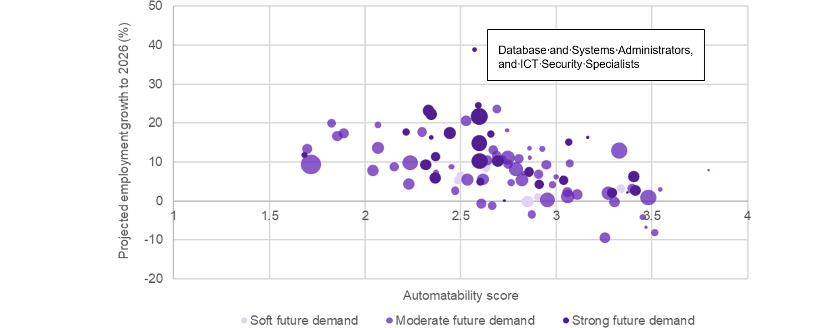Figure 7: Projected employment growth by future demand and automatability score

|  |  |  |  |  |  |  |  |  |  |  |  |  |  |  |  |  |  |  |  |  |  |  |  |  |  |  |  |  |  |  |  |  |  |  |  |  |  |  |  |  |  |  |  |  |  |  |  |  |  |  |  |  |  |  |  |  |  |  |  |  |  |  |
| --- | --- | --- | --- | --- | --- | --- | --- | --- | --- | --- | --- | --- | --- | --- | --- | --- | --- | --- | --- | --- | --- | --- | --- | --- | --- | --- | --- | --- | --- | --- | --- | --- | --- | --- | --- | --- | --- | --- | --- | --- | --- | --- | --- | --- | --- | --- | --- | --- | --- | --- | --- | --- | --- | --- | --- | --- | --- | --- | --- | --- | --- | --- |
| ANZSCO Title | Tertiary Education Teachers | School Teachers | Legal Professionals | Social and Welfare Professionals | Education Aides | Chief Executives, General Managers and Legislators | Education, Health and Welfare Services Managers | Business Administration Managers | Sports and Fitness Workers | Advertising, Public Relations and Sales Managers | Construction, Distribution and Production Managers | Accommodation and Hospitality Managers | Media Professionals | Arts Professionals | Natural and Physical Science Professionals | Architects, Designers, Planners and Surveyors | Sales, Marketing and Public Relations Professionals | Automotive Electricians and Mechanics | Miscellaneous Hospitality, Retail and Service Managers | Engineering Professionals | Electronics and Telecommunications Trades Workers | Health Diagnostic and Promotion Professionals | Medical Practitioners | Health Therapy Professionals | Financial Brokers and Dealers, and Investment Advisers | Air and Marine Transport Professionals | Accountants, Auditors and Company Secretaries | Real Estate Sales Agents | Construction and Mining Labourers | Food Trades Workers | Building and Engineering Technicians | Office and Practice Managers | Miscellaneous Labourers | Animal Attendants and Trainers, and Veterinary Nurses | Horticultural Trades Workers | Glaziers, Plasterers and Tilers | Personal Service and Travel Workers | Agricultural, Medical and Science Technicians | Automobile, Bus and Rail Drivers | Retail Managers | Miscellaneous Technicians and Trades Workers | Panelbeaters, and Vehicle Body Builders, Trimmers and Painters | Mobile Plant Operators | Truck Drivers | Hairdressers | Sales Assistants and Salespersons | Personal Assistants and Secretaries | Receptionists | Financial and Insurance Clerks | General Clerks | Mechanical Engineering Trades Workers | Machine Operators | Printing Trades Workers | Accounting Clerks and Bookkeepers | Keyboard Operators | Wood Trades Workers | Textile, Clothing and Footwear Trades Workers | Farmers and Farm Managers | Defence Force Members, Fire Fighters and Police | Plumbers | Bricklayers, and Carpenters and Joiners | Floor Finishers and PaintersFabrication Engineering Trades Workers Miscellaneous Education Professionals ICT Managers Contract, Program and Project Administrators Business and Systems Analysts, and Programmers Information and Organisation Professionals Miscellaneous Specialist Managers Child Carers Human Resource and Training Professionals Health and Welfare Support Workers Database and Systems Administrators, and ICT Security Specialists ICT Network and Support Professionals Midwifery and Nursing Professionals Personal Carers and Assistants Hospitality Workers Prison and Security Officers ICT and Telecommunications Technicians Electricians Miscellaneous Sales Support Workers Miscellaneous Clerical and Administrative Workers Stationary Plant Operators Cleaners and Laundry Workers Insurance Agents and Sales Representatives Delivery Drivers Food Process Workers Call or Contact Centre Information Clerks Miscellaneous Factory Process Workers Storepersons Logistics Clerks |
| Future Demand | Moderate future demand | Moderate future demand | Moderate future demand | Moderate future demand | Moderate future demand | Moderate future demand | Moderate future demand | Moderate future demand | Moderate future demand | Moderate future demand | Moderate future demand | Moderate future demand | Moderate future demand | Moderate future demand | Moderate future demand | Moderate future demand | Moderate future demand | Moderate future demand | Moderate future demand | Moderate future demand | Moderate future demand | Moderate future demand | Moderate future demand | Moderate future demand | Moderate future demand | Moderate future demand | Moderate future demand | Moderate future demand | Moderate future demand | Moderate future demand | Moderate future demand | Moderate future demand | Moderate future demand | Moderate future demand | Moderate future demand | Moderate future demand | Moderate future demand | Moderate future demand | Moderate future demand | Moderate future demand | Moderate future demand | Moderate future demand | Moderate future demand | Moderate future demand | Moderate future demand | Moderate future demand | Moderate future demand | Moderate future demand | Moderate future demand | Moderate future demand | Moderate future demand | Moderate future demand | Moderate future demand | Moderate future demand | Moderate future demand | Moderate future demand | Moderate future demand | Soft future demand | Soft future demand | Soft future demand | Soft future demand | Soft future demandSoft future demand Strong future demand Strong future demand Strong future demand Strong future demand Strong future demand Strong future demand Strong future demand Strong future demand Strong future demand Strong future demand Strong future demand Strong future demand Strong future demand Strong future demand Strong future demand Strong future demand Strong future demand Strong future demand Strong future demand Strong future demand Strong future demand Strong future demand Strong future demand Strong future demand Strong future demand Strong future demand Strong future demand Strong future demand |
| Automatability score | 1.69834 | 1.716758 | 1.826628 | 1.854404 | 1.889547 | 2.040369 | 2.06812 | 2.068475 | 2.153948 | 2.228389 | 2.235739 | 2.298192 | 2.370727 | 2.452357 | 2.470902 | 2.529333 | 2.536473 | 2.608037 | 2.616764 | 2.640009 | 2.663172 | 2.670921 | 2.686937 | 2.689031 | 2.718709 | 2.742199 | 2.746437 | 2.747378 | 2.763526 | 2.789216 | 2.803544 | 2.820321 | 2.829249 | 2.859377 | 2.8611 | 2.872084 | 2.906942 | 2.926353 | 2.948315 | 2.953148 | 2.979369 | 2.999573 | 3.056513 | 3.058778 | 3.071267 | 3.107833 | 3.253064 | 3.272878 | 3.304701 | 3.329314 | 3.395364 | 3.452176 | 3.46809 | 3.480896 | 3.514491 | 3.542277 | 3.795435 | 2.487015 | 2.501539 | 2.633394 | 2.849592 | 2.9039173.336308 1.684405 2.215298 2.31835 2.331374 2.345472 2.346026 2.36815 2.369282 2.441841 2.572775 2.593194 2.597698 2.597764 2.598797 2.601963 2.659217 2.695272 2.727223 2.85728 2.911155 3.027511 3.039703 3.064603 3.163155 3.289857 3.370812 3.405232 3.412616 |
| Projected employment growth to November 2026 (%) | 13.41375 | 9.395171 | 20.04277 | 16.65433 | 17.44491 | 7.884636 | 19.52202 | 13.63759 | 8.830148 | 4.374352 | 9.828744 | 17.73318 | 7.292508 | 8.790383 | 2.658467 | 20.52788 | 5.401796 | -0.67364 | 5.522305 | 10.48761 | -1.16128 | 13.09722 | 11.69335 | 23.59585 | 10.66581 | 18.14543 | 11.12212 | 9.476916 | 4.699696 | 8.146995 | 10.91001 | 5.429372 | 7.202099 | 13.54706 | 11.10419 | -3.42137 | 6.860119 | 13.45513 | 9.253219 | 0.304765 | 4.242266 | 6.134818 | 2.21319 | 1.109582 | 9.597563 | 1.648879 | -9.46557 | 2.065363 | -0.28963 | 12.93568 | 3.147307 | -4.10008 | -6.73855 | 0.862329 | -8.05515 | 2.987172 | 7.927291 | 5.322707 | 6.398872 | 8.616486 | -0.14362 | 0.9647143.17247 11.83933 17.74713 9.288914 23.19288 22.26733 16.39991 5.916024 11.34841 17.50557 38.89778 24.62296 14.864 21.75653 10.205 5.019044 17.17545 10.22245 0.106133 7.515873 4.298225 6.297728 5.318572 15.14466 16.39447 2.158863 2.156143 6.205716 2.722027 |

Source: Jobs and Skills Australia Occupation and Task Automatability Scores (2022) (unpublished), The Skills Priority List, (2022) and NSC Employment Projections 2021 to 2026 (2022)

An interesting outlier in Figure 7 is Database and Systems Administrators, and ICT Security Specialists, with very strong future growth and a medium level of automatability. There are likely to be changes in the way work is performed in these occupations as specific tasks are automated, but the demand for workers is projected to remain strong. This illustrates an important factor of automation – changes within occupations are as important as overall growth and decline.

The national skills system will need to take account of the likelihood of the automation dynamic across the labour market – including the way existing occupations will be subject to change; the decline in growth of traditional occupations that may be replaced and the growth of new occupations that support automation. This presents a challenge, as automatable occupations tend to draw on similar skill sets and aptitudes as each other, indicating that significant retraining may be required for some people.

Generative Artificial Intelligence (AI) is a branch of artificial intelligence that uses deep learning models to create new data and content. Examples include Chat GPT, Meta AI, Bard or the GitHub co-pilot code writer. Generative AI can write essays, poems or project plans, design new products, living spaces and houses, make memes, create a video, art or compose music.

The potential for generative artificial intelligence to replace or substantially alter higher-skilled, cognitive non-routine roles presents a step change from findings about the impact of automation that identified lower skilled jobs as more at risk (Bell, Burgess, Thomas, & Sadiq, 2023; Gmyrek, Berg, & Bescond, 2023). Generative AI also has the potential to augment existing roles through improving capability and accessibility across different sectors such as healthcare, manufacturing, retail, and professional services (Tech Council of Australia, 2023; Bell, Burgess, Thomas, & Sadiq, 2023).

While there is considerable public attention on the power of generative AI and its associated risks, it is difficult to fully identify its impact on the labour market at this early stage. Commentary suggests that it is likely to impact more, and different, roles than prior technological advances, including some knowledge-based roles like copywriters, software developers, designers and analysts (Tech Council of Australia, 2023).

Stakeholders have indicated that with the emergence of generative AI, further work is required to better understand its potential impacts on the labour market, job design, and skills needs. This would be a beneficial area of analytical focus by Jobs and Skills Australia.

## Clean energy and the net zero transformation

Achieving the net zero transformation represents one of the most significant economic structural shifts since the Industrial Revolution. It presents both challenges and opportunities for the Australian economy and will accelerate investment in capital, people, and communities.

Australia is reshaping the way we generate, use and export our energy. Significant investments in clean energy generation and the electrification of our houses, vehicles and industries will help reduce emissions and cut power costs. Growing international demand for renewable energy and low emissions products also has the potential to support economic and employment growth (The Treasury, 2023b).

This transition will not be possible without a workforce that is equipped with the right skills. To meet these skills needs, investment in skills development will take proper planning and time. Coordination across education, training, migration settings and industry will be critical to the success of the net zero transformation.

The fast pace of technological innovation in clean energy means the skill requirements and supporting job roles are constantly evolving. It will be critical for industry, VET and higher education sectors to collaborate as the technology is developed and deployed. Stakeholders have consistently emphasised Australia will need to lift the pipeline of VET-trained workers, including in regional areas, to meet the needs of the clean energy transition.

Overall economic growth and development provides good prospects for supporting communities affected by decarbonisation, provided there is local investment in new industries and impacted workers receive targeted training and other support to transition to new roles. The transition to clean energy should also provide education, training and workforce opportunities for disadvantaged groups that were excluded or underutilised in traditional energy.

The Australian Government commissioned a Clean Energy Workforce Capacity Study as the first major priority for Jobs and Skills Australia, in recognition of how important this workforce is for our energy future and the government’s net zero agenda.

Clean energy and the net zero transition, including key findings and roadmap opportunities, are discussed in detail in Chapter 5.

## The growth of the health, care and support workforce

The growth of the health and care sector is another important development shaping the labour market, driven by an ageing population, a transition from informal to formal care, and increased citizens’ expectations of government. This area is currently experiencing skills shortages with employment projected to grow strongly in the future.

The overall Health Care and Social Assistance industry is projected to make the largest contribution to employment growth over the 10-year period to May 2033 (Chapter 4). Employment is projected to grow by 533,400 persons or around 25% to 2033. The Health Care and Social Assistance industry is already the largest employing industry, and the share of total employment in this industry will rise from 15.2% in 2023 to 16.7% in 2033.

Significant growth is expected in the care and support workforce – early childhood education and care, residential aged care and disability and other care (PM&C, 2023a). Over the last 5 years, growth in the care and support workforce has been 3 times faster than total employment. Projections by Victoria University for Jobs and Skills Australia indicate that employment in the care and support workforce will increase by around 145,000 over the next decade to 2033, or by around 22% from current levels (Figure 8). The demand for workers is likely to be higher than this. The largest share of the expected growth is expected in personal care and support workers, which includes aged and disability carers and nursing support and personal care workers. Allied health professionals are the second largest group, which includes occupational therapists, physiotherapists, and podiatrists.

Figure 8: Care and support workforce employment to 2033 (‘000 persons)

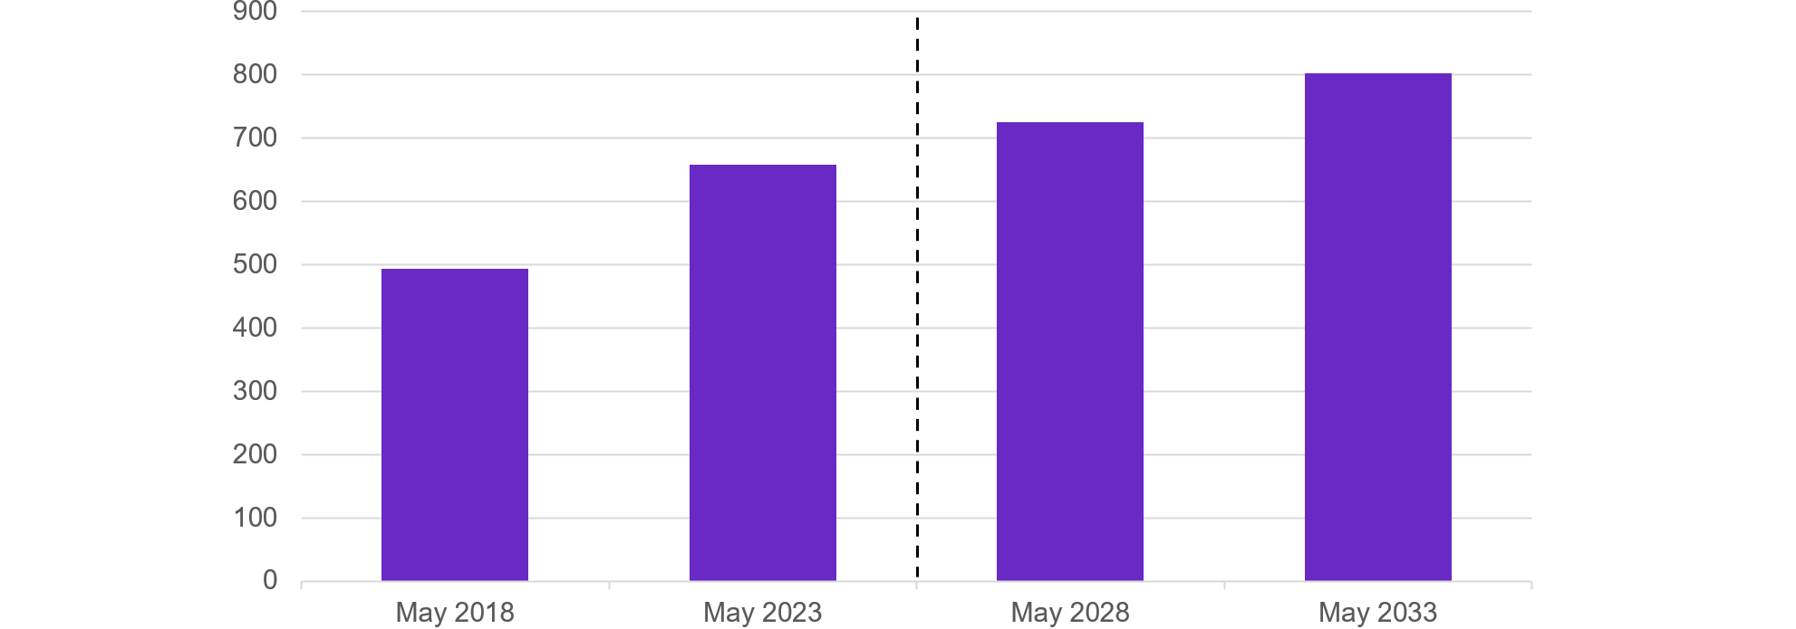

|  |  |  |  |  |
| --- | --- | --- | --- | --- |
|  | May 2018 | May 2023 | May 2028 | May 2033 |
| Care Workforce ('000) | 494.1 | 657.2 | 725.4 | 801.7 |

Source: Projections produced by Victoria University for Jobs and Skills Australia; May 2023, Detailed Labour Force Survey, ABS; data trended by Jobs and Skills Australia

A concerted effort will be needed to address workforce challenges in the care and support economy. As well as pursuing options to grow the size of the workforce, ensuring the workforce has appropriate training and skills will be crucial. This includes investment in digital skills, as well as more specialised skill sets needed to deliver quality care and support (including both technical and soft skills). Ongoing professional development will be needed in response to several features of care and support work, given its evolving and complex nature (NSC, 2021a). This will require collaboration between the university and VET sectors, as well as leveraging on‑the-job training, short form qualifications such as microcredentials and pursuing opportunities for lifelong learning.

Dealing with existing shortages and the expected future growth, will require more effort to improve the quality of the jobs to attract more workers to the sector. Common reasons for difficultly in filling jobs in this sector include lack of competitive wages, perceptions that there are not clear pathways for career progression, and concerns that workloads are too high. Data also indicates that care and support workers are more likely to experience a serious injury at work (PM&C, 2023b).

In May 2023, the Australian Government released a draft National Strategy for the Care and Support Economy which sets a road map of actions to a sustainable and productive care and support economy that delivers quality care with decent jobs (PM&C, 2023b). The strategy encompasses aged care, disability care and support, veterans' care and early childhood education and care. A key aim of the strategy is to provide a holistic view across the care and support economy to facilitate comprehensive solutions in a more coordinated way than sector‑based policies. Actions to implement the strategy will necessarily entail a strong focus on workforce and skills needs. In August 2023 the Australian Government announced the development of a National Nursing Workforce Strategy which will be developed in collaboration with all states and territories and the nursing profession.

## Conclusions

The megatrends outlined in this chapter are not a far-off future state, they are impacting and shaping our economy and labour market today.

These 3 structural shifts all point to the need for an increasingly highly skilled workforce and a highly responsive skills system. Actions to support this include identifying skills needs, monitoring how the skills system responds to these structural shifts, and informing policy makers and other stakeholders of current and emerging pressures.

The development of a joined-up, collaborative approach to address these issues will be essential to ensure the national skills system adapts and responds to these structural shifts.

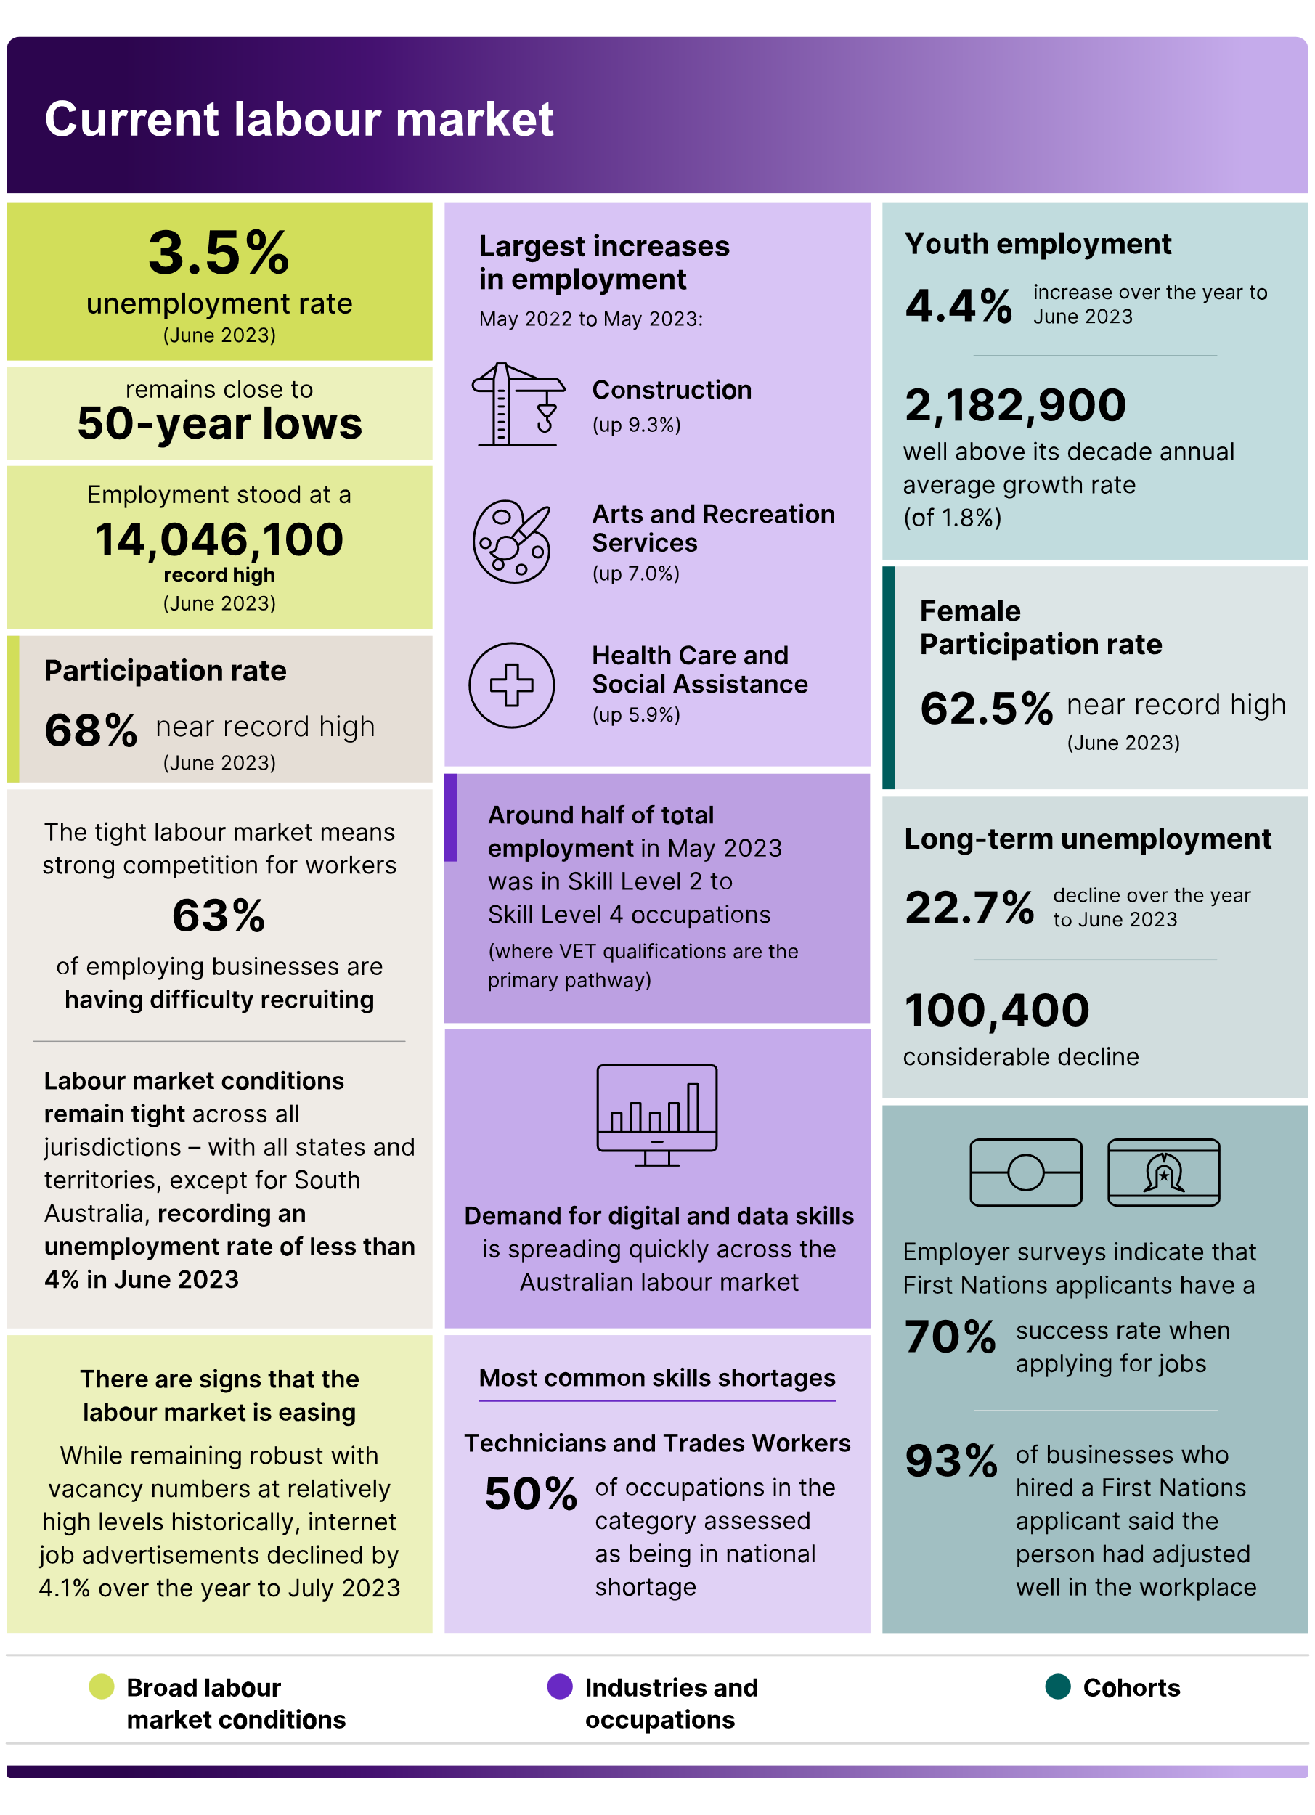An infographic providing an overview of some current labour market statistics in 3 categories:

Broad labour market conditions

Industries and occupations

Cohorts

Broad labour market conditions

3.5% unemployment rate (June 2023)

Remains close to 50-year lows

Employment stood at 14,046,100 record high (June 2023)

Participation rate 68% near record high (June 2023)

The tight labour market means strong competition for workers – 63% of employing businesses are having difficulty recruiting.

Labour market conditions remain tight across all jurisdictions – with all states and territories, except for South Australia, recording an unemployment rate of less than 4% in June 2023.

There are signs that the labour market is easing – while remaining robust with vacancy numbers at relatively high levels historically, internet job advertisements declined by 4.1% over the year to July 2023.

Industries and occupations

Largest increases in employment May 2022 to May 2023:

Construction (up 9.3%)

Arts and Recreation Services (up 7.0%)

Health Care and Social Assistance (up 5.9%)

Around half of total employment in May 2023 was in Skill Level 2 to Skill Level 4 occupations (where VET qualifications are the primary pathway).

Demand for digital and data skills is spreading quickly across the Australian labour market.

Most common skills shortages – Technicians and Trades Workers – 50% of occupations in the category assessed as being in national shortage.

Cohorts

Youth employment:

4.4% increase over the year to June 2023

2,182,900 – well above its decade annual average growth rate (of 1.8%)

Female participation rate – 62.5% - near record high (June 2023)

Long term unemployment:

22.7% decline over year to June 2023

100,400 – considerable decline

Employers indicate that First Nations applicants have a 70% success rate when applying for jobs

93% of businesses who hired a First Nations applicant said that the person had adjusted well to the workplace

Source: ABS: Labour Force Survey, Detailed Labour Force; Jobs and Skills Australia: Recruitment Experience and Outlook Survey, Internet Vacancy Index, Skills Priority List, digital skills analysis based on Lightcast data



# Current skills shortages



|  |
| --- |
| Key themes in this chapter  Skills shortages are present across many occupations. Some shortages are persistent.  Recruitment challenges are more pronounced in regional and remote areas.  Occupations with a strong gender imbalance are more likely to be in shortage.  The drivers of skills shortages differ across occupations and require different responses across the national skills system.  There is a need to continue to work closely with stakeholders to further understand the drivers and issues contributing to skills shortages and the responses that may be required to address these. |



Identifying which occupations are in shortage, and understanding the reasons for these shortages, is a critical aspect of identifying the short-term pressures in the labour market and considering what can be done to address them. Identifying skills shortages can be used to better align skill supply with workforce demands, including through VET, higher education and the migration systems.

The Skills Priority List (SPL) (Box 4) presents occupations in shortage, nationally, and by state and territory, as well as the future demand for occupations in Australia.

|  |
| --- |
| Box 4: Skills Priority List  The SPL provides a (current) point-in-time rating on whether an occupation is in shortage, including its future demand. It covers over 900 occupations (at the 2022 ANZSCO 6-digit level) from skill levels 1 to 4.  Along with other analysis and intelligence produced by Jobs and Skills Australia, the SPL and key findings report informs advice on targeting of policy initiatives. Some examples include:   * the Australian Apprenticeship Priority List * extension of post-study working rights for international students * (anticipated) use as part of future Jobs and Skills Australia's analysis to support the Australian Government’s migration strategy.   A key component of the SPL is the assessment of occupational shortages. An occupation is considered to be in shortage when employers are unable to fill or have considerable difficulty filling vacancies for an occupation or cannot meet significant specialised skill needs within that occupation, at current levels of remuneration and conditions of employment, and in reasonably accessible locations.  Based on this definition, the primary measure of an occupational shortage is the ability of employers to fill vacancies – the vacancy fill rate.  There are 3 key forms of evidence that inform Jobs and Skills Australia’s current labour market rating for each occupation assessed in the 2023 SPL, namely:   * quantitative input from the SPL Indicator Model, an econometric model encompassing a range of labour market indicators * quantitative input from the Survey of Employers who have Recently Advertised (SERA) * quantitative and qualitative stakeholder input and feedback (from businesses, employer and peak/representative bodies, unions, Australian and state/territory governments). |

## Skills shortages remain elevated

The 2023 SPL shows that 36% of occupations assessed were in national shortage (332 out of 916), 5 percentage points higher than the 2022 SPL. The increase between 2022 and 2023 SPLs reflects the cumulative impacts of a consistently tight labour market, with the unemployment rate remaining below 4% from March 2022 onwards and the employment-to-population ratio remaining at or near record highs. The Jobs and Skills Australia Recruitment Experiences and Outlook Survey reveals employers have reported increased recruitment difficulty in recent years, peaking at 75% of recruiting employers in July 2022.

Comparisons from the 2022 SPL highlight that there were 66 (or 7%) occupations newly in shortage in 2023, concentrated among high-skilled professional occupations. This follows the substantial increase in the number of occupations assessed as being in shortage between 2021 and 2022, in line with the tightening of the labour market following the COVID-19 pandemic (Figure 9).

Figure 9: Proportion of occupations in shortage in Skills Priority Lists: 2021, 2022 and 2023

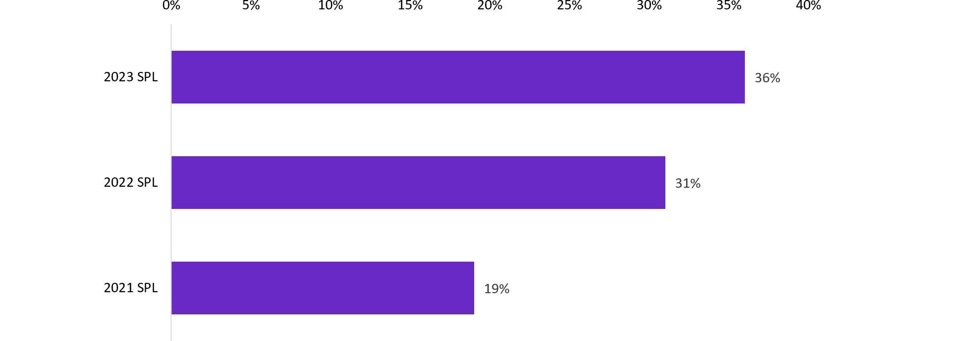

|  |  |
| --- | --- |
| Release | Occupations in shortage |
| 2021 SPL | 19% |
| 2022 SPL | 31% |
| 2023 SPL | 36% |

Source: National Skills Commission, Skill Priority List 2021 and 2022; Jobs and Skills Australia, Skills Priority List 2023  
Note: the number of occupations assessed has changed for each SPL. This reflects both changes in the ANZSCO framework and the inclusion of skills shortage assessments for 'not elsewhere classified' (nec) occupations in both the 2022 and 2023 SPL assessments.

A significant percentage of occupations assessed were found to be in shortage in both 2022 and 2023 – 29% (266 out of 916). Of these:

* 47% were Professionals occupations mostly related to health, engineering, information communication technology (ICT) and science
* 33% were occupations within various Technician and Trade Workers.

Around 61% of occupations assessed (561 out of 916) were rated as no shortage in both 2022 and 2023.

### Occupations in shortage comprise a large share of the workforce

The implications of skill shortages across the Australian labour market can be seen by analysing the top 20 largest employing occupations that were in shortage (Table 4). These are a diverse range of occupations across a range of sectors, including health, aged care, education, construction and food services.

Aged and Disabled Carer was the largest employing occupation found to be in shortage, followed by Retail Manager (General), Primary School Teacher, and Secondary School Teacher. Based on 2021 Australian Bureau of Statistics (ABS) Census data, these 4 occupations made up 8% of all people employed in occupations within the scope of the SPL, while the top 20 represented 22% of all people employed in occupations within the scope of the SPL. Given their relatively large share of employment, addressing the skill shortages among these occupations is important, particularly given the roles they play as inputs into various sectors of the economy and delivery of services.

Three larger employing occupations which are newly in shortage in the 2023 SPL are Sales and Marketing Manager, Waiter and Solicitor. Employers for these occupations reported difficulty in filling advertised vacancies and attracted few applicants they considered to be suitable.

Table 4: Top 20 largest employing occupations in shortage, 2023 SPL

| **ANZSCO** | ****ANZSCO description**** | ****Shortage description**** | ****Male proportion (2021)**** | ****Female proportion (2021)**** | ****Employment size, persons (2021)**** |
| --- | --- | --- | --- | --- | --- |
| 423111 | Aged or Disabled Carer | Shortage since 2021 | 23.3% | 76.7% | 227,500 |
| 142111 | Retail Manager (General) | Shortage since 2022 | 49.8% | 50.2% | 183,500 |
| 241213 | Primary School Teacher | Shortage since 2022 | 14.9% | 85.1% | 164,900 |
| 241411 | Secondary School Teacher | Shortage since 2022 | 37.8% | 62.2% | 155,900 |
| 733111 | Truck Driver (General) | Shortage since 2022 | 95.6% | 4.4% | 148,400 |
| 341111 | Electrician (General) | Shortage since 2021 | 97.9% | 2.1% | 128,300 |
| 421111 | Child Care Worker | Shortage since 2021 | 3.2% | 96.8% | 123,800 |
| 131112 | Sales and Marketing Manager | New shortage in 2023 | 58.3% | 41.7% | 119,700 |
| 331212 | Carpenter | Shortage since 2021 | 99.0% | 1.0% | 104,900 |
| 351311 | Chef | Shortage since 2021 | 72.8% | 27.2% | 90,500 |
| 431511 | Waiter | New shortage in 2023 | 25.6% | 74.4% | 86,900 |
| 321211 | Motor Mechanic (General) | Shortage since 2021 | 98.1% | 1.9% | 79,300 |
| 271311 | Solicitor | New shortage in 2023 | 45.7% | 54.3% | 69,700 |
| 323211 | Fitter (General) | Shortage since 2021 | 97.9% | 2.1% | 68,500 |
| 133111 | Construction Project Manager | Shortage since 2021 | 86.0% | 14.0% | 64,900 |
| 225113 | Marketing Specialist | Shortage since 2022 | 37.4% | 62.6% | 64,500 |
| 261313 | Software Engineer | Shortage since 2021 | 84.4% | 15.6% | 54,300 |
| 391111 | Hairdresser | Shortage since 2021 | 16.2% | 83.8% | 53,600 |
| 253111 | General Practitioner | Shortage since 2021 | 52.3% | 47.7% | 48,700 |
| 133112 | Project Builder | Shortage since 2021 | 95.2% | 4.8% | 47,800 |
| ****Total**** |  |  |  |  | **2,085,600** |

Source: Jobs and Skills Australia, Skills Priority List 2023. Employment size and gender share are from the ABS Census 2021 (the most recent data available at the 6-digit occupation level)  
Note: the number of occupations assessed has changed for each SPL. This reflects both changes in the ANZSCO framework and the inclusion of skills shortage assessments for 'not elsewhere classified' (nec) occupations in both the 2022 and 2023 SPL assessments.

The top 20 occupations in demand in 2023 for each state and territory are outlined in Appendix C.

### Occupations with a gender imbalance were more likely to be in shortage

Analysis of the 2023 SPL outcomes show that occupations that have a strong gender imbalance were more likely to be in shortage (Figure 10Figure 9). Some 54% of occupations where males make up at least 80% of the workforce were found to be in shortage. These disproportionately male occupations were concentrated in Machinery Operators and Drivers, Labourers, and Technicians and Trade Workers groups. Further, 40% of occupations where females make up at least 80% of the workforce were found to be in shortage. These were concentrated in health sector occupations such as Registered Nurses, and other early education and care-based occupations within Community and Personal Service Workers.

Of the top 20 largest occupations in shortage (Table 4):

* around a third of people employed were in 8 predominantly male occupations, including Carpenter (99% were men), Motor Mechanic (General) (98%), Fitter (General) (98%) and Electrician (General) (98%)
* around 16% of people were employed in 3 predominantly female occupations, including Primary School Teacher (85%), Child Care Worker (97%), and Hairdresser (84%). It is worth noting that the largest occupation in shortage, Aged and Disabled Carer, has over three-quarters of workers who are women, which falls just outside the 80% threshold used in the analysis in Figure 10.

Figure 10: Share of occupations in shortage in the 2021, 2022 and 2023 SPLs, by gender imbalanced occupations

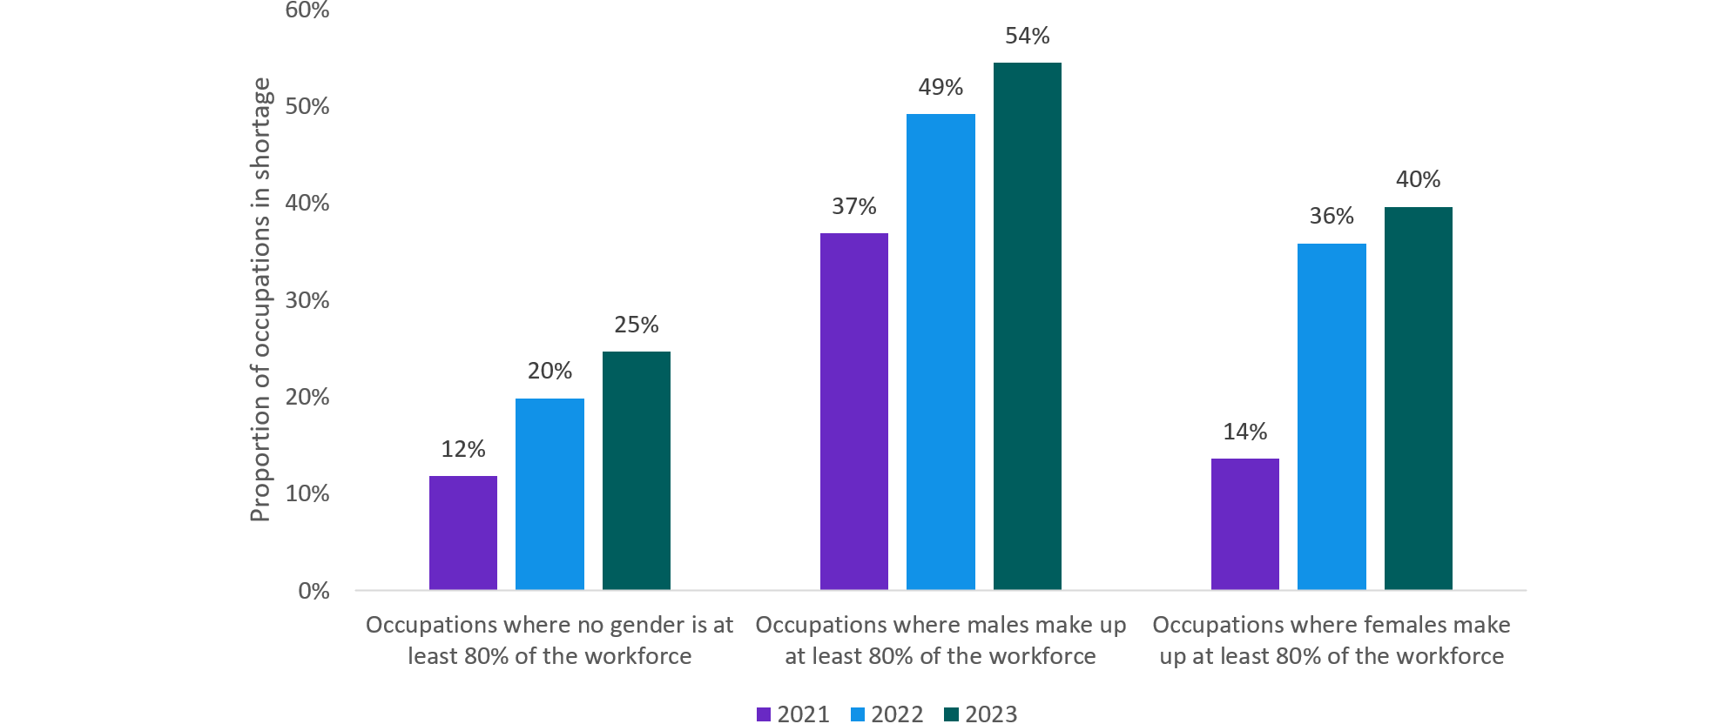

|  |  |  |  |
| --- | --- | --- | --- |
|  | 2021 | 2022 | 2023 |
| Occupations where no gender is at least 80% of the workforce | 12% | 20% | 25% |
| Occupations where males make up at least 80% of the workforce | 37% | 49% | 54% |
| Occupations where females make up at least 80% of the workforce | 14% | 36% | 40% |

Source: National Skills Commission, Skill Priority List 2021 and 2022; Jobs and Skills Australia, Skills Priority List 2023  
Note: the number of occupations assessed has changed for each SPL. This reflects both changes in the ANZSCO framework and the inclusion of skills shortage assessments for 'not elsewhere classified' (nec) occupations in both the 2022 and 2023 SPL assessments.

While there are likely to be other factors in play, a heavily gender skewed workforce may constrain labour supply, increasing the likelihood of a skills shortage. Improving the gender balance of occupations may be a way to address skill shortages in areas of the labour market (Box 5). Professor Jeff Borland from the University of Melbourne states that occupational segregation is entrenched, and to reduce this segregation will require action to remove barriers that currently exist to keep segregation in place: in education and training and in practices and cultures in the workplace (Borland, 2022).

|  |
| --- |
| Box 5: Gender imbalances across the national skills system  With gender imbalance a feature of occupations in shortage, a view of the national skills system from a gender lens indicates that gender imbalance is a shared characteristic across the national skills system and labour market.  VET and higher education pathways into occupations in shortage exhibit significant gender imbalances. For example:   * 96% of people who completed a Certificate III in Early Childhood Education and Care in 2022 were female * 98% of people who completed a Certificate III in Carpentry in 2022 were male * 84% of people whose highest qualification in 2021 was in the Teacher Education (Primary) field of education were female * 73% of people whose highest qualification in 2021 was in the computer science field of education were male (ABS, 2022d; NCVER, 2022a).   Gender imbalance is also observed across employer sponsored visas, with skilled migration reflecting similar predominant trends to the resident population.  This suggests that more will need to be done across all pillars of the national skills system to better understand the barriers that lead to gendered outcomes across training and education pathways and in occupations, industries and workplaces – from gender norms, perceptions and culture, to access and participation issues. It will also be important to monitor national skills system initiatives, like the Women in STEM Cadetships and Advanced Apprenticeships Program which aim to increase access to, and participation of, women in a Science, Technology, Engineering and Mathematics (STEM) field, for the effectiveness in removing barriers to gender equity. |

### Shortages were pronounced in Professionals, particularly Health Professionals

Almost half (or 48%) of the occupations within the Professionals major occupation group were in shortage in 2023 (up from 39% in 2022), largely comprised of shortages in Health Professionals and ICT Professionals. Over 80% of Health Professional occupations were in shortage, while almost 70% of ICT Professionals were in shortage (Figure 11). Common to all of the Professionals occupations in shortage is their requirement for high levels of skills, qualifications and experience. This is evidenced by employer survey data indicating a lack of specific skills or experience being among the most common reason applicants were found unsuitable.

Figure 11: Professionals: proportion of sub-group in shortage (%), 2023 SPL

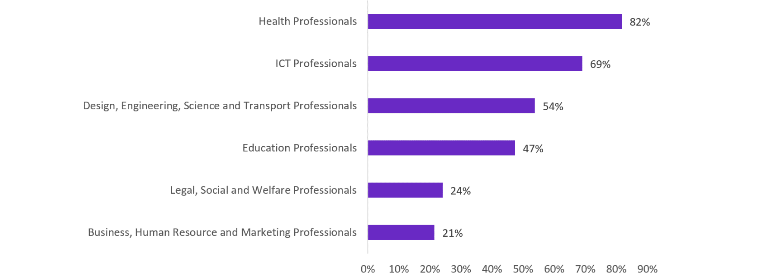

|  |  |
| --- | --- |
| Business, Human Resource and Marketing Professionals | 21% |
| Legal, Social and Welfare Professionals | 24% |
| Education Professionals | 47% |
| Design, Engineering, Science and Transport Professionals | 54% |
| ICT Professionals | 69% |
| Health Professionals | 82% |

Source: Jobs and Skills Australia, Skills Priority List, 2023

The Survey of Employers who Recently Advertised also revealed that only 44% of Professional vacancies in the health sector were filled in 2022–23, despite employers finding an average of 1.3 suitable applicants per vacancy (Figure 12). One of the main reasons for this was due to applicants finding alternative work in the same occupation, providing further evidence of intensifying competition among employers for experienced and qualified workers.

Figure 12: Health Professionals: proportion of vacancies filled (%) and suitable applicants per vacancy (number), 2021 to 2023

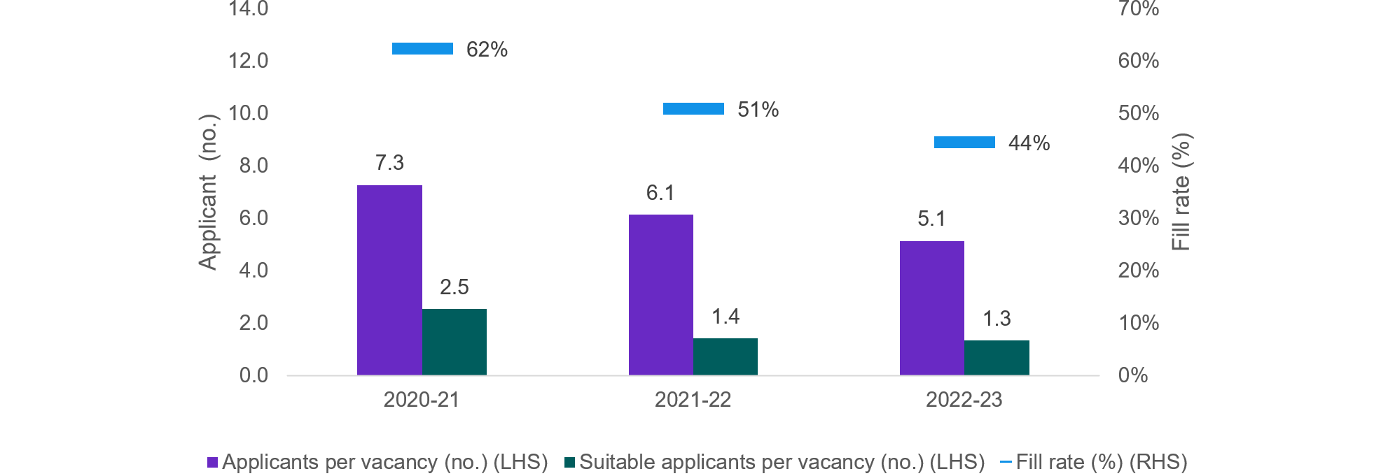

|  |  |  |  |
| --- | --- | --- | --- |
|  | Fill rate (%) (RHS) | Applicants per vacancy (no.) (LHS) | Suitable applicants per vacancy (no.) (LHS) |
| 2020-21 | 62% | 7.3 | 2.5 |
| 2021-22 | 51% | 6.1 | 1.4 |
| 2022-23 | 44% | 5.1 | 1.3 |

Source: Jobs and Skills Australia, Survey of Employers who Recently Advertised (SERA), 2020–2023

### Shortages for Community and Personal Service Workers

The shortage of Community and Personal Services Worker occupations rose to 24% in 2023, from the 20% observed in 2022. As with the Health Professionals category, shortages for Community and Personal Service Workers in the health, care and support sectors are considerable (Figure 13).

There are some occupations within this major group in persistent shortage, such as Aged and Disabled Carers, Personal Care Assistants and Child Care Workers. All of these have been in shortage across all 3 SPLs from 2021 to 2023.

With Australia’s ageing population and the likelihood that many core care-related tasks will not be automated in the foreseeable future, the demand for health and care workers is projected to increase into the future. Further, low staff retention stemming from poor working conditions could be a factor driving skill shortages in the sector (CEDA, 2021b; NSC, 2021a).

Figure 13: Community and Personal Service Workers: proportion of sub-group in shortage (%)

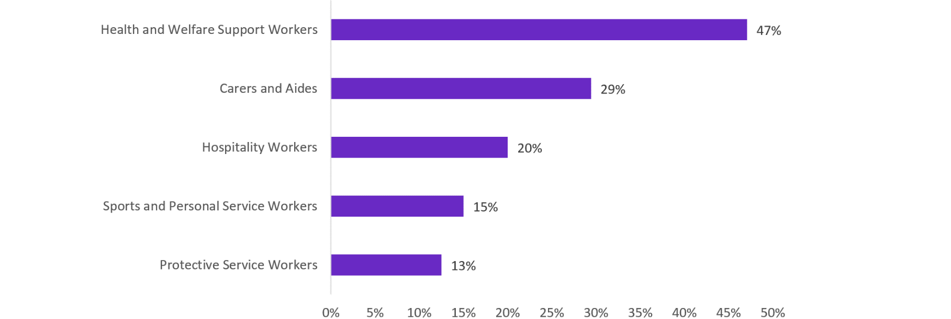

|  |  |
| --- | --- |
| Protective Service Workers | 13% |
| Sports and Personal Service Workers | 15% |
| Hospitality Workers | 20% |
| Carers and Aides | 29% |
| Health and Welfare Support Workers | 47% |

Source: Jobs and Skills Australia, Skills Priority List, 2023

### Shortages were most common for Technicians and Trades Workers

Shortages were most common for Technicians and Trades Workers, with 50% of occupations in this group assessed as being in national shortage. This group was also a key feature of shortages in the 2021 and 2022 SPLs. As with the Professionals group, there were large differences in the sub-categories of this broad occupation group. All occupations in the Construction Trades Workers and Food Trades Workers groups were found to be in national shortage (Figure 14Figure 13).

Figure 14: Technician and Trades Workers: proportion of sub-group in shortage (%)

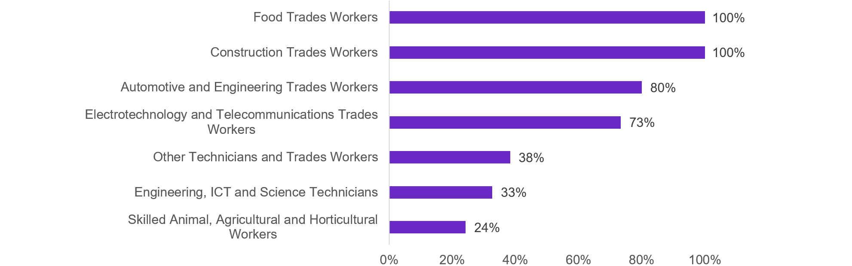

|  |  |
| --- | --- |
| Skilled Animal, Agricultural and Horticultural Workers | 24% |
| Engineering, ICT and Science Technicians | 33% |
| Other Technicians and Trades Workers | 38% |
| Electrotechnology and Telecommunications Trades Workers | 73% |
| Automotive and Engineering Trades Workers | 80% |
| Construction Trades Workers | 100% |
| Food Trades Workers | 100% |

Source: Jobs and Skills Australia, Skills Priority List, 2023

Shortages are also apparent across other trades outside the construction sector. All 5 of the largest employing non-construction trade occupations were in shortage. These include Chef, Motor Mechanic (General), Fitter (General), Hairdresser and Metal Fabricator.

### Regional skill shortages

Even if an occupation is not in shortage nationally, in specific locations the picture can be very different, particularly in remote and regional areas. While labour supply nationally might be enough to satisfy demand, not all potential employees are able or willing to move to areas where there may be employment opportunities. Although there has been an increase in remote work in recent years, this is not an option for many occupations for which location is likely to remain a barrier for the foreseeable future.

In recent times, skill shortages have been particularly acute in regional areas (see Jobs and Skills Australia, Quarterly Labour Market Updates (JSA, 2023d; JSA, 2023e). Recruitment difficulty in regional areas remain particularly acute in high skilled occupations like General Practitioners, engineers and nurses but childcare issues are another key issue, with so many ‘childcare deserts’ (Hurley, Matthews, & Pennicuik, 2022) in regional Australia. If we are going to attract enough professionals to work in regional areas, childcare support for working parents will be a key factor.

The share of employers reporting location as a reason for recruitment difficulties increases with remoteness. In Very Remote areas, more than 80% of employers believed the reason they did not receive many applicants was because of the job location and over 40% of employers had a suitable applicant not take a job offer because of the location (Figure 15).

Figure 15: Location as a reason for receiving few applicants or for a vacancy remaining unfilled, remoteness areas, 2023

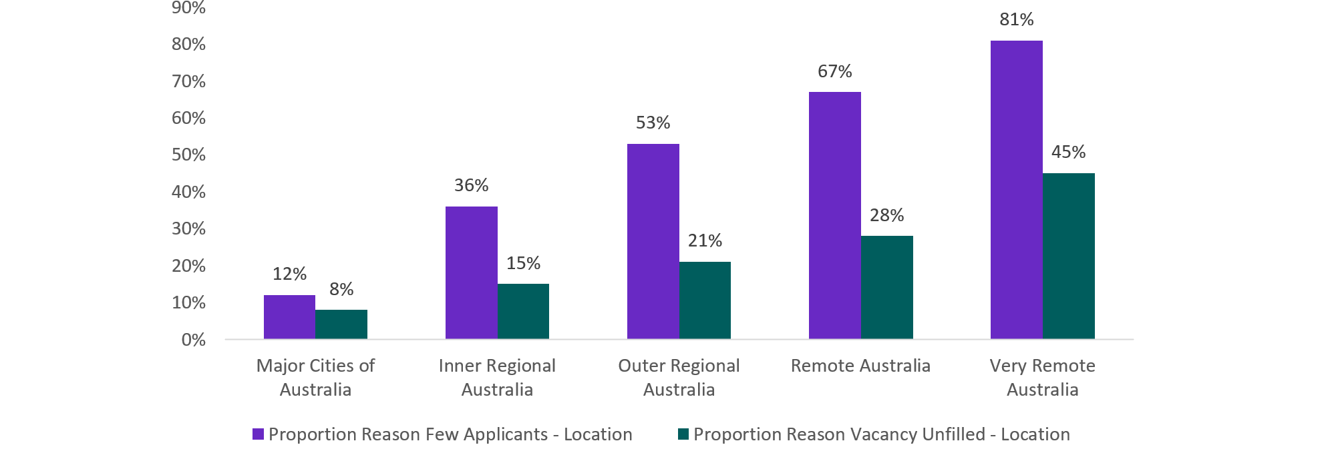

|  |  |  |
| --- | --- | --- |
| Remoteness | Proportion Reason Few Applicants - Location | Proportion Reason Vacancy Unfilled - Location |
| Major Cities of Australia | 12% | 8% |
| Inner Regional Australia | 36% | 15% |
| Outer Regional Australia | 53% | 21% |
| Remote Australia | 67% | 28% |
| Very Remote Australia | 81% | 45% |

Source: Jobs and Skills Australia analysis of SERA data, 2023

This poses an additional challenge in addressing skills shortages for states and territories with large remote and regional areas such as the Northern Territory and Western Australia. In the Northern Territory, 55% of employers who had few applicants and 25% of employers with an unfilled vacancy listed location as the reason. In Western Australia, these figures were 36% and 20% respectively.

### Most persistent shortages

Persistent shortages across major occupation groups have been prevalent in Professionals and Technicians and Trade Workers (ANZSCO major groups 2 and 3) over the last 3 years (Table 5). Such shortages are multifaceted and the reasons for them are complex. These may include the impact of structural trends across the labour market, availability of qualified workers, apprenticeship pathways and completions, remuneration and workplace conditions, and employer expectations and perceptions, including in relation to diversity and gender.

Table 5: Persistent shortage since 2021 in ANZSCO major groups

|  |  |  |  |
| --- | --- | --- | --- |
| **Major group** | Description | Occupations in persistent shortage | Percentage of major group |
| 1 | Managers | 3 | 3% |
| 2 | Professionals | 55 | 17% |
| 3 | Technicians and Trades Workers | 67 | 33% |
| 4 | Community and Personal Service Workers | 5 | 6% |
| 7 | Machinery Operators and Drivers | 8 | 10% |

Source: National Skills Commission, Skill Priority List 2021 and 2022; Jobs and Skills Australia, Skills Priority List, 2021–2023  
Note: the number of occupations assessed has changed for each SPL. This reflects both changes in the ANZSCO framework and the inclusion of skills shortage assessments for 'not elsewhere classified' (nec) occupations in both the 2022 and 2023 SPL assessments.

All 5 of the largest employing non-construction trade occupations – Chef, Motor Mechanic (General), Fitter (General), Hairdresser and Metal Fabricator – were in shortage, either nationally or regionally, on the SPL across 2021, 2022 and 2023. Moreover, skills shortage analysis which preceded the Skills Priority List indicates that Motor Mechanic (General) and Hairdresser were in shortage in the last 10 years to 2023.

## The types of skills shortages

There are many possible causes of skills shortages. A clearer understanding of the factors driving shortages is necessary to target strategies needed by employers, job seekers and governments to address them.

In a paper for the National Centre for Vocational Education Research (NCVER), Professor Sue Richardson suggested a scheme for classifying skills shortages (Richardson, 2007):

* Level 1 shortage – shortage of people who have the essential technical skills who are not already using them and a long training time to develop the skills
* Level 2 shortage – shortage of people who have the essential technical skills who are not already using them and a short training time to develop the skills
* Quality gap – there are sufficient people with the essential technical skills who are not already using them and who are willing to apply for the vacancies, but they lack some qualities that employers consider are important
* Skills mismatch – there are sufficient people who have the essential technical skills who are not already using them, but they are not willing to apply for the vacancies under current conditions.

Jobs and Skills Australia has adapted this framework to develop a typology we use empirically with data about Australia's skills shortages (Box 6). This typology has 4 categories that are similar to Professor Richardson's 4 categories. They are:

* Longer training gap – there are fewer than average qualified applicants per vacancy with above average qualification requirements (apprenticeship, Certificate IV or above in the AQF)
* Shorter training gap – there are fewer than average qualified applicants per vacancy with below average qualifications requirements (Certificate III or below)
* Suitability gap – there are above average qualified applicants per job, but a low proportion of suitable applicants compared with the number of qualified applicants
* Retention gap – there is above average job mobility (employees leaving these jobs).

|  |  |  |  |  |  |  |  |  |  |  |
| --- | --- | --- | --- | --- | --- | --- | --- | --- | --- | --- |
| Box 6: Classifying skills shortages  A range of available data sources are used to identify different elements and interactions to categorise occupations to the skills shortages typology. The data sources include:   * Average number of applicants per vacancy (from the Survey of Employers who Recently Advertised (SERA)) * Suitability of applicants (SERA) * Job mobility (available from the annual ABS Job Mobility survey at the 3-digit ANZSCO level) * Level of education and training required for an occupation (based on ANZSCO skill levels) * Employment level (ABS Labour Force Survey).   Each data source contributes to the understanding of the types of shortage in different ways. Different weights have been applied to the data inputs to classify each occupation to a type of shortage.   |  |  | | --- | --- | | **Type of shortage** | **Occupation characterised by** | | Longer training gap | average or below average job mobility  fewer than average qualified applicants per vacancy  above average requirement for a qualification (apprenticeship, Certificate IV or above) | | Shorter training gap | average or below average job mobility  fewer than average qualified applicants per vacancy  below average requirement for a qualification (Certificate III or below) | | Suitability gap | average or below average job mobility  above average number of qualified applicants per vacancy  a low proportion of suitable applicants compared with the number of qualified applicants | | Retention gap | above average job mobility |   Some occupations require further data and analysis before they can be adequately categorised. |

This work is intended to highlight the importance of ensuring policy responses to skills shortages are tailored to address the specific drivers of a shortage. These findings are preliminary and work to further develop the methodology to classify skill shortages is ongoing.

These definitions are mutually exclusive. However, it needs to be noted that not all shortage occupations fit neatly in one category or another, and for some occupations assigned to one category, they may have some issues in common with occupations in other categories.

For all categories, conventional economics suggest that increasing wages is one lever that employers can pull to attract more workers. How successful that will be depends on the 'elasticity of supply of labour' which is contingent partly on how many people have the skills required.

The existence of extensive persistent skill shortages in our labour market implies that it is one in which wage adjustments of this kind are not solving the problem. This could be that for some reason, wage adjustments are not being used as much as they could be, or that there are wider issues at stake.

Indeed, Jobs and Skills Australia's Survey of Employer Recruitment Activity found that over the 3 years from 2021 to 2023, few employers changed remuneration in response to skill shortages. In the 2023 SPL period, around 1% of employers adjusted remuneration to attract skilled workers to fill vacancies. While this is surprisingly low, it was up significantly on the 2022 result when 0.4% of employers adjusted remuneration for this purpose.

### Classifying Australia’s top 20 occupations in demand

Jobs and Skills Australia produces and regularly updates a list of the top 20 occupations in demand.[5] The list is based on the occupations determined to be in shortage from the 2023 Skills Priority List. Of the occupations determined to be in shortage, occupations are then sorted by whether they have significant vacancies, have a large number of employees, are persistently in shortage and demonstrate a reasonable level of future demand. These top 20 occupations have then been categorised using the skills shortage typology (Table 6).

### The drivers of shortages

In addition to categorising skills shortages, analysis was undertaken to identify the potential reasons occupations can be in shortage. The reasons could include: a general lack of applicants; a lack of people obtaining the relevant qualifications (training gap); a lack of experienced applicants and/or a pool of applicants who do not have the broad skills requirements set by the employer (suitability gap); the location of work; and undesirable working conditions or pay scales (retention gap). Some of these are discussed in the next sections.

Table 6: Top 20 occupations in demand by shortage type, 2023

|  |  |
| --- | --- |
| **Classification of skills shortage** | ****Top 20 occupations in demand**** |
| Longer training gap  Few qualified applicants per vacancy, bachelor degree, Certificate IV or apprenticeship required | Early Childhood (Pre-primary School) Teachers  Occupational Therapists  Physiotherapists  Registered Nurses  Solicitors  Social Workers  Metal Fitters and Machinists  Electricians |
| Shorter training gap  Few qualified applicants per vacancy, Certificate I to III or less required | Retail Managers |
| ****Suitability gap****  Many qualified applicants per vacancy, but few suitable applicants per qualified applicant | Advertising, Public Relations and Sales Managers  Construction Managers  Advertising and Marketing Professionals  Civil Engineering Professionals |
| ****Retention gap****  Above average job mobility (below average rates of retention), potentially reinforced by low number of total new applicants per vacancy | Human Resource Professionals  Chefs  Child Carers  Aged and Disabled Carers |

Source: Jobs and Skills Australia, Skills Priority List, 2023  
Note: There are 3 occupations in the top 20 occupations in demand – General Practitioners and Resident Medical Officers, Software and Applications Programmers, and Motor Mechanics – which are yet to be categorised. Additional analysis required as they may fall in more than one skills shortage category.

#### The training gap (longer and shorter training gap shortages)

Occupations may be in shortage due to a lack of qualified applicants. These shortages can be partially addressed by employers by increasing employee retention, but solutions will largely come from policy and educational providers.

Occupations where shortage pressures may be caused by a training gap include: Early Childhood (Pre-primary School) Teacher; Occupational Therapist; Physiotherapist; Registered Nurse; Solicitors; Social Worker; Metal Fitters and Machinists; Electricians.

While some occupations require a qualification due to knowledge or licensing requirements, others can be more flexible and use on-the-job training as a replacement for formal qualifications. Over the past 3 calendar years, there has been a fall in the proportion of employers requiring applicants to have qualifications, a possible reflection of the tight labour market (Figure 16). However, there has been a rise in the proportion of employers who cite a lack of qualifications as a reason for finding an applicant unsuitable. The trends in these 2 results are somewhat contradictory and may indicate that while employers say they are willing to compromise on qualification requirements, when it comes to assessing applicants, it becomes clear that qualifications remain an essential factor in their hiring decisions.

Figure 16: Proportion of employers requiring qualifications and employers who cite a lack of qualifications

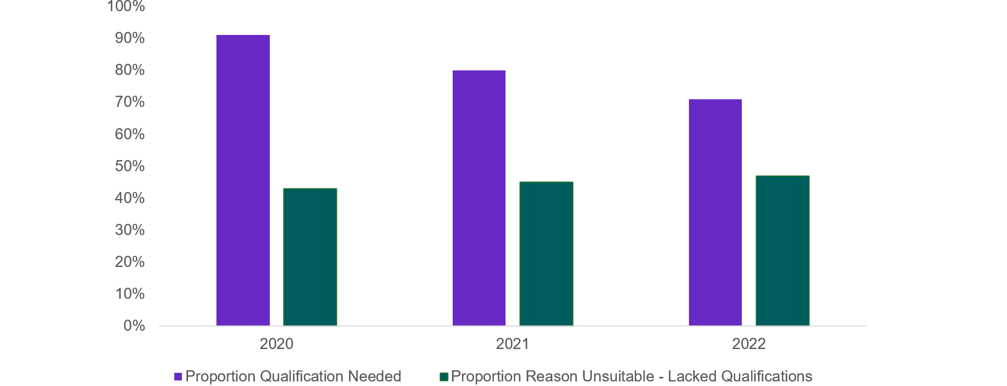

|  |  |  |
| --- | --- | --- |
| Calendar Year | Proportion Qualification Needed | Proportion Reason Unsuitable - Lacked Qualifications |
| 2020 | 0.91 | 0.43 |
| 2021 | 0.8 | 0.45 |
| 2022 | 0.71 | 0.47 |

Source: Jobs and Skills Australia analysis of SERA data 2020–2022

#### The suitability gap

Even if an applicant possesses the requisite qualifications an employer may still deem them to be unsuitable for the job. They may still lack the skills or the experience that the employer has deemed necessary. Using data from the SERA, the suitability gap may be the reason for shortage for occupations for which the number of qualified applicants is high but suitable applicants is low. This may point to an issue in the training programs (both VET and higher education) for these occupations in that they do not adequately prepare individuals for entry into the workforce, or employers have unrealistic expectations of graduates.

Occupations where shortage pressures may be caused by a suitability gap include: Advertising, Public Relations and Sales Manager; Construction Manager; Advertising and Marketing Professional; and Civil Engineering Professional.

Labour market conditions can have an impact on the suitability gap. Over the past 3 years, there has been a fall in the share of employers identifying a lack of specific skills as a reason for unsuitability alongside a fall in the average number of years of experience required to fill vacancies. Due to recent labour market tightness, employers may be more willing to look for basic skills and then train employees on the job (Figure 17).

Figure 17: Proportion of employers identifying lack of specific skills as reason for unsuitability and average number of years of experience sought

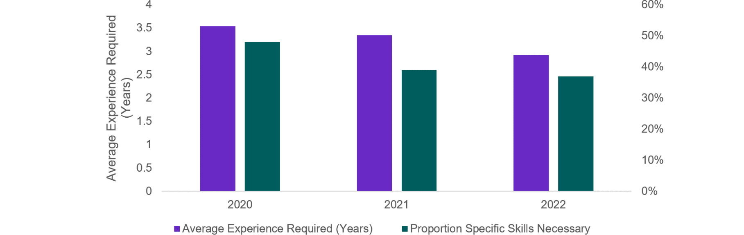

|  |  |  |
| --- | --- | --- |
| Calendar Year | Average Experience Required (Years) | Proportion Specific Skills Necessary |
| 2020 | 3.54 | 48% |
| 2021 | 3.35 | 39% |
| 2022 | 2.92 | 37% |

Source: Jobs and Skills Australia analysis of SERA data 2020–2022

#### Retention gap

A retention gap occurs when there is a sufficient number of people with the requisite skills, qualifications and experience to fill vacancies in a given occupation, but they are unwilling to accept offers from employers under the current conditions. Using data from the ABS Job Mobility survey and the SERA, these are the occupations with a higher-than-average job mobility, potentially reinforced by low numbers of new applicants per vacancy.

Occupations where shortage pressures may be caused by a retention gap include: Human Resource Professional; Chef; Child Carer; and Aged and Disabled Carer.

Recent analysis by both Jobs and Skills Australia and the Reserve Bank of Australia highlights that wage adjustments are rarely used by employers as a short-term response to skills shortages.

The Reserve Bank of Australia has noted that firms facing skills shortages have responded by means other than increasing wages such as hiring less-skilled workers, increasing training for existing staff, and increasing automation (Leal, 2019). Increasing wages is one of many strategies firms use to address skills shortages. However, such strategies are generally chosen only after a range of other responses (Figure 18). There may be limited scope for the education and training system to provide solutions to these types of skills shortages. Rather, employers could consider making pay and other working conditions more attractive to current and prospective employees.

Further analysis of wage growth over a longer time horizon may shed light on whether wage adjustments are being used as much as they could be, particularly for occupations that have been in persistent shortage.

Figure 18: Employer responses to unfilled vacancies (share of employers with unfilled vacancies)

|  |  |
| --- | --- |
|  | 2023 SPL |
| Change the working conditions of the position | 1% |
| Give up/put position on hold due to COVID 19 | 1% |
| Change remuneration | 1% |
| Turn down work or cancel existing work | 1% |
| Don't know | 3% |
| Other | 3% |
| Change job advertisement | 3% |
| Change position requirements | 4% |
| Give up on filling the position | 6% |
| Restructure the organisation | 6% |
| Advertise in different sites/areas | 17% |
| Seek candidates other than through advertising | 26% |
| Keep advertising/Readvertise | 73% |

Source: Jobs and Skills Australia, SERA, 2023

## Responding to skills shortages

The responses or levers for each type of shortage depend on the drivers and classification of the skills shortage. Depending on the nature and significance of the shortage a combination of responses may be required (Figure 19).

For **longer training gap** shortages the emphasis should be on increasing the supply in priority VET and higher education qualifications (bachelor degree, Certificate IV or apprenticeships) either by a larger intake and/or higher completion rates, supported by collaboration with industry. Given that there is likely to be a significant time-lag in creating this throughput or supply, in the meantime other strategies would be required including upskilling people with relevant skills working in other occupations, attracting back people who have left the occupation, and exploring migration options.

For **shorter training gap** shortages, similarly, there is a need to lift supply or the throughput of qualified people either by higher completion rates and/or a larger intake in the VET sector (Certificate I to III in priority areas such as education, health and trades). Alternative strategies of upskilling people with the relevant skills, attracting back people who left the occupation, or exploring migration options, may also be required.

Forboth **longer training gap** and **shorter training gap** shortages the proportion of employers who cite a lack of qualifications as a reason for rejecting an applicant has remained steady and perhaps increased slightly. This is despite a fall in the proportion of employers requiring their applicants to have qualifications and a fall in qualified applicants per vacancy overall. This may indicate that those employers who do require qualifications are becoming more stringent in their assessments of qualifications, and/or employers are looking for broader employability skills.

Figure 19: Possible responses by skills shortage type

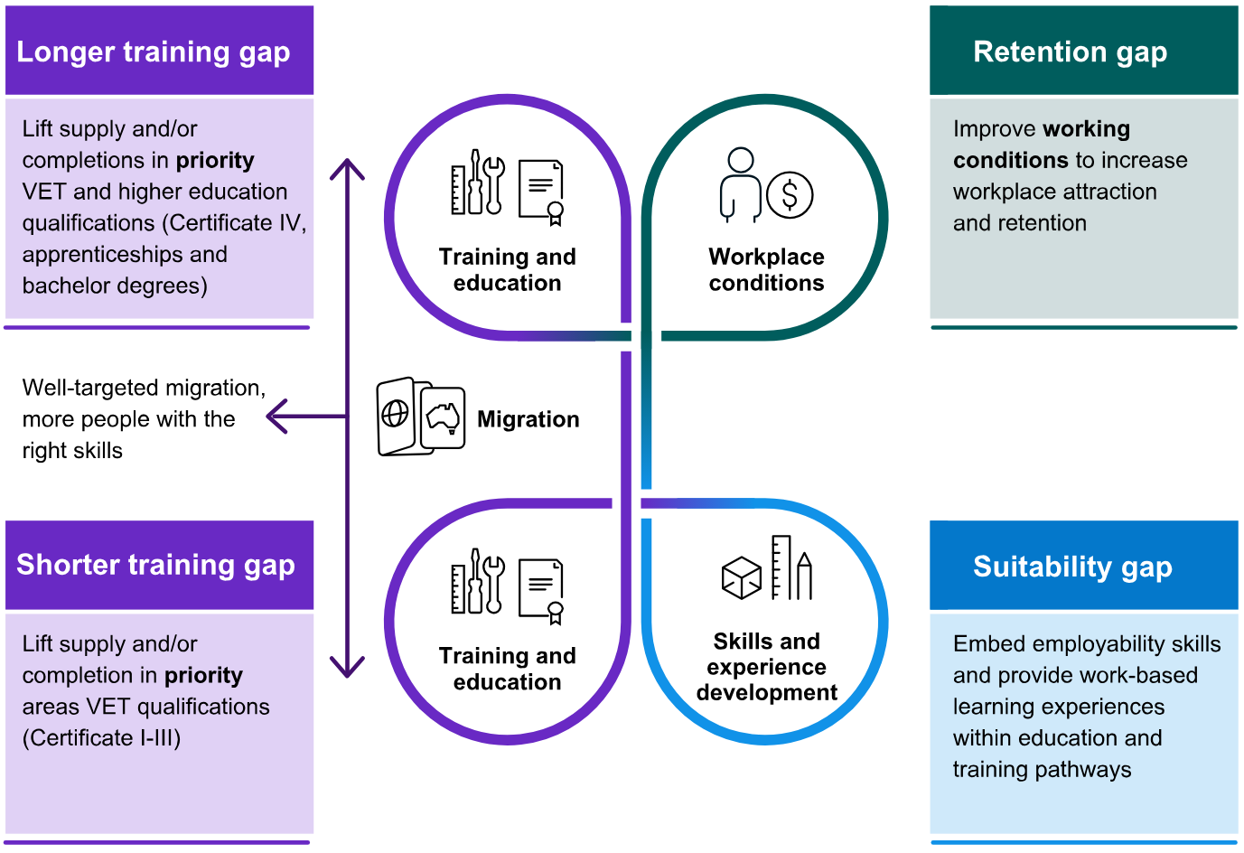

Source: Jobs and Skills Australia

Forshortages where there is a **suitability gap** simply increasing the throughput of qualified people is unlikely to be effective. The challenge is to enhance the attributes of qualified applicants through investing in their employability skills and their work experience. This would indicate that the training programs that feed into these occupations may not be adequately preparing prospective employees for entry into the workforce. The appropriate responses may include engagement with industry to improve VET and higher education course work to better reflect employer expectations or to incorporate more formal work-integrated learning, such as work placements or internships.

Forshortages where there is a **retention gap** there is limited value in lifting supply and throughput in the VET and higher education systems because of the low probability of retaining workers in the occupation. Rather, employers should consider improving the attractiveness of their job offer, for example, by changing remuneration and other workplace conditions to attract applicants, for it is likely that applicants are working in other occupations which can offer more amenable arrangements. The care and support sector challenge on this front is frequently discussed, but similar challenges exist for other areas such as for Machinery Operators and Drivers. If attention was paid to these aspects, then increasing the throughput of qualified people would be more likely to pay dividends. Exploring migration options may be another part of the strategy, especially in the short-term, but the longer-term solution would be to focus on improving workplace conditions.

This typology is a useful way to understand a complex set of dynamics in the labour market and there are ways to improve the approach to skills shortages assessments (Box 7). In reality, for some occupations it is likely that there are several factors leading to a shortage and elements from more than one of the categories outlined in this section may be at play. This means that responding to the shortage may require multiple strategies. For example, resolving a particular occupational shortage may involve increasing training places while in the short-term migration options may need to be explored, combined with higher wages to attract more workers to the roles.

|  |
| --- |
| Box 7: What we’ve heard about skill shortages  Stakeholders have generally agreed that it is important to better understand the factors driving skill shortages. To continue to improve our understanding of the range of factors, stakeholders have suggested further work on:   * greater clarity on the difference between skills shortages and labour shortages, and assessment of the supply gap to inform workforce planning and decision making * how shortages change over time and the underlying variation in the drivers across industries and regions * assessment of the relative importance of different factors where there are multiple drivers * analysis and evaluation of best practice strategies to understand the most effective strategies, or combination of strategies, to address shortages.   These are areas that Jobs and Skills Australia will consider as it continues to deepen and enhance the approach to skills shortage analysis to better inform workforce planning and advice into policy processes. |

## Conclusions

The impact of the trends shaping the economy and labour market is resulting in persistent skills shortages, particularly in Technicians and Trades Workers and Professional occupations, with these shortages being more pronounced in regional and remote areas. Further, occupations with a strong gender imbalance are more likely to be in shortage.

Employers are responding by shifting how they advertise for vacancies, restructuring their organisations, using migration programs and, often as a last resort, raising wages.

The underlying drivers of these shortages may point to the level and quality of qualifications of workers, pay and working conditions, and employer perceptions relating to diversity and gender. Further work needs to be undertaken to unpack the multifaceted drivers of these shortages.

The responses to these shortages also depend on the drivers of shortages and span the national skills system across VET, higher education, migration and broader labour market conditions. This underscores the need for a holistic approach and a systems-wide view to address skills shortages – supported by engagement with industry and the states and territories.



# Employment projections for the decade ahead



|  |
| --- |
| Key themes in this chapter  Employment projections over the next decade indicate a continued shift towards employment in the services industries with the largest projected growth, in terms of persons employed, led by Health Care and Social Assistance, Professional, Scientific and Technical Services, and Education and Training.  Employment in occupations with VET and higher education pathways is expected to grow strongly over the next decade.  The largest increases in employment in terms of number of persons are expected to be in Victoria, followed by NSW and Queensland, with Victoria also showing the largest growth in percentage terms, closely followed by the ACT.  There are similarities between the trends identified in employment projections, the current skills needs and the trends shaping the economy.  It will be important to work with partners across jurisdictions and sectors to enhance the employment projections over time and make them more accessible to better inform workforce planning and decision-making, especially in VET and higher education. |



## Approach to the employment projections

Employment projections are important to understand how the current expected economic and labour market outlook is impacting Australia’s future workforce needs. Projections can be used to inform decision making and planning across the national skills system. That said, any forecasts are based on assumptions and are inherently uncertain. They are useful to demonstrate how current trends could be expected to play out rather than precise predictions of the future.

Jobs and Skills Australia has worked with Victoria University to produce employment projections to 2033, using their Victoria University Employment Forecasting Model (VUEF) model which is underpinned by a computable general equilibrium (CGE) model.

Such CGE models are large numerical models that combine real world economic data with economic theory to computationally derive estimates of how an economy may develop based on assumptions about factors including demographic change, productivity growth, the world economy, investment, changes in tastes and production methods, and educational attainment.

The modelling produces forecasts of the likely paths for employment by industry and occupation, with the method taking into account both demand for labour and supply of labour. Key drivers of labour demand include household expenditure and tastes, investment, trade conditions, and changes in production processes. The key driver of labour supply is demographics, with younger cohorts more likely to have undertaken higher education. Older cohorts retiring from the labour force are more likely to have undertaken vocational education or no post-school education.

The data in CGE models typically come from national input-output tables, which contain detailed information about the supply and use of goods and services in the economy and the structure of and inter-relationships between industries. The data are fitted to a set of equations that ascribe behavioural rules to approximate the way firms, governments and households respond to change.

The projections outlined here have been calibrated to the macroeconomic and labour market outlook provided by the Australian Treasury. The forecasts in this chapter have been produced over a 10-year horizon. They are presented in the following section over a 5-year period to highlight the shorter-term trends, and over a 10-year horizon, to show the impact of longer-term or structural trends.

## The industry outlook over the next 5 and 10 years

Over the 5 years from May 2023 to May 2028, total employment is projected to increase by around 6.5% to stand at 14.8 million people. Over the 10-year horizon from May 2023 to May 2033, total employment is projected to increase by 14.2% to stand at 15.9 million people.

The long-term structural shift in employment towards services-related industries is projected to continue. The industries with the largest growth, in terms of the size of the employment increase by persons, are the same over both the 5 and 10-year horizon (Figure 20):

* Health Care and Social Assistance is projected to grow by 257,300 persons to 2028 and by 533,400 persons to 2033, with its share of total employment increasing from 15.2% in 2023 to 16.7% in 2033
* Professional, Scientific and Technical Services is projected to grow by 116,900 persons to 2028 and by 233,600 persons to 2033, with its share of total employment increasing from 9.4% in 2023 to 9.7% in 2033
* Education and Training is projected to grow by 81,600 persons to 2028 and 156,000 persons to 2033, with its share of total employment remaining broadly unchanged between 2023 and 2033 at over 8.3% of total employment.

Figure 20: Employment projections by industry, May 2023 to May 2033, persons

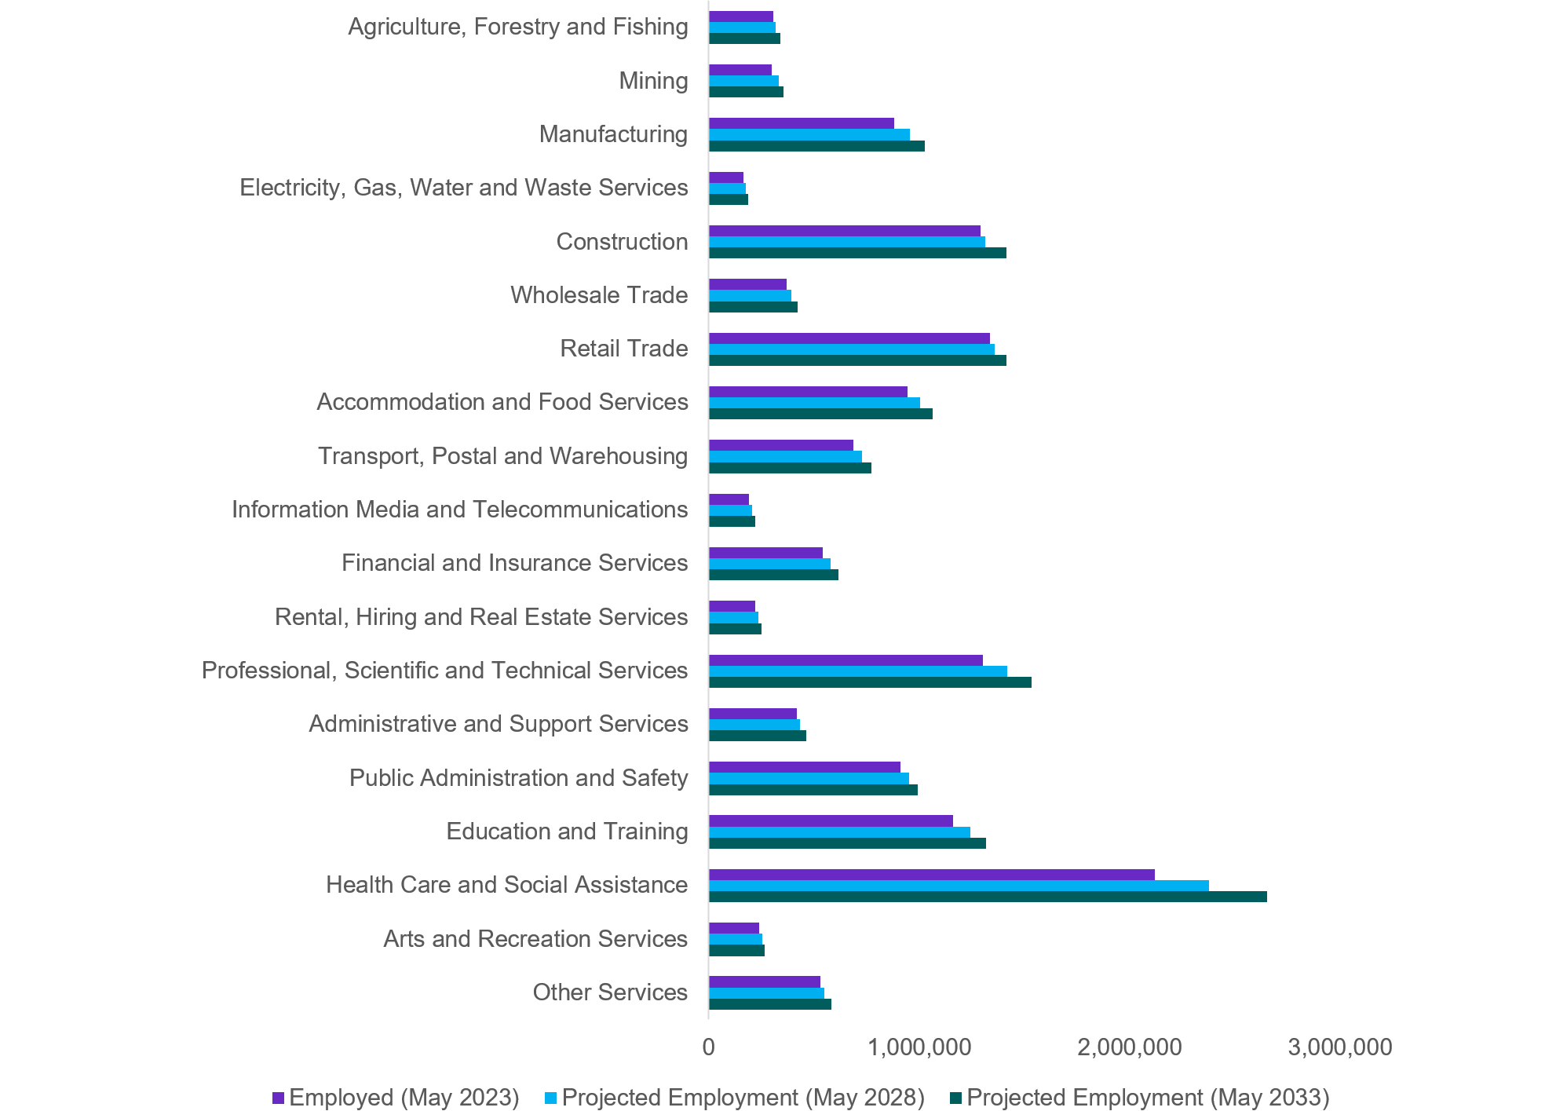

| Industry | Employed (May 2023) | Projected Employment (May 2028) | Projected Employment (May 2033) |
| --- | --- | --- | --- |
| Agriculture, Forestry and Fishing | 306031 | 319417 | 341,047 |
| Mining | 298107 | 333457 | 354,011 |
| Manufacturing | 880987 | 953883 | 1,024,618 |
| Electricity, Gas, Water and Waste Services | 164185 | 175740 | 187,411 |
| Construction | 1290865 | 1314356 | 1,413,457 |
| Wholesale Trade | 370027 | 392081 | 420,625 |
| Retail Trade | 1334493 | 1358921 | 1,415,921 |
| Accommodation and Food Services | 944967 | 1004405 | 1,063,107 |
| Transport, Postal and Warehousing | 688448 | 727375 | 771,173 |
| Information Media and Telecommunications | 191682 | 205936 | 220,924 |
| Financial and Insurance Services | 542373 | 577774 | 617,157 |
| Rental, Hiring and Real Estate Services | 219725 | 234778 | 251,273 |
| Professional, Scientific and Technical Services | 1301680 | 1418536 | 1,535,327 |
| Administrative and Support Services | 420108 | 434349 | 463,975 |
| Public Administration and Safety | 910590 | 953475 | 991,126 |
| Education and Training | 1162323 | 1243918 | 1,318,361 |
| Health Care and Social Assistance | 2117481 | 2374746 | 2,650,930 |
| Arts and Recreation Services | 240258 | 253512 | 266,872 |
| Other Services | 530549 | 548609 | 581,440 |

Source: Projections produced by Victoria University for Jobs and Skills Australia

In terms of growth by percentage increase over the next 10 years to 2033, the fastest growing industry is Health Care and Social Assistance (growing at 25.2%), followed by Mining (growing at 18.8%) reflecting investment in this area, and Professional, Scientific and Technical Services (growing at 17.9%).

For Manufacturing, after a long period of decline in its share of employment, the industry is expected to experience significant growth in employment with its share of total employment slightly increasing from 6.3% in 2023 to 6.4% in 2033. There has been an upswing in employment in the industry over the past 12 months.

The overall industry structure remains broadly unchanged over the next 10 years, with the largest change in Health Care and Social Assistance by share of employment (up by 1.5 percentage points), while Construction and Retail Trade decrease their respective shares of employment (by 0.4 percentage points and 0.7 percentage points respectively) (Table 7).

Table 7: Projected employment growth and share of employment by industry 10 years to May 2033

|  | Share of employment | | | Employment growth | |
| --- | --- | --- | --- | --- | --- |
| **Industry** | May 2023 (%) | May 2028 (%) | May 2033 (%) | 5-year (%) | 10-year (%) |
| **Agriculture, Forestry and Fishing** | 2.2% | 2.2% | 2.1% | 4.4% | 11.4% |
| **Mining** | 2.1% | 2.2% | 2.2% | 11.9% | 18.8% |
| **Manufacturing** | 6.3% | 6.4% | 6.4% | 8.3% | 16.3% |
| **Electricity, Gas, Water and Waste Services** | 1.2% | 1.2% | 1.2% | 7.0% | 14.1% |
| **Construction** | 9.3% | 8.9% | 8.9% | 1.8% | 9.5% |
| **Wholesale Trade** | 2.7% | 2.6% | 2.6% | 6.0% | 13.7% |
| **Retail Trade** | 9.6% | 9.2% | 8.9% | 1.8% | 6.1% |
| **Accommodation and Food Services** | 6.8% | 6.8% | 6.7% | 6.3% | 12.5% |
| **Transport, Postal and Warehousing** | 4.9% | 4.9% | 4.9% | 5.7% | 12.0% |
| **Information Media and Telecommunications** | 1.4% | 1.4% | 1.4% | 7.4% | 15.3% |
| **Financial and Insurance Services** | 3.9% | 3.9% | 3.9% | 6.5% | 13.8% |
| **Rental, Hiring and Real Estate Services** | 1.6% | 1.6% | 1.6% | 6.9% | 14.4% |
| **Professional, Scientific and Technical Services** | 9.4% | 9.6% | 9.7% | 9.0% | 17.9% |
| **Administrative and Support Services** | 3.0% | 2.9% | 2.9% | 3.4% | 10.4% |
| **Public Administration and Safety** | 6.5% | 6.4% | 6.2% | 4.7% | 8.8% |
| **Education and Training** | 8.4% | 8.4% | 8.3% | 7.0% | 13.4% |
| **Health Care and Social Assistance** | 15.2% | 16.0% | 16.7% | 12.1% | 25.2% |
| **Arts and Recreation Services** | 1.7% | 1.7% | 1.7% | 5.5% | 11.1% |
| **Other Services** | 3.8% | 3.7% | 3.7% | 3.4% | 9.6% |
| Total | 100.0% | 100.0% | 100.0% | 6.5% | 14.2% |

Source: Projections produced by Victoria University for Jobs and Skills Australia

Health Care and Social Assistance, the primary provider of new jobs in the Australian labour market since the 1990s, is projected to make the largest contribution to employment growth over the period to May 2033 (Box 8). This growth is supported by continued investment in public health care at the state and federal levels along with ongoing demand generated by the National Disability Insurance Scheme and strong discretionary and non-discretionary spending on health services. Increasing demand for early childhood education and care and Australia’s ageing population also contribute to this strong projected growth.

|  |
| --- |
| Box 8: Longer-term growth in the care and support workforce  A number of longer-term projections have been made for continuing growth in the care and support workforce. While there are some variations due to the modelling assumptions, and differing definitions of workforce composition, there is broad consensus about the significant growth required if projected needs for care and support services are to be met adequately.  The National Skills Commission’s Care Workforce Labour Market Study (2021a) estimated that total demand for the care and support workforce (excluding early childhood education and care) would be around double the 2020–21 figure by 2049–50, reaching around 531,620 full-time equivalent (FTE) positions. The care and support workforce would need to account for approximately 3.9% of total employment by 204950, up from 2.9% in 2019–20. However, demand is predicted to exceed supply – a workforce gap is predicted to emerge in the short-term and continues to grow to approximately 211,430 FTE positions by 2049–50 (NSC, 2021a).  The Australian Treasury’s Intergenerational reports project outlooks for the economy and the Australian Government’s budget over the next 40 years using current data trends. The 2023 Intergenerational Report predicts that the care economy could increase from about 8% of Gross Domestic Product (GDP) in 2023 to about 15% of GDP in 2062–63, with the number of workers in the Health Care and Social Assistance industry predicted to double over the next 40 years (The Treasury, 2023b). |

Employment in Professional, Scientific and Technical Services is projected to increase, reflecting ongoing strength in demand for the services of qualified and highly educated workers throughout the economy, given that this industry is being impacted by digital and data services.

## The occupations outlook over the next 5 and 10 years

All 8 major occupation groups are projected to increase in employment in the next 10 years. The occupational groups projected to experience the highest growth are (Figure 21):

* Professionals (projected to grow by 398,800 persons or 11.1% to 2028 and projected to grow by 733,700 persons or 20.4% to 2033)
* Managers (projected to grow by 148,700 persons or 8.1% to 2028 and projected to grow by 289,700 people or 15.7% to 2033)
* Community and Personal Service Workers (projected to grow by 122,900 persons or 7.9% and projected to grow by 255,400 people or 16.5% to 2033).

Figure 21: Employment projections by major occupation group, May 2023 to May 2033, persons

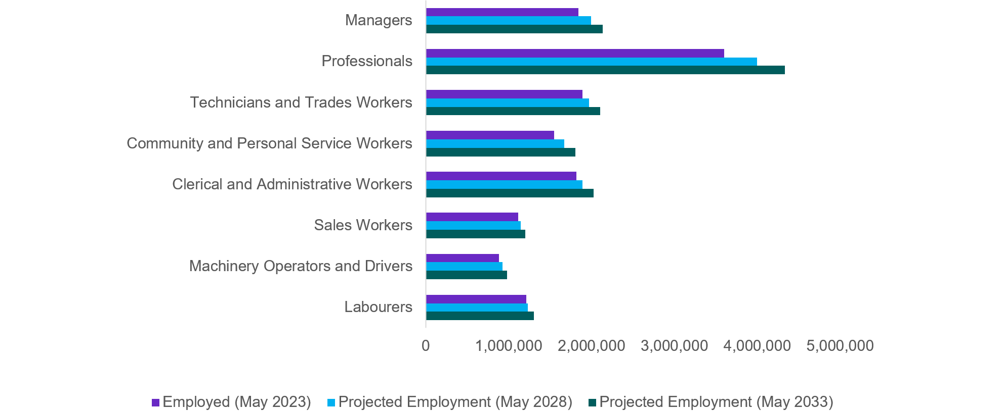

|  |  |  |  |
| --- | --- | --- | --- |
| Occupation | Employed (May 2023) | Projected Employment (May 2028) | Projected Employment (May 2033) |
| Managers | 1843761 | 1992470 | 2133451 |
| Professionals | 3599690 | 3998521 | 4333379 |
| Technicians and Trades Workers | 1893248 | 1968691 | 2102851 |
| Community and Personal Service Workers | 1548123 | 1671052 | 1803516 |
| Clerical and Administrative Workers | 1814779 | 1890392 | 2022500 |
| Sales Workers | 1117832 | 1146148 | 1203801 |
| Machinery Operators and Drivers | 882403 | 926476 | 982239 |
| Labourers | 1215043 | 1231517 | 1307018 |

Source: Projections produced by Victoria University for Jobs and Skills Australia

It is anticipated that the shift towards employment in occupation group such as Professionals and Managers will continue over the next decade, with these 2 occupation groups constituting 39.1% of total employment in May 2023 with this projected to rise to 40.7% of employment in May 2033. Growth in care and support occupations is also expected to continue with Community and Personal Services Workers growing by 16.5% over the 10 years to May 2033 (Table 8Table 8).

Table 8: Share of employment by occupation, 10 years to May 2033

|  |  |  |  |  |  |  |
| --- | --- | --- | --- | --- | --- | --- |
|  | **Share of employment** | | | **Employment growth** | | |
| Occupation | **May 2023 (%)** | **May 2028 (%)** | **May 2033 (%)** | | **5-years (%)** | **10-years (%)** |
| **Managers** | 13.3% | 13.4% | 13.4% | | 8.1% | 15.7% |
| **Professionals** | 25.9% | 27.0% | 27.3% | | 11.1% | 20.4% |
| **Technicians and Trades Workers** | 13.6% | 13.3% | 13.2% | | 4.0% | 11.1% |
| **Community and Personal Service Workers** | 11.1% | 11.3% | 11.4% | | 7.9% | 16.5% |
| **Clerical and Administrative Support Workers** | 13.0% | 12.8% | 12.7% | | 4.2% | 11.4% |
| **Sales Workers** | 8.0% | 7.7% | 7.6% | | 2.5% | 7.7% |
| **Machinery Operators and Drivers** | 6.3% | 6.2% | 6.2% | | 5.0% | 11.3% |
| **Labourers** | 8.7% | 8.3% | 8.2% | | 1.4% | 7.6% |
| Total | 100.0% | 100.0% | 100.0% | | 6.5% | 14.2% |

Source: Projections produced by Victoria University for Jobs and Skills Australia

## Employment of VET and higher education graduates is expected to grow strongly

Over the next 10 years, more than 9 out of 10 new jobs (around 92%) expected to be created will require post-secondary qualifications (Skill levels 1 to 4). Around half (48.4%) will require a bachelor degree or higher qualification as the primary education training pathway (Skill Level 1), and around 44% will have VET as the primary pathway (Skill Levels 2 to 4) (Table 9).

Table 9: Projections by skill level, May 2023 to May 2033, persons

|  |  |  |  |  |
| --- | --- | --- | --- | --- |
| **Skill Level** | **Employed, May 2023 (000s)** | **May 2033 projection (000s)** | **10-year employment growth (000s)** | **Share of 10‑year employment growth (%)** |
| Skill Level 1 | 4,811 | 5,766 | 955 | 48.4% |
| Skill Level 2 | 1,720 | 1,941 | 221 | 11.2% |
| Skill Level 3 | 2,049 | 2,275 | 226 | 11.5% |
| Skill Level 4 | 3,322 | 3,744 | 422 | 21.4% |
| Skill Level 5 | 2,012 | 2,162 | 150 | 7.6% |
| **Total** | **13,915** | **15,889** | **1,974** | **100.0%** |

Source: Projections produced by Victoria University for Jobs and Skills Australia  
Note: Skill Level 1 relates to bachelor degree or higher qualification; Skill Level 2 relates to advanced diploma or diploma; Skill Level 3 relates to Certificate IV or III (including at least 2 years’ on-the-job training); Skill Level 4 relates to Certificate II or III; Skill Level 5 relates to Certificate I or secondary education.

## The employment outlook for the states and territories

Employment is projected to increase in all states and territories over the next 10 years to 2033. The largest increase in employment by persons is expected to occur in Victoria (578,300 persons or 16.1% growth), followed by NSW (562,200 persons or 13.0% growth) and Queensland (394,900 persons or 14.0% growth). The largest growth in percentage terms over the next 10 years is expected in Victoria and the ACT, with both growing at 16.1%. The jurisdictions with the smallest projected growth in persons employed over the period are the Northern Territory (projected to grow by 20,500 people or 13.6%) and Tasmania (projected to grow by 38,500 people or 13.1%) (Figure 22Table 10, Table 10).

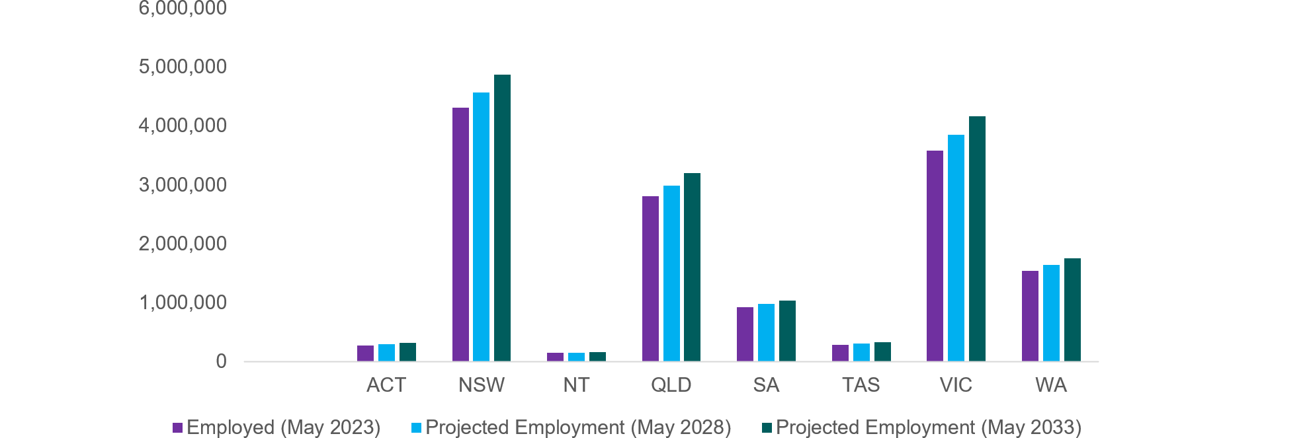Figure 22: Employment projections by state and territory, May 2023 to May 2033, persons

|  |  |  |  |
| --- | --- | --- | --- |
| Occupation | Employed (May 2023) | Projected Employment (May 2028) | Projected Employment (May 2033) |
| Managers | 1843761 | 1992470 | 2133451 |
| Professionals | 3599690 | 3998521 | 4333379 |
| Technicians and Trades Workers | 1893248 | 1968691 | 2102851 |
| Community and Personal Service Workers | 1548123 | 1671052 | 1803516 |
| Clerical and Administrative Workers | 1814779 | 1890392 | 2022500 |
| Sales Workers | 1117832 | 1146148 | 1203801 |
| Machinery Operators and Drivers | 882403 | 926476 | 982239 |
| Labourers | 1215043 | 1231517 | 1307018 |

Source: Projections produced by Victoria University for Jobs and Skills Australia

Table 10: Share of employment by state and territory, May 2023 to May 2033

|  |  |  |  |  |  |
| --- | --- | --- | --- | --- | --- |
|  | Employment share | | | Employment growth | |
| State/Territory | **May 2023 (%)** | **May 2028 (%)** | **May 2033 (%)** | **5-year** **(%)** | **10-year (%)** |
| **ACT** | 2.0% | 2.1% | 2.1% | 8.1% | 16.1% |
| **NSW** | 31.0% | 30.8% | 30.7% | 5.9% | 13.0% |
| **NT** | 1.1% | 1.1% | 1.1% | 6.3% | 13.6% |
| **QLD** | 20.2% | 20.2% | 20.2% | 6.3% | 14.0% |
| **SA** | 6.7% | 6.6% | 6.6% | 5.6% | 12.5% |
| **TAS** | 2.1% | 2.1% | 2.1% | 5.9% | 13.1% |
| **VIC** | 25.8% | 26.0% | 26.2% | 7.5% | 16.1% |
| **WA** | 11.1% | 11.1% | 11.1% | 6.9% | 14.1% |
| Total | 100.0% | 100.0% | 100.0% | 6.5% | 14.2% |

Source: Projections produced by Victoria University for Jobs and Skills Australia

Looking at changes in the industry structure across the states and territories over the next 10 years to 2033, there are some common themes as well as differences across the jurisdictions.

* Health Care and Social Assistance is the highest employing industry by share of employment in 2033 in all states and territories (at over 15% of employment), except for the ACT. This industry is also the fastest growing across all states and territories (growing at over 20% between May 2023 and May 2033), except for the NT.
* Professional, Scientific and Technical Services is projected to be the second largest employing industry in NSW, Victoria, and the ACT, contributing over 10% of employment in all these jurisdictions.
* Construction is expected to be the second largest employer in Queensland (9.0% in 2033); and the third largest employer in Victoria (9.6% in 2033), SA (8.4% in 2033) and WA (8.3% in 2033).

In terms of the most pronounced differences across jurisdictions:

* Mining is the second largest growth industry in WA (growing at 23.0% between 2023 and 2033), as well as being the second largest employer (at 11.1% of employment in 2033). Mining is also largest growing industry between 2023 and 2033 in the NT (at 24.4%), and the second largest growing industry in SA over the same period (growing at 21.4%).
* Manufacturing is the third largest growing industry between 2023 and 2033 in NSW (growing at 17.4%) and Queensland (growing at 15.3%), as well as being the fourth largest growing industry in Victoria (growing at 16.8%) and WA (growing at 16.6%). Across all these jurisdictions, Manufacturing is projected to employ over 5% of the workforce in 2033.
* Public Administration and Safety is expected to be the largest employer in the ACT to 2033 (at 25.3% in 2033), and the second highest employing industry in the NT (at 14.2% in 2033).

## Areas of common focus across current skills shortages and the projections

There are a number of similarities between the trends identified in employment projections and the skills shortages discussed in Chapter 3 that help to identify points of focus for the national skills system into the future.

Chapter 3 identified that the current skills shortages are more pronounced in the Professionals and Technicians and Trades major occupation groups and grew among Community and Personal Service Workers, driven by the current labour market conditions and the structural trends identified in Chapter 2.

The employment projections indicate that employment is likewise expected to grow significantly in these occupation groups. In line with the projections identified in this chapter, the current skills needs are also concentrated around occupations in the services sector, related to health care, ICT and science, technology, engineering and mathematics (STEM)-related occupations.

A common thread among shortages across occupations, is that they require high level of skills, qualifications and experience. When it comes to work in the care and support sectors, the core tasks are also unlikely to be automated in the foreseeable future, while the demand for health and care workers is likely to only increase. In addition, these shortages are not new and have been persistent across the past 3 years at least.

Such persistent shortages into the future are likely to be multifaceted. If not addressed, they are likely to create risks of significant workforce imbalances and be an impediment to current and future economic growth and prosperity.

A more sophisticated assessment at the national level of both demand and supply at the detailed occupational level of the labour market is needed to inform individual and policy decision making. The projections presented in this report are estimates of the likely level of employment in the economy, on the basis that both wages and prices are assumed to adjust over time to changes in the underlying conditions determining demand and supply. Demand for labour is driven by consumer and government decisions about spending on goods and services and business’ decisions about how best to produce them. Supply of labour is driven by the demographic profile of the population, levels of educational attainment, and people’s preferences for how and when they want to work.

The relationship between employment growth and the potential impact of this growth on skills shortages is complex. In some cases, significant future growth in employment may help to reduce current skills shortages, because the future supply of skills is growing faster than the additional future demand from employers, and therefore current skills shortage would ease in the future. However, in other cases, strong future growth in employment may still not be enough to meet growth in demand for those skills, which would lead to a persistent shortage of those skills.

To illustrate the complexity of the relationship between employment growth and skills shortages, 2 occupations that Jobs and Skills Australia has found to be in persistent shortage are Structural Steel and Welding Trades Workers, and Aged and Disabled Carers. While both occupations have been in shortage across the past 3 years at least, total employment growth for Structural Steel and Welding Trades Workers has only been 1.5% over the past 10 years, compared to growth of 133.1% over the same period for Aged and Disabled Carers.

Similarly, many occupations have not been in shortage in any of the past 3 years, despite recording a wide range of different employment growth rates over recent years.

More work needs to be done on understanding the likely interplay between demand and supply in the future, and to maximise the value of employment projections for ensuring Australia has the right skills at the right time (Box 9). Separate estimates of demand and supply for different types of labour, under conditions where labour markets do not fully adjust to impediments (such as wages not fully adjusting in response to current skills shortages), provide an effective way to understand where future skills shortages may occur.

A more sophisticated assessment of the future of the labour market should also include better information on the variable pathways between qualifications and jobs. Some qualifications are tightly connected to a specific occupation (for example, Doctor of Dental Medicine) while others equip people to work in a range of different occupations (for example, Bachelor of Arts). This in turn will allow us to give advice on which part of the national skills system is best placed to train or provide these workers, whether it be the VET sector, higher education sector, the migration system, industry itself or some combination thereof. In many, if not most cases, a hybrid approach drawing on a combination of these possible pathways will likely be the most effective.

|  |
| --- |
| Box 9: What we’ve heard from stakeholders about employment projections  Employment projections are a valuable tool informing workforce planning, assisting business and the national skills system in preparing for shifts in skills demand. Stakeholders have called for a range of enhancements to the approach to projections, which include:  exploring ways to bring greater regional granularity, to better understand the different skills needs across metropolitan, rural, regional and remote  translating occupational and industry projections into skills projections to enhance the understanding of skills growth areas and how skills are anticipated to change  development of scenarios to better understand the impact of trends and changing skills needs under different assumptions  regular comparison of the projections against actual employment outcomes, to better calibrate forecasting assumptions. |

## Conclusions

There are clear similarities between the trends identified in the employment projections, the current occupational and skills needs and the trends shaping the economy – including a continued shift towards employment in the services industries with the largest projected growth in persons employed led by Health Care and Social Assistance, Professional, Scientific and Technical Services, and Education and Training.

It will be important to work with states and territories and Jobs and Skills Councils, as well as other stakeholders to enhance the employment projections over time to better inform workforce planning and decision-making.

This can be bolstered by a national conversation on the drivers and outlook for labour market supply and demand, particularly where there appear to be impediments to the market fully adjusting to any differences between supply and demand. This will enable an assessment of whether the needs of the national skills system are being met, where the gaps are and how these could be addressed.



# Meeting the skill needs of the clean energy transformation



|  |
| --- |
| Key themes in this chapter  The scale of the industrial and workforce transformation for Australia to reach net zero by 2050 will have economy-wide implications for the national skills system.  To meet demand for the most critical occupations for the clean energy workforce, mainly in the trades and engineering professions, Australia can draw on the existing strength of its workforce as well as our education and training system.  However stronger pathways and better coordination between industry, VET and higher education is needed to scale-up the supply of critical trades roles and to develop new qualifications and credentials for emerging roles in the clean energy sector.  This chapter draws on the work of Jobs and Skills Australia’s 'The Clean Energy Generation: Workforce needs for a net zero economy'. Full details of the study are available at [www.jobsandskills.gov.au](http://www.jobsandskills.gov.au). |



## Understanding the clean energy transformation

Australia is reshaping the way we generate, use and export our energy. Significant investments in clean energy generation and the electrification of our houses, vehicles and industries and adoption of sustainable fuels will help reduce emissions, cut power costs, and set us on the pathway to net zero by 2050.

However, this transition will only be possible with a workforce that is equipped with the right skills. New technologies mean new jobs, new skills and new industries. Coordination will also be needed across education, training, migration, and industry to ensure the success of the transition to net zero.

A Clean Energy Workforce Capacity Study was set out by the Australian Government as the first major priority for Jobs and Skills Australia, in recognition of how important the workforce is for our energy future and the government’s net zero agenda. The Study aims to clarify the jobs and industries that make up our clean energy workforce and to understand how the transition to clean energy affects our future workforce needs. It explores how workforce opportunities created by clean energy can be shared across regions and with First Nations Australians, women, people with disability and Australians from culturally and linguistically diverse backgrounds. It also identifies the education, training and migration pathways that should be developed and the underlying system settings needed to enable these pathways.

Jobs and Skills Australia has considered the broader labour market impacts of the clean energy transformation. This has allowed us to see where opportunity exists for clean energy sectors to draw on workers elsewhere in the economy with all or some of the most in-demand skills. The approach also allows us to think broadly about transition opportunities for workers in fossil-fuel intensive sectors.

Jobs and Skills Australia’s approach has been informed by deep stakeholder engagement throughout the project. Guidance was provided by a Project Steering Group including representatives from industry groups, unions, universities, TAFEs, research bodies and state and territory agencies. Responses to a discussion paper released on 4 April 2023 provided additional guidance, and roundtables were held with union representatives, educators from universities, TAFEs, other education and training providers, and businesses. In addition, monthly forums were held with states and territories.

This deep engagement reflects the understanding that building the clean energy workforce is a shared responsibility that cannot be left to one area of government, let alone one initiative or program. The implications of this study require action across a range of portfolios, including energy, employment, education, migration and skills and training.

## Opportunities for the Australian economy and our workforce

Government’s commitment to supporting the net zero transformation is underpinned by clear and legislated emissions reduction targets of 43% by 2030 and net zero by 2050. This shift to a low carbon economy potentially presents regions with enormous opportunities and requires coordinated effort by all levels of government, industry and the skills system (Commonwealth of Australia, 2023).

### Three scenarios about the clean energy future

Australia’s path to net zero by 2050 – and the workforce implications – are not fixed. How it occurs will depend on the level of policy and investment ambition and certainty. The Clean Energy Workforce Capacity Study presents initial results from modelling the impact on occupations and regions tested across 3 scenarios which model how sectors and regions interact based on different assumptions about technology, investment, consumption, wages and broader economic activities. The main scenario is:

* The central scenario (aligned with government climate and energy policy) which sees coordinated policy action with increased public and private investment into low-emissions activities. Australia delivers Rewiring the Nation, and the national electricity system has 82% renewable energy by 2030. Beyond 2030, continued coordination of public and private investment across higher emitting sectors, such as agriculture, reduces the costs of transition by increasing new low‑emissions activities. This scenario broadly aligns to current government policy to 2030, including Government support for hard-to-abate sectors and reflects the stated policy intent to meet net zero by 2050.

The other 2 scenarios are:

* A low scenario that sees slow implementation, does not deliver current government policy settings and sees slower progress in expanding the share of renewable energy in the national electricity system with only 69% renewable energy by 2030.
* A high scenario that sees more ambitious and coordinated policy action, giving the national electricity system over 90% renewable energy by 2030. There are 3 times as many investments in low-emission technologies and more renewable energy capacity supports exporting green manufacturing and a larger critical minerals mining and processing industry. Australia becomes a renewable energy and green industrial superpower due to its role in global supply chains.

Under all the scenarios, demand for employment in the sectors related to clean energy – supply, demand and enabling – will be among the sectors with the largest employment growth in the Australian economy over the next 10 years.

### Expanding the clean energy workforce

The clean energy workforce includes the workers involved in: designing, developing, constructing and operating the infrastructure for generating, storing, transmitting and distributing energy from renewable, zero emissions sources; installing and maintaining the technology that uses clean energy rather than fossil fuels; reducing and managing the energy required to deliver energy services; as well as those that enable the clean energy transition through research, education, training, regulation, and supply chains.

Jobs and Skills Australia has identified 38 critical occupations across all clean energy segments that will need to be developed and grown to support the transition, under all scenarios. As would be expected, Electricians and Electrical Engineers recur across multiple segments but so do engineering trades such as Metal Fitters and Machinists, technician roles, engineering roles such as Electrical Engineers and Industrial, Mechanical and Production Engineers, and managerial occupations such as Production Managers and Construction Managers. In all the scenarios, demand for these occupations will be greatest. Evidence shows many occupations are common across transitioning and clean energy sectors, increasing the likelihood that skills need not be a barrier for many workers in transitioning sectors to find new opportunities.

The clean energy workforce draws heavily on Australia’s higher education and VET systems, and both sectors provide many diverse trade and non-trade pathways into clean energy occupations. Almost all new jobs in Australia over the next 10 years will require tertiary education through either general qualifications – for the clean energy sector this will include top‑ups and electives (including post-trade and post-graduate courses) and new, specialised qualifications (Box 10).

|  |
| --- |
| Box 10: Preparing the national skills system for the clean energy future  The clean energy workforce draws heavily on Australia’s higher education and VET sectors. Both provide diverse trade, non-trade and professional pathways into clean energy occupations. Almost all new jobs in Australia over the next 10 years will require tertiary education. Within tertiary education, there are 3 main pathways into the clean energy sector:  **Broad-based qualifications** like the Certificate III in Electrotechnology (VET) or Bachelor of Electrical Engineering (higher education). These existing qualifications provide the broad range of skills required across a wide range of roles, including clean energy. These qualifications are already delivered in large numbers across Australia.  Increasing the capacity of education and training providers to scale these courses will be a key challenge going forward. In the short-term, many graduates with these qualifications will need to work in larger, adjacent sectors such as construction, mining and manufacturing. But as the demand for clean energy workers grows, the early investment in these skills pipelines will pay dividends, as these qualifications will be highly transferable and relevant into the future.  **Clean energy top-ups and electives** including post-trade and post-graduate courses, allow workers to build on their qualifications, gain specific clean energy skills and specialise. There are several VET electives already available for electrical apprentices to gain skills in areas like solar and battery installation during their apprenticeship. However, the availability of these electives is not always widespread, particularly for emerging technologies.  There are also accredited courses and post-graduate qualifications starting to emerge that can provide additional ‘top-up’ skills for workers after the completion of their core qualification. These top-up skilling opportunities are not just for recent graduates – a large pool of qualified workers in areas like construction could move into clean energy if short, accessible and affordable training were available. These could prove particularly important for workers in transitioning industries, like coal fired power generation, who would benefit from short skilling pathways that can bridge gaps to new opportunities.  **New, specialised qualifications** like the Bachelor of Renewable Energy Engineering (higher education) and the Certificate III in Electric Vehicle Technology (VET), are beneficial where new technologies require a larger suite of specialised skills. Scaling these new qualifications requires a critical mass of students able and willing to enrol and enough employers that recognise the qualification as a suitable pathway into the industry before providers may be willing to make the upfront investment in curriculum, capital and equipment. This has proved difficult in some regions and sectors. |

### Regional implications

Jobs and Skills Australia’s preliminary clean energy jobs modelling suggests that employment growth in regional Australia is likely to be higher than in metropolitan areas. By region, under the central scenario many regions are likely to have average annual employment growth rates close to 2% between 2023 and 2030, including Northern NSW and Southern NSW, Eastern Victoria and the Northern Territory. This growth reflects renewable energy projects and the associated construction pipelines. Some of these regions, for example Northern NSW and Eastern Victoria, also have transitioning sectors. These regions are also likely to have stronger growth rates under the most positive scenario. Under this scenario Tasmania and South-Eastern Queensland are also likely to have annual average growth above 2%.

### Opportunities around decarbonisation

The net zero transformation will create new opportunities in emerging green industries that will facilitate a decarbonised global economy. Australia has the resources, knowledge and experience to seize these opportunities, including low emissions technologies that flow from global transformation, critical minerals, and other related industries. Australia’s future prosperity will depend on how quickly and how well the economy adapts to these changes. Delayed action will increase the cost of transformation and could reduce the competitiveness of some of Australia’s industries, particularly given the scale of direct investment in clean energy technology in other jurisdictions (Commonwealth of Australia, 2023).

The preliminary modelling also considers a scenario which would provide communities impacted by decarbonisation – and deindustrialisation before that – with opportunities to expand industrial activities such as iron ore, bauxite and critical minerals processing, iron and alumina smelting. Other opportunities arise through manufacturing clean energy technology components such as wind turbines, and other specialised areas of advanced manufacturing. Overall economic growth and development provides good prospects for supporting these communities, provided there is local investment in new industries and impacted workers receive targeted training and other forms of support to transition to roles that build on their existing skills. Workforce opportunities must be sustainable and equitably shared with all Australians, particularly communities impacted by decarbonisation and disadvantaged groups that were excluded and underutilised in traditional energy.

The transformation to net zero emissions will fundamentally reshape our economy. Australia’s targets to reduce emissions by 43% by 2030 from 2005 levels, and reach net zero emissions by 2050 are catalysing change in industrial processes, which has implications for the types of skills needed in the economy. Australia will need more trades and technicians to help build the infrastructure necessary to support a green economy (The Treasury, 2023b).

### Embedding industry in the skills system

The transition to net zero will require concerted effort across all parts of the education and training sector, and close alignment with industry will be central to our success. It will be crucial to stand up initiatives to increase the number of apprentices in electrical and related trades and increase the number of firms engaging apprentices. By targeting higher education, it should be possible to sustain large numbers of engineering graduates across multiple disciplines, as well as maintain university programs in several other specialist fields such a geology and metallurgy. This is a big challenge, noting that this is already an area of significant skills shortage.

Stronger links between industry, and the VET and higher education sectors are also needed, including expanding opportunities for work-based and integrated learning such as higher apprenticeships and degree apprenticeships. Development of collaborative approaches that bring higher education, VET and industry together, such as Centres of Excellence, Institutes of Advanced Technology and Cooperative Research Centres, should be a core part of future system architecture.

Ensuring there are sufficient VET trainers and teachers with relevant clean energy sector experience will be critical to this process. Tripartite partners have raised shortages of suitable VET teachers and trainers in relation to the clean energy sector, and more broadly, as a critical issue. Crucially, the VET sector must find new ways to leverage the experience of senior industry practitioners to scale-up workplace-based training and improve and maintain the currency of existing VET trainers and teachers.

### Pathways towards the clean energy future

Realising Australia’s transformation to a clean energy economy will require a large, skilled and agile workforce. While the workforce transformation will be substantial, the challenge can be met through 3 main pathways:

* the clean energy sector will be able **to draw on the strength of Australia’s workforce** at large, with many (though not all) of the required skills found in other parts of the economy, particularly those transitioning from industry sectors impacted by decarbonisation
* a **robust tertiary education and training system** will also support and sustain the growth of the clean energy sector. The clean energy workforce draws heavily on Australia’s higher education and VET sectors through both well-established qualifications such as electrotechnology apprenticeships and engineering degrees, and post-trade and postgraduate training options to support job transitions. Both sectors provide many diverse trade and non-trade pathways into clean energy. An industry-informed focus on incorporating practical skills and work-integrated learning into these pathways will enhance the job readiness of graduates (Box 10)
* **skilled migration** will contribute to the clean energy workforce required, complementing domestic efforts to skill, upskill and reskill the population. Migration programs will help to supplement existing and anticipated skills gaps and support the growth of the clean energy workforce.

## Conclusions from the clean energy capacity study

The transition to net zero offers opportunities to better align the separate parts of the national skills system around a critical challenge – a more joined-up approach between VET, higher education and industry may assist in producing more graduates in clean energy qualifications who are ready to work, have the theoretical knowledge and practical experience to be productive right away, and who are familiar with the technology and workplace arrangements of the clean energy sector.

A coordinated approach to designing qualifications and training programs will maximise the likelihood of producing suitably trained and skilled workers for the clean energy sector. It can also enable the retraining and upskilling of workers to take advantage of the opportunities offered by the clean energy transition.

The Jobs and Skills Councils will be well placed to ensure that the skills needs of industry are captured in new qualifications, and adapting existing qualifications. Consideration should be given to new approaches to incentivising employer engagement in higher education, as well as in the development of secondary school curriculum (including but not limited to VET in schools course offerings and an emphasis on STEM subjects).

There is potential for utilising the clean energy sector transition as a 'test bed' for developing high-quality, industry-endorsed education and training that draw on the strengths of both the higher education and VET sectors, while avoiding the long lead times for mainstream accredited training that can affect emerging industries. This can be done through close engagement with industry to produce highly trained workers with the skills, competencies and qualifications that clean energy sector employers value.

The VET training workforce is a critical constraint to the success of the clean energy transition – reports of shortages are widespread, and many training providers may lack practical experience in the clean energy sector – promoting partnerships with industry may be one approach to address these concerns. Jobs and Skills Australia has identified a study on the VET workforce as a piece of key research for our near-term work plan.



# The national skills system: an emerging reform agenda



|  |
| --- |
| Key themes in this chapter  Each pillar of the national skills systems – VET, higher education and migration – plays an important role in the labour market and skills supply, and society.  Each pillar of the national skills system has many strengths, but also areas for improvement. The interactions across the pillars are also complex and interconnected.  To achieve low unemployment, strong productivity and wages growth and increased inclusion in the labour market will require all elements of the national skills system to improve and work better together. Reforms underway are helping to pave the way for a more joined-up approach in the national skills system. |



The national skills system delivers social and economic outcomes for individuals, employers and industry and to the nation through increased productivity, participation and inclusion. This chapter outlines the contribution of VET, higher education and migration as individual pillars of the national skills system, their inherent strengths and areas of improvement.

## The role of the national skills system in the labour market

### Workforce composition by VET or higher education pathway

At present, the VET and higher education sectors are roughly equally represented in the labour force. In 2021, on average 33.5% of employed persons across all occupations had a VET qualification as their highest education level and 35.4% had a higher education qualification (ABS, 2022c). Figure 23 shows VET-qualified workers are more prominent in the Technicians and Trades Workers and the Community and Personal Service Workers occupations, VET‑qualified workers account for more than 30% of those employed in all broad occupational groups except Sales Workers and Professionals. While higher education qualified workers are more prominent in Professional and Manager occupation groups, VET-qualified workers operate in these groups based on their qualification and experience.

Figure 23: VET and higher education distribution across occupations (1-digit level)

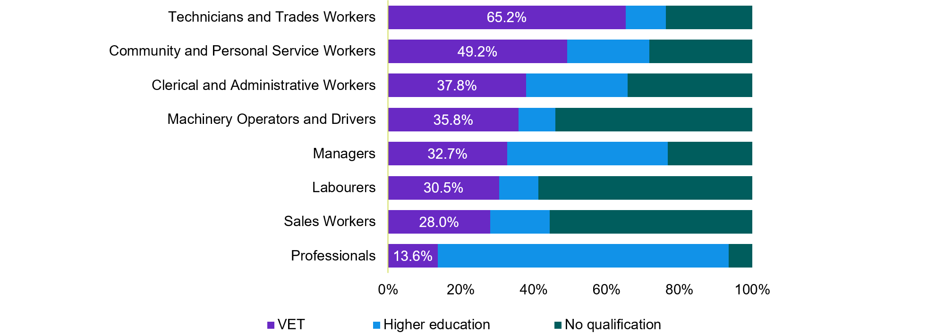

|  |  |  |  |
| --- | --- | --- | --- |
| occupation | VET | Higher education | No qualification |
| Professionals | 13.6% | 79.9% | 6.5% |
| Sales Workers | 28.0% | 16.3% | 55.6% |
| Labourers | 30.5% | 10.8% | 58.8% |
| Managers | 32.7% | 44.1% | 23.3% |
| Machinery Operators and Drivers | 35.8% | 10.0% | 54.1% |
| Clerical and Administrative Workers | 37.8% | 27.9% | 34.3% |
| Community and Personal Service Workers | 49.2% | 22.5% | 28.4% |
| Technicians and Trades Workers | 65.2% | 11.0% | 23.8% |

Source: ABS Census 2021, Jobs and Skills Australia analysis   
Note: VET includes all certificate levels to advanced diploma. Higher education includes bachelor to postgraduate degrees.

This pattern has changed significantly over time, with the share of higher education qualified workers increasing over the past 2 decades (Figure 24). While the number of people with a post-school qualification has increased since 2006, growth in higher education has overshadowed growth in VET. The growth is changing the nature of the stock of skills in the workforce. In 2021, 33.1% of employed people aged 20 to 44 in 2021 had a VET qualification as their highest qualification, compared to 42.0% who had a higher education qualification as their highest qualification.

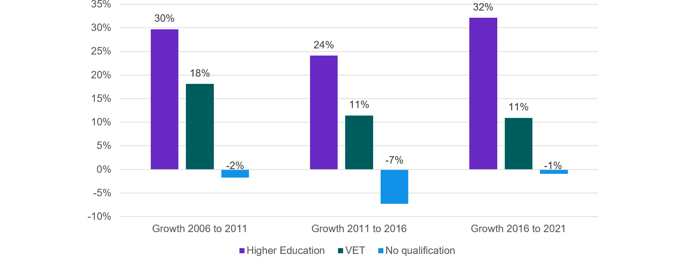Figure 24: Post-school qualification growth rates for people in labour market, 2006–2021

|  |  |  |  |
| --- | --- | --- | --- |
|  | Growth 2006 to 2011 | Growth 2011 to 2016 | Growth 2016 to 2021 |
| Higher Education | 30% | 24% | 32% |
| VET | 18% | 11% | 11% |
| No qualification | -2% | -7% | -1% |

Source: ABS Census 2006, 2011, 2016, 2021  
Note: VET includes all certificate levels to advanced diploma. Higher education includes bachelor to postgraduate degrees. Includes all 1-digit occupations, inadequately described and not stated.

### Current shortages by VET or higher education pathway

The Skills Priority List 2023 found that 42% of Skill Level 1 occupations were in shortage (that is, occupations typically requiring a bachelor degree or higher qualifications) – with many of these shortages relating to health, education, engineering or information technology roles. For occupations with primarily VET pathways (Skill Levels 2 to 4), 32% of occupations were in shortage. This masks significant variation within occupations with a VET pathway, with almost half of Skill Level 3 occupations, which typically require a Certificate III or IV, in shortage in 2023.

At present, there is only limited information on how well course completions from across the tertiary education system match the pattern of current shortages in the labour market. There is some information on VET, which shows that apart from Community and Personal Service Workers and Technicians and Trades Workers occupations, there are more VET qualification completions in qualifications not in skills shortage than those that are in shortage (Figure 25).

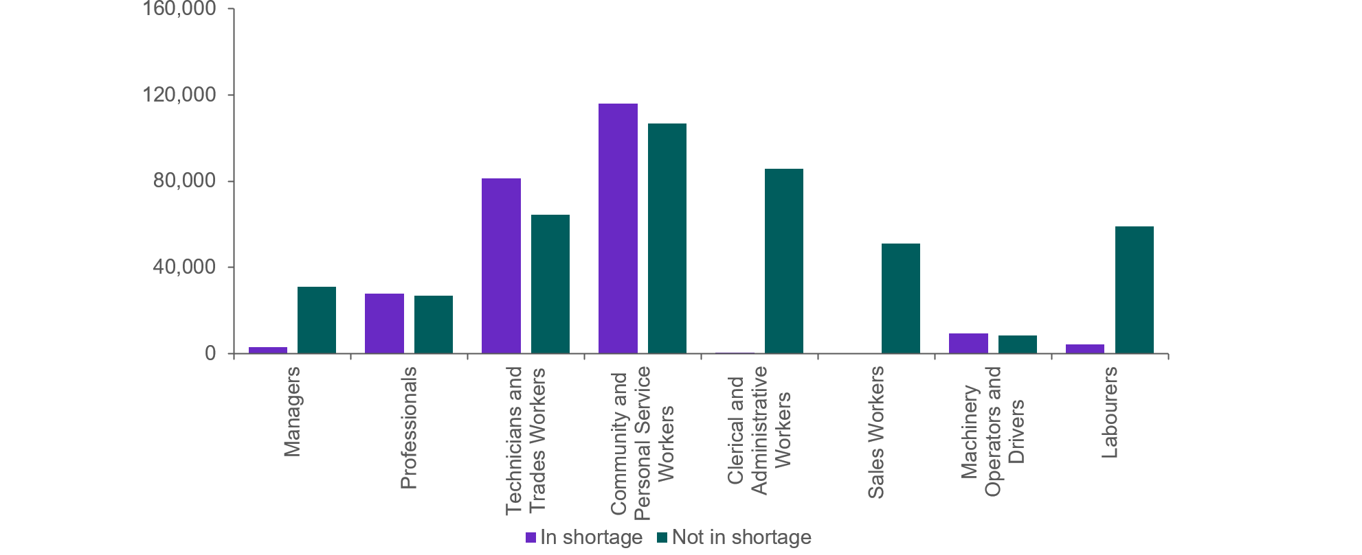Figure 25: Qualification completions by 1-digit occupation and SPL shortage status

|  |  |  |  |  |
| --- | --- | --- | --- | --- |
|  | In shortage | On SPL (no shortage) | Not on SPL | Not in shortage |
| Managers | 3,111 | 30,497 | 518 | 31,015 |
| Professionals | 27,661 | 26,288 | 593 | 26,881 |
| Technicians and Trades Workers | 81,150 | 55,441 | 9,005 | 64,446 |
| Community and Personal Service Workers | 116,085 | 99,693 | 6,951 | 106,643 |
| Clerical and Administrative Workers | 92 | 82,628 | 3,032 | 85,660 |
| Sales Workers | 0 | 42,201 | 8,862 | 51,062 |
| Machinery Operators and Drivers | 9,218 | 8,324 | 0 | 8,324 |
| Labourers | 4,299 | 8,371 | 50,672 | 59,043 |

Source: ABS Census 2021, Jobs and Skills Australia analysis

### Projected employment by pathway

The employment projections presented in Chapter 4 indicate that the demand for tertiary educated graduates will grow significantly over the next decade. It is projected that around half of all new jobs in the coming decade will require a higher education qualification as the primary pathway, while 44% will have a VET primary pathway. These projections, combined with the profile of educational attainment by age, suggest that the proportion of workers with a higher education qualification will increase over the next decade. For example, of the almost 2 million projected increase in employment between 2023 and 2033, around 1 million is projected to be in the highest Skill level 1 category, with this number concentrated amongst the Professionals (76%) and Managers (24%) major occupation groups (Figure 26).

Figure 26: Projected employment to 2033, by major occupation group and skill level

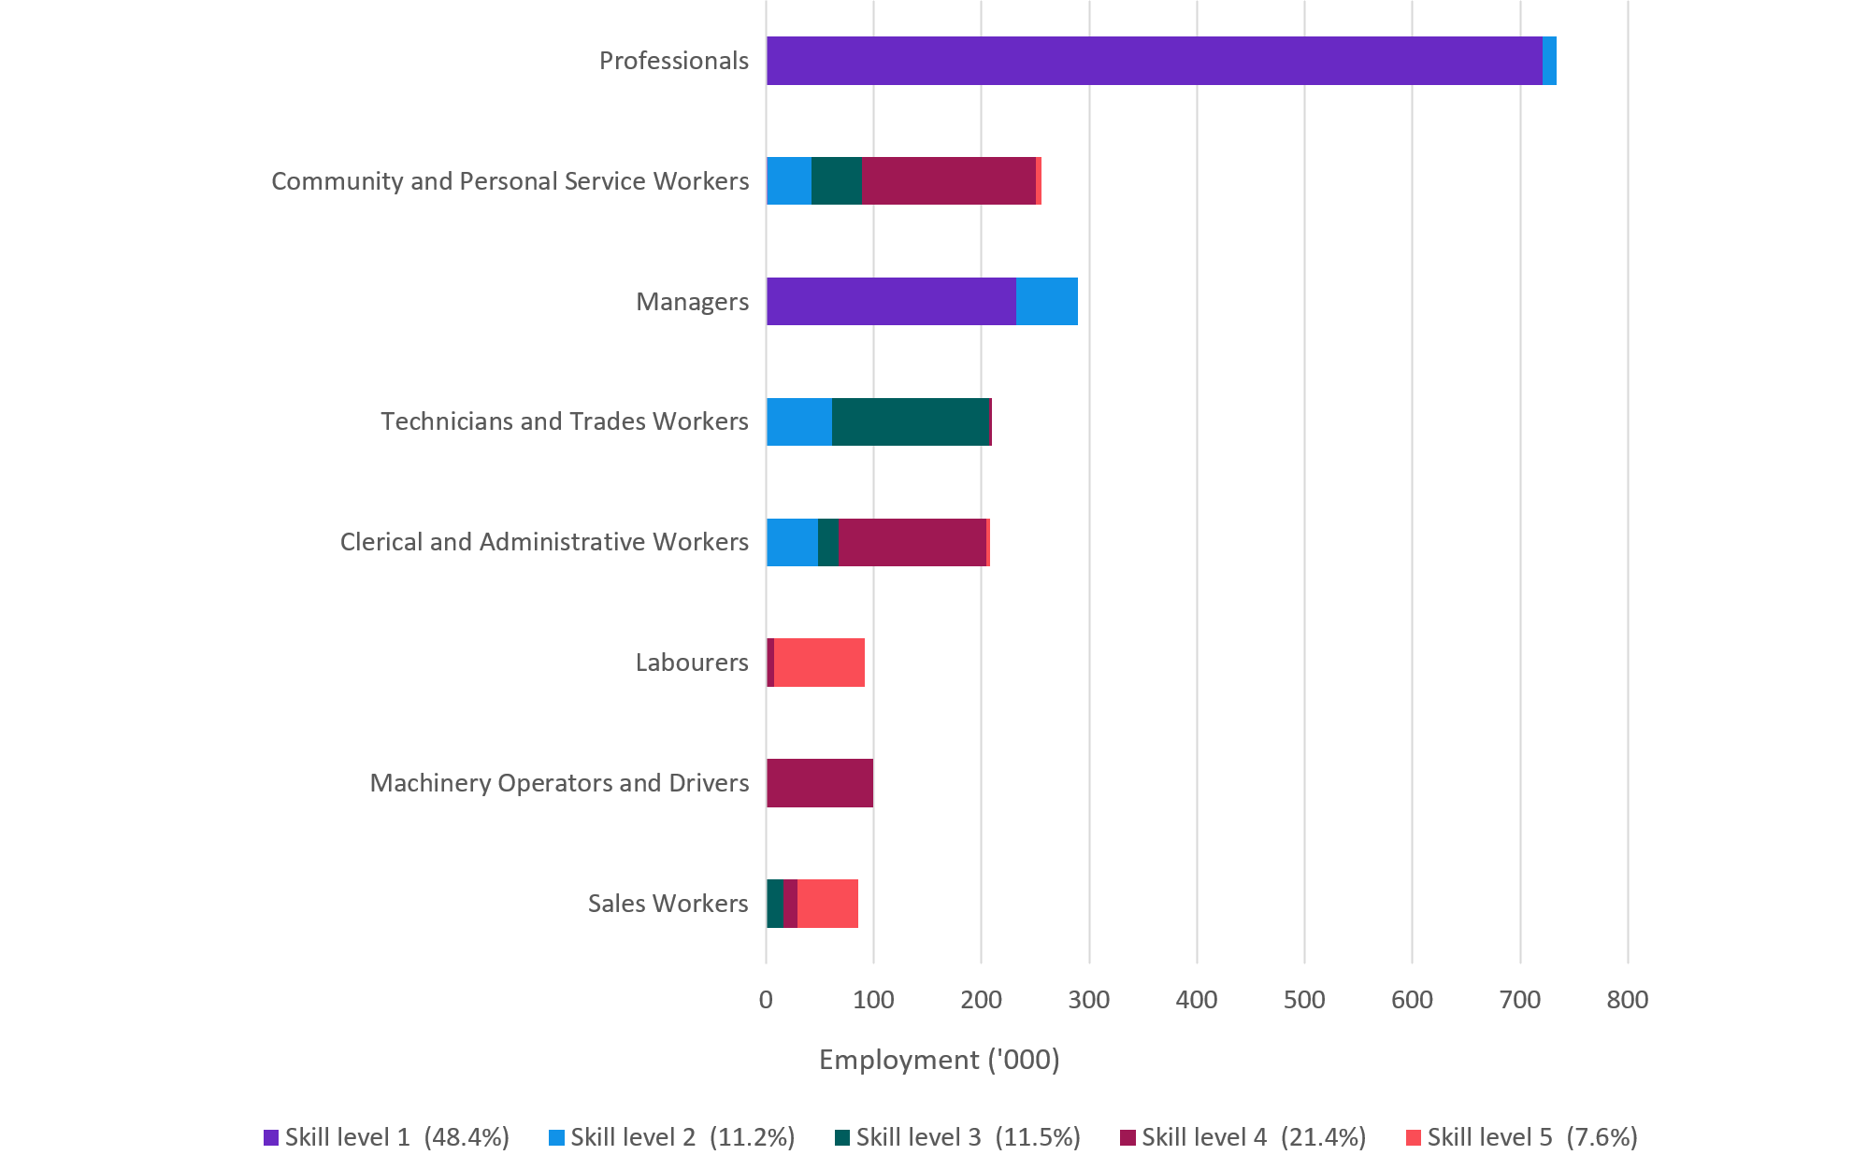

|  |  |  |  |  |  |  |  |  |
| --- | --- | --- | --- | --- | --- | --- | --- | --- |
| Ten years projection | Sales Workers | Machinery Operators and Drivers | Labourers | Clerical and Administrative Workers | Technicians and Trades Workers | Managers | Community and Personal Service Workers | Professionals |
| Skill level 5 (7.6%) | 56.7% | 0.0% | 84.7% | 3.6% | 0.0% | 0.0% | 4.9% | 0.0% |
| Skill level 4 (21.4%) | 13.4% | 99.8% | 7.3% | 137.0% | 2.7% | 0.0% | 161.8% | 0.0% |
| Skill level 3 (11.5%) | 15.9% | 0.0% | 0.0% | 18.4% | 145.7% | 0.0% | 46.2% | 0.0% |
| Skill level 2 (11.2%) | 0.0% | 0.0% | 0.0% | 48.8% | 61.2% | 57.6% | 40.9% | 12.8% |
| Skill level 1 (48.4%) | 0.0% | 0.0% | 0.0% | 0.0% | 0.0% | 232.1% | 1.7% | 720.9% |

Source: Projections produced by Victoria University for Jobs and Skills Australia

### Migration and the labour force

Migration has been an increasingly significant factor shaping the labour force. Around 33% of the labour force is foreign born, and this has increased by almost 10 percentage points over the last 20 years (Figure 27). However, labour market outcomes are variable for migrants, reflecting the mixed composition of Australia’s migration programs which include significant components for refugees and humanitarian entrants, and for partners and dependants of migrants (Box 11).

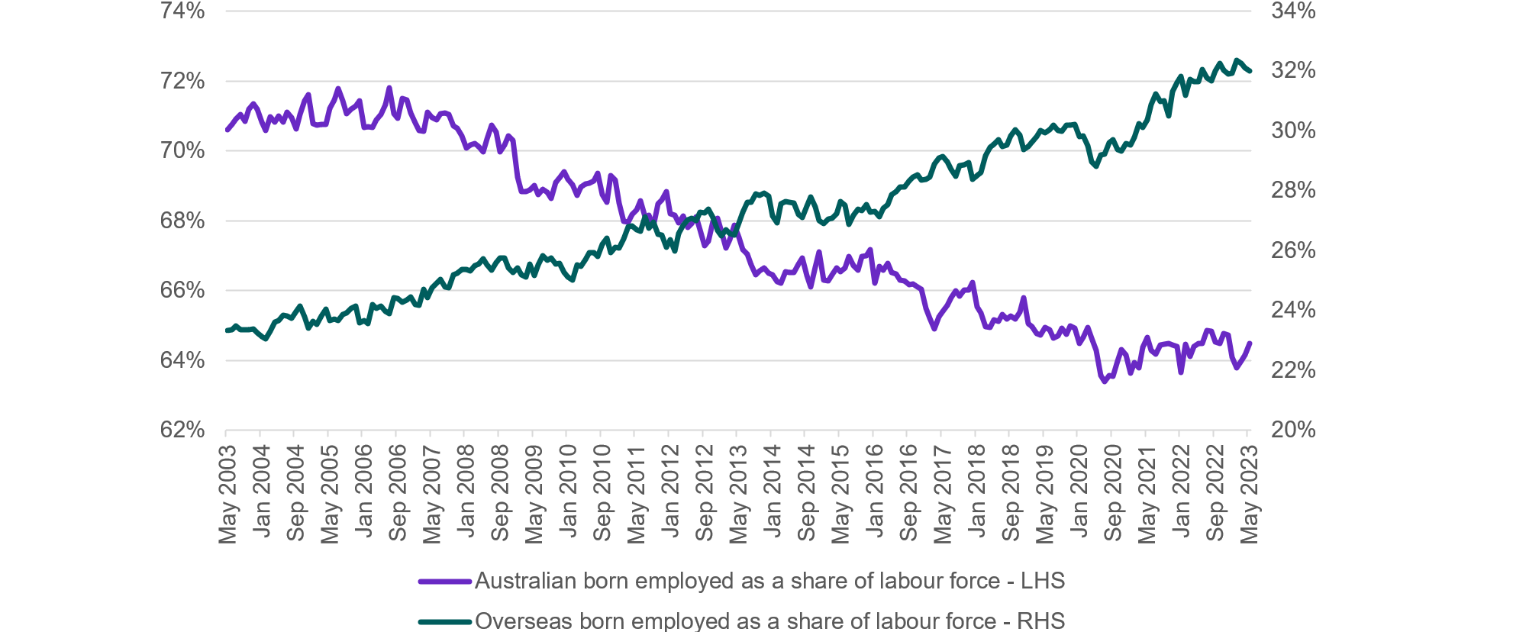Figure 27: Australian born employed and overseas born employed as a share of the labour force

|  |  |  |  |  |  |  |  |  |  |  |  |  |  |  |  |  |  |  |  |  |  |  |  |  |  |  |  |  |  |  |  |  |  |  |  |  |  |  |  |  |  |  |  |  |  |  |  |  |  |  |  |  |  |  |  |  |  |  |  |  |  |  |
| --- | --- | --- | --- | --- | --- | --- | --- | --- | --- | --- | --- | --- | --- | --- | --- | --- | --- | --- | --- | --- | --- | --- | --- | --- | --- | --- | --- | --- | --- | --- | --- | --- | --- | --- | --- | --- | --- | --- | --- | --- | --- | --- | --- | --- | --- | --- | --- | --- | --- | --- | --- | --- | --- | --- | --- | --- | --- | --- | --- | --- | --- | --- |
| Date | May 2003 | Jun 2003 | Jul 2003 | Aug 2003 | Sep 2003 | Oct 2003 | Nov 2003 | Dec 2003 | Jan 2004 | Feb 2004 | Mar 2004 | Apr 2004 | May 2004 | Jun 2004 | Jul 2004 | Aug 2004 | Sep 2004 | Oct 2004 | Nov 2004 | Dec 2004 | Jan 2005 | Feb 2005 | Mar 2005 | Apr 2005 | May 2005 | Jun 2005 | Jul 2005 | Aug 2005 | Sep 2005 | Oct 2005 | Nov 2005 | Dec 2005 | Jan 2006 | Feb 2006 | Mar 2006 | Apr 2006 | May 2006 | Jun 2006 | Jul 2006 | Aug 2006 | Sep 2006 | Oct 2006 | Nov 2006 | Dec 2006 | Jan 2007 | Feb 2007 | Mar 2007 | Apr 2007 | May 2007 | Jun 2007 | Jul 2007 | Aug 2007 | Sep 2007 | Oct 2007 | Nov 2007 | Dec 2007 | Jan 2008 | Feb 2008 | Mar 2008 | Apr 2008 | May 2008 | Jun 2008Jul 2008 Aug 2008 Sep 2008 Oct 2008 Nov 2008 Dec 2008 Jan 2009 Feb 2009 Mar 2009 Apr 2009 May 2009 Jun 2009 Jul 2009 Aug 2009 Sep 2009 Oct 2009 Nov 2009 Dec 2009 Jan 2010 Feb 2010 Mar 2010 Apr 2010 May 2010 Jun 2010 Jul 2010 Aug 2010 Sep 2010 Oct 2010 Nov 2010 Dec 2010 Jan 2011 Feb 2011 Mar 2011 Apr 2011 May 2011 Jun 2011 Jul 2011 Aug 2011 Sep 2011 Oct 2011 Nov 2011 Dec 2011 Jan 2012 Feb 2012 Mar 2012 Apr 2012 May 2012 Jun 2012 Jul 2012 Aug 2012 Sep 2012 Oct 2012 Nov 2012 Dec 2012 Jan 2013 Feb 2013 Mar 2013 Apr 2013 May 2013 Jun 2013 Jul 2013 Aug 2013 Sep 2013 Oct 2013 Nov 2013 Dec 2013 Jan 2014 Feb 2014 Mar 2014 Apr 2014 May 2014 Jun 2014 Jul 2014 Aug 2014 Sep 2014 Oct 2014 Nov 2014 Dec 2014 Jan 2015 Feb 2015 Mar 2015 Apr 2015 May 2015 Jun 2015 Jul 2015 Aug 2015 Sep 2015 Oct 2015 Nov 2015 Dec 2015 Jan 2016 Feb 2016 Mar 2016 Apr 2016 May 2016 Jun 2016 Jul 2016 Aug 2016 Sep 2016 Oct 2016 Nov 2016 Dec 2016 Jan 2017 Feb 2017 Mar 2017 Apr 2017 May 2017 Jun 2017 Jul 2017 Aug 2017 Sep 2017 Oct 2017 Nov 2017 Dec 2017 Jan 2018 Feb 2018 Mar 2018 Apr 2018 May 2018 Jun 2018 Jul 2018 Aug 2018 Sep 2018 Oct 2018 Nov 2018 Dec 2018 Jan 2019 Feb 2019 Mar 2019 Apr 2019 May 2019 Jun 2019 Jul 2019 Aug 2019 Sep 2019 Oct 2019 Nov 2019 Dec 2019 Jan 2020 Feb 2020 Mar 2020 Apr 2020 May 2020 Jun 2020 Jul 2020 Aug 2020 Sep 2020 Oct 2020 Nov 2020 Dec 2020 Jan 2021 Feb 2021 Mar 2021 Apr 2021 May 2021 Jun 2021 Jul 2021 Aug 2021 Sep 2021 Oct 2021 Nov 2021 Dec 2021 Jan 2022 Feb 2022 Mar 2022 Apr 2022 May 2022 Jun 2022 Jul 2022 Aug 2022 Sep 2022 Oct 2022 Nov 2022 Dec 2022 Jan 2023 Feb 2023 Mar 2023 Apr 2023 May 2023 Jun 2023 Jul 2023 |
| Australian born employed as a share of labour force - LHS | 0.706091 | 0.707527 | 0.709059 | 0.710526 | 0.708413 | 0.71191 | 0.713466 | 0.711937 | 0.708158 | 0.70586 | 0.709805 | 0.708164 | 0.710019 | 0.708288 | 0.710999 | 0.709519 | 0.70631 | 0.710312 | 0.714246 | 0.716084 | 0.707841 | 0.707387 | 0.707488 | 0.707537 | 0.712252 | 0.714602 | 0.717893 | 0.714336 | 0.71059 | 0.712034 | 0.712736 | 0.714422 | 0.706599 | 0.706886 | 0.70672 | 0.708881 | 0.710475 | 0.713266 | 0.718169 | 0.710661 | 0.709351 | 0.714999 | 0.714614 | 0.710871 | 0.708039 | 0.705924 | 0.705697 | 0.711048 | 0.709597 | 0.708822 | 0.71056 | 0.710942 | 0.710334 | 0.707109 | 0.706573 | 0.704282 | 0.700722 | 0.701724 | 0.702093 | 0.701267 | 0.699808 | 0.7034220.707296 0.705488 0.699639 0.701667 0.704221 0.702885 0.692582 0.688412 0.688299 0.688776 0.690146 0.687498 0.688903 0.688145 0.686283 0.690926 0.692362 0.693978 0.691829 0.690289 0.687187 0.689755 0.690617 0.690709 0.691378 0.693524 0.687382 0.685373 0.692857 0.691567 0.685124 0.679844 0.679684 0.681744 0.68304 0.685762 0.681029 0.681503 0.678493 0.684805 0.685976 0.688414 0.681965 0.681524 0.679374 0.6813 0.678095 0.679176 0.681191 0.677318 0.672864 0.674234 0.679709 0.680718 0.677045 0.672226 0.67466 0.678785 0.675154 0.671783 0.670506 0.667373 0.664469 0.665585 0.666466 0.665018 0.664536 0.662634 0.662063 0.665448 0.665223 0.665233 0.667512 0.66928 0.664399 0.660916 0.666619 0.671114 0.662999 0.662817 0.664601 0.666444 0.665342 0.666491 0.669776 0.667237 0.665917 0.669833 0.669957 0.671808 0.662079 0.666976 0.665867 0.667881 0.665157 0.664779 0.663045 0.662697 0.66159 0.661915 0.661011 0.660328 0.654837 0.652037 0.649028 0.652588 0.654098 0.655738 0.657959 0.660012 0.658413 0.660043 0.660041 0.662252 0.655344 0.653517 0.649696 0.649449 0.651565 0.651104 0.653168 0.651865 0.652696 0.651911 0.65383 0.657988 0.650525 0.649712 0.647743 0.647211 0.649491 0.6487 0.646396 0.647126 0.649243 0.647546 0.64995 0.64922 0.64489 0.64659 0.649358 0.646278 0.642859 0.63565 0.633959 0.635619 0.635424 0.639786 0.643077 0.641505 0.636372 0.639365 0.637831 0.643795 0.646582 0.642828 0.641739 0.644369 0.644519 0.644902 0.644317 0.643901 0.6366 0.644563 0.641022 0.643967 0.644955 0.64474 0.64866 0.648296 0.645214 0.644836 0.647622 0.647345 0.640957 0.637811 0.639763 0.64151 0.644882 0.64585 0.638269 |
| Overseas born employed as a share of labour force - RHS | 0.233236 | 0.23347 | 0.234738 | 0.233563 | 0.233608 | 0.233616 | 0.233936 | 0.232479 | 0.231268 | 0.230539 | 0.233079 | 0.236065 | 0.236554 | 0.238413 | 0.238104 | 0.2375 | 0.23975 | 0.241412 | 0.237832 | 0.234112 | 0.236401 | 0.23534 | 0.238119 | 0.240568 | 0.236629 | 0.237072 | 0.236511 | 0.238683 | 0.239306 | 0.240663 | 0.241552 | 0.235973 | 0.236711 | 0.235701 | 0.242034 | 0.240712 | 0.241388 | 0.239818 | 0.239044 | 0.244225 | 0.243957 | 0.242831 | 0.24344 | 0.244419 | 0.241961 | 0.241775 | 0.247162 | 0.244387 | 0.247628 | 0.249049 | 0.250291 | 0.247891 | 0.24755 | 0.25192 | 0.252345 | 0.253614 | 0.253637 | 0.253293 | 0.254914 | 0.255471 | 0.257367 | 0.2552950.253439 0.255968 0.257603 0.25762 0.254269 0.25277 0.254229 0.251912 0.251275 0.255491 0.251577 0.255199 0.258363 0.256825 0.257583 0.255517 0.255685 0.252787 0.251115 0.250077 0.255328 0.254754 0.25709 0.25922 0.259319 0.257982 0.262236 0.264297 0.259442 0.261072 0.260915 0.264038 0.267999 0.268301 0.266915 0.266364 0.271252 0.267596 0.269552 0.265568 0.2651 0.261239 0.263612 0.259869 0.265612 0.26847 0.270221 0.270698 0.269999 0.272849 0.272585 0.273926 0.27106 0.266825 0.264896 0.26687 0.265646 0.265073 0.269219 0.272865 0.276128 0.276079 0.27885 0.278472 0.279204 0.278196 0.271634 0.269314 0.275608 0.276339 0.276272 0.275963 0.272107 0.271091 0.274818 0.277959 0.274565 0.270083 0.268928 0.270513 0.270732 0.272265 0.276297 0.275052 0.268699 0.271756 0.273917 0.273428 0.27546 0.272961 0.273028 0.271299 0.274148 0.275422 0.278599 0.279801 0.281159 0.281157 0.28334 0.284665 0.285286 0.283472 0.283741 0.284472 0.288813 0.290849 0.291548 0.28977 0.2871 0.284844 0.288406 0.288672 0.289478 0.283756 0.284991 0.285985 0.291628 0.294643 0.295472 0.297073 0.294791 0.295329 0.29836 0.300271 0.298616 0.293787 0.294853 0.29639 0.298092 0.300016 0.299406 0.300304 0.301836 0.300147 0.299887 0.30193 0.302019 0.302234 0.298097 0.298283 0.295068 0.289702 0.288113 0.292012 0.29216 0.29597 0.297092 0.293864 0.293369 0.29568 0.295166 0.297938 0.302386 0.301116 0.303638 0.308921 0.312247 0.309933 0.310035 0.305063 0.313086 0.316315 0.318314 0.31186 0.317164 0.316567 0.316547 0.320602 0.317687 0.316674 0.320127 0.322547 0.320283 0.319117 0.319151 0.323496 0.322581 0.320976 0.32009 0.320651 0.325451 |

Source: ABS Labour Force, Australia, Detailed; Jobs and Skills Australia analysis

It is likely that the share in the labour market of people born overseas will continue to increase over the coming decade. Net overseas migration accounted for over 60% of Australia’s population growth over the past decade. Net overseas migration dropped to a net outflow of 85,000 people in 2020–21 because of international travel restrictions introduced during the COVID-19 pandemic. This was the first net outflow of overseas migrants from Australia since the end of the Second World War. By the time border restrictions were relaxed at the end of 2021, net overseas migration was cumulatively almost 500,000 lower than expected prior to the pandemic (The Treasury, 2023b). The 2023–24 Federal Budget forecasts that net overseas migration will recover in the near-term due to the temporary catch-up from the pandemic. It is expected to largely return to normal patterns from 2024–25 but this means net overseas migration would not return to pre-pandemic levels until 2029–30. Once this temporary catch-up subsides, net overseas migration is expected to fall to 235,000 per year (The Treasury, 2023b).

There are significant concerns about how well migration is matching current needs in the labour market, including how well the skills of migrants are currently being utilised. Analysis by the Committee for Economic Development Australia based on data from the Continuous Survey of Australia’s Migrants (CSAM) indicates that nearly 1 in 4 permanent skilled migrants are working in a job beneath their skill level (CEDA, 2021a).

This backs up evidence that people from Culturally and Linguistically Diverse (CALD) backgrounds have higher than average educational attainment, and some may experience difficulties having overseas qualification recognised (ABS, 2011; CEDA, 2021a). Further, migrant women, who are particularly likely to be the ‘secondary’ visa holder, can have more difficulty getting their qualifications recognised and finding work matching their skills (Batainah, Hawkins, & Miranti, 2022).

|  |  |  |  |  |  |  |  |  |  |  |  |  |  |  |  |  |  |  |  |  |  |  |  |  |  |  |  |  |  |  |  |  |  |  |  |  |  |  |  |  |  |  |  |  |  |  |  |  |
| --- | --- | --- | --- | --- | --- | --- | --- | --- | --- | --- | --- | --- | --- | --- | --- | --- | --- | --- | --- | --- | --- | --- | --- | --- | --- | --- | --- | --- | --- | --- | --- | --- | --- | --- | --- | --- | --- | --- | --- | --- | --- | --- | --- | --- | --- | --- | --- | --- |
| Box 11: The unemployment rates for people who migrate to Australia vary appreciably  Several factors influence migrant unemployment rates including skill level, age, English proficiency, recent and relevant work experience, and the period since arrival in Australia. Data consistently shows recently arrived migrants have a higher unemployment rate on average than those who have lived in Australia for some years.  Figure 28 and Figure 29 show the participation and unemployment rates of the Australian-born and migrants by broad country of birth groups and period of residence in Australia (average of the last 12 months to May 2023).  Figure 28: Years since arrival in Australia by labour force participation rates (percentage) for broad country of birth groups—12 months to May 2023     |  |  |  |  |  |  |  |  |  |  |  |  | | --- | --- | --- | --- | --- | --- | --- | --- | --- | --- | --- | --- | | Years since arrival | MESC-born persons who arrived 20 or more years ago | OTMESC-born persons who arrived 20 or more years ago | MESC-born persons who arrived 15-19 years ago | OTMESC-born persons who arrived 15-19 years ago | MESC-born persons who arrived 10-14 years ago | OTMESC-born persons who arrived 10-14 years ago | MESC-born persons who arrived 5-9 years ago | OTMESC-born persons who arrived 5-9 years ago | MESC-born persons who arrived within last 5 years | OTMESC-born persons who arrived within last 5 years | Born in Australia | | Participation rate | 52.2% | 52.3% | 82.7% | 82.0% | 84.5% | 79.0% | 84.9% | 78.0% | 81.6% | 67.9% | 68.0% |   Source: ABS Labour Force, Australia, Detailed Note: MESC - Main English Speaking Countries, OTMESC - Other Than Main English Speaking Countries.  Figure 29: Years since arrival in Australia by unemployment rate (percentage) for broad country of birth groups—12 months to May 2023     |  |  |  |  |  |  |  |  |  |  |  |  | | --- | --- | --- | --- | --- | --- | --- | --- | --- | --- | --- | --- | | Years since arrival | MESC-born persons who arrived 20 or more years ago | OTMESC-born persons who arrived 20 or more years ago | MESC-born persons who arrived 15-19 years ago | OTMESC-born persons who arrived 15-19 years ago | MESC-born persons who arrived 10-14 years ago | OTMESC-born persons who arrived 10-14 years ago | MESC-born persons who arrived 5-9 years ago | OTMESC-born persons who arrived 5-9 years ago | MESC-born persons who arrived within last 5 years | OTMESC-born persons who arrived within last 5 years | Born in Australia | | Unemployment rate | 2.7% | 2.8% | 2.6% | 3.3% | 2.8% | 3.7% | 2.8% | 3.6% | 4.1% | 5.6% | 3.6% |   Source: ABS Labour Force, Australia, Detailed Note: MESC - Main English Speaking Countries, OTMESC - Other Than Main English Speaking Countries. |

## Differences between the VET and higher education sectors

The VET and higher education sectors both have strengths and areas for improvement, and reform efforts are underway. To get the most out of these reform efforts, there is increasing interest in how the sectors could be made to work better together. First it is important to understand the differences.

The student cohorts are significantly different. VET is the largest education sector with 2.1 million students enrolled in nationally recognised programs (training package qualifications, accredited qualifications, training package skill sets and accredited courses) and 3.0 million students enrolled in subjects not delivered as part of a nationally recognised program (e.g. individual units of competency). Noting that students can be enrolled in programs and VET training not delivered as part of nationally recognised training program, a total of 4.5 million students, including 377,700 apprentices and trainees were in training in 2022 (NCVER, 2023b).

In 2021, 1,602,573 students studied in the Australian higher education sector. This includes both universities and non-university higher education providers. Of these, 72.5% (or 1,161,912) were domestic students and the remaining 27.5% (or 440,661) were international students (Department of Education, 2023c).

In recent years, while higher education enrolments have been growing, VET activity has fluctuated and remained mostly steady. Higher education enrolments have increased 31.3% since 2011. Domestic enrolments have increased by 31.1% while international enrolments have risen 31.6% over the period.

It is important to note that the 2 sectors are not as distinct and separate as might be perceived. 51.2% of VET students are 25 to 49 years old, indicating the majority of students are not doing VET to gain entry into their first career. At least half of all enrolments in 2022 were by students who were already working and 19.3% of enrolments were by students who already possessed a bachelor degree or higher qualification (NCVER, 2023a). VET provides pathways into further study – the percentage of students who commenced further education or training in VET in the 2018–19 financial year was 15.7% while the progression to higher education rate was 6.7% (NSC, 2021b).

A key difference between the 2 sectors is the provider landscape. There are significantly more VET than higher education providers, and a diverse range of private providers play an important role in the VET system. Dual sector universities have identifiable TAFE divisions and seek to offer courses bridging VET and higher education, concurrently or sequentially.

Higher education institutions are located around Australia, albeit concentrated in the capital cities. VET plays an important role in Australia’s regions – due to its relevance and applicability to regional-focused industries, as well as the role it plays in delivering core skills to those who have not been able to gain these skills in other settings (JSA, 2023h).

Universities are the research and innovation backbone of Australia with their mandate to undertake research that leads to the creation of new knowledge and original creative endeavour. Their commitment to academic excellence is ensured by the requirement that their teachers, researchers, course designers and assessors are committed to the systematic advancement and dissemination of knowledge.

There are also significant differences between the 2 sectors in terms of how courses and content are developed and regulated, how providers are regulated, and how the sectors are funded. Table 11 highlights the key differences.

Table 11: Key institutional differences between VET and higher education

| ****VET**** | Higher education |
| --- | --- |
| Legislation, standards and regulator |  |
| Legislation: ***National Vocational Education and Training Regulator Act 2011***  Regulators: Australian Skills Authority, Victorian Registration & Qualifications Authority, Western Australian Training Accreditation Council  **Standards: Standards for Registered Training Organisations 2015, training Package Organisation Framework, Standards for VET Accredited Courses 2021** | Legislation: *Tertiary Education Quality and Standards Agency Act 2021*  Regulator: Tertiary Education Quality and Standards Agency  Standards: Higher Education Standards Framework (Threshold Standards) 2021 |
| Teaching approach, AQF levels and qualification design | |
| Competency-based training focusing on knowledge and capability required to perform a skill.  National VET qualification content is developed and endorsed by industry and is consistent across providers. Training packages are used as the basis for most subjects, skillsets and qualifications. Training package qualifications are industry-endorsed occupational skills standards against which training delivery and assessment of competency can take place.  **Registered Training Organisations can also develop short courses or AQF accredited qualifications and seek accreditation for this course from one of the regulators.** | Curriculum based teaching: higher education generally focuses on academic and advanced level knowledge research (although many do have vocational focus)  Higher education providers develop qualifications that meet the standards. They are able to self-accredit qualifications which results in a diversity of curriculum within the higher education sector. Qualifications are mapped to fields of education but each subject is unique to the higher education institution. |
| Provider types |  |
| **In 2022, 3,589 registered training organisations (RTOs) delivered VET, including 24 TAFEs, 15, universities, 192 community education providers, 349 schools, 125 enterprise providers and 2,884 private training providers** (NCVER, 2023b)**.** | The Australian higher education sector includes 37 public universities, 4 private universities and 1 Australian branch of an overseas university, as well as 6 university colleges and 149 non-university higher education institutions (TEQSA, n.d.). Six Australian universities are dual-sector universities offering both VET and higher education qualifications. |
| Government funding support |  |
| **Funding is split between the Commonwealth and states and territories. The state and territories administer large scale funding systems (using both state and commonwealth funding) which subsidises courses in need in the labour market or which meet industry development priorities as well as targeted programs for priority groups. The Commonwealth offers income contingent loans for some courses at the diploma level and above, provides incentives and support for apprenticeships and funds foundation skills programs.** | Higher education is the funding responsibility of the Commonwealth Government. The primary support for students is through Commonwealth grants in the form of Commonwealth supported places and the availability of income contingent loans through HECS/HELP student loans |
| Data collection |  |
| RTOs are required to submit training data to NCVER, as the body responsible for collecting, managing, analysing and communicating research and statistics in VET. The VET Data Streamlining program is modernising the way VET student activity data is collected, managed and used.  **NCVER also publishes the results of the annual NET National Student Outcomes survey and the biennial Survey of employers' Use and View of the VET system.** | Data is predominately collected by the Australian Government Department of Education using the Tertiary Collection of Student information portal. It is used by higher education and VET student loan providers. The Department of Education is also responsible for the Quality Indicators for Learning and Teaching survey. |

## The need to strengthen the VET sector

### Improving the perceptions of VET

It is apparent that perceptions of vocational education and training in Australia are impacting its status (Parliament of Australia, 2023a), and in turn its ability to address key skills shortages currently facing the economy. The Australian Parliament's House Standing Committee on Employment, Education and Training has commenced an inquiry into the perceptions and status of VET, focusing on the information available to students on VET career pathways, and perceptions of the VET sector and its impact on student enrolment choices and employer engagement with the sector (Parliament of Australia, 2023b).

Promoting VET as a worthy option for gaining skills and pursuing career goals, where higher education is often seen as the ideal post-schooling pathway, has been noted by stakeholders as a key challenge. The importance of VET branding, which includes framing a positive perception of careers from VET and demonstrating VET’s value as a quality education experience has also been raised.

The National Careers Institute (NCI) aims to provide quality and consistent information to students about VET and careers. The NCI was formed in 2019 following the Strengthening Skills: Expert Review of Australia’s Vocational Education and Training System (the Joyce review) which described careers information in Australia as ‘a confusing maze of fragmented information that did not support citizens to make informed choices about their career pathway’. The NCI’s strategic direction is informed by the NCI Advisory Board, members of which include youth advocates, First Nations people and women, who represent a diverse cross-section of Australian business, industry and education providers and ensure the NCI is connected to and advised by the sector.

### Concerns around the need to increase completion rates

Lifting employment rates is seen as one of the ways to improve the status of VET. Fewer than half of commenced VET qualifications are completed, and around 60% of apprenticeships are completed (NCVER, 2022a).

There are a range of reasons why students do not complete. According to the 2022 NCVER Student Outcomes Survey, the most common reason for qualification non-completion (accounting for almost 20% of survey respondents) was changing or commencing a new job (NCVER, 2022b).

In February 2023, Skills Ministers endorsed a project to be led by South Australia to improve VET completions, with future directions to be driven by collective national leadership (DEWR, 2023c). The study aims to better understand major factors impacting completion rates and key intervention points, and identify practical solutions, as well as exploring national and international best practice models.

|  |
| --- |
| Box 12: A case for taking a systems-wide view to policy problems: stagnant growth in apprenticeships  Limited growth in number of apprentices in training and corresponding shortages in Certificate III and IV qualified workers is a key concern of government and industry. Stagnant growth in apprenticeships could be viewed as a VET only issue, yet the factors impacting apprenticeships rates are much broader:   * Employers' perception of current and future economic and business confidence influences their willingness to take on an apprentice. The availability of free or low‑cost training may attract a potential apprentice, but without a willing employer, they will be unable to complete an apprenticeship. * Educational alternatives to apprenticeships have grown with increased numbers of people finishing secondary school and pursuing a tertiary pathway, rather than an apprenticeship as a post-school option. AQF levels may underplay the complexity of some apprenticeships (with trade apprenticeships typically at AQF levels 3 and 4), relative to bachelor degrees (AQF level 7) (NSW Government, 2019). The application of knowledge and skills requiring judgement in changing workplace contexts is a daily reality for apprentices who are generally working full-time. * For a young person, an apprenticeship is a relatively long-term commitment to an employer, a tertiary provider and a qualification. Some students may prefer the flexibility higher education offers. Further, limited transferability of trade-qualifications commits the learner to an extended period of study to change vocation or career. * Migration has a limited role in apprenticeships as it is difficult for a student to migrate to Australia for the purposes of undertaking an apprenticeship. International students, and migrants to Australia often preference studying for a degree over a VET pathway. * Workplace culture can also deter women from undertaking an apprenticeship, with bullying and sexual harassment experienced in the workplace (Queensland Training Ombudsman, 2022). |

### The role of TAFEs and other providers

The structure of the VET sector has fluctuated over recent decades due to opening access to public funding to support student enrolment to a range of providers outside of TAFEs. The extent to which this has expanded the reach of VET and the quality of outcomes is subject to strong debate.

Until the early 1990s the institutes of TAFE delivered the vast majority of publicly funded and accredited vocational education and training. Competitive tendering was introduced in 1994 but remained a small portion of VET activity until 2008. From 2009 contestable funding arrangements were extended, with Victoria being the first to adopt them in 2009, followed by South Australia in 2012. In both states, funding for VET was increased substantially but led to unintended consequences, with increases in training in some areas running ahead of employment needs and concerns about quality (NCVER, 2016). As part of the expansion of the VET FEE-HELP scheme in 2012, the sector experienced an increase in training at the diploma level. This scheme was replaced in 2017 with the VET Student Loans program, due in part to the extensive issues around misuse of the VET FEE-HELP scheme. Based on this, views on the benefits of opening the VET market through contestable funding arrangements have been mixed.

The most recent major review of VET in 2019, the Joyce Review, highlighted concerns around underinvestment in VET, quality issues, and the perceived value of VET – particularly in contrast with funding growth in higher education and schools (PM&C, 2019). The proposed funding arrangements recommended by the Joyce Review were to operate a contestable national funding system with a fixed subsidy price based on costs. The Productivity Commission’s review of the National Agreement on Skills and Workforce Development in 2020 also advocated increased competition in the market (Productivity Commission, 2020). While there was agreement around underinvestment in VET, allocation of funding on a contestable basis was criticised as being impractical, in particular as it did not reflect the cost differences between providers.

The guiding principles of the new National Skills Agreement include supporting training providers to deliver quality education and training, with a modern responsive TAFE at the heart of the VET sector (DEWR, 2023f).

Private providers continue to have a significant role to play in the VET sector. Private providers offer government-funded places, deliver niche qualifications, short courses and are being contracted to deliver training in thin markets where TAFE provision would be more expensive.

What has become clear from the Victorian and South Australian contestable funding arrangements and the expansion of VET FEE-HELP is the value of taking a more nuanced approach to the VET sector than the traditional public-private dichotomy. The Registered Training Organisation typology, developed by Jobs and Skills Australia, offers a valuable tool for policy makers to tailor regulation, funding programs and research that reflects the diversity of RTOs and the purposes they serve. For the first time, a detailed national categorisation of registered providers will be available (Box 13).

|  |
| --- |
| Box 13:Jobs and Skills Australia’s Registered Training Organisations typology  A classification system, or typology, of RTOs, complementary to the existing categories of RTO Type defined by the National Centre for Vocational Education Research, permits a richer analysis and understanding of the operation of the VET system.[6]  The current standard of categorisation is too broad to permit detailed analysis, grouping together around four-fifths of training providers as ‘Private’. This limits the ability of policy makers creating regulations, determining student or block funding and contracting arrangements to account for the nuances of private providers.  The RTO Typology brings together detailed understanding of the operation and organisation of the VET system, including input from stakeholders across the sector and data-driven segmentation techniques to develop a new system of describing provider type based on the following key principles:  **Comparability** – segments should be relatively consistent in size, and the overall number is not too large to be unmanageable  **Distinctness** – the characteristics of providers that define each segment in the typology are clear, distinct across segments, and relatively simple to apply  **Exclusivity** – providers belong to one (and only one) primary segment.  Applying these core principles to the set of training providers, the resulting typology follows a hierarchical structure with 3 distinct layers:  **Generalist** – providers that offer a relatively broad scope to meet the needs of various learner cohorts  **Program specialist** – providers that focus on a relatively narrow range of qualifications or training packages, or a specific set of industries  **Cohort specific** – providers focused on a relatively definite cohort of students.  There are a number of further categories that sit beneath these primary categories of provider, further breaking down the VET system into more manageable and meaningful groups.  Jobs and Skills Australia is currently finalising the Typology’s structure in response to a range of feedback received in consultations with key stakeholders. The first iteration of the Typology will be published at [www.jobsandskills.gov.au](http://www.jobsandskills.gov.au/) in late 2023. |

### Complexity in training products

Competency-based training, a long-time central and distinguishing feature of Australia's VET system, is training which develops an individual's skills, knowledge and attitudes required to achieve competency standards. VET qualifications comprise a number of Units of Competency, and each unit has a description of the skills and knowledge required to perform effectively to a specific standard in a particular workplace role or function.

Over time, the VET system of qualifications has grown considerably and become diverse and complex. There are currently around 1,200 qualifications, 1,600 skill sets, 15,000 units of competency and 670 accredited short courses and qualifications. Proliferation and duplication also exist, with over 5,000 units having more than 70% overlap with another unit, creating a difficult VET system for learners, employers, and training providers to understand and navigate (DEWR, 2023e).

While context specific learning is important, some units have become overly detailed, which can stifle innovation and flexibility in training delivery and add cost to training providers. It can also hinder the recognition of transferable skills meaning that a learner who is upskilling or reskilling will likely undertake some training on skills they already have, increasing the time and cost of retraining. There is also the consideration of the time and effort required to update training packages that are so detailed and complex. This can cause delays to incorporating new and emerging skills. At the same time, prescription may have been used to ensure quality which may stifle the innovation in teaching and impact pedagogy. It is important if specificity is going to be relaxed that quality is addressed by other measures.

### VET workforce

Like many industries across Australia, supply and retention issues are a significant concern facing the VET workforce, with RTOs under increasing pressure to attract and retain a skilled teaching workforce.

In turn, industry and employers are increasingly looking to the VET sector to address their own skills shortages, which has created a substantial set of further pressures on the VET workforce. Additionally, recent research and stakeholder feedback shows there is a need to build and support the skills and capability of the existing VET workforce, particularly early career VET practitioners.

## The need to strengthen the higher education sector

The Australian higher education sector, in general and the university sector in particular, is widely regarded as world class, but there are a number of ways that it could be strengthened. The Universities Accord Interim Report argues that the higher education system needs to be greatly strengthened:

'to successfully tackle our big national priorities – including lifting productivity, making a clean energy transition, building a caring society, meeting the defence and security challenges of our region, and strengthening our democratic culture – our higher education sector needs to become much, much stronger. Scientists, engineers, qualified carers and others will be needed in larger numbers. So will cutting edge research that can be more easily absorbed by government and industry' (Department of Education, 2023b, p. 6).

The connection between universities and industry has long been regarded as a vulnerability of the higher education system. The 2021 Review into University–Industry Collaboration in Teaching and Learning found there is significant scope to enhance the higher education sector's engagement with industry and with the VET and secondary education sector to achieve a more equitable and efficient universal tertiary education system. The report also highlighted the uptake of the way that COVID-19 accelerated the use of online learning (Bean & Dawkins, 2021).

As explored in Chapter 3, in a number of areas of critical skills shortages, qualified graduates are often not deemed suitable to hire because of their perceived lack of work experience and employability skills. While these may be misperceptions, there is a strong case for a reform agenda to address the lack of industry exposure and employability skills in Australian graduates.

Higher education has a tradition of focusing primarily on knowledge as a higher order attribute than skills but is becoming increasingly interested in the skills its develops and the need to enhance its approach to skill development. A stronger focus on defining the skills developed in higher education should result, along with greater transparency in the skills possessed by graduates.

Equity issues are also important to address. First Nations students, those from low socio‑economic status backgrounds and students with disability participate in higher education at lower rates than other groups. People from regional, rural, remote and outer suburban areas can also find it difficult to access higher education. Interestingly, while socio-economic status (SES) differences in university participation remain wide, university participation rates differ little across different socio-economic backgrounds when Australian Tertiary Admission Rank rankings are taken into account (Norton, Cherastidtham, & Mackey, 2018). This may mean that further work is required in schooling to prepare a larger cohort of low SES students for university.

* 1. Reform of the VET sector

### A new National Skills Agreement

In August 2022, Skills Ministers agreed to negotiate a new National Skills Agreement (NSA) to replace the National Agreement for Skills and Workforce Development (NASWD). As part of the vision statement and guiding principles, Ministers agreed to an NSA that pursues greater national consistency where beneficial to ensure access, equity, and transparency, while providing states and territories with appropriate flexibility and autonomy to deliver national, state and territory priorities; is clear and simple; and reflects genuine tripartite engagement with the sector on reform (DEWR, 2023f).

Once agreed, the NSA will provide states and territories with access to additional Commonwealth investment of $3.7 billion over 5 years from 1 January 2024 on top of the amount currently paid through the specific purpose payment attached to the NASWD. This makes total Commonwealth funding available around $12.6 billion over 5 years (DEWR, 2023d).

In order to access the funding, state and territories will need to commit to the reform agenda outlined in the agreement. Commonwealth, State and Territory Skills Ministers have agreed that the NSA will embed a model for shared national stewardship, to provide national and state and territory leadership on shared priorities (DEWR, 2023g), including:

* gender equality
* Closing the Gap
* foundation skills
* supporting the net zero transformation
* sustaining essential care services
* developing Australia's sovereign capability and food security
* ensuring Australia's digital and technology capability
* improving the quality of apprenticeships and improving completion rates
* delivering reforms to improve the regulation of VET qualifications and quality
* boosting VET workforce capacity.

### VET qualifications reform

Skills Ministers have committed to important qualifications reform (DEWR, 2023e) and a system which is:

* high-performing, easy to navigate, and meets the needs of employers and learners now and into the future
* supports innovation and excellence in training delivery and assessment
* supports safety and quality in training outcomes
* delivers an adaptable skilled workforce resilient to structural changes
* supports more employers to use nationally recognised training.

A tripartite Qualifications Reform Design Group has been established and will draft new principles for the development of qualifications that recognise the differing needs of industry. This will be the first step of a multi-year program of work to deliver on the Skills Ministers’ reform ambition.

The new Jobs and Skills Councils will provide expert advice to the Design Group on the proposed design and their application within their industries. The Jobs and Skills Councils will provide industry with a stronger, more strategic voice in ensuring Australia’s VET sector delivers stronger outcomes for learners and employers. As a national network of industry-owned and industry-led organisations, Jobs and Skills Councils will provide strategic leadership in addressing skills and workforce challenges, aligning effort across industries to improve system responsiveness, build stakeholder confidence and drive high-quality outcomes for the VET sector, learners and business.

### VET Workforce Blueprint

The Australian Government has announced the development of a VET Workforce Blueprint as an outcome of the Jobs and Skills Summit. It aims to ensure the long-term sustainability of the VET sector by supporting and growing a quality VET workforce. It will aim to identify effective strategies for VET workforce issues such as attraction, retention, career development and succession planning.

### 6.5.4 Revised Standards for Registered Training Organisations

The Australian Government, in collaboration with states and territories, is revising the Standards for Registered Training Organisations (RTOs) 2015 (the Standards) to ensure they are clear, lead to quality outcomes for learners and employers, and support flexibility and innovation in delivery. The revised Standards are scheduled to commence on 1 January 2025, and will help to ensure high-quality training delivery in the VET sector.

* 1. Higher education reform and the Australian Universities Accord

### Universities Accord overview and Interim Report

The Australian Government has committed to an Australian Universities Accord (the Accord) to drive lasting and transformative reform in Australia’s higher education system. The Accord is an opportunity to build a visionary plan for Australia’s universities and higher education sector. The Minister for Education, the Hon Jason Clare MP, announced the appointment of the Panel and the Accord Terms of Reference on 16 November 2022. The Panel was asked to consider current and future skills needs, learning and teaching, access and opportunity, research, innovation, international education, funding and regulatory settings, employment conditions and strengthening engagement between the higher education and vocational education and training (VET) sectors.

The Panel’s Interim Report released in July 2023, provides directions for the future of the higher education sector and wider tertiary system. The Interim Report identified 5 priority actions for the short-term and a further 10 possible ‘system shifts’ to improve higher education in Australia. The Interim Report presents those in terms of what the higher education system might look like in 2035 as a result of possible changes:

* it will be an integrated tertiary system, with a commitment to access for everyone with the potential and application, achieving significant growth in pursuit of national skills and equity targets
* First Nations will be at the heart of higher education
* there will be population parity in participation by 2035, supported by student-centred, needs‑based funding
* there will be systematic investment in student support and equitable, efficient HELP arrangements
* research will be reprioritised, to strengthen its foundations and bring about widespread impact through translation and use
* learning and teaching will be transformed, with an ambitious commitment to student experience and use of technology
* higher education and vocational education and training will be connected though pathways, partnership and an up-to-date qualifications framework
* reskilling and lifelong learning will be provided through more modular, stackable qualifications, including microcredentials, with full scaffolding and pathways
* a new approach to mission-based compacts will address future planning, distinctive place‑based impact, and institutional governance responsibilities
* national governance will be coordinated and forward looking though a new Tertiary Education Commission (Department of Education, 2023b).

### Interim Report: skills needs

There is a very strong focus on skills needs and on equity in the Interim Report which states 'our goal must be growth for skills though greater equity' (Department of Education, 2023b, p. 14).

It states that 'more ambitious enrolment and equity targets will be crucial' and for these reasons, the Review is giving further consideration to:

* setting targets for tertiary education participation and attainment, including for higher education, though consultation with Jobs and Skills Australia and the VET sector
* setting targets to raise First Nations participation and completion rates in higher education
* creating specific targets for students from under-represented backgrounds and equity groups to achieve parity by 2035. These groups will include students from low socioeconomic, regional, rural and remote backgrounds and people with disability
* developing a universal learning entitlement to ensure Australians can gain the qualifications and credentials as they need or desire
* as a priority element in the universal learning entitlement, ensuring that all students from equity cohorts are eligible for a funded place at university (Department of Education, 2023a).

While increasing the number of graduates is emphasised, it is also noted that:

'[Jobs and Skills Australia] analysis suggests that students are graduating without enough of the professional skills required to address the skills needs of business. Their analysis shows that in the final quarter of 2022, employers received (applications from) around 4.3 qualified candidates per vacancy, but less than half of the number were deemed suitable (2.1 applicants per vacancy). Increased collaboration and enhanced [work integrated learning] is necessary to ensure that students are graduating with the specific skills required to do the jobs that are required of them' (Department of Education, 2023b, p. 56).

* 1. A more joined-up tertiary education system

### The case for a more joined-up tertiary system

We have noted that there are strong differences between the way the VET and higher education sectors operate which has led to calls for a more joined-up tertiary system.

In 2008 the Bradley review argued 'the time has come for a more coherent approach to tertiary educational provision' (Bradley, Noonan, Nugent, & Scales, 2008, p. xvi).

Reconceptualising Tertiary Education Research Program led by Peter Noonan between 2014 and 2021 delivered 8 papers covering elements of the tertiary system that could be better integrated (see, for example, (Dawkins P. , 2014; Dawkins, Hurley, & Noonan, 2019; Noonan, 2016)).

Similarly the Gonski and Shergold Report (2021), In the same sentence: Bringing higher and vocational education together, put forward 5 recommendations, which were accepted by the NSW Government and included establishing a new form of tertiary education known as NSW Institute of Applied Technology.

A more connected VET and higher education system should enhance the ability of students to navigate the education and training system to obtain the knowledge, skills and capabilities they need to successfully participate in the labour market. Currently the learner experience is that the 2 sectors are very different and navigating between them is complex.

It should promote access to high quality tertiary education – where students are able to study at a world class provider regardless of qualification type.

It should also encourage education and training providers, industry and employers to collaborate on designing curriculum and training programs that ensure leaders develop knowledge and skills that are needed by the Australian economy (Box 13).

|  |
| --- |
| Box 14: Case study: connecting nursing qualifications  According to recent Jobs and Skills Australia analysis, students completing a Diploma of Nursing experience positive employment outcomes, with 85% being employed post-completion (NSC, 2021b).  The Diploma of Nursing caters to a diverse range of people who require more support to complete a qualification for a range of reasons. This could include students returning to the workforce and students needing more flexible training options to suit family and work life. The qualification is also important in the context of access and equity and for increasing participation of specific cohorts such as First Nations healthcare and nursing workforce. It is also an important pathway to a Registered Nurse with 35% of students progressing from a Diploma of Nursing into further higher education.  Some stakeholders have expressed concern that the nursing diploma training package is overly prescriptive, with students being heavily assessed (often with duplication) to meet accreditation and nursing standards. This inhibits providers ability to collaborate with industry on the design of flexible learning programs. Further, very few students enrol in the Advanced Diploma in Nursing because there is no real benefit in terms of career progression and wage increase.  Higher education providers who offer degrees for students to become Registered Nurses do not face the same barriers to developing course content. Universities self‑accredit their qualifications making it easy to work directly with industry to update their curriculum.  The disparity in the training package content for the diploma and the curriculum for the higher education qualifications does not serve a practical purpose. For a learner looking to progress from the diploma straight into higher education, the student must learn to navigate 2 systems with highly different learner-experiences.  Stakeholders have argued that the scope of practice for enrolled nurses is not being utilised effectively and the workforce needs to be better valued. From an industry perspective Enrolled and Registered Nurses work together and both pathways play a valuable role in meeting the increased demand for the health and aged care workforce. There is an opportunity to do this better. |

### The Universities Accord Interim Report on a more aligned tertiary system

The Accord Interim Report makes a strong case for greater complementarity between the VET and higher education sectors, stating that 'Australia’s skills needs will only be met if the higher education system and an expanded VET system, with TAFE at its core, work together within a more integrated system to deliver flexible, transferrable skills people want and need' (Department of Education, 2023b, p. 15).

It argues that we should be 'continually working towards an aligned tertiary education system, including encouraging parity of esteem between the VET and higher education sectors' (Department of Education, 2023b, p. 21).

In recognition of this, the Panel is giving further consideration to a range of policy levers including for example:

* the creation of a universal learning entitlement
* new types of qualifications integrating VET and higher education – starting in areas of national priority – like clean energy, the care economy and defence
* modular, stackable and transferable between institutions and institution types
* extending Commonwealth Supported Places at some AQF levels to the TAFE.

It is noted that 'students are increasingly engaging in multidirectional and non-linear learning pathways' (Department of Education, 2023b, p. 58). The proportion of VET students who had a bachelor degree or higher has increased from 15.5% in 2018 to 19.3% in 2022.

But it is argued that the complementarity of VET and higher education needs to be strengthened and that '[w]e need to eliminate some of the cultural barriers that have historically existed between VET and higher education providers and see both sectors as distinct but equally important parts of the skills development system' (Department of Education, 2023b, p. 58).

The Report also sees the need for reform of funding arrangements to support greater complementarity of VET and higher education.

#### A Tertiary Education Commission

To develop a more coherent tertiary education system, the Interim Report indicates that:

'the Review is giving further consideration to the benefits of establishing a new national body, a Tertiary Education Commission, working with the Minister and the Department, which could:

– be based on the principles of independence and expert decision-making to provide oversight, coordination and expert advice to the higher education

– lead relevant analysis, including with other agencies, to provide advice to government on policy and funding settings to enhance student, teaching and research outcomes

– function as a pricing authority for Commonwealth higher education funding for the purposes of a potential student-centred, needs based funding model

– negotiate new mission-based compacts with institutions to deliver against local regional and national priorities and needs

– over time and in partnership with the states and territories, be expanded from higher education to encompass the whole tertiary system to pursue greater opportunities for alignment and collaboration between the higher education and VET sectors' (Department of Education, 2023b, p. 21).

The Interim Report advises 'the role of the Tertiary Education Commission and its relationship with [Jobs and Skills Australia] could be an important part of [better planning of funding], ensuring the higher education system responds to economy-wide skills requirements, and delivers against new participation and attainment targets for equity cohorts' (Department of Education, 2023b p. 147).

Attainment targets and subsequent advice require a whole of economy position to understand the dynamics between demand in the labour market and the optimal supply and distribution of education attainment and migration.

#### Reforming the Australian Qualification Framework

In 2018–19, an independent review of the Australian Qualifications Framework (AQF) was conducted chaired by Professor Peter Noonan (Professor of Tertiary Education Policy at Victoria University) and recommended significant reforms to reinvigorate the connection between VET and higher education, including:

* a revised AQF architecture that is simpler and more flexible to promote the equal value of qualification types across higher education and VET and to reflect the changing nature of work and post-secondary education.
* the creation of a Higher Diploma at the same level as a bachelor degree and renaming of VET certificates to reflect their purpose.
* recognition of microcredentials and greater fluidity between VET, higher education and schools (Department of Education, 2019).

On the need to reform the AQF, the Interim Report states that AQF reform 'could be a critical element of a new tertiary education system,' and that 'improv[ing] the recognition of skills in the AQF architecture and taxonomy would ensure that both higher education and VET are equally recognised and valued, and that providers are supported in creating innovative and integrated qualifications' (Department of Education, 2023b, p. 122).

#### Toward an Australian Skills Taxonomy

The Interim Report also notes 'the development of a shared national skills taxonomy, through Jobs and Skills Australia' (Department of Education, 2023b, p. 54). This will be developed in consultation with industry and consider the applicability of the ASC and how this work can be enhanced.

This would offer a common language which would enable stakeholders 'to identify and articulate skills consistently. Agreement on this is an essential component in the build-out of short-form qualifications and the identification of generic and high-level skills across all types of qualification' (Department of Education, 2023b, p. 54).

The Australian Skills Classification (ASC) was made public as a BETA product for engagement with stakeholders in 2021. The ASC is currently being used in several contexts, one example of which was highlighted in the Universities Accord Review Interim report:

'[Jobs and Skills Australia] is currently working to map higher education curricula to a common taxonomy so that qualifications can be defined by the specific skills that are taught. Matching this framework with the skills needs of occupations will allow for better matching of skills demand and supply and will be a useful tool in course design. It could facilitate the expansion of more flexible, timely modular forms of learning, that could be more readily updated to reflect changing workforce needs' (Department of Education, 2023b, p. 54).

Consultation with Jobs and Skills Australia’s Consultative Forum and with some Jobs and Skills Councils has identified some limitations and weaknesses of the ASC. This includes questions about the utility of the ASC to achieve the aim of a more joined-up tertiary education system. As a result Jobs and Skills Australia is considering how stakeholder consultation could inform a national skills taxonomy going forward. This could start with gaining a joint understanding across industry and government of the purpose of a national skills taxonomy, its role in a more joined-up tertiary education sector and principles that should underpin its design.

The benefits of a comprehensive national skills taxonomy for Australia are to:

* enable workers to identify how transferable their skills are into other occupations, or for career progression opportunities within their current field of work
* assist employers to design job roles and be clear about their expectations of the skills employees require to perform the job
* enable education and training providers to design their courses and qualifications for the skills that students need in the labour market
* to identify the additional skills that may be required to meet the needs of evolving industries.

#### A skills passport: opening up pathways and value of skills and qualifications

The Accord Interim Report supports the idea of a national skills passport as a way of facilitating an individual’s ability to build a portfolio of credentials and provide a way to demonstrate their skills to potential employers and identify potential opportunities for further study (Department of Education, 2023b).

It is anticipated that the implementation of a national skills passport would facilitate recognition of learning and relevant work experience. The Report states that the skills passport would allow for an individual’s 'full range of qualifications, micro-credentials, prior learning, workplace experience and general capabilities [to be] recognised across the education and training system' (Department of Education, 2023b, p. 15).

Having the passport contain both qualifications and work experience as skills would provide a consolidated view of an individual’s skill development, and more accurately reflect lifelong learning. Using skills as a base in the skills passport is a potential way to bring education, training, non-accredited courses and work experience together using a common language. Skills mapping as referred to above could be a valuable tool to assist in the conversion of existing qualifications and experience into skills language.

The Accord Interim Report notes the ability to navigate sectors and pathways will become increasingly important as people undertake more learning across their lifetime. The Report suggests a national skills passport will facilitate the individual’s ability to build a portfolio of credentials and provide a way to demonstrate their skills to potential employers and identify potential opportunities for further study (Department of Education, 2023b).

### The Employment White Paper on better collaboration between VET, higher education and industry

A more collaborative tertiary education and training approach is highlighted in the Employment White Paper as essential for creating the right skills mix and building the future workforce. Areas identified as contributing to this collaborative approach include (The Treasury, 2023a):

* increasing access to and outcomes from tertiary education
* new models for tertiary education delivery
* removing barriers to lifelong learning and a greater focus on workplace training.

Improved workforce planning is identified as an important input for skills development, responsiveness of the tertiary education system, and better coordination of skills priorities across policies and the economy. This will require better forecasting of future employment and skills needs. Jobs and Skills Australia will work with Jobs and Skills Councils, unions, business, education and training providers and government to better prepare for shifts in skills demand and leverage analysis to inform policy making across education, training and migration for more targeted labour market interventions.

Continued growth in tertiary attainment – VET and higher education – is required to meet anticipated employment growth (Chapter 4). This underscores the importance of removing barriers to access, financial and non-financial, to increase the number of people with tertiary qualifications needed in Australian’s workforce. It also highlights the need to improve outcomes and completion rates for education and training, including for underrepresented cohorts.

The White Paper calls out the impact of differences between VET and higher education. It notes the distortions the current differences, including differences in funding, regulatory systems, credit transfer and status, can create for students when making decisions about what and where to study and the implications of this for the economy. Analysis by Jobs and Skills Australia will help inform students of the potential labour market outcomes of their qualification choices.

Greater collaboration between industry and the tertiary education system is identified as key to being responsive to Australia’s skills needs and for innovation in course delivery and qualification design. The Employment White Paper identifies a number of examples of innovative models of teaching and learning aimed at developing in-demand skills, co-designing new qualifications and microcredentials.

Six new TAFE Centres of Excellence will further boost collaboration with industry, universities and government, to address some of the critical challenges in our economy such as net zero, digital transformation and care and support.

The expansion of higher apprenticeships, which combine structured on-the-job training through apprenticeships with study leading to qualifications at the diploma level or higher could provide opportunities for students to obtain higher-level skills. The Australian Government has announced its intention is to create new bachelor equivalent higher apprenticeships qualifications and enable TAFEs to deliver them independent of universities, giving TAFEs broader capacity to provide students with opportunities to gain the advanced skills needed by industries (The Treasury, 2023c). The Government is aiming to double higher apprenticeship commencements in the priority areas identified in the White Paper over 5 years.

The White Paper also notes that it will also be important to ensure that industry engagement is a core feature of training development to ensure that they are relevant and responsive to changing skills needs. Improved recognition of prior learning and experience is also key element in improving the connection between higher education and VET.

As the nature of work and the skills required changes, upskilling and reskilling are increasingly important and removing barriers to lifelong learning will be essential. A lifelong learning approach could be facilitated by a skill passport to support the transferability and portability of skills, recognition of prior leaning and experience and assist navigation of the tertiary education system and better job matching. Microcredentials are increasingly viewed as a way of providing stackable learning in short timeframes, which could be recognised by a skills passport. The Australian Government has announced that a business case to define the scope, outcomes and benefits of a National Skills Passport will be progressed in consultation with businesses, unions, tertiary institutions, and states and territories (The Treasury, 2023c).

## Migration system reform

The migration system, working alongside our education and training sectors, can make an important contribution to addressing labour market needs and promoting broader economic prosperity. Migration can help alleviate labour supply shortages if well targeted and can also make a positive long-term contribution to the economy by increasing labour force participation and encouraging innovation. As a consequence, migrants can have a positive impact on productivity, economic growth and the fiscal position.

However, the Government’s Review of the Migration System released in April 2023 (the Review) concluded that Australia’s migration system is not fit for purpose (Department of Home Affairs, 2023c). It fails to attract the most highly skilled migrants and to enable business to efficiently access workers. At the same time, there is clear evidence of systemic exploitation of migrant workers and the risk of an emerging permanently temporary underclass.

The Review also noted that '[b]uilding migrant networks and generating opportunities for migrants to gain local experience is difficult for government to deliver alone – industry groups, businesses and workers need to be involved. There is good evidence of the powerful role outreach by these groups can play in helping migrants succeed. Joint efforts are also required to improve Australia’s appreciation of all migrants have to offer and overcome unconscious biases' (Department of Home Affairs, 2023c, p. 154).

The Review report observes that there needs to be a more evidence-based approach to identifying skills needs. It saw Jobs and Skills Australia as having an important role in any new approach for identifying labour needs, taking an economy-wide approach that considers the impact of vocational education and training, higher education and other relevant factors (such as wages and working conditions) in providing its advice to support the targeting of migration.

The Review’s finding informed the Government’s draft migration strategy – A Migration System for a More Prosperous and Secure Australia: Outline of the Government’s Migration Strategy released in April 2023. The draft strategy outlined directions for a better targeted, more efficient and outcomes-focused migration system that:

* prioritises migrants needed to enhance Australia’s economic prosperity and security
* makes it simple and efficient for employers and migrants
* delivers outcomes for Australians and migrants post arrival
* restores the Australian values of integrity, fairness and inclusion.

The draft strategy identified a formal role for Jobs and Skills Australia in developing an evidence-based system, with advice from tripartite mechanisms, to identify labour market pressures and how migration can complement the domestic skills system in addressing these pressures.

Building on this groundwork, the Government is undertaking a wholesale reform of the migration system. It has focused on restoring integrity to the migration system, including through reducing visa backlogs, streamlining visa processing, ending pandemic concessions and increasing the Temporary Skilled Migration Income Threshold (TSMIT) from $53,900 to $70,000, as well as other complementary measures.

The Government has signalled that it will continue to build on these reforms through a new Migration Strategy, which will be underpinned by the following 5 core objectives to help build a more prosperous and secure Australia:

* Raising living standards for Australians by boosting productivity, meeting skills shortages and supporting exports
* Ensuring a fair go in the workplace by complementing the jobs, wages and conditions of all workers and preventing migrant worker exploitation
* Building stronger Australian communities by better planning the migration intake, and giving migrants the opportunity to invest in their lives in Australia through permanent residence and citizenship
* Strengthening international relationships by building stronger economic and social connections with our regional neighbours and international partners
* Making the system work by being fast, efficient and fair for migrants and employers.

## Joining up tertiary education and migration policy

A truly integrated national skills system requires the education and training and migration systems to work together to meet Australia’s current, emerging and future skill needs. To achieve this requires 2 streams of work – better understanding the current and future needs of the labour market, and better understanding of how well each system meets those needs.

### Better understanding labour market needs

Chapters 3 and 4 of this report outline Jobs and Skills Australia's approach to assessing current skills shortages and expected future employment growth in the Australian economy. These chapters also outline some potential opportunities to improve these assessments, working with industry, states and territories and Jobs and Skill Councils.

There may be opportunities to better integrate how these assessments are included in policy decisions. For example, the Skills Priority List currently informs the Australian Apprenticeship Priority List and extension of post-study working rights for international students. Jobs and Skills Australia intends to support the implementation of the government's Migration Strategy by building on the SPL. There is presently no consistent labour market analysis that informs decisions about funding for higher education qualifications and state and territory government decisions about subsidies for VET courses.

### Better understanding outcomes for students and migrants

Analysis of outcomes for students in the tertiary education system is inconsistent. At present, analysis of outcomes for students from the higher education system is based on the Quality Indicators for Learning and Teaching framework. This includes a student experience survey, Graduate Outcomes Survey (including a longitudinal component), and an Employer Satisfaction Survey. These data are compiled into a national report for each survey and presented in the ComparED website to facilitate comparison across higher education institutions and study areas (ComparED, n.d.). In VET, the National Centre for Vocational Education Research conducts an annual Student Outcomes Survey and a biennial Survey of Employer Use and Views of VET.

Jobs and Skills Australia has developed a new data asset called the VET National Data Asset (VNDA). It is a secure integrated data asset that links unit records from the Total VET Activity (TVA) data collected by the NCVER with government administrative data from the Australian Taxation Office, Department of Social Services, Department of Education and other sources within the Multi–Agency Data Integration Project (MADIP), within ABS secure environment. VNDA allows for analysis of course level outcomes of students who undertake VET training in terms of employment change, income uplift and reliance on social security. This is an important complement to the existing survey-based measures (NSC, 2021b).

There is an opportunity to expand the analysis being undertaken on VET with VNDA to the higher education sector to both supplement the survey data for higher education and also provide for a consistent basis for comparisons across the 2 sectors.

Jobs and Skills Australia intends to incorporate new data assets which link MADIP data with visa processing data from the Department of Home Affairs to better understand the labour market outcomes for migrants in the Australian economy.

## Conclusions

Across the skills system, policies can be developed in silos without considering the interactions between VET, higher education and migration. At the same time, there are common factors that drive people, governments and industry to engage and invest in the skills system.

Stakeholders continue to agree that perceptions of VET can be improved. The VET sector's competency-based system has strengths but could benefit from focusing more on general skills that help people make the most of pathways and lifelong learning across the labour market. Governments are working towards a National Skills Agreement that supports TAFEs as the centre of the VET system, as well as reforming the way training packages are developed and building the VET workforce.

Demand for higher education-qualified professions is expected to continue to grow strongly in future. Enrolments and commencements in higher education are also growing over a long period. Significant reforms to the higher education system are foreshowed in the Interim Report of the Universities Accord Panel.

Migrants are another important source of labour for businesses in meeting skills shortages and future demands. Jobs and Skills Australia can provide an evidence base, in collaboration with stakeholders, about how migration can meet current and prospective labour market needs. Jobs and Skills Australia’s role in the migration system will be articulated through the Migration Strategy.

There are opportunities to develop a better integrated tertiary system and to bring together stakeholder views from interconnected but at times disparate parts of the system.



# Towards a national jobs and skills roadmap



|  |
| --- |
| Key themes in this chapter  Achieving the objectives of minimising unemployment, increasing productivity and wages growth and reducing disadvantage will require a joined-up approach to the national skills system.  A roadmap is needed to set out how this can be achieved, encompassing identification of system pressures, reform priorities, implementation and monitoring.  Articulating a national jobs and skills roadmap will require engagement and collaboration with all parties in the system, improved evidence and a strong focus on outcomes. |



This report has been anchored in 3 key objectives:

* minimising unemployment and underemployment
* increasing productivity, economic growth, participation and real wages
* increasing equity and reducing disadvantage.

These are ambitious objectives. To achieve them will need sustained and intentional action across all pillars and stakeholders in the national skills system.

## What is a roadmap?

A roadmap is an indicative strategic plan that has goals in focus and charts out major steps or milestones in contributing to those goals, in this case, the national skills system. It is suggested that a roadmap for the national skills system should include (Figure 30):

* **identifying system pressures and drivers** in the short, medium, and long-term across the national skills system and the variance across jurisdictions, regions, and industries
* **system reform** and initiatives to alleviate system pressures and effectively support skills priorities
* **system implementation** which outlinesthe delivery and roll out of various reform and initiatives over time
* **system monitoring and feedback** assessing, in consultation with stakeholders, the adequacy of system in meeting skills needs, together with the regular identification of new or emerging systems pressures and drivers.

Figure 30: National jobs and skills roadmap elements



Source: Jobs and Skills Australia

These roadmap elements reflect the dynamic nature of the economy and labour market, which is constantly changing. This also reflects that Australia’s national skills system cannot be set and forget. The system evolves over time, with heightened system reform and implementation a feature of the policy landscape in the short-term.

In the next 12 months, the following major systemic reform processes in the national skills system will develop:

* the Employment White paper
* the National Skills Agreement
* the Universities Accord
* the Migration Strategy.

In addition, there are a range of other reforms under way within each of the elements of the national skills system.

The development of a roadmap is aimed at creating the enabling environment for a joined-up approach to collaborative stewardship of the national skills system. This includes encouraging wherever possible that the significant reform efforts under way consider the whole national skills system and the interlinkages between its elements.

The roadmap would provide the opportunity for all stakeholders across the system – the Australian, state and territory governments, employers, unions, the education and training sectors, Jobs and Skills Councils and the broader community – to come together and play their role in meeting Australia’s diverse skills needs, now and into the future. This is a shared responsibility.

## Priorities guiding the roadmap’s development

We suggest that 8 priorities (Figure 31) should guide the further development of the national jobs and skills roadmap.

Figure 31: Priorities guiding development of the roadmap

Infographic illustrating the 8 suggested priorities guiding the development of the national jobs and skills roadmap, which are:
1. Engage: deep engagement with key partners and stakeholders
2. Collaborate: close collaboration with key policy making and policy advisory bodies and departments of government
3. Goals: set ambitious goals/outcomes to guide the roadmap
4. Actions: set and chart intermediate actions and implementation milestones for the national skills system
5. Focus: ensure Jobs and Skills Australia focuses strongly on the complementarity of the component parts of the national skills system
6. Progress: chart progress against roadmap milestones
7. Subsidiary roadmaps: produce subsidiary roadmaps for priority areas
8. Feedback: ensure feedback loops and continue to improve the evidence base.

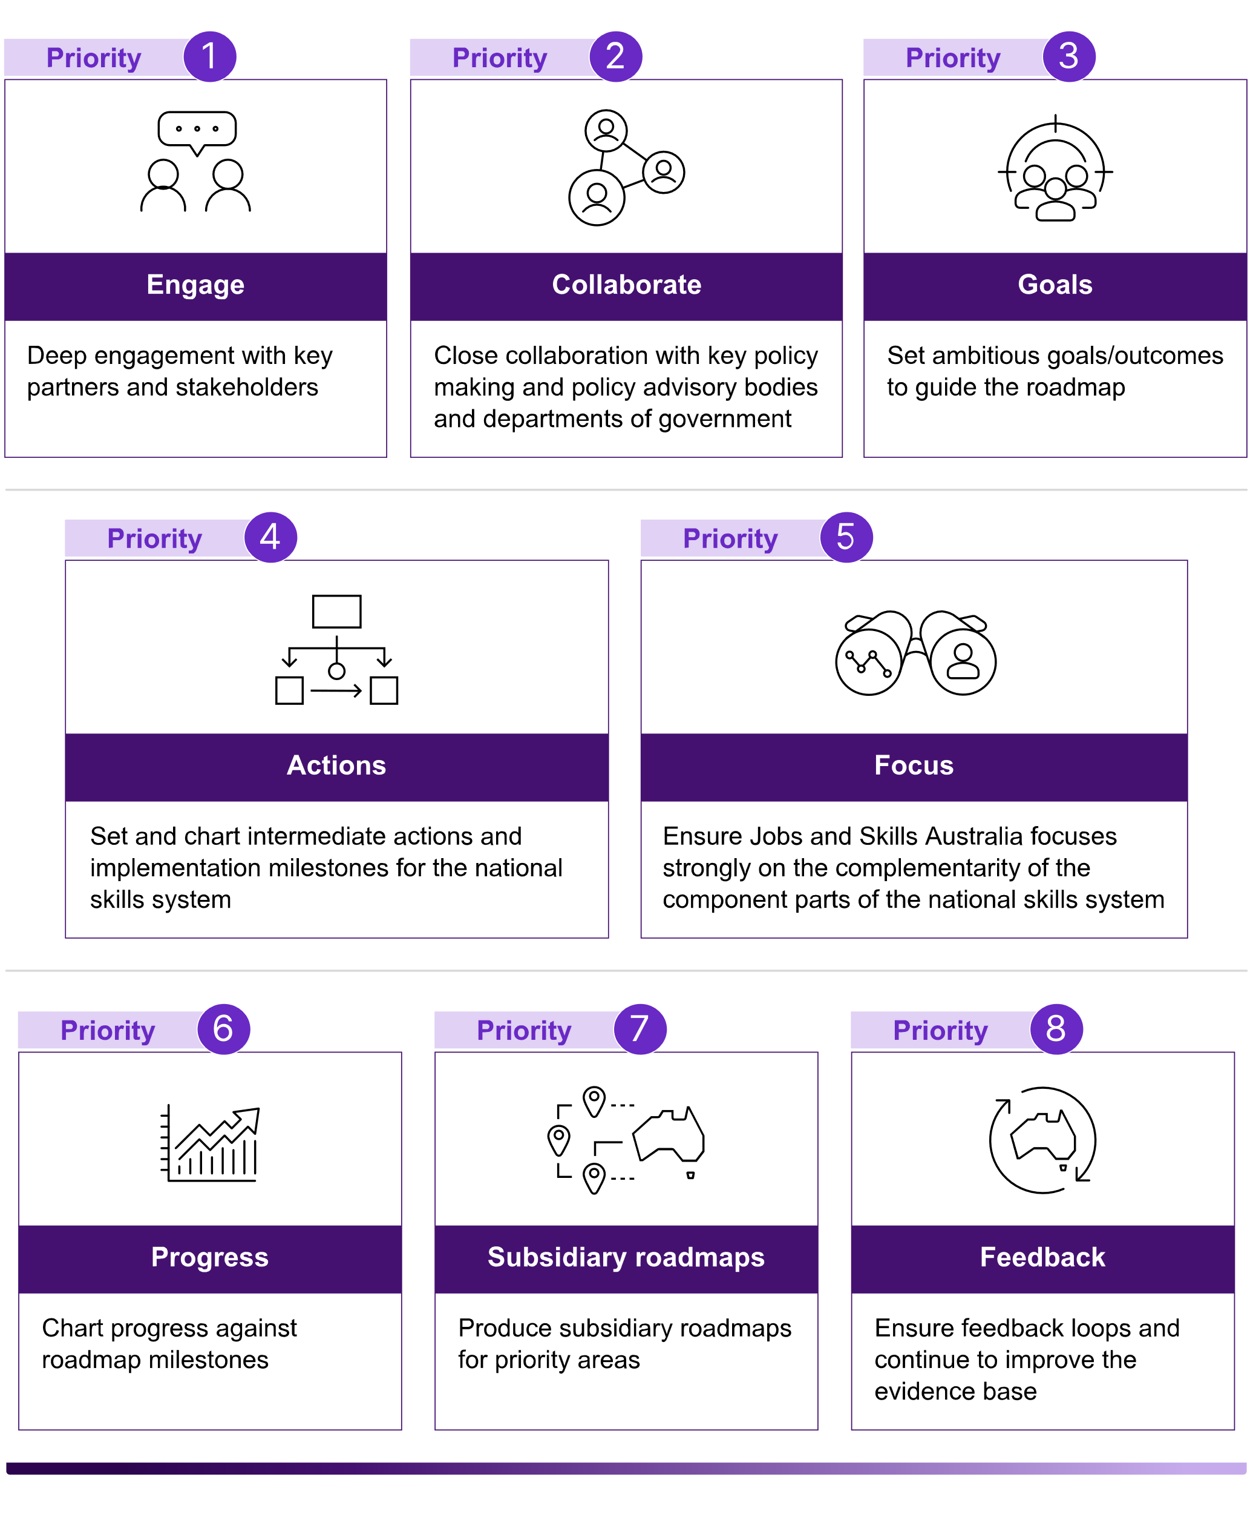

Source: Jobs and Skills Australia

Engagement and collaboration are central to the development and ongoing value of the national jobs and skills roadmap in facilitating a joined-up approach to meeting Australia’s skills needs.

Accordingly, progress towards the roadmap, like all of Jobs and Skills Australia’s work, will embed tripartism. This will ensure both a joined-up approach between the different pillars of the national skills system, and importantly, a joined-up approach between business, unions, government and the education and training sector. Jobs and Skills Australia's tripartite Ministerial Advisory Board will be an important, ongoing and consistent starting point for this approach.

Jobs and Skills Australia’s intention is to coordinate a dialogue with unions, business groups, Jobs and Skills Councils, Australian, state and territory governments, and groups representing specific segments of society, including First Nations people and regional Australians.

The national jobs and skills roadmap will reflect the implementation of the proposed new National Skills Agreement in the VET sector, the Australian Universities Accord in the higher education sector, and the reform of the migration system that is under development. Close collaboration with those parts of the Australian and state and territory governments with responsibility for those reform agendas will be critical. Collaboration with other government agencies such as the new Net Zero Authority, Climate Change Authority, the Productivity Commission and the National Indigenous Australians Agency will also be critical for different aspects of the roadmap, especially subsidiary roadmaps in priority areas.

In this report we have identified 3 important strategic objectives for the Australian population and economy. Confirming such high-level goals in relation to population and labour market outcomes will set an important framework for the roadmap. It will also be important to identify how the national skills system and each of its 3 key pillars make big contributions to the high‑level strategic objectives. This will enable the establishment of immediate and intermediate steps each pillar will progress and to chart their contribution to the high-level objectives. As the reform agendas for the key pillars unfold, progress on these intermediate steps can be mapped.

Jobs and Skills Australia is in a unique position to examine and advise on the interoperability and complementarity of the component parts of the national skills system. This should be a key component of its advice to government and the pillars of the national skills system. Monitoring the interaction of the different policies will be an important priority, as will monitoring the progress of roadmap milestones and their impact and outcomes.

Within the broader national jobs and skills roadmap, it will be important to reflect other priority workforce areas. In this report we have identified roadmap opportunities for workforce issues in priority areas relating to decarbonisation, regional jobs and skills and First Nations workforce. Others will emerge.

A key role for Jobs and Skills Australia is to monitor the progress and success of policies and strategies to meet Australia's skill needs. Jobs and Skills Australia will provide feedback to relevant government agencies on how successful they are, what additional challenges and opportunities might be explored, and explore how strategies and policies might be modified along the way. A key question that will need to be tackled in developing the national jobs and skills roadmap is, how best to monitor progress of the national skills system?

In the coming year, Jobs and Skills Australia will progress a dialogue with stakeholders around possible whole-of-system monitoring approaches to generate feedback for continuous improvement and system optimisation, and drive timely and evidenced-based responses to evolving skills needs.

## Jobs and Skills Australia's work plan

The best available evidence-based advice, both quantitative and qualitative, is needed to enable successful collaborative stewardship of the national skills system. The analysis in this report provides a strong evidentiary foundation for the national jobs and skills roadmap, outlining an initial assessment of system pressures and drivers:

* The assessment of current skills shortages and pressures provides rich intelligence to identify immediate skills priorities and inform coordinated decision making on which lever(s) should be activated to ensure the entire system is aligned to meet current and future skills needs (Chapter 3).
* Over the medium to longer-term the employment projections and workforce studies, like the Clean Energy Workforce Capacity Study, provide a future outlook of the labour market to inform workforce planning, careers information, and assist in preparing and responding effectively for growth and change (Chapter 4 and Chapter 5).

Yet, more can be done to enhance the quality and coverage of this analysis and align it with the information needs of stakeholders across the national skills system. Jobs and Skills Australia is committed to continuous improvement of its analysis and advice, including through further enhancing it with the insights and intelligence of our partners. Jobs and Skills Australia's workplan for 2023–24 outlines a range of projects that will be undertaken over the coming year to contribute to improving the evidence base for a joined-up national skills system. Key projects include workforce capacity studies in priority areas such as early childhood education and care, and food supply chain. Analysis and consultation, as part of the annual work plan development process, will identity further areas for future workforce studies such as the defence industry (Appendix A).

## Conclusion

The national skills system is only one part of the national economy, but it makes a critical contribution driving the economic and social outcomes that we aspire to as a nation.

Navigating the course together and working collaboratively in a joined-up way will see Australia achieve a world-class national skills system – a system that activates the full skills potential of Australians. To assist in catalysing this potential, 14 roadmap opportunities are offered to continue the collaborative dialogue that has begun with all stakeholders in the national skills system towards a national jobs and skills roadmap.

|  |
| --- |
| Potential roadmap opportunities   1. Identifying Australia’s top 20 persistent skill shortages and charting a joined-up approach to solving them, including the respective roles of a range of different levers such as:    * increasing the throughput of qualified workers by increasing intake and/or completion rates of relevant training and education pathways    * enhancing the attributes of graduates of VET and higher education by improving their employability skills and creating greater work experience opportunities    * working with employers and unions and governments to enhance job opportunities through better working conditions, including strategies to tackle gender imbalance in key skill shortage occupations    * supplementing the Australian workforce through well-targeted migration. 2. Continue the dialogue between Jobs and Skills Australia, the states and territories and Jobs and Skills Councils on a nationally consistent approach for labour market and skills forecasting, and improve the coherence of workforce planning across regions and industries. 3. Support the reform of the VET, higher education and migration systems by providing advice and analysis and monitoring achievement of progress against their objectives. This should be done in a way that highlights the synergies between the 3 reform processes. 4. Work with Jobs and Skills Councils to assess how the range of reforms implemented as a result of the National Skills Agreement, the Australian Universities Accord and migration reforms, help meet the skills needs of industry sectors. 5. Identifying the top 10 examples of weak pathways between VET and higher education, where collaboration between VET and higher education, supported by Jobs and Skills Australia and Jobs and Skills Councils, in consultation with business and unions can create a stronger pipeline of skilled graduates. 6. Identifying VET qualifications which if completed alongside higher education qualifications would enhance graduate employability. 7. Supporting the existing process of VET qualifications reform to enhance the adaptability, resilience and employment prospects of VET graduates. 8. Identifying key enhancements in the evidence base that will assist the development of the roadmap and improve our ability to monitor its success, including in relations to the outcomes of learners and workers. For example, expanding the VET National Data Asset into the higher education sector. 9. Supporting the net zero transition challenge by charting a roadmap for education, training and migration to make that transition successful, in partnership with the new Net Zero Authority. 10. Shaping a national skills taxonomy in a collaborative partnership between business, unions, higher education and VET, and the Jobs and Skills Councils, to underpin more joined-up tertiary education system. 11. Develop a regional Australia jobs and skills roadmap to identify the key steps in enhancing regional Australia’s human capital in ways that will ensure success in meeting regional employment opportunities. 12. Co-create a First Nations workforce roadmap in partnership with First Nations people and with key partners in the national skills system. 13. Develop a roadmap for enhancing the prospects of international students playing a significant role in enhancing Australia's skills profile as permanent migrants. 14. Establish a dialogue between Jobs and Skills Australia and the Productivity Commission to identify key elements of the national jobs and skills roadmap that will assist Australia’s productivity growth strategy. |

In parallel, Jobs and Skills Australia will work with partners and stakeholders to progress a range of practical steps, outlined in our workplan for 2023–24, to enhance and expand the analysis and evidence to activate Australia’s skills potential.

The prize for following a successfully joined-up national jobs and skills roadmap is potentially immense: minimising unemployment and underemployment; increasing productivity, participation, real wages and economic growth; and increasing equity and reducing disadvantage.

References

ABS. (2011). *Perspectives on Education and Training: Social Inclusion, 2009*. Retrieved from Australian Bureau of Statistics: https://www.abs.gov.au/ausstats/abs@.nsf/Lookup/4250.0.55.001Main+Features62009

ABS. (2022a). *2021 Census data shows Australia going high tech.* Australian Bureau of Statistics. Retrieved from https://www.abs.gov.au/media-centre/media-releases/2021-census-data-shows-australia-going-high-tech

ABS. (2022b). *Australian Bureau of Statistics 2021 Census: Population and Housing.* Australian Bureau of Statistics.

ABS. (2022c). *Education and training: Census*. Retrieved from Australian Bureau of Statistics: https://www.abs.gov.au/statistics/people/education/education-and-training-census/2021

ABS. (2022d). *Education and Work, Australia.* Australian Bureau of Statistics.

ABS. (2023). LM7 - Labour force status by elapsed years since arrival, main English-speaking countries, sex, state and territory. *Labour Force, Australia, Detailed*. Retrieved from Australian Bureau of Statistics: https://www.abs.gov.au/statistics/labour/employment-and-unemployment/labour-force-australia-detailed/may-2023

ANMF. (2023). *ANMF Priorities 2023*. Retrieved from Australian Nursing and Midwifery Federation: https://www.anmf.org.au/media-campaigns/news/anmf-priorities-2023/

APO. (2021). *Sector Strengthening Plan: Early Childhood Care and Development.* Retrieved from Analysis & Policy Observatory: https://www.closingthegap.gov.au/sites/default/files/2022-10/sector-strengthening-plan-early-childhood-care-development.pdf

Batainah, H., Hawkins, J., & Miranti, R. (2022). *Untapped potential: trends and disparities in the economic participation of migrant and refugee women in Australia.* National Centre for Social and Economic Modelling, Settlement Services International.

Bean, M., & Dawkins, P. (2021). *Review of University-Industry Collaboration in Teaching and Learning.* Canberra: Department of Education, Skills and Employment.

Bell, G., Burgess, J., Thomas, J., & Sadiq, S. (2023). *Rapid Response Information Report: Generative AI - language models (LLMs) and multimodal foundation models (MFMs).* Australian Council of Learned Academies.

Bell, M., Briggs, P., Romanis, J., & MacMaster, J. (2022). *Strengthening the engineering workforce in Australia: Solutions to address the skills shortage in the short, medium, and long term.* Institution of Engineers Australia.

Borland, J. (2022). *Australian women are largely doing the same jobs they've always had, latest data shows*. Retrieved from The Conversation: https://theconversation.com/australian-women-are-largely-doing-the-same-jobs-theyve-always-had-latest-data-shows-195014

Borland, J. (2023). *Why is wage growth so low when the rate of unemployment is 3.5%?* Reserve Bank of Australia.

Bradley, D., Noonan, P., Nugent, H., & Scales, B. (2008). *Review of Australian Higher Education: final report.* Department of Education, Employment and Workplace Relations.

Buchan, J., Catton, H., & Shaffer, F. (2022). *Sustain and Retain in 2022 and Beyond.* Philadelphia: International Centre on Nurse Migration.

CEDA. (2021a). *A good match: Optimising Australia’s permanent skilled migration.* Committee for Economic Development of Australia.

CEDA. (2021b). *Duty of Care: Meeting the Aged Care Workforce Challenge.* Committee for Economic Development of Australia.

Commonwealth of Australia. (2023). *Budget Strategy and Outlook: Budget Paper No.1.* Commonwealth of Australia. Retrieved from https://budget.gov.au/content/bp1/index.htm

ComparED. (n.d.). *Explore and compare institutions and study areas based on real life student experiences*. Retrieved from ComparED: https://www.compared.edu.au/

Dawkins, P. (2014). *Reconceptualising tertiary education: and the case for re-crafting aspects of the Abbott Government's proposed higher education reforms.* Melbourne: Mitchell Institute at Victoria University. Retrieved from https://vuir.vu.edu.au/33672/1/Inaugural_policy_lecture_Reconceptualising_tertiary_education.pdf

Dawkins, P., & Garnaut, R. (2022). Full employment, participation and productivity. In P. Dawkins, & A. A. Payne, *Melbourne Institute Compendium 2022.* Melbourne Institute Applied Economic and Social Research.

Dawkins, P., Hurley, P., & Noonan, P. (2019). *Rethinking and revitalising tertiary education in Australia.* Melbourne: Mitchell Institute at Victoria University .

Department of Education. (2019). *Review of the Australian Qualifications Framework Final Report 2019.* Australian Qualifications Framework.

Department of Education. (2023a). *Australian Universities Accord*. Retrieved from https://www.education.gov.au/australian-universities-accord

Department of Education. (2023b). *Australian Universities Accord Interim Report.* Department of Education.

Department of Education. (2023c). *Student Enrolments Pivot Table 2021.* Retrieved from https://www.education.gov.au/higher-education-statistics/resources/student-enrolments-pivot-table-2021

Department of Education. (2023d). *National Children’s Education and Care Workforce Strategy*. Retrieved from https://www.education.gov.au/early-childhood/early-childhood-workforce/national-childrens-education-and-care-workforce-strategy#toc-about-the-strategy

Department of Home Affairs. (2023a). *Skilled migration program: New Aged Care Industry Labour Agreement*. Retrieved from Department of Home Affairs: https://immi.homeaffairs.gov.au/what-we-do/skilled-migration-program/recent-changes/new-aged-care-industry-labour-agreement

Department of Home Affairs. (2023b). *A Migration System for a More Prosperous and Secure Australia.*

Department of Home Affairs. (2023c). *Review of the Migration System: Final Report.*

DEWR. (2023a). *180,000 Fee-Free TAFE courses now available*. Retrieved from Department of Employment and Workplace Relations: https://www.dewr.gov.au/newsroom/articles/180000-feefree-tafe-courses-now-available-0

DEWR. (2023b). *Australian Apprenticeships Priority List*. Retrieved from Department of Employment and Workplace Relations: https://www.dewr.gov.au/skills-support-individuals/resources/appendix-australian-apprenticeship-priority-list

DEWR. (2023c). *Joint Media Release| 19 May 2023 Communique of meeting of Federal, State and Territory Skills Ministers.* Retrieved from Minister's Media Centre: https://ministers.dewr.gov.au/oconnor/communique-meeting-federal-state-and-territory-skills-ministers-0

DEWR. (2023d). *Media Release| 27 April 2023 Investment of $4.1 billion in skills and training to meet critical economic challenges*. Retrieved from Minister's Media Centre: https://ministers.dewr.gov.au/oconnor/investment-41-billion-skills-and-training-meet-critical-economic-challenges

DEWR. (2023e). *VET Qualification Reform*. Retrieved from Department of Employment and Workplace Relations: https://www.dewr.gov.au/skills-reform/vet-qualification-reform

DEWR. (2023f). *National Skills Agreement: Vision and Principles.* Retrieved from Department of Employment and Workplace Relations: https://www.dewr.gov.au/skills-reform/skills-reform-priorities/national-skills-agreement-vision-and-principles

DEWR. (2023g). *Skills and Workforce Ministerial Council Communique-25 August 2023.* Retrieved from Department of Employment and Workplace Relations: https://www.dewr.gov.au/skills-commonwealth-state-relations/resources/skills-and-workforce-ministerial-council-communique-25-august-2023

DSO. (2023). *Growing Australia’s digital workforce.* Digital Skills Organisation.

Duckworth, P., Graham, L., & Osbourne, M. (2019). Inferring Work Task Automatability from AI Expert Evidence. *AAAI/ACM.*

Fair Work Ombudsman. (2023). *15% wage increase for aged care sector*. Retrieved from Fair Work Ombudsman: https://www.fairwork.gov.au/newsroom/news/15-per-cent-wage-increase-aged-care-sector

Gmyrek, P., Berg, J., & Bescond, D. (2023). Generative AI and Jobs: A global analysis of potential effects on job quantity and quality. *ILO Working Paper 96*.

Gonski, D., & Shergold, P. (2021). *In the same sentence: Bringing higher and vocational education together.* Sydney: NSW Department of Education and Training.

Hambur, J. (2023). *Did labour market concentration lower wages growth pre-COVID?* Canberra: The Australian Government: The Treasury. Retrieved from https://treasury.gov.au/sites/default/files/2023-03/p2023-368379.pdf

Heath, A. (2020). *Skills, Technology and the Future of Work.* Reserve Bank of Australia.

Hurley, P., Matthews, H., & Pennicuik, S. (2022). *Deserts and oases: How accessible is childcare in Australia?* Melbourne: Mitchell Institute at Victoria University.

Infrastructure Australia. (2022). *Infrastructure Market Capacity: 2022 Report.* Infrastructure Australia. Retrieved from https://www.infrastructureaustralia.gov.au/sites/default/files/2022-12/20221219_IA_Market-Capacity-Report_LR.pdf

JSA. (2023a). *Clean Energy Capacity Study: Interim Report.* Jobs and Skills Australia.

JSA. (2023b). *First Nations People Workforce Analysis.* Jobs and Skills Australia.

JSA. (2023c). *Labour Market Update: August 2023.* Jobs and Skills Australia.

JSA. (2023d). *Labour Market Update: February 2023.* Canberra: Jobs and Skills Australia. Retrieved from Jobs and Skills Australia: https://www.jobsandskills.gov.au/reports/labour-market-update-december-2022

JSA. (2023e). *Labour Market Update: May 2023.* Jobs and Skills Australia.

JSA. (2023f). *Skills Shortage Quarterly: June 2023.* Jobs and Skills Australia.

JSA. (2023g). *Skills Shortage Quarterly: March 2023.* Jobs and Skills Australia.

JSA. (2023h). *Vocational education and training in regional, rural and remote Australia.* Jobs and Skills Australia.

Leal, H. (2019). Firm-level Insights into Skill Shortages and Wages Growth. *Bulletin March 2019: Reserve Bank of Australia*. Retrieved from https://www.rba.gov.au/publications/bulletin/2019/mar/pdf/firm-level-insights-into-skills-shortages-and-wages-growth.pdf

Lowe, P. (2023). *A Narrow Path: Address at the Morgan Stanley 5th Australia Summit*. Retrieved from Reserve Bank of Australia: https://www.rba.gov.au/speeches/2023/sp-gov-2023-06-07.html

Martin, P. (2022). *Why unemployment is set to stay below 5% for years to come*. Retrieved from The Conversaation: https://theconversation.com/why-unemployment-is-set-to-stay-below-5-for-years-to-come-188705

NCVER. (2016). *The development of Australia’s national training system: a dynamic tension between consistency and flexibility.* Adelaide: NCVER. Retrieved from https://www.ncver.edu.au/__data/assets/file/0020/17138/development-of-aust-training-system-2849.pdf

NCVER. (2022a). *VET qualification completion rates, 2021.* Adelaide: NCVER (National Centre for Vocational Education Research).

NCVER. (2022b). *VET student outcomes 2022.* Adelaide: NCVER.

NCVER. (2023a). *Data Builder Total VET students and courses 2022: program enrolments*. Retrieved from NCVER: https://www.ncver.edu.au/research-and-statistics/publications/all-publications/total-vet-students-and-courses-2022

NCVER. (2023b). *Total VET students and courses 2022.* Adelaide: NCVER. Retrieved from National Centre for Vocational Education Research: https://www.ncver.edu.au/research-and-statistics/visualisation-gallery/latest-vet-statistics

Noonan, P. (2016). *A new system for financing Australian tertiary education.* Melbourne: Mitchell Institute at Victoria University.

Norton, A., Cherastidtham, I., & Mackey, W. (2018). *Mapping Australian higher education 2018.* Grattan Institute.

NSC. (2021a). *Care Workforce Labour Market Study Final Report.* National Skills Commission. Retrieved from https://www.nationalskillscommission.gov.au/sites/default/files/2022-10/Care%20Workforce%20Labour%20Market%20Study.pdf

NSC. (2021b). *State of Australia's Skills 2021: now and into the future.* National Skills Commission.

NSC. (2022). *2022 Skills Priority Key Findings Report.* National Skills Commission.

NSW Government. (2019). *NSW Government Submission to the Australian Qualifications Framework Review.*

Nugent, T. (2023). *Australian Markets Weekly.* National Australia Bank.

OECD. (2011). *Skills for Innovation and Research.* Organisation for Economic Co-operation and Development Publishing.

OECD. (2017). *Building Skills for All in Australia: Policy Insights from the Survey of Adult Skills.* Organisation for Economic Co-operation and Development Publishing.

OECD. (2021). *Health at a Glance 2021: OECD Indicators.* Organisation for Economic Co-operation and Development Publishing.

OECD. (2022). *OECD Economic Outlook, Interim Report September 2022: Paying the Price of War.* Organisation for Economic Co-operation and Development Publishing.

PALM. (2022). *Working in Aged Care.* Pacific Australia Labour Mobility.

Parliament of Australia. (2023a). *Submissions: Inquiry into the Perceptions and Status of Vocational Education and Training*. Retrieved from Parliament of Australia: https://www.aph.gov.au/Parliamentary_Business/Committees/House/Employment_Education_and_Training/VETInquiry/Submissions

Parliament of Australia. (2023b). *Terms of Reference: Inquiry into the Perceptions and Status of Vocational Education and Training*. Retrieved from Parliament of Australia: https://www.aph.gov.au/Parliamentary_Business/Committees/House/Employment_Education_and_Training/VETInquiry/Terms_of_Reference

PM&C. (2019). *Strengthening Skills: Expert Review of Australia’s Vocational Education and Training System.* Department of the Prime Minister and Cabinet. Retrieved from https://www.pmc.gov.au/publications/strengthening-skills-expert-review-australias-vocational-education-and-training-system

PM&C. (2023a). *Draft National Care and Support Economy Strategy 2023*. Retrieved from Department of the Prime Minister and Cabinet: https://www.pmc.gov.au/sites/default/files/resource/download/draft-national-care-and-support-economy-strategy-2023.pdf

PM&C. (2023b). *Draft National Strategy for the Care and Support Economy.* Department of Prime Minister and Cabinet. Retrieved from https://www.pmc.gov.au/resources/draft-national-strategy-care-and-support-economy/introduction-care-and-support-australia

Productivity Commission. (2020). *National Agreement for Skills and Workforce Development Review, Study Report.* Australian Government: Productivity Commission.

Productivity Commission. (2021). *Working from home: Research paper.* Australian Government: Productivity Commission.

Productivity Commission. (2023a). *5-year Productivity Inquiry: Australia's data and digital dividend.* Australian Government: Productivity Commission. Retrieved from https://www.pc.gov.au/inquiries/completed/productivity/report/productivity-volume4-data-digital-dividend.pdf

Productivity Commission. (2023b). *Early childhood education and care*. Retrieved from Australian Government: Productivity Commission: https://www.pc.gov.au/inquiries/current/childhood#draft

Professionals Australia. (2023). *Australia faces engineering skills crisis by 2040.* [Media Release]. Retrieved from Professionals Australia: https://www.professionalsaustralia.org.au/PA/Latest_News/Australia_faces_engineering_skills_crisis-by_2040.aspx

Queensland Training Ombudsman. (2022). *Review of support provided to Queensland Apprentices and Trainees, with a focus on female apprentices in male dominated occupations.*

RBA. (1978). *RDP 1978-02: Unemployment: An Econometric Dissection; The Labour Market: Some Facts and Figures*. Retrieved from Reserve Bank of Australia: https://www.rba.gov.au/publications/rdp/1978/7802/the-labour-market-some-facts-and-figures.html

Richardson, S. (2007). *What is skills shortage?* Adelaide: NCVER. Retrieved from https://www.ncver.edu.au/__data/assets/file/0019/7282/what-is-skill-shortage-4022.pdf

Tech Council of Australia. (2023). *Australia’s Generative AI opportunity.* Tech Council of Australia. Retrieved from https://techcouncil.com.au/wp-content/uploads/2023/07/230714-Australias-Gen-AI-Opportunity-Final-report-vF4.pdf

TEQSA. (n.d.). *National Register*. Retrieved from Tertiary Education Quality and Standards Agency: https://www.teqsa.gov.au/national-register

The Treasury. (2021). *Estimating the NAIRU in Australia.* Canberra: The Australian Government: The Treasury.

The Treasury. (2023a). *Employment White Paper.* Canberra: Australian Government: The Treasury.

The Treasury. (2023b). *Intergenerational Report 2023: Australia’s future to 2063.* Canberra: Australian Government: The Treasury.

The Treasury. (2023c). *Turbocharging TAFE Centres of Exellence and accelerating apprenticeships*. Retrieved from The Hon Dr Jim Chalmers MP Media Releases: https://ministers.education.gov.au/oconnor/turbocharging-tafe-centres-excellence-and-accelerating-apprenticeships

Victoria University. (2023). *Centre of Policy Studies.* [Economic Modelling].

# Glossary

|  |  |
| --- | --- |
| **ABS** | **Australian Bureau of Statistics** |
| **AI** | Artificial Intelligence |
| **ANZSCO** | Australian and New Zealand Standard Classification of Occupations |
| **AQF** | Australian Qualifications Framework |
| **ASC** | Australian Skills Classification |
| **ATO** | Australian Tax Office |
| **CALD** | Culturally and Linguistically Diverse |
| **CEDA** | Committee for Economic Development of Australia |
| **CGE** | Computable general equilibrium |
| **CoPS** | Victoria University Centre of Policy Studies |
| **COVID-19** | Coronavirus disease 2019 |
| **CSAM** | Continuous Survey of Australia's Migrants |
| **DEWR** | Department of Employment and Workplace Relations |
| **DSO** | Digital Skills Organisation |
| **DSS** | Department of Social Services |
| **ECEC** | Early childhood education and care |
| **FTE** | Full-time equivalent |
| **GDP** | Gross domestic product |
| **HECS** | Higher Education Contribution Scheme |
| **HEIMS** | Higher Education Information Management System |
| **HELP** | Higher Education Loan Program |
| **ICT** | Information and communications technology |
| **IT** | Information technology |
| **IVI** | Internet Vacancy Index |
| **JEDI** | Jobs and Education Data Infrastructure |
| **JSA** | Jobs and Skills Australia |
| **JSC** | Jobs and Skills Council |
| **Lightcast** | A source of online job advertisements |
| **MADIP** | Multi-Agency Data Integration Project |
| **MESC** | Main English Speaking Countries |
| **NAIRU** | Non-accelerating inflation rate of unemployment |
| **NASWD** | National Agreement for Skills and Workforce Development |
| **NEC or nec** | Not elsewhere classified |
| **NCI** | National Careers Institute |
| **NCVER** | National Centre for Vocational Education Research |
| **NSA** | National Skills Agreement |
| **NSC** | National Skills Commission |
| **OECD** | Organisation for Economic Co-operation and Development |
| **OTMESC** | Other Than Main English Speaking Countries |
| **PALM** | Pacific Australia Labour Mobility |
| **PM&C** | Department of Prime Minister and Cabinet |
| **RBA** | Reserve Bank of Australia |
| **REZ** | Renewable Energy Zone |
| **RTO** | Registered training organisation |
| **SERA** | Survey of Employers who have Recently Advertised |
| **SPL** | Skills Priority List |
| **STEM** | Science, technology, engineering and mathematics |
| **TAFE** | Technical and Further Education |
| **TEQSA** | Tertiary Education Quality and Standards Agency |
| **The Accord** | Australian Universities Accord |
| **TSMIT** | Temporary Skilled Migration Income Threshold |
| **TRA** | Trades Recognition Australia |
| **VET** | Vocational Education and Training |
| **VNDA** | VET National Data Asset |
| **VUEF** | Victoria University Employment Forecasting Model |

# Appendix A

## Jobs and Skills Australia 2023–24 work plan

The Jobs and Skills Australia work plan focuses on providing high-quality independent advice to underpin Australia’s response to current, emerging and future workforce, skills and training needs. Each annual work plan will set out the key outcomes and priorities for the financial year.

The table below outlines the priorities for 2023-24, mapped against the national jobs and skills roadmap elements:

identifying system pressures and drivers

system reform

system implementation

system monitoring and feedback.

|  |  |  |  |
| --- | --- | --- | --- |
| **Annual Jobs and Skills Report** *Analysis and advice on the short, medium and long-term skills needs of the Australian economy and how they could be met* | | | |
| The annual **Jobs and Skills Report** will bring together our analysis and advice on Australia’s jobs and skills needs. | Badge 1 with solid fillBadge with solid fillBadge 3 with solid fillBadge 4 with solid fill | Published by October 2023 | |
| **Checklist with solid fillStrategic advice and deliverables** *Strategic advice on the national skills system, including our major in-depth studies and input into policy processes* | | | |
| Undertaking **capacity studies** of national significance for the labour market and the national skills system, including a focus on regional, rural and remote aspects, and cohort-specific issues: |  |  | |
| * the [National Study of Adult Literacy, Numeracy and Digital Skills](https://www.jobsandskills.gov.au/consultations/foundation-skills-discussion-paper) to assess the current foundation skills across Australia | Badge 1 with solid fillBadge 4 with solid fill | Study commenced as part of 2022-23 work plan and will continue in 2023-24, with initial findings by end 2024 | |
| * the [Clean Energy Capacity Study](https://www.jobsandskills.gov.au/work/clean-energy-capacity-study) to examine the workforce that Australia needs to transition to a clean energy economy | Badge 1 with solid fillBadge 4 with solid fill | Ongoing into first quarter of 2023-24, with a final report by September 2023 | |
| * anearly childhood education and care (ECEC) workforce capacity study | Badge 1 with solid fillBadge 4 with solid fill | July 2023 – March 2024 | |
| * food supply chain capacity study. | Badge 1 with solid fillBadge 4 with solid fill | January 2024 – June 2024 | |
| Delivering studies on priority **cohorts** including in key industries and including a focus on regional, rural and remote aspects, and cohort-specific issues: |  |  | |
| * Vocational education and training (VET) workforce | Badge 1 with solid fillBadge 4 with solid fill | July 2023 – December 2023 | |
| * International student pathways and outcomes. | Badge 1 with solid fillBadge 4 with solid fill | October 2023 – June 2024 | |
| Making significant contributions to shape **national projects**.This includes: |  | Ongoing through 2023-24 and beyond | |
| * responding to any **new priorities** in the 2023‑24 Budget and the Mid-Year Economic and Fiscal Outlook | Badge 1 with solid fillBadge with solid fillBadge 3 with solid fillBadge 4 with solid fill | Details to be determined | |
| * supporting the [National Skills Agreement](https://www.dewr.gov.au/skills-reform/national-skills-agreement-vision-and-principles) process; with an option to co-design a performance framework for the VET system to support the National Skills Agreement | Badge 1 with solid fillBadge with solid fillBadge 3 with solid fillBadge 4 with solid fill | Commenced as part of 2022-23 work plan and ongoing through 2023-24 | |
| * follow on work from the [Employment White Paper](https://treasury.gov.au/review/employment-whitepaper), [Review of the Migration System](https://www.homeaffairs.gov.au/reports-and-publications/reviews-and-inquiries/departmental-reviews/migration-system-for-australias-future) and [Universities Accord](https://www.education.gov.au/australian-universities-accord) processes. | Badge 1 with solid fillBadge with solid fillBadge 3 with solid fillBadge 4 with solid fill | Details to be determined | |
| Strengthening our **partnerships with Jobs and Skills** **Councils** **(JSCs)** and collaboration with the **states and territories**, including by: | Badge 1 with solid fillBadge 3 with solid fillBadge 4 with solid fill | Ongoing through 2023-24 and beyond | |
| * providing a platform to share workforce planning and training data with Jobs and Skills Councils and settling a regular cadence of engagement between JSA and JSCs | Badge 1 with solid fillBadge 3 with solid fillBadge 4 with solid fill |
| * pursuing opportunities to better integrate our data into state and territory analysis and products, including providing a platform for data sharing with states and territories | Badge 1 with solid fillBadge 3 with solid fillBadge 4 with solid fill |
| * better integrating state and territory information into our products such as the Skills Priority List | Badge 1 with solid fillBadge 4 with solid fill |
| * a joint project with the Finance, Technology and Business Jobs and Skills Council to define digital skills and pilot measuring them in the workplace | Badge 1 with solid fillBadge 4 with solid fill |
| * a joint project with the Northern Territory Government on measuring foundation skills in First Nations communities | Badge 1 with solid fillBadge 4 with solid fill |
| * a project with the Victorian Skills Authority using a skills approach to analyse VET to employment pathways. | Badge 1 with solid fillBadge 4 with solid fill |
| **Supply And Demand with solid fillLabour market and skills analysis and products** *Ongoing and regular publications, including analysis of labour markets, skills needs and skills shortages* | | | |
| Refining approaches to delivery of legislative functions and developing approaches for **new functions in the *Jobs and Skills Australia Amendment Act 2023*** – including on the impact of work arrangements and insecure work, and labour market imbalances. | Badge 1 with solid fillBadge 4 with solid fill | Ongoing through 2023-24 and beyond | |
| Continuing to deliver **analysis of the labour market**, including the following **regular releases** –including a focus on regional, rural and remote aspects, and cohort-specific issues: | Badge 1 with solid fillBadge 4 with solid fill | **Frequency** | **Publication timing** |
| * Nowcast of Employment by Region and Occupation | Badge 1 with solid fillBadge 4 with solid fill | Monthly | ~Week 1 of each month |
| * Labour Market Dashboards | Badge 1 with solid fillBadge 4 with solid fill | Monthly | ~Week 2-3 of each month |
| * Recruitment Insights Report | Badge 1 with solid fillBadge 4 with solid fill | Monthly | ~Week 3 of each month |
| * Internet Vacancy Index | Badge 1 with solid fillBadge 4 with solid fill | Monthly | ~Week 3-4 of each month |
| * Small Area Labour Markets | Badge 1 with solid fillBadge 4 with solid fill | Quarterly | September, December, March, June |
| * Australian Labour Market for Migrants | Badge 1 with solid fillBadge 4 with solid fill | Quarterly | July, October, January, April |
| * Skills Shortage Quarterly. | Badge 1 with solid fillBadge 4 with solid fill | Quarterly | August, November, February, May |
| Progressing detailed analysis of **skills and skills needs**, including through the: | Badge 1 with solid fillBadge 4 with solid fill | **Frequency** | **Publication timing** |
| * Quarterly Labour Market Update | Badge 1 with solid fillBadge 4 with solid fill | Quarterly | August, November, February, May |
| * Skills Priority List | Badge 1 with solid fillBadge 4 with solid fill | Yearly | September |
| * 5-yearly employment projections | Badge 1 with solid fillBadge 4 with solid fill | Yearly | November/December |
| * National skills taxonomy project. | Badge 1 with solid fillBadge 4 with solid fill | Ongoing throughout 2023-24 and beyond | |
| **Building Brick Wall with solid fillExpanding the evidence base** *Ongoing research and development to enhance advice, drive continuous innovation and improvement, develop new intellectual property and address data gaps* | | | |
| **Expanding our capability** on the labour market and skills outlook across industries, occupations, regions, and cohorts. Priorities also include development of: | Badge 1 with solid fillBadge 4 with solid fill | Ongoing through 2023-24 and beyond | |
| * a national skills supply and demand framework to assess the demand and supply of skills across the economy over time | Badge 1 with solid fillBadge 4 with solid fill | Details to be determined – the specific projects in this area will be developed with partners and stakeholders; new areas for expanding the evidence may also be identified based on these consultations – to be implemented as our resourcing capacity allows | |
| * search and matching model to understand how well the labour market is matching supply and demand | Badge 1 with solid fillBadge 4 with solid fill |
| * analysis of VET and Higher Education outcomes, transitions and career pathways (combining Jobs and Education Data Infrastructure model with real-world transitions from administrative data) | Badge 1 with solid fillBadge 4 with solid fill |
| * development of further outputs based on the VET National Data Asset (for example, on student outcomes), and scoping a Higher Education Data Asset | Badge 1 with solid fillBadge 4 with solid fill |
| * utilising the Skills Tracker linked dataset to analyse labour market transitions for occupations, regions and cohorts | Badge 1 with solid fillBadge 4 with solid fill |
| * emerging occupations analysis, including analysis of real-time data on job advertisements | Badge 1 with solid fillBadge 4 with solid fill |
| * cognitive skills research and analysis | Badge 1 with solid fillBadge 4 with solid fill |
| * integrated analysis of employment and related formal training by gender | Badge 1 with solid fillBadge 4 with solid fill |
| * developing and publishing a framework for assessing the relative strength of regional labour markets | Badge 1 with solid fillBadge 4 with solid fill |
| * more detailed region-specific analysis that integrates labour market outcomes, labour demand and income volatility. | Badge 1 with solid fillBadge 4 with solid fill |
| **Gears with solid fillEnabling activities** *Enterprise systems and enabling activities to support strategic and effective operations* | | | |
| Operationalising the functions and responsibilities in the permanent legislative model following passage of the ***Jobs and Skills Australia Amendment Act 2023***. | Badge 1 with solid fillBadge 4 with solid fill | Ongoing through 2023-24 and beyond | |
| * This includes investing in **deepening our engagement** and outreach and onboarding the proposed Ministerial Advisory Board. | Badge 1 with solid fillBadge 4 with solid fill | Details to be determined | |
| Ensure our **governance and data sharing** are fit for purpose in a tripartite arrangement, including expansion of data access and digital products to reflect user requirements and legislative functions. | Badge 1 with solid fill | Ongoing through 2023-24 and beyond | |

# Appendix B

First Nations workforce analysis

First Nations People Workforce Analysis report

First Nations people make diverse and important contributions to Australia’s workforce and are leading the way at the pinnacle of many sectors, but unacceptable gaps persist in education and employment outcomes at the population level. First Nations people continue to face additional barriers to work, and study compared to other Australians.

In June 2023, Jobs and Skills Australia released the First Nations People Workforce Analysis report (JSA, 2023b). The report uses administrative data to piece together new information on First Nations education and employment outcomes, to aid conversations about supporting First Nations people to thrive in Australia’s workforce.

The report found that the gap is in favour of First Nations people when it comes to the bounce back of the employment index post COVID-19. While employment losses were higher early in the pandemic, the number of First Nations people in employment rose more quickly than in the wider workforce (Figure 32). The rise in employment in the Public Administration sector and lower reliance in hospitality jobs has contributed to this positive impact.

Figure 32: First Nations and non-Indigenous employment index from February 2020 to May 2022

|  |  |  |  |  |  |  |  |  |  |  |  |  |  |  |  |  |  |  |  |  |  |  |  |  |  |  |  |  |  |  |  |  |  |  |  |  |  |  |  |  |  |  |  |  |  |  |  |  |  |  |  |  |  |  |  |  |  |  |  |  |  |  |
| --- | --- | --- | --- | --- | --- | --- | --- | --- | --- | --- | --- | --- | --- | --- | --- | --- | --- | --- | --- | --- | --- | --- | --- | --- | --- | --- | --- | --- | --- | --- | --- | --- | --- | --- | --- | --- | --- | --- | --- | --- | --- | --- | --- | --- | --- | --- | --- | --- | --- | --- | --- | --- | --- | --- | --- | --- | --- | --- | --- | --- | --- | --- |
| date | 27/02/2020 | 05/03/2020 | 12/03/2020 | 19/03/2020 | 26/03/2020 | 02/04/2020 | 09/04/2020 | 16/04/2020 | 23/04/2020 | 30/04/2020 | 07/05/2020 | 14/05/2020 | 21/05/2020 | 28/05/2020 | 04/06/2020 | 11/06/2020 | 18/06/2020 | 25/06/2020 | 02/07/2020 | 09/07/2020 | 16/07/2020 | 23/07/2020 | 30/07/2020 | 06/08/2020 | 13/08/2020 | 20/08/2020 | 27/08/2020 | 03/09/2020 | 10/09/2020 | 17/09/2020 | 24/09/2020 | 01/10/2020 | 08/10/2020 | 15/10/2020 | 22/10/2020 | 29/10/2020 | 05/11/2020 | 12/11/2020 | 19/11/2020 | 26/11/2020 | 03/12/2020 | 10/12/2020 | 17/12/2020 | 24/12/2020 | 31/12/2020 | 07/01/2021 | 14/01/2021 | 21/01/2021 | 28/01/2021 | 04/02/2021 | 11/02/2021 | 18/02/2021 | 25/02/2021 | 04/03/2021 | 11/03/2021 | 18/03/2021 | 25/03/2021 | 01/04/2021 | 08/04/2021 | 15/04/2021 | 22/04/2021 | 29/04/202106/05/2021 13/05/2021 20/05/2021 27/05/2021 03/06/2021 10/06/2021 17/06/2021 24/06/2021 01/07/2021 08/07/2021 15/07/2021 22/07/2021 29/07/2021 05/08/2021 12/08/2021 19/08/2021 26/08/2021 02/09/2021 09/09/2021 16/09/2021 23/09/2021 30/09/2021 07/10/2021 14/10/2021 21/10/2021 28/10/2021 04/11/2021 11/11/2021 18/11/2021 25/11/2021 02/12/2021 09/12/2021 16/12/2021 23/12/2021 30/12/2021 06/01/2022 13/01/2022 20/01/2022 27/01/2022 03/02/2022 10/02/2022 17/02/2022 24/02/2022 03/03/2022 10/03/2022 17/03/2022 24/03/2022 31/03/2022 07/04/2022 14/04/2022 21/04/2022 28/04/2022 05/05/2022 |
| First Nations | 100.0 | 101.0 | 100.7 | 100.5 | 98.2 | 96.6 | 93.1 | 92.1 | 92.1 | 92.5 | 92.5 | 93.0 | 93.0 | 93.7 | 94.9 | 95.3 | 95.8 | 97.7 | 100.5 | 99.7 | 99.4 | 100.0 | 100.1 | 100.7 | 100.3 | 100.7 | 100.8 | 101.6 | 101.5 | 102.1 | 102.1 | 102.6 | 102.0 | 103.1 | 103.5 | 104.2 | 104.6 | 105.1 | 105.7 | 106.4 | 107.1 | 107.3 | 106.4 | 104.3 | 99.5 | 100.4 | 102.1 | 103.6 | 104.3 | 105.8 | 106.1 | 107.0 | 107.1 | 108.0 | 107.8 | 108.2 | 108.0 | 108.4 | 107.9 | 108.5 | 108.6 | 109.2109.8 110.1 110.2 110.7 111.0 111.2 111.7 112.0 113.2 111.5 110.8 110.7 110.1 110.6 110.2 109.6 108.3 108.5 109.2 110.3 110.1 110.1 109.9 111.1 112.0 112.7 113.0 113.2 113.6 113.9 114.2 114.2 113.4 111.4 106.2 105.3 106.8 108.2 108.6 109.9 110.0 110.2 109.7 110.6 110.4 110.9 110.4 110.6 110.3 110.0 109.0 109.8 110.2 |
| Non-Indigenous | 100.0 | 101.0 | 100.5 | 100.5 | 98.8 | 98.0 | 95.2 | 94.6 | 94.6 | 95.2 | 95.2 | 95.7 | 95.7 | 96.3 | 97.4 | 97.6 | 97.9 | 99.1 | 102.7 | 102.0 | 101.7 | 102.0 | 102.0 | 102.6 | 102.0 | 102.1 | 101.9 | 102.7 | 102.3 | 102.7 | 102.6 | 103.1 | 102.1 | 102.8 | 102.8 | 103.2 | 103.6 | 103.9 | 104.2 | 104.4 | 105.0 | 105.1 | 104.7 | 103.6 | 100.5 | 100.9 | 101.9 | 102.8 | 103.2 | 104.4 | 104.2 | 104.7 | 104.8 | 105.5 | 105.0 | 104.9 | 104.8 | 105.4 | 104.7 | 104.8 | 104.8 | 105.0105.6 105.5 105.4 105.4 105.7 105.4 105.7 105.9 108.0 106.1 105.7 105.4 104.6 105.1 104.4 103.9 102.8 102.8 103.0 103.5 103.5 103.3 103.2 104.4 105.1 105.9 106.5 106.5 106.7 106.9 107.4 107.1 106.6 105.4 102.3 101.9 102.4 103.4 103.7 105.0 104.4 104.4 103.7 104.6 104.6 104.8 104.2 104.3 104.3 104.0 103.0 103.5 104.1 |

Source: MADIP 2022: Single Touch Payroll data, ABN information sourced from the ABS Business Register  
Note: Only the primary ABN employer-employee is counted here to avoid double-counting those with multiple jobs. Some of the peaks in December and dips in January 2020 and 2021 may be related to altered patterns of reporting over Christmas.

The difference between First Nations and non-Indigenous employment is significant but less so for females than males (Figure 33). For example, the difference was 17% for First Nations females compared to 23% for First Nations males aged 15–24.

Figure 33: Difference between First Nations and non-Indigenous employment rates for gender by age

|  |  |  |  |
| --- | --- | --- | --- |
|  | First Nations | Non-Indigenous | Difference |
| Females 15-24 | 76 | 93 | 17 |
| Males 15-24 | 69 | 92 | 23 |
| Females 25-34 | 75 | 94 | 19 |
| Males 25-34 | 60 | 90 | 30 |
| Females 35-64 | 70 | 92 | 22 |
| Males 35-64 | 66 | 89 | 23 |

|  |  |
| --- | --- |
|  |  |

Source: MADIP: DOMINO (2022), STP (2022)

On the education side, First Nations people with qualifications in high-demand fields were likely to be employed and to be working in a role directly relevant to their study. For example, 71% of First Nations people who studied Education were employed in an occupation which utilised these skills (Figure 34).

Figure 34: First Nations and non-Indigenous people working in occupations related to their studies

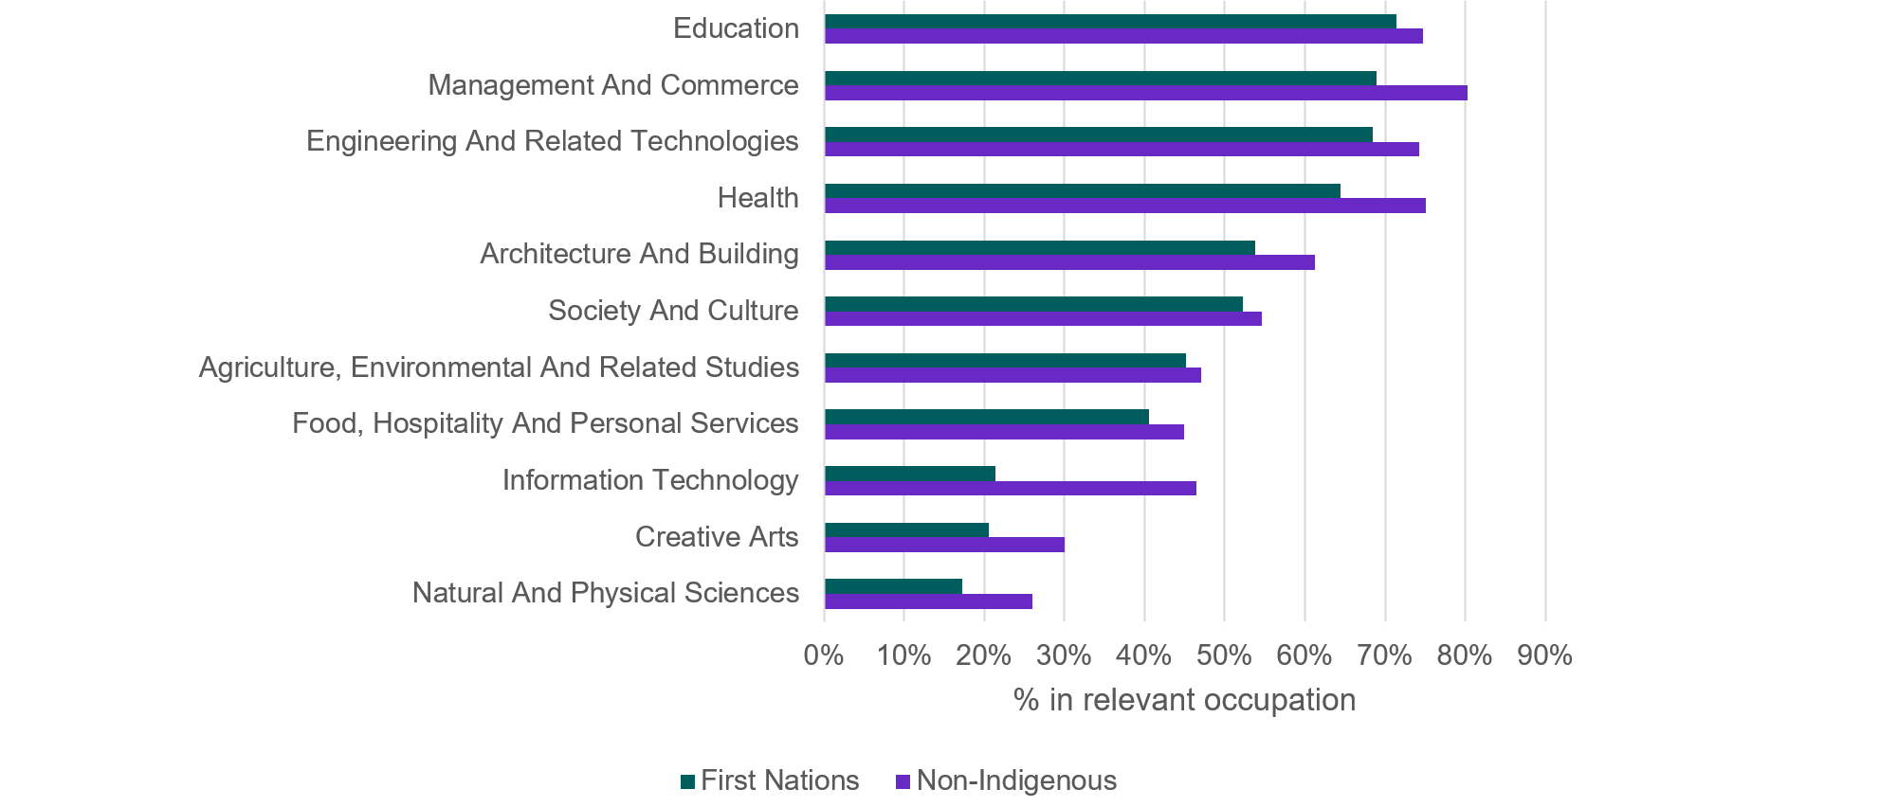

|  |  |  |
| --- | --- | --- |
|  | Non-Indigenous | First Nations |
| Natural And Physical Sciences | 25.9% | 17.3% |
| Creative Arts | 30.0% | 20.6% |
| Information Technology | 46.4% | 21.3% |
| Food, Hospitality And Personal Services | 44.9% | 40.5% |
| Agriculture, Environmental And Related Studies | 47.0% | 45.2% |
| Society And Culture | 54.7% | 52.3% |
| Architecture And Building | 61.2% | 53.7% |
| Health | 75.1% | 64.5% |
| Engineering And Related Technologies | 74.2% | 68.5% |
| Management And Commerce | 80.3% | 68.9% |
| Education | 74.8% | 71.4% |

Source: MADIP Census (2016), Total VET Activity (2017–2020), HEIMS (2017–2019), ATO Tax Records (2019–20), JEDI Occupation-Field of Education concordance, Occupation – Field of Education concordance

On the other hand, First Nations people who had studied Information Technology were unlikely be working in this field. This was likely because over a third had completed Certificate II level training or below, which may be insufficient for many entry-level jobs in the sector (Figure 35).

Figure 35: Level of education for people who had studied an IT qualification

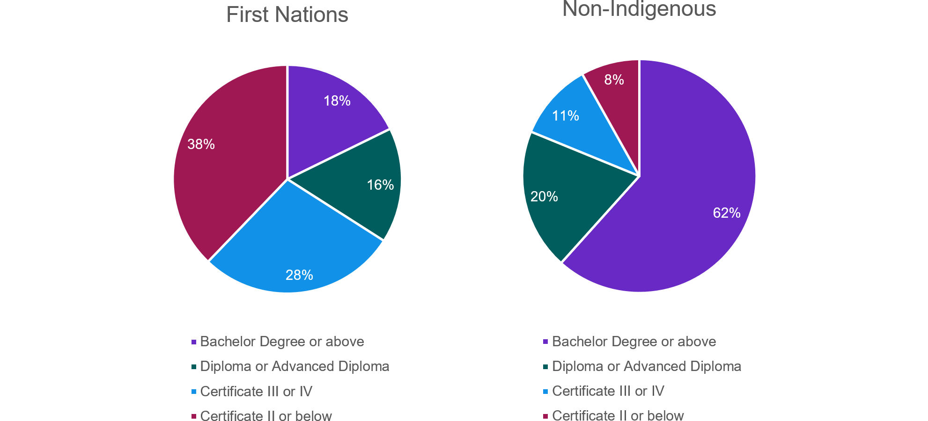

|  |  |  |
| --- | --- | --- |
|  | Non-Indigenous | First Nations |
| Bachelor Degree or above | 61.6% | 17.7% |
| Diploma or Advanced Diploma | 19.6% | 16.3% |
| Certificate III or IV | 10.7% | 28.1% |
| Certificate II or below | 8.1% | 37.8% |

Source: MADIP Census (2016), Total VET Activity (2017–2020), HEIMS (2017–2019), DSS Combined Demographics (2021)

Analysis based on administrative data has its limitations, including size and complexity, and the inability to measure important skills like cultural knowledge and resilience. When interpreting results, it is important to note many First Nations people face individual and systemic barriers which affect their education and employment outcomes. These barriers may be complex and can compound on one another and may be invisible in available data.

Employers’ experiences of First Nations job applicants, findings from the Recruitment Experiences and Outlook Survey

The Recruitment Experiences and Outlook Survey (of around 1,000 employers each month) sought views about their experiences with First Nations job applicants and the kinds of strategies and programs employers typically used to assist successful First Nations applicants into the workplace.

The [survey](https://msg.dese.gov.au/link/id/zzzz649277762e587258Pzzzz6396af4db4f8d578/page.html) found that First Nations applicants have a 70% success rate when applying for jobs and 93% of businesses who hired a First Nations applicant said the person had adjusted well in the workplace.

Some 52% of businesses used strategies to assist First Nations applicants to transition into the job, with a buddy or mentoring system being most common. However, employers rarely adopted strategies such as Reconciliation Action Plans or cultural competency training for staff. Large businesses were more likely to adopt transition strategies (68%) than medium sized and small businesses (50% and 49%, respectively).

Ten per cent of businesses accessed programs and subsidies when employing a First Nations applicant. The 93% success rate of job transitions cited by businesses suggests the lack of uptake of programs or subsidies is not having an impact on the successful transition of job applicants. Medium to small businesses were more likely to access a program and/or subsidy (12% and 11%, respectively) than large businesses (5%).

Even though the transitions of applicants into small business’ workplaces are good (92%), First Nations applicants are less likely to be successful in getting a job in small businesses (61% of applicants) compared to medium to large businesses (82% and 73% respectively).

# Appendix C

## Top 20 occupations in demand in each state and territory, 2023

The analysis that follows is based on:

* the 2023 Skills Priority List ratings of current skills shortages (for each state and territory) and expected future demand (national rating only)
* data on job vacancies, based on the most recent 3-month average of internet job vacancies (IVI) from May to July 2023 for each state and territory
* projected growth in national employment over the 5 years to May 2028 (both in number of jobs and in percentage terms).

### New South Wales

Table 12: Top 20 occupations in demand in New South Wales

|  |  |
| --- | --- |
| **Top 20 occupations in demand** | ****IVI job ads**** |
| Registered Nurses | 2,881 |
| Advertising and Sales Managers | 2,238 |
| Software and Applications Programmers | 1,883 |
| Child Carers | 1,518 |
| Construction Managers | 1,467 |
| Aged and Disabled Carers | 1,413 |
| Generalist Medical Practitioners | 1,371 |
| Retail Managers | 1,334 |
| Motor Mechanics | 1,332 |
| Human Resource Professionals | 1,115 |
| Advertising and Marketing Professionals | 1,008 |
| Civil Engineering Professionals | 999 |
| Early Childhood (Pre-primary School) Teachers | 975 |
| Electricians | 944 |
| Chefs | 926 |
| Contract, Program and Project Administrators | 876 |
| Occupational Therapists | 650 |
| Solicitors | 628 |
| Social Workers | 544 |
| Physiotherapists | 481 |

Source: Analysis based on Skills Priority List 2023, Internet Vacancy Index and Jobs and Skills Australia employment projections   
Note: Occupations are ordered by the monthly average of internet job vacancies from May to July 2023.

### Victoria

Table 13: Top 20 occupations in demand in Victoria

|  |  |
| --- | --- |
| **Top 20 occupations in demand** | ****IVI job ads**** |
| Registered Nurses | 3,024 |
| Advertising and Sales Managers | 1,722 |
| Software and Applications Programmers | 1,475 |
| Aged and Disabled Carers | 1,233 |
| Retail Managers | 1,215 |
| Construction Managers | 1,210 |
| Child Carers | 1,182 |
| Motor Mechanics | 1,040 |
| Generalist Medical Practitioners | 1,030 |
| Human Resource Professionals | 881 |
| Early Childhood (Pre-primary School) Teachers | 821 |
| Sales Representatives | 766 |
| Advertising and Marketing Professionals | 740 |
| Chefs | 676 |
| Occupational Therapists | 607 |
| Solicitors | 604 |
| Social Workers | 583 |
| Civil Engineering Professionals | 550 |
| Physiotherapists | 503 |
| Electricians | 480 |

Source: Analysis based on Skills Priority List 2023, Internet Vacancy Index and Jobs and Skills Australia employment projections  
Note: Occupations are ordered by the monthly average of internet job vacancies from May to July 2023.

### Queensland

Table 14: Top 20 occupations in demand in Queensland

|  |  |
| --- | --- |
| **Top 20 occupations in demand** | ****IVI job ads**** |
| Registered Nurses | 1,868 |
| Generalist Medical Practitioners | 1,474 |
| Metal Fitters and Machinists | 1,212 |
| Child Carers | 1,132 |
| Motor Mechanics | 1,114 |
| Aged and Disabled Carers | 1,056 |
| Advertising and Sales Managers | 1,049 |
| Construction Managers | 976 |
| Electricians | 955 |
| Civil Engineering Professionals | 815 |
| Software and Applications Programmers | 815 |
| Retail Managers | 772 |
| Chefs | 767 |
| Solicitors | 480 |
| Early Childhood (Pre-primary School) Teachers | 470 |
| Advertising and Marketing Professionals | 432 |
| Occupational Therapists | 407 |
| Physiotherapists | 297 |
| Social Workers | 278 |
| Pharmacists | 221 |

Source: Analysis based on Skills Priority List 2023, Internet Vacancy Index and Jobs and Skills Australia employment projections  
Note: Occupations are ordered by the monthly average of internet job vacancies from May to July 2023.

### South Australia

Table 15: Top 20 occupations in demand in South Australia

|  |  |
| --- | --- |
| **Top 20 occupations in demand** | ****IVI job ads**** |
| Registered Nurses | 688 |
| Aged and Disabled Carers | 315 |
| Software and Applications Programmers | 309 |
| Generalist Medical Practitioners | 302 |
| Motor Mechanics | 293 |
| Construction Managers | 278 |
| Metal Fitters and Machinists | 262 |
| Retail Managers | 259 |
| Advertising and Sales Managers | 242 |
| Electricians | 226 |
| Human Resource Professionals | 201 |
| Child Carers | 201 |
| Civil Engineering Professionals | 154 |
| Chefs | 152 |
| Occupational Therapists | 140 |
| Contract, Program and Project Administrators | 131 |
| Social Workers | 108 |
| Early Childhood (Pre-primary School) Teachers | 106 |
| Physiotherapists | 90 |
| Advertising and Marketing Professionals | 77 |

Source: Analysis based on Skills Priority List 2023, Internet Vacancy Index and Jobs and Skills Australia employment projections  
Note: Occupations are ordered by the monthly average of internet job vacancies from May to July 2023.

### Western Australia

Table 16: Top 20 occupations in demand in Western Australia

|  |  |
| --- | --- |
| **Top 20 occupations in demand** | ****IVI job ads**** |
| Metal Fitters and Machinists | 1,026 |
| Registered Nurses | 911 |
| Motor Mechanics | 854 |
| Civil Engineering Professionals | 675 |
| Electricians | 636 |
| Waiters | 551 |
| Retail Managers | 529 |
| Generalist Medical Practitioners | 524 |
| Mining Engineers | 509 |
| Construction Managers | 497 |
| Advertising and Sales Managers | 484 |
| Software and Applications Programmers | 376 |
| Child Carers | 366 |
| Chefs | 351 |
| Drillers, Miners and Shot Firers | 329 |
| Aged and Disabled Carers | 296 |
| Plumbers | 227 |
| Other Building and Engineering Technicians | 205 |
| Early Childhood (Pre-primary School) Teachers | 160 |
| Social Workers | 137 |

Source: Analysis based on Skills Priority List 2023, Internet Vacancy Index and Jobs and Skills Australia employment projections  
Note: Occupations are ordered by the monthly average of internet job vacancies from May to July 2023.

### Tasmania

Table 17: Top 20 occupations in demand in Tasmania

|  |  |
| --- | --- |
| **Top 20 occupations in demand** | ****IVI job ads**** |
| Registered Nurses | 282 |
| Generalist Medical Practitioners | 140 |
| Aged and Disabled Carers | 97 |
| Motor Mechanics | 65 |
| Occupational Therapists | 61 |
| Advertising and Sales Managers | 61 |
| Retail Managers | 54 |
| Chefs | 53 |
| Internal Medicine Specialists | 51 |
| Social Workers | 49 |
| Electricians | 44 |
| Metal Fitters and Machinists | 44 |
| Physiotherapists | 44 |
| Construction Managers | 39 |
| Speech Professionals and Audiologists | 33 |
| Child Carers | 29 |
| Civil Engineering Professionals | 29 |
| Advertising and Marketing Professionals | 22 |
| Early Childhood (Pre-primary School) Teachers | 20 |
| Pharmacists | 17 |

Source: Analysis based on Skills Priority List 2023, Internet Vacancy Index and Jobs and Skills Australia employment projections  
Note: Occupations are ordered by the monthly average of internet job vacancies from May to July 2023.

### Northern Territory

Table 18: Top 20 occupations in demand in the Northern Territory

|  |  |
| --- | --- |
| **Top 20 occupations in demand** | ****IVI job ads**** |
| Registered Nurses | 182 |
| Construction Managers | 64 |
| Generalist Medical Practitioners | 63 |
| Welfare, Recreation and Community Arts Workers | 57 |
| Social Workers | 54 |
| Aged and Disabled Carers | 53 |
| Civil Engineering Professionals | 49 |
| Electricians | 47 |
| Child Carers | 46 |
| Occupational Therapists | 43 |
| Retail Managers | 42 |
| Storepersons | 41 |
| Human Resource Professionals | 38 |
| Chefs | 35 |
| Welfare Support Workers | 35 |
| Physiotherapists | 30 |
| Solicitors | 25 |
| Occupational and Environmental Health Professionals | 21 |
| Pharmacists | 21 |
| Early Childhood (Pre-primary School) Teachers | 20 |

Source: Analysis based on Skills Priority List 2023, Internet Vacancy Index and Jobs and Skills Australia employment projections  
Note: Occupations are ordered by the monthly average of internet job vacancies from May to July 2023.

### Australian Capital Territory

Table 19: Top 20 occupations in demand in the Australian Capital Territory

|  |  |
| --- | --- |
| **Top 20 occupations in demand** | ****IVI job ads**** |
| Software and Applications Programmers | 433 |
| Construction Managers | 247 |
| Registered Nurses | 240 |
| Generalist Medical Practitioners | 145 |
| Database and Systems Administrators, and ICT Security Specialists | 130 |
| Security Officers and Guards | 125 |
| Child Carers | 119 |
| Advertising and Sales Managers | 116 |
| Computer Network Professionals | 76 |
| Social Workers | 71 |
| Early Childhood (Pre-primary School) Teachers | 69 |
| Solicitors | 64 |
| Motor Mechanics | 62 |
| Occupational Therapists | 60 |
| Aged and Disabled Carers | 59 |
| Civil Engineering Professionals | 49 |
| Physiotherapists | 43 |
| Advertising and Marketing Professionals | 40 |
| Electricians | 35 |
| Speech Professionals and Audiologists | 34 |

Source: Analysis based on Skills Priority List 2023, Internet Vacancy Index and Jobs and Skills Australia employment projections  
Note: Occupations are ordered by the monthly average of internet job vacancies from May to July 2023.

# Appendix D

## Occupational profiles by shortage type

**Longer training gap**

* Registered Nurses
* Electricians

**Shorter training gap**

* Retail Managers

**Suitability gap**

* Construction Managers
* Civil Engineering Professionals

**Retention gap**

* Aged and Disabled Carers
* Child Carers

**Skills shortage category to be determined**

* Software and Applications Programmer

|  |
| --- |
| Registered Nurses: Longer training gap  Registered Nurse is one of the top 20 occupations in demand and is categorised as a longer training gap shortage. Employment projections produced by Victoria University for Jobs and Skills Australia indicate the number of Registered Nurses is projected to grow from 328,400 in 2023 to 408,900 in 2033, an increase of 80,500 (24.5%).  A bachelor degree in nursing is the usual qualification pathway to work as a Registered Nurse and Registered Nurses must be registered with the Nursing and Midwifery Board of Australia.  The Australian, state and territory governments offer initiatives and programs such as funding for training and scholarships. State governments are major employers of nurses through the public hospital system and actively promote career opportunities in nursing.  In August 2023, the Australian Government announced the development of a National Nursing Workforce Strategy which will be developed in collaboration with states and territories and the nursing profession.  As for a number of other care occupations, Registered Nurses are predominantly female (87%). This high degree of gender imbalance may present an artificial barrier to workforce growth.  A number of visa pathways including general skilled and employer-sponsored visa categories are available for internationally qualified Registered Nurses to work in Australia. In addition to having a visa, nurses must meet the registration requirements before being able to work in Australia. The share of overseas-trained nurses in Australia is 18% (OECD, 2021).  There is a global shortage of nurses and concerns have been raised about the impacts on source countries’ health systems due to overseas recruitment by destination countries (Buchan, Catton, & Shaffer, 2022). This suggests there are both practical and ethical reasons to maximise the domestic supply of nurses.  While Registered Nurse has been categorised as a longer training gap shortage, Jobs and Skills Australia analysis also points to a secondary yet still important role for attraction and retention of workers to mitigate future skills shortages. ABS job mobility data highlight that while job mobility for Registered Nurses is below the economy-wide average, it is above the level recorded for other Health Professional roles. Similarly, SERA data point to an average number of total applicants for Registered Nurse roles that is well below the economy-wide average, which is one indicator that a role may be less attractive to applicants. The Australian Nursing and Midwifery Federation's 2023 priorities include advocating for greater flexibility in the workplace for nurses, midwives, and personal care workers, many of whom are women juggling multiple work and caring responsibilities (ANMF, 2023).  The COVID-19 pandemic has intensified workplace stressors on nurses with burnout identified as a contributor to nurses leaving the profession. Prolonged declines in retention rates will have an impact on workforce shortages. |

|  |
| --- |
| Electricians: Longer training gap  Electricians are one of the top 20 occupations in demand which fall into the longer training gap shortage category (JSA, 2023e).  Employment projections produced by Victoria University for Jobs and Skills Australia indicate an increase of 21,200 persons (or 11.9%) working as Electricians in the 10 years to 2033.  In addition to traditional roles, Electricians will be in increasing demand for clean energy transformation in manufacture and fabrication, construction and installation, and maintenance and operational phases. The largest supply of skills will come from existing apprenticeships. Top up courses, electives and post-trade qualifications will also be important to facilitate workers in related and transitioning industries moving into clean energy (JSA, 2023a).  A number of steps have been taken to address this. The Australian Government partnered with state and territory governments to establish a $1 billion 12-month Skills Agreement to deliver 180,000 Fee-Free TAFE and vocational educational places from January 2023. Construction is one of the areas of national priority for training places, which may include electrical qualifications.  The Australian Apprentice Training Support Payment provides up to 2 years of direct financial assistance for Australian Apprentices undertaking a Certificate III level or above qualification in an occupation on the Australian Apprenticeships Priority List, which includes Electrician (General).  The New Energy Apprenticeships Program provides direct financial assistance to apprentices in the clean energy sector.  Additional support is available for women who commence in eligible trade occupations on the Australian Apprenticeships Priority List (DEWR, 2023b). Eligible Australian Apprentices will have increased access to comprehensive wraparound support.  A range of visa categories are available to electricians to migrate to Australia including skilled independent and employer-sponsored visas. However, to come to Australia through a skilled migration pathway, overseas qualified tradespeople are required to undertake a skills assessment with Trades Recognition Australia (TRA). In addition, licensed occupations such as an air-conditioning and refrigeration mechanic, electrician or plumber must obtain a state or territory occupational license to work in their occupation. The total cost of skilled migration processes can be more than $9,000 and take up to 18 months. Existing skills pipelines are not operating efficiently. Looking at possible next steps, and features of the system such as skills recognition and licensing requirements may be having unintended consequences. Socio-cultural factors, notably the heavily gender skewed workforce in electrical and other trades, may also be barriers to meeting future workforce needs and coordinated action should be taken to address these challenges. |

|  |
| --- |
| Retail Managers: Shorter training gap  Retail Managers are one of the top 20 occupations in demand which fall into the shorter training gap shortage.  While formal qualifications can be acquired relatively quickly, Retail Managers typically have at least several years of experience to be considered suitable for recruitment.  Over 5 years to August 2023, online job advertisements increased by 158.0% in regional Australia compared with 46.1% in capital cities. Employers may be seeking to attract a larger proportion of high-skill workers for customer-facing roles in response to industry level structural changes accelerated by the pandemic. There have been declines in other large employing occupations in Retail Trade such as Sales Assistants (General) and Checkout Operators.  Employment projections produced by Victoria University for Jobs and Skills Australia indicate an increase of 81,400 persons (or 6.1%) in the Retail Trade industry in the 10 years to 2033. Employment of Retail Managers is expected to grow by 17,600 persons or 7.2% in the 10 years to 2033.  Structural changes associated with increasing digitalisation, use of big data and automation in Retail Trade with consequences for ‘brick and mortar’ stores may be increasing the complexity of Retail Manager roles. For example, use of data analytics to inform management decisions, more highly developed interpersonal skills and deeper product knowledge to respond to higher customer expectations. Future job opportunities may increasingly be found in e-commerce rather than ‘bricks and mortar’ retail.  Qualifications in retail services include Certificate III in Retail or a Certificate IV in Leadership and Management.  The Australian Government partnered with state and territory governments to establish a $1 billion 12-month Skills Agreement to deliver 180,000 Fee-Free TAFE and vocational educational places from January 2023. Fee-Free TAFE places may include Retail qualifications, for example, in New South Wales.  Addressing future workforce demand would appear to invite a relatively greater role for industry compared with some other sectors for which government has a stronger interest in workforce growth and development (such as clean energy or care and support).  There may be opportunities for industry to work closely with the VET sector to ensure that qualifications remain current and reflect changing job roles. There may also be opportunities for work-integrated learning and informal on-the-job training, given the likely ongoing impact of structural changes on job roles. This could involve opportunities to upskill other retail workers. |

|  |
| --- |
| Construction Managers: Suitability gap  Construction Managers are one of the top 20 occupations in demand which fall into the suitability gap category. A suitability gap shortage is typified by having above average number of qualified applicants per vacancy, but a low proportion of suitable applicants compared with the number of qualified applicants. This indicates that while applicants may possess the relevant technical skills or qualifications, many are not considered suitable due to a lack of employability skills and/or relevant experience.  The Construction industry has experienced 7 consecutive quarters of employment growth, with employment increasing by 187,200 people seasonally adjusted (or 16.5%) since August 2021, creating strong demand for Construction Managers (JSA, 2023e). Construction Managers as an occupation group have been in persistent shortage on the Skills Priority List since 2021. Employment projections produced by Victoria University for Jobs and Skills Australia indicate that employment in Construction Manager roles will increase by 19,700 persons or 15.6% in the 10 years to 2033.  Construction Managers are a Skill Level 1 occupation group, indicating that the primary source of workers will be the higher education pathway, with most Construction Managers holding a bachelor degree or higher qualification. SERA data indicates that employers on average are seeking around 5 years of experience for Construction Managers.  Addressing suitability gap scenarios reinforces the need for a joined-up systems approach, prioritising engagement, and collaboration between all stakeholders. Where shortages exist in occupations for which there are many qualified applicants, but the number of suitable applicants is low, deeper analysis of training programs (both VET and higher education) may be required to embed employability skills and provide work-based learning experiences within education and training pathways.  Additional engagement with industry may ensure the VET and higher education pathways produce graduates that reflect employer expectations. This may include the acquisition and development of employability skills through work-integrated learning, or by including industry-recognised training and certification as part of vocational or higher education pathway. |

|  |
| --- |
| Civil Engineering Professionals: Suitability gap  Civil Engineers plan, design, organise and oversee the construction and operation of dams, bridges, pipelines, gas and water supply schemes, sewerage systems, airports, and other civil engineering projects. Most occupations in this unit group have a level of skill commensurate with a bachelor degree or higher qualification at Skill Level 1.  Reflecting a broader global trend, the 2022 SPL shows that all 5 civil engineering occupations were in shortage across all states and territories with future demand for these occupations being moderate to strong. The high demand for civil engineers is likely to continue until 2026 and beyond, driven by investment in large and complex public infrastructure projects, maintenance of infrastructure assets such as roads, bridges, and ports, and the increasing need for sustainable solutions in areas like waste management and water supply. Population growth, urbanisation, and the rapid development of new industries such as renewable energy are also driving the demand for skilled engineers (Infrastructure Australia, 2022). Supporting this assessment, and despite current shortage, Civil Engineering Professionals are projected to grow as an occupation by 18.2% in the next decade (Victoria University, 2023).  Low numbers of domestic engineering graduates are a significant part of the skills shortage yet increasing intakes of engineering students is unlikely to solve the shortage problem (Professionals Australia, 2023). The changing nature of work, shaped by technology advances and globalisation, results in employers demanding more skills and experience pertaining to client relations, project management, data and digital technology use, critical thinking, communication, and teamwork may be contributing to an element of shortage related to suitability. This view is supported by analysis that shows the average years of relevant labour market experience required by employers is high for Engineering occupations (between 3.5 to 4 years) compared to all occupations across all the major occupation groups (JSA, 2023g). Investing in internships and graduate engineers through work integrated learning may help young engineers to resist external ‘pull’ factors and keep more of this in demand cohort in the profession. As they develop the highly sought after skills of an ‘experienced’ engineer they will address one of the prime drivers of suitability gap shortage (Bell, Briggs, Romanis, & MacMaster, 2022).  Compounding shortage issues for Civil Engineering Professionals is Australia’s high degree of reliance on migration for engineering professionals. Over 58% of engineers are born overseas. The difficulties the growing number of engineers trained overseas and seeking to work in Australia face such as visa-related job restrictions and a lack of local networks comprise suitability gap type issues facing this occupation.  Research reveals that migrant engineers are much more likely than Australian born counterparts to work in non-engineering roles or to be under employed or unemployed, with a latent supply of overseas born engineers struggling to find work at their skill and experience level (Bell, Briggs, Romanis, & MacMaster, 2022). This suggests that there is more to be done to address suitability gaps to support qualified migrant engineers secure engineering work. |

|  |
| --- |
| Aged and Disabled Carers: Retention gap  Aged and Disabled Carers is one of the top 20 occupations in demand which is experiencing a retention gap – defined as above average job mobility (below average rates of retention), potentially reinforced by low number of new applicants per vacancy. Aged and Disabled Carers has a total applicants-per-vacancy figure that was significantly below the economy-wide figure (JSA, 2023e).  Employment is expected to grow significantly for care and support occupations, including for Aged and Disabled Carers. Employment projections produced by Victoria University for Jobs and Skills Australia indicate growth of 86,500 workers (or 29.1%) over the 10 years to 2033. If workforce shortages are not addressed, this could impact the provision of services to the Australian community (NSC, 2021a).  A number of steps have been taken to address workforce shortages. The Australian Government is investing $11.3 billion over 4 years to fund a 15% pay raise for aged care workers in scope of a Fair Work Commission decision (Fair Work Ombudsman, 2023).  Amendments to the Fair Work Act have also been introduced to support workers in female-dominated industries and occupations and help close the gender pay gap more broadly; as well as to allow enterprise bargaining to be a more effective driver of care and support wages and conditions (PM&C, 2023a).  The Australian Government partnered with state and territory governments to establish a $1 billion 12-month Skills Agreement to deliver 180,000 Fee-Free TAFE and vocational educational places from January 2023. Care (aged care, childcare, health care and disability care) is one of the areas of national priority for these training places (DEWR, 2023a).  The Australian Apprentice Training Support Payment provides up to 2 years of direct financial assistance for Australian Apprentices undertaking a Certificate III level or above qualification in an occupation on the Australian Apprenticeships Priority List, which includes Aged or Disabled Carer (DEWR, 2023b).  On 5 May 2023, the Australian Government announced the establishment of the Aged Care Industry Labour Agreement to provide a streamlined pathway for aged care providers to sponsor care workers, where standard visa programs are not available (Department of Home Affairs, 2023a). In addition, the Pacific Australia Labour Mobility Scheme is currently being trialled in aged care (PALM, 2022).  Looking at potential next steps, the draft National Strategy for the Care and Support Economy will set a road map of actions to a sustainable and productive care and support economy that delivers quality care with decent jobs (PM&C, 2023a). Further action by employers to address working conditions and workplace culture, workforce development and career pathways will also be necessary to improve retention rates. More action may be needed to encourage workforce supply in thin markets, such as providing better training pathways for people in regional areas (JSA, 2023e). |

|  |
| --- |
| Child Carers: Retention gap  Occupations where shortage pressures may be caused by a retention gap include Child Carer. A retention gap is defined as above average job mobility (below average rates of retention), potentially reinforced by low number of new applicants per vacancy. Child Carer has a total applicants-per-vacancy figure that is significantly below the economy‑wide figure (JSA, 2023e).  Child Carers provide care and supervision for children in residential homes and non-residential childcare centres. Occupations within this group include Child Care Worker, Family Day Care Worker, Nanny and Out of School Hours Care Worker. Child Carer is one of the top 20 occupations in demand.  Child Carers were one of the top 3 occupations with the largest growth in employment over the year to May 2023 (JSA, 2023c). Employment is expected to grow significantly in this occupation, with the number of Child Carers (163,000 in 2023) projected to increase by 11,600 (7.1%) between 2023 and 2028 and a 10-year increase of 31,000 (19.0%) between 2023 and 2033.  Skills shortages in this area have been present across a number of years, with Child Care Workers being assessed as in shortage across all 3 Skills Priority Lists, from 2021 to 2023. In addition, this occupation group tends to experience gender imbalances, for example with 97% of Child Care Workers being female.  Amendments to the Fair Work Act have been introduced to support workers in female‑dominated industries and occupations and help close the gender pay gap more broadly; as well as to allow enterprise bargaining to be a more effective driver of care and support wages and conditions (PM&C, 2023a).  Shaping our Future, the National Children’s Education and Care Workforce Strategy, outlines 21 short, medium and long-term actions across the focus areas of professional recognition, attraction and retention, leadership and capability, wellbeing, qualifications and career pathways, and data and evidence. All Australian governments and the early childhood education and care sector have committed to progressing the strategy’s actions (Department of Education, 2023d).  The Closing the Gap Early Childhood Care and Development Sector Strengthening Plan provides a framework for a national and coordinated approach to strengthening the community-controlled early childhood education and care sector, including actions to strengthen the workforce (APO, 2021).  Looking at potential next steps, the draft National Strategy for the Care and Support Economy will set a road map of actions to a sustainable and productive care and support economy, including early childhood education and care, that delivers quality care with decent jobs (PM&C, 2023a).  A Productivity Commission inquiry to consider a universal early education system was announced in February 2023. The inquiry will explore affordability, access, workforce and benefits for children especially children from disadvantaged backgrounds. The inquiry will provide a final report to Government by 30 June 2024 (Productivity Commission, 2023b).  Jobs and Skills Australia will also undertake a capacity study for the early childhood education and care workforce in 2023–24.  Further action by employers to address working conditions and workplace culture, workforce development and career pathways will also be necessary to improve retention rates. More action may be needed to encourage workforce supply in thin markets, such as providing better training pathways for people in regional areas. |

|  |
| --- |
| Software and Applications Programmer: skills shortage category to be determined  Software and Applications Programmers design, develop, test, maintain and document program code in accordance with user requirements, and system and technical specifications. Most occupations in this unit group have a level of skill commensurate with a bachelor degree or higher qualification. Software and Applications Programmers are the second largest employing occupation within the Professional, Scientific and Technical Services industry.  A shortage in this occupation represents a tangible risk to Australia's ability to compete in a global digital world. Software and Applications Programmer is projected to grow in employment by 22.3% in the 10 years to 2033 according to projections produced by Victoria University for Jobs and Skills Australia.  Migration is a major contributor to the technology workforce. Two-thirds of Software and Applications Programmers were born overseas, with India representing the largest cohort. Software and Applications Programmers is the third most common occupation for recent overseas arrivals, with 24,000 arriving since 2016 (ABS, 2022a).  Software Engineer is one occupation within this occupational group which is of key interest, as it has been in persistent shortage on the Skills Priority List since 2021.  Software Engineers are much more likely to be male – in 2021, 84.4% were male. This indicates that gender imbalance may be a contributing factor to this shortage.  Many of the other occupations within the Software and Application Programmer unit group are relatively new additions to ANZSCO, with Cybersecurity Engineer, DevOps Engineer and Penetration Tester added in November 2021. Insufficient time has elapsed to collect a meaningful amount of data on these occupations, making it difficult to categorise the shortage type for this occupational category.  ICT Professionals demonstrate a relatively large suitability gap, which has remained high over time. This may signify that the acquisition of skills occurs to a greater extent through on-the-job-learning (JSA, 2023f). |

1. Digital engagement is the ability to identify and use technology (including hardware and software) confidently, creatively and critically.
2. In this typology a basic proficiency is roughly equivalent to being able to send a short and simple reply to an email communication, intermediate to building and maintaining an effective online profile for career management, while a high proficiency is equivalent to setting up a new computer system for a large multinational company.
3. Automatability refers to the susceptibility of an occupation or its tasks to become automated or undertaken by machines.
4. The analysis used a number of key datasets including:

   The Occupational Automatability Scores (2022) from Jobs and Skills Australia

   The [Skills Transition dataset](https://www.jobsandskills.gov.au/australian-skills-classification#similarity) (2022) from Jobs and Skills Australia, which quantifies the degree of similarity between occupations based on their underlying skills, based on skills data from the [Australian Skills Classification](https://www.jobsandskills.gov.au/australian-skills-classification#home) (release 2.1, 2022) from Jobs and Skills Australia

   The [Skills Priority List](https://www.nationalskillscommission.gov.au/topics/skills-priority-list), (2021 and 2022) from the National Skills Commission, which provides a detailed view of occupations in shortage, nationally, and by state and territory, as well as the future demand for occupations in Australia.

   [Employment Projections](https://www.nationalskillscommission.gov.au/topics/employment-projections) (2022) from the National Skills Commission, which provide a guide to the likely direction of the jobs market over the next 5 years.
5. Refer to Jobs and Skills Australia's quarterly Labour Market Update, February and May 2023 editions.
6. See for example, [AVETMISS data element definitions: edition 2.3 (ncver.edu.au)](https://www.ncver.edu.au/rto-hub/statistical-standard-software/avetmiss-data-element-definitions-edition-2.3) for a detailed breakdown of RTO Type.